Cultural Manifestations of Mental Illness: A Sociological Study of 'Manichitrathazhu' in Kerala

Project Report

Submitted by
Hiba Ummer (SB22CE012)
Under the guidance of Ansu Joseph

In partial fulfilment of requirements for award of the degree
Of Bachelor of Arts
St. Teresa’s College (Autonomous), Ernakulam

College With Potential for
Excellence Accredited by NAAC with ‘A++’
Grade
Affiliated to
Mahatma Gandhi University
Kottayam-686560
March 2025

Declaration

I do affirm that the project “Cultural Manifestations of Mental Illness: A Sociological Study of ‘Manichithrathazhu’ in Kerala” submitted in partial fulfilment of the requirement for the award of the Bachelor of Arts degree in English Literature and Communication Studies has not previously formed the basis for the award of any degree, diploma, fellowship or any other similar title or recognition.

Ernakulam. Hiba Ummer
Date: 20 March 2023 Reg No: SB22CE012
BA English Literature and Communication Studies
St. Teresa’s College (Autonomous)

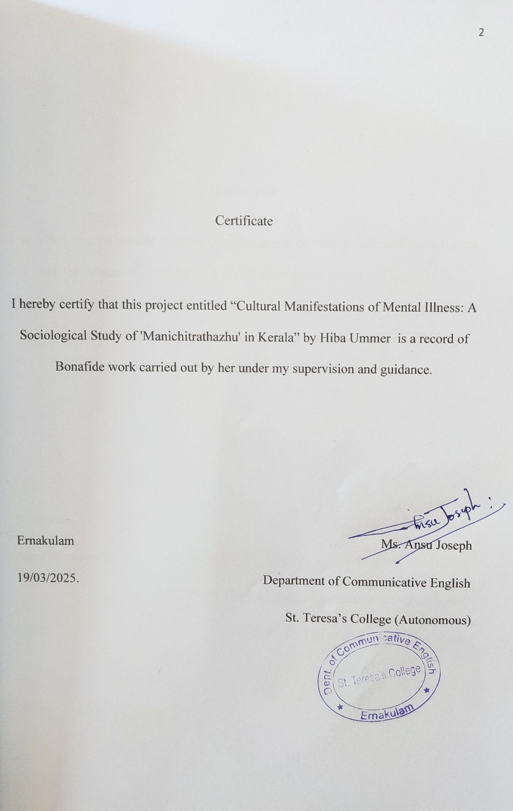Acknowledgement

I take this opportunity to offer my humble prayers and thanks to God Almighty for
His mercy and blessings for the completion of this project.
I am deeply grateful to Rev. Sr. Nilima, CSST, Provincial Superior and Manager, St.
Teresa’s College (Autonomous), Ernakulam, for her kind cooperation and I am highly
indebted to Rev. Sr. Tessa, CSST, Director, St. Teresa’s College (Autonomous),
Ernakulam and Prof. Dr. Alphonsa Vijaya Joseph, Principal, St. Teresa’s College
(Autonomous), Ernakulam for their unconditional support and encouragement during
my course of study in this institution.
I am extremely grateful to Allu Alfred, Head of the Department of Communicative
English, St. Teresa’s College (Autonomous) for the valuable support and encouragement in fulfilling this project. I am profoundly indebted to my
guide Ansu Jospeh for her constant support and help for the successful completion of this project.
I am extremely thankful to my supervising guide, Ms. Ansu Joseph for her guidance and to all the teachers of the department for their valuable help rendered for the successful completion of this project.
Last but not the least, I wish to express my gratitude to my friends and family for their
love and support.

Hiba Ummer

Abstract

Mental illness is deeply embedded in cultural and social contexts, shaping both its perception and treatment. This study explores the sociological dimensions of mental illness as depicted in the Malayalam film Manichitrathazhu (1993), a cinematic masterpiece that intertwines folklore, psychology, and societal beliefs. The film’s portrayal of dissociative identity disorder (DID) in the protagonist, Nagavalli, reflects the intersection of traditional beliefs, gender roles, and medical discourse in Kerala’s cultural landscape.
By analyzing the narrative, character dynamics, and the tension between indigenous healing practices and psychiatric intervention, this research highlights how mental illness is socially constructed and navigated within Kerala’s milieu. The study also examines how Manichitrathazhu serves as a cultural text that mirrors and challenges prevailing attitudes towards mental health, superstition, and patriarchal control. Through a sociological lens, this work underscores the film’s role in shaping public perceptions and sparking discourse on mental health in Kerala.

TABLE OF CONTENTS

- Chapter 1: Introduction……………………………….6
- Chapter 2: Literary Analysis…………………………..12
- Chapter 3: Methodology………………………………19
- Chapter 4: Content Analysis…………………………..23
- Conclusion……………………………………………31
- Works Cited……………………………………………33

CHAPTER- 1
Introduction

Superstitions are rooted in collective memories, fears, and traditions. They attempt to explain the unexplainable or provide comfort in times of uncertainty and are passed down from generation to generation in rituals, folklore, and customs. Superstitions are part of belief systems in many religions and folk practices, and rituals include prayers or offerings to ward off misfortune. These beliefs vary greatly across countries; for example, some people install a rooster on their altar for protection, while others believe that they must empty all of their tiebacks to succeed. In some communities, completing the last of anything is regarded as a way to avoid bad luck. Even in secular communities, superstitions such as the bad luck associated with black cats or Friday the 13th continue to exist.
Superstitions originate from an individual’s ability to weave connections between disparate activities. This is sometimes referred to as Apophenia; finding meaning within meaningless details. Humans have an innate tendency to seek connections in their surroundings and as a result, they tend to believe in superstitions. They can also serve as a form of relief when one is confronted by the unfamiliar. In stressful times, people tend to resort to rituals which give them a sense of control, even if it is for a brief moment.
For many decades in a row, superstition has remained one of the most commonly utilized themes in the movie industry. It is a subject that is selected so that it may be used to explore sociological and psychological anxiety in addition to horror and suspense. In films, as in real life, superstition beliefs and practices underline the point that human emotion is much more complex than this simple word, fear, and reflects the interrelation of faith and reality.
Another way in which some films deal with superstition is by making fun of it. Beetlejuice (1988) for instance, makes fun of the ridiculous nature of supernatural rituals and afterlife beliefs. The film still incorporates traditional superstitions about ghosts and the afterlife, but it does so in a lighthearted, comical way. This approach criticizes the rigidity and fear associated with superstition, suggesting that superstition can be fun if taken to an extreme.
Superstition is something that everyone experiences, and as a cultural and psychological phenomenon, it’s incredibly important. In the film, superstition is used as a way to examine the human condition, our fears as a society, and the stories that we tell ourselves. Whether used to build tension in horror films, to create psychological conflict in thrillers, or as a way to make social commentary in dramas, superstition is an extremely important movie theme. By addressing universal fears and anxieties, filmmakers use superstition to reflect and challenge the beliefs of the culture it is coming from, which makes it a lasting and powerful storytelling device.
The intriguing Malayalam psychological thriller "Manichitrathazhu" (1993), which was directed by Fazil, explores themes of mental illness, superstition, and the human mind while combining elements of drama, suspense, and horror. The video explores the effects of superstition on people and society, particularly how it can influence behaviour and perceptions when combined with psychological trauma. The superstition in the film is rooted in the traditional and rural context where folk beliefs, spirituality and customs are part and parcel of everyday life. The mythology, folklore and religious practices prevalent in Kerala influence the way people view supernatural phenomena and interpret events. Stories about spirits, ghosts and haunted places are passed down from generation to generation and are preserved as part of the cultural legacy. The movie is based on the legend of a haunted house, which has been cursed by a tragic past event. The curse is portrayed as a superstition that reflects and reinforces cultural norms about the supernatural and provides insight into the region’s deeply rooted beliefs and practices. The characters are reliant on local lore to explain the unexplained events in their lives. The belief in ghosts and spirits is central and deeply ingrained in the cultural context. It creates a sense of fear, anxiety and powerlessness. The superstition manifests itself in the community’s interpretation of unexplained events and shows how the beliefs are deeply ingrained in the psyche of the individual. This is a film that looks at the way folk beliefs get passed down through families and are not always critically examined. The horror and suspense come from the way these superstitions shape the way characters act. For instance, the house curse belief causes people to experience paranormal activity as though it is real. This becomes a way that the characters try to understand and make sense of what is happening to them.
However, superstition is also used as a vehicle to reexamine and critique traditional values and practices. Dr. Sunny, a rational and scientific character, actively confronts these superstitions and tries to find the real psychological explanations behind the film’s various events. This clash between superstition and reason looks at how superstition is embedded in cultural practices and how it can get in the way of understanding and rational thought. This study focuses on the representation of superstition in films, in particular analyzing how filmmakers utilize this concept to address sociological, psychological, and cultural issues. The research will analyze how superstition is depicted in films as a cultural phenomenon which embodies the fears, beliefs, and anxieties of the culture. It will analyze how superstition functions as a coping mechanism for characters overwhelmed by stress and how these characters reflect larger societal issues. The research will also analyze the employment of superstition as a narrative device to achieve tension, suspense, and conflict in films.
One major focus of this study will be to dive into the connection between superstition and mental health, especially as seen in the film ‘Manichitrathazhu’. In this film, superstitions are often tied to psychological struggles or past traumas. We’ll explore how these superstitions act as a cover for deeper mental health issues and the societal pressures that come into play, particularly regarding gender and cultural norms.
The research will include in-depth case studies of significant films, with a special spotlight on ‘Manichitrathazhu’ (1993). We’ll analyze how superstition weaves into the story, influences character development, and shapes the overarching themes. Additionally, we’ll examine how superstitions are portrayed within specific cultural settings, like Kerala, to grasp both the unique cultural aspects and the broader, universal themes at play. This study will dive into the fascinating ways superstition intertwines with gender norms and expectations, especially in traditional contexts. It will take a closer look at female characters, like Ganga in ‘Manichitrathazhu’, who are often tied to superstitions that mirror societal pressures and repression. This suggests that superstition can serve as a means of controlling gender roles. Additionally, the study will evaluate the lasting impact of superstition in cinema throughout the years, exploring why it remains a relevant and persistent theme in contemporary filmmaking. It will reflect on what keeps superstition so intriguing for both filmmakers and audiences, considering its emotional, psychological, and cultural significance.
In summary, this study aims to provide a thorough analysis of how superstition operates in cinema—not just as a belief system, but as a lens through which filmmakers tackle complex human emotions, societal challenges, and psychological experiences. The superstition in the film is also connected to mental health, especially when we look at Ganga who suffers from visions and actions that are said to be caused by supernatural forces. The film suggests that superstition can reflect repressed psychological trauma, especially in gender contexts. Ganga’s breakdown is initially attributed to an ancestral curse, but it becomes apparent that her situation is more connected to emotional and mental health problems, intensified by societal pressure and repression. This element of the film shows how superstition can be tied to cultural ideas about gender and how these ideas can be used to mask and justify more complicated issues like mental illness. In this way, the film shows superstition as a cultural construct that can sometimes be used to repress, especially women, who are often expected to conform to certain social norms in traditional contexts.
In Manichitrathazhu, superstition is both a cultural phenomenon and a narrative device that propels the plot and enhances the psychological characterization of its characters. The film explores the extent to which deeply held traditional beliefs can exert a powerful influence on behaviour, but it also challenges these beliefs by highlighting the dangers of using superstition to explain complex emotional and mental states. In so doing, it suggests that superstition is not simply a reflection of cultural beliefs, but is also a tool through which individuals and communities attempt to make sense of the world around them—sometimes at the expense of truth and understanding.

CHAPTER 2:
Literary Analysis

The interconnection between culture, superstition, and mental illness is a strong theme in the 1993 Malayalam film 'Manichitrathazhu', which was directed by Fazil. Against the rich folklore and traditional beliefs of Kerala, the film explores the psychological turmoil of its protagonist, Ganga, whose mental health problems are first explained as the work of supernatural forces. This chapter features a sequence of literary critiques exploring the psychological and cultural aspects of the film and how superstition crosses paths with mental illness within the sociocultural fabric of Kerala. Drawing on a meticulous examination of interpretations by scholars, this chapter aims to examine how 'Manichitrathazhu' deals with the nuances of mental illness within a conservative framework, whereby superstitions and folklore tend to be used to explain psychological trauma.
The analyses take into account multiple theoretical perspectives such as sociocultural and psychological—to uncover how cultural beliefs impact the understanding and treatment of mental health in Kerala. Through the multiple perspectives of analyzing the film, the chapter will illuminate how the movie critiques traditional dependence on superstition in treating advanced psychological problems and examines the deep influence of social norms on personal mental well-being. This thesis is analyzes the movie ‘Manichithrathazhu’ in the light of two studies named “Portrayal of Mental Health Issues in Manichitrathazhu and Taare Zameen Par” and “Cultural Aspects of Major Mental Disorders: A Critical Review from an Indian Perspective".
- Portrayal of Mental Health Issues in Manichitrathazhu and Taare Zameen Par
The paper "Portrayal of Mental Health Issues in ‘Manichitrathazhu’ and ‘Taare Zameen Par’" analyzes the way mental health is depicted in Indian films and how cultural beliefs regarding mental illness affect responses by characters and the audience's understanding of these problems.
At the center of "Manichitrathazhu" is the underlying theme of mental illness mistaken as supernatural events. The main character, Ganga, is considered possessed by a vengeful ghost from the past due to the ancestral curse and develops erratic and violent behavior. This supernatural cause hides what is presumably a case of dissociative identity disorder (DID), where Ganga's personality fragments as a result of past trauma. Here, cultural thought regarding mental illness is central in misdiagnosing and not understanding her state. The film satirizes the excessive dependency on superstition in Kerala's society, whereby modern psychological illnesses frequently conflict with long-standing conventions.
The state of possession, normally found among traditional folk practices, is invoked as a symbol for the incompetence of society in comprehending mental illness from the clinical perspective. This is the point where the thesis might look to derive its main sociological analysis: what does the movie reveal about tension between contemporary psychiatric science and prevailing cultural explanations for mental illness?
The cultural manifestations of mental illness in “Manichitrathazhu” are not limited to individual behaviors but extend to the communal and familial systems that shape how mental health is perceived. Kerala’s deep cultural history is steeped in folklore, temple rituals, and ancestral beliefs. The sociological aspect of the thesis could explore how the community’s collective belief system influences the way Ganga’s mental illness is interpreted and managed. This aligns with the themes highlighted in the study, which suggests that in Indian cinema, cultural stereotypes and societal views often overshadow the clinical understanding of psychological conditions. Through this lens, “Manichitrathazhu” reflects the larger social reality where traditional practices often determine the treatment of mental health conditions. The family’s initial reliance on superstitions and rituals to cure Ganga mirrors the everyday practices in rural or culturally conservative regions of Kerala, where modern psychiatry is often sidelined. This connection between culture and the portrayal of mental illness suggests that the film not only critiques the misrepresentation of psychological conditions but also addresses the implications of such portrayals on societal attitudes.
By comparison, the paper also addresses 'Taare Zameen Par', wherein the visualization of a child battling dyslexia is done in a more clinical, but still culturally relevant manner. The differing portrayals of mental illness in both films can then be utilized in order to stress the ways in which varying cultural contexts impact the cinematic depiction of mental illness and the sociological consequences of such portrayals.
'Manichitrathazhu' offers a complex story that interlinks cultural belief and misinterpretation of mental illness in a rich sociological context. The thesis on "Cultural Manifestations of Mental Illness: A Sociological Study of Manichitrathazhu" is able to present a sophisticated analysis of how the movie disapproves of societal attitudes towards mental health in its presentation of possession, superstition, and refusing to recognize mental illness. Basing ourselves on the conclusions drawn from the study "Portrayal of Mental Health Issues in "Manichitrathazhu" and "Taare Zameen Par", this analysis is able to illustrate how film plays an influential part in shaping and expressing societal perspectives towards mental health, particularly where traditional beliefs compete with contemporary psychological interventions.
By integrating the analysis of cinema and sociological insights, the study offers an analysis of how cultural contexts shape mental health representation and how these representations affect public views, ultimately destabilizing the stigmas in Indian society about mental illness.
- Cultural Aspects of Major Mental Disorders: A Critical Review from an Indian Perspective
The film ‘Manichitrathazhu’ offers a rich sociocultural exploration of mental illness, where the protagonist Ganga is mistakenly believed to be possessed by an ancestral spirit. This portrayal reflects the intersection of cultural beliefs and mental health, where traditional views on supernatural forces often overshadow modern psychological diagnoses. The study ‘Cultural Aspects of Major Mental Disorders: A Critical Review from an Indian Perspective’ provides a critical framework for understanding how cultural beliefs in India shape the manifestation, treatment, and stigma surrounding mental disorders. By examining ‘Manichitrathazhu’ through the lens of this study, we can explore how cultural aspects of mental illness influence societal attitudes toward mental health in Kerala.
This study emphasizes the significant role that cultural beliefs play in shaping both the diagnosis and treatment of mental illness in India. According to the study, mental health is often viewed through a cultural lens that includes folklore, religion, and traditional healing practices. For example, mental disorders in India are frequently seen as manifestations of spiritual disturbances, such as possession, black magic, or curses. This cultural interpretation of mental health can be contrasted with a clinical or psychological understanding of disorders, leading to misdiagnosis or underdiagnosis, as well as delays in seeking appropriate treatment.
In ‘Manichitrathazhu’, Ganga’s mental health crisis is attributed to supernatural causes, specifically the spirit of a woman from her family's past. The film’s central conflict revolves around the belief that her psychological breakdown is not a result of trauma or mental illness, but the vengeance of a vengeful spirit. This supernatural explanation reflects the cultural aspect of mental health in Kerala, where traditional beliefs often intersect with modern psychiatric understandings. The sociological analysis provided in the thesis ‘Cultural Manifestations of Mental Illness: A Sociological Study of ‘Manichitrathazhu’ in Kerala’ could explore how such cultural interpretations complicate the treatment of mental illness in a region steeped in these traditions. This cultural manifestation of mental illness in ‘Manichitrathazhu’ directly correlates with the study's assertion that cultural frameworks—specifically those rooted in Hindu beliefs, folklore, and community practices—have a profound impact on how mental illness is understood and managed. In Kerala, where the interplay of modernity and tradition is complex, the supernatural explanations for mental disorders continue to hold influence, as seen in the film's portrayal.
The thesis on ‘Cultural Manifestations of Mental Illness’ highlights the importance of understanding mental illness within the specific sociocultural context of Kerala. The region’s historical attachment to Hindu practices, its cultural reliance on temple rituals, and the legacy of ancestral beliefs are all factors that contribute to how mental health issues are perceived. In this setting, traditional medicine and spiritual practices often remain preferred methods of intervention, even as modern psychiatry and psychology gain ground in urban areas. In ‘Manichitrathazhu’, the family’s initial response to Ganga's condition is to consult traditional practices, rather than seek professional psychological help. This hesitation to embrace psychiatry and psychology is a key aspect of the sociological study, as it illustrates how cultural beliefs around illness—especially those rooted in spirituality and ancestral traditions—can prevent individuals and families from seeking appropriate clinical care.
The sociological implications, as described in the thesis, can be extended to the broader societal context of Kerala, where mental illness is often hidden behind a veneer of cultural customs and superstitions. This misinterpretation of mental health issues in ‘Manichitrathazhu’ can be examined as a representation of the societal conflict between modern mental health care and traditional cultural beliefs. As the film progresses, it becomes clear that the character's behavior is not the result of a supernatural force, but rather a deeply ingrained psychological trauma, one that is invisible to those around her because they view it through a cultural lens that emphasizes the supernatural over the scientific.
The study ‘Cultural Aspects of Major Mental Disorders’ points out that stigma is one of the most significant barriers to effective mental health treatment in India. Mental illness is often seen as a social taboo, with affected individuals frequently subjected to shame and exclusion. In the context of Kerala, the sociological study could examine how ‘Manichitrathazhu’ portrays the stigma surrounding mental illness, particularly through the character of Ganga. Her erratic behavior is not only seen as a personal crisis but is also viewed with suspicion by the community, and her family is reluctant to acknowledge her condition as a mental health issue. The film’s depiction of the social and familial stigma associated with Ganga’s behavior highlights how cultural beliefs about mental illness contribute to societal rejection and isolation.
The sociological analysis in the thesis can further explore how ‘Manichitrathazhu’ reflects the societal tendency to view mental illness through the prism of spiritual or moral failure, rather than as a medical issue. This perception reinforces stigma and hinders open discussions about mental health, making it difficult for individuals to seek help.
In conclusion, the study ‘Cultural Aspects of Major Mental Disorders: A Critical Review from an Indian Perspective’ offers valuable insights into how cultural beliefs influence the perception and treatment of mental illness in India. By connecting this study with the thesis ‘Cultural Manifestations of Mental Illness: A Sociological Study of ‘Manichitrathazhu’ in Kerala’, we can gain a deeper understanding of how Kerala's cultural traditions, which include spiritual beliefs, community practices, and folklore, shape the representation of mental illness in the film. ‘Manichitrathazhu’ serves as a cinematic microcosm of the larger sociocultural dynamics at play in Kerala, where mental illness is often misdiagnosed due to cultural beliefs, leading to stigma, mismanagement, and, in some cases, social isolation. The cultural misinterpretations of mental illness presented in the film provide an opportunity for a critical sociological analysis of how cultural practices and beliefs can shape societal attitudes toward mental health in Kerala, ultimately influencing both the treatment and perception of mental illness.

CHAPTER - 3
Methodology

The research analyzes mental illness cultural manifestations in Kerala through sociological exploration by studying the 1993 Malayalam film 'Manichitrathazhu' as its central case. The film depicts mental illness through its main character Ganga suffering from dissociative identity disorder (DID) which reveals Kerala's societal understanding of mental health. The study examines mental illness representation in public attitudes by studying these social and cultural aspects in Kerala specifically. The study utilizes symbolic interactionist theories and conducts qualitative research analysis through expert and general population interviews together with movie analysis among mental healthcare professionals. The outcomes from 'Manichitrathazhu' show how the film maintains standard understandings of mental disease and simultaneously confronts several psychiatric treatment-related stigmas that exist in Kerala.
Throughout history in Kerala, people have understood mental illness through multiple cultural factors. The state has made substantial progress in its mental health initiatives but various traditional religious perspectives together with cultural customs and influence remain influential in public responses. 'Manichitrathazhu' is a well-known Malayalam movie showing dissociative identity disorder as a vivid portrayal of mental illness in 1993. This study examines mental illness portrayal in the film to evaluate media-based relations with public comprehension in Kerala.
This scholarly research focuses on answering two linked questions through the theme set by 'How does the movie 'Manichithrathazhu' portray mental illness and what cultural understanding of mental health emerges in Kerala from this portrayal?'
The research will fulfil the following goals:
1. Discuss the portrayal of mental illness in the film 'Manichitrathazhu'.
2. Discuss the cultural context of Kerala towards mental illness and the role of traditional beliefs.
3. Find out how the film affects public perception about mental illness.
4. Discuss the role played by the media in perpetuating or dissolving social stigma towards mental health.
This research is important when considering how mental illness is presented in popular culture and the resulting impact on public opinion. 'Manichitrathazhu' being a widely watched film has determined the way many people in Kerala comprehend mental illness. An exploration of this representation will add to wider debates surrounding mental health stigma and the role of media in reinforcing or disassembling such assumptions. It can be contended in this thesis that 'Manichitrathazhu' not only describes Kerala's cultural conceptualization of mental illness but is also crucially responsible for helping to propagate pre-existing stigmas alongside critically presenting how the subject has been addressed within the state.

The current research is based on a qualitative study, and it incorporates both film analysis and field research. A case study is employed, and 'Manichitrathazhu' is taken as the point of reference for the study of mental illness representation in Kerala. The major data for the study will be derived from a close examination of the film. Topics like the presentation of mental illness, the societal reaction to the condition of the protagonist, and the interaction between cultural beliefs and how they condition these reactions will be examined. The literature review will offer secondary information to place the analysis in context, using scholarly articles and books on mental illness in Kerala and representations of culture in the media.
The movie 'Manichitrathazhu' depicts mental illness in the form of Ganga, who displays symptoms of dissociative identity disorder (DID). The movie integrates psychological theories with cultural beliefs, especially the concept of possession. The depiction of mental illness as a supernatural phenomenon brings forth significant issues regarding the confluence of traditional beliefs and contemporary psychiatric knowledge in Kerala. The movie has left a lasting impression on Societal Attitudes. It serves a double purpose in the mental illness discourse in Kerala. Although it does portray the suffering of the protagonist sympathetically, it also perpetuates the notion that mental illness is caused by supernatural forces, which could be a factor in the continuation of stigma. This section will examine the social implications of the movie.
This research finds that 'Manichitrathazhu' is part of a cultural discourse in Kerala where mental illness is both a psychological and supernatural phenomenon. The way the film portrays mental illness appeals to popular beliefs, which are still shaped by traditional notions, even as contemporary psychiatric interventions are gaining ground. The research indicates that media portrayals, as in 'Manichitrathazhu', are influential in shaping public opinion about mental illness. Through the presentation of mental illness both in terms of psychological science and supernatural belief, the film provides a nuanced reflection of Kerala's changing attitudes toward mental health. Future studies may involve comparing the representation of mental illness in 'Manichitrathazhu' to that in other state films to look for different ways that media representation is influenced by cultural context. Longitudinal studies on the evolving attitudes towards mental illness in Kerala would help monitor the evolution of public understanding.

CHAPTER-4
Content Analysis

Popular culture representations of mental illness are frequently informed by the dominant cultural beliefs, traditions, and historical contexts. In the state of Kerala, where there is a strong cultural heritage, folklore and supernatural factors tend to intersect with psychological illness, affecting popular attitudes towards mental health. The 1993 Malayalam movie Manichitrathazhu provides a strong case study for the exploration of these cultural expressions. This essay uses content analysis to analyze the movie's representation of mental illness from a sociological perspective, breaking down particular scenes in order to demonstrate the intersections of folklore, gender, and mental health discourse. Manichitrathazhu unfolds a rich plot in which madness is rooted firmly in cultural folklore. The story tracks the main character, Ganga, when she moves into an old family mansion and gets obsessed with one room that has a tragic tale attached to it. Her ultimate psychological metamorphosis into mythological dancer Nagavalli unfolds through a combination of visual and narrative signals reiterating classic myths about madness.

Content Analysis: Scene-by-Scene Breakdown:
The movie begins with an establishing shot of the Illam (traditional Kerala mansion) and at once places the audience into a world of history and mystery. With the arrival of Ganaga, she demands that the forbidden room be searched for the priceless objects contained within it.
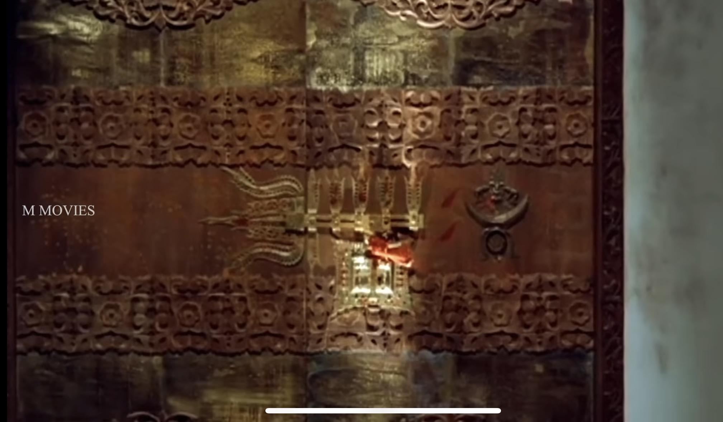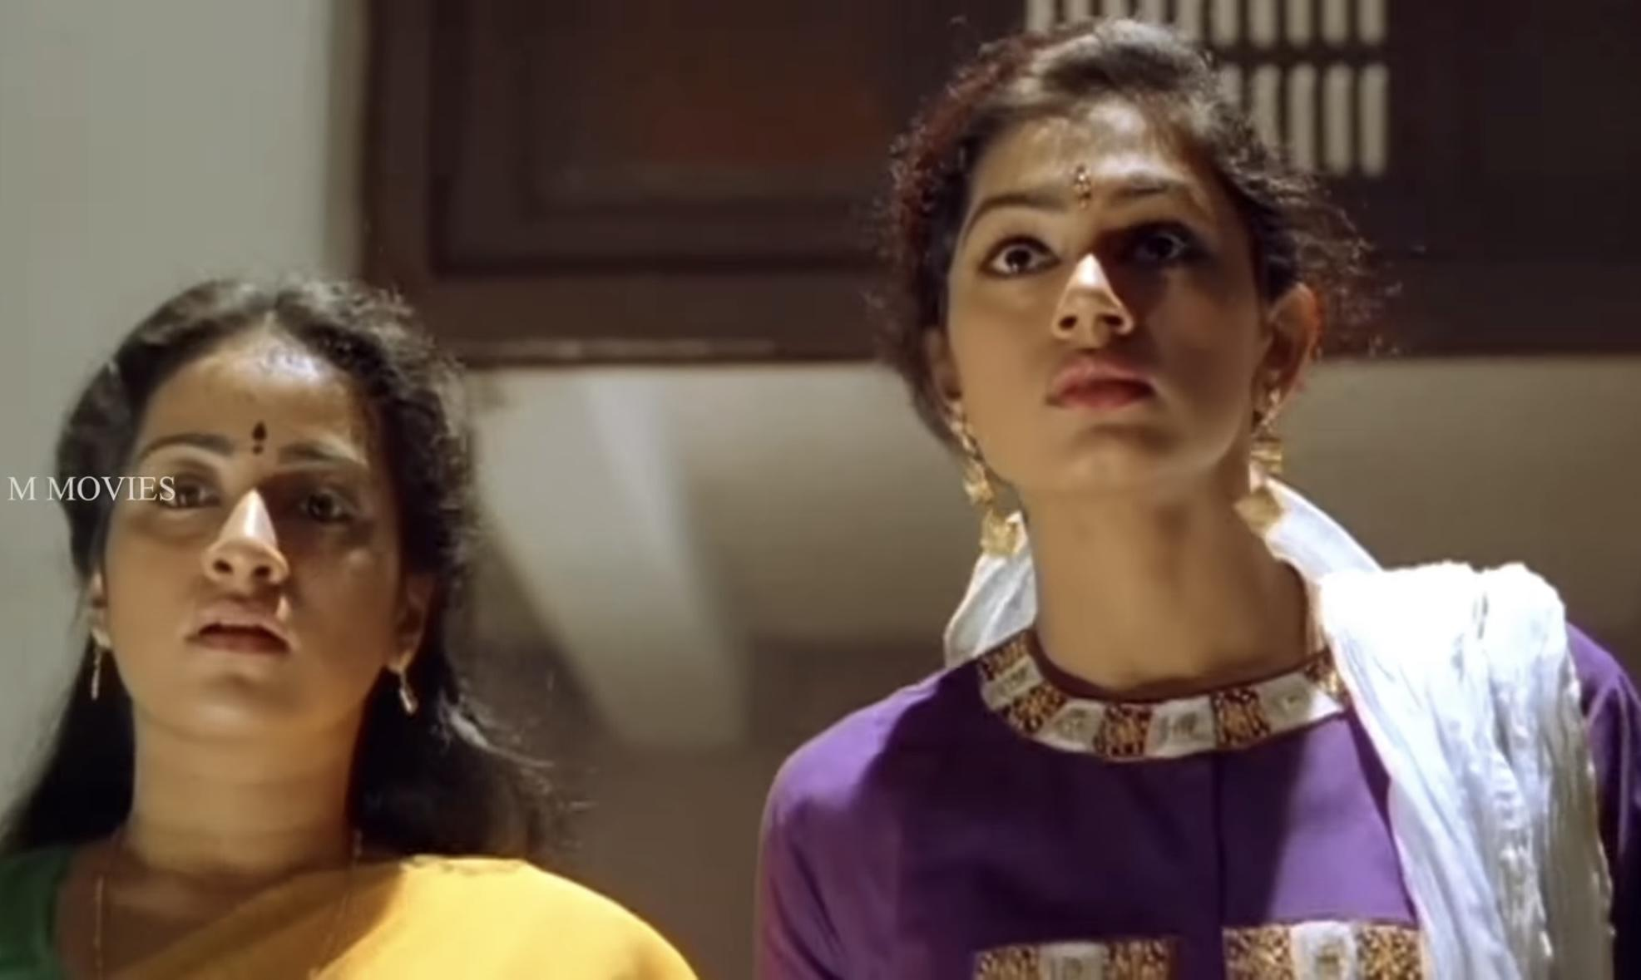
One of the movie's most climactic moments is when Ganga gets attracted to the locked room. She is pictured in a mid-shot in front of the door, a look of curiosity along with intrigue on her face. The camera pauses for a moment on the heavy wooden door, a metaphorical barrier of repressed memories and off-roading information. The locked room, similar to Freud's idea of the unconscious mind, represents the limitations placed by societal norms on women's agency and psychological liberty. The imagery of the locked room is a metaphor for the stigma surrounding mental disorders, which implies that these problems are hidden rather than treated.

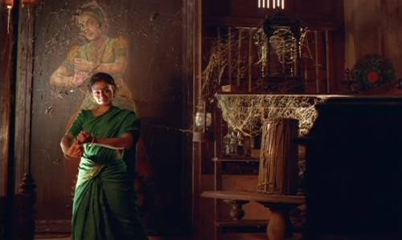
Ganga had felt loneliness in her childhood due to her parent's unavailability in her life. Her grandmother and stories of folklore and traditions had remained her companions throughout her childhood. The psychological agony of not being able to remain with the people she loves and the feeling of abandonment that went with it had deeply troubled Ganga. In the subsequent years when her parents showed a desire to send her to Calcutta for her higher studies, Ganga went through a mental breakdown. The grandmother whom she loved, the surroundings which she was fond of and the myths which were present around her since childhood are all being snatched away from her. The legend of Nagavalli in Nakulan's Illam had tantalized her. The interest and fascination gradually began turning into an obsession. On later occasions, we can observe Ganga trying to imitate Nagavalli's stance in the photograph in the forbidden room. This indicates how she had begun to identify with character.
The most visually and narratively striking moment of the film is Ganga's full transformation into Nagavalli. The sequence features extreme close-ups of her face, representing her transition from peace to unbridled anger. Her opened eyes and heightened expressions show the process from repressed feelings to open rage. A low-angle shot of her towering figure in traditional dance clothes adds a supernatural illusion, further heightening the sense that she has been possessed and not afflicted with a psychological disorder.

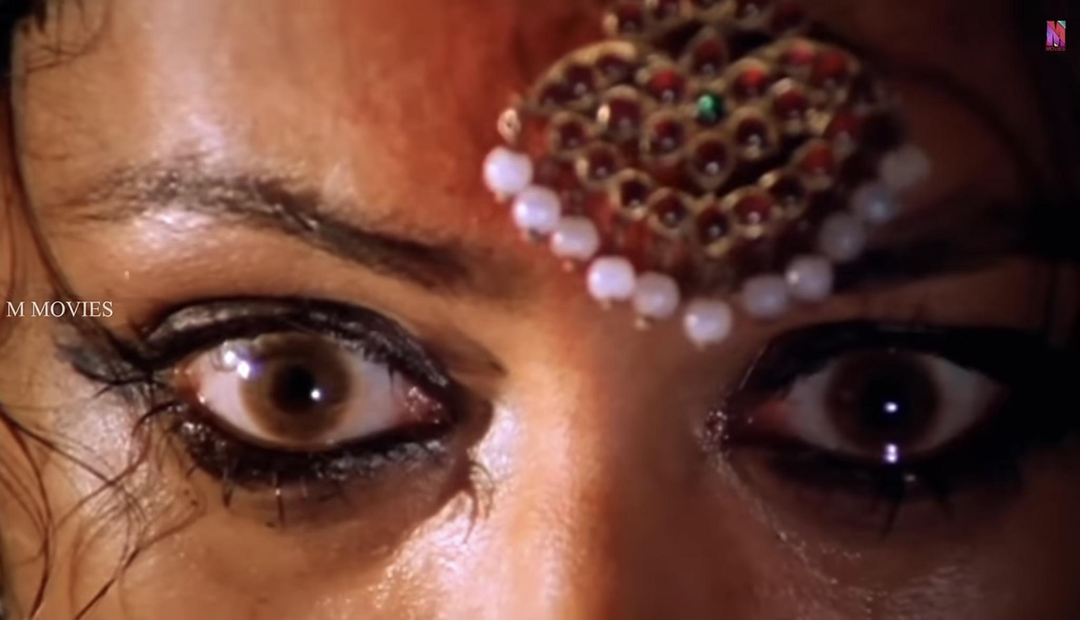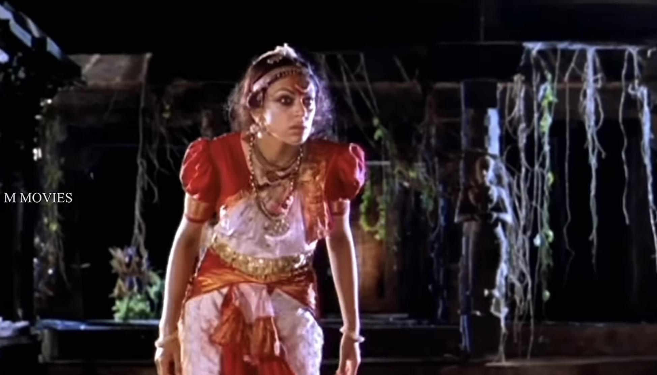

A long shot of Ganga dancing a classical dance in the dark corridor, with fire dancing around her, further enhances the film's aesthetic dependence on cultural symbolism. The fusion of traditional dance steps with her unstable behavior blurs the boundary between theatrical performance and psychological turmoil. Her eyes are wide and untamed from mental anguish in a close-up shot. Sociologically, this order demonstrates the gendered aspect of mental illness in Kerala society. The psychological problems of women are devalued or reinterpreted into acceptable cultural storylines, including possession or the intervention of gods, instead of being acknowledged as clinical conditions necessitating medical attention.
From this content analysis, a number of major themes that characterize the cultural construction of mental illness in Kerala are identified and they are:
- Association of Mental Illness with Folklore and Superstition
The movie sustains the belief that mental afflictions are the result of supernatural forces. Ganga's illness being presented as a possession and not a psychiatric condition is symptomatic of a larger social hesitation to embrace scientific explanations for mental illness.
- Gender and Psychological Suppression
Ganga's transformation into Nagavalli can be seen as a revolt against patriarchal domination. Her inner conflicts, which would otherwise be ignored or belittled in a domestic environment, only receive notice when articulated through culturally meaningful performance and mythological imagery.
- Visual Symbolism and Narrative Structure
The locked door, the dark corridors, and the flickering flames are symbols for the concealed nature of mental illness. The heavy use of visual narrative points to the unconscious means by which cultural narratives influence public perception of psychological disorders.
- Intersection of Tradition and Psychiatry
The film reflects Kerala’s dual approach to mental health—where scientific psychiatry coexists with traditional healing practices. This duality is evident in the way the protagonist’s condition is addressed: medical professionals diagnose her with dissociative identity disorder, yet her transformation is still framed within the context of Nagavalli’s myth. Manichitrathazhu's shot-by-shot content analysis unravels that it is not merely a psychological thriller but rather an expression of Kerala's cultural psyche towards mental illness. Through its complex combination of folklore, cinematography, and gendered narratives, the film summarizes the tension between modern psychiatric discourse and old belief systems. The depiction of Ganga's condition highlights the difficulty in destigmatizing mental conditions in cultures where supernatural interpretations are strongly ingrained. Through critical analysis of such movie portrayals, we can have a clearer understanding of the social paradigms that guide mental health understandings and strive for more embracing and evidence-based conceptualizations of psychological well-being.
Manichitrathazhu is an effective prism through which the sociocultural dynamics of mental illness in Kerala can be analyzed. The film's enduring cultural relevance attests to the continued presence of these narratives, and it is therefore imperative to question how visual media plays a role in shaping public perceptions of mental health. An awareness of these cultural expressions is an important step toward the development of a more educated and empathetic discourse on mental illness in South Asian societies.

Conclusion

This scholarly research focuses on answering two linked questions through the theme set by ‘How does the movie Manichitrathazhu portray mental illness, and what cultural understanding of mental health emerges in Kerala from this portrayal?’ The sociological analysis of Manichitrathazhu discloses the intricate manner in which cultural stories shape the understanding and management of mental illness in Kerala. Through its dense interaction of folklore, gender relations, and psychiatric talk, the film captures the ingrained beliefs that continue to inform social attitudes toward mental illness.
The persistence of supernatural causations for mental illness, as seen in the film, illustrates the continuing conflict between old-fashioned belief and newfangled psychiatric techniques, showing how entrenched cultural conceptions can make it difficult for medical treatment to be accepted. Among the important findings of this research is how folklore supports stigma towards mental illness. Through its depiction of Ganga's affliction as mystical possession, as opposed to psychiatric illness, the film reflects society's proclivity for blaming psychological pain on external supernatural agents. Such a cultural context may deter sufferers from seeking the proper mental health interventions, resulting in cycles of misdiagnosis and ineffective care. To respond to this challenge, there is an urgent need to incorporate psychiatric education into cultural storytelling, assisting the community to grasp mental illness in a manner that is respectful of tradition yet supports scientific consciousness.
Manichitrathazhu emphasizes the intermixture of traditional healing and modern psychiatry in Kerala. As scientific psychiatric interventions rise to prominence, traditional belief systems continue to exert considerable power over the treatment of mental health. The coexistence implies the need for an integrated model that is respectful of cultural beliefs yet encourages evidence-based mental health intervention. By closing the gap between medical and traditional paradigms, mental health practitioners can develop more effective and culturally appropriate interventions.
Manichitrathazhu is an effective case study for the study of the cultural expressions of mental illness in Kerala. The film condenses the contradictions between tradition and modernity, gender and agency, and superstition and science, providing a window through which to view the larger sociological issues of mental health awareness in South Asia. Overcoming these challenges involves sustained action in education, policy-making, and community outreach to decrease stigma, encourage acceptance of psychiatric treatment, and foster a more inclusive mental health discourse. Through critical engagement with cultural narratives such as those in Manichitrathazhu, society can make significant strides toward dismantling misconceptions and adopting a more empathetic and informed response to mental health.

Works Cited
- Prentice-Hall: Stigma: Notes on the Management of Spoiled Identity, 1963. Erving Goffman.
- Kerala Sociological Review: A Study of Mental Illness in Kerala's Popular Cinema, 2015. N. Nair.
- ‘Manichithrathazhu’ Malayalam Movie directed by Fazil.
- ‘Taare Zameen Par’ Bollywood Movie directed by Aamir Khan and Amole Gupta.
- Journal of Positive School Psychology: . Portrayal of Mental Health Issues in Manichitrathazhu and Taare Zameen Par, 2022. Anoop K Ajay, Abhinand J Raj, Gopika Unni R, P S Aiswarya, Shilpa M Chandran
- National Institute of Health: Cultural Aspects of Major Mental Disorders: A Critical Review from an Indian Perspective, 2012. Biju Viswanath, Santosh K Chaturvedi

