

A COMPREHENSIVE STUDY OF CULTURAL CAPITAL
IN THE FILM CHURULI
Project submitted to St. Teresa’s College (Autonomous) in partial fulfilment of the
requirement for the degree of BACHELOR OF ARTS in English Language and Literature
By
ANJANAPRIYA P.P
Register No. AB18ENG037
III B. A. English Literature
St. Teresa’s College
Ernakulam
Cochin - 682 011
Kerala
Supervisor
MS. VINITHA JOHN
Assistant Professor
Department of English
St. Teresa’s College
Ernakulam
Kerala
March 2024

DECLARATION
I hereby declare that this project titled “A Comprehensive Study of Cultural Capital in
the Film Churuli.” is the record of bona fide work done by me under the guidance and
supervision of Ms. Vinitha John, Assistant Professor, Department of English.
Anjanapriya P.P
Register No. AB18ENG037
III B.A. English Literature
Ernakulam St. Teresa’s College (Autonomous)
March 2024 Ernakulam

CERTIFICATE
I hereby certify that this project entitled “A Comprehensive Study of Cultural Capital
in the Film Churuli.” by Anjanapriya P.P is a record of bona fide work carried out by her
under my supervision and guidance.
Ms. Vinitha John.
Assistant Professor
Department of English
Ernakulam St. Teresa’s College (Autonomous)
March 2024 Ernakulam

A COMPREHENSIVE STUDY OF CULTURAL CAPITAL IN THE FILM CHURULI
By
Anjanapriya P.P
B.A. English Language and Literature
St. Teresa’s College (Autonomous)
Ernakulam
Register No: AB18ENG037
2021 - 2024
Supervising Teacher: Ms. Vinitha john
Culture is a significant element of a society and is passed down from generation to
generation. It influences various aspects of an individual’s life. Culture includes shared
belief, values, customs, religion, language, etc. It is a way of life of a society. This project
undertakes a literary analysis of the film Churuli directed by Lijo Jose Pellissery to identify
the cultural capitals employed by the two major characters, Anthony and Shajeevan in the
film in order to be a part of the alien society of Churuli. This project is divided into two
chapters. The first chapter is a theoretical exploration of Pierre Bourdieu’s theory of cultural
capital and it also delves deeper into the theories of assimilation and acculturation. The
second chapter is the study of the film Churuli using the conceptual framework of Bourdieu’s
theory of cultural capitals to outline the cultural capitals of the people of Churuli. It analyses
how through studying and mirroring these cultural capitals the two foreign characters become
part of the society.

ACKNOWLEDGEMENT
I take this opportunity to thank God Almighty for showering his abundant blessings and grace
upon me during the course of my project.
I would like to place on record my sincere gratitude to Rev Dr. Sr. Vinitha (CSST),
Provincial Superior and Manager, St Teresa’s College (Autonomous), Ernakulam and
Dr. Alphonsa Vijaya Joseph, Principal, St Teresa’s College (Autonomous), Ernakulam for
their continued support throughout the course of my study in this institution.
I would like to express my heartfelt gratitude and appreciation to my supervisor Ms. Vinitha
John for guiding my thoughts in the right direction and for helping me to express them in the
best possible manner.
I extend my sincere gratitude to the Head of the Department, Dr. Preeti Kumar and all the
other teachers of the department without whose guidance this project could never have been
completed.
Anjanapriya P.P



CONTENTS
List of figures (i)
Introduction 1
Chapter 1 | Understanding Cultural Capital | 3

Chapter 2 | Deciphering Cultural Capitals in Churuli | 9
Conclusion 18
Work Consulted 21

List of Figures
SL No. | Title | Page No.

Fig. 1 | Behaves like normal people | 9

Fig. 2 | The wooden bridge linking Churuli to the outer world | 10

Fig. 3 | Communicating with curse words which is normal | 12

Fig. 4 | Disrespectfully talking to his superior officer | 13

Fig.5 | Turned the tavern to the church | 14

Fig.6 | Enjoying slapping each other | 15

Fig.7 | They disguised as one of them | 16
(i)

1
Introduction
‘Culture’ consists of the beliefs, behaviours, objects, and other characteristics
common to members of a particular group or society. Culture is a characteristic of a group of
people defined by everything such as language, lifestyle, etc. Sociologists define society as
the people who interact in such a way to share a common culture. The cultural bond may be
ethnic, racial, based on gender or due to shared belief, values and activities. Society can also
have a geographic significance and refer to a group of people who share a common culture in
a particular location. Culture is considered as the central concept in a society.
This paper analyses the cultural capitals depicted in the film Churuli, which enabled
two foreign characters to assimilate into an unfamiliar society. The characters in the film
explore society and its customs, which are surreal to them. The project studies the film
through the theoretical background of the cultural capital. ‘Cultural Capital’ is a term
propounded by the famous French sociologist and public intellectual Pierre Bourdieu in his
1973 paper “Cultural Reproduction and Social Reproduction''. It consists of intangible
resources that can have a significant impact on social mobility and success. These resources
may include knowledge, skills, experiences, and other factors that are related to culture and
society. It comprises social assets of a person like the way of dressing, language, style of
speech, etc. Pierre Bourdieu developed the concept of cultural capital to illustrate how power
is transferred in a society and social classes are maintained. This accumulation of cultural
capital can result in disparities in opportunities and life outcomes favouring those with
greater resources and more likely to succeed.
Churuli is a 2021 Malayalam film directed by Lijo Jose Pellissery and written by S
Hareesh. The film revolves around a mysterious place called Churuli where the inhabitants
are trapped in a never-ending cycle. The story follows two undercover cops, Antony and

2
Shajeevan, on the hunt for a wanted criminal, mayladumparambil Joy who is believed to be
hiding in the village of Churuli. The two officers assume false identities as Shajeevan and
Antony becomes entangled in a complex web of deception and intrigue. They spend more
days in Churuli. Antony and Shajeevan stay and work in a tavern owned by a character
named Phillip and wait for Thangan’s return. Tavern is the main place in the movie where
they inquire about the criminal. After the arrival of Thangan from town and being informed
about this duo, Thangan becomes furious as Thangan has not asked anyone to work for him.
Villagers question the duo and decide to kill them both. Shajeevan fires a warning, and
Thangan reveals that he is not Joy, and Thangan leads the way to Joy’s house while the locals
follow behind. After their arrival, they find Joy is paralyzed, and the police tie him up and
take him away in the jeep. On the way he starts to narrate a story of a monk and a Perumadan,
mirroring these two policemen as a monk and Joy as the Perumadan himself. In the middle,
they lose their way to get out of the Churuli, but Joy guides them down another road, and the
story continues. In the climax, the characters Joy and Shajeevan exchange seats, indicating
that Shajeevan becomes the criminal, which is the Perumadan who is controlling the loop and
the Joy becomes free from the loop, and everything will continue again.
This paper is divided into two chapters. The first chapter is the theoretical study of
Pierre Bourdieu’s theory of cultural capital. It explains the different cultural capitals, namely
embodied, objectified and institutionalised. The chapter also delves deep into the ideas like
cultural assimilation and acculturation. The second chapter is the analysis of cultural capitals
the characters Anthony and Shajeevan in the film Churuli employs to acculturate into a
unreal society of Churuli.



3
Chapter 1
Understanding Cultural Capital
‘Culture’ represents the beliefs and practices of a group, while society represents the
people who share those beliefs and practices. Different societies have different cultures;
however, it is important not to confuse the idea of culture with society. Neither society nor
culture could exist without each other. The word “society” means “companion” or “being
with others”. A society consists of people who share territories and a culture with each other.
Society brings people together, creating a sense of belonging and shared identity. It promotes
social cohesion by providing a framework for cooperation, collaboration, and mutual support.
Social cohesion strengthens community bonds, fosters trust and reduces social isolation.
Society functions by providing for the basic needs of its members such as food, shelter, and
healthcare, creating and enforcing law and regulations to maintain order and ensure justice,
and also promoting social and economic stability through systems such as education,
employment and public service. One of the major advantages of society is collaboration. In a
society people can work together to achieve common goals, leading to greater productivity
and innovation. Family is the basic unit of society. It forms a community. Many communities
together form a nation. In every society, there will be a system followed by the people who
live there. This system can change over a period. When an outsider or an individual comes to
a society that person learns and accepts the patterns of behaviour, values, language, norms,
and becomes identical with the society. It will change the person's behaviour.
‘Cultural Capital’ is a term propounded by the famous French sociologist and public
intellectual Pierre Bourdieu in his 1973 paper "Cultural Reproduction and Social
Reproduction”. Cultural capital promotes social mobility in a stratified society. Pierre
Bourdieu also discusses other theories like habitus, fields, etc in his work. According to him,



4
cultural capital consists of intangible resources that can have a significant impact on social
mobility and success. These resources may include knowledge, skills, experiences, and other
factors that are related to culture and society.
One of the key ideas of Bourdieu's theory is that cultural capital is not evenly
distributed among members of society. Instead, it is concentrated among certain social
groups, such as the upper class. This concentration of cultural capital has the potential to lead
to inequalities in opportunities and life outcomes, as those with more resources are more
likely to succeed.
The theory of cultural capital has been the subject of much debate and research over
the years, with scholars continuing to explore its many implications for society. Despite this,
it remains an important concept that helps us to better understand the role of culture in
shaping social outcomes. Pierre Bourdieu developed the idea of cultural capital as a way to
explain how power in society was transferred and social classes maintained. “Karl Marx
believed that economic capital dictated one’s position in a social order. Bourdieu believed
that cultural capital played a vital and subtle role. For both Marx and Bourdieu, the more
capital you have the more powerful you are” (Sam).
Bourdieu identified three sources of cultural capital: Objective, Embodied and
Institutionalised. ‘Objective’ stands for the cultural goods, books, works of art, etc.
‘embodied’ stands for language, mannerisms, preferences, etc and ‘institutionalised’ stands
for qualifications, education credentials, etc.
Embodied cultural capital includes the knowledge that is consciously acquired and
passively inherited to the next generation, by socialization to culture and tradition. Linguistic
cultural capital is the mastery of language and its relations. The embodied cultural capital,



5
which is a person's means of communication and self-presentation, is acquired from the
national culture. Unlike property, cultural capital is not transmissible, but is acquired over
time, as it is like character and way of thinking.
Objectified cultural capital comprises the person's property such as a work of art,
scientific instruments, etc. that can be transmitted for economic profit like buying-and-selling
and for symbolically conveying the possession of cultural capital facilitated by owning such
things. As such, cultural capital is not transmitted in the sale of the work of art, except by
coincidental and independent causation, when the seller explains the artwork's significance to
the buyer.
Institutionalized cultural capital comprises an institution's formal recognition of a
person's cultural capital, usually academic credentials or professional qualifications. The
greatest social role of institutionalized cultural-capitalism is in the labour market, “allowing
the expression of the person's array of cultural capital as qualitative and quantitative
measurements which are compared against the measures of cultural capital of other people.
Institutional recognition makes it easier to turn cultural capital into economic capital by
providing a practical way for the seller to explain their cultural capital to the buyer” (Course
Hero).
Pierre Bourdieu also explained the theory of habitus and field. Habitus is created by
society and when individual lives in a society different from their society for a period of time,
the ideology of people in these societies will influence the individual. It's not fixed or
permanent and can be changed under unexpected situations or over a long historical period.
Studying society's ways of thinking, dressing, and the use of language forms the “lived
experience” of the individual. This “lived experience” together with the elements that the



6
individual is made to forcefully study as per the rules of society contribute to the habitus.
Habitus teaches the individual how to survive in a society. The combination of both lived
experience and forcefully learned elements from society is called habitus. The elements of a
habitus are different in different societies. Habitus is neither the result of free will nor
determined by any structures. It's an interplay of both. It is the result of our decisions
voluntarily taken and things that the society has determined.
Field is the space of interaction. A place for exchanging these things. Field helps to
circulate the ideas and also produce certain values and ideas. Sometimes these ideas may
change the perspective of everyone. It is a site of production, manipulation and exchange of
ideas, cultures, values, etc.
Assimilation into a society or a community is a slow and gradual process. Different
societies have different norms and cultural practices. When these several forms of society
contact or interact, there happens an exchange of practices and culture, through this exchange
lots of changes happen. It takes time to apply these changes to our daily life. “Successful
accommodation sets the stage for an additional consequence of human interactions, namely
assimilation. This implies complete merging and fusion as the individual comes to share the
expectations of another group and slowly acquires the new set of values” (Samiksha 1). It's
the process whereby an individual or group acquires or studies practices of other groups or
societies in which they have come to live by accepting their culture, values, and norms. They
learn the cultural capitals of the host society like behaviour, dressing style, language, etc in
order to assimilate into that society. The process of assimilation involves imitating the traits
of dominant society through observing the environment of the society.



7
It's a two-way process that takes place when groups of individuals borrow cultural
elements from each other and incorporate them into their own culture. Both groups discard
their cultural elements and substitute them with new ones. It takes quite some time to become
similar. For example, immigrants in America or Europe usually begin to wear American or
European-style clothes almost as soon as they land. The factors of assimilation are the
development of society, the numbers involved, etc.
Acculturation is another process of cultural change that balances two cultures while
adapting one to another dominant culture in the society. It occurs when a person or group
from one culture adopts the practices and values of another culture while still maintaining
their own cultural identity. This can happen when individuals are placed in a new cultural
environment or when another culture introduced to them. Typically, minority cultures adopt
elements of the dominant culture in society. Immigrant group for example, may have distinct
cultural backgrounds from the dominant society they have migrated to. Individual from
different culture may try to integrate themselves into the new culture by participating the
aspects of dominant society, such as their culture, norms, values may change, but still hold
onto their original cultural values and traditions. Acculturation can occur at both the group
and individual level and can be facilitated through in person contact, art, literature, or media.
It often leads to changes in culture, religious practices, healthcare, and other social
institutions, food. Clothing and language may also be influenced by acculturation. The term is
used to describe the socialization process involves blending values, communication styles,
norms, culture attitudes, and behaviours. Psychological and physical well-being, as well as
daily behaviour, can be affected by acculturation.
In a society assimilation and acculturation are significant processes which lead to the
cultural growth and development of a society. It is through the mimicking of cultural capitals



8
of the host society that an individual external to the society would be able to assimilate into
the society. They acculturate into a society through studying cultural capitals.


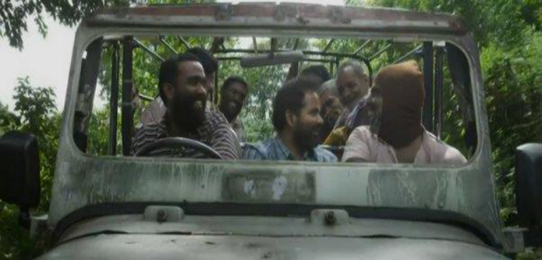
9
Chapter 2
Deciphering Cultural Capitals in Churuli
The word ‘churuli' means a helix, a spiral shape or an endless cycle. In the movie
Churuli, Churuli is a place where the people are trapped in an endless cycle. Most of the
people are criminals and by nature aggressive and they communicate in a different manner
which is normal for them. They use curse words in their language. Most of them spend the
day drinking alcohol and eating game meat. They are an aggressive community of strange
people.
Fig.1. Behaves like normal people. (Churuli 0:0:14:16)
This film is centered around two undercover cops who are searching for a wanted
criminal Mayiladumparambil Joy who is hiding in a place named Churuli. The duo characters
assume the false names, Shajeevan and Antony. They are the two main characters in this
movie, who are two outsiders entering this particular society which is entirely different from
their culture and their cultural practices. Churuli is a completely different world for them.
There is a wooden bridge that connects Churuli to the outside world. The people in that place


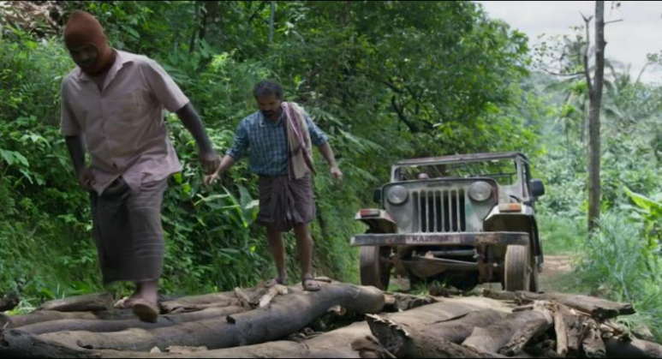

10
are friendly once they come out from Churuli. The behaviour will be pleasant and welcoming
and they act like normal people. But once they cross the bridge and step inside the place
Churuli they become a completely different person and it changes their behaviour and also
their language. On their way to the village, Anthony initiates a conversation with a jeep
driver and his companions. Antony says “Whoa! this a badass engine” (00:13:55–00:13:58).
Antony also compliments the soil which is good for planting the crops, “wow such fertile
soil, it must be very easy to farm, especially yams!” (00:14:11–00:14:18) The character
Anthony attempts to befriend fellow passengers who seem friendly, try to adapt with society.
But once they cross a wooden bridge, the passengers and the driver abruptly change their
pleasant demeanour and start being crass towards the duo, which shocks them. After the jeep
crosses the bridge Antony eagerly comes congratulating the jeep driver for his courage to
drive through the narrow wooden bridge. Antony says “whoa you could drive over a heir
strand wow!” it's a wonder you're still here” (Churuli 00:19:12–00:19:16). They expected
him to say thank you but the reply surprised them. The jeep driver replies “why the hell are
you pulling on? get off, your asshole”, “you think they are all standing around for nothing,
his freaking bag!” (00:19:17–00:19:23)



11
Fig. 2. The wooden bridge linking Churuli to the outer world. (Churuli 00:17:02)
The bridge is like a transition path which keeps the two different worlds separate. The
bridge here works as a path of entrance. It at the same time separates the unreal world of
Churuli from the real outside world and connects them. Once a person passes the bridge they
become a part of that place. The bridge symbolizes a transition path for both societies, to
come and go. It's the only path connecting Churuli to the outer realm. Once an individual
enters the place of Churuli they become a different person.
This chapter of the project explores the different cultural capitals of the place Churuli
that these duo characters Shajeevan and Antony try to mimic in order to be part of this
society. Antony and Shajeevan start observing the inhabitants of the place Churuli. It's a two-
way process where characters borrow cultural practices from the dominant society. These two
characters borrow cultural elements from this dominant society Churuli to assimilate into
their culture. The cultural differences between divergent groupings of these characters
dissipate thus, they come to feel, think, and act similarly as they absorb new common cultural
attitudes and consequently take on a new cultural identity.
Shajeevan and Antony enter Churuli which is an unrealistic world in search to capture
a criminal named Myladumparambil Joy. They slowly start to assimilate into the village
Churuli by adopting their values, culture, language, and become one of them. They try to
assimilate with them by practicing their culture. The character Antony easily assimilates into
this society but the other character Shajeevan takes time to assimilate. They adopt new
common cultural attitudes and consequently develop a new cultural identity. Through
interaction, they share the culture and become part of it.


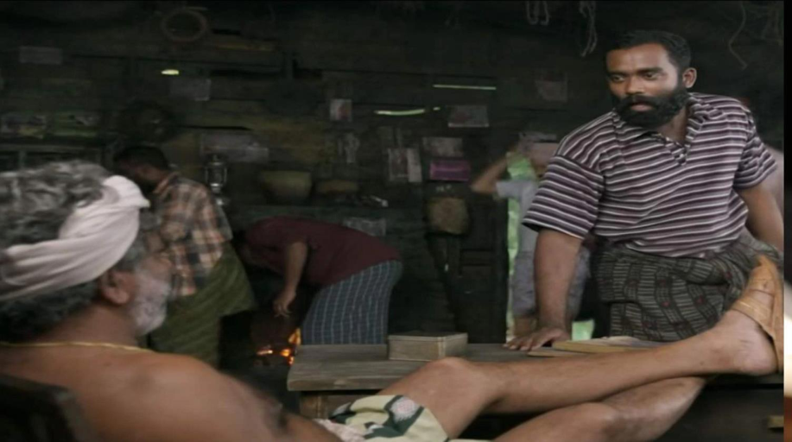

12
Fig.3. Communicating with curse words which is normal. (Churuli 00:21:33)
The language used in the movie is a major factor in showing how easily individuals
can assimilate into a different society. In the film Churuli, language serves as a form of
cultural capital. Effective communication is essential, and the ability to interact with others is
vital for individuals or groups to integrate into a dominant society. The inhabitant of Churuli
use a distinct language that is different from the language spoke outside their community. In
the dominant society depicted in the film, curse words are commonly used in their language
for communication. When the characters Shajeevan and Antony encounter this unique
community, they gradually adopt the use of curse words in their language. Initially, they are
taken a back and intrigued by the unfamiliar language, as it is a departure from their usual
way of speaking. The first establishment that Antony and Shajeevan visit is a tavern, a place
where people gather to drink.
When the jeep driver enters the shop, he says “Hey fetch me something to eat you
scumbag!”, to which the owner Philip replies “if you’re so hungry, bring your wife’s thing


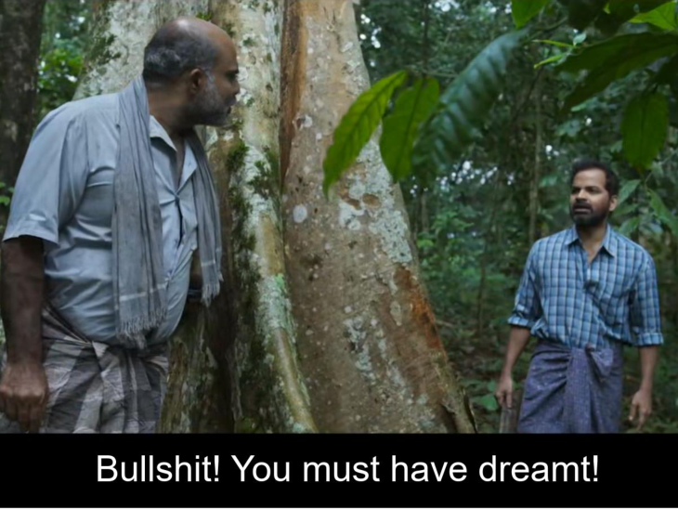

13
you scumbag!” (Churuli 00:21:03–00:21:37). In Churuli people use curse words to
communicate to people. They don't regard the age or the relationship of the person spoken to.
They treat all of them equally. In the film, a jeep driver who seems younger talks to Phillip,
an old man who owns a tavern, using curse words and they enjoy it. Everyone in this unreal
world communicates using this particular language.
Fig.4.Disrespectfully talking to his superior officer. (Churuli 01:09:09)
In a later scene, Shajeevan who is a low rank officer uses curse words to address his
superior officer, Antony. This disrespectful behaviour is a reflection of the culture to which
they have assimilated. They were used to speaking in a polite manner before entering this
particular place. Once they step inside slowly they start to talk to each other differently,


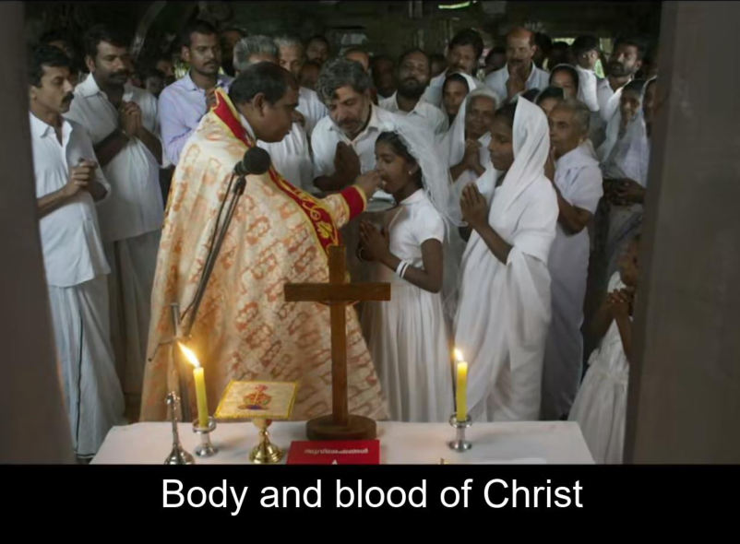

14
indicating that they are assimilating to this dominant society and becoming one of them.
Shajeevan, addressing Antony with curse words without any hesitation, hints on the fact that
he has completely adapted to the dominant society.
Fig.5. Turned the tavern to the church (Churuli 00:47:11)
The tavern which Philip owns is a place of significance in this film. It is a tavern cum
chapel for the people of Churuli. It serves as the central gathering place for the people in the
Churuli community. When it is converted into a chapel, it provides a new perspective of the
spiritual concept that brings people together in Churuli. In the daytime the tavern would be
peopled with male inhabitants drinking alcohol and eating meat. Characters Antony and
Shajeevan deliberately choose this main gathering place, the tavern, to work and stay, in
order to merge into the society. The tavern provides ample opportunity for interaction,

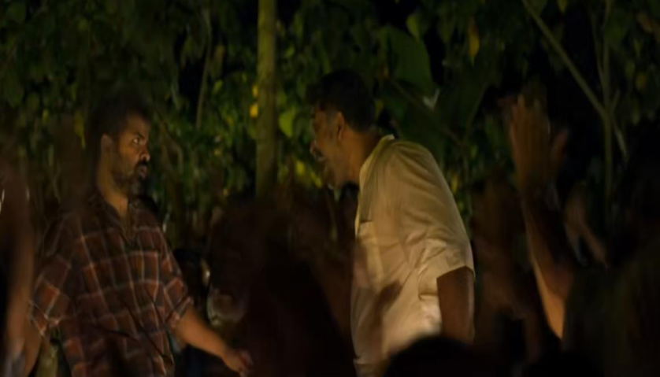

15
allowing them to acculturate and change their values. In the movie Antony quickly adapts to
Churuli's unique environment, while Shajeevan struggles to adjust to the society and cultural
changes. The tavern is the only place that everyone gathers in the society. In the film, the
tavern is also used as a chapel to celebrate the first mass of Phillip’s daughter. It is Antony
and Shajeevan who take care of the cooking and decoration in the tavern cum chapel. It
clearly shows how they have become part of this society. By accepting their culture, they
slowly became one of them and the people in this society starts accepting them as one of their
own.
Fig.6. Enjoying slapping each other. (Churuli 01:04:35)
The games are also a part of society that helps individuals or groups to assimilate into
a society. The film Churuli shows how a game can help to acculturate a person to a society.
The natives of Churuli used to play a game that contained lots of violence. In the game two
participants would sit face to face on wood and slap each other’s face hard. The winner was
determined by who fainted first. It's a game they played in the village to entertain themselves.


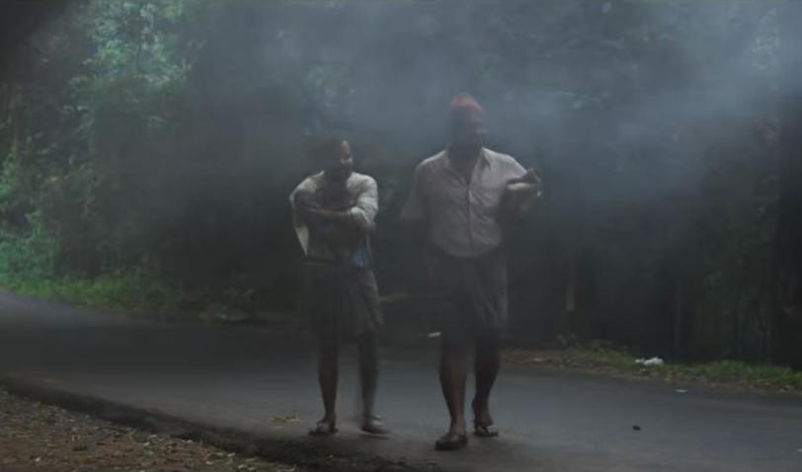

16
People of Churuli enjoy violence and normalize it. The character Shajeevan takes part in their
game and tries to assimilate into their culture. Shajeevan starts slapping the opponent and
also gets beaten up by him. It shows that Shajeevan accepts the culture and practices of
Churuli. By taking part in the game, he becomes part of their society.
Fig.7. They disguised as one of them. (Churuli 00:08:56)
The dressing can also be considered as a significant way to merge into the society. In
the film the leading characters use the dressing style of the people of Churuli, which is dhoti
and shirt, as a tool to become part of the region. Undercover police officers Antony and
Shajeevan dressed up as one of the flock and through this they believe that they can catch the
criminal Myladumparambil Joy and accomplish their mission easily. It's deeply influenced by
the culture of dominant society, through which they explore their culture. The village
Churuli, the unrealistic setting of the film, is a very mysterious place where the villagers are
very complicated. They are raw in nature. Their oral language and behaviour is unrefined.



17
The film Churuli is analysed here as an example to illustrate how cultural capitals
work in a society. The central characters in the film borrow language and dressing styles as
tools to merge into the foreign society. The main characters Shajeevan and Antony use these
major tools to become a part of the society. They also try to fully integrate into society by
taking part in their traditional games and working in their tavern cum chapel. This paper
explores the acculturation of two people into a dominant society and discusses the various
elements they used for integrating.



18
Conclusion
Culture encompasses a wide range of elements, including beliefs, values, customs,
traditions and artifacts that define a specific group of people or society. It includes language,
religion, art, music, food, clothing, ritual, and social norms and is passed from one generation
to the next through socialization and community interaction. Valuing and appreciating
cultural diversity is crucial for fostering unity, compassion, and collaboration among
individuals from various cultural backgrounds. Moreover, exploring diverse cultures can
offer valuable perspectives on human history, sociology, psychology, and anthropology.
Churuli is a Malayalam language Indian film directed by Lijo Jose Pellissery, released
in 2021. The film is a fantasy drama thriller that revolves around a mysterious society Churuli
and the bizarre occurrence that take place there. The storyline follows a group of people who
venture into the society and encounter strange and supernatural events. The film received
positive reviews for its unique storytelling, atmospheric visuals, and performances by the
cast. It explores themes of fear, mystery, and human nature while incorporating elements of
folklore and surrealism.
This project attempts to explore the different cultural capitals of the place Churuli
employed by two foreigners to enter and be a part of it. Cultural capital refers to the non-
monetary resources that individuals have, such as knowledge, skills, education, tastes, values,
attitude, and behaviours. These resources are obtained through socialization and often reflect
a person’s cultural heritage, upbringing, and social interactions.
The characters in the film churuli adapt to the culture of a specific society by utilizing
cultural capitals. They integrate into the host world by adopting the cultural capitals of the
host society. Antony and Shajeevan are characters in the film who assimilate into the unique

19
atmosphere of Churuli, becoming part of the society. As they absorb new common culture
attitudes, the cultural differences between these characters from different groups fade away,
leading them to feel, think, and act similarly and ultimately take on a new cultural identity.
Language, clothing, the tavern cum chapel and their traditional game, are the main
cultural elements that Antony and Shajeevan embrace. They immense themselves in the local
culture by disguising themselves as natives and dressing accordingly. They are heavily
influenced by the dominant society’s culture and actively engage with it. The village of
Churuli, the fanatical setting of the film is a mysterious place inhabited by complex villagers.
One of the key cultural aspects they embrace is their language, which holds great
significance for them. The language has a strong influence on their behaviour and
interactions. In the movie Churuli, the mainstream society casually uses curse words in their
language as a form of communication, considering it a normal practice. As the characters
Shajeevan and Antony become part of this society, they gradually adopt the use of curse
words in their language. Shajeevan even starts using curse words when addressing his
superior officer, Antony.
The tavern which Philip owns is a place of significance in this film. It is a tavern cum
chapel for the people of Churuli. It serves as the central gathering place for the people in the
Churuli community. The space is unique as both the men and women folk gather here.
Characters Antony and Shajeevan deliberately choose this main gathering place, the tavern,
to work and stay, in order to merge into the society. The tavern in the society provides ample
opportunity for interaction, allowing individuals to acculturate and change their values.
The traditional game of their village Churuli village is distinct from other cultures due
its violence nature. The film Churuli demonstrates how a game can facilitate assimilation into

20
a society. The residence of Churuli used to participate in a violent game where two players
would sit facing each other on a wooden surface and slap each other’s face forcefully until
one fainted. The character Shajeevan joins in this game to integrate in the violent gameplay.
By embracing these customs and values of the Churuli people, Antony and Shajeevan
become accepted members of the community. Initially becomes a place where the characters
find belongings and acceptance. once they study and mirror the cultural capitals of the people
of Churuli, they easily be a part of the it.





21
Works Consulted
“Acculturation.” Merriam-Webster.com Dictionary, Merriam-Webster,
https://www.merriam-webster.com/dictionary/acculturation.6 Mar.
2024.
“Bourdieu and ‘Habitus’.” Powercube.net, 2011,
www.powercube.net/other-forms-of-power/bourdieu-and-habitus/.
Bourdieu, Pierre. “Cultural Reproduction and Social Reproduction.” Knowledge, Education,
and Cultural Change, 1sted., Routledge, 1973. Tailor & Francis Group,
https://www.taylorfrancis.com/chapters/edit/10.4324/9781351018142-3/cultural-
reproduction-social-reproduction-pierre-bourdieu.
Cairns, Sam. “The Cultural Learning Alliance.” What Is Cultural Capital, 1 July 2019,
www.culturallearningalliance.org.uk/what-is-cultural-capital/.
“Churuli Explained (Plot and Ending Explained).” This Is Barry, 2 Jan. 2022,
www.thisisbarry.com/film/churuli-explained-plot-and-ending-explained/.
Churuli. Directed by Lijo Jose Pellissery, Chembosky Motion Pictures, 2021.
“Cultural Capital-Bourdieu .” Course Hero, 4 Sept. 2019,
www.coursehero.com/file/39996405/Cultural-capitalpdf/.
“Cultural Reader: Bourdieu’s Field Theory Explained Simply.” Cultural Reader, 21 Feb.
2022,culturalstudiesnow.blogspot.com/2022/02/bourdieus-field-theory-explained-
simply.ht ml.
Mahr, Nathan. “What Is Cultural Capital? - Definition, Examples & Theory”
Study.com, 2015,https://study.com/academy/lesson/what-is-cultural-capital-definition-
examples-theory.html.





22
Mcleod, Saul. “Pierre Bourdieu & Habitus (Sociology): Definition & Examples.”
Simplypsychology, 13 Feb. 2024, www.simplypsychology.org/pierre-bourdieu-
habitus.html.
Staff, T. N. M. “Lijo Jose Pellissery’s Churuli Sparks Row on Foul Language in Films.” The
News Minute, 21 Nov. 2021,
www.thenewsminute.com/kerala/lijo-jose-pellissery-s-churuli-sparks-row-foul-
language-films-157877.
S, Samksha. “Social Processes: The Meaning, Types, Characteristics of Social Processes.”
Your Article Library, 13 Sept. 2013,
www.yourarticlelibrary.com/sociology/social-processes-the-meaning-types-
characteristics-of-social-
processes/8545#:~:text=Assimilation%3A&text=Successful%20accommodation%20s
ets%20the%20stage.

