

WHEN FAMILIARITY BREEDS CONFUSION- THE ROLE OF REPEATED AD EXPOSURE IN MAGNIFYING THE PARADOX OF CHOICE
Project Report
Submitted By
RACHAEL JOANNA PATRIC (Reg. No. SB22BMS024)
Under the guidance of
Dr. MINU MARY JOSEPH
In partial fulfilment of the requirements for the award of the degree of
Bachelor of Management Studies (International Business)



ST. TERESA’S COLLEGE (AUTONOMOUS), ERNAKULAM COLLEGE WITH
POTENTIAL FOR EXCELLENCE
Nationally Re-Accredited at ‘A++’ Level (Fourth Cycle)
3rd Rank in KIRF Ranking 2024. 46th NIRF Ranking 2024.
March 2025

ST.TERESA’S COLLEGE (AUTONOMOUS) , ERNAKULAM, KOCHI - 682011

CERTIFICATE

This is to certify that the project report entitled, “When familiarity breeds confusion- The role of repeated AD exposure in magnifying the paradox of choice”, is a Bonafide record submitted by Ms. Rachael Joanna Patric, Reg. No.SB22BMS024, in partial fulfilment of the requirements for the award of the Degree of Bachelor of Management Studies in International Business during the academic years 2022-2025.

Date : Dr. Alphonsa Vijaya Joseph
PRINCIPAL

ST.TERESA’S COLLEGE (AUTONOMOUS) , ERNAKULAM, KOCHI - 682011

CERTIFICATE

This is to certify that the project report entitled, “When familiarity breeds confusion- The role of repeated AD exposure in magnifying the paradox of choice”, is a Bonafide record submitted by Ms. Rachael Joanna Patric, Reg. No.SB22BMS024, in partial fulfilment of the requirements for the award of the Degree of Bachelor of Management Studies in International Business during the academic years 2022-2025.

Date : Dr. Minu Mary Joseph INTERNAL FACULTY GUIDE

DECLARATION

I, RACHAEL JOANNA PATRIC, Reg. No. SB22BMS024, hereby declare that this project work entitled “When familiarity breeds confusion- The role of repeated AD exposure on magnifying the paradox of choice” is my original work. I further declare that this report is based on the information collected by me and has not previously been submitted to any other university or academic body.

Date: RACHAEL JOANNA PATRIC
Reg. No. SB22BMS024

TABLE OF CONTENTS
CHAPTER NO. | TITLE | PAGE NO.
 | ACKNOWLEDGMENT | 1
 | EXECUTIVE SUMMARY | 2
ONE | INTRODUCTION | 3
 | 1.1 INTRODUCTION TO STUDY | 4
 | 1.2 STATEMENT OF PROBLEM | 4
 | 1.3 LITERATURE REVIEW | 5
 | 1.4 SIGNIFICANCE OF STUDY | 7
 | 1.5 SCOPE OF STUDY | 8
 | 1.6 OBJECTIVES OF STUDY | 8
 | 1.7 RESEARCH METHODOLOGY | 9
 | 1.7.1 DATA COLLECTION | 9
 | 1.7.2 SAMPLING | 9
 | 1.7.2.1 POPULATION | 9
 | 1.7.2.2 SAMPLE SIZE | 10
 | 1.7.2.3 SAMPLING TECHNIQUE | 10
 | 1.7.2.4 TOOLS USED FOR DATA COLLECTION | 11
 | 1.2.7.5 DATA ANALYSIS TECHNIQUE | 12
 | 1.8 LIMITATIONS OF THE STUDY | 12
TWO | INDUSTRY PROFILE | 13
THREE | DATA ANALYSIS AND INTERPRETATION | 18
 | 3.1 DATA ANALYSIS AND INTERPRETATION | 19
 | 3.2 DESCRIPTIVE STATISTICS | 19
 | 3.2.1 DEMOGRAPHIC REPRESENTATION | 19
 | 3.3 INFERENTIAL STATISTICS | 23
 | 3.4 HYPOTHESIS TESTING | 23
FOUR | FINDINGS, SUMMARY, SUGGESTIONS AND CONCLUSION | 27
 | 4.1 FINDINGS | 28
 | 4.2 SUMMARY | 29
 | 4.3 SUGGESTIONS | 30
 | 4.4 CONCLUSION | 31
 | REFERENCES | 33
 | ANNEXURE | 34

TABLE AND GRAPH NO. | LIST OF TABLE AND GRAPHS | PAGE NO.
Table 3.2.1(a) | Tabular representation of respondents age | 20
Table 3.2.1(b) | Tabular representation of respondents gender | 20
Table 3.2.1(c) | Tabular representation of respondents nationality | 21
Table 3.2.1(d) | Tabular representation of respondents education level | 22
Figure 3.2.1(a) | Graphical representation of respondents age | 19
Figure 3.2.1(b) | Graphical representation of respondents gender | 20
Figure 3.2.1(c) | Graphical representation of respondents nationality | 21
Figure 3.2.1(d) | Graphical representation of respondents education level | 22
Table 3.4.1 | Tabular representation of ANOVA | 24
Table 3.4.2 | Tabular representation of Model Summary | 24
Table 3.4.3 | Tabular representation of Coefficients | 25

ACKNOWLEDGMENT

First and foremost, I would like to thank God Almighty for giving me the strength, knowledge, ability, and opportunity to complete this project work successfully. I extend my sincere gratitude to the Directors of the college, Rev. Dr. Sr. Francis Ann CSST and Rev. Sr. Tessa CSST, the principal of the college, Dr. Alphonsa Vijaya Joseph, and all the faculty members of the Department of Management Studies for their overall guidance, inspiration, and suggestions throughout my project work.

I wish to express my heartfelt thanks to the Head of the Department, Mrs. Namitha Peter, and my project guide, Ms. Minu Mary Joseph , for her persistent help, guidance, and encouragement. Her valuable comments and insights have greatly benefitted me and helped me complete the project successfully.

My acknowledgment would be incomplete without thanking my parents, other family members, friends, and everyone who has either directly or indirectly extended their support and guidance throughout the journey of making my research project a success.

RACHAEL JOANNA PATRIC
EXECUTIVE SUMMARY

This project explores the intricate relationship between choice overload, repeated advertising exposure, and consumer decision-making. It examines how an excess of choices can lead to decision paralysis, lower satisfaction, and post-decision regret. Additionally, it delves into the impact of repeated ad exposure, highlighting how constant visibility of advertisements influences brand recognition, consumer preferences, and ultimately, purchasing behaviour.
Drawing from established psychological and consumer behaviour theories, such as Schwartz’s (2004) paradox of choice and Zajonc’s (1968) mere exposure effect, the study integrates insights from established research to assess how these factors interplay. Notably, it addresses how excessive advertising may amplify the paradox of choice, leading to heightened regret and decreased choice satisfaction.
The project employs a mixed-methods approach, combining qualitative and quantitative data analysis techniques. Primary data was collected from 64 respondents through structured questionnaires designed to measure decision satisfaction, regret levels, and ad influence. SPSS regression analysis was utilized to identify relationships between choice overload, repeated ad exposure, and consumer decision-making. Additionally, statistical tools such as ANOVA were applied to assess the significance of these factors.
Key findings suggest that while choice variety enhances autonomy, an overabundance of options without clear differentiation can overwhelm consumers. Likewise, persistent exposure to alternative products post-purchase may intensify regret, fostering brand-switching tendencies. The study concludes that strategic marketing efforts should focus on simplifying consumer choices and optimizing ad frequency to enhance decision confidence and satisfaction. Understanding these dynamics is crucial for businesses to refine their approaches and improve consumer experiences.
This research contributes to the field by bridging gaps in literature concerning the combined effects of choice overload and advertising exposure. The insights provided aim to assist marketers in refining their approaches to minimize decision fatigue and maximize positive consumer experiences.

CHAPTER- 1
INTRODUCTION

1.1 INTRODUCTION TO THE STUDY
In today’s world of limitless consumer possibilities, the paradox of choice is a widely recognized issue, wherein too many options can result in decision fatigue, reduced satisfaction, and lingering regret. This phenomenon is often driven by choice overload and emerges when the sheer number of alternatives overwhelms the consumers ability to evaluate them, leaving them feeling mentally drained and uncertain. Marketers, eager to grab consumer attention, often rely on repetitive advertising to foster brand recognition and sway buying decisions. Yet, the connection between this repeated ad exposure and the overwhelm of choice overload remains underexplored. As consumers face a barrage of ads, their mental capacity becomes strained, leading to exhaustion and a growing sense of being swamped by options. This in turn intensifies the fatigue and confusion tied to navigating an excess of choices.
This overload can negatively impact their decision-making, foster doubt about their choices, and result in consumers to fixate on potentially better unpicked options.
The constant reinforcement of alternatives through ads can deepen decision regret by keeping competing options salient, erode choice satisfaction by sowing seeds of doubt, and heighten switching likelihood as consumers seek to escape their dissatisfaction. Understanding these dynamics is vital for marketers and psychologists alike, offering clues to fine-tune ad frequency and lessen the downsides of too many choices, such as the mental toll of overload and the emotional weight of regret.

1.2 STATEMENT OF PROBLEM
The paradox of choice proposes that an excessive amount of options can overwhelm consumers, leading to mental fatigue, dissatisfaction, and post-decision regret. Marketers tend to rely on repeated advertising to increase brand familiarity and influence consumer behaviour. However, the consequences of repeated ad exposure in an environment of excessive choices remain understudied.
This study aims to explore the relationship between repeated ad exposure with choice overload, decision regret, switching likelihood and choice satisfaction. Alongside that, this study also seeks to enrich academic understanding and refine practical marketing approaches, striking a balance between the advantages of recognition and the pitfalls of mental overload.
While repeated ads might make choosing easier by creating familiarity, they might also make decisions feel more mentally draining and complex. Consumer may end up feeling stuck in between picking a familiar brand and wanting to make the best choice, which can lead to more regret and a higher chance of switching brands after buying due to the lack of satisfaction.
Without a clear understanding of these dynamics, brands may unknowingly contribute to consumer frustration and reduced loyalty. This research aims to uncover the threshold at which ad exposure shifts from being beneficial to detrimental, providing insights for marketers to refine advertising strategies that foster confident decision-making rather than cognitive overload.

1.3 LITERATURE REVIEW
This literature review explores the relationship between repeated ad exposure and consumer decision-making, with a focus on choice overload, decision regret, switching likelihood, and choice satisfaction. It integrates research from different concepts like “The Attitudinal Effects of Mere Exposure” and the “Theory of Regret Regulation” to understand the dynamics between these forces and how it ultimately results in the paradox of choice.
Although previous research has examined these factors separately, limited studies have explored how they interconnect to further intensify choice paradoxes. Understanding the dynamic interplay between them is essential for optimizing marketing strategies and improving consumer well-being.
THE PARADOX OF CHOICE
The concept of the paradox of choice, introduced by Barry Schwartz (2004), suggests that while having many options may seem advantageous at first, an excessive amount of choices can overwhelm consumers, causing decision paralysis, lower satisfaction, and greater regret. Research puts forward that as the amount of choices increase, consumers exert more mental effort, which can result in post-decision uncertainty and self-doubt (Iyengar & Lepper, 2000). In today’s digital era, where consumers face endless options online, it’s increasingly important to understand the factors that intensify choice overload.

REPEATED AD EXPOSURE
Repeated Ad exposure refers to a very frequently used marketing tactic wherein marketers aim to increase the familiarity of a brand by constantly overexposing consumers to the same advertisements. This is ultimately done to increase brand recognition and favourability. This concept of excess visibility is mainly derived from The Attitudinal Effects of Mere Exposure (Zajnoc,1968). It proposes that repeated exposure to a stimulus increases liking or preference for that stimulus, however brief or fleeting it was. Recurring brand exposure can subconsciously cultivate consumer preferences and result in choosing familiar products rather than unfamiliar ones. This familiarity reduces perceived risk and builds a sense of attachment which eventually influences purchasing behaviour and brand loyalty.
CHOICE OVERLOAD
Choice overload is a paradoxical phenomenon that occurs when an abundance of options overwhelms consumers, impairing decision quality and diminishing satisfaction (Chernev, Böckenholt, & Goodman, 2015). It illuminates the idea that larger assortments tend to increase decision fatigue, reduce satisfaction and heighten regret when consumers are faced with too many choices. It also sheds light on the contrary, that when consumers have clear goals and expertise, large assortments can enhance satisfaction and confidence that they’ve made the right choice.
DECISION REGRET AND SWITCHING LIKELIHOOD
Decision regret can be described as a sense of remorse or guilt that one experiences after making a decision. This is mainly characterized by the realization that a different choice could have led to a better result. Decision regret is a common outcome of choice overload, where consumers, overwhelmed by too many options, fear making the wrong choice (Zeelenberg & Pieters, 2007). This theory of regret regulation is primarily built upon a foundation of psychology and aims to understand the nature and consequence of regret after making a decision
Research indicates that regret magnifies when consumers are constantly made aware of foregone alternatives, especially if those alternatives are continuously advertised post-purchase. The appeal of these alternatives tend to increase rather than diminish. When consumers fully consume and complete their experience with their chosen product, or they are not satisfied with their experience after they have purchased it, the attractiveness of the unchosen options bounces back to its original level (Arens & Hamilton, 2017). This regret can fuel switching likelihood, as consumers may seek to rectify their decision by exploring alternative options, leading to a cycle of dissatisfaction and instability
CHOICE SATISFACTION AND THE TRADE OFF BETWEEN FAMILIARITY AND COMPLEXITY
Choice satisfaction can be explained as a feeling of contentment that an individual may experience after making a choice. This is signified by a sense of pleasure for the outcome of a decision. While advertising can help consumers make a decision, overexposure may paradoxically reduce choice satisfaction. The availability of choices may be important for autonomy, however, excessive options may overwhelm consumers to make the wrong choice and lower satisfaction greatly (Schwartz, 2004). This mainly occurs when the outcome does not match expectations.
Although previous research has examined forces like choice overload and advertising effects separately, limited studies have explored how repeated ad exposure may intensify choice paradoxes. The existing literature has shed light on the individual effects of these forces, however, understanding the dynamic interplay between them is essential for optimizing marketing strategies and improving consumer well-being.

1.4 SIGNIFICANCE OF STUDY
The significance of this research lies in its potential to deepen our understanding of how modern marketing strategies, particularly the pervasive repetition of advertisements, may unintentionally worsen consumer decision-making challenges. Choice overload, characterized by paralysis or stress from excessive options, can diminish satisfaction and increase regret, ultimately driving consumers to switch brands or abandon decisions altogether.
For marketers and businesses, the findings could inform more effective advertising strategies, balancing frequency and variety to optimize consumer satisfaction and loyalty while minimizing regret and switching behaviour. For consumer psychology, this research adds to the discussion on the paradox of choice by showing how repeated ads can make decision-making harder. Understanding this can help consumers make better choices in a complex market and guide policymakers in creating advertising rules that support mental well-being. Overall, this study connects theory with real-world impact, revealing how ads subtly shape our decisions.

1.5 SCOPE OF STUDY
While the paradox of choice can manifest across various domains, this study narrows its lens to the marketing industry.
Specifically, it investigates how frequent encounters with advertisements influence four key variables: choice overload, decision regret, choice satisfaction, and switching likelihood. The research focuses on understanding whether the familiarity generated by repetitive ad campaigns, a common strategy in modern marketing, amplifies the paradox of choice within a controlled marketing context.
This study limits its scope to the marketing industry, targeting advertising campaigns across digital and traditional platforms (e.g., social media and television) where repetition is a deliberate tactic to build brand recognition. The population of interest includes active consumers exposed to such campaigns, with an emphasis on industries characterized by high product variety, such as consumer goods, technology, or fashion.

1.6 OBJECTIVE OF STUDY
To investigate the relationship between repeated ad exposure and choice overload, decision regret, choice satisfaction and switching likelihood
To pinpoint the threshold at which repeated ad exposure shifts from beneficial familiarity to confusion, amplifying the paradox of choice
To provide actionable suggestions for marketing strategies that balance frequency with consumer decision making outcomes

1.7 RESEARCH METHODOLOGY
1.7.1 DATA COLLECTION
Data collection or data gathering is the process of gathering and measuring information on targeted variables in an established system, which then enables one to answer relevant questions and evaluate outcomes.
When it comes to data collection, there are two methods that are commonly used by researchers. These methods are classified as primary data collection methods and secondary data collection methods. Data collection methods for primary data include observation, interviews, questionnaires, case studies, projective techniques, and schedules. Secondary data is data that already exists and can be acquired through published or unpublished sources. Published sources include government publications, public records, bank records, and so on. Unpublished data sources encompass letters, diaries, unpublished biographies and work, and so on.
The tool used by for the primary data collection was questionnaires. The primary data collection aims to generate original, empirical evidence on how repeated ad exposure influences choice overload, decision regret, choice satisfaction, and switching likelihood in a marketing context. By directly measuring consumer responses to controlled and real-world ad repetition, this approach ensures data specificity to the study’s objectives and offers actionable insights for the marketing industry.
Secondary data in research was used to enhance understanding about of how repeated ad exposure influences choice overload, decision regret, choice satisfaction, and switching likelihood within the marketing industry, drawing on pre-existing, credible sources to validate and enrich primary findings.

1.7.2 SAMPLING
1.7.2.1 POPULATION
A population is a group of elements that share some or all their characteristics. The population size is determined by the number of elements in the population.
The target population for this study comprises active consumers aged 17–38, a demographic heavily engaged with advertising and representative of key marketing industry audiences. This age range is selected due to its high exposure to both digital and traditional ad platforms (e.g., social media, television, print) and its relevance to purchasing decisions in high-choice product categories such as consumer electronics, fashion, and personal care products.

1.7.2.2 SAMPLE SIZE
A sample size is the number of observations or data points selected from a larger population for a study, survey, or experiment. It represents a subset of the population used to make inferences about the whole group.
The sample size for this study comprised of 64 respondents, who were accessible through social media platforms like Instagram and WhatsApp. The respondents were required to meet the criteria of being between the ages of 17-38, along with being a heavy user of social media platforms and purchase activity in the high choice market.

1.7.2.3 SAMPLING TECHNIQUE
Sampling techniques are broadly classified into two main categories: probability sampling and non-probability sampling. These methods are used to select a subset of individuals from a larger population to participate in a study, and the choice between them depends on the research goals, resources, and desired level of accuracy.
Probability sampling involves random selection, which means that every individual in the population has a known and equal chance of being selected. This approach reduces bias and allows researchers to generalize findings to the entire population. Common types of probability sampling include:
- Simple random sampling: Every individual has an equal chance of being chosen, like drawing names from a hat.
- Systematic sampling: Participants are selected at regular intervals from a list, such as every 10th person.
- Stratified sampling: The population is divided into subgroups (strata) based on characteristics like age or gender, and samples are drawn from each group proportionally.
- Cluster sampling: The population is divided into clusters (often based on location), and entire clusters are randomly selected for the study.
On the other hand, non-probability sampling does not rely on random selection. Instead, participants are chosen based on convenience, judgment, or other non-random criteria. This method is often used when probability sampling is impractical or when the research does not require generalization to the entire population. Common types of non-probability sampling include:
- Convenience sampling: Participants are selected based on their availability and willingness to take part.
- Purposive sampling: Individuals are chosen based on specific characteristics or knowledge relevant to the study.
- Snowball sampling: Existing participants help recruit future participants, often used for hard-to-reach populations.
- Quota sampling: The researcher ensures certain characteristics are represented by filling specific “quotas” from the population.
In this project, the researcher has chosen to use convenience sampling, a type of non-probability sampling. This method involves selecting participants who are easiest to access, such as classmates, nearby individuals, or people who are readily willing to participate. The decision to use convenience sampling was based on practical considerations such as time constraints, ease of data collection, and limited resources. While this method may not yield results that are fully representative of the broader population, it is effective for exploratory research and provides valuable initial insights, making it a suitable choice for this study.

1.7.2.4 TOOLS USED FOR DATA COLLECTION
The questionnaire for this research has been carefully designed to meet the research objectives and assemble data to understand the impact of the paradox of choice on the minds of consumers. The initial section of the questionnaire focuses on collecting demographic information like age, gender, nationality and educational qualifications to set a general background for the respondents. The core section of the questionnaire focuses on the variables of the study, such as choice overload, decision regret, choice satisfaction and switching likelihood.
Likert scale questions form the basis of this survey whereby respondents get to choose on a range between 1- strongly disagree to 5- strongly agree. Nominal scale questions were also incorporated into the questionnaire. The structure and segregation of the sections ensures that the data obtained is comprehensive and quantifiable in order to establish relationships between the variables and to ultimately correlate it to the paradox of choice.

1.7.2.5 DATA ANALYSIS TECHNIQUES
The data has been analysed using SPSS software

1.8 LIMITATIONS OF THE STUDY
The study was done within a limited period of time, restricting the collection of a wider dataset and more extensive potential methods of analysis

CHAPTER- 2
INDUSTRY PROFILE

2.1 MARKETING INDUSTRY
Marketing is the process of creating, communicating, delivering, and exchanging offerings that have value for customers, clients, partners, and society at large. It’s about understanding what people want or need, shaping products or services to fit those desires, and then getting the word out in a way that drives action, usually a purchase, but sometimes loyalty or advocacy.
The core purpose is to connect supply with demand. It’s about identifying a market’s needs, building something that fills that gap, and ensuring people know it exists and want it. Beyond sales, marketing aims to build relationships, foster trust, and create long-term value, both for the business (profit, growth) and the customer (satisfaction, solutions). It’s also a tool for differentiation in a crowded world, helping brands stand out and stick in people’s minds.
The 4 P’s of marketing are product, price, place, and promotion. They are a classic framework for breaking down the marketing mix. They are the levers a business pulls to influence consumer behaviour.
- Product: This is what you’re selling, goods, services, or even ideas. It’s about designing something that solves a problem or fulfils a desire, from its features and quality to branding and packaging.
- Price: The amount customers pay. It’s not just about covering costs or maximizing profit, it signals value. Low prices might scream affordability but risk cheapening perception, while premium pricing can position something as exclusive.
- Place: Where and how the product gets to the customer. It’s logistics, distribution channels, retail locations, or online platforms. A great product flops if it’s not where people can find it.
- Promotion: This refers to how you tell the world about it. This spans advertising, sales pitches, social media, discounts or any effort to grab attention and drive action. It’s the megaphone that turns a product from a secret to a must-have.
Promotion is the voice of marketing. It’s how you cut through the noise and make people care. It’s not just about informing, it’s about convincing. That’s where persuasion comes in. At its heart, promotion uses persuasion to shift attitudes and behaviours. It leans on psychology, tapping emotions, building trust, or sparking desire. Take a car ad, it’s not just "this vehicle has four wheels", it’s "feel the freedom of the open road" with sleek visuals and a stirring soundtrack. That’s persuasion, making you want the experience, not just the product.
attention. With digital platforms and personalized marketing algorithms bombarding individuals with advertisements for countless variations of the same product, decision-making becomes overwhelming rather than empowering.
Repeated ad exposure plays a crucial role in this phenomenon, increasing cognitive load as consumers process and compare multiple options, leading to decision paralysis where every choice seems equally compelling. Instead of reinforcing trust, excessive ads often cause brand fatigue, making people tune out marketing messages or question their authenticity. This, in turn, reduces brand loyalty, as consumers continuously explore alternatives rather than commit to one option.
Brands that recognize this challenge often simplify choices, offering curated selections or clear guidance to reduce cognitive overload. Clear and minimalist messaging replaces excessive persuasion, ensuring that consumers feel confident rather than overwhelmed. Ultimately, choice overload isn’t just about too many products, it’s about too many competing persuasive. Ironically, true influence in marketing isn’t just about persuasion, it’s about making choices easier, not harder
Decision regret is a natural consequence of choice overload and excessive ad exposure, where consumers, after making a purchase, second-guess their decision due to the overwhelming number of alternatives they encountered. In a marketplace flooded with persuasive marketing, every product is advertised as the best, leading consumers to feel uncertain about whether they made the right choice.
When people are repeatedly exposed to ads showcasing similar or seemingly better options after their purchase, they experience post-purchase dissonance, questioning whether they should have chosen differently. This regret is intensified by FOMO (fear of missing out), the idea that a better deal, feature, or brand was available but overlooked. Instead of feeling satisfied, consumers may experience diminished enjoyment of their purchase, reducing brand trust and making them less likely to stay loyal to a brand in the future.
To minimize decision regret, brands must focus on reinforcing consumer confidence post-purchase. Strategies like reaffirming the customer’s choice through follow-up messages, or offering flexible return policies can help alleviate regret and enhance satisfaction. Loyalty programs, exclusive benefits, and continuous relationship-building efforts can also help retain customers by making them feel more invested in the brand.
Decision regret directly increases switching likelihood, as dissatisfied consumers become more open to exploring alternative brands or products in search of a better experience. When individuals feel they may have made the wrong choice, especially after being exposed to more persuasive marketing from competing brands, they start seeking reassurance or validation. If their current choice doesn’t meet expectations, they may quickly switch to another option in hopes of reducing their regret.
Repeated exposure to advertisements showcasing better deals, features, or customer reviews can amplify this regret, making consumers feel they missed out on a superior choice. This fuels a cycle where brand loyalty weakens, and consumers become more prone to experimenting with different products rather than sticking with their initial decision.
On the other hand, when consumers are satisfied with their choice, they exhibit an alternate response, brand loyalty and advocacy. Instead of switching, satisfied customers develop a sense of confidence and emotional attachment to their chosen brand, reinforcing their decision as the right one. This satisfaction often leads to repeat purchases, reducing their likelihood of considering competitors in the future.
Moreover, satisfied customers are more likely to become brand advocates, recommending the product to friends, family, or even through online reviews and social media. This form of organic word-of-mouth marketing is powerful, as people tend to trust recommendations from peers more than traditional advertising. Brands that cultivate customer satisfaction through high-quality products, exceptional service, and positive post-purchase engagement create a loyal customer base that not only sticks around but also attracts new buyers.
To enhance satisfaction and encourage advocacy, brands should focus on consistent value delivery, ensuring that customers continue to feel validated in their choice. Engaging with them through personalized appreciation, exclusive perks, or interactive experiences further deepens this connection. In the end, true marketing success isn’t just about getting people to buy, it’s about making them feel so confident and satisfied with their decision that they never need to look elsewhere.
There are layers to this. Promotion might use repetition to lodge a brand in your brain, familiarity breeds preference. It might appeal to authority to borrow credibility, or it could trigger scarcity to nudge you into acting fast. Each tactic is a persuasion play, designed to bypass pure logic and hit you where decisions really live, your gut.
Promotion’s persuasive power can either simplify decisions or complicate them. A well-crafted campaign might anchor a consumer to one option, easing fatigue. But if it’s too aggressive or vague, it risks adding to the mental clutter, making persuasion backfire into scepticism or avoidance. In short, promotion isn’t just shouting about a product, it’s a calculated dance of influence, steering people through a world of options toward your door. Persuasion is its engine, turning awareness into action. But when persuasion becomes excessive, it leads to a phenomenon known as the paradox of choice, where having too many options overwhelms rather than empowers the consumer. In a marketplace flooded with persuasive marketing messages, each product is presented as the best, the most essential, or the most life-changing. Instead of making a confident choice, consumers often experience a mental gridlock.
This paradox stems from the cognitive burden of comparing endless features, prices, and benefits. Rather than feeling satisfied with their decision, consumers may experience buyer’s remorse, questioning whether another option would have been better. In an age of hyper-personalized advertising and algorithm-driven recommendations, excessive persuasion doesn’t just guide decisions, it can hijack them, creating stress rather than satisfaction.
In today’s saturated market, choice overload has become a major challenge as brands constantly compete for consumer

CHAPTER- 3
DATA ANALYSIS AND INTERPRETATION

3.1 DATA ANALYSIS AND INTERPRETATION
The study was conducted to understand the hold that repeated ad exposure had on consumers and how it affected their ability to make purchase decisions. Therefore, this research study focused on individuals belonging to a certain age category to target those consumers that are heavy users of social media and are exposed to repeated advertisements. Several questions were asked pertaining to the dependent and independent factors. The questions were obtained from the extensive literature review that was conducted prior to embarking the data collection. Regression analysis was done to understand the relationship between the dependent and independent variables.
The sample size consisted of 64 respondents and the primary data was collected from the general audience through surveys and questionnaires.

3.2 DESCRIPTIVE STATISTICS
3.2.1 DEMOGRAPHIC REPRESENTATIONS
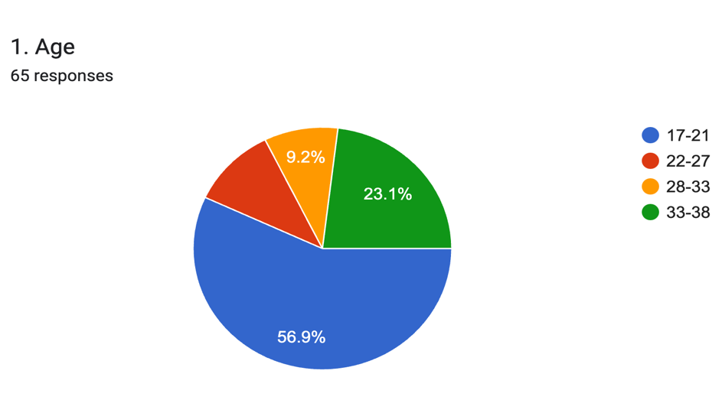
Figure 3.2.1 (a) graphical representation of respondents age

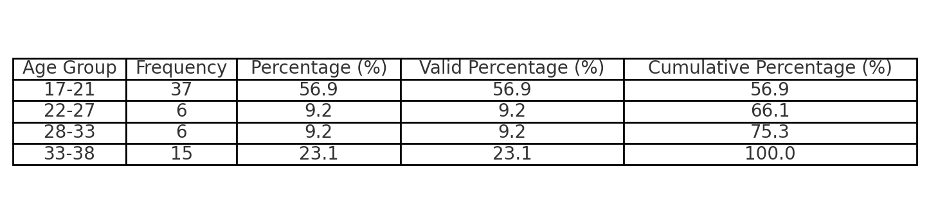
Figure 3.2.1 (a) table showing respondents age

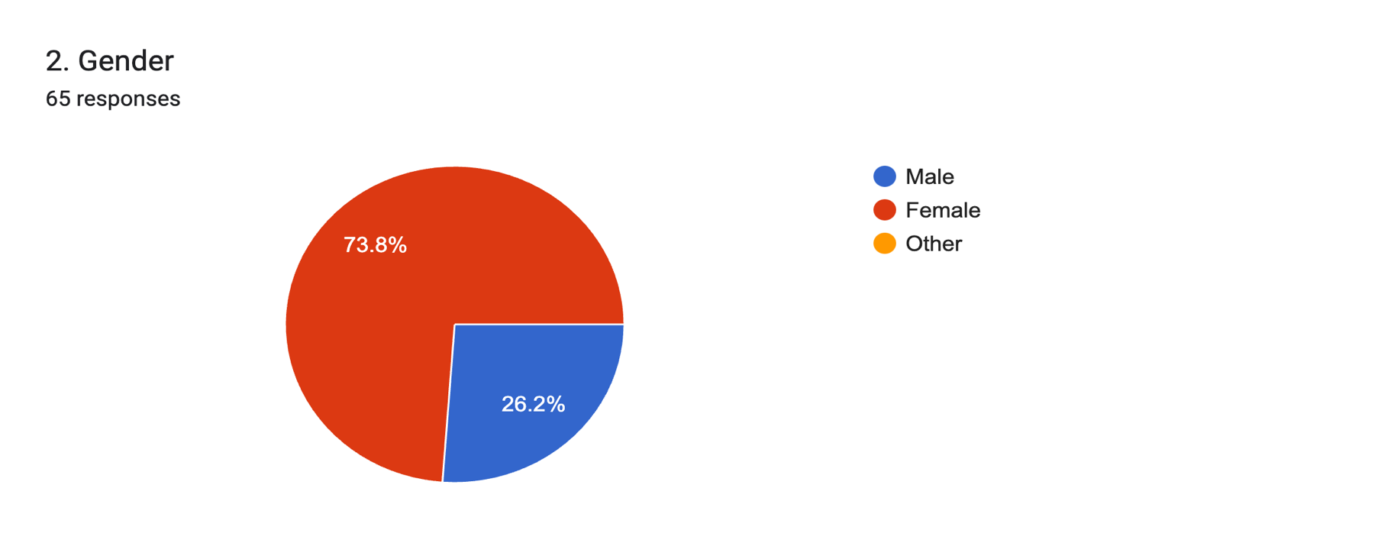
Figure 3.2.1 (b) graphical representation of respondents gender

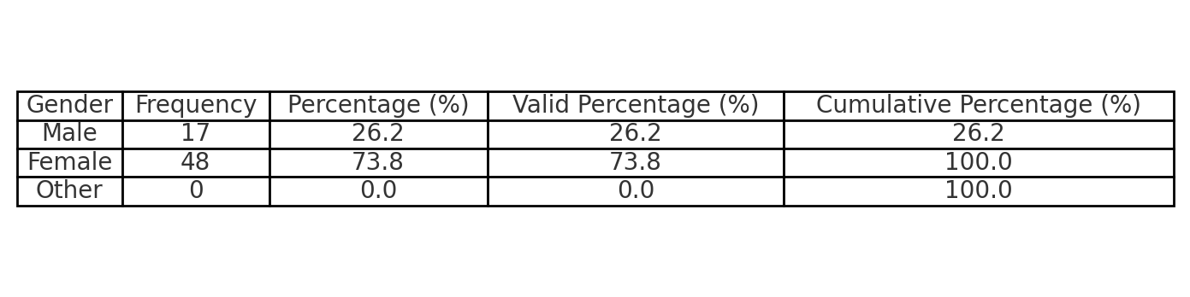
Figure 3.2.1 (b) table showing respondents gender
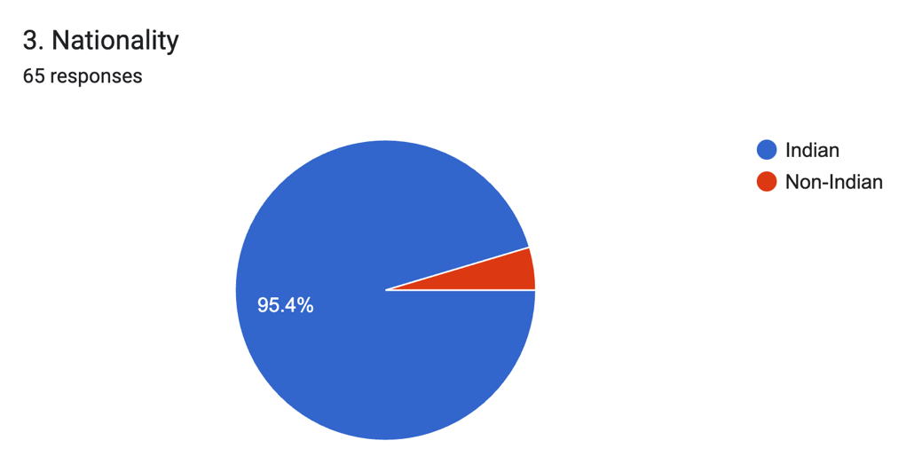
Figure 3.2.1 (c) graphical representation of respondents nationality

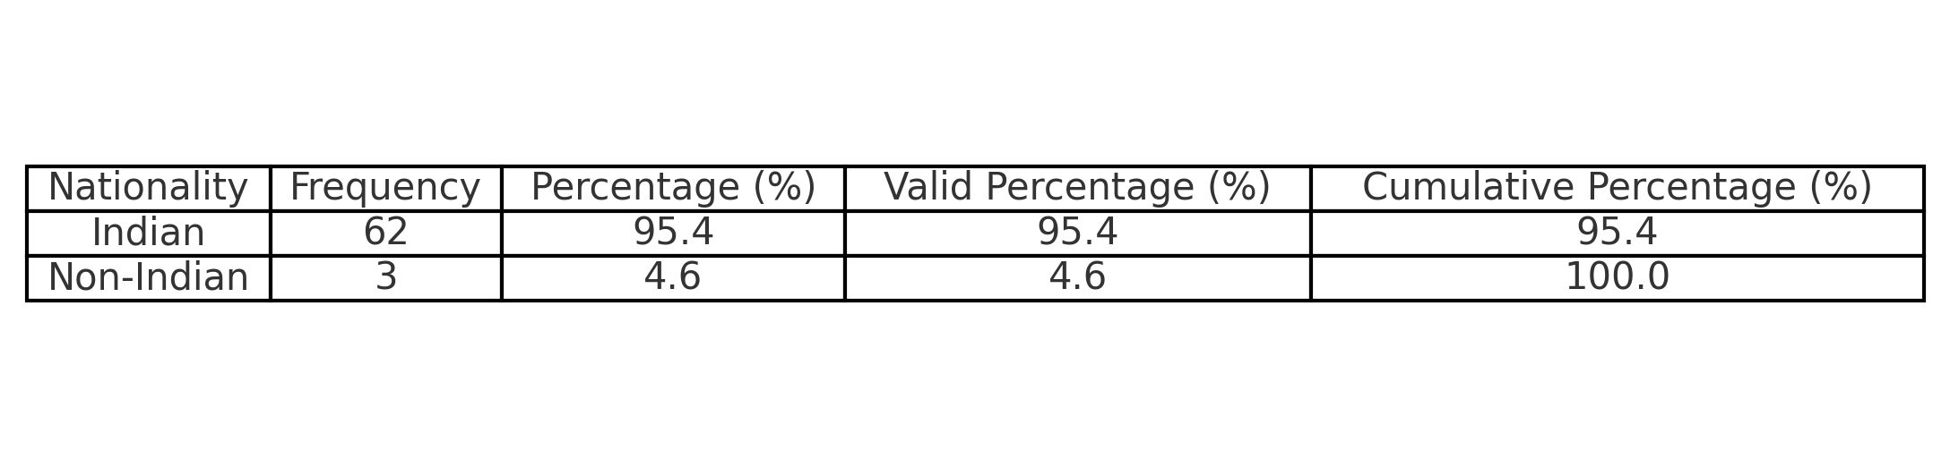
Figure 3.2.1 (c) table representing respondents nationality

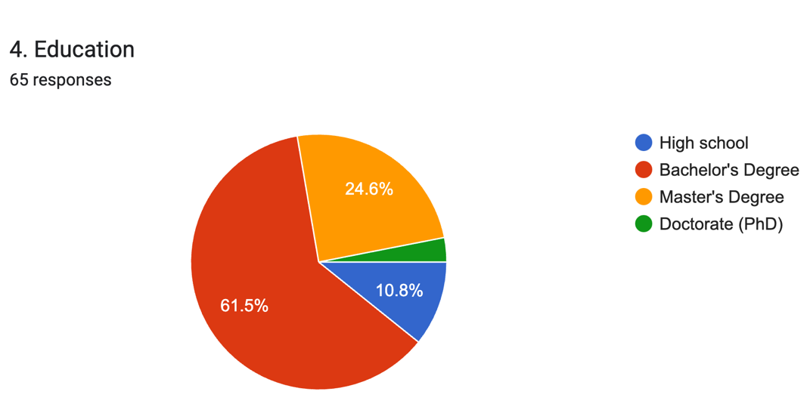
Figure 3.2.1 (d) graphical representation of respondents education

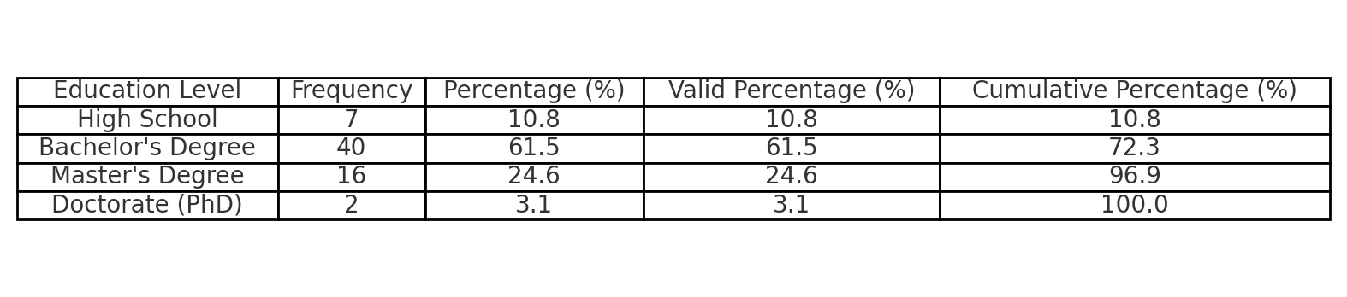
Figure 3.2.1 (d) table representing respondents education

3.3 INFERENTIAL STATISTICS
Researchers can obtain a deeper understanding of the interconnection between repeated ad exposure and choice overload, decision regret, switching likelihood and choice satisfaction by using regression analysis as their inferential statistical method. The knowledge received from this can help marketers to understand the consumer psyche and develop more effective and efficient marketing strategies to help consumers make better choice decisions.
The whole purpose of using regression analysis is to determine how well one or more independent variables such as choice overload, choice satisfaction and decision regret and predict or explain changes in a dependent variable such as switching likelihood.

3.4 HYPOTHESIS TESTING
To test if choice overload, choice satisfaction and decision regret has an impact on switching behaviour, a multiple linear regression was performed using SPSS.
Multiple regression is an extension of simple linear regression. It is used to predict the value of a variable based on the value of two or more other variables. In this project, the independent variables are as follows-
- Choice Overload
- Choice Satisfaction
- Decision Regret
The dependent variable is-
- Switching behaviour
Multiple regression also allows us to determine the overall fit (variance explained) of the model and the relative contribution of each of the predictors to the total variance explained.
The output from the MLR is discussed below.

Statistical significance
The F-ratio in the ANOVA table (see below) tests whether the overall regression model is a good fit for the data. The table shows that the independent variables, namely choice overload, choice satisfaction and decision regret, statistically significantly predict the dependent variable, F(3, 59) = 50.530, p < .05 (i.e., the regression model is a good fit of the data).
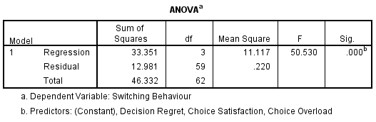
Figure 3.4.1
Determining how well the model fits
The model summary table provides the R, R², adjusted R², and the standard error of the estimate, which can be used to determine how well a regression model fits the data:
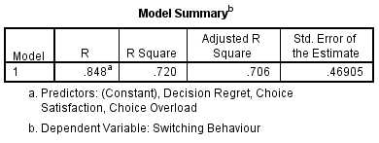
Figure 3.4.2
The "R" column represents the value of R, the multiple correlation coefficient. R can be considered to be one measure of the quality of the prediction of the dependent variable
The "R Square" column represents the R² value (also called the coefficient of determination), which is the proportion of variance in the dependent variable that can be explained by the independent variables (technically, it is the proportion of variation accounted for by the regression model above and beyond the mean model).

In our study, we can observe that the R² is 0.72, that is all the independent variables together explain 72% of the variability of the dependent variable.
Estimated model coefficients
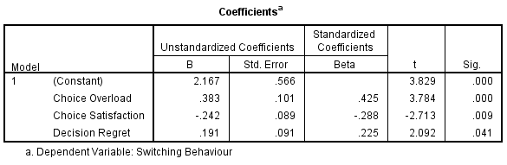
Figure 3.4.3
Unstandardized coefficients indicate how much the dependent variable varies with an independent variable when all other independent variables are held constant. The effect of Choice Overload, the unstandardized coefficient, B₁, is equal to .383. This means that for one degree increase in choice overload, there will be an increase in .383 degrees in switching behaviour.
Similarly, the effect of Choice satisfaction, the unstandardized coefficient, B₁, is equal to -. 242. This means that for one degree increase in choice satisfaction, there will be an decrease in .242 degrees in switching behaviour.
The effect of decision regret, the unstandardized coefficient, B₁, is equal to .191. This means that for one degree increase in decision regret, there will be an increase in .191 degrees in switching behaviour.
Statistical significance of the independent variables
Testing for the statistical significance of each of the independent variables. This tests whether the unstandardized (or standardized) coefficients are equal to 0 (zero) in the population. If p < .05, you can conclude that the coefficients are statistically significantly different to 0 (zero). The t-value and corresponding p-value are located in the "t" and "Sig." We can see from the "Sig." column that all independent variable coefficients are statistically significantly different from 0 (zero).
Conclusion
A multiple regression was run to predict Switching Behaviour from choice overload, choice satisfaction and decision regret. These variables statistically significantly predicted switching behaviour, F(3, 59) = 50.53, p < .05, R² = .72. All three variables added statistically significantly to the prediction, p < .05.

CHAPTER 4
FINDINGS, SUMMARY, SUGGESTIONS AND CONCLUSION

4.1 FINDINGS
- A multiple linear regression analysis was performed using SPSS to test the hypothesis that choice overload, choice satisfaction, and decision regret have a significant impact on switching behaviour. The regression model was found to be statistically significant, indicating that these independent variables collectively influence the dependent variable. The analysis produced the following result:
The ANOVA results as shown in Figure 3.4.1 statistically represented as, F(3, 59) = 50.530, p < .05. This suggests that the regression model is a good fit for the data.

- To determine the effectiveness of the regression model, the coefficient of determination (R²) was examined in figure 3.4.2 (Model Summary)
R² = 0.72, meaning that 72% of the variability in switching behaviour is explained by the independent variables (choice overload, choice satisfaction, and decision regret). This indicates a strong explanatory power of the model.

- The regression analysis provided the unstandardized coefficients, which indicate how much the dependent variable (switching behaviour) changes when an independent variable changes, while holding all other variables constant.
Figure 3.4.3 illustrates Choice Overload: The unstandardized coefficient (B1) is 0.383, indicating that a one-unit increase in choice overload results in a 0.383 increase in switching behaviour.
Choice Satisfaction: The unstandardized coefficient (B1) is -0.242, implying that a one-unit increase in choice satisfaction leads to a 0.242 decrease in switching behaviour.
Decision Regret: The unstandardized coefficient (B1) is 0.191, suggesting that a one-unit increase in decision regret leads to a 0.191 increase in switching behaviour.
- To further assess the contribution of each predictor, their significance levels were examined. The p-values for all three independent variables were found to be < .05, indicating that each variable significantly contributes to the prediction of switching behaviour.

- The multiple regression analysis confirms that choice overload, choice satisfaction, and decision regret are significant predictors of switching behaviour. The findings suggest that increasing choice overload and decision regret lead to higher switching behaviour, while greater choice satisfaction reduces the likelihood of switching. These results underscore the importance of managing consumer choice experiences to influence their decision-making and retention strategies.
- This analysis provides a foundation for future research on consumer behaviour, particularly in contexts where decision-making complexity affects customer loyalty and brand-switching tendencies.

4.2 SUMMARY
This research project investigates the interplay between repeated ad exposure and its impact on consumer decision-making, focusing on the paradox of choice within the marketing industry. The study explores how excessive options and persistent advertising influence four key variables: choice overload, decision regret, choice satisfaction, and switching likelihood. It aims to uncover how marketers reliance on repetitive advertising, intended to boost brand familiarity, might inadvertently exacerbate decision fatigue, regret, and dissatisfaction among consumers, ultimately affecting brand loyalty.
The theoretical foundation draws from concepts like the Paradox of Choice (Schwartz, 2004), which posits that too many options can overwhelm consumers, and the Attitudinal Effects of Mere Exposure (Zajonc, 1968), which suggests familiarity increases preference. The literature review highlights that while repeated ads can simplify choices by fostering recognition, they may also intensify cognitive overload, leading to regret and a higher propensity to switch brands when satisfaction wanes.
The study’s methodology involved collecting primary data via questionnaires from 64 respondents aged 17–38, a demographic heavily exposed to digital and traditional advertising. Probability sampling ensured diverse perspectives, and data was analysed using SPSS software with multiple linear regression to examine relationships between variables. Secondary data from existing research complemented the findings.
Key findings from the regression analysis indicate that:
- The model significantly predicts switching behaviour (F(3, 59) = 50.53, p < .05, R² = 0.72), explaining 72% of the variance.
- Choice overload (B = 0.383) and decision regret (B = 0.191) positively correlate with switching behaviour, increasing it as they rise.
- Choice satisfaction (B = -0.242) negatively correlates, reducing switching likelihood as satisfaction grows.
- All variables were statistically significant (p < .05), confirming their impact.
The study concludes that while repeated ad exposure can enhance familiarity, excessive repetition risks amplifying choice overload and regret, driving consumers to switch brands. Conversely, fostering satisfaction can bolster loyalty. These insights suggest marketers should balance ad frequency to avoid overwhelming consumers, offering clear, curated choices to enhance decision confidence.
The research contributes to consumer psychology and marketing strategy by highlighting the need to mitigate the downsides of choice overload. Future studies could expand the sample and explore additional contexts to refine these findings. Overall, the project bridges theory and practice, offering actionable guidance for creating consumer-friendly advertising approaches that prioritize mental well-being and loyalty over saturation.

4.3 SUGGESTIONS
The findings of this study highlight the dual-edged nature of repeated ad exposure in marketing. While it fosters brand familiarity, it can also intensify the paradox of choice, leading to consumer confusion, decision fatigue, regret, and reduced loyalty. Although familiarity is a cornerstone of marketing strategies, excessive exposure can overwhelm consumers with a barrage of options and competing messages.
To address these challenges, marketers should optimize ad frequency to prevent overexposure, using data-driven tools to determine the ideal number of impressions that maximize recognition without leading to saturation. Implementing adaptive frequency models that adjust based on consumer responses can help mitigate ad fatigue while preserving engagement. Simplifying choices through curated messaging can also reduce overload, ensuring that advertisements focus on guiding consumers toward a single, clear choice rather than bombarding them with multiple alternatives. Personalization algorithms can further streamline decision-making by presenting fewer, highly relevant options instead of overwhelming users with an abundance of choices.
Additionally, reinforcing post-purchase confidence is crucial, as persistent exposure to unpicked alternatives can increase decision regret and reduce satisfaction. Brands can counteract this effect by deploying targeted follow-ups that affirm the consumer’s decision, along with loyalty incentives that strengthen emotional attachment. Rather than relying on aggressive persuasion, shifting toward decision-enabling tools such as comparison charts, interactive quizzes, and AI-driven recommendations can help consumers navigate choices with greater confidence. Educating consumers on managing choice overload through informative content and partnerships with wellness platforms can also foster resilience against decision fatigue.
Furthermore, measuring cognitive load alongside traditional engagement metrics allows marketers to fine-tune campaigns based on consumer effort, confusion, and satisfaction levels, ensuring that familiarity enhances clarity rather than fostering frustration.
By adopting these strategies, marketers can transform ad exposure into a tool for clarity rather than confusion. Prioritizing decision ease over relentless repetition can reshape marketing into a more consumer-centric discipline, reducing switching behaviour and cultivating stronger brand loyalty. In a marketplace where choice is unavoidable, the true competitive advantage lies in making decision-making more manageable, turning the paradox of choice into an opportunity for connection rather than a source of regret.

4.4 CONCLUSION
This project set out to unravel the complex effects of repeated advertising on consumer decision-making, with a focus on how it ties into the paradox of choice. The purpose was to understand whether the constant stream of ads—designed to make brands familiar and appealing—might actually overwhelm consumers, leaving them frustrated, regretful, and less loyal. By exploring the connections between ad repetition, choice overload, decision regret, satisfaction, and switching behaviour, the study aimed to shed light on a hidden cost of modern marketing tactics.
The findings reveal a clear message: familiarity can be a double-edged sword. While it helps consumers recognize brands, too much exposure can backfire, amplifying confusion and dissatisfaction in a world already brimming with options. This has real implications for the marketing industry. It suggests that bombarding consumers with ads isn’t always the answer—instead, it can push them away, searching for alternatives or tuning out entirely.
The potential contribution to the marketing industry lies in its call for smarter, more thoughtful strategies. It encourages marketers to move beyond sheer volume and focus on making choices easier and more satisfying for consumers. By offering practical ideas—like limiting ad frequency, simplifying options, and supporting buyers after their purchase—the project provides a roadmap for building trust and loyalty without overwhelming the audience. Ultimately, it’s about creating a marketing approach that respects people’s limits and turns decision-making into a positive experience, benefiting both brands and the consumers they serve.

REFERENCES
- Schwartz, Barry. (2004). The Paradox of Choice: Why More Is Less.

- Iyengar, Sheena S., & Lepper, Mark R. (2000). "When Choice is Demotivating: Can One Desire Too Much of a Good Thing?" Journal of Personality and Social Psychology, 79(6), 995–1006.

- Arens, Z. G., & Hamilton, R. W. (2017). The rebound of the forgone alternative. Journal of Consumer Psychology, 27(3), 318–332.

- Zajonc, R. B. (1968). Attitudinal Effects of Mere Exposure. Journal of Personality and Social Psychology, 9(2, Pt. 2), 1–27.

- Chernev, A., Böckenholt, U., & Goodman, J. (2015). Choice overload: A conceptual review and meta-analysis. Journal of Consumer Psychology, 25(2), 333-358.

- Zeelenberg, M., & Pieters, R. (2007). A Theory of Regret Regulation 1.0. Journal of Consumer Psychology, 17(1), 3–18.

ANNEXURE

Demographic information
- Age
- 17-21
- 22-27
- 28-33
- 33-38

- Gender
- Male
- Female
- Other

- Nationality
- Indian
- Non- Indian

- Education
- High school
- Bachelor’s Degree
- Master’s Degree
- Doctorate (PhD)

Questions related to access to social media
- Do you have access to social media?
- Yes
- No

- How often do you use social media?
- Never
- Rarely
- Sometimes
- Often
- Always

- On which social media platform do you receive the most ads?
- Instagram
- YouTube
- Facebook
- Twitter
- TikTok

- While encountering social media sites, do you encounter the same ads being played repeatedly?
- Yes
- No

- Do you find repeated ads bothersome?
- Yes
- No

- Do you ever feel tempted to buy products because of ads on social media?
- Yes
- No

- Have often have you purchased products after watching an ad on social media?
- Never
- Rarely
- Sometimes
- Often
- Always

- Because of your interest in a particular product, do you encounter multiple ads and feel confused on which one to choose?
- Yes
- No

Choice decisions
Please read the below statements and indicate your level of agreement with each

- When put in a multiple choice decision situation while buying a product, I feel overwhelmed by all the choices available
- Strongly Disagree
- Disagree
- Neutral
- Agree
- Strongly Agree

- While buying a product, the availability of multiple choices exhausts me
- Strongly Disagree
- Disagree
- Neutral
- Agree
- Strongly Agree

- While buying a product, I find it difficult to differentiate between them when given multiple choices
- Strongly Disagree
- Disagree
- Neutral
- Agree
- Strongly Agree

- Once I’ve purchased the product, I’m convinced that I’ve made the right choice
- Strongly Disagree
- Disagree
- Neutral
- Agree
- Strongly Agree

- I would make the same choice again anytime, even in an offline medium

- Strongly Disagree
- Disagree
- Neutral
- Agree
- Strongly Agree

- In sum, I am satisfied with the outcome of my choice
- Strongly Disagree
- Disagree
- Neutral
- Agree
- Strongly Agree

- I tend to blame myself for making a decision out of force when given too many choices
- Strongly Disagree
- Disagree
- Neutral
- Agree
- Strongly Agree

- I tend to feel guilty for choosing one product often over another, in a multiple choice situation

- Strongly Disagree
- Disagree
- Neutral
- Agree
- Strongly Agree

- Sometimes I think that things would have gone differently if I had chosen another product
- Strongly Disagree
- Disagree
- Neutral
- Agree
- Strongly Agree

- How likely are you to switch to a competing brand because their ads are more appealing to you?
- Very Likely
- Somewhat Likely
- Neutral
- Unlikely
- Very Unlikely

- When faced with multiple similar product options and repeated ads, how likely are you to switch from your initially preferred product to another?
- Very Likely
- Somewhat Likely
- Neutral
- Unlikely
- Very Unlikely

- How likely are you to continuously switch brands, trying different options available in the market because you struggle to decide on a single preferred choice?
- Very Likely
- Somewhat Likely
- Neutral
- Unlikely
- Very Unlikely

