Project on
  - COMPARATIVE STUDY ON CLASSICAL DANCES:ODISSI&BHARATHANATYAM

  - SUBMITTED BY
ATHIRA BABY
MA.BHARATHANATYAM
SM23BHA003

ST.TERESA’S COLLEGE
DEPARTMENT OF BHARATHANATYAM
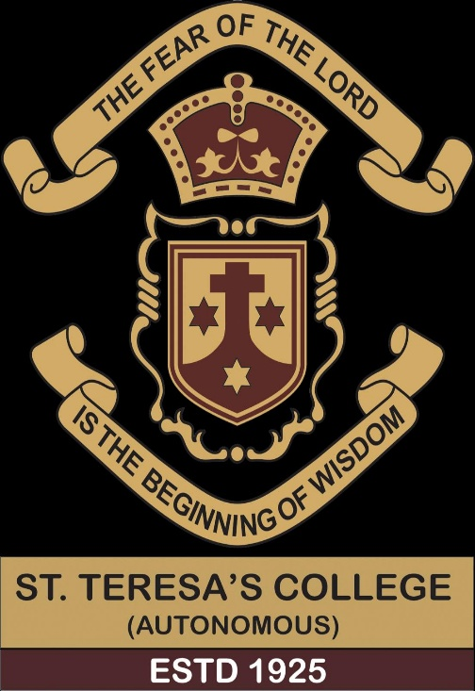
AFFILATEDTO M.G UNIVERSITY 2023_2025
CERTIFICATE

CERTIFICATE THAT THIS IS A CONFIDE RECORD OF FINAL YEAR DISSERTATION ON ‘COMPARATIVE STUDY ON CLASSICAL DANCES:ODISSI&BHARTAHANTYAM' submitted by ATHIRA BABY(SM23BHA003)AND SUBMITTTED IN PARTIAL FULFILMENTOF REQUIREMENT OF AWARD OF M.A. BHARATHANATYAM THIS COLLEGE.
Mrs .Dr.Beena D
Head of the department&
Assistant professor
Department of bharathanattam
St.Terasa’s college
Ernakulam

College seal ExternalExaminer

COMPARATIVE STUDY ON CLASSICAL DANCES:ODISSI&BHARTHANATYAM

CONTENT

- Introduction
- Origin and history
- Bharathanatyam origin and history
- Odissi history and evolution
- Odissi dance repertoire
- Basic definitions of odissi term
- Elements of dance
- Asamyukta hasta
- Samyukata hasta
- Bhangis
- Odissi costume
- Makeup and hair style, jewellery
- Musical instruments
- Conclusion

INTRODUCTION

India has rich cultural heritage that lies in its music and dance. The indian dance forms vary from state to state are odissi,Bharathantyam,kathak, ,kuchipudi,kathakali,manipuri,and satriya etc.Among all these dances,odissi and bharathnatyam are most ancient and bear the orginal styles ofperformance, which makethem stand out differeny superb.
If you love to dance,india is the place to be.The country is home to some of the world's oldest dance form,including folk dances like bhangara,and classic dtyles like odissiand bharathantyam.each dance has uniquesteps and far from being random,these steps have very significant meanings.
Dance is any one prescribed sequence of such movement in the music to which it is performed or an event.There are hundreds of different types of dances in india. Most of the india classical dance forms are very ancient in nature.There are eight dance forms recognised as classical dance by sahityaNatak Accademy.Dance in indiacomprise thevaried styles of Dances in the country.With other aspect of insian cultures differ forms of dancesorginated in different parts of india.But particularly in our country classical dance has lot ofsignificanes.It is not merely meant forentertaining oneself but it serves as a fabous way to express the innate feelings of heart.It is also the best means to get corrected with god.It can be traced back during thr period of natya sastra of bharathamuni.It was performrd to appease the dieties and wad considered avital element of spitituality. All the prevailing dance form use basically the same mudras or significant signs of hands as a commom language of expression were orginally performed in the temple to entertain various Gods and Goddesess. They were also effected in carrying forward the various mythological stories from generation to generation while entertaing the audiences.
ORIGIN AND HISTORY

The common root of all indian classical dance forms can be traced to bharaths natyasastra.it contains delibrayions on the differentkindof postures the mudras,the kind of emotions the kind of attires, the sage, the ornaments and the audiences.According to the natyasastra, Brahma the creatoe of the universr, createfdrama.He took the following components to create the fifth veda called Natyavedha
- Pathya(words)from RRigvedha
- Abhinaya(gestures)from theyajurveda
- Geet(musicand chant) from samavedha
- Rasa(sentimentand emotions)from atharvavedha

There are ample evidences of popularitu of dances in the indaian societt right from the Mesolithic period.The first and oldest of evidences to date are the discovery of the brinze figurine of a dancer from the indus valley.Civilization excavations of Mohenjo-Daro and harappa.Indian classical dances are dancers of the mind and soul and extremely rraditional.it is verysensousbut the ecprience of Ananda is evoke is very spiritual. Odissi the term itslf represent its origin from the state od odisha. It is the one of the famous classical traditional dance form of tve easter part of the india. It is is an estatic sensious form of dance performed in the temple of odissha as a religious rite and offering by the Devadasis popularly known as “Maharis”. The dance is found in the Manchapuri cave in udayagiri which was carved during the religion emperor kharavela. Hence it can be traced centuiries back the to its origin as a seculer dance. Later it got attachex with the temple culture of odissha.
Odissiis a highly inspired, passionate,ecstatic and sensous from the dance. In odissi dance the whole body of the dancer is their instrument means of artistic expression and elevate body fitness.it is also make a dancer both physical psycholgical strong as as its requirement high stamina and pratice, patience, tied with spirited mindedness it creates devotion the ones mind and heart. Thus it id consideted the most spritual and religious based dance form like other indian dance pattern.
Bharathanatyam is also one of the traditional classical dance form in south india orginated from state of Tamilnadu.its is basicaly praticed in the temples of shiva for many centuries It was performed only by certain families in the district of thanjavur like devadasis or mahari of or DC dance the performance of the bharatanatyam one known as ‘ Nattuvans’. It is combined artistic expression with a sense of spirituality the dancers generally dance to a Traditional South Indian carnatic orchestra consisting of voice, strings ,percussion And flute. Through this dance form is purely originated from the state of Tamil Nadu now it has become One of the classical dance form all

BHARATHANATYAM

ORIGIN AND HISTORY

Bharatanatyam is the traditional art form of Tamil Nadu Is a classical dance style from from South India performed by both Men and woman it is called 5th veda and is whitely considered to the oldest dance form in India . The name bharatanatyam Is explained 2 different ways the first is that is compost of related words.
- Bhava(Expression)
- Raga(melodic mode)
- TaLa(rhytm)

Bharatanatyam orgin at thanjavur of Tamil Nadu bharatanatyam is an East India dance having its roots in Tamil Nadu and it performed Hindu temples of Tamil Nadu. It is classical dance form Recognised by the sangeet natak Academy an express South Indian religious themes and spiritual ideas of Hinduis And Jainism.
The word Bharathanatysm mean to dance avcording to the principles of bharaths bhava, raag and Taal.long back this dance form was caled as 'Dasiattsm'.(which was known to be the dance of the devadasis).
Trafitionally Bharathanatyam was a dance of the Devadasis.The temple were maintained by the local rulers of the chief.The dancers, her guru and her musician were held in high esteem and were supportrd from temple funds. The dancers performed in front of the diety. Devadasis were married to the diety. The term ‘Devadasis' means ‘servant of god'.The dance wad performed at the suitable hours on auspicious occasions.
During the British rule, aperiod of degenerations set in. Their status fell as the dancers started to dance in thecourts even at the residence of landlords. Pioneers like Balasaraswati,rajalakskmi, rukmini Devi and E krishna iyer took up cause.The madras music academy contributes considerl.Rukmini devis first public recital in 1935 finally established the recital.

Myths About Origin of Dance

According to natyashastra:-
When satyug ended and dwapar yuv started,everyone started moving away from the path of truth, then all Gods got worried and went to lord brahma and requested to bring some kind of such knowledge on Earth, that woulf revive or establish dharama among people once again.lord brahma collected education from rig veda, abhinaya from yajurveda ,music from samveda, and emotiond from Atharvedha and wrote a fifth veda calledNatyaveda.
Lord shiva taught dance to his discipline Tandu and later Bharat Muni gave sacred knowledge to all human beings seeing and listening to which this dance spread further.

According to Abhinaya chandrika:-
Shiva taught the ancient art of dancing to his son ganesh and ganesh taught the art to mani Rambha,eho was the gem among the apsaras who in turn taught it to the sage Bharat Muni.After Bharatha muni, the transition was carried in turn by Gargacharya ,Bitkatacharya,kumara charya,Ranti Deva and finally Attahasa.Attahasa has been described as odra nritya visharad .the grand master of odissi dance.Attahasa probably taught this dance to Devadasi.

According to Abhinaya Darpana:-
In the beginning , brahma gave the natya veda to Bharata. Bharats together with his groupof gandharva and apsara performed Nirtya,n
Natya and nritta before shiva.
Then shiva having remembered his own majestic performance of dance, instructec Bharata by his attendants. Through parvati,he instrucyed Bharatha the lasya aspect of dance. Knowing about tandava from Tandu sages spread it among mortals.parvati instructed the art to the daughter of Banasut,usha the lasua aspect of dance.usha taught the art to milkmaids od Dwarka. And they taught it to the women of swarashtra,who in their turn taught it to the women of other countries.In this manner, the art of dancing was traditionallu handed down snd has come to stay In this world.
Ancient
In Asian times the theoretical structure of bharatha natyAm Is known as sadhir and traces back it become artistic expression. The creature of bharatanatyam reveal as legend of Lord brahma Lord brahma performed dance for the sage of In bharatha. In Asian times Bharatanatyam style evoked from South Indian temples . Devadasi were perform the dance In the Temple . Devadasi Are the dancers Dedicated to Serving the Lord as servants. Thus back to 300 BCE, this was the original performance of bharatanatyam style.

Medieval
The practice of devadasi system were grew up And continued popularity in South India . Later it's South Indian temples sculptures of Lord Shiva in bharatanatyam pose were adorned. The eastern Gopuram of thillai nataraja temple Dedicate to Lord Shiva, adorned by sculptures of 108 bharatanatyam poses. Those poses carved into small rectangular panels. Karnataka badami KU temples Lord Shiva is displayed in a5- ft tall Sculpture as nataraja,posing like tandava dance
MODERN
During British colonial rule ,devadasis system were looked as disgraceful ,disrespectful,degrading.Invaders were banned on numerous classical indian art forms ,thus it effect the custom of temple bharathanatyam performance. Later many legends of bharatanatyam Like Ek Krishna iyer Rukmini devi arundale worked to save bharathanatyam dance.
E Krishna iyer fight to revive of traditional dance.while in prison iyer advocated to the renewal of bharathanatyam dance with theosophisit and choreographer Rukmini arundale. Later, founded Madras music Academy were they worked with community to save bharatanatyam dance.
Later the revived classical dance style continued grew up popular in more students. today bharatanatyam dance is performed all over india including abroads.Bharathanatyam became one of the prominent indan dance.

ODISSI HISTORY AND EVOLUTION

Kharabela is the greatest of all monarchs who rule over orissa.In an inscription,he was proud to give out to the world that he excelled in the knowledge of the science of music and dance rather than in that of more profound philosophy that jainism had to teach.

The earlieast evidence od dance by the professional female dancers id found in the caves of khandgiri and udaygiri, near Bhubhaneshwar,the capital city of orissa excavated in 100B.C from the Hayigumpha insvriptoons incised in the ceiling of a natural cavern, it is known that kalinga, by the1st century B.cexvelles in the art of danceand musi underthe patronage of kharavela who stands as the esrliesr luminous personalitu having proficiency in Gandharva veda.
The coustume, ornaments, hairstyle and stance of the first danseuse fo not bear any aimilaritu with the poses of the present form od odissi.But the pode of the second danseuse can beidentified as a particulatpose of odissi,mostly used in Batu-Nrutya.
The sculptires in Ranigumpha caves,udaygiri, of 2nd century Bc are the earliest rvidence of odissi dance. The sculpture in the temple of bhubhaneshaar,konark, and puri from the 6th to the 13th century.A.D. show odissi dance figures.king chodagangadeva built the jagannath temple at puri which became the centre of all religious activity. Odissi was traditionlayy performed by the ‘Maharis'in thejagannatha temple and later also by theGotipuas(young boys dressed as girl)

BUDDHIST PERIOD
Mahajana Buddism, then a supremely aesthetic religion expressed itself not only on architectural and iconographicplasticitu but also in the artisticeccellence of dancing and mudic, serving yhe purpose of innumerable devotes and connoisseurs.In several sculptural pieces of this peripd, we find human beings,as well as Gods and goddessess such as Marichi,vajra varahi,Achala, Aparajitha and Heruka,representes in dance poses that bear persuasive testimony of a particulat school of dancinh in ancient orissa.

TANTRISM PERIOD
It id undoubtedly a fact that tsntrism, since its evolution,inspirrd a dance style of its own. Yhe continuation ofthis tradition is evidenced in the yogini pithas of orissa established when the Brahmanical Tantridm became very popular in society.The first Brahmanical Tantric pitha in india orginated and developed in odra Desh (orissa) the presiding deity of which country was jaganath.In the circular wall around the encloses space at Hirapir, there are 64 niches each holding an image of yogini carved in black chlorite in standing postures. A number of them bedecked with exquisite jewelry,dance in spiritual ectasy. This temple is ascribed to the 8th -9th century of the christian era.

SHAIVISM PERIOD
Through it had yet to br known how and when shaivism came to orissa, we have enouh evidencr since the 4th century A.D .An image of Nataraj with 13 lines of inscription in sidhamatrika script had recently been discovered in the village of Asanpat in the district of keonjhar.

EARLY TEMPLES OF BHUBANESWAR

Four early shiva temples of bhubaneswar viz Bharateswat,laxmaneswar,satrughneeswar, and parsurameswar are ascribed to the 6th -7th century A.D.The temples were built by the sailodbhava rulers. Besides the nataraja images, the appearances of dancing girls in a number of siperb panels of the highest artistry are evidently the sculptural equivalent of the mody significant phases of dancing of that time.

VAISHNAVISM
The sun temple of konark the natna Mandap wad used for dancine performancrz in honor of the deity, ehich formed an essential part of morning and evening offices of the temple. A considerable number of dancing girls were attached to the temple for that purposr. The plinth and pillars are carved with dancing figures. Hundreds of dancing images and musicians with various musical instruments give us a clear vision of distinct mode of dancing at that time.
ODISSI DANCE REPERTOIRE

Manglacharan
It is invocation piece of odissi dance.After paying homage to lord jagannath, a shloka in praise of some God or Goddess is sung,the meaning of which is brought through dance.Manglacharan also includes the Bhumi pranam,salutation to mother earth(wjich is offered to mother Estth as a way of begging forgiveness for stamping on her)and Trikhandi pranam three fold salutation,above the head to the God, in front of face to the Gurus and in front of chest to audience.
BARU
This item of pure dance is held in honour of shiva, also known as Batika Bhairava in one of his sixty-four terrific aspect.It is an item of pure nritta snd remains the most difficult item of odissi.It begins with a series of sculptiresqieposesrepresentinh such actions as playing for various musical instruments like veena, Drum, flute, and pair of cymbals.These actions have been elaborately carved in orissa templea.The danceis not accompamied by an songor recitation,but throghoutthe item a phrase of rhythmic syllable is provided. The sccompanying phrase is in the form of one line of ukuta and this is recitad in the taal and different taal patternsare improvised and executed with feet. Some taalvariations are also introducedand each sequenceof dance terminated with aTihayi called as katar.

PALLAVI
It is usually the third piece on the traditional odissi repertoire.It means to elaborate or to blossom. It shows the technically of the style. It starts with simple rhythm patterns, goes on to become complec and finally builds upa beautiful and complicated blend of music, rhythm and dance. Music and dance both complicated each other.A pallavi is usually set to a patticular raag with swara and movements.it is ways named after it own raag, for example, kalyani pallavi is based on kalyani raag.

ABHINAYA
Abhinaya is the name of expressing different emotions and presenting them on the stage. Through Abhinaya the meanings of metaphors are conveyed to the society and people.Abhinaya is thebasicbasis for the origin of rasa.Various types of meaning related to thr eorld are showcased by abhinaya, which makes them simple and causes the origin of Rasa.
All human activitiea are vidible througj dpeaking thinking and doing. They are also used in abhinaya to reach the internet of the society.The processs of thinking gives birth to virtuous action.The vocal part of speaking and the pary of doing rise to Abhinaya.
Bharata mentions a fourth abhinaya in addition to theseAharya Abhinaya.Aharya Abhinaya is related to costumes used in the drama.Thus there are four types of acting
- Aangik
- Vaachij
- Aaharya
- Saatvik
“Aasyenalambyed geetam hastenaartha pradarshayrt chakshubhraysam darshayed bhavam paadabhyam taal maacharet
Yato hastasto drishtiryato drishtistato manah
Yato manastato bhavo yato bhavastato rassh”
The meaning of the first teo lines in this that the songs should be presented througj the voice of the mouth And theeaning of that song should be displayed with both hands(hand gesturrs)and whileexpressing its meaning with both eyes,the movement of the feet should be according to the rhythm.
In the next two lines,he says that whatever the hand goes the vision goes. And whetever the vidion goes, the mind should also be there.where thete is mind, there is feeling thete is origin of Rass.

Abhinaya chandrika
This treatise wad written by Maheshwara Mahapatra. It is estimated to been written in the 16th century A.D. It is the only text that specifically focuses on the odissi dance style thougj the authenticitu of the text has not yet been established. It covers topics such as the hasta mudras,padbhedas, Bhangris,charis,Bhramaris,etc. It includes the depictions of the karanas merely sakhsya, chakramandda, Gangautras,etc. It includes the depictions of the ‘karnas' namely sakhsya,chakramandda,Gangasutra,etc There are names of movements that arr also found in the Natyashastra like the vishnu,kronya,vrichika kutila.
Abhinaya in the text means movement of the body siggesting rasa and bhava. Abhinaya is meant for narrating a particular story,verse, phrase,etc through the dancers mukhabhinya,body language and hamd gestures.The text Abhinaya chadrika contains 284verses on all.The first two verses are ganapati and lordjagannath. The rest upto verse 18th,the author gives an account of nrutya prasana and them describe the origin of odissi dance.
ABHINAYA DARPAN
This treatise is written by Nadikeshwar. It is belived that it was written somewhete around the 10th and 13th centuryA.D.There are approximately 300 verses of this text.this text is the most important treatise for yhe gestures used in odissi.

This treatise primarily deals with the details of the ‘angikabhinaya'describing gestures,postures, and movement such as
- Shirobheda-movement of head
- Drishtibedha-movement of eyes
- Grivabheda-movement of neck
- Hastabheda-hand gestures in both single and combined
- Sthanaka bheda-standing postures describing the foot positions
- Utplavana bheda-various kind of jumps
- Charibheda-various kind of walk
- Bhramari bhedas-various kind of pirouette
- Gatibheda-various kind of gaits

It should be noted that the terms of natyashastra and Abhinaya darpan are quitesimilar,dome of the terms are common in both some agree partially and some arecompletely different.The numbers of the varioud gedtures are also differ in number.

BASIC DEFINITIONS OF ODISSI TERMS

- Avartan-one complete cycle of a song on a taal, played on a instrument is sn avsrtan

- Vibhaag-Time cycle of a taal is when divided into sections the sections is called vibhaang

- Arsa -It is combination of rhythmic patterns exprresed in syllables /bols set in a particulae taal. It is much more emebellished aesthetically.

- Anga-The taal of a particular musical piesce is indicated usually by a series of rhythmic hand gesture performed against the thigh,while seated in crossed legged position.The hand gestures are called kriyas and difined as the Anga

- Dharan/sthayi ukuta -A set of Bani or syllables that gives a defined character and compostion to a taal being played on Mardala. It is the first basic compostion to a arsa in dance. Taal is being recognised through its Dharan or sthayi ukuta

- Maatra -In indian Music, the smallesy rhythmic unit of a taal is called Maatra. It is the basic unit of time measurement.The avtual time duration of a maatra depends on the speed on the rhythm

Laya-The speed or tempo at which a taal is played is called laya. The timedistsnce between one maatra to srcond mastra determines the laya.There are three types of laya vilambit,madhya, and druta.If time taken between theexecution of two maareas is large, it will be vilambit.If it is very less then it is called Druta.If the time taken is less than vilambit but more than Druta it is called Madhya.

- TAAL-Taal is group of maatrasarranged aesthetically.It is cyclic in nature,keeps on representing,comes back in sama.it is a way of measuring time in singing,music or dance

- GADI-One phrase repeated many times,for example,Dhi Na Kar Tank,Dhi Na karTak.

- SAMA -The first maatra of taal where laya is a bit leeaned is called sama. Mostly head of the person who understand music, shkaes head a little at this point.Here ,a little force is felt while playing or ainging a taal. Main function is to establiah a point of resolution

- TAALI-The supports of pakhawaj or Mardal where clapped with hands is called Taali. It is used to designate the beats (maatra)which are joghly emphasised

- KHAALI- KHAALI MEANS EMPTY. It is used to denote empty or voidsound. It denotes beats that is not emphasised intaal.Almost in all taal, one or more khaali is there.

- Padi-In a dance piece,where there isa changein laya occur along with atext or aong, It is called padi.

- POHAPATA- IN A dance piece,when forming a crescendo at the final is called pohapata

- JHULA- TAAL of six matras where the vibhaag is of 3-3

- MAANA OR TIHAYI – IN the concluding part of the arsa,when a phrase is repeated 3times ,it is calledManna or Tihayi

- BAANI- DIFFERENT SOUNDS PLAYED ON MARDALA IS CALLED BANI FOR EXMPLE,DHA, DHI, NA TA, THI.

- UKUTA – THE group of two or three matras is called ukuta,for example,jhe na,Kar Tak, Gadi Gana.

- KHANDI – A part of taal which is musical but has less maatras than taal is called khandi for example, kartakgadiganadha.

- TANDAVA -It is that aspect of dance which is rigorous and masculine. This is to ahow movements of male vigour.This was first danced by shiva and taught to his disciple Tandu.

- LASYA – lasya id the soft and feminine dance using the graceful movement. It wad first danced by parvati and then taught to usha daughtet of Banasur.

ELEMENTS OF DANCE
- NRITTA
It is that aspect of dance which has the rhythmic element. It interprets of dance which has the rhythmic element. It interprets the language of rhythm with the help of body movements, absent of any textual or emotive element

- NRITYA
Combination of rhythm with expression.it conveys poetic meaning with the help of expressions rhythmic gaits and posture, for example, varma,shabda, padam etc

- NATYA

This is tge dramatic element in dance which is performrd by differenr charactdrs portraying a story or a theme. The story or theme could be from Ramayan or Mahabharata.

BELI AND ANGA, PRATYANGA, UPANGA

BELI
“utha Baitha thiya chali,
Bhudha bhasa bhauri pali,
Odissi Nachara atha beli”

Beli body position, movements and pattern that are used particularly odissi dance are called Belis they are 8 in numbers

- Utha

Utha is any standimg position from ditting to standimg or to jump in astanding pose or just a standimg .

- BAITHA
Baitha is any position in sitting to jump and shit

- THIYA
- Thiya is any redting podition, for expamle AAbhanga
- Chali
Chali is kind of walk in odissi
- BUDHA
Budha is odissiovements that shows happiness and joy.Hands are generalay raised yo express joy.

- Bhosa
Bhosa is any waving movement.
- Bhauri
Bhauri is various kinds of spins used in odissi dance.
- Pali
Paliis to makedifferent patterns using particular steps like circle,square hexagaon,etc.

ANGA,pRATYANGA,UPANGA
We use almost all parts of the body in executing Nritta Ntitya and Natya.The entire body is dividedas Anga, pratyanga and upanga.

Anga-head,hands,chest,waist,bottom,legsare the six angas.some people also consider neck to be seventh aanga.
Pratyanga-
Shoulder,arms,syomach thighs,calves,back are six pratyanga,some people includewrist,elbowand ankle.
Upanga-
Sight eyebroe,eyelids,eyeballs,cheeks,nose,gums,lowerlip,terth,tongue,chin,face are 12upanfas.Few people include heels,ginger, feet, palm,also into upsngas,they shouldmovd along with angas.
Mukhanga-
Eyes,eyebrow,pupil/eyeball,cheek,nose,jaws,lips,teeth,tongue,chin,face,eyelid.

ASAMYUKTA HASTA
AsamyuktaHasta shlok

Pathaakas tripathako ardhapathaakah
Karthareemukhahmayoorakhyo ardhavhandrascha araalah shukathundakah mushtishcha sikharakhyascha kapiththah katakamukhahasoochee chandrakala padmakosha sarpashirasthathamrgashirsha simhamukhah kangulascha alapadmakahachathuro bhramarasjchaiva hamsaasyo hamsapakshakahasandamsho mukulaschaiva thamrachoodathrishoolakah
1.pATAKA HASTA

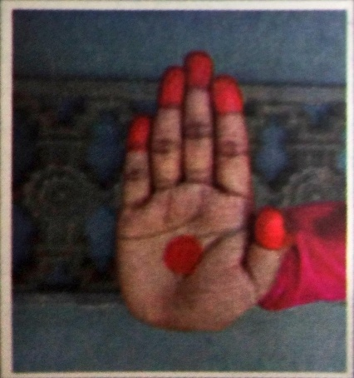
HOW TO DO IT?
STRECH all the fingers &hold them tightly togher to show pataka hasta.
Pataka hasta used for represent various convept like to begin dance,clouds,nightsky,sleeping,bright aunlight,waves,bless,ideal king,to ahow equality, to enter street,palm leaf,shield,wind etc.

2.TRIPATAKA HASTA
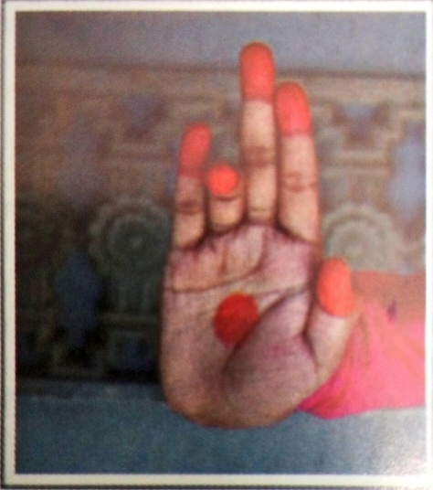

How to do it?
Bend the fourth finger &hold the rest tightly,like in pataka hasta to ahow tripataka Hasta
Tripataka hasta used to represent crown,tree,lord indra,lamp,flames,arrow,etc.

3.ARDHAPATAKA HASTA
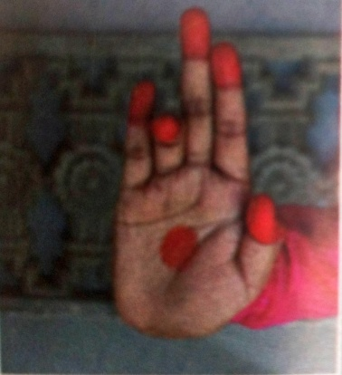

How to do it?
Bend the fourth and &last finger and hold the rest tightly like in tripataka hasta to show
Ardhapatakahasta had used to represent sprouts
,banks of river, to ahow two person,sword,flag,horns etc.

4.KARTAREEMUKHA HASTA
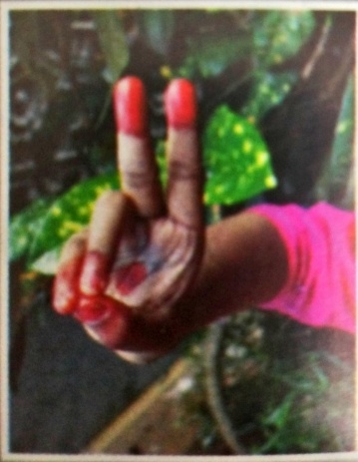
How to do it?
Hold ardhapatha hasta.then make an angle between the second &third fingers to show kartarrrmukha hasta
Kartarremuka hasta used to represent separation of mana&woan diferentoation,stealimg,glance,death,showing difference,falling down etc

5.MAYURA HASTA
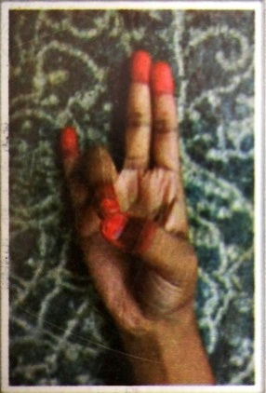
HOW TO DO IT?
Hold tripataka hasta but toucj the fourth finger wiyh thumb to show mayura hasta
Mayura hasta used to represent peacock,vreeper,bird,vomiting,tears, famous etc..
6.ARDHACHANDRA HASTA
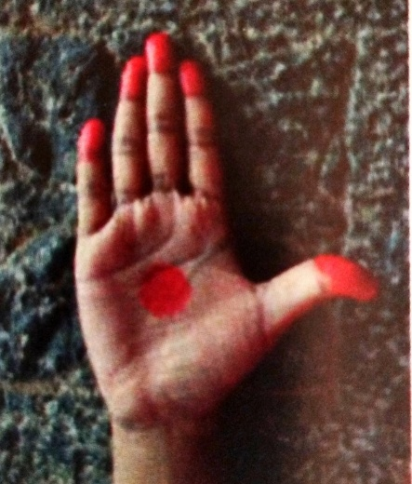
How to do it?
Leave the thumb in pataka hasta to show ardhachandrahasta
Ardachandra hasta used to show holding the neck, weapon, worshiping the god,creation, plate,waist,worryinh,saying that”it is mine”,praying,to salute ,meditation,touching the limb,etc..
7.ARALA HASTA
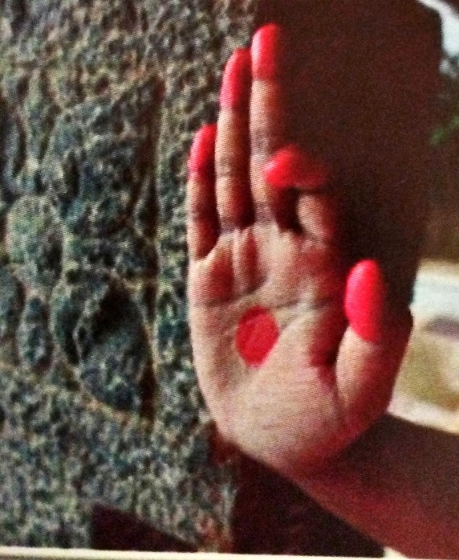
How to do it?
Fold the second finger in pataka hasta to ahow arala hasta
Arala hasta used to represent drinking poison, or nector, thunder storm,etc.
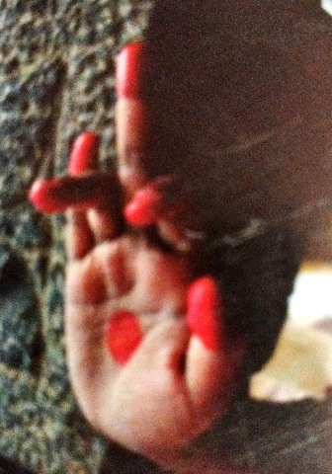
8.SHUKATUNDA HASTA
How to do it?
Bend thefourth finger in arala
Shukatunda hasta uses to represent to shoot an arrow, eeapon,saying cunning thimgs, dhowing fury etc.
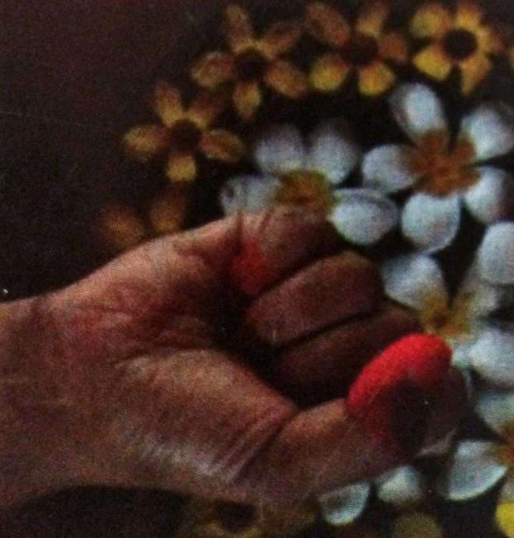
9.MUSHTI HASTA
How to do it?
Fold all the fingers in to the palm &keep the thumb on them to ahow mushti hasta (like a fist)
Mushti hasta usualy used to represent strength, dragging by the hair, courageous, holding things etc.

10.SHIKHARA HASTA
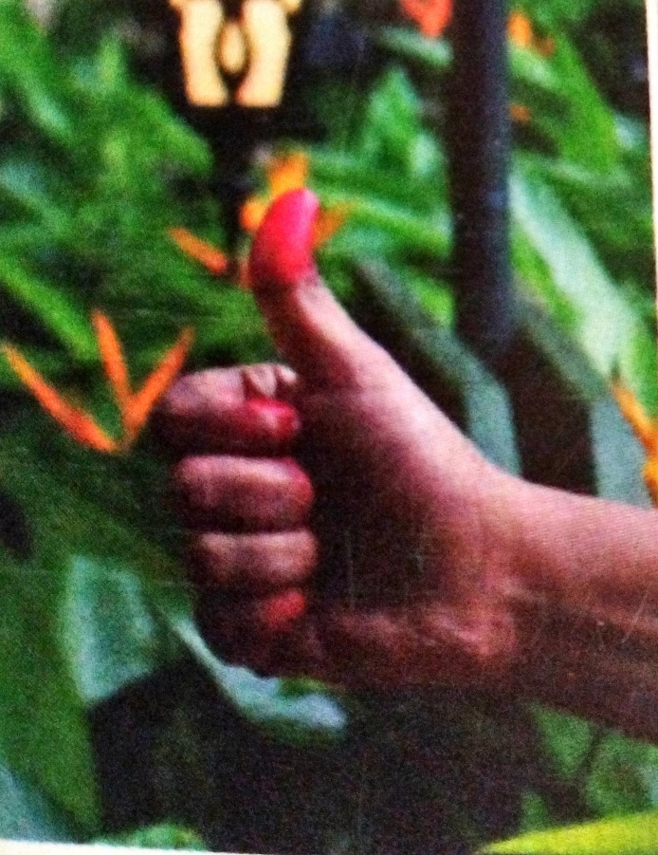
How to do it?
Strech the thumb finger in mushti hasta to show shikara hasta.
Shikhara hasta used to represent cupid,bow, piller, silence, offerimgs,lips,enterung,teeth,questioning,ringing the bell,weapon names shakti,tomara,hugging,teing ariund waist.

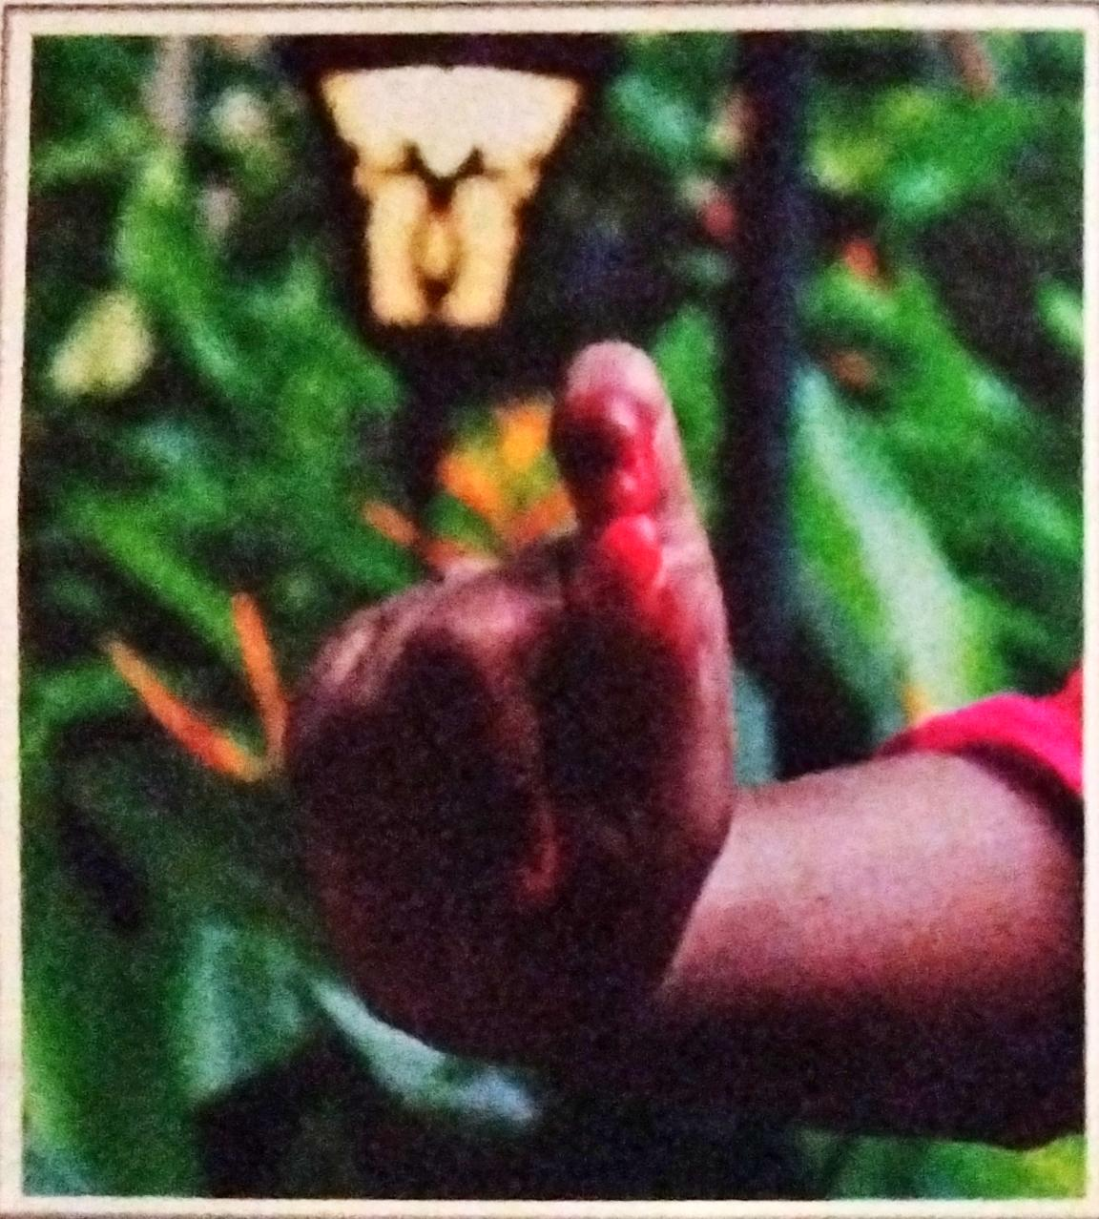
11.KAPITHA HASTA

How to do it?
Fold the decond finger on thb in shikhara hasta to show kapitha hasta.
Kapitha hasta usually show to represent show goddess lakshmi, saraswati,going around,holding the symbols,milking the cows, putting eye liner, holding flowers,holding the saree,drapping a cloth on the face, to hold lamp and incense etc.

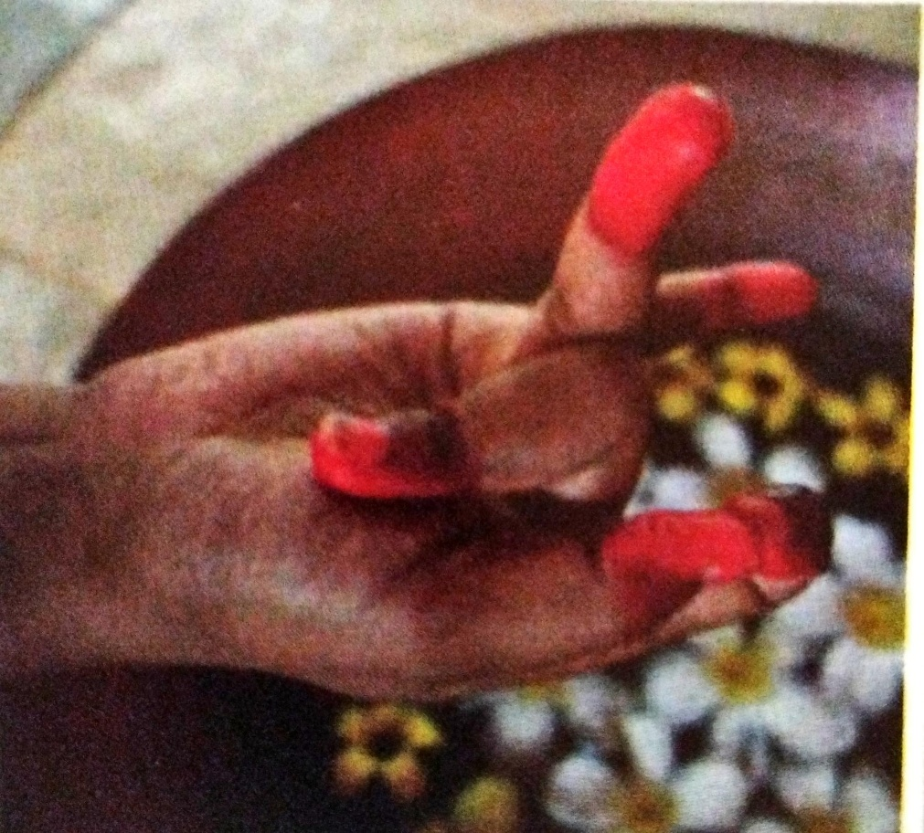
12.KATAKAMUKHA HASTA
How to do it?
Bring togethet thn, index,&middle fingers&strech the the other two fingers at an angle to ahow katakamukha hasta
Katakamukha hasta used to represent plucking the flower, pearl necklace, eearing flower , getting attracted by thecupid arrow,giving bettle leaf, showing kastoori&other perfumes, enjoyimg the perfumes etc.

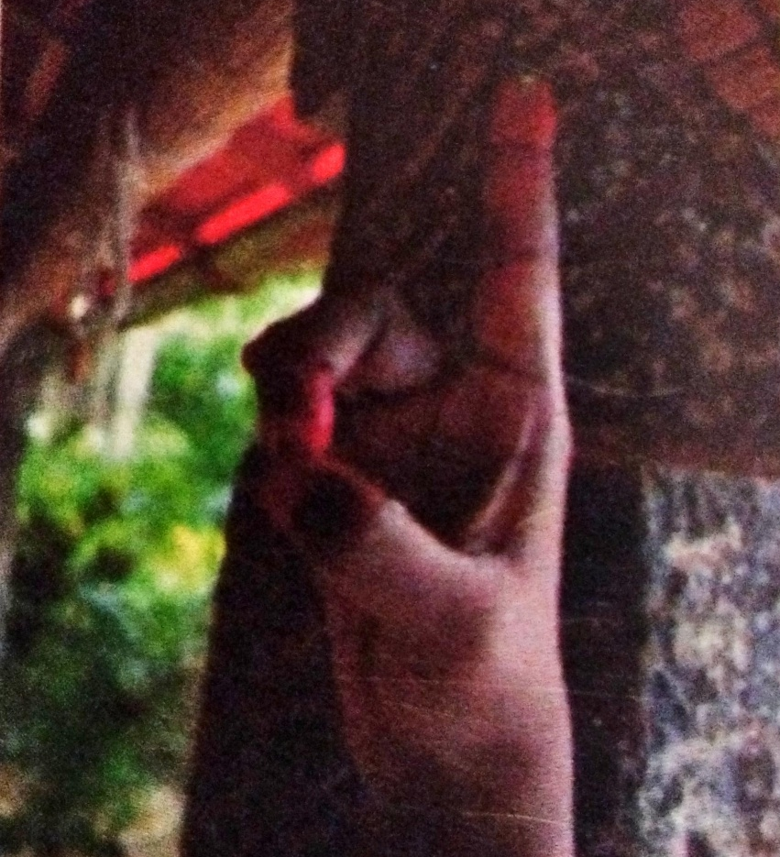
13.SUCHI HASTA
How to do it?
Strech the index finger &bring together all other to show suchi hasta
Suchi hasta is used to represent showing nber one,showing para brahma,sun,universe,city,saying'that'show it is',thin, skinny,wonder, shoeing the hair,exitment, beating an instrument called bheri,showing potters wheel, wheel of chariot,group of people,thinking,etc.
14.CHANDRAKALA HASTA
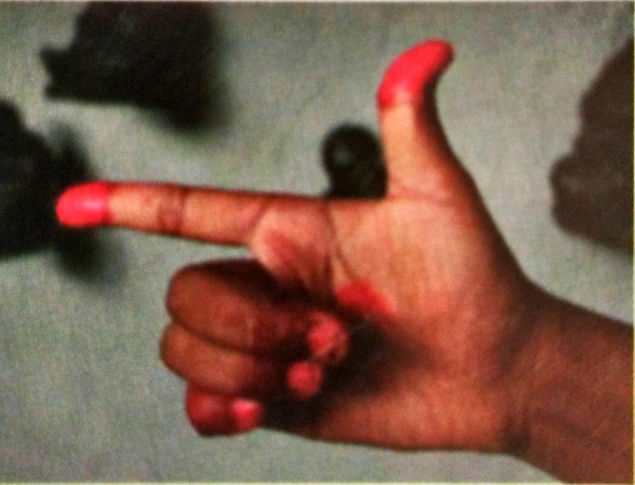
How to do it?
Strech the thumb finger in suchi hasta to show chandrakala hasta
Chandrakala hasta used to represent show moon.
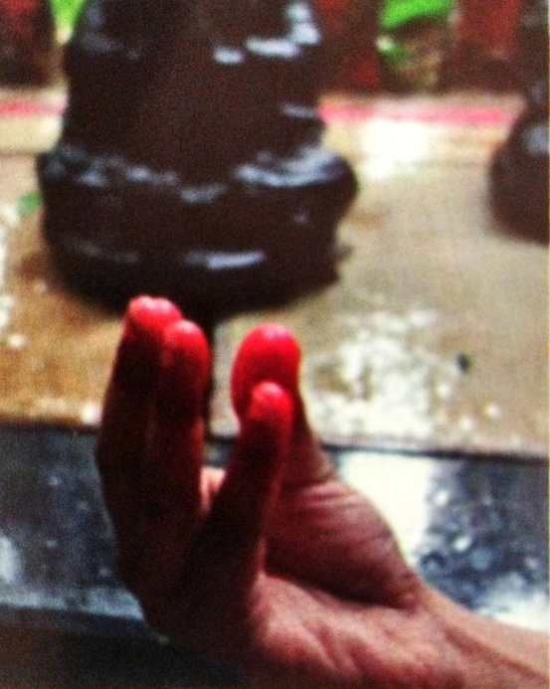
15.PADMAKOSHA HASTA
How to do it?
Bend all the fingers towards the palm to ahow padmakosha hasta
Padmakosha hasta used to represent to show fruit like Bilwa&kapitha,breasts,round,ball,small quantity of food,bud,mango,rain of flower,bunch offlowers, bell,lilly,egg etc.
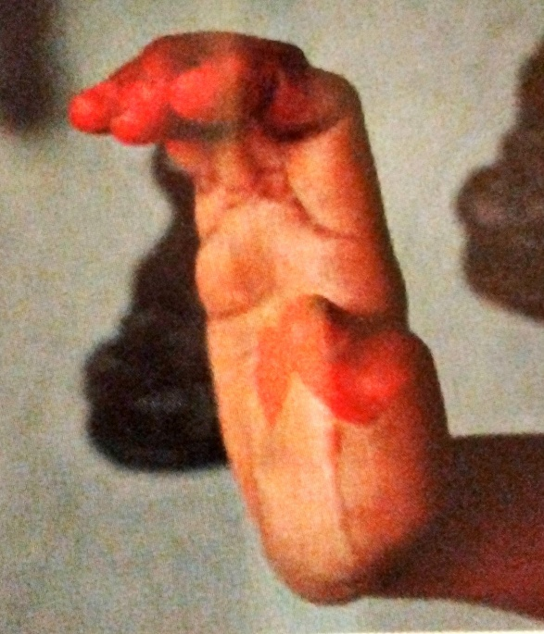
16.SARPASHEERSHA HASTA
HOW TO DO IT?
Bend the fingers a little in pataka hasta to shoe sarpasheershs hasta
Sarpasheersha hasta used to represent sandalwood paste, snake, slow, sprinkling,caring,holy water, elephant forehead etc.
17.MRIGASHEERSHA HASTA
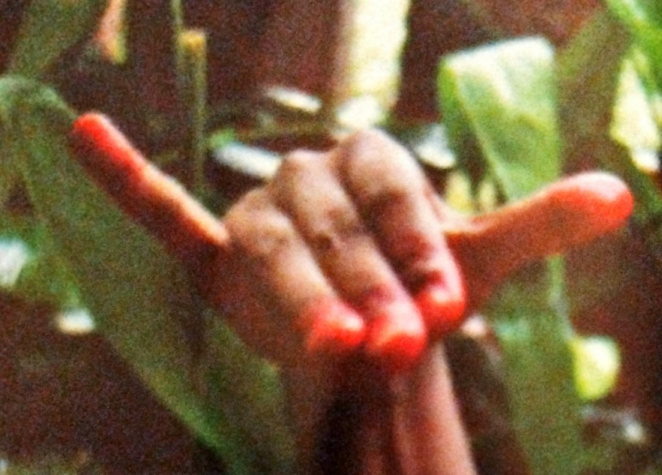
How to do it?
Strech the thumb & the little fingers in sarpasgeersha jasta to shoe mrugasheershs hasta.
Mrugasheersha hasta used to represent women, cheeks,way of foing things, to show respect,scare, argument,bsck stage, forehead ,messaging the feet,holding the umberlla, stairs to the loved one,getting people together,house,gaite etc.
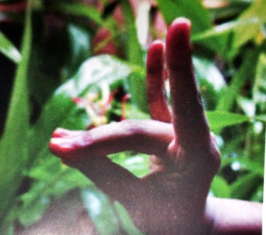
18.SIMHAMUKHA HASTA
How to do it?
Touch the middle&the ring finger with thumb &strech the second &little fingers to show simhamukha hasta
Simhamukha hasta used to represent to show carol,pearl,fragnance, curls,hearing, point, salvation, heart,savred fire rabbit,elephant,sacred grass,flower
Lions face,etc.

19.LANGULA HASTA

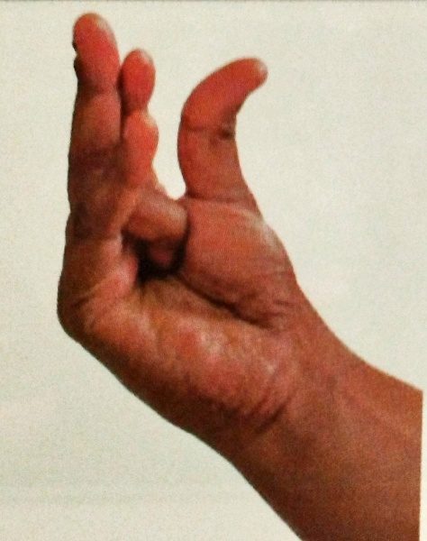
How to do it?
Foldthe rimg finger in padmakosha hadta to showlangoola hasta.
Langula hasta used to represent show lemon, breasts of teenager, flowe called kalhara, a birdcalled chakora,beetle nut,jingles,tablets,etc.
20.ALAPADMA HASTA
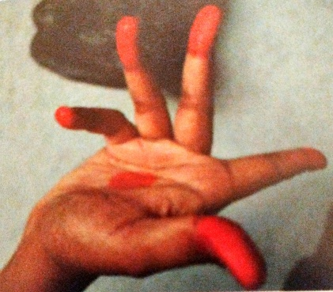

How to do it?
Strech &hold all the fingers at an angle to each other to show alapadma hasta
Alapadma hasta used to represent to show lotus, fruit caled kapitha,Turning,Breasts,pain of seperation,mirror full moon, beautiful things, knotted hair, moon chamber, village , height, angerLake,cart,bird,to praise etc.
21.CHATURA HASTA
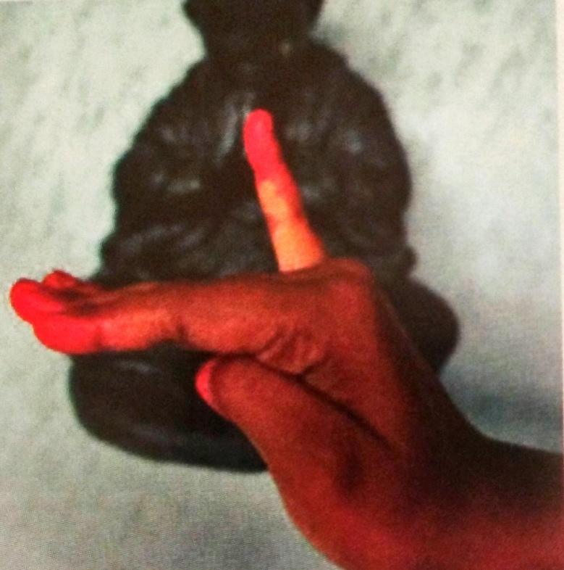

How to do it?
Strech all thr fingers,hold the little finger at an angle to the the other fingers &fold the thumb &touch the bottom of the ring finger to ahow chatura hasta.
Chatura hasta used to represent to show small wuantity, gold other metals,wetness, sadness,taste, eye,diferentiate colors,promise,romance,slow movement,breaking,seat,melted butter,oil etc.

22.BRAHMA HASTA
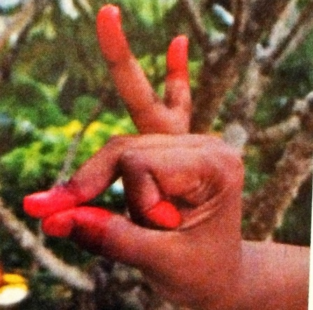

How to do it?
Touch the midfle finger with thumb, bend the second finger completely,strch the last two fingers at an angle to show bhramara hasta.
Brahma hasta used to show honey bee, parrot meditation,birdsetc.
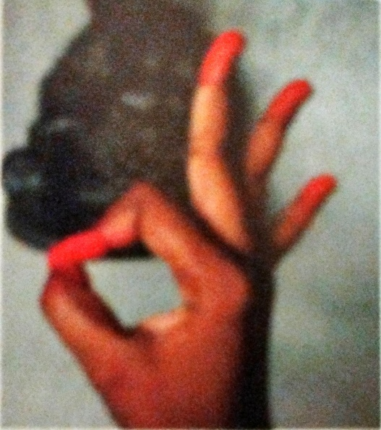
23.HAMSASYA HASTA
How to do it?
Touchthe index fingerwith thumb&holdthe otherfingers at an angle to show hamsasya hasta.
Hamsasya hasta used to show tying the sacred thread of marriage,advice decission,excitement, pearls,other precious stones,drawimg,fly,drop of water,wick of the lamp,polishing,sesrching,jadmine,other flower,drawing line,holding garland, to say “I am brahma”,etc.

24.HAMSAPAKSHA HASTA
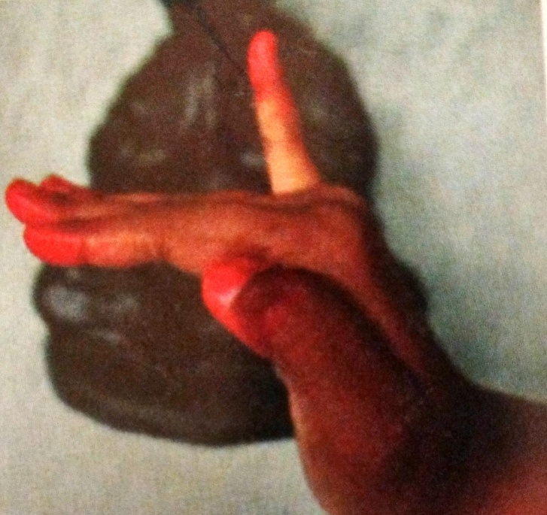

How to do it?
Strech the little finger in sarpasheersa hasta to show hamsapaksha hasta.
Hamsapaksha usef to represent to ahow number6, bridge, impresion pg thenails,way of doing things etc.
25.SAMDAMSHA HASTA
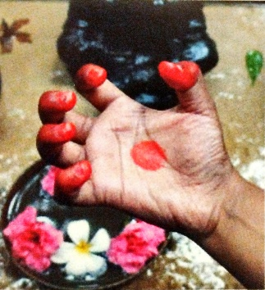

How to do it?
Hold the padmakosha hasta, close &ope the fingers often tPsshow samdamsha hasta.
Samdamsha hasta is used to represent shoe generosity,sacrificialoffering, woundinsects,fear
Worship offering,number5 etc.
26.MUKULA HASTA
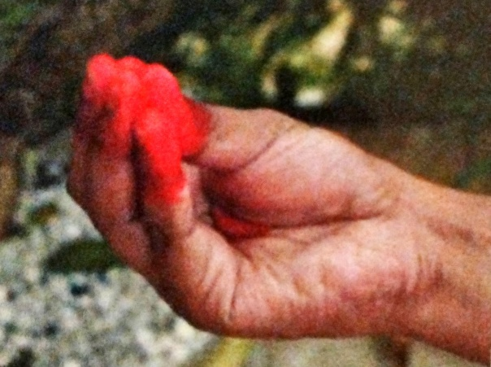
How to do it?
Touch the tips of all fingers to show mukula hasta.
Mukula hasta used to reprsent to show lilly,eating,cupid, smearing,belly buttom,bannana flower etc.
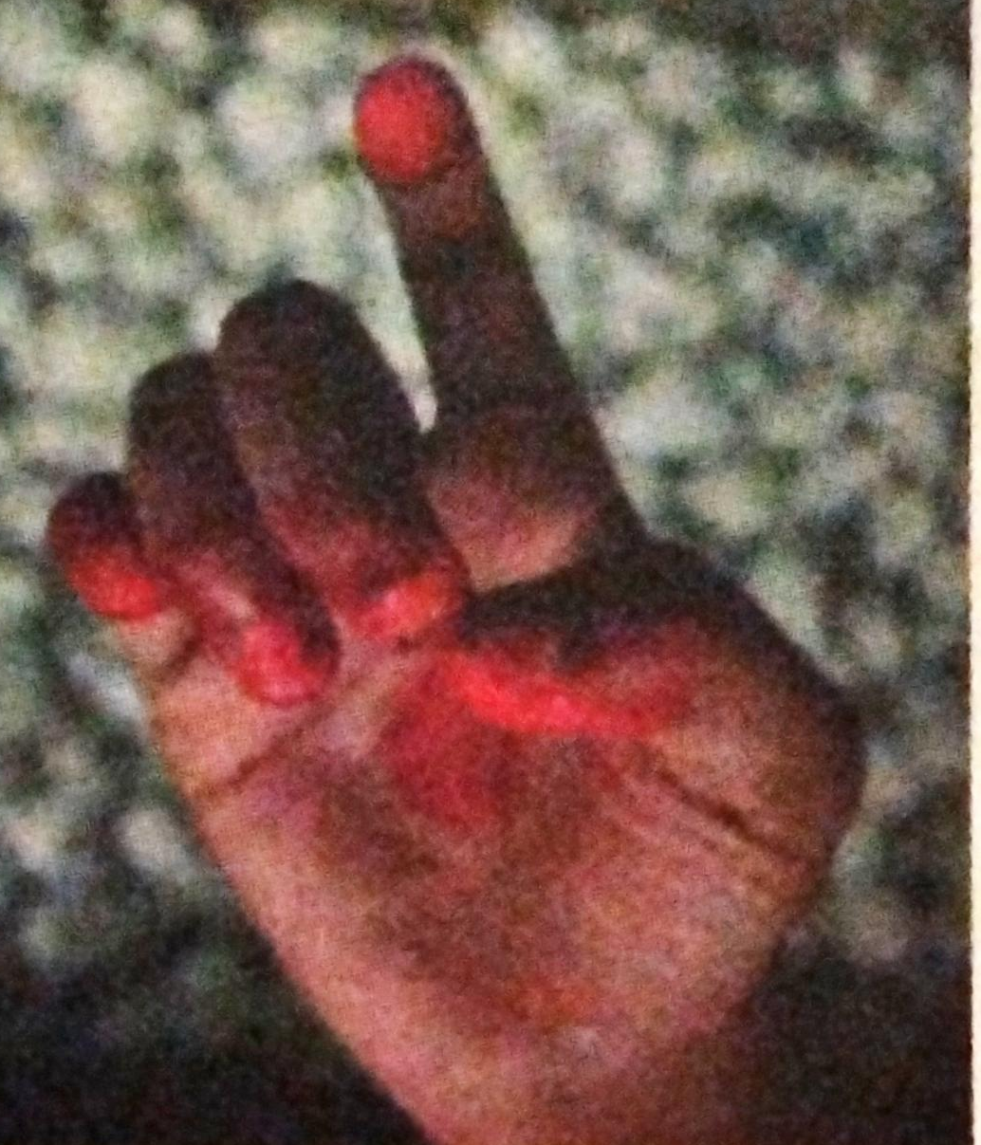
27.TAMRACHOODA HASTA

How to do it?
Hold the mukula hasta, separate the index finger, bend a littleto show tamrachoida hasta
Tamarachooda hasta used to show rooster,A bird calledbaka,crow, cmael, calfetc.
28.TRISHOOLA HASTA
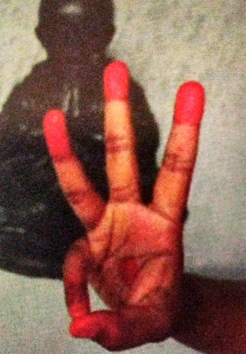

How to do it
Fold the thumb & the little finger strech the other fingers &hold thrm together to show Trishoola hasta.
Trishoola hasta used to show a leaf &to show the number3 etc.

SAMYUKTA HASTA

Samyukts hasta:-
Anjalischa kapotashcha karkata swastikastatha
Dolahasta pushpaputahautsanga shivalingakaha
Katakavardhanashchivs kartRee swatikastata
Shakata shanka chakreshcha sputapashs keelakau
Matsya koorma varahashcha garudonagabandakaha
Khatwa bherundakakhyashcha avahittastathivscha chaturvimshatisankhyaha samyuta kathithakaraha

1ANJALI HASTA

Hold pataka in both the hands &join the palms to show anjali hasta
Anjaly hasta are used to show to salute god, teacher,the learned.

2.kAPOTA HASTA
In kapota hasta only borders of the hands are joined (palm should not touch one another)to ahow kapota hasta)
Kapota hasta are used to make promise,speak to the teacher,to be polite,to agree.

3.karkata hasta
Bring the fingers of both the hands beteeen ine anothet to show karkata hasta
Karataka hasta used to show crowd,thick articles,blowing of shanka,bending the branches of a tree.

4.swastika hasta
Hold pataka hands&cross the hands at wrist so that hands are opposite to each other to show swastiks hasta.
Swatika hasta used to aligater, to talk in fesr,to argument,to praise.

5.dola hasta
Hold patska hasta,strech the aramd &keep the hasta upside down along the hip line to show dola hasta
Dola hasta used to beginning of a dance
6.pushpaputa hasta
Hold sarpasheersha in both the hands &join them at the wrist to show pushpapuya hasta.
Pushpaputa hasta used to show lamp offering,children,accept fruits,offering to the sun in the evening,holy prayers etc.

7.utsanga hasta
Hold mrugasheershs hasta in both the hands,cross the hands,touch oppositeshiuldets to show utsanga hasta.
Utsanga hasta used to show shyness, ones bodys,to deciplinechildren.

8.shivalinga hasta
Hold srdhachandra hasta in the left hand keep shikara hasta in right hand &place it on the left hand toshow shivalinga hasta.
Shivalinga hasta used to show lord shiva.

9.katakavardhana hasta
Hold katakamukha hasta in both hands,cross the hands at the wrist to show.
To show coronation,to worship,to ahow wedding

10 kartareeswastika hasta
Hold kartareemukha hasta in both the hands &cross the hands at the wrist to show
To show branches of atree, tip of montain, trees.

11.shakata hasta
Leave the thumb &the middle fingers in Bhrahmara hasta.hold like this both the hands &cross at the wrist to ahow shakata hasta.another way of showing shakata hadta is to cross arala hasta at the wrist.
This hasta is uesd to ahow demons.

12.shanka Hasta
Hold the left thumb with the last three fingers of the right hand, strech the other fingers, of the hand,strech &touch the thumb &index fingers of thr right hand with the streched fingers of the left hand to shoe shankhs hasta.
This hasta used to shoe conch.

13.chakra hasta
Hold ardhachandra hasta in both the hands,place them one above the other likeplus mark to show chakra hasta.
This hasta used to show chakra,the weapon of lord vishnu.

14.samputa hasta
Hold chakra hasta,fold the thumb &little gimgers in both the hands to show samputa hasta.
This hasta is used to show to cover things, to show sacred box.

15.paasha hasta.
Hold suchi hasta in bothhands, bend the index finger a little &join these fingers like a chain to show paasha hasta.
To show playful quarrel, rope, chains

16. Keelaka hasta
Hold mrugasheersha hasta in both hands,bend the little finger a little &join these fingers like a chain to show keelaka hasta.
To show friendly talk this hasta is used

17.Matsya hasta
Hold pataka hasta in both the hands, place them one above the other,strech the thumb a bit
(Like fins of fish) to shoe matsya hasta.this hasta used to shiw fish.

18.koorma hasta
Opposite of chakra hadta in koorma hasta strech the thumb &little fingers &fold the other fingers in chakra hasta to show koorma hasta
This hasta is used to show turtle,tortoise.

19.varaha hasta
Hold mrugasheersha hasta in both hands,place them one abovethe other to show varahas hasta.
This hasta is used to ahow boar(wild pig)

20.Garuda hasta
Hold ardhachsndrs in both the hands, turns them& hold them with thumbs to ahow garuda hasta.
This hasta is used to show a bird caled garuda.

21.Nagabandha hasta
Hold sarpasheersha in both the hands &cross them at the wrist to ahiw Nagabandha hasta
This hasta is usef to show snakes,creeper champer.

22.khatva hasta
Hold chaturva hasta in both hands,place the hands one above the other,stretch the index fingers down to show khatva hasta.
This hasta used to show bed.

23.Bherundha hasta
Hold kapitha hasta &cross them at the wrist to show bherunda hasta.
To show a bird couple called bherundha this hasta is used.

BHANGIS (BODY POSTURES)

The basic body positions used in odissi dance sre called bhangis
Samabhanga -standing straight with your vision straight too.

Abhanga- Also callexrelaxing position,stanf with one leg,totally relaxed

Tribhanga-Three bends is what it means. It had three bends in neck,torso and legs

Atibhanga- Sit with one leg curled and curl your hand around it and try to touch both your hands as the other is curled around the head.

Chauka- it is fundamental poses in oddissi it represent masculine . It is also belived to stand for lord jagannath.half squatting with your feet a little more than shoulder length.

ODISSI COSTUME

In odissi women dancers are mainly used to wear patta sari which is brightly coloured silk sari also having nine yards long.accompnied saree with red or black blouse called kanchula. An apron like silk cloth called 'nibibhanda'.Is tied from the waist like a frill around the legs. The waist band is called jhoba, is a length of cord with tasseled ends. The patta saree is usually weared by oddiddi dancers saree having particular bright colur like purple,red,orange,or green.sambalpuri saree and bomkai sareesre also used in odissi dance format.The beautiful pallu in this saree is called thallaippu. The pleat is made in the front that makes the coustumes very rich and colourful.The decorative head liece of the dancer is made from styrofoam, which id shaped like flower.

MAKEUP AND HAIR STYLE

There are 3type of hair styles in odissi dance. They are the ardh bathaks or semicircular bun, pushpa juda with the hair of dancer coiled into the shape of flowe and the kati beni. In oddidi dancer decorated their eyes with kohi and there is small mark in chin Dancers also use criwb namely mookuy in their head.the mukoot consist of two parts one is ghoba and other tahiya. The flower decorated bsck piece of the crown is known as theGhoba.The longer piece that emerged from the centre of the bsck piece is called Tahiya. Those #piece of the crown on the so called mukoot of the dancer represent the temple spire of lord jagannath or the flute of lord krishna.

JEWELLERY

In odiisi filigreesilver jewellery ate used by the dancer if both genders.But these are important part of a female dancers costume.The hair is drawn into a elebrate bun on which tahiya is placed. The seenthi is jewellery piece placed on thr hair snd gorehead.The dancers face us decorrated with tikka made by hand qith sandalwood paste.Mathami or mathapatti(forehead ornament),Alaka( head piece)unique ear piece called kapa it indicate shapes of depicting the peacocks feathers an ear chain jhumkas, a short necklace, and alonger necklace with ahanging pendant.for hand ornaments the dancers wear apir of armlet also called bahichudi or bajuband which is put in the upper arm.A pai of kanga kanka at wrist part ankle bells around the ankles.The dancers palm and sole are painted with red coloured dye called alta.

MUSICAL INSTRUMENT

There are a number of musical instrument used in odissi dance.one of the most importsnt od thr pakhawaj also known ad mardal.the other importsnt instrument are Tabala, flute, manjra,sitar,voilin.

CONCLUSION

A comparative study between odissi and bharathanatyam I came to conclusion with know about similarities and dissimilaries of 2 art form.Both are a indian classical art form.cultures differ from place to place .All art form is evolved and belongs to according based on culturr,life style,worship of idols etc. Dance is one type of class of many forms of cultural program. In this project acomparison has been given among two different dance form named ad bharathsnatysm and odissi These two type of indian art form are unpaired in terms of coustume, musical instruments,jewellery,and steps of dances.
A comparison between odissi and bharathanayatam dance showed difference interm of style, technique,origin, history, costume, jewellery,hairstyle,instruments,odissi had more torso movements which make it look so beautiful.do oddisi preferable as compared to bharathantysm dance

BIBLIOGRAPHY
Natyakala by p.j janardan
Dance gestures mirror of expresions by Dr.p.Ramachandran
Ansnda coomaraswamy &Gopala krishnayya duggirala
D.N pattnaik,’odissi dance',orissa sangeeth natak academy bhubsneswar 2006
Odissi envyclopediaBrittanica (2013)
Willians2004,pp the othermajor classical infian dance are Bharathsnatyam,kathak, kuchipudi

