

“Evaluationofefficacyofsilicapowderagainstthestoredproductpest,
Sitophilusoryzae(Linnaeus)inrice(OryzasativaL.)grains”

DissertationWorkReport

Submittedinthepartialfulfilmentofthedegree of
MASTEROFVOCATION

in

FOODPROCESSINGTECHNOLOGY

Submitted by ANAGHAMADHU
(VM23FPT004)

Undertheguidanceof

Dr.PARTHIBANP
Scientist

FoodProtectantsandInfestationControlDepartment CSIR-CentralFoodTechnologicalResearchInstitute Mysuru – 570 020
December2024-April 2025

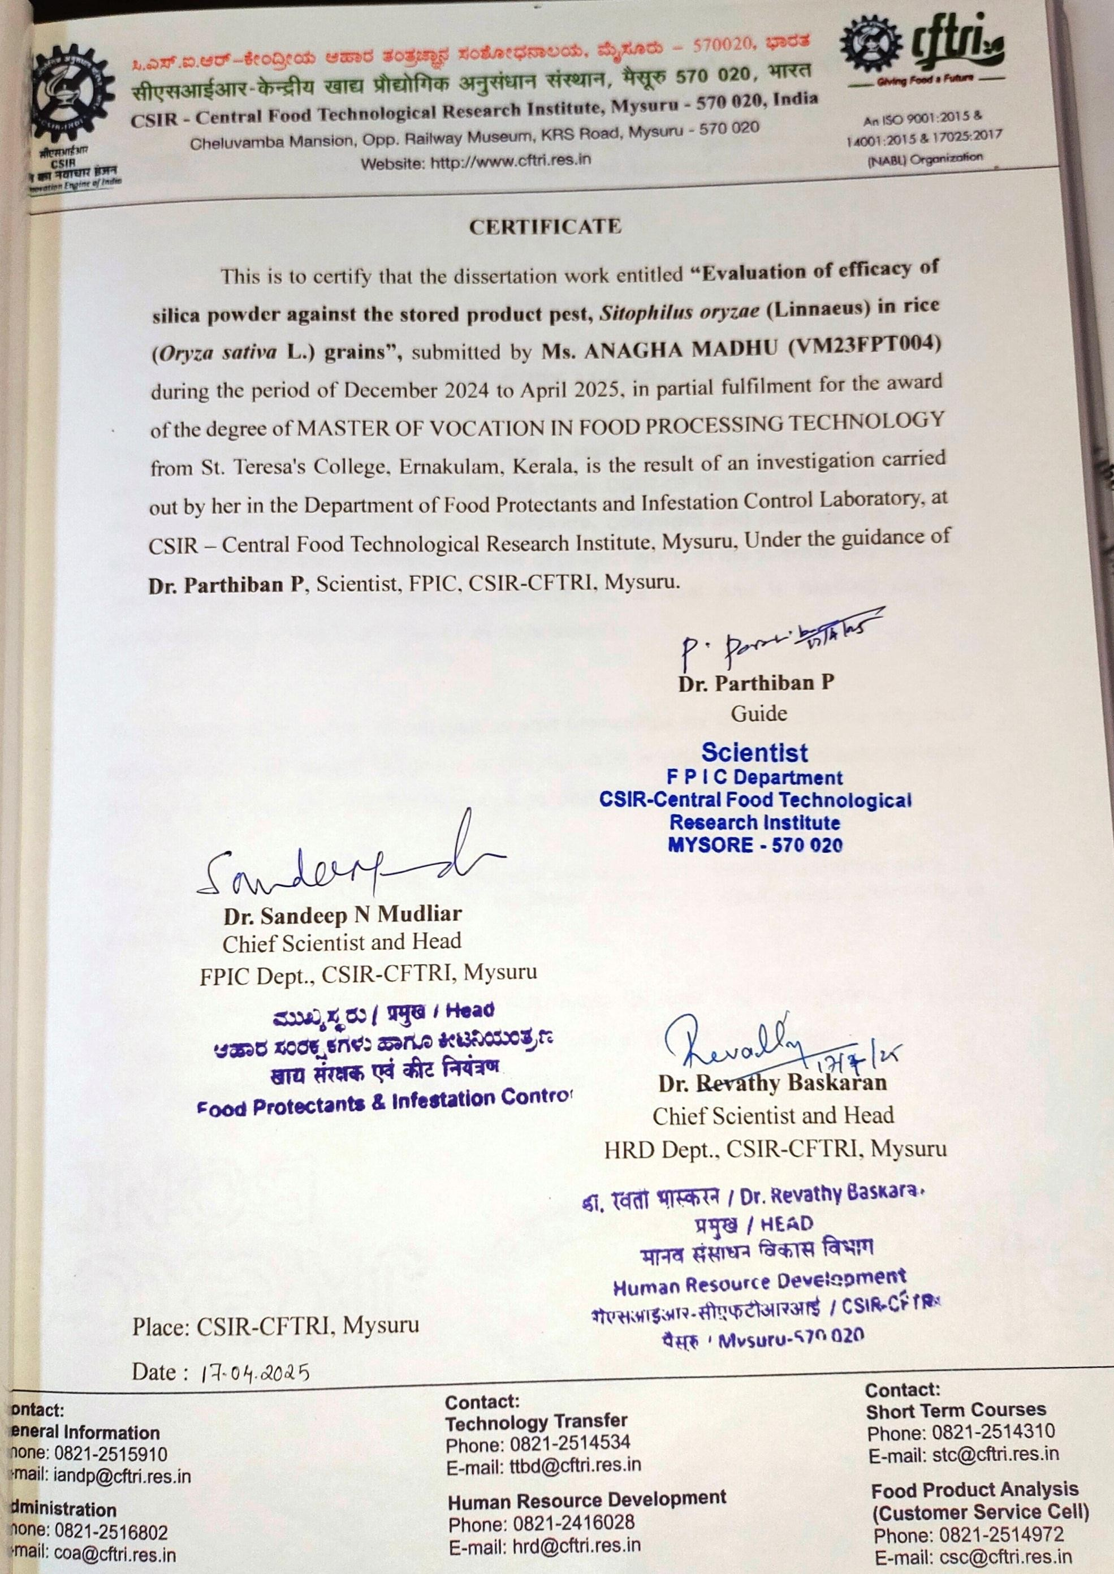

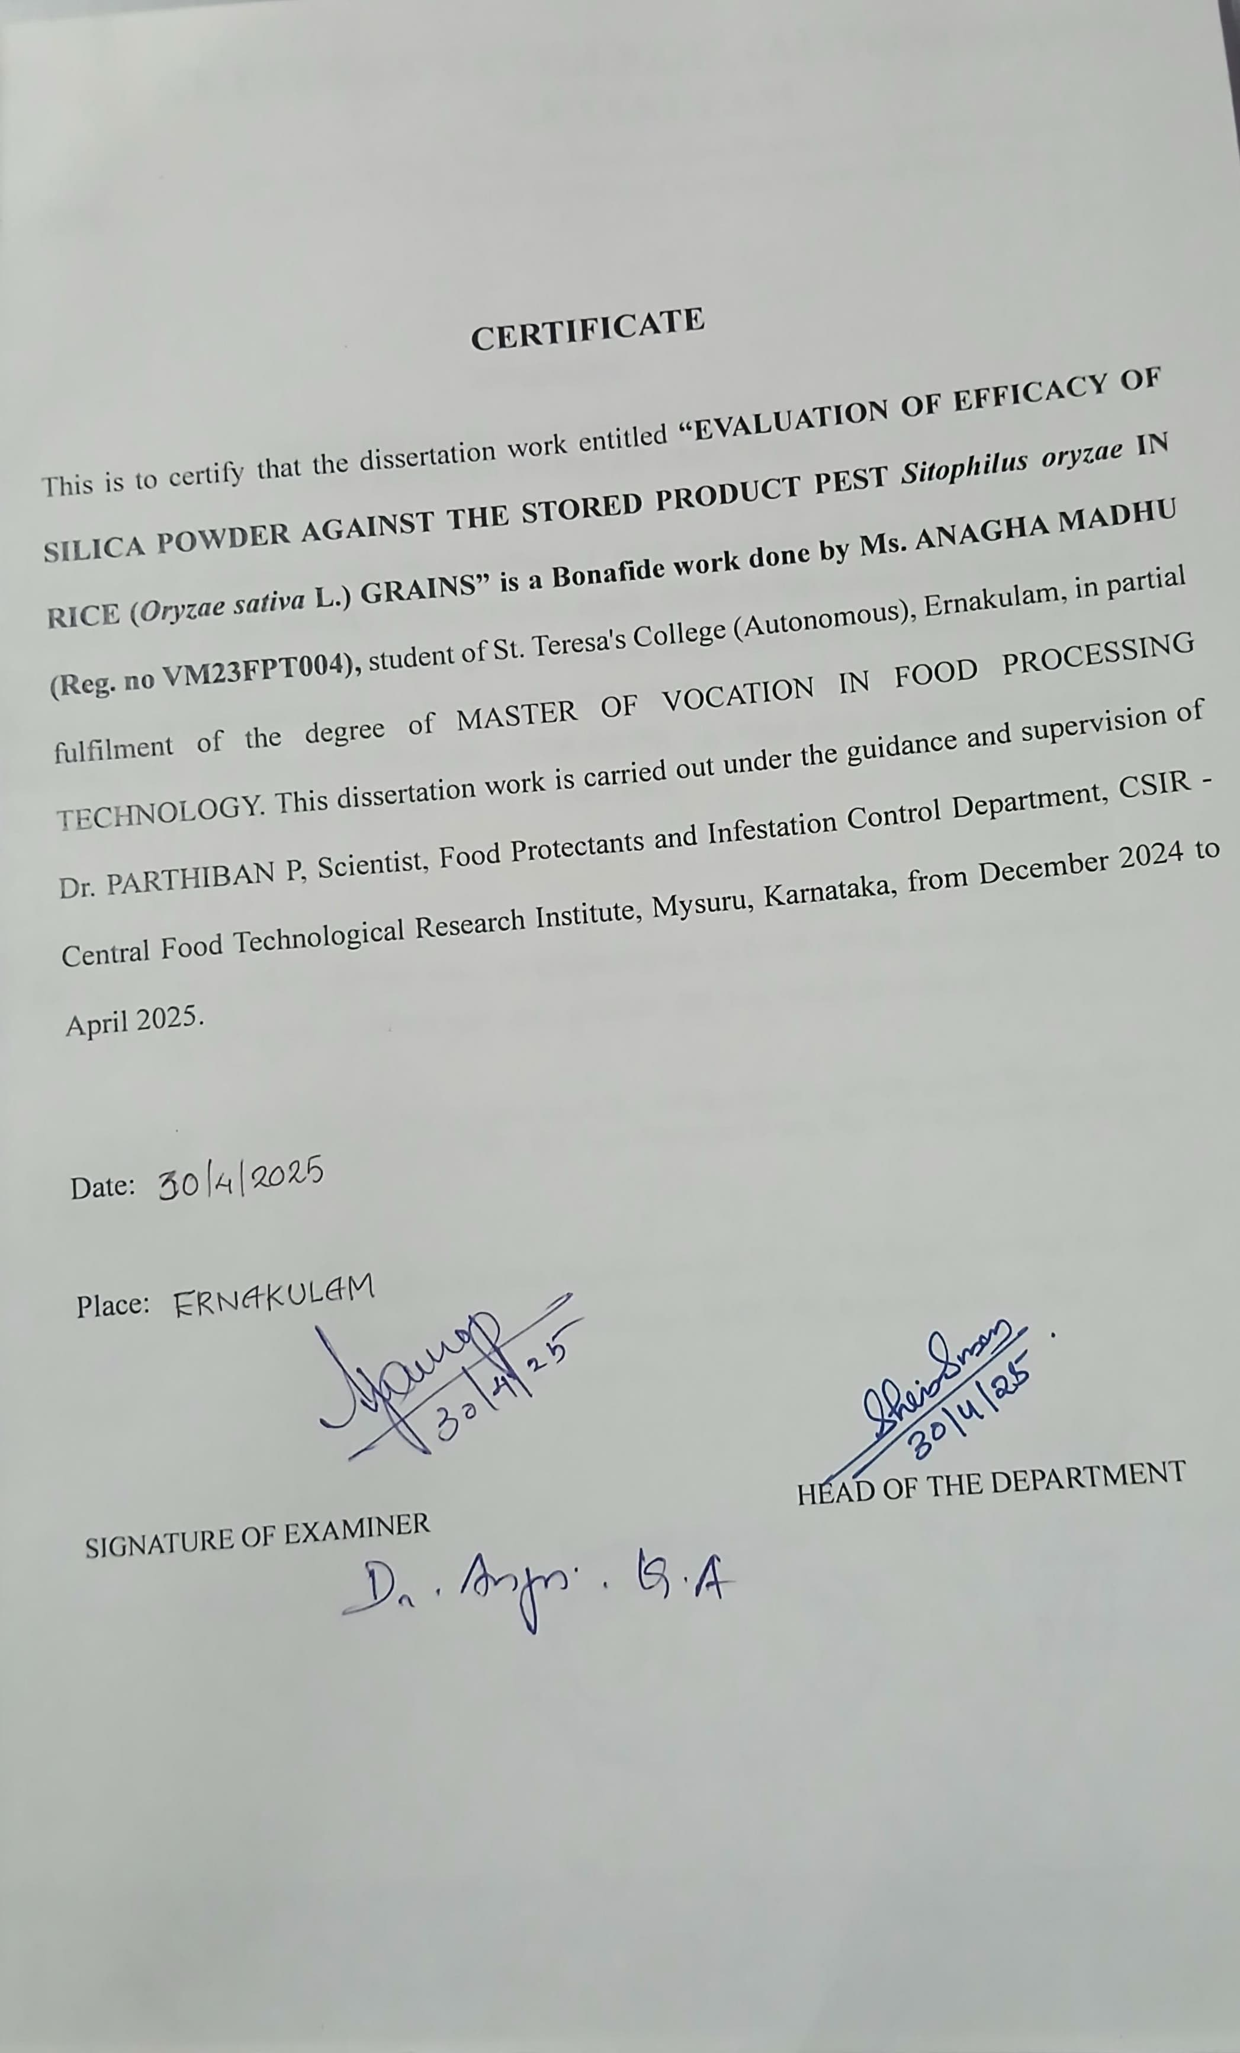
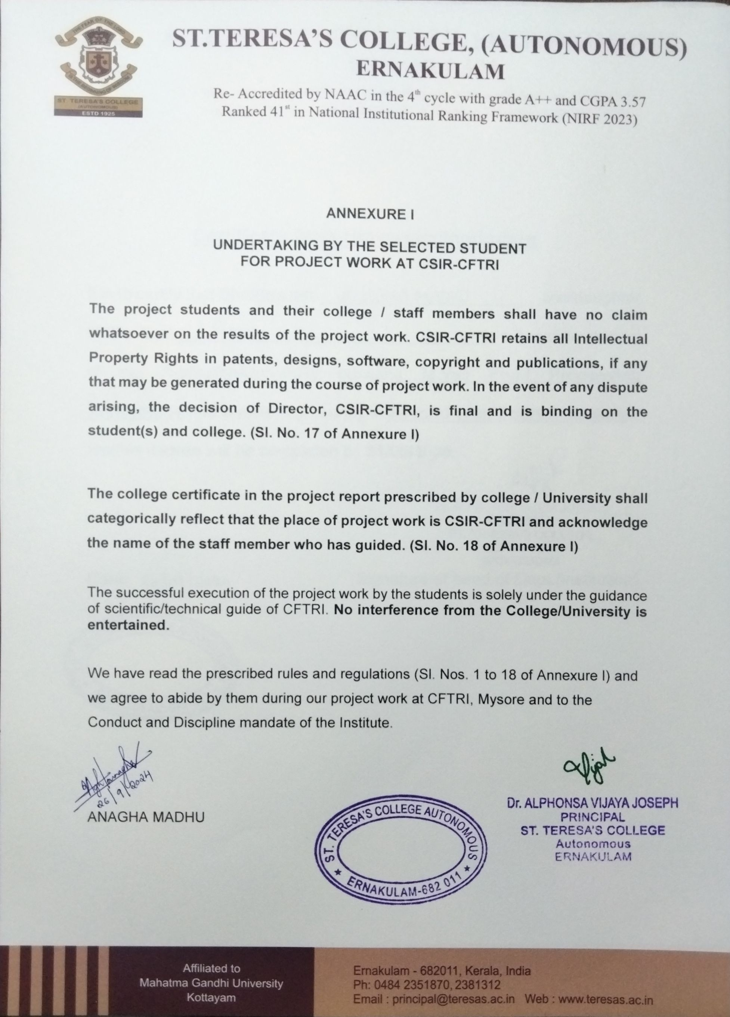

DECLARATION

I, ANAGHA MADHU, declare the dissertation work entitled “Evaluation of efficacyofsilicapowderagainstthestoredproductpest, Sitophilusoryzae(Linnaeus) inrice(OryzasativaL.)grains”submittedbymeinthepartialfulfilmentofthedegreeof M.Voc. (Food ProcessingTechnology) in St. Teresa's College, Ernakulam, Kerala - work carried out by me during the period December 2024 toApril 2025 under the supervision andguidanceofDr.ParthibanP,Scientist,DepartmentofFoodProtectantsandInfestation Control, CSIR- Central Food Technological Research Institute, Mysuru. The results representedinthisthesishavenotbeensubmittedtoanyotheruniversityorinstituteforthe award of any degree or diploma.


ANAGHA MADHU

Date:17 /04/2024

Place:CSIR-CFTRI,Mysu

Acknowledgements

ACKNOWLEDGEMENTS
Iwouldliketotakethisopportunitytothankeveryonewhohelpedmakethisproject a success and an experience to remember. I feel a great sense of obligation to thank God, firstandforemost,forenablingmetocompletethisthesis.Forallowingmetosuccessfully finish the project, Iwould like to express mysincere gratitude to the CSIR-Central Food Technological Research Institute in Mysuru and the Department of Food Processing Technology, St. Teresa's College, Ernakulam.
I would like to express my sincere gratitude and appreciation for my guide, my mentor, Dr. Parthiban P, Scientist, FPIC Department, CSIR-CFTRI, Mysuru, for his guidance, encouragement, and constant support throughout my project.
I am greatly indebted to Dr. Sridevi Annapurna Singh, The Director of CSIR- CFTRI, Mysore, and Dr. Revathy Baskaran, Chief Scientist and Head of the HRD Department,CSIR-CFTRI,Mysore,foralltheinstitutionsupport.
I would like to extend my special thanks to Dr. Sandeep N Mudliar, Chief ScientistandHeadofFPICDepartment,CSIR-CFTRI,Mysore,forprovidingme withallthelaboratoryfacilitiesrequiredinthedepartment.
I am grateful to Mr.Anant Chintamani Gahire (Scientist), FVT, CSIR-CFTRI, Mysore, for lending me the laboratory equipment that the department needs.
I would also like to thank Dr. Dinesha B L(Scientist), Dr. Chavan Ashutosh Namdeo (Scientist), FED, CSIR-CFTRI, Mysore for providing me their laboratory facilities required in the department at CSIR-CFTRI.
IwouldliketoextendmythankstoDr.AmudhaSenthil(Sr.PrincipalScientist), Ms. Teena, and Ms.Arya for permitting me to use their lab facility.
My sincere gratitude goes out to Ms. JinuAnna Varghese, Ms. Chitra R., Mr. Manikannan,Mr.AmalAnand,andMs.Aswathifortheirassistanceineveryway,from the beginning of my work to the end of my stay here. Until the very end, they provided unwavering support and assistance. It would have been difficult without their assistance.
My friend and lab partner, Savya Suresh, helped me with all of the studies, and I genuinely appreciate her unwavering support.

I am extremely thankful to Ms. Sherin Mary Simon, Head of the Department of Food Processing Technology, and Ms. Pinku Maria, Coordinator (Tutor), St. Teresas College, Ernakulam, for their wonderful support and academic direction provided for the completion of my project.
I want to express my deep gratitude to Ms. Anna Aleena, Ms. Sandra, Ms. Elizabeth, and Ms. Carmala Sindhya from the Department of Food Processing Technology, MG University, Kottayam, for providing me with a golden opportunity to pursue my dissertation at CSIR-CFTRI.
No words can truly capture the depth of gratitude I feel for my family, whose unwavering support has been the foundation of my journey. My heartfelt thanks go to my wonderful parents, Mr. Madhu Raghavamenon and Mrs. Mini Madhu,whoselove and encouragement have been my greatest strength, and to my dear brother, Mr. Aadinath Madhu, whose constant support has been a source of inspiration. Their belief in me has given me the courage to chase my dreams, and this project would not have been possible without their endless love and guidance. I owe a debt of gratitude to my closest friends, Abi, Jishnu, Najiya, and Jepson, for their unfailing mental and emotional support.



ANAGHA MADHU

Abstract

ABSTRACT

This study evaluates the effectiveness of silica particles in protecting Oryza sativa L. grains from infestation by Sitophilus oryzae L., a common grain pest. Important physical characteristicsofthe grains were evaluated to identifyanyimpacts of the silica treatment, including moisture content, test grain weight, bulk density, particle density, porosity, kernel elongation ratio, volume expansion ratio, and water uptake. The use of silica was found to have little effect on these parameters.
Thestudyalsoevaluated themortality,death,and survivalratesof S.oryzaeat different doses of silica (200–1000 ppm). There was a definite inverse relationship betweensilicaconcentrationandpestsurvival,withgreaterconcentrationsresultingin noticeably higher mortality. A 100% death rate was reported within 3–5 days of exposure at doses ranging from 700 to 1000 ppm. The protective effectiveness of silica particles against S. oryzae was further demonstrated by the much lower weight loss and damage sustained by grains treated with silica.
The cuticular surface of S. oryzae exposed to grains treated with silica showed considerable morphological damage, according to SEM examination. The silica particles caused abrasion, rupture of the waxy coating, and desiccation by adhering to the insect's exoskeleton. In contrast, the cuticular surfaces of untreated insects remained intact and smooth. These findings support the idea that silica particles work through physical processes as opposed to chemical ones to suppress pests. Bywashing the samples three times with distilled water at a 1:2 (sample to water ratio), the residual persistence of samples treated with an optimal dosage of silica particles was investigated. It was discovered that a single washing before cooking wasadequate to remove the silica powder from the treated rice, and it is safe to cook and eat. This method may also turn out to be an effective and environmentally friendly pest control technique. The technologycan be used industriallyto control stored grain insect pests in huge warehouses and storage go-downs.

CONTENTS

ChapterNo.
I
II
III
IV
V
VI

Title
INTRODUCTION
REVIEW OFLITERATURE
MATERIALSANDMETHODS
EXPERIMENTALRESULTS
DISCUSSION
CONCLUSION
REFERENCES

PageNo.
01-03
04-10
11-41
42-53
54-58
59
60-69

LISTOFPLATES
Title | Page No.
Silica powder | 13
BaseMaterial | 14
Experimental setup | 15
T1–200ppmTreatedanddamagedgrains | 15
T2-300ppmTreatedanddamagedrice | 16
T3-400ppmTreatedanddamagedrice | 16
T4-500ppmTreatedanddamagedrice | 17
T5-600ppmTreatedanddamagedrice | 17
T6-700ppmTreatedanddamagedrice | 18
T7-800ppmTreatedanddamagedrice | 18
T8-1000ppmTreatedanddamagedrice | 19
T9-Untreatedanddamagedrice | 19
Imageof testinsect(S.oryzae) | 20
Different microscopic views of S. oryzae treated with silica in rice grains | 20
SEMimages ofsilicadepositedonrice weevil | 21

Plate No.
1.
2.
3.
4.
5.
6.
7.
8.
9.
10.
11.
12.

13.
14.

Title | Page No.
Bulkdensityofdifferentconcentrationsofsilica-treated rice | 21
Particle density of different concentrations of silica-treated rice | 22
Volumeexpansionratioofdifferentconcentrationsofsilica treated rice | 22
Kernel elongation ratio of different concentrations of silica treated rice | 23
Moistureanalyser | 23
Weighingbalance | 24
Testgrainweightofdifferentconcentrationsofsilica-treated rice | 24
Keeping the test glass bottles and test grains (treated with silica) in an incubator before the inoculation of insects | 25
Insectcultureroom | 25
BaseMaterials | 27
Experimental setup | 27
Pulsebeetle | 28
Eggs laidby female | 28
Different microscopic images of C. maculatus treated with silica | 28
PictureofScanningElectron Microscope | 29
Experimental setup | 31

Plate No.
16.
17.
18.
19.
20.
21.
22.
23.
24.
25.
26.
27.

28.
29.

30.

Plate No.
32.
33.
34.
35.
36.
37.
38.
39.
40.
41.
42.
43.
44.

45.
Title | Page No.
Charringprocess | 34
Samplekeptinsidemuffle furnace | 34
Sampleturnintoash | 35
Filtrationprocess | 35
Samples | 35
Ashlessfilterpaper | 35
Hot plate | 35
Muffle furnace | 35
Schematicdiagramof GC-MS | 37
G-C Vials | 39
Micro-filter | 39
Micropipette | 39
Tips | 39
GC-MSMachine | 41
Silicatreatedriceataconcentrationof 700ppm | 46

46.

LISTOF TABLES
Table No.
1.
2.
3.
4.
5.
6.
7.

Title
Different parameters of Oryza sativa L. grains treated with silica particles
Survival of Sitophilus oryzae L. in Oryzae sativa L. grains treated with Silica Particles
DeathofS.oryzaein O.sativagrains treatedwithSilica particles
ThemortalitypercentageofS.oryzaeinO.sativagrainstreated with Silica Particles
Grain damage percentage of Oryza sativa L. grains treated with silica particles on a number basis
Weight loss percentage of Oryza sativa grains treated with silica particles on a weight basis
ResultofAcid-InsolubleAshTestinpercentage

Page No.
47
48
49
50
51
52
53

Introduction

CHAPTERI

INTRODUCTION

Rice (Oryza sativa L.) is a vital food crop, feeding half of the world's population (Jialiang et al., 2021). It serves as a primary source of energy, vitamins, and minerals for millions globally (Sen et al., 2020). Grain quality is affectedbyfactorssuchasvariety,weather,pre-harvestpractices,andtechnical management,butpost-harvestproceduresareequallyimportant(Amandaetal., 2022).Riceprovidesaround21%oftheworld'scaloricneedsandupto76%in Southeast Asia (Melissa et al., 2009). Quality attributes, including physical appearance and nutritional value, significantly influence market value and the adoption of new varieties.
Grain storage is essential in the post-harvest system, with cereals, oilseeds, and pulses facing a weight loss of 5-15% after harvest. Insect infestations contribute to issues such as weight reduction, lowered product quality, increased rejections, and industrial losses, while also damaging seed embryosanddecreasinggerminationrates(Padínetal.,2002).Properstoragein warehouses is vital for maintaining production levels and ensuring a food supply, as well-preserved cereals are crucial for both producers and consumers (Darka et al., 2020).
Insects cause 5-30% of post-harvest grain losses, making pest management a global concern. Damages from pests like the rice weevil affect rice, corn, and wheat, leading to decreased grain value. Adult females can lay up to 400 eggs, with larvae feeding on the grain until maturity, consuming 10- 25 grams over their 4-5 month lifespan (Ethan et al., 2022; Shadi et al., 2023).
Morphological differences exist between male and female S. oryzae, including variations in genitalia and body structure (Omar, 2012). Adult males liveapproximately114-115days,whilefemaleslive119-120days,witheggand larvalstageslastingfrom5-6to16-20days(Bhuiyahetal.,1991).Duetolarvae being protected within the kernels, controlling S. oryzae with insecticides is challenging(Franketal.,2002).Researchintotheresistanceofvariouscereal

grainstoS.oryzaehighlightstheimportanceofphysicochemicalpropertiessuch as grain hardness and moisture content (Zahra et al., 2024).
Silicananoparticlesserveasefficientinsecticideswhileenhancingplant resistance, attracting natural enemies, and being environmentally friendly, making them a safer alternative to synthetic pesticides (Aisvarya et al., 2023). Insects often suffer from the detrimental effects of contact pesticides, which damage the protective wax layer on their cuticles, leading to water loss and desiccation. Diatomaceous earth (DE) offers a potential substitute because it operates through physical means rather than chemicals, meaning it does not induce physiological resistance in pests. DE is effective against various pests, easy to remove during processing, and non-toxic to mammals (Athanassiou et al., 2005).
Unlike chemical pesticides that degrade over time, diatomaceous earth dusts can provide long-lasting protection for stored food grains. Additionally, while DE has a strong insecticidal effect, it remains harmless to mammals. Insects perish from desiccation as the dust directly contacts and adsorbs the epicuticularlipidsontheirbodies.Therefore,diatomaceousearthplaysacrucial role in integrated pest management strategies for stored product insects, with most research focusing on its use as a grain protectant (Selladurai and Bhadriraju, 2023).
Laboratory studies have shown that diatomaceous earth can effectively reduce stored-grain insect populations at application rates significantly lower than those used with conventional DE-based insecticides. This study also examined the effects of cereal quality, physical properties, and other characteristics (Koranic et al., 1996). Higher application rates of diatomaceous earthcannegativelyimpactgrainqualitybyreducingbulkdensity,flowability, and moisture content. Consequently, formulations of diatomaceous earth that performwellatlowerapplicationratescanhelpminimizethephysiologicaland mechanical changes associated with grain preservation (Selladurai and Bhadriraju et al., 2024).

The situation described above has prompted the preparation of this project to “Evaluation of efficacy of silica powder against the stored product pest, Sitophilus oryzae (Linnaeus) in rice (Oryza sativa L.) grains” with the following objective.
- To evaluate the efficacyof silica powder against stored product pest, Sitophilus oryzae (Linnaeus) in rice (Oryza sativa L.)

- Toevaluatethe analysis oftheresidualonsilicapowder-treatedwheatgrains.

ReviewofLiterature

CHAPTERII

REVIEWOFLITERATURE

Rice (Oryza sativa L.) is the most important food crop in the world, supplying approximately21% of the caloric needs of the global population and up to 76% of the caloric intake for people in Southeast Asia. The quality characteristics of rice grainsplayacrucialroleindeterminingmarketvalueandinfluencetheadoptionof new varieties in rice-consuming countries. Factors such as visual appeal, cooking and sensory qualities, and, more recently, nutritional value are all important attributes of rice quality. (Fitzgerald et al., 2009)
Chen et al. (2012) emphasized the importance of mineral micronutrients, such aszinc,iron,manganese,andselenium,forhumanhealth.Thesemicronutrientsare significant for the nutritional value of rice grains, alongside starch and storage proteins. However, rice grains generally contain low levels of these metal ions. Additionally, the cooking characteristics of rice are associated with its mineral content. A recent study found that the levels of mineral elements in rice grains correlate with the amounts of protein and amino acids.
In Asia,whichishometo60%oftheworld'spopulation,morethan90%ofthe world's rice is cultivated and consumed. Between 35% and 60% of the 3 billion Asians consume their calories from rice. Each year, around 11% of the world’s arable land, totalling 148 million hectares, is dedicated to rice cultivation. While wheat occupies a slightly larger geographical area, a significant portion is used for animal feed. Rice stands out as the only major cereal crop that is predominantly consumed byhumans. In 1996, global rice production reached 553 milliontons, of which only4% was traded internationally. Thailand emerged as the world's largest riceexporter,shippingbetween4and6milliontonsannually.AlthoughtheUnited Statesranksastheeleventh-largestproducerofrice,itisthesecond-largestexporter, withabout40%ofits6milliontonsofannualproductionbeingexported.Vietnam, Pakistan, and Myanmar each export approximately one million tons, while India exported around 4 million tons in 1995 but reduced its exports to about 2 million tons in 1996. The primary importers of rice include Saudi Arabia, Iran, and Iraq, whichcollectivelyimportroughly0.5,0.7,and0.9milliontonsannually,

respectively. In African countries, the demand for rice is increasing at a rate of approximately 2% per year (Khush, 1997).
Korunic et al. (1996) reported that assessing grain quality relies on analytical evaluations of moisture content, specific gravity, grain size, 1000-kernel weight, germination, bulk density, and visual assessments of factors like uniformity, seed coat soundness, impurities, color, gloss, and protein content. The overall qualityof bulk commodities is also influenced by the physical and mechanical properties of grains, including cohesiveness, density, flow ability, and particle characteristics. Research indicates that the physicochemical properties of rice grains affect their resistancetoriceweevilinfestation.Hardergrainsarelesslikelytobecomeinfested, while larger, heavier grains also show reduced susceptibility. Additionally, higher protein content correlates with increased weevil emergence, while higher amylose levels are associated with resistance (Gowda et al., 2019).
Abd El Salam et al. (2024) found that parboiling rice not only reduces insect infestation but also enhances grain hardness, making it more difficult for pests to penetrate. While many studies focus on climate change's effects on rice growth, research on how temperature increases and atmospheric factors like CO2impact grainqualityisstilllimited.Hightemperaturesgenerallyreducemillingqualityand rice classification, and interactions between rising CO2and temperature warrant further investigation. This highlights the need for comprehensive research to improve food security and adapt rice productivity to climate change (Yang and Wang, 2019).
Kar et al. (2011) reported on a study that utilized silica nanoparticles (SNP) to controlrice weevils,a commongrainpest.Experimentsconducted atfive different doses indicated mortality rates of 80% after 7 days and 97.4% after 14 days of storage. Moreover, the treated rice was deemed safe for consumption. This eco- friendly technology effectively manages insect pests in stored grains within large warehouses and storage facilities.
Nath et al. (2021) highlighted a significant opportunity to increase food availability by minimizing post-harvest losses without requiring additional production resources. Factors such as unconscious handling behaviors, a lack of science-basedinformation,inferiortechnicalefficiency,andinadequate

infrastructure contribute to the substantial wastage of wheat grain each year. The article provides in-depth evaluations of post-harvest losses for various crops and examines a range of post-harvest practices across different countries. It includes a detaileddiscussionofthelatestadvancementsinpost-harvesttechnologicalresearch and addresses the main issues hindering the adoption and deployment of post- harvest technologies. The optimal post-harvest technique is influenced by the type ofcrop,productionlocation,season,andcurrentsocioeconomicandenvironmental conditions.
Awadalla et al. (2024) evaluated the common and serious pest S. oryzae, an internal-feedinginsectthatburrowsintostoredgrain.Thelarvaeprimarilyconsume thegraingerm,depletingessentialproteinandvitamins,whileadultweevilsmainly feed on the endosperm, reducing carbohydrate content. The study monitored S. oryzae infection across five-grain types: maize, rice, wheat, oats, and barley. The grainsweresubjectedtoaphotoperiodof14:10(L:D)hoursandmaintainedat32± 2 °C and 65 ± 5% relative humidity. The findings indicated that maize and wheat were the most susceptible to infestation. In both non-choice and free-choice tests, wheatgrainswerepreferredoveroats,whichweretheleastfavored.Theweightloss of the grains and the emergence of adult weevils were significantly influenced by the different types of grains. The highest average number of S. oryzae adults that emergedafter30and60dayswasobservedinthenon-choicetestwithwheatgrains (11.8±0.96and16.8±0.86individuals),followedbymaizegrains(8.8±1.15and 15.2 ± 1.56 individuals). In the free-choice test, the highest average number of emergedadultswasalsofoundonwheatgrains,followedbymaizeandricegrains, 48 and 72 hours after infestation.
Qader et al. (2022) highlighted that storage loss from insect infestation, particularly by the rice weevil, is a significant concern in grain preservation, especiallyfor rice, a staple food. Theyfound that silica gel can effectively manage these insect populations, acting as a non-toxic barrier to reduce weight loss and maintain the qualityof stored rice. This approach is essential for marketabilityand encourages further research into its use in various grain storage facilities.
Saeed et al. (2024) reported that pest infestations, notably from rice weevils, leadtomajorstoragelossesbydamaginggrainsandreducingtheirnutritionaland

commercial value. These pests can breed unnoticed in storage areas, necessitating effective pest control methods, such as fumigants and surface treatments. The development of insect resistance to traditional pesticides highlights the need for environmentally friendly pest management solutions.
Costa et al. (2016) found varying levels of resistance among 22 rice types to Sitophilus oryzae. Highly susceptible varieties like "Pepita" and "Progresso" had lower resistance, while more resistant types included "Bonança" and "Esmeralda." Susceptibilitywasaffectedbyfactorslikegrainhardnessandcracks,suggestingthat selectingresistantcultivarscouldhelpreducepost-harvestlosses.Thericeweevilis amongthemostharmfulpestsofwholegrains,causingsignificantdeteriorationand spoilage. With infestations potentially resulting in over 25% yield loss, these pests also negatively impact the quality of cereal grains, altering the physicochemical properties of flours (Abd El Salam et al., 2024).
FloydandNewsom(1959)notedthatS.oryzaeundergoesfourlifestages.The weevil's body is short and slender, measuring 2 to 2.8 mm, with dull, coarse punctures. The prothorax is as broad as long, and the antennae are short and thick. The upper half of the penis is wider and more tapered than the lower half. Kiritani (1965) researched the Sitophilus complex in Japan, focusing on the life cycle, reproductive behavior, and species differentiation. The study examined S. oryzae and S. zeamais infestation patterns, developmental stages, and reproductive capacity. It also explored ecological factors like population dynamics and competition, establishing a foundation for future research in pest management for grain storage.
In 2004, Perez-Mendoza et al. investigated the ovarian physiology and age- gradingofS.oryzae,identifyingfourfemalereproductivestages:immature,mature, post-reproductive, and newly emerged. Immature females (4–7 days old) showed early vitellogenesis, while newly emerged females (0–3 days old) had underdevelopedovaries.Maturefemales(8–16daysold)laideggs,indicatingpeak reproductive capacity, whereas post-reproductive females (17+ days old) showed signs of ovarian regression.
OpitandThrone(2007)studiedhowmaternalageaffectsoffspringfitnessin S. oryzae,focusingoneggviability,larvalsurvival,andadultemergence.Theyfound

thatyoungerfemales(1–7daysold)producedsignificantlymoreviableeggs(about 90%survivability) thanolderfemales(≥28days old),whose eggs had a50%–60% dropinsurvivability.Progenyfromoldermothers(35–40daysold)alsoexperienced longer developmental periods and higher survival rates than those from younger mothers (25–30 days old). Additionally, adults from younger mothers were larger and healthier, whereas those from older mothers were smaller and less fertile. The studynotedashiftinthesexratio,witholderfemalesproducingmoremales,which could impact population dynamics. These findings suggest that targeting younger females during their prime reproductive period may improve pest management strategies for S. oryzae.
Odeyemi et al. (2010) examined five strains of S. oryzae for resistance to pirimiphos-methyl in Nigerian rice. They found that mortality rates increased with concentration and exposure time, with laboratory strains showing the least resistanceand Ibadanstrainsshowingthehighest. Subedietal.(2009)investigated the host preference of rice weevils in Chitwan, Nepal. They discovered that maize andwheatweremostsusceptibletoinfestation,exhibitingthehighestratesofadult emergence and weight loss. Grains with higher moisture and softer endosperms were more prone to infestation, while harder grains (like millet and sorghum) showed lower rates. These results highlight the importance of effective pest management in reducing postharvest losses through careful selection of storage grains.
Abedi et al. (2024) found that various grain species affect the biological properties and life history of the rice weevil in laboratory conditions. Millet and sorghum hosts resulted in the longest development times, while maize seeds led to the shortest. There were negative correlations between seed protein content and insect fecundity, and starch content and development time. These findings could inform integrated pest management strategies and support the development of transgenic grains resistant to S. oryzae.
Yanyu et al. (2020) stated that synthetic amorphous silica (SAS) is safe for human consumption but can harm insect cuticles. Their hyperspectral reflectance imagingstudyrevealed significantdifferencesinLT95 values for hydrophobicand

hydrophilic SAS against Sitophilus oryzae and Tribolium castaneum, indicating SAS'spotentialasanew pesticideduetoitsvaryingefficacyamonginsectspecies.
Debnathetal.(2011)showedthatsilicananoparticles(SNP)at0.5g/kgofgrain reduced Sitophilus oryzae mortality rates, with minimal weight losses after four months, and SNP-treated rice remained safe to consume. Padmasri et al. (2023) reported that 500 ppm of micro-silica was most effective for pest suppression, showing negligible mortality after one day. After five days, nano alumina resulted in only modest mortality, while nano clay at varying concentrations did not cause fatalities.
Erturk et al. (2017) evaluated the effectiveness of diatomaceous earth (DE) formulations in managing S. oryzae, a significant pest of stored rice. They emphasizedtheneedforenvironmentallyfriendlypestcontrolandsuggestedDEas asustainable,non-toxicalternativeto syntheticpesticides,whilenotingits reduced effectiveness in high humidity.
Zeni et al. (2021) highlighted concerns over the excessive use of synthetic pesticides regarding food security and biodiversity. They explored the use of inert dusts,particularlyDE,as anenvironmentallyfriendlyalternativein IntegratedPest Management (IPM)procedures, reviewingitsapplicationagainstvariouspestsand the challenges faced. Manivannan and Subramanyam (2024) assessed two amorphoussilicapowdersagainstriceweevilsonhardredspringwheat.Theyfound that silicapowder2, applied at 0.25 g/kg, resulted in 100%mortalityafter14 days, demonstrating its effectiveness over the other powder.
Chiriloaie et al. (2014) explored how grain type affected the insecticidal effectiveness of DEs against adult rice weevils. They found that in several grains, thecommercialproductPyriSecwasmosteffective,whileDEswereineffectiveon paddyricebuteffectiveonwheat.Theirresultssuggestedthatnon-commercialDEs from Romania and Greece were also effective at controlling pests in wheat. Fields and Korunic (2000) reported that several factors influence the mortality rate of stored-product insects, including the supply of diatomaceous earth (DE), insect species, grain moisture content, temperature, application technique, and exposure time. Lower grain moisture content results in higher insect mortality. The efficacy ofDEvariesdependingontheapplicationarea.TheinsectmostsusceptibletoDE

isCryptolestesferrugineus,followedbyOryzaephilussurinamensis andSitophilus oryzae. The most tolerant species are Tribolium castaneum and Rhyzopertha dominica. DE is most effective when applied as a dust.
Korunic et al. (1998) investigated how the bulk density of wheat, corn, barley, rye,andoatsatdifferentmoisturelevelswasaffectedbytheenhanceddiatomaceous earth (EDE) insecticide Protect-ItTM. The study found that EDE concentrations between50and200ppmcausedthemostsignificantchangesinbulkdensity.Grain withamoisturecontentof15%experiencedmuchgreaterreductionsinbulkdensity thangrainwithamoisturelevelof12%.Additionally,theresearchindicatedthatall active DE formulations had a notable impact on bulk density against stored grain insects.
Aisvarya et al. (2021) evaluated the effectiveness of DE as a natural, environmentally friendly alternative to conventional insecticides for controlling stored grain pests. The authors assessed the mortality rate of S. oryzae exposed to various DE concentrations and found a significant reduction in adult emergence. Furthermore, the study examined the effects of DE treatment on maize seed viability, germination rate, and other growth characteristics. The results indicated that DE is a suitable strategy for integrated pest management in stored grains, as it effectivelyreducedinsectinfestationswithoutnegativelyimpactingplantgrowthor seed quality. These findings contribute to the growing bodyof research supporting sustainable insect management methods that promote environmental health and food security.

MaterialsandMethods

CHAPTERIII

MATERIALSANDMETHODS

Various materials were used, and methods were adopted in the laboratory experiments to study the “Evaluation of efficacy of silica powder against the stored product pest, Sitophilus oryzae (Linnaeus) in rice (Oryza sativa L.) grains” at CSIR - Central Food Technological Research Institute (CFTRI), Mysore – 570 020, Karnataka, India during December 2024 to April 2025. The materials and methodologies adopted for various studies are described below.
MasscultureofSitophilusoryzaeinthelaboratory Materials Required
- Glassjars
- Testinsects
- Muslin cloths
- Brushes
- Rubberbands
- Rice grains
- Gloves
- Sieves
- Mask
- Weighingbalance

Massculturing ofinsects

Commonly,themasscultureofSitophylusoryzaewasmaintainedatthe Department of Stored-Product Pests, Plant Protection Research Institute laboratory,etc.,withoutexposuretoanyinsecticide.Thecolonywasrearedina glasscontainerandmaintainedundercontrolledlaboratoryconditionsof28±1
°C, 65 ± 5% R.H., and continuous darkness. The S. oryzae was collected from the old stock culture from the department's insect culture room (FPIC, CSIR- CFTRI, Mysore). The trials were conducted on adults younger than two weeks Karetal.,(2021).Theinsectswererearedinclean,transparentglassjars(250

ml). The glass jars were washed and kept in a hot air oven for 2 hrs for drying and sterilization. After drying, clean rice grains without foreign materials were added in 1|3 amounts into the glass jars. The live insects that are mature and active are chosen from older stock isolated using a sieve and small brushes introducedorinoculatedtotheglassjarcontaininggrains.Bothmaleandfemale pests are there. After the jars are covered with muslin cloths tied tight with rubberbands and kept in thecultureroom,newlyemerged insects aretaken for further experiments. The trials included both male and female newlyemerging adults Batta et al., (2004)
LaboratoryExperiments

Screeningofefficientdosesof silicaagainstS.oryzae
The Department of Food Protectants & Infestation Control (FPIC) laboratory (Cultureroom),CSIR-CentralFoodTechnologicalResearchInstitute(CFTRI), Mysore,wasthesiteofthelaboratoryexperiment.Thewheatgrainsweretreated withvaryingdosesofsilicatoscreenforaneffectivedoseagainstS.oryzae.The followingtreatmentswereincludedinthecompletelyrandomizedblockdesign (CRD) used.
Treatmentdetails

Treatment DosageLevel
T1 Silica powder @ 200 ppm T2 Silica powder @ 300 ppm T3 Silica powder @ 400 ppm T4 Silica powder @ 500 ppm T5 Silica powder @ 600 ppm T6 Silica powder @ 700 ppm T7 Silica powder @ 800 ppm T8 Silicapowder@1000ppm T9 Untreated

Silicapowderand characterization

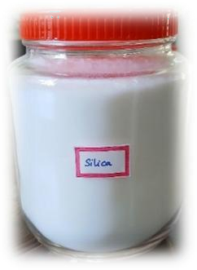
Thefoodindustry-gradesilicapowderwasutilizedforresearch.
- Highresistancetoinsectpests
- Highspecificsurfacearea
- Lowtoxicity
- Biocompatibility
- Optical transparency
- Chemical/thermal/waterstability

Plate1.Silica powder
Itcausesinsectstodryoutanddiebyabsorbingmoistureandscratching the insect's exoskeleton
Ricegrainsmixed withsilica powderand storedinaglass jar

Thepesticide-freerice grains wereprocured from the local market. The efficacystudies ofsilica against S. oryzae weredonein clean, transparent glass jars (250 ml of size: 8.5 diameter, length 12.5). 500 grams of rice were taken andkeptinanincubatortofreethesamplefromanyotherinfestation.Afterthat, 20gramsofricegrainsareweighedandplacedineach glassjar,andeachglass jar of rice is treated with different concentrations of silica 200, 300, 400, 500, 600, 700, 800, and 1000 ppm by manually shaking for about 10 minutes to achieve equal distribution of silica particles on rice for each dose of concentrations, three replicate were taken (R1, R2, R3) and samples without silicatreatmentconsideredasanuntreatedcontrol.Thestudywas conductedin totaldarknesswitharoomtemperatureofabout30±1°Candarelativehumidity of 65±5%. Ten species of S. oryzae were put into each glass jar, and the jars were covered with a khada cloth to provide adequate aeration. Adult insect mortality was noted on days 1, 3, 5, 7, 10, and 15. Insects were deemed dead whentherewasnomovementoftheirlegsorantennalparts.Lastly,weusedthe algorithm to determine adult mortality, weight loss, and grain damage.
The results of combining silica nanoparticles with rice grains and keeping them in glass jars. study shows that the rice weevil, a common pest in stored rice, has a much higher mortality rate when silica nanoparticles are applieddirectlytoricegrainskeptinglassjars.Dependingonthequantityof

silica nanoparticles utilised, the studyfound statisticallysignificant differences in cumulative weevil mortality across periods of 1, 2, 4, 7, and 14 days. (Alhadhrami et al., 2022)
Adultmortality(%)

Numberofdead weevil
Adultmortality(%)= ----------------------------- x 100
Totalnumberof weevil

Weight loss (%)

Initialweightofthesample-Finalweightofthe sample
Grainweightloss(%) = x100
Initialweightofthe sample

Graindamage(%)

Numberofgrainsdamaged
Graindamage(%) = x100
Totalnumberofgrainsinthe sample

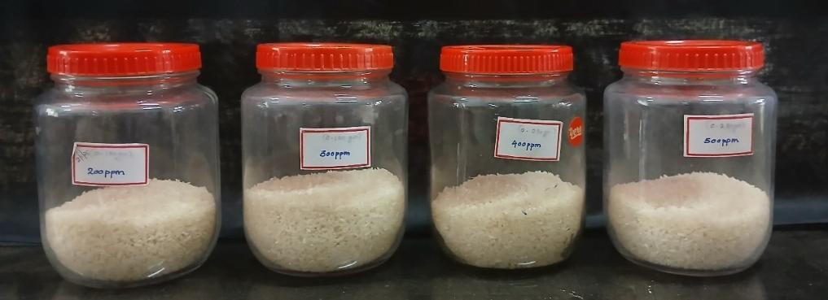

Plate2.BaseMaterial

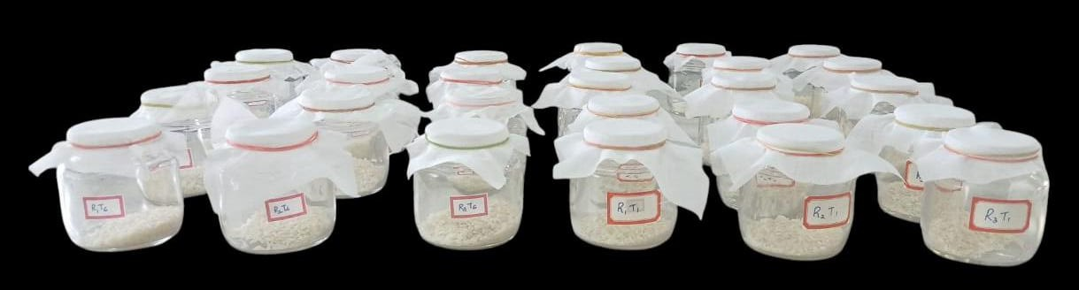

Plate3.Experimental setup

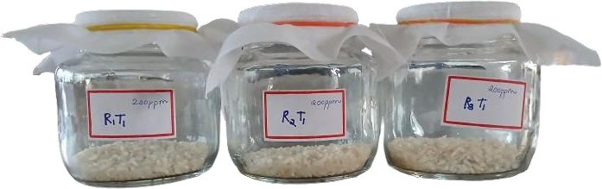
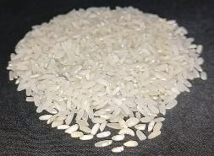
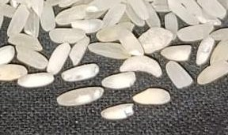
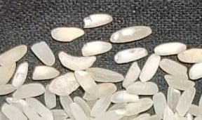

Plate4.T1–200ppmTreatedanddamaged grains

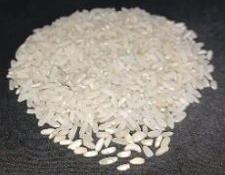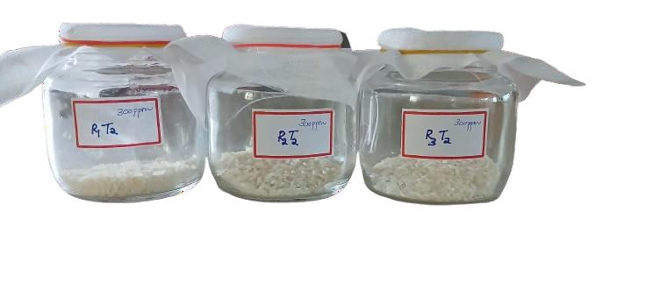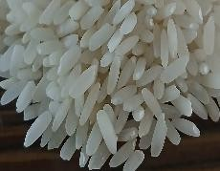
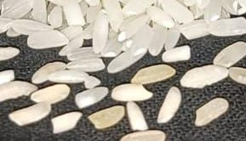

Plate5.T2-300ppmTreatedanddamagedrice

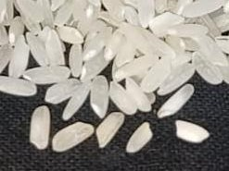
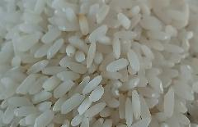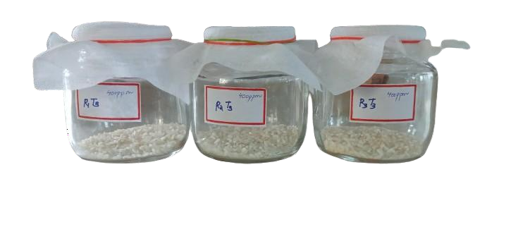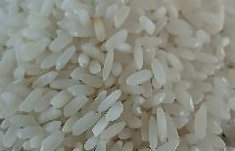

Plate6.T3-400ppmTreatedanddamagedrice

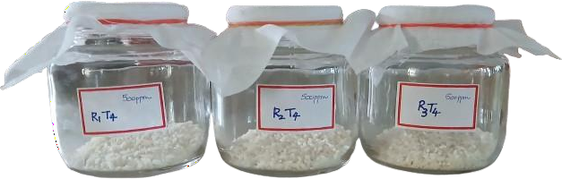
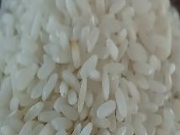
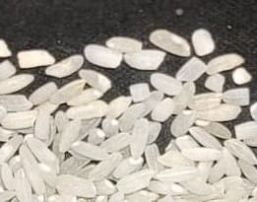
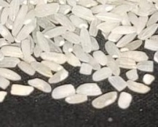
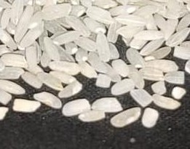

Plate7.T4-500ppmTreatedanddamagedrice
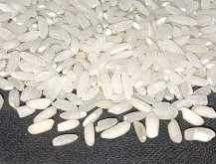
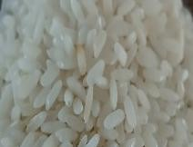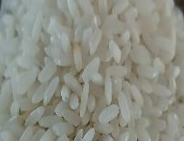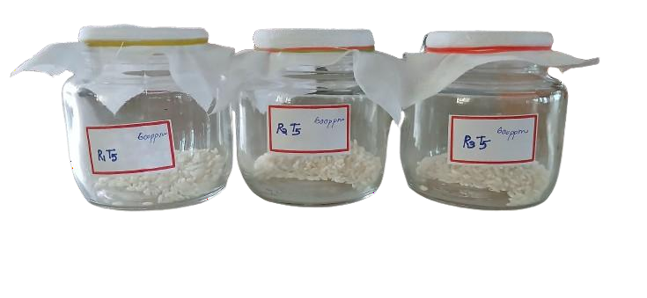

Plate8.T5-600ppmTreatedanddamagedrice

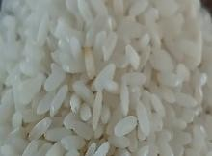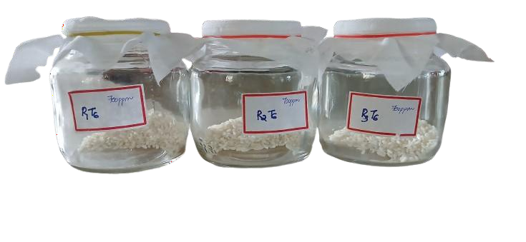
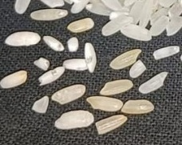
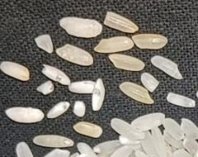
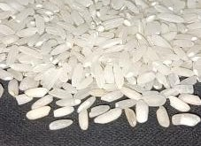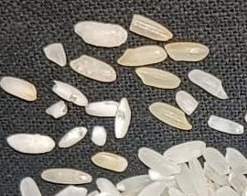

Plate9.T6-700ppmTreatedanddamaged rice

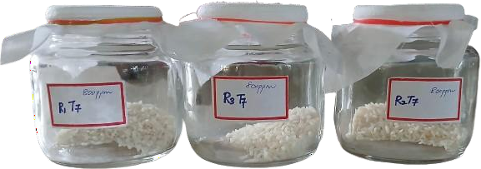
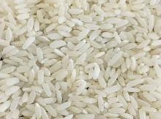
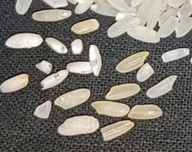
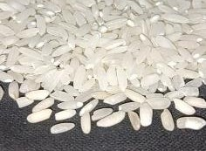

Plate10.T7-800ppmTreatedanddamaged rice

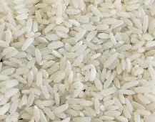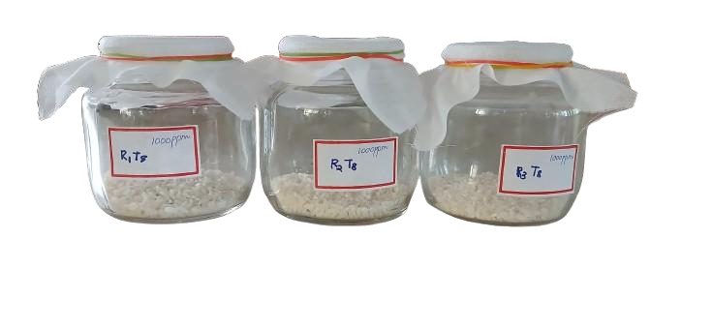
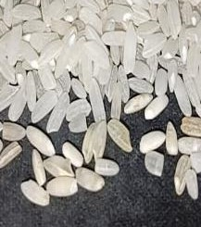
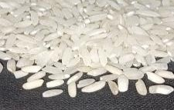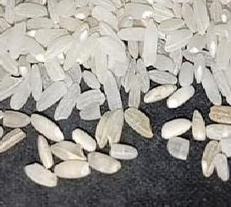

Plate11.T8-1000ppmTreatedanddamagedrice

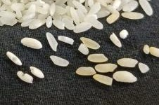
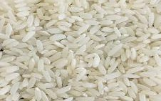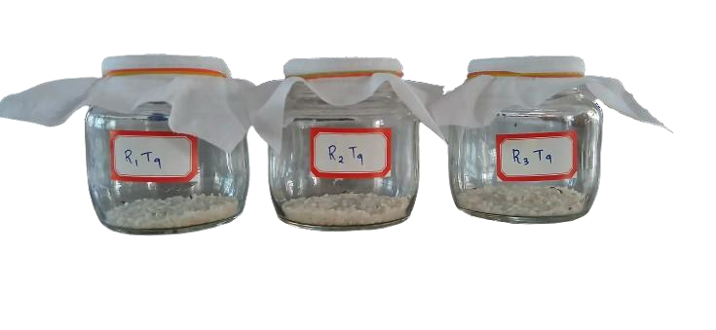

Plate12.T9-Untreatedanddamagedrice

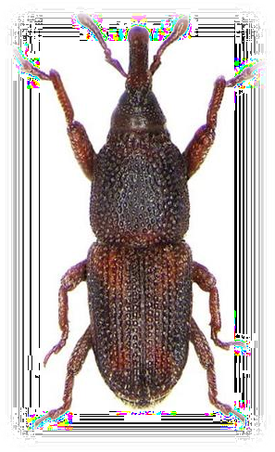

Plate13.Imageof testinsect(S.oryzae)
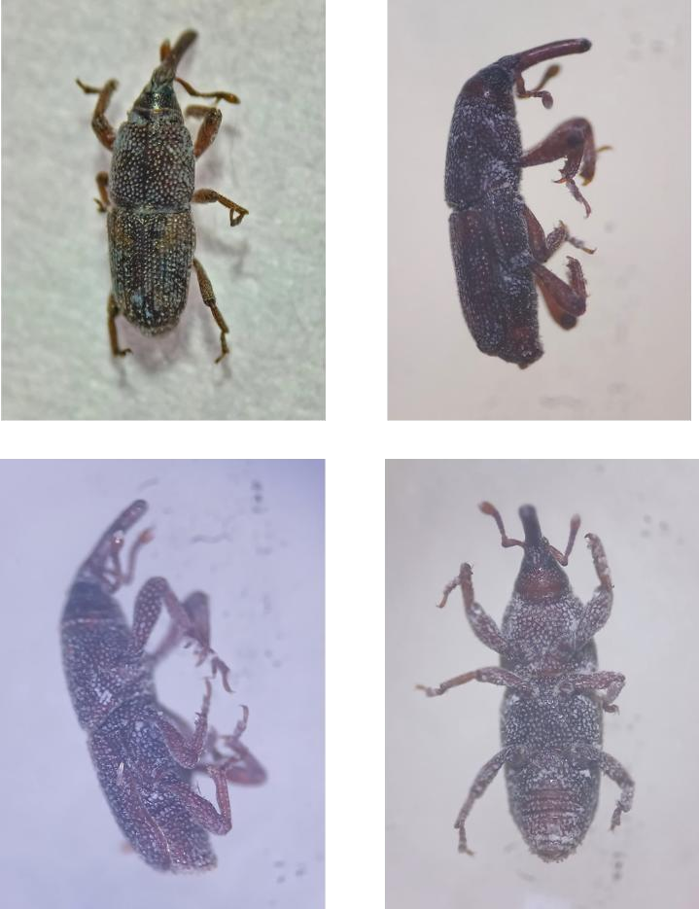

Plate14.Differentmicroscopicviewsof Sitophilusoryzaetreatedwithsilica in rice grains

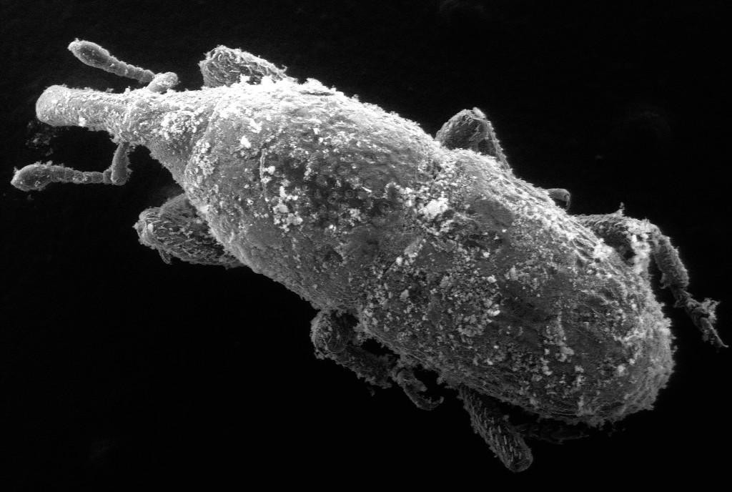

Plate15.SEMimages ofsilicadepositedonrice weevil

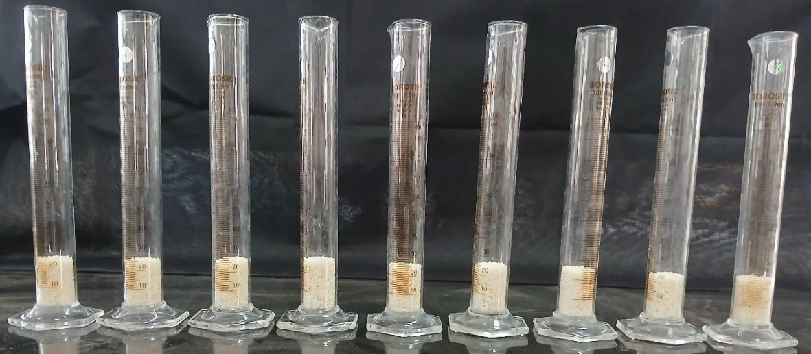

Plate16.Bulkdensityof differentconcentrationsofsilica-treatedrice

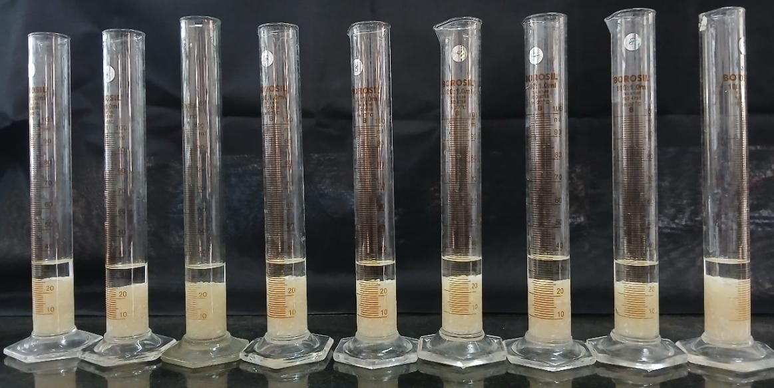

Plate17.Particledensityofdifferentconcentrationsof silica-treatedrice

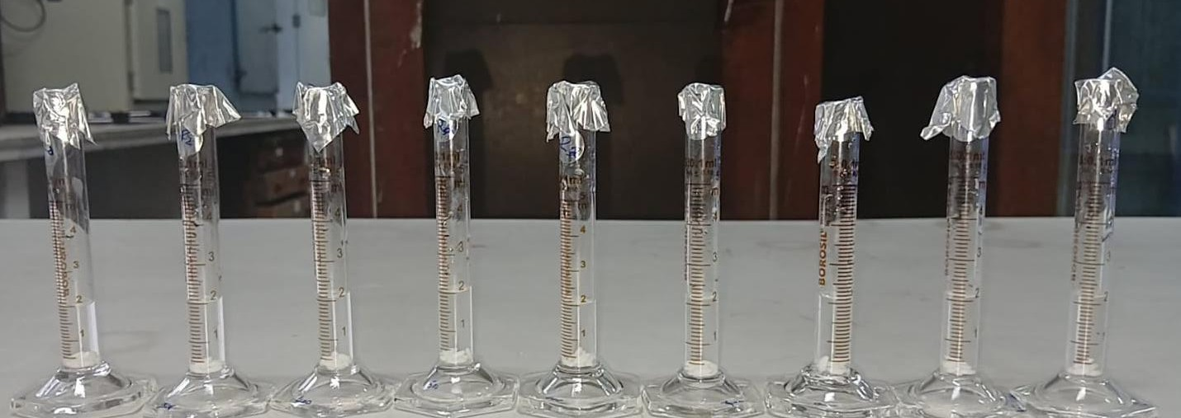

Plate18.Volumeexpansion ratioofdifferentconcentrationsofsilicatreatedrice

- Rawrice b)Soaked rice
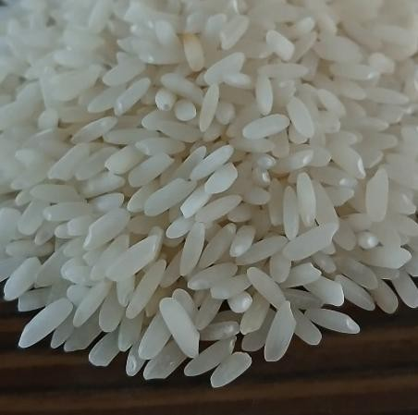
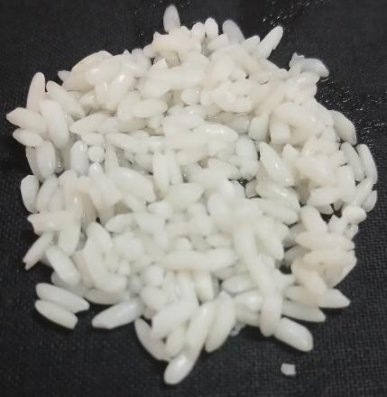

Plate19.Kernelelongationratioof differentconcentrationsofsilicatreatedrice

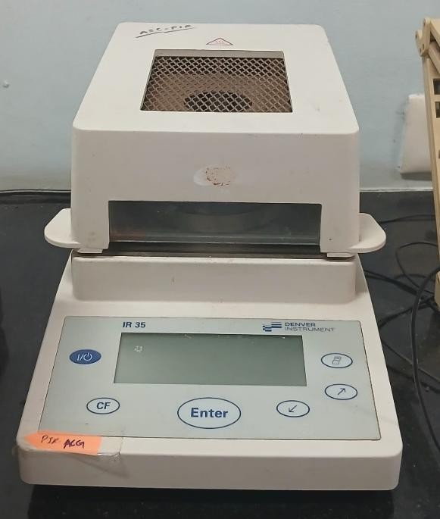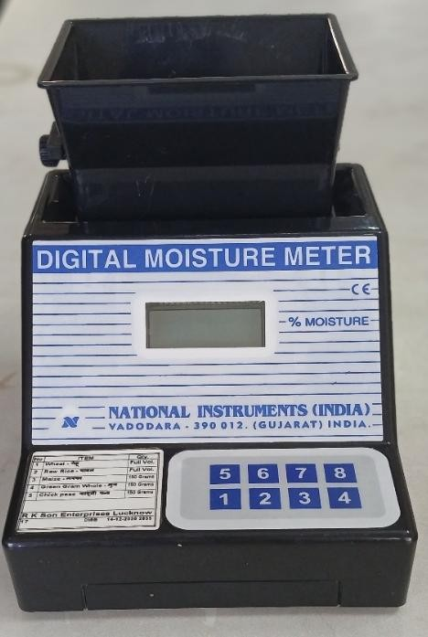
Plate20.Moisture analyser

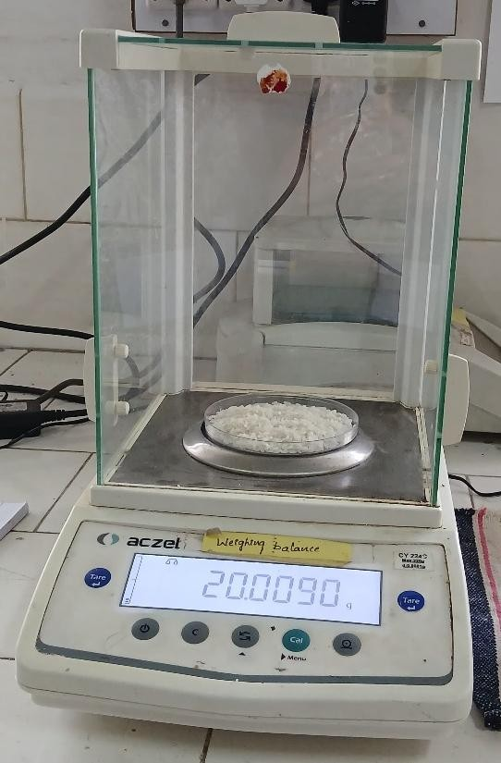
Plate21. Weighing balance

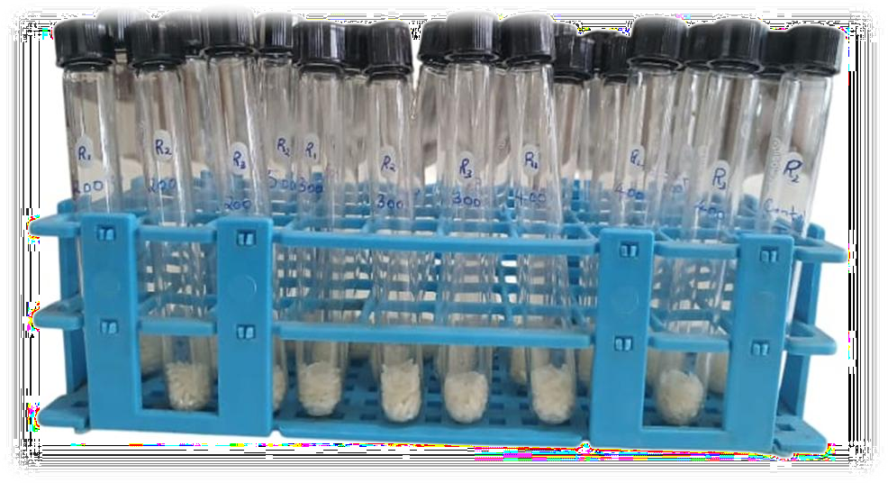
Plate22.Testgrain weightofdifferentconcentrationsofsilica-treatedrice

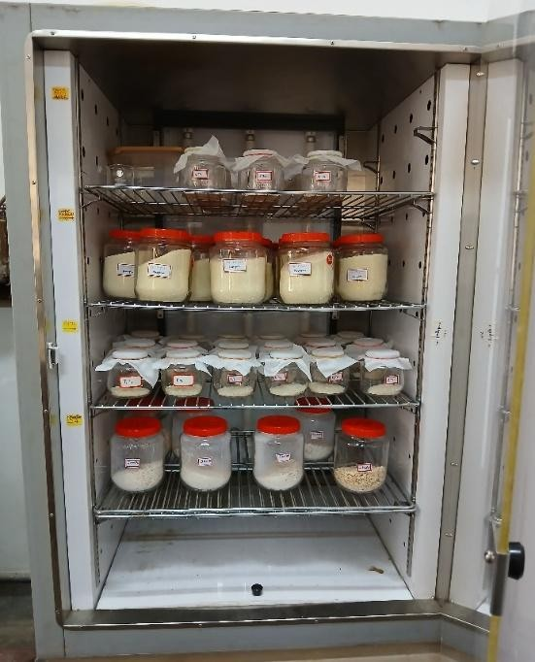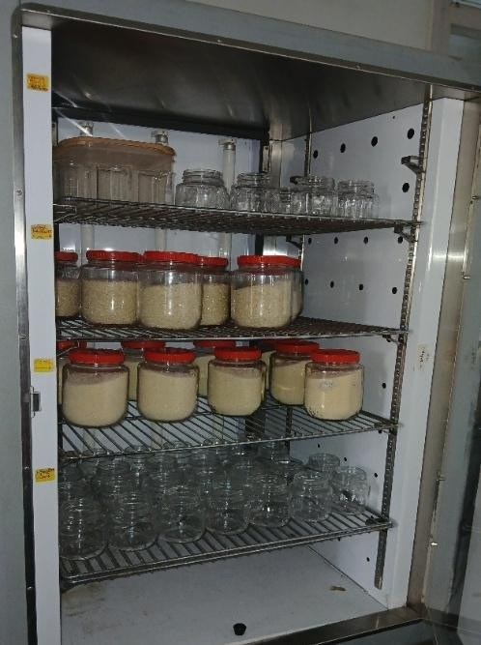

Plate 23. Keeping the test glass bottles and test grains (treated with silica) in anincubator before the inoculation of insects

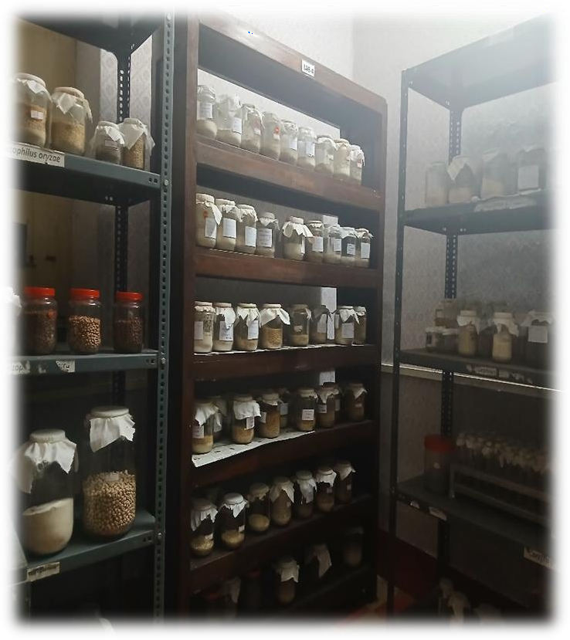
Plate24.Insectculture room

OtherLearnedTechniques

OvipositorActivityofthePulse Beetle*

The pulse beetle, Callosobruchus maculatus, is a major storage pest of pulses,causing30–40%lossesinvarioustypesandupto50%instoredcowpeas. This pest significantly impacts seed viability, leading to quantitative and qualitative losses in India. A studyfound that green gram exhibited the longest oviposition period and adult longevity for both male and female beetles, while chickpeas had the shortest. The ovipositional preference for C. maculatus was highest on green gram (19.25%) and lowest on chickpeas (7.00%) (Karthik et al., 2023). Females employ two rules when deciding where to lay eggs: a "relative" rule, which compares current egg loads to previous seeds, and an "absolute" rule, based solely on the weight of eggs on the current seed (Ken, 2008). The studyalso evaluated the effects of silica nanoparticles (SNPs) as an alternativetotraditionalinsecticides.ResultsshowedsignificantmortalityinC. maculatus at low SNP doses, with increased mortalityrates observed at higher concentrations after 48 hours (Samar et al., 2024).
Greengramsmixedwithsilicapowderandstoredinaglassjar

Pesticide-free green grams were sourced from the local market for efficacy studies of silica against C. maculatus conducted in 250 ml glass jars. To prevent infestation, 500 grams of wheat were incubated. Each jar contained 50greengramstreatedwithvarioussilicaconcentrations(200,300,400,500,
600, 700, 800, and 1000 ppm), achieved by shaking for 10 minutes. Untreated samples served as controls.
Thestudyoccurredindarknessatabout30±1°Cand65±5%humidity. Five newly emerged female C. maculatus were added to each jar, which were covered with khada cloth for aeration. Mortality was recorded over 5 days, consideringinsectsdeadiftherewasnomovementintheirlegsorantennae.The number of eggs laid by C. maculatus was also counted.

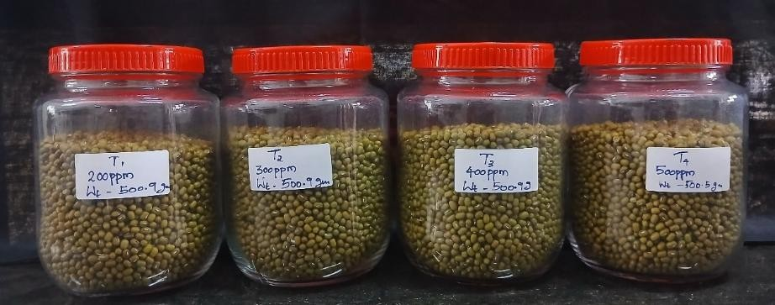
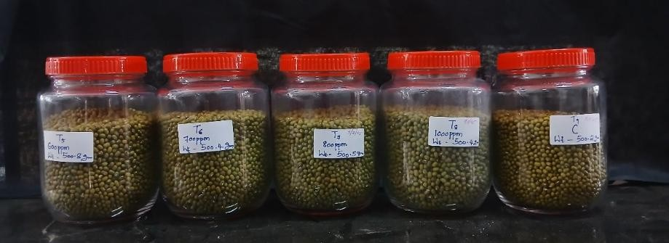

Plate25.BaseMaterials

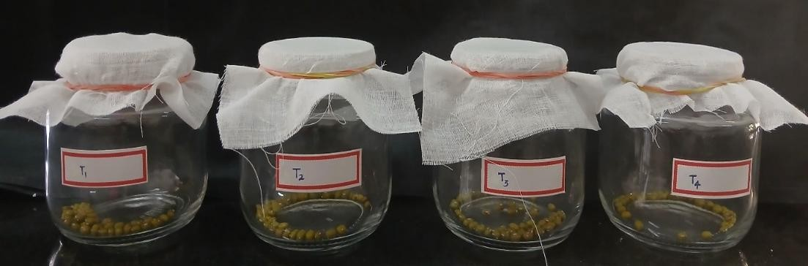
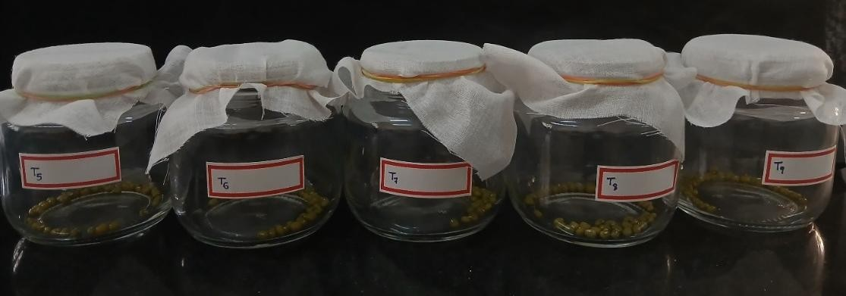

Plate26.Experimentalsetup

Stockcultureof insects

AtinycolonyoftheCallosobruchusmaculatusstrainwasobtainedfrom the infected green grams that were available in the CSIR-CFTRI, Mysore’s insect culture room in the Department of Food Protectant and Infestation Control. The green gram was purchased from a local grocery store in Mysore, andthemorphologicalfeaturesof the green gram allowedfortheidentification of C. maculatus. The recovered C. maculatus were placed in green gram jars, which were covered with muslin fabric secured with rubber bands. The adults were free to mate, lay eggs, and have more children. The green gram with the eggs was employed for the experiment, and the newly emerged adult was trapped for the experiment (Nosheen and Nasreen 2020)
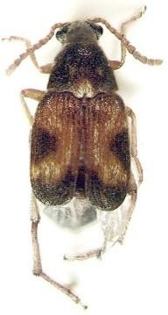
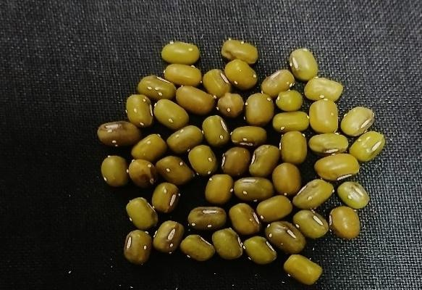

Plate27.a)Pulsebeetle Plate28. b) Eggs laidbyfemale

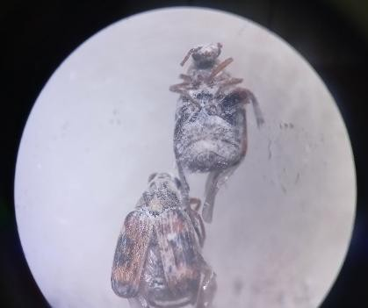
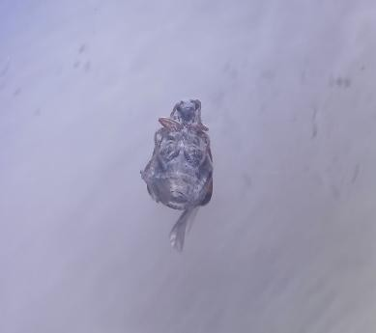

Plate29.DifferentmicroscopicimagesofC.maculatustreatedwithsilica

ScanningElectronMicroscopy(SEM)
SEMisadevicethatusesahigh-energyelectron beamappliedtoaheat source to disclose the invisible worlds of micro and nano space. SEMs include lenses to compress the spot and guide focussed electrons to the specimen, creatingsignals for apicturebecausethespot sizecreated is too bigforasharp image.
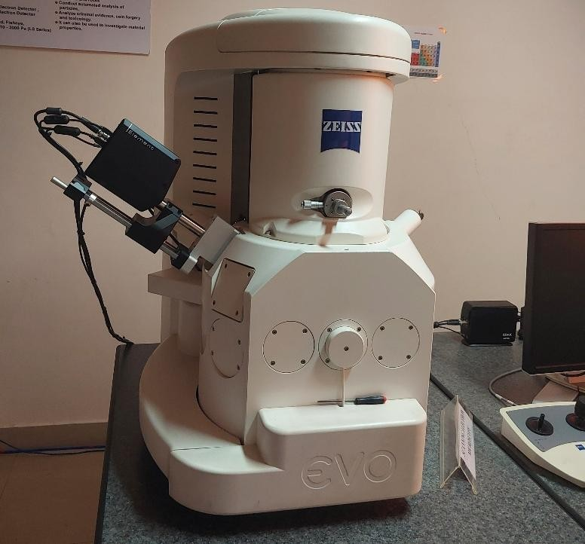

Plate30. PictureofScanningElectronMicroscope

PrincipleofSEM
Scanning Electron Microscopy (SEM) utilizes a focused beam of high- energy electrons to interact with a specimen's surface, generating secondary electrons, backscattered electrons, and characteristic X-rays. These signals provide high-resolution images and compositional information about the sample. The emitted secondary electrons primarily contribute to surface morphology imaging, while backscattered electrons help distinguish elements based on atomic number contrast. SEM is widely used for studying the microstructuraldetailsofinsectexoskeletons,includingsurfacetexture,sensilla, and microstructural adaptations Goldstein et al., (2017).

SamplePreparationforInsectSEM Analysis

To ensure high-quality imaging, the insect samples were prepared using the following protocol:
  - Fixation: The insect specimens were fixed in 2.5% glutaraldehyde in phosphate-buffered saline (PBS) for 24 hours to preserve structural integrity.
  - Dehydration: The fixed specimens were dehydrated using a graded ethanol series (30%, 50%, 70%, 90%, and 100%) to remove water content, preventing structural collapse.
  - Drying: Critical point drying (CPD) was performed using liquid CO₂ to preserve delicate surface features without distortion.
  - Mounting: The dried insect samples were carefully mounted on aluminum stubs using carbon adhesive tape to ensure stability during imaging.
  - SputterCoating:Athinlayerof goldorplatinumwasappliedusingasputter coater to enhance conductivity and prevent charging effects.
SEMImagingand Analysis

The prepared insect samples were analyzed using a Scanning Electron Microscope(JEOL/JSM-IT500,UniversityofMysore).Theimagingconditions includedanacceleratingvoltageof5–20kV,aworkingdistanceof10mm,and a secondary electron detector for high-resolution imaging of exoskeletal microstructures. The obtained SEM micrographs were analyzed to study the insect samples' morphology, surface texture, and structural adaptations.

CLEVENGERMETHOD

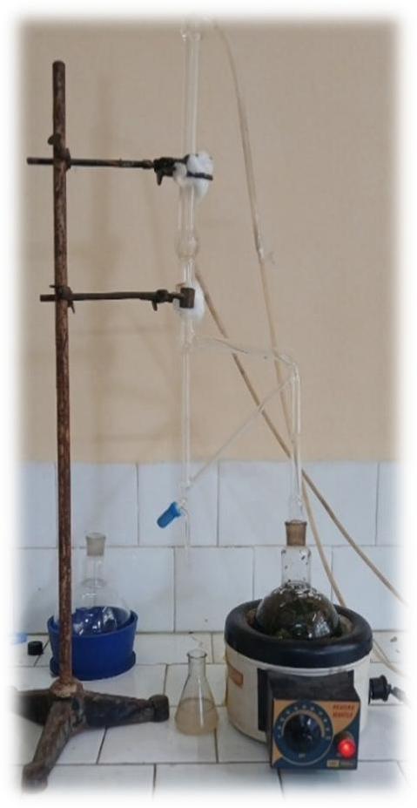
The Clevenger Apparatus is a laboratory setup used for the determinationofvolatileorganiccompounds(VOCs)inasample.Itisatypeof distillation apparatus commonly used to analyze essential oils, perfumes, and other volatile organic compounds. It consists of 2 elements: a flask and a modifiedglasspiece(verticaltubecombinedwithacondenser+glassstopcock burette). Experimental Setup: The experimental setup is shown below. The experiment was conducted in a Clevenger’s Apparatus. The apparatus consists ofoneroundbottomflaskof1000ml,whichisconnectedwithanothertwo-way round flask, which holds the raw material. The top flask is connected to the condenser through the connector. The separating funnel is used for the separation of essential oil and water.
Materialsrequired

    - Freshleaves
    - Weighingbalance
    - Condenser
    - Round bottom flask
    - Bodytube
    - Distilled water

Plate31.Experimental setup

Experimentalprocedure

Plantmaterialcanyieldessentialoils(EOs),whicharevolatile,fragrant, and greasyliquids. These fragrant oilyliquids are made from a varietyof plant parts,includingpeels,bark,leaves,flowers,buds,seeds,andmore.Avarietyof extraction methods are utilised in the extraction process. Sharma et al., (2022)
Compared to hydro distillation, this process is quicker and more effective.Thismethod'sbenefitsincludeaquickerextractiontime,superior quality of extract, reduced extraction agent costs, and its environmentally beneficial characteristics. Surbhi et al., (2021)
FLOWCHART

Preparationofleaves(eg;FreshEukalyptusleaf)
Washthoroughly&drytoremovemoisture
Choppingintosmallpieces (for easyextraction)
SetupofClevengerApparatus(bodytube,condenser,roundbottomflask, heating mantle)
Loadingthe leaves to round bottom flask
Add¾ ofdistilled waterinsideit to avoid unnecessary
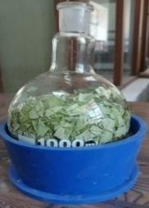
foreignparticles or dirt thatmayaffect thequantityand qualityofoil
Steamdistillationprocess happens
Heatingthemixtureusingaheating mantle
Waterboilsinbetween45to55degrees,releasingessentialoilalongwithsteam (3- 6 hr)

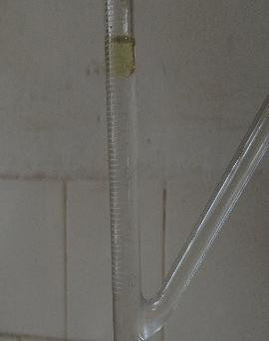
Steam carries the volatile oil into the condenser, where it is cooled and condensed back to liquid form.
Collectionofessentialoil
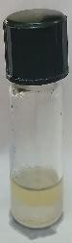

PROCEDURE

Principle:Steamdistillationmethod

Freshleaves,itisthenwashedthoroughlytomakedustfreeanddriedin the air to remove excess moisture the leaves are chopped into small pieces for easy extraction. and it is then inserted inside the round bottom flask and ¾ of distilled water is added to it flask is kept on a heating mantle When then water starts boiling steam generates.it penetrates inside the cells of the leaves. The volatileoilgoesalongwiththewatervapour,andthispassesthroughtheYtube. From here, it will pass through the condenser. When the mixture of water and volatile oil comes into contact with cold water, it condenses slowly. It falls throughthegraduationtubeandwillbedepositedontheYtube.Thedistillation time takes around 3-6 hours.
The volatileoilislighterthanwater,soitcanbeseenintheupperpart.
So,wecan collectit inasmall-sized, tightglass bottle

Time

The time spent on the extraction process affected the yield. In some extraction methods, the longer the extraction time, the higher the yield.

ACIDINSOLUBLEASHMETHOD

Theashfractionthatisinsolubleinanacid,moreespeciallyinadiluted HCl solution, is known as acid-insoluble ash (AIA). It is a portion of the total ash produced when a test material is burned (dry ashed). (Liu et al., 2022)
PRINCIPLE

Acid-insolubleashisdeterminedbydissolvingashindilutehydrochloric acid (10% m/m), The liquid is filtered through an ashless filter paper and thoroughlywashedwithhotwater.Thefilterpaperisignitedintheoriginaldish, cooled, and weighed.
Materialsneeded

- RiceSample:A clean,dryricesampleto betested
- Concentrated Hydrochloric Acid (HCl):Typically, 10% hydrochloric acid is used for dissolving the soluble minerals.
- SilicaCrucible:Ahigh-temperature-resistantcrucible.
- MuffleFurnace:Afurnaceisusedtoashthe sample.
- BunsenBurner:Forheatinganddrying.
- Desiccator:This is used to cool the sample post-ashing to avoid moisture absorption.
- AnalyticalBalance:To weighthesampleandresidues.
- DistilledWater:To washthe sample.

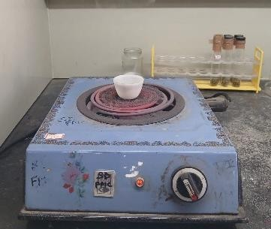
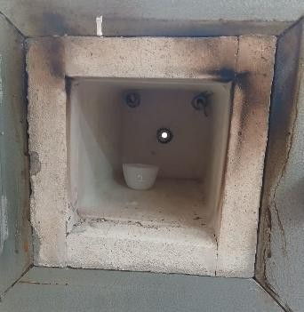
Plate32. a)Charring process Plate33.b)Samplekeptinside muffle
furnace

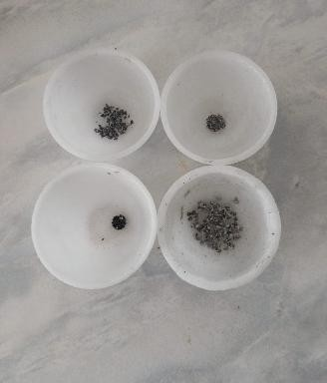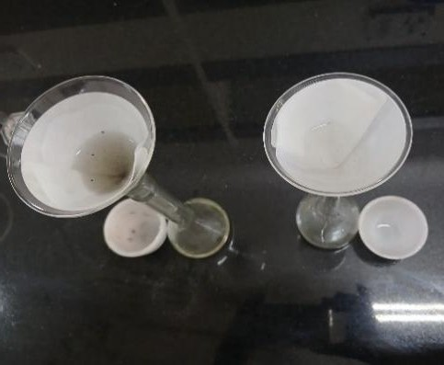

Plate34.c)Sampleturninto ash Plate35. d)Filtrationprocess
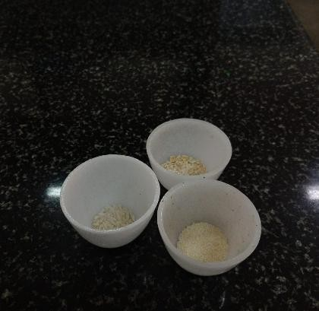
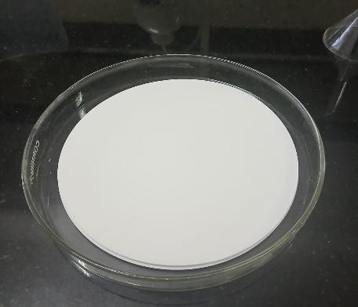
Plate36.e)Samples Plate37.f)Ashlessfilterpaper

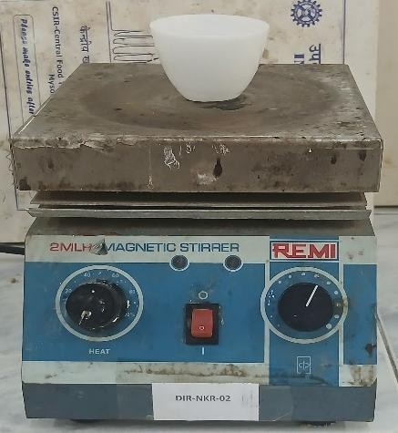
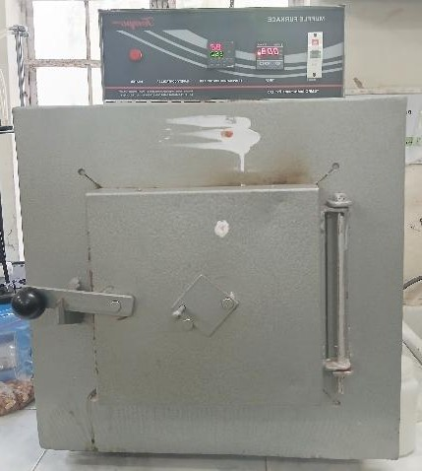

Plate38.g) Hotplate Plate.39h)Muffle furnace

Procedure

- Note the emptyweight of the sample, then weigh 2gof the sample to be tested. Keep it for the charring process until the fumes vanish after taking it with the tong and place it inside the muffle by covering its lid for more than 8 hours at 550 degrees Celsius. After taking it to cool in a desiccator. Now, examine the ash closely and add a few drops of distilled water to the ash content. The development of a black color indicates that the ash hasn’t become carbon-free yet, so it needs to burn again at 550 degrees Celsius until it becomes carbon- free. Placethecrucibleonthehotplateanddrythemoistash completely. After drying,coverthecruciblewiththelidandburnat550degreesformorethan40 minutes. Cool it and check whether carefully ash has a black color or not. Add a few drops of water to the ash; if it is not black, can go to the next step.
- Measure25mlof40%HCLandpouritintothecruciblecontainingash. Place the crucible on the hot plate for 5 minutes and remove it with the tong
- Prepareafiltersystem usinganashlessfilter paper
- Now we can see a few particles are trapped on the filter paper. These particles will be counted as acid-insoluble ash. Now, with hot water, wash the crucible entirely and transfer the balance of ash
- Placethecrucibleandlidin ahot airovenat 110degreesC for30 minutes
- Weightheweightofthe driedblankcrucible
- Fold the filter paper carefully to avoid loss of filtrate Put it inside the crucible and burn at 550 degrees Celsius for 90 minutes
- Takeit aftercoolingandweighit

Calculation
Sample weight (Ws) Crucible weight (Wc) Crucible+Ashweight(Wf)
Acidinsoluble ash% =Wf-Wc

Ws

x100

GASCHROMATOGRAPHY MASSSPECTROMETRY

Gas Chromatography-Mass Spectrometry (GC-MS) is a powerful and versatile technique used in Applied Sciences and Technology. It separates chemical mixtures using the GC component and identifies individual compounds at the molecular level through the MS component without decomposing them. The GC works by heating a mixture to separate it into distinct substances, which are carried through a column by an inert gas like nitrogenorhelium.TheseparatedcompoundsthenentertheMS,wheretheyare analyzed based on their mass, providing precise identification.

Components
This system has several key parts, including an injector that introduces andheatsthesampletoturnitintovapor.Asilicacolumn,madeofmetaltubing filled with a solid material coated in a liquid, helps separate the different components of the sample. A carrier gas, such as nitrogen (N₂) or helium (He), is used to move the sample through the column. Equipment to regulate and maintain a steady flow of carrier gas is essential. The mass spectrometer (MS) acts as the detector, identifying and measuring the separated components. Programmableovensandheatersareusedtocontrolthetemplate35.mperatures of the column, detector, and injector. In modern GC-MS systems, specialized software provided by the manufacturer has replaced integrators or integrator/strip chart recorders, ensuring a permanent record of the analysis.
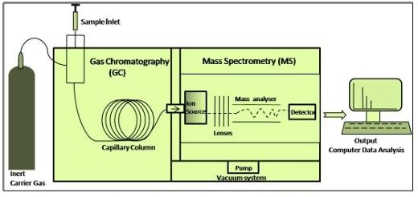

Plate40.Schematic diagramofGC-MS

LiquidSample Preparation

Dilution: Liquid samples are typically diluted in a low-boiling-point solvent, such as methanol, acetone, or dichloromethane, to achieve a concentrationofapproximately0.1to1mg/mL.Thisensuresthatthe sampleis compatible with the GC system and minimizes the risk of clogging the inlet.
Filtration:Beforeanalysis,thesampleshouldbefilteredtoremoveany particlesthat mayinterferewith theanalysis.A0.22 μm filter is typicallyused.
Centrifugation:Forsamplesthatmaycontainsolids,centrifugationcan help separate the liquid from any undissolved material before transferring to a vial.

SamplePreparationConsiderations
EnsurethatallsolventsusedarevolatileandsuitableforGC-MS;water and nonvolatile solvents should be avoided.
Samplesmustnotcontainanystrongacids,bases,salts,orother contaminants that could damage the GC column or interfere with the analysis.
Finalsamplesshouldbefreeofparticlesandarepreferably prepared in glass vials to prevent the leaching of materials from the plastic.
Basic Materials
  - SampleVials(glass orplastic, usually1.5 mLor2 mL)

  - SealedCaps (toprevent sampleevaporation)

  - Micropipettes(20,1000&100microlitres)andTips(forpreciseliquid handling)
  - Syringes(gas-tightsyringesforliquidorgaseous samples)

  - FiltrationMaterials(syringefiltersormembranefilterstoremove particulates)

ChemicalsandReagents
- Solvents(forsampledilutionorextraction) Hexane (HPLC grade)
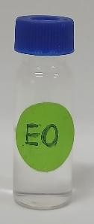
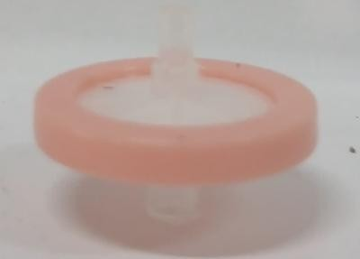

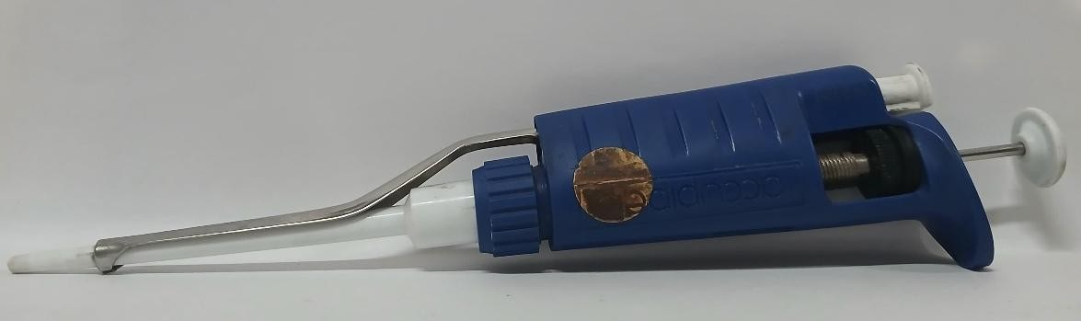
Plate41.a)G-CVials Plate42.b)Micro-filter

Plate43.c) Micro-pipette–20,100,1000micro-litreareused
Plate43.Micropipette
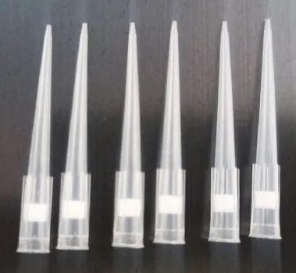
Plate44. d)Tips

Procedure

- SampleIntroduction

The prepared sample is injected into the GC system, where it is heated and combined with a carrier gas (such as helium or nitrogen) to move through the system.
- Separation

Asthevaporizedsamplepassesthroughthechromatographycolumn,its componentsareseparatedbasedontheirboilingpointsandtheirinteractionwith the stationary phase.
- Ionization

When the separated components leave the column, they enter the mass spectrometer’s ion source, where they are converted into ions (charged particles).
- Detection

The mass analyzer sorts these ions by their mass-to-charge ratio (m/z), and a detector captures the signals to produce a mass spectrum for each substance.
- Data Analysis

The generated mass spectra are analyzed using specialized software to identifyandmeasurethesample’scomponentsbycomparingthemwithknown references or databases

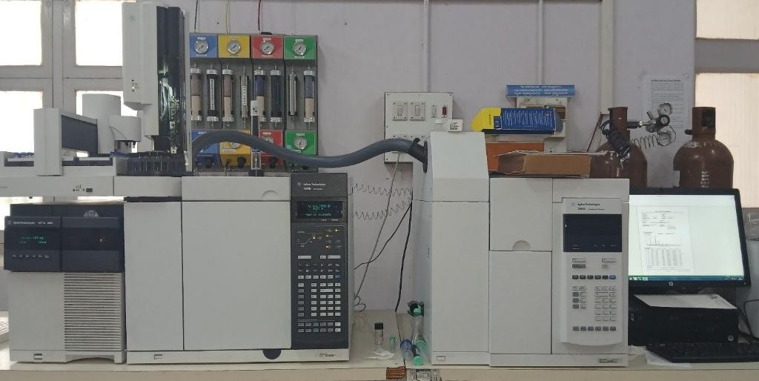

Plate45.GC-MSMachine

ApplicationsofGC-MS
- EnvironmentalAnalysis:Detectionofpollutantsandanalysisofairandwater quality.
- ForensicScience:Identificationofsubstancesincriminalinvestigations,including drug analysis.
- FoodandFlavorIndustry:Analysisoffoodcomposition,detectionof contaminants, and flavor profiling.
ClinicalResearch:Metaboliteprofilinganddiseasemarkeridentification.

ExperimentalResults

CHAPTERIV

EXPERIMENTALRESULTS

Different parametres of Oryza sativa L. grains treated with silica particles
The current study investigated the impact of varying silica particle concentrationsonthephysicalandmoisturepropertiesofOryzasativaL.grains. Between 10.68% and 11.74%, the moisture content (MC) varied little between treatments,withthecontrolhavingthehighestvalue.Atthe1000ppmtreatment level,the100-grainweight(TGW)reacheditsmaximum,rangingfrom1.508g to 1.558 g. Throughout the treatments, bulk density (BD) remained mostly constant, ranging from 0.80 to 0.83 g/cm³, while particle density (PD) varied between 1.33 and 1.42 g/cm³. Porosity (P), which correlated with variations in the packing and structural arrangement of grains caused by silica application, ranged from 39.17% to 46.67%. The volume expansion ratio (VER) stayed within a small range of 1.078 to 1.139, and the kernel elongation ratio (KER) variedfrom1.054to1.121,withthemaximumelongationrecordedat400ppm. Significant variation was seen in water intake (WU), which ranged from 130.546%inthecontrolto206.278%afterthe500ppmtreatment.Thissuggests that silica treatment may have improved hydration capacity. With certain concentrations improving certain measures related to grain quality and storage behaviour, the data suggest that silica particles can have a moderate impact on the physicochemical characteristics of rice grains. (Table 1).
Survival of Sitophilus oryzae in Oryza sativa grains treated with silica particles
During a 15-dayobservation period, bioassays wereused to assess how wellsilicaparticletreatmentssuppressedthesurvivalof SitophilusoryzaeL.in storedOryzasativaL.grains.Accordingtothedata,therewasanoticeabledose- dependent decrease in insect survival, suggesting that silica could be a useful grain protectant. With mean survival rates of 12.56 and 12.11, respectively, insect mortality was moderate at lower concentrations (200–300 ppm). A significantdeclineininsectsurvivalwasnotedastheconcentrationrose.With

finalmeanvaluesof9.94and9.61,respectively,treatmentsat400ppmand500 ppm dramatically decreased survival by the tenth and fifteenth days. The declines were more severe at higher concentrations; survival decreased to an average of 8.33 insects at 600 ppm and below 7 insects at 700 ppm and higher. Byday10,allinsectsinthe600ppmto1000ppmtreatmentshaddied,withthe 1000 ppm treatment having the lowest mean survival rate (6.56). With a mean of19.61,theuntreatedcontrolgroup,ontheotherhand,maintainedconsistently excellent survival rates throughout the research, suggesting very little natural mortality. The efficiency of silica particles as an insecticide, especially at concentrations higher than 600 parts per million, is well demonstrated by our results,whichalsolendcredencetotheirpotentialapplicationasanonchemical substituteforcontrollingS.oryzaeinfestationsinricegrainsthathavebeenkept. (Table 2).
DeathpercentageofSitophilusoryzaeL.inOryzaesativagrainstreated with silica particles
The insecticidal effectiveness of different silica concentrations was assessed by measuring the mortality of Sitophilus oryzae L. in grains of Oryza sativaL.treatedwithsilicaover15days.Thefindingsrevealedvariedtrendsin mortalityforvarioustreatmentdosagesandperiods.Meandeathcountswere
2.67 and 2.83 at lower exposures (200–300 ppm), indicating a progressive rate of mortality. Although there was an initial increase in insect mortality by the thirdandfifthdaysatmoderateconcentrations(400–600ppm),overallmortality stayed low, with all three treatments averaging 3.28 to 3.33 dead insects. Remarkably, as early as the third day, greater concentrations (700–1000 ppm) demonstratedextremelysignificantmortality,with19.00and19.67deathsnoted for treatments at 700 ppm and 800–1000 ppm, respectively. But after the fifth day, no more fatalities were noted, suggesting that silica acts quickly and with an early start at greater dosages. Because of the sharp decline in the number of live insects, the mean mortality for all high-dose treatments stayed at 3.33 despitethestrikingearlykill.Thecontrolgroup,ontheotherhand,showedvery littlemortality,withanaverageofjust0.22deadinsectsduringthecourseofthe trial.Theseresultssuggestthatsilicaisafeasiblenon-toxicalternativeforpost- harvestpestmanagementinricegrainssincehigherdosesofsilica(700–1000

ppm) are very effective in causing early mortality of S. oryzae, most likely through desiccation or cuticle abrasion. (Table 3).
Mortalitypercentageof S.oryzaeinO.sativagrainstreatedwithSilica Particles
The mortality rate of Sitophilus oryzae L. in grains of Oryza sativa L. treatedwithsilicawasmeasuredatvariouspointsthroughout15daysatvarious silica concentrations. Higher silica particle concentrations resulted in a quicker andmorethoroughinsectkill,accordingtothedata,whichdemonstratedadose- dependentincreaseinmortality.Mortalityincreasedgradually,reaching80.00% and85.00%onthefifteenthdayatthelowerdosagesof200ppmand300 ppm, respectively. On the fifth day, notable effects were already apparent, with moderatedosagesof400ppmand500ppmexhibitingincreaseddeath,reaching 100% mortality by the fifteenth day (73.33% and 80.00%, respectively). With treatments of 700 ppm, 800 ppm, and 1000 ppm reaching full mortality even earlier between the third and fifth days, higher doses, particularly600 ppm and beyond, showed remarkable efficacy, achieving 100% death as early as the seventh day. By the end of the experiment, the untreated control group's mortalityratehaddroppedto6.67%,indicatingminimalmortality.Theseresults demonstrate the appropriateness of silica particles as an efficient, residue-free, and eco-friendly substitute for traditional chemical grain protectants, and they provide compelling evidence of their insecticidal potential, especially at doses above 600 ppm. (Table 4).
Grain damage of Oryza sativa grains treated with silica particles after the feeding of S. oryzae
Whenthe Sitophilusoryzae L.-caused grain damagepercentage(GD%) was assessed in Oryza sativa L. grains treated with different dosages of silica particles, a definite dose-dependent protective effect was seen. The greatest grain damage, 12.73%, was seen in the untreated control group, demonstrating how vulnerable rice grains are when no preventative treatment is applied. As silica concentrations increased, the damage was considerably lessened in the treated groups. The GD% of grains treated with 200 ppm was 10.53%; this progressivelydroppedasthetreatmentsprogressed,reachingaslowas1.12%

and 1.39% in the 800 ppm and 1000 ppm doses, respectively. Additionally, treatments with 600 ppm and 700 ppm provide significant protection, lowering damage levels to 5.02% and 3.48%, respectively. Between 6.83% and 5.89%, the300ppmto500ppmtreatmentsshowedmoderatedecreasesingraindamage. Based on thesefindings, silicaparticles, especiallyat concentrations exceeding 600ppm,arehighlyeffectiveinreducingthedamagecausedbyS.oryzaetothe grain. This bolsters theiruse as an effective and environmentallyfriendly grain protectant in systems for managing stored rice. (Table 5).
Weight loss % of Oryza sativa grains treated with silica particles after the feeding of S. oryzae
Theimpactofsilicaparticletreatmentsatdifferentconcentrationsonthe weightloss(WL%)ofOryzasativa L. grainsasaresultofSitophilusoryzae L. infestation was assessed. The findings showed that, in comparison to the untreated control, silica application successfully decreased grain weight loss. Thecontrolgrouplostthemostweight(3.63%),followedbygrainstreatedwith
500 ppm (3.73%) and 300 ppm (3.20), suggesting comparatively less effectiveness at these dosages. Higher silica dosage treatments, however, demonstrated a discernible reduction in grain damage. Grain treated with 1000 partspermillionsilicahadtheleastamountofweightloss(2.18%),followedby treatmentswith700and800partspermillion(2.38%and2.38%,respectively). Thispatternshowsasteadydeclineinweightlossassilicacontentrises.Damage was also lessened by treatments with 600 ppm and 400 ppm, with WL percentages of 2.90% and 3.08%, respectively. Based on these results, silica particles may be employed in integrated pest control techniques for stored rice grains since they considerably reduce grain weight loss from S. oryzae, especially at 600 ppm and higher concentrations. (Table 6).
Residualofsilicaonricegrain

Theseresultsindicatethat,afteranalysisofresidualsilicaonricegrains byenergy-dispersiveX-ray(EDX)analysis,asinglewashshowsasmallamount ofsilicaispresentontheabovericegrains.Ultimately,theEDSspectrumshows thatthemostabundantelementintheexaminedmaterialiscarbon,followedby magnesium, phosphorus, and sulphur.

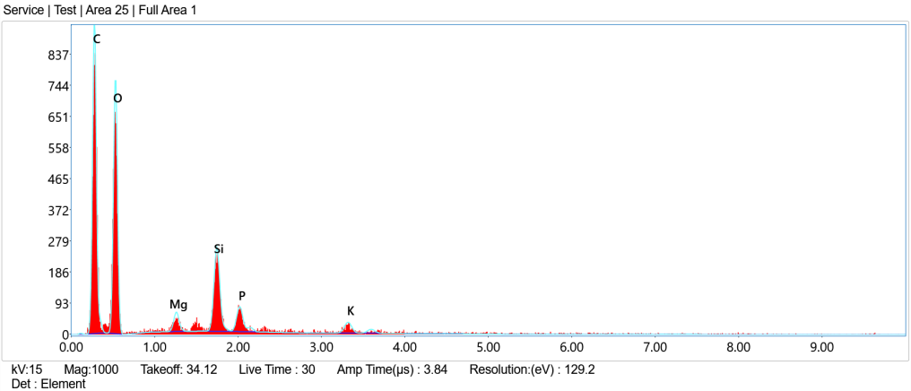

Plate46.Silicatreatedriceata concentrationof 700ppm

AcidInsolubleAshtestofbothtreatedanduntreatedgrains

Thetreatedricesamplehadagreateracid-insolubleashlevel(0.2240%) than the control sample (0.1495%). This suggests good surface deposition or absorption of mineral content in the treated grains, as there is a larger presence ofinorganicresidues,mostlikelyasaresultoftheapplicationofsilicaparticles. (Table 7).

Table1.DifferentparametersofOryzasativaL.grainstreatedwithsilicaparticles

Treatment | Dose(ppm) | MC | TGW  (gm) | BD  (v/w) | PD | P % | KER | VER | WU
T1 | 200 | 11.60 | 1.543 | 0.83 | 1.42 | 41.66 | 1.077 | 1.091 | 206.052
T2 | 300 | 11.06 | 1.528 | 0.81 | 1.33 | 39.17 | 1.075 | 1.110 | 172.90
T3 | 400 | 10.77 | 1.551 | 0.80 | 1.33 | 40.00 | 1.121 | 1.078 | 144.693
T4 | 500 | 10.96 | 1.553 | 0.81 | 1.36 | 40.55 | 1.079 | 1.089 | 206.278
T5 | 600 | 11.24 | 1.528 | 0.80 | 1.33 | 46.67 | 1.054 | 1.139 | 176.054
T6 | 700 | 10.68 | 1.554 | 0.81 | 1.36 | 40.56 | 1.090 | 1.091 | 156.702
T7 | 800 | 11.31 | 1.557 | 0.81 | 1.39 | 45.88 | 1.085 | 1.110 | 154.191
T8 | 1000 | 11.62 | 1.558 | 0.81 | 1.33 | 39.17 | 1.085 | 1.103 | 151.470
T9 | Control | 11.74 | 1.508 | 0.82 | 1.39 | 41.11 | 1.065 | 1.078 | 130.546
MC-Moisturecontent;TGW-Testgrainweight;BD-Bulkdensity;PD-Particledensity;P- Porosity; KER-Kernel Elongation Ratio; VER-Volume Expansion Ratio; WU-Water Uptake.

Table2.SurvivalofSitophilusoryzaeL.inOryzaesativaL.grainstreatedwith Silica Particles

Treatment | Dose  (ppm) | Survivalof S.oryzae(nos./20 insects)* |  |  |  |  |  | Mean
Treatment | Dose  (ppm) | 1 DAT** | 3 DAT | 5 DAT | 7 DAT | 10 DAT | 15 DAT | Mean
T1 | 200 | 20.00 | 20.00 | 14.67 | 9.67 | 6.33 | 4.67 | 12.56
T2 | 300 | 20.00 | 20.00 | 14.67 | 9.33 | 5.67 | 3.00 | 12.11
T3 | 400 | 20.00 | 20.00 | 13.33 | 5.33 | 0.67 | 0.33 | 9.94
T4 | 500 | 20.00 | 20.00 | 12.67 | 4.00 | 1.00 | 0.00 | 9.61
T5 | 600 | 20.00 | 20.00 | 8.00 | 2.00 | 0.00 | 0.00 | 8.33
T6 | 700 | 20.00 | 20.00 | 1.00 | 0.00 | 0.00 | 0.00 | 6.83
T7 | 800 | 20.00 | 19.67 | 0.67 | 0.00 | 0.00 | 0.00 | 6.72
T8 | 1000 | 20.00 | 19.33 | 0.00 | 0.00 | 0.00 | 0.00 | 6.56
T9 | Control | 20.00 | 20.00 | 19.67 | 19.67 | 19.67 | 18.67 | 19.61
*Eachvalueisthemeanofthreereplications;**DAT:Daysafter treatment

Table3.DeathofS.oryzaeinO.sativagrainstreatedwithSilica particles

Treatment | Dose  (ppm) | Deathof S. oryzae(nos./20 insects)* |  |  |  |  |  | Mean
Treatment | Dose  (ppm) | 1 DAT** | 3 DAT | 5 DAT | 7 DAT | 10 DAT | 15 DAT | Mean
T1 | 200 | 0.00 | 5.33 | 5.00 | 3.33 | 1.67 | 0.67 | 2.67
T2 | 300 | 0.00 | 5.33 | 5.33 | 3.67 | 2.67 | 0.00 | 2.83
T3 | 400 | 0.00 | 6.67 | 7.67 | 4.67 | 0.33 | 0.33 | 3.28
T4 | 500 | 0.00 | 7.33 | 8.67 | 3.00 | 1.00 | 0.00 | 3.33
T5 | 600 | 0.00 | 12.00 | 6.00 | 2.00 | 0.00 | 0.00 | 3.33
T6 | 700 | 0.00 | 19.00 | 1.00 | 0.00 | 0.00 | 0.00 | 3.33
T7 | 800 | 0.33 | 19.67 | 0.00 | 0.00 | 0.00 | 0.00 | 3.33
T8 | 1000 | 0.33 | 19.67 | 0.00 | 0.00 | 0.00 | 0.00 | 3.33
T9 | Control | 0.00 | 0.33 | 0.00 | 0.00 | 1.00 | 0.00 | 0.22
*Eachvalueisthemeanofthreereplications;**DAT:Daysaftertreatment

Table4.ThemortalitypercentageofS.oryzaeinO.sativagrainstreatedwithSilica Particles
Treatment | Dose  (ppm) | MoralitypercentageofS.oryzae*(%)
Treatment | Dose  (ppm) | 1 DAT** | 3 DAT | 5 DAT | 7 DAT | 10 DAT | 15 DAT
T1 | 200 | 0.00 | 26.67 | 51.67 | 68.33 | 76.67 | 80.00
T2 | 300 | 0.00 | 26.67 | 53.33 | 71.67 | 85.00 | 85.00
T3 | 400 | 0.00 | 33.33 | 73.33 | 96.67 | 98.33 | 100.00
T4 | 500 | 0.00 | 36.67 | 80.00 | 95.00 | 100.00 | 100.00
T5 | 600 | 0.00 | 60.00 | 90.00 | 100.00 | 100.00 | 100.00
T6 | 700 | 0.00 | 95.00 | 100.00 | 100.00 | 100.00 | 100.00
T7 | 800 | 1.67 | 100.00 | 100.00 | 100.00 | 100.00 | 100.00
T8 | 1000 | 1.67 | 100.00 | 100.00 | 100.00 | 100.00 | 100.00
T9 | Control | 0.00 | 1.67 | 1.67 | 1.67 | 6.67 | 6.67
*Eachvalueisthemeanofthreereplications;**DAT:Daysafter treatment

Table5.GraindamagepercentageofOryzasativaL.grainstreatedwithsilica particles on a number basis

Treatment | Dose  (ppm) | *GD  (%)
T1 | 200 | 10.53
T2 | 300 | 6.83
T3 | 400 | 6.89
T4 | 500 | 5.89
T5 | 600 | 5.02
T6 | 700 | 3.48
T7 | 800 | 1.12
T8 | 1000 | 1.39
T9 | Control | 12.73
*Eachvalueisthemeanofthreereplications

Table6.Weightlosspercentageof Oryzasativa grainstreatedwithsilicaparticles on a weight basis

Treatment | Dose  (ppm) | *WL  (%)
T1 | 200 | 3.15
T2 | 300 | 3.20
T3 | 400 | 3.08
T4 | 500 | 3.73
T5 | 600 | 2.90
T6 | 700 | 2.38
T7 | 800 | 2.38
T8 | 1000 | 2.18
T9 | Control | 3.63

Table7.Resultof Acid-InsolubleAshTestinpercentage

Grains | Resultin%
TreatedRice | 0.2240 %
ControlledRice | 0.1495 %

Discussion

CHAPTERV

DISCUSSION

Different parameters of Oryza sativa L. grain treated with silica particles.
Different parameters, such as moisture content (MC), test grain weight (TGW), Bulk density (BD), Particle density (PD), Porosity (P), Kernel elongationratio(KER),VolumeexpansionratioVER),andwateruptake(WU), were measured. This revealed no significant variation in the parameters. These findings are corroborated by Kar et al., (2021), who found no significant difference between the results of normal and cooked rice.
SurvivalofS.oryzaein O. sativagrainstreatedwithsilica particles.

ThesurvivalrateofS.oryzaewasfoundtobehighestintheT9treatment group. The untreated control group recorded a survival rate of 19.61 insects. Theseresultsareconsistentwithearlierstudiesontheapplicationofsilica-based pesticides to stored grain. The effectiveness of several natural and synthetic silicasagainstS.oryzaewasassessedbyMucha-Pelzeretal.,(2010),whofound that larger dosages considerably increased mortality rates. Their research highlightedhowenvironmentalfactors,likehumidityandparticlesize,affected how effective silica treatments were, with smaller particles typicallyleading to higher mortality rates. Similarly, Li et al. (2020) demonstrated that S. oryzae's cuticle was physically harmed by synthetic amorphous silica (SAS), leading to ahighmortalityrate and amarkedlydecreased survivalrate ina briefperiodof time. Their findings lend credence to the idea that silica particles undermine insect viability by absorbing cuticular lipids and resulting in fatal water loss.
DeathofS. oryzaein O. sativagrainstreated withsilica particles.

The mortality statistics of Sitophilus oryzae treated to different silica treatmentconcentrationsshowastrongandquickinsecticidalaction,especially at higher doses. Mortality was over 100% at concentrations of 700 ppm and higheras earlyas 3DAT(days aftertreatment),with19.00and19.67 outof20 insectsdyinginthe700–1000ppmrange,respectively.Thisimpliesthatsilica

particleshaveapotentinitialknockdownimpactathighdosages.Curiously,no more deaths were reported in the days following the early peak (5–15 DAT), suggestingthat themajorityofvulnerablepeople werekilledearlyand that any survivors were unaffected, maybe as a result of behavioural avoidance or insufficient exposure. Athanassiou et al., (2006) also noted that S. oryzae died significantly within 48 to 72 hours of being exposed to diatomaceous earth formulations, especially when the treatment rates were higher. Low humidity and high temperatures, which hasten water loss from the silica absorption of cuticular lipids, were found to have the greatest effectiveness. Their findings align nicely with the current study's early and thorough knockdown.
Mortality percentageof S. oryzae in O. sativa grains treated with silica particles.
The mortality percentage of S. oryzae significantly increased with both time and dosage of the treatment. Lower doses (200–300 ppm) resulted in moderate mortality, reaching up to 85% by 15 DAT, whereas higher concentrations (700–1000 ppm) achieved near-complete mortality (100%) as earlyas3–5DAT.Thisindicatesacleardose-dependentresponsewherehigher treatmentlevelsweremoreeffectiveinmanagingthepestpopulation.Therapid and sustained mortality observed at 600 ppm and above demonstrates the potentialofthetestedcompoundasan efficientstored grainprotectant.Similar findings were reported by Kar et al. (2021), who observed that increased concentrations of botanical or bio-based insecticidal treatments significantly enhanced mortality rates of S. oryzae within shorter exposure periods, highlighting their utility in integrated pest management (IPM) strategies. Moreover, the slow and minimal mortalityin the untreated control (T9) further validates the efficacy of the treatment regimes.
Weight loss % and grain damage of Oryzae sativa treated with silica particles after the feeding of S. oryzae
Whentreatmentdosesareincreased,thereisadiscernibletrendtowards less grain damage in the weight loss (WL) data of grains that have been stored with S. oryzae infestation. The untreated control (3.63%) and lesser treatment dosages,includingT1(200ppm,3.15%)andT2(300ppm,3.20%),showedthe

greatest grainweightloss,suggestinginsufficient suppressionofinsectactivity at these levels. WL values were considerably lower in higher dose treatments, however, T8 (1000 ppm) exhibited the least amount of grain loss (2.18%), closely followed by T6 and T7 (700–800 ppm, 2.38%). According to this pattern, grain integrity is preserved by greater treatment concentrations, which are more effective at reducing S. oryzae feeding damage and reproduction.
These results align with those of Athanassiou et al., (2005), who found that silica-based formulations at higher dosages considerably decreased grain damage and weight loss in stored cereals. Similarly, diatomaceous earth and other inert dusts can effectively inhibit insect movement and feeding, resulting in reduced economic losses in stored grains (Subramanyam and Roesli, 2000). Therefore,thecurrentstudy'sobserveddecreaseinWLathigherdosessupports the effectiveness of these treatments in protecting against pests and their usefulness in integrated pest control systems for stored goods.
Residualofsilicaonricegrains

Thisresultindicatesthatafteranalysisofresidualsilicaonricegrainsby energy diffraction X-ray (EDX analysis, a single wash shows little amount of silica present on the above rice grains El-Rahman, (2013).
Acid-insolubleashcontentofbothtreatedandcontrolledrice

Accordingtothestudy'sacid-insolubleashtestresults,treatedricegrains had a greater proportion of acid-insoluble ash (0.2240%) than control grains (0.1495%). This implies that adding silica particles to grains enhances their inorganic residue, which could improve their resistance to Sitophilus oryzae infestation.Similarresultshavebeendocumentedinpreviousresearch.Kishore et al., (2024) found, for example, that traditional rice varieties with higher ash content showed reduced adult emergence of S. oryzae, suggesting that higher ash levels can discourage insect feeding and reproduction.
InsecticidalactivityofSilicapowderonS.oryzae.

Many studies have examined the insecticidal properties of silica, especially diatomaceous earth (DE) and synthetic amorphous silica, as a substituteforsyntheticchemicalpesticidesinthemanagementofSitophilus

oryzae, a significant pest in stored grains. As a result of the absorption of epicuticular lipids, silica mostly damages the insect's cuticle and causes dehydration (Korunic, 1998; Subramanyam and Roesli, 2000). Silica is a good non-chemicalalternativebecauseofitsmechanismofaction,particularlywhen it comes to managing resistance. Under ideal temperature and humidity conditions, Athanassiou et al., (2005) showed that nano-structured silica formulationsconsiderablyenhancedmortality,attainingover95%deathratesin 7 days. Comparably, Barros et al., (2003) discovered that applying synthetic silicadusttostoredwheatatratesof0.5–1.0g/kgresultedin90–100%S.oryzae mortalitywithin 10 days. Additionally, in a comparable timeframe, Khashaveh andSafieh(2007)foundthatIraniandiatomaceousearththatwaslocallysourced successfully controlled S. oryzae with >95% mortality at 0.25% (w/w). AccordingtoKorunicetal.,(1996),silica'sperformanceishighlydependenton its surroundings; it works better in environments with higher temperatures and lower relative humidity (<55%). Conversely, because of the decreased desiccationpotentialinhumidsettings,efficacydecreases.Asdemonstratedby Kavallieratos et al., (2005), particle size also matters; smaller particles have superior adherence and cuticular penetration. The potential of silica as an environmentally benign, residue-free, and resistance-breaking insecticide that works well with integrated pest control techniques in grain storage systems is supported by these findings.
Healthaspectsrelatedtotheuseof silicapowderonstoredgrains

DEis regarded as safe forhumanhealth because ofits minimal toxicity tomammals.Importantly,though,occupationalexposuretoairbornecrystalline silica,whichmaybefoundincertainDEproducts,hasbeenlinkedtorespiratory problems such as silicosis. For grain storage applications, it is, therefore, essential to utilize food-grade, amorphous DE formulations and to take the proper precautions while handling to reduce the risk of inhalation. " Diatomaceous earth (DE), particularly in its food-grade amorphous form, is widely recognized for its efficacy in controlling stored-product pests like Sitophilusoryzae.Itsmodeofactioninvolvesthephysicaldesiccationofinsects, leadingtomortalitywithoutrelyingonchemicaltoxicity.Importantly,food-

grade DE is composed predominantly of amorphous silica, which exhibits low mammaliantoxicityandis considered safefor use in food storageapplications.

Conclusion

CHAPTERVI

CONCLUSION

The study thoroughly investigated how silica particles affected the survival, mortality, and death rates of Sitophilus oryzae L., as well as moisture content, grain weight, and bulk density of Oryza sativa L. grains. Consistent withfindingsfromearlierstudies,theresultsdemonstratedthatsilicatreatments had no discernible impact on the physical characteristics of the rice grains. A significant inverse relationship between silica concentration and S. oryzae survival was found regarding pest control. Insect mortality increased significantly at higher concentrations (700–1000 ppm), reaching total (100%) mortality within a few days of exposure.
Reduced weight loss and grain damage further corroborated this, showinghowwellsilicaprotectsricegrainswhiletheyarestored.Furthermore, it was discovered that the silica residues on the treated grains were negligible andmostlyeliminatedwithjustonewash,indicatingalimitedchanceofresidue accumulation. For preserving Oryza sativa L. grains, these results provide credence to the use of silica-based treatments as an effective and sustainable substitute for traditional chemical pesticides.
The presenceof silica residue on treated grains was negligible after a single wash showing that silica particles can be a feasible choice for insect management with limited danger of residue formation. Consistent with earlier research, the results demonstrate the possibility of silica-based therapy as a viable and efficient substitute for traditional chemical pesticides in grain preservation.

59

References

REFERENCES
AbdElSalamK.M.H., AbouEl-SoudG.M.,MareiA.E.S.M.,Abdel-Rheim
K.H.,AbdelMegeedA.,andLamlomS.F.2024.Influenceofparboiling conditionsonricegrainqualitycharactersandinsectinfestationwithrice weevil(SitophilusoryzaeL)ofsomericecultivars.BMCPlantBiology, 24, Article 56. https://doi.org/10.1186/s12870-024-05651-y.
Abedi,Z.,Razmjou,J.,Dastjerdi,H.R.,andEbadollahi,A.2024.Physicaland biochemical characteristics of cereal grains affect population growth parameters of Sitophilus oryzae (L.) (Coleoptera: Curculionidae). Journal of Stored Products Research, 109, 102459. https://doi.org/10.1016/j.jspr.2024.102459
Abedi,Z.,Razmjou,J.,RafieeDastjerdi,H.,Ebadollahi,A. 2024.Physicaland biochemical characteristics of cereal grains affect population growth parameters of Sitophilus oryzae (L.) (Coleoptera: Curculionidae). Journal of Stored Products Research, 2024: 102459. https://doi.org/10.1016/j.jspr.2024.102459
Aisvarya, M., Kalyanasundaram, M., Kannan, M., Lakshmanan, A., and Srinivasan, T. 2021. Toxicity of diatomaceous earth on seed weevil, Sitophilus oryzae L. and its effect on agro-morphological characters of maizeseeds.JournalofAppliedandNaturalScience,13(4),1180-1186. https://doi.org/10.31018/jans.v13i4.3003
Aisvarya, S., Kalyanasundaram, M., Kannan, M., Preetha, S., Elango, K., Srinivasan, T., Govindaraju, K. 2023. Preparation and characterization of silica nanoparticles (sol–gel & river sand): A comparative toxicity study against seed weevil (Sitophilus oryzae L.) and effect on agro- morphological characteristics of maize seeds. Materials Science and Engineering: B, 2023: 116503.
https://doi.org/10.1016/j.mseb.2023.116503

AlhadhramiA,MohamedGG,SadekAH,IsmailSH,EbnalwaledAAand AlmalkiASA.2022.Behaviorofsilicananoparticlessynthesizedfrom

ricehuskashbythesol-gelmethodasaphotocatalyticandantibacterial agent. Materials, 15(22), 8211. DOI:10.3390/ma15228211.
Arthur, F.H. 2002. Survival of Sitophilus oryzae (L.) on wheat treated with diatomaceousearth:impactofbiologicalandenvironmentalparameters onproductefficacy.JournalofStoredProductsResearch,38(3):305-
313.https://doi.org/10.1016/S0022-474X(01)00033-9

Athanassiou, C. G., Kavallieratos, N. G., and Vayias, B. J. 2006. Insecticidal efficacy of diatomaceous earth against Sitophilus oryzae (L.) (Coleoptera: Curculionidae) in stored wheat: influence of dose rate, temperatureandexposureinterval.JournalofStoredProductsResearch, 42(3), 253–260.https://doi.org/10.1016/j.jspr.2005.04.001.
Athanassiou, C. G., Korunic, Z., and Kavallieratos, N. G. 2005. Evaluation of three diatomaceous earths against Sitophilus oryzae (L.) (Coleoptera: Curculionidae) on four commodities. Crop Protection, 24(9), 849–853. https://doi.org/10.1016/j.cropro.2005.01.005
Athanassiou, C.G., Kavallieratos, N.G., and Papagregoriou, A.S. 2005. Insecticidalefficacyofsilicagelagainststored-productbeetles.Journal of Stored Products Research, 41(3), 299–306. https://doi.org/10.1016/j.jspr.2004.06.004
Awadalla, S. S., Ata, T. E., Hashem, A. S., and Shetefa, M. F. 2024. Influence of different stored grains on adult emergence rates and weight loss by the rice weevil Sitophilus oryzae (Coleoptera: Curculionidae). Journal of Plant Protection and Pathology, 15(1), 45–49. https://doi.org/10.21608/jppp.2024.258681.1201
Barros, J., Gondim Jr, M.G.C., and Oliveira, J.V. 2003. Activity of synthetic silica dust against stored-product pests. Brazilian Journal of Entomology, 47(3), 419–423. https://doi.org/10.1590/S1519-566X2003000300017
Batta YA. 2004. Control of rice weevil (Sitophilus oryzae L., Coleoptera: Curculionidae) with various formulations of Metarhizium anisopliae. Crop Protection, 23(2), 103–108. DOI:10.1016/j.cropro.2003.07.001.

Bhuiyah,M.I.M., Islam,N.,Begum,A.,Karim,M.A.1990.Biologyoftherice weevil, Sitophilus oryzae (Linnaeus). Bangladesh Journal of Zoology, 18(1): 67-73.
Chen Y., Wang M. and Ouwerkerk P.B.F. 2012. Molecular and environmental factorsdetermininggrainqualityinrice.FoodandEnergySecurity,1(2), 111–132. https://doi.org/10.1002/fes3.11
Chiriloaie,A.,Athanassiou,C.,Vassilakos,T.,Fătu,V.,Drosu,S.,andCiobanu,
M.2014.Influenceofgraintypeontheefficacyofsomeformulationsof diatomaceous earth against the rice weevil (Sitophilus oryzae L.). Scientific Papers. Series A. Agronomy, LVII, 2014
Costa,D.C.S.,Almeida,A.C.S.,Araújo,M.S.,Heinrichs,E.A.,Lacerda,M. C., Barrigossi, J. A. F., and de Jesus, F. G. 2016. Resistance of rice varieties to Sitophilus oryzae (Coleoptera: Curculionidae). Neotropical Entomology,45(6),663–670.https://doi.org/10.1007/s13744-016-
0421-8

Debnath,N.,Das,S.,Seth,D.,Chandra,R.,Bhattacharya,S.C.,andGoswami,
A. 2011. Entomotoxic effect of silica nanoparticles against Sitophilus oryzae (L.). Journal of Pest Science, 84(1), 99–105. https://doi.org/10.1007/s10340-010-0332-3
Doherty, E.M., Sun, Q., Wilson, B.E. 2022. Stored rice varietal resistance towards Sitophilus oryzae. Crop Protection, 2022: 106162. https://doi.org/10.1016/j.cropro.2022.106162
El-Rahman,A.A.(2013).Effectofsilicaapplicationongrowthandyieldofrice.
JournalofAppliedSciencesResearch,9(6):3623–3631

Ertürk, S., Ferizli, A. G., and Emekçi, M. 2017. Evaluation of diatomaceous earth formulations for the control of rice weevil, Sitophilus oryzae L., 1763 (Coleoptera: Curculionidae) in stored rice. Turkish Journal of Entomology,41(3),347–354.https://doi.org/10.16970/entoted.307914
Fields,P.,andKorunic,Z.2000.Theeffectofgrainmoisturecontentand temperatureontheefficacyofdiatomaceousearthsfromdifferent

geographicallocationsagainststored-productbeetles.JournalofStored Products Research, 36(1), 1–13. https://doi.org/10.1016/S0022-474X(99)00021-1
Fitzgerald,M.A.,McCouch,S.R.,andHal,R.D.2009.Notjustagrainofrice: the quest for quality. Trends in Plant Science, 14(3), 133-139. https://doi.org/10.1016/j.tplants.2008.12.004
Floyd, E.H., Newsom, L.D. 1959. Biological studyof the rice weevil complex. Annals of the Entomological Society of America, 52(6): 687-695. https://doi.org/10.1093/aesa/52.6.687
Goldstein JI, Newbury DE, Joy DC, Lyman CE, Echlin P, Lifshin E, Michael JR, Ritchie NWM and Scott JHJ. 2017. Scanning Electron Microscopy andX-RayMicroanalysis(4thed.).Springer.DOI:10.1007/978-1-4939-6676-9.
Gowda, G. B., Patil, N. B., Adak, T., Pandi, G. P., Basak, N., Dhali, K., Annamalai, M., Prasanthi, G., Mohapatra, S. D., Jena, M., Pokhare, S., and Rath, P. C. 2019. Physico-chemical characteristics of rice (Oryza sativa L.) grain imparting resistance and their association with development of rice weevil, Sitophilus oryzae (L.) (Coleoptera: Curculionidae). Environmental Sustainability, 2, 369–379. https://doi.org/10.1007/s42398-019-00087-9
HamelD,RozmanVandLiškaA.2021.StorageofCerealsinWarehouseswith or without Pesticides. PAENTA, 1(22), Article 846 https://doi.org/10.3390/insects11120846
Ibrahim,S.S.,Elbehery,H.H.,andSamy,A.2024.Theefficacyofgreensilica nanoparticles synthesized from rice straw in the management of Callosobruchus maculatus (Col., Bruchidae). Scientific Reports, 14, Article 8834. https://doi.org/10.1038/s41598-024-44839-2
Jehajo, N., and Memon, N. 2020. Evaluation of the host preference and life historyofCallosobruchusmaculatus(F.)(Cowpeaweevil)(Coleoptera: Chrysomelidae)onstoredpulses.PureandAppliedBiology,9(4),2167- 2174. http://dx.doi.org/10.19045/bspab.2020.90231

Kar S, Nayak RN, Sahoo NR, Bakhara CK, Panda MK, Pal US and Bal LM. 2021. Rice weevil management through application of silica nanoparticle and physico-chemical and cooking characterization of the treated rice. Journal of Stored Products Research, 94, 101892. DOI:10.1016/j.jspr.2021.101892.
Kar, A., Ghosh, S. K., and Roy, P. 2021. Bioefficacy of botanicals against Sitophilusoryzae(L.)instoredrice.JournalofEntomologicalResearch, 45(2), 215–221. https://doi.org/10.5958/0974-4576.2021.00036.7
Karthik, R., Deka, M. K., Dumala,S., and Pamala, P. J. 2023. Generation-wise comparative biology of pulse beetle, Callosobruchus maculatus on different stored pulses. Biological Forum – An International Journal, 15(6), 442-449.
Kavallieratos, N.G., Athanassiou, C.G., and Andris, N.S. 2005. Evaluation of three diatomaceous earth formulations against Sitophilus oryzae. Crop Protection, 24(9), 819–826. https://doi.org/10.1016/j.cropro.2005.01.005
Khashaveh, A., and Safieh, S. 2007. The effect of diatomaceous earth on mortality and population suppression of Sitophilus oryzae. Iranian Journal of Agricultural Sciences, 38(2), 251–257.
Khush G. S. 1997. Origin, dispersal, cultivation, and variation of rice. Plant Molecular Biology, 35, 25–34. https://doi.org/10.1023/A:1005810616885.
Kiritani, K. 1965. Biological studies on the Sitophilus complex (Coleoptera: Curculionidae) in Japan. Applied Entomology and Zoology, 1(1), 1-20. https://doi.org/10.1303/aez.1.1
Kishore, K., Raja, R., and Thomas, M. 2024. Traditional rice varieties differ in susceptibility to Sitophilus oryzae infestation. Journal of Experimental Agriculture International, 46(4), 1–9. https://doi.org/10.9734/jeai/2024/v46i42636

Korunic, A., Fields, P.G., Kovacs, M.I.P., Noll, J.S., Lukow, O.M., Demianyk, C.J., Shibley, K.J. 1996. The effect of diatomaceous earth on grain quality. Journal of Stored Products Research, 33(2): 113-127. https://doi.org/10.1016/S0925-5214(96)00038-5
Korunić,Z.1998.Diatomaceousearths,agroupofnaturalinsecticides.Journal of Stored Products Research, 34(2–3), 87–97. https://doi.org/10.1016/S0022-474X(97)00039-8
Korunić,Z.2000.Grainsurface-layertreatmentofdiatomaceousearthforinsect control. Archives of Industrial Hygiene and Toxicology, 51(3), 269– 276.)https://doi.org/10.1016/S0022-474X(97)00039-8
Korunic, Z., Cenkowski, S., and Fields, P. 1998. Grain bulk densityas affected bydiatomaceousearthandapplicationmethod.PostharvestBiologyand Technology,13(1),81–89.https://doi.org/10.1016/S0925-
5214(97)00076-8

Korunić, Z., Fields, P. G., Kovacs, M. I. P., Noll, J. S., Lukow, O. M., Demianyk, C. J., and Shibley, K. J. 1996. The effect of diatomaceous earthongrainquality.PostharvestBiologyandTechnology,9(3),373–
387.https://doi.org/10.1016/0925-5214(96)00038-5

Korunić,Z.,Rozman,V.,Kalinovic,I.,Liska,A.,andZoric,M.1996.Efficacy ofdiatomaceousearths against stored-productpestsatvarious humidity levels. Journal of Economic Entomology, 89(3), 655–665. https://doi.org/10.1093/jee/89.3.655
Li, Y., Agarwal, M., Cao, Y.,and Ren, Y.2020. Effect ofsyntheticamorphous silica powder on the cuticle of Tribolium castaneum and Sitophilus oryzae using hyperspectral imaging technique. Pest Management Science, 76(1), 314-323. https://doi.org/10.1002/ps.5517
Liu K. 2022. New and improved methods for measuring acid-insoluble ash. Animal Feed Science and Technology, 288, 115282. DOI:10.1016/j.anifeedsci.2022.115282.

Majd-Marani, S., Naseri, B., Hassanpour, M., Razmjou, J., Jalaeian, M. 2023. Lifehistoryandlifetableparametersofthericeweevil,Sitophilusoryzae
L.(Coleoptera:Curculionidae)fedon10ricecultivarsandlinesinIran. Journal of Stored Products Research, 2023: 102118. https://doi.org/10.1016/j.jspr.2023.102118
Maji M, Roy C, and Sinha S. 2023. Gas chromatography-mass spectrometry (GC-MS): A comprehensive review of synergistic combinations and theirapplicationsinthepasttwodecades.JournalofAnalyticalSciences and Applied Biotechnology, 5(2), 72-85.
DOI:10.48402/IMIST.PRSM/jasab-v5i2.40209.

Manivannan,S.,andSubramanyam,B.2024.Efficacyoftwoamorphoussilica powders applied to hard red spring wheat against the rice weevil, Sitophilus oryzae (L.) (Coleoptera: Curculionidae). Journal of Stored Products Research, 107, Article 102343.
https://doi.org/10.1016/j.jspr.2024.102343

Manivannan,S.,Subramanyam,B.2023. Insecticidalefficacyoftwocandidate diatomaceousearthpowdersagainstthelessergrainborer, Rhyzopertha dominica (F.) (Coleoptera: Bostrichidae). Journal of Stored Products Research, 2023: 102212. https://doi.org/10.1016/j.jspr.2023.102212
MohammedAandAbdullahA.2018.ScanningElectronMicroscopy(SEM):A Review. Proceedings of the 2018 International Conference on Hydraulics and Pneumatics - HERVEX, 7-9 November, Băile Govora, Romania.
Mucha-Pelzer, T., Reichmuth, C., and Adler, C. 2010. Efficacy of different natural and synthetic silicas against two stored grain pests: Sitophilus granarius (L.) and Sitophilus oryzae (L.). Proceedings of the 10th International Working Conference on Stored Product Protection, 858, 781–786.https://doi.org/10.5073/jka.2010.425.258
Müller,A.,Nunes,M.T.,Maldaner,V.,Coradi,P.C.,Moraes,R.S.,Martens,S., Leal,A.F.,Pereira,V.F.,Marin,C.K.2021.Ricedrying,storageand

processing:Effectsofpost-harvestoperationsongrainquality.Rice Science, 28(6): 515-523. https://doi.org/10.1016/j.rsci.2021.12.002
Nath, B., Chen, G., and O'Sullivan, C. M. 2021. Research and technologies to reduce grain postharvest losses: A review. Agriculture, 11(8), 720. https://doi.org/10.3390/agriculture11080720
Odeyemi,O.O.,Ashamo,M.O.,Akinkurolere,R.O.,andOlatunji,A.A.2010. Resistance of strains of rice weevil, Sitophilus oryzae (Coleoptera: Curculionidae)topirimiphosmethyl.Julius-Kühn-Archiv,425,167–
172. https://doi.org/10.5073/jka.2010.425.433

Opit, G. P., and Throne, J. E. 2007. Influence of maternal age on the fitness of progeny in the rice weevil, Sitophilus oryzae (Coleoptera: Curculionidae). Environmental Entomology, 36(1), 83-89. https://doi.org/10.1603/0046-225X(2007)36[83:IOMAOT]2.0.CO;2.
Padín, S., Dal Bello, G., Fabrizio, M. 2000. Grain loss caused by Tribolium castaneum, Sitophilus oryzae and Acanthoscelides obtectus in stored durum wheat and beans treated with Beauveria bassiana. Journal of Stored Products Research, 37(3): 223-232.
https://doi.org/10.1016/S0022-474X(00)00046-1

Padmasri,A.,Kumara,J.A.,Anil,B.,Ramesh,K.,Srinivas,C.,VijayaLakshmi, K., and Pradeep, T. 2018. Efficacy of nanoparticles against rice weevil (Sitophilus oryzae Linnaeus) on maize seeds. International Journal of Current Microbiology and Applied Sciences, 7(9), 765–774. https://doi.org/10.20546/ijcmas.2018.709.092
Parr, M. J., Tran, B. M. D., Simmonds, M. S. J., and Credland, P. F. 1998. Durationofbehaviourpatternsduringovipositionbythebruchidbeetle, Callosobruchusmaculatus.PhysiologicalEntomology,23(2),150–157. DOI:10.1046/j.1365-3032.1998.232075.x.
Peerzada, G.J., Ramalingam, C. 2021. Statistical approach to synthesise biogenicsilicananoparticlesfromricehuskandconjugatedwithJusticia adhatoda extract as green, slow-release biocide. IET Nanobiotechnology, 15(2): 56-64. https://doi.org/10.1049/nbt2.12027

Perez-Mendoza,J.,Throne,J.E.,andBaker,J.E.2004.Ovarianphysiologyand age-grading in the rice weevil, Sitophilus oryzae (Coleoptera: Curculionidae). Journal of Stored Products Research, 40(2), 179–196. https://doi.org/10.1016/S0022-474X(02)00096-6
Qader, F.A.,Ameen,H.N.H.,andMohammed,B.M.H.2022.Effectoffood treated with silica gel on three types of storehouse insects. IOP ConferenceSeries:EarthandEnvironmentalScience,1060(1),012098. https://doi.org/10.1088/1755-1315/1060/1/012098
Saeed, Q., Amir, W., Batool, M., Parvaiz, F., Chen, T., and Ahmad, F. 2024. Eco-friendly control of rice weevil, Sitophilus oryzae L. (Coleoptera, Curculionidae) in grain storage structures using diatomaceous earth admixedinsecticides.InternationalJournalofPestManagement,70(4), 1338-1348. https://doi.org/10.1080/09670874.2022.2124324
Sen, S., Chakraborty, R., Kalita, P. 2020. Rice - not just a staple food: A comprehensive review on its phytochemicals and therapeutic potential. Trends in Food Science & Technology, 98: 1-13. https://doi.org/10.1016/j.tifs.2020.01.022
SharmaA,DikshitM,JhunjhunwalaA,andSomA.2022.Extractionprocessof Haridra and Tulsi essential oil with their medicinal uses. Journal of Ayurveda and Integrated Medical Sciences, 7(5), 41–47. DOI:10.21760/jaims.7.5.7.
Subedi,S.,Gc,Y.D.,Thapa,R.B.,andRijal,J.P.2009.Riceweevil(Sitophilus oryzae L.) host preference of selected stored grains in Chitwan, Nepal. JournaloftheInstituteofAgricultureandAnimalScience,30,151–158.
Subramanyam, B., and Roesli, R. 2000. Inert dusts. In: Subramanyam, B., Hagstrum, D.W. (Eds.), Alternatives to Pesticides in Stored-Product IPM. Kluwer Academic Publishers, Boston, MA, pp. 321–380.
Surbhi, Kumar A, Singh S, Kumari P, and Rasane P. 2021. Eucalyptus: Phytochemicalcomposition,extractionmethodsandfoodandmedicinal applications. Advances in Traditional Medicine, 21(4), 621–638. DOI:10.1007/s13596-021-00582-7.

Wilson,K.(1988).EgglayingdecisionsbythebeanweevilCallosobruchus maculatus. Ecological Entomology, 13(1), 107–
118.doi:10.1111/j.1365-2311.1988.tb00338.x

Yang,L.,andWang,Y.2019.Impactofclimatechangeonricegrainquality.
Rice,427–441.https://doi.org/10.1016/B978-0-12-811508-4.00013-7

Zeni, V., Baliota, G. V., Benelli, G., Canale, A., and Athanassiou, C. G. 2021. Diatomaceous earth for arthropod pest control: Back to the future. Molecules, 26(24), 7487. https://doi.org/10.3390/molecules26247487
Zhang,J.,Zhu,Y.,Yu,L.,Yang,M.,Zou,X.,Yin,Y.2022.Researchadvances in cadmium uptake, transport and resistance in rice (Oryza sativa L.). Cells, 11(3): 569. https://doi.org/10.3390/cells11030569

