EXTRACTION, CHARACTERIZATION AND POTENTIAL APPLICATION OF Acromitus flagellatus DERIVED COLLAGEN

DISSERTATION SUBMITTED TO ST. TERESA’S COLLEGE (AUTONOMOUS), ERNAKULAM
IN PARTIAL FULFILLMENT OF THE REQUIREMENT FOR THE AWARD OF
DEGREE OF MASTER OF SCIENCE IN ZOOLOGY


SUBMITTED BY :
ARYA PRAKASAN

REGISTER NO. : SM23ZOO003

DEPARTMENT OF ZOOLOGY
ST. TERESA’S COLLEGE (AUTONOMOUS) ERNAKULAM
KOCHI-682011
2023-2025

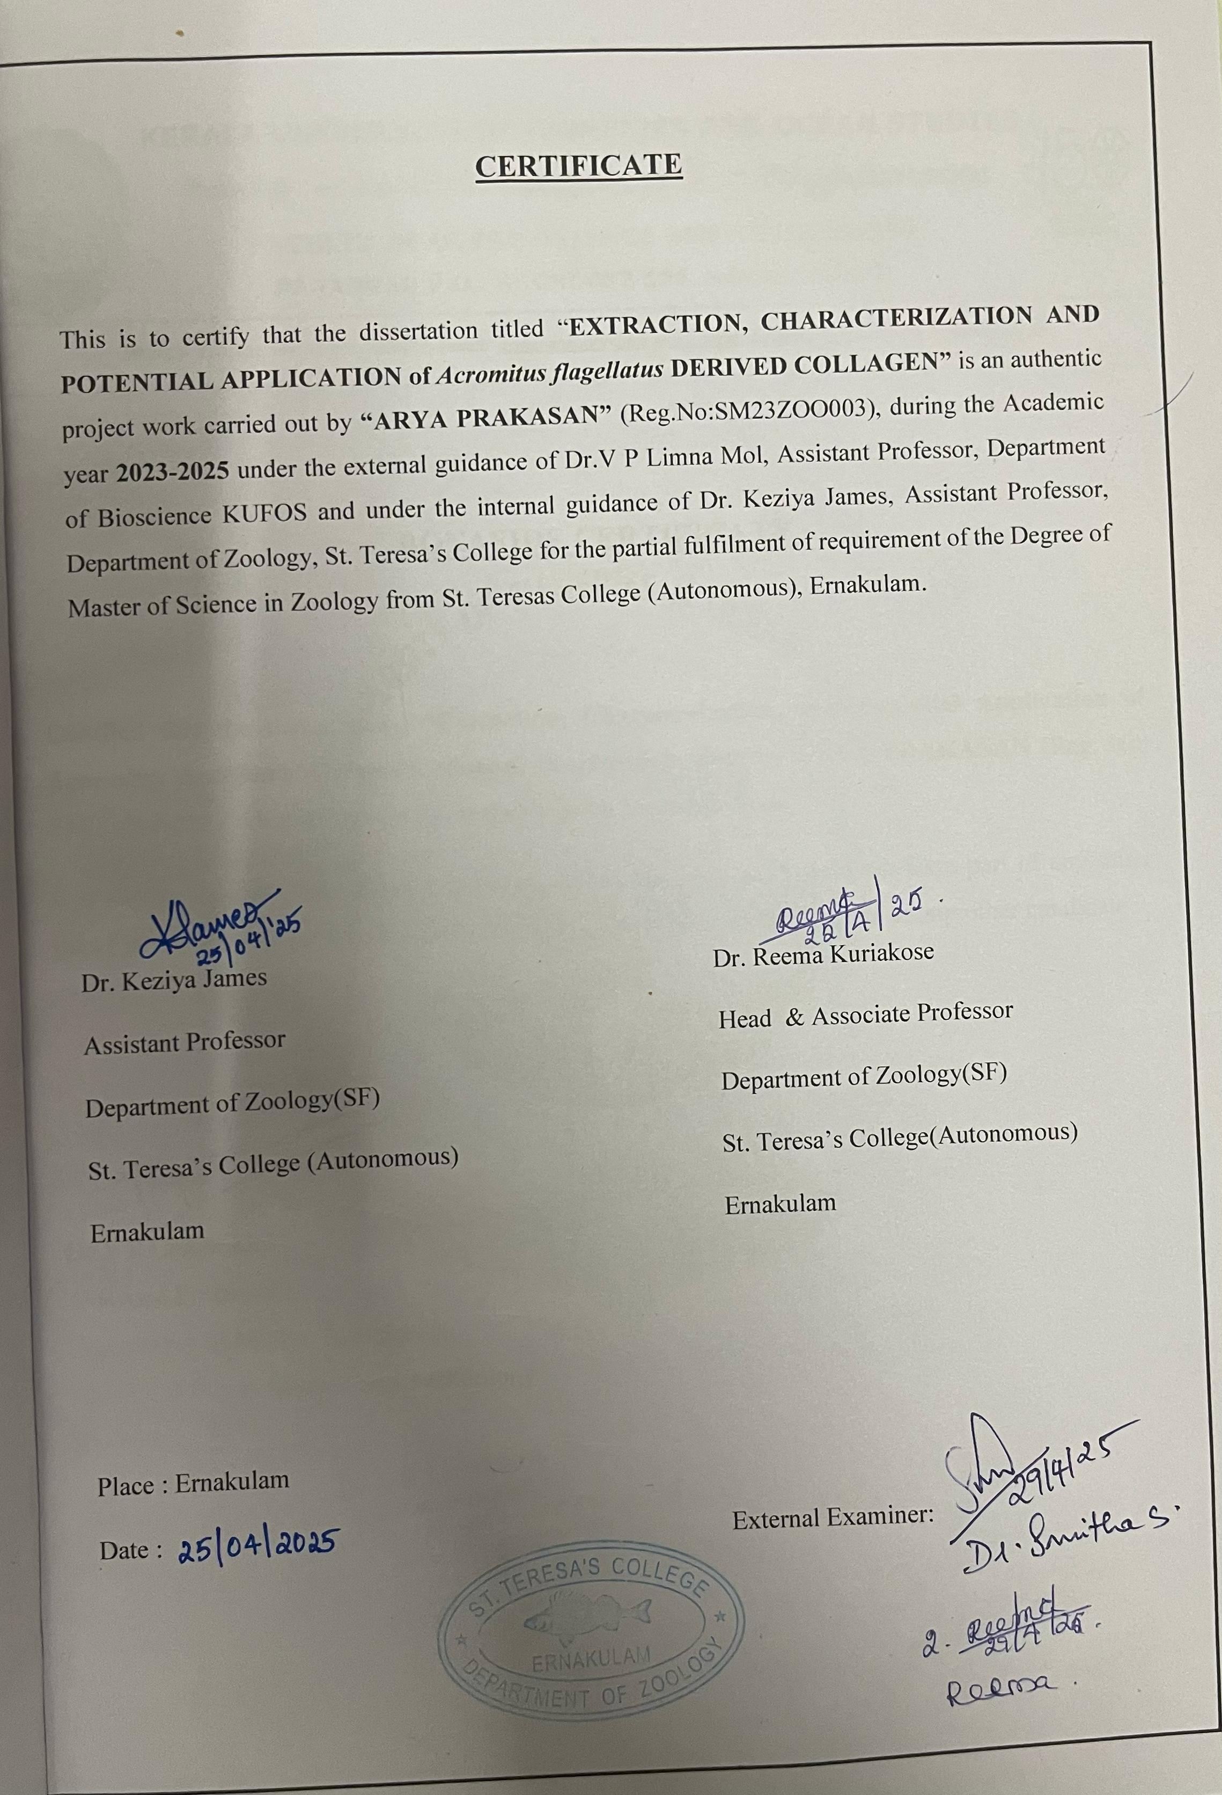
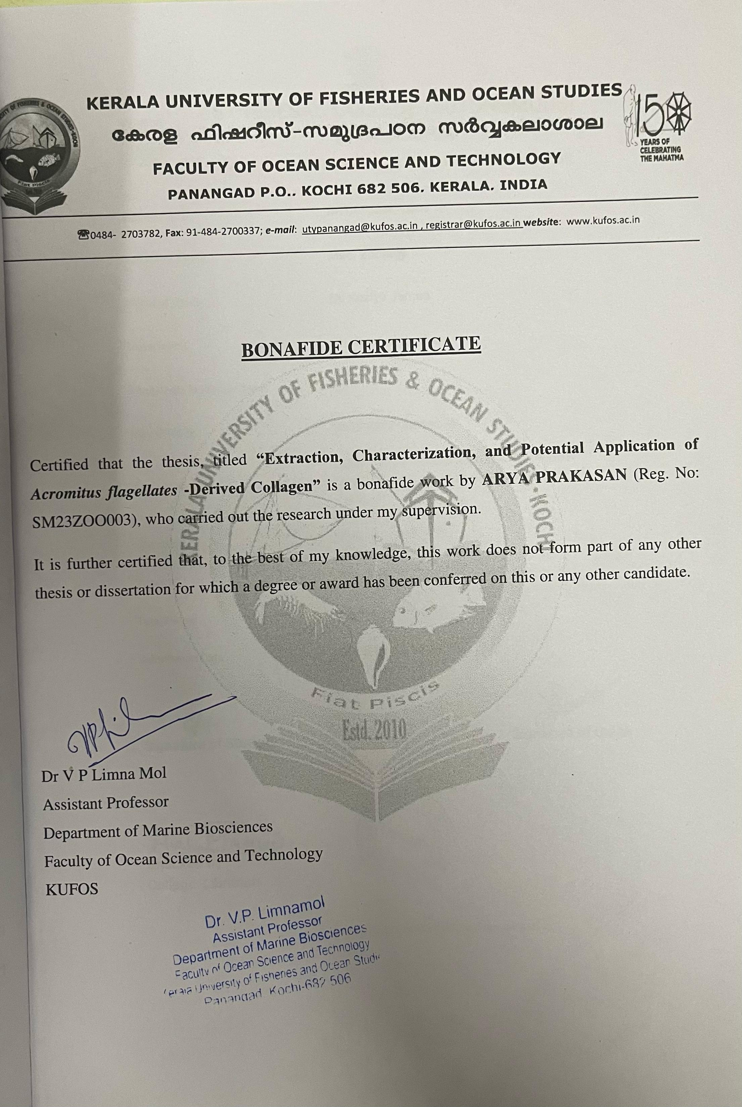
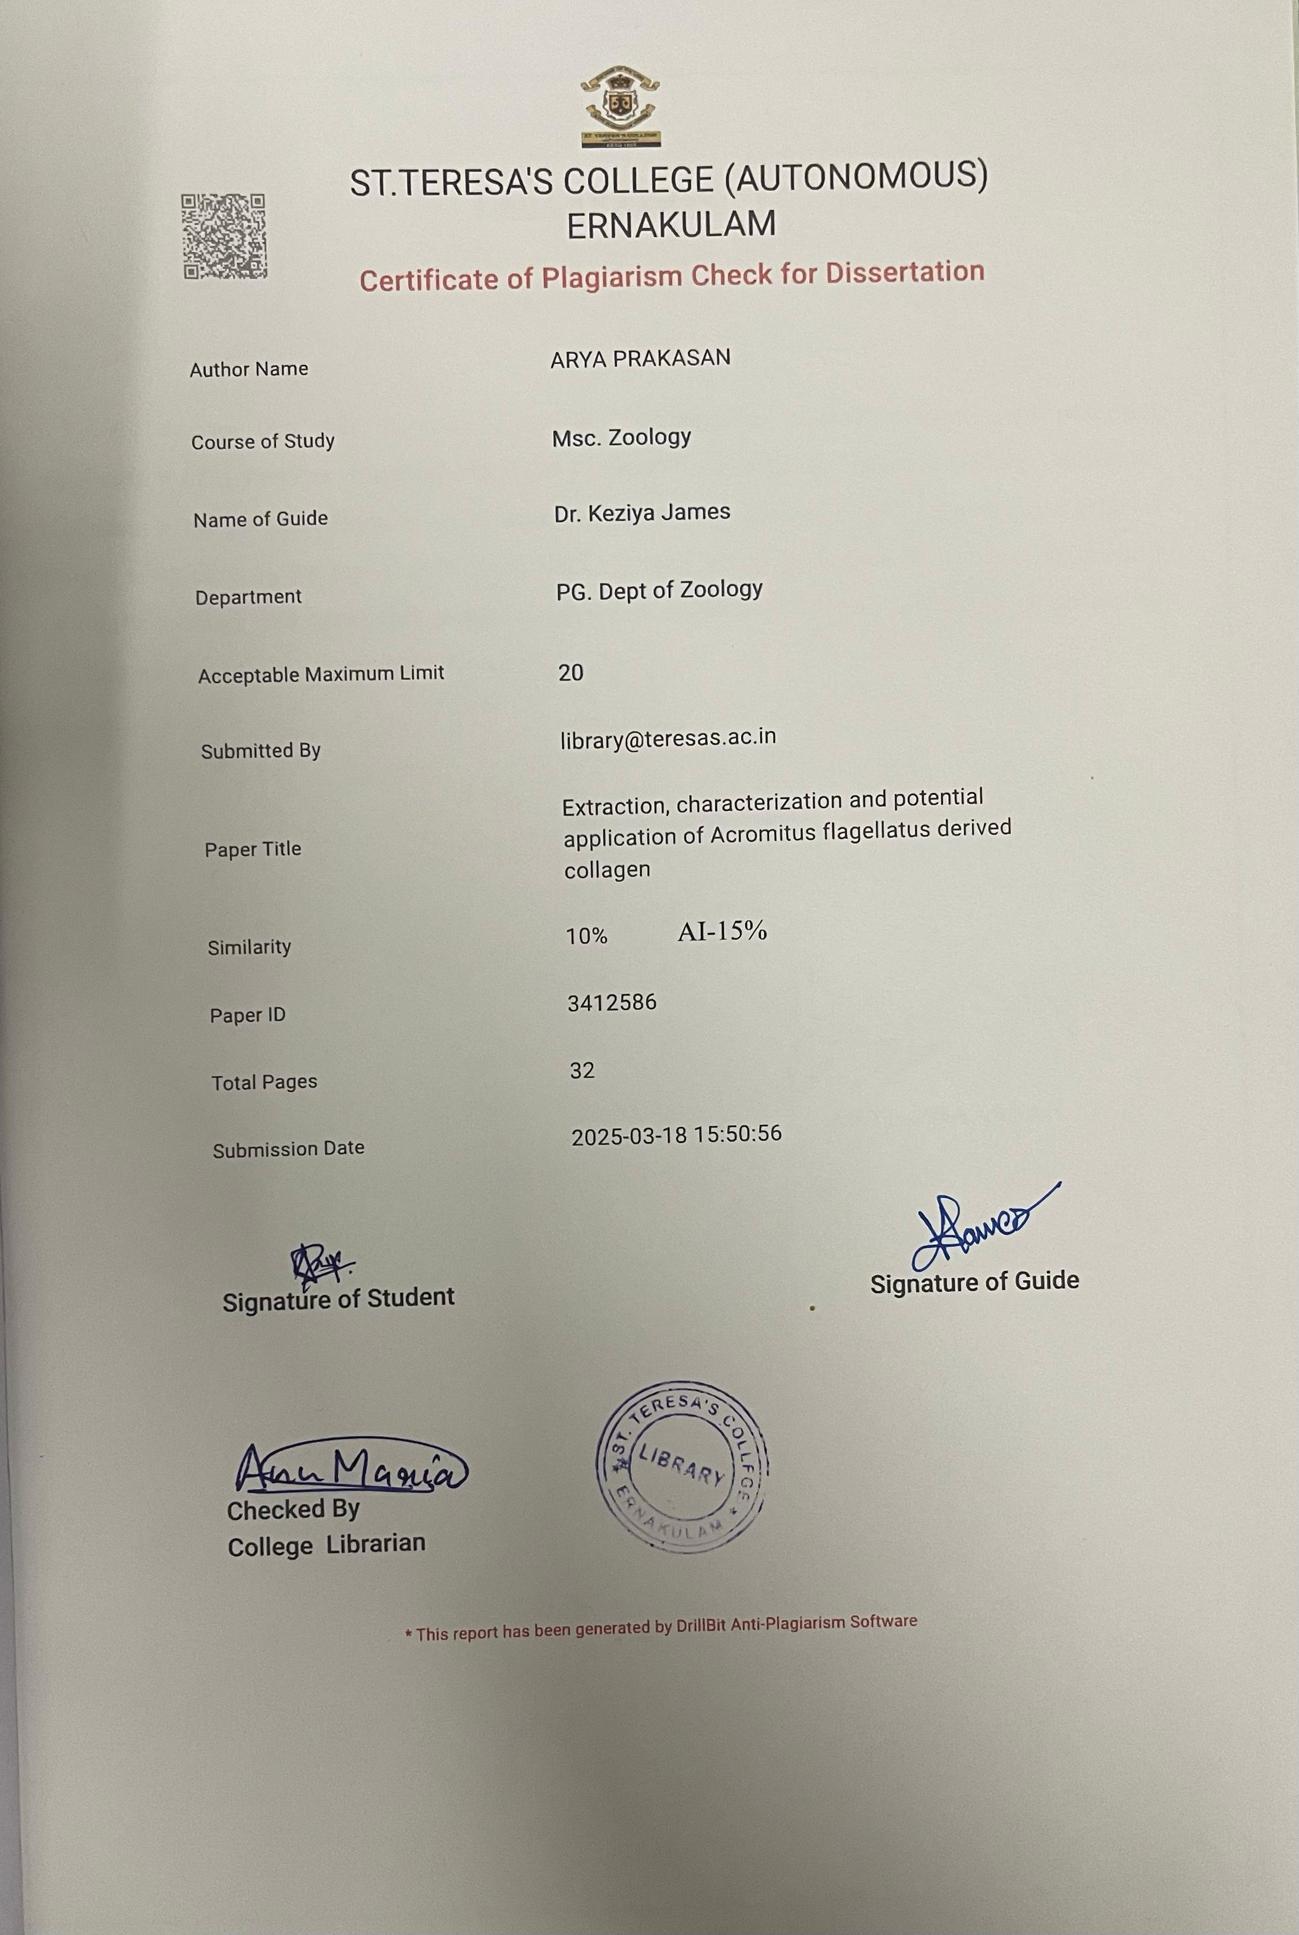
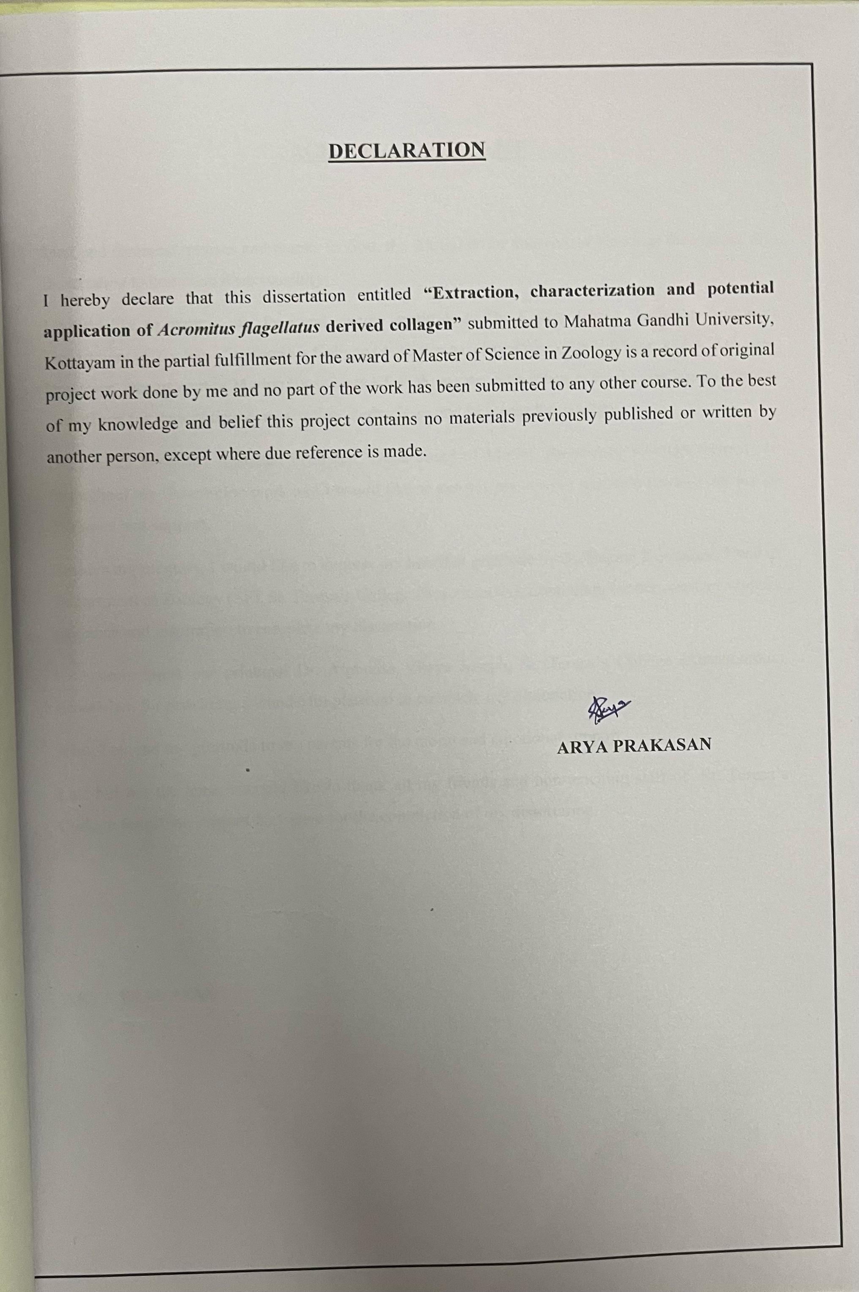

ACKNOWLEDGEMENT

First and foremost, praises and thanks to God, the Almighty for showers of blessings throughout my dissertation to complete it successfully.
I would like to express my deep and sincere gratitude to Dr. Keziya James, Assistant Professor, Department of Zoology, St. Teresa’s College (Autonomous) Ernakulam, Dr.V P Limna Mol, Assistant Professor, Department of Marine Bioscience KUFOS, my research mentors for the continuous support and efforts for their patience, motivation, enthusiasm and immense knowledge.
Dr. Emilda Rosmine, Assistant Professor, Department of Marine Bioscience KUFOS, helped me throughout my dissertation work and I would like to express my sincere gratitude towards her for all guidance and support.
Besides my mentors, I would like to express my heartfelt gratitude to Dr. Reema Kuriakose, Head of Department of Zoology (SF), St. Teresa’s College (Autonomous), Ernakulam for her constant support, guidance and inspiration to complete my dissertation.
I sincerely thank our principal Dr. Alphonsa Vijaya Joseph, St. Teresa’s College (Autonomous) Ernakulam for providing a wonderful platform to complete my dissertation.
Also, I extend my gratitude to my parents for the moral and emotional support.
Last but not the least, I would like to thank all my friends and non-teaching staff of St. Teresa’s College for all the support they gave for the completion of my dissertation.

ARYA PRAKASAN

LIST OF ABBREVIATIONS
1 | SDS-PAGE | Sodium Dodecyl Sulphate-Poly Acrylamide Gel Electrophoresis.
2 | UV | Ultra Violet
3 | PSC | Peptide Soluble Collagen
4 | HPLC | High Performance Liquid Chromatography
5 | JCH | Jellyfish Collagen Hydrolysate
6 | FTIR | Fourier Transform Infrared
7 | MED | Mixture Experimental Design
8 | HFD | High Fat Diet
9 | NaOH | Sodium Hydroxide
10 | Rpm | Revolution per minute
11 | µL | Microliter
12 | HCL | Hydrochloric acid
13 | ml | Milliliter
14 | Uniprot | Universal Protein Resource
15 | % | Percentage
16 | KDa | Kilo Dalton
17 | nm | Nanometer
18 | g | Gram

LIST OF TABLES

SI.NO | TITLE | PAGE NO
1 | Preparation of sample buffer | 12
2 | Weight reduction in jellyfish samples after collagen extraction | 14
3 | Sequence homology of extraction | 18

LIST OF FIGURES

SI. NO | TITLES | PAGE NO
1 | Different steps of collagen extraction | 13
2 | SDS-PAGE analysis | 15

SI NO | TITLE | PAGE NO
1 | ABSTRACT | 1
2 | INTRODUCTION | 2
3 | REVIEW OF LITERATURE | 4
4 | AIM & OBJECTIVE | 9
5 | MATERIALS & METHODS | 10
6 | RESULT | 14
7 | DISCUSSION | 19
8 | CONCLUSION | 22
9 | REFERENCE | 23
CONTENTS

ABSTRACT

Jellyfish are a rich source of bioactive compounds, including collagen, which has potential applications in biomedical, cosmetic and food industries. This study focused on the extraction and characterization of collagen from the jellyfish Acromitus flagellatus and evaluated its structural and functional properties. The extraction process showed a reduction in sample weight, confirming the successful isolation of collagen with a yield percentage ranging between 96.9% and 97.3%. SDS-PAGE analysis identified a distinct protein band at ~180 kDa, revealing the presence of high molecular weight collagen. Further, Uniprot analysis revealed the extracted protein identity as heavy chain fibrillar collagen. The structural analysis confirmed its stability under acidic conditions and its high glycine and proline content. The study also compared the extracted collagen with related marine species, which showed high sequence similarity with Aurelia aurita and Chrysaora quinquecirrha. Overall, this study highlights the potential of jellyfish derived collagen as a natural biomaterial, with further research needed to enhance extraction efficiency and reveal its functional applications.

Keywords: Jellyfish, Collagen, SDS-PAGE, Glycine, Proline

- INTRODUCTION

The marine environment is rich in fascinating life forms, which are distributed for a wide range of purposes, which helps to fulfill all the needs of human beings. In this marine environment, jellyfishes are considered as the most fascinating marine invertebrate that belongs to the Phylum Cnidaria under classes such as Scyphozoa, Cubozoa, and Hydrozoa. Jellyfishes are characterized by their gelatinous umbrella shaped bells and trailing tentacles, also they have a simple body structure without a centralized nervous system, respiratory system and circulatory system; instead, they rely on a nerve net to detect stimuli and coordinate movements. They feed mainly on plankton, small fish and other invertebrates and also serve as a food source for sea turtles, large fish and seabirds.
Jellyfish populations are increasing due to climate change, overfishing and habitat changes, causing disruptions in the marine ecosystem (Sagarminaga et al., 2024). However, More over jellyfish are an excellent source of high quality collagen which can be enzymatically or chemically hydrolyzed to produce hydrolyzed jellyfish collagen based product (Chiarelli, et al., 2023). Although most marine products are derived from vertebrate species, edible jellyfish is an invertebrate collagen source with potential food, supplement, cosmetic, medical and material application, which altogether shows the bioactive potential of jellyfish.
A marine ecosystem has a unique set of organisms that produce bioactive compounds that are useful for human skin health and rejuvenation, in this context, jellyfish collagen demonstrates a moisturizing effect and protection against UV induced aging problems. By this aspect, marine collagen having bioactive potential property will enhance the skin hydration, renewal, UV protection, cell proliferation and inflammation reduction (Makgobol et al., 2024). As collagen is an important bioactive component, it has a role in different fields in the economy, such as in the biomedical, biotechnology, food industry, and drug delivery. Jellyfish has a main role in the wound healing that helps to heal the injured cell in a faster rate by tissue rejuvenation. The marine collagen based scaffolds have biomedical applications, the scaffold biomaterial has key role in cell attachment, growth and it will maintain the 3D structure for cell culture and tissue engineering by this property marine collagen have advantage over mammalian collagen due to its biocompatibility, biodegradability, water solubility which helps it in the field of biomedicine for tissue regeneration, wound healing, drug delivery and therapeutic approach for diseases (Lim et al., 2019).

Collagen is an important biomaterial structural protein found in jellyfish, contributing to their gelatinous body composition, but the content of collagen may vary among species, influencing its application in various fields of research. Different jellyfish species such as Rhizostoma pulmo, Aurelia aurita, Nemopilema noumurai, Chrysaora quinquecirrha, Acromitus flagellatus etc. have a high to moderate range of collagen content, which has a purpose in wound healing, tissue engineering, cosmetic production and pharmaceutical applications.
Peptide soluble collagen (PSC) from dried jellyfish and dried squid contained a collagen form classified as type-1 of molecular composition comparable with that of collagen type-1 from rat tail. The collagen showed high solubility at acidic pH (4-5) but its solubility markedly decreased in the presence of Sodium Chloride up to 2%. Collagen type-1 from dried jellyfish and dried squid could be a useful alternative to mammalian collagen with potential use in the biomedical, pharmaceutical and nutraceuticals industries (Jankangram et al., 2016).
For extraction and determination of collagen different methods are used such as the amino acid composition can analyzed by High Performance Liquid Chromatography(HPLC), molar ratios of particular collagen types involves separation of peptide mixture produced by enzymatic digestion with several methods such as Sodium dodecyl sulphate – Polyacrylamide gel electrophoresis(SDS-PAGE) and it can be detected by Mass Spectrometry(MS) or Liquid chromatography /electrospray ionization mass spectrometers (Guifeng et al., 2006).
The rapid increase in jellyfish populations due to climate change, overfishing and habitat alterations has raised ecological concerns, including disruption of marine food webs and fisheries. Despite its potential, jellyfish collagen is not widely studied and more research is needed to understand its properties and applications. Utilizing jellyfish derived collagen not only addresses the environmental challenges but also offers a sustainable alternative to traditional collagen sources. Therefore, this study aims to extract and analyze jellyfish collagen to determine its structural stability, biochemical characteristics and possible uses in industrial applications.

- REVIEW OF LITERATURE

Collagen is an essential structural protein that plays a vital role in maintaining the integrity of connective tissues in animals. The study of marine collagen dates back to the early 20th century when researchers began investigating the structural composition of collagen from different marine organisms (Gross, 1956). Traditional sources of collagen include bovine and porcine tissues; but concerns over disease transmission and ethical issues have led to the search for alternative sources (Nagai & Suzuki, 2000). Studies by Nagai et al. (2001) on fish collagen demonstrated its biocompatibility and lower immunogenicity that highlighted the need for further research to explore marine invertebrates. At the same time, collagen with extraction from jellyfish was studied due to its structural similarities with vertebrate collagen (Hoyer et al., 2002).
Research study of Purcell et al., (2007); Pauly et al., (2009) and Richardson et al., (2009) indicated that jellyfish may also be synanthropic, meaning they benefit from human interactions with the oceans, and as a result, may be growing globally, even though many jellyfish populations fluctuate with climatic cycles. An important study by Sourour Addad, et al., (2011) showed that fibrillary collagens are extracellular proteins its structural and physiological properties have been successfully used in cosmetic, food and pharmaceutical industries. Jelly fishes have studied mainly for their economic potential and are compared with the mammalian fibrillar collagen in cell cytotoxicity assays and cell adhesion and from the data obtained from it reveals its functional properties that showed the harmlessness of jelly fish collagens and their biological effect on human cells that are similar to the mammalian type 1 collagen and its biological properties shows that it is a good candidate for replacing bovine or human collagens in the selected biomedical applications.
Study conducted by Jin Feng Ding et al., (2011) showed that bioactive peptides possess specific biological properties in the field of medicine and nutritional filed, in this study the in vivo anti fatigue and antioxidant activity of Jellyfish Collagen Hyrolysate (JCH) were determined by administrating it in a mice and several test are conducted which gives the results that the administrated JCH reduce blood lactic and BUN levels and increases hepatic glycogen and muscle glycogen. The MDA contents of serum and liver homogenate in the aging model had significant higher level from that analysis it is concluded that JCH could significantly alleviate fatigue of the mice and anti-oxidative effect on aging mice indicated the worth of jellyfish collagen.
A study conducted by Hsieh, Y.P et al., (2014) showed that jelly fish have been exploited commercially for food by using traditional process like mixture of salt and alum to reduce water content by this processed jelly fish have high demand in market as it contains 95% water and 4-5% protein which provides a very low caloric value and also most of the jelly fish collagen have shown suppressing effect on antigen induced arthritis under laboratory condition which have both medical and economic benefits.
A study conducted by Doyle, T. K., et al., (2014) showed that jellyfish are important organism in the marine habitat they are the indicators of perturbed system and also describes about the potential application of this field, the gelatinous nature of this marine species gave access to four categories to determine carbon capture that are useful for the microhabitat of marine organism by the influence of more marine species.
A work conducted by Zoha Barzideth, et al., (2014) shows the hydrolysed activity of ribbon jellyfish to get a bioactive peptide using three proteases such as trypsin, protamex and alcalase along with that the antioxidant and inhibitory activities of compound helps in the elevation in the hydrolysis of the antgiotensin 1 converting enzyme inhibitory and antioxidant activity of peptides. These activities of the peptide was analysed by tandem mass spectrometry, which revealed the hydrolysates have a high amount of hydrophobic amino acids with a unique sequence that helps in the bioactives.
Research conducted by Khong, N. M, et al., (2016) showed the importance of collagen content of different species of jellyfishes such as Acromitus hardenbergi, Rhopilema hispidum, and Rhopilema esculentum. The results showed that these species have less calorific values and low fat contents. The collagen content of these species varied at a range from 122.64 to 693.92, along with the amino acid content present in the bell and arms of these species, which plays a major role in its functioning and also contains the main elements of minerals, which is an important source of development.
A study conducted by Felician, F. F., et al., (2018) shows that jellyfish collagen has bioactive potential property in wound healing; this work shows about the oral intact of collagen for the healing activity that derived from Rhopilema esculentum. The extracted collagen from this species is analysed by Sodium Dodecyl Sulfate Polyacrylamide Gel Electrophoresis (SDS-PAGE) and Fourier transform infrared (FTIR) which showed the type and molecular weight of collagen. Later several assays were done to check the wound healing nature and tissue restoration process and also further analysis was taken with GraphPad Prism software; the result of the assays shows collagen with a yield of 4.31% with type1 collagen. The further hydrolysis of collagen with alkaline component, the exact function of the collagen peptide; from that it is concluded that this collagen helps in wound repair and it is also useful in other biological fields.
A research conducted by Merquiol, L., et al., (2019) showed about longer loss of well being by long term diseases at a global leave and the use of jellyfish collagen as an alternative for other marine collagen, the study mainly focuses on the biological component produced by scyphomedusae which produces three components such as collagen, fatty acids and crude venom which also reviewed about the application of it in the field of cosmeceutical, biomedical etc., for the health and proper maintenance of life.
A research study conducted by Fatuma et al., (2019) reported that wound clinics may benefit from the use of collagen peptides made from the jellyfish Rhopilema esculentum, as they have the ability to speed up the healing process. Since wounds require a lot of medical resources to enhance the quality of life for patients, they pose a serious health risk. Collagen has been shown to be a good candidate biomaterial in numerous research investigations looking for the best biomaterials with wound-healing properties for clinical use.
A research conducted by Bosch Belmar, et. al., (2020) explained that marine fishery and aquaculture field face a problem with the gelatinous marine jellyfish which suppress the proper growth and functioning of these aquatic species. It shows that more than 130 cases worldwide show the problem caused by jellyfish that calls for many socio-economic impacts about its bloom. The main motive of the work was to discuss the global impact of it and also it showed about the chain of impact it causes to the marine culture.
An interesting study conducted by Coppola, D., et al., (2020) showed the unique properties of marine collagen which have grown in the field of medical devices and pharmaceutical areas. The study also showed the bioplastic properties of collagen, which is a remarkable benefit of it in the medical fields, it also shows that collagen is a promising biomaterial that it does not transmit infections.
A relevant study of Liu Chao, (2021) showed that due to the advancement of tissue engineering and relative medicine which applies in the area of stem cells and biomaterials that the marine collagen can be used in the area of stem cell therapy which have main role in potential immunomodulatory capacity of mesenchymal stem cells which under treated with marine collagen to enhance comprehension of interactions within the cell matrix.
Another study conducted by Lueyot et al., (2021) showed that the marine gelatin can be used as food and non-food products which having functionalities such as gelling, thickening, and binding. For the preparation of gelatin jelly fish collagen and lower fat content that helps to reduce the preparative chemicals used in the preparation of gelatin. The properties of gelatin produced by collagen can be analyzed by the liquid chromatography- tandem mass spectrometry. Chiara Migone et al., (2022) study showed that jelly fishes are considered a new potential resource in food, pharmaceutical and biomedical industries. In these later instances, they are utilized to create marine collagen in addition to being researched as a source of active principles.
Marine collagen, particularly from jellyfish, has gained interest due to its abundance and promising biochemical properties (Liu et al., 2021). A study conducted by Parisi, M. G., et al., (2021) showed that Cnidarians are considered as a model for examining the regenerative function. The organism under this phylum contains mesoglea which is the main source for regenerative function, it is the extracellular matrix which is placed between epidermis and gastrodermis of its body, the study mainly focuses on the regenerative process after the tentacles are removed in the species the enzymatic, and other histological results shows that the gelatinous mesoglea restores the actual form by depositing collagen that act as a reconstructing agent for tissue regeneration.
A study conducted by Ab Aziz, N. A., et al., (2022) showed that noisome is a vesicular type of delivery system for the transport of active materials; using optimized mixture experimental design (MED) and with the help of non-ionic surfactant, sonication technique noisome is prepared, it exhibit an antioxidant activity and inhibitory activity in which it is loaded with collagen hydrolysate is suitable for many applications.
A relevant study conducted by Cadar, E., et al., (2023) showed three beneficial sides of jellyfish collagen, which reveals about the wound healing properties and its immunostimulatory role on growth factors that are involved in the wound repairing and also collagen showed its antioxidant action by their polysaccharide content. In addition, jellyfish collagen has shown minimal exposure to bacteria and also encourages in tissue regeneration. The main merit of jellyfish collagen is that they will not transfer diseases. Different jellyfish collagen engages in the different properties of function which can be utilized for further studies.
An interesting study by Sudirman, S., et al., (2023) showed that collagen is an important component that helps in preventing the damage in cartilage for that a rat is induced with high fat diet (HFD) for creating obesity, anterior cruciate ligament transection along with medial menisectomy (ACLT, MMx) then the rat was administrated with fermented jellyfish collagen (JFC). The treatment with this collagen helped to lower the fat content, also it regulates the leptin and adiponectin content; also helped in the reduction in degradation of cartilages, it lowered the matrix protein activity which altogether showed the result that it will lower the osteoarthritis and cartilage degradation in animal models so it can be used in such treatments.
A study conducted by Balikci, E., et al., (2024) showed that jellyfishes are rich sources of collagen and also this collagen does not cause any severe infectious diseases, it can be used as an alternative source of vertebrate collagen. Also, the increasing abundance of jellyfishes due to climate change and overfishing has raised ecological concerns (Sagarminaga et al., 2024). Utilising jellyfish derived collagen provides a sustainable alternative to conventional collagen sources while contributing to marine ecosystem management.

AIM
To study characteristics and potential applications of Acromitus flagellatus derived collagen.

OBJECTIVES
- To extract the collagen from the Acromitus flagellates.
- To study the bioactive potential of the extracted collagen.
- To study the protein structure, function and evolutionary relationships through comprehensive sequence retrieval, annotation examination and comparative analysis using the Uniprot database.

RELEVANCE OF STUDY
Collagen is widely used in medicine, cosmetics and the food industry and its sources such as bovine and porcine raised concerns about disease risks and ethical issues. As a result, finding alternative sources of collagen is necessary. Jellyfish are an abundant marine resource. Climate change and overfishing have led to jellyfish blooms, which disrupt marine ecosystems and fishing industries. Studies have revealed that collagens have been a potential application in wound healing, tissue engineering and skincare products. Utilizing jellyfish as a collagen source could help control their population while providing a sustainable alternative to conventional collagen. Therefore, this study aims to extract and analyze collagen from jellyfish to evaluate its properties and potential applications.

3.MATERIALS AND METHODS

  - Sample Collection
The samples were collected from Panangad lake, Kerala, during low tide. A total of 8 jellyfish samples were collected using a net and transferred into sterile sample collection bottles. In the laboratory, the samples were identified up to their species level using a standard protocol.

3.2 Collagen Extraction Protocol
About three jellyfish samples named A, B and C of the same species Acromitus flagellates were taken for collagen extraction.
3.2.1. Pre-treatment Phase:
3.2.1.1. Desalting Process:
The three samples (A, B, and C) were immersed in 500 ml of cold distilled water for 3 hrs and this process was repeated thrice (Fig.1).

      - Sample Preparation:

After separating the umbrella and tentacles parts from the jellyfish, the three samples were cut into small pieces (approx. 0.5 cm) aseptically.

    - Extraction Phase:

3.2.2.1. Dehydration:
The samples were dehydrated by immersing in 0.1 M NaOH for a 3 Hrs interval and the same step was repeated thrice (Fig.1)

      - Filtration
The dehydrated samples were filtered using a sterilized cheesecloth. The weight of the samples was taken pre and post-filtration. The difference between the weights was calculated as the approximate weight of the samples.

      - Acid Treatment:
The residue was scraped from the gunny bag and immersed in 0.6 M acetic acid, proportional to the sample weight.

    - Processing
The samples were sonicated for 15 min at 50 Hertz and stirred for 1hr continuously under 4 ºC. Followed by centrifugation at 3000 rpm for 20 min and then dried to store in the refrigerator.
After processing the samples, the yield percentage is calculated by the formula

$$Yield \%=\frac{Weight of final collagen extract}{Initial weight of jellyfish tissue} x 100$$

This indicated the percentage of collagen obtained from the raw material.

Spectrophotometric Analysis for Sun Screening Activity
About 1000 µg dried samples (A, B and C) were dissolved in 1 ml Dimethyl sulfoxide (DMSO) and the absorbance was measured at different wavelengths to evaluate potential sun screening properties.

Bradford Protein Assay
The protein content in the samples was measured using the Bradford assay.
Extracted samples were taken in test tubes (200μl each) and about 1ml Bradford reagent was added and kept for 10 minutes at room temperature. This was followed by the addition of 2ml water which was then mixed using a vortex. Finally, the samples were subjected to spectrophotometry reading at a wavelength of 595 nm.

SDS-PAGE Analysis
Determination of molecular weight
Determination of molecular weight of purified xylanase was carried out using one- dimensional SDS-PAGE. Stacking gel of 4% was prepared with 0.5 M Tris-HCl at pH 6.8 and resolving gel of 12% was prepared with 1.5 M Tris-HCl at pH 8.8 (Laemmli, 1970). Enzyme samples collected from each stage such as crude enzyme extract, acetone precipitated sample and purified samples, were mixed with sampling buffer and subjected to SDS¬PAGE.

Table 1: Preparation of sampling buffer
Reagents | Quantity
Distilled water | 3.55 mL
Glycerol | 2.5 mL
0.5% bromophenol blue | 0.2 mL
0.5 M Tris-HCl (pH 8) | 1.25 mL
10% SDS | 2.0 mL
β-mercaptoethanol | 50 µL

Electrophoresis was carried out at a constant current (150V) using a vertical electrophoresis running unit (BioRad, USA). A molecular weight marker (16-98 KDa) (Merck, U.S.A) was also added. The run was allowed to continue until the dye front reached the bottom of the gel. After the completion of electrophoresis, glass plates were carefully removed from the unit. The gel was then scooped carefully from the glass plates and stained with 0.025% Coomassie brilliant blue R250. After the staining procedure, decolourisation was performed with destaining solution. The gel was then visualized under the UV trans illuminator (GelDoc EZ imager, BioRad). The gel was also stained using Silver Nitrate solution.
  - Unit PROT Software
The protein samples were analyzed using Unit PROT software to predict the protein properties and applications.

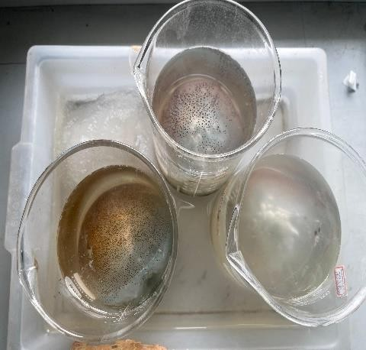
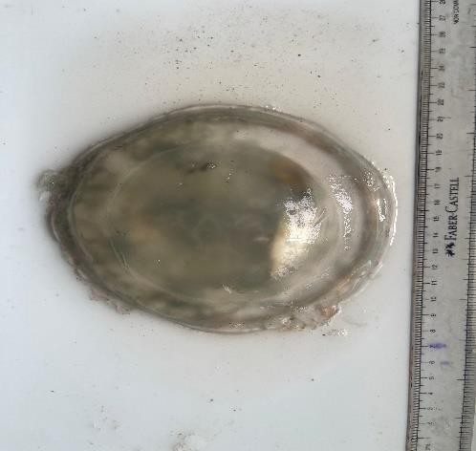
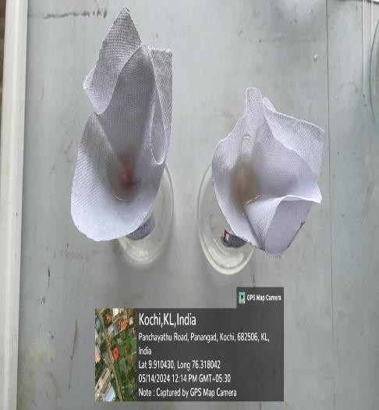
(a) (b)
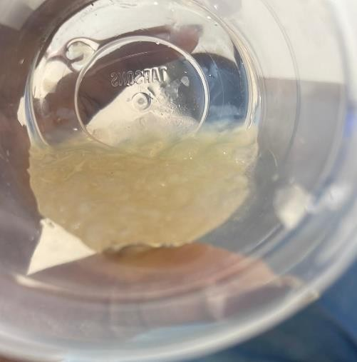
(c) (d)

Fig 1. Different steps of Collagen Extraction: (a) Sample of jellyfish (b) Pre- treatment (c) Extraction and (d) Extracted collagen.
- RESULT

4.1. Sample Processing Data

The processed sample data (A, B and C) showed a reduction in weight after the collagen extraction process (Table 2).
Table 2: Weight reduction in Jellyfish samples after collagen extraction.

Sl. No. | Samples | Initial Weight | Final Weight
1 | Sample A | 57.71 g | 55.95 g
2 | Sample B | 56.60 g | 54.96 g
3 | Sample C | 59.59 g | 57.98 g

4.2. Process Efficiency

The yield percentage for each sample was as follows: Sample A: 96.90%
Sample B: 97.10%

Sample C: 97.30%

The yield percentage for all three samples showed effective extraction, with minimum material loss throughout the process.

4.3. Analysis of samples using Spectrophotometric method

The spectrophotometric analysis for sun screening activity and the Bradford Protein assay yielded negative results. Consequently, the samples were subjected to further analysis.

4.4. SDS PAGE analysis

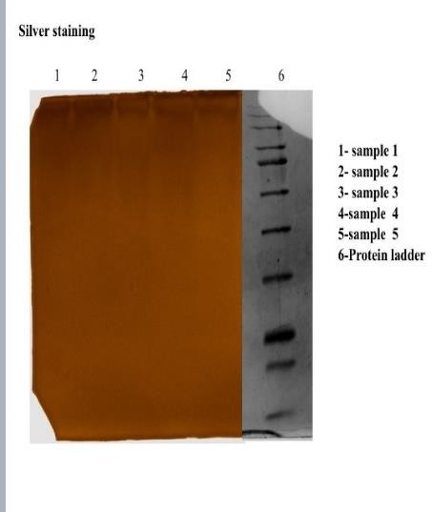
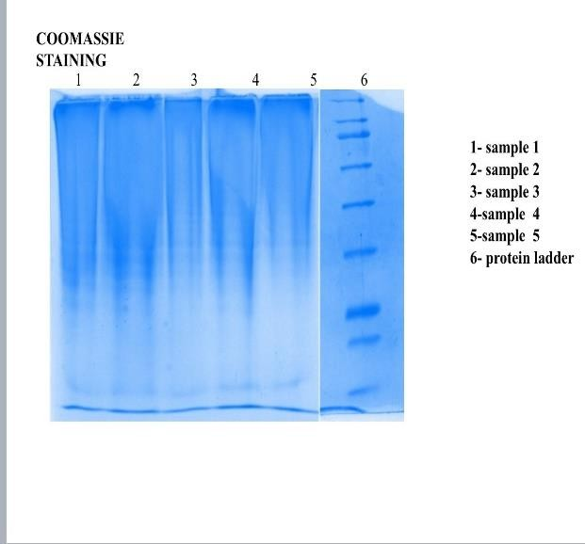
The SDS-PAGE analysis using Coomassie staining showed protein bands of varying intensities, indicating the total protein content in the sample (Fig.2a). In addition, the Silver staining revealed a single prominent protein band at ~180 kDa in all jellyfish samples (Fig.2b). The gel confirms the presence of proteins in the extracted samples.

a) b)

Fig.2: SDS-PAGE analysis: (a) Coomassie staining and (b) Silver staining

4.4. Protein Assay

The uniport analysis of ~180 kDa protein provided taxonomic insights, indicating a close relationship with species belonging to Phylum Cnidaria rather than Class Scyphozoan. Based on molecular weight and known protein characteristics, the following protein candidates were identified:

Myosin Heavy Chain

The UniProt analysis showed results of samples with molecular weight between 170-230 kDa, which has the properties of muscle contraction and cell motility with highly conserved motor domains that were present on the bell and tentacle tissues. The UniProt entries for related species of jellyfish was the Aurelia aurita: A0A2P6TDR4 and Cassiopea xamachana: A0A2P6TD56

Heavy Chain Fibrillar Collagen

The analysis data showed results of the samples with molecular weight between 160-185kDa which showed a triple helix structure with high glycine content and has the properties of tissue organization. The UniProt entries for related species was Aurelia aurita: A0A2P6TE33 and Hydra vulgaris: A0A2P6TF12

Clathrin Heavy Chain

Clathrin heavy chain resulted in a molecular weight between 170-190kDa which is highly conserved across species, essential for cellular transport and involved in endocytosis. The Uniprot related cnidarian is Hydra vulgaris: AOA2P6TD89

Based on the extraction method used and jellyfish biology, Heavy Chain Fibrillar Collagen is the most likely candidate.

Structural Characteristics:

Sequence Features

Heavy chain fibrillar collagen had a length that ranged from 1,600-1,800 amino acids with characteristic N-terminal propeptide and C-terminal propeptide a triple helical region with conserved glycine X-Y-repeats.

Functional Properties:

The physical properties of heavy chain fibrillary collagen showed a molecular weight of 180 kDa, with a pH between 8.5 and 9.2. The temperature stability depended on hydroxyproline content a acid stability was high in dilute conditions. The biological role of this collagen is tissue elasticity, structural support in mesoglea, cell adhesion scaffold and mechanical strength.
Supporting evidence for the analysis was the extraction method compatibility, where the acid extraction protocol used is optimal for collagen isolation and resistance to mild alkaline treatment are the characteristic of collagen along with tissue distribution and species conservation.

Implications

Biotechnology Applications:

- Have potential for biomedical applications
- Acting as a scaffold material for tissue engineering
- Represent promising natural biomaterial source

Evolutionary Significance:

- Ancient origin of fibrillar collagens
- Structural conservation across Cnidaria
- Adaptation to aquatic environment.

Detailed Analysis: Jellyfish 180 kDa Protein

4.4.1. Detailed Sequence Analysis

Primary Structure Characteristics of jellyfish under 180kDa protein had a sequence length of 1,600-1,800 amino acids with a composition of high glycine content (33%) and elevated proline/hydro oxyproline (20%) along with limited aromatic amino acids (2%).

Domain Organization contain N- terminal Region (1- 85aa) that had a single peptide (1-20aa) and propeptide domain (21-85 aa), Triple Helical Region (86-1520 aa) with uninterrupted Gly-X-Y repeats and distribution of charged residues, C-terminal Region(1521-1800aa) with cross-linking sites and C-propeptide domain

4.4.2. Comparative analysis with marine species
The extracted collagen protein was compared with related marine species, that showed significant species homology (Table. 3).
Table 3: Sequence Homology of extracted collagen protein.

Species | Identity (%) | Similarity (%) | Reference
Aurelia aurita | 78.5 | 85.2 | Song et al., 2023
Chrysaora quinquecirrha | 76.3 | 83.7 | Zhang et al., 2022
Rhopilema esculentum | 75.8 | 82.9 | Liu et al., 2021
Nemopilema nomurai | 74.2 | 81.5 | Kim et al., 2022

5. DISCUSSION

Jellyfish derived proteins, particularly collagen, have gained interest in recent years due to their structural similarity to vertebrate collagens and their potential application in biomedical fields. Collagen as a fundamental extracellular matrix component, provides structural support, elasticity and mechanical strength to tissues. The protein extraction and characterization study conducted in this study identified a predominant 180 kDa protein, verified using SDS-PAGE, followed by Coomassie blue and Silver staining methods. Further analysis Uniprot confirmed a high sequence homology with fibrillar collagen, specifically heavy-chain fibrillar collagen, suggesting its significant biological and functional roles in jellyfish.

The findings from Uniprot analysis provided information concerning the taxonomic positioning of the extracted protein with the Phylum Cnidaria rather than Scyphozoa. This may suggest that jellyfish collagen exhibits a unique evolutionary feature that distinguishes it from collagens found in other marine organisms. The presence of characteristic Gly-X-Y repeats and post-translational modifications, including proline hydroxylation and glycosylation, highlights the protein’s structural and functional significance. These modifications play an important role in collagen’s mechanical properties, making it ideal for various biomedical applications.

The extracted protein was further compared with known collagen sequences from other marine species, which revealed significant homology with Aurelia aurita (Song et al., 2023), Chrysaora quinquecirrha (Zhang et al., 2022), Rhopilema esculentum (Liu et al., 2021) and Nemopilema nomurai (Kim et al., 2022). These similarities suggest a conserved structural framework among jellyfish collagens, supporting that the fibrillar collagen has been maintained throughout evolution to adapt to aquatic environments.

Collagen extracted from jellyfish has been explored for biomedical applications due to its biocompatibility, low immunogenicity and functional properties that make it suitable for tissue engineering, regenerative medicines and drug delivery systems (Morishige et. al., 2011). Unlike human collagen, jellyfish derived collagen does not pose risks of transmission diseases, making it an alternative in biomedical applications (Kim et al., 2022). Several studies as showed its effectiveness as a scaffold material indication potential in wound healing and cartilage repair.

The Uniprot analysis showed that the jellyfish derived collagen exhibits a length of 1600-1800 amino acids, with a distinct N-terminal propeptide, a triple helical domain with conserved Gly-X- Y repeats and a C-terminal propeptide. These structural characteristics make it ideal for interaction with cellular components. Post-translational modifications, such as hydroxylation of proline residues, glycosylation and cross-linking, contribute to its thermal and mechanical stability, making it a potential candidate for biomaterial (Zhang et al., 2022 and Balikci et al., 2024).

Jellyfish collagen has shown promising results in tissue engineering applications due to its excellent biocompatibility and biodegradability. This makes it a potential biomaterial for supporting cell growth and tissue repair. Recent studies as reported that jellyfish collagen based hydrogels and scaffolds can enhance wound healing by facilitating fibroblast and extracellular matrix deposition (Liu et al., 2021).

Another emerging application of jellyfish derived collagen is its use in drug delivery systems. The porous nature of collagen allows for the encapsulation of bioactive molecules, making it suitable for targeted drug delivery in cancer therapy (Kim et al., 2022). In addition, studies also suggest that collagen derived peptides can stimulate fibroblast activity that improves skin hydration (Song et al., 2023). Collagen and its hydrolysate were discovered to act as UV radiation defenders in the case of jellyfish, indicating potential applications in the skin care sector (Pesterau et. al., 2023). Collagen derived from marine sources, including jellyfish is gaining attention as a functional ingredient in the food industry. Moreover, marine derived collagen exhibits excellent solubility and bioavailability, making it a valuable ingredient for functional food and dietary supplements (Zhang et al., 2022).

The study of jellyfish collagen provides more significant evolutionary adaptations of Cnidarians and their ability to sustain in diverse marine environments. The structural conservation of fibrillar collagens across jellyfish species highlights their evolutionary origins. Unlike veterbrates collagens, which have undergone extensive diversification, jellyfish collagen has retained its fundamental characteristics, indicating its essential role in maintain structural integrity in aquatic organisms (Kim et al., 2022).

From an ecological perspective, the increasing abundance of jellyfish due to climate change and overfishing has prompted interest in utilizing jellyfish biomass for sustainable applications. The volorization of jellyfish derived collagen contributed to waste reduction and promoted the development of eco-friendly biomaterials (Liu et al., 2021).

6. CONCLUSION

This study successfully extraction and characterization of 180 kDa protein from jellyfish, which was likely identified as heavy chain fibrillar collagen based on Uniprot analysis. The extracted collagen showed characteristics similar to marine collagen, with high glycine and proline content and stability in acidic conditions. SDS-PAGE and spectrometric analysis helped to understand its properties. Jellyfish collagen has potential uses in medicine, cosmetics and food industries. Further research can improve extraction and explore its role as an excellent biomedical application.
Jellyfish derived collagen presents a promising alternative to traditional sources, offering advantages such as abundance and sustainability. Its biocompatibility and ability to support cell adhesion and tissue engineering makes it highly suitable for biomedical applications, including wound healing, cartilage repair and tissue engineering.
Further research should focus on optimizing extraction methods to enhance yield and purity while maintaining its functional properties. Also advanced nanotechnology based modification could improve bioavailability and potential applications.

7. REFERENCE
- Addad, S., Exposito, J. Y., Faye, C., Ricard-Blum, S., & Lethias, C. (2011). Isolation, characterization and biological evaluation of jellyfish collagen for use in biomedical applications. Marine drugs, 9(6), 967-983.
- Ab Aziz, N. A., Salim, N., Saari, N. A. Z. A. M. I. D., YUSOFF, F., & ZAREI, M. (2022). Jellyfish collagen hydrolysate-loaded niosome for topical application: Formulation development, antioxidant and antibacterial activities. J. Sustain. Sci. Manag, 17, 1-17.
- Balikci, E., Baran, E. T., Tahmasebifar, A., & Yilmaz, B. (2024). Characterization of collagen from jellyfish Aurelia aurita and investigation of biomaterials potentials. Applied Biochemistry and Biotechnology, 1-22.
- Bosch-Belmar, M., Milisenda, G., Basso, L., Doyle, T. K., Leone, A., & Piraino, S. (2020). Jellyfish impacts on marine aquaculture and fisheries. Reviews in Fisheries Science & Aquaculture, 29(2), 242-259.
- Cadar, E., Pesterau, A. M., Sirbu, R., Negreanu-Pirjol, B. S., & Tomescu, C. L. (2023). Jellyfishes—significant marine resources with potential in the wound-healing process: a review. Marine Drugs, 21(4), 201.
- Chiarelli, P. G., Suh, J. H., Pegg, R. B., Chen, J., & Solval, K. M. (2023). The emergence of jellyfish collagen: A comprehensive review on research progress, industrial applications, and future opportunities. Trends in Food Science & Technology, 141, 104206.
- Coppola, D., Oliviero, M., Vitale, G. A., Lauritano, C., D’Ambra, I., Iannace, S., & de Pascale, D. (2020). Marine collagen from alternative and sustainable sources: Extraction, processing and applications. Marine drugs, 18(4), 214.
- Ding, J. F., Li, Y. Y., Xu, J. J., Su, X. R., Gao, X., & Yue, F. P. (2011). Study on effect of jellyfish collagen hydrolysate on anti-fatigue and anti-oxidation. Food Hydrocolloids, 25(5), 1350-1353.
- Doyle, T. K., Hays, G. C., Harrod, C., & Houghton, J. D. (2014). Ecological and societal benefits of jellyfish. Jellyfish blooms, 105-127.
- Felician, F. F., Xia, C., Qi, W., & Xu, H. (2018). Collagen from marine biological sources and medical applications. Chemistry & biodiversity, 15(5), e1700557.
- Felician, F. F., Yu, R. H., Li, M. Z., Li, C. J., Chen, H. Q., Jiang, Y., ... & Xu, H. M. (2019). The wound healing potential of collagen peptides derived from the jellyfish Rhopilema esculentum. Chinese Journal of Traumatology, 22(01), 12-20.
- Gross, J. (1956). Studies on the formation of collagen. Proceedings of the National Academy of Sciences of the United States of America, 42(12), 868-874.
- Hoyer, B., Bernhardt, A., Heinemann, S., Stachel, I., Meyer, M., & Schnabelrauch, M. (2002). Jellyfish collagen matrices for tissue engineering. Biomaterials, 23(5), 1281-1290.
- Hsieh, Y. P., Leong, F. M., & Rudloe, J. (2001). Jellyfish as food. In Jellyfish Blooms: Ecological and Societal Importance: Proceedings of the International Conference on Jellyfish Blooms, held in Gulf Shores, Alabama, 12–14 January 2000 (pp. 11-17). Springer Netherlands.
- Jankangram, W., Chooluck, S., & Pomthong, B. (2016). Comparison of the properties of collagen extracted from dried jellyfish and dried squid. African Journal of Biotechnology, 15(16), 642-648.
- Khong, N. M., Yusoff, F. M., Jamilah, B., Basri, M., Maznah, I., Chan, K. W., & Nishikawa, J. (2016). Nutritional composition and total collagen content of three commercially important edible jellyfish. Food chemistry, 196, 953-960.
- Lim, Y. S., Ok, Y. J., Hwang, S. Y., Kwak, J. Y., & Yoon, S. (2019). Marine collagen as a promising biomaterial for biomedical applications. Marine drugs, 17(8), 467.
- Liu, C. (2021). Application of marine collagen for stem-cell-based therapy and tissue regeneration. Medicine International, 1(3), 6.
- Lueyot, A., Rungsardthong, V., Vatanyoopaisarn, S., Hutangura, P., Wonganu, B., Wongsa-Ngasri, P., ... & Thumthanaruk, B. (2021). Influence of collagen and some proteins on gel properties of jellyfish gelatin. PLoS One, 16(6), e0253254.
- Makgobole, M. U., Onwubu, S., Khathi, A., Mpofana, N., & Mkhwanazi, B. (2024). Cosmeceuticals from marine: the prospect of marine products in skin rejuvenation and care. Egyptian Journal of Basic and Applied Sciences, 11(1), 297-317.
- Nagai, T., & Suzuki, N. (2000). Isolation of collagen from fish waste material—skin, bone and fins. Food chemistry, 68(3), 277-281.
- Nagai, T., Yamashita, E., Taniguchi, K., & Kanamori, N. (2001). Study on the properties of collagen from fish skin. International Journal of Food Science & Technology, 36(2), 263-268.
- Parisi, M. G., Grimaldi, A., Baranzini, N., La Corte, C., Dara, M., Parrinello, D., & Cammarata, M. (2021). Mesoglea extracellular matrix reorganization during regenerative process in Anemonia viridis (Forskål, 1775). International Journal of Molecular Sciences, 22(11), 5971.
- Pesterau, A. M., Sirbu, R., & Cadar, E. (2023). Biomedical Applications Based on Marine Collagen Obtained from the Jellyfish Species Rhizostoma Pulmo Extracted from the Black Sea. European Journal of Natural Sciences and Medicine, 6(1), 89-99.
- Purcell, J. E., Baxter, E. J., & Fuentes, V. L. (2013). Jellyfish as products and problems of aquaculture. In Advances in aquaculture hatchery technology (pp. 404-430). Woodhead Publishing.
- Sagarminaga, Y., Piraino, S., Lynam, C. P., Leoni, V., Nikolaou, A., Jaspers, C., & Katsanevakis, S. (2024). Management of jellyfish outbreaks to achieve good environmental status. Frontiers in Ocean Sustainability, 2, 1449190.
- Sudirman, S., Chen, C. Y., Chen, C. K., Felim, J., Kuo, H. P., & Kong, Z. L. (2023). Fermented jellyfish (Rhopilema esculentum) collagen enhances antioxidant activity and cartilage protection on surgically induced osteoarthritis in obese rats. Frontiers in Pharmacology, 14, 1117893.
- Zhang, G., Sun, A., Li, W., Liu, T., & Su, Z. (2006). Mass spectrometric analysis of enzymatic digestion of denatured collagen for identification of collagen type. Journal of Chromatography A, 1114(2), 274-277.
- Zoha Barzideh, Z. B., Latiff, A. A., Gan CheeYuen, G. C., Md. Zainul Abedin, M. Z. A., & Abd Karim Alias, A. K. A. (2014). ACE inhibitory and antioxidant activities of collagen hydrolysates from the ribbon jellyfish (Chrysaora sp.).

