1
A Feminist Reading of ‘The Princess Diaries’ I and II: Liberal, Marxist and Post Structuralist Approaches

Project Report

Submitted by
Ann Jomon (Reg. No. SB22CE006 )
Under the guidance of
Ms. Neena George

In partial fulfilment of requirements for award of the degree
Of Bachelor of Arts
St. Teresa’s College (Autonomous), Ernakulam
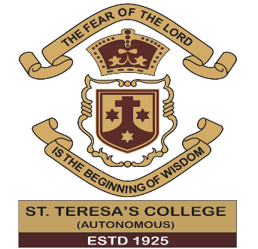
College With Potential for
Excellence Accredited by NAAC with ‘A++’
Grade
Affiliated to
Mahatma Gandhi University
Kottayam-686560
March 2025

A Feminist Reading of ‘The Princess Diaries’ I and II: Liberal, Marxist and Post Structuralist Approaches

Project Report

Submitted by
Ann Jomon (Reg. No. SB22CE006)
Under the guidance of
Ms. Neena George

In partial fulfilment of requirements for award of the degree
Of Bachelor of Arts
St. Teresa’s College (Autonomous), Ernakulam
College With Potential for
Excellence Accredited by NAAC with ‘A++’
Grade
Affiliated to
Mahatma Gandhi University
Kottayam-686560
March 2025

Declaration

I do affirm that the project ‘A Feminist Reading of The Princess Diaries I and II: Liberal, Marxist and Post Structuralist Approaches’ submitted in partial fulfilment of the requirement for the award of the Bachelor of Arts degree in English Literature and Communication Studies has not previously formed the basis for the award of any degree, diploma, fellowship or any other similar title or recognition.

Ernakulam Name: Ann Jomon
20/03/2025 Reg No: SB22CE006
B.A. English Literature and Communication Studies
St. Teresa’s College (Autonomous)

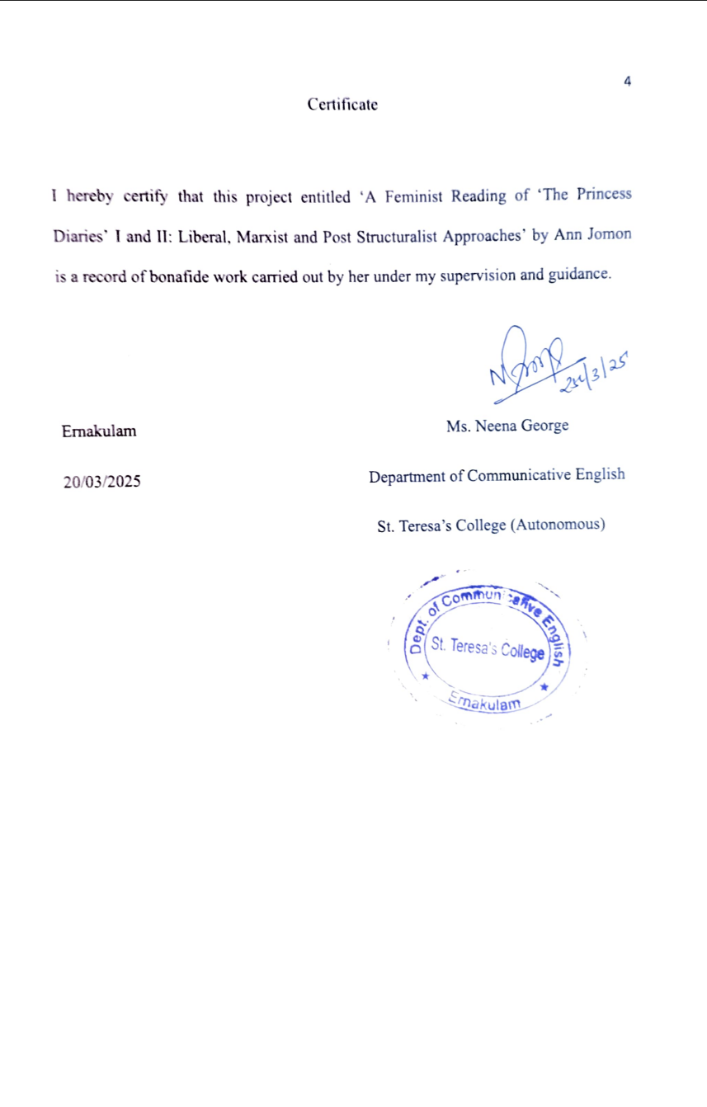
Acknowledgement

I take this opportunity to offer my humble prayers and thanks to God Almighty for His mercy and blessings for the completion of this project.
I am deeply grateful to Rev. Dr. Sr. Nilima, CSST, Provincial Superior and Manager, St. Teresa’s College (Autonomous), Ernakulam, for her kind cooperation and I am highly indebted to Rev. Sr. Tessa, CSST, Director, St. Teresa’s College (Autonomous), Ernakulam and Dr. Alphonsa Vijaya Joseph, Principal, St. Teresa’s College (Autonomous), Ernakulam for their unconditional support and encouragement during my course of study in this institution.
I am extremely grateful to Ms Allu Alfred, Head of the Department of Communicative English, St. Teresa’s College (Autonomous) for the valuable suggestions and guidance provided by her in fulfilling this project. I am profoundly indebted to my guide for her constant support and help for the successful completion of this project.
I am extremely thankful to my supervising guide, Ms Neena George, Department of Communicative English for her guidance and for all the teachers of the department for their valuable help rendered for the successful completion of this project.
Last but not the least, I wish to express my gratitude to my friends and family for their love and support.
Ann Jomon

Abstract
The problems faced by the protagonist Mia in the movie ‘Princess Diaries’ are very similar to the problems faced by women in general. For instance, men don’t like women in lead roles. A typical example would be movies with male leads are more in demand than movies with female leads. Another example would be till now not a single woman has got the chance to be the first female president of the United States of America. Women have become candidates, they contested. However, they never won the position of the President in America.
My objective in doing this research is to analyse how the movie Princess Diaries challenges traditional gender roles imposed on women. The methods that have been used for analysing the movie from a feminist perspective include Liberal Feminist Approach, Marxist Feminist Approach and Post-Structuralism.
This research paper finds that the Princess Diaries challenges patriarchal norms by depicting Mia’s initial subjugation to a marriage law that prohibits an unmarried woman from ascending the throne. This law reinforces traditional gender expectations, leaving Mia with no apparent alternative but to confirm through marriage. However, towards the end of the movie she speaks up and tells them she is ready to be their Queen without getting married. The people of the Genovian parliament finally agree to her demand and they abolish the marriage law which prohibits an unmarried woman from becoming the Queen. This shows that even women are capable of being good leaders. It also challenges the traditional notions of what it means to be a princess. Princesses are poised but on the other hand Mia is clumsy and awkward. But that doesn’t stop her from being the Queen that she is meant to be. To conclude, this project analyses the movie “Princess Diaries” from a feminist perspective using the Liberal, Marxist and post structuralist approaches.
Table of Contents

Chapter 1 7
Introduction 7
Chapter 2 5
Liberal Feminist Approach 5
Chapter 3 10
Marxist Feminist Approach 10
Chapter 4 14
Post Structuralist Approach 14

Chapter 1- Introduction

Coming of age stories are prevalent among today’s generation, as they evoke a sense of nostalgia . Coming of age genre focuses on the transformation of the protagonist from child to adult. Princess Diaries directed by Gary Marshall is a coming-of-age film. The film offers opportunities for feminist analysis. Some of the coming-of-age movies include the Lion King, Encanto, Frozen I and II, The Parent Trap and What a Girl Wants.
In the movie Lion King, Simba develops from a carefree cub into a responsible king after undergoing the loss, self-doubt and discovering his purpose. Some of the similar themes in Lion King and Princess Diaries are self-discovery, responsibility and guidance from mentors. Both Mia and Simba become responsible as they step up to leadership and both of them have mentors. Simba's mentors are Mufasa and Rafiki. Mirabel in Encanto grapples with self-worth in a family of magical individuals. However, in time she understands that her value is not defined by special gifts. The similar themes in the movie Encanto and Princess Diaries are finding one’s true worth, personal growth and family expectations. Mia and Mirabel both face pressure from their respected families and they realize that they don’t have to fit into others expectations to be significant.
Frozen I and II is a coming-of-age movie as Elsa and Anna journey through self-discovery, the meaning of familial bonds and personal fears. The similar themes in Frozen and Princess Diaries include self-acceptance, duty vs personal desires and familial bonds. In the movie The Parent Trap, two separated twin sisters reunite, journey through the family relationships and gain an understanding about love and identity. The similar themes in the movie Princess Diaries and Parent Trap include family reconnection, identity and transformation and newfound confidence. In the movie What a Girl Wants the protagonist Daphne journeys to London to find her father and grapples between her free-spirited self and aristocratic expectations. The similar themes in the movie Princess Diaries and What a Girl Wants include finding where you belong, balancing tradition and individuality and romance and self-growth.
Research Problem and Its Significance
The problems faced by the protagonist Mia are very similar to the problems faced by women in general. For instance, Men don’t like women in lead roles. A typical example would be movies with male leads are more in demand than movies with female leads. Another example would be till now not a single woman has got the chance to be the first female President of America. Women have become candidates, they contested. However, they never won the position of the President in America
Research Objectives
My objective in doing this research is to analyse how the movie Princess
Diaries challenges traditional gender roles imposed on women, using Liberal, Marxist, and post-modern feminist perspectives. This movie is an example which shows how popular media can contribute to challenging the prevailing gender norms. It challenges the gender norms that a woman can become a Queen even if she is not married. It shows that even women can become successful leaders. It challenges the prevailing gender norms about how princesses are supposed to be. It also fights against the oppression that patriarchy tries to impose upon it.

Scope
This research paper examines The Princess Diaries from a feminist perspective, focusing on three key areas. First, it explores the portrayal of female empowerment in the film, analysing how Mia's journey challenges traditional gender norms and highlights women's agency. Second, it investigates perceptions of beauty and societal expectations, addressing how the film critiques or reinforces conventional beauty standards imposed on women. Finally, it examines the representation of women in power, considering how the film presents female leadership and its implications for broader feminist discourse.
The movie portrays traditional gender stereotypes. Furthermore, there is a scarcity of diversity as the movie mainly focuses on white and upper-class characters. In addition to that, the movie has a basic approach to female empowerment as it does not show the struggles in female leadership, power dynamics and the real-life issues of governance. Also, it doesn’t dive deeper into the critiques of patriarchy.
A feminist analysis of the movie is approached through Liberal, Marxist and Post structuralist perspectives. Liberal feminism focuses on upholding women’s legal and political rights. Mia is forced to find a husband in one month otherwise she will lose her claim to the throne because of the marriage law. The law instead of safeguarding women is jeopardizing them. Initially she feels that she is left with no option but to conform to the law. However towards the end she fights back and changes the marriage thereby becoming the queen without a husband.
According to Marxist Feminism the main cause of women's oppression is Capitalism. Mia was living an ordinary middle-class life until her grandmother showed up and told her that she is a princess. After she officially becomes a princess there is a huge difference in her lifestyle. The main reason why she decides to accept her claim to the throne is because she feels that if she officially becomes the princess the voice of hers and the others who are much smarter than her could be better heard. She decides to get married to a guy that she doesn’t love so that she doesn’t lose her claim to the throne. So it is her desire for power and authority that made her take this decision.
Post Structuralism focuses on the subjective nature of meaning. Princesses are supposed to be very poise. Mia on the other hand is awkward and clumsy. It challenges the traditional notions of how a princess is supposed to be. However it does conform to some of the notions. Princesses are supposed to be beautiful. She undergoes a transformation to fit into the beauty standards. It challenges the traditional notions of how a princess is supposed to be.
This research paper is divided into five chapters, each covering a distinct aspect of the study. Introduction, provides background information, defines the research problem and its significance, outlines objectives, research questions and explains the study's scope and limitation, methodology overview and structure of the paper. Liberal feminist approach, talks about its origin in movies and literature and how the movie can be analysed from liberal feminist perspective including Mia’s transformation and how it challenges traditional gender roles. Marxist Feminist Approach gives details about its origin in literature and movies and how the movie can be analysed from Marxist feminist approach including how Mia’s initial status as an ordinary girl contrasts with her later royal identity. It also analyses the film's portrayal of class differences, particularly the contrast between Mia’s middle-class upbringing and her newfound royal status and it also examines how class influences Mia’s access to power and resources. Post Structuralism gives facts about its origin in movies and literature. It analyses how the film challenges the traditional notions of what it means to be a ‘princess’ highlighting the tension between traditional expectations and Mia’s individuality.
Chapter 2
Liberal Feminist Approach
The key source analysed for the research paper is "Political Discrimination Toward Woman in The Princess Diaries 2: Royal Engagement as a Feminism Study" authored by Vera Putri Ramadhanty and Yulistiyant coming from the Faculty of
Languages and Cultural Studies, Stikubank University and "The Princess Diaries 2:
Royal Engagement Through the Lens of Liberal Feminism" is written by Morgan
Croshal, Elizabeth Kresse, Angelee Valdez, Nelly Figueroa-Herrera, and Rylee Gonzales.
The paper "Political Discrimination Toward Woman in The Princess Diaries 2: Royal Engagement as a Feminism Study" talks about political inequity faced by Mia, the female protagonist in the movie Princess Diaries. It makes use of Kate Millet’s Sexual Politics theory which asserts that gender roles are politically arranged to favour men over women. The cause of this political discrimination is the Genovian law which prohibits an unmarried woman from becoming the Queen. One member of the parliament tries to replace Mia with his nephew Nicholas by making use of the discriminatory law. Political Discrimination is shown in the movie as Mia is forced to find a husband in thirty days to remain qualified for the throne. She has more claim to the throne than Napolean but she is considered unsuitable because she is unmarried. Queen Clarisse opposes this marriage law, asserting that if men can rule without marriage, then women should be able to as well. Mia tries to overcome this discrimination. She learns archery and horse riding as she prepares for royal duties. She urges the Royal Parliament to change the marriage law allowing women to rule without marriage. Queen Clarisse assists Mia by recommending for gender equality in leadership. The study calls attention to how political discrimination strengthens male dominance and limits women’s freedom. Women must acknowledge and claim their
rights to break free from societal constraints
Liberal Feminism
Liberal Feminism is an important branch of feminism which focuses on upholding women’s legal and political rights. The idea of liberalism was embedded in liberalism, a political ideology that supports the growth of freedom especially in political and economic spheres. Equal rights, equal opportunity, democracy and individual freedom are the key ideas of liberalism. According to Liberal Feminists, the main reason for women’s oppression is lack of political and civil rights. Liberal feminism focuses on the rights of individual women and through legislation they focus on granting equal access to equal rights and representation.Women liberation can be achieved by destroying the discriminatory practices and advocating for equal rights.
The liberal feminist approach in movies and literature originates from the broader liberal feminist movement which came out in the eighteenth and nineteenth centuries with the growth of enlightenment ideals promoting individual rights, equality and freedom
Origin in Literature
Liberal Feminist thought in literature is found to originate from the early feminist writers like Mary Wollstonecraft, Virginia Wolf and John Stuart Mill. Mary Wollstonecraft focuses on equal rights by insisting on women’s education and rationality in her work “A Vindication of the Rights of Women”. Virginia Woolf in her work “A Room of One’s Own” takes a look at women’s access to education and independence. John Stuart Mill in his work “The Subjugation of Women” promotes equal legal rights for women. These works set the base for liberal feminist themes in literature, which often describes women striving for independence, education, and equal opportunities within society.
Origin in Movies
With the growth of cinema in the twentieth century, liberal feminist ideas began appearing in films, especially with the second wave feminist movement of the
1960s and 1970s. Early Hollywood films mostly strengthen traditional gender roles. However afterwards movies started to reflect women’s empowerment and legal equality. The roles played by Katharine Hepburn in movies like Adam’s Rib show strong career-oriented women. Normae Rae depicted a working-class woman quarrelling for labour rights which corresponds with liberal feminist ideals. Erin Brockovich portrayed a real-life legal fight led by a strong woman protagonist, focusing attention on women’s agency within existing structures. Women’s access to education and careers, Legal rights and social reform and the significance of individual freedom and empowerment are the main themes in movies and literature that come under the liberal feminist approach.
Liberal Feminist theory challenges traditional gender roles. In the film Mia has more claim to the throne than Napolean but the marriage law of the Genovian parliament acts as a roadblock which says that an unmarried woman cannot become queen. But this marriage law is only applicable to women and not to men. An unmarried man can become king. The parliament gives her a time period of one month in which she has to find a husband. If she could not find a husband she would lose her claim to the throne. Therefore, she decides to do an arranged marriage and get married to a man whom she doesn’t love so that she does not lose her claim to the throne. However, towards the end she speaks up to the parliament and tells them that she is ready to be the Queen without a husband. The other heir to the throne understands that Mia can become a great queen, so he declines his claim to be the king. Then parliament gets persuaded by Mia’s monologue and the refusal of Napolean’s claim to the throne lead them to make the decision to abolish the marriage law. Finally, Mia becomes the Queen without a husband.
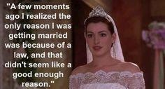

Chapter 3
Marxist Feminist Approach

Marxist Feminism is a subdivision of feminist theory which asserts capitalism as the major cause of women’s oppression. It was put forward by Karl Marx along with the collaborator Friedrich Engels by the 19th century. Marx showed how capitalism was allowed to grow via the misuse of labour. The high-class people based on economic conditions came under bourgeoisie and the low class came under the proletariat. The proletariat were laborers of the bourgeoisie. According to Marxist feminism, the fundamental cause of women oppression is classism rather than sexism. It argues that women are used by a capitalist society. Marxist feminist can be used to take a look at how the political economy is involving gender differences in late-stage capitalism. Marxist feminism can affect all individuals as class and capitalist system is considered to be the oppressor.
The main aim of Marxist feminist theory was to produce a classless society in which both the upper class together with the lower class are treated equally. By forming a classless society, the vision of Marx and Engels was to make sure that there was collective ownership along with the basic dignity of women in society.
Origin in Literature
Marxist feminism in literature started to take shape during the nineteenth and early twentieth centuries, affected by Karl Marx and Friedrich Engels theories. Especially the communist manifesto, the private property and the state and the origin of the family. According to Engels women’s oppression was associated to private property and capitalism which resulted in the gender division of labour. In literature writers like Charlotte Perkins Gilman analysed the economic dependence of women and Virginia Woolf evaluated women’s financial and intellectual oppression. By the 1970s, Marxist feminism turned into a formal literary approach, examining how capitalist economies strengthen patriarchal narratives in literature
Origin in Movies
In cinema, Marxist feminist perspectives started to come out during the 1960s and 1970s corresponding with the growth of second wave feminism and leftist film theories. The early Marxist feminist film theorists include Laura Mulvey and Claire Johnston. Laura Mulvey presented the concept of male gaze and criticised capitalist cinema for objectifying women. Claire Johnston asserted that Hollywood protected patriarchal myths and called for feminist counter cinema. Salt of the earth is an influential Marxist Feminist film. It is a groundbreaking movie that portrays female workers in labour strikes. By the Late 20th century, Marxist feminist themes got more well known in mainstream films, calling into question the intersection of gender, class and labour exploitation.
In the movie Princess Diaries Mia’s initial status as an ordinary girl contrast with her later royal identity. In the beginning of the movie, we can see that she lives an ordinary lifestyle with her mother who is an artist in a not so luxurious house. She was going to school by a skating board. This shows that she was living a middle-class
life.


In the portrayal of class differences there is a sharp contrast between Mia’s middle class upbringing and her new found royal status. Initially she was not much liked by her classmates. After her princess identity gets revealed her best friend Lilly tells Mia that everybody wants to be her best friend. The guy, Josh Bryant who she had a crush on asked her out. He was not initially nice to her. But after her princess identity got revealed, he acts like he loves her just for fame.

Even her best friend invites her as a guest for her Tv show. Physically also she is made to undergo a transformation to fit into the beauty standards of a princess. Her Grandmother Queen Clarisse teaches her on how to conduct herself like a princess including how to walk, talk, sit and greet people like a princess. After she officially becomes the princess, we can see that there is a drastic change in her lifestyle. She was given a luxurious suit that was designed specifically for her by her grandmother Queen Clarisse. She is given a huge walk-in wardrobe with a lot of clothes, footwear and expensive jewellery in it. She is also given two maids. The way her maids greet her shows the class difference. When she decides to find a husband, her list is confined to royalty alone which highlights class differences.
Class influences Mia’s access to power and resources. She decides to officially be a princess because she thought that if she becomes a princess the voice of hers and the others who are much smarter than her could be better heard. She thinks that if she has power, she could help other people. During the big annual parade of the Independence Day of Genovia princess Mia notices an orphan girl who was being bullied by some boys. She stops the parade by walking towards the children. She tells them that anybody can become a princess today and distributes tiaras to the orphan girls. Mia asks them to walk the parade with her. She decides to house those children at the winter castle which she planned to convert into a children’s shelter until money could be raised for their own. She decides to raise money for the project and appoints an architect to proceed with it.
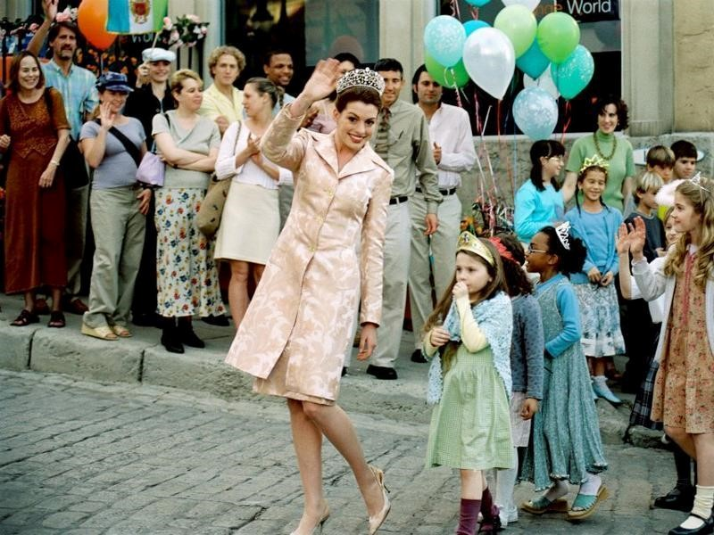

Chapter 4
Post Structuralist Approach

Post Structuralism is a philosophical and literary theory that questions the idea that meaning is fixed and stable. It claims that language texts and ideas can have dissimilar interpretations depending on context and individual perspectives of the people interpreting them. According to Post Structuralists there is no one accurate meaning for anything. Meaning always adapts or modifies and is dynamic based on how we use language and how we experience the world. Post structuralist approach originated during the mid twentieth century as a response to structuralism, which wanted to recognize deep structures underlying texts, language and culture. Post structuralism challenged these hard structures, focusing attention on instability, ambiguity and the subjective nature of meaning.
Origin in Literature
Post structuralism emerged in literary theory and French philosophy in the 1960s and 1970s, inspired from thinkers like Karl Marx, Ferdinand Saussure,
Sigmund Freud and Friedrich Nietzsche. While structuralists like Roland Barthes and Claude Le’vi-Strauss examined texts found on universal structures, post structuralists refused the idea of a fixed meaning in texts. Key theorists include Jacques Derrida, Roland Barthes, Michael Foucault and Julia Kristeva. The key features in Marxist literature include Intertextuality, language play and Self reflexivity. Intertextuality refers to text that makes reference to other texts. Self reflexivity accepts its fictionality. Language play questions fixed meanings. Post structuralism affected postmodern literature, focusing on unreliable narrators, fragmented narratives and paradoxes.
Origin in Movies
Post structuralist cinema developed during the late twentieth century, challenging authorship, conventional storytelling and reality. The characters of post structuralist films include Unstable narratives, Blurring reality and fiction and Meta-Cinema. Unstable narrative refers to broken, non-linear narrative. Meta-Cinema refers to films conscious of their artificiality. Some Influential Post Structuralist films include Last Year at Marienbad, Mulloholland Drive, and Truman Show. Last Year at Marienbad questions linear time and memory. Mulloholland Drive challenges identity, reality and narrative coherence. The Truman Show criticises media control over perceptions.
Usually princesses are supposed to be poised but Mia on the other hand is very clumsy and awkward which is contradictory to the traditional notions of how a Princess is supposed to be. Initially she has a bad posture, frizzy hair. During the princess lessons Queen Clarisse tries to fix her bad posture and gives her a makeover in which her frizzy hair is taken care of and transformed into beautiful silky straight hair. By getting the transformation done she is conforming to the traditional notions of how a princess is supposed to look like. During the princess lessons she is asked to wear heels and stockings. She starts to dress like a princess. However after she officially becomes a princess she can be seen violating the dress code of a princess a few times. Princesses are supposed to dress modestly and not wear anything more shorter than knee length. She was seen violating this dress code while playing tennis with Andrew and during her birthday party she was wearing a dress that was not modest. Princesses are also supposed to have good posture which is something Mia didn’t have initially. Queen Clarisse tries to correct Mia’s bad posture by using scarves while she was having food.
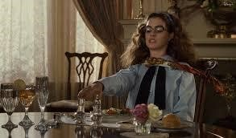

The film challenges the traditional notions of how a princess is supposed to be. According to the traditional notions, a princess is supposed to be rescued by her prince charming. But in Mia’s case she stands up for herself , she doesn’t wait for her prince charming to come and rescue her. She convinces the people of the Genovian parliament that she will become their queen without a husband. The people of the parliament agree to her demand and change the law and she becomes the queen.

Chapter 5
Conclusion
Princess Diaries is a coming-of-age movie that can be analysed from a feminist perspective. It challenges the traditional gender notions. It can be analysed from the Marxist, Liberal and Post structuralist perspective. According to Liberal Feminist approach sexism is the main reason for women’s discrimination and their main goal is equality in public and private sphere. Napolean who is the other heir to the throne is not affected by the marriage law. He can become the king whether he is married or not. Mia, on the other hand who has more claim to the throne is affected by the marriage law according to which an unmarried woman cannot become the queen. Initially she agrees to it as she feels that she does not have another option and decides to find a husband. However, towards the end she fights back and becomes the queen without getting married. According to Marxist feminism capitalism is the main cause for women’s oppression. There is a huge contrast with her initial status as an ordinary girl and her later royal identity. The movie portrays class difference, particularly the contrast between Mia’s middle class upbringing and her newfound royal status. As she decided to officially become a princess because she thought that if she becomes a princess the voice of hers and those who are smarter than her could be better heard. She decided to accept her claim to the throne for power and authority. After she becomes a princess, she does good deeds to those who are less privileged including trying to raise funds for the housing of orphan children. However there is class difference in the movie. She decides to get married to man whom she doesn’t love so that she doesn’t lose her claim to the throne. The movie can also be analysed from post structuralist perspective. The movie challenges the traditional notions of what it means to be a princess. Princesses are supposed to be poised which is contradicting with Mia’s clumsy nature. There isn’t much scope for further research on this paper.
Gender equity
The film subtly reviews gender inequity, especially in how Mia Thermopolis is at first perceived as not worthy of being a ruler because of her appearance and deficiency of confidence. The story, however questions this by showing her develop into a capable leader, strengthening the feminist idea that leadership qualities aren’t inherently gendered. The difference between male and female rulers in Genovia calls attentions to the expectations that placed on women in positions of power.
Mia’s Journey and Self-Discovery
At first insecure and unaware of her potential, Mia grapples with societal beauty standards and self-worth. Through her experiences she understands that being a princess is not about complying with the external expectations but about accepting her intelligence, inner strength and kindness.
Women Empowerment through Education and Self-Reliance
The film advocates for the empowerment that comes from self-awareness, knowledge and the ability to make informed choices instead of chasing external validation.
Societal Expectations vs Personal Choice
If the marriage law wasn’t there should wouldn’t have decided to do an arranged marriage. Later she overcomes the societal expectations and becomes the queen without getting married.
Role of Female Mentors
Her grandmother queen Clarisse guides her and doesn’t force her into anything. She motivates and encourages her each time she commits a blunder and thereby giving her confidence to move forward in life.
Bibliography
McLeod, Saul. “Liberal Feminism.” Simply Psychology, https://www.simplypsychology.org/liberal-feminism.html. Accessed [insert date].
StudioBinder. “What Is a Coming-of-Age Movie? Definition & Examples.” StudioBinder, https://www.studiobinder.com/blog/what-is-a-coming-of-age-movie-definition/. Accessed [insert date].
Oxfam. Feminist Principles: Gender Transformative Humanitarian Action. Oxfam Library,
2020, https://oxfamilibrary.openrepository.com/bitstream/handle/10546/621064/ogb-feminist-princi ples-091020-en.pdf?sequence=1.
McLeod, Saul. “Marxist Feminism.” Simply Psychology, https://www.simplypsychology.org/marxist-feminism.html. Accessed [insert date].
iPleaders. “Marxist Feminism: An Analysis.” iPleaders Blog, https://blog.ipleaders.in/marxist-feminism/. Accessed [insert date].
"What is Post-Structuralism? (Explained in 3 Minutes)." YouTube, uploaded by Then & Now, 1 Oct. 2017, https://www.youtube.com/watch?v=tqFgR3PP3sE.
Croshal, Morgan, et al. The Princess Diaries 2: Royal Engagement Through the Lens of
Liberal Feminism. Pepperdine Journal of Communication Research, vol. 8, 2020, pp. 1-12. Pepperdine University, https://digitalcommons.pepperdine.edu/cgi/viewcontent.cgi?article=1181&context=pjcr.
Ramadhanty, Vera Putri, and Yulistiyanti. Political Discrimination Toward Woman in The Princess Diaries 2: Royal Engagement as a Feminism Study.Stikubank University, 2021, https://www.unisbank.ac.id/ojs/index.php/fbib1/article/view/8381.

