TC222530W Reg. No:..................................
Name: ....................................

DIPLOMA EXAMINATION, MARCH 2023
(2022 Admission Regular and 2018, 2019, 2020 and 2021 Admissions Supplementary)
SECOND SEMESTER – COMMON COURSE (ENGLISH)
VHA2G03D18 - ENGLISH FOR COMMUNICATION II
(For Diploma in Health Care Assistance)
Time: 3 Hours Maximum Marks: 80
PART-A
I. Answer any 10 questions. Each question carries 2 marks.
- Explain how this mail is seen by A, B, and C:
to: editor@manorama.in (A), cc: james@gmail.com (B) bcc: principal@stc.edu (C) Sub: Poem for Publication.
(N.B.: Context: you have mailed your poem for publication to Manorama, with your English teacher, Mr. James as cc and your principal as bcc.)
- IRSF stands for- Initiate- _______(a)- Sustain- ________(b)
- Correct and rewrite the sentence (if necessary): “Myself Athira Mahesh. I am coming from Vypin.”
- Describe a celebrity in a sentence or two based on his/her qualities.
- “Are road accidents on a rise in Kerala in 2023?” is an example of _______ topic in G.D.
- What is meant by “References” in a CV?
- List any two barriers to listening.
- “Sub: Letter asking for leave yesterday as I went to hospital due to fever to meet the doctor.” Correct the Subject Line as required.
- What is the difference between “Chronological” and “reverse chronological” in a resume?
- List any two positive body language/gestures to be displayed during an interview.
- What does “Block Letters Only” signify in an application form?
- Is it ok to wear casuals for an interview? Why/Why not?
(10x2=20)
PART-B
II. Answer any six questions. Each question carries 5 marks.
- Match the following:
A B
a. Traditional interview: 1. Popular during the pandemic
b. Panel Interview: 2. Seems, but is never casual
c. Situational/Behavioural Interview: 3. Common interview questions
d. Telephonic/Video Interview: 4. Several interviewers are sitting to ask
questions to the interviewee
e. Interview during a meal: 5. Focussed on problem solving skills
- Attempt a telephonic conversation with a bank executive, enquiring to him/her about how to open a new zero balance account.
- You meet your friend after a long time. Construct a conversation between you and your friend. (Minimum 5 exchanges)
- You recently ordered an item via Myntra, but you got an entirely different product. Write an e-mail to the company:
-give details about the order you made
-explain what was wrong with the item
-tell the company what you want them to do about it
Write at least 150 words.
Mail to support@myntra.co.in
- Describe a Mall/Shopping complex in your locality. Include: its location, history, facts and figures, legends, popularity and significance of the Mall/Shopping complex.
- Dos and Donts in a Group Discussion.
- How different is a personal self-introduction from an academic self-introduction? Substantiate.
- Attempt a self-introduction of Shreya based on the details given below:
Name: Shreya Akhil
Place: Thevara
Family Details: Father (Akhil Kumar, Business), Mother (House Wife), a younger Sister (5th Standard)
Shreya just completed her Diploma at St. Teresa’s.
Hobbies- Singing, Dancing, Listening to Music, Watching Movies etc.
Aim: To become an accomplished professional in her discipline.
- Prepare a Report based on the following details:
Topic: Jailer Movie Audio Launch
Venue: Hotel Marriot
Keynote Address: Kalanithi Maran
What he said: "No matter who comes and goes, Rajni is the only superstar!", "There is no other actor who has such a fan base and vibrancy even at the age of 70", "Jailer will be a treat for all Rajni fans and will surpass hits like Baasha."
Presidential Address: Superstar Rajnikanth. He said: “I have never gone beyond acclaims. I am what I am today due to the almighty and my fans.” “Crows may try to get above the Eagles, but Eagle will always remain atop!” “Director Nelson’s previous movie didn’t do well. But, that doesn’t mean he isn’t a good director. He is done an excellent job in Jailer.”
Welcome speech: Kavya Maran, CEO, Sun Pictures.
Vote of Thanks: Nelson, Director, Jailer movie.
End
(6x5=30)
PART-C
III. Answer any two questions. Each question carries 15 marks.
- You are Ms. Devi Krishna, and you came across a vacancy notification suitable to you from The Hindu newspaper yesterday. Prepare a Resume, accompanied by a well-drafted cover letter.
- Attempt an essay on Interview Preparation. You must include:
1. Processes involved before an interview and significance of pre-research about the company/firm
2. How to project yourself through an impressive resume
3. Dressing etiquette
4. Different types of interviews and the Dos and Don’ts in an interview
5. How to anticipate and answer questions in an interview

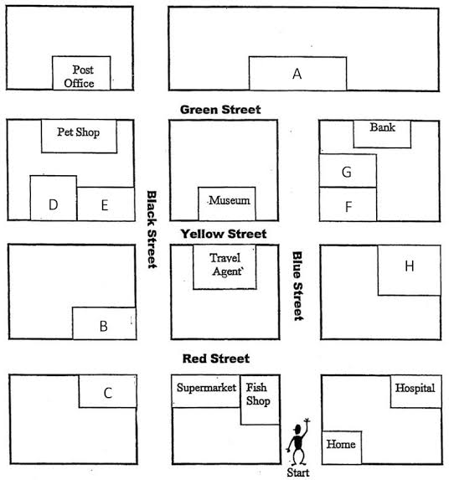
You are a traffic inspector at the “Start” junction.

Mr.David approaches you seeking directions to go to the post office... He wants to collect money order sent by his son, and book tickets to London from the Travel Agent.

Ms. Elizabeth wants to know how to go to the Pet Shop. But, she needs to go to the Bank before going there.

Ms. Alicealso wants to go to the bank and then to the Museum.

Please help them with the directions.

- Write an essay on a popular festival in your State.
(2x15=30)

