**A COMPARATIVE STUDY ON THE CHARACTERISTICS OF WATER SAMPLES COLLECTED FROM SELECTED SOURCES**

**DISSERTATION**

**SUBMITTED IN PARTIAL FULFILLMENT OF**

**THE REQUIREMENTS FOR THE AWARD OF THE DEGREE**

**OF BACHELOR OF SCIENCE IN**

**BOTANY**

**BY**

**NAFEESA NAZRIN T.S**

**AB21BOT016**

**DEPARTMENT OF BOTANY**

**ST. TERESA’S COLLEGE(AUTONOMOUS)**

**ERNAKULAM**

**2023-24**

**DECLARATION**

I hearby declare that the project entitled “A COMPARATIVE STUDY ON THE CHARACTERISTICS OF WATER SAMPLES COLLECTED FROM SELECTED SOURCES “ submitted to Mahatma Gandhi University, Kottayam, in partial fulfilment of the requirements for the Degree of Bachelor of Science in Botany is an original project done by me under the supervision and guidance of Dr. Liza Jacob, Associate Professor, Department of Botany and Centre for Research, St. Teresa’s College (Autonomous ), Ernakulam.

Place : Ernakulam **NAFEESA NAZRIN T.S**

Date :

**ACKNOWLEDGEMENT**

This is a golden opportunity for me to convey our sincere regards to all those who helped to accomplish my dissertation work successfully.

Firstly, I thank Almighty God for the numerous favours and mercies bestowed upon us, particularly during the project’s duration.

I am grateful to Dr.Liza Jacob, the supervising teacher, for her invaluable and unselfish aid and encouragement throughout the project.

I also take this opportunity to sincerely thank all the teaching and non-teaching staff of Botany Department of St. Teresa’s College (Autonomous), Ernakulam for their constant help and support that enabled me to complete this work successfully.

I express my love and heartfelt gratitude ttowards my parents and beloved ones for their constant encouragement and prayers. I extend my sincere thanks to aall my friends for their help, cooperation and encouragement to complete this project successfully.

**NAFEESA NAZRIN T.S**

**CONTENTS**

|  |  |
| --- | --- |
| **CHAPTERS** | **PAGE NO.** |
| INTRODUCTION |  |
| REVIEW OF LITERATURE |  |
| MATERIALS AND METHODS |  |
| RESULTS |  |
| DISCUSSION |  |
| SUMMARY AND CONCLUSION |  |
| REFERENCE |  |

**INTRODUCTION**

Water is the universal solvent necessary for life. Water is essential for human beings and other organisms. About 71 percentage of earth is covered by water but only little amount of water can be used to sustain life. Day by day, availability of uncontainated water is getting reduced due to rise in population, less rate of rain, destruction of water resources, industrialisation, Deforestation, water pollution, over use of pesticides etc. According to the study done by UNESCO, 2021, found few alarming fact about water. One of the most serious source of water contamination is a lack of cleanliness. In under developed countries about 90 percentage of save is released into water bodies. Every year Industry released and estimated 300 to 400 megatons of garbage into water bodies, which lead to contamination of water.

Water pollution is a complex and pressing global issue that requires coordinated action at the local, national, and international levels. Water pollution is a pervasive environmental problem with far-reaching consequences for ecosystems, human health, and economic Development. It occurs when harmful substances, such as chemicals, plastics, and Pathogens contaminate water bodies, rendering them unsafe for drinking, recreation, and Aquatic life.

**Water from different sources**

Water is essential for life and plays a crucial role in sustaining ecosystems, supporting Human activities, and ensuring global food security. There are various sources of water, Each with its unique characteristics and suitability for different purposes. The source of drinking water varies depending on location and availability. In many urban areas, drinking water is sourced from treated surface water, such as rivers, lakes, and reservoirs, or from Groundwater extracted through wells. In rural areas, drinking water may come from groundwater wells, springs, or rainwater harvesting systems. Desalinated water is also used in regions with limited freshwater resources, especially

in coastal areas. Ultimately, the source of drinking water is determined by factors such as water quality, accessibility, and infrastructure development.

**Water pollution in Kerala**

Water pollution in Kerala has been a significant concern due to various factors such as Industrial waste, agricultural runoff, and untreated sewage disposal. The state has been Working on implementing measures to mitigate pollution through stricter regulations and Wastewater treatment initiatives. However, challenges remain, and continuous efforts are needed to safeguard water quality and ecosystems in Kerala.

The rapid industrialization in Kerala has led to the discharge of untreated or inadequately treated industrial effluents into water bodies, contaminating them with heavy metals, chemicals, and toxins. Intensive agricultural practices, including the use of fertilizers and pesticides, result in runoff carrying pollutants such as nitrogen, phosphorus, and pesticides into rivers and lakes, causing eutrophication and harming aquatic life.: The Increase in urban population and inadequate sewage treatment infrastructure lead to the discharge of untreated sewage directly into water bodies, contributing to bacterial contamination and health risks. Contaminated water sources pose health risks to communities, causing waterborne diseases such as cholera, typhoid, and hepatitis, particularly among those reliant on untreated water for drinking and sanitation.

**Quality of water**

Water quality is typically measured by several key factors such as the concentration F dissolved oxygen, bacteria levels, amount of salt, amount of material, suspend in water pesticides, besides, heavy, metal and other contaminants may also be measured to

Scientific measurements are used to define water quality, it is not a simple thing to say that It is good water or it is not good water. Poor water quality can pose a health risk for people. Poor water quality can also pose a health risk for ecosystem.

**Water quality parameters**

Water quality determines the goodness of water for particular purpose. Water quality testes will give information about the health of the waterway. Water quality mainly referred to concentration of dissolved constitutions in water in terms of physical(like

Turbidity, conductivity, etc) chemical(like sodium, potassium,cadmium etc) and biological Parameters (like algae, bacteria etc) Some of these water quality parameters can be measure at site, it is called field parameters. The other parameters are analysed in a Laboratory. Laboratories of different levels are distinguished level I laboratories and level ll And ll+ laboratories .Level I laboratories are small laboratories at or near the sampling Location. Higher level laboratories(level II and II+) Are you located in major cities and Provide analytical capacity to larger region covering more sampling locations. 68 water Quality parameters are considered to the water quality parameters(Kerala State Council for Science, technology and environment environment)

**Physico -chemical parameters used for water quality testing**

Physical parameters commonly used to test water quality include colour, order, test, Temperature, turbidity, solid and conductivity .

Chemical parameters commonly used to test water quality, total dissolved, solids, total Hardness, carbon oxide, concentration, sulphate, nitrate, chloride, dissolved, pH , Conductivity, oxygen, biological oxygen demand and chemical oxygen demand etc.CO2 is an acidic oxide and it act as an acidic compound in water medium . nitrates are salt Or ester anion of nitrous acid, which can be naturally or artificially occurring in Groundwater. Sulphate is a 2nd to bicarbonate the major anion in the hard water reservoirs. Sulphate can be naturally occurring or the result of municipal or industrial discharges. Chloride is a naturally occurring element that is common in most natural water and is most often found as a component of salt(sodium chloride) or in some cases in combination with Potassium or calcium). PH of different water bodies, salinity, dissolved, salt, conduct of Water. It is a strong contributor to conductivity.

**Objectives**

1. Estimation of physical parameters of the water samples collected.
2. Estimation of chemical parameters of the water samples collected.

**REVIEW OF LITERATURE**

Gorge (1974) studied on the aspects of prawn culture in the seasonal and perennial filleds of vypin islands.Prawn culture is extensively practised in the paddy fields (seasonal fields) and other low lying areas (perennial fields) of Vypeen Island. Though the seasonal fields are found to be more productive, the perennial fields, which are available for prawn culture throughout the year, are not less important. Prawns stay for longer time and attains larger size in this type of fields. The average annual production of prawns is 903.3 and 838.6 kg|ha in the seasonal and perennial field respectively. The month-wise catch rates show that higher catch rate is generally observed in January-iMarch period. Four species of penaeid prawns, Metapenaeus Dobsoni, M. monoceros, Penaeus indicus and P. Monodon constitute the culture fishery of which M. dobsoni contributes more than 50% of the catch. It is observed that M. dobsoni in the perennial fields grow at an average rate of 10.0 mm per month. Although, the total expenditure to run the seasonal field is higher than that of the perennial fields, the net income realised from the seasonal field is always found to be better. It is therefore concluded that the paddy field prawn culture is more profitable than the culture of prawns in perennial fields.

Babu Jose and Balakrishnan (1999) did assessment of some selected nutrient profile in river Chitrapuzha Industrial effluents are the major sources of water pollutants and the disposal of these effluents without affecting the biota of the surrounding system has become a serious concern of the day. Balancing human demands on the environment with the overall welfare of the biosphere is one of our greatest challenges. The limits of use and abuse of fresh water rivers and estuaries which supply fresh water to and receive effluents from most of the industries are determined by many biogeochemical processes which can affect the quality of water.

Joseph and Chacko Jacob (2002) investigated the dynamics and speciation of the heavy metals in the lower reaches of Chitrapuzha – a tropical tridal river The proposed study is an attempt to quantify and study the seasonal and spatial variations in the distribution of Cr, Mn, Fe, Co, Ni, Cu, Zn, Cd and Pb among the various geochemical phases in the surficial sediments of Chitrapuzha river. The study also estimates the concentration of heavy metals in dissolved, particulate and sediments and their variation in seasonal and spatial distribution. Chitrapuzha River originates as a small stream from the upper reaches of high ranges in the eastern boundary of Kerala, passes through the valley and finally joints in the Cochin backwaters. Numerous industrial units located along the banks of the river discharge treated and untreated effluents into the water. These are long standing local complaints about water pollution causing fish mortality and serious damage to agricultural crops resulting in extensive unemployment in the area. The river is thus of considerable social and economic Importance.

Krishnan et al., (2011) A comprehensive study was undertaken to assess soil and water quality of three different farming areas in Trichur and Ernakulam districts of Kerala during traditional paddy cultivation period from June to December 2000 and the extensive shrimp culture season from January to April 2001. Studies revealed that organic carbon in soil was higher during Pokkali paddy crop vis a vis extensive shrimp culture. Soil was acidic during both the crops. There was no difference in other soil parameters such as electrical conductivity and redox potential. Water parameters like salinity, ammonia and nitrite values were marginally higher during extensive shrimp culture than during paddy crop. However, pH, chemical oxygen demand, phosphates and total phosphorous were not different between the two crops. The soil and water parameters, except soil pH, were observed to be within optimum range for shrimp farming.

Subin and Aneesha (2011) studied on the physico-chemico properties to access well water quality in some areas of Ernakulam district, Kerala, India. Five samples of home well water from various regions and one sample of water from Kerala Water Authority of Ernakulam district were Collected and assessment of physico-chemical properties was made to see whether these water sources are satisfying the standards of drinking Water. The investigation reveals that with the exception of water sample collected from Kerala Water Authority, all the home well waters have water quality problems. Therefore, it indicates that all the samples of home well waters in the present study are undesirable or

otherwise unfit for human consumption (Sumangala , Akhil and Sujatha, 2013.) The t study paved the way to provide the baseline data on chemical characteristics of water samples. The district lies between North latitudes 90 42’ and 10 0 18’and East longitudes 760 09’and 77 0 02’, having a geographical area of 2408 sq km. Due to the inherent industrial pollution augmented in the district, an urgent need for conducting water quality monitoring studies is essential. Fifteen groundwater samples Were examined and quantified for major ions, trace metals and pesticides during the period of September 2007 to May 2008. Out of the 15 observation stations (12 Open wells and 3 Bore wells) none of them were affected by the influence of pesticides as they are well protected groundwater structures. Concentration of Lead, Zinc, Cadmium and Arsenic were below the BIS permissible limits.

Deepa and Magudeswaran (2014) did a study on the water quality index of Chithrapuzha river, Eranakulam, India. The present investigation was carried out for determining the various physico-chemical parameters and biological characteristic of Chitrapuzha River for two different seasons rainy and summer in Ernamkulam district. The following parameters were analyzed DO, FC, pH,BOD, Phosphate, Nitrates, Turbidity and TDS. All the measured parameters were found to be very high compared to limit prescribed by WHO, and thereby unfit for both drinking and irrigation. The Chitrapuzha River has been facing severe anthropogenic activities mostly due to industrial Wastes.

Sanil Kumar et al., (2016) investigsted (seasonal and spatial) the aliphatic and polycyclic aromatic hydrocarbons (PAHs) in surface sediments of the Chitrapuzha River, Cochin, India, using gas chromatography. Significantly high concentrations prevailed during the pre-monsoon season with the industrial zones of the river appearing to be hot spots with particularly elevated levels of the hydrocarbons. AHCs ranged between 7754 and 41,173 ng/g with an average of 25,256 ng/g, while total PAHs varied from 5046 to 33,087 ng/g. n-Alkane indices and PAH diagnostic ratios point to petroleum contamination in the sediments. The significance of PAHs in the sediments was explored using universally accepted interpretation tools. Observed levels of PAHs in sediments of Chitrapuzha are likely to cause adverse effects on biota.

Sanil Kumar et al., (2017) investigated the distribution and sources of sedimentary organic matter in Chitrapuzha, a tropical tridal river, southwest coast of India Surface sediment samples were collected from five stations along the Chitrapuzha River, during the monsoon, post-monsoon and pre-monsoon seasons, and analyzed for biochemical composition, total organic carbon (TOC), total nitrogen (TN), and stable isotopic ratios of carbon (δ13C) and nitrogen (δ15N) to identify the major sources of organic matter. Sediment grain size was found to be the key factor influencing the organic matter accumulation in surface sediments. The δ13C values vary between −27.94‰ and −26.05‰ and δ15N values ranges from −1.66‰ to −4.75‰ in surface sediments. The δ13C values indicate terrestrial inputs from higher plants, while δ15N values suggest decomposition processes in the sediments. The fraction of terrestrial organic matter (TrOM) to the total organic matter (TOM) pool ranges from 41 to 84% in the surface sediments as estimated by δ13C-based two end members mixing model. Intermediate values of TOC/TN ratios signal a combined input of both autochthonous and terrestrial organic matter sources, while protein-to-carbohydrate ratios show freshly deposited detritus in the majority of the stations. The threshold levels of protein, biopolymeric carbon, and algal contribution to biopolymeric carbon (BPC) indicate eutrophic conditions prevailing in the study area.

Nishan Ahammad and Lity Alen Vargese(2020) investigated on the ecological risk associated with the release of industrial effluents containing anionic contaminants in Chitrapuzha river, Kerala. The current work emphasis on an Ecological Risk Assessment study based on a river ecosystem polluted by industrial release containing anionic contaminants. The analysis comprises a risk assessment associated with the consumption of water and other river organisms pertained due to these effluent releases. The analysis was conducted for both resident and worker. The water samples for the analysis were collected from Chitrapuzha river located at Ernakulam in Kerala state. This river is a release basin for around a dozen chemical industries. The results from analysis clearly showed a drastic reduction in the quality of water and an alarming rate of various anionic contaminants such as sulphate, nitrate, chloride and fluoride. The risk pertained due to these contaminants by consumption of river water is presented in this work. The future recommendations in light of this assessment are also included.

Abdalrahman Alsulaili, Meshari Al-Hurbi and Khaliad Elsayed (2020) studied on the influence of household filter types in quality of drinking water. In this study, people opinions about household water filters were obtained via well-constructed questionnaire distributed to 1200 participants in the state of Kuwait. Analyses revealed that respondents installed multiple household filtration systems due to the doubts that municipal water could include physical (40 %), chemical (36 %), and biological contaminants (31 %) that induces infectious and non-infectious diseases. Based on results of questionnaires, published studies, and market study, a testing station was developed and eight different configurations of household water filters were investigated for 10 continues months. Results demonstrated that singular filters can efficiently remove water impurities if these household filters undergo to periodic cleaning activities. Removal efficiency of filters, with a proper regeneration, varied from 75 % (carbon wrapped filter) to 91 % (ceramic filter) for turbidity, from 58 % (polyspun filter) to 83 % (ceramic filter) for total coliforms, and 100 % for TSS with all filters over the tested period.

Asha Raj Kariyil Rajappan and Joseph (2017) studied on the seasonal variation of heavy metals in selected stations of p Periyar River at Ernakulam district, Kerala, India. Pollution status of heavy metals like nickel, zinc, arsenic and cadmium in water, sediment and the corresponding bioaccumulation in biomass of *Anabas testudineus* from different stations of Periyar river at Ernakulam district during three seasons of an year was analysed. Result showed that the concentration of heavy metals was higher in the water, sediment, biomass from station I and II than control station indicating the pollution status of the river system

**MATERIALS AND METHODS**

For the present study, water samples were collected on the month of August 2023 from different water sources of Enakulam. Three water samples were collected. The samples were filtered water, well water and shrimp farm water. Filter water was collected from St.Teresas College, Ernakulam(sample 1 ) . Well water was collected from Chittethukara, Kakkanad(sample 2). Shrimp farm water was collected from Vypin, Ernakulam(sample 3). The collected water samples were further used to analyse their physical and chemical properties. The various parameters taken for this analysis were conductivity ,pH ,CO2 , dissolved chlorine ions, alkalinity, sulphate and nitrite.

Chittethukara is a small village/hamlet in Kanayannur block in Ernakulam district of kerala State, India (10° 1′ 1.2″ N, 76° 20′ 38.4″ E). It is located 13 km towards East from District Head quarters Kakkanad. Kadambrayar acts as the main source of water for Infopark, smart City , Cochin Special Economic Zone (CSEZ) andany industrial units,

but it is fast getting Polluted due to the dumbing of waste and lack of proper cleaning drives. The brahmapuran Waste treatment pnt is also a threat to the water body as it is not fully functional yet and Waste is being dumbped straight into the river

Edavanakkad is a part of vypin islands , which comes under Ernakulam district of Kerala, India (10° 0′ 54″ N, 76° 13′ 12″ E). It is a suburb of Kochi city. The Vypin island is surrounded by water. Shrimp culture is practiced in many areas of Vypin. The water was taken from ‘chemmeen kettu’ or shrimp farm of Edavanakkad.

**Physical analysis of water sample**

To find out the physical properties of sample, two parameters namely conductivity and pH were taken.

1. Conductivity

This was estimated using Water analyzer (Type: 371) Systronics. For this, water sample and control were taken in separate beakers were kept in the analyzer. After each sample testing, calibration was done.

2. pH

The pH meter was first calibrated with a buffer solution of known value which was followed by finding the pH value of water sample. The values were noted and used for further Analysis.

**Chemical analysis of water samples**

For this, parameters such as salinity, Carbon Dioxide, Dissolved chloride ions, total Alkalinity, Sulphate and Nitrate were estimated.

1. Estimation of Carbon Dioxide

A known volume of water containing CO₂ is treated against NaOH solution taken in the burette. Weight of CO₂ contained in the volume of NaOH is taken into account. Standard

NAOH solution (0.01 N) was prepared. For this, 40 gm of NAOH was dissolved in 1 Litre of distilled water and took 10 ml of this and made up to 100 ml.50 ml of water sample was taken in a clean conical flask. Added 3-4 drops of phenolphthalein as indicator and Titrated against the NaOH solution taken in the burette, until the end point that is the appearance of light pink colour. Repeated the titration till a concordant value was obtained.

The following formula was used: N_{2}=V_{1}N_{1}\times44\times1000/V_{2}

Where,

V_{1}= Volume of NaOH

N_{1}= Normality of NaOH

V_{2}= Volume of water sample

N_{2}= Normality of water sample

2. Estimation of dissolved chloride ions

Most of the chlorides are soluble in water can be determined by direct titration using silver Nitrate and Potassium chromate. The most important source of chloride in natural water is the discharge of sewage.

The reagents used were Silver nitrate (0.02N) which was prepared by dissolving 3.4gm of prepared AgNO in distilled water and made up to 1 litre of solution and kept it in a dark glass bottle. Another reagent, Potassium chromate 5% was prepared by dissolving 5gm of K_{2}Cr_{2}O_{x} in 100 ml of distilled water.Then 50 ml of sample was taken in a conical flask and added 2 ml of K_{2}Cr_{2}O_{4} solution. Titrated the content against 0.02N AgNO until a persistent reddish brown tinge appeared. Calculations were done using the formula,

N_{2}=V_{1}N_{1}\times35\times1000/V_{2}

Where,

V_{1}= Volume of AgNO3

N_{1}= Normality of AgNO3

V_{2}= Volume of water sample

N_{2}= Normality of water sample

3. Determination of total alkalinity

Alkalinity was measured volumetrically by titration with M/50 H2SO4. For this , 100 ml of sample was taken in a 250 ml conical flask. 4 drops of phenolphthalein indicator was added.

N/50 H2SO4 was added in drops from a burette until the pink colour disappeared. Their Values was noted. Two drops of methyl orange was added. Yellow colour was produced.

N/50 H2SO4 was added till the colour changed from yellow to faint orange. The titre value was noted. ‘T’ was obtained by adding the two titre value.

4) Estimation of sulphate ions

It can be analysed by colorimetric method. The procedure taken for the present study is as follows. To 100 ml of clear sample, 50 ml of conditioning reagent was added. This was added to each sample just prior to further processing. Stirred the sample ona magnetic Stirrer for 2 minute and during stirring added a spoon full of barium chloride and stirred for 1 more minute. After the stirring was over, took the optical density reading on a colorimeter at 420 mm.

5) Estimation of the nitrite ions

The reagents used for the nitrite estimation are sulphanilamide solution and N (1-Naphthyl ) ethylene diamine dihydrochloride solution. To 50 ml of the water sample added 1 ml of sulphanilamide solution . Allow the reagent to react for 2 – 8 minutes. Add 1 ml of N (1- Naphthyl )- ethylene diamine dihydrochloride Solution and mix immediately and note the absordance at 543 nm.

**RESULTS**

For the three water samples collected from different parts of Ernakulam and analyzed for the physico- chemical properties gave the following observations and results.

**Physical analysis of water samples**

1. pH

Sample 1 and sample 2 showed approximately neutral pH value while sample 3 showed an Acidic nature. (Table 7)

2. Conductivity

The conductivity of water samples were given in the table 1. Out of the conductivity recorded among the samples, sample 2 showed the highest and sample 1 showed the least value. Sample 3 showed conductivity a bit more than sample 1. (Table 3)

**Chemical analysis of water samples**

1. Concentration of Carbon dioxide in water sample

The estimation showed that sample 1 has a higher CO2 concentration than sample 1 and 2. (Table 6)

2. Estimation of dissolved chloride ions in the water samples

The estimation showed that sample 1 and 2 has a higher chloride ion concentration than sample 3. (Table 4)

3. Determination of total alkalinity

The present study showed sample 3 had a higher alkalinity than sample 1 and 2 (Table 5)

3. Estimation of sulphate ions

Sample 3 showed the highest concentration of sulphate ions . Sample 2 showed a trace of sulphate ions. Sample 1 didn’t show any presence of sulphate ions (Table 1).

4. Estimation of the nitrite ions

Sample 3 showed the highest concentration of nitrite ions and sample 1 showed the least. Sample 2 showed intermediate value. Out of the seven physico-chemical water quality testing done, the three samples showed varying results of different tests

(Table 2 ).

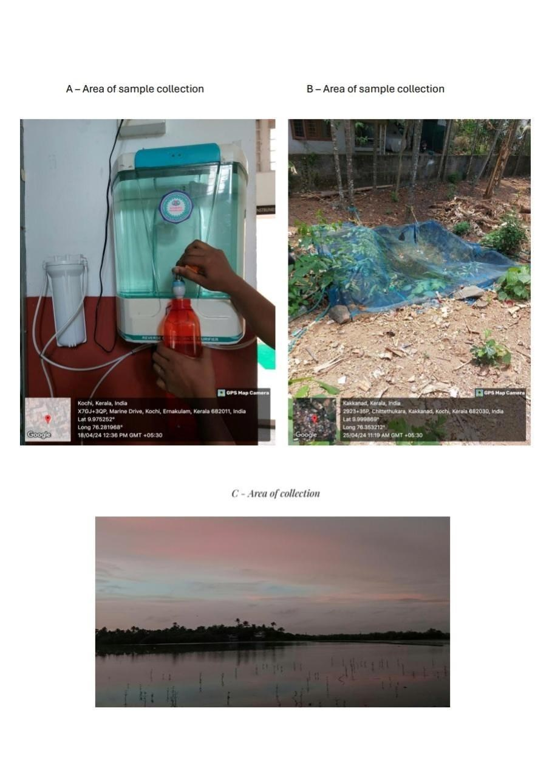

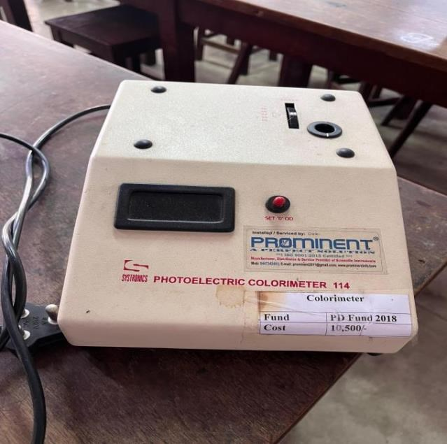

1.Colorimeter

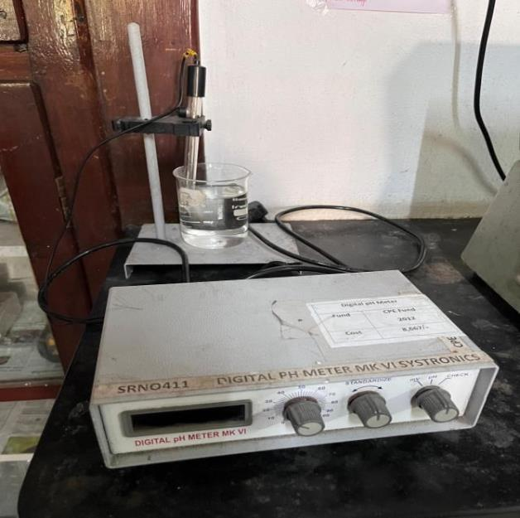2. pH meter

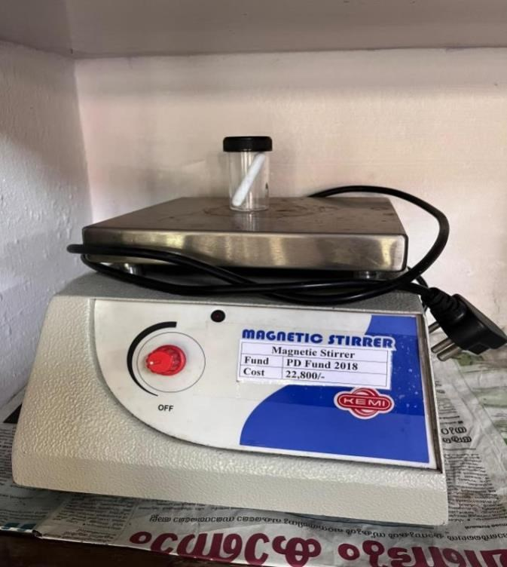

3. Magnetic stirrer

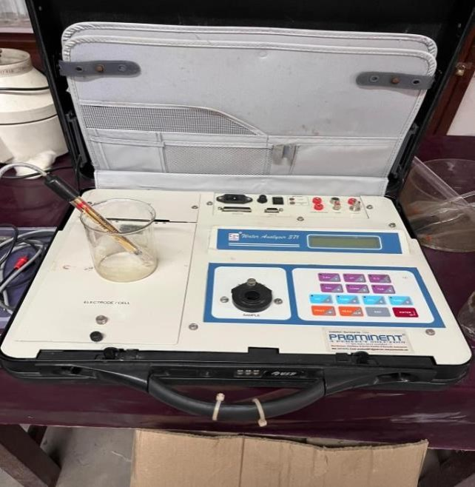4. Water analyzer

Table 1- Sulphate ion concentration of the water samples

**Sl.no** **Water samples**

1 Sample 1 2 Sample 2 3 Sample 3

**Concentration of sulphate ions (mg/L)**

0 0.2 0.02

Table 2- Nitrite ion concentration of the water samples

**Sl.no** **Water samples**

1 Sample 1 2 Sample 2 3 Sample 3

**Concentration of Nitrite ion (mg/L)**

0 0.14 0.07

Table 3- Conductivity of water samples and control

**Sl.no** **Water samples** 1 Sample 1

2 Sample 2 3 Sample 3

**Conductivity** 0.61

2.41 41.1

Table 4- Concentration of chloride ions in water samples

**Sl.no** **Water samples**

1 Sample 1 2 Sample 2 3 Sample 3

**Chloride ion concentration (mg/L)** 40

42 11.1

Table 5- Alkalinity of the water samples

**Sl.no** **Water samples** 1 Sample 1

2 Sample 2 3 Sample 3

**Alkalinity** 20

20 28

Table 6- Concentration of Carbon dioxide of the water samples and control

**Sl.no** **Water samples** 1 Sample 1

2 Sample 2 3 Sample 3

**CO2 concentration** 10

22 7.4

Table 7- pH of water samples and control

**Sl.no** **Water samples** **pH** 1 Sample 1 6.8 2 Sample 2 6.7 3 Sample 3 4.7

Figure 1 shows Sulphate ion concentration of water samples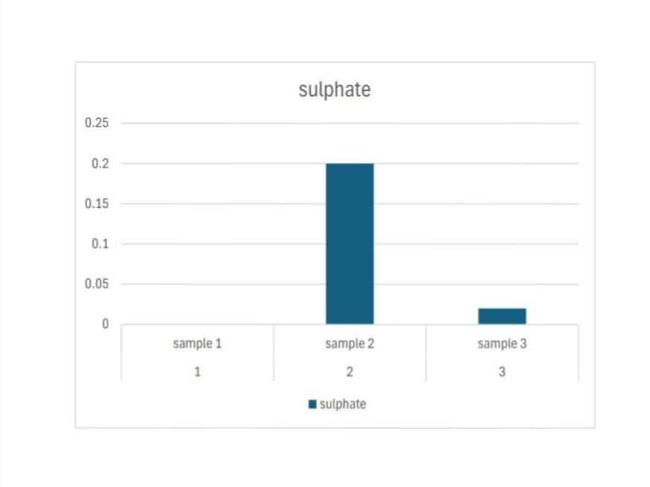

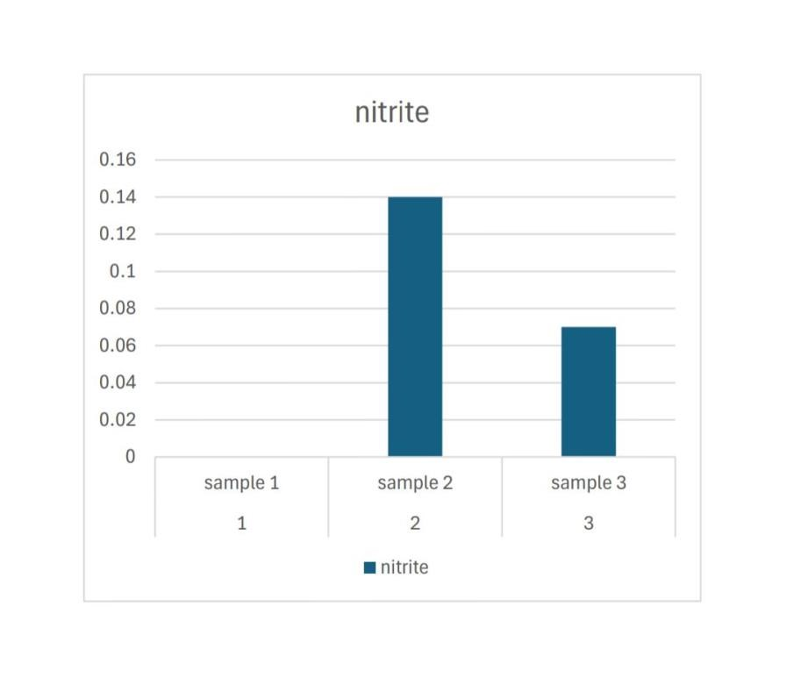Figure 2 shows Nitrate ion concentration of water samples

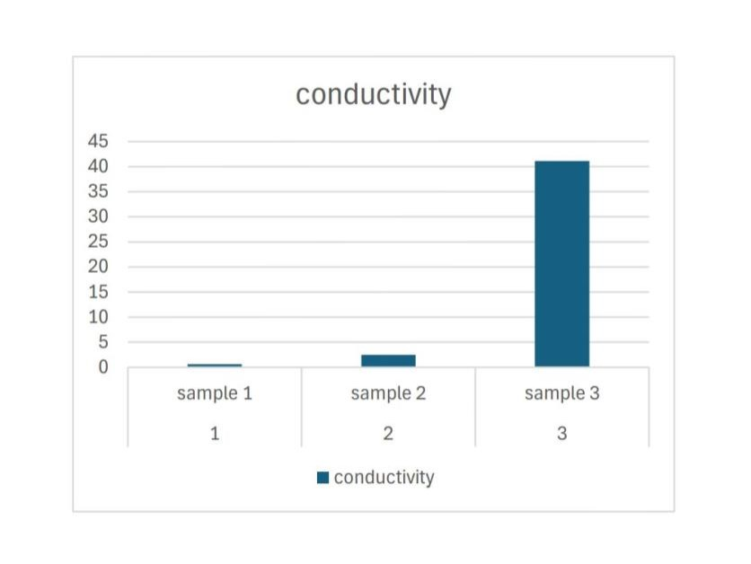

Figure 3 shows the Conductivity of water samples

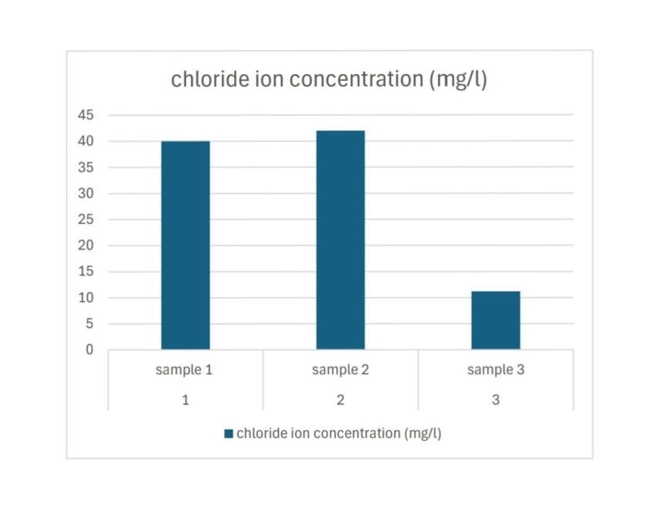Figure 4 shows the chloride ion concentration in water samples

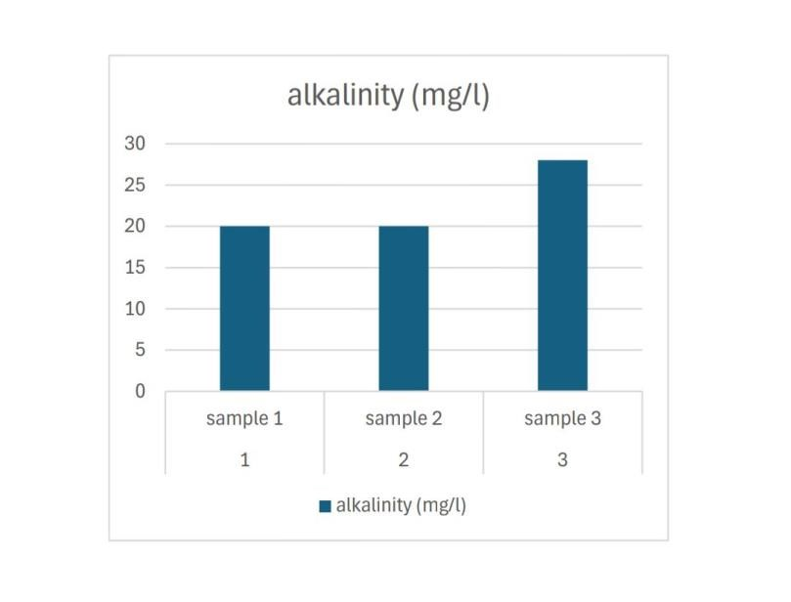

Figure 5 : Alkalinity of water samples

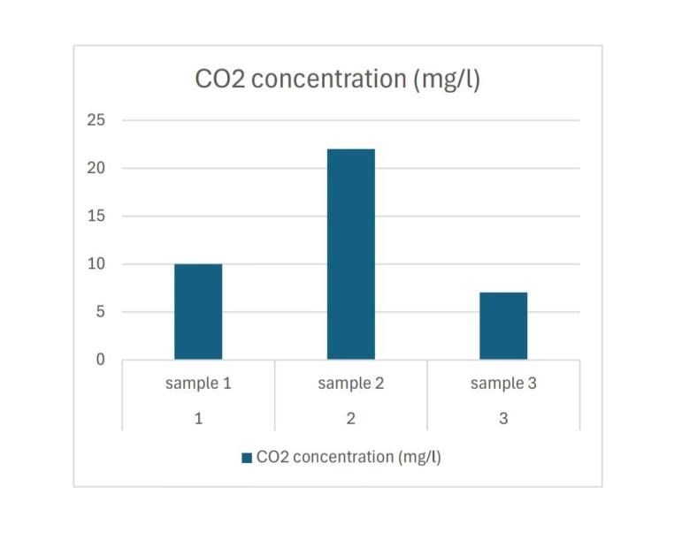Figure 6 shows the concentration of carbon dioxide in water samples

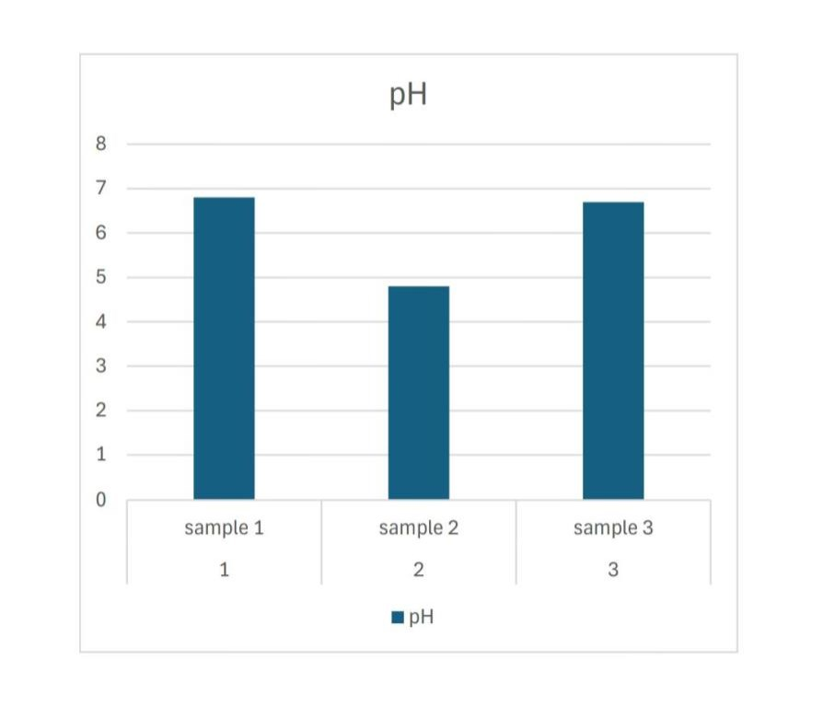Figure 7 shows the pH of water samples

**DISCUSSION**

Water testing in coastal areas is a critical aspect of environmental management and public health. Coastal regions serve as vital habitats for diverse ecosystems and support various human activities such as fishing and tourism. However, these areas are susceptible to pollution from sources like industrial runoff, agricultural activities, and urban development. Regular water testing is essential to monitor the quality of coastal waters and identify potential sources of contamination. Parameters such as pH, salinity, dissolved oxygen, and nutrient levels are commonly measured to assess water quality. Furthermore, testing for contaminants like heavy metals, pathogens, and harmful algal blooms is crucial for ensuring the safety of water for human consumption and recreational purposes. Effective water testing strategies involve both field measurements using portable instruments and laboratory analysis of collected samples. By implementing robust testing protocols and monitoring programs, we can protect coastal ecosystems, safeguard public health, and promote sustainable water management practices.

Edavanakkad is a part of Vypin islands , which comes under Ernakulam district of Kerala.The vypin island is surrounded by water. The water in Shrimp farm typically exhibits differences in pH levels, salinity, and temperature between the freshwater and saltwater bodies. The freshwater side often has a lower salinity and slightly different pH compared to the saltwater side. This creates distinct ecological niches and supports different types of aquatic life in each zone. The specific pH levels can vary depending on various factors such as weather conditions, time of year, and human activities in the area.

Chittethukara is place in Kakkanad which is closer to Cochin refinery,Brahamapuram plant,Hindustan organic chemicals etc.The chemical waste from these industries are dumped into Chitrappuzha river,which is the main water source of the area.

Industrial pollution can significantly impact the chemical composition and pH of water in wells. The introduction of chemicals such as heavy metals, solvents, and acids from industrial activities can alter the pH balance, making the water more acidic or

alkaline. High levels of pollutants can also disrupt the ecological balance of the water, affecting both aquatic life and the suitability of the water for human consumption or agricultural use. Regular monitoring and remediation efforts are crucial to address industrial pollution and safeguard water quality.

Electric conductivity in water is influenced by the presence of ions. When salts or other substances dissolve in water, they dissociate into ions, which are electrically charged particles. These ions can carry electric current through the water. Chusov (2014) made a study of specific electric conductivity of water samples in a polluted urban stream was compared with other water quality parameters such as concentration, of inorganic carbon, total organic carbon, and total nitrogen.By measuring the conductivity of water, scientists and engineers can determine its purity, assess its suitability for various uses (such as drinking water or industrial processes), and monitor changes in water quality over time. This information is crucial for ensuring water safety and environmental health.

Coastal areas in South Asian countries are particularly vulnerable to elevated water salinity. Drinking water salinity has been found to be associated with cardiovascular diseases (CVD), diarrhea, and abdominal pain. Water salinity is a public health concern that will continue to rise due to climate change. (Chakraborty, 2019). The samples used for the present study showed a result which is not harmful.

Nitrates and nitrites are the most abundant forms of dissolved nitrogen in groundwater. It is caused naturally or due to industrial influences. In the present study sample 5 showed a high value of nitrite ion concentration compare to other samples due to the presence of a printing press nearby.

A sulphate test is a chemical analysis used to detect the presence of sulphate ions in a sample. It typically involves adding a reagent like barium chloride to the sample, which forms a white precipitate if sulphate ions are present. This test is commonly used in environmental, industrial, and educational settings to monitor water quality and assess the purity of various substances.

The chloride test is a chemical analysis method used to determine the concentration of chloride ions (Cl-) in a sample. It typically involves adding a silver nitrate solution to the sample, which forms a white precipitate of silver chloride if chloride ions are present. The amount of precipitate formed is then measured to calculate the chloride concentration.

The CO2 test in water is a method used to measure the concentration of dissolved carbon dioxide (CO2) in water samples. High levels of CO2 in water can affect its pH, making it more acidic, which can impact aquatic life and corrosion in water distribution systems. The test typically involves titration with a standardized solution to determine the CO2 concentration. Monitoring CO2 levels in water is essential for assessing water quality, particularly in aquaculture, environmental studies, and industrial processes such as water treatment.

Alkalinity of water refers to its capacity to resist changes in pH when acids are added. It is primarily due to the presence of carbonate, bicarbonate, and hydroxide ions. Alkalinity is crucial in maintaining stable pH levels in aquatic ecosystems and water treatment processes. It helps buffer against acidic substances and provides stability for aquatic life. Alkalinity is measured through titration with acid, and its levels vary depending on factors such as geology, land use, and human activities. Understanding water alkalinity is essential for ensuring water quality and ecosystem health.

The pH test of water measures its acidity or alkalinity on a scale from 0 to 14, with 7 being neutral. Values below 7 indicate acidity, while those above 7 indicate alkalinity. This test is vital for assessing water quality in various applications, including drinking water, environmental monitoring, and industrial processes. Maintaining proper pH levels is crucial for the health of aquatic ecosystems, the effectiveness of water treatment, and the corrosion protection of infrastructure. pH testing is typically

performed using pH meters or colorimetric test kits, providing valuable insights into water chemistry and its impact on ecosystems and human health.

Conductivity of water refers to its ability to conduct electrical current, primarily due to the presence of dissolved ions. It is a crucial parameter in assessing water quality, with higher conductivity indicating a greater concentration of dissolved salts and minerals. Monitoring water conductivity is essential for various applications, including assessing salinity levels in aquatic ecosystems, detecting pollution, and optimizing industrial processes such as water treatment and desalination. Changes in conductivity can indicate shifts in water chemistry, highlighting potential environmental impacts or changes in water source quality

**SUMMARY AND CONCLUSION**

Water is an inevitable factor of life on earth. As human and other organisms depend on water for various purposes specially for drinking, it is important to check the quality of water and the elements present in the water to know its purity.

The present study was done to carry out the physico-chemical analysis of the different water sources of different sources. The study areas were St Teresa’s College Ernakulam, *Chittethukara Kakkanad* and *Vypin*. The water quality analysis was carried out based on relevant parameters such as pH, conductivity, Dissolved CO2, Dissolved chlorine ions, Alkalinity, Sulphate and Nitrite.

The test results were compared and interpreted and from the study, the water sample showed variations in different parameters. Sample 1 , filter water taken from purifier showed normal values to all the tests. Sample 2 , well water taken from Kakkanad showed the highest conductivity and it was found to be the most acidic sample. Sample 3 , water taken from shrimp farm , showed a higher rate of nitrite and sulphate ion concentration. In conclusion, sample 2 showed higher value in two tests and sample 3 showed higher values in another two of the tests.

The present study showed the water quality differences of different water sources and it also showed how industrialization affected water quality of well. Necessary steps can be taken to control the pollution

**REFERENCE**

1. Abdalrahman Alsulaili, Meshari Al-Harbi, Khalad

Elsayed “The influence of household filter types on quality of drinking water” *Process Safety and Environmental Protection* 143*,* 204-211, 2020

2. Asha Raj, Kariyil Rajappan, Joseph LM “Seasonal variation of heavy metals in selected stations of Periyar river at Ernakulam district, Kerala, India” *IOSR Journal of Pharmacy and Biological Sciences (IOSR-JPBS):* 2278-3008, : (12), 4, 2017

3. Babu Jose P, Balakrishnan KP “*Assessment of some selected Nutrient profile River Chitrapuzha*”School of Environmental Studies, 1999

4. Deepa G, Magudeswaran PN“Water Quality Index of ChitraPuzha River, Ernamkulam, Kerala, India” *International Journal of Research Studies in* Science, Engineering and Technology 1 (7), 17-23, 2014

5. George KV “Some aspects of prawn culture in the seasonal and perennial fields of Vypeen Island” *Indian Journal of Fisheries* 21 (1), 1-19, 1974

6. Joseph PV, Chacko Jacob “ *Dynamics and Speciation of the Heavy Metals in the Lower Reaches of Chithrapuzha-A Tropical Tidal River*” Department of Chemical Oceanography, 2002

7. Krishnani kk, Gupta BP, Muralidhar M, Saraswathy R,

Pillai SM, Ponnusamy K, Nagavel A “Soil and water characteristics of traditional paddy and shrimp fields of Kerala” *Indian Journal of Fisheries, 58 (4), 71-77, 2011*

8. Nishan Ahammed, Lity Alen Varghese “An investigative study on the Ecological risk associated with the release of industrial effluents containing anionic contaminants in Chitrapuzha river, Kerala” *Journal of The Indian Chemical Society,* 97 (3), 287-293, 2020

9. Sanil Kumar KS, Nair SM, Salas PM, Eldhose Cheriyar“ Distribution and sources of Sedimentary organic matter in Chitrapuzha, a tropical tidal river, Southwest coast of India” *Environmental forensics 18 (2), 135-146, 2017*

10. Sanil Kumar KS, Nair SM, Salas PM, Prashob KJ Peter CS, Ratheesh Kumar “Aliphatic and polycyclic aromatic Hydrocarbon contamination in surface sediment of the Chitrapuzha River, South West India” *Chemistry and Ecology 32 (2), 117-135,* 2016

11.Subin MP, Aneesha VA “An Evaluation of Physico-Chemica Properties to Asses Well Water Quality In Some Areas of Ernakulam District Kerala, India” *Nature, Environment and Pollution Technology 10* (3), 409-413, 2011

12.Sumangala KN, Akhil PS, Sujatha CH “Hydrogeochemical quality assessment of ground waters in Ernakulam District, Kerala, India” *Journal of Environmental Science, Computer Science and Engineering & Technology* 2 (4), 1353-1368, 2013