**DEVELOPMENT OF ADAPTIVE APPAREL FOR ABDOMINAL DISTENDED PEOPLE FOR THE PHYSICAL AND MENTAL WELLBEING**



**DISSERTATION SUBMITTED**

**In partial Fulfillment of the Requirement for the**

**Award of the Degree of**

**MASTER’S PROGRAMME IN FASHION DESIGNING**

**BY**

**KRISHNA PRIYA K J**

**(Register No. SM21MFD003)**

**DEPARTMENT OF FASHION DESIGNING**

**WOMEN’S STUDY CENTRE**

**ST. TERESA’S COLLEGE (AUTONOMOUS)**

**ERNAKULAM**

**APRIL 2023**

**DEVELOPMENT OF ADAPTIVE APPAREL FOR ABDOMINAL DISTENDED PEOPLE FOR THE PHYSICAL AND MENTAL WELLBEING**



**DISSERTATION SUBMITTED**

**In partial fulfillment of the requirement for the**

**Award of the degree of**

**MASTER’S PROGRAMME IN FASHION DESIGNING**

**BY**

**KRISHNA PRIYA K J**

**(Register No. SM21MFD003)**

**DEPARTMENT OF FASHION DESIGNING**

**WOMEN’S STUDY CENTRE**

**ST. TERESA’S COLLEGE (AUTONOMOUS)**

**ERNAKULAM**

**APRIL 2023**

**DEVELOPMENT OF ADAPTIVE APPAREL FOR ABDOMINAL DISTENDED PEOPLE FOR THE PHYSICAL AND MENTAL WELLBEING**



**DISSERTATION SUBMITTED**

**In partial fulfillment of the requirement for the**

**Award of the degree of**

**MASTER’S PROGRAMME IN FASHION DESIGNING**

**BY**

**KRISHNA PRIYA K J**

**(Register No. SM21MFD003)**

**DEPARTMENT OF FASHION DESIGNING**

**WOMEN’S STUDY CENTRE**

**ST. TERESA’S COLLEGE (AUTONOMOUS)**

**ERNAKULAM**

**APRIL 2023**

**Name and Signature Name and Signature of**

**External Examiner Internal Examiner**

**DEVELOPMENT OF ADAPTIVE APPAREL FOR ABDOMINAL DISTENDED PEOPLE FOR THE PHYSICAL AND MENTAL WELLBEING**



**DISSERTATION SUBMITTED**

**In partial fulfillment of the requirement for the**

**Award of the degree of**

**MASTER’S PROGRAMME IN FASHION DESIGNING**

**BY**

**KRISHNA PRIYA K J**

**(Register No. SM21MFD003)**

**DEPARTMENT OF FASHION DESIGNING**

**WOMEN’S STUDY CENTRE**

**ST. TERESA’S COLLEGE (AUTONOMOUS)**

**ERNAKULAM**

**APRIL 2023**

**Name and Signature of Name and Signature of Head of the Department Guide**

**CONTENTS**

|  |  |  |
| --- | --- | --- |
| Chapter No: | Title | Page no: |
|  | Declaration | 7 |
|  | Acknowledgement | 9 |
|  | Abstract | 10 |
| **1** | **INTRODUCTION** | 11 |
| 1.1 | Purpose of Study | 13 |
| 1.2 | Objectives | 15 |
| 1.3 | Scope of The Study | 16 |
| **2** | **REVIEW OF LITERATURE** | 17 |
| **3** | **METHODOLOGY** | 28 |
| 3.1 | Selection of Sample | 29 |
| 3.3 | Design Development | 29 |
| 3.2 | Pattern Making | 30 |
| 3.4 | Development of Products | 30 |
| **4** | **RESULT** | 32 |
| **5** | **CONCLUSION** | 34 |
| **6** | **RECOMMENDATION** | 37 |
| **7** | **BIBLIOGRAPHY** | 38 |

**LIST OF FIGURES**

|  |  |  |
| --- | --- | --- |
| **Figure No:** | **Title** | **Page No:** |
| 1 | Figure: 1 | 29 |
| 2 | Figure: 2 | 30 |
| 3 | Figure: 3 | 31 |
| 4 | Figure: 4 | 36 |
| 5 | Figure: 5 | 36 |

DECLARATION

I , Krishna Priya K J, hereby declare that the project entitled “Development of adaptive apparel for abdominal distended people for the physical and mental well being**”**is submitted in partial fulfillment of the requirement for the award of the Degree of Master’s Programme in Fashion Designing. This record is an original research done by me under supervision and guidance of Dr. Lekha Sreenivas, Department of Fashion Designing, St. Teresa’s College,

Ernakulum. This work has not been submitted in part or full or any other Degree, Diploma, Associateship /Fellowship of this or any other university.

Name and Signature of the Candidate Name and Signature of the Guide

Place:

Date:

Seal:

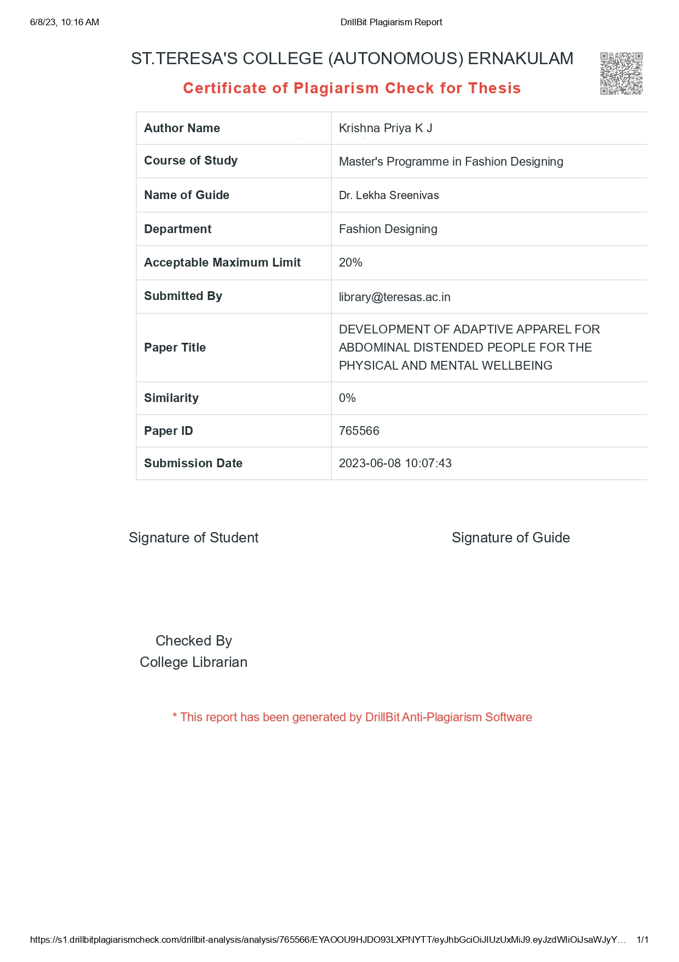

**ACKNOWLEDGEMENT**

I bow my head before **God Almighty** whose grace and blessing enabled me to complete this project successfully. An opportunity to pay tributes to those who have contributed to the preparation of this thesis is indeed joyful.

I would like to express my heartfelt gratitude to **Rev. Dr. Sr. Vinitha**, CSST, Provincial Superior and Manager, **Rev. Sr. Emeline**, CSST, Director of the College and our Principal **Dr. Alphonsa Vijaya Joseph**, St. Teresa’s College, Autonomous, Ernakulam. I extend my gratitude to **Dr. Lekha Sreenivas**, Centre Coordinatorand **Dr. Vinitha Paulose** Head of the Department, Department of Fashion Designing, St. Teresa’s College, Autonomous, Ernakulam.

I would like to extend my deep and sincere gratitude to **Dr. Lekha Sreenivas,** research guide for her constant support and guidance throughout the work.

I take this opportunity to thank all the parents, teachers and staff of **Sradha Special School** and **Adarsh Rehabiltion Centre** for their assistance and encouragement for completing the work.

I express my deep sense of gratitude to my parents for their motivation, encouragement and financial as well as moral support throughout the study.

Finally, I would like to thank all my classmates for their constant encouragement, support and prayers during the course of this study.

ABSTRACT

Abdominal binders are also called belly binder or abdomen belt. The abdominal binders

commonly used to speed up the recovery process after surgery. It helps to tone the loosen

muscle around the belly during post-surgery period. People like to use abdominal binders to

correct their figure and to look good. Women use these abdominal binders to compress their

belly to wear their favourite clothing which makes to feel good. Good looking figure and

good clothing makes people feel better and also it can positively impact their life. Nice

dressing will provides confidence and happiness among the individuals. Studies show that

what we wear directly influences our thoughts and behaviour. It also influences how others

observe our personality. A good outfit impact our own self-image. This image which we

create with our outfits can direct our behaviours. Some types of binders are not confortable

as it is too tight. This creates difficulty to sit and breathe comfortably.

Key words: Abdominal binders, belt, clothing, psychological well-being

**INTRODUCTION**

INTRODUCTION

Abdominal binders are compression belts which wear around the abdomen. Most common

type of abdominal binder is elasticised abdominal binders and non-elasticised abdominal

binders. Abdominal binders with elastic will allow the user to move comfortably. The non-

elastic abdominal binders are more compressing in nature. The elasticity in the abdominal

binders encourages more activity after operation. The abdominal binders commonly used to

speed up the recovery process after surgery such as laparotomy, bariatric surgery, and

caesarean section. This abdominal binder helps to reduce pain during post –operation period.

This also helps to improve mobility among patients after their surgery. Studies show that

these kinds of abdominal binders helps to improve psychological satisfaction of the patients

along with reducing the pain.

Women widely use abdominal binders after childbirth to shrink their uterus and to reduce

weight. During post pregnancy period there is a tendency to sag the abdomen and loosen the

muscles around the abdominal area. Studies show regular use of abdominal belt will help to

tone the muscles around the belly. It helps to reduce the fat and helps to tighten the muscles

after delivery. A few more benefits of using abdominal binders other than the support to the

abdomen after delivery, it helps to increase the blood flow, and also it reduces the abdomen

swelling. The use of abdominal binders will also help to support the abdomen during

exercise after surgery.

The abdominal binders provide good results when they take care of healthy and balanced diet

along with its use. No evidence is there for any significant side effects of using abdominal

binders. Some types of binders are not confortable as it is too tight. This create difficulty to

sit and breathe comfortably. Some abdominal binders are made with thick fabric bands which

wrap around the abdomen area. This wrap can secure by attaching Velcro or series of hooks

and eyes or buttons.

The abdominal binders are available in all sizes and shapes. It is also available in varieties of

design and material. Abdominal binders are also called belly binder or abdomen belt. People

like to use it to correct their figure and look good. Women use these abdominal binders to

compress their belly to wear favourite clothing and to feel good. Good looking figure and

good clothing makes people feel better and also it can positively impact their life. Nice

dressing will provides confidence and happiness among the individuals. Studies show that

what we wear directly influences our thoughts and behaviour. It also influences how others

observe our personality. A good outfit impact our own self-image. This image which we

create with our outfits can direct our behaviours.

Enlarged belly brings changes in body shape and size which look odd. This hinders in decent

dressing as it creates difficulty in the availability of suitable designs. This makes people to

feel low. This creates a inferiority complex among these kinds of people. Studies show that

there are social and emotional complications due to overweight. The obese people feel

anxious and stressful because of body image issues. These people have more body

dissatisfaction than slim people. They also seem to have high stress and lower self-esteem.

The view of their own body image comprises their feelings and perceptions about themselves.

This affects their self-esteem. The overweight people have to compromise many times on

what they really like to wear. This indirectly affects their mental health. Many people use

tight body shapers to look more firm. But these products are very uncomfortable or

unhealthy.

1.1 PURPOSE OF THE STUDY

“God maid man and the tailor made him a gentleman” is one of the saying. Human nature has an innate predisposition to be drawn to beauty. We observe that many people dress modestly in order to appear attractive to their social circle

In this current living situation everyone are conscious about dressing well and look good in any attire. Where ever we go for attending a function, a meeting or even when we go in a grocery store we select dress which is suitable for us to wear in public. In presence of public, we all are consciously or subconsciously concerned about our appearance. Each and every one would like to well present by themselves in front of others. When we choose to fill our wardrobe we are aware of our style.

We select dress according to many factors like our taste, the occasion that we are going to attend, current trend, upcoming festival, our skin color, price, body type, quality of the product that we are purchasing and there are so many other concerns running behind our thoughts when we select a dress.

When all these comes to a person who is suffering from abdominal distortion, they will have an extra concern due to their distended abdomen. They wish to wear dresses like others, but various styles may not fit for them due to the abdomen. They need to cover up their abdomen in front of public. This lead to some mental anxiety and depression. The abdominal distension condition might be quite familiar for everyone who see them. Still, they will be always conscious about their situation.

In most of the cases abdominal distension is occurring as an after effect of some condition or may be as a symptom of some medical conditions. In addition to that, this condition is occur as surgical effect in others. In women, the large percentage of them are suffering this condition after giving child birth. Postpartum period is difficult in many cases. Along with that, in the postpartum period most of the women are concerned about their physical changes. The physical change occurring in them are lead to mental stress as well.

Not only women, men are also suffering from this condition after a age. Even if many people want to stay fit and they workout well for their wellbeing. But in some situation abdomen may not stay in their control. Abdomen is the body part, which they try hard to reduce. The decrease of muscular mass is the main cause. We lose muscle mass as we get older, which slows down our metabolism and causes us to start burning less calories. Both of these things make it more difficult to lose weight, especially around the middle. And in such situation they want to cover their abdomen for look better in front of others.

This research study is going on for understanding their difficulties and for developing adaptive apparel for those who need an abdominal compression system. An apparel that provide more comfort and confidence in their daily life.

Distended abdomen may be an effect of organic problem or a functional problem. An organic problem can be defined by physical evidence, like a disease. Functional problems are observable but they cannot defined by means.

This study is conducted as a helping hand for those who suffer from their any of the problems that mentioned above. The relevance of an apparel for abdominal distended person. A apparel can improve or help the health condition. The dress provide comfort for using.

An adaptive clothing can reduce their difficulties in some way. Adaptive clothing typically incorporates flat seams to reduce discreet adaptations that provide an outward appearance as consist with fashion norms as possible. Adaptive clothing can increase social acceptance and participation in social activities. It also saves people from making costly alterations to their wardrobe.

If a apparel can be made out of all these requirements then it would be a valuable for the medical condition make easier for an individual.

All the supportive information for the report is collected from:

Primary data including interviewing doctors and interviewing patients. Secondary data have collected from internet articles and resources.

1.2 OBJECTIVES OF THE STUDY

• To study the problems faced by the patients in using the external abdominal binders available in the market.

• To design and develop a garment incorporated with abdominal binder for compressing the abdominal muscles.

• To obtain feedback regarding the performance and comfort of the developed product.

1.3 SCOPE OF THE STUDY

This study is based on the design and development of a trouser with attached abdominal

binder. This garment will help to tone the muscles around the belly. The abdominal binders

which are currently available in the market are not user friendly and it creates discomfort for

the wearer. The newly developed easy to wear garment with attached abdominal binders will

encourage the people to buy and use it and to enjoys its benefits.

**REVIEW OF LITERATURE**

REVIEW OF LITERATURE

The review of literature related to the study has been classified under the following heads:

An abdomen that is distended is significantly the size of abdomen, larger than it should be appeared in. It frequently comes with the sensation of being bloated from stomach contents or trapped gas. However, digestive processes aren't the only cause of abdominal distension. The 'five 'f's' used by medical professionals to diagnose an enlarged abdomen include flatus, foetus, faeces, fluid or fat.

A really uncomfortable stomach condition or merely a visible symptom that you and your healthcare professional may see. It could be chronic, which is something that constantly arises and resolves itself in a predictable manner, or acute, which is a sudden, uncommon occurrence. Chronic abdominal distension that is accompanied by an uneasy feeling of bloating is frequently indicative of a digestive issue.

The abdominal distention may be due to several reasons. Both a biological and a functional issue can cause an enlarged abdomen. A physical manifestation, like a sickness, might be used to describe an organic issue. It is possible to see functional

Organs in the abdominal area are classified into two, those are solid organs and hollow organs. Ovaries, pancreas, liver, adrenals, kidney and spleen are solid abdomen organs. These organs may expand due to either infection or diseases. Intestine, [gallbladder](https://my.clevelandclinic.org/health/body/21690-gallbladder), [stomach](https://my.clevelandclinic.org/health/body/21758-stomach), colon, fallopian tubes, uterus, bile ducts and bladder are the hollow organs of abdomen. The hollow organs are mostly visible when they are distended.

Women with irritable bowel syndrome (IBS) frequently complain of bloating. In comparison to women with minimum or mild bloating symptoms, more women with moderate to severe levels of bloating reported a history of hard stools, straining to have a stool, a history of depressive disorders, and more severe daily sensations of melancholy and anxiety. Said by [Margaret Heitkemper](https://pubmed.ncbi.nlm.nih.gov/?term=Heitkemper+M&cauthor_id=18181134) (2008)

People of all ages may have bloating, which is a fairly prevalent and subjective illness. It may be linked to any of the reasons of abdominal bloating, but irritable bowel syndrome is the most typical link. Bloating can have a significant psychological and social impact. It is frequently not appropriately diagnosed and treated. New dietary restrictions may be beneficial.

In accordance with [William L. Hasler](https://pubmed.ncbi.nlm.nih.gov/?term=Hasler%20WL%5BAuthor%5D)(2006), burping, collection of gas in the intestine and swelling are the symptom of flatus or gaseous condition. Present state, is due to the profligacy (too much) production of gas, reversal gas movement or by abdominal sensitivity to the balancing amount gas in the gastrointestinal path. Several other reasons for the cause of gas in the intestine like, a person swallow large amount of air (aerophagia), carbohydrate intolerance syndrome, overgrowth of bacteria in the intestine, issue in the movement inside intestine and functional causes like irritable bowel syndrome(IBS).

Second “F” in the five is pregnancy. Fetal development or pregnancy is one of the reason for abdominal distention seen in women. The process of foetal (Feature of fetus) development is meticulous and well-organized. It starts before you even realize you're pregnant and concludes when your baby is born. There are numerous intricate stages that must be taken between conception and delivery. Said by clevlnd clinic. (2023)

Clevland clinic (2023) is describing on, faecal impaction (FI) is the second most frequent cause of lower gastrointestinal obstruction after diverticulitis stricture and colon cancer. The elderly are most frequently affected by it because of persistent or severe constipation. Surgery to remove the affected colon or rectum is only performed in FI instances that have been complicated by ulceration and perforation that have resulted in peritonitis.

[Lukas Van Oudenhove](https://pubmed.ncbi.nlm.nih.gov/?term=Van+Oudenhove+L&cauthor_id=26602216) (2016) with his team speaks about, psychosocial morbidities are linked to higher levels of gastrointestinal symptoms overall, according to a prospective study of IBS patients. Particularly elevated postprandial symptoms are linked to depression and somatization levels.

Another for the abdominal distension may due to the collection of fluid in the abdominal area. Presence fluid in the abdomen is due to several reasons. A buildup of fluid in the peritoneum, the lining of the abdominal cavity, is another reason for abdominal distension. These tissues may swell due to an infection (peritonitis), or they may become engorged with fluid as a result of ascites. Again said by Clevland clinic.(2023)

On the report of Sanchari Sinha Dutta(2021), a functional gastrointestinal condition like irritable bowel syndrome (IBS) can appear as abdominal distension, which is marked by a rise in abdominal pressure as well as a noticeable increase in total abdominal diameter. Abdominal distension, which is seen as an objective symptom, frequently coexists with abdominal bloating, which is essentially thought of as a subjective feeling of heaviness in the abdomen. Bloating and distension both cause discomfort and an unpleasant sensation, which lowers one's overall standard of living.

A functional gastrointestinal condition like irritable bowel syndrome (IBS) can appear as abdominal distension, which is marked by a rise in abdominal pressure as well as a noticeable increase in total abdominal diameter. Gas, Irritable Bowel Syndrome (IBS), and constipation are typically the main contributors to abdominal distension. Ascites, intra-abdominal haemorrhage, and fibroids are potential additional causes. Cysts, tumors, and neoplasms are less frequent potential causes. On the basis of article by Namitha A Kumar (2014)

A study conducted by Mayo clinic (2021)states that, persons with a wide range of underlying medical and surgical conditions, abdominal bloating and distension are two of the most often reported gastrointestinal symptoms. among the general population, about 40% of people report experiencing issues with these symptoms, and this percentage is significantly greater among persons who have been given the functional gastrointestinal diseases functional dyspepsia, irritable bowel syndrome (IBS), and functional constipation. People who experience moderate to severe chronic illnesses claim that these symptoms have a detrimental impact on their activity level and quality of life.

According to [Josephine Philip Rothman](https://pubmed.ncbi.nlm.nih.gov/?term=Rothman+JP&cauthor_id=25370959)’s (2014) article, it is still entirely unknown whether post-operative abdominal binders have any influence on patients' post-operative discomfort, seroma (An accumulation of clear fluid in a tissue, organ, or body cavity that results in a lump or mass) formation, physical function, pulmonary function, and increased intra-abdominal pressure. Methods, a thorough review was done on abdominal binders. Studies on the application of abdominal binders following abdominoplasty (A surgical procedure that involves removing extra abdominal tissue) or abdominal surgery were sought out in the PubMed, EMBASE, and Cochrane databases. Clinical trials of every kind were included. The scientific value of the studies was appraised by two impartial judges. Pain, seroma development, and physical function were the main effects.

Jonatho Hardcastle claims (2006) that, every member of the human species covers their bodies with clothing, often referred to as a dress, a garment, or an article of garb, in order to protect them from the harsh weather conditions. However, people dress for both social and functional purposes. In addition to serving practical purposes by being worn above the skin, clothing has distinct cultural and social connotations. For instance, it is considered offensive in many cultures to display the genitalia in particular to others.

According to Negar (2015) and team obesity has numerous negative effects on people's bodies, finances, social relationships, families, emotions, and behaviors. The flaw in body image is one of the most prevalent psychological issues.6 There are three aspects to body image: cognitive, subjective, and behavioral. The subjective dimension is related to satisfaction or concern and anxiety about the appearance; the behavioral aspect is related to avoidance of exposure as well as anxiety and discomfort. The cognitive aspect is related to the perception of their physical appearance (weight, size, and body shape).

Boutique owner Lopez Carmen (2007) says, scientists have discovered a phenomenon they have named "enclothed cognition." This is just a fancy way of saying that what we wear affects how we think. According to the hypothesis, what we wear (or what others are wearing) genuinely alters how we think. Furthermore, this is nothing new. Nearly since the beginning of time, humans have worn clothing.

Studies have also revealed men's clothing insecurities, which goes against the gender stereotype that females are more fashion-aware and observant of others' clothing and cosmetics efforts than males. Contrary to popular assumption, men have been demonstrated to frequently be more self-conscious than women when it comes to their personal style of dress and how they are perceived in public. According to Solomon M R. (1982)

Roberts, Owen and Havlicek (2010) declare shows in their report, even when the colour of the clothing was hidden from the raters and kept constant by digital manipulation, correlations between garment colour and attractiveness still existed. These findings imply that clothing colour has a psychological impact on wearers at least as much as it does on raters, and that this eventually affects how others perceive your beauty. Our findings support the notion that colour associations with evolutionary origins might skew interpersonal judgements, even if these effects are not specific to raters nor the colour red.

Research of Lennon and Davis (1989) have perfume that, frequently employed clothing as a stimulus variable while examining the social psychology of clothes, such as the impact of clothing on social perception, attribution, and impression formation.

The study's findings, which showed a strong beneficial association between patients with morbid obesity's body image satisfaction and psychological well-being. This research suggests that a person's likelihood of experiencing higher or better psychological well-being increases with how satisfied they are with their body image. This suggests that bad psychological well-being may be linked to body image problems brought on by obesity. This conclusion is in line with a descriptive study's findings, which demonstrated a similar positive and direct association between the two factors. Said by Dotse (2015).

Holland and Haslam (2013) changed the attire of two models—thin or overweight—who were judged to have equal facial attractiveness in order to examine the relationship between provocative apparel and the objectification of others. The authors examined participants' attention to the bodies of the models since objectification includes examining the body. Denying the objectified person human attributes is another aspect of objectification. Perceived agency (such as the capacity to think and form intentions) and moral agency (such as the ability to engage in moral or immoral behaviours) are two such attributes.

Karazia’s openion (2013) describes, Western societies frequently value a slim appearance for women and a mesomorphic but muscular appearance for men when defining attractiveness

It is well known that internalising cultural norms as they are portrayed in the media is a major predictor of body dissatisfaction and dangerous appearance management behaviours, such as eating disorders in women and disordered eating in men. Statement of Cafri. (2005).

Another study by Dotse(2015), found that obese girls might feel self-conscious about their bodies while still having high psychological health. As a result, they tended to be more outgoing, have more close friends, and have more family support.37 The different investigated samples (kind and number) and methods employed in this study and the current investigation could be the cause of the discrepancy in results.

Sometimes the fear is connected to a certain physical trait or to the obvious signs of a disease or accident. Other people's worries are more widespread. These concerns can cause a lot of distress and are occasionally associated with melancholy, social isolation, or extreme self-consciousness.

When it comes to a person who with an abnormal abdominal bloating or distension the society behave the same. As a concern towards them some solutions based on this are available in the current world.

Abdominal binders lessen post-operative psychological suffering, but it's unclear how they affect seroma formation after ventral hernia repair and post-laparotomy pain. A procedure-specific, high-quality randomized clinical study is required because there is insufficient evidence and the literature is of poor quality, making it difficult to draw firm conclusions.

Debra Rose Wilson (2002) explains, during pregnancy, belly bands are made to support the lower back and abdomen. Active pregnant women may benefit greatly from these flexible support garments, especially in the second and third trimesters. Belly bands reduce discomfort. Having back and joint discomfort during pregnancy can be annoying and make it challenging to carry out daily activities. An investigation into the prevalence of back and pelvic discomfort during pregnancy was published in the Spine Journal Trusted Source. They discovered that 65 percent of women and 71 percent of women, respectively, report pelvic girdle pain.

Flack, Hay-Smith studied two different pelvic belts for upliftment of pregnancy-related symphyseal (Symphysis is a joining part of left and right pelvic bone) pain and represent that the flexible belt was defined as the most effective and comfortable by large percentage of the people who agreed, while the thicker belt tended to move towards the chest and change its position when sitting down and was irritating while using.

A study held by Cakmak, Inanir (2019)explains, the effect of a smooth, elastic belt on shape balance and concluded that elastic belts are useful to reduce the risk of collapse and crucial for pregnant ladies and doctors because of they are easy to wear and it can adjust to according to the abdominal development.

Finally, the study by Bertuit (2018), Van Lint used two pelvic belts for pregnant women a adaptive delt thin, and flexible belt that can be used in high position at the frontal major iliac spine or below the pubis, and an adaptive wide and thicker belt with metal attachments in the lumbar region. The study found that two belts are helped in reducing amount of pain, amount of pain at the SIJ (Sacroilaic joint), and back bone pain.

The weak abdominal muscles are strengthened by hernia belts, according to surgeons, preventing the tissues from jutting out. The majority of belts are made from elastic materials or fibers. Additionally, some of them include metal or plastic support plates. Hernia belts for women have a different design than hernia belts for males, yet they work just as well. Hernia belts support the belly while soothingly relieving discomfort brought on by protruding organs.

On basis of a study conducted in France, abdominal binders have only been used in four exposed trials, all of which involved a limited number of participants. Some authors claimed that using binders improved postoperative comfort, but no discernible variation was discovered. Additionally, one study hypothesized that respiratory volumes would improve.

According to Annette McDermott, an abdominal binder is a garment which wear around the abdominal area of the body. It is wearing by many people at the present time. Abdominal binders are available in various size, shape, price range even in different comfort level. Abdominal binders are used for various purposes such as post abdominal surgeries, abdominal support, during maternal period , as an under garment, for the proper fitting and so on.

From a study held by Alessandra Fanciulli (2010), found that abdominal binders are the first drug that prescribed by the doctors for those who suffered from orthostatic intolerance (OI). OI is a condition of people who experience a severe drop on blood pressure standing. Several studies shows that providing compression to abdomen helps to defend blood pooling from those who suffer from OI. Wearing an abdominal binder helps to maintain blood presser by 11mmHG and diastolic blood pressure up to 6 mmHG. Taking these into account, this is how an abdominal binder works on a OI patient. For those patients hurt by OI, abdominal binders will be the foremost defending drug.

Some people use a regular abdominal binders which provides support to their back during daily life activity. Women after giving vaginal child birth who uses abdominal binders for the purpose of contraction of uterus and reducing weight.

Summaya Saeed and team (2019) explained that, The body is put under a great deal of stress after major abdominal surgery. The postoperative phase must be optimized to speed up recovery even though the body has its own mechanisms for dealing with the stress of surgery. Morbidity from such operations includes pain at the incision site and issues with the wound. Abdominal binders have been shown to hasten healing of wounds and speed up recovery. Both swelling and increased blood flow, two important elements of the healing process, are decreased by compression. This research was done to find out how wearing a binder affected postoperative healing.

According to the VAS score used in the current investigation, the binder group experienced significantly less postoperative discomfort. This was in line with the findings of Arici (2016), who also showed that the binder group had considerably lower pain scores. Women who underwent caesarean sections were included in study population. Lower pain scores were observed in numerous earlier research looking into the impact of abdominal binder in lowering postoperative pain following caesarean section.

However, according to Gillier (2021), there was no discernible change in the VAS pain score between the binder and non-binder group. In a recent integrative review, Stoker. came to the conclusion that using an abdominal binder postoperatively reduces psychological distress, increases patient satisfaction, and relieves pain . Although Rothman et al. reported lessened psychological distress, their impact on postoperative pain.

The patient's postoperative mobility status was the second important factor evaluated in the study. On the fourth and seventh postoperative days, but not on the first, the binder group had considerably greater mobility. This was in line with what Cheifetz and Arici (2021) had discovered. This can be partially explained by the idea that patients are reluctant to move around after major surgery because of concern that their stitches might come undone, but employing abdominal binder gives them an additional sense of assurance surrounding the wound. Despite the fact that wearing a binder considerably enhanced physical performance and reduced postoperative discomfort, there was no discernible difference in the length of stay between the two groups.

According to Virginia, people with severe obesity, especially those who opt for bariatric surgery to treat their obesity, tend to have a more negative perception of their bodies. In a clinical sample of patients receiving bariatric surgery, this study looked at the relative importance of body image in relation to body mass index in the link with psychophysical well-being. The findings indicated that body image had a more significant impact on psychological and physical outcomes than did BMI, highlighting the significance of taking body image into account while evaluating and treating obese individuals who need bariatric treatment.

Accept your curves and confidently show them! We are here to give you advice on how to highlight your curves and always perform at your best. always on point. You should be proud of your body overall! Said by Michelle Wagman (2023), entrepreneur in the fashion business.

Health and Social Care Committee said that, According to the data we gathered, people of all ages experience both negative body image and mental health problems. The Mental Health Foundation emphasized that while body image issues are not in and of itself a mental health issue, they can be a risk factor for the emergence of such issues. House Of Doctors The determining effects of increasing rates of body dissatisfaction on health are becoming more apparent. We got a wealth of information outlining the various ways that negative body image can lead to the emergence of mental and physical health issues, some of which are linked to those mental health issues.

By wearing the compressive garment or abdominal binders for whole day, cause for breathing problem. As a day passing through, this problem increases and this lead to the working efficiency of a person.

Some of the abdominal binders are thicker and more compressive. This is becoming a issue in several cases. The thickness and extra compressive effect the general and everyday mobility for working.

Rigidness gives more comfort when the rest period but when comes to a general use it became as a struggle for people.

For a person who use an compression belt, should sear minimum three layers if garment. Including, under garment, compressive belt and the covering garment. This lead to breathing issue, difficulty for using wash rooms are one of the major issue.

Itching and Skin irritations

In case of wearing the belts, the dress give compression and the skin becoming less breathing. The sweating is another problem that leads to itching. The sweat will stuck up in these dresses.

Several issues are seen by wearing the abdominal binders and compression belts for whole day. The above mentioned Breathing problem, mobility issue, over layering of dresses, skin irritations and itching all are become issue.

These are some problems faced by the people wearing compression garments.

**Research Methodology**

* 1. Sample Selection

Sample selection for the present situation, was according to the everyday solution for people who suffering the abdominal distension problem. As a helping hand towards working people, has selected as the specific group. As a solution for working people, choose to select an easily available fabric in the market. A fabric that can affordable for all social classes, which provide a compression for working. That can stitched according to the required measurement.

* 1. Design Development

The design development was based on the problems that faced by the abdominal distorted people. A design which provide wearing dresses that give more comfortably during the whole day, accessibility and affordability towards the product for all social classes. Washable and reuse dresses. A garment that can easily wearable, and avoid over layering of different garment. Easily use for a working day outside.

These are some problem which aimed to reduce while design the particular garment.

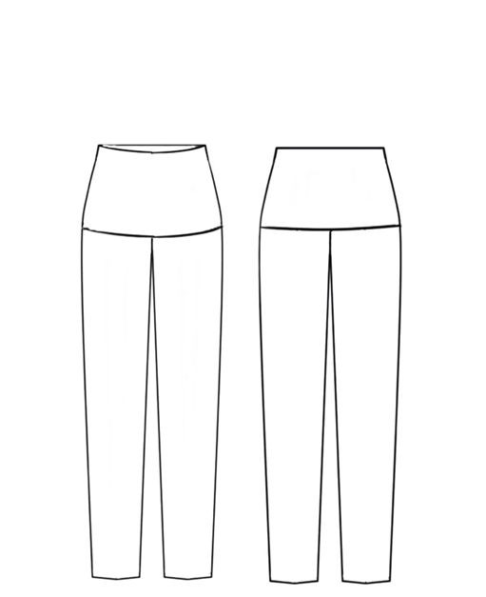 Fig: 1

Stretchable fabric

Fabric of pant

Back

Front

* 1. Pattern making

Pattern has developed from an average measurement of a 30 year old person (Indian size). As per the design the pattern is basically designed from a skirt pattern for the required design.

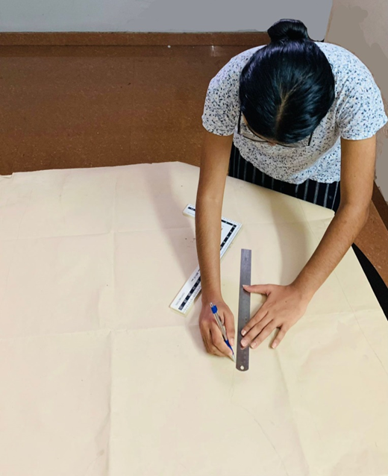 Fig: 2

Pattern Making

* 1. Garment construction

As per the design the garment has constructed. The construction was made out of in-visible stitches for the extra comfort of the wearer. So that the seam will not disturb them anymore. In addition to that the garment which made from the discarded fabric as a contribution to the sustainability of the environment. Along with that the garment has constructed in reversible manner it can increase the efficiency of the product.

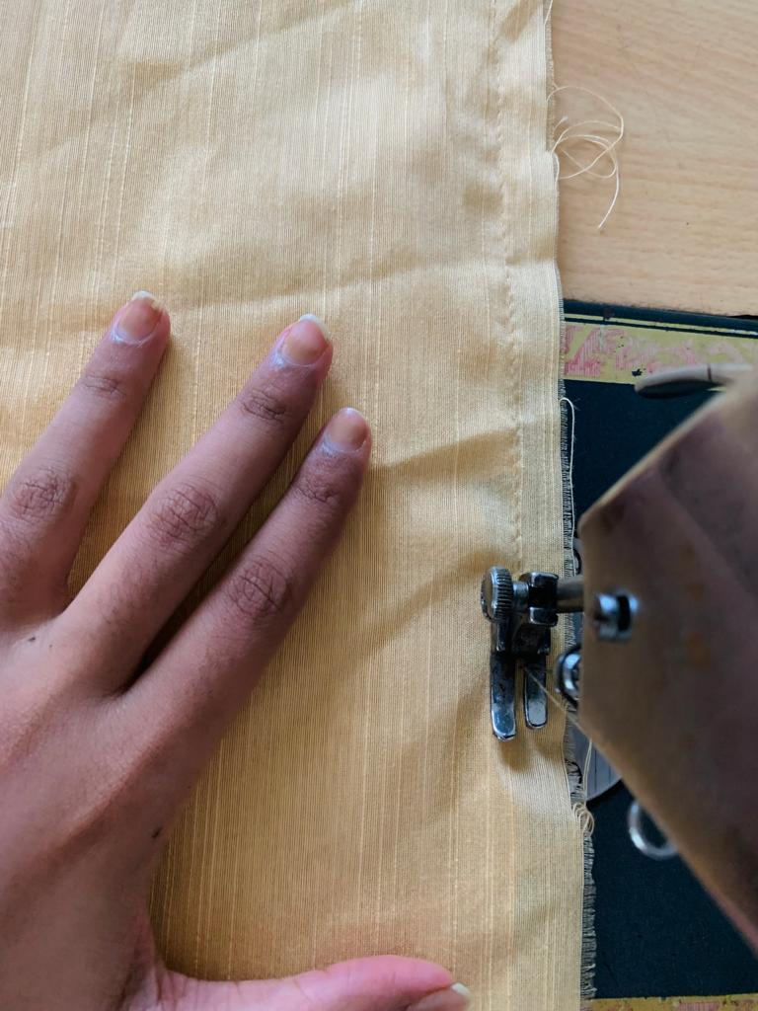 Fig: 3

Development of Product

**Result**

RESULT

As per the study, I could understand that, abdominal distension is one of the major problem that faced by a large percentage of people. . Increased despair and anxiety were reported in abdomen bloated people. In several cases the abdominal distension is occurring either by after effect of some disease or it may be the symptom showing by some issues undertaking in the abdominal area.

Abdominal binders and compression belts that are available in the marker are actually a relief for those who suffer from the issue. However, it processes some kind of problems like breathing issues, skin irritations, over layering garment discomfort, itching. When it comes to a compression binder or compression belt that it consist of thick material. It compresses the abdominal area but still this materials itself need enough space to occupy under the dress. Also it may decrease the comfort of mobility in daily life. And it not satisfying the requirement of people.

Some shaping under garments shows less efficiency while the usage. As the time passes its elasticity decreases or it loses its function of compression. Some other shows the issue of rolling upwards or downwards while wearing. These issues are shown by most of the shape wears. Most of them are made out of thin fabrics that give an instant compression and then it don’t doing its function after a while. In this case also the necessity of public are not convincing.

A physically appealing, well-groomed person can make an impression on others. Although it goes without saying that he must also be a man of substance, a gorgeous politician has the power to capture the public's attention. Everyone wants to look their best. He or she spends a great deal of time making an effort to look their best. In society, a gorgeous man or a lovely woman are highly regarded. Less attractive individuals with high levels of self-esteem and confidence just attract others and are popular due to their personalities.

As a contribution to this problem, a solution has made out within the presence of these troubles. A garment that provide more comfort, reusable, reversible, smooth mobility, easily available and easily useable.

CONCLUSION

CONCLUSION

The purpose of study was to explore and understand the physical and mental stress experienced by abdominal distended people. I analyze several online data to acknowledge about the scenario. How a person become obese, What are changes happening to them while the abdomen distended, How abdominal binders and compression belts help them, How the abdominal distortion effect their mental health and How to dress up if a person is over weighted one. These are the core area which I analyzed for the study.

The result shows that, measurably larger than usual, an abdomen is distended the person will be less confident. It frequently comes with the sensation of being bloated from trapped gas or stomach secretions. There are other causes of abdominal distension besides digestion. A bloated abdomen person may be incredibly unpleasant or it may only be a visual sign that healthcare professional notice if we go for a medical help. It could be acute, meaning it happens suddenly and unusually, or it could be chronic, meaning it happens frequently and resolves in a predictable way. A digestive issue is frequently the cause of persistent abdominal distension and an uneasy bloated sensation.

The psychology of dressing well assesses how we feel about our clothing internally. What we wear reflects who we are and how we wish to present ourselves to the outside world. Clothes and perception are known to be related. Every day, we judge others by their outward look, and they judge us in return. This fact is related to each and every person.

When it comes to a person who is suffering from certain body disorders are most of the one who is constantly in a battle with their own mind. To present themselves, well in front of others. This project study is particularly focused on abdominal distorted people and their mental wellbeing. In the current life style there are several abdominal compression belts are available.

An abdominal binder is typically tolerated satisfactorily. It's hot and uncomfortable for some folks. Compression around a surgical site, though intended to reduce discomfort, may instead make it worse. Although there is no proof that using an abdominal binder causes or worsens breathing issues, it may also make breathing uncomfortable.

Itching, redness, and other skin irritations could be brought on by compression clothing. Use an abdominal binder that fits properly and is made of hypoallergenic material to lower your risk.

A remedy has emerged in the midst of these issues as a contribution to this issue. A clothing that offers increased comfort, is reusable, reversible, easy to move in, readily accessible, and easy to handle.

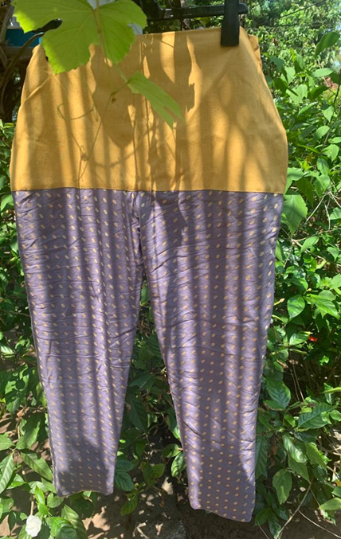 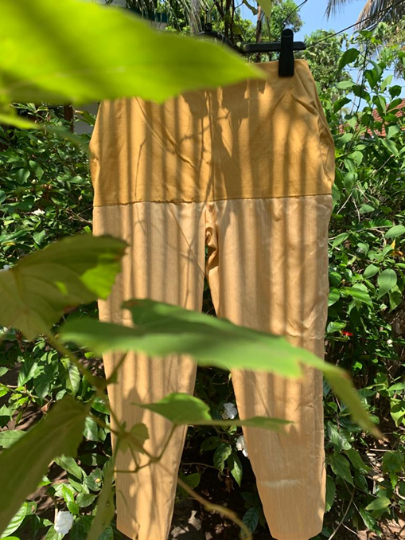

Fig: 4 Fig: 5

Investigate the connection between the symptoms with an abdominal bloating and discomfort condition and their emotional issues. Bloating people were shown to resemble disease patients suffering from hospital Anxiety and Depression. Scale In this busy world most of the people are suffering from physical and mental issues by abdominal distension. Can Feel Stronger in Clothes. Can feel more powerful and confident and be more willing to take on problems at work and in personal life if wear high-quality, well-tailored apparel. There is a constrained solution that they can easily solve. According to research, dressing formally might alter how you perceive and handle events. Their concern on reducing this issue.

RECOMMENDATION

According to this research and the researchers from the theoretical overview, the psychology of dressing well assesses how we feel about our clothing internally. What we wear reflects who we are and how we wish to present ourselves to the outside world. Clothes and perception are known to be related. People judge others by their outward look, and they judge us in return. In this world of social media all are connected to each other. So the large percentage of people are able to watch the changing styles and trends. And by the influencing of that every one wish to look fashionable. In accordance with this mentality to a bloated person, they have much limitations. So a further study can conduct to develop on compression belt that can wear with modern outfits.

BIBLIOGRAPHY

BIBLIOGRAPHY

Hasler,L,W (2006). ‘Gas and bloating’*. National Library Of Medicine,* sept, Vol:2, Issue 9,Pp:654-662. Retrieved from:<https://www.ncbi.nlm.nih.gov/pmc/articles/PMC5350578/>

Meno, K ( 2017).’What you should know about abdominal binders’. *Healthline,mar* Retrieved from: <https://www.healthline.com/health/abdominal-binder>

Saeed, S(2016). ‘Elastic abdominal binders attenuate orthostatic hypotension in parkinson's disease’*.* [*Movement Disorder Clinical Practic,.*](https://www.ncbi.nlm.nih.gov/pmc/articles/PMC6178725/) Oct,Vol:11**,**Issue10,,Retrieved from: <https://www.ncbi.nlm.nih.gov/pmc/articles/PMC6827701/>

Clevland Clinic Medical Professional. (2023). ‘Fetal development: week by week stage of pregnancy’*. Clevland Clinic Medical Professional*, Vol**:,**Issue, Pp:,Retrieved from: Retrived from: <https://my.clevelandclinic.org/health/articles/7247-fetal-development-stages-of-growth>

Rothman,J,P.. Ulf,G,B**.** & [Thue](https://pubmed.ncbi.nlm.nih.gov/?term=Bisgaard+T&cauthor_id=25370959) . (2014). ‘Abdominal binders may reduce pain and improve physical function after major abdominal surgery - a systematic review’*. National Library of Medicine,Nov*Vol:61,Issue 11,Retrieved from:

https://pubmed.ncbi.nlm.nih.gov/25370959/

Volpi,A(2017). ‘Long lasting postoperative ileus after surgery for intestinal obstruction due to left paraduodenal hernia (LPDH)’*.National Library of Medicine,Nov-Dec,*Vol:37,Issue 6, Pp:271-274,Retrieved from:

<https://www.ncbi.nlm.nih.gov › articles › PMC5505486>

Goodwin,M. *‘*What to know about ascites (excess abdominal fluid)’*. [Medical News Today, July](C:\\Users\\HP\\Downloads\\Medical News Today, July,Retrieved from:                                                                                                                                 https:\\www.medicalnewstoday.com › articles)*[,Retrieved from:](C:\\Users\\HP\\Downloads\\Medical News Today, July,Retrieved from:                                                                                                                                 https:\\www.medicalnewstoday.com › articles) [https://www.medicalnewstoday.com › articles](C:\\Users\\HP\\Downloads\\Medical News Today, July,Retrieved from:                                                                                                                                 https:\\www.medicalnewstoday.com › articles)

Khosravi,A. ‘Why is my stomach bigger after hernia surgery?’*.Orange County Robotic General Surgery*, Oct,Retrieved from:

<https://ocroboticsurgery.com/why-is-my-stomach-bigger-after-hernia-surgery/>

House Of Doctors (2021)‘[Hernia Belts: Understanding their benefits and uses’](https://www.google.com/url?sa=t&rct=j&q=&esrc=s&source=web&cd=&ved=2ahUKEwjCmqDrkqD_AhVKg2MGHdi3BmsQFnoECAkQAw&url=https%3A%2F%2Fwww.houseofdoctors.in%2Fblogs%2Fhernia-belts.php%23%3A~%3Atext%3DHernia%2520belts%2520(truss)%2520are%2520highly%2Chave%2520recently%2520developed%2520inguinal%2520hernia.&usg=AOvVaw3cLMGCfXuAuBLeq5-ZZUtT)*[.](https://www.google.com/url?sa=t&rct=j&q=&esrc=s&source=web&cd=&ved=2ahUKEwjCmqDrkqD_AhVKg2MGHdi3BmsQFnoECAkQAw&url=https%3A%2F%2Fwww.houseofdoctors.in%2Fblogs%2Fhernia-belts.php%23%3A~%3Atext%3DHernia%2520belts%2520(truss)%2520are%2520highly%2Chave%2520recently%2520developed%2520inguinal%2520hernia.&usg=AOvVaw3cLMGCfXuAuBLeq5-ZZUtT)* [House Of Doctors,Aug,Vol](https://www.google.com/url?sa=t&rct=j&q=&esrc=s&source=web&cd=&ved=2ahUKEwjCmqDrkqD_AhVKg2MGHdi3BmsQFnoECAkQAw&url=https%3A%2F%2Fwww.houseofdoctors.in%2Fblogs%2Fhernia-belts.php%23%3A~%3Atext%3DHernia%2520belts%2520(truss)%2520are%2520highly%2Chave%2520recently%2520developed%2520inguinal%2520hernia.&usg=AOvVaw3cLMGCfXuAuBLeq5-ZZUtT)**[:,](https://www.google.com/url?sa=t&rct=j&q=&esrc=s&source=web&cd=&ved=2ahUKEwjCmqDrkqD_AhVKg2MGHdi3BmsQFnoECAkQAw&url=https%3A%2F%2Fwww.houseofdoctors.in%2Fblogs%2Fhernia-belts.php%23%3A~%3Atext%3DHernia%2520belts%2520(truss)%2520are%2520highly%2Chave%2520recently%2520developed%2520inguinal%2520hernia.&usg=AOvVaw3cLMGCfXuAuBLeq5-ZZUtT)**[Issue, Pp:,Retrieved from:](https://www.google.com/url?sa=t&rct=j&q=&esrc=s&source=web&cd=&ved=2ahUKEwjCmqDrkqD_AhVKg2MGHdi3BmsQFnoECAkQAw&url=https%3A%2F%2Fwww.houseofdoctors.in%2Fblogs%2Fhernia-belts.php%23%3A~%3Atext%3DHernia%2520belts%2520(truss)%2520are%2520highly%2Chave%2520recently%2520developed%2520inguinal%2520hernia.&usg=AOvVaw3cLMGCfXuAuBLeq5-ZZUtT)

https://www.houseofdoctors.in › blogs › hernia-belts

Quintero Carolina R, Troynikov [Olga. (2019).](https://pubmed.ncbi.nlm.nih.gov/?term=Troynikov%20O%5BAuthor%5D)  The Effect of Maternity Support Garments on Alleviation of Pains and Discomforts during Pregnancy: A Systematic Review*. National Library Of Medicine,*Aug,Retrieved from: <https://www.ncbi.nlm.nih.gov/pmc/articles/PMC6699320/>

Brennan,[D. (2021).](https://www.webmd.com/dan-brennan)  ‘What is a stomach binder?’ [*Webmd Editorial Contributors*](https://www.webmd.com/webmd-editorial-contributors)*,Nov*,Retrieved from: https://www.webmd.com/a-to-z-guides/what-is-a-stomach-binder

Bouvier,A.Eat,P. Chibihi-Drissi, F.Lacaine,F. Mariette,C&Debellon-Ortega,P.(2014) ‘Abdominal binders after laparotomy: review of the literature and French survey of policies’. *Palgrave Macmillan,*May,Vol:18, Pp:501-506,Retrieved from:https://link.springer.com/article/10.1007/s10029-014-1264-2

Stoker, Carnet,Kelsey(2019).‘Use of Abdominal Binders for Postoperative Pain After Gastrointestinal Surgery: An Integrative Review’.*Journal of PeriAnesthesia Nursing, Aug,*Vol:34, Pp:829-833,Retrieved from: <https://www.sciencedirect.com/science/article/abs/pii/S1089947218304088>

Dutta,s,s(2021). ‘Cause of abdominal distension’. *News MedicalLife Ssience.* Jan. Retrieved from: <https://www.news-medical.net/health/Causes-of-Abdominal-Distension.aspx>

Kumar,A,Namitha(2014). ‘Abdominal Destension’. *Med India.* Nov. Retrieved From: https://www.medindia.net/patients/patientinfo/abdominal-distension.htm#about

Hardcastle Jonathn(2006).’The Importance of Cloth.’ *Fiber2Fashion.*Nov.Retrieved From: <https://www.fibre2fashion.com/industry-article/848/the-importance-of-clothes>

Lopez,Carmen(2007)‘LOOK GOOD, FEEL GREAT: THE PSYCHOLOGY OF CLOTHING’ *Current boutique.* Retrieved From: <https://currentboutique.com/blogs/cravingcurrent/psychology-of-clothing>

Solomon,M,R(1982).’Self-Consciousness and Clothing’. *Personality and Social Psychology Bulletin,*Sep.Vol: 8, Issue 3,Pp: 508-524, Retrieved From: <https://journals.sagepub.com/doi/10.1177/0146167282083018>

Roberts, C., Owen, R. C., & Havlicek, J. (2010). ‘Distinguishing between perceiver and wearer effects in clothing color-associated attributions’. *Evolutionary Psychology,*July,Vol: *8*, Issue 3, Pp: 350–364, Retrieved From: <https://journals.sagepub.com/doi/10.1177/147470491000800304>

Johnson,K. Lennon,J,[Sharron](https://fashionandtextiles.springeropen.com/articles/10.1186/s40691-014-0020-7#auth-Sharron_J-Lennon)  & Rudd [Nancy](https://fashionandtextiles.springeropen.com/articles/10.1186/s40691-014-0020-7#auth-Nancy-Rudd) (2014)‘Dress, body and self: research in the social psychology of dress’. *SpringerOpen,*Nov,Vol:1,Issue 20, Retrieved From: <https://fashionandtextiles.springeropen.com/articles/10.1186/s40691-014-0020-7>

Van,Oudenhove,L. Törnblom H. Störsrud S. Tack, J & Simrén M. (2016)‘Depression and Somatization Are Associated With Increased Postprandial Symptoms in Patients With Irritable Bowel Syndrome’. *Gastroenterology*, Apr, Vol: 150, Issue 4, Pp:866-74, Retrieved From: <https://pubmed.ncbi.nlm.nih.gov/26602216/>

Wagman,Michelle(2023).’How to Dress IF You Are Overweight’.*STYLECRAZE,*Apr,Retrived From: https://www.stylecraze.com/articles/how-to-dress-when-you-are-overweight/