**PHYTOCHEMICAL ANALYSIS AND STUDY ON THE**

**ANTIBACTERIAL PROPERTY**

**OF**

***OCIMUM SANCTUM L.* (TULSI)**

Dissertation submitted in practical fulfillment of

the requirements for the award of the Degree of

**BACHELOR OF SCIENCE IN BOTANY**

**By**

**JOVITA JOHNSON**

**REG NO: AB21BOT006**



**DEPARTMENT OF BOTANY AND CENTRE FOR RESEARCH**

**ST. TERESA’S COLLEGE (AUTONOMOUS)**

**ERNAKULAM**

**APRIL 2024**

**CERTIFICATE**

This is to certify that the dissertation entitled “Phytochemical Analysis and Study on the Antibacterial property of *Ocimum sanctum L.* (Tulsi)” submitted in partial fulfillment of the requirements for the award of the Degree of Bachelor of Science in Botany is an authentic work carried out by Jovita Johnson (Reg. No: AB21BOT006) under the supervision and guidance of Dr. Elsam Joseph.

Dr. Liza Jacob

Head, Department of Botany,

St. Teresa’s College (Autonomous),

Ernakulam

Dr. Elsam Joseph (Supervising Teacher)

Associate Professor,

Department of Botany

St. Teresa’s College (Autonomous),

Ernakulam

Examiners:

Place: Ernakulam

Date:

**ACKNOWLEDGMENT**

First and foremost, I would like to thank Almighty God for guiding me throughout this project for inspiring me, and courage, and for being my strength every step of the way.

I would like to thank all the people who have been a guiding light by helping me immensely in completing my project. It was due to their combined efforts that this project was able to come to fruition.

I owe my gratitude to the Head of the Department of Botany, Dr. Liza Jacob, for helping us by providing the laboratory facilities, equipment, and chemicals that were needed to complete this project.

I am very grateful to Dr. Elsam Joseph, my project guide for guiding me through the project and providing valuable insights from the beginning throughout to the completion of this project.

I would like to thank Mrs. Tia of the Instrumentation Lab of St. Teresa’s College and Savitr Bioscience Pvt. Ltd, Thrikkakara, for helping us conduct all the tests required to complete this project.

With pleasure, I also thank my project partner, Ms. Catherine Charly, for cooperating with me on this project and being the most earnest in doing this project with me.

I heartily thank all the teacher staff and Research students who guided me throughout the project and all also the non-teaching staff, who were of incredible help to me throughout the project.

Finally, I would also like to thank all my classmates and family who gave me valuable information and great support to complete this project. They provided strength and positivity and helped me complete this project on time.

Date :

Place : Ernakulam Jovita Johnson

**TABLE OF CONTENTS**

|  |  |  |
| --- | --- | --- |
| **SL.NO** | **CONTENT** | **PAGE NO.** |
| 1 | Abstract | 1 |
| 2 | Introduction | 2 |
| 3 | Review of Literature | 5 |
| 4 | Materials and Methods | 9 |
| 5 | Observation and Results | 12 |
| 6 | Discussion | 24 |
| 7 | Conclusion | 25 |
| 8 | References | 26 |

**Abstract**

*Ocimum sanctum*, also called locally as Tulsi, comes from the family Lamiaceae. It is native to the tropical and subtropical regions of Australia, Malesia, Asia, especially the Indian subcontinent. It is considered sacred in the Hindu religion, as well as is used for treating a lot of ailments. It is believed to have antibacterial, antifungal, antimalarial, calming, cardioprotective, anti-inflammatory, anti-carcinogenic, radioprotective, immunomodulatory, and neuroprotective properties. They also contain numerous phytochemicals like phenols, alkaloids, proteins, etc. In this study, various tests were conducted to identify and analyze the presence of carbohydrates, flavonoids, alkaloids, phenols, terpenoids, saponins, and resins in the ethanol extract of Tulsi leaves. Well diffusion method was used to study its antibacterial effects on the bacteria *Staphylococcus aureus* and *Escherichia coli.* The antibacterial tests yielded positive results in aqueous solution of the sample. Phytochemical tests indicated the presence of alkaloids, phenols, saponins, terpenoids, and flavonoids.

Keywords: *Ocimum Sanctum,* antibacterial, antifungal, anticarcinogenic, phytochemicals, antibacterial analysis, well-diffusion method.

**INTRODUCTION**

Tulsi, also called holy basil is considered to be sacred and medicinal [1]. It is used to treat many ailments such as cold, irritation, intestinal sickness, coronary illness, migraines, stomach issues, kidney stones, heart issues, etc [2].

**Scientific Classification**

Kingdom: Plantae

Phylum: Tracheophyta

Clade: Angiospermae

Class: Magnoliopsida

Order: Lamiales

Family: Lamiaceae

Genus: *Ocimum* L.

Species: *Ocimum sanctum L.* [24]

**Description and Habitat**

Holy basil is an erect, tall plant (30-60 cm) with hairy stems. The leaves are green or purple in colour; simple, and petiolated with ovate blade of up to 5 cm long. The leaves also have slightly toothed margin, are aromatic, and have decussate phyllotaxy [3]. The flowers are arranged in close whorls on elongated racemes; their inflorescence being thyrsus. The three types of Tulsi based on morphology are Ram Tulsi (having broad bright green leaves that are slightly sweet), Krishna Tulsi (purplish green-leaved), and Vana Tulsi [3]. They are fragrant and taste bitter [18].

This plant is native to the southeast Asia tropics like India, Nepal, China, Pakistan, Philippines, Queensland, Solomon Is., South China Sea, Sri Lanka, Sulawesi, Sumatra, Taiwan, Thailand, Vanuatu, Vietnam, etc. It has been introduced to some Latin American countries like Bahamas, Cayman Is., Colombia, Cuba, Dominican Republic, etc, and African countries like Kenya, Zambia, Malawi, etc. [2][7]

**Tulsi as a sacred plant**

It is considered sacred in Hinduism, especially the Vaishnavite sect. It is believed to be an avatar of the goddess Lakshmi and is often planted in the gardens of Hindu homes and temples. In many Hindu homes, the lighting of lamps in the evening includes the worship of Tulsi [4]. Many Hindu ceremonies are celebrated like Tulsi Vivah, performed between Prabodhini Ekadashi and Kartik Pu­rnima [5].

**Tulsi – various properties**

Tulsi has been used to treat many ailments. It has been used in Ayurvedic medicines for thousands of years [8]. For sore throat, the leaves of Tulsi are boiled in water and the water is effective in calming the throat, after taking it consistently. For treating kidney stones, the juice of Tulsi leaves is extracted and mixed with nectar. It is also believed to help with high cholesterol levels [9]. It is used to cure respiratory disorders, bronchitis, skin infections, and earaches. Its roots are used to treat malarial infections, in some remote areas in India [10]. The seeds are mucilaginous and relieve inflammation so they are used to treat different ailments of the Genito-urinary system [1].

Tulsi is good for the heart, stimulates digestion, and reduces breathing difficulties and cough [11]. It has also been used in the treatment of snake-bite and scorpion sting, as described in ancient texts like Charaka and Sushruta [12]. Concoctions with the root of Tulsi are used as a diaphoretic in malarial fevers in remote parts of India [1].

Tusi shows chemo-preventive and anti-cancer abilities, anti-diabetic properties, anti-stress properties, contraceptive properties, Hypoglycaemic and Hypolipidaemic activity, hepatoprotective activity, immunomodulatory activity, psychopharmacological activity, antioxidant properties, analgesic, antipyretic and antidiarrhoeal activity, radioprotective activity, wound healing abilities, etc. [14,15,18]

All these effects are due to the effects of many active principles, and secondary metabolites, like flavonoids, phenols, terpenoids, resins, and saponins, especially a compound called eugenol, which was almost 71 % in the leaves [18].

**Objectives**

• To analyze the active principles of Ocimum sanctum L.

• To test the Anti-bacterial property of O. sanctum L.

• To review the phytochemical and antibacterial properties of o. sanctum

**REVIEW OF LITERATURE**

Plants contain numerous, perhaps thousands of chemical compounds that provide them with therapeutic value, which produces great economic value too. Tulsi is one such plant. It contains lots of medicinal properties, which have been evidenced through numerous studies; certain phytochemical compounds being the cause of it.

Ocimum sanctum has a specific aroma because of the presence of volatile oil, concentrated in the leaf. This is due to the presence of many phytochemicals like phenols terpene and aldehydes. The seeds also contain oil. Besides oil, they also have alkaloids, saponins, and tannins. And carotene and ascorbic acid [1]. Eugenol (1-hydroxy-2-methoxy-4-allylbenzene), the active constituent present in O. sanctum has been found to be largely responsible for their therapeutic potential [16]. It also contains a sesquiterpene called caryophyllene [18].

**Anti-Cancer property**

Anti-carcinogenic properties were evaluated in animals that were induced by different carcinogens. Tulsi leaves, 600mg/g diet, were fed to experimental rats for 10 weeks, significantly reducing the occurrence of both B[a]P-induced neoplasia and 3'MeDAB-induced hepatomas [13]. In the Philippines, it was reported that juices from the leaves of Tulsi had anti-cancerous activity, when applied to the skin of mice along with cancer promoter agents, thrice a week [14].

*Ocimum sanctum* was reported to have chemo-preventive properties in its leaf extract. The glutathione in the liver, lung, etc. was found to be significantly lowered in treated mice as compared to the control. The occurrence of squamous cell carcinomas was considerably reduced when the paste of its leaves was applied topically, as well as administered orally [18].

**Antidiabetic property**

Numerous studies have been done to evaluate the anti-diabetic properties of *Ocimum sanctum.* In an experiment on rats where diabetes mellitus was induced by alloxan, upon 15 days of treatment with Tulsi leaf extract, there was a reduction in blood sugar levels. Once the treatment was stopped, the condition returned, showing a strong effect of Tulsi on diabetes [15,17].

**Other Miscellaneous properties**

Ethanolic extract of Tulsi increased the endurance and resistance against a variety of stresses in animals. So, Tulsi also has the capability to help organisms adapt better to stressful conditions. The plant has immunostimulant abilities [18].

*Ocimum sanctum* also contains contraceptive potential, as reported from studies conducted on mice by Batta S. K. et al. They observed that the benzene extract had more effectiveness than any other extract [18].

Tulsi also shows significant analgesic, anti-inflammatory antipyretic, and anti-diarrhetic activity. Especially since Tulsi oil has higher activity due to the higher concentration of phytochemicals, it is normally used to reduce inflammation and pain. It has also been found to have antiasthmatic activity; the ethanolic extract of fresh leaves and oil from seeds brought about the effect on guinea pigs [18].

**Phytochemical and Anti-bacterial properties**

The aqueous extract of Tulsi leaves indicated insecticidal and antibacterial activity against gram-positive and gram-negative bacteria. At high concentrations, they also show antifungal activity. The antimicrobial activity was due to eugenol, inhibiting the aflatoxin activity [18].

Numerous flavonoid compounds have been isolated from *Ocimum sanctum*, from the aqueous extract of its leaves: orientin and vicenin. Kelm et al. have been able to isolate lots of phenolic compounds from Tulsi: cirsilineol, isothymonin, rosmarinic acid, apigenin, and a good amount of phenol, among others [19].

Significant anti-microbial activity was shown by *Ocimum sanctum* in a study conducted by Khold Al Ahdal et al. The highest anti-bacterial activity was shown in the CAD (carious affected dentin) disinfected by *Ocimum sanctum* [20].

*Ocimum tenuiflorum*, another variety of Tulsi, showed great anti-microbial effect. Its essential oils completely inhibited the growth of bacteria *S.aureus* and *E.coli*. Detailed analysis of all the compounds in Tulsi indicated that camphor, eucalyptol, and eugenol were most likely causing this effect. So Tulsi essential oil has the potential to be used against skin irritations and infections [21].

Phytochemical studies by Panchal and Parvez 2019, indicated the presence of alkaloids, flavonoids, tannins as well as glycosides. These compounds are responsible for the anti-bacterial, as well as other properties of Tulsi [22].

Studies conducted by Naik et al., revealed the presence of secondary metabolites like tannins, Alkaloids, terpenoids, steroids and Flavonoids, Phlobatannins, and Glycosides in the leaves of *Ocimum tenuiflorum*, while saponins were absent. An anti-microbial assay was also conducted, which revealed antibacterial activity against the gram-positive and gram-negative bacteria [23].

In the study conducted by R. Borah and S. P. Biswas, the GS-MS chromatogram of methanolic extract of *Ocimum sanctum* indicated four main constituents - Eugenol, Benzene-1,2-dimethoxy- 4- (2- propenyl), α - Farnesene and Cyclohexane, 1, 2, 4- triethenyl. They also observed the presence of phytochemicals carbohydrate, tannin, flavonoids, saponins, glycoside, terpenoid, fatty acids and phenol are present in Tulsi leaf extract [25].

Praveen Garg and Rajesh Garg, found the occurrence of flavonoids, alkaloids, glycosides, saponins, tannins, phenolics, amino acids, and diterpenes, in the methanolic and ethanolic extract of leaves and stem of Tulsi. However, the chloroform extract didn’t contain any phytochemicals. Total flavonoids were more in the methanolic leaf extract and ethanolic stem extract. The flavonoids were found to have antioxidant properties [26].

Eugenol (1-hydroxy-2-methoxy-4-allylbenzene), euginal (also known as eugenic acid), urosolic acid, carvacrol (5-isopropyl-2-methylphenol), linalool (3,7-dimethylocta-1,6-dien-3-o, limatrol, caryophyllene, Methyl carvicol, also known as, Estragol are all present in the leaf volatile oil, while sitosterol and fatty acids are found in the seed volatile oil. Certain carbohydrates are also present in the seed mucilage, and green leaves contain anthocyanins. Polysaccharides and xylose make up the sugars [29].

Singh et al observed in their study that the antibacterial effect was due to the presence of the linoleic acid on the fixed oil of *Ocimum sanctum.* It showed activity against *Staphylococcus aureus, Bacillus pumius,* and *Pseudomonas aeruginosa*. It was strongest in the case of *S. aureus* [30].

Geeta et al observed that there were wider zones of inhibition shown in the aqueous extract of the *Ocimum sanctum,* than in the ethanolic extract against *E. coli. S. aureus, Candida albicans* etc [31].

A study conducted by Siya and Mary showed the presence of, steroids, saponins, terpenoids, glycosides, anthraquinone and protein flavonoids, triterpenoid alkaloids, and the absence of tannin, alkaloids, protein, carbohydrate, phlobatannins, phenolics in the aqueous extract of *Ocimum sanctum.* The methanolic extract revealed the presence of alkaloids, steroids, saponins, Flavonoids, triterpenoids, Polyphenols, anthraquinone, and glycosides while tannin, alkaloids, protein, and phlobatannins, were absent [32]. It also showed considerable antibacterial activity against *E. coli* and *S. aureus*.

**MATERIALS AND METHODS**

The study conducted is to find out the presence of active principles (phytochemicals) in *Ocimum sanctum L* under the family Lamiaceae.

**Chemicals**: Hager’s reagent, 2% Sodium hydroxide, Dil. HCl, Fehling’s A, Fehling’s B, Neutral Ferric Chloride, Chloroform, Conc.H2SO4, 50% HNO3,Ethanol.

**Plant Collection**: 1kg of Fresh Tulsi Plant was collected from Chirakkakkam, Varapuzha (Fig 1). The Leaves were washed and sun-dried (Fig 3). The dried leaves were properly ground using a grinder into fine powder. The dry weight was measured as 105 g.

**Ethanol Extract**: 20 g powder was used with 200 mL of Ethanol to produce the extract. 20 Tulsi powder was placed in the thimble of Soxhlet Apparatus. The Extraction process was done for 4 hours (Fig 4). 150 mL of extract was obtained which was refrigerated for future use [23].

**Essential Oil**: The Clevenger apparatus was used to obtain essential oil from tulsi leaves [33]

**1. Phytochemical analysis**

The qualitative analysis of various chemicals was done using various biochemical methods:

1. **Detection of Alkaloids:**

Hager’s Reagent test: Hager’s reagent was prepared by mixing 0.5 g of picric acid in 50 mL of water. A few drops of Hager’s reagent (saturated Picric acid solution) were added to 2 mL of ethanolic plant extract. Yellow precipitate indicates the existence of alkaloids. [27]

1. **Detection of Saponins:**

1 ml of crude extract was mixed with 5 mL of distilled water in a conical flask and shaken vigorously. The froth or foam formation indicates the presence of saponin [23]. The sample was shaken via a magnetic stirrer.

1. **Detection of Resin:**

50 % HNO3 was added to a few drops of the plant extract. The formation of brown colour indicates the presence of Resin [28].

1. **Detection of Phenols:**

The crude extract is mixed with a few drops of neutral 5% ferric chloride solution. A blue-green colour indicates the presence of phenols [28].

1. **Detection of Flavonoids:**

Alkaline reagent test: The plant extract was mixed with 2mL of 2% solution of NaOH. An intense yellow colour was formed. It turns colourless with the addition of a few drops of Dil. HCl. This indicates the presence of flavonoids [28].

1. **Detection of Terpenoids:**

The plant extract was mixed with 2 mL of chloroform and evaporated to dryness. To this, 2 mL concentrated H2SO4 was added and heated. The presence of terpenoids is indicated by a greyish colour [28].

1. **Detection of Glycosides:**

Salkowski’s test: To the plant extract 2mL of chloroform was added and mixed, in which 2 mL of concentrated H2SO4 was added carefully and then gently shaken. A reddish-brown colour indicated the presence of glycosides [28].

1. **Detection of steroids:**

Salkowski’s test: To the plant extract 2mL of chloroform was added and mixed, in which 2 mL of concentrated H2SO4 was added carefully and then gently shaken. A red colour indicated the presence of steroids [28].

1. **Detection of Carbohydrate**:

Fehling’s test: Equal volumes of Fehling’s A and B solutions are mixed. 2 mL of it was added to a few drops of the plant extract and heated. A Brick red precipitate indicates the presence of reducing sugars [28].

**2. Anti-bacterial assay**

**Preparation of extract for assay**

A small amount of ethanolic plant extract prepared earlier using Soxhlet extraction was dried using evaporation. The dried sample that was obtained was mixed in Dimethyl sulfoxide solution in 0.5:500 (g: µl) ratio.

**Test Pathogens**

The bacterial cultures used were *E. coli* and *Staphylococcus aureus sp*.

**Agar-well diffusion method**

The antibacterial activity of the extract was tested against the selected Gram-positive bacteria *Staphylococcus aureus* and Gram-negative bacteria *Escherichia coli* using the agar well diffusion method [34]. The standard inoculum suspension (106 CFU/ml) was streaked over the surface of the Sterile Mueller Hinton Agar (MHA) plates using a sterile cotton swab to ensure the confluent growth of the organisms. Wells of 6 mm size were cut in the agar plates and the wells were loaded with the extract (100µl). The negative control used was DMSO. All the plates were incubated at 37ºC for 24-48 hours. After incubation, the plates were observed for the formation of a zone of inhibition, and the zone sizes were measured in mm and recorded [34,35].

**OBSERVATIONS AND RESULTS**

The plant studied was *Ocimum sanctum* from the family Lamiaceae. Phytochemical analysis and anti-bacterial study against gram-positive and gram-negative bacteria were conducted. The results were as follows:

**Phytochemical Analysis**

Various tests were done to identify the presence of tannins, resins, phenols, alkaloids, carbohydrates, saponins, and flavonoids in the ethanol extract of *Ocimum sanctum* leaves.

1. **Detection of alkaloids**

Detection of alkaloids was done using Hager’s reagent. The addition of Hager’s reagent to the sample led to the production of a brownish-yellow colour to appear in the solution (Fig 9). It indicated the presence of alkaloids.

1. **Detection of Saponins**

Detection of Saponins was done using the foam/froth formation test. Vigorous shaking by the magnetic stirrer led to the formation of foam on standing (Fig 10), indicating the presence of saponins in Tulsi.

1. **Detection of Resin**

Detection of Resin was done by adding a few drops of 50% HNO3 to the plant sample. It led to the formation of a brown colour (Fig 11), indicating that resins are present in Tulsi.

1. **Detection of Phenols**

Detection of Phenols was done using neutral Ferric Chloride. It led to the formation of a bluish-green colour. It indicated the presence of phenols in Tulsi. (Fig 18)

1. **Detection of Flavonoids**

Detection of flavonoids was done using the alkaline reagent test. It led to the formation of yellow colour (Fig 13) after adding NaOH into the plant extract and then colourless, after adding dil. HCl into it (Fig 14), indicating Flavonoids are present in the *Ocimum sanctum.*

1. **Detection of Terpenoids**

Detection of terpenoids was done using Chloroform and H2SO4 as reagents. There was the absence of formation of reddish brown, indicating the absence of terpenoids. (Fig 15)

1. **Detection of Steroids**

The detection of steroids was done by Salkowski’s test, which did not produce any colour in the extract, indicating the absence of steroids. (Fig 16)

1. **Detection of Glycosides**:

Detection of glycosides was also done by Salkowski’s test, which indicated a reddish-brown colour, indicating the presence of glycosides in Tulsi. (Fig 17)

1. **Detection of Carbohydrates**

Detection of carbohydrates was done using Fehling’s reagent. There was no formation of brick-red precipitate. The original colour (dark green) remained (Fig 12), showing the absence or very minute presence of carbohydrates in Tulsi leaves.

Table 1: Result of Phytochemical screening of *Ocimum sanctum*

|  |  |  |
| --- | --- | --- |
| **Sl.No** | **Constituents** | **Ethanolic extract of leaf** |
| 1 | Alkaloids | + |
| 2 | Saponins | + |
| 3 | Resins | + |
| 4 | Phenols | + |
| 5 | Flavonoids | + |
| 6 | Terpenoids | - |
| 7 | Steroids | - |
| 8 | Glycosides | + |
| 9 | Carbohydrates | - |

**Anti-bacterial analysis**

Antibacterial analysis of *Ocimum sanctum* leaves was conducted against *Staphylococcus aureus* and *E. coli* bacteria. It led to the formation of considerable results. Tulsi showed zones of inhibition (ZOI) against both bacteria. The negative control, Dimethyl sulfoxide had the smallest ZOI, as expected. The ZOI was larger for *Staphylococcus aureus* than *E. coli* when tested against negative control. (Fig 19,20)

Table 2: Results of Antibacterial analysis

|  |  |  |
| --- | --- | --- |
|  | ***Staphylococcus aureus*** | ***Escherichia coli*** |
| **ZOI (mm)** | 23 | 20 |

**Essential oil**

Essential oil was obtained from fresh leaves of Tulsi with the help of hydro distillation technique using the Clevenger apparatus. A total of 0.3 mL oil was obtained from 100 g of fresh leaves. The oil as well as the water used in boiling the leaves possessed a strong fragrance. (Fig 6)

**Plate I**

***Ocimum sanctum L.* – plant collection**

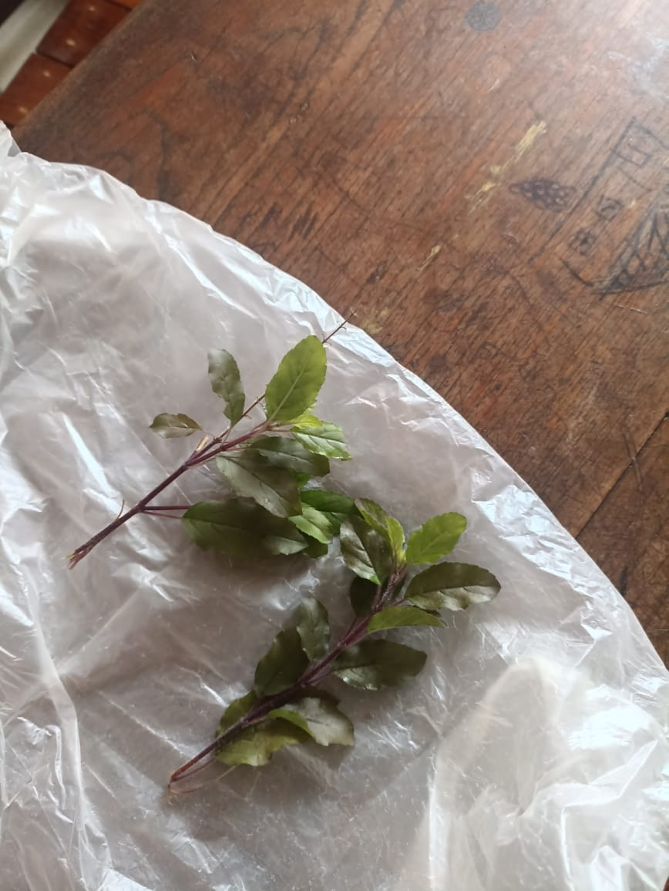

Fig 1.

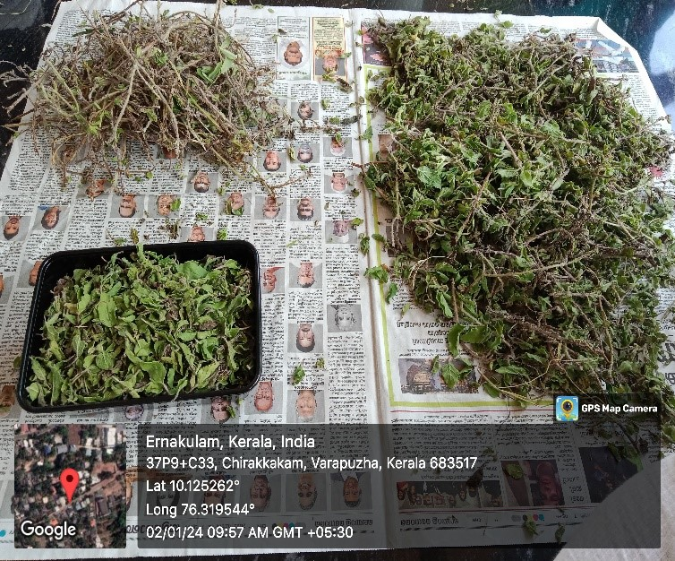

Fig 2.

**Plate II**

**Plant drying**

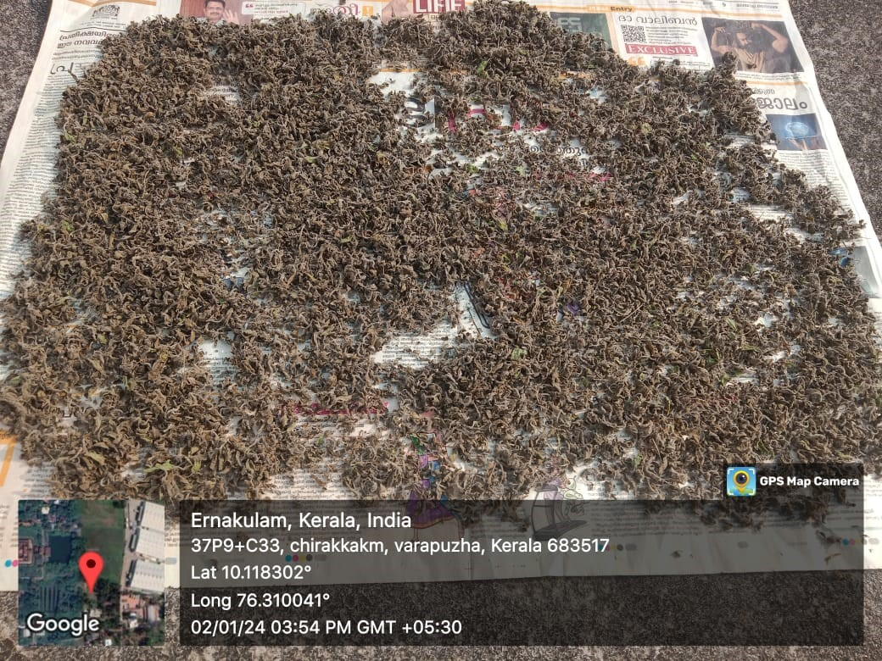

Fig 3.

**Plate III**

**Soxhlet extraction**

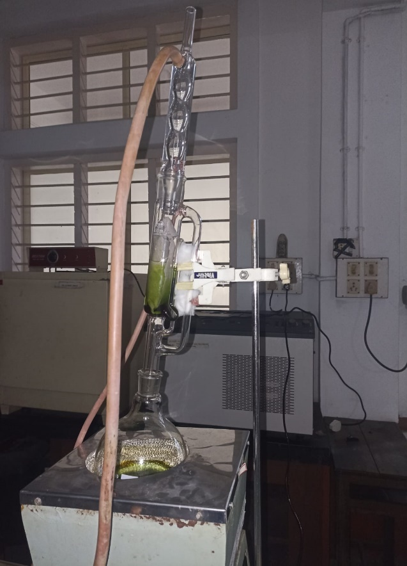

Fig 4.

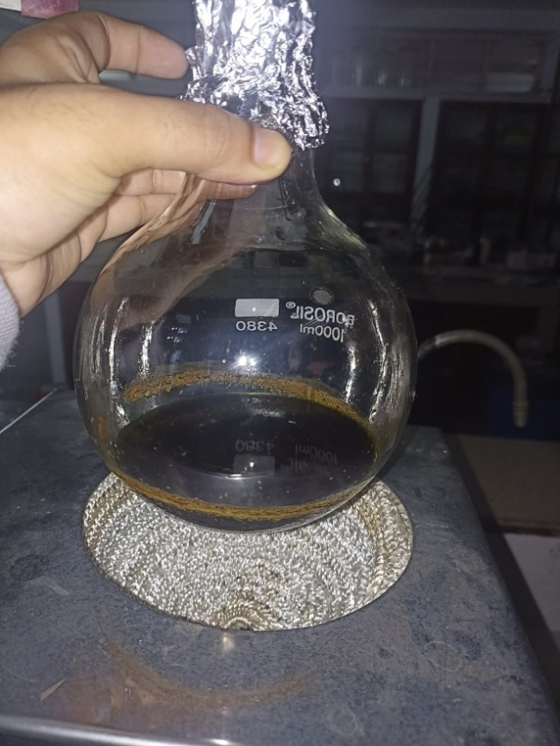

Fig 5.

**Plate IV**

**Essential oil**

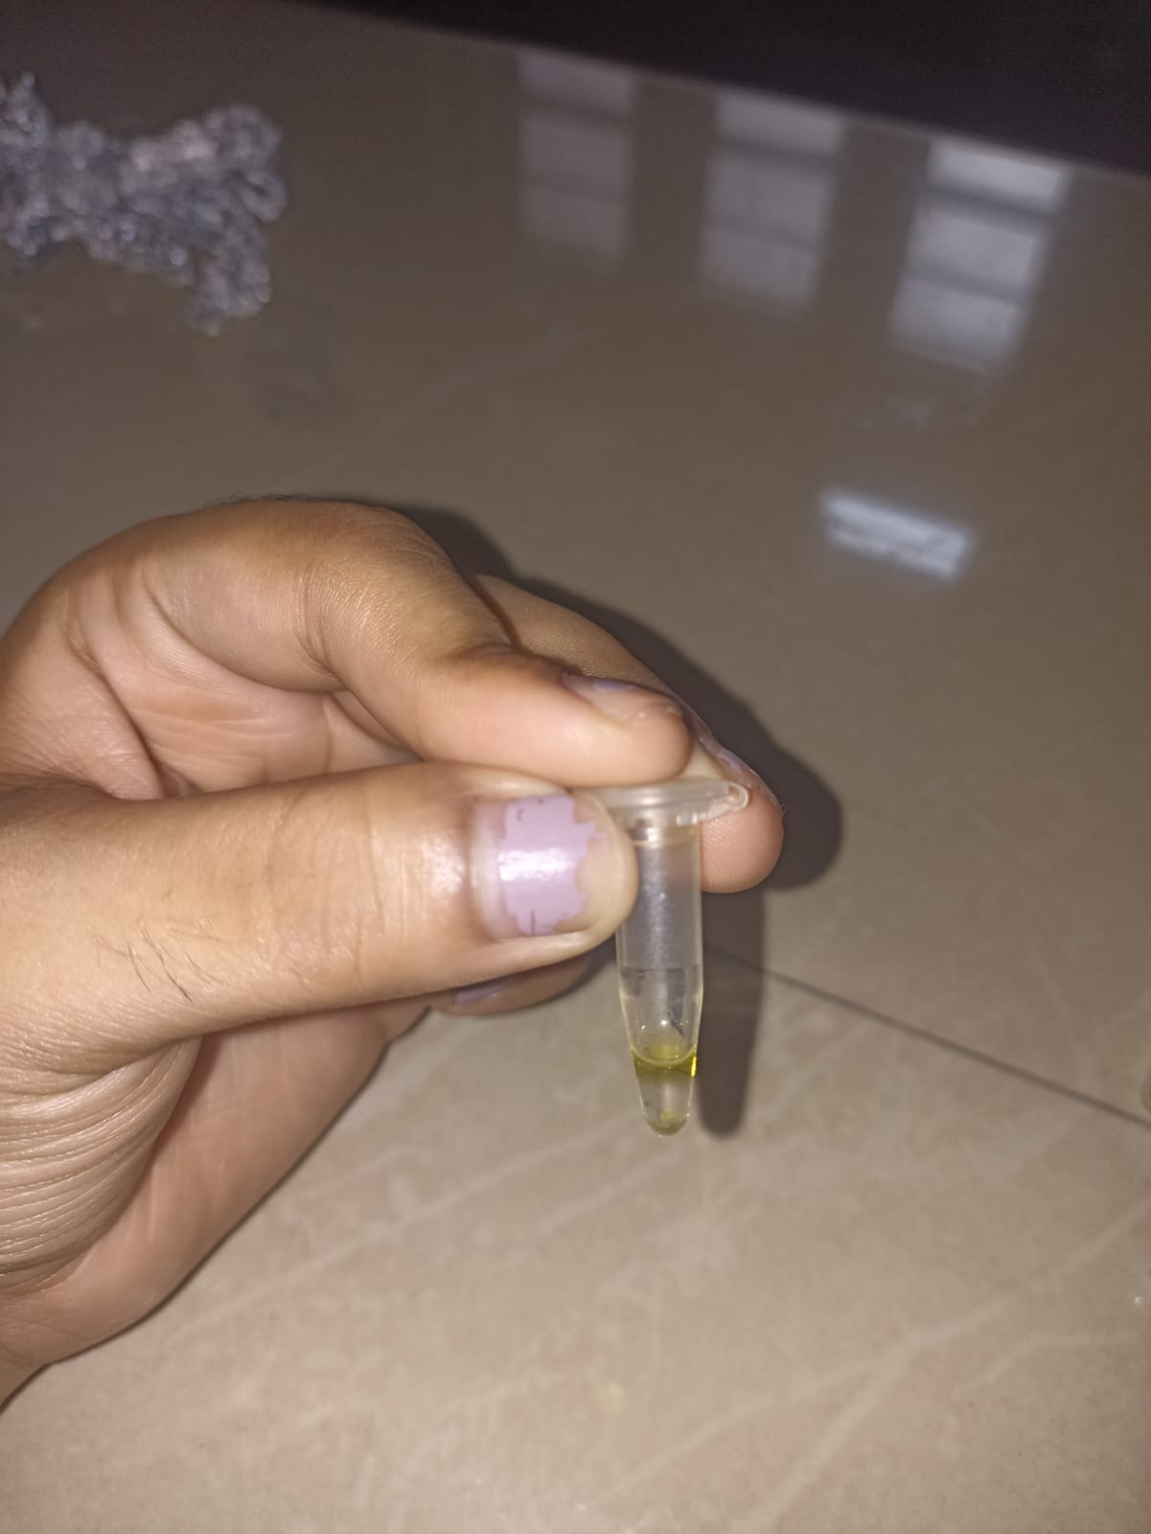

Fig 6.

**Plate V**

**Ethanol extract evaporation**

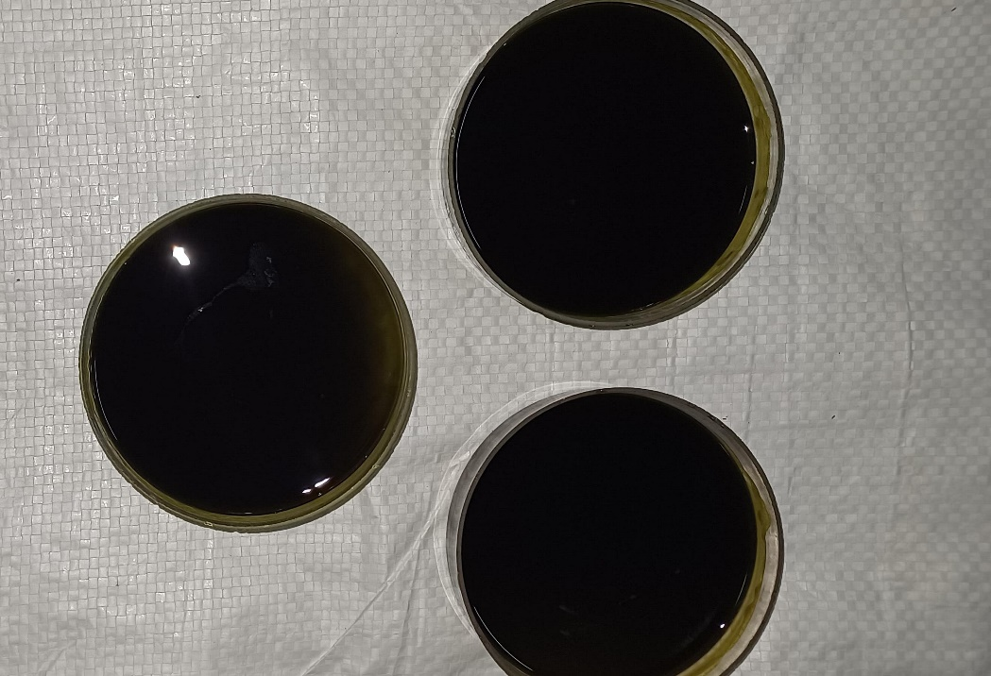

Fig 7.

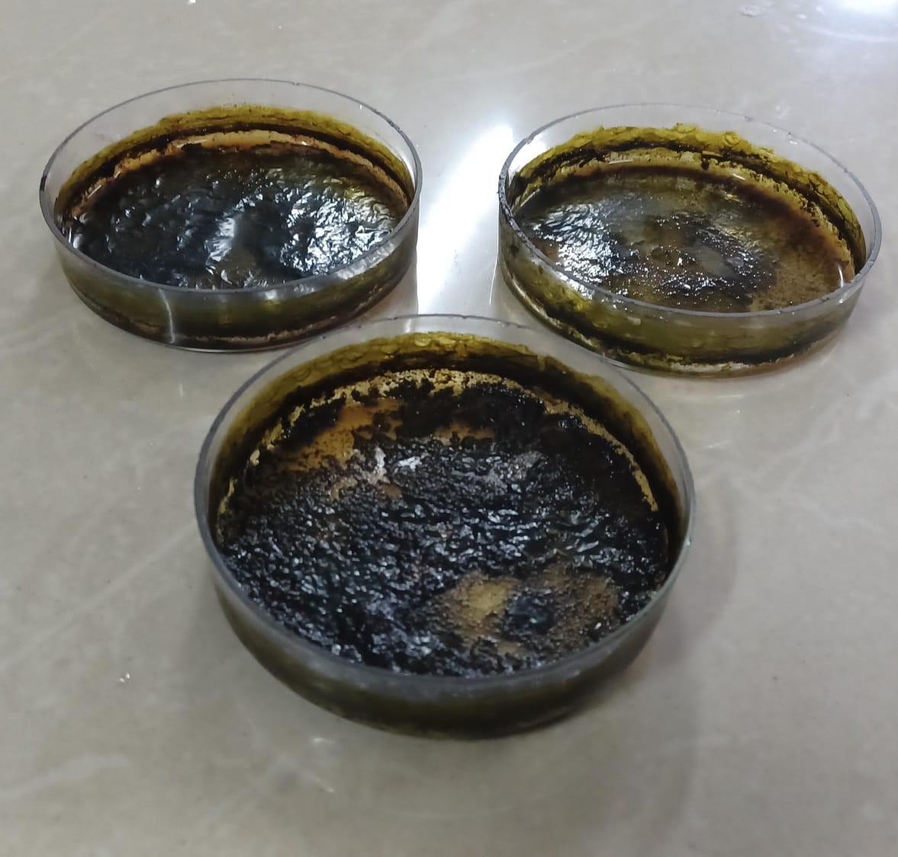

Fig 8.

**Plate VI**

**Phytochemical analysis**

**Test for Alkaloids -Hager’s test Test for saponins-Foam**

**formation**

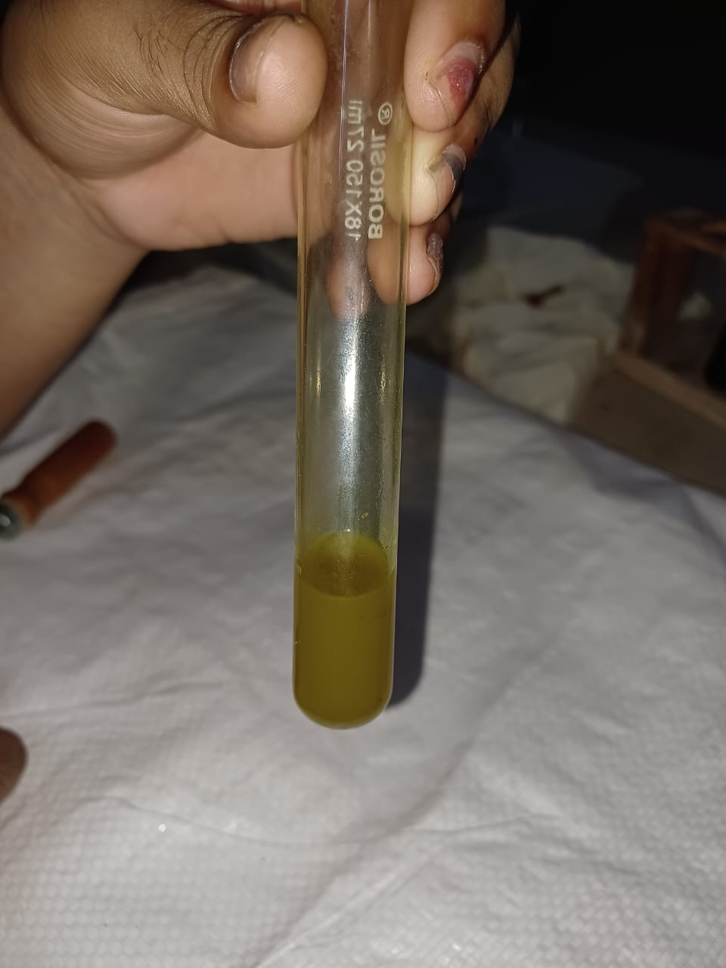 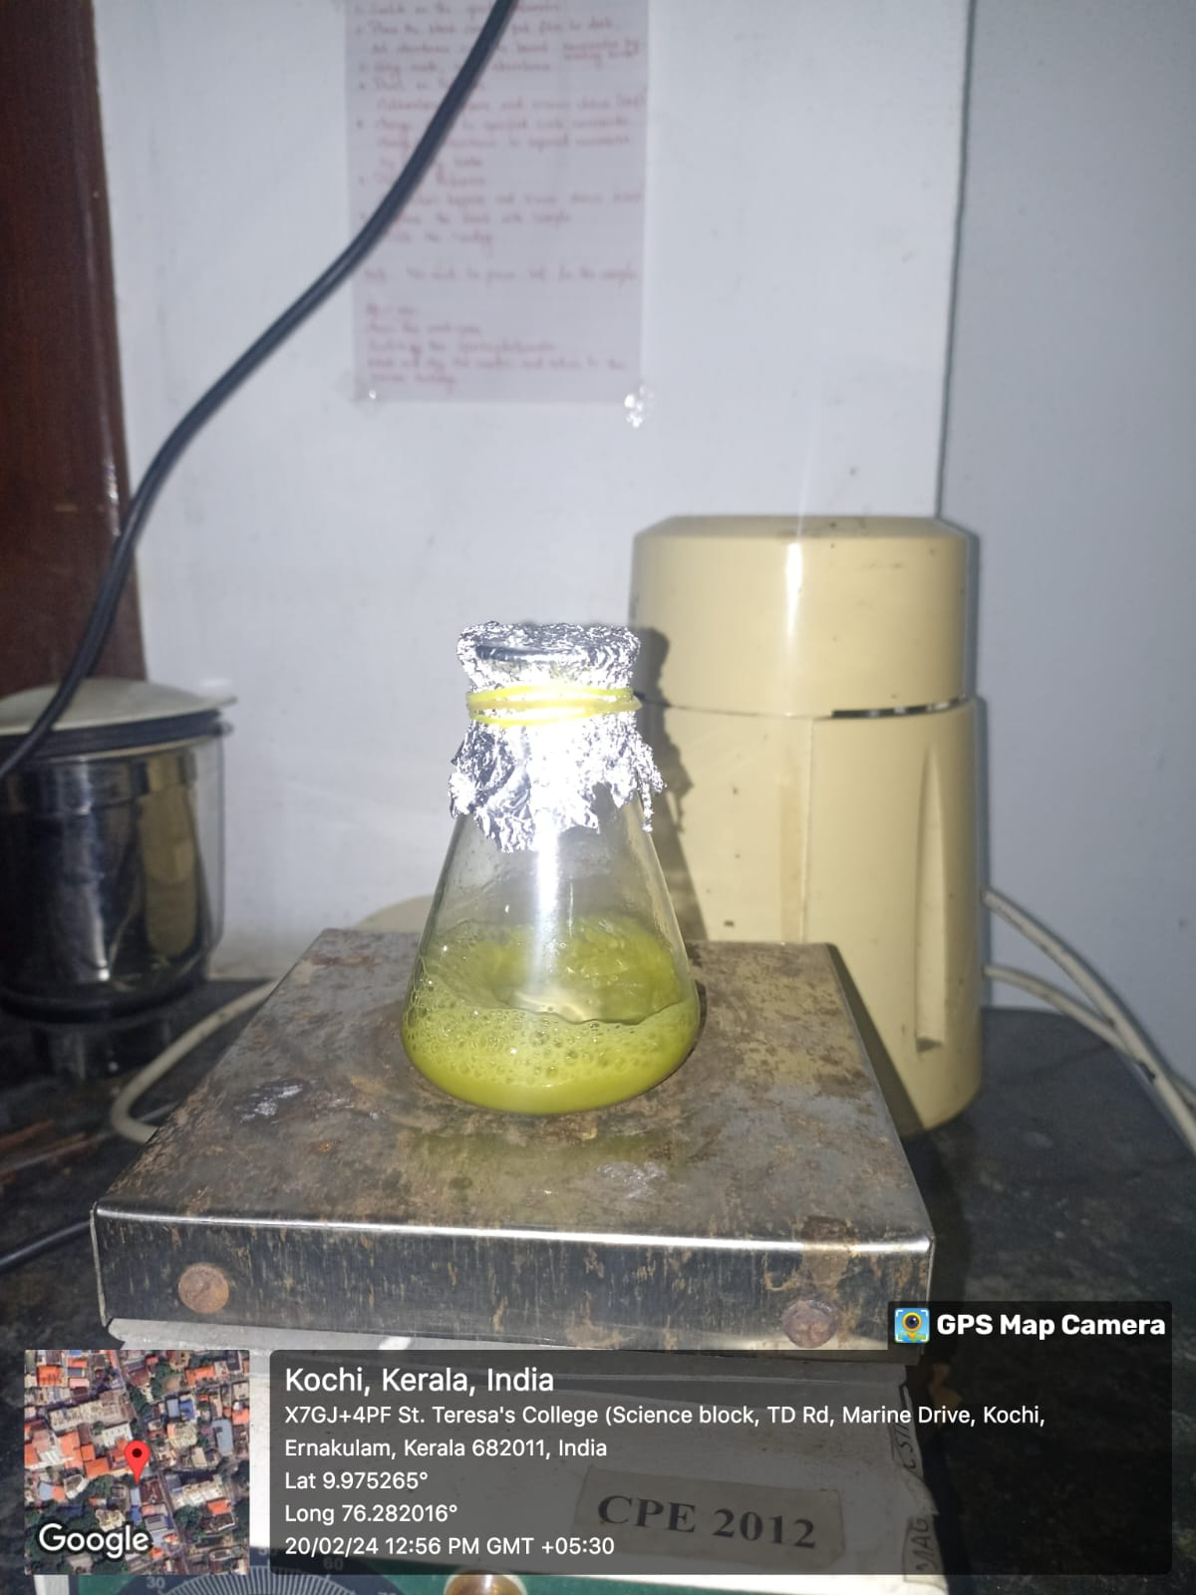

Fig 9. Fig 10.

**Test for Resin- Conc. HNO3 Test for Carbohydrates**

**-Fehling’s test**

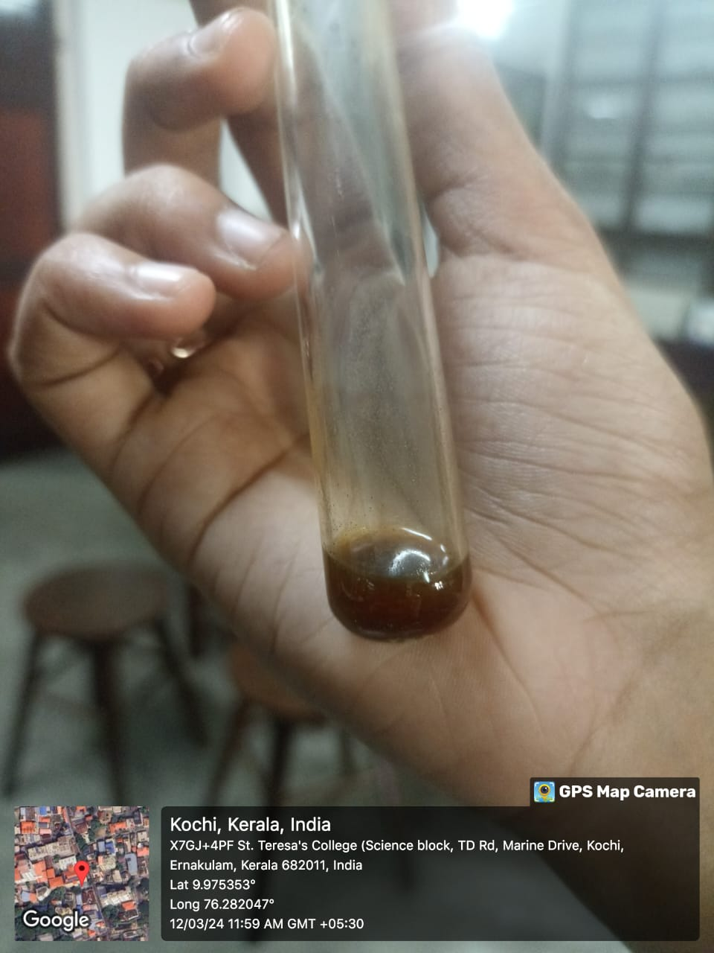 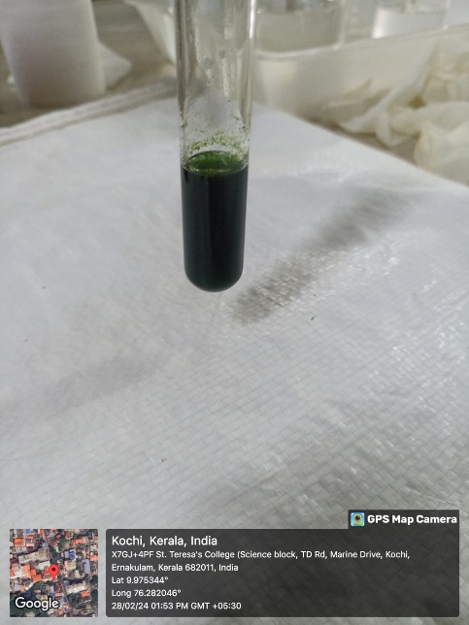

Fig 11. Fig 12.

**Test for flavonoids- Alkaline reagent test**

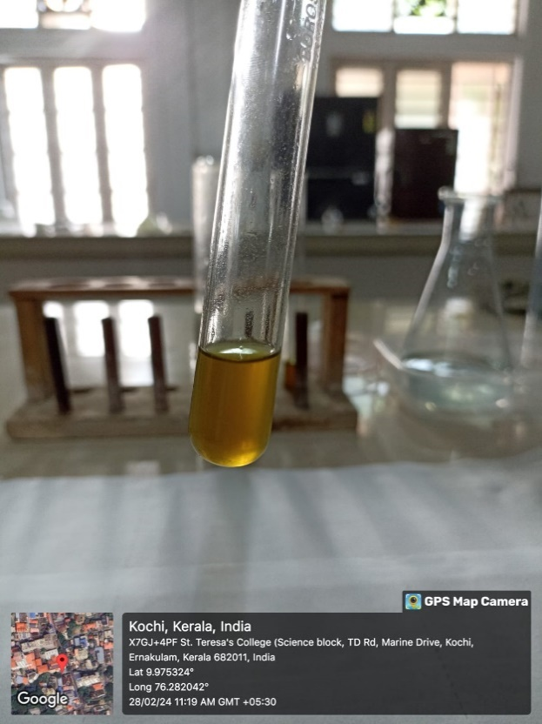 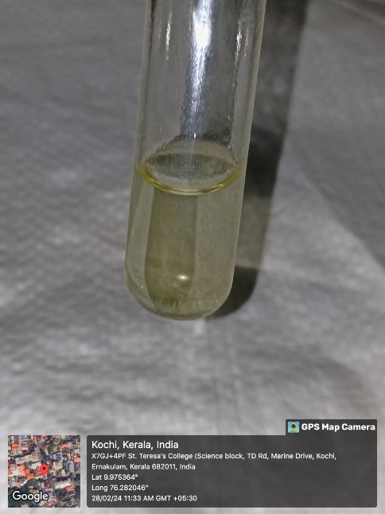

Fig 13. Fig 14.

**Test for Terpenoids – Test for Steroids-**

**Salkowski’s test Salkowski’s Test**

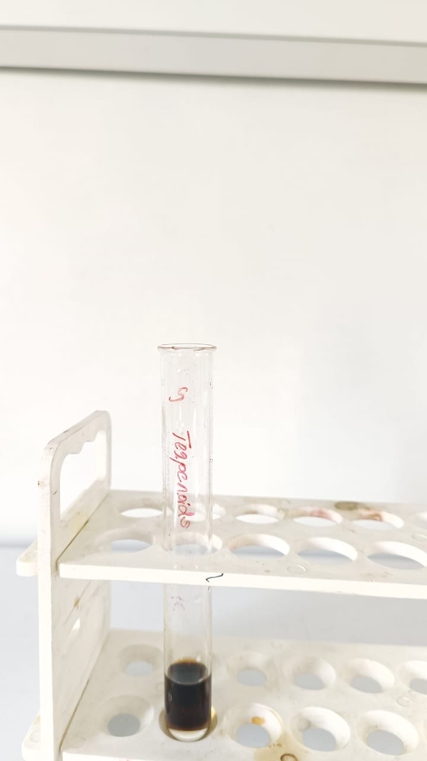 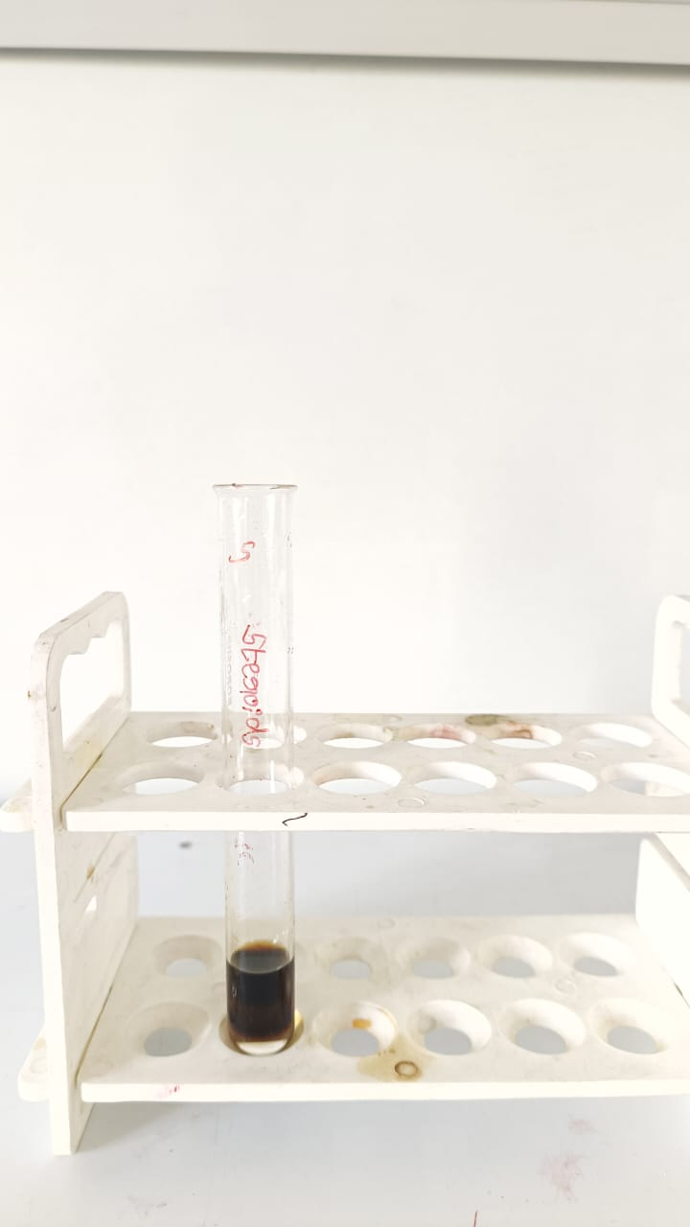

Fig 15. Fig 16.

**Test for Glycosides Test for Phenols**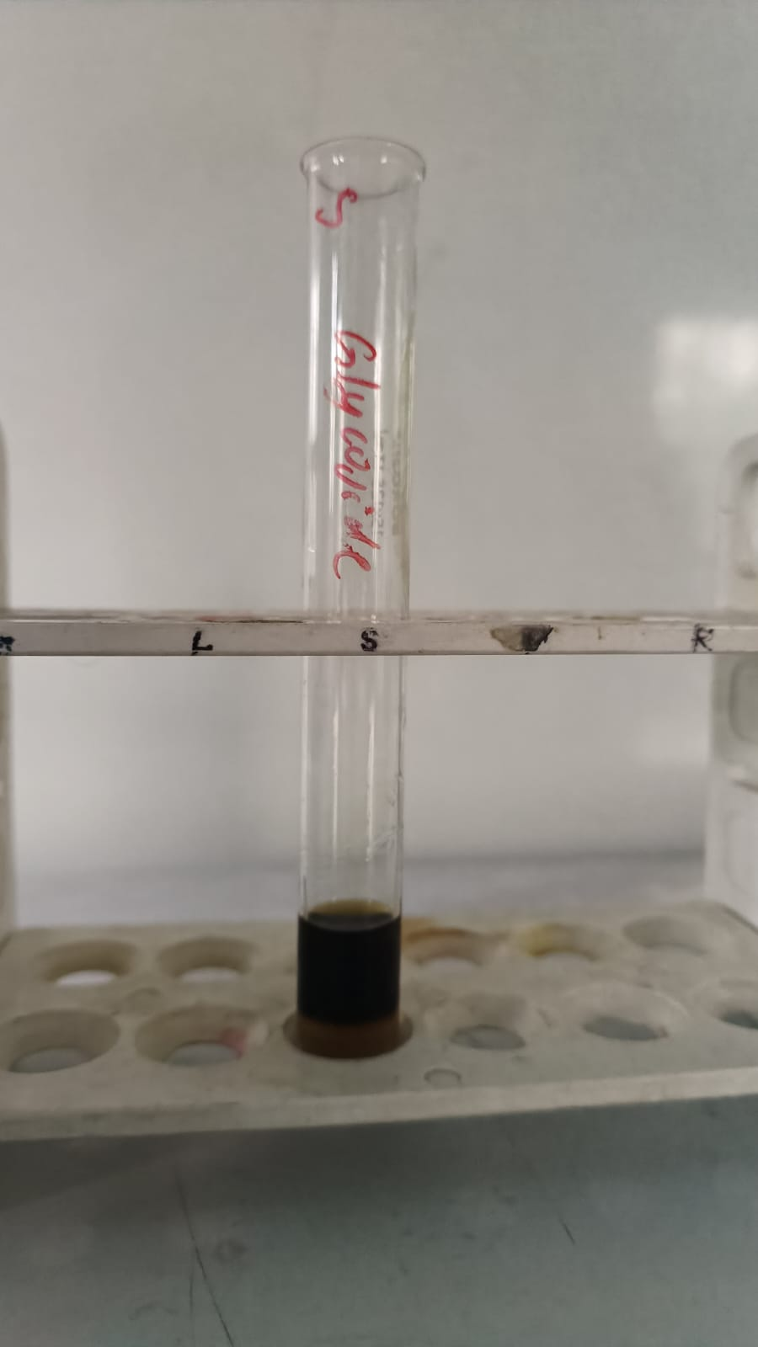 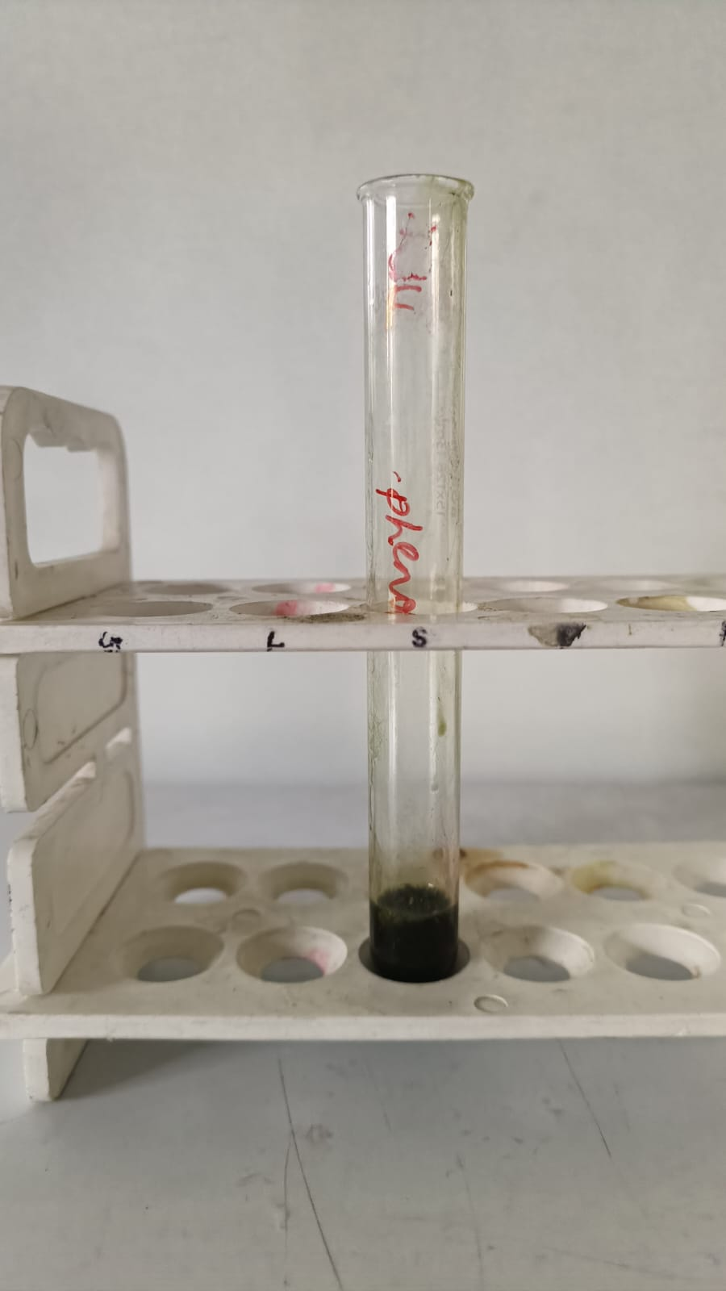

Fig 17. Fig 18.

**Plate VII**

**Antibacterial analysis**

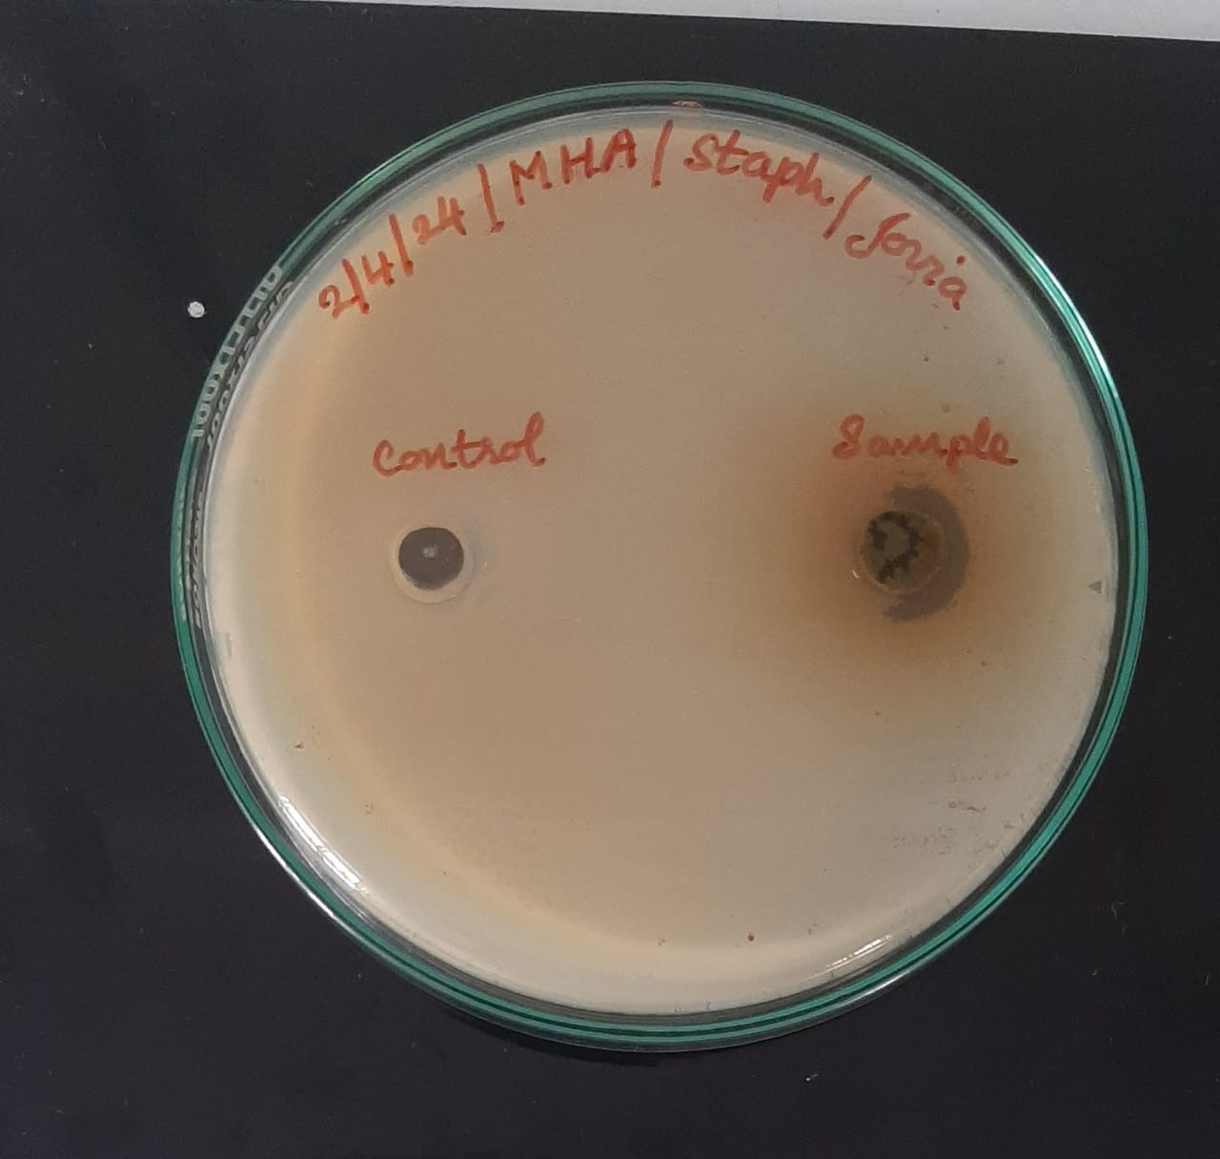

Fig 19. Anti-bacterial activity against *S. aureus*

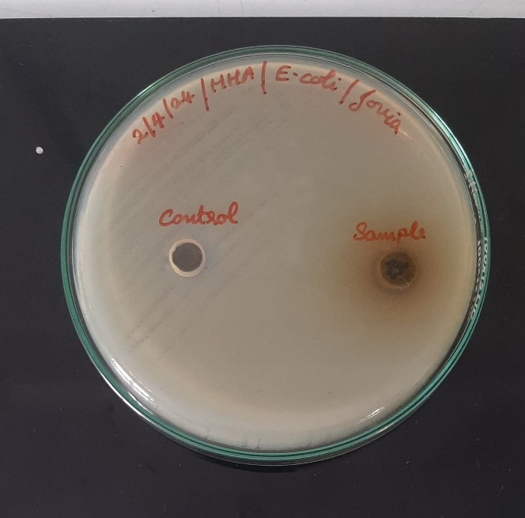

Fig 20. Antibacterial activity of Tulsi against *E. coli*

**DISCUSSION**

The present study was to conduct phytochemical screening of the plant, *Ocimum sanctum* and to study its antibacterial property. The study has given results consistent with previous studies conducted on the topic. We have found that the phytochemicals present in the ethanolic extract consist of alkaloids, saponins, phenols, glycosides, flavonoids, and resins and the absence of terpenoids, steroids, or carbohydrates.

Studies conducted by Naik et al, Panchal and Parvez 2019, Praveen Garg and Rajesh Garg, and many other studies have confirmed the presence of the above secondary metabolites in the *Ocimum sanctum* [22,23,26]. As was documented, these above phytochemicals, especially the presence of phenol have been the cause of antimicrobial activity that has been observed in Tulsi.

The ethanolic extract was dried and the plant was mixed in DMSO and tested for antibacterial activity, with DMSO as negative control. The analysis of Tulsi conducted indicated very good results. The ZOI shown by the Tulsi against *E. coli* bacteria was 20 mm and that showed against *S. aureus* was 23 mm. The test results are in accordance with that of the experiments conducted by Rai. A, et al in methanolic extract of Tulsi [36] as well as by Joshi. B, et al [37].

The antimicrobial as well as other properties of Tulsi like antidiabetic, anticancer, antiasthmatic, anti-inflammatory, hepatoprotective, anti-stress properties, contraceptive properties, etc are due to the presence of not only the various active principles that are present in it but also due to the combination of all of it. So, we can consider Tulsi as a medicinal plant, having the ability to cure a lot many diseases.

**CONCLUSION**

The present study conducted was to identify the various phytochemical constituents present in it and to analyze the antibacterial property of *Ocimum sanctum L.* The study has successfully identified the presence of alkaloids, phenols, flavonoids, resins, and saponins in its ethanolic extract. The phytochemical constituents are the reason for the antimicrobial property and various other health benefits that have been found to occur due to Tulsi. This medicinal plant can be used in daily life for common ailments, as well as its oil, for enriching and enhancing daily life. Further studies can be conducted on it so that in the future, it can be used by a larger population as a side-effect-free and cost-effective medicine.

**REFERENCES**

1. Anonymous. *Wealth of India* (1991); Vol. 7. Publication and Information Directorate, CSIR, New Delhi. p. 79–89.
2. Warrier, P. K., Nambiar, V. P. K., Ramankutty, C., & Vaidya, S. A. (1995). *Indian Medicinal Plants*. Orient Longman. Chennai (India).
3. Kothari, S. K.; Bhattacharya, A. K.; Ramesh, S.; Garg, S. N.; Khanuja, S. P. S. (November–December 2005). "Volatile Constituents in Oil from Different Plant Parts of Methyl Eugenol-Rich *Ocimum tenuiflorum L.f.* (syn. *O. sanctum L.*) Grown in South India". *Journal of Essential Oil Research*. 17 (6): 656–658.
4. Simoons, Frederick J. (1998). *Plants of life, plants of death*. Univ of Wisconsin Press. pp. 7–40.
5. Underhill, M. M. (1991). The Hindu Religious Year. Asian Educational Services. pp. 129–131.
6. Pawar, S., & Patil, D. A. (2008). Ethnobotany of Jalgaon District, Maharashtra. Daya Books.
7. POWO (2024). "Plants of the World Online”. Facilitated by the Royal Botanic Gardens, Kew. Published on the Internet; <https://powo.science.kew.org/taxon/urn:lsid:ipni.org:names:453130-1>
8. Bhadra, P., & Sethi, L. (2020). A review paper on the Tulsi plant (*Ocimum sanctum*). Indian Journal of Natural Sciences, 10(60), 20854-20860.
9. Cragg, G. M., & Newman, D. J. (2001). Natural product drug discovery in the next millennium. *Pharmaceutical biology*, 39(sup1), 8-17.
10. Harsha, V. H., Hebbar, S. S., Shripathi, V., & Hegde, G. R. (2003). Ethnomedicobotany of Uttara Kannada District in Karnataka, India—plants in treatment of skin diseases. *Journal of Ethnopharmacology*, 84(1), 37-40.
11. Ghosh, G. R. (1995). Tulasi (NO labiatae, genus-Ocimum). New Approaches to Medicine and Health (NAMAH), 3(1), 23-29.
12. Kirtikar KR, Basu BD. (1975) *Indian Medicinal Plant* 2nd Ed. Vol. 3. Bishen Singh Mahendra Pal Singh, New Connaught Place, Dehradun, (Uttarakhand) (India). p. 1965–1968.
13. Aruna, K., & Sivaramakrishnan, V. M. (1992). Anticarcinogenic effects of some Indian plant products. *Food and Chemical Toxicology*, 30(11), 953-956.
14. Serrame, E., & Lim-Sylianco, C. Y. (1995). Anti-tumor promoting activity of decoctions and expressed juices from Philippine medicinal plants. *Philippine Journal of Science*, 124(3), 275-281.
15. Sethi, J., Sood, S., Seth, S., & Talwar, A. (2004). Evaluation of hypoglycemic and antioxidant effect of *Ocimum sanctum*. *Indian Journal of Clinical Biochemistry*, 19, 152-155.
16. Sailaja, I., Shaker, I.A. and Ratna, Y.K., (2010), Antioxidant activity and phenolic contents in *Ocimum sanctum* and *Ocimum bascilicum*. *Asian Journal of BioScience*, 5(1): 1-5.
17. Mondal, S., Mirdha, B. R., & Mahapatra, S. C. (2009). The science behind sacredness of Tulsi (*Ocimum sanctum Linn*.). *Indian Journal of Physiology and Pharmacology*, 53(4), 291-306.
18. Gupta SK, Prakash J, Srivastava S (2002) Validation of traditional claim of Tulsi, *Ocimum sanctum Linn.*, as a medicinal plant. *Indian Journal of Experimental Biology* 40: 765773.
19. Kelm, M. A., Nair, M. G., Strasburg, G. M., & DeWitt, D. L. (2000). Antioxidant and cyclooxygenase inhibitory phenolic compounds from *Ocimum sanctum Linn.* *Phytomedicine*, 7(1), 7-13.
20. Al Ahdal, K., Maawadh, A. M., Al Deeb, L., Alshamrani, A. S., Almohareb, T., & Alrahlah, A. (2023). Effect of malachite green, *Ocimum sanctum*, and Er, Cr: YSGG laser on antimicrobial activity against *S. mutans* and CAD disinfection bonded to resin restoration. *Photodiagnosis and Photodynamic Therapy*, 42, 103571.
21. Yamani, H. A., Pang, E. C., Mantri, N., & Deighton, M. A. (2016). Antimicrobial activity of Tulsi (*Ocimum tenuiflorum*) essential oil and their major constituents against three species of bacteria. *Frontiers in microbiology*, 7, 195885.
22. Panchal, P., & Parvez, N. (2019). Phytochemical analysis of medicinal herb (*Ocimum sanctum*). *International Journal of Nanomaterials, Nanotechnology and Nanomedicine*, 5(2), 008-011.
23. Naik, L. S., Shyam, P., Marx, K. P., Baskari, S., & Devi, V. R. (2015). Antimicrobial activity and phytochemical analysis of *Ocimum tenuiflorum* leaf extract. *Int. J. PharmTech Res*, 8(1), 88-95.
24. *Ocimum sanctum L*. in GBIF Secretariat (2023). GBIF Backbone Taxonomy. Checklist dataset https://doi.org/10.15468/39omei accessed via GBIF.org on 2024-03-03.
25. Borah, R., & Biswas, S. P. (2018). Tulsi (*Ocimum sanctum*), excellent source of phytochemicals. *International Journal of Environment, Agriculture and Biotechnology*, 3(5), 265258.
26. Garg, P., & Garg, R. (2019). Phytochemical screening and quantitative estimation of total flavonoids of *Ocimum sanctum* in different solvent extract. *Pharma Innov J*, 8(2), 16-21.
27. Ali, S., Khan, M. R., Irfanullah, Sajid, M., & Zahra, Z. (2018). Phytochemical investigation and antimicrobial appraisal of *Parrotiopsis jacquemontiana* (Decne) Rehder. *BMC complementary and alternative medicine*, 18(1), 43.
28. Yadav, R. N. S., & Agarwala, M. (2011). Phytochemical analysis of some medicinal plants. *Journal of Phytology*, 3(12).
29. Pattanayak, P., Behera, P., Das, D., & Panda, S. K. (2010). *Ocimum sanctum Linn.* A reservoir plant for therapeutic applications: An overview. *Pharmacognosy reviews*, 4(7), 95.
30. Singh S, Malhotra M, Majumdar DK. Antibacterial activity of *Ocimum sanctum* L. fixed oil. *Indian J Exp Biol*. 2005;43:835–7.
31. Samak, G., Vasudevan, D. M., Kedlaya, R., Deepa, S., & Ballal, M. (2001). Activity of *Ocimum sanctum* (the traditional Indian medicinal plant) against the enteric pathogens*. Indian journal of medical sciences*, 55(8), 434-8.
32. Siya, M., & Mary, A. P. (2017). Studies on pharmacognosy, phytochemical and antimicrobial activity of *Ocimum sanctum L*. *World Journal of Science and Research,* 2(2), 01-12.
33. Sharma, A., Dikshit, M., Jhunjhunwala, A., & Som, A. K. (2022). Extraction process of Haridra & Tulsi essential oil with their medicinal uses. *Journal of Ayurveda and Integrated Medical Sciences*, 7(5), 41-47.
34. Perez, C. (1990). Antibiotic assay by agar-well diffusion method. *Acta Biol Med Exp*, 15, 113-115.
35. Balouiri, M., Sadiki, M., & Ibnsouda, S. K. (2016). Methods for in vitro evaluating antimicrobial activity: A review*. Journal of pharmaceutical analysis*, 6(2), 71-79.
36. Rai, A., Singh, A., & Sharma, A. (2022). Phytochemical analysis & antimicrobial activity of the leaves of *Ocimum sanctum*. *Journal of Pharmacognosy and Phytochemistry*, 11(3), 174-176.
37. Joshi, B., Sah, G. P., Basnet, B. B., Bhatt, M. R., Sharma, D., Subedi, K., Pandey, J., & Malla, R. (2011). Phytochemical extraction and antimicrobial properties of different medicinal plants: *Ocimum sanctum* (Tulsi), *Eugenia caryophyllata* (Clove), *Achyranthes bidentata* (Datiwan), and *Azadirachta indica* (Neem). *Journal of Microbiology and Antimicrobials*, 3(1), 1-7.