**“DOCUMENTATION AND NUTRITIVE EVALUATION OF**

**TRADITIONAL FOODS OF KERALA –KOZHIKODE DISTRICT”**



PROJECT SUBMITTED

In the Partial Fulfilment of the Requirement for the Award of the Degree of

B.Sc. NUTRITION AND DIETETICS

BY

**Dona Joy**

**Nandana Menon**

**Sanujas**

**SB21ND014**

**SB21ND029**

**SB21ND038**

DEPARTMENT OF CLINICAL NUTRITION AND DIETETICS

ST. TERESA’S COLLEGE (AUTONOMOUS) ERNAKULAM

APRIL 2024

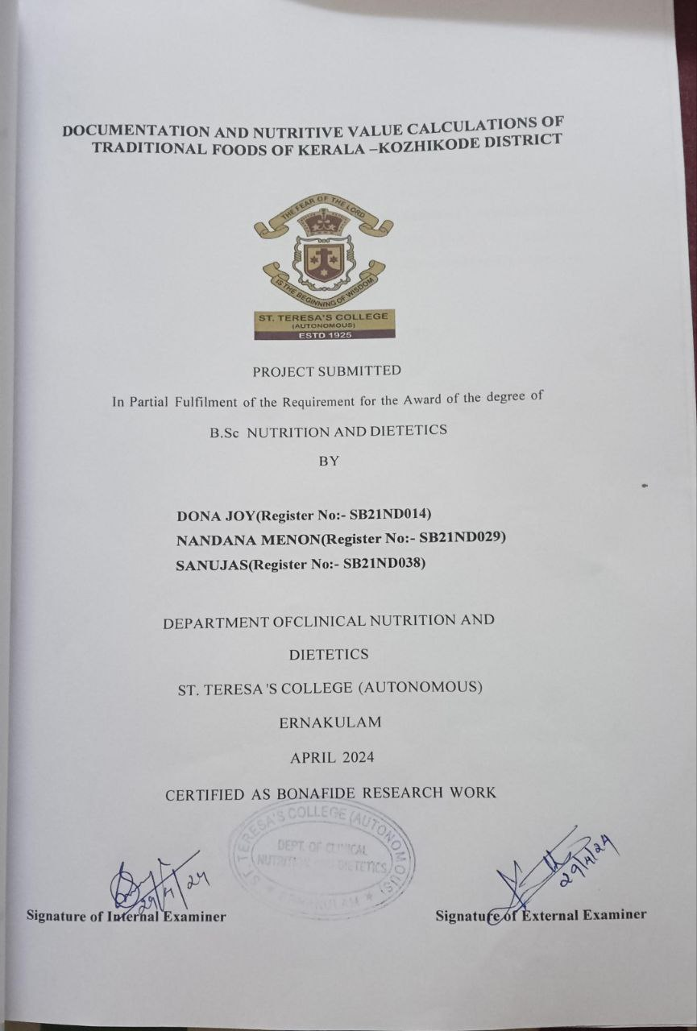

**LIST OF CONTENTS**

|  |  |  |
| --- | --- | --- |
| SL. No | Title | Page No. |
| Chapter I | Introduction |  |
| Chapter II | Review of literature |  |
| Chapter III | Materials and methods |  |
| Chapter IV | Result and discussion |  |
| Chapter V | Summary and conclusion |  |
|  | Reference |  |
|  | Appendix |  |

**LIST OF TITLE**

|  |  |  |
| --- | --- | --- |
| Table no | Title | Page no |
| 1. | Localities of the study |  |
| 2. | Different traditional foods |  |
| 3. | Selected traditional foods |  |
| 4. | Frequency of preparation of traditional foods |  |
| 5. | Reason for the preference of traditional food |  |
| 6. | How often traditional foods are prepared |  |
| 7. | Individual preferences on traditional or non-traditional food |  |
| 8. | List of traditional kitchen utensils and equipments |  |
| 9. | Nutritive value calculation of traditional food |  |

**LIST OF PLATES**

|  |  |  |
| --- | --- | --- |
| Plate no | Title | Page no |
| 1. | Selected traditional foods |  |
| 2. | Traditional kitchen utensils |  |

# 

# DECLARATION

I hereby declare that the project entitled **“DOCUMENTATION AND NUTRITIVE**

## EVALUATION OF TRADITIONAL FOODS OF KERALA – KOZHIKODE

**DISTRICT”**, submitted in partial fulfilment of the requirement for the award of the degree of B.Sc Nutrition and Dietetics is a record of original research work done by me under the supervision and guidance of **Ms. Elizabeth Varghese Anthikkat** ,Assistant Professor, Department of Clinical Nutrition and Dietetics, St. Teresa's College (Autonomous), Ernakulam and has not been submitted in part or full of any other degree/diploma/fellowship or the similar titles to any candidate of any other university.

**Place : Ernakulam**

**Date : 29 – 04 -2024 Name : Dona Joy**

**Nandana Menon**

**Sanujas**

# CERTIFICATE

We hereby certify that the project entitled **“ DOCUMENTATION AND NUTRITIVE**

## EVALUATION OF TRADITIONAL FOODS OF KERALA – KOZHIKODE

**DISTRICT”**, submitted in partial fulfilment of the requirement for the award of the degree of B.Sc. Nutrition and Dietetics is a record of original work done by **Ms. Dona Joy, Ms.Nandana Menon , Ms. Sanujas** , during the period of the study under my guidance and supervision.

**Signature of HOD Signature of Research Guide with**

## Designation

Ms. Surya M. Kottaram Ms. Elizabeth Varghese Anthikkat

Head of the Department Assistant professor

Department of Clinical Nutrition Department of Clinical Nutrition And

And Dietetics Dietetics

St. Teresa’s College (autonomous) St. Teresa’s College (autonomous)

Ernakulam Ernakulam

# 

# ACKNOWLEDGEMENT

This project has been kept on track and has been seen through to completion with the support and encouragement of numerous people especially my friends and colleagues. I thank everyone who made the completion of this project, possible. I would like to thank all those who had contributed in ways they can, to complete my study.

First and foremost, We thank God Almighty, for providing us all the strength and courage to complete this project.

We hereby express my sincere gratitude to Rev. Sr. Emeline CSST, Director, Rev. Dr. Sr. Celine E (Sr. Vinitha CSST), Provincial Superior and Manager, and Dr. Alphonsa Vijaya Joseph, Principal, St. Teresa’s College (Autonomous) Ernakulam, for granting us the permission to commence this project in the first instance and for allowing us to continue the same.

We are highly indebted to the Head of the Department of Clinical Nutrition and Dietetics, Ms. Surya M Kottaram , for her support and encouragement throughout the study.

We also express my sincere and deep gratitude to my research guide, Ms. Elizabeth Varghese Anthikkat, for the help and co-operation received from her during the entire programme. Her valuable suggestions, inspiring guidance and encouragement helped me complete my study more effectively. This project would have not been possible without her immense help.

Also, Our sincere and hearty thanks to all the teachers of the Department of Clinical Nutrition and Dietetics for their valuable suggestions.

We express my unreserved gratitude and thanks to the residents of Kozhikode who helped me with my data collection.

We also wish to place on record my deep sense of appreciation and humble thanks to my beloved parents for their encouragement to withstand the stress and kind motivation in completing my project. Their unconditional love and support provided me all the courage to finish my study.

We would also like to thank all my well-wishers who deserve special mention for their never-ending love and prayers.

Once again, thanks to all those who gave me the strength, courage, motivation, guidance and suggestions for making my project a success

# 1.INTRODUCTION

**“Let food be thy medicine and medicine be thy food”**

**-Hippocrates**

Food plays a crucial role all over the world .India is a country with several indigenous food and diversities. Every nook and corner of the country has unique and delicious cuisines. India, with its rich culture and biodiversity, has varied food patterns in different regions. The vast diversity in foods that are consumed on a daily basis makes Indian diets unique. (Ridhima et al,2022) Food is not only an indispensable commodity for survival but also a component of showcasing and pleasure(Nabeesa et al,2022)

After going through many researches it was found that Indian cuisines are greatly influenced by availability of local spices, variations of climatic conditions, variations of soil, tradition and food habits and culture. (Hoque, 2019)

Traditional Indian foods have been prepared for many years and preparation varies across the country. Traditional wisdom about processing of food, its preservation techniques, and their therapeutic effects have been established for many generations in India.Indian traditional foods are also recognized as functional foods because of the presence of functional components such as body-healing chemicals, antioxidants, dietary fibres, and probiotics.(Platel, 2020)

A healthy diet is the one which ensures the adequacy of energy and all other essential nutrients in order to promote the health and to prevent malnutrition in all it's forms.Consumption of whole grains and pulses appear to seen in rural and informal food systems types whereas the consumption of fruits and vegetables peak in the emerging and industrializing food system type(Brouwer et al, 2021)

India possesses numerous native foods (NFs) with significant cultural importance within local and ethnic communities, yet there has been no systematic effort to compile their nutritional values.The recent directive from FAO to establish a "Global-Hub on Indigenous Food Systems" underscores the renewed global acknowledgment of the potential of NFs to enhance food security and biodiversity worldwide.Therefore, it is essential to conduct thorough research and documentation on the beneficial properties of wild NFs to bridge the divide between scientific evidence and the ancestral knowledge of indigenous peoples (Kapoor et al,2022) .

Contemporary dietary habits have shifted, local residents still take pleasure in traditional dishes. Participatory Rural Appraisal methods were employed to gather necessary data.Locals utilize various parts of plants, including leaves, flowers, stems, fruits, and roots for cooking.The availability of raw materials typically spans from one to three months,Traditional recipes, particularly those utilizing plant leaves such as Colocasia, fig, basil, pigweed, buckwheat, and watercress, are rich sources of essential nutrients like calcium, phosphorus,and iron. Unfortunately,these recipes are losing popularity amidst the prevalence of fast-food culture.Therefore, there is an imperative to safeguard our traditional culinary heritage since theplant materials used are completely organic, ensuring nutritious and safe consumption(Kapoor et al,2010)

The significance of indigenous foods in improving dietary quality and enhancing food and nutrition security has been highlighted. However, their utilization has declined due to factors such as their limited availability in modern commercial markets and insufficient investment in research and development. Commercial farming and research efforts have largely overlooked indigenous crops, leading to a decrease in their competitiveness compared to more established crops and a loss of traditional knowledge and diversity associated with them. Dietary Guidelines underscore the nutritional value of indigenous crops by advocating for messages that are practical, achievable, and promote the consumption of indigenous and traditional foods.(M bhenyane,2017)

Preserving the rich tapestry of traditional Indian food culture is essential, as it serves as a cornerstone of the nation's identity, reflecting its unique cultural heritage and societal norms. Each culinary instrument holds its own narrative and sentimental value, contributing to the distinctiveness of Indian cuisine. Without these elements, Indian food would lack its inherent charm and would not have achieved the recognition it enjoys today. Therefore, it is imperative to commend efforts aimed at supporting and preserving these cultural traditions for future generations.

Despite the absence of reliable sources containing authentic information on existing traditional recipes, our initiative seeks to fill this gap through a study titled "Documentation and Nutritive

Evaluation of Traditional Foods of Kerala – Kozhikode District," with the following objectives:

* To identify and gather information on the diverse array of traditional foods across different districts of Kerala.
* To document the time-honored methods of preparing these traditional foods, ensuring their preservation for posterity.
* To conduct a thorough evaluation of the nutritional characteristics inherent in the selected traditional foods, shedding light on their health benefits and nutritional value.

# 

# 2.REVIEW OF LITERATURE

Literature relevant to the present study entitled “Documentation and quality evaluation of traditional foods of south zone of Kerala” is reviewed under the following heads.

2.1. Importance of traditional knowledge

2.2. History of traditional foods

2.2.1. Authenthic Indian Cuisine

2.2.2. kerala’s culinary heritage

2.2.3. Meaning, Concepts and Definition

2.2.4. History and Ethical Background

2.3. Health Benefits of Traditional Indian Cuisine

2.4. Key challenges of traditional foods

2.5. Future scope of traditional foods

## 2.1 IMPORTANCE OF TRADITIONAL KNOWLEDGE

Indian food is most popular for its diversity. The variety of foods, spices and dishes that are native to India. But lately, Indian food has begun to be categorised as unhealthy because it is having high sugar and high carb content which can contribute to high cholesterol. Traditional Indian food, however, is not only healthy, but is also incredibly tasty and have a lot of health benefits (Coutinho,2018)

Indian food is shown to support immunity, inflammation, brain function and several other functions in the humans. A variety of spices and vegetables in your diet is important for living healthy. Indian Diet has a variety of spices, where every spice has many health benefits. Eating local and seasonal vegetables and fruits at the right time is essential for good health and strong immunity (Desai,2024)

Food is eaten for the survival and strength of the body, but not for pleasure. Fasting is a practise of traditional food system. It is meant to purify the mind as well as the body. These traditional food concepts have been changed drastically in our society because of our contemporary lifestyle. The various aspects of traditional food system has been recorded in ancient scriptures, literature and as well as in oral narratives of folk. We may find special food items and many dietary varieties in Karnataka. These varieties have a number of little used; uncommon vegetables with perceived health benefits. Key traditional staple food and other food groups such as nuts, seeds, wild fruits and vegetables used in the diet are area specific. Traditional food system plays a significant role in maintaining the well-being and health of Indigenous People. Yet, evidence abounds showing that the traditional food base and knowledge of Indigenous People are being eroded. This has resulted in the use of fewer species, decreased dietary diversity due to household food insecurity and consequently poor health status. The knowledge of the traditional food system can change this scenario. Awareness created on traditional food system can contribute to create a healthy society to build strong nation. The traditional knowledge of food is considered to be the best for particular geographical condition. Changing food pattern can damage the good health of the society. So, it is vital to know the importance of good food habits of our own tradition and balanced diet. In this chapter, importance of traditional foods like staple, special, seasonal, region specific and their methods will be discussed.(Bhat,2016)

Our body is made to digest and assimilate things which are available locally for you on regular basis. Import of any edible things may not be suitable for your body and may invite some trouble which may not be reflected in a short duration but may require generations to learn their ill effects. Therefore, we can see different food products at different locations all over the globe. Such special food products made by using locally available edible material has its own value for particular locality or even it may have therapeutic or medicinal benefits also. All such products are made by using wisdom and knowledge which is traditionally transferred from one generation to next hence these food products are known as traditional foods.(Halde et al,2016) Traditional food refers to foods consumed over the longterm duration of civilisation that have been passed through generations.Traditional foods and dishes may have a historic precedent in a national dish, regional cuisine or local cuisine.Traditional foods and beverages may be produced as homemade, by restaurants and small manufacturers, and by large food processingplant facilities. Indian cuisine encompasses a wide variety of regional cuisines native to India.Given the range of diversity in soil type, climate, culture, ethnic group and occupations, these cuisines vary significantly from each other and use locally available spices, herbs, vegetables and fruits.(Halde et al,2016)

## 2.2 HISTORY OF TRADITIONAL FOODS

Indian cuisine encompasses a rich array of regional and traditional cooking styles native to the Indian Subcontinent. This culinary diversity stems from variations in soil, climate, culture, ethnicities, and occupations, resulting in the utilization of locally sourced spices, herbs,vegetables, and fruits. Religious beliefs, particularly Hinduism and Islam, along with cultural practices and traditions,heavily influence Indian food.Historical factors such as invasions, trade relations, and colonialism have also left their mark on Indian cuisine. The Columbian discovery of the New World introduced a plethora of new vegetables and fruits to India, including potatoes, tomatoes, chillies, peanuts, and guava, which have since become dietary staplesin many regions.(Aquino ,2021)

Indian cuisine has played a significant role in shaping international relations, notably through the spice trade between India and Europe, which catalyzed Europe's Age of Discovery. Spices sourced from India were traded extensively across Europe and Asia, influencing culinary traditions worldwide, including those in Europe (particularly Britain), the Middle East, Southern Africa, East Africa, Southeast Asia, North America, Mauritius, Fiji, Oceania, and the Caribbean.(Aquino,2021)

Understanding prehistoric food habits in India remains challenging, with limited written records and linguistic barriers complicating the interpretation of ancient cuisines. However, anthropological evidence and cave paintings found in regions such as Rajasthan, Gujarat, and Punjab offer glimpses into early dietary practices, revealing a story of survival and the transition to agrarian communities.(Aquino,2021)

At Harappan excavation sites, archaeologists have uncovered bones from cattle, goats, sheep, buffalo, and pigs. While it's likely that cattle, goats, and sheep were domesticated, there's also the possibility that they were hunted or raised for meat. Cattle farming primarily involved Zebu cattle, indigenous to the Indus Valley region.Additionally, bones of wild animals such as boar, deer, and gharial have been unearthed, along with remains of fish and birds.Grilling emerged as the preferred method for cooking meat during this era.Animals were either roasted whole over an open fire or cut into small pieces.These pieces were skewered and grilled, reminiscent of modern-day tikkas. The animal would be impaled on a stick, allowing it to be rotated over the fire for even cooking.(Aquino,2021)

Interest in traditional foods has persisted over time as they form the cornerstone of nutrition across diverse cultures and societies. However, with the advent of food industrialization in the mid-twentieth century, a discernible gap in quality emerged, particularly noticeable to consumers. This division categorized food into two main groups: mass-produced, standardized items whose raw material origins and production processes are often obscure, and small-scale, somewhat heterogeneous artisanal products. The latter fosters a closer producer-consumer relationship, as the production process is more transparent, allowing consumers to infer the raw material origins and thus instilling greater confidence.(Aquino,2021)

### 2.2.1 AUTHENTIC INDIAN CUISINE

Our research delved into the food habits of the Mundas, an indigenous community in Jharkhand, India, despite their access to abundant agroforestry resources, malnutrition remains prevalent. By employing a mixed-methods approach, including focus group discussions and key informant interviews, we explored the types of indigenous foods (IFs) they rely on, their nutritional value, and the factors influencing their consumption. Through qualitative analysis, we identified both commonly consumed and underutilized IFs, shedding light on the complexities of their dietary choices despite their rich food environment.(Shauna Downs).

The ancient science of Ayurveda offers extensive insights into health and nutrition, including dietary recommendations. Traditional Indian foods align closely with Ayurvedic principles, making them synonymous with Ayurvedic health foods.This review article delves into the concept of Ayurvedic health foods in India, highlighting various traditional foods from different regions along with dietary guidelines tailored to age, health status, and seasonal considerations.With globalization and increased awareness of health, people worldwide stand to gain valuable knowledge from India's rich tradition of Ayurvedic health foods.(PreetamSarkar).

### 2.2.2 KERALA’S CULINARY HERITAGE

Ancient Trade-Influenced Cuisines of Kerala is an invaluable compendium of a culinary tradition and variety of food recipes that evolved out of Kerala’s kitchens. The food trail is extensive and as varied as it can get. The proximity to the sea and the natural beauty and resources of the state–especially the fragrant spices which grew in abundance–attracted inhabitants of foreign soils and inspired them to initiate overseas trade along what was later known as the Spice Route. In a state with fish, other sea food and vegetables dominating people’s food habits, the various kinds of meats, foreign cooking techniques and exotic flavours were curried to life from foreign trade influences and became significant foods. There are numerous recipes in each foreign-influenced community in Kerala, well represented in this book, in meticulous detail. These recipes were cherished by the families and handed down generations via cross-cultural interactions within Jews of the Paradesi and Malabari sects, Syrian Christians, Muslims, Anglo-Indians, Latin Catholics and others who mingled with and evolved from the local populace. The book provides a well-researched and rich cultural history of foreign food culture, tracing how the new elements adapted to local food traditions and evolved as a parallel line of foods, creating new textures, flavours and tastes.(Abraham,2020)

### 2.2.3 MEANING, CONCEPTS AND DEFINITION

Kerala's culinary heritage has evolved through a rich tapestry of native spices and local ingredients cultivated over generations.With the advent of globalization, there has been an influx of new ingredients, cooking techniques, and culinary influences into Kerala's gastronomic landscape.This intersection of tradition and modernity is evident in dishes such as Kerala-style spicy chicken and sushi crafted from locally sourced seafood,showcasing a harmonious fusion of traditional and contemporary elements in the state's cuisine.(Thamp,2023)

The traditional Indian diet typically revolves around staple foods, fruits, vegetables, and grains seasoned with a variety of spices. These dietary practices have long been recognized for their integral role in promoting health and overall wellness. However, the colonial period introduced significant changes to these dietary patterns, introducing foreign influences that gradually infiltrated Indian food habits.(pai,Balakrishnan,2022)

In the postcolonial era, the forces of globalization and urbanization have further reshaped dietary norms, shifting the focus away from food as a fundamental necessity for sustenance and health towards a more status-oriented and consumer-driven approach. This shift has been largely driven by the pressures of capitalist consumerism, leading to the emergence of a new food culture that prioritizes consumption for the sake of social status and personal gratification. Consequently, food itself has become intertwined with notions of culture, reflecting the broader societal shifts and values of the contemporary era.(Pai, Balakrishnan 2022)

Traditional foods serve as significant cultural artifacts, shaping contemporary dietary habits and serving as essential components for assessing population dietary intakes accurately. They embody the cultural heritage, historical legacy, and lifestyle practices of various societies. Traditional foods encompass items that have been locally or regionally consumed over extended periods. The preparation methods for these foods are often ingrained in the cultural folklore of the country, passed down through generations.(trichopoulou,2007)

## 2.3 HEALTH BENEFITS OF TRADITIONAL INDIAN CUISINE

Traditional Indian cuisine offers a wealth of nutrients essential for supporting overall human health. Many Indian dishes center around grains, making them excellent choices for lowcarbohydrate foods. Curd, a staple in Indian meals, holds significant medicinal value and is commonly consumed at the end of every meal. Plant oils used in Indian cooking provide both nutritional and therapeutic benefits. Additionally, medicinal herbs like Amla extract, rich in Vitamin C, contribute to overall well-being.South Indian cuisine, primarily centered on dishes like Idli and Dosa, promotes probiotic activity, enhancing gut health. Traditional Indian Rasam boasts antipyretic, hypoglycemic, antimicrobial properties, and aids in reducing hypertension. Certain Indian foods have even shown promising effects in cancer treatment. Beetroot-based dishes are known to significantly impact hemoglobin levels. Medical professionals often recommend consuming nutritious foods to improve overall health. Furthermore, the addition of cloves to dishes has been found to benefit dental health.(Theivachandran,2021)

Many Indian dishes are prescribed as Ayurvedic remedies for various health conditions. Foods incorporating ingredients like curcumin, ginger, and neem are utilized as immunomodulators in Rasayana therapy. Ayurveda categorizes the body's dominant constituents into doshas, namely kapha, pitta, and vata. Indian cuisine plays a crucial role in adhering to the principles of Ayurvedic diet, emphasizing concepts such as kedarakulyanyaya, khale kapota nyaya, and kshiradadhinyaya, which elucidate different aspects of digestion and food function within the body.( Theivachandran , 2021)

Indian diets exhibit remarkable diversity, with approximately 30 popular cuisines found across the country. Traditional Indian foods are often referred to as functional foods due to their abundance of functional components, including dietary fibers, prebiotics, probiotics, and more.South Indian cuisine, in particular, offers a harmonious blend of legumes, coconut, rice, sprouted grams, drumstick, and vegetables, all rich in antioxidants. These dishes draw inspiration from Ayurveda, incorporating various spices such as black pepper, curry leaves, turmeric, tamarind, coriander, garlic, mustard, and chilies, each possessing potent antioxidant properties. Tamarind, in particular, boasts therapeutic qualities, containing natural phytochemicals, phytohormones, and being rich in fatty acids, flavonoids, and saponins(Choudary et al2022)

The traditional Indian diet is abundant in phytochemicals and nutrients known for their antiinflammatory properties. Indian cuisine incorporates numerous spices, each rich in phytonutrients that contribute to nerve health and enhance mitochondrial functions. For instance, turmeric is renowned for its ability to shield the brain from oxidative stress-induced damage, while saffron exhibits neuroprotective qualities, safeguarding the hippocampus from age-related deterioration.(Choudhary et al 2022)

## 2.4 KEY CHALENGES OF TRADITIONAL FOODS

In West Africa, traditional agricultural products play a crucial role in enhancing food security as they undergo traditional processing for value addition. Both nonfermented and fermented foods contribute significantly to the dietary needs of the population, promoting nutritional wellbeing. Despite their importance, large-scale industrial production of these traditional foods is limited in the region, with many processing facilities still operating at the household or cottage industry level, utilizing basic tools and techniques. Over the years, some mechanization methods such as mechanical grating, sieving, and hydraulic pressing have been adopted, improving efficiency and productivity (oguntoyinbo,2014)

However, an assessment of food safety practices in the subregion reveals a lack of emphasis on good manufacturing practices (GMP) and inadequate sanitation, leading to frequent instances of chemical and microbial contamination. Food safety challenges persist, with documented cases of foodborne diseases and outbreaks, often poorly documented. Identifying these safety issues is crucial for enhancing risk management and ensuring a safe food supply. This review highlights the various food safety challenges associated with the processing and consumption of traditional foods in West Africa, emphasizing the need for accurate information to inform policy development and control measures.( oguntoyinbo,2014)

The impact of urbanization on food insecurity has received little attention,there has been limited exploration into how food insecurity evolves and the varying risks it poses across different levels of human development.Traditionally, discussions surrounding food insecurity have primarily focused on undernutrition and hunger as the sole outcomes. However, recently contemporary food insecurity is also significantly influenced by obesity. obesity and emerging nutrition challenges are increasingly intertwined with the consequences of urbanization, including modern lifestyles prevalent in urban area.( Szabo 2016)

## 2.5 FUTURE SCOPE OF TRADITIONAL FOOD

Traditional rice landraces possess intricate genetic backgrounds, abundant diversity, and strong adaptability to various environmental conditions, making them valuable sources of resistance genes against pests and diseases.They offer novel alleles for enhancing desirable traits in rice, particularly amidst the challenges posed by global climate change.These landraces exhibit resistance to pests, diseases, drought, waterlogging, and floods.However, the gradual replacement of traditional landraces by modern cultivars threatens the loss of invaluable traits. Preserving indigenous rice varieties is crucial for sustainable agriculture, as they hold significance in agronomic, social, and cultural practices.Utilizing molecular breeding techniques alongside conventional methods can unlock the genetic potential of rice landraces, facilitating the identification and incorporation of novel genes and quantitative trait loci (QTLs) into commercial rice varieties.This review paper summarizes research findings on enhancing yield and tolerance to biotic and abiotic stresses in traditional rice landraces.(sivakumar et al,2021)

Electrochemical biosensors represent a category of sensors that convert biological information, such as analyte concentration, into current or voltage, utilizing a biochemical receptor. They offer promising diagnostic capabilities for detecting biomarkers in bodily fluids like sweat, blood, feces, or urine. By combining effective immobilization techniques with appropriate transducers, biosensors become efficient tools, finding applications across various sectors including food industry, medical sciences, defense, and plant biology. However, the complexity of the data generated during sensing processes often poses challenges in manual interpretation. Machine learning emerges as a valuable tool for deciphering large sensing datasets, particularly in removing signals from contaminants to enhance sensitivity, especially in the presence of impurities. This review explores diverse types of biosensors, their applications, and the integration of machine learning, aiming to be a comprehensive resource for newcomers in the interdisciplinary field of electrochemical biosensors. Additionally, it discusses challenges, knowledge gaps, and potential solutions, offering insights into the future of electrochemical biosensors and the role of machine learning.( Singh et al,2021)

Bioactive compounds are secondary metabolites sourced from plants, fungi, microbes, or animals, possessing pharmacological or toxicological effects, making them valuable in food and pharmaceutical industries. The exploration of their diverse properties has expanded their applications to include cosmetics, biomaterials, bioremediation, and alternative fuels. Traditional extraction methods, which are time-consuming and solvent-intensive, are being supplanted by eco-friendly solvents like ionic liquids, supercritical fluids, and deep eutectic solvents, alongside unconventional techniques such as microwave, electric fields, enzymeassisted, ultrasound, and pressure-assisted extraction. These advancements, coupled with improved characterization and optimization strategies, enhance the commercial feasibility of extracting bioactives from agricultural waste and organic residues, thereby promoting a sustainable circular economy. Future developments in microfluidics, optimization models, nanoencapsulation, and metabolic engineering are anticipated to address existing limitations, facilitating better screening, extraction efficiency, and economic viability while preserving biodiversity and enhancing the stability and functionality of bioactive compounds. This review provides an overview of extraction and characterization methods for bioactive compounds, highlighting their applications in various sectors including food, pharmaceuticals, chemicals, energy, and bioremediation, while also addressing key limitations and opportunities for improvement.( Pai et al,2022)

# 3. MATERIALS AND METHODS

This chapter deals with the methods and tools followed in the various phases of the study and the details are presented under the following headings:

3.1. Locality of the study.

3.2. Selection of sample.

3.3. Plan of study.

3.3.1. Collection of information regarding traditional food habits in Kozhikode

3.3.2. Documentation of traditional foods in Kozhikode

3.3.3. Preparation of selected traditional foods in Kozhikode.

3.3.4. To develop nutritive value of selected traditional foods in Kozhikode district.

## 3.1 Locality of the study

Kozhikode district was purposely selected for the study.Kozhikode district is located on the southwest coast of India, in the state of Kerala. It is known for its rich history, cultural heritage, and beautiful beaches. Kozhikode, the district's administrative headquarters, was once a major trading port for spices like pepper and cardamom. The district is also famous for its cuisine, especially the Malabar biryani and various seafood delicacies.The following localities were namely selected:

Table 1.Localities of the study

|  |  |
| --- | --- |
| **SL.no** | **Localities selected** |
| 1 | Vadakara |
| 2 | Koduvally |
| 3 | Kunnamangalam |
| 4 | Nadapuram |
| 5 | Nadakkavu |

## 3.2 Selection of sample

Population above the age of 50 years with knowledge in traditional food preparations were also selected randomly from each study locality. As traditional food habits differ with respect to region, religion, and caste, the selected samples were categorised based on the communities they represent. A total of 10 people, belonging to different communities like Hindus, Muslims and Christians were selected.

Table 2. Distribution of respondents selected for the study

|  |  |  |  |  |
| --- | --- | --- | --- | --- |
| Sl no | Hindus | Muslims | Christians | Total |
| 1. | 8 | 12 | 5 | 25 |

## 3.3 Plan of Study

3.3.1 Collection of information regarding the traditional food habits in Kozhikode

3.3.2 Documentation of traditional foods in Kozhikode

3.3.3 Preparation of selected traditional foods in Kozhikode

3.3.4 To develop nutritive value of selected traditional foods in Kozhikode district

### 3.3.1 Collection of information regarding the traditional food habits in Kozhikode

From the identified study locations, information regarding the traditional foods and food habits of each community associated with religious customs, festivals, special occasions, the ingredients and their methods of preparation, were collected through questionnaires that contained information about the same. The samples were also interviewed to collect further details on their childhood experiences involving the traditional foods, different festivities and special foods prepared during those occasions, foods they consumed during their school life, etc. We were also shown different traditional kitchen equipments and utensils including churner, Bharani or canister, muram, mortar and pestle, arakallu, cheena chatti, or mann chatti or clay pot, kal chatti or stone pot, para or bushel, kooja or earthen pot etc.

**3.3.2. Documentation of traditional foods in Kozhikode**.

From the questionnaire and interviews, the details of different traditional foods of different communities were identified and a list of traditional foods thus identified is given in table. We also gathered detailed information of method of preparation of selected traditional foods. Documentation of the process through photographic and written methods was done. The history of selected traditional foods and the changes occurred to traditional food preparations were also collected from the skilled experts using time/trend line through in-person interviews.

Table 3: Different traditional foods

|  |  |
| --- | --- |
| **SL NO** | **Different traditional foods** |
| 1 | CHATTIPATHIRI |
| 2 | KAIPOLA |
| 3 | KALLUMAKAYA FRY |
| 4 | BUN NIRACHATHU |
| 5 | ARIKADUKKA |
| 6 | KOZHI NIRACHATHU |
| 7 | NEYPATHAL |
| 8 | KANNU VECHA PATHIRI |
| 9 | MUTTAMALA |
| 10 | THARIPOLA |
| 11 | KAPPA PURATIYATH |
| 12 | COCONUT RICE |
| 13 | CHICKEN BREAD POCKET |
| 14 | THARI KANJI |
| 15 | MUTTA MARICHATHU |
| 16 | PORICHA PATHIRI |
| 17 | KILIKOODU |
| 18 | KOZHI ADA |
| 19 | PAALVAZHAKA |
| 20 | ERACHI ULARTHIYATH |

Out of the above foods, the following foods were selected for further study

|  |  |
| --- | --- |
| **SL NO** | **Selected traditional foods** |
| 1 | PAALVAZHAKA |
| 2 | KAPPA PURATIYATH |
| 3 | BUN NIRACHATH |
| 4 | KAIPOLA |
| 5 | CHATTIPATHIRI |
| 6 | KANNU VECHA PATHIRI |
| 7 | NEYPATHAL |
| 8 | THARIPOLA |
| 9 | MUTTAMALA |
| 10 | COCONUT RICE |

Table 4 :Selected traditional foods

### 3.3.3 Preparation of selected traditional foods in Kozhikode

#### 3.3.3.1 PAALVAZHAKA

INGREDIENTS

* large sago pearls -1/2 cup (100g)
* Thin coconut milk-1 cup
* medium sized ripe plantains nenthrapazham -3
* sugar-1/3 cup
* cardamom powder-1/2 tsp
* A pinch of salt
* thick coconut milk-1 cup FOR TEMPERING:
* Ghee-1 tbsp
* onions cheriyulli thinly sliced-3,4
* cashews chopped
* raisins-10-15

PREPARATION

* Soak the sago pearls in water for an hour or till totally plump. Wash once and drain

* Mix into the thin coconut milk and bring the mixture to cook. Cook on lowest flame with lid on, stirring occasionally to avoid sticking to the bottom of the pan.
* Halfway, add plantains, cardamom, sugar and salt and continue to cook till the sago looks all fluffed up and transparent. Add in some water only if the mixture looks too dry.
* Once the sago looks completely cooked, add in the thick coconut milk and give a good mix. Switch off.
* Heat ghee in a small saucepan. Fry the pearl onions till golden brown. Quickly fry the cashews and raisins and pour the mixture into the prepared paal vazhakka. Close the lid and keep covered for five minutes.

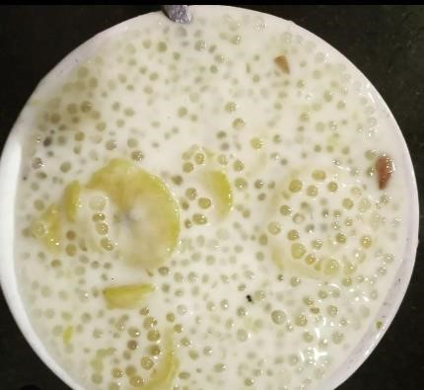

Plate 1.Paalvazhaka

#### 3.3.3.2 KAPPA PURATIYATH

INGREDIENTS

* 1 kg tapioca
* 1 cup grated coconut
* 4 green chilies
* 1 tsp garlic
* ½ tsp cumin seeds
* ½ tsp turmeric powder
* Salt as required
* For seasoning
* 2 tsp oil
* ½ tsp mustard
* 1 tbsp shallots, sliced
* 2 dried chilies
* 2 sprig curry leaves

PREPARATION

* Grind green chilies, grated coconut, turmeric powder, garlic and cumin seeds using a blender and set it aside.Peel, chop and wash the tapioca.
* Boil water and add the tapioca pieces in it.When the tapioca pieces become soft, drain the excess water.

Now add the ground mixture to the tapioca and mix well.Mash the tapioca using a ladle.Place another pan on the stove.Heat oil.Splutter the mustard seeds in it.

* Add sliced shallots to the pan.Add dry chilies and curry leaves to the pan and saute well for till the shallots change color.
* Add the seasoning to the mashed tapioca and mix well.Kappa purattiyath is ready to be relished.

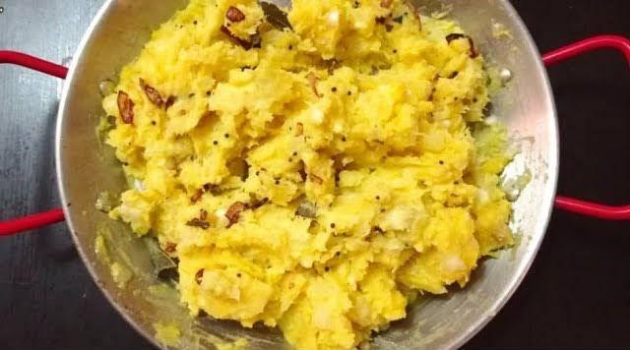

Plate 2.Kappa puratiyath

#### 3.3.3.3 BUN NIRACHATHU

INGREDIENTS

* For 4 large buns
* Eggs – 2 – 3, hard-boiled and halved
* Oil – 1.5 tbsp
* Onion – 1 large, thinly sliced
* Ginger-garlic paste – 2 tsp or minced ginger and garlic – 1 – 1.5 tsp each
* Green chilly – 1, finely chopped
* Curry leaves – 4 – 5, chopped
* Turmeric powder – ¼ tsp
* Chilly powder – ½ tsp
* Pepper powder – ¼ tsp
* Gram masala powder – ¾ tsp
* Buns, unsliced – 4 large or 5 – 6 medium
* Salt – To taste
* Oil / ghee – 1 – 1.5 tbsp (To shallow fry the buns)

Egg – 1, beaten with 1 tsp milk and a tiny pinch of salt and pepper

PREPARATION

* Heat 1.5 tbsp oil over medium-high flame. Saute thinly sliced onion, salt, ginger-garlic paste, green chilly and chopped curry leaves. Saute until onion turns light golden. Add the spice powders numbered 3. Mix everything well and cook until their raw smell is gone. Switch off. Check for salt. Set aside until ready to use.
* Using a knife, make a round or square cut on the bottom side of the bun. Remove some crumbs from the inner section without breaking the bun. Repeat with the remaining buns. Stuff each bun with 1 – 1.5 tbsp onion masala. Place an egg half on top followed by 1 – 2 tsp onion masala. Cover with the outer part of the bun. Press gently.
* Beat an egg adding 1 tsp milk and a tiny pinch of salt and pepper. Place it in a wide bowl or plate.
* Heat 1 – 1.5 tbsp ghee over medium heat. Dip the bottom part of the bun into the beaten egg and place inside the frying pan. This will help seal the bottom part. Fry for 1 – 2 minutes on both sides. Serve warm with tea.

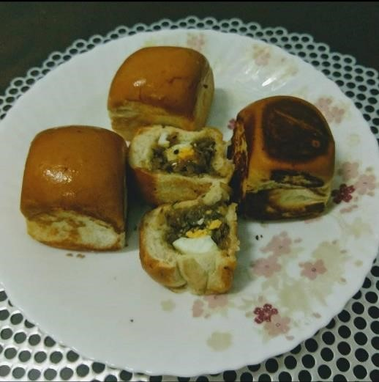 Plate 3 Bun Nirachathu

#### 3.3.3.4 KAIPOLA

INGREDIENTS

* Ripe Plantain – 3 Nos
* Egg – 4 No
* Sugar – 4 Table spoons
* Cardamom powder – 1½ Tea spoon
* Cashew nuts – 15 Nos

Raisins – 15 Nos

* Ghee – 2 Table spoon

PREPARATION

* Peel the plantains and cut it into small pieces.Heat 2 table spoons of ghee in a non-stick sauce pan.Fry the cashew nuts and raisins separately until they turn golden in colour. Keep them aside.
* To the same pan (in the remaining ghee), add plantain pieces and sauté them well.Turn off the flame and allow the pan to cool down.
* Put the eggs, sugar and cardamom powder in a bowl and whisk them well.Pour this egg mixture into the pan that contains the sautéed plantain.
* Combine it and top the mixture with fried cashew nuts and raisins.Cook this mixture covered in a very low flame for about 20 minutes.
* Remove from the flame and cut it into pie shaped pieces.Kaipola is ready to serve

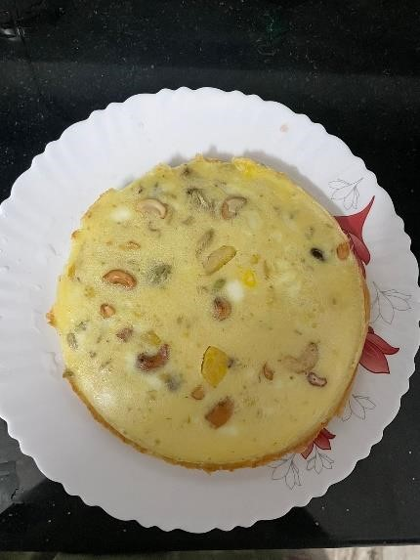

Plate 4.Kaipola

#### 3.3.3.5 CHATTIPATHIRI

INGREDIENTS

For the Chicken Stuffing

* 300 grams Chicken, minced
* 1 Onion, sliced
* 1 sprig Curry leaves
* 4 cloves Garlic, chopped
* 1 inch Ginger, chopped
* 1 teaspoon Turmeric powder (Haldi)
* 2 teaspoons Red Chilli powder
* 2 teaspoons Garam masala powder
* 1 teaspoon Black pepper powder
* Coconut Oil, for cooking
* Salt, to taste

For the Pathiri

* ½ cup Whole Wheat Flour
* ½ cup All Purpose Flour (Maida)
* Salt, to taste

PREAPARATION

* + To begin making the Kerala Style Chicken Chatti Pathiri Recipe, we will first heat a saucepan over medium heat.
  + Add coconut oil, add curry leaves and allow it splutter. Add chopped ginger and garlic and saute for few seconds.
  + Add sliced onions and fry them till they turn translucent. At this point you can add minced chicken along with all the spice powders – turmeric powder, red chilli powder, garam masala powder, pepper powder, salt and give it a toss.
  + To make the pathiri batter, in a mixing bowl, combine wheat flour, all purpose flour along with ½ cup of water and mix to form batter that is similar to that of a pancake batter.
  + Now heat up a small flat skillet on medium heat, add a ladle full of the pathiri batter and swirl it around, Shape it like crepes and keep it as thin as possible. Flip and cook, ensuring it is juts about cooked and no brown spots appear.
  + Repeat the same process till you finish the batter, to make enough crepes for layering.Now layer each crepe with the chicken mixture and build it up. Crepe-chickencrepe, repeat the layers.
  + Heat a skillet with oil, carefully place the layered Chicken Pathiri and roast till it is light brown. Turn off the flame.
  + Serve the Kerala Style Chicken Chatti Pathiri Recipe along

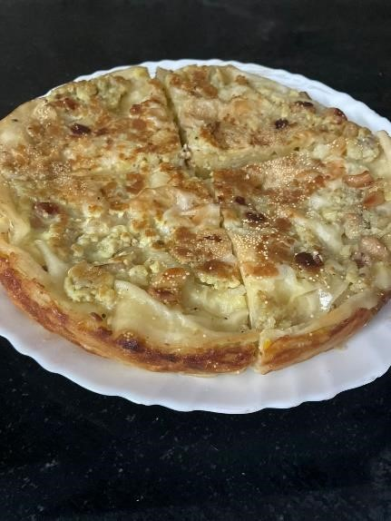

Plate 5 Chattipathiri

#### 3.3.3.6 KANNU VECHA PATHIRI INGREDIENTS

* Flour
* Wheat flour
* Ghee
* Salt
* Sugar

PREPARATION

* Into a bowl add in flour, wheat flour, 1 tsp ghee, salt, and sugar. Lightly give it a mix. Add water little by little and knead it into a soft dough. Brush with ghee or oil and keep it covered with a wet cloth for 15 mins.After 15 mins, knead it again into a smooth dough and divide into 4 equal size balls.Roll out one ball into a round disc. Spread/brush melted ghee or oil on top. Fold one half into the middle.
* And fold the other side overlapping the first one and spread/brush ghee or oil on top. Fold one side again and spread/brush ghee or oil.
* Again fold the other half overlapping the first one. Press/flatten with your fingers (it will be square shaped). Then with a rolling pin roll out into a square. Spread/brush oil or ghee on top.
* Fold each corner of the rolled out square pathiri inside (it looks like an envelope). Now again press it with fingers and lightly roll it out a little, keeping the square shape intact.

Repeat the rest of the balls in the same manner.

Deep fry each kannu pathiri in hot oil, remember keep the folded (kannu side) on top. Gently press on it as it will help to puff up. The slowly flip to the other side and when it is light golden brown remove it to a paper napkin and fry the rest.You can see the layers in this pathiri.

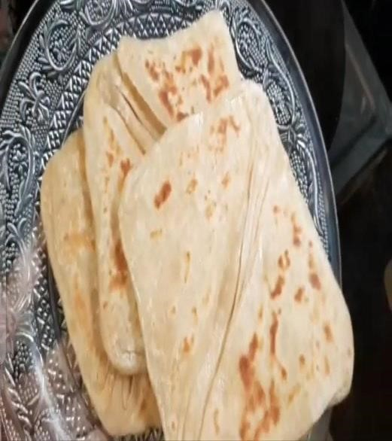

Plate 6.Kann vecha pathiri

#### 3.3.3.7 NEYPATHAL

INGREDIENTS

* 2 cups puttu podi
* 1 1/2 cup grated coconut
* 1 1/2 tsp fennel seeds
* 4 shallots / 1/2 onion
* salt to taste
* oil, for frying

PREPARATION

* Crush together grated coconut, fennel seeds and shallots and keep it aside.
* In a mixing bowl, add puttu podi and salt and mix well.
* Add 2 cups of boiling water into this and keep covered for 5 minutes. Then mix well with spoon.
* Add warm water as required and knead well with hand.
* Add crushed coconut mixture and knead well together to a dough. Don’t make too tight dough.

Make small balls from the dough and flatten them using palm by placing on a cloth / plastic sheet spread with oil.

* Heat oil in a pan, slide the neypathal into the hot oil and deep fry until they puff up and turns golden brown on both sides.

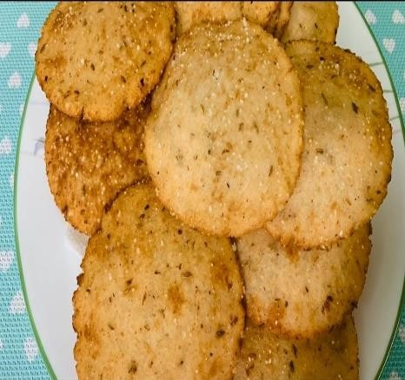

Plate 7.Neypathal

#### 3.3.3.8 THARIPOLA

INGREDIENTS

* Semolina or Rava – 3/4cup
* Egg – 3 nos
* Sugar – 4 tbsp
* Cardamom powder – 1 tsp
* Ghee – 3 tbsp
* Cashew nuts – 5 nos
* Raisins – 5 nos
* Badam – 5 nos

PREPARATION

* In a pan dry roast the semolina for 4 minutes on low flame and keep it aside.
* Mix egg, sugar and cardamom powder in a separate bowl. Beat with mixer until it is fluffy.
* Carefully add fried semolina and 2 tsp of ghee to the egg mixture and mix it well.
* Heat a pressure cooker at low flame and add 1 tsp of ghee to it.
* Pour semolina-egg mixture into it and close the lid (don’t put weight on lid)

After 3 minutes open the lid and add dry fruits on top of it and close the lid.

* Keep this on low flame until steam comes out through the nozzle. After 3 minutes switch of the flame.

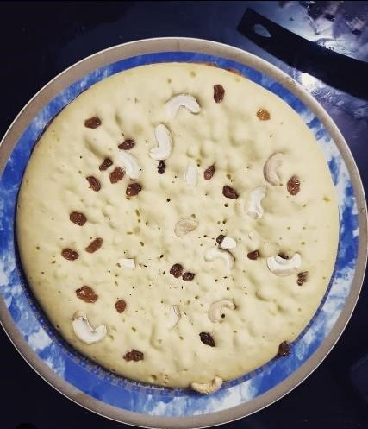

Plate 8.Tharipola

#### 3.3.3.9MUTTAMALA

INGREDIENTS

* Eggs: 25
* Sugar: 750 gms
* Milk: 1 cup
* Water
* Ghee

PREPARATION

* Take 25 eggs and use two bowls to separate the egg whites and yolks. Set aside the egg whites and strain the yolks.
* Next make sugar syrup by boiling sugar and water until it is the right consistency (one string consistency).
* Strain the egg yolks (using a cup with holes) in a circular manner into the hot syrup to make a netted necklace of yolks. When the muttamala is ready, sprinkle some water for the easy removal of the yolk nets from the syrup.
* If they are clumped together, separate gently and keep aside.

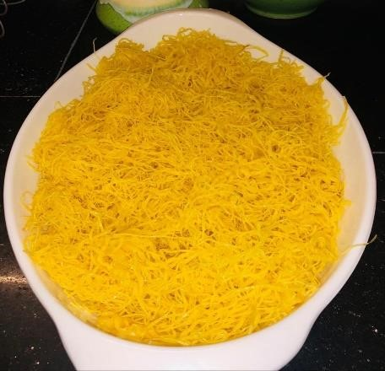 Plate 9 Muttamala

##### 3.3.3.10 COCONUT RICE

INGREDIENTS

* Tbsp oil1/2 tbsp
* peanut1 tsp
* mustard seeds1 tsp
* cumin seeds1/2 tbsp
* chana dal,
* soaked1/2 tbsp
* urad dal,
* soaked10 nos
* curry leaves1 nos
* red whole chilli1/2 nos
* green chilli12 nos
* cashewnut1/2 tsp
* salt1 cup coconut,
* grated2 cups
* basmati rice (cooked)2 tbsp
* coconut, grated

PREPARATION

* Take oil in a pan and add peanuts.Saute peanuts and add mustard seeds.Saute them together and add cumin seeds.
* Mix them together followed by soaked chana and urad dal.Saute all the ingredients together.Now add curry leaves, red whole chilli and green chilli.Saute them well.Add cashewnuts followed by salt to the pan and mix thoroughly.
* Now add grated coconut to the pan.Mix the coconut thoroughly with the other ingredients to infuse the coconut flavour completely.
* Now put the cooked rice to the pan.Mix it well together. • Add grated coconut to the rice and mix again.Serve hot.

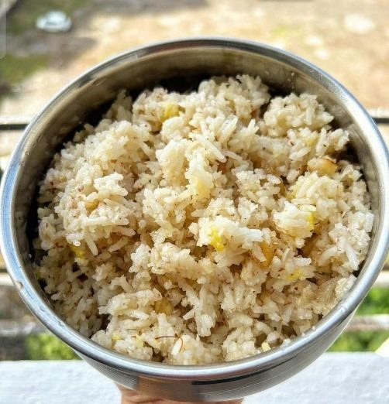

Plate 10.Coconut rice

## 3.3.4To develop a nutritive value of selected food in Kozhikode district

### Energy

Energy is the fuel that powers our bodies, derived from the food and beverages we consume. It provides the necessary calories for essential physiological functions, including metabolism, movement, and bodily repair. The body breaks down carbohydrates, fats, and proteins from our diet into smaller molecules during digestion. These molecules are then converted into energy through cellular processes, primarily in the form of adenosine triphosphate (ATP), which serves as the body's energy currency. Balancing energy intake with expenditure is crucial for maintaining overall health and well-being.

### Protein

Protein is essential for building, repairing, and maintaining tissues in the body. It is composed of amino acids, which are the building blocks of protein. Proteins play a critical role in various bodily functions, including muscle development, immune function, and hormone production. Dietary sources of protein include meat, poultry, fish, dairy products, legumes, nuts, and seeds. Adequate protein intake is vital for supporting growth and development, as well as preserving muscle mass and promoting overall health.

### Carbohydrates

Carbohydrates are the body's primary source of energy. They are found in foods such as grains, fruits, vegetables, and legumes. Carbohydrates are broken down into glucose during digestion, which is then utilized by cells for energy production. Additionally, carbohydrates play a role in maintaining blood sugar levels, supporting brain function, and providing dietary fiber for digestive health. Choosing complex carbohydrates such as whole grains, fruits, and vegetables over simple sugars is important for sustained energy levels and overall health.

### Fats

Fats are another essential macronutrient that serves as a concentrated source of energy. They are necessary for cell membrane structure, hormone production, and the absorption of fatsoluble vitamins (A, D, E, and K). Dietary fats are classified into saturated fats, unsaturated fats (including monounsaturated and polyunsaturated fats), and trans fats. Sources of healthy fats include avocados, nuts, seeds, olive oil, fatty fish, and plant-based oils. Balancing fat intake and choosing healthy fats over unhealthy saturated and trans fats is crucial for supporting heart health and overall well-being.

### Iron

Iron is a mineral that plays a vital role in various physiological processes, including oxygen transport, energy metabolism, and DNA synthesis. It is a key component of hemoglobin, the protein in red blood cells responsible for carrying oxygen from the lungs to the rest of the body. Iron is also involved in immune function and cognitive development. Dietary sources of iron include meat, poultry, fish, fortified cereals, legumes, and leafy green vegetables. Consuming iron-rich foods and ensuring adequate absorption through dietary strategies such as pairing iron-rich foods with vitamin C-rich foods is essential for preventing iron deficiency anemia.

### Calcium

Calcium is a mineral critical for bone health, muscle function, nerve transmission, and blood clotting. It is the most abundant mineral in the body, with about 99% stored in bones and teeth. Adequate calcium intake is essential for building and maintaining strong bones throughout life, reducing the risk of osteoporosis and fractures. Dairy products such as milk, cheese, and yogurt are rich sources of calcium, along with fortified plant-based alternatives, leafy green vegetables, and calcium-fortified foods. Consuming enough calcium, along with vitamin D and other nutrients that support calcium absorption, is vital for optimal bone health.

### Phosphorous

Phosphorus is a mineral that works closely with calcium in the body, playing a crucial role in bone formation and maintenance. It is also involved in various cellular processes, including energy metabolism, DNA synthesis, and regulation of enzyme activity. Phosphorus is found in abundance in protein-rich foods such as meat, poultry, fish, dairy products, nuts, and seeds. Maintaining a balance between dietary phosphorus and calcium intake is important for bone health and overall metabolic function.

### Potasium

Potassium is an essential mineral and electrolyte that plays a critical role in maintaining fluid balance, nerve function, muscle contractions, and heart rhythm. It works in tandem with sodium to regulate blood pressure and cardiovascular health. Potassium-rich foods include bananas, oranges, potatoes, sweet potatoes, leafy green vegetables, tomatoes, and beans. Consuming an adequate amount of potassium from natural food sources can help lower blood pressure, reduce the risk of stroke, and support overall heart health.

### Magnesium

Magnesium is a mineral involved in over 300 biochemical reactions in the body, including energy production, muscle function, and bone health. It plays a crucial role in nerve transmission, muscle relaxation, and DNA synthesis. Magnesium is found in a variety of foods, including leafy green vegetables, nuts, seeds, whole grains, legumes, and dark chocolate. Adequate magnesium intake is essential for maintaining optimal health and well-being, supporting cardiovascular function, muscle performance, and bone density.

### Sodium

Sodium is an essential mineral and electrolyte that plays a vital role in maintaining fluid balance, nerve function, and muscle contractions. It is primarily obtained from salt (sodium chloride) added to food during processing or cooking. While sodium is necessary for various physiological processes, excessive intake can contribute to high blood pressure, heart disease, and stroke. Therefore, it is important to consume sodium in moderation and focus on whole,

# 

# 4.RESULT AND DISCUSSION

Results of the study conducted on traditional foods of Kozhikode disctrict are presented in this chapter under the following headings:

4.1 Traditional food habits of different communities

4.1.1 Preference of traditional foods of different communities

4.1.2 Reasons for preference of traditional foods

4.1.3 Frequency of preparation of traditional food items

4.1.4 Frequency of preparation of traditional health foods

4.1.5 Traditional food items prepared on special occasions

4.1.6 Traditional kitchen utensils

4.2 Nutritive value calculation of traditional food items collected

## 4.1 Traditional food habits of different communities

The study investigated the traditional food preferences among respondents from various communities, exploring their reasons for favoring traditional foods, the frequency of preparing these dishes, and the specific traditional foods prepared during special occasions, religious festivals, and rituals. Additionally, it examined the frequency of preparing traditional health foods and documented details regarding the traditional kitchen utensils and equipment used by the respondents.

## 4.1.1Preference of traditional food of different communities

The details regarding the preference for traditional foods among different communities are given in the Table 5:

|  |  |  |
| --- | --- | --- |
| Communities[n] | Preferred | Not preferred |
| Christians[5] | 5[100] | - |
| Muslims[12] | 8[66.6] | 4[33.3] |
| Hindus[8] | 5[62.5] | 3[37.5] |

### 4.1.2 Reasons for preference of traditional food

The data regarding the reason for preference of traditional food is given in table 6

|  |  |  |  |
| --- | --- | --- | --- |
| Reason | Christians(5) | Muslims(12) | Hindus(8) |
| Healthy | 5(100) | 12(100) | 8(100) |
| Tasty | 4(80) | 9(75) | 8(100) |
| No adulteration | 4(80) | 5(41.6) | 6(75) |
| Less expensive | 1(20) | - | 1(12.5) |
| Ingredients are  locally produced | 1(20) | 3(25) | - |

All Christian and Hindu respondents preferred traditional foods primarily for their health benefits. Among Muslims, traditional foods were preferred for their taste and health benefits. 75% of Muslims and 80% of Hindus cited taste as a reason for their preference, while 41.6% of Muslims, 75% of Hindus, and 80% of Christians preferred traditional foods because they are not adulterated. Additionally, 12.5% of Hindus and 20% of Christians chose traditional foods because they are less expensive, and 25% of Muslims and 20% of Christians preferred them because the ingredients are locally available. Among Hindus, all respondents who preferred traditional foods emphasized their health benefits, while all Christian respondents preferred them primarily for their taste. The majority of those who preferred traditional foods mentioned that they did so because they are not adulterated.

### 4.1.3 Frequency of preparation of traditional food items

The frequency of preparation of traditional health foods by the respondents who preferred traditional food items was found to be as follows:

Table 7: Frequency of preparation of traditional health foods

|  |  |  |  |
| --- | --- | --- | --- |
| Frequency | Hindus(5) | Muslims(8) | Christians(5) |
| Daily | 3 (60%) | 5 (62.5%) | 5  (100%) |
| Weekly thrice | 2 (40%) | 1 (12.5%) | 0 |
| Weekly twice | 0 | 2 (25%) | 0 |

From the table, it is evident that 62.5% of Muslims prepared traditional food items daily, 12.5% of Muslims weekly thrice and 25% of weekly twice. 60% of Hindus who preferred traditional foods prepared traditional foods daily and 40% prepared them weekly thrice. All the Christians who preferred traditional foods, prepared and consumed traditional food items on a daily basis. In a study conducted , it is clear that all respondents of Kerala Brahmin and Scheduled Caste communities prepared traditional food items daily for breakfast. Altogether it was found that

81.78 per cent of respondents prepared traditional food items daily for breakfast

### 4.1.4 Frequency of preparation of traditional health foods

The frequency of preparation of traditional health foods by the respondents who preferred traditional food items was found to be as follows:

Table 8: Frequency of preparation of traditional health foods.

|  |  |  |  |
| --- | --- | --- | --- |
| Frequency | Hindus(5) | Muslims(8) | Christians(5) |
| Occasionally | 1(20%) | 4(50%) | 2(40%) |
| Never | 4(80%) | 4(50%) | 3(60%) |

From the table, it is evident that 50% of the Muslims who preferred traditional foods was found to prepare traditional health foods occasionally and the remaining 50% never prepared any. Likewise, 20% of the Hindus who preferred traditional food items prepared them occasionally and 80% did not prepare any traditional health food. 40% of the Christians who preferred consuming traditional foods prepared traditional health foods occasionally and the remaining 60% never prepared any. In a study conducted, it was indicated that none of the respondents of Tamil Brahmin and Ezhava communities prepared traditional health foods at home. Majority of Scheduled Caste (77.78%) and Christian (80%) respondents also did not prepare traditional health foods at home. About 88.89 per cent of Muslim respondents indicated that they prepared traditional health foods at home occasionally

### 4.1.5 Traditional food items prepared on special occasions

Traditional foods prepared during special occasions by different communities are detailed

#### 4.1.5.1 Muslims

Muslims around the world celebrate various special occasions with traditional foods that vary depending on cultural and regional influences. These traditional foods reflect the rich cultural heritage of the Muslim community

Table 9.Traditional foods Prepared by Muslims on special occasion

|  |  |
| --- | --- |
| **Occasion** | **Items** |
| Marriage celebration | Neychoru,pathiri,pazham,nirachathu  ,unnakaya,valayappam,muttamala |
| Ramadan | Kuzhal  pathiri,unnakaya,nirachapathiri,biriyani,aleesa,kalathappam |
| Muharram | Paalayikkapam,Wheat verakiyathu |
| Death Anniversary | Kanji,kurry kurukkuka, |

Muslims celebrate various occasions with traditional foods that hold significance in their culture. These special dishes vary depending on the event and regional customs. During weddings, Muslim families traditionally host grand feasts for guests. The spread typically includes dishes like neychoru(ghee rice), pathiri, beef curry, or other meat preparations, and biriyani,Unnakkaya,pazham nirachathu ,mutta mala

During times of bereavement, the community comes together to offer comfort and sustenance. Meals typically consist of cooked rice or kanji along with one or two vegetarian curries. On the seventh or fifteenth day after a death, a special porridge known as kurry kurukkuka, is prepared using raw rice flour and jaggery syrup. On the 40th day, ghee rice and beef curry are prepared and shared with close relatives.

During Noyambu Thura ,special dishes like kuzhal pathiri.unnakkaya,niracha pathiri,aleesa, and kalathappam are prepared and served alongside other traditional items.

The day of Ramadan, a significant religious festival for Muslims, is marked by a grand feast in households. The spread includes delicacies like pathiri, neichoru, and biriyani, accompanied by beef or mutton curry as side dishes. Fried snacks are also prepared and exchanged among friends, relatives, and neighbors during this festive occasion.

Muharram, another important occasion, is observed with traditional treats such as paalayikkappam and wheat verakiyathu,

#### 4.1.5.2 Christians

Christians celebrate various occasions with traditional foods that hold significance in their culture. These special dishes vary depending on the event and regional customs. Table 10.Traditional foods prepared by Christians on special occasions

|  |  |
| --- | --- |
| **Occasions** | **Items** |
| Easter | Appam,Chicken curry,Pidi,Cutlet |
| Baptism | Biriyani,,fish molly,Beef dry fry,Chicken curry,Beef stew |
| Death Anniversary | Appam,Veg stew,Rice,Puliserry,Beef ularthiyathu,Unniyappam,Sambar |
| Christmas | Vattayappam,Mutton Stew,Fiah molly |
| Perunnal | vattayappam, achappam, kuzhalappam, thamukku, kaliyadakka, and vettappam. |

During baptism, Christians prepare a lavish spread featuring dishes such as beef stew, beef ularthiyathu , pulissery , , fish molly , biriyani, and paachoru

During times of mourning, Christian families offer vegetarian meals and kanji to family members and relatives. On the seventh day after the demise, a modest vegetarian feast is served, including dishes like vegetable stew, appam are prepared and serve

During Easter, Christians prepare symbolic dishes like appam, beef stew, beef cutlet, meen pattichathu, beef ularthiyathu, and pulissery

For Christmas celebrations, Christians prepare vattayappam muttayappam, vettappam, and other traditional treats at home. On Christmas day, a grand non-vegetarian feast is arranged, featuring dishes like appam, beef stew, thaaraavu mappas and fish molly.

During religious observances such as Palm Sunday and Osana Perunnal, special dishes like kozhukkatta On Maundy Thursday, Christians prepare a porridge called paalu kurukku made. Good Friday is marked with the preparation of pesaha kurukku, a similar porridge without sugar. Vattayappam and appam are traditional dishes for Easter. Twenty-fifth day religious observances, such as ambathu noyambu before Christmas, feature special dishes like inderiyappam, a rice flour dish with coconut and seasonings. On the 40th day of these religious observances, chakkara paachoru is prepared.

Church festivals are celebrated with a variety of dishes like vattayappam, achappam, kuzhalappam, thamukku, velichenna appam, kaliyadakka, and vettappam.

These traditional foods not only signify the importance of the occasion but also reflect the rich culinary heritage of the Christian community in Kozhikode

#### 4.1.5.3 Hindus

Hindus celebrate various special occasions with traditional foods that hold cultural and religious significance**.**

Table11.Traditional foods prepared by Hinduson special occasion

|  |  |
| --- | --- |
| **Occasion** | **Items** |
| Marriage | Sadhya |
| Adiyantharam | Adhiyanthara sadhya,vada,ellunda,Ada |
| Onam | Sadhya,poo Ada |
| Vishu | Sadhya,Vishu katta |
| karkkidakam | Karkkidaka kanji, |
| Uthradam | Ada |
| Ekadasi | Gothambu kanji,puzhukk, |
| Thiruvathira | Ettangadi,Koovakurukku |
| Temple Festivals | Ada,Unniyappam,Murukku |

For marriage traditionally prepares a special sadya (feast) consisting of rice accompanied by a variety of dishes.. During times of mourning, fasting is observed until the cremation, after which the family members are served kanji (rice porridge) or black tea prepared at a nearby house. On the sixteenth day following the death of a family member, adiyanthiram is conducted with a sadya similar to the one served during marriage ceremonies, with the exception of papadam, plantain, and payasam.

During, Onam, offerings like ada rice flakes, karolappam, puffed rice, bananas, and kadali pazham.These offerings are later distributed among family members. Starting from Atham, a series of sadya feasts are prepared, with the most elaborate sadya served on the day of Thiruvonam. In the month of Karkkidakam, ada, marunnu kanji (medicinal rice porridge).

Vishu, another important festival, Sadya is served for lunch on Vishu day .Karthika, special traditional items like ada and appam are prepared as part of the festivities.

### 4.1.6 Traditional kitchen utensils

Data on traditional household utensils and equipment were gathered and compiled in Table 12. The findings revealed the use of various traditional kitchen utensils such as churner, bharani, arakallu, and kooja among the households surveyed.

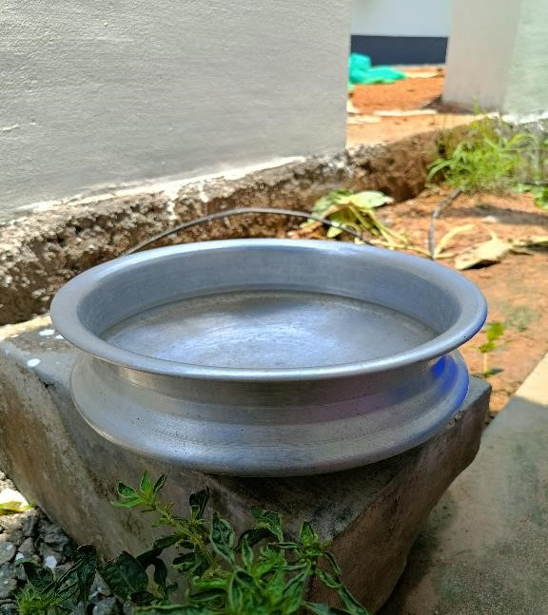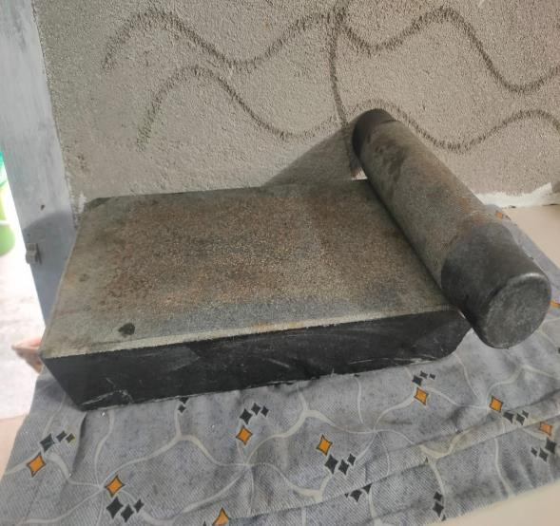

Fig1.Uruli

Fig.2.Ammikallu

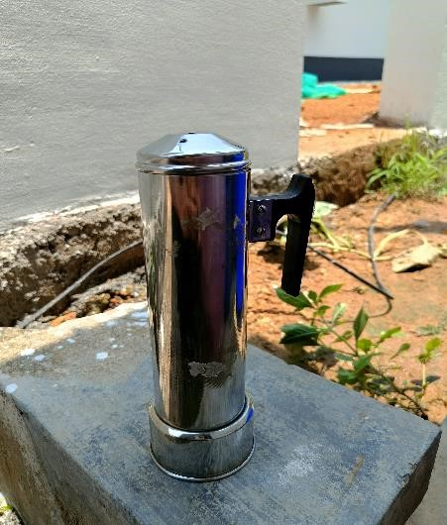

Fig.3 Puttukutti

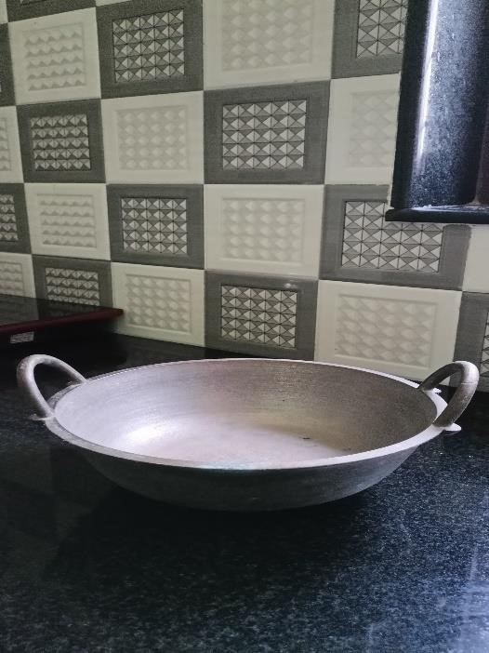

Fig4.Idiyappam maker Fig 5.Cheenachatti

:

Table12.List of Traditional kitchen utensils and equipment

|  |  |  |
| --- | --- | --- |
| **SL.NO** | **Utensils and equipment** | **Purpose of use** |
| 1 | Uruli | Used for cooking various dishes,especially payasam |
| 2 | Cheena Chatti | Used for making dosa,appam,other delicacies |
| 3 | Idiyappam Maker | Used to make Idiyappam, |
| 4 | Ammikallu | Used to grinf spices and other  Ingredients |
| 5 | Puttu kutti | Used to make puttu |

These are just a few examples of the traditional kitchen utensils used in Kerala. Many of these utensils are still used in Kerala households, especially in rural areas, preserving the state's culinary heritage.

### 4.2 Nutritive Value Calculation of traditional foods collected

Table 13.Nutritive value calculation of traditional foods

**MACRONUTRIENTS**

|  |  |  |  |  |  |
| --- | --- | --- | --- | --- | --- |
| **Sl.**  **No** | **NAME OF THE**  **FOOD** | **ENERGY(Kcal)** | **CHO(g)** | **PROTEIN(g)** | **FAT(g)** |
| 1. | PALVAZHAKA | 331.73 | 26.62 | 20 | 16.06 |
| 2. | KAPPAPURATIYATH | 648.35 | 59.73 | 6.93 | 41.38 |
| 3. | BUN NIRACHATH | 331.81 | 26.62 | 20 | 16.09 |
| 4. | KAIPOLA | 213.5 | 21.44 | 9.17 | 6.52 |
| 5. | CHATTIPATHIRI | 370.39 | 50.84 | 18.7 | 20.36 |
| 6. | KANNUVECHA  PATHIRI | 846.43 | 160.43 | 26.24 | 3.83 |
| 7. | NEYPATHAL | 208.21 | 36.43 | 9.55 | 3.42 |
| 8. | THARIPOLA | 834 | 171.08 | 28.48 | - |
| 9. | MUTTAMALA | 252.39 | - | 19.71 | 75.21 |
| 10. | COCONUT RICE | 1374.07 | 121.65 | 12.86 | 93.32 |

**MICRONUTRIENTS**

|  |  |  |  |  |  |  |
| --- | --- | --- | --- | --- | --- | --- |
| **Sl.**  **No** | **NAME OF THE**  **FOOD** | **Ca(mg)** | **K(mg)** | **P(mg)** | **Zn(mg)** | **Fe(mg)** |
| 1. | PALVAZHAKA | 22.2 | 360.8 | 137.43 | 1.11 | 3.6 |
| 2. | KAPPAPURATIYATH | 102.08 | 1325.5 | 276.05 | 1.16 | 2.6 |
| 3. | BUN NIRACHATH | 62.72 | 246.9 | 215.2 | 1.17 | 1.22 |
| 4. | KAIPOLA | 57.62 | 299.1 | 348.4 | 2.51 | 2.63 |
| 5. | CHATTIPATHIRI | 97.42 | 502.7 | 562.3 | 4.19 | 6.01 |
| 6. | KANNUVECHA  PATHIRI | 46.42 | 466.5 | 472.5 | 4.28 | 6.15 |
| 7. | NEYPATHAL | 21.55 | 277.1 | 226.94 | 1.18 | 1.03 |
| 8. | THARIPOLA | 88.18 | 583.1 | 386.9 | 4.63 | 6.38 |
| 9. | MUTTAMALA | 75.21 | 175.5 | 297 | 1.68 | 2.46 |
| 10. | COCONUT RICE | 12.27 | 271.7 | 167.87 | 1.28 | 1.66 |

Macro nutrients of 10 different traditional foods are mentioned here. Among these food items Coconut rice has highest calorie (1374.07 kcal) and the lowest one is Kaipola(213.5kcal). Almost all food items have sufficient amount of carbohydrates but the highest of these are Tharipola (171.08g) and the lowest one is Bun nirachathu and paalvazhaka.

Highest protein content is noticed in Meen Tharipola (28.48 g) and the lowest of these are in Kaipola (9.17 g). Other traditional foods have a protein content between 6.93 to 26.24 g. As there are more of non-vegetable food items that we selected; so that all food items selected have enough amount of fat content present in it. Among these traditional foods the lowest fat content present in Tharipola and the highest is in Coconut rice (93.32 g). minimally processed foods to limit excessive salt intake and promote overall health.

Most the traditional foods contain high amount of calcium. Kappa puratiyath contained highest amount of it. i.e. (102.08 mg). Coconut rice contained the lowest amount (12.27 mg). Potassium content is assessed only in food items that contain more of potassium. Highest amount of potassium present in Kappa puratiyath (1325.5 mg). Lowest amount among this is present in Muttamala(175.5mg). Phosphorus content is mostly present in the Chattipathiri(562.3 mg) and the lowest amount of it in Palvazhaka(137.43 mg). Amount of zinc present in Tharipola is (4.63mg). Another micronutrient is iron that mostly present among this food is in Tharipola(6.38 mg). Lower amount is noticed in Bun nirachathu (1.22mg).

# 5. SUMMARY AND CONCLUSION

The present study entitled “Documentation and Nutritive Evaluation of Traditional Foods of Kerala – Kozhikode District” was undertaken with the aim of identifying and collecting information on the information regarding the traditional foods and food habits of each community associated with religious customs, festivals, special occasions, the ingredients and their methods of preparation. Kozhikode district of Kerala was selected for the study. During classical antiquity and the Middle Ages, Kozhikode was dubbed the “City of Spices” for its role as the major trading point of Eastern spices.The respondents were categorised into different communities like Hindus, Muslims and Christians.

It was found that all respondents of Hindus preferred traditional foods and only [66.6] percentage of Muslims preferred traditional foods and only [62.5] percentage of Hindus preferred these types of traditional foods. Respondents belonging to the Christian and Hindu communities preferred traditional foods because of its health benefits. All respondents of Hindus preferred traditional foods due to its taste and health benefits. 75% of Muslims and 80% of Christians preferred these foods due to its taste. 41.6% of Muslims, 75% of Hindus and 80% of Christians preferred traditional foods as there was no adulteration in it. Less expensive was one of the reasons for choosing traditional food for 12.5% Hindus and 20% Christians. 25% of Christians and 20% of Muslims prefer it because the ingredients are locally available. On collecting data on the frequency of preparation of traditional foods, it was found that, 62.5% of Muslims prepared traditional food items daily, 12.5% of Muslims weekly thrice and 25% of Muslims weekly twice. 60% of Hindus who preferred traditional foods prepared traditional foods daily and 40% prepared them weekly thrice. It was also found that 50% of the Muslims who preferred traditional foods was found to prepare traditional health foods occasionally and the remaining 50% never prepared any. 58 Likewise, 20% of the Hindus who preferred traditional food items prepared them occasionally and 80% did not prepare any traditional health food. 40% of the Christians who preferred consuming traditional foods prepared traditional health foods occasionally and the remaining 60% never prepared any of the food

As traditional food habits were highly diversified and these items have strong link with religious and cultural practices, the food patterns of different communities during special occasions, festivals/rituals were also studied. The important traditional food items of Muslims on special occasions included unnakkaya, pazham nirachathu, mutta mala, mutta surukka, mutta marichathu, kozhi nirachathu, valayappam, tharippola, pinjanathappam, neichoru, beef curry kalathappam and different types of pathiri, The important traditional food items of Hindus on special occasions included sadya, Vishu kanji, , ada, aval, unniyappam, murukku, Vishu katta. The important traditional food items of Christians on special occasions included appam, beef stew, mappas, fish molly, vindaloo, paachoru, beef ularthiyathu.

The nutritive value of these foods were also calculated. It was found that among these food items Coconut rice contained the highest calories (1374.05kcal) and kaipola(213.5 kcal) contained the lowest calories. Tharipola (171.08 g) contained the highest carbohydrates and Bun nirachathu and paal vazhaka contained the lowest amount of carbohydrates. Tharipola(28.48g) contained the highest protein content and Kaipola (9.17 g) contained the lowest amount. The lowest fat content was present in Tharipola and the highest was in Coconut rice (93.32 g). Kappa puratiyath contained highest amount of it. i.e. (102.08 mg). Coconut rice contained the lowest amount (12.27 mg). Potassium content is assessed only in food items that contain more of potassium. Highest amount of potassium present in Kappa puratiyath (1325.5 mg). Lowest amount among this is present in Muttamala(175.5mg). Phosphorus content is mostly present in the Chattipathiri(562.3 mg) and the lowest amount of it in Palvazhaka(137.43 mg). Amount of zinc present in Tharipola is (4.63mg). Another micronutrient is iron that mostly present among this food is in Tharipola(6.38 mg). Lower amount is noticed in Bun nirachathu (1.22mg).

Therefore, it is evident that while Kozhikode boasts a wealth of diverse traditional foods, many of them are experiencing significant changes. Shifts and adaptations have occurred in traditional food habits and dietary patterns. The current study aimed to document these traditional foods with the goal of preserving them from potential endangerment. Future endeavors could focus on further documentation, replication, and promotion of traditional foods in Kozhikode.

# REFERENCE

1. Aguilar-Pérez, K. M., Ruiz-Pulido, G., Medina, D. I., Parra‐Saldívar, R., & Iqbal, H. M. (2021). Insight of nanotechnological processing for nanofortified functional foods and nutraceutical—opportunities, challenges, and future scope in food for better health. Critical Reviews in Food Science andNutrition,63(20),46184635.https://doi.org/10.1080/10408398.2021.20 04994

1. Bharati, P., & Kulkarni, U. N. (2020). Nutritional sufficiency of traditional meal patterns. In Elsevier eBooks (pp. 31–50)

1. Brouwer, I. D., Van Liere, M., De Brauw, A., Domínguez-Salas, P.,

Herforth, A., Kennedy, G., Lachat, C., Omosa, E. B., Talsma, E. F., Vandevijvere, S., Fanzo, J., & Ruel, M. T. (2021). Reverse thinking: taking a healthy diet perspective towards food systems transformations. Food Security, 13(6), 1497–1523.

1. THE INDIAN CUISINE. (n.d.). Google Books. https://books.google.com/books?hl=en&lr=&id=U4woRbF8irsC&oi=fnd &pg=PR1&dq=traditional+cuisines+of+india&ots=s0je_8bvhI&sig=PJlv

8rLK_bFfb4fvvH7tiHIVBt

1. Kapoor, R., Sabharwal, M., & Ghosh-Jerath, S. (2022). Indigenous Foods of India: A comprehensive narrative review of nutritive values, antinutrient content and mineral bioavailability of traditional foods consumed by Indigenous communities of India.

1. Kapoor, A., Kanwar, P., & Gupta, R. (2010). Traditional recipes of district Kangra of Himachal Pradesh.

1. Mbhenyane, X. (2017). Indigenous foods and their contribution to nutrient requirements.

1. Nabeesa, S. B. (2022). Consumerism and gendering in food culture: a study of urban Kerala.

https://www.semanticscholar.org/paper/13def0b00a50c832ca412ec89e96 ad634c86d802

1. Oguntoyinbo, F. (2014). Safety Challenges Associated with Traditional Foods of West Africa.

1. Platel, K. (2020). Functional foods in Indian tradition and their significance for health. In Elsevier eBooks (pp. 87–98)

1. Rathore, M. S., & Shekhawat, N. S. (2008). Incredible Spices of India: from Traditions to Cuisine [Article]. American-Eurasian Journal of Botany, 85–89.

1. Rocillo-Aquino, Z., Escoto, F. C., Leos-Rodríguez, J. A., Cruz-Delgado, D., & Espinoza‐Ortega, A. (2021). What is a traditional food? Conceptual evolution from four dimensions. Journal of Ethnic Foods, 8(1)

1. R, G. K. (2023). Food tourism research in India – current trends and future scope. Tourism Review.

1. Singh, A., Sharma, A., Ahmed, A., Sundramoorthy, A. K., Furukawa, H., Arya, S., & Khosla, A. (2021). Recent advances in Electrochemical biosensors: applications, challenges, and future scope. Biosensors, 11(9), 336.

1. Szabo, S. (2015). Urbanisation and evolving food security challenges. In SpringerBriefs in population studies (pp. 29–55).

1. Vidanapathirana, R., Hector Kobbekaduwa Agrarian Research and Training Institute, Wijesooriya, N., & Hector Kobbekaduwa Agrarian Research and Training Institute. (2014). Export market for organic food: Present status, constraints and future scope. In Research.

# APPENDIX

## Question for Traditional Recipe

1.Name:

2.Age:

3.Sex: Male/Female

1. How often you eat traditional food?

………………………………………………………………………………………..

1. Do you prefer traditional food for breakfast?

…………………………………………………………………………………………

1. Do you prefer traditional food for lunch?

……………………………………………………………………………....................

1. Do you prefer traditional food for dinner?

…………………………………………………………………………………………

8.What is the traditional recipe you followed till now?

………………………………………………………………………………………….

9.How you prepare traditional food?

………………………………………………………………………………………………………… …………………………………………………………………………………………………………

…………………………………….

10.Do you eat traditional food for health benefits?

…………………………………………………………………………………………