**ASSESSMENT OF GENETIC DIVERSITY OF *ZAMIA FURFURACEA* (L.) f. USING RANDOM AMPLIFIED POLYMORPHIC DNA (RAPD) MARKERS, ITS PHYTOCHEMICAL SCREENING AND**

**ANTIBACTERIAL STUDY**

**Dissertation submitted in partial fulfillment of the requirements**

**for the award of the degree of Master of Science in**

**BOTANY**

**AISWARYA S. NAIR**

**REG. NO: AM22BOT003**



**DEPARTMENT OF BOTANY AND CENTRE FOR RESEARCH**

**ST. TERESA’S COLLEGE (AUTONOMOUS), ERNAKULAM**

**2023 – 2024**

**CERTIFICATE**

This is to certify that the dissertation entitled **“Assessment of Genetic Diversity of *Zamia furfuracea* (L.) f. Using Random Amplified Polymorphic DNA (RAPD) markers, its Phytochemical Screening and Antibacterial Study”** is an authentic record of work carried out by **Ms. Aiswarya S. Nair** (**Reg. No.: AM22BOT003**) under my supervision and guidance in the partial fulfillment of the requirement of the Master of Science Degree of Mahatma Gandhi University, Kottayam. I, further certify that no part of the work embodied in this dissertation work has been submitted for the award of any other degree or diploma.

**Dr.** **Aghil Soorya A.** **Dr. Liza Jacob**

Supervising Teacher Head, Department of Botany

Department of Botany St. Teresa’s College (Autonomous) St. Teresa's College (Autonomous) Ernakulam Ernakulam

Place: Ernakulam

Date: 20/03/2024

External Examiners

1.

2.

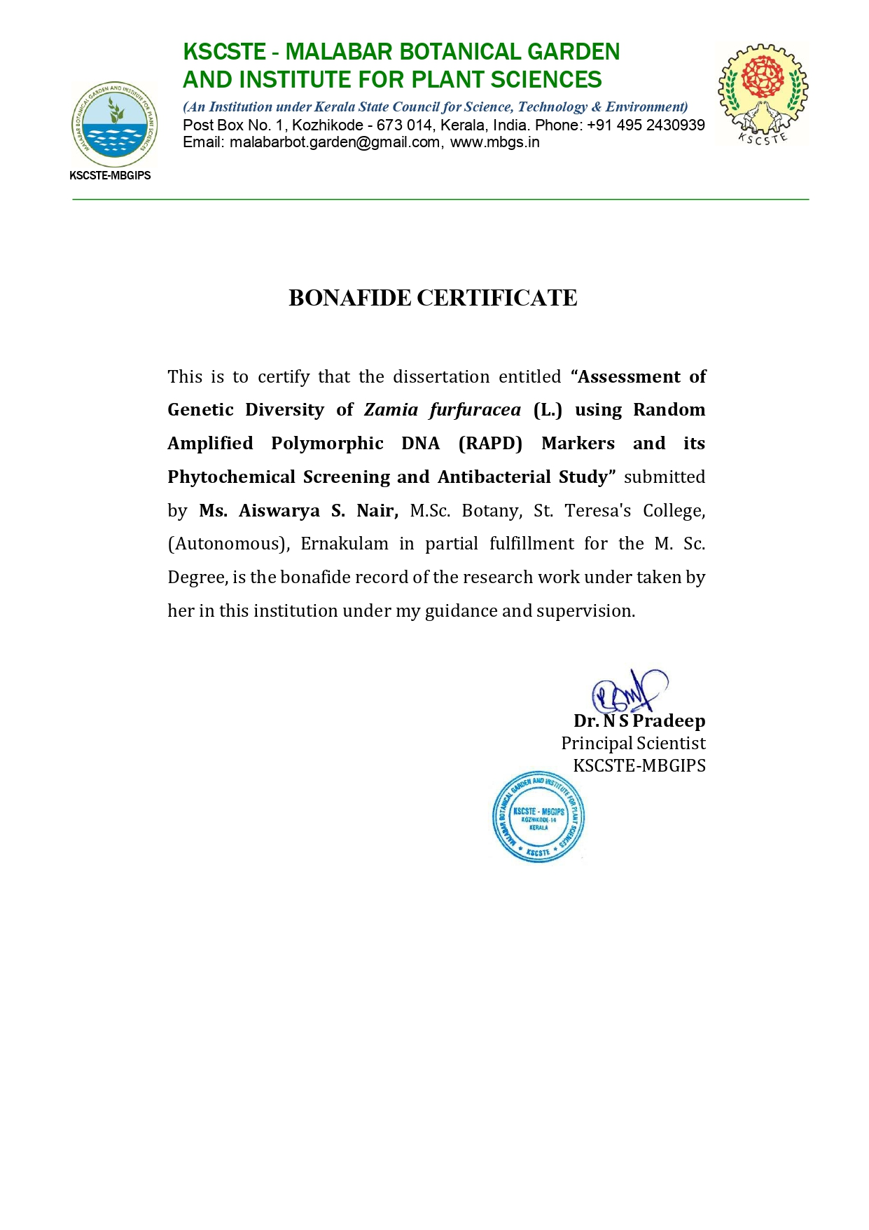

# **DECLARATION**

I hereby declare that the work which is being presented in the dissertation, entitled **“Assessment of Genetic Diversity of *Zamia furfuracea* (L.) f. Using Random Amplified Polymorphic DNA (RAPD) markers, its Phytochemical Screening and Antibacterial Study”** in fulfilment of the requirements for the award of the degree of **Master of** Science in Botany and submitted to St. Teresa’s College (Autonomous), Ernakulam is anauthentic record of my own work carried out during M.Sc. period under the supervision of Dr. Aghil Soorya A.

The matter embodied in this dissertation has not been submitted by me for the award of any other degree of this or any other University/ Institute.

**Place:** Ernakulam

**Date:** **Signature of the Candidate**

**ACKNOWLEDGMENT**

I would like to express my sincere thanks and deep sense of gratitude to **Mr. Harshid P** KSCSTE**-** Malabar Botanical Garden and Institute for Plant Sciences**,** Calicut, for introducing the present topic and for his inspiring guidance and valuable suggestion throughout this work. His able knowledge and expert supervision with patience helped my work at every stage, for without his warm affection and encouragement, fulfillment of the task would have been difficult.

I would like to express my sincere thanks to **Dr. S Pradeep Kumar**, Director, Malabar Botanical Garden and Institute for Plant Sciences**,** Calicut**-** 14, and **Dr. N S Pradeep**, Senior scientist for his immense concern throughout the project work and for providing laboratory facilities.

I consider it as a pleasure and privilege to extend my profound sense of gratitude to **Dr. Liza Jacob**, Head of the Department, Department of Botany and Centre for Research, St. Teresa’s College (Autonomous), Ernakulam, for permitting me to carry out my project at KSCSTE**-** Malabar Botanical Garden and Institute for Plant Sciences**,** Calicut, as well as to continue my work at Savitr Bioscience Pvt. Ltd, Thrikkakara and the laboratory at Department of Botany.

I wish to express my sincere thanks to **Dr.** **Aghil Soorya A.** Faculty of Department of Botany and Centre for Research, St. Teresa’s College (Autonomous), Ernakulam, for the guidance and intellectual support extended to me for the successful completion of my work.

I also express my deepest gratitude and appreciation for the guidance and encouragement given by all the teachers.

I gratefully acknowledge **Dr. Alphonsa Vijaya Joseph**, The Principal, St. Teresa’s College (Autonomous), Ernakulam, for permitting me to do a project in this institution.

A special word of thanks to **Ms. Pooja P, Mrs. Jaseela V T and Dr. Anjana J. C** for their support during different stages of this work.

Sincere thanks to the non-teaching staff and also my friends who have helped me to take this work to completion.

I am extremely grateful to my beloved parents who have given their love, affection, encouragement, and blessing which have guided me to complete this work.

Last but not least, I would like to thank the almighty God whose blessings have enabled me to accomplish my dissertation work.

**AISWARYA S. NAIR**

**ABSTRACT**

***Zamia furfuracea* (L.) f.**commonly known as Cardboard Palm belongs to the family Zamiaceae. The purpose of this study was to understand whether the introduced cultivar variety *Zamia furfuracea* (L.) f. contain any phytochemical properties and antibacterial activity. Prior to this, a study on Genetic Diversity of *Zamia furfuracea* (L.) f.using Random Amplified Polymorphic DNA (RAPD) markers was conducted. A number of 6 available samples from different locations of Kerala were collected. Each sample of the plants were named as Z1 to Z6. A Numerical Taxonomy system for the personal computer (NTSYS) was used to determine phylogenetic tree using UPGMA software. For identifying the variance and genetic diversity, RAPD markers system was found to be more efficient. The phytochemical compounds present in the sample was determined using the sample obtained by Soxhlet plant extraction method using ethanolic solvent. Phytochemical Screening of the ethanolic extract of the plant revealed the presence of many significant phytochemicals. The Antibacterial property of the plant extract was studied to determine effectiveness of inhibition against the selected pathogen *Staphylococcus aureus* and *Escherichia coli.* The Antibacterial study of ethanolic extract of the plantshowed highest activity against *Staphylococcus aureus* followed by *Escherichia coli.* Since *Zamia furfuracea* (L.) f. possess significant antibacterial activity with certain vital phytochemicals, it can be used as a medicinal agent.

**Key Words:** *Zamia furfuracea* (L.) f.*,* Random Amplified Polymorphic DNA (RAPD) markers, Phytochemical analysis, Antibacterial Study, Genetic Diversity, Multivariate Analysis System (NTSYS)

**TABLE OF CONTENT**

|  |  |  |
| --- | --- | --- |
| **SI.NO.** | **CHAPTER** | **PAGE NO.** |
| **1.** | **INTRODUCTION** | 1-6 |
| **2.** | **OBJECTIVES** | 7 |
| **3.** | **REVIEW OF LITERATURE** | 8-14 |
| **4.** | **MATERIALS AND METHODS** | 15-26 |
| **5.** | **RESULT** | 27–36 |
| **6.** | **DISCUSSION** | 37-40 |
| **7.** | **CONCLUSION** | 41-42 |
| **8.** | **REFERENCE** | 43-46 |

**LIST OF TABLES**

|  |  |  |
| --- | --- | --- |
| **SL. NO.** | **TITLE** | **PG.NO.** |
| 1. | Stock solution required for Genomic DNA extraction*.* | 17-18 |
| 2. | Stock solution required for Agarose gel electrophoresis | 19 |
| 3. | List of RAPD primers used in the study | 20 |
| 4. | Conditions for PCR reaction | 21 |
| 5. | Details of *Z. furfuracea* (L.) f.samples collected from different regions of Kerala for genetic diversity analysis | 27 |
| 6. | Quantitative Estimation of Genomic DNA | 30 |
| 7. | Data for RAPD primers used for analysing 6 samples of *Z. furfuracea* | 31 |
| 8. | Similarity index table sowing Jaccard’s coefficient for genetic similarity | 33 |
| 9. | Phytochemical Screening of Ethanolic Extract *Z. furfuracea* (L.) f. | 34 |
| 10. | Antibacterial activity of Ethanolic extract of *Z. furfuracea* (L.) f.by Disc Diffusion | 36 |

**LIST OF PLATES**

|  |  |  |
| --- | --- | --- |
| **SL. NO.** | **TITLE** | **PG.NO.** |
| 1. | *Zamia furfuracea* (L.) f. | 15 |
| 2. | *Z. furfuracea* (L.) f. [SampleZ1] | 28 |
| 3. | *Z. furfuracea* (L.) f. [Sample - Z2] | 28 |
| 4. | *Z. furfuracea* (L.) f.- Regions of collection  from Kerala | 29 |
| 5. | Gel image of genomic DNA of *Z. furfuracea* (L.) f. | 30 |
| 6. | Presence of phytochemicals in the extract of *Z. furfuracea* (L.) f. | 35 |
| 7. | Petri plates with zone of inhibition against bacterial strains. | 36 |

**LIST OF FIGURES**

|  |  |  |
| --- | --- | --- |
| **SL. NO.** | **TITLE** | **PG.NO.** |
| 1. | Dendrogram Based on Jaccard’s coefficient of Genetic similarity (UPGMA) Showing genetic distance | 33 |

**I. INTRODUCTION**

Conifers, cycads, gnetophytes, and ginkgo are among the seed-producing plants that make up the clade Gymnospermae, which is comprised of gymnosperms. Gymnosperm is derived from a composite Greek word which means literally 'naked seeds'. The fact that their seeds are not enclosed gives rise to this name. They do not possess flowers, rather, their reproductive systems are usually cones. There are no stamens, pistil, corolla, or calyx present. The majority of species have cones that produce both pollen and seeds in their blooms. Gymnosperms first appeared in the late Carboniferous Period, later reached its peak in late Triassic followed by evolutionary stasis thereafter. Gymnosperms are a group of great ecological significance in presence of various resins, fibres, fatty oils, volatile compounds in them and they can be used in the field of medicine, food industries as well as for ornamental purposes. They also comprise of poisonous properties. Today, gymnosperms are the most threatened of all plant groups. As the members of gymnosperms are out–competed by the angiosperms in this anthropogenic age, they are often described as a threatened and marginal group. The present-day distribution of the four groups of Gymnosperms, Cycads, Conifers, Ginkgoales and Gnetales is jumbled and widespread in the northern hemisphere in contrast to the southern hemisphere with a few species. India is home to 44 genera and 82 species of gymnosperms, a significant but often overlooked group in the kingdom of plants. The endemism of the many gymnosperms in this arc of Himalayan hotspot demands for sustainable conservation strategies that may be formulated for the different taxa at national level (Das, A. P., & Bera, S. 2018). Over four classes, four orders, thirteen families, eighty-eight genera and thousand eighty-five species of extant gymnosperms can be found throughout the globe. The four groups of gymnospermous plants that are still alive are classified as Pinophyta, Cycadophyta, Ginkgophyta, and Gnetophyta (Delevoryas, 2023). The class Cycadophyta is of more economically important compared to others comprising of three families Cycadaceae (with one genus, *Cycas*), Stangeriaceae (with a single species, *Stangeria eriapus*) and Zamiaceae (with eight genera, of which *Zamia* species are encountered most frequently in United States. *Zamia* is not a native plant, rather it is an introduced cultivar variety species normally grown as nursery plants.

***Zamia,* a genus** of diverse group of Cycads, which are of ancient seed plants that have existed for millions of years. They belong to the family Zamiaceae that include most Cycads. Some species of *Zamia* are native to America, while others are found in Caribbean and Africa. They are known for their large-glossy leaves, their attractive and unique appearance and their wide range of ecological adaptivity. *Zamia* ranks the second-largest genus of extant Cycads in the new world (Seadawy *et. al.,* 2023). In contrast to other Cycads, *Zamia* species are trunkless deciduous shrubs. They are generally small stocky fern like plants. They have a turnip like, mostly underground stem that in some species reaches 3 meters (10 feet) or more in length. Some species of *Zamia* are commonly grown as ornamental plants in the gardens and landscaping. They prized for their low maintenance requirements and their ability to purify the air by removing pollutants and filtering harmful gases such as formaldehyde and benzene. *Zamia* can tolerate a wide range of environmental conditions, making it suitable for growing in different climates and regions (Clark, D. A.,1987).

**Ornamental properties** exhibited by *Zamia* make them unique and distinct from other genus of the family. They are widely grown for its attractive, feathery leaves and unique appearance, making it a popular choice for ornamental gardens and as indoor plants. As per vaastu many believe that keeping these plants at home will bring good fortune, and it can be lucky for many people. Some species of *Zamia* have been traditionally used in indigenous medicine for treatment of various ailments, including infections, skin conditions and digestive problems.

The popular ornamental species *Zamia* is observed to consist of many metabolites. Flavonoids, bioflavonoids, phenolic acids, volatile oils and lignans are considered to be the significant components of the **phytochemical profile** of *Zamia*. It is also acknowledged as a therapeutic herb in both conventional and western medicine. The ethnobotanical uses of them lead researchers to discover some valuable pharmacological properties of some *Zamia species* like cytotoxic, antiprotozoal, antioxidant, antimicrobial and anti-Alzheimer activities. (El-Aasr, M., & Ragab, A. E.,2023).

***Zamia furfuracea* (L.) f.** is a cycad, having an underground stem that gradually emerges above ground as it gets older. The Latin terms "pine nut" *(Zamia)* and "mealy" *(furfuracea),* which translate to 'scurfy' are the source of the plant's binomial. *Zamia* is ranked as the second-largest genus of extant cycads in the new world. In contrast to other cycad species, *Zamia* species are trunkless, deciduous shrubs. Its growth habit superficially resembles that of a palm, despite it not being a palm tree (arecaceae). Hence it is commonly called ‘cardboard palm’ or ‘cardboard cycad’. Other names for it are Mexican cycad, cardboard sago and Jamaican sago. The genus *Zamia* is by far the most ecologically varied, widely dispersed, and species-rich genus in Americas. *Zamia* plants is considered rich sources for numerous different natural metabolites which may contribute to various biological activities such as cytotoxic, antimicrobial, antioxidant, and anti-inflammatory activities. *Z. furfuracea* (L.) f.which is a tropical deciduous plant of Mexico, commonly called as ‘cardboard cycad’ is used in traditional medicine for the treatment of fever, malaria, and dysentery. *Z. furfuracea* (L.) f. is a great houseplant tough enough to survive occasional neglet and harsh indoor environments. It makes a great dramatic accent or specimen plant. Also it makes a great container plant for the patio or deck.It is also used as a flavoring agent and as a dye for fabrics. Cardboard palm is extremely heat-loving, and any cold temperatures can cause harm to it. In the autumn, it is recommended to bring outdoor and place it near a bright window, but it should be kept at a certain distance from heaters. Maintaining temperatures above 20°C during winter is beneficial for plant growth. Any temperatures approaching 0°C are detrimental to the plant.

**Genetic diversity** is referred as a wide range of variability that arises between genotypes with regard to the overall genetic composition of a single species or between the species. Evolutionary changes are based on genetic diversity. A plant species’ genetic diversity and its distribution are influenced by various factors, such as its breeding system, evolution, and environment. For genetic variety to be used and conserved effectively, a deeper comprehension of genetic diversity and its distribution is necessary (Ramanatha Rao, 2002).

The molecular underpinnings of the fundamental biological processes in plants must be understood in order to effectively conserve, manage, and use plant genetic resources (PGR). The evaluation of genetic diversity is often carried out at the molecular level by a variety of laboratory-based methods, including direct measurement of levels of variation through allozyme or DNA analysis (Mondini, L., *et al.* 2009). There are several different types of DNA molecular markers used in molecular investigations of genetic variation. A genomic locus is called a molecular marker if its existence clearly separates the chromosomal feature it represents from the surrounding areas at the 3’ and 5’ extremities. A genomic locus can be discovered using a probe or specialized initiator (primer) Barcaccia, G., *et al.* 2000).

Since increasing population pressure, agricultural land urbanization, and rapid modernization are the main causes of food insecurity in the developing world, the significance of plant genetic diversity (PGD) is now understood. Workers are most interested in genetic variety. There are significant concerns about the declining genetic variability and diversity among crop plant species, and it will be difficult to enhance crop varieties going forward.

**Molecular markers** are heritable, identifiable DNA sequences that are found at specific locations within the genome and can be used to detect DNA polymorphism.Each and every organism has an own DNA sequence. Variations are mutations that happen in an organism’s DNA sequences, and they cause the emergence of new alleles in a population. Polymorphism is the existence of two or more alternative variants of a certain DNA sequence that can exist in various people or communities. Balanced polymorphism is the state in which non-identical alleles for a trait are preserved at frequencies higher than 1% in a population. The degree of polymorphism in a species’ gene pool determines both its chances of surviving and its capacity for evolution. The majority of plants have significant genetic variation in their natural populations, and these variations that set each plant apart (Sebastian, V. A., 2009).

A gene or DNA sequence that has a defined position on a chromosome and is always linked to a certain gene or trait is called a genetic marker. A genetic marker can be a long DNA sequence, such as mini- and microsatellites, or a short one, such as a single nucleotide polymorphism (SNP). DNA polymorphism is shown by molecular markers (Al-Samarai, F. R., 2015).

Allozymes and other physical and biochemical features have long been used to quantify genetic diversity within a species’ gene pool. But these days, allozymes are Insufficient to evaluate genetic diversity among populations (Heun *et al.* 1994). These population-level investigations are now feasible because to a variety of molecular-based methods, such as RFLP (Restricted Fragment Length Polymorphism), ISSR (Inter Simple Sequence Repeat), and RAPD (Random Amplified Polymorphic DNA).

Because of their simplicity and speed, RAPDs are among the molecular markers that have been utilized most frequently in genetic studies (Penner, 1996). Every technique has benefits and drawbacks of its own. The degree to which these techniques can address genetic Distinctions, the kinds of data they provide, and the extent of their applicability. Molecular markers find application in a wide range of fields, including population history, genetic mapping, paternity testing, cultivar identification, marker-assisted crop breeding, and the detection of mutant genes linked to hereditary disorders.

**Random Amplified Polymorphic DNA (RAPD) markers** are preferred among popular molecular markers because they can identify polymorphisms in nucleic acid sequences. For random amplification of polymorphic DNA, it is an independent, straightforward, fast, affordable method that takes a tiny amount of DNA. PD pronounces this method as rapid. It's a kind of PCR reaction in which the amplified DNA segments are chosen at random. Since the primer will bind to the targeted gene at an unknown location in the sequence, knowledge of the targeted gene's DNA sequence is not necessary for RAPD analysis, which is primarily used in molecular marker studies related to genetic diversity. This makes the method popular for comparing the DNA of biological systems that have not received much attention from the scientific community or in systems where relatively few DNA sequences are compared. The key to the achievement is the use of many genetic markers, which just needed a small quantity of DNA and didn't require cloning. Any type of molecular characterisation of the species' genome, including sequencing, is done using the RAPD method. Markers are longer oligonucleotide primers, typically 10 BP, that bind to complementary sequences throughout the genome to create band profiles. When the area between the opposing primer sides is within the amplifiable distances, PCR amplification takes place.

The following benefits have led to the widespread usage of RAPD markers:

* DNA probes and sequence data are not required for the synthesis of specific primers.
* It is fast, easy to use, and efficient because it doesn't require any blotting or hybridization processes.
* Only little amounts of DNA (about 10 mg) are required for each reaction, and it can be automated.
* A large quantity of fragments can be generated.
* Easily obtainable are arbitrary primers.
* When compared to other marker technologies, the unit costs per test are minimal (Kumar, N. S., 2011).

**The objectives of the present study were;**

1. Isolation and PCR amplification of genomic DNA with **Random Amplified Polymorphic DNA (RAPD) markers**, by collecting samples from various locations of Kerala.
2. Analysis of genetic diversity in ***Zamia furfuracea* (L.) f.**
3. Determine the phytochemical compounds present in ***Z. furfuracea* (L.) f.**
4. Determination of antibacterial activity of ***Z. furfuracea* (L.) f.**

.

**II. REVIEW OF LITERATURE**

**2.1 GENETIC DIVERSITY**

In 2008, Hughes, A. R. *et al.* published a research titled "Ecological consequences of Genetic Diversity." According to their research, genetic diversity has a major impact on ecological processes like population recovery, community structure, and primary productivity. Population recovery from disruption, competition between species, and nutrient and energy fluxes. Significant ecological effects of genetic variety can be shown in populations, communities, and 13 ecosystems. The ecological implications can occasionally be compared to the effects of species variety.

The study by Gonzalez-Astorga *et al.* (2006) titled "Genetic diversity and structure of the cycad *Zamia loddigesii* Miq. (Zamiaceae): implications for evolution and conservation" focuses on the genetic composition and structure of this particular cycad species. Its genetic diversity and organization are examined in detail, and the study explores the potential consequences of the results for both conservation efforts and evolutionary processes. The genetic diversity of *Zamia loddigesii* Miq. populations is thoroughly evaluated by the researchers. This probably includes using different methods like DNA analysis to find genetic variance among individuals. The paper explores how *Zamia loddigesii* 's population structure and genetic diversity patterns reveal information about the species' evolutionary past. This could entail knowledge of previous population fluctuations, evolutionary processes like speciation or adaptation, and the relationships between the species' and other cycad taxa. The conservation of *Zamia loddigesii* Miq. and related cycad species is directly impacted by the findings. Designing successful conservation methods, such as selecting priority populations for preservation and managing genetic resources to guarantee the long-term survival of the species, necessitates an understanding of genetic diversity and population structure.

The results have immediate implications for the conservation of *Zamia loddigesii* Miq. and related cycad species. Understanding genetic diversity and population structure is essential to designing effective conservation strategies, such as prioritizing populations for preservation and managing genetic resources to ensure the species' long-term survival.

**2.2 MOLECULAR MARKERS**

The study by Amiteye (2021)., comprehensively covers the basic concepts and methodologies of DNA marker systems in plant molecular breeding. Some significant fundamental ideas related to marker applications, such as marker polymorphism, dominant or co-dominant mode of inheritance, agronomic trait-marker linkage, genetic mutations and variation, have been thoroughly explained together with the main principles of molecular marker approaches. The molecular marker methods that have been extensively reviewed are RFLP, RAPD, SCAR, AFLP, SSR, SSR, ISSR, RAMP etc. In this paper overall thirty-four markers have been presented.

The work done by Dave G. S*. et al.,* (2017) highlights the major advancements in genetic variation, cytogenetics, quantitative genetics, and molecular biology that have led to considerable advancements in plant breeding. Plant biotechnology emphasizes the value of molecular markers as effective instruments for polymorphism identification. These markers can be classified into two types: hybridization-based (RFLP) or PCR-based markers (RAPD, AFLP, SSR, SNP, etc.). The study gives a summary of the numerous kinds of molecular markers that are employed in plant biotechnology procedures.

The research paper by Zebire (2020) explores the utilization of molecular markers in genetic diversity studies of maize. Molecular markers are useful in maize for assessing the genetic diversity of inbred lines and grouping them into heterozygous groups. These markers are used to evaluate the genetic diversity of maize and identify the genetic similarities between the lines. Zebire discusses the application of different molecular markers such as RFLP, AFLP, SSR and SSLP for Genetic diversity assessment in maize.

Pourmohammad, A., (2013) studied the application of molecular markers in medicinal plants. DNA-based techniques are widely used for the authentication of medicinal important plant species. Geographical conditions influence the active ingredients of medicinal plants and their efficacy profile. DNA-based molecular markers help improve medicinal plant species. DNA markers are more reliable because the genetic information is unique to each species and independent of age, physiological condition, and environmental factors. RAPD markers have been reported to help distinguish different specimens of his *Codonopsis pilosula*, *Allium schoenoprasum* L., and *Andrographis paniculata* collected from different geographic regions. Similarly, different specimens of Arabidopsis thaliana are distinguished by ISSR markers. RFLP technology was used to assess the intraspecific genetic diversity of the genus Capsicum and the DNA fingerprinting of pepper cultivars. Markers differ in their ability to discriminate, mechanism of polymorphism, and genomic coverage. Therefore, they can complement each other, depending on the technology available. Molecular techniques offer an independent method for describing medicinal plant materials.

**2.3 RANDOM AMPLIFIED POLYMORPHIC DNA (RAPD) MARKERS**

Bardakci, F., (2001) reported in a study that advances in molecular biology techniques have led to the development of a large number of highly informative DNA markers for the identification of genetic polymorphisms. Randomly amplified polymorphic DNA (RAPD) technology, based on the polymerase chain reaction (PCR), is one of the most commonly used molecular techniques for the development of DNA markers. The RAPD marker is the amplification product of an anonymous DNA sequence using single, short, and random oligonucleotide primers, so no prior knowledge of the DNA sequence is required. Although the reproducibility of RAPD profiles remains a focus of debate, the low cost, the efficiency of developing large numbers of DNA markers in a short time, and the need for less sophisticated equipment make the RAPD technique worthwhile.

B.k. Chikkaswamy (2015) in the international journal: Assessment of genetic diversity and relationships of medicinal plants using RAPD marker provided the result that Molecular genetic fingerprints of medicinal species were developed using Randomly Amplified Polymorphic DNA (RAPD) marker to elucidate the genetic diversity among the 18 species. DNA was isolated using the CTAB method. The amplification was accomplished by using 10 primers and the specific PCR working program. Some of the RAPD markers were useful for species discrimination and identification. Most of the RAPD markers studied showed different level of genetic polymorphism.

**2.4 PHYTOCHEMICAL ANALYSIS**

Amit Vashishth (2023) in the Asian journal of chemistry ‘Phytochemicals from Medicinal Plants as Antiviral Agents: Recent Trends and Advancements.’ provided an overview of a number of phytochemicals, their synthesis and their medicinal qualities, which offer a wide range of therapeutic effects for the treatment of various viral infections. Many compounds from therapeutic plants have been studied as potential antiviral agents. To control the spread, phytochemicals are employed to decrease viral copy production. This evaluation will be helpful to the scientific community's investigations into microbes and their infection. Other common viruses that are impacted by the phytochemicals of medicinal plants include herpes simplex, DNA viruses, poliovirus, cytomegalovirus, influenza, para influenza type 3 and herpes simplex. The root of the plant is the most important and effective part for manufacturing strong phytochemicals. This review provides an overview of a number of phytochemicals, their synthesis

The research conducted by Sakshi Pathak and Bharti Jain in 2023, explores the phytochemical composition of dried *Moringa oleifera* leaf powder. The investigation explores the identification and measurement of several bioactive compounds present in the powder. The authors examine the existence of phytochemicals such as flavonoids, phenolics, alkaloids, and other antioxidants using methods including chromatography and spectroscopy. Alkaloids were found to contain the greatest amount of these phytochemicals in dried *M. oleifera* leaves. The results advance knowledge of *M. oleifera’s* nutritional and therapeutic qualities, which may have consequences for the plant’s use in food, medicine, and nutraceuticals.

In the study conducted by Dubale *et* *al*. (2023), a total of chosen medicinal plants from Ethiopia were screened using phytochemicals, and their antibacterial activity was assessed. The phytochemical components of the plants were extracted by the researchers using conventional techniques, and they then carried out qualitative and quantitative studies to determine the presence of several bioactive elements like alkaloids, flavonoids, tannins, saponins, and phenols. Additionally, the plant extracts’ antibacterial activity was evaluated against a variety of microbiological species, including bacteria and fungi, using known methodologies. The results of the study demonstrated that the chosen medicinal plants included a variety of phytochemical substances, suggesting that these compounds might possess therapeutic value.

In the ‘research article preliminary investigation of various secondary metabolites from some gymnosperm species’ by Thite, S. V*. et al.,* in Jan 2013; the preliminary investigation revealed a wide array of secondary metabolites across the examined gymnosperm species. Phenolic compounds such as flavonoids, lignans, and tannins were prominent in many species, exhibiting diverse structural variations. Terpenoids, including mono-, sesqui-, and diterpenes, were also abundant, with species-specific profiles. Alkaloids, although less common, were detected in certain taxa, indicating potential chemotaxonomic significance. Additionally, flavonoids, steroids, and other miscellaneous compounds were identified in some extracts. Significant variations in secondary metabolite composition were observed both within and among species, suggesting genetic, environmental, and developmental influences.

**2.5 ANTIBACTERIAL ANALYSIS**

Nascimento *et al.* (2000) investigated the antibacterial activity of plant extracts and phytochemicals against antibiotic-resistant bacteria. They conducted tests using different methods such as disc diffusion and MIC determination. The results revealed that several plant extracts and phytochemicals exhibited significant antibacterial effects against antibiotic-resistant bacteria. These findings highlight the potential of natural compounds derived from plants as alternative treatments for infections caused by antibiotic-resistant bacteria, suggesting a promising avenue for further research in combating antibiotic resistance.

The study conducted by Kumar et al. (2012) aimed to evaluate the antibacterial properties of plant extracts against various bacterial pathogens. They used different methods to assess the effectiveness of these extracts, including agar well diffusion and minimum inhibitory concentration (MIC) determination. Results showed that certain plant extracts exhibited significant antibacterial activity against the tested pathogens, suggesting their potential as natural antibacterial agents. The study underscores the importance of exploring plant-derived compounds as alternatives to conventional antibiotics in combating bacterial infections.

The paper by R.M. Tripathi, 2023 examined the comparative antimicrobial activities of extracts of Aloe vera (Aloe-vera), Neem (*Azadirachta indica)* and Tulsi (*Ocimum sanctum*). The phytochemical analysis identified metabolites that are responsible for the antibacterial activity of plants, including oilphenolic compound, saponin, flavonoid, alkaloid, carbohydrate, and glycoside. In order to compare the antibacterial properties of plant extracts from Neem (*Azadirachta* *indica*), Tulsi (*Ocimum* *sanctum*), and *Aloe* *vera*, diffusion and dilution methods have been used. The bacterium strains found were *Escherichia* *coli*, *Pseudomonas* *fluorescence*, *Bacillus* *subtilis*, Bacillus cereus, and Staphylococcus aureus. The extracts of the plants under research were utilized against these bacteria. The bacteria were isolated from the semi-arid soil in the Banasthali region. *Aloe* *vera* demonstrated maximum zone against Pseudomonas fluroscens and maximum inhibition against S. aureus, while *Ocimum* *sanctum* showed maximum zone against *E*. *coli*. When tested separately for antibacterial action against these infections, the aqueous extracts of different leaves demonstrated decreased inhibitory effect against the majority of the test bacterial pathogens

Antibacterial potential of three naked – seeded plants by Sharad Bissa, A. Bohra in Oct 2008 study highlighted the antibacterial potential of three naked-seeded gymnosperm plants. The observed activity against a panel of pathogenic bacteria underscores the therapeutic potential of these plants in combating bacterial infections. Further research is needed to isolate and identify the active compounds responsible for the antibacterial activity and to elucidate their mechanisms of action. Additionally, exploring the synergistic effects of these compounds with conventional antibiotics could provide insights into the development of novel antibacterial therapies.

El-Seadawy *et al.* (2023) conducted a mini-review focusing on the phytochemical profile, ethnobotanical significance, and biological impacts of various Zamia species. The study examined the chemical composition of these plants, their traditional uses in different cultures, and their biological effects such as antioxidant, antimicrobial, and anti-inflammatory properties. The review highlights the importance of Zamia species in traditional medicine and suggests their potential therapeutic applications in modern medicine, emphasizing the need for further research to fully understand their pharmacological properties.

**III. MATERIALS AND METHODS**

## **3.1 PLANT MATERIALS**

*Zamia furfuracea* (L.) f.is a cycad, despite not being a palm tree (Arecaceae), it bears a superficial resemblance to a palm, hence its popular name, cardboard palm. The plant has short, occasionally underground trunk that grow up to 20 cm in width and height. Old leaf bases often leave scars present on the trunk. When it is young, it develops very slowly; but as the trunk matures, it expands more quickly. The entire plant, including the leaves, usually reaches a height of 1.3 m and width of roughly 2 m.

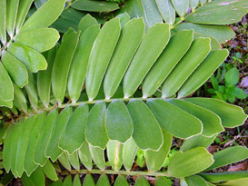

**Plate 1: *Zamia furfuracea* (L.) f.**

From the centre of the trunk, the green leaves radiate forth; each leaf is between 50 and 150 cm long, with a petiole that is between 15 and 30 cm long and 6- 12 pairs of incredibly stiff, pubescent green leaflets. These leaflets measure 3-5 cm in width and 8-20 cm in length. The leaflets are sometimes serrated toward the tips. The leaf crowns are round and resemble the fronds of palm trees or ferns. They stand straight in the sun and lay flat in the shade. Z. furfuracea (L.) f. has small yellow-green flowers with six petals and six sepals. The seeds are small and black, and the seedlings are small and green.

A total of 6 genotypes of *Z.* furfuracea (L.) f. were collected from different regions of Kerala. These plants were then successfully maintained in the lab facilities at KSCSTE- Malabar Botanical Garden and Institute for Plant Science, Calicut, Kerala, India. Plant populations are named Z1 (*Z.* furfuracea (L.) f.1) to Z6 (*Z.* furfuracea (L.) f.6) (Table 1). Two samples were collected from same region (Z2 & Z6).

**3.2 PREPARATION OF GENOMIC DNA FROM PLANT TISSUE**

Tender, healthy leaves’ sample from all samples were taken. It was then rinsed well and pat dried with sterile filter paper. One gram of leaf material was weighed and then chopped it into pieces in a mortar that has already cooled. Polyvinylpyrrolidone (PVP) was added to CTAB Extraction Buffer prior to the extraction, and preheated. Pulverized the tissue using a mortar and pestle. 500–1000 µl of extraction buffer was added to form a slurry, and then transferred to a 2 ml centrifuge tube. The tubes were then kept in the water bath for 45 minutes at 65°C, with periodic stirring.

The liquid was brought down to the room temperature and added with 70 μl of the chloroform-isoamyl alcohol (24:1) combination. It was stirred thoroughly and mixed well, then centrifuged for 15 minutes at 25°C at 12,000 rpm. The top aqueous phase was then transferred to a fresh tube and filled with 1/10 of the CTAB/NaCl solution. The mixture was stirred gently. Same amount of chloroform was added to it and centrifuged it for ten minutes at 4°C at 12,000 rpm. The top aqueous phase was again transferred to a fresh eppendorf tube. The same volume of chloroform was added and centrifuged for ten minutes at 4°C at 12,000 rpm. Tubes were inverted for better mixing and the supernatant was transferred to a new eppendorf tube. Cold 100% isopropanol was added through the walls of the tubes. The mixture was kept for one hour at 20°C. Centrifuged for 15 minutes at 4°C at 7850 rpm. The pellets were dried in the air after collecting them twice with cold 70% ethanol at 1000 rpm for five minutes. Pellets were then suspended in 200 µl of TE buffer. It was then incubated in a water bath at 37°C for one to two hours after adding 4 μl of RNase.

500 μl of phenol: Chloroform: Isoamyl mixture (24:25:1) was incorporate into it and centrifuged for 10 minutes at 4 °C at 10,000 rpm. Supernatant was collected to a new eppendorf tube, then it was carefully mixed with 500 μl of chloroform. Centrifuged for ten minutes at 1000 rpm. The supernatant was collected and mixed with double the volume of cooled ethanol 0.1 litre of 7.5 M sodium acetate.

The sample was then stored overnight at -20 °C. It was then centrifuged for 15 minutes at 4 °C at 10,000 rpm and the pellets were collected. After cleaning the pellets were collected, cleaned in cold 75% ethanol and kept for drying. 50 μl of TE buffer was added to it (Table 1 ) and kept at -20 °C for long term storage.

**Table 1: Stock solution required for Genomic DNA extraction**

|  |  |  |
| --- | --- | --- |
| **Solutions** | **Composition** | **Quantity** |
| 8  Tris buffer  pH 8 | Tris 1M  H2O | 12.11 gm  100 ml |
| EDTA | Na  Na2EDTA  H2O | 18.61 gm  100 ml |
| CTAB Extraction buffer pH 8.0  (stored at room temperature) | CTAB 2% W/V  Tris buffer 100 mM Na2EDTA 20 mM  PVP 1%  NaCl 1.4 M  H2O | 2 gm  10 ml  4 ml  1 gm  8.2 gm  100 ml |
| TE buffer | Tris buffer 10mM Na2EDTA 1M  H2O | 1 ml  0.2 ml  100 ml |
| Sodium acetate | Sodium acetate 3 M  H2O | 24.61 gm  100 ml |

**3.3 QUANTIFICATION AND VISUALIZATION OF DNA**

Using a nanodrop spectrophotometer (Multiskan sky), optical density (O.D.) at A260 and A280 was measured in order to quantify DNA. The software called nanodrop (Thermo Scientific, USA) was used to record the samples' concentration and purity. The samples of DNA that were diluted to a 50 ng/μl concentration and kept for usage at -20°C. To prepare DNA samples, 6X loading dye was mixed with 1X final concentration. To assess the quality of the isolated DNA, 1μl loading dye (Table 2) and 5μl of isolated genomic DNA were loaded onto a 0.8% agarose gel stained with ethidium bromide. The gel was then electrophoresed in 1x TAE buffer (Table 2) for 30 minutes at 100 V. The gels were captured on camera using a Bio-Rad Gel Documentation system.

**Table 2: Stock solution required for Agarose gel electrophoresis**

|  |  |  |
| --- | --- | --- |
| **Solution** | **Composition** | **Quantity** |
| TAE Buffer (10x) pH 8 | Tris base  Acetic acid  Na2EDTA 0.5Mm  H2O | 21.6 gm  11 gm  8 ml  100 ml |
| Gel loading buffer | Bromo phenol blue 0.25%  Xylene cyanole 0.25 %  Sucrose 40%(w/v)  H2O | 250 gm  250 gm  40 gm  100 ml |
| Ethidium bromide | Ethidium bromide  H2O | 1gm |

## **3.4 PCR AMPLIFICATION**

Six accessions of *Z. furfuracea* (L.) f.genomic DNA were amplified by PCR utilising six RAPD primers, which was created by Bioserve Biotechnologies in accordance with the Operon Technologies, Inc. USA sequence. A 25 μl volume was used for PCR amplification procedures, which included 1 μl of template DNA, 12.5 μl of Takara Master Mix, 1 μl of 10 pmol primers, and enough Milli Q water to get the volume to 25 μl. All of the reagents were combined with a quick spin. A Bio-Rad thermal cycler was used to carry out the amplification process.

**Table 3: List of RAPD primers used in the study**

|  |  |  |  |
| --- | --- | --- | --- |
| **Primer name** | **Primer sequence (5︲- 3︲)** | **No. of BP** | **GC content (%)** |
| OPA 2 | 5︲- TGCCGAGCTG - 3︲ | 10 | 70 |
| OPA 5 | 5︲- AGGGGTCTTG - 3︲ | 10 | 60 |
| OPB 1 | 5︲- GTTTCGCTCC - 3︲ | 10 | 60 |
| OPB 17 | 5︲- AGGGAACGAG - 3︲ | 10 | 60 |
| OPB 18 | 5︲- CCACAGCAGT - 3︲ | 10 | 60 |
| OPG 2 | 5︲- GGCACTGAGG - 3︲ | 10 | 70 |

10-mer short oligonucleotide primers chosen at random from the operon series were used for RAPD amplification. The steps in the RAPD amplification sequence were as follows: 39 cycles of 1 minute at 36 degrees Celsius & 2 minutes at 72 degrees Celsius were followed by 1 cycle of 2 minutes at 95 degrees Celsius, 35 degrees Celsius & 75 degrees Celsius. A 7-minute extension at 72°C occurred after the last cycle. Samples were stored at 12°C. (Table 4)

**Table 4: Conditions for PCR reaction**

|  |  |  |
| --- | --- | --- |
| **PCR steps** | **Temperature** | **Time** |
| Initial denaturation | 94℃ | 2 min |
| Denaturation | 95℃ | 2 min |
| Annealing | 35℃ | 2min |
| Extension | 72℃ | 2min |
| No. of cycles of denaturation, annealing, extension | 39 cycles at 93℃,36℃,72℃ | 1min,  1min, &  2min |
| Final extension | 72℃ | 7 min |

**3.5 DATA ANALYSIS**

The bands were qualitatively scored using gel photos derived from RAPD analysis. Datas were recorded in a binary matrix sheet with “0” denoting absence and “1” denoting presence, based on clearly repeatable bands from each accession that were scored as unit characters. The data set contained both polymorphism and monomorphic bands to demonstrate an objective assessment of genetic variation. The software package Numerical Taxonomy and Multivariate Analysis System (NTSYSpc) (version 2.02) was utilized to evaluate the binary data that was acquired from the marker systems.

The “J” (Jaccard’s) Coefficient was chosen in NTSYS, and a dendrogram was created using UPGMA (Unweighted Pair Group Method with Arithmetic Mean) to analyze diversity patterns and interpret data.

**3.6 PIC (POLYMORPHISM INFORMATION CONTENT)**

Due to the polymorphism that the dominant marker reveals, we elaborate on a binary matrix of bands' presence or absence. The following general equation can be used to estimate the Polymorphism Information Content (PIC) if we take the frequency of bands present as P and the frequency of absents as q.

**PIC = 1- (p2 +q2)** (Nunes dos Santos, K., *et.al,* 2019)

By dividing the number of isolate alleles where the band was discovered by the total number of isolates, the frequency of an allele was determined. To evaluate genetic diversity, PIC is a useful metric. When measuring a genetic marker's information for linkage studies, PIC value is frequently employed. It is possible to assess the degree of gene variation whereby using the PIC index. A locus with a;

* PIC > 0.5 is considered to have great variety.
* PIC < 0.25 denotes a low level of diversity at the locus.
* PIC of 0.25 to 0.5 suggests that the locus has an intermediate level of diversity.
* PIC analyses can be used to assess markers, allowing the best marker to be chosen for phylogenetic and genomic mapping.

**3.7 EMR (EFFECTIVE MULTIPLEX RATIO)**

According to Melbourne *et al. (*1997), the EMR of a primer is "the product of the fraction of polymorphic loci and the number of polymorphic loci of the individual assay." It is the result of multiplying the fraction of polymorphic DNA by the total number of fragments per primer (n) and the fraction of polymorphic fragments β.

**E=nβ**

were β = total number of polymorphic DNA and n = total number of bands.

**3.8 MARKER INDEX**

The marker index MI was computed for each of the ten markers in order to assess the overall utility of a particular marker system. Rather than the degree of polymorphism found, the high MI is a reflection of the marker's ability to assess a greater number of bands simultaneously. PIC and EMR produce MI (Varshney *et al.,* 2005).

**MI=PIC *EMR**

Were PIC =Polymorphism information content and EMR =Effective Multiplex Ratio

**3.9 PHYTOCHEMICAL ANALYSIS**

**3.9.1 Plant Material Collection**

The plant material was collected from Malabar Botanical Garden and Institute for Plant Science, Calicut, Kerala, India. The fresh leaves were collected and washed to ensure the absence of any impurities. The sample was shade dried for two weeks and then powdered using a blender. The extract was prepared by using Soxhlet apparatus. Powdered leaves were extracted with ethanol using the Soxhlet method.

**3.9.2 Extract Preparation**

A Soxhlet apparatus was used to extract the 15g of grounded, dried leaf powder using an organic solvent (ethanol). The boiling point was set up at 30°C to 40°C. The extract was collected, stored in a glass container, and then used for further phytochemical analysis.

**3.9.3 Phytochemical Analysis**

Phytochemical analysis of extracts was carried out to identify the presence of various phytoconstituents by employing standard protocols (Banu, K. S., *et. al.,* 2015)

**3.9.4 Test For Alkaloids**

Mayer’s test: Few drops of Mayer’s reagent were added to 0.5 mL of extract. The formation of a yellowish or white precipitate indicates the presence of alkaloids.

Dragendorff ’s test: Few drops of Dragendorff’s reagent is added to 0.5mL of extract. The formation of an orange red precipitate indicates the presence of alkaloids. An orange red precipitate was formed, indicating the presence of alkaloids.

**3.9.5 Test for flavonoids**

Sodium hydroxide test: 1ml of 10% of Sodium hydroxide is added to 0.5ml of extract. Initially, a deep yellow color appeared but it gradually became colorless by adding few drops of dilute HCL, indicating that flavonoids were present.

**3.9.6 Test For Glycosides**

Salkowski test: 1 ml of Chloroform and 1ml of Concentrated Sulphuric acid is added to 0.5ml of extract. The formation of a reddish brown precipitate indicates the presence of Glycosides.

**3.9.7 Test for Tannins**

Ferric chloride test: Few drops of 10% ferric chloride solution is added to 0.5ml extract. Occurrence of blackish blue or blackish green color indicates the presence of tannins.

**3.9.8 Test for Terpenoid**

Salkowski test: 1 ml of Chloroform and 1ml of Concentrated Sulphuric acid is added to 0.5ml of extract. The formation of a reddish brown precipitate indicates the presence of Terpenoid.

**3.9.9 Test for Steroids**

Salkowski test: 1 ml of Chloroform and 1ml of Concentrated Sulphuric acid is added to 0.5ml of extract. The formation of a reddish brown precipitate indicates the presence of Steroids.

**3.9.10 Test for Saponins**

Foam test: 0.5ml of sample is added to 2ml of Distilled water and shaken for 15 minutes. The formation of foam indicates the presence of saponin.

**3.9.11 Test for Phenol**

Ferric chloride test: 0.5ml of sample is added to 1 ml ferric chloride solution. The formation of blue black color indicates the presence of phenol.

**3.10 ANTIBACTERIAL ANALYSIS**

**3.10.1 Preparation of Bacterial Culture**

The plant extract was evaluated for antimicrobial activity against *Staphylococcus* strain and *Escherichia coli* in the present study.The bacteria taken for the study is gram positive and a gram-negative bacterium respectively.100ml of distilled water taken in a conical flask was dissolved with 3gm of nutrient broth. The broth was subjected to autoclaving for sterilization for 15 minutes. In a laminar air flow chamber setup, both of the obtained bacteria strains were inoculated in the nutrient broth and incubated in appropriate conditions for 24hrs.

**3.10.2 Preparation of Petri Plates**

Using the disc diffusion method, the selected species of plant *Z. furfuracea* (L.) f.were analysed for the antimicrobial activity for gram negative *Escherichia coli* and gram positive *Staphylococcus aureus*. By dissolving 4gm of MHC Agar and 2.6gm of nutrient broth in 100ml distilled water agar medium was prepared. The mixture was sterilized for 15 minutes in an autoclave. The mixture was poured into petri plates in laminar air flow after sterilization. The petri plates were allowed to solidify under aseptic conditions.

**3.10.3 Antimicrobial Test by Disc Diffusion Method**

Using agar well diffusion method (Perez *et al.,1990*), the antibacterial activity of the extract was tested against the gram negative and gram-positive bacterial strain. Using a sterile cotton swab the standard inoculums suspension (106 CFU/ml) was streaked over the surface of the sterile Muller Hinton Agar plates to ensure confluent growth of the organisms. The wells of 6mm size were cut in the Agar Plates and the wells were loaded with various concentrations of extract (100µl). The control used was DMSO. All the plates were subjected for incubation at 37℃ for 24 - 48hrs. After incubation, the plates were observed for the formation of zone of inhibition. The zone of inhibition of bacterial growth was then measured in millimeters (mm) and recorded.

**IV. RESULT**

**4.1 PLANT COLLECTION**

*Zamia* furfuracea (L.) f. available at five different locations of Kerala were collected. These plants were then successfully maintained in the lab facilities at KSCSTE- Malabar Botanical Garden and Institute for Plant Science, Calicut, Kerala, India. Plant populations are named Z1 (*Z.* furfuracea (L.) f.1) to Z6 (*Z.* furfuracea (L.) f.6) (Table 5). Two samples were collected from same region (Z2 & Z6) during different time period.

**Table 5: Details of *Z. furfuracea* (L.) f.samples collected from different regions of Kerala for genetic diversity analysis:**

|  |  |
| --- | --- |
| **SL. NO.** | **Location** |
| **Z 1** | St. Joseph's College Devagiri, Kozhikode |
| **Z 2** | Malabar Botanical Garden, Kozhikode |
| **Z 3** | Kerala Kisan Kendra Agriculture Nursery and Super Bazar, Ernakulum |
| **Z 4** | Dev Garden Nursery, Subhash Chandrabose Road, Kochi |
| **Z 5** | Royal Green House Karyavattom, Trivandrum |

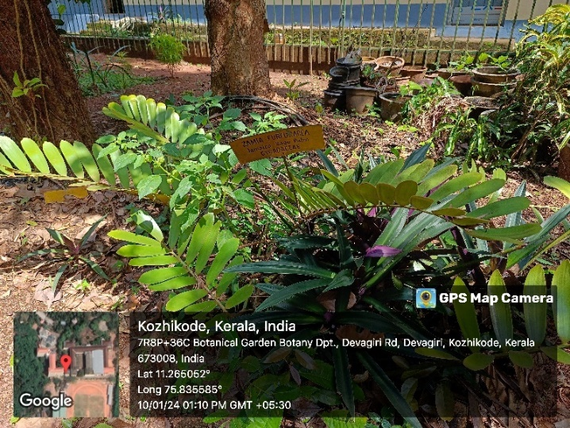

**Plate 2: *Z. furfuracea* (L.) f. [Z1]**

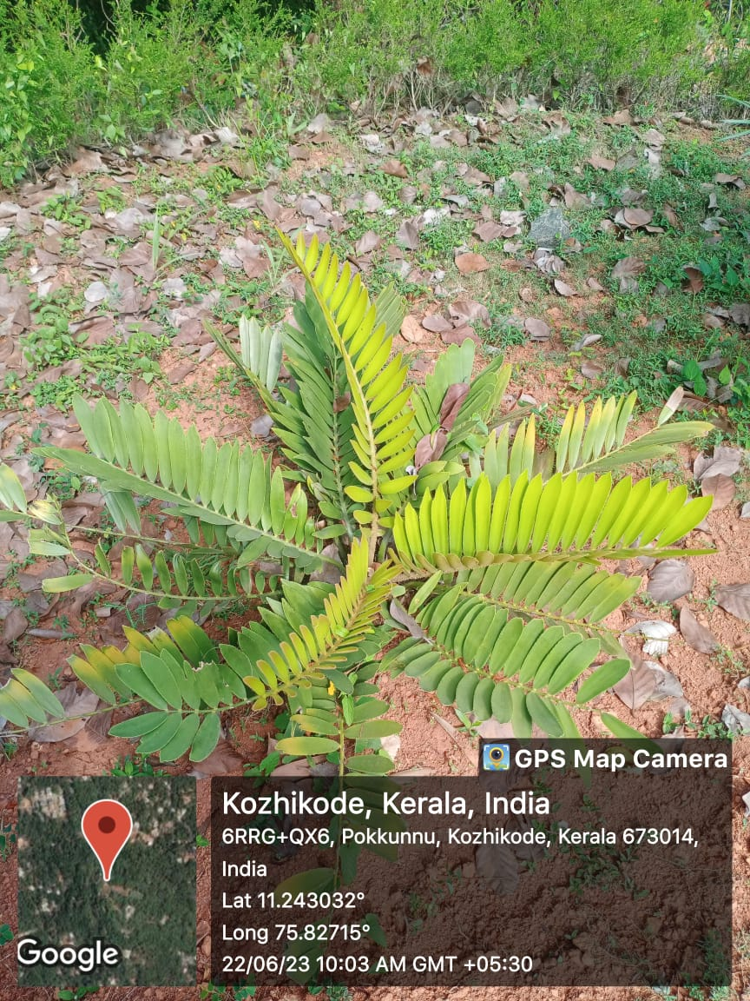

**Plate 3: *Z. furfuracea* (L.) f. [Z2]**

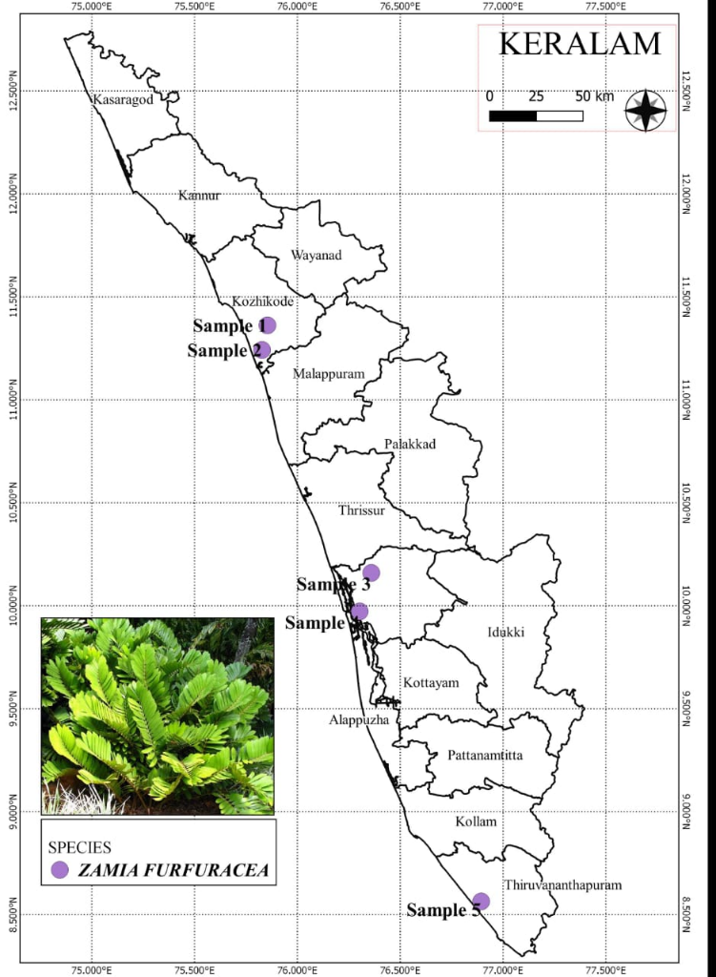

**Plate 4: *Z. furfuracea* (L.) f.- Regions of collection from Kerala**

**4.2 GENOMIC DNA ISOLATION**

For the genetic diversity analysis of cultivar varieties of *Z. furfuracea* (L.) f. RAPD markers were used. The genomic DNA of *Z. furfuracea* (L.) f. was isolatedfrom6 natural populations. The purity and concentration of the DNA samples are given in the table 6. Plate 5 represent the qualitative estimation of these isolates.

|  |  |  |  |
| --- | --- | --- | --- |
| **Sl. No.** | **Plant ID** | **Concentration of Genomic DNA (ng/µl)** | **Purity**  **(A260/A280)** |
| 1 | Z-01 | 158.3 | 1.71 |
| 2 | Z-02 | 508 | 1.78 |
| 3 | Z-03 | 418 | 1.77 |
| 4 | Z-04 | 1350 | 1.77 |
| 5 | Z-05 | 379 | 1.8 |
| 6 | Z-06 | 969 | 1.23 |

**Table 6: Quantitative Estimation of Genomic** **DNA**

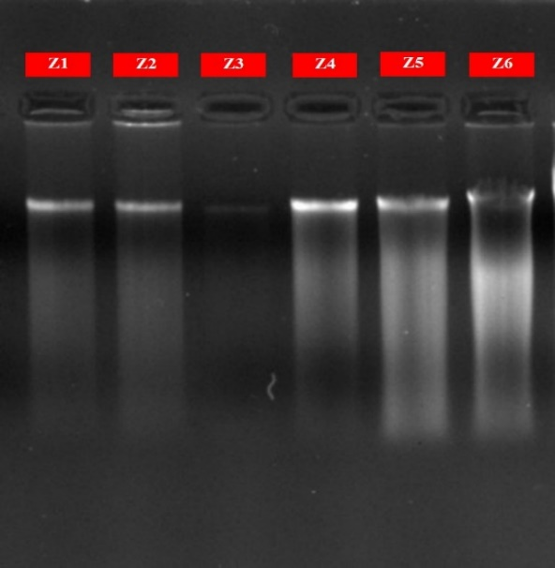

**Plate 5: Gel image of genomic DNA of *Z. furfuracea* (L.) f.**

**4.3 RAPD BAND ANALYSIS**

The present study analysed genetic diversity among *Z. furfuracea* (L.) f. populations in various geographical regions of Kerala. Samples from six populations were subjected to amplification using RAPD primers. The banding pattern obtained by RAPD primers clearly distinguished populations into different clusters, indicating genetic diversity among them. Diversity estimates provide useful information for understanding the genetic structure of the plant using RAPD. In this study, six RAPD primers were screened for polymorphism survey in pooled DNA accessions of *Z. furfuracea* (L.) f.

The PCR analysis for 06 samples taken in the study with 6 RAPD primers (Random Amplified Polymorphic DNA) primers generated 41 scorable bands. An average of 6.83 bands per primer was generated. Among 6 RAPD primers OPB01 produced a maximum number of bands (10) whereas OPB 18 and OPA 05 produced less no: of bands (5). The primers OPA 02 produce 07 bands, OPB 17 produce 06 bands and OPG 02 produced 08 bands respectively.

**Table 7: Data for RAPD primers used for analysing 06 accessions of *Z. furfuracea* (L.) f.**

|  |  |  |  |  |  |  |
| --- | --- | --- | --- | --- | --- | --- |
| **RAPD**  **Primer** | **No.**  **Of**  **bands** | **No. of Polymorphic bands** | **% of**  **Polymo-rphism** | **PIC** | **EMR** | **MI** |
| OPB01 | 10 | 08 | 80% | 0.24 | 80 | 19.24 |
| OPA02 | 07 | 06 | 85.7 % | 0.32 | 42 | 13.68 |
| OPB17 | 06 | 06 | 100 % | 0.43 | 36 | 15.48 |
| OPB18 | 05 | 05 | 100 % | 0.36 | 25 | 9 |
| OPG02 | 08 | 05 | 62.5 % | 0.25 | 40 | 10.30 |
| OPA05 | 05 | 03 | 60% | 0.21 | 15 | 3.15 |
| **Total** | 41 | 33 | 488.2% | 1.81 | 238 | 70.85 |
| **Average** | 6.83 | 5.5 | 81.36% | 0.301 | 39.6 | 11.80 |

Out of 41 scoring bands 33 were found to be polymorphic and the average number of polymorphic bands was found to be 5.5. OPB01 was found to have a higher number of polymorphic bands whereas OPA05 was found to have minimum number of bands. The level of polymorphism was found high for OPB 17 and OPB 18 (100%) and minimum for OPA 05 (60%). The average level of polymorphism was found to be 81.36%.

PIC (Polymorphism Information Content) values obtained from the primers ranged from 0.21(OPA 05) to 0.43(OPB 17) with an average of 0.301 for all the primers. The primer OPB 17 was found to more convenient for studies in this species as the PIC value came closest to 0.43. The Effective Multiplex Ratio (EMR) was calculated by multiplying the number of polymorphic bands and number of bands. The maximum EMR value was found in OPB01 (80) and minimum value for OPA05 (15). The marker index was calculated by multiplying EMR and PIC. RAPD primer OPB01 shows the highest Marker index with a value of 19.24 and primer OPA05 shows the lowest (3.15). (Table 7).

**4.4 CLUSTER ANALYSIS**

A dendrogram generated from UPGMA (Unweighted Paired Group Method using arithmetic averages) cluster analysis of RAPD primer is shown in (Figure 1). The dendrogram was based on Jaccard’s coefficient of genetic similarity. This dendrogram separates the whole genotype into two major clusters. The first major cluster contain two populations; Z1 and Z6. Second cluster contain four populations; Z2, Z4, Z5 and Z3. Cluster 1 is divided into 2 subclusters. Cluster 2 is also divided into 2 subclusters of which subcluster1 which contain 2 CLADES, CLADE 1 & CLADE 2. CLADE 1 possess Z2 population. CLADE 2 possess Z4 and Z5 populations. Subcluster2 contain Z3 population.

The cluster analysis of six population of *Z. furfuracea* (L.) f. reveals that their genetical similarity coefficient (Jaccard’s coefficient, J) ranges from very low (0.4137) to high (0.8666) range. Notably, populations 4 and 5 exhibit the highest level of similarity, characterized by a Jaccard’s coefficient of genetic similarity of 0.8666, suggesting a close genetic affinity between them. Similarly, population 2 demonstrates considerable genetic similarity with population 5, with a Jaccard coefficient of 0.7857, reinforcing their close genetic relationship. Z2 and Z4 exhibit a modest similarity with similarity index value 0.6774. Z1 and Z3 populations shoes least genetic similarity with a Jaccard’s coefficient of 0.4137.

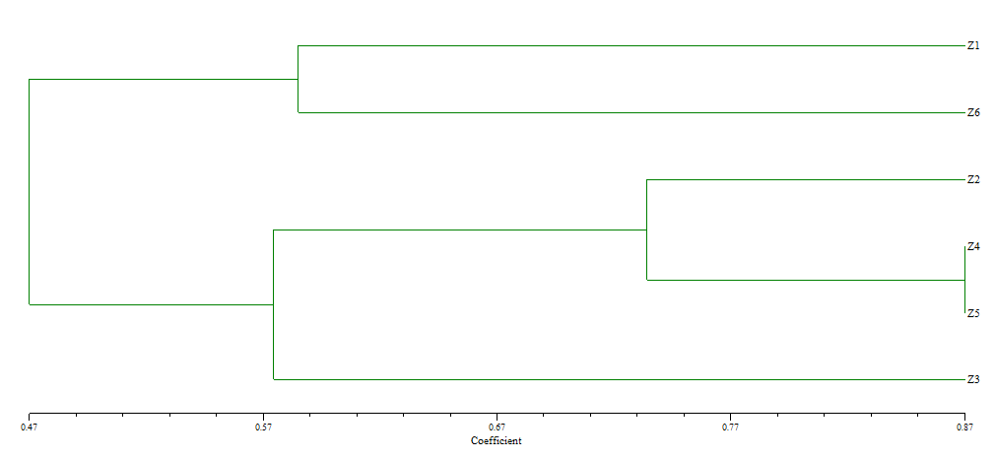

**Fig.1: Dendrogram Based on Jaccard’s coefficient of Genetic similarity (UPGMA) Showing genetic distance**

**Table 8: Similarity index table sowing Jaccard’s coefficient foe genetic similarity**

|  |  |  |  |  |  |  |
| --- | --- | --- | --- | --- | --- | --- |
| Rows/ Cols | Z1 | Z2 | Z3 | Z4 | Z5 | Z6 |
| Z1 | 1.0000000 |  |  |  |  |  |
| Z2 | 1.5000000 | 1.0000000 |  |  |  |  |
| Z3 | **0.4137931** | 0.6000000 | 1.0000000 |  |  |  |
| Z4 | 0.4516129 | 0.6774194 | 0.5428571 | 1.0000000 |  |  |
| Z5 | 0.4827586 | 0.7857143 | 0.5757576 | **0.8666667** | 1.0000000 |  |
| Z6 | 0.5833333 | 0.4516129 | 0.4242424 | 0.5454545 | 0.4848485 | 1.0000000 |

**4.5 PHYTOCHEMICAL ANALYSIS OF *ZAMIA FURFURACEA* (L.) f.**

The phytochemical screening of ethanolic extract of plant was conducted with the help of various tests. The tests provided the presence of many compounds (Plate 6).

**Table 9: Phytochemical Screening of Ethanolic Extract *Z. furfuracea* (L.) f.**

|  |  |  |  |
| --- | --- | --- | --- |
| **SL. No** | **Name of the Phytochemical** | **Name of the Test** | **Result** |
| 01 | ALKALOIDS | HAGER’S TEST | +++ |
| WAGNER’S TEST | ++ |
| 02 | FLAVONOIDS | SODIUM HYDROXIDE TEST | +++ |
| 03 | GLYCOSIDES | SALKOWSKI’S TEST | +++ |
| 04 | TANNINS | FERRIC CHLORIDE TEST | +++ |
| 05 | TERPENOIDS | SALKOWSKI’S TEST | - |
| 06 | STEROIDS | SALKOWSKI’S TEST | ++ |
| 07 | SAPONINS | FOAM TEST | +++ |
| 08 | PHENOL | FERRIC CHLORIDE TEST | +++ |

Strongly present: +++, Moderately present: ++, Poorly present: +, Absent: –

|  |  |
| --- | --- |
|  |  |
| **TEST FOR ALKALOID** | **TEST FOR FLAVANOID** |
|  |  |
| **TEST FOR GLYCOSIDE** | **TEST FOR STEROID** |
|  |  |
| **TEST FOR TANNIN** | **TEST FOR PHENOL** |
| **TEST FOR SAPONIN** |  |
|  |  |

**Plate 6: Represents the presence of phytochemicals in the extract of *Z. furfuracea* (L.) f.**

**4.6 ANTIBACTERIAL ANALYSIS OF *ZAMIA FURFURACEA* (L.) f.**

The ethanolic extract of *Z. furfuracea* (L.) f.exhibited antibacterial activity against the two test microorganisms namely ***Escherichia coli***and ***Staphylococcus aureus*** (Plate 7).

**Table 10: Antibacterial activity of Ethanolic extract of *Z. furfuracea* (L.) f.by Disc Diffusion Method using DMSO (negative control).**

|  |  |  |  |
| --- | --- | --- | --- |
| **SL. NO.** | **BACTERIAL STRAIN** | **ZONE OF INHIBITION (mm)**  ***Zamia furfuracea* (L.) f.** | |
| **Extract (100µl)** | **Control DMSO** |
| 1 | *Escherichia coli* | 16mm | R |
| 2 | *Staphylococcus aureus* | 18mm | R |

|  |  |
| --- | --- |
|  |  |
| ***E. coli*** | ***S. aureus*** |

**Plate 7: Petri plates with zone of inhibition against bacterial strains.**

**V. DISSCUSSION**

According to the Botanical Survey of India, India is home to more than 8,000 species of medicinal plants. Gymnosperms, a vital but often over looked group in the plant kingdom has 44 genera and 82 species in India with the majority flourishing in Himalayan regions, desert areas and southern hills. Apart from being a good source of food for both wildlife and humans, these plants also have great medicinal, ornamental and economic values. *Zamia* a genus of cycad of the family Zamiaceae, under Gymnospermae is a non-native species belonging to North America from the United States (in Georgia and Florida) as well as throughout the West Indies, Central America and South America. Even though they are introduced cultivar varieties, they contribute to the medicinal, economic and ornamental values.

The degree of genetic variability found in individuals of a variation or a population within a species is known as genetic diversity. A healthy population depends on genetic diversity to preserve the variety of genes that may provide resistance towards diseases, pests, or different types of stress. It also makes it possible for living things to adjust to different biotic and abiotic stresses. It also makes it possible for people to adjust to different biotic and abiotic stresses (Salgotra *et al.,* 2023).

Phenotypic qualities are the foundation of genetic diversity research generally because they are simple, inexpensive, and do not require complex instruments or methods. However, because the environment affects gene expression, phenotypic assessments of genetic diversity could not be reliable or accurate. Therefore, more molecular analysis of the genetic diversity of germplasm accessions is needed (Fonseca R. M, 2008).

Population genetic studies are essential for conservation programmes and restoring the threatened population. The development in molecular genetics has laid the groundwork for genomics. Population ecology and plant demography are integrated research fields that provide insights into the performance of plant populations in the environment. In the context of conservation biology, it is important to understand how plant population’s function. This knowledge is relevant to the potential for developing comprehensive and effective conservation plans for endangered plant species. On the other hand, because evolutionary change begins at the population level, studies of population ecology shed light on the forces that influence the survival and fertility of individual plants, and assess the fitness of all different variants of a population.

Genetic diversity within and between populations is regularly evaluated at the molecular level using a variety of techniques developed in laboratories. Molecular analyses comprise a large variety of DNA molecular markers, which can be employed for analysis of variation. Different markers have different genetic qualities (they can be dominant or co-dominant, can contain expressed or non-expressed sequences, etc.).

Molecular markers are permanent and detectable in all tissues regardless of the growth, differentiation, development, or defensive status of the cell, which gives them several advantages over traditional, phenotype-based alternatives. Molecular markers function by emphasizing variations (polymorphisms) in a nucleic sequence that exist between distinct individuals (Mondini *et al*., 2009). The review work of Muhammad Idrees and Muhammad Irshad in 2004 on “Molecular markers in plants for analysis of genetic diversity” provides a detailed description of the major molecular markers. A molecular marker is a sequence of DNA, which are located with a known position on the chromosome (Pearce S. R, 1999), or a gene whose phenotypic expression is frequently easily discerned and used to detect an individual, or as a probe to mark chromosomes, nucleus, or locus (Schulmann, 2007). Markers exhibit polymorphisms resulting from nucleotide changes or mutations in genomic loci, allowing genetic differences between individual organisms or species to be identified (Collard, *et al.* 2005)

In the present study, 6 populations of *Zamia furfuracea* (L.) f. were collected and primarily DNA isolation was done using the suitable protocol. There are different protocols used by different workers. Good quality DNA is a prerequisite for all experiments of DNA manipulation. This is brought by disruptions of the tissue in mortar and pestle aided by liquid nitrogen and the various components of homogenizations or extraction buffer followed by the precipitating and purification method employed. The most commonly used basic plant DNA extraction protocols are those of Murray, M. G., & Thompson, W. (1980)

The protocol adopted in this work is ideal to isolate a considerable amount of DNA which was quantified in a spectrophotometer. The isolated DNA was treated with 6 RAPD primers, i.e., OPA 2, OPA 5 OPB1, OPB 17, OPB 18 and OPG 2. In a PCR thermocycler with appropriate conditions amplified fragments of DNA produced by the PCR were subjected to gel electrophoresis to separate the bands according to their size and charge. A clear banding pattern was obtained by viewing the gel under the gel imager. The genetic calculations analysed these scoring bands. The data of scored bands from amplified products of PCR revealed the polymorphism exhibited by these populations. The binary scored data used NTSYS software and it generated the genetic distance and genetic similarity. A dendrogram was generated from UPGMA (Unweighted Pair Group Method with Arithmetic Mean) cluster analysis of RAPD primers in which plant populations were grouped into certain clusters.

Numerical Taxonomy and Multivariate Analysis System (NTSYS) were used to estimate phylogenetic tree using the UPGMA methods for constructing dendrograms. The genetic distance and genetic similarity between 06 samples were able to relate with the help of Jaccard’s coefficient.

Plants are recognized in the pharmaceutical industry for their broad structural diversity as well as their wide range of pharmacological activities. The biologically active compounds present in plants are called phytochemicals. These phytochemicals are derived from various parts of plants such as leaves, flowers, seeds, barks, roots and pulps. These phytochemicals are used as sources of direct medicinal agents. They serve as a raw material base for elaboration of more complex semi-synthetic chemical compounds. K. S Banu, L Cathrine (2015), in their paper discussed the collection of plants, the extraction of active compounds from the various parts of plants, qualitative and quantitative analysis of the phytochemicals

Phytochemical analysis refers to the examination of the chemical compounds present in plants, which often have medicinal or biological significance. In the study conducted by Qu (2021), the focus was on analyzing the phytochemical composition and antifungal properties of gymnosperm against Fusarium wilt, a significant disease affecting bananas. The findings likely provided insights into the potential of gymnosperm as a natural resource for developing antifungal agents or alternative methods for managing Fusarium wilt in banana cultivation.

El- Seadawy *et al.* (2023) conducted a mini review focusing on the phytochemical profile, ethnobotanical uses and biological impacts of various *Zamia* species. Published in the Journal of Advanced Medical and Pharmaceutical Research. The review provides insights into the diverse chemical compounds present in Zamia plants along with their traditional medicinal and cultural significance. It further explored the traditional uses of Zamia species in different cultures, shedding light on their historical roles in folk medicine and rituals. Review also encompases the traditional uses of Zamia species in different cultures, shedding light on their historical roles in folk medicine and rituals.

In this current study, phytochemical analysis is investigated on the ethanol extract of *Z. furfuracea* (L.) f. leaves. The leaf extract is made by using Soxhlet apparatus. Standard procedures were carried out for phytochemical screening. The result showed the presence of alkaloids, flavonoids, glycosides, tannins, saponins, steroids and phenol.

Chassagne et al. (2021) conducted a systematic review focusing on plants possessing antibacterial properties, with a particular emphasis on the taxonomic and phylogenetic aspects. Published in Frontiers in Pharmacology, the review aimed to provide a comprehensive overview of antibacterial plants while considering their evolutionary relationships and taxonomic classifications. The findings likely revealed patterns and trends in the occurrence of antibacterial activity among phylogenetically related plants, shedding light on the evolutionary aspects of plant-microbial interactions. By considering taxonomic and phylogenetic perspectives, the review likely provided insights into the diversity and potential of plant-based antimicrobial agents. In this current study using *Z. furfuracea* (L.) f., the anti-bacterial analysis of ethanolic extract showed its resistance against (Gram- negative bacteria) *E. coli* and (Gram-positive *bacteri*a) *S. aureus.*

**VI. CONCLUSION**

The current study was aimed at collection of the introduced cultivar variety *Zamia furfuracea* (L.) f. that aregenerally available in different regions of Kerala and to analyse its genetic variability according to the change in space and time of collection. Identifying whether this non-native species of *Z. furfuracea* (L.) f.contain any phytochemical properties and antibacterial activity were also relevant part of the study.

The loss of habitats is a common indicator of the environmental degradation we are living in. This posses a threat not only to human life but also to every other organism on the planet. With the growing urban population, the significance of plant genetic diversity (PGD) is now acknowledged as a distinct field. Several plant species’ natural habitats, including common marshlands, are under danger of disappearing. Diversity contributes to ecosystem productivity, increased resilience to adverse weather conditions. For the purpose of effective utilization and conservation of *Zamia* plant species, it is essential to understand the variability that exists among them in various habitats.

The study on genetic diversity of *Z. furfuracea* (L.) f. was conductedby developing Random Amplified Polymorphic DNA (RAPD) markers (OPA 2, OPA 5 OPB1, OPB 17, OPB 18 and OPG 2). A number of 6 available samples from different locations of Kerala were selected for the study. Each sample of the plants were named as Z1 to Z6. The amplified products are visualized by Gel Electrophoresis. A qualitative score band was created using gel photographs. NTSYSpc version 2.2 software was used to analyze the binary data that was collected from the marker system. Finding patterns and structures in multivariate data is possible with NTSYSpc method. Dendrograms are constructed using the UPGMA software. The genetic features, namely the polymorphism among the population (PIC), the effective multiplex ratio (EMR), and the marker index (MI), were calculated using the same programme. RAPD markers have the ability to disclose each population’s genetic makeup. In this study, the genomic diversity of *Z. furfuracea* (L.) f. from several geographic locations was compared.

DNA technologies yield consistent results regardless of age, tissue, origin, physiological circumstances, environmental factors, harvest, storage, and sample processing, making them robust and dependable instruments for taxonomic identification at different levels. This study establishes the usefulness of the RAPD markers in comparison to other molecular markers for determining *Z. furfuracea* (L.) f. genetic diversity

From the dendrogram based on RAPD analysis, the highest genetic diversity has been exhibited by *Z. furfuracea* (L.) f.plants collected from St. Joseph's College Devagiri, Kozhikode (Z1) and Kerala Kisan Kendra Agriculture Nursery and Super Bazar, Ernakulum (Z3) with a maximum identity value of 0.5863. The least genetic diversity was shown by the plants collected from Dev Garden Nursery, Subhash Chandrabose Road, Kochi (Z4) and Royal Green House Karyavattom, Trivandrum (Z5) with a minimum identity value of 0.1334.

In order to understand the scope and relevance of the plant species in the field of medicine and ethnobotany, the phytochemical contents present in it should be evaluated. So that qualitative screening of *Z. furfuracea* (L.) f.was conducted. The study was done by using sample extracted via ethanolic Soxhlet extraction method. Phytochemical screening of this ethanolic extract revealed the presence of secondary metabolites such as Alkaloids, Flavonoids, Tannins, Glycosides, Steroids, Saponin and phenols.

This study also demonstrated the great potential of plant extract as antibacterial agents against *Escherichia coli* and *Staphylococcus aureus* bacteria. Antibacterial analysis using ethanolic extract of *Z. furfuracea* (L.) f. showed its resistance against *E. coli* and *S. aureus.* Themaximum zone of inhibition was shown against *Staphylococcus* *aureus* with 18mm (in 100ml) and the minimum zone of inhibition was against *Escherichia* *coli* with 16mm. These results can be the strong scientific evidence for plant as a useful source in medical field for treating various infectious diseases. Therefore, these kinds of analyses are the first step toward comprehending the nature of the active ingredients in this ornamental plant, aids to its medicinal property, which will be beneficial for further studies.

**VII. REFERENCE**

* Al-Samarai,F. R., & Al-Kazaz, A. A. (2015).Molecular markers: An introduction and applications. European journal of molecular biotechnology,9(3), 118-130.
* Amiteye, S. (2021). Basic concepts and methodologies of DNA marker systems in plant molecular breeding. *Heliyon*, *7*(10).
* Chikkaswamy, B. K. (2015). Assessment of genetic diversity and relationships of medicinal plants using RAPD marker. *International Journal of Advanced Research in IT and Engineering*, *4*(2), 25-35.
* Banu, K. S., & Cathrine, L. (2015). General techniques involved in phytochemical analysis. *International journal of advanced research in chemical science*, *2*(4), 25-32.
* Barcaccia, G., Mazzucato, A., & Falcinelli, M. (2000). Inheritance of apomictic seed production in Kentucky bluegrass (Poa pratensis L.). Journal of New Seeds, 2(1), 43-58.
* Bissa, S., Bohra, A., & Bohra, A. (2008). Antibacterial potential of three naked-seeded (Gymnosperm) plants.
* Chassagne, F., Samarakoon, T., Porras, G., Lyles, J. T., Dettweiler, M., Marquez, L., ... & Quave, C. L. (2021). A systematic review of plants with antibacterial activities: A taxonomic and phylogenetic perspective. *Frontiers in pharmacology*, *11*, 586548.
* Clark, D. A., & Clark, D. B. (1987). Temporal and environmental patterns of reproduction in Zamia skinneri, a tropical rain forest cycad. *The Journal of Ecology*, 135-149.
* Das, A. P., & Bera, S. (2018). Plant diversity in the Himalaya hotspot region. *Bishen Singh Mahendra Pal Singh, Dehradun*.
* Delevoryas, T. (2023), November 243. Gymnosperm. Encyclopedia Britannica
* El-Seadawy, H. M., Abo El-Seoud, K. A., El-Aasr, M., & Ragab, A. E. (2023). Phytochemical profile, Ethnobotanical and Biological Impacts of Various Zamia Species: A Mini-Review. *Journal of Advanced Medical and Pharmaceutical Research*.
* El-Seadawy, H. M., Abo El-Seoud, K. A., El-Aasr, M., & Ragab, A. E. (2023). Phytochemical profile, Ethnobotanical and Biological Impacts of Various Zamia Species: A Mini-Review. *Journal of Advanced Medical and Pharmaceutical Research.*
* Ferlitsch, M., Moss, A., Hassan, C., Bhandari, P., Dumonceau, J. M., Paspatis, G., ... & Bourke, M. J. (2017). Colorectal polypectomy and endoscopic mucosal resection (EMR): European Society of Gastrointestinal Endoscopy (ESGE) clinical guideline. *Endoscopy*, *49*(03), 270-297.
* Fonseca, R. M., Lopes, R., Barros, W. S., Lopes, M. T. G., & Ferreira, F. M. (2008). Morphologic characterization and genetic diversity of Capsicum chinense Jacq. Accesions along the upper Rio Negro-Amazonas. Embrapa Amazônia Ocidental- Artigo em periódico indexado (ALICE).
* Gebrewbet, G. H., & Hndeya, A. G. (2023). Phytochemical screening and antibacterial activity studies on the crude leaf extract of Solanum sisymbriifolium: traditional Ethiopian medicinal plant. *Advanced Gut & Microbiome Research*, *2023*, 1-7.
* Gonzalez-Astorga, J., Vovides, A. P., Octavio-Aguilar, P., Aguirre-Fey, D., Nicolalde-Morejon, F., & Iglesias, C. (2006). Genetic diversity and structure of the cycad Zamia loddigesii Miq.(Zamiaceae): implications for evolution and conservation. *Botanical Journal of the Linnean Society*, *152*(4), 533-544.
* Gurav, K. D., Patil, D. T., Thite, S. V., Patil, P. R., Kore, B. A., & Aparadh, V. T. (2013). Preliminary investigation of various secondary metabolites from some gymnosperm species. *International Journal of Pharmaceutical and Chemical Sciences*, *2*(2), 841-843.
* Heun, M., Murphy, J. P., & Phillips, T. D. (1994). A comparison of RAPD and isozyme analyses for determining the genetic relationships among Avena sterilis L.accessions. Theoretical and Applied Genetics,87(6), 689-696.
* Hughes, A. R., Inouye, B. D., Johnson, M. T., Underwood, N., & Vellend, M. (2008). Ecological consequences of genetic diversity. *Ecology letters*, *11*(6), 609-623.
* Idrees, M. U. H. A. M. M. A. D., & Irshad, M. U. H. A. M. M. A. D. (2014). Molecular markers in plants for analysis of genetic diversity: a review. *European academic research*, *2*(1), 1513-1540.
* Jantsch, V., Tang, L., Pasierbek, P., Penkner, A., Nayak, S., Baudrimont, A., ... & Loidl, J. (2007). Caenorhabditis elegans prom-1 is required for meiotic prophase progression and homologous chromosome pairing. *Molecular biology of the cell*, *18*(12), 4911-4920.
* Kumar, A., Singh, A. K., & Tripathi, G. (2020). Phytochemicals as potential curative agents against viral infection: A review. *Current Organic Chemistry*, *24*(20), 2356-2366.
* Kumar, N. S., & Gurusubramanian, G. (2011). Random amplified polymorphic DNA (RAPD) markers and its applications. *Sci Vis*, *11*(3), 116-124.
* Kumar, S., Marwaha, N., Singh, D., & Kumar, V. (2012). Evaluating the antibacterial activity of plant extracts against bacterial pathogens. *Journal of Drug Delivery and Therapeutics*, *2*(4).
* MACHII, H. (1989). Isolation of total mulberry DNA. *The Journal of Sericultural Science of Japan*, *58*(4), 349-350.
* Mondini, L., Noorani, A., & Pagnotta, M. A. (2009). Assessing plant genetic diversity by molecular tools. Diversity, 1(1), 19-35.
* Nascimento, G. G., Locatelli, J., Freitas, P. C., & Silva, G. L. (2000). Antibacterial activity of plant extracts and phytochemicals on antibiotic-resistant bacteria. *Brazilian journal of microbiology*, *31*, 247-256.
* Nunes dos Santos, K., Florentino, R. M., França, A., Lima Filho, A. C. M., Santos, M. L. D., Missiaggia, D., ... & Leite, M. F. (2019). Polymorphism in the promoter region of NFE2L2 gene is a genetic marker of susceptibility to cirrhosis associated with alcohol abuse. International Journal of Molecular Sciences, 20(14), 3589.
* Pearce, S. R., Li, D., Flavell, A. J., Harrison, G., Heslop-Harrison, J. S., & Kumar, A. (1996). The Ty1-copia group retrotransposons in Vicia species: copy number, sequence heterogeneity and chromosomal localisation. *Molecular and General Genetics MGG*, *250*, 305-315.
* Penner, G. A. (1996). RAPD analysis of plant genome.In “Methods of genomeanalysisin plants”. (P. P.Jaguar, Ed.0,pp. 251-268,CRC Press, NewYork.
* Perez, R., Ineichen, P., Seals, R., Michalsky, J., & Stewart, R. (1990). Modeling daylight availability and irradiance components from direct and global irradiance components from direct and global irradiance. Solar energy 44950, 271-289.
* Pourmohammad, A. (2013). Application of molecular markers in medicinal plant studies. *Acta Universitatis Sapientiae, Agriculture and Environment*, *5*(1), 80-90.
* Pourmohammad, A. (2013). Application of molecular markers in medicinal plant studies. Acta Univ.Sapientiae, AgricEnviron, 5(1), 80-90.
* Pratap, A., More, U., Dhat, V., Phalak, P., & Borgaonkar, C. (2023). Letter regarding “Elastase and COVID-19 relationship, and potential natural resource as elastase inhibitors: A comprehensive review”. *Journal of Applied Biology and Biotechnology*, *11*(Issue), 255-255.
* QU, A. (2021). Phytochemical analysis and antifungal activity of gymnosperm against Fusarium wilt of banana. *Applied Ecology & Environmental Research*, *19*(3).
* R.M., Tripathi. (2023). Antibacterial activity of phyto-chemicals obtained from leafextracts of some medicinal plants on pathogens of semi-arid soil. THE SCIENTIFIC TEMPER, 3(1&2):33-42.
* Ramanatha Rao, V., & Hodgkin, T. (2002). Genetic diversity and conservation and utilization of plant genetic resources. Plant cell, tissue and organ culture, 68,1-19.
* Salgotra, R. K., & Chauhan, B. S. (2023). Genetic Diversity, Conservation, and Utilization of Plant Genetic Resources. Genes, 14(1), 174.
* Sanghvi, G. V., & Dave, G. S. (2017). Molecular markers in plant biotechnology. In *Plant Biotechnology, Volume 1* (pp. 415-453). Apple Academic Press.
* Sebastian, V. A., (2009). Development and analysis of molecular markers for certain endangered species of Tylophora.
* Varshney, R. K., Graner, A., & Sorrells, M. E. (2005). Genic microsatellite markers in plants: features and applications. TRENDS in Biotechnology, 23(1), 48-55.
* Zebire, D. A. (2020). Applications of molecular markers in Genetic Diversity Studies of maize. *Nigerian Journal of Biotechnology*, *37*(1), 101-108.