

**CRAFT REPORT**

In the partial fulfilment of the requirements for the award of

# BSC APPAREL AND FASHION DESIGN

**2021 -2024**

*Submitted by*

**NAME: ANN MARIA DEVASIA**

**REG. NO.: SB21FT007**

**Under the guidance of**

# BESSY ROY

**DEPARTMENT OF FASHION DESIGNING WOMEN’S STUDY CENTRE**

# ST. TERESA’S COLLEGE (AUTONOMOUS) ERNAKULAM, KOCHI 682011



# CRAFT REPORT

In the partial fulfilment of the requirements for the award of

# BSC APPAREL AND FASHION DESIGN

**2021 -2024**

*Submitted by*

**NAME: ANN MARIA DEVASIA**

**REG. NO.: SB21FT007**

**Under the guidance of**

# BESSY ROY

**DEPARTMENT OF FASHION DESIGNING WOMEN’S STUDY CENTRE**

# ST. TERESA’S COLLEGE (AUTONOMOUS) ERNAKULAM, KOCHI 682011

EXTERNAL EXAMINER INTERNAL EXAMINER

**ACKNOWLEDGEMENT**

I express my special thanks to the Almighty God for helping me in the successful completion of th**i**s Craft Project**.** I would like to express my deepest appreciation to **Rev. Dr. Sr. Vinitha, CSST** Provincial Superior and Manage**r, Rev. Sr. Emeline CSST**, Director the St. Teresa’s College, Ernakulam, **Dr. Alphonsa Vijaya Joseph** Principal, St. Teresa’s College, Ernakulam.

A special gratitude to **Dr. Lekha Sreenivas,** Centre Coordinator, Associate professor, Department Fashion Designing who gave full support and encouragement to undergo this project.

I am extremely thankful to **Ms. Nair Supriya Damodaran,** Assistant professor, Head of the Department, Fashion Designing for the support and kind assistance.

I am extremely thankful to my project guide **Ms. BESSY ROY**, Assistant professor Department Fashion Designing for her guidance, encouragement which helps me a lot during the period of my project.

I also thank all other teachers of the Fashion Designing Department for their kind assistance.

I would like to thank the artisan, Sixonfor giving me guidance and opportunity in doing the project work.

A debt of gratitude is also owed to my husband / parents who was constantly helping and encouraging in many ways to finish this internship successfully.

|  |  |  |
| --- | --- | --- |
| SI. NO. | CONTENT | REMARKS |
|  | **INTRODUCTION** |  |
| 1.1 | HANDICRAFT OF INDIA |  |
| 1.2 | HANDICRAFT OF SOUTH INDIA |  |
| 1.3 | HANDICRAFT OF KERALA |  |
| 1.4 | HISTORY OF WOODCRAFT IN INDIA |  |
| 1.5 | HISTORY OF WOODCRAFT IN KERALA |  |
|  | **OBJECTIVES** |  |
|  | **PROJECT DESCRIPTION** |  |
| 3.1 | SELECTION OF CRAFT |  |
| 3.2 | SELECTION OF AREA |  |
| 3.3 | ARTISAN PROFILE |  |
| 3.4 | DESIGN INTERVENTION |  |
| 3.5 | PROCESS OF MAKING FINAL PRODUCT |  |
|  | **DIFFICULTIES FACED BY ARTISANS** |  |
|  | **SUGGESTIONS FOR IMPROVING THE PROBLEMS** |  |
|  | **CONCLUSION** |  |

1. **INTRODUCTION**

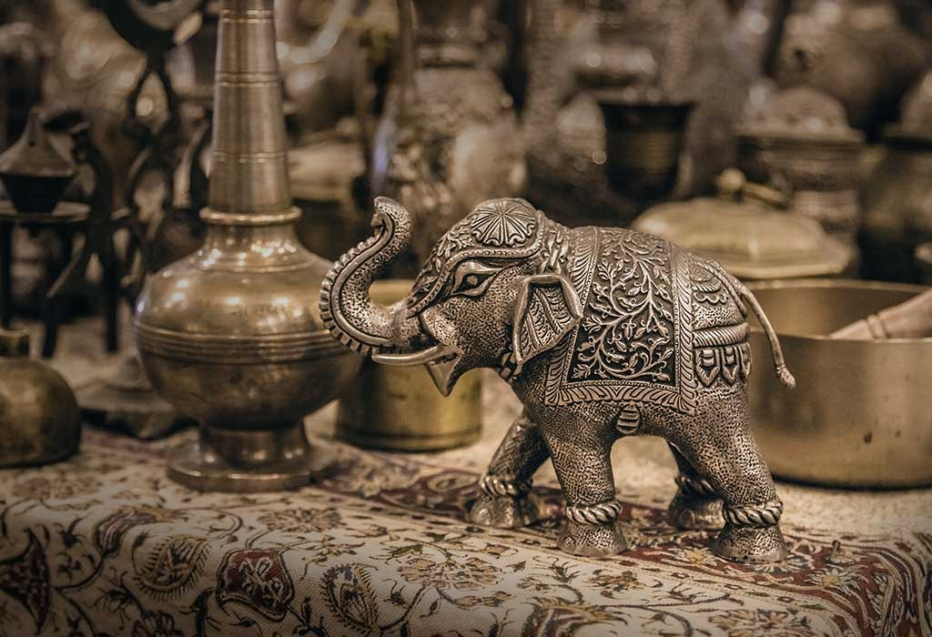

**FIG. 1.**

India's handicraft tradition, steeped in millennia of cultural heritage, epitomizes the country's diverse artistic expressions and skilled craftsmanship. Spanning textiles, pottery, metalwork, woodwork, and jewelry, these crafts encapsulate India's history, spirituality, and regional uniqueness. From the intricate designs of saris to the vibrant hues of carpets, each piece tells a story of tradition, passed down through generations, making Indian handicrafts revered globally for their beauty and artistry.

**1.1 HANDICRAFT IN INDIA**

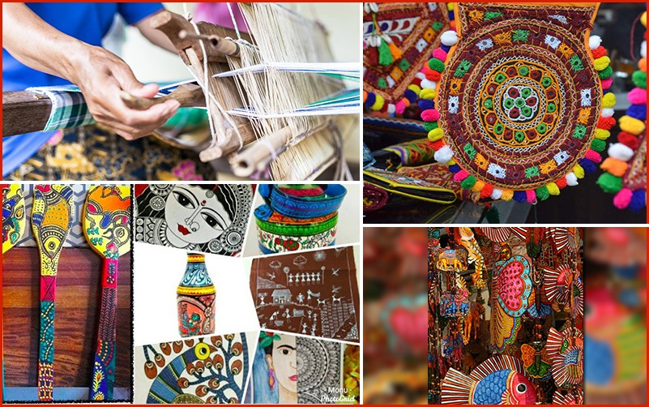

**FIG. 2.**

India boasts a rich tradition of handicrafts that reflects its diverse cultural heritage and skilled artisans. From intricate embroidery to exquisite pottery, India's handicrafts showcase a blend of artistic prowess and cultural significance. These crafts not only serve as expressions of creativity but also as a means of livelihood for millions across the country.

**1.2 HANDICRAFT IN SOUTH INDIA**

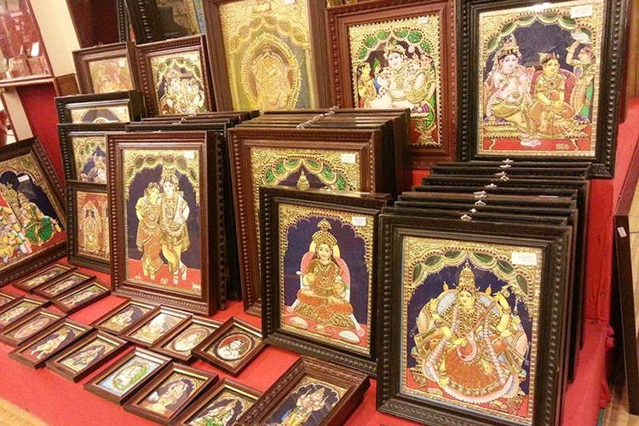

**FIG. 3.**

The southern region of India is renowned for its unique handicrafts, characterized by intricate designs and vibrant colors. From the famous Tanjore paintings of Tamil Nadu to the intricate metalwork of Karnataka and the elegant silk sarees of Andhra Pradesh, South India's handicrafts showcase a rich tapestry of artistry and tradition.

**1.3 HANDICRAFT OF KERALA**

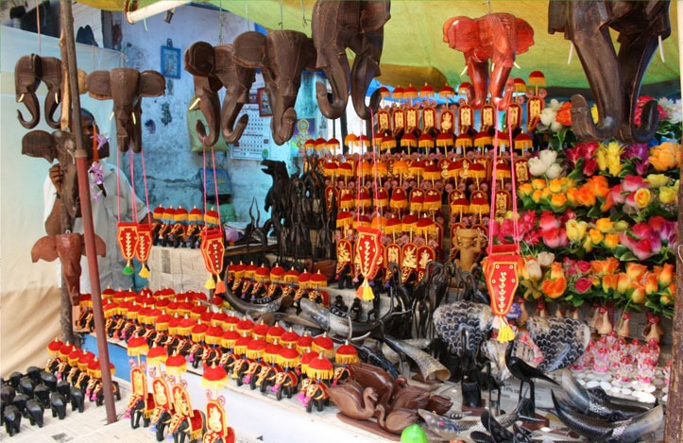

**FIG. 4.**

Kerala, often referred to as "God's Own Country," is renowned for its rich tradition of handicrafts. The handicrafts of Kerala reflect the state's natural beauty and cultural heritage. From intricately woven coir products to elegant metal ware, Kerala's artisans display remarkable skill and artistry in their creations. The state's vibrant festivals and rituals also play a significant role in influencing its handicraft traditions, with many artisans drawing inspiration from religious ceremonies and folklore.

**1.4 HISTORY OF WOODCRAFT IN INDIA**

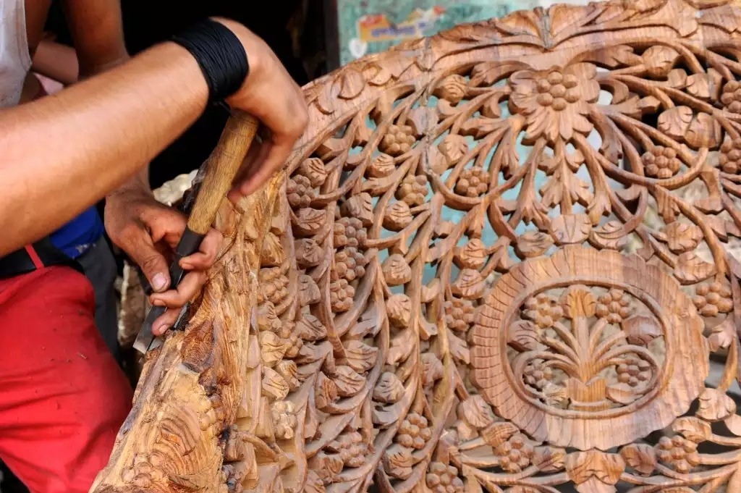

**FIG. 5.**

Woodcraft has been an integral part of Indian craftsmanship since ancient times. The history of woodcraft in India dates back to the Indus Valley Civilization, where evidence of exquisite wooden artifacts has been found. Over the centuries, Indian woodcraft has evolved, with artisans mastering techniques such as carving, inlay work, and lacquering. Woodcraft in India encompasses a wide range of products, including furniture, sculptures, and decorative items, each showcasing the unparalleled skill and creativity of Indian artisans.

**1.5 HISTORY OF WOODCRAFT IN KERALA**

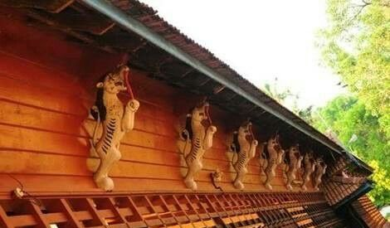

**FIG. 5.**

Kerala's woodcraft tradition is deeply rooted in its lush forests and rich cultural heritage. The state is renowned for its skilled artisans who transform locally available woods like rosewood, teak, and jackfruit into exquisite works of art. Influenced by traditional architectural styles and religious motifs, Kerala's woodcraft features intricate carvings and detailed craftsmanship. From ornate temple sculptures to intricately carved furniture, woodcraft in Kerala continues to be a celebrated art form, preserving the state's cultural legacy for generations to come.

India’s crafts also play a significant role in economic empowerment, particularly for marginalized communities and rural artisans. Many craft traditions are sustained through artisan cooperatives, non-profit organizations and government initiatives aimed at preserving traditional skills and providing sustainable livelihood.

In an increasingly globalized world, India’s tradition of crafts serves as a powerful reminder of the value of handmade, sustainable production and the enduring beauty of the cultural heritage. These crafts not only adorn homes and wardrobes but also serve as bridges between the past and the present, preserving age-old traditions while adapting to contemporary tastes and trends.

1. **OBJECTIVES**

The Artisan Project aims to empower and uplift artisans through the provision of resources and opportunities to showcase their handmade products. It seeks to preserve traditional crafts and skills while promoting economic sustainability and cultural heritage within communities. The key objectives of the Artisan Project include:

* To empower artisans, facilitating their journey towards financial independence and stability through the promotion and sale of their handmade products.
* To foster the development and mastery of artisanal skills, ensuring artisans' continual advancement and excellence in their craft.
* To uphold and advocate for traditional crafts and cultural practices, thereby preserving the diverse heritage of communities for future generations.
* To offer artisans greater opportunities to reach markets, both locally and globally, facilitating the distribution and sale of their products.
* To nurture positive societal transformations within communities by empowering artisans, fostering job creation, and advocating for social inclusion.
* To advocate for sustainable practices in craftsmanship, promoting the utilization of eco-friendly materials and methods to ensure the longevity of traditional crafts and their beneficial effects on the environment.

1. **PROJECT DESCRIPTION**

This project work was done at Palluruthy for a duration of a week. The methodology of the project is discussed below: -

**3.1) SELECTION OF THE CRAFT**

**3.2) SELECTION OF AREA**

**3.3) ARTISAN PROFILE**

**3.4) PROCESS OF MAKING SAMPLE PRODUCT**

**3.5) DESIGN INTERVENTION**

**3.6) PROCESS OF MAKING FINAL PRODUCT**

**3.1) SELECTION OF THE CRAFT**

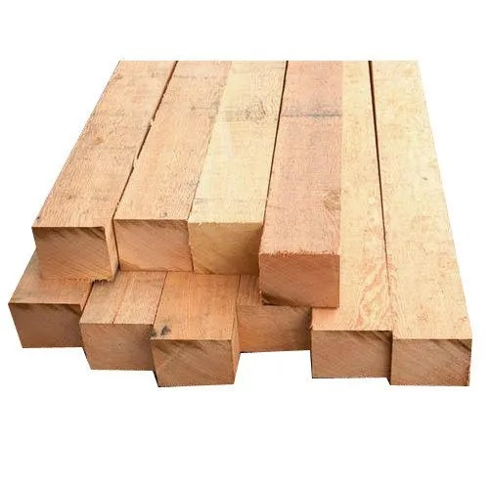

**FIG.6.**

Wood has been a primary material for crafting various products, including sculptures, furniture, and construction materials, owing to its versatility and durability. Its significance spans across different fields, serving as a canvas for artistic expression and a foundational element in practical applications. From intricate carvings to sturdy structures, wood plays an indispensable role, blending functionality with aesthetic appeal, enriching our surroundings and daily lives. Furthermore, its natural warmth and texture imbue each creation with a unique charm, inviting tactile exploration and appreciation

**3.2) SELECTION OF AREA**

During the project, a visit was made to a woodcraft artisan who had done woodwork for 15 years, where discussions revolved around the intricacies of product creation. Through this interaction process, insights were gained into how the artisan's income supported and sustained their family.

**3.3) ARTISAN PROFILE**

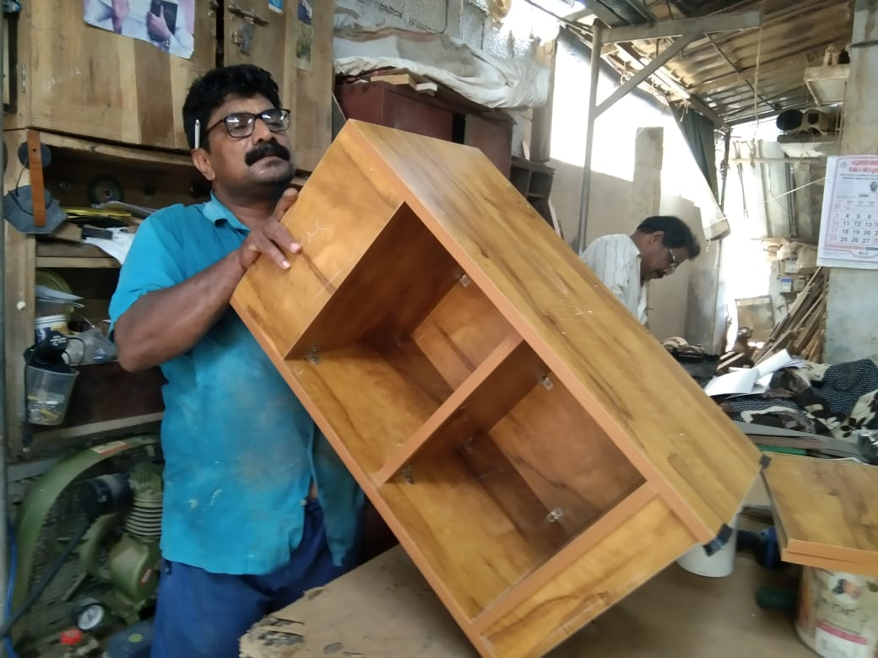

**FIG. 7.**

Artisan Name: Josy TJ  
Experience: 15 years  
Age: 50

Monthly Income:13,000 INR   
Craft Specialization: Woodwork, Interior Work.  
Location: Palluruthy, Kerala, India

**HIS WORKS:**

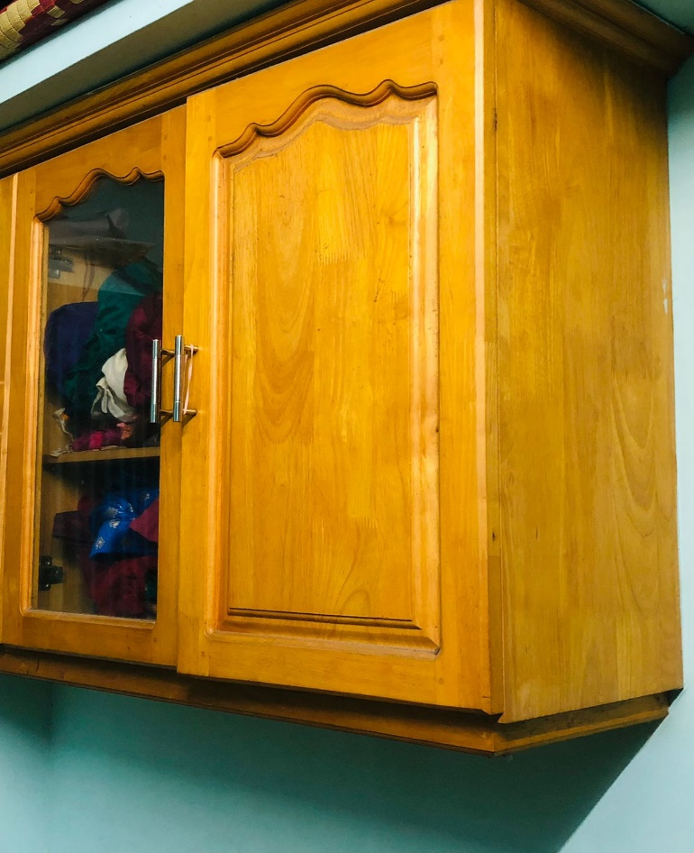

**FIG. 8.**

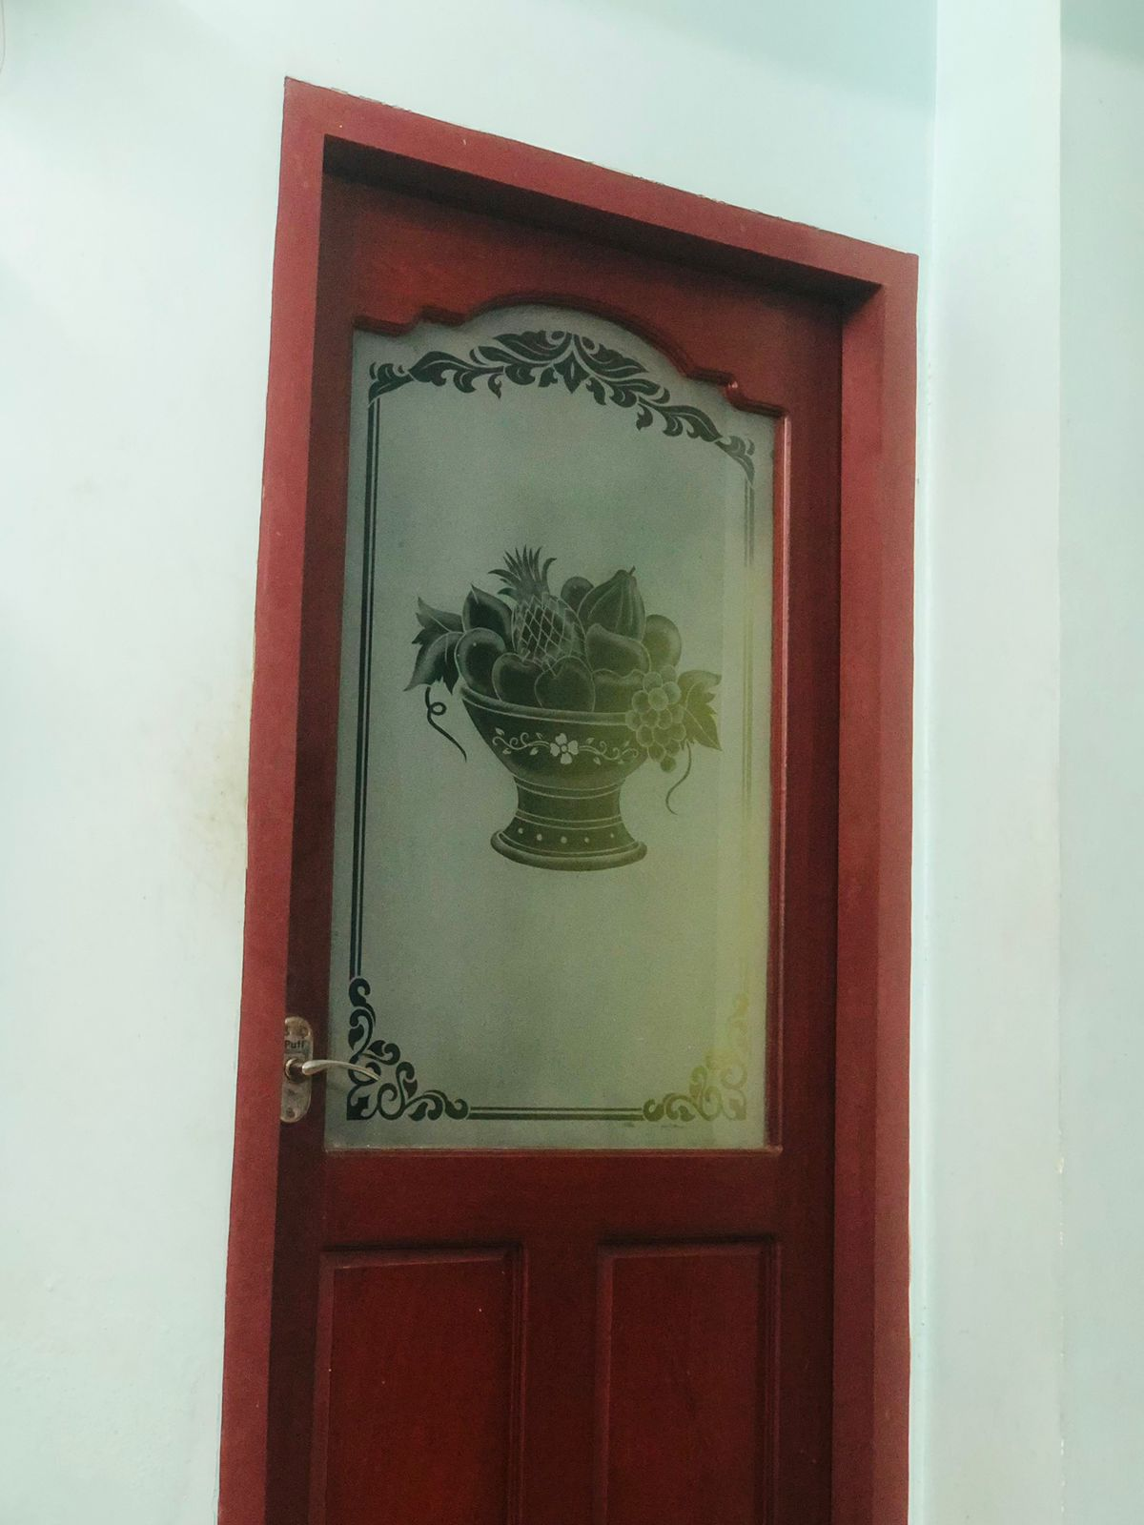

**FIG. 9.**

**3.4) DESIGN INTERVENTION**

Intervention refers to an interaction with an existing artwork, design, venue, space, or situation, often under the guise of conceptual art. Its aim is to alter prevailing conditions, bringing awareness to a previously unrecognized state.

As part of a design intervention in woodcraft, five products were designed and presented for approval. Among them, one was chosen. Below are the specification sheets for all five designs:

**SPECIFICATION SHEET 1**

|  |  |
| --- | --- |
| **SPECIFICATION SHEET NO. 1** | |
| DESIGNER: **ANN MARIA DEVASIA** | DATE: 23. 01.2024 |
| DESCRIPTION: MULTI – FUNCTIONAL LIVING TABLE | |
|  | |

**SPECIFICATION SHEET 2**

|  |  |
| --- | --- |
| **SPECIFICATION SHEET NO. 2** | |
| DESIGNER: **ANN MARIA DEVASIA** | DATE: 23.01.2024 |
| DESCRIPTION: STACKABLE PENCIL STAND & STORAGE STAND | |
|  | |

**SPECIFICATION SHEET 3**

|  |  |
| --- | --- |
| **SPECIFICATION SHEET NO. 3** | |
| DESIGNER: **ANN MARIA DEVASIA** | DATE: 23.01.2024 |
| DESCRIPTION: MULTI - FACETED STAND/ COFFE TABLE | |
|  | |

**SPECIFICATION SHEET 4**

|  |  |
| --- | --- |
| **SPECIFICATION SHEET NO. 4** | |
| DESIGNER:  **ANN MARIA DEVASIA** | DATE: 23.01.2024 |
| DESCRIPTION: BOOK HOLDER/ READING STAND WITH STORAGE | |
|  | |

**3.5) PROCESS OF MAKING FINAL PRODUCT**

**PRODUCT: COMPACT VANITY TABLE**30-inch height of the vanity table allows for comfortable seating and easy access to the mirror, facilitating tasks like makeup application and hair styling. it is suitable for fitting into various spaces, whether in bedrooms, bathrooms, or dressing areas, without overwhelming the room. The main purpose of making this compact vanity table are as follows:

1. Its dimensions make it suitable for fitting into various spaces
2. It serves as a versatile piece of furniture
3. The vanity table fulfils the practical needs of individuals for daily grooming
4. The vanity table provides ample surface area for organising cosmetics, toiletries and other essentials
5. It has storage compartments
6. It has multi-usage

**STEP 1: COLLECTING RAW MATERIALS**

For the raw material, wood that was left over from a previous work where the artisan had been responsible for a wardrobe.

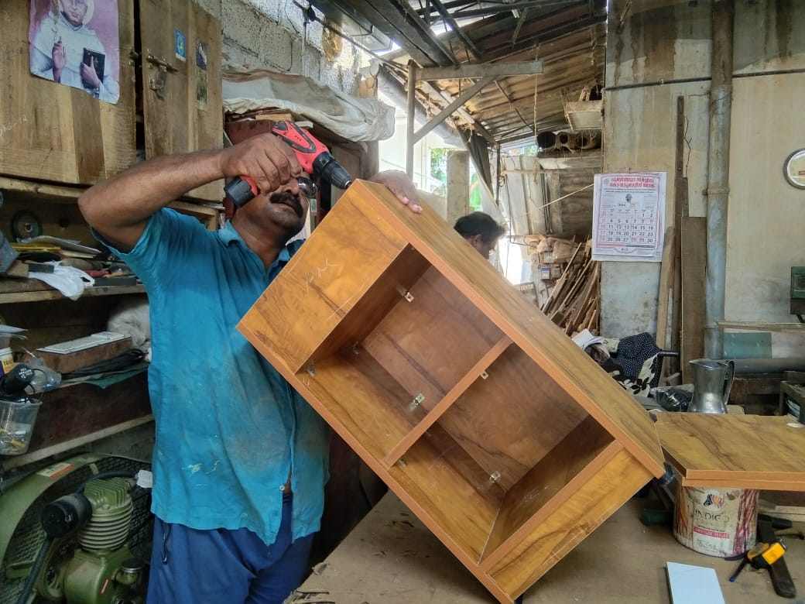

**FIG. 10.**

**STEP 2: CUTTING THE WOOD**

The wood is cut into the required shape and size for the construction of the product.

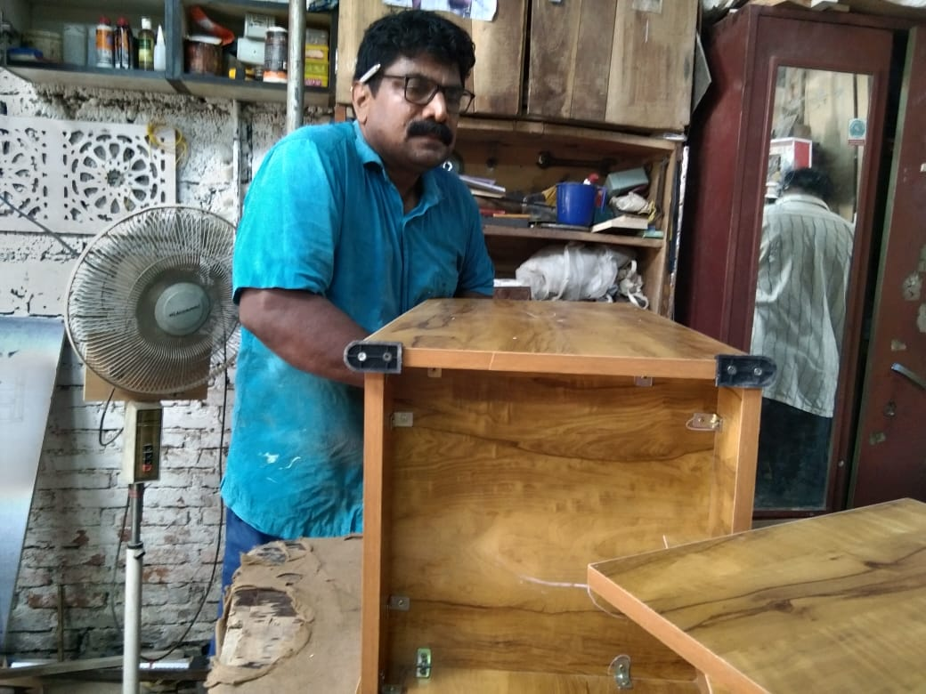

**FIG. 11.**

**STEP 3: ATTACHING THE WOOD PIECES**

After it is cut into required pieces, now the wood pieces are being joined to form the table.



**FIG. 12.**

**STEP 4: THE FINAL PRODUCT**

The purpose of crafting a 30-inch-tall vanity table lies in its functionality and aesthetic appeal. This specific height is chosen to ensure optimal comfort and convenience during grooming routines, enabling easy access to the mirror for grooming tasks like makeup application or hairstyling. The table's design maximizes space efficiency, offering ample storage for cosmetics and toiletries, making it a versatile and stylish addition to any bedroom or dressing area.

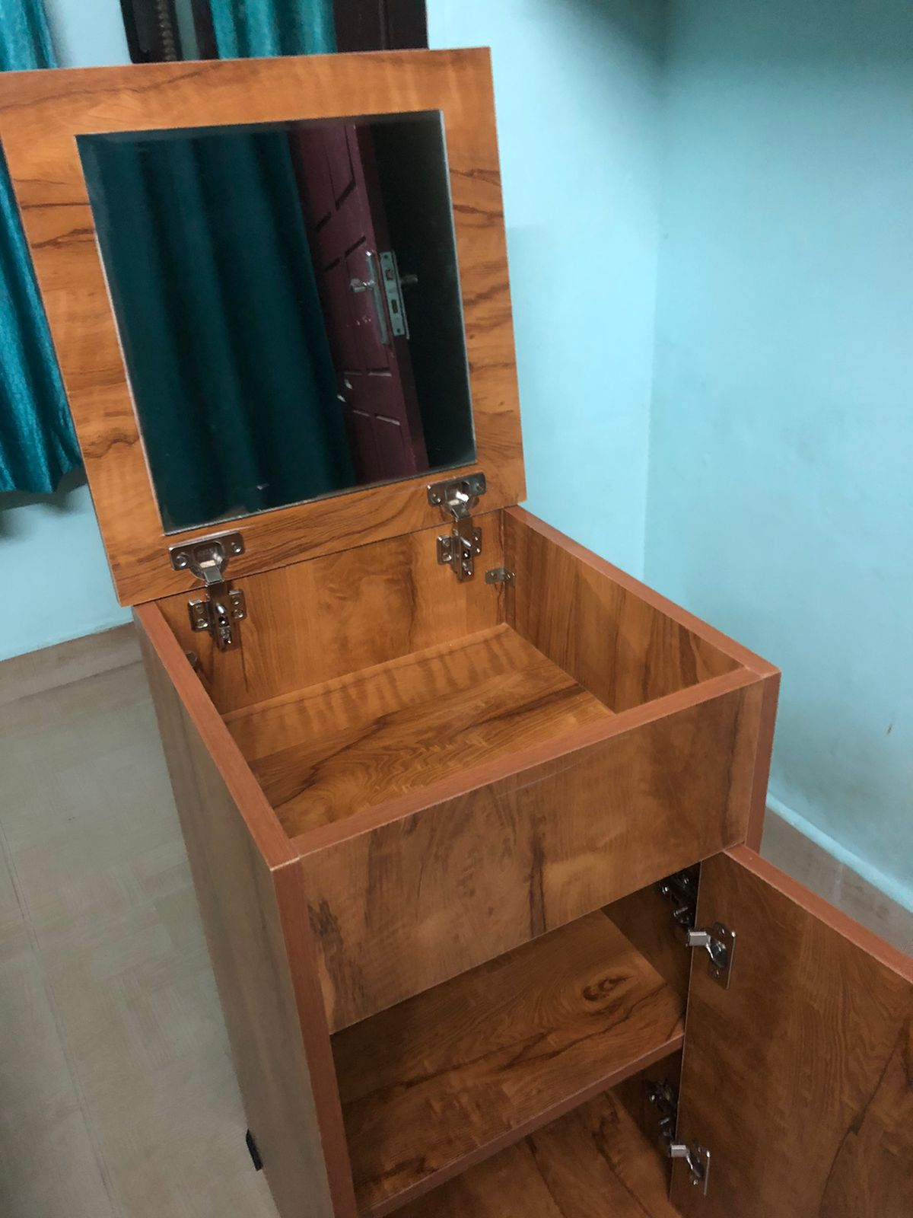

**FIG. 13.**

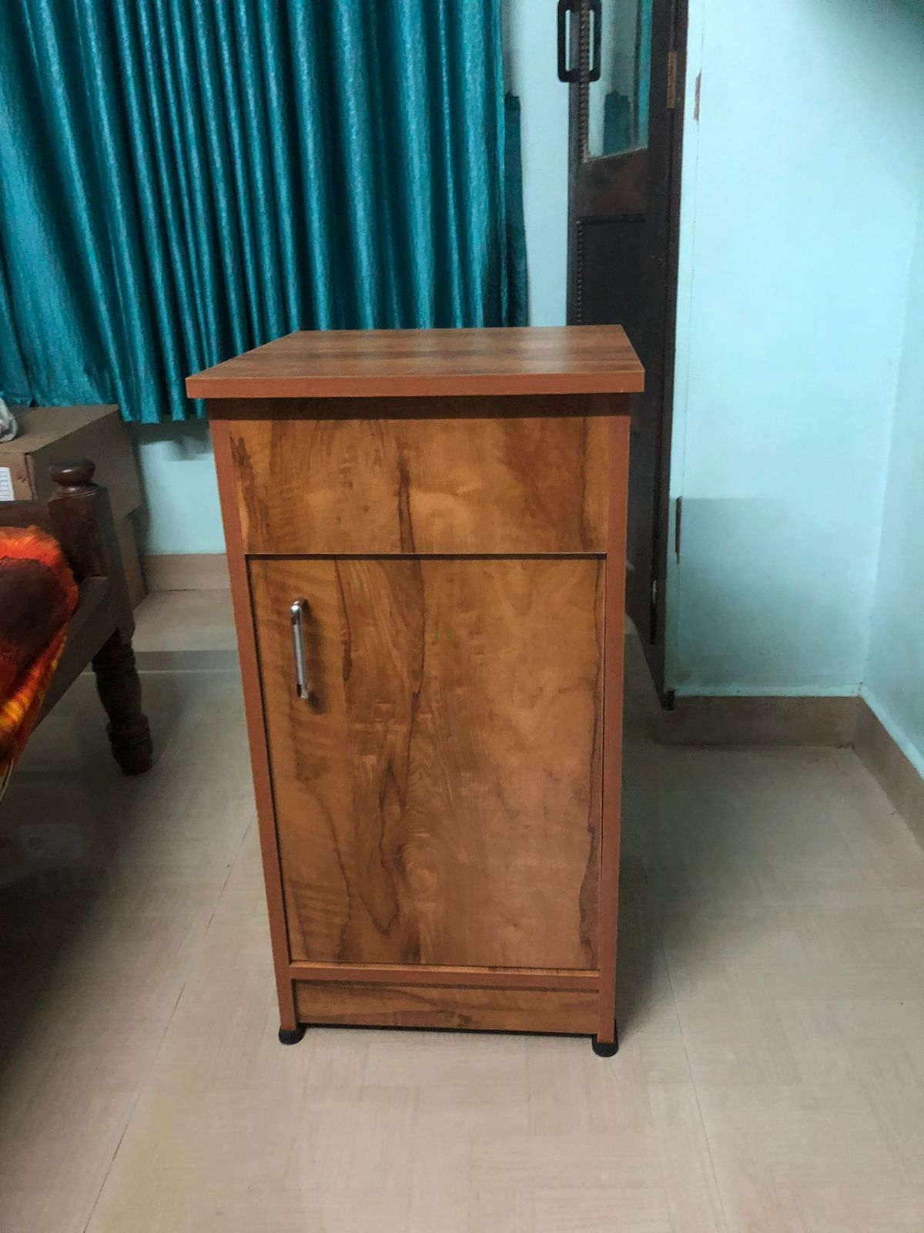

**FIG. 14.**

1. **DIFFICULTIES FACED BY ARTISANS**

My artisan is a small wood worker from Palluruthy. He deals with acoustics, doors, cabinets, etc. Although he does works of big studios, he isn’t able to make enough to make ends meet. So, by doing a table, it made him able to make various kinds of products of the sort and it help him attract more customers and put himself in the market.  
Despite being skilled in crafting acoustics, doors, and cabinets for big studios, the artisan struggled to earn enough to sustain himself. However, by diversifying his products and venturing into making tables, he found new avenues to showcase his craftsmanship and attract a wider range of customers. This expansion not only increased his income but also strengthened his position in the market, allowing him to better support himself and his family.

1. **SUGGESTION FOR IMPROVING THE PROBLEMS**

* Improving the challenges faced by rural artisans engaged in woodwork requires a multi-faceted approach that addresses various aspects of their livelihoods and operating environment. Here are some suggestions for tackling these problems:
* Market Access Enhancement: Establishing market linkages through cooperatives, online platforms, or artisan fairs can help rural artisans reach a wider customer base. Providing training on marketing techniques and product branding can also empower artisans to effectively showcase their products and negotiate fair prices.
* Infrastructure Development: Investment in infrastructure such as workshops, storage facilities, and transportation networks can improve artisans' productivity and efficiency. Access to electricity, modern tools, and equipment can enhance the quality and consistency of their craftwork.
* Skills Training and Technology Adoption: Offering training programs and workshops on new techniques, design trends, and technology use can enhance artisans' skills and competitiveness. Incorporating eco-friendly practices and sustainable harvesting methods can ensure the long-term viability of woodwork crafts while minimizing environmental impact.
* Empowerment and Advocacy: Empowering artisans through collective organizing, advocacy campaigns, and capacity-building initiatives can amplify their voices and promote their rights. Strengthening artisan associations and cooperatives can provide a platform for collective bargaining, skill-sharing, and mutual support.
* Value Addition and Diversification: Encouraging artisans to diversify their product range, explore new markets, and add value through innovation can expand their income opportunities. Collaboration with designers, retailers, and export agents can facilitate access to higher-value markets and premium pricing for unique artisanal products.
* Cultural Recognition and Tourism Promotion: Promoting cultural tourism initiatives that showcase artisanal crafts and traditional skills can raise awareness about the value of artisanal work and generate income for rural communities. Collaborating with local governments, tourism agencies, and cultural organizations can create opportunities for artisans to showcase their craft to a wider audience.
* Research and Development Support: Investing in research and development initiatives focused on improving woodcraft techniques, product design, and market intelligence can foster innovation and competitiveness within the artisan sector. Providing grants or subsidies for research projects and product development can incentivize artisans to experiment with new ideas and approaches.

1. **CONCLUSION**

This project has been a journey of discovery, where various techniques and intricacies of the craft have been explored and learned. Craftwork proves to be an engaging and fascinating subject, requiring a plethora of innovative ideas to captivate customers. Through design intervention, artisans are empowered to broaden their repertoire, creating products beyond their initial capabilities. Moreover, delving into this craft has fostered an appreciation for the dedication and patience required to complete each product. I am grateful to have had the opportunity to embark on this learning experience and extend my thanks to the divine for granting me this enriching opportunity.