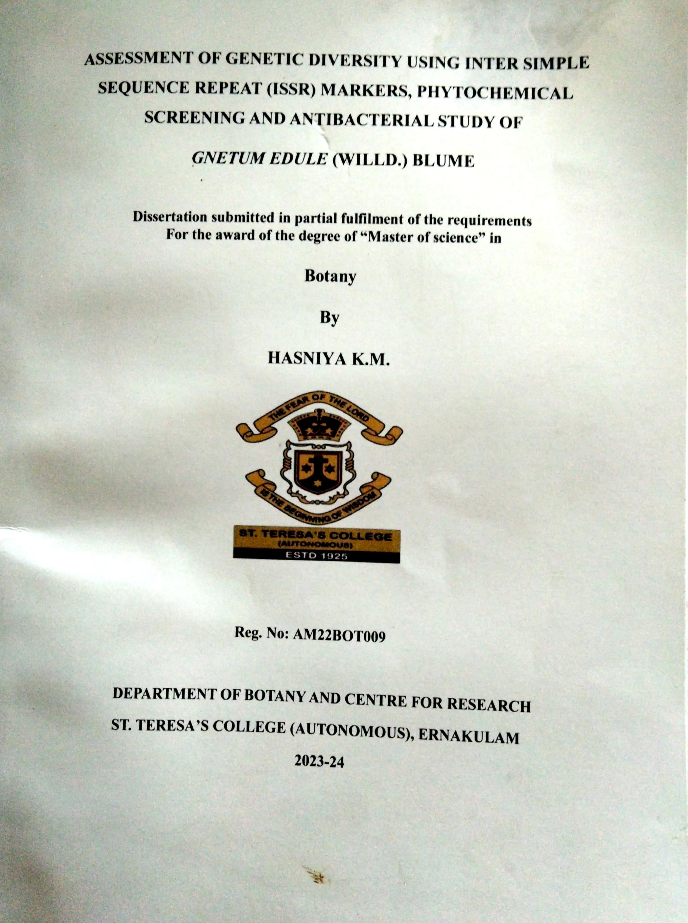



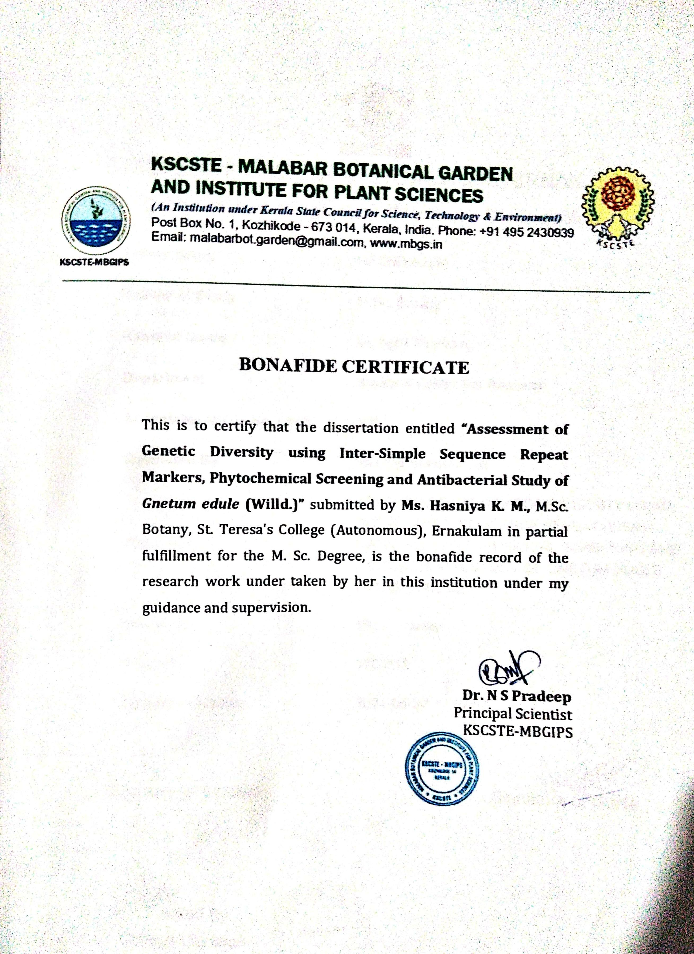

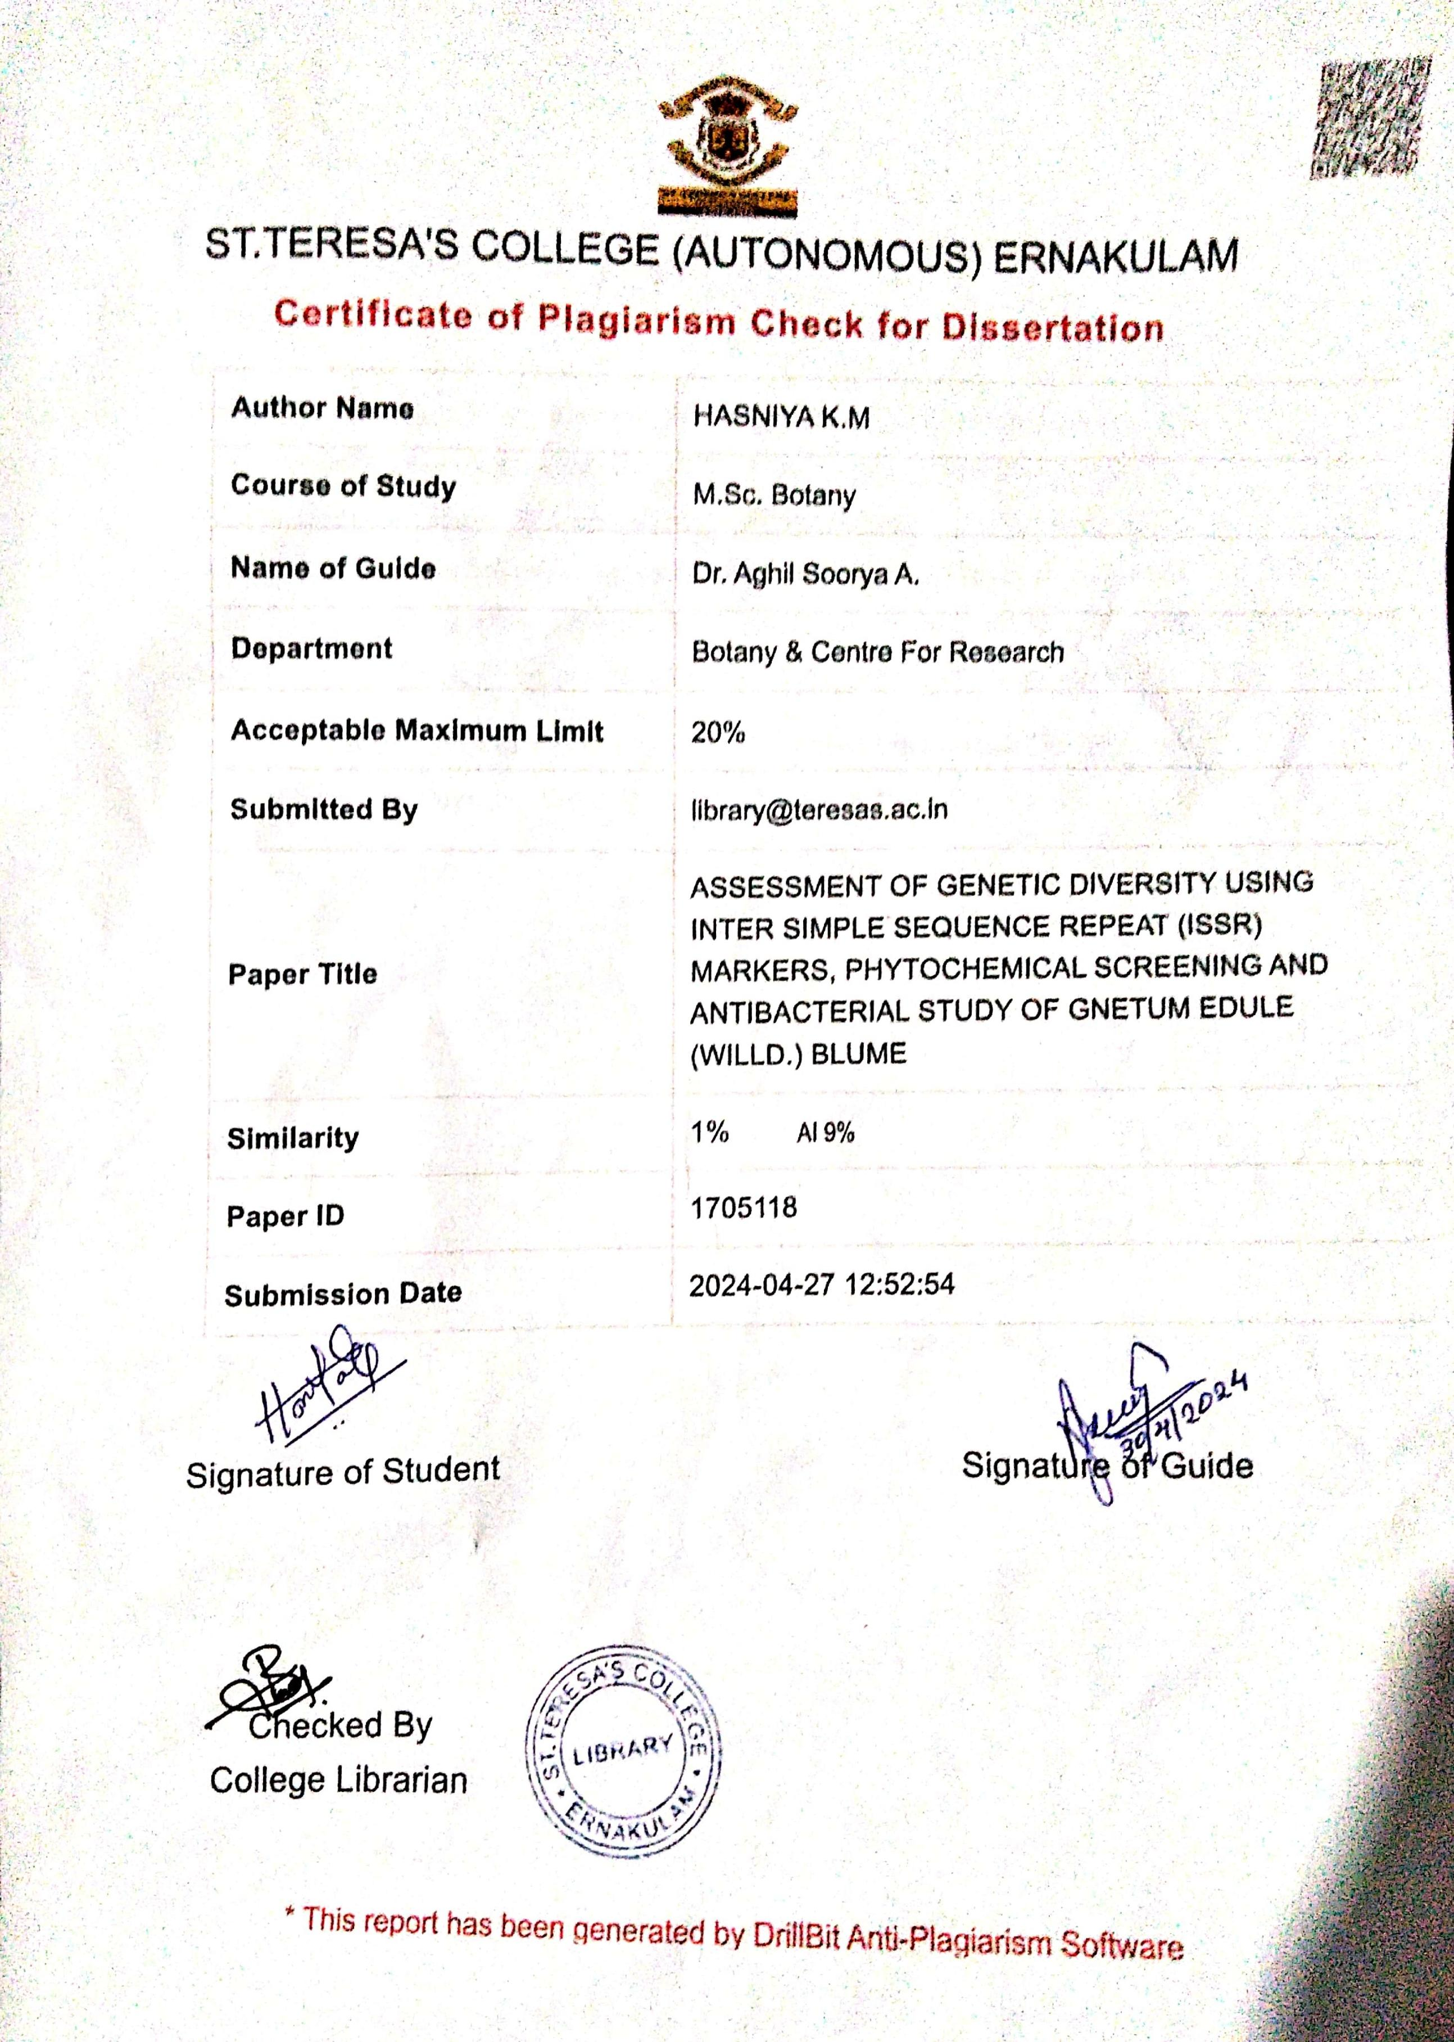







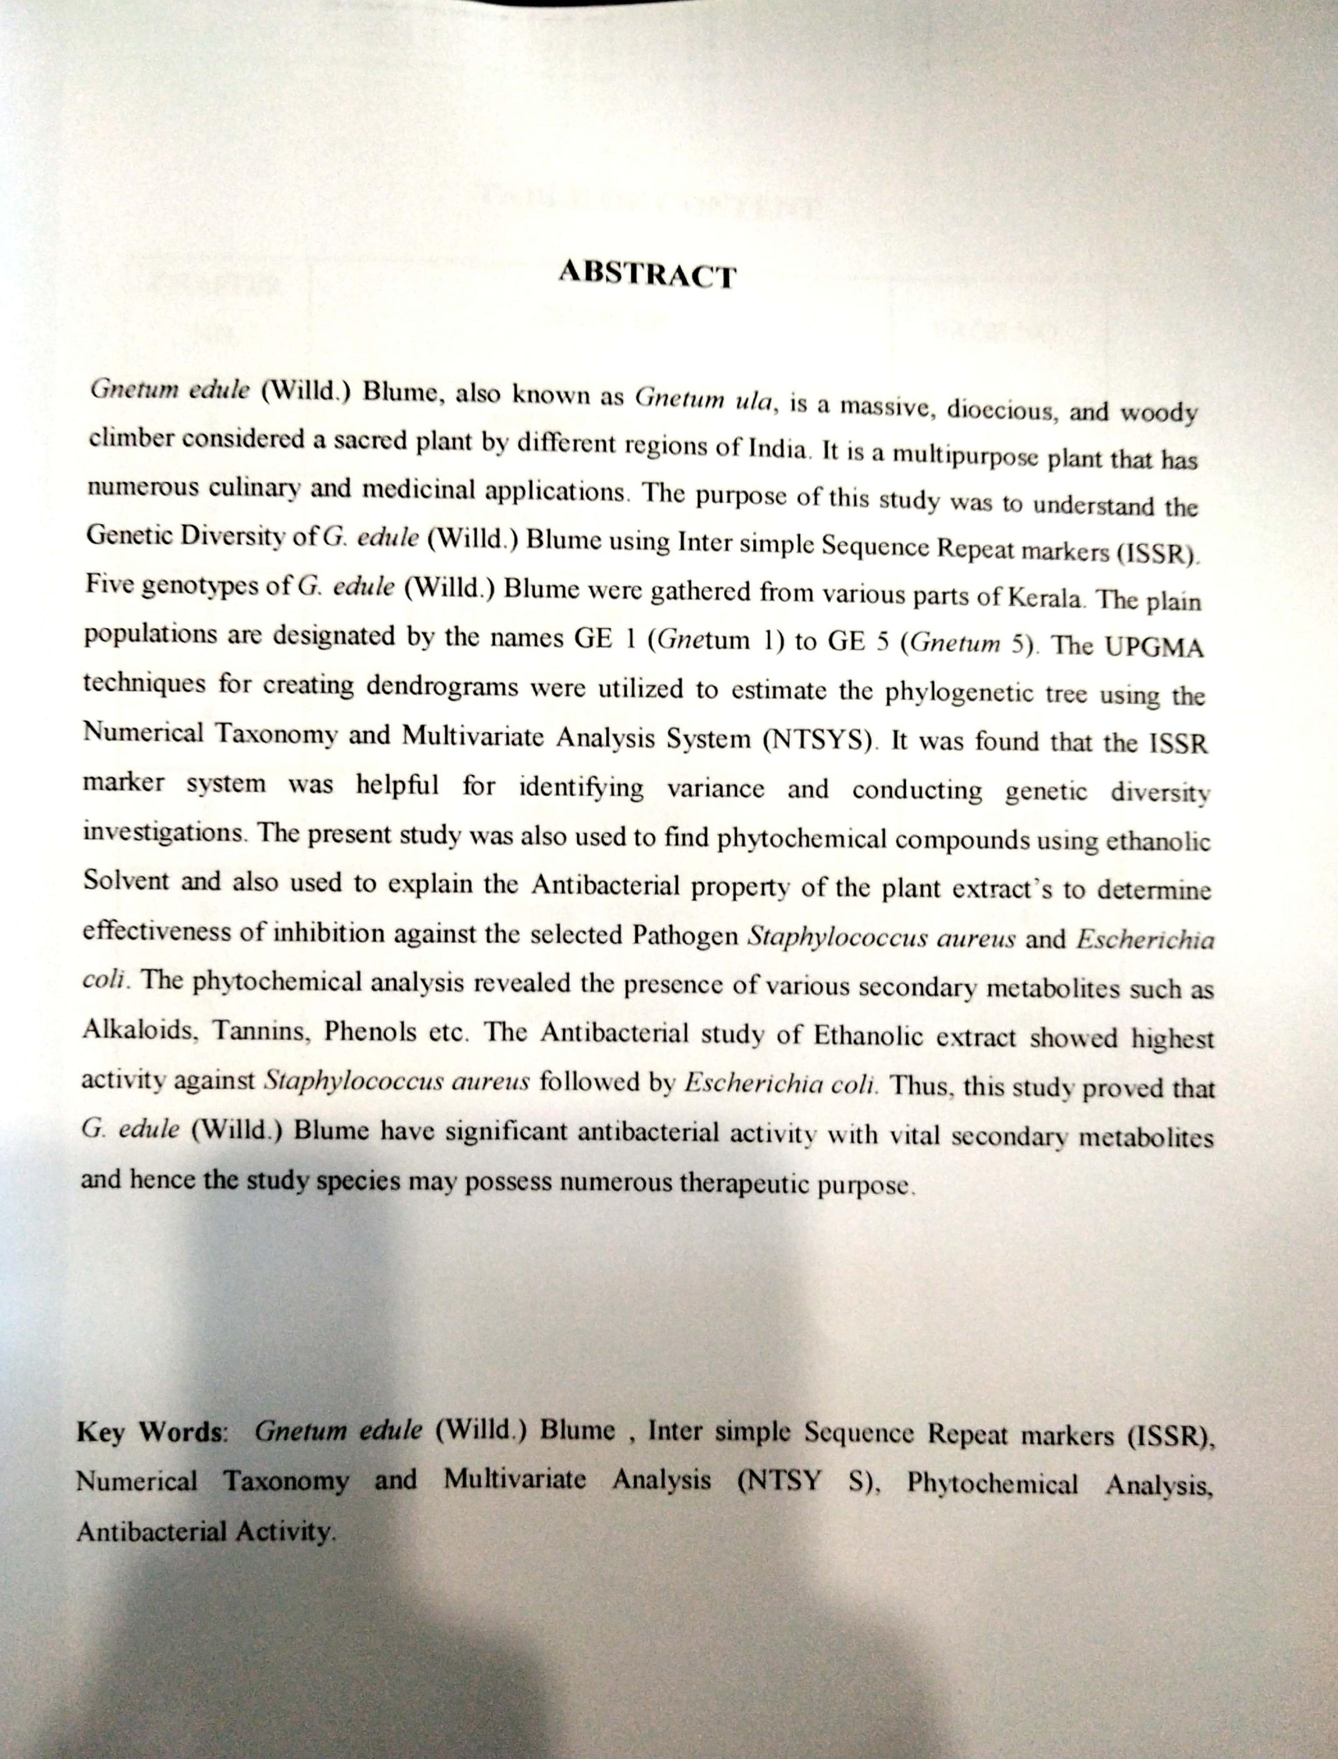

**I. INTRODUCTION**

Gymnosperms are a group of seed-producing plants that do not have flowers. Instead, they typically have cones as reproductive structures. The calyx, corolla, stamens, and pistil are lacking. The majority of species have flowers that are made up of seed-producing cones and pollen-producing cones. There are 88 genera and more than 1000 species, which are distributed all over the world. Gymnospermous plants are divided into four groups namely, *Pinophyta*, *Cycadophyta*, *Ginkgophyta*, and *Gnetophyta* (Delevoryas, 2023). They had a period of diversification in the late Paleozoic era, during which they played a significant role as organic matter providers for some of the world’s greatest coal reserves (McLoughlin, 2020). In India, there are 161 taxa (154 species) representing 46 genera and 11 families of gymnosperms, an important but frequently disregarded group in the plant kingdom. Most of these species thrive in the southern hills, the Himalayan region, and arid region (Srivastava, 2021).

*Gnetum*, a genus of Gymnosperms constitutes about 40 species that inhabit tropical areas of the world. The majority of species have angiospermous vegetative habits and are tropical lianas (Deng *et al*., 2015). With two exceptions (*G. gnemon* and *G. costatum*), all genera of *Gnetum* are shrubs or climbers that resemble dicotyledonous angiosperm plants. Pinnate leaf veins, large decussate leaves and vascular vessels in stems are characteristics of *Gnetum* *sp*. that are similar to those of angiosperms (Deng *et* *al*, 2019). Reproductive structures are compound structures that occur in whorled patterns on spike-like cones. Male or female units are separated by hair-like extensions (Jorgensen *et* *al*., 2015). The female strobili consist of central axis with two opposing bracts at the base. This is followed by five to eight distally oriented collars, each containing five to seven ovules. A single, big seed is produced by each female unit (Deng *et* *al*., 2015).

*Gnetum edule* (Willd.) Blume (Synonym: *Gnetum* *ula*) is a massive, dioecious, woody climber with a compressed trunk, thick, scaly bark, and enlarged joints. It is considered as sacred plant by different regions of India. Leaves are ovate, oblong or elliptic in shape and are arranged in opposite manner. Flowers are monoecious. Fruit is a drupe. Seed is solitary, ellipsoid and hard (Priya, *et* *al*., 2019). They possess an unmatched collection of traits shared by both gymnosperms and angiosperms. They are distributed in Assam, Sikkim, the Himalayan region, the Andaman Islands, Malaysia, and the evergreen forests of the Eastern and Western Ghats up to 1800 meters (Sensharma *et al.,* 2001).

*Gnetum edule* (Willd.) Blume is a multipurpose plant that has numerous culinary and medicinal applications, contributing significantly to Southeast Asian culture and biodiversity.

The stem of *G. edule* (Willd.) Blume was reportedly used to treat jaundice in Tamil Nadu (Mohan, 2008. Extracts from in leaves and stems can be used to treat liver enlargement (Pushpangadan, *et* *al*., 1986). It is possible to treat arthritis with leaf paste administered externally (Devi Prasad, *et* *al*., 2014). In Karnataka district of Hassan, the plant’s fruits and oil are utilized as a stimulant and anti-rheumatic agent (Prashanth, 2016). Roots and stems were used as antiperiodic. It offers defense against hepatic damage due to its strong antioxidant activity (Jinadatta, *et* *al*., 2019). The stem is also prescribed for treating piles and hemicranias (Basu, *et* *al*., 1992). It also exhibit antidiabetic effect (Seema, *et* *al*., 2022). Seeds produces oils which can be used for various medical purpose (Warrier, *et* *al*., 1993). The fruits of *G*. *edule* (Willd.) Blume can be consumed as food. Its dense twines, cones, and green canopy make it perfect for use as a premium ornamental. Moreover, *G. edule’s* ethanolic extract has strong, deadly ovicidal and larvicidal effects on dengue and malaria vectors (Dhanasekaran *et al*., 2013).

Genetic diversity is referred as a wide range of variability that arises between genotypes with regard to the overall genetic composition of a single species or between species. Evolutionary changes are based on genetic diversity. A plant species’ genetic diversity and its distribution are influenced by various factors, such as its breeding system, evolution, and environment. For genetic variety to be used and conserved effectively, a deeper comprehension of genetic diversity and its distribution is necessary (Ramanatha Rao, 2002).

The molecular underpinnings of the fundamental biological processes in plants must be understood in order to effectively conserve, manage, and use plant genetic resources (PGR). The evaluation of genetic diversity is often carried out at the molecular level by a variety of laboratory-based methods, including direct measurement of levels of variation through allozyme or DNA analysis (Mondini et al., 2009). There are several different types of DNA molecular markers used in molecular investigations of genetic variation. A genomic locus is called a molecular marker if its existence clearly separates the chromosomal feature it represents from the surrounding areas at the 3’ and 5’ extremities. A genomic locus can be discovered using a probe or specialized initiator (primer) Barcaccia., *et al.* 2000).

Each and every organism has an own DNA sequence. Variations are mutations that happen in an organism’s DNA sequences, and they cause the emergence of new alleles in a population. Polymorphism is the existence of two or more alternative variants of a certain DNA sequence that can exist in various people or communities. Balanced polymorphism is the state in which non-identical alleles for a trait are preserved at frequencies higher than 1% in a population. The degree of polymorphism in a species’ gene pool determines both its chances of surviving and its capacity for evolution. The majority of plants have significant genetic variation in their natural populations, and these variations that set each plant apart (Sebastian., 2009).

Genetic marker is a gene or DNA sequence that has a defined position on a chromosome and is always linked to a certain gene or trait. A genetic marker can be a long DNA sequence, such as mini- and microsatellites, or a short one, such as a single nucleotide polymorphism (SNP). DNA polymorphism is shown by molecular markers (Al-Samarai., 2015).

Allozymes and other physical and biochemical features have long been used to quantify genetic diversity within a species’ gene pool. But these days, allozyme are Insufficient to evaluate genetic diversity among populations (Heun *et* *al*. 1994). These population-level investigations are now feasible because to a variety of molecular-based methods, such as RFLP (Restricted Fragment Length Polymorphism), ISSR (Inter Simple Sequence Repeat), and RAPD (Random Amplified Polymorphic DNA) (Penner, 1996). Every technique has benefits and drawbacks of its own. The degree to which these techniques can address genetic Distinctions, the kinds of data they provide, and the extent of their applicability. Molecular markers find application in a wide range of fields, including population history, genetic mapping, paternity testing, cultivar identification, marker-assisted crop breeding, and the detection of mutant genes linked to hereditary disorders.

Inter-simple sequence repeats (ISSR) are microsatellite sequences that surrounds certain areas of the genome. When a single primer is used to amplify these areas, several amplification products are produced that can be used as a dominant multi-locus marker system to investigate genetic diversity in a variety of organisms. Compared to other ascendant markers, ISSR markers are inexpensive, easy to use, and require less rigorous methodology, which makes them a perfect genetic marker for tyros and species with incomplete genetic information. The very diversified and widely distributed microsatellite sequences used in the creation of ISSR markers are found across the genome. It is less expensive and time-consuming than AFLP and more reproducible than RAPD. For a variety of research, including those on genetic variation and diversity, DNA fingerprinting, and phylogenetics, among others, all of these make ISSR an excellent genetic marker (Ng, W. L., & Tan, S. G. (2015).). ISSR markers are categorized as dominant markers and display the Mendelian method of inheritance. Numerous studies in the fields of molecular ecology, genetic diversity, genetic mapping, gene tagging, and cultivar identification have made extensive use of this technique.

The fact that ISSR does not require sequence data for primer creation is a significant benefit. Because the analytical approach uses PCR, very little template DNA is needed. Additionally, ISSRs are dispersed at random across the entire genome. The drawback of ISSR, being a multilocus technique, is that homology may not be present in pieces of comparable sizes.

Furthermore, ISSR has repeatability issues just like his RAPD. ISSR analysis can be applied to research pertaining to genetic identity, phylogeny, clone and strain identification, and taxonomy investigations of closely related species because of the multilocus fingerprinting patterns that are obtained. Furthermore, ISSR is thought to be helpful for research on genomic mapping.

Photochemistry is the study of phytochemicals, which are plant derived compounds. A vast class of chemical substances that are found in plants naturally and give them their color, flavor, scent, and texture are phytochemicals. Over millions of years of evolution, these substances have been created to protect organisms from the damaging effects of bacteria, fungus, viruses, and free radicals. According to their chemical structure and characteristics, phytochemicals are divided into multiple major groups: Alkaloids, terpenoids, polyphenols etc. (Barbieri *et* *al*., 2017). In the pharmaceutical sector, plants are the primary source of many active chemicals. The pharmacological effects that they display can be utilized for the management of fungal and bacterial infections, as well as chronic degenerative illnesses like cancer and diabetes (Mendoza *et* *al*, 2018).

In recent years, photochemistry has emerged as a separate field that lies between natural substances of organic chemistry and plant biochemistry, while it is strongly related to both of these. It deals with their natural distribution, biosynthesis, chemical structures, biological function, metabolism and so forth. Different techniques are needed for each of these procedures to be able to identify, separate, and purify the various plant elements. The phytochemical composition of *G.edule* was remains relatively unexplored. Hence, phytochemical analysis of *G. edule* (Willd.) Blume is essential for uncovering its medicinal and nutritional constituents, assessing its pharmacological potential, aiding conservation efforts, and understanding its biological diversity.

Antibacterial activity refers to chemicals that either kill or inhibit the growth of bacteria locally, while not damaging nearby tissues (Kenawy *et al*., 2007). Analyzing the antibacterial properties of *G.edule* would involve conducting experiments to test its effectiveness against various bacterial strains. This would typically include methods such as disc diffusion assays or broth dilution assays to assess the inhibitory effects of *G. edule* (Willd.) Blume extracts or compounds on bacterial growth. Researchers would then analyze the results to determine the potency and spectrum of antibacterial activity exhibited by *G. edule* (Willd.) Blume.

Based on the information pertaining the literature and knowledge, the currents study was carried out with the following objectives:

1. Isolation and PCR amplification genomic DNA using Inter simple Sequence Repeat (ISSR) markers gathered from various locations of Kerala.
2. Analysis of genetic diversity in ***Gnetum edule* (Willd.) Blume**.
3. Preliminary Phytochemical Analysis of ***G. edule* (Willd.) Blume**plant extract.
4. Determination of Antibacterial Activity of ***G. edule* (Willd.) Blume**.

**II. REVIEW LITERATURE**

**2.1 GENETIC DIVERSITY**

The study by Hughes *et* *al*. (2008) explores the significant impact of genetic diversity on ecological systems. It highlights how genetic variation influences population dynamics, species interactions, and ecosystem functioning. The authors emphasize the significant effects of genetic diversity on ecological processes such as primary productivity, population recovery from disturbance, interspecific competition, community structure, and fluxes of energy and nutrients. Thus, genetic diversity can have important ecological consequences at the population, community and ecosystem levels, and in some cases the effects are comparable in magnitude to the effects of species diversity.

Caliskan (2012) in his book- Books on demand explains about the species ability to adapt to its current biotic and abiotic environmental conditions and to modify its genetic makeup in response to environmental changes is made possible by genetic variety, which is essential to the species’ continued existence. The study reveals how genetic diversity in plants shows how much genetic variation there is in plant populations. The growing availability of PCR-based molecular markers makes it possible to analyze and assess plant genetic variation in great detail as well as identify the genes determining features that are significant to the economy.

Minaeifar *et* *al*., (2015) in their investigation on 90 plant specimens of 10 geographical populations of *Cousinia cylindracea* (Asteraceae)in Iran. They studied from morphological and Genetic (ISSR) points of view. In the populations under study, genetic and physical heterogeneity was found both within and between groups. The significant morphological difference among these populations were studied. Similarly, certain tests revealed significant molecular difference, significant positive correlation between Genetic distance and geographical distance of the studied populations. The results identified two different gene pools of *C. Cylindracea* in Iran.

Rispail *et* *al*. (2023) investigated the genetic diversity and population structure of a broad core collection of *Pisum* spp*.* by utilizing advanced molecular methods for analysis. The study employs molecular techniques to analyze genetic variations within the collection. Results provide insights into the diversity and structure of *Pisum* spp. populations, which are valuable for breeding and conservation efforts in pea crops. The high genetic diversity found in the collection and the high marker coverage are expected to improve trait discovery and the efficient implementation of advanced breeding approaches

The study by Huang, *et* *al*., (2010) titled “Genetic diversity of *Gnetum* *parvifolium* of Fujian by ISSR markers” examines the genetic variety of this native plant of Fujian province using ISSR markers. It highlights *G.* *parvifolium’s* great genetic variety at the species level and relatively low genetic diversity at the population level, suggesting the plant’s capacity for survival, adaptation, and growth. The study suggests that habitat fragmentation and human activity have influenced the population genetic diversity of *G. parvifolium.*

**2.2 MOLECULAR MARKERS**

The study by Amiteye (2021)., comprehensively covers the basic concepts and methodologies of DNA marker systems in plant molecular breeding. Some significant fundamental ideas related to marker applications, such as marker polymorphism, dominant or co-dominant mode of inheritance, agronomic trait-marker linkage, genetic mutations and variation, have been thoroughly explained together with the main principles of molecular marker approaches. The molecular marker methods that have been extensively reviewed are RFLP, RAPD, SCAR, AFLP, SSR, CpSSR, ISSR, RAMP etc. In this paper overall thirty-four markers have been presented.

The work done by Gaurav *et* *al*., (2017) highlights the major advancements in genetic variation, cytogenetics, quantitative genetics, and molecular biology that have led to considerable advancements in plant breeding. Plant biotechnology emphasizes the value of molecular markers as effective instruments for polymorphism identification. These markers can be classified into two types: hybridization-based (RFLP) or PCR-based markers (RAPD, AFLP, SSR, SNP, etc.). The study gives a summary of the numerous kinds of molecular markers that are employed in plant biotechnology procedures.

The research paper by Zebire (2020) explores the utilization of molecular markers in genetic diversity studies of maize. Molecular markers are useful in maize for assessing the genetic diversity of inbred lines and grouping them into heterozygous groups. These markers are used to evaluate the genetic diversity of maize and identify the genetic similarities between the lines. He discusses the application of different molecular markers such as RFLP, AFLP, SSR and SSLP for Genetic diversity assessment in maize.

According to a study by Wang., *et* *al*. (2002), RAPD and ISSR markers did not show any genetic variation in the invasive clonal plant *Eichhornia crassipes* in China. Six populations of invasive *E.crassipes* plants were gathered from an introduced area in Southern China, and their genetic makeup was examined using Random Amplified Polymorphic DNA (RAPD) and Inter Simple Sequence Repeat (ISSR) markers. 18 ISSR primers and 25 RAPD primers were used to yield 145 ISSR bands and 172 RAPD bands, respectively. Neither marker, however, revealed any polymorphism bands within or between groups. This study proposed various other factors associated with the expansion of *E. crassipes* in China, in addition to genetic diversity.

In 2013, Pourmohammad conducted research on the use of molecular markers in therapeutic plants. Many essential medicinal plant species are authenticated using DNA-based methods. The active components and effectiveness profile of medicinal plants are influenced by geographic factors. Molecular markers based on DNA are useful in enhancing medicinal plant species. Since genetic information is specific to each species and unaffected by age, physiological state, or environmental variables, DNA markers are considered more dependable than other methods. It has been reported that RAPD markers can be used to identify specimens of *Andrographis* *paniculata*, *Allium* *schoenoprasum* L., and *Codonopsis* *pilosula* that have been collected from various geographical locations. Similar to this, ISSR markers are used to differentiate between several *Arabidopsis* *thaliana* specimens.

**2.3 INTER-SIMPLE SEQUENCE REPEATS (ISSRS) MARKERS**

In 2002, Wang, J. B. examined ISSR markers and their uses in plant genetics.   
Microsatellites (SSR) are a dependable system that has been replaced by intersimple sequence repeat (ISSR) markers. This method entails the amplification of   
of genomic regions surrounded by contiguous, reverse-oriented microsatellite sequences, each flanked by one or more primers based on SSRs anchored 5' or 3' by 1-4 purine or pyrimidine residues. The anchor nucleate and repetition sequences are selected at random. When combined with amplification product separation on polyacrylamide or agarose gels, ISSR amplification yields significantly more fragments per primer than PCR amplified detection (RAPD). The ISSR method was found to offer a quick, dependable, and enlightening DNA fingerprinting system. Mendelian mode inheritance characterizes ISSR markers, which segregate as dominant markers. Breed identification, genetic mapping, genetic marking, genetic diversity, evolution, and molecular ecology research can all benefit from the application of this method.

Using ISSR markers, Nan *et* *al*., (2003) evaluated the genetic diversity of *Primula* *obonica* from central and southwest China. The investigation involved 60 *P*. *obonica* *species*. A wild population and a cultured population were the two sorts of populations that were chosen. It was discovered that there was more genetic variety in the natural population variations than in the produced ones. They were able to carry out a trustworthy and accurate population research of the *P. obonica* populations by employing ISSR markers.

The study conducted by Contescu *et* *al*., (2023) in Romanian Agricultural Research (RAR) aimed to assess the genetic diversity present in various wild sunflower species. Because of their high genetic diversity, wild sunflower species are an important source for enhancing the genetic basis of farmed sunflower crops. The genotypes of wild and/or cultivated sunflowers might be distinguished from one another using ISSR markers. The study found that there was a great deal of genetic heterogeneity among the accessions, with a total of 120 alleles and a wide range of fragment lengths.

Liliana *et* *al*., (2022) evaluated the genetic diversity among multiple apple genotypes utilizing ISSR markers. The study analyzed DNA variations within the genotypes of apples by using molecular techniques. The genetic variability of seven Romanian apple cultivars was evaluated in this work using ISSR markers, and the results showed that genotypes that were closely related could be distinguished, and duplicates could be removed from collections without affecting genetic variability. Since the cultivars “Remer” and “Iris” were produced from the same genitor by seed irradiation, it was found that they shared genetic similarities. The work highlights how molecular markers may be used in marker-assisted plant breeding to develop new cultivars with enhanced organoleptic properties and increased resilience to both biotic and abiotic stress.

The study by Wang *et* *al*., (2022) explores genetic diversity and hybrid identification in clematis plants utilizing ISSR (Inter-Simple Sequence Repeat) markers. In order to understand the genetic links between the different Clematis species and possible hybridization occurrences, the study entails gathering genetic data from these species and evaluating it using ISSR markers. Using ISSR markers, the study examined the genetic diversity of 17 parental taxa, comprising 12 Texas cultivars and 5 wild species. The genetic characteristics indicated a high degree of diversity among these 17 taxa. The results indicate that ISSR molecular markers can be helpful in reducing the length of the breeding cycle, increasing breeding efficiency, and confirming the existence of genuine Clematis hybrids.

**2.3 PHYTOCHEMICAL ANALYSIS**

The research conducted by Sakshi and Jain in 2023, explores the phytochemical composition of dried *Moringa oleifera* leaf powder. The investigation explores the identification and measurement of several bioactive compounds present in the powder. The authors examine the existence of phytochemicals such as flavonoids, phenolics, alkaloids, and other antioxidants using methods including chromatography and spectroscopy. Alkaloids were found to contain the greatest amount of these phytochemicals in dried *M. oleifera* leaves. The results advance knowledge of *M. oleifera’s* nutritional and therapeutic qualities, which may have consequences for the plant’s use in food, medicine, and nutraceuticals.

In the study conducted by Dubale *et* *al*. (2023), a total of chosen medicinal plants from Ethiopia were screened using phytochemicals, and their antibacterial activity was assessed. The phytochemical components of the plants were extracted by the researchers using conventional techniques, and they then carried out qualitative and quantitative studies to determine the presence of several bioactive elements like alkaloids, flavonoids, tannins, saponins, and phenols. Additionally, the plant extracts’ antibacterial activity was evaluated against a variety of microbiological species, including bacteria and fungi, using known methodologies. The results of the study demonstrated that the chosen medicinal plants included a variety of phytochemical substances, suggesting that these compounds might possess therapeutic value.

The study by Ahmat *et* *al*., (2022) investigates the phytochemical composition of ethanolic extracts from three plant species found in “Kuala Keniam, Pahang”: *Gnetum gnemon, Gnetum latifolium, and Cynometra malaccensis.* Standard procedures were used to screen the extracts for different phytochemical components as part of the investigation. The ethanolic extracts of the stem bark, stem, leaves, and twigs of the three species were tested. The results revealed that all plant components included tannins, terpenes, and flavonoids. This study advances our knowledge of the chemical makeup of these plants and their possible uses in pharmacology, nutrition, and medicine.

Bansode’s 2015 study emphasizes on the phytochemical analysis of particular Indian medicinal herbs. The presence of flavonoids, saponins, and tannins was found in nearly all of the four medicinal plants that were chosen for phytochemical analysis: *Salvadora* *persica*, *Syzygium* *cumini*, *Terminalia* *chebula*, and *Trigonella* *foenum*-*graecum*. Out of the four plant species examined, *Salvadora* *persica* had the highest mineral content (19%). The phytochemical content of the investigated plants was found to be high, suggesting that they may have important pharmacological and medical uses.

The study by Sari *et* *al*., (2023), explores the phytochemical compounds, antioxidant activity and their characteristics of compounds. The main objective of the study is to compare the antioxidant activity of melinjo (*Gnetum* *gnemon* *L*.) seed flour and extract from industrial sources. The phytochemical research shows that melinjau seed flour contains flavonoids, saponins, tannins, and steroids, whereas melinjau seed extract contains flavonoids, terpenoids, and steroids. Compared to seed flour, the industrial extract from melinjau seeds has a higher level of antioxidant activity.

The study by Akin *et al.,* (2019), examined the phytochemical analysis of Methanol and Hexane extracts of *Gnetum afraicanum* root and stem. Using cold maceration method, the root and stem were extracted. Phytochemical screening was carried out utilizing standardized chemical tests. The result showed that both the methanol and ethanol extracts of the *G. africanum* contains saponins, steroid and tannins. Alkaloids, Flavinoids and glycosides are absent in both the extract.

**2.4 ANTIBACTERIAL ANALYSIS**

Tripathi, (2023) examined the comparative antimicrobial activities of extracts of Aloe vera (Aloe-vera), Neem (*Azadirachta indica)* and Tulsi (*Ocimum sanctum*). The phytochemical analysis identified metabolites that are responsible for the antibacterial activity of plants, including phenolic compound, saponin, flavonoid, alkaloid, carbohydrate, and glycoside. In order to compare the antibacterial properties of plant extracts from Neem (*Azadirachta* *indica*), Tulsi (*Ocimum* *sanctum*), and *Aloe* *vera*, diffusion and dilution methods have been used. The bacterium strains found were *Escherichia* *coli*, *Pseudomonas* *fluorescence*, *Bacillus* *subtilis*, *Bacillus* *cereus*, and *Staphylococcus* *aureus*. The extracts of the plants under research were utilized against these bacteria. The bacteria were isolated from the semi-arid soil in the Banasthali region. *Aloe* *vera* demonstrated maximum zone against *Pseudomonas* *fluroscens* and maximum inhibition against *S*. *aureus*, while *Ocimum* *sanctum* showed maximum zone against *E*. *coli*. When tested separately for antibacterial action against these infections, the aqueous extracts of different leaves demonstrated decreased inhibitory effect against the majority of the test bacterial pathogens.

In the study by Hure *et* *al*., 2023, examined the effect of the *Hyptis suaveolens* plant extract on the growth of *E*. *coli* and *S.* *aureus*, the phytochemical profile qualitative test methods were employed in this work. The purpose of this study is to ascertain the phytochemical profile qualitatively and the effect of the *Hyptis* *suaveolens* plant extract on the growth of *E*. *coli* and *S. aureus* bacteria. The qualitative test method is the one that is employed. The agar diffusion method was used to test for antibacterial activity. Herbal extract from the leaves of *Hyptis* *suaveolens* affects *S*. *aureus* bacteria more than *E.* *coli* bacteria. This is most likely caused by variations in the elements of *S. aureus* and *E. coli*’s bacterial cell walls. Compared to *E. coli* bacteria, *S. aureus* bacteria have a reduced lipid content in their cell walls. The study’s findings indicate that the inhibitory zone that forms increases with concentration, and the results of the phytochemical profile test suggested that the antibacterial chemicals in *Hyptis suaveolens* extract included flavonoids, saponins, and tannins.

The study by Vlad *et* *al*., 2019 highlights the antibacterial activity of plant extracts against human pathogenic bacteria, specifically *S*. *aureus*, *B. cereus, E. coli, Klebsiella spp.*, and *Enterobacter* *aerogenes*. The presence of numerous bioactive compounds was demonstrated by gas chromatographic results, and extracts applied to human pathogenic bacteria demonstrated antibacterial effects based on the type of solvent used and the particular bacterial strain. The chloroformic extract, on the other hand, showed no antibacterial effect on the strains of bacteria chosen for the study.

The study by Jayaraj *et* *al*., 2019 demonstrated that the *V*. *rosea* plant has strong antibacterial properties in the ETOH extracts. These properties are caused by the presence of saponin, tannins, and flavonoids. In this study, ethyl acetate (ETOAC), ethanol (ETOH), and dimethyl sulfoxide (DMSO) were used as different solvents to extract phytochemicals from different plant sections. The activities of the shoot extracts were higher to those of the flower and root extracts, and all of the examined bacteria and fungus were effectively controlled. The zone of inhibition and antibacterial activity were assessed using the Agar well-diffusion method. The ETOH extracts of the *V. rosea* plant have strong antibacterial properties. The saponin, tannins, and Flavonoids found in *V. rosea* are responsible for its potent antifungal and antibacterial properties

**III. MATERIALS AND METHODS**

A total of 5 genotypes of *Gnetum edule* (Willd.) Blume were collected from different regions of Kerala (Table 1). These plants were then successfully maintained in the plant Conservatory at KSCSTE- Malabar Botanical Garden and Institute for Plant Science, Calicut, Kerala, India. Plant populations are named GE 1 (*Gnetum edula 1*) to GE 5 (*Gnetum* *edula* 5) (Table 1). The germplasm was well maintained with proper irrigation and under favorable conditions of growth. Thus, a healthy plant population of all 5 samples was available for study at any time.

*G*. *edule* (Willd.) Blume is a woody liana that climbs to tall trees. The roots, stem, and leaves constitute the plant body. Taproot roots, lacking leaves in the bottom part, exhibit abundant branching. The stem is articulated with noticeable joints, allowing the plant to climb on the host plant. Overall, the leaves resemble angiosperms because they are oval, whole, and have reticulate venation. Plant *G.edule* (Willd.) Blume is dioecious. Every male flower has a stalk with two unilocular anthers encased in a perianth.

|  |  |
| --- | --- |
|  |  |

**Plate 1: *Gnetum edule* (Willd.) Blume**

Table 1: Details of *Gnetum edule* (Willd.) Blume accession collected from different regions of

Kerala for genetic diversity analysis

|  |  |  |  |
| --- | --- | --- | --- |
| **S. No**. | **Location** | **Latitude (°)** | **Longitude**  **(°)** |
| **GE 1** | Nedumaghad, Thiruvananthapuram | 8.7098 | 77.1291 |
| **GE 2** | Ambalappuzha, Alappuzha | 9.4981 | 76.3389 |
| **GE 3** | Kodunghallur, Thrissur, | 10.2761 | 76.1711 |
| **GE 4** | Kottuvally, Ernakulam | 10.130996 | 76.241049 |
| **GE 5** | Malabar botanical garden, Kozhikode | 11.243038 | 75.82708 |

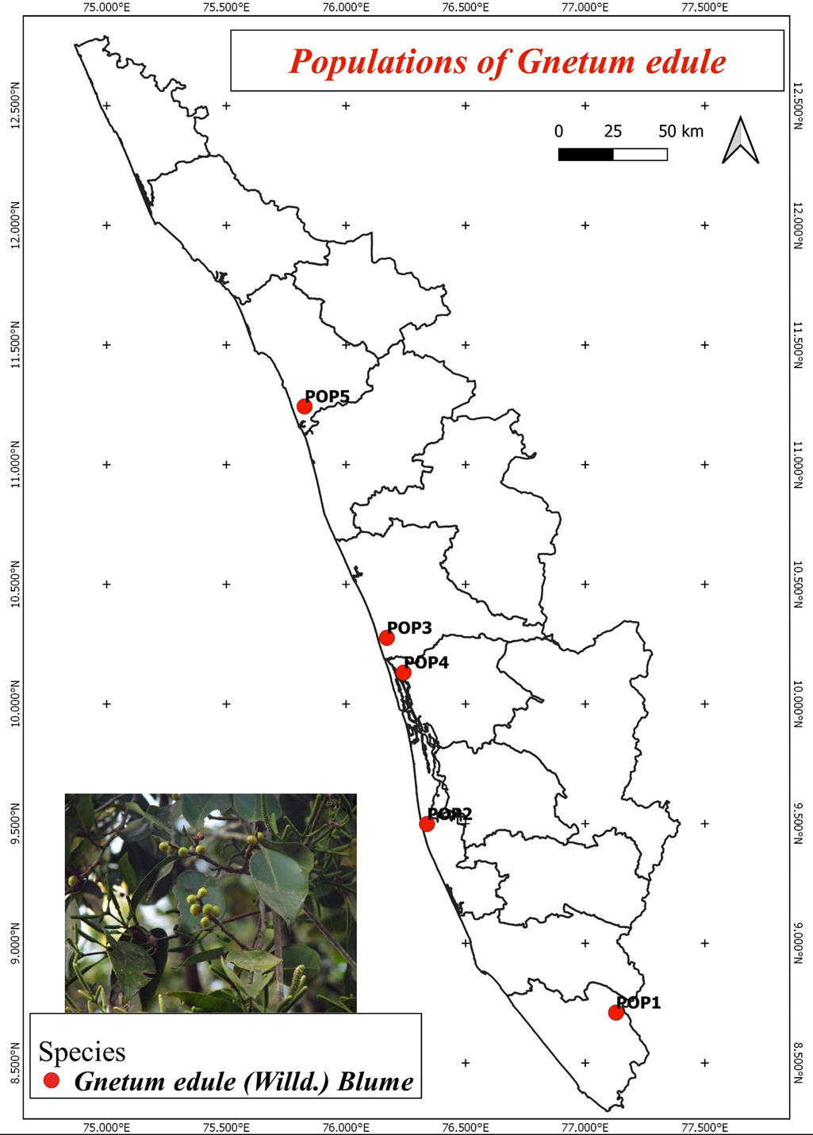

Plate 2: *G. edule* (Willd.) Blume geographical distribution in Kerala

**3.1 PREPARATION OF GENOMIC DNA FROM PLANT TISSUE**

Tender, healthy leaves from every accessions were taken. It was then rinsed well and pat dried with sterile filter paper. One gram of leaf material was weighed and then chopped into small pieces using mortar. Poly vinyl pyrrolidone (PVP) was added to the CTAB Extraction Buffer and then preheated. Pulverize the tissue using mortar and pestle. 500–1000 µl of extraction buffer was added to form slurry and it is then transferred it into 2 ml centrifuge tube. The tubes were then kept in the water bath for 45 minutes at 65°C, with periodic stirring.

The liquid was brought down to the room temperature and added with 70 μl of the chloroform: isoamyl alcohol (24:1) combination, mixed well and centrifuged for 15 minutes at 25°C at 12,000 rpm. Top aqueous phase was transferred to a fresh tube and filled with 1/10 of the CTAB/NaCl solution. The mixture was stirred gently. Same amount of Chloroform was added to it and centrifuged it for ten minutes at 4°C at 12,000 rpm. Top aqueous phase was transferred to a fresh Eppendorf tube. The same volume of Chloroform was added to it and centrifuged it for 4°C at 12,000 rpm. Tubes were inverted for better mixing and supernatant was transferred to a new Eppendorf tube. Cold 100% isopropanol was added through the walls of the tube. The mixture was kept for one hour at 20°C. Centrifuged for 15 minutes at 4°C at 7850 rpm. The pellets were dried in the air after collecting them twice with cold 70% ethanol at 1000 rpm for five minutes. Pellets were suspended in 200 µl of TE buffer. It was incubated in a water bath at 37°C for one to two hours after adding 4 μl of RNase.

500 μl of Phenol: Chloroform: Isoamyl mixture (24:25:1), was incorporated into it and centrifuged for 10 minutes at 4 °C at 10,000 rpm. Supernatant was collected to a new eppendorf tube, then it was mixed with 500 μl of chloroform. Centrifuged for ten minutes at 1000 rpm. Supernatant was collected and mixed with double volume of cooled ethanol and 0.1 liter of 7.5 M sodium acetate.

The sample was stored overnight at -20 °C. It was then centrifuge for 15 minutes at 4 °C at 10,000 rpm and the pellets were collected, cleaned in cold 75% ethanol kept it air dry. 50 μl of TE buffer (Table 2) was added to it and kepted at -20 °C for long term storage.

**Table 2: Stock solutions required for Genomic DNA extraction**

|  |  |  |
| --- | --- | --- |
| **Solutions** | **Compositions** | **Quantity** |
| Tris buffer  pH 8 | Tris 1M  H2O | 12.11  100 ml |
| EDTA | Na2EDTA  H2O | 18.61gm  100 ml |
| CTAB Extraction buffer pH  8.0  (stored at room temperature) | CTAB 2% W/V  Tris buffer 100 mM  Na2EDTA 20 mM  PVP 1%  NaCl 1.4 M  H2O | 2 gm  10 ml  4 ml  1 gm  8.2 gm  100 m |
| TE buffer | Tris buffer 10mM  Na2EDTA 1M  H2O | 1 ml  0.2 ml  100 ml |
| Sodium acetate | Sodium acetate 3 M  H2O | 24.61 gm  100 ml |

**3.2. QUANTIFICATION AND VISUALIZATION OF DNA**

Using a nanodrop spectrophotometer (Multiskan sky), optical density (O.D.) at A260 and A280 was measured in order to quantify DNA. The software called nanodrop (Thermo Scientific, USA) was used to record the samples' concentration and purity. The samples of DNA that were diluted to a 50 ng/μl concentration and kept for usage at -20°C. To prepare DNA samples, 6X loading dye was mixed with 1X final concentration. To assess the quality of the isolated DNA, 1μl loading dye (Table 3) and 5μl of isolated genomic DNA were loaded onto a 0.8% agarose gel stained with ethidium bromide. The gel was then electrophoresed in 1x TAE buffer (Table 3) for 30 minutes at 100 V. The gels were captured on camera using a Bio-Rad Gel Documentation system.

## **Table 3: Stock solution required for Agarose gel electrophoresis**

|  |  |  |
| --- | --- | --- |
| Solution | Composition | Quantity |
| TAE Buffer (10x) pH 8 | Tris base acetic acid  Na2EDTA 0.5Mm  H2O | 21.6 gm 11 gm  8 ml  100 ml |
| Gel loading buffer | Bromo phenol blue 0.25% Xylene cyanole 0.25 % Sucrose 40%(w/v)  H2O | 250 gm  250 gm  40 gm  100 ml |
| Ethidium bromide | Ethidium bromide H2O | 1gm 100 ml |

**3.3 PCR AMPLIFICATIONS**

Five accessions of *G. edule* (Willd.) Blumegenomic DNA were amplified by PCR utilizing five Inter Simple Sequence Repeats (ISSR) which was created by Bioserve Biotechnologies in accordance with the Operon Technologies, Inc. USA sequence. A 25 μl volume was used for PCR amplification procedures, which included 1 μl of template DNA, 12.5 μl of Takara Master Mix, 1 μl of 10 pmol primers, and enough Mille Q water to get the volume to 25 μl. All of the reagents were combined with a quick spin. A Bio-Rad thermal cycler was used to carry out the amplification process.

The ISSR amplification sequential steps involved, 1 cycle of 2 min at 95 ◦C, 2 min at 53◦C and 2 min at 72◦C followed by 39 cycles of 0.30 min at 94 ◦C, 1 min at 53 ◦C and 2 min at 72 ◦C.

A 10-minute extension at 72 °C was performed after the final cycle.

**Table 4: List of ISSR primers used in the study**

|  |  |  |  |
| --- | --- | --- | --- |
| **ISSR MARKER NO.** | **PRIMERS SEQUENCE** | **NO. OF BASE PAIRS** | **GC CONTENT (%)** |
| **ISSR 2** | 5’-CTCTCTCTCTCTCTCTAC-3’ | 18 | 46.7 |
| **ISSR 8** | 5’-CTCTCTCTCTCTCTCTG-3’ | 17 | 52.9 |
| **ISSR 11** | 5’-AGAGAGAGAGAGAGAGT-3’ | 17 | 47.1 |
| **ISSR 12** | 5’-CACCACCACGC-3’ | 11 | 72.7 |
| **ISSR 13** | 5’-ACACACACACACACACG-3’ | 17 | 52.9 |

**Table 5: Conditions for PCR reaction**

|  |  |  |
| --- | --- | --- |
| **PCR steps** | **Temperature** | **Time** |
| Initial denaturation | 94℃ | 2 min |
| Denaturation | 95℃ | 2 min |
| Annealing | 35℃ | 2min |
| Extension | 72℃ | 2min |
| No. of cycles of denaturation,  Annealing, extension | 39 cycles at  93℃,36℃,72℃ | 1min,1min, and  2min |
| Final extension | 72℃ | 7 min |

**3.4 DATA ANALYSIS**

The bands were qualitatively scored using gel photos derived from ISSR analysis. Data were recorded in a binary matrix sheet with “0” denoting absence and “1” denoting presence, based on clearly repeatable bands from each accession that were scored as unit characters. The data set contained both polymorphism and monomorphic bands to demonstrate an objective assessment of genetic variation. The software package Numerical Taxonomy and Multivariate Analysis System (NTSYSpc) (version 2.02) was utilized to evaluate the binary data that was acquired from the marker systems.

The “J” coefficient was chosen In NTSYS, and a dendrogram was created using UPGMA (Unweighted Pair Group Method with Arithmetic Mean) to analyze diversity patterns and interpret data.

**3.5 PIC (POLYMORPHISM INFORMATION CONTENT)**

Due to the polymorphism that the dominant marker reveals, we elaborate on a binary matrix of bands’ presence or absence. The following general equation can be used to estimate the Polymorphism Information Content (PIC) if we take the frequency of bands present as P and the frequency of absents as q.

**PIC = 1 - (p2 + q2)** (Nunes dos Santos, K*., et.al*, 2019)

By dividing the number of isolate alleles where the band was discovered by the total number of isolates, the frequency of an allele was determined. To evaluate genetic diversity, PIC is a useful metric. When measuring a genetic marker’s information for linkage studies, PIC value is frequently employed. It is possible to assess the degree of gene variation whereby using the PIC index. A locus with a PIC >0.5 is considered to have great variety. PIC <0.25 denotes a low level of diversity at the locus.

PIC of 0.25 to 0.5 suggests that the locus has an intermediate level of diversity.

PIC analyses can be used to assess markers, allowing the best marker to be chosen for phylogenetic and genomic mapping.

**3.6 EMR (EFFECTIVE MULTIPLEX RATIO)**

According to Milbourne *et al.* (1997), the EMR of a primer is “the product of the fraction of polymorphic loci and the number of polymorphic loci of the individual assay.” It is the result of multiplying the fraction of polymorphic fragments (β) by the total number of fragments per primer (n).

E=nβ

Where β = total number of polymorphic DNA and n = total number of bands.

**3.7 MARKER INDEX**

The marker index MI was computed for each of the ten markers in order to assess the overall utility of a particular marker system. Rather than the degree of polymorphism found, the high MI is a reflection of the marker’s ability to assess a greater number of bands simultaneously. PIC and EMR produce MI (Varshney *et* *al*., 2005).

MI=PIC *EMR

**3.8 PHYTOCHEMICAL ANALYSIS**

**Plant Material Collection**

The fresh leaves of *G. edule* (Willd.) Blume was collected from Malabar Botanical Garden and Institute for Plant Science, Calicut, Kerala India and washed to ensure the absence of any impurities. The sample was shade dried for two weeks and powdered using a blender. The extract were prepared by using soxhlet apparatus and stored in air tight container.

**Extract Preparation**

A Soxhlet apparatus was used to extract the 15g of grounded, dried leaf powder using an organic solvent (ethanol). The boiling point was set up at 40°C. The extract was air dried and stored in a glass container for further analysis.

**Phytochemical Analysis**

Secondary metabolite screening of extracts was carried out to identify the presence of various secondary metabolites by employing standard protocols (Banu *et al.,* 2015).

**Test for Alkaloids**

Mayer’s test: Few drops of Mayer’s reagent were added to 0.5 mL of extract. The formation of a yellowish or white precipitate indicates the presence of alkaloids.

Dragendorff’s test: Few drops of Dragendorff’s reagent is added to 0.5mL of extract. The formation of an orange red precipitate indicates the presence of alkaloids. An orange red precipitate was formed, indicating the presence of alkaloids.

Wagner’s test : Few drops of Wagner ‘s reagent is added to the extract. Yellow precipitate shows the presence of Alkaloids.

**Test for flavonoids**

Sodium hydroxide test: 1ml of 10% of Sodium hydroxide is added to 0.5ml of extract. Initially, a deep yellow color appeared but it gradually became colorless by adding few drops of dilute HCL, indicating that flavonoids were present.

**Test for Glycosides**

Salkowski test: 1 ml of Chloroform and 1ml of Concentrated Sulphuric acid is added to 0.5ml of extract. The formation of a reddish brown precipitate indicates the presence of Glycosides.

**Test for Tannins**

Ferric chloride test: Few drops of 10% ferric chloride solution is added to 0.5ml extract. Occurrence of blackish blue or blackish green color indicates the presence of tannins.

**Test for Terpenoid**

Salkowski test: 1 ml of Chloroform and 1ml of Concentrated Sulphuric acid is added to 0.5ml of extract. The formation of a reddish brown precipitate indicates the presence of Terpenoid.

**Test for Steroids**

Salkowski test: 1 ml of Chloroform and 1ml of Concentrated Sulphuric acid is added to 0.5ml of extract. The formation of a reddish brown precipitate in the interphase indicates the presence of Steroids.

**Test for Saponins**

Foam test: 0.5ml of sample is added to 2ml of Distilled water and shaken for 15 minutes. The formation of foam indicates the presence of saponin.

**Test for Phenol**

Ferric chloride test: 0.5ml of sample is added to 1 ml ferric chloride solution. The formation of blue black color indicates the presence of phenol.

**3.9 ANTIBACTERIAL ANALYSIS**

**Preparation of Bacterial Culture**

In the current study, the plant extract were evaluated for antimicrobial activity against Staphylococcus strain and *E.coli*, a Gram positive and a Gram negative bacteria respectively. 3gm of nutrient broth was dissolved in 100ml of distilled water in a conical flask. The broth is sterilized by autoclaving for 15 minutes. Both of the obtained bacteria strains were inoculated in the nutrient broth in laminar air flow and incubated in appropriate conditions for 24hrs.

**Preparation** **of Petri Plates**

The selected species of plant *Gnetum* *edule* were analysed for the antimicrobial activity for gram negative Escherichia coli and gram positive *Staphylococcus aureus* by disc diffusion methods. Agar medium was prepared by dissolving 4gm MHC Agar and 2.6gm of nutrient broth in 100ml distilled water. The mixture is sterilized in an autoclave for 15 minutes. Just after sterilization the mixture was poured into petri plates in laminar air flow. The petri plates were allowed to solidify under aseptic conditions.

**Antimicrobial Test by Disc Diffusion Method**

The antibacterial activity of the extract was tested against the gram negative and gram positive bacterial strain using agar well diffusion method (Perez., et al ,1990). The standard inoculums suspension (106 CFU/ml) was streaked over the surface of the sterile Muller Hinton Agar plates using sterile cotton swab to ensure confluent growth of the organisms. The wells of 6mm size were cut in the Agar Plates and the wells were loaded with various concentrations of extract (100µl). The DMSO was taken as the control. All the plates were incubated at 37℃ for 24 – 48hrs. The zone of inhibition of bacterial growth was measured in millimeters (mm) and recorded. After incubation, the plates were observed for the formation of zone of inhibition and the zone sizes were measured in mm.

**IV. RESULT**

**4.1 GENOMIC DNA ISOLATION**

In this study, genomic DNA extracted from *Gnetum edule* (Willd.) Blume specimens collected from five distinct natural populations across various regions of Kerala. Table 6 presents the purity and the concentration measurements of the isolated DNA. Figure 1 showing the qualitative estimation of these isolates. Samples exhibiting a purity range of 1.7 to 2.0 were selected for subsequent analysis.

**Table 6: Quantitative Estimation of Genomic DNA**

|  |  |  |  |
| --- | --- | --- | --- |
| **Sl. No.** | **Plant ID** | **Concentration of Genomic DNA (mg/µl)** | **Purity**  **(A260/A280)** |
| 1 | GE 1 | 154 | 1.4 |
| 2 | GE 2 | 167 | 1.57 |
| 3 | GE 3 | 157 | 1.51 |
| 4 | GE 4 | 183 | 1.46 |
| 5 | GE 5 | 1600 | 1.73 |

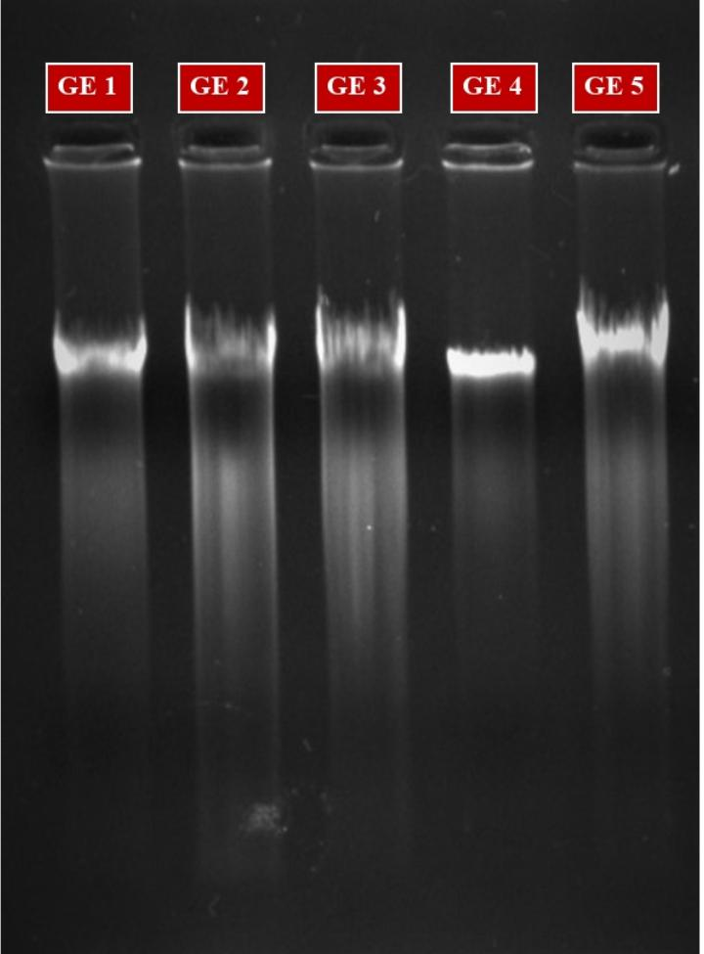

Plate 3: Gel image of genomic DNA of *G. edule* (Willd.) Blume

**4.2 ISSR BAND ANALYSIS**

The present study analyzed the genetic diversity among the five populations of *G. edule* (Willd.) Blume using ISSR markers. Samples from five distinct populations were subjected to amplification using ISSR primers. The banding pattern obtained by ISSR primers clearly distinguished populations into different clusters, indicating genetic diversity among them. Diversity estimates provide useful information for understanding the genetic structure of the plant using ISSR. In this study, five ISSR primers were screened for polymorphism survey in pooled DNA accessions of *G. edule*.

The PCR analysis for five samples taken in the study with five ISSR (Inter Simple Sequence Repeat) primers generated 43 scorable bands. An average of 8.6 bands per primer was generated. Among the five ISSR primers ISSR 13 produced a maximum number of bands (14 bands) followed by ISSR 08, ISSR 12, ISSR 2. Whereas ISSR 11 produced a minimum number of bands (06 bands) in all the genomic pools.

|  |  |  |  |  |  |  |
| --- | --- | --- | --- | --- | --- | --- |
| **ISSR**  **Primer** | **Number of bands** | **No. of Polymorphic bands** | **Percentage of Polymorphism** | **PIC** | **EMR** | **MI** |
| **ISSR 2** | 9 | 4 | 44 % | 0.14 | 36 | 5.24 |
| **ISSR 8** | 7 | 7 | 100 % | 0.45 | 49 | 22.05 |
| **ISSR 11** | 6 | 6 | 100% | 0.42 | 36 | 15.37 |
| **ISSR 12** | 7 | 3 | 42 % | 0.12 | 21 | 2.71 |
| **ISSR 13** | 14 | 14 | 100 % | 0.40 | 196 | 78.4 |
| **Total** | 43 | 34 | 386% | 1.53 | 338 | 123.7 |
| **Average** | 8.6 | 6.8 | 77.2 % | 0.306 | 67.6 | 24.7 |

Table 7: Data for ISSR primers used for analyzing 05 accessions of *G.edule* (Willd.) Blume

Out of 43 scoring bands 34 were found to be polymorphic. They showed 77.2% polymorphism and the average number of the polymorphic band per primer was 6.8. (Table 6). ISSR 13 is found to have a higher number of polymorphic bands 100-percentage polymorphism. Similarly, ISSR 8 and 11 also shown 100-percentage polymorphism but the number of band is comparatively less (7 and 6 respectively). The level of polymorphism were found to be minimum for ISSR 12 (42%). The average level of polymorphism is 43.54%.

PIC (polymorphism information content) values obtained from the primers ranged from 0.12 (ISSR 12) to 0.45 (ISSR 8) with an average of 0.306 for all the primers. Intermediate PIC values are shown in Table 7. The primer ISSR 8 was found to be more convenient for studies in this species as the PIC value came closest to 0.45. The effective multiplex ratio (EMR) was calculated by multiplying the of polymorphic bands and no: of bands, which is highest for the primers ISSR 13 (196) and lowest for the primer ISSR (12). The marker index was calculated by multiplying EMR and PIC. RAPD primer ISSR 13 shows the highest Marker index with a value of 78.4 and primer ISSR 12 shows the lowest (2.71).

**4.3 CLUSTER ANALYSIS**

Based on the ISSR marker band pattern a dendrogram was constructed using the UPGMA method (Unweighted Paired Group Method using arithmetic averages (Plate 2). Jaccord’s coefficient of genetic similarity (J) was considered for analysing the genetic distance between each population in this analysis. The similarity index was given in the Plate 2.

This dendrogram gropus the whole populations in to a single cluster except the population GE 2.

It forms an outgroup from other population indicating its genetic distance. It has least similarity with Population GE 5 (J=0.465) which are the most genetically distinct populations. The cluster 1 further out grouped the population GE 1 and groups the rest in to a single cluster. Again the cluster 2 seperates GE 5 and groups GE 3 and GE 4 indicating their high genetic similarity among all the studied populations (J= 0.6977). The cluster analysis of five population of *G.edule* reveals that all the populations have moderate to low genetical similarity as thier genetical similarity coefficient (Jaccard’s coefficient, J) value ranges from 0.4651 to 0.6977.

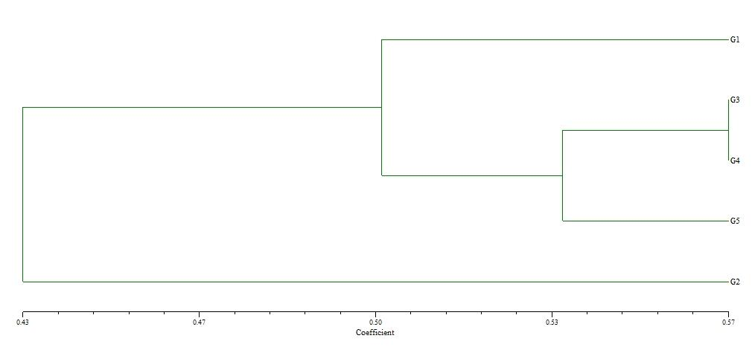

Figure 1: Dendrogram Based on Jaccards coefficient of Genetic similarity (UPGMA) Showing genetic distance

Table 8: Similarity index table showing Jaccords coeficint foe genetic similarity

|  |  |  |  |  |  |
| --- | --- | --- | --- | --- | --- |
| **Rows/columns** | **GE 1** | **GE 2** | **GE 3** | **GE 4** | **GE 5** |
| **GE 1** | **1.0000000** |  |  |  |  |
| **GE 2** | **0.4642857** | **1.0000000** |  |  |  |
| **GE 3** | **0.5483871** | **0.4444444** | **1.0000000** |  |  |
| **GE 4** | **0.4411765** | **0.4814815** | **0.5666667** | **1.0000000** |  |
| **GE 5** | **0.5135135** | **0.3428571** | **0.5428571** | **0.5277778** | **1.0000000** |

**4.4 PHYTOCHEMICAL ANALYSIS OF *GNETUM EDULE*** (WILLD.) BLUME

Table 9: Phytochemical Screening of Ethanolic Extract of *G.edule* (Willd.) Blume

|  |  |  |  |
| --- | --- | --- | --- |
| **SI. No.** | **NAME OF THE PHYTOCHEMICAL** | **NAME OF THE TEST** | **RESULT** |
| 1. | ALKALOIDS | WAGNER’S TEST | + |
| 2. | FLAVANOIDS | SODIUM HYDROXIDE TEST | - |
| 3. | GLYCOSIDES | SALKOWSKI’S TEST | ++ |
| 4. | TANNINS | FERRIC CHLORIDE TEST | ++ |
| 5. | TERPENOIDS | SALKOWSKI’S TEST | + |
| 6. | STEROIDS | SALKOWSKI’S TEST | ++ |
| 7. | SAPONINS | FOAM TEST | - |
| 8. | PHENOL | FERRIC CHLORIDE TEST | +++ |

Strongly Present - +++, Moderately Present - ++, Poorly Present - +, Absent –

Plate 4 : Represents the presence of Phytochemicals Present in the Extract of *G. edule*

|  |  |
| --- | --- |
|  |  |
| TEST FOR ALKALOIDS | TEST FOR GLYCOSIDES |
|  |  |
| TEST FOR TANNINS | TEST FOR TERPENOID |
|  |  |
| TEST FOR SAPONIN | TEST FOR PHENOL |

**4.6** **ANTEBACTERIAL ANALYSIS OF *GNETUM EDULE* (WILLD.) BLUME**

The ethanolic extract of *G. edule* (Willd.) Blumeexhibited antibacterial activity against the two test microorganisms namely ***Escherichia coli***and ***Staphylococcus aureus***.

Table 10: Antibacterial Activity of Ethanolic Extract of *G.edule* by Disc Diffusion Method

Method using DMSO (negative control).

|  |  |  |  |
| --- | --- | --- | --- |
| **SL. NO** | **BACTERIAL STRAIN** | **ZONE OF INHIBITION (mm)**  ***Gnetum edule*** | |
| **Extract (100µl)** | **Control DMSO** |
| 1 | *Escherichia coli* | 13mm | R |
| 2 | *Staphylococcus aureus* | 19mm | R |

|  |  |
| --- | --- |
|  |  |
| *S. aureus* | *E. coli* |

Plate 5: Antibacterial Activity *G. edule* (Willd.) Blume by Disc Diffusion Method

**V. DISCUSSION**

India is the home of many plants with important medical use. People have been using these plants for hundreds of years. *G. edule* (Willd.) Blume is one among them. *G.edule* (Willd.) Blume a genus of Gymnosperms is a tropical evergreen trees, shrubs and lianas. They are historically significant and has been utilized for a variety of conditions from ancient times. It differs from other plants in that it possesses both gymnosperm and angiosperm traits. They are extremely unique and beneficial since it possesses the traits of both. *G. edule* (Willd.) Blume a species of *G. edule* (Willd.) Blume is a dioecious woody climber which is important due it’s wide range applications. It has been discovered on trees in hill forests in the Western Ghats, Nilgiris, and hills near the Coromandel Coast in southwest and southeast India. It has also been reported from the Andaman and Nicobar Island (Baloche *et al*., 2013).

*G. edule* (Willd.) Blume is a multipurpose plant that has numerous culinary and medicinal applications, contributing significantly to Southeast Asian culture and biodiversity. The stem of *G. edule* was reportedly used to treat jaundice in Tamil Nadu (Mohan, 2008). Extracts from in leaves and stems can be used to treat liver enlargement (Pushpangadan, *et al.,* 1986). It is possible to treat arthritis with leaf paste administered externally (Devi Prasad*, et al.,* 2014). In Karnataka district of Hassan, the plant’s fruits and oil are utilized as a stimulant and anti-rheumatic agent (Prashanth, 2016). The stem is also prescribed for treating piles and hemicranias (Basu, *et al*., 1992). It offers defense against hepatic damage due to its strong antioxidant activity (Jinadatta, *et al*., 2019). It also exhibit antidiabetic effect (Seema, et al., 2022). Seeds produces oils which can be used for various medical purpose (Warrier, *et al*., 1993). The fruits of *G.* *edule* (Willd.) Blume can be consumed as food. Its dense twines, cones, and green canopy make it perfect for use as a premium ornamental. Moreover, *G. edule*’s ethanolic extract has strong, deadly ovicidal and larvicidal effects on dengue and malaria vectors (Dhanasekaran *et al*., 2013).

The degree of genetic variability found in individuals of a variation or a population within a species is known as genetic diversity. A healthy population depends on genetic diversity to preserve the variety of genes that may provide resistance towards diseases, pests, or different types of stress. It also makes it possible for living things to adjust to different biotic and abiotic stressors. It also makes it possible for people to adjust to different biotic and abiotic stressors (Salgotra *et al.,* 2023).

Phenotypic qualities are the foundation of genetic diversity research generally because they are simple, inexpensive, and do not require complex instruments or methods. However, because the environment affects gene expression, phenotypic assessments of genetic diversity could not be reliable or accurate. Therefore, more molecular analysis of the genetic diversity of germplasm accessions is needed (Fonseca R. M, 2008).

Genetic diversity within and between populations is regularly evaluated at the molecular level using a variety of techniques developed in laboratories. Molecular analyses comprise a large variety of DNA molecular markers, which can be employed for analysis of variation. Different markers have different genetic qualities (they can be dominant or co-dominant, can contain expressed or non-expressed sequences, etc.). Molecular markers are permanent and detectable in all tissues regardless of the growth, differentiation, development, or defensive status of the cell, which gives them several advantages over traditional, phenotype-based alternatives. Molecular markers function by emphasizing variations (polymorphisms) in a nucleic sequence that exist between distinct individuals (Mondini *et al*., 2009).

Inter-simple sequence repeat (ISSR) markers are a new system that has the advantages of microsatellites (SSR) and is reliable. Through the use of one or two primers based on SSRs attached 5’ or 3’ with 1-4 purine or pyramidine residues, genomic regions bordered by inversely orientated and closely spaced microsatellite sequences are amplified using this approach. The anchor nucleate and repetition sequences are chosen at random. ISSR amplification, when combined with the separation of amplified products on polyacrylamide or agarose gels, can uncover significantly more fragments per primer than RAPD. Mendelin mode inheritance defines ISSR markers into dominant markers. Numerous research on cultivar identification, genetic mapping, gene tagging, genetic diversity, evolution, and molecular ecology have made extensive use of this technique (Wang et al., 2002).

In the present study, genomic DNA from 5 populations of *G.* *edule* (Willd.) Blume collected from different regions of Kerala is isolated and DNA is amplified in PCR using Inter simple Sequence Repeat markers and they are ISSR 2, ISSR 8, ISSR 11, ISSR 12 and ISSR 13. The amplified products are visualized by Gel Electrophoresis. Populations were clearly divided into several groups according to the banding pattern produced by ISSR primers, demonstrating genetic variation among them. Diversity estimates provide useful information for understanding the genetic structure of the plant using ISSR. 43 scorable bands were produced by the PCR analysis using five ISSR primers on the five study samples. An average of 8.6 bands per primer was generated. Among the five ISSR primers ISSR 13 produced a maximum number of bands (14 bands). Whereas ISSR 11 produced a minimum number of bands (06 bands) in all the genomic pools.

Out of 43 scoring bands 34 were found to be polymorphic and the average number of polymorphic bands was found to be 6.8. ISSR 13 is found to have a higher number of polymorphic bands whereas ISSR 08 produced to be found have 07 polymorphic bands. The level of polymorphism were found high for ISSR 8, ISSR 11 and ISSR 13 and minimum for ISSR 12 (42%). The average level of polymorphism was found to be 43.54%.

PIC (polymorphism information content) values obtained from the primers ranged from 0.12 (ISSR 12) to 0.45 (ISSR 8) with an average of 0.306 for all the primers. The primer ISSR 8 was found to be more convenient for studies in this species as the PIC value came closest to 0.45. The effective multiplex ratio (EMR) was calculated by multiplying the of polymorphic bands and no: of bands, which is highest for the primers ISSR 13 (196) and lowest for the primer ISSR (12). The marker index was calculated by multiplying EMR and PIC. RAPD primer ISSR 13 shows the highest Marker index with a value of 78.4 and primer ISSR 12 shows the lowest (2.71).

Based on the ISSR marker band pattern a dendrogram was constructed using the UPGMA method (Unweighted Paired Group Method using arithmetic averages). Jaccord’s coefficient of genetic similarity (J) was considered for analyzing the genetic distance between each population in this analysis.

This dendrogram groups the whole populations in to a single cluster except the population GE 2.

It form an out group from other population indicating its genetic distance. It has least similarity with Population GE 5 (J=0.465) which are the most genetically distinct populations. The cluster 1 further out grouped the population GE 1 and groups the rest in to a single cluster. Again the cluster 2 separates GE 5 and groups GE 3 and GE 4 indicating their high genetic similarity among all the studied populations (J= 0.6977). The cluster analysis of five population of *G.edule* (Willd.) Blume reveals that all the populations have moderate to low genetical similarity as their genetical similarity coefficient (Jaccard’s coefficient, J) value ranges from 0.4651 to 0.6977.

From the dendrogram based on ISSR analysis, the highest genetic diversity has been exhibited by Gnetum edule Plant collected from Ambalappuzha, Alappuzha (GE 2) and the plant from Malabar botanical garden, Kozhikode (GE 5) with maximum identity value of 0.342. The least genetic diversity was shown by Gnetum edule Plant collected from Kodunghallur, Thrissur (GE 3) and the plant from Kottuvally, Ernakulam (GE 4) with minimum identity value of 0.566.

The study by B., C., Akin *et al.,* (2019), examined the phytochemical analysis of Methanol and Hexane extracts of *Gnetum afraicanum* root and stem. Using cold maceration method, the root and stem were extracted. Phytochemical screening was carried out utilizing standardized chemical tests. The result showed that both the methanol and ethanol extracts of the *G. africanum* contains saponins, steroid and tannins. Alkaloids, Flavinoids and glycosides are absent in both the extract.

In the present study, phytochemical analysis is investigated on the ethanol extract of G. edule leaf. The leaf extract is made by using Soxhlet apparatus. Standard procedures were carried out for phytochemical screening. The result showed the presence of Flavonoids, Phenol, glycosides, tannin and terpenoids.

Dayoh *et al*., 2021, examined the antibacterial activity of *G.gnemon* against *Staphylococcus aureus* bacteria. The study showed that a minimum inhibitory concentration (MIC) of 640 mg/m was observed in the extract obtained from Melinjuo leaves, which exhibited antibacterial properties against Staphylococcus aureus. Vlad et al., 2019, evaluated the antibacterial activity of G. africanum extracts against various human pathogenic bacterium such as *E.coli, S.aureus* etc. The chloroformic extract did not show any antibacterial activity. As per the study by Eneh *et al*., 2017, the water and ethanolic extracts of *G.africanum* leaves showed dose dependent Inhibitory effects on growth of *Stephylococcus aureus* bacteria. However, the extracts lack of efficacy against E. coli suggests that they are ineffective against gram-negative bacteria. In the current study, the antibacterial analysis of ethanolic extract of *G.edule* showed its resistance against *E.coli* and *S.aureus.*

**VI. SUMMARY AND CONCLUSION**

The present study was aimed at developing ISSR-based molecular markers for studying genetic diversity among the different accessions of *G. edule* (Willd.) Blume plant populations collected from various geographical regions of Kerala.

The loss of habitats is a common indicator of the environmental degradation we are living in. This poses a threat not only to human life but also to every other organism on the planet. With the growing urban population, the significance of plant genetic diversity (PGD) is now acknowledged as a distinct field. Several plant species natural habitats, including common marshlands, are under danger of disappearing. Diversity contributes to ecosystem productivity, increased resilience to adverse weather conditions. If the reasons that ecosystems are valuable to humans are because they support a greater diversity of species, then the loss of species has the potential to reduce the value of ecosystems. For the purpose of effectively utilizing and conserving *Gnetum* plant species, it is essential to understand the variability that exists among them in various habits.

In the present study , genomic DNA from 5 populations of *G. edule* (Willd.) Blume is isolated and DNA is amplified in PCR using Inter simple Sequence Repeat markers and they are ISSR 2, ISSR 8, ISSR 11, ISSR 12 and ISSR 13. The amplified products are visualized by Gel Electrophoresis. A qualitative score band was created using gel Photographs. NTSYSpc version 2.2 software was used to analyze the binary data that was collected from the marker system. Finding patterns and structures in multivariate data is possible with NISXSpc. .Dendrograms are constructed using the UPGMA method. The genetic features, namely the polymorphism among the population (PIC), the effective multiplex ratio (EMR), and the marker index (MI), were calculated using the same program. ISSR markers have the ability to disclose each population’s genetic makeup. In the study, the genomic diversity of *G. edule* (Willd) Blume from several geographic locations was compared.

DNA technologies yield consistent results regardless of age, tissue, origin, physiological circumstances, environmental factors, harvest, storage, and sample processing, making them robust and dependable instruments for taxonomic identification at different levels. The need for DNA identification will grow in response to the growing demand for premium herbs. This will ensure that medications are used effectively, promote fair trade, and boost customer confidence. This study establishes the usefulness of the ISSR marker in comparison to other molecular markers for determining *G.* *edule’s* genetic diversity.

From the dendrogram based on ISSR analysis, the highest genetic diversity has been exhibited by Gnetum edule Plant collected from Ambalappuzha, Alappuzha (GE 2) and the plant from Malabar botanical garden, Kozhikode (GE 5) with maximum identity value of 0.342. The least genetic diversity was shown by Gnetum edule Plant collected from Kodunghallur, Thrissur (GE 3) and the plant from Kottuvally, Ernakulam (GE 4) with minimum identity value of 0.566.

*Gnetum edule* is a versatile medicinal plant with a broad range of ethnobotanical uses, primarily derived from the various secondary metabolite present in the plant. Phytochemical screening was conducted on plant sample. The study revealed the presence various secondary metabolites such as Alkaloids, Tannins, Terpenoids, Phenols and Saponins respectively. Such phytochemicals were intriguing source of medical properties.

This study also demonstrated the great potential of plant extracts as antibacterial agents against *Escherichia coli* and *Staphylococcus aureus* bacteria. These results can be the strong scientific evidence for plant as a useful source in medical field for treating various infectious diseases. Therefore, these kinds of analyses are the first step toward comprehending the nature of the active ingredients in this medicinal plant, which will be beneficial for further study.

**VII. REFERENCE**

* Ahmat, N., Kamarozaman, A. S., Johari, M. S. M., Abas, F., Mohamad, S. A. S., & Yunoh, S. M. M. (2022, April). Screening of phytochemicals from the ethanolic extracts of Gnetum gnemon, Gnetum latifolium and Cynometra malaccensis of Kuala Keniam, Pahang. In *IOP Conference Series: Earth and Environmental Science* (Vol. 1019, No. 1, p. 012001). IOP Publishing.
* Al-Samarai, F. R., & Al-Kazaz, A. A. (2015). Molecular markers: An introduction and applications. *European journal of molecular biotechnology*, *9*(3), 118-130.Amiteye S. (2021). Basic concepts and methodologies of DNA marker systems in plant molecular breeding. Heliyon, 7(10), e08093.
* BalochE. & Bachman S. Gnetum ula. The IUCN Red List of Threatened Species 2013. Version 2014.3.
* Bansode, T. S., Gupta, A., Shinde, B., & Salalkar, B. K. (2017). Partial purification and antidiabetic effect of bioactive compounds isolated from medicinal plants. *MicroMedicine*, *5*(1), 1-7.Barbieri, R., E. Coppo, A. Marchese, M. Daglia, E. Sobarzo- Snchez, S. F. Nabavi and S. M. Nabavi (2017).Phytochemicals for human disease: An update on plant-Derived compounds antibacterial activity. Microbiol. Res.196: 44–68.
* Banu, K. S., & Cathrine, L. (2015). General techniques involved in phytochemical analysis. International journal of advanced research in chemical science, 2(4), 25-32.
* Barcaccia, G., Mazzucato, A., & Falcinelli, M. (2000). Inheritance of apomictic seed production in Kentucky bluegrass (Poa pratensis L.). *Journal of New Seeds*, *2*(1), 43-58.
* Basu P, Mitra B. Preliminary notes on the climbing taxa of Andaman and Nicobar Islands with special reference to their importance. J Econ Taxon Bot. 1992;16:393–399.
* Caliskan, M. (Ed.). (2012). Genetic diversity in plants. BoD–Books on Demand.
* Dayoh, P. J., Isbandiati, E., & Rahayu, T. (2021). Antibacterial effect of Gnetum gnemon L. leaves extract on Staphylococcus aureus. *Journal of Widya Medika Junior*, *3*(2), 122-130.
* Deng, N., Hou, C., Liu, C., Li, M., Bartish, I., Tian, Y., ... & Shi, S. (2019). Significance of photosynthetic characters in the evolution of Asian Gnetum (Gnetales). *Frontiers in Plant Science*, *10*, 39.Devi Prasad AG, Raghavendra MP, Shyma TB. World journal of Pharmaceutical Research 2014; 3(2): 2476-92.
* Devi Prasad, A.G., M.P. Raghavendra and T.B. Shyma (2014) Antimicrobial activity of tribal medicines collected from Wayanad district, kerala. World J. Pharm. Res., 3(2): 2476- 92.
* Dhanasekaran, S., K. Krishnappa, A. Anandan and K. Elumalai (2013). Larvicidal, ovicidal and repellent activity of selected Indigenous medicinal plants against malarial vector Anopheles stephensi (liston), dengue vector aedesaegypt (linn.), japanese encephalitis vector, culex tritaeniorynchus (giles.) (diptera: Culicidae). J. Agri. Tech., 9(1): 29-47.
* Dubale, S., Kebebe, D., Zeynudin, A., Abdissa, N., & Suleman, S. (2023). Phytochemical screening and antimicrobial activity evaluation of selected medicinal plants in Ethiopia. *Journal of experimental pharmacology*, 51-62.E., L., Contescu., Florin, Gabriel, Anton. (2023). Study of the Genetic Diversity of Some Wild Sunflower Species Using ISSR Markers. Romanian Agricultural Research, 40:31-37.
* Eneh, F. U., Onwubiko, C. E., & Ugochukwu, G. C. (2017). Phytochemical and antimicrobial activity screening of Gnetum africanum leaf extracts. *International Journal of Herbal Medicine*, *5*(3), 105-109.1
* Fonseca, R. M., Lopes, R., Barros, W. S., Lopes, M. T. G., & Ferreira, F. M. (2008). Morphologic characterization and genetic diversity of Capsicum chinense Jacq. accesions along the upper Rio Negro-Amazonas.Gaurav, V., Sanghvi., Gaurav, S., Dave. (2017). Molecular Markers in Plant Biotechnology. 415-453.
* Heun, M., Murphy, J. P., & Phillips, T. D. (1994). A comparison of RAPD andisozyme analyses for determining the genetic relationships among Avena sterilis L.accessions.Theoretical and Applied Genetics,87(6), 689-696.
* Hou, C., Humphreys, A. M., Thureborn, O., & Rydin, C. (2015). New insights into the evolutionary history of Gnetum (Gnetales). *Taxon*, *64*(2), 239-253.
* Huang, S., Hu, Y., Wu, D., Tian, Q., & Li, H. (2010). Genetic diversity of Gnetum parvifolium of Fujian by ISSR markers. *Guangxi Zhiwu/Guihaia*, *30*(5), 601-607.
* Hughes, A. R., Inouye, B. D., Johnson, M. T., Underwood, N., & Vellend, M. (2008). Ecological consequences of genetic diversity. *Ecology letters*, *11*(6), 609-623.
* Hure, Y. E. D., Moi, M. Y. M., & Ernaningsih, D. E. (2023). Plant Antibacterial Activity Herb Klate (Hyptis Suaveolens) Against Bacteria Escherichia coli and Staphylococcus Aureus. *Holistic Science*, *3*(1), 64-71.
* Jayaraj, A. J., Uchimahali, J., Gnanasundaram, T., & Thirumal, S. (2019). Evaluation of antimicrobial activity and phytochemicals analysis of whole plant extract of Vinca rosea. *Evaluation*, *12*, 132-136.B., C., Akin-Osanaiye., E., J., Ekpeyong., I., W., Olobayotan. (2019). Phytochemical and Antimicrobial Screening of Gnetum Africanum Stem and Root. 1-11.
* Jinadatta, P., Rajshekarappa, S., Rao, K. S. R., Subbaiah, S. G. P., & Shastri, S. (2019). In silico, in vitro: antioxidant and antihepatotoxic activity of gnetol from Gnetum ula Brongn. *BioImpacts: BI*, *9*(4), 239.
* Jörgensen, A., & Rydin, C. (2015). Reproductive morphology in the Gnetum cuspidatum group (Gnetales) and its implications for pollination biology in the Gnetales. *Plant Ecology and Evolution*, *148*(3), 387-396.
* Kenawy, E. R., Worley, S. D., & Broughton, R. (2007). The chemistry and applications of antimicrobial polymers: a state-of-the-art review. *Biomacromolecules*, *8*(5), 1359-1384.
* Liliana, B., Anca-Amalia, U., Cornelia, B. A., & Mihaela, I. (2022). Genetic diversity analysis among several apple genotypes using ISSR markers.
* McLoughlin, S. (2021). Gymnosperms: History of Life: Plants: Gymnosperms.
* Mendoza, N., & Silva, E. M. E. (2018). Introduction to phytochemicals: secondary metabolites from plants with active principles for pharmacological importance. *Phytochemicals: Source of antioxidants and role in disease prevention*, *25*, 1-5.
* Milbourne, D., Meyer, R., Bradshaw, J. E., Baird, E., Bonar, N., Provan, J., ... & Waugh, R. (1997). Comparison of PCR-based marker systems for the analysis of genetic relationships in cultivated potato. *Molecular breeding*, *3*, 127-136.
* MINAEIFAR, A. A., SHEIDAI, M., & ATTAR, F. (2015). Genetic and morphological diversity in Cousinia cylindracea (Asteraceae) populations: Identification of gene pools. *Biodiversitas Journal of Biological Diversity*, *16*(2).
* Mohan, V. R. (2008). Ethnomedicinal plants of the Tirunelveli district, Tamil Nadu, India. *Ethnobotanical leaflets*, *2008*(1), 10.
* Mondini, L., Noorani, A., & Pagnotta, M. A. (2009). Assessing plant genetic diversity by molecular tools. *Diversity*, *1*(1), 19-35.
* Nan, P., Shi, S., Peng, S., Tian, C., & Zhong, Y. (2003). Genetic diversity in Primula obconica (Primulaceae) from Central and South‐west China as revealed by ISSR markers. *Annals of Botany*, *91*(3), 329-333.Ng, W. L., & Tan, S. G. (2015). Inter-simple sequence repeat (ISSR) markers: are wedoingit right.ASMScienceJournal, 9(1), 30-39.
* Nunes dos Santos, K., Florentino, R. M., França, A., Lima Filho, A. C. M., Santos, M. L. D., Missiaggia, D., ... & Leite, M. F. (2019). Polymorphism in the promoter region of NFE2L2 gene is a genetic marker of susceptibility to cirrhosis associated with alcohol abuse. *International Journal of Molecular Sciences*, *20*(14), 3589.
* Penner, G. A. (1996). RAPD analysis of plant genomes. *Methods of genome analysis in plants*, *15*, 251-264.
* Perez, R., Ineichen, P., Seals, R., Michalsky, J., & Stewart, R. (1990). Modeling daylight availability and irradiance components from direct and global irradiance components from direct and global irradiance. Solar energy 44950, 271-289.
* Pourmohammad, A. (2013). Application of molecular markers in medicinal plantstudies.Acta Univ.Sapientiae, AgricEnviron, 5(1), 80-90.
* Prashanth Kumar, G. M., & Shiddamallayya, N. (2016). Survey of wild medicinal plants of Hassan district, Karnataka. J Med Plants Stud, 4(1), 91-102.
* Priya, V., & Anjana, P. V. (2019). Phytochemical screening and antimicrobial activity in leaves of Gnetum ula, Brongn.
* Pushpangadan, P., & Atal, C. K. (1986). Ethnomedical and ethnobotanical investigations among some scheduled caste communities of Travancore, Kerala, India. *Journal of ethnopharmacology*, *16*(2-3), 175-190.
* R.M., Tripathi. (2023). Antibacterial activity of phyto-chemicals obtained from leafextracts of some medicinal plants on pathogens of semi-arid soil. THE SCIENTIFIC TEMPER, 3(1&2):33-42.
* Ramanatha Rao, V., & Hodgkin, T. (2002). Genetic diversity and conservation and utilization of plant genetic resources. *Plant cell, tissue and organ culture*, *68*, 1-19.
* Rispail, N., Wohor, O. Z., Osuna-Caballero, S., Barilli, E., & Rubiales, D. (2023). Genetic diversity and population structure of a wide Pisum spp. core collection. *International Journal of Molecular Sciences*, *24*(3), 2470.
* Sakshi, Pathak., Bharti, Jain. (2023). Phytochemical Analysis of Dried Moringa oleifera Leaf Powder. The Journal of Plant Science Research, 39(1):177-184.
* Salgotra, R. K., & Chauhan, B. S. (2023). Genetic diversity, conservation, and utilization of plant genetic resources. *Genes*, *14*(1), 174.
* Sari, M., Wulandari, D. A., Gustini, N., Septiana, E., Rachman, F., Bustanussalam, B., ... & Putra, M. Y. (2023, January). The comparation of melinjau (Gnetum gnemon L.) seed flour and extract from industrial and their activity test as an antioxidant. In *AIP Conference Proceedings* (Vol. 2606, No. 1). AIP Publishing.
* Sebastian, V. A., (2009). Development and analysis of molecular markers for certain endangered species of Tylophora.
* Seema S, Shakena Fathima T, Roselin Jenifer D, BeemaShafreen R and Palak Singh: Evaluation Of Phytochemical And In Vitro Studies On Antioxidant, Anti-Diabetic Activities of Gnetum Ula. Bull. Env.Pharmacol. Life Sci., Spl Issue [5]: 2022: 665-669.
* Sensarma, P., & Pal, D. C. (2001). *A Lexicon of Medicinal Plants in India*. Naya Prokash.
* Srivastava, R. C., Agrawal, P. K., Ramabharathi, V., & Patil, S. (2021). Gymnosperms in India: ethnic and economic uses. *J Eco Tax Bot (1)*, 173-183.
* Varshney, R. K., Graner, A., & Sorrells, M. E. (2005). Genic microsatellite markers in plants: features and applications. *TRENDS in Biotechnology*, *23*(1), 48-55.
* Vlad, C. S., Vlaia, L., VLAIA, V., DUMITRAŞCU, V., Filimon, M. N., Popescu, R., ... & Daliborca, C. V. (2019). CHROMATOGRAPHIC ANALYSIS AND ANTIBACTERIAL POTENTIAL OF EXTRACTS OF GNETUM AFRICANUM. *Farmacia*, *67*(6). Delevoryas, T. (2023), November 243. Gymnosperm. Encyclopedia Britannica.
* Wang, J. B. (2002). ISSR markers and their applications in plant genetics. *Yi Chuan= Hereditas*, *24*(5), 613-616.
* Wang, J. B. (2002). ISSR markers and their applications in plant genetics. Yi ChuanHereditas,24(5), 613-616.
* Wang, X., Mingyang, L. I., Lin, T., & Dongyun, L. I. U. (2022). Clematis Genetic Diversity and Hybrid Identification using ISSR Markers.
* Warrier, P. K. (1993). *Indian medicinal plants: a compendium of 500 species* (Vol. 5). Orient Blackswan.
* Zebire, D. A. (2020). Applications of molecular markers in Genetic Diversity Studies of maize. *Nigerian Journal of Biotechnology*, *37*(1), 101-108.