**A study on**

**THE PERCEPTION TOWARDS FAST FASHION AND ITS IMPACT**

**AMONG YOUNSTERS IN ERNAKULAM CITY**

**Project Report**

**Submitted by**

**NANDANA B (SB21BCOM013)**

**ANJANA P M (SB21BCOM024)**

**HEBA K N (SB21BCOM041)**

**Under the guidance of**

**Smt. MAYA P**

**In partial fulfillment of the requirement for the Degree of**

**BACHELOR OF COMMERCE**



**ST. TERESA'S COLLEGE (AUTONOMOUS), ERNAKULAM**

**COLLEGE WITH POTENTIAL FOR EXCELLENCE**

**Nationally Re-Accredited with A++ Grade**

**Affiliated to**

**Mahatma Gandhi University**

**Kottayam-686560**

**March-2024**

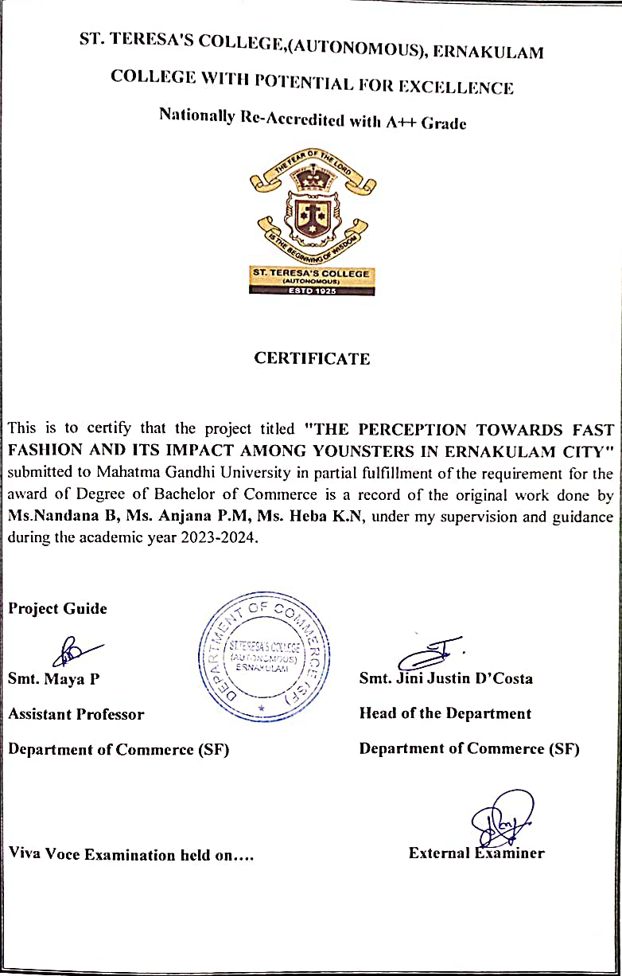

**DECLARATION**

We Ms. Nandana B, Ms. Anjana P.M, Ms. Heba K. N, final year B.Com students, Department of Commerce (SF), St. Teresa's College (Autonomous), Ernakulam do hereby declare that the project report entitled “THE PERCEPTION TOWARDS FAST FASHION AND ITS IMPACT AMONG YOUNSTERS IN ERNAKULAM CITY” submitted to Mahatma Gandhi University is a bonafide record of the work done under the supervision and guidance of Smt. Maya P, Assistant Professor, Department of Commerce (SF), St. Teresa's College (Autonomous) and this work has not previously formed the basis for the award of any academic qualification, fellowship, or other similar title of any other university or board.

**PLACE: ERNAKULAM NANDANA B**

**DATE: ANJANA P M**

**HEBA K N**

**ACKNOWLEDGEMENT**

First of all, we are grateful to God Almighty for his blessings showered upon us for the successful completion of our project.

It is our privilege to place a word of gratitude to all persons who have helped us in the successful completion of the project.

We are grateful to our guide **Smt. Maya P**, Assistant Professor, Department of Commerce (SF), St. Teresa's College (Autonomous), Ernakulam for her valuable guidance and encouragement for completing this work.

We would like to acknowledge **Dr. Alphonsa Vijaya Joseph**, Principal, St. Teresa's College (Autonomous), Ernakulam for providing necessary encouragement and infrastructure facilities needed for us.

We would like to thank **Smt. Jini Justin D’Costa**, Head of the Department, Department of Commerce (SF), St. Teresa’s College(Autonomous), Ernakulam for her assistance and support throughout the course of this study for the completion of the project.

We will remain always indebted to our family and friends who helped us in the completion of this project.

Last but not the least; we would like to thank the respondents of our questionnaire who have helped me to provide the necessary information for my study.

**Nandana B**

**Anjana P M**

**Heba K N**

**CONTENTS**

| **Chapters** | **Content** | **Page Number** |
| --- | --- | --- |
| Chapter 1 | INTRODUCTION | 9 -13 |
| Chapter 2 | REVIEW OF LITERATURE | 15 - 17 |
| Chapter 3 | THEORETICAL FRAMEWORK | 19 - 35 |
| Chapter 3 | DATAANALYSISAND INTERPRETATION | 37 - 59 |
| Chapter 4 | FINDINGS, SUGGESTIONS, AND CONCLUSION | 61 - 64 |
|  | Bibliography |  |
|  | Annexure |  |

**LIST OF TABLES**

| **Sl.No.** | **Contents** | **Page No.** |
| --- | --- | --- |
| 4.1 | Table OF gender | 37 |
| 4.2 | Table of age group | 38 |
| 4.3 | Table of status of the respondents | 39 |
| 4.4 | Table of fast fashion brands shopping | 40 |
| 4.5 | Frequency of shopping from fast fashion brands | 41 |
| 4.6 | Fast fashion brands preferred | 42 |
| 4.7 | Price Point of fast fashion products | 44 |
| 4.8 | Examining the quality of fast fashion brands | 45 |
| 4.9 | Fashionability of products offered by fast fashion brands | 46 |
| 4.10 | Impact of social media on youth’s perception on fast fashion brands | 47 |
| 4.11 | Awareness about the adverse effects of fast fashion brands on the environment | 48 |
| 4.12 | Awareness about the working conditions under which the products are manufactured | 49 |
| 4.13 | Assessing youth’s awareness about the consequences of fast fashion | 50 |
| 4.14 | Exploring awareness of sustainable fashion practices | 51 |
| 4.15 | Importance of promoting sustainable fashion for global environment protection | 52 |
| 4.16 | Willingness to shift to slow or sustainable fashion | 53 |
| 4.17 | Embracing thrifted and pre-owned garments | 55 |
| 4.18 | Incorporating sustainable and ethical considerations into shopping practices | 56 |
| 4.19 | The call for transparency | 57 |
| 4.20 | The impact of fast fashion in shortening the lifespan of fashion trends | 58 |

**LIST OF FIGURES**

| **Sl.No.** | **Contents** | **Page No.** |
| --- | --- | --- |
| 4.1 | Gender of respondents | 37 |
| 4.2 | Age group of the respondents | 38 |
| 4.3 | Status of the respondents | 39 |
| 4.4 | Fast fashion brand shopping | 40 |
| 4.5 | Frequency of shopping from fast fashion brands | 41 |
| 4.6 | Preferred fast fashion brands | 43 |
| 4.7 | Price point of fast fashion products | 44 |
| 4.8 | Quality of products offered by fast fashion brands | 45 |
| 4.9 | Fashionability of the products | 46 |
| 4.10 | Impact of social media on youth’s perception on fast fashion brands | 47 |
| 4.11 | Awareness about the adverse effects of fast fashion brands on the environment | 48 |
| 4.12 | Awareness about the working condition under which the products are manufactured. | 49 |
| 4.13 | Youth’s awareness about the consequences of fast fashion | 50 |
| 4.14 | Awareness of sustainable fashion practices | 51 |
| 4.15 | Importance of promoting sustainable fashion for global environmental protection | 52 |
| 4.16 | Willingness to shift to slow or sustainable fashion | 53 |
| 4.17 | Strategies for practising sustainable fashion | 54 |
| 4.18 | Embracing Thrifted and pre-owned garments | 55 |
| 4.19 | Incorporating Sustainable and ethical considerations into shopping practices | 56 |
| 4.20 | Call for transparency | 57 |
| 4.21 | Impact of fast fashion in shortening the lifespan of fashion trends | 58 |
| 4.22 | Evaluation of brand’s satisfaction | 59 |

**CHAPTER 1**

**INTRODUCTION**

# INTRODUCTION

Fast fashion is the term used to describe clothing designs that move quickly from the catwalk to stores to meet new trends, and the collections are often based on designs presented at Fashion Weeks. Fast fashion lets shoppers buy trendy clothes at a very affordable price. Fast fashion is defined as clothing designs that quickly move from idea to mass production, and available to consumers within weeks.

The reasons why fast fashion became so popular are the cheap prices, an increased appetite for staying trendy and increased purchasing power of consumers. These factors challenged traditional fashion houses that were introducing new fashion lines on a seasonal basis.

However, it is very common in fast fashion to introduce new trends multiple times, perhaps even in a week. This condition allows people to stay within trends and feel as if they are wearing the same garments at fashion events. Innovations in supply chain management made fast fashion even faster. This innovation led to production of cost- efficient fashion items quickly which eventually meets the expectation of high fashion for low price. The speed at which fast fashion is happening requires a mutually beneficial relationship between manufacturers and consumers.

Of course, social media and the ability to post images in different clothing outfits daily has not helped the situation. It also leads to social media followers wanting to copy trends and stay up to date. ‘Clothing hauls’ are very common videos posted by social media influencers, where followers can see how many items were bought from particular brands. Usually these videos are sponsored by brands and encourage viewers to buy at their stores.

Fast fashion is advantageous mostly for retailers and businesses. Continuous introduction of new products encourages customers to be in stores more often, and this increases purchases. Fast fashion helps retailers and fashion brands to sustain higher inventory turnover as customers buy items quickly, in case they won’t be available for a long period of time.

# SIGNIFICANCE OF THE STUDY

Fast fashion has revolutionized the fashion industry at a cost to the environment and human rights. The fast fashion business model relies on the exploitation of resources and human labor to deliver garments following the latest trends to its consumers at an unprecedented rate. This quick output of garments demands a sizable volume of raw materials fed into the fast fashion industry, creating a significant amount of waste, pollution and degradation to air, water and wildlife habitat. The pollution introduced by the fast fashion industry results in devastating impacts to both terrestrial and aquatic environments, with harmful effects linked to habitat degradation, proliferation of chemicals and micro-plastics in waterways, and the increasing impact of climate change from greenhouse gas emissions.

Despite the increased demand and consumption of fast fashion garments and people’s apparent growing interest in fashion, they are buying more while wearing fewer of the items they own. The poor quality of fast fashion clothing contributes to the limited life spans of garments, which often end up decomposing slowly in landfills or being incinerated. In addition to degrading in landfills or being incinerated, fast fashion clothing has also become a notorious source of micro plastics in marine environments as the cheap, plastic-based materials shed fibers that make their way to the oceans.

On top of the environmental exploitation that allows for fast fashion’s cheap prices, the other contributing factor is worker exploitation in low-income countries where factories are based. Workers — primarily young women — are subjected to hazardous working conditions while earning unlivable wages, despite the companies pulling in massive profits.

# STATEMENT OF THE PROBLEM

The environmental and social cost of the fashion industry forces us to rethink fast fashion, and stresses the need for more sustainable business models and practices. While international organizations, governments and businesses work on solutions to shift the fashion industry toward a more sustainable pathway, consumers can also play a role with their daily actions. This section provides resources on the actions individuals can take to support sustainability in their apparel choices.

# OBJECTIVES OF THE STUDY

1. To analyze the scope of fast fashion
2. To understand why youngsters prefer fast fashion.

3.To identify whether youngsters are aware about its harmful effects on the environment.

4.To understand whether youngsters will switch to sustainable fashion.

# SCOPE OF THE STUDY

The study is based on fast fashion and its impact on the environment and economy. It analyzes whether the youngsters are aware about its consequences and also to know whether they are willing to follow sustainable fashion paths.

# RESEARCH METHODOLOGY OF THE STUDY

Type Of Research Design : The study is descriptive in nature.

Collection Of Data : Both primary and secondary data is used for data collection.

Primary Data : Original data derived from research endeavors.

Secondary Data : Data derived from primary data.

Sampling Design : A convenient random sampling is used to analyze the objectives of the study.

Population : The population is limited to youngsters.

Sample Space : A total of 75 is the sample space.

# LIMITATIONS OF THE STUDY

1. Study is limited to time constraints.
2. Literature review for the study has been limited.
3. The data does not provide accurate information.
4. The study might be biased.

5. There is a great chance that the nature of implementation of data collection method is flawed

# CHAPTERISATION

This study contains the following chapters. They are as follows :

## CHAPTER 1- INTRODUCTION

This chapter gives a brief introduction about the topic. It deals with the significance of the study, statement of problem, objectives , scope of study, research methodology and limitations of the study.

## CHAPTER 2 - REVIEW OF LITERATURE

This study gives us literature relating to the topic under study. It includes analysis of secondary data of the study.

## CHAPTER 3- THEORETICAL FRAMEWORK

## This chapter deals with the related topics under study . It includes meaning, importance ,objectives , types and its benefits, advantages, disadvantages and future scope of fast fashion.

## CHAPTER 4-DATA ANALYSIS AND INTERPRETATIONS

This chapter deals with the analysis and interpretation relating to the topic under study. It includes analysis of primary data collected from youngsters. It is shown with the help of tables and figures.

## CHAPTER 5- FINDINGS SUGGESTIONS AND CONCLUSION

This chapter gives us the findings , suggestions and conclusions related to the topic . It is done with the help of the primary data collected from various youngsters.

**CHAPTER 2**

**REVIEW OF LITERATURE**

**1.Madhurendra Kumar (2020):**

Fashion industry is struggling hard during the recent pandemic should not be a matter of surprise as it is also a part of the same ecosystem, after all. To delve deeper into this tale, a series of research papers, journal articles, research projects , media reports, and forecasts by reputed agencies is reviewed and presented in this paper which will be beneficial in unlocking the true potential and adaptive measures for the future. A qualitative approach to review the past reputed articles in context to covid –19 impact on fashion industry is followed here.

**2. Joung (2014):**

In recent years the clothing industry has gotten a reduced lifecycle by adopting the so-called fast fashion business strategy dropping it to a month or even less (Joung, 2014) . It is considered to be a new business model, made to respond to the increased demand-driven industry of fashion where the focus lies on copying trends from the catwalk and putting them in the stores fast.

**3.Gabrielli Baghi & Codeluppi (2013):**

The study is based on the supply chain, which was once long, has shortened and become more flexible to reply to the wants and the demands of the consumers that has then led to the creation of fast fashion.

**4.McNeill & Moore (2015):**

The study states that the decrease in the clothes lifecycle and crisis and an increase in fashion purchase frequency has led to a large wastage, addressing just one of the many problems of fast fashion. H&M, Topshop and ZARA sell clothes that are expected to be used ten times less than average, building the foundation for throw away fashion.

**5.Wiederhold & Martinez (2018):**

The study clearly states that this concept is not environmentally concerned or sustainable. It leaves large pollution footprints generating environmental hazards and contributing to global warming by using fabrics such as polyester, one of the more well-used materials in manufacturing the clothes.

**6.Claudio (2007):**

The study states the process of producing this fabric is very energy-consuming and requires large amounts of crude oil and acid gasses which is negatively affecting both the human health and the waters and the oceans. Another well-used material is cotton, which is also a fabric that leaves an environmental footprint.

**7.Brooks (2015):**

The study states that as globalization has increased it has opened opportunities for the fast fashion retailers to move production to the lower-wage countries such as China and other third-world countries, exploiting their poor wages and poor labor rights to manufacture the clothes cheaply.

**8.Valaei et al (2017):**

Study determined that the price, style and brands are “good predictors of purchase intentions toward fashion apparel”, strengthening the explanation.

**9.Cook &Yurischin (2017):**

The study states that increased knowledge about the negative effects affects the conscience and therefore the emotions of the buyer which is an important facin the purchase process(Cook &Yurischin, 2017).

**10. Perry (2018):**

The study analyzes the reasons for a bad environment. One reason for the risk of bad health is due to the toxic chemicals used when making and dying the fabrics. The toxic chemicals not only affect human health but also the environment. Fabrics such as polyester contribute to global warming on the continuous increase of plastic in the oceans. It also affects the sea life, plankton eating the microfibres released from washing the clothes which continues up the food chain through fishes and then reach humans (Perry,2018).

**11. Simon Peter Nadeem (2022):**

The research has shown that nowadays, the number of consumers that are more willing to pay higher prices for clothes with high sustainable content is growing.The EU strategy for sustainable and circular textiles is expected to help fashion enterprises to achieve more circular, sustainable, and resilient value chains.

**12. Sull and Turconi (2018):**

The study describes that fast fashion has changed the designer push model to the opportunity pull approach. The market is the one which decides what to produce and the retailers have to respond to it within a few weeks unlike the industry average of six months (Sull and Turconi, 2018).

**13.Lopez (2009):**

The retail stores of ZARA are not only acting as a point of sale but also the starting point of the business system (Lopez and Fan, 2009). H&M is more internationalized compared with its competitors. 90% of its turnover is from overseas in 2005 (Lopez and Fan ,2009).To keep its fast fashion buying cycle, the production of H&M is outsourced to seven hundred suppliers.

**CHAPTER 3**

**THEORETICAL FRAMEWORK**

## 3.1 MEANING OF FAST FASHION

## Fast fashion is the term used to describe clothing designs that move quickly from the catwalk to stores to take advantage of trends. The collections are often based on styles presented at Fashion Week runway shows or worn by celebrities. Fast fashion allows mainstream consumers to purchase the hot new look or the next big thing at an affordable price.

## Fast fashion became common because of cheaper, speedier manufacturing and shipping methods, an increase in consumers' appetite for up-to-the-minute styles, and the increase in consumer purchasing power—especially among young people—to indulge these instant gratification desires. Because of all this, fast fashion is challenging the established clothing labels' tradition of introducing new collections and lines on an orderly, seasonal basis. In fact, it's not uncommon for fast-fashion retailers to introduce new products multiple times in one week to stay on trend.

## 3.2 CHARACTERISTICS

## 1. Rapid Production Cycles:Fast fashion is characterized by quick turnaround times in designing, manufacturing, and distributing clothing to respond swiftly to changing trends and consumer preferences.

## 2. Low Cost: Fast fashion brands prioritize cost efficiency, often achieved through mass production, outsourcing manufacturing to lower-wage countries, and utilizing affordable materials to offer budget-friendly clothing.

## 3. High Fashion Imitation:Fast fashion involves replicating the latest runway trends and designer styles at a fraction of the cost, making fashionable items accessible to a broader consumer base.

## 4. Short Product Lifespan: Products in the fast fashion industry have a short lifecycle, as they are designed to be worn for a limited period, aligning with the rapid turnover of trends.

## 5. Frequent Inventory Turnover:Fast fashion retailers frequently update their inventory with new collections, encouraging consumers to make more frequent purchases and driving a constant flow of products through the supply chain.

## 

## 3.3 OBJECTIVES OF FAST FASHION

## 1. Rapid Production:Achieve faster production cycles to quickly respond to changing fashion trends and consumer demands.

## 2. Cost Efficiency: Implement cost-effective manufacturing processes to offer affordable and accessible fashion options to a wide consumer base.

## 3. Market Responsiveness:Stay agile and responsive to emerging fashion trends, ensuring that products are aligned with current styles and preferences.

## 4. Inventory Management: Optimize inventory levels to minimize excess stock and reduce markdowns, improving overall efficiency and profitability.

## 5. Global Sourcing: Establish a global and diverse network of suppliers to access a variety of materials and components, enhancing flexibility in production.

## 6. Brand Loyalty:Build customer loyalty through frequent product launches, collaborations, and limited-edition releases to keep consumers engaged and returning.

## 7. Supply Chain Integration:Integrate and streamline the supply chain processes for seamless coordination between design, production, and distribution.

## 8. Digital Presence:Enhance online presence and e-commerce capabilities to cater to the growing trend of online shopping and reach a wider audience.

## 9. Adaptability to Microtrends: Quickly adapt to microtrends and niche markets, allowing for the exploration of diverse styles and preferences.

## 10. Environmental Sustainability: Incorporate sustainable practices to address environmental concerns, aligning with the growing demand for eco-friendly and socially responsible fashion.

## 3.4 IMPORTANCE OF FAST FASHION

## • Affordability

## Over the years, numerous sustainable fashion brands have emerged, challenging the notion that eco-friendly clothing must come at a high cost. Brands like Patagonia, Veja, People Tree, Everlane, and Tentree offer stylish and affordable sustainable options. These brands have gained recognition for their commitment to sustainability, from using organic and recycled materials to advocating for fair trade and transparency.

## • Growth

## Fashion is a growing industry and fast fashion is the major contributor to its growth. Using the Internet, social media, and technological innovation, many fast fashion brands such as Forever 21, H&M, Primark, Zara, Fashion Nova grew into large global corporations.

## • So many styles to choose from

## Zara is one of the most well-known and highly popular fast-fashion giants. There are 2259 Zara stores in 96 countries. Zara also sells its designs and styles inspired by the latest trends.

## The large variety of choices and product availability is very appealing to consumers. Because design and production time have decreased dramatically, it's now possible for fast-fashion retailers like Zara to deliver new styles every week.

## •The influence of the Internet and social media

## Fashion models and celebrities aren't the only ones who can now influence consumers on fashion choices

## .The rise of new technologies, communication innovations, and social media has pushed fast fashion in front of many indecisive customers.Brands and retailers will often partner with social media personalities to promote their products in front of new audiences.

## •Fast fashion brands and retailers make huge profits

## Profit increase is part of the recent fast fashion success. The concept has changed the clothing industry fundamentally. Design, manufacturing, and distribution occur at very high speeds.

## Consumers buy more clothes now than ever before from fast fashion brands and retailers such as H&M, Zara, Forever 21, and others because they are everywhere.Fast fashion is a worldwide phenomenon where brands and retailers use all possible means to acquire more customers and make more profits.

## 3.5 FUTURE SCOPE OF FAST FASHION

## 1. Sustainable Practices: Embracing eco-friendly materials, ethical sourcing, and reducing environmental impact to meet the growing demand for sustainable fashion.

## 2. Circular Fashion: Implementing circular economy principles, such as recycling and upcycling, to extend the lifespan of products and minimize waste in the fast fashion cycle.

## 3.Digital Transformation: Leveraging technology for efficient supply chain management, e-commerce innovations, and data analytics to better understand consumer preferences.

## 4. Innovative Materials: Exploring and adopting new materials, such as bio-fabrics and recycled fibers, to create fashionable and sustainable clothing alternatives.

## 5. Ethical Labour Practices: Ensuring fair labor practices and improving working conditions throughout the supply chain to meet increasing consumer demands for ethical and socially responsible fashion.

## 6.Customization and Personalization: Offering personalized shopping experiences, allowing customers to tailor and customize their clothing, fostering a sense of uniqueness in fast fashion.

## 7. Virtual Try-Ons: Integrating augmented reality (AR) and virtual try-on technologies to enhance the online shopping experience and reduce return rates.

## 8. Rent and Resale Models: Exploring rental and resale business models to extend the life cycle of garments, providing more affordable and sustainable options for consumers.

## 9. Transparency and Traceability: Enhancing transparency in the supply chain, allowing consumers to trace the origins of their clothing, ensuring accountability and building trust.

## 10. Collaborations and Limited Editions: Collaborating with influencers, designers, and artists for limited-edition collections, creating exclusive and sought-after products to drive customer engagement.

## 3.6 MEANING OF SLOW FASHION

## Slow fashion is the opposite of fast fashion. It takes an ethical and sustainable approach to producing clothes. The slow fashion movement is a direct response to the harmful impact of fast fashion on the environment and garment workers. It advocates for making fashion choices that are kinder to people and the planet.

## 3.7 FAST FASHION VS. SLOW FASHION

If fast fashion is getting garments to consumers as quickly as possible, regardless of the impact on workers and the environment, slow fashion is the exact opposite.

Slow fashion—a concept first introduced in 2008 by fashion and sustainability consultant Kate Fletcher—uses environmentally friendly processes and materials through "mindful manufacturing," focusing on quality rather than quantity.Mindful manufacturing, an idea championed by 3D printing company Stratasys, is the concept of developing more efficient production, sound chemical and solid waste disposal practices, reusable materials, and recycled packaging.

**3.8 ADVANTAGES OF FAST FASHION:**

* **Profitable for manufacturers and retailers**: The constant introduction of new products encourages customers to frequent stores more often, which means they end up making more purchases. The retailer does not replenish its stock—instead, it replaces items that sell out with new items. Accordingly, consumers know to purchase an item they like when they see it, no matter the price because it's not likely to be available for long. And because the clothing is cheap (and cheaply made), it's easy to get people back into stores or online to make fresh purchases.
* **Quick to consumers**: As for advantages for the consumer, fast fashion has enabled people to get the clothes they want when they want them. Also, it's made clothing more affordable—and not just any clothing, but innovative, imaginative, stylish clothing.
* **Makes clothes affordable**: Even those of modest means can constantly buy smart new clothes, indulge in fun or impractical items, and wear something different every day.
* **Democratizes fashion**: No longer is the latest look, being "well-dressed," or having a large wardrobe the province of the rich and famous. Everyone can look good.

**3.9 DISADVANTAGES OF FAST FASHION:**

* **Environmental impact:** Fast fashion has a significant environmental impact, with the production and disposal of clothing contributing to pollution and waste.
* **Labour issues:** Brands have faced criticism for exploiting labor in their supply chains, leading to poor working conditions and low wages for workers, though it has improved in recent times.
* **Low quality:** Fast fashion garments are made from cheap materials and are not designed to last, contributing to the problem of clothing waste.
* **Ethical concerns:** Fast fashion retailers are copying designs from smaller, independent designers and for not paying fair prices for their garments.
* **Consumer culture:** Fast fashion promotes a culture of excessive consumerism, which results in waste and overconsumption.
* **Too many brands:** The fact that there are too many brands producing an absurd quantity of clothing while using dubious supply chains is part of the issue

.

**3.10 FAST FASHION BRANDS IN INDIA**

With the growing influence of social media, the emphasis on fashion and trendy clothing has become greater than ever before. The Indian fashion enthusiast crowd often finds itself rushing while trying to keep up with all the latest trending styles as numerous influencers and celebrities come up with entirely new looks every day.

As today's fashion industry is extremely dynamic and versatile, the easiest way to keep up with the trends is to look into the fast fashion brands available in the market. Fast fashion is a term that is widely used to define clothing designs that are similar to catwalk fashion and are a closer alternative to them available at the cheaper price range. As the trending styles flow into the market at affordable prices, the public has more accessibility to hop on to the catwalk fashion trends. Even though there are several flaws in the fast fashion industry, the cheap prices and easy accessibility to trending garments have kept the brands in the fast fashion industry growing. Here are the top 10 fast fashion brands for Indian millennials :

**1. H&M:** Hennes & Mauritz AB, better known as H&M is one of the largest growing fast fashion brands in India. As the Swedish brand offers a variety of trending stylish clothing at a comparatively affordable range, H&M has consistently kept the youngsters of the country hooked to their stores. In addition to this, it is also the second-largest clothing retailer in the world. It is available offline and online stores alike.

**2. Zara:** The list of the most popular clothing brands among the teenagers and youngsters of the country always has Zara making its appearance on it. It is a Spanish apparel retailer and also the largest clothing retailer in the world. It is a part of the Inditex group. In comparison to H&M, Zara has a larger variety of more luxury-styled garments which also pushes the cost of Zara clothing higher compared to the other fast fashion brands. It is available on both offline and online stores.

**3. Forever 21:** The American fast-fashion brand has had its share of ups and downs but it is still one of the most liked fast fashion brands in India. The brand has given the Indian audience a variety of clothing and fashion accessories but the Aditya Birla Fashion (ABFRL) owned Forever 21 had also faced challenges after going bankrupt but several stores are still running in the country. ABFRL had said earlier that it would downsize the operations of the brand.

**4. GAP:** Clothing retail company GAP is also an American fast fashion brand that has gained fame around the globe. GAP has offline and online stores in the country but is on the costlier edge of fast fashion, it offers quality clothing.

**5. Roadster:** The Indian fast fashion brand is owned by fashion e-commerce site Myntra which calls itself an intelligent fast fashion brand. The Myntra owned brand specializes in an exclusive range of riding gear.

**6. Urbanic:** Urbanic has rapidly grown in the country to become one of the most liked online trendy fashionable clothing. The London fashion brand brings to the Indian market the trendiest catwalk fashion wear at the most affordable rates. The western clothing brand also made steady progress as it was an acceptable alternative for buyers who used to shop from Shein.

**7. UNIQLO**: It is a Japanese casual wear clothing brand that is available both offline and in online stores. The brand has nearly 6 offline stores across the country and it first came to India in 2019. In just a few years it has widely become one of the topmost liked fast fashion clothing brands in the country and it is also the third-largest clothing retail brand in the world after Zara and H&M.

**8. ZUDIO:** Zudio is a value-oriented brand in Tata’s portfolio. Zudio is owned by Tata Group. It serves as a distinct fashion destination encompassing diverse departments. Here you will get all the products for self-grooming and fashion ranging from beauty to women’s, men’s, and kids’ apparel, loungewear, and footwear.

**3.11 IMPACT ON THE ENVIRONMENT**

It's argued in some circles that fast fashion is wasteful and harmful to the environment. When accounting for quality of workmanship, materials, cheap labor, rapid turnaround, and low stock for quick sales on the newest fashion items, it's easy to observe that waste can occur. However, the environmental impact is much more severe than a cursory look at the industry reveals. Here's a quick look at some figures:

* The industry uses 93 billion cubic meters of water per year.
* It takes 3,781 liters of water to make one pair of jeans.
* Of all the wastewater in the world, 20% is from textile dyeing and is highly toxic—many countries where clothes are made have reduced or no regulations for wastewater disposal.
* Microplastic fibers used in clothing make their way to the ocean, amounting to about 500,000 tons—close to 50 billion plastic bottles.
* Fashion emits more than 10% of global carbon emissions.

**3.12 ECONOMIC IMPACT**

The apparel industry, in general, has been growing by as much as 8% annually (aside from the blip of the 2020 pandemic year)—and fast fashion leads the apparel industry. It's estimated to grow nearly 7% to $39.84 billion in 2025.

However, the industry growth is unlikely to be felt by the fast fashion manufacturing industry workers—profits are not returned to the local economies for the work being done. Instead, revenues are recognized in the countries the companies are headquartered in, leaving these local economies to stagnate while others enjoy the fruits of their labor.

**3.13 WORKERS IMPACT**

Fast fashion companies employ thousands in their offices, stores, and factories, making millions in profits yearly. Unfortunately, workers are underpaid, work long hours, and are exposed to harmful chemicals used in the process.

**3.14 HOW TO SPOT FAST FASHION BRANDS?**

The most obvious signs of a fast-fashion brand are as follows:

* Made from cheap materials like polyester, polyurethane, rayon, spandex, and nylon
* Offer a large volume of clothing with frequent new arrivals that focus on the latest trends and styles
* Always have a limited quantity

Fast fashion brands are relatively easy to spot. Most are incredibly obvious while others require some research. [Good On You](https://directory.goodonyou.eco/) is a fashion brand rating site that measures brand sustainability and ethics. This is a great resource for anyone who wants to know whether a brand falls into the fast fashion category or not.

**3.15 WHY SHOULD I AVOID FAST FASHION?**

There are many reasons to avoid fast fashion including long-term financial loss, cookie-cutter style, the negative environmental impact, and ethical and moral implications. On the extreme end, many fast fashion brands will even burn their old stock and returned items instead of donating or reselling them, because they say donating their clothes to those in need is bad for their image or it costs less to dispose of the garment instead of getting it ready for reselling.Let’s take a closer look at why you should avoid fast fashion:

### Personal reasons

#### 1. Financial:

Over time, if you invest your clothing budget into fast fashion, you will have a wardrobe full of low-quality garments that do not last. Fast fashion clothing often shrinks after the first wash, does not hold its shape or color, and gets damaged after only a few wears. You will be forced to replace these cheap items with more cheap new clothes and you will be stuck in an endless cycle.

2.Style:

Your personal style is compromised when you purchase fast fashion clothing. These styles are not timeless and when you try to follow the latest trends, you end up looking like everyone else. The clothes almost always look cheap as well.

**Environmental reasons**

1.Global greenhouse gas emissions:

The fashion industry is [the second largest polluter](https://www.onegreenplanet.org/environment/clothing-industry-second-most-polluting/) on the planet after the oil industry and is responsible for [10%](https://www.worldbank.org/en/news/feature/2019/09/23/costo-moda-medio-ambiente) of annual global carbon emissions

2.Harmful chemicals:

Over [8,000 harmful chemicals](https://www.commonobjective.co/article/the-issues-chemicals) are used in the fast fashion industry to make synthetic clothing and many are known carcinogens and hormone disruptors. There is no guarantee that these completely wash out before they reach the consumer, putting garment workers and the consumer at risk.

#### 3.Water pollution:

In countries where fast fashion garments are produced, the toxic wastewaters from textile factories are left untreated and dumped directly into the rivers. Textile wastewater contains toxins such as lead and mercury and harms the aquatic life and the health of the millions of people living near those rivers. These contaminated waters eventually reach the sea and spread globally.

#### 4.Water usage:

A great deal of water is required to manufacture clothing. To produce just one cotton shirt requires approximately [3000 liters of water](https://www.theconsciouschallenge.org/ecologicalfootprintbibleoverview/water-clothing).

#### 5.Microplastics in our drinking water:

When synthetic clothing is washed, they release tiny microplastics called microfibres that make their way into the ocean and our [drinking water](https://www.plasticpollutioncoalition.org/blog/2017/9/6/microfibers-the-plastic-inside-us).

#### 6.Waste accumulation:

The average person throws away [81 pounds](https://rco.on.ca/the-average-person-throws-away-37-kilograms-of-textiles-annually/) of textiles every year. The growing accumulation of clothing waste in landfills is a global crisis considering the rate of manufacturing far outweighs the [rate of decomposition](https://docs.google.com/document/d/1F1sxWltxgfmbX-M-QB-EzBNZg34fl9g7uSP7nAOosiQ/edit#heading=h.of6d7c15exk6).

**Ethical reasons**

#### 1.Labour standards:

The fashion industry is one of the most labor-dependent industries on the planet. It requires manual labor from garment workers, which can be sourced cheaply overseas. They are required to work long hours for low wages in poor working conditions—in fact, garment factories have some of the worst working conditions in our modern age.

In 2013, an eight-story garment factory in Bangladesh collapsed, killing 1,132 people and leaving more than 2,500 injured. To this day, fast fashion factories are still incredibly unsafe—both structurally and in their manufacturing processes.

2.Human rights:

Fast fashion has been called modern slavery due to its unfair wages and use of child labour. When children are forced to work, they are often unable to go to school and get an education—thus perpetuating the cycle of poverty and poor job opportunities.Not only that, the harsh chemicals used to make the clothes are incredibly harmful to workers and can enter their bodies through the skin. And even in these harsh working conditions, the minimum wage paid to garment workers is, on average, [two to five times less](https://cleanclothes.org/poverty-wages) than a living wage in their home country.

**3.16WHAT CAN I DO INSTEAD OF BUYING FAST FASHION?**

There are many alternative options to buying fast fashion including shopping at second-hand stores, organizing a clothing swap, renting clothes, and adopting new habits to help you resist the urge to buy fast fashion items.

### 1. Buy second-hand from thrift stores and charity shops

Shop for second-hand clothes at thrift stores or charity shops to give clothing new life. If you can’t get to the physical stores, many will post their stock for purchase on their website for easy online shopping.

### 2. Organize a clothing swap

“One man’s trash is another man’s treasure.” And in this scenario, the people are actually your friends! You might have an item in your closet that you’ve grown out of or grown less fond of. That doesn’t make the item worthy of the landfill.Organizing a clothing swap is one of the best ways to give clothing a second chance at fulfilling their destiny: being worn.

### 3. Rent clothes

Remember that wedding you went to three years ago? The outfit you bought specifically for the big day and never wore again? Wouldn’t it have been better to rent an outfit for the event and return it after the weekend is over? Renting clothes is one of the smartest approaches to sustainable fashion available to us today—especially for special occasions! Renting clothes allows you to try new trends without taking up space in your closet or creating waste in landfills.

### 4. Shop local

[97%](https://truecostmovie.com/learn-more/human-rights/) of fashion items are made overseas. If you can find goods that are made and sold nearby, you are winning the war against fast fashion! Look for local shops that follow ethical and sustainable practices. Buying items that are made locally reduces emissions because the items don’t have to travel as far to get from the manufacturer to the consumer.Check to see if the items are manufactured in your country. If so, this might be the most ethical and environmentally-friendly option for you!

### 5. Invest in timeless pieces

There is a common misconception that sustainable fashion is expensive. In fact, slow fashion items end up saving you money in the long run. Well-made and timeless items will last for years (even decades) and never go out of style.Consider stocking your closet with quality pieces that will stand the test of time and always be in style.

### 6. Change your habits

Changing your clothing habits begins by adopting The Five R’s of Responsible Style:

1. Refuse: Challenge yourself to say ‘no’ to impulse purchases. The less your act on impulse, the less you will feel impulsed.
2. Reduce: Cut down on how much you buy and the size of our closets. Capsule wardrobes or minimalist closets are a great example of how to reduce.
3. Reuse: Wear each article of clothing until the bitter end. Once they are unwearable, instead of donating them, turn them into something useful like rags, dog toys, or reusable tote bags.
4. Repair: Sew that rip. Patch that elbow. Alter and upcycle your old garments into something else. Those old pants? Now shorts! That old t-shirt? Now a crop top! Let your inner designer out and get creative.
5. Recycle: Sell your old clothes online or give them to a friend before offering them to a consignment store or shelter.

### 7. Look for sustainable materials

Sustainable fabrics are biodegradable and do not require chemicals to be produced. These fabrics can naturally be returned to the ecosystem in a reasonable timeframe. For example, organic linen takes [two weeks](https://hellojackalo.com/blogs/news/fabric-decompose) to decompose where polyester takes [20 to 200 years](https://ro.uow.edu.au/cgi/viewcontent.cgi?referer=&httpsredir=1&article=4097&context=sspapers) to decompose.

[Sustainable fabrics](https://www.eco-stylist.com/a-guide-to-the-most-and-least-sustainable-fabrics/) to look for:

* Recycled and organic cotton
* Organic hemp
* Organic linen
* Organic bamboo (bamboo linen)
* Wool (merino, cashmere, etc.)
* Modal
* Silk
* Corl
* Econyl (recycled nylon)

Unsustainable fabrics to avoid:

* Polyester
* Polyamide
* Polyurethane
* Acrylic
* Elastane (Spandex or Lycra)
* Nylon
* Rayon
* Conventional cotton

### 8. Choose ethically made clothing

If you can’t shop second-hand or buy locally, opting for ethically made clothing is one of the best approaches to avoiding fast fashionKnow which brands care about human rights and follow labor standards as part of their supply chain.

Manufacturing details should be listed on brand websites—if they aren’t, it’s probably because their clothing is not ethically made. It’s important to note that not every ethical brand will have a certification. Some of the smaller sustainable clothing brands will not have the funding or resources to afford these certifications so it’s best to dig a little deeper to stay truly sustainable and support the little guys

### 9. Do your research

Before making any transactions, do your research! Know which brands follow sustainable practices, what materials are bad for the environment, and which companies have stricter manufacturing guidelines.

**3.17 GREEN WASHING IN FAST FASHION**

A study conducted by the Changing Markets Foundation has shed light on the disturbing trend of greenwashing, revealing that several prominent fast fashion brands, such as Shein and H&M are guilty of misleading consumers with false claims about their eco-friendly practices.

As consumers increasingly prioritize eco-conscious choices, greenwashing becomes an attractive strategy for these brands to maintain their market share and appeal to sustainability-minded customers.Amidst this disheartening scenario, there are commendable exceptions among fast fashion brands genuinely embracing sustainability.

The responsibility lies with shoppers to conduct thorough research before buying products from fast fashion brands, scrutinizing marketing claims that may seem too good to be true. By cultivating a critical eye, consumers can demand transparency and accountability from brands, discouraging greenwashing practices.

The issue of greenwashing in fast fashion is a pressing concern that demands attention and action. As the demand for sustainable products grows, brands must prioritize genuine sustainability efforts over deceptive marketing strategies.Consumers have the power to shape the future of the fashion industry by making informed choices and supporting brands that truly prioritize environmental responsibility. By holding fast fashion brands accountable for their claims and supporting those committed to sustainable practices, we can encourage positive change and promote a more environmentally conscious fashion landscape.

**Examples of greenwashing in fast fashion**

One of the most glaring examples of greenwashing came to light when Shein boasted that 64% of its textiles were derived from recycled materials. The study, however, revealed that this figure was vastly exagerated Similarly, H&M, a brand that has pledged to transition to 100% recycled polyester by 2025, was found to have only 33% of its winter 2022 collection1%.

These revelations expose the disturbing reality that some fast fashion brands are more interested in capitalizing on the growing demand for sustainable products rather than genuinely implementing sustainable practices .

**3.18 EMERGENCE OF ZUDIO AS A FAST FASHION BRAND IN INDIA**

Zudio is a fast-fashion brand that has achieved rapid growth in recent years. The company is known for its affordable prices, high-quality products, and convenient shopping experience. Zudio’s target market is young, middle-class Indians in tier two, three, and four citiesZudio’s success can be attributed to many factors, including:

* Affordability: Zudio offers high-quality products at affordable prices, making them accessible to a wide range of consumers.
* Wide range of products: Zudio sells a wide range of products, including clothing, footwear, and accessories for men, women, and children. This one-stop shop convenience is appealing to consumers.
* Convenient shopping experience: Zudio has a strong focus on customer convenience. The company has over 200 stores across India and also sells its products online.
* Strong marketing strategy: Zudio has a strong marketing strategy that focuses on reaching its target audience through a variety of channels, including television, print, and social media.
* Focus on tier two, three, and four cities: Zudio has focused on expanding its reach to tier two, three, and four cities, which have a growing population and a growing demand for affordable fashion.
* Understanding of its core user base: Zudio has a deep understanding of its core user base of young, middle-class Indians in tier two, three, and four cities. This understanding helps the company to develop products and services that meet the needs of its target customers.
* Zudio is also committed to social responsibility and sustainability. The company supports many social initiatives and is working to reduce its environmental impact.

Overall, Zudio is a successful company with a strong future outlook. The company’s focus on affordability, convenience, trendiness, and social responsibility has made it a popular choice for consumers in tier two, three, and four cities.

**CHAPTER 4**

**DATA ANALYSIS AND INTERPRETATION**

**4.1 GENDER OF RESPONDENTS**

This table shows the gender wise classification of the respondents. Gender is grouped as male and female.

**Table 4.1**

| GENDER | FREQUENCY | PERCENTAGE |
| --- | --- | --- |
| MALE | 25 | 33.3 |
| FEMALE | 50 | 66.7 |
| TOTAL | 75 | 100 |

The figure shows the percentage of gender wise classification of the respondents.

**Figure 4.1**

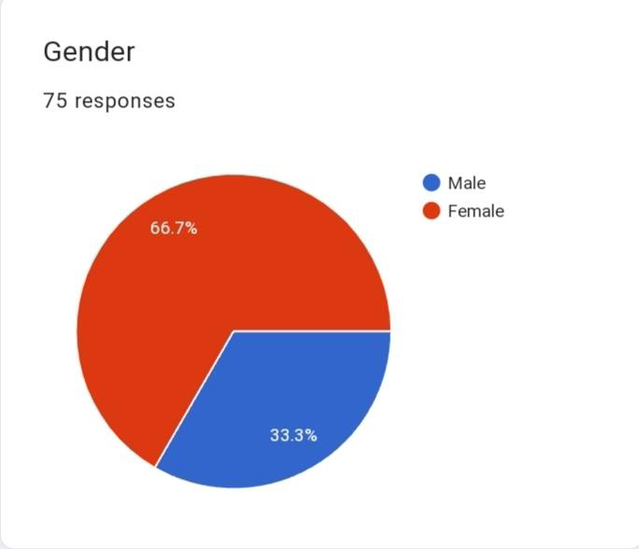

Among 75 respondents, 50 of them are females and the remaining 25 are males.

**4.2 AGE OF RESPONDENTS**

This table shows the age wise classification of the respondents.

**Table 4.2**

| AGE | FREQUENCY | PERCENTAGE |
| --- | --- | --- |
| 13-20 | 19 | 25.3 |
| 20-25 | 51 | 68 |
| 25-30 | 5 | 6.7 |
| TOTAL | 75 | 100 |

The figure shows the age wise classification of the respondents.

**figure 4.2**

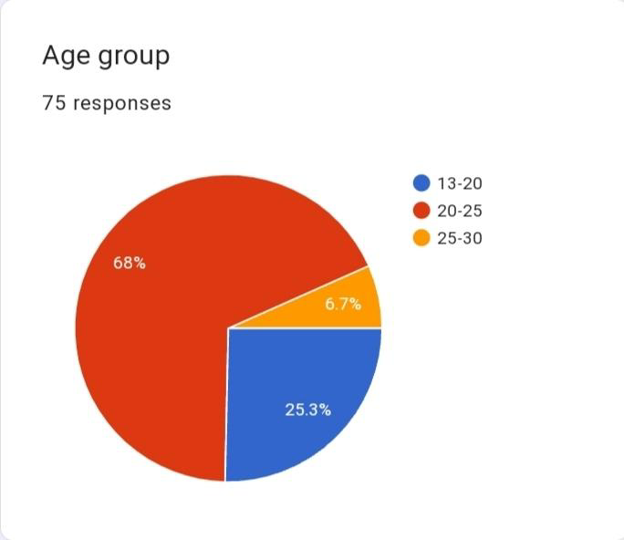

The above table shows the data is collected from 19 respondents of age between 13-20 and 51 respondents of age between 20-25 and 5 respondents of 25-30 age group.

**4.3 STATUS OF THE RESPONDENTS**

The table shows the status of the respondents whether they are students, working or doing business.

**Table 4.3**

| STATUS | FREQUENCY | PERCENTAGE |
| --- | --- | --- |
| STUDENT | 62 | 82.7 |
| WORKING | 12 | 16 |
| BUSINESS | 1 | 1.3 |
| TOTAL | 75 | 100 |

The figure shows the status of the respondents , whether they are students, working or doing business.

**figure 4.3**

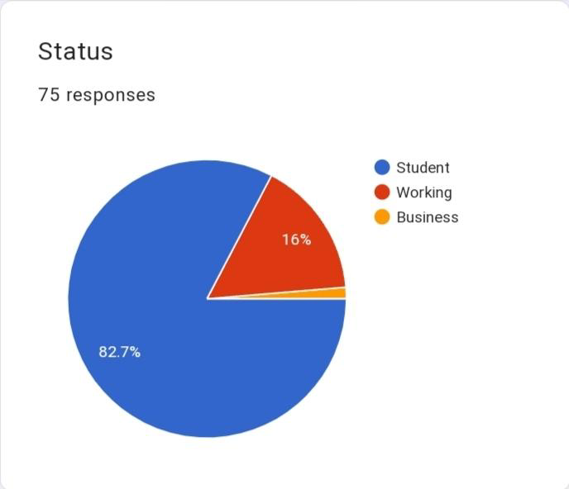

The table shows that among the respondents 62 were students , 12 were working and one of them is doing business.

**4.4 FAST FASHION BRAND SHOPPING**

The table shows whether the respondents shops from fast fashion brand.

**Table4.4**

| OPTIONS | FREQUENCY | OPTIONS |
| --- | --- | --- |
| YES | 55 | 73.3 |
| NO | 20 | 26.7 |
| TOTAL | 75 | 100 |

The figure shows whether the respondents shop from fast fashion brands.

**Figure 4.4**

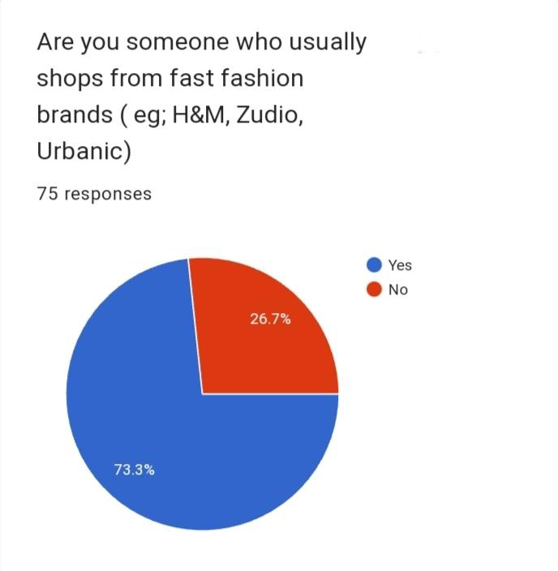

The above table shows that among the respondents 73.3% does shopping from fast fashion brands, while 26.7% is not into fast fashion shopping.

**4.5 FREQUENCY OF SHOPPING FROM FAST FASHION BRANDS**

The table shows how frequent the respondents shops from fast fashion brands.

**Table 4.5**

| OPTIONS | FREQUENCY | PERCENTAGE |
| --- | --- | --- |
| OCCASIONALLY | 36 | 48 |
| MONTHLY | 5 | 6.7 |
| QUARTERLY | 17 | 22.7 |
| HALF YEARLY | 8 | 10.7 |
| ANNUALLY | 9 | 12 |
| TOTAL | 75 | 100 |

The figure shows how frequent the respondents shops from fast fashion brands.

**Figure 4.5**

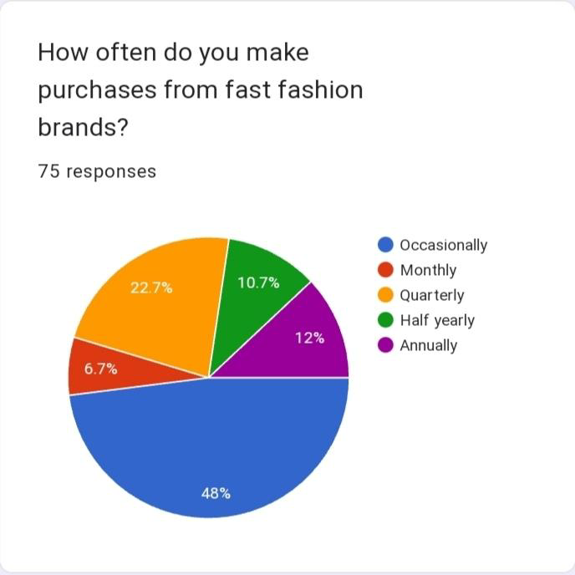

The above table shows that 48% of the respondents purchase from fast fashion brands occasionally, 6.7% of the respondents purchases monthly, 22.7% of the respondents purchases quarterly, 10.7% purchases half yearly and 12% purchases on a yearly basis.

**4.6 FAST FASHION BRANDS PREFERED BY THE RESPONDENTS**

The table shows the brands preferred by the respondents

**Table 4.6**

| OPTIONS | FREQUENCY | PERCENTAGE |
| --- | --- | --- |
| H&M | 7 | 9.3 |
| ZARA | 2 | 3.6 |
| URBANIC | 5 | 7.8 |
| ZUDIO | 55 | 73.3 |
| TRENDS | 1 | 1 |
| MAX | 1 | 1 |
| LIFESTYLE | 1 | 1 |
| OTHERS | 1 | 1 |
| NA | 1 | 1 |
| FACTORY OUTLETS | 1 | 1 |
| TOTAL | 75 | 100 |

The figure shows the brands preferred by the respondents.

**Figure 4.6**

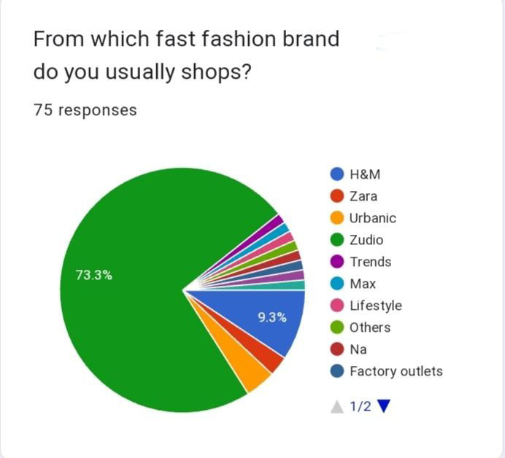

The above table shows that among the respondents 9.3% are purchasers of H&M, 3.6% are ZARA, 7.8% are URBANIC, 73.3% that is the majority of the respondents are purchasers of Zudio and the remaining respondents purchase from other options by 1%.

**4.7 PRICE POINT OF FAST FASHION PRODUCTS**

The table shows the respondents view on reasonability of price of fast fashion products.

**Table 4.7**

| OPTIONS | FREQUENCY | PERCENTAGE |
| --- | --- | --- |
| STRONGLY AGREE | 4 | 5.3 |
| AGREE | 20 | 26.7 |
| NEUTRAL | 41 | 54.7 |
| DISAGREE | 8 | 10.7 |
| STRONGLY DISAGREE | 2 | 2.7 |

The figure shows the respondents view on responsibility of price of fast fashion products.

**Figure 4.7**

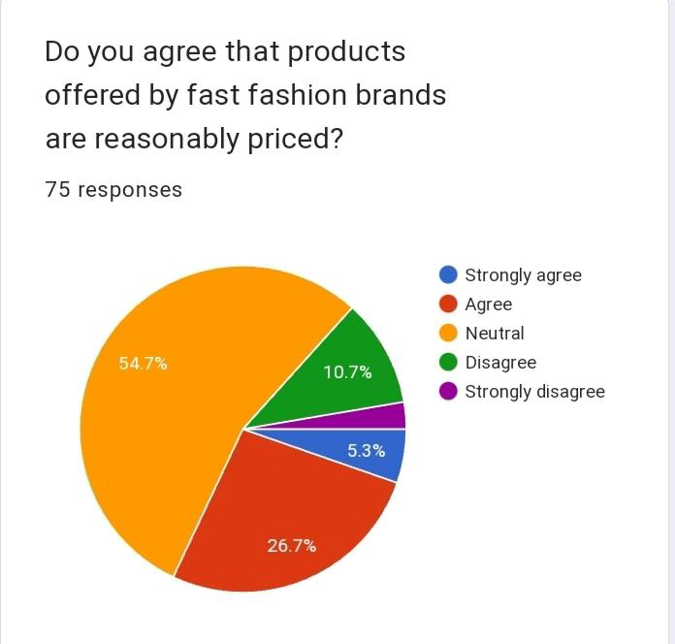

The above table shows that among 75 respondents ,5.3% strongly agrees that fast fashion products are reasonably priced, while 26.7% agrees, 54.7% are of neutral view, 10.7% 0f the respondents disagree with the statement and the remaining 2.7% strongly disagree.

**4.8 EXAMINING THE QUALITY OF FAST FASHION BRANDS**

The table shows the respondents point of view on the basis of quality of the products offered by fast fashion brands.

**Table 4.8**

| OPTIONS | FREQUENCY | PERCENTAGE |
| --- | --- | --- |
| STRONGLY AGREE | 4 | 5.3 |
| AGREE | 43 | 57.3 |
| NEUTRAL | 26 | 34.7 |
| DISAGREE | 2 | 2.7 |
| STRONGLY DISAGREE | 0 | 0 |
| TOTAL | 75 | 100 |

The figure shows the respondents point of view on the basis of quality of the products offered by fast fashion brands.

**Figure 4.8**

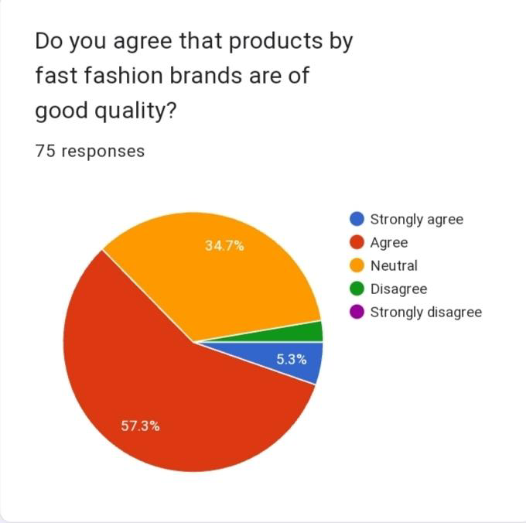

The above table shows that 5.3% 0f 75 respondents strongly agree on the statement of good quality fast fashion products, 57.3% agrees, 34.7% are on neutral view and 2.7% of the respondents disagrees and none of them strongly disagrees on the quality of fast fashion products.

**4.9 FASHIONABILITY OF PRODUCTS OFFERED BY FAST FASHION BRANDS**

The table shows the respondents view on the products offered by fast fashion brands are fashionable.

**Table 4.9**

| OPTIONS | FREQUENCY | PERCENTAGE |
| --- | --- | --- |
| STRONGLY AGREE | 13 | 17.3 |
| AGREE | 51 | 68 |
| NEUTRAL | 10 | 13.3 |
| DISAGREE | 1 | 1.4 |
| STRONGLY DISAGREE | 0 | 0 |
| TOTAL | 75 | 100 |

The figure shows the respondents view on the products offered by the fast fashion brands are fashionable.

**Figure 4.9**

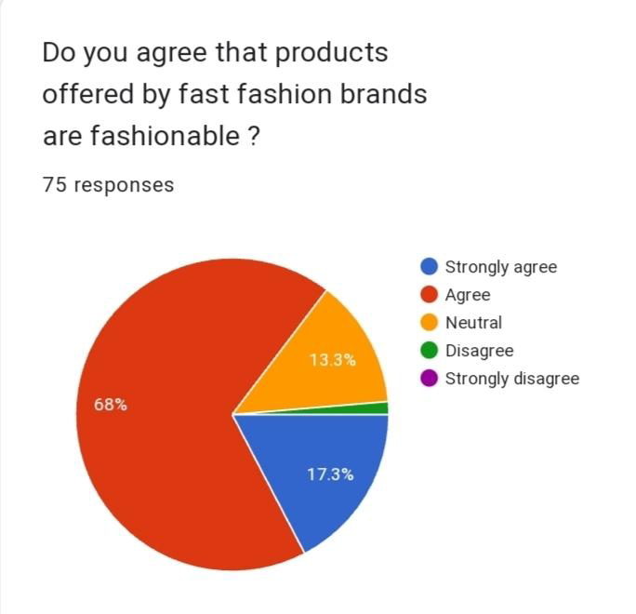

The above figure shows that 17.3% of the respondents strongly agree that products offered by fast fashion brands are fashionable, 68% agree with the statement, 13.3% are of neutral option, 1.4% disagree with the statement and none strongly disagrees regarding the fashion of the fast fashion products.

**4.10 IMPACT OF SOCIAL MEDIA ON YOUTH’S PERCEPTION ON FAST FASHION BRANDS**

The table shows the influence of social media on youth’s perception on fast fashion brands.

**Table 4.10**

| OPTION | FREQUENCY | PERCENTAGE |
| --- | --- | --- |
| YES | 64 | 85.3 |
| NO | 3 | 4 |
| MAYBE | 8 | 10.7 |
| TOTAL | 75 | 100 |

The figure shows the influence of social media on the youth’s perception on fast fashion brands.

**Figure 4.10**

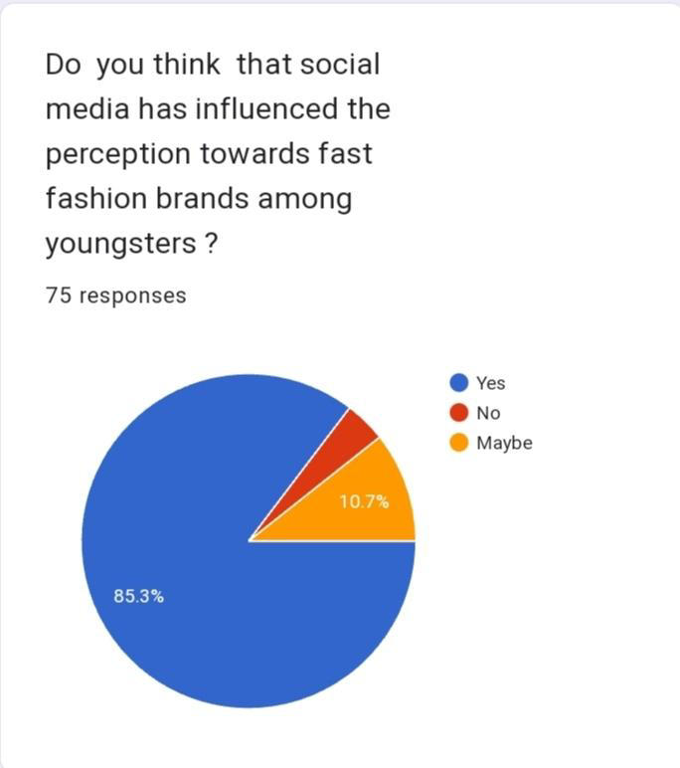

The above chart shows that 85.3% of the respondents think that social media has influence on fast fashion brands among the youth, 4% of the respondents have opted no and the remaining 10.7% have given a maybe option.

**4.11 AWARENESS ABOUT THE ADVERSE EFFECTS OF FAST FASHION BRANDS ON THE ENVIRONMENT**

The table shows the awareness of the respondents regarding the adverse effect of fast fashion brands on the environment.

**Table 4.11**

| OPTIONS | FREQUENCY | PERCENTAGE |
| --- | --- | --- |
| YES | 53 | 70.7 |
| NO | 22 | 29.3 |
| TOTAL | 75 | 100 |

The figure shows the awareness of the respondents regarding the adverse effect of fast fashion brands on the environment

**Figure 4.11**

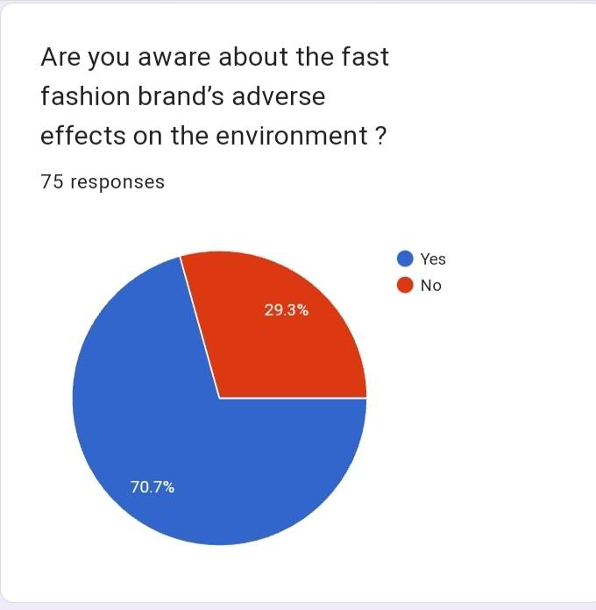

The above chart shows that 70.7% of the respondents are aware of the adverse effects of fast fashion brands on the environment, 29.3% of the respondents are unaware of the effects on the environment.

**4.12 AWARENESS ABOUT THE WORKING CONDITION UNDER WHICH THE PRODUCTS ARE MANUFACTURED.**

The table shows whether the respondents are aware about the working conditions under which the products are manufactured.

**Table 4.12**

| OPTION | FREQUENCY | PERCENTAGE |
| --- | --- | --- |
| YES | 29 | 38.7 |
| NO | 46 | 61.3 |
| TOTAL | 75 | 100 |

The figure shows whether the respondents are aware about the working conditions under which the products are manufactured.

**Figure 4.12**

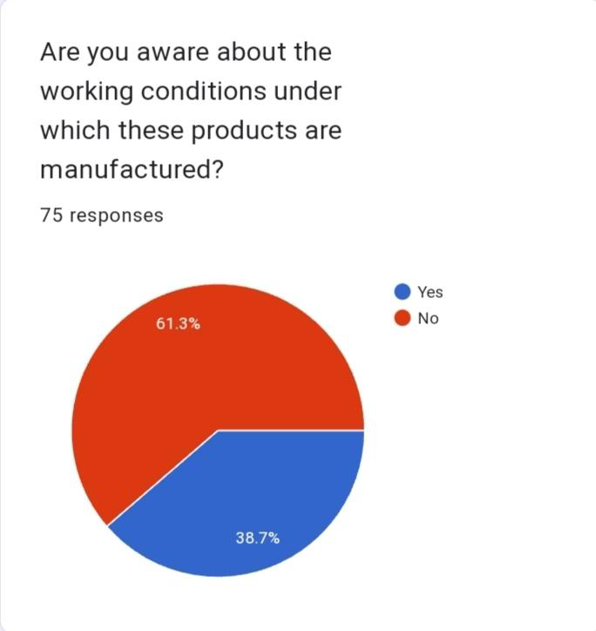

The above chart shows that 38.7% of the respondents are aware of the working conditions , while 61.3% of the respondents are not aware of the working conditions under which these products are manufactured.

**4.13 ASSESSING YOUTH’S AWARENESS ABOUT THE CONSEQUENCES OF FAST FASHION**

This table shows whether the youth is aware about the consequences of fast fashion.

**Table 4.13**

| OPTIONS | FREQUENCY | PERCENTAGE |
| --- | --- | --- |
| YES | 17 | 22.7 |
| NO | 23 | 30.7 |
| MAYBE | 35 | 46.7 |
| TOTAL | 75 | 100 |

This figure shows whether the youth is aware about the consequences of fast fashion.

**Figure 4.13**

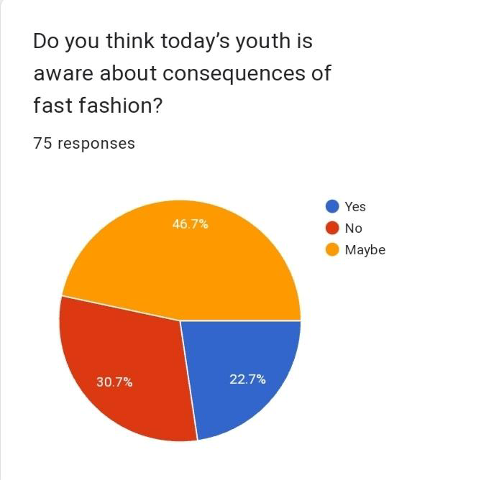

The above chart shows that 22.7% of the respondents are aware of the consequences of fast fashion, 30.7% of the respondents are not aware, while the remaining 46.7% of the respondents are not sure

**4.14 EXPLORING AWARENESS OF SUSTAINABLE FASHION PRACTICES**

The table shows whether the respondents are aware about sustainable fashion practices.

**Table 4.14**

| OPTION | FREQUENCY | PERCENTAGE |
| --- | --- | --- |
| YES | 51 | 68 |
| NO | 24 | 32 |
| TOTAL | 75 | 100 |

The figure shows whether the respondents are aware about sustainable fashion practices.

**Figure 4.14**

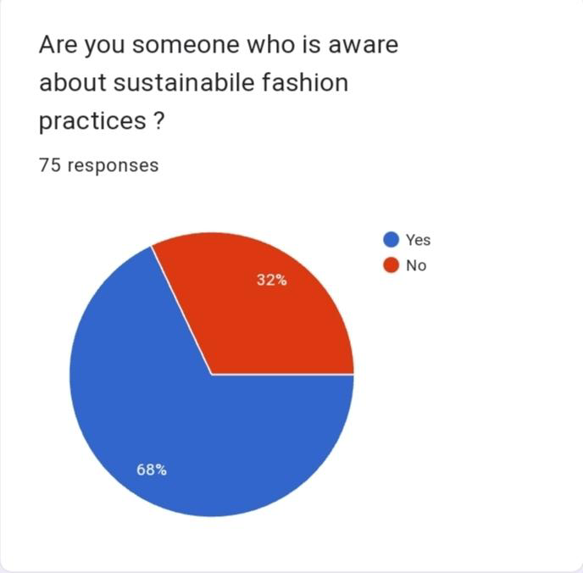

The above figure shows the awareness of the respondents about sustainable fashion practices where 68% of the respondents are aware and the remaining 32% are not aware.

**4.15 THE IMPORTANCE OF PROMOTING SUSTAINABLE FASHION FOR GLOBAL ENVIRONMENTAL PROTECTION**

The following table shows the necessity for promoting sustainable fashion for protecting the global environment.

**Table 4.15**

| OPTIONS | FREQUENCY | PERCENTAGE |
| --- | --- | --- |
| STRONGLY AGREE | 22 | 29.3 |
| AGREE | 33 | 44 |
| NEUTRAL | 15 | 20 |
| DISAGREE | 4 | 5.3 |
| STRONGLY DISAGREE | 1 | 1. 3 |
| TOTAL | 75 | 100 |

The folwing figure shows the necessity for promoting sustainable fashion for protectingthe global environment.

**Figure 4.15**

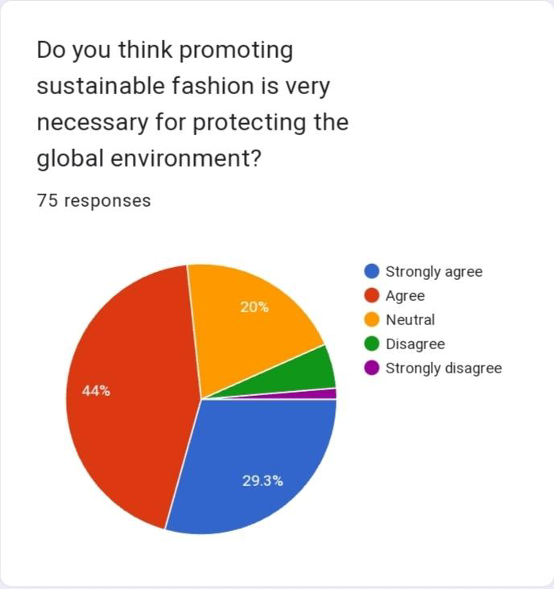

The above chart shows that among 75 respondents 29.3% strongly agree with the promotion of sustainable fashion for protecting the global environment, 44% of the respondents agree with the statement, 20% are of neutral option, 5.3% disagree with the statement and the remaining 1.3% strongly disagree.

**4.16 WILLINGNESS TO SHIFT TO SLOW OR SUSTAINABLE FASHION**

The table shows the willingness of the respondents to shift to slow or sustainable fashion.

**Table 4.16**

| OPTIONS | FREQUENCY | PERCENTAGE |
| --- | --- | --- |
| YES | 30 | 40 |
| NO | 12 | 16 |
| MAYBE | 33 | 44 |
| TOTAL | 75 | 100 |

The figure shows the willingness of the respondents to shift to slow or sustainable fashion.

**Figure 4.16**

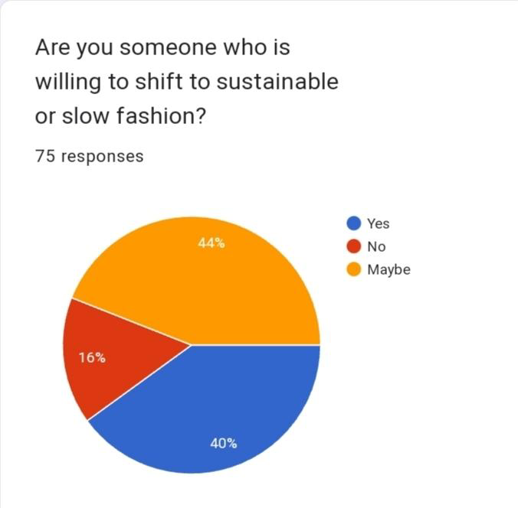

The above chart shows that among 75 respondents 40% are willing to shift to slow or sustainable fashion, 16% of the respondents are not willing to shift and 44% have opted maybe.

**4.17 STRATEGIES FOR PRACTICING SUSTAINABLE FASHION**

The following figure shows the ways in which the respondents practice sustainable fashion.

**Figure 4.17**

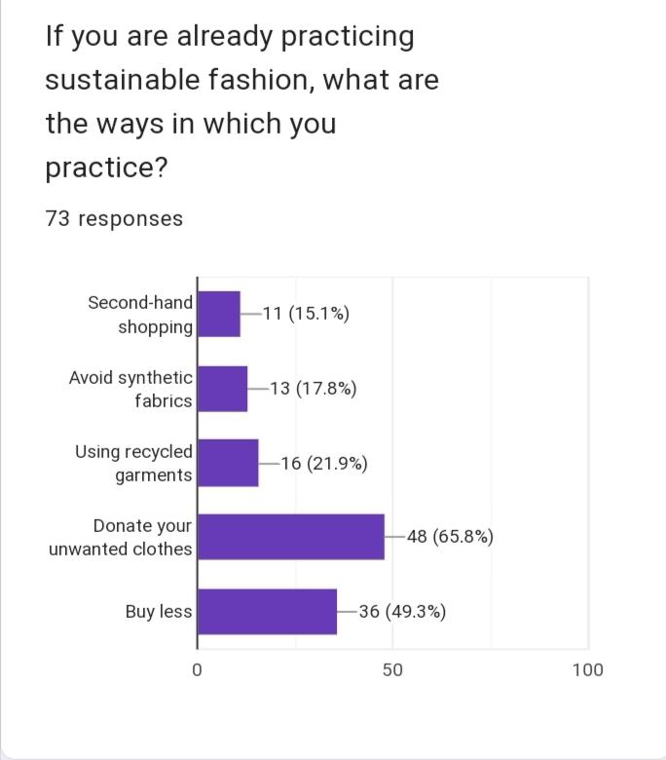

The above graph shows that among 75 respondents 15.1% of the respondentspractices scond hand shopping, 17.8% avoids the use of synthetic fibers, 21.9% uses recycled garments, 65.8% donates unwanted clothes and the remaining 49.3% respondents buy less.

**4.18 EMBRACING THRIFTED AND PRE-OWNED GARMENTS**

The following table shows whether the respondents use pre-owned garments.

**Table 4.17**

| OPTIONS | FREQUENCY | PERCENTAGE |
| --- | --- | --- |
| YES | 31 | 41.3 |
| NO | 44 | 58.7 |
| TOTAL | 75 | 100 |

The following figure shows whether the respondents use pre-owned garments.

**Figure 4.18**

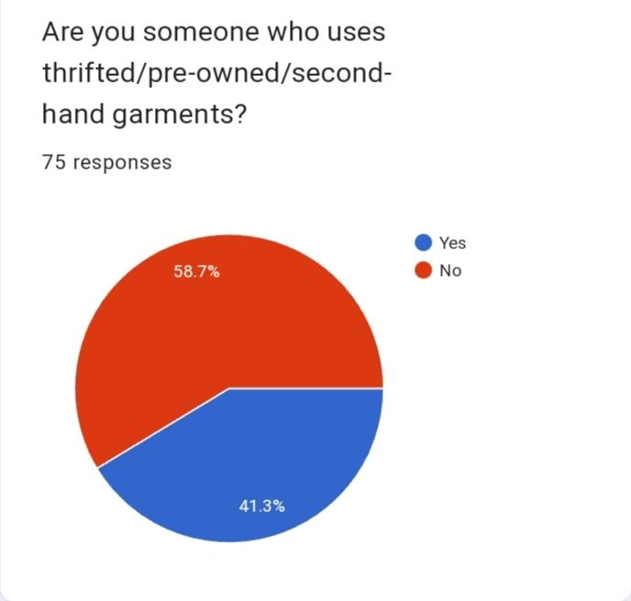

The above chart shows that among 75 respondents 58.7% of the respondents use thrifted garments, while the remaining 41.3% does not use thrifted garments.

**4.19 INCORPORATING SUSTAINABLE AND ETHICAL CONSIDERATIONS INTO SHOPPING PRACTICES**

The following table shows whether the respondents consider sustainable and ethical practices of brands while shopping.

**Table 4.18**

| OPTIONS | FREQUENCY | PERCENTAGE |
| --- | --- | --- |
| YES | 14 | 18.7 |
| NOT YET | 24 | 32 |
| SOMETIMES | 37 | 49.3 |
| TOTAL | 75 | 100 |

The following figure shows whether the respondents consider sustainable and ethical practices of brands while shopping.

**Figure 4.19**

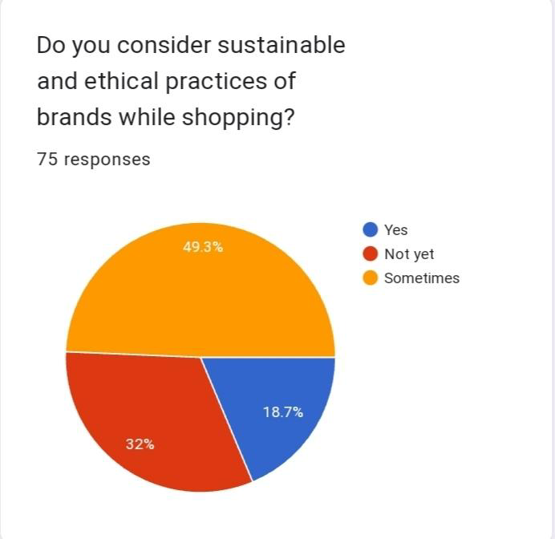

The above chart shows that among 75 respondents 18.7% of the respondents considers sustainable and ethical practices while shopping, 32% has not yet thought about it, while the remaining 49.3% considers the statement sometimes.

**4.20 THE CALL FOR TRANSPARENCY**

The following table shows respondents point of view on whether the brands should be more transparent about their production process.

**Table 4.19**

| OPTIONS | FREQUENCY | PERCENTAGE |
| --- | --- | --- |
| YES | 66 | 88 |
| NO | 9 | 12 |
| TOTAL | 75 | 100 |

The following figure shows respondents point of view on whether the brands should be more transparent about their production process.

**Figure 4.20**

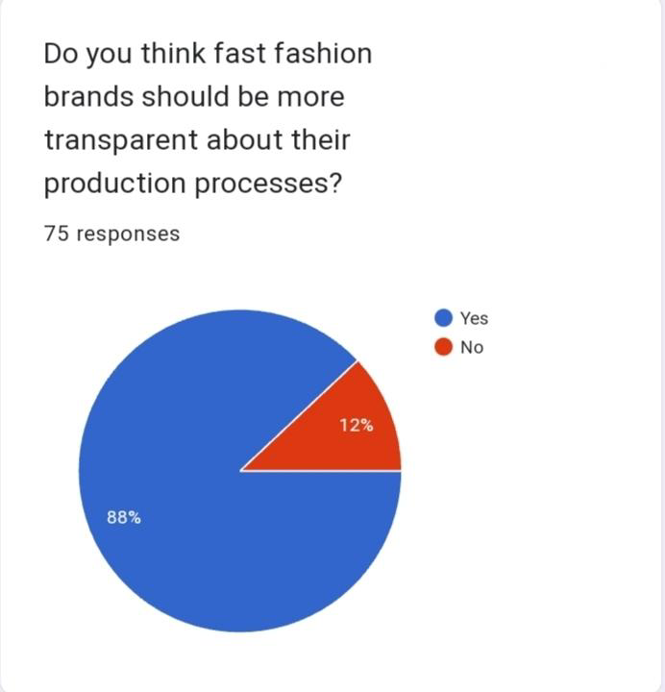

The above chart shows that among the respondents 88% think that fast fashion brands should be transparent about their production processes, while the remaining 12% do not think likewise.

**4.21 THE IMPACT OF FAST FASHION IN SHORTENING THE LIFESPAN OF FASHION TRENDS**

The following table shows the respondents view on the impact of fast fashion in shortening the lifespan of fashion trends.

**Table 4.20**

| OPTIONS | FREQUENCY | PERCENTAGE |
| --- | --- | --- |
| YES | 40 | 53.3 |
| NO | 7 | 9.3 |
| MAYBE | 28 | 37.3 |
| TOTAL | 75 | 100 |

The following figure shows the respondents view on the impact of fast fashion in shortening the lifespan of fashion trends.

**Figure 4.21**

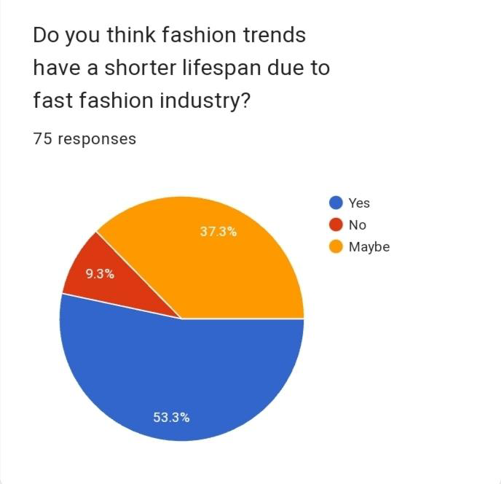

The above chart shows that among the respondents 53.3% have chosen yes, 9.3% thinks no and the remaining 37.3% have chosen maybe.

**4.22 EVALUATING BRAND’S SATISFACTION**

The following chart shows the ratings given to brands such as H&M, GAP, Urbanic, Zudio & Roadster by the customers on the basis of customer satisfaction.

**Figure 4.22**

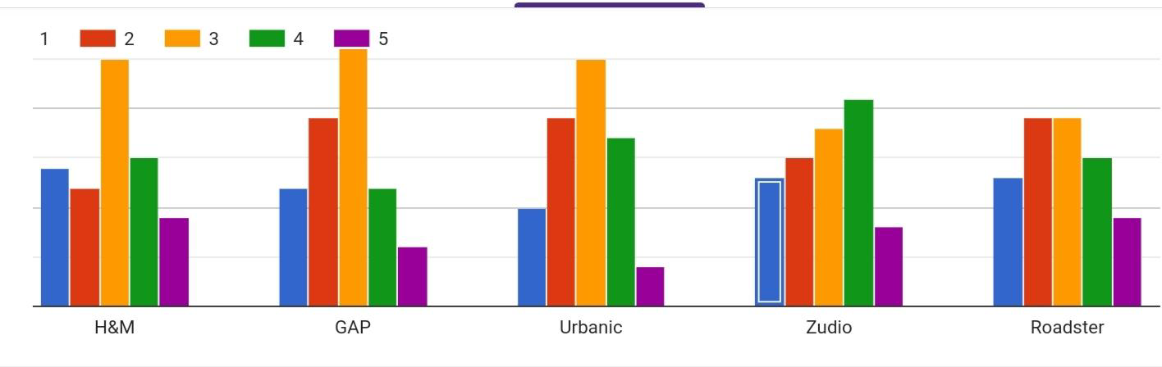

**H&M;**

Among the 75 respondents, the majority of the respondents have rated 3 for H&M (ie;25).

**GAP;**

Among the respondents, the majority of the ones rated 3 for GAP (ie;26).

**Urbanic;**

Among the respondents, the majority of them rated 3 for Urbanic (ie;25).

**Zudio;**

Among the five brands Zudio has gained more ratings on the basis of customer satisfaction. The majority of the respondents rated 4 (ie;21) and 3 (ie;18).

**Roadster;**

Among the respondents, more than half of them have opted for both 2 & 3 (ie38) to rate their customer satisfaction.

**CHAPTER 4**

**FINDINGS, SUGGESTIONS AND CONCLUSION**

**5.1 FINDINGS**

1. In this study, out of the 75 respondents, 50 respondents are female(66.7%) and 25 respondents are male (33.3%).
2. It is observed that most of the respondents belong to the age category of 20-25 years.
3. All the respondents were from Ernakulam District.
4. It is found that 82.7% of the respondents are students.
5. It is observed that the majority of the respondents (73.3%) usually shop from fast fashion brands such as H&M, ZARA, Zudio etc.
6. The study shows that 48% of the respondents occasionally shop from fast fashion brands, 22.7% shops quarterly from fast fashion brands , 12% shops annually , 10.7% shops half yearly and only 6.7% shops monthly from fast fashion brands.
7. The study shows that the majority of the respondents shop from Zudio (73.3%)and 9.3% shops from H&M and 4% shops from Urbanic and the rest from ZARA, Max, Lifestyle, factory outlets etc.
8. It is observed that 54.7% of the respondents neutrally agree that products offered by fast fashion brands are reasonably priced. Only 10.7% strongly agree that the products are reasonably priced.
9. The study shows that only 5.3% of the respondents strongly agree that the products offered by fast fashion brands are of good quality and 57.3% agree and 34.7% voted for neutral.
10. The study shows that 68% of the respondents agreed that the products offered by fast
11. fashion brands are fashionable.
12. It is found that 85.3% of the respondents think that social media has influenced the perception towards fast fashion brands among youngsters.
13. It is observed that 70.7% of the respondents are aware about fast fashion brands' adverse effect on the environment and also 61.3% of the respondents are aware about the working conditions under which these products are manufactured.
14. The study shows that 68% of the respondents are aware about sustainable fashion.
15. The study also shows that 40% of the respondents are willing to shift to sustainable or slow fashion.
16. It is observed that out of the respondents who are already practicing sustainable fashion, 65.8% donates their unwanted clothes and 49.3% choose buying less.
17. The study shows that 58.7% of the respondents use thrifted , pre-owned , second hand garments.
18. The study shows that 49.3% of the respondents sometimes consider sustainable and ethical practices of brands while shopping.
19. It is found that 88% of the respondents think that fast fashion brands should be more transparent about their production processes.
20. It is found that 53.3% of the respondents think that fashion trends have a shorter lifespan due to the fast fashion industry.
21. Among the five brandsi.e’ H&M, GAP, Urbanic , Zudio and roadster, Zudio has gained more ratings on the basis of customer satisfaction.

**5.2 SUGGESTIONS**

1. Proper awareness must be given to people regarding the environmental problems that fast fashion brands create.
2. Working environment of the workers of the fast fashion industry must be made saYfer for them to work.
3. We must follow sustainable fashion and also encourage others to practice sustainable and slow fashion in their life and reduce the harmful effects on the environment.
4. Sustainable fashion practices such as avoiding synthetic fabrics, using recycled garments , buying less and donating unwanted clothes must be encouraged.
5. Proper rules and regulations must be made for the fast fashion industry to follow.
6. Brands must be more transparent about their production processes and other policies so that customers can analyze them.
7. HBrands must carry out their production and other policies sustainable and environment friendly in the most ethical manner.
8. People must consider sustainable and ethical practices of brands before making purchase decisions.
9. Youngsters must be given awareness about sustainable slow fashion practices and encourage them to practice it.
10. More thrift shops and thrifting programs must be organized .
11. Supporting brands that prioritize ethical production.

**5.3 CONCLUSION**

In the study we found that young people have diverse perspectives on fast fashion. While some view it as a convenient and affordable way to keep up with the trends , others have become more aware of its detrimental effects .The negative impact of fast fashion on the environment and labor conditions cannot be ignored . However, it was encouraging to see that some youth are seeking sustainable and ethical fashion choices . This study emphasizes the importance of education and awareness to promote responsible fashion consumption among the younger generation . By encouraging sustainable practices and supporting brands that prioritize ethical production , we can work together to create a more sustainable future.

Some young people see fast fashion as a convenient way to stay stylish on a budget, others are becoming increasingly aware of its negative consequences. They are concerned about the environmental impact, such as excessive waste and pollution, as well as the ethical concerns surrounding labor conditions in the fashion industry.

However, amidst these concerns, there is a glimmer of hope. We found that a significant portion o f the youth are open to embracing sustainable fashion practices. They are willing to make more conscious choices, supporting brands that prioritize ethical production and opting for second-hand or upcycled clothing. This highlights the potential for positive change and the importance of education and awareness campaigns to empower young people to make more informed fashion decisions.

To truly address the impact of fast fashion, it is crucial to foster a collaborative approach. Brands, consumers, and policymakers must come together to create a more sustainable and ethical fashion industry. By promoting transparency, encouraging responsible consumption, and supporting initiatives that prioritize sustainability, we can pave the way for a brighter future in fashion.

**BIBLIOGRAPHY**

**BIBLIOGRAPHY**

**WEBSITES:**

[**https://m.economictimes.com**](https://m.economictimes.com)

[**https://marketingmind.in**](https://marketingmind.in)

[**https://www.biologicaldiversity.org**](https://www.biologicaldiversity.org)

[**https://earth.org**](https://earth.org)

[**https://www.unep.org**](https://www.unep.org)

[**https://www.investopedia.com/terms/f/fast-fashion.asp**](https://www.investopedia.com/terms/f/fast-fashion.asp)

[**https://www.genevaenvironmentnetwork.org/resources/updates/sustainable-fashion**](https://www.genevaenvironmentnetwork.org/resources/updates/sustainable-fashion)

**ANNEXURE**

**QUESTIONNAIRE**

1. Name

2. E-Mail ID

3.Age group

1. 13-20
2. 20-25
3. 25-30

 4. Gender

1. Male
2. Female

 5.District

Ernakulam

6. Status

1. Student
2. Working
3. other

7.Are you someone who usually shops forms fast fashion brands

1. Yes
2. no

8.How often do you make purchases from fast fashion brands?

1. occasionally
2. Monthly
3. Quarterly
4. Half yearly
5. Annually

9. From which fast fashion brand do you usually shop

1. H&M
2. Zara
3. Urbanic
4. Zudio
5. other

10. Do you agree that products offered by fast fashion brands are reasonably priced?

1. Strongly agree
2. Agree
3. Neutral
4. Disagree
5. Strongly disagree

11. Do you agree that products by fast fashion brands are of good quality?

1. Strongly agree
2. Agree
3. Neutral
4. Disagree
5. Strongly disagree

12. Do you  agree that products offered by fast fashion brands are fashionable?

1. Strongly agree
2. Agree
3. Neutral
4. Disagree
5. Strongly disagree

13. Do you think that social media has influenced the perception  towards fast fashion among youngsters?

1. Yes
2. No
3. Maybe

14. Are you aware about the fast fashion brands adverse  effect on the environment?

1. Yes
2. no

15. Are you aware about the working conditions under which these products are manufactured?

1. Yes
2. no

16. Do you think today's youth are aware of the consequences of fast fashion?

1. Yes
2. No
3. May be

17. Are you someone who is aware of sustainable fashion practices?

1. Yes
2. no

18. Do you think promoting sustainable fashion is very necessary for protecting the global environment?

1. Strongly agree
2. Agree
3. Neutral
4. Disagree
5. Strongly disagree

19. Are you someone who is willing to shift to sustainable or slow fashion?

1. Yes
2. No
3. May be

20. If you are already practising sustainable fashion, what are the ways in which you practise ?

1. Second hand shopping
2. Avoid synthetic fabrics
3. Using recycled garments
4. Donate your unwanted clothes
5. Buy less
6. other

21. Are you someone who uses thrifted/ pre-owned / second-hand garments?

1. Yes
2. no

22. Do you consider sustainable and ethical practices of brands while shopping?

1. Yes
2. Not yet
3. sometimes

23. Do you think fast fashion brands should be more transparent about their production processes?

1. Yes
2. no

24. Do you think fashion trends have a shorter lifespan due to the fast fashion industry?

1. Yes
2. No
3. May be

25.  Rate the following brands according to the level of satisfaction ( considering price, quality and fashionability

1. H&M
2. GAP
3. Urbanic
4. Zudio
5. Roadster