**SOLAR POWERED BAG**

**PROJECT REPORT**

Submitted by

MELNA ANN BERNCY

**(AB21PHY004)**

Under the guidance of

**Dr. FRINCY FRANCIS**

**Assistant Professor**

**Department of Physics,**

**St. Teresa’s College (Autonomous), Ernakulam**

*In the partial fulfillment of the requirements of award of*

*Bachelor degree of Science in Physics.*

**

**ST. TERESA’S COLLEGE (AUTONOMOUS)**

**ERNAKULAM**

**2023-24**

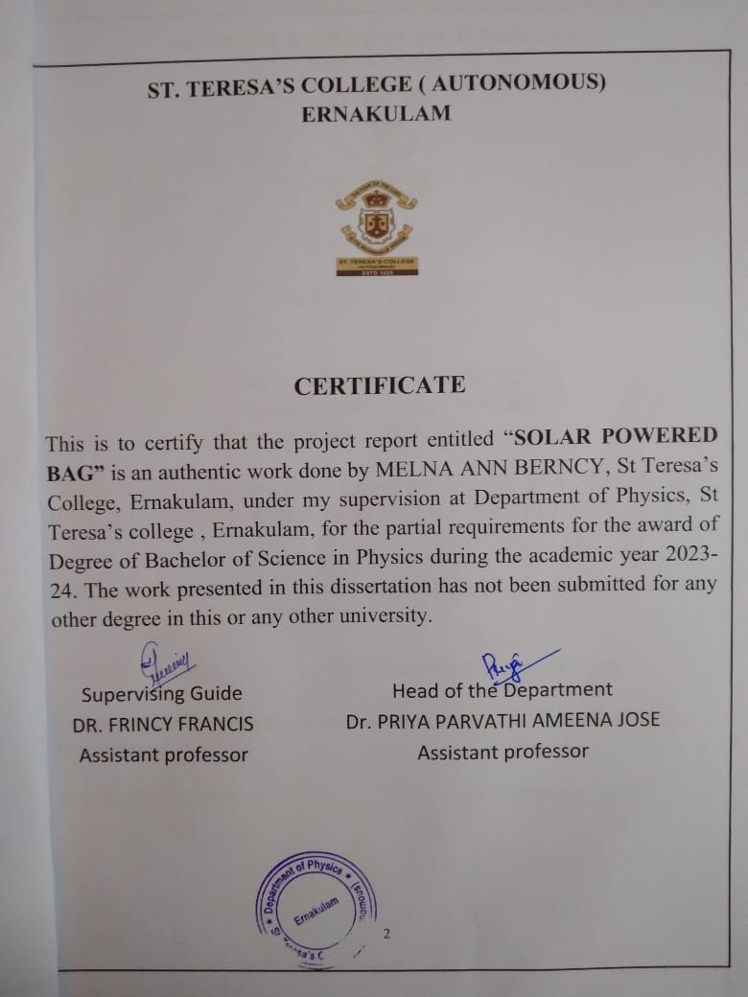

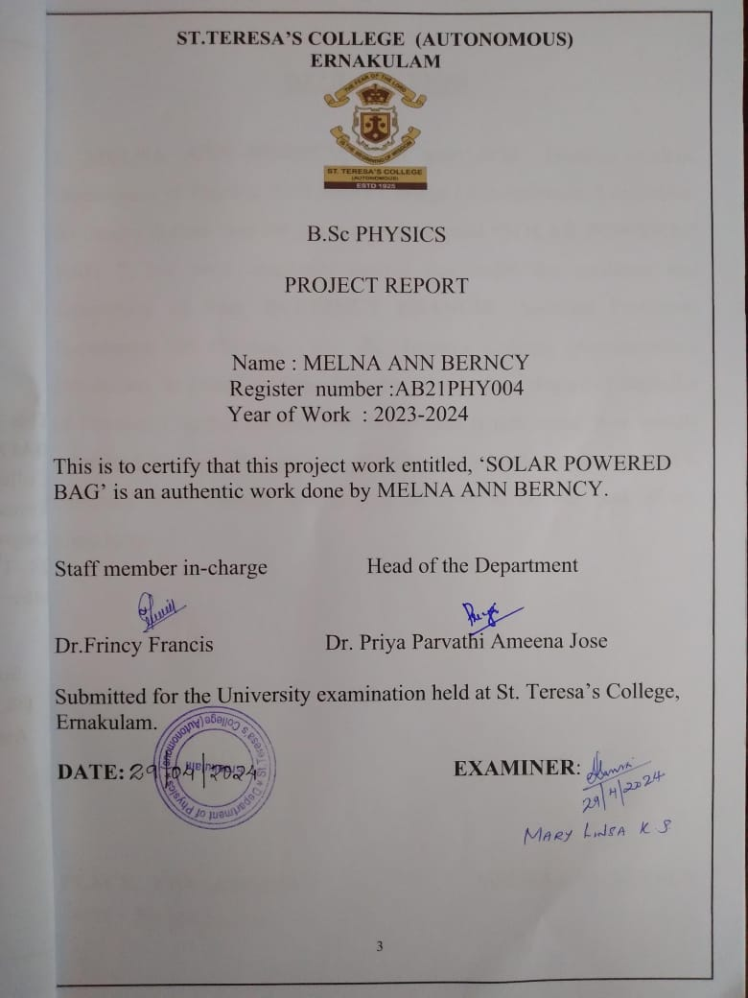

**DECLARATION**

I, **MELNA ANN BERNCY,** final year B.Sc. Physics student, Department of Physics, St. Teresa's College (Autonomous), Ernakulam, do hereby declare that the project work entitled **“SOLAR POWERED BAG ”**, has been originally carried out under the guidance and supervision of **Smt. Dr.FRINCY FRANCIS**, Assistant Professor, Department Of Physics, St. Teresa's College (Autonomous), Ernakulam, in partial fulfilment for the award of the degree of Bachelor of Physics. I further declare that this project is not partially or wholly submitted for any other purpose and the data included in the project is collected from various sources and are true to be the best of my knowledge.

**PLACE: ERNAKULAM** MELNA ANN BERNCY

**DATE : 29/04/2024**

**ACKNOWLEGEMENT**

I would want to offer my heartfelt gratitude to everyone who assisted me in reaching this point of fulfilment .First and foremost, I thank the Lord Almighty for His abundant mercy throughout this project .I am grateful to DR.FRINCY FRANCIS , St. Teresa’s College (Autonomous),for her invaluable direction and regular monitoring ,as well as for supplying vital project information and assistance in finishing the project .I want to thank all of the teachers and non-teaching staffs for their helpful advice and suggestions in completing the project .My gratitude and appreciation also go to everyone who has freely assisted us.

**ABSTRACT**

This project aims to design and construct a solar mobile charging unit implemented in the bag that will charge from solar energy. This technology will help people to charge their mobile devices at places where electricity is unavailable. The solar bags are useful especially while traveling, so that the consumers do not need to carry chargers and cables. One of the primary benefits of this project is the reduction of reliance on traditional energy sources such as fossil fuels generating electricity from solar panels. The renewable solar bag represents a ground breaking innovation in portable energy solutions by integrating solar assisted technology into everyday handbags. We can also lower energy bills and reduce their impact on the environment. This abstract explores the design, functionality and environmental impact of renewable bag, highlighting it ability to harness solar energy to charge mobile devices especially crucial in emergency situations and difficult environment. Additionally, solar power is a renewable energy source that is continuously replenishing, unlike finite fossil fuels.

**MOTIVATION**

The motivation behind the project of incorporating solar mobile charging unit into the bags arises from the growing concerns for sustainable energy solutions and the increasing reliance on electronic devices in today's world. Integrating these solar mobile charging unit into the bags helps individuals harness solar energy to charge their devices without the need for traditional electricity sources.

India‘s new education policy aims to provide equitable and inclusive education, this project is a strategic and innovative initiative that addresses the growing need for sustainable energy.

This project aims to contribute towards sustainable living practices and foster a greener future by utilizing renewable energy in everyday essentials.

**SOLAR POWERED BAG**

**CONTENTS**

**ABSTRACT 6**

**MOTIVATION 7**

**CHAPTER 1 11**

INTRODUCTION

* 1. NON RENEWABLE SOURCES OF ENERGY  **11**

1.2 RENEWABLE SOURCES OF ENERGY **11**

1.3 SOLAR CELL **13**

1.4 TYPES OF SOLAR CELLS **15**

1.5 SOLAR PANEL **16**

1.6 ADVANTAGES **18**

1.7 DISADVANTAGES **19**

**CHAPTER 2**

BASIC OF PHOTOVOLTAICS **20**

2.1 SOLAR CELL PARAMETERS **22**

2.2 SOLAR CELL SERIES CONNECTION  **23**

2.3 SOLAR CELL PARALLEL CONNECTION **24**

2.4 V-I CHARACTERISTICS OF SOLAR **25**

2.5 OBSERVATION **26**

2.6 APPLICATION OF PHOTOVOLTAIC CELL  **29**

**CHAPTER 3 31**

EXPERIMENTAL STUDIES

3.1 SOLAR MOBILE CHARGING UNIT  **31**

3.2 STORAGE SYSTEM **36**

**CHAPTER 4**

CONCLUSION **39**

4.1 INFERENCE **39**

4.2 DISCUSSION **40**

4.3 FUTURE SCOPE **40**

4.4 REFERENCE  **41**

**CHAPTER 1**

**INTRODUCTION**

The classical description of energy is the ability of a system to perform work. Numerous sources of energy can be classified into two categories, non-renewable and renewable sources of energy.

1.1 NON-RENEWABLE SOURCES OF ENERGY

Non-renewable sources of energy are finite resources that can’t be easily replaced and are being depletion condition. These sources include fossil fuels such as coal, oil, and natural gases, as well as nuclear power. However, the extraction and burning of fossil fuels contribute to air pollution, climate change, and environmental degradation. The combustion of these fossil fuels releases greenhouse gases such as carbon dioxide, methane, and nitrous oxide, which leads to global warming. The depletion of non-renewable energy is a major concern for global energy security and economic stability. Therefore the reliance on non-renewable sources of energy is unsustainable and poses serious risks to the environment, public health, and global security. As a result, there is a growing urgency for the transition into a clear and more sustainable source of energy.

1.2 RENEWABLE SOURCES OF ENERGY

It produce heat and electricity which is a renewable source of energy . The types of biomass are solid waste, animal waste, biofuels, etc. Renewable sources of energy are resources that can be renewed once they are consumed. These sources of energy, such as solar, wind, geothermal and hydroelectric power are derived from natural resources Unlike non-renewable sources of energy like fossil fuels, renewable energy sources do not deplete over time and do not emit any greenhouse gases.

One of the widely recognized forms of renewable energy is solar power, which harnesses the energy of the sun through photovoltaic panels, or solar thermal systems Solar energy is an abundant, clean, and sustainable form of energy.

Wind power is another form of renewable source of energy that relies on the kinetic energy of wind to generate electricity through wind turbines. wind power is a clean and abundant resource that can help to decrease our dependence on fossil fuels.

Hydroelectric power is generated by capturing the energy of flowing water. dams and other hydroelectric facilities can generate large amounts of electricity, however, they also have significant environmental impacts on local ecosystems and wildlife.

Geothermal power is another form of energy. It power taps into the earth’s natural heat to produce electricity.it is produced from volcanoes, fumaroles, boric acid, etc.

Biomass energy utilizes organic materials like wood, crops, and agricultural residues.

Renewable sources of energy offer numerous advantages over the traditional force of fuels They produce significantly lower levels of greenhouse gas emissions, helping emit gate, climate change, and reducing air pollution. Furthermore, renewable energy sources are abundant and widely available, making them more reliable and secure energy options in the future Unlike fossil fuels, renewable sources of energy are stable and sustainable in the long term.

A solar mobile charging power bank uses solar energy to produce electricity. The electricity is stored and is used to charge mobile phones at any time. In the present scenario, this allows people to charge their phones whenever they need to. The concept of charging through solar panels implemented in bags is an innovation project that seeks to deal with the growing concern for sustainable energy solutions. This type of energy is beneficial for environmental factors and also offers endless possibilities for consumer usability and portability. The solar energy is harnessed to charge the power bank through wiring PV- -photovoltaic cells. This project involves integrating highly efficient solar panels into the bag, allowing the users to harness the light energy and convert it into electrical energy to charge the gadgets at any time, by utilizing renewable sources of energy(solar energy). Additionally, the integration of solar panels in bags promotes convenience and portability, enabling users to charge their mobile phones at any time and anywhere with access to sunlight. Exploring and developing solar consumer goods such as a solar mobile charging power bank, will increase the scope of research and development within this field.

1.3 SOLAR CELL

Solar cells, also known as photovoltaic cells, are electronic devices that convert sunlight directly into electricity through the photovoltaic effect. These cells are typically made of silicon-based materials and consist of several layers designed to capture and convert sunlight effectively. When photons from the sun strike the solar cell, the electrons are released hence generating an electric current. This current can be used to power various devices or stored in batteries . Solar cells have become increasingly popular in recent years due to their environmentally friendly nature and potential for significantly reducing electricity costs over time.

A solar cell module, or photovoltaic module, is a key component of solar panels that convert sunlight into electricity. These modules are made up of multiple interconnected solar cells, typically made from silicon, which work together to generate electrical current when exposed to sunlight. The efficiency and power output of a solar cell module depend on various factors such as the quality of materials used, the design and configuration of the cells, and the amount of sunlight received.

A solar cell string is a collection of individual solar cells connected in series to form a larger, more powerful unit. These strings are then combined with other strings to create a solar panel capable of converting sunlight into electricity. A key advantage of using solar cell strings is the ability to customize the size and output of solar panels based on specific energy needs.

A solar cell array, also referred to as a photovoltaic system, is an interconnected collection of solar cells that work together to convert sunlight into electricity. These arrays are utilized in a wide range of applications, from residential rooftops to large-scale commercial installations.

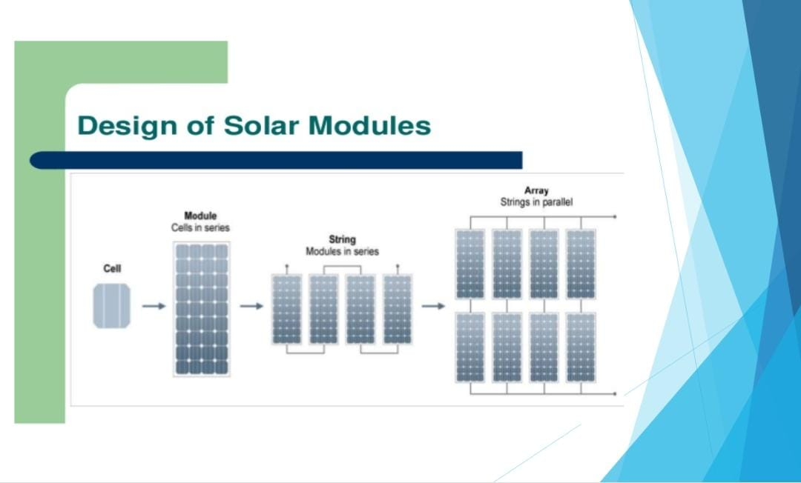

Figure 1.1- Design of solar modules.

1.4 TYPES OF SOLAR CELLS

Monocrystalline

The monocrystalline silicon cell is made from pure silicon (single crystal). Since the monocrystalline silicon is pure and defect-free, its efficiency is higher. Monocrystalline silicon is the first generation of solar cell technology, it has the highest conversion efficiency. Monocrystalline solar cells are the cells that are made from monocrystalline wafers. Crystalline silicon is the key raw material for these cells. On average, monocrystalline solar panels last about 25 years, sometimes a bit more or less. These solar panels have an efficiency rate of anywhere between 15% and 22%.

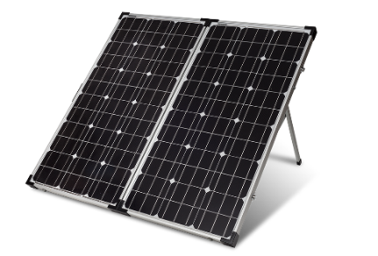

[This Photo](https://www.pngall.com/solar-panel-png/) by Unknown Author is licensed under [CC BY-NC](https://creativecommons.org/licenses/by-nc/3.0/)

Figure 1.2- monocrystalline panel.

Polycrystalline

Polycrystalline solar cell is also known as multi-crystalline or many-crystal solar cells, liquid silicon is used as a raw material, and polycrystalline silicon is obtained followed by a solidification process.

The materials contain various crystalline sizes. Hence, the efficiency of this type is between 13 %-15%, and the efficiency is less than monocrystalline cells.

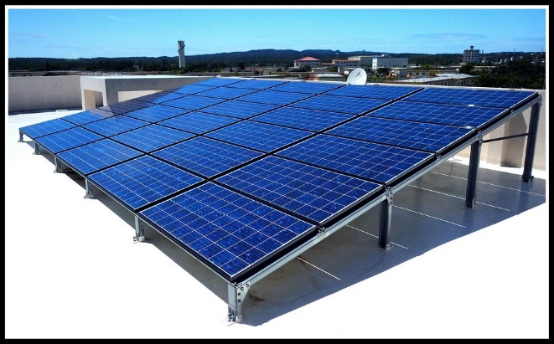

[This Photo](https://www.flickr.com/photos/okinawa-soba/9068490219) by Unknown Author is licensed under [CC BY-SA-NC](https://creativecommons.org/licenses/by-nc-sa/3.0/)

Figure 1.3- polycrystalline panel

Amorphous

Amorphous solar cells are prepared by attaching a thin silicon film to a durable material steel. The efficiency rate is around 10%, which is low.

Some of the key merits of amorphous solar cells are cost-effective, flexibility, and versatility.

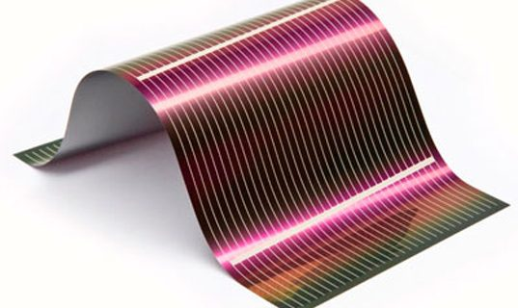

[This Photo](https://mappingignorance.org/2016/10/14/organic-photovoltaic-advantages-challenges/) by Unknown Author is licensed under [CC BY-NC-ND](https://creativecommons.org/licenses/by-nc-nd/3.0/)

Figure 1.4- Amorphous panel.

1.5 SOLAR PANELS

Solar panels also known as photovoltaic(PV) panels are devices that capture sunlight and convert it into electrical energy. It is composed of silicon cells, solar panels harness the sun's photons to generate direct current, which is then converted into alternating current. Harnessing the power of solar energy not only reduces dependence on non-renewable resources but also cuts down greenhouse gas emissions

.IMPORTANCE OF SOLAR CHARGING UNIT

In this scenario of increasing reliance on portable gadgets, the availability of continuous power supply has become a growing concern. The following points discuss the importance of solar mobile charging unit.

1.CONVENIENCEAND ACCESSIBILITY

The integration of solar charging technology into the bag eliminates the need to carry bulky charges. With the availability to harness solar energy, these unit can charge electronic devices at any time, replacing the traditional way of charging. This is an important feature when traveling or during outdoor activities. It also ensures that users have a readily available power supply all the time.

2.EMERGENCY PREPAREDNESS

During certain circumstances such as natural disasters or emergencies, access to a reliable power source is an essential matter. The charge stored in the battery can be utilized in emergencies like this.

3.RENEWABLE SOURCE OF ENERGY

Solar radiation is one of the fastest-growing renewable energies. This form of energy releases no greenhouse gases. Hence the solar-powered mobile charger doesn’t release any harmful emissions. By utilizing solar power for charging mobile phones, it keeps energy production at a low cost. It is one of the fastest technology that plays a crucial role in the global energy transformation.

4.PORTABILITY

One of the key features of the mobile charging unit is its portability and it can be detached from the bag as consumers wish. The solar panel is designed in such a way that it is lightweight and durable ensuring that the user can easily carry the device without burden.

1.6ADVANTAGES

1.Cost-effectiveness: Solar cells have become increasingly affordable in recent years, making them a cost-effective option for generating electricity. Solar cells offer a cost effective advantage by providing a renewable and sustainable energy source that can significantly reduce long-term energy costs.

2.Environmental friendliness: Solar cells produce clean energy without emitting harmful greenhouse gases, making them a sustainable choice for reducing carbon emissions. By using solar cells to generate electricity, we can reduce our dependency on fossil fuels, which are finite resources that release harmful emissions when burned. This reduction in fossil fuel usage leads to decreased air pollution and greenhouse gas emissions, helping to mitigate the effects of climate change.

3.Reliability: Solar cells have a long lifespan and require minimal maintenance, providing a reliable source of energy for years to come.

4.Versatility: Solar cells can be installed on a variety of surfaces, including rooftops, buildings, and even vehicles, making them a versatile option for generating electricity.

1.7 DISADVANTAGES

1.High initial cost: The initial cost of purchasing and installing solar panels can be quite expensive, making it difficult.

2.efficiency and reliability: Solar panels are only able to generate electricity when the sun is shining, which poses a challenge during periods of cloudy weather or at night when there is no sunlight

3.Furthermore, the production of photovoltaic cells can have negative environmental impacts. The manufacturing process of solar panels requires the use of toxic materials and chemicals that can harm the environment if not properly managed.

4.Additionally, the disposal of old or damaged solar panels can lead to pollution and contribute to electronic waste.

**CHAPTER 2**

**BASICS OF PHOTOVOLTAICS**

Photovoltaic cells, also known as solar cells, are devices that convert sunlight into electrical energy. These cells consist of semiconductor materials, such as silicon, that absorb photons (particles of light) and release electrons, thereby generating electricity. The efficiency and performance of photovoltaic cells depend on several factors, such as the quality of the semiconductor material, the arrangement of the cell structure, and external conditions such as sunlight intensity and temperature. The key advantage of this technology is its environmental friendliness.

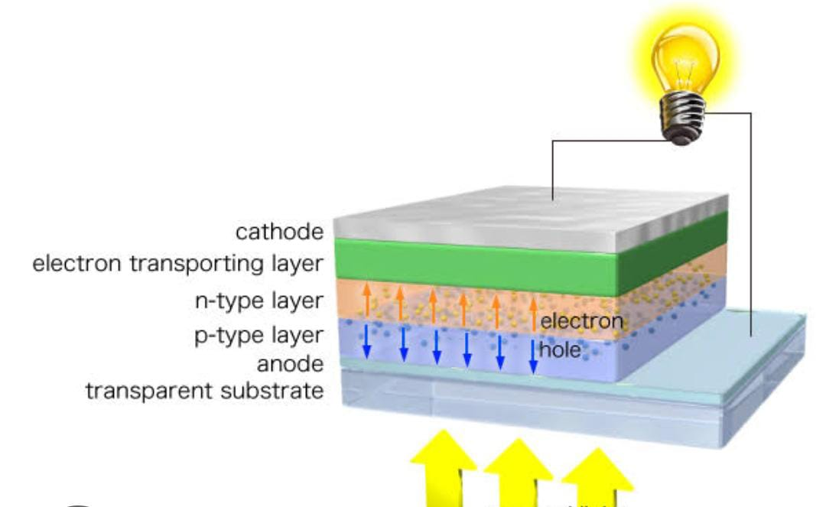

Figure 2.1-Structure of solar cell.

The solar cells are based on the principles of photovoltaic effect. The photovoltaic effect is the photogeneration of charge carriers in light-absorbing materials as a result of absorption of light radiation. The solar cell consists of a n-type semiconductor(emitter) layer and a p-type layer(base). The two layers are sandwiched and hence there is a formation of p-n junction. The surfaces are coated with an anti-reflection coating to avoid loss of incident light energy due to reflection. Proper metal contacts are made on the n-type and p-type sides of the semiconductor for electric connection.

A PV cell is made up of semiconducting material such as silicon. When the light strikes the cell, that light may be reflected, absorbed or pass right through the cell. only the absorbed photons in the semiconductor provide energy to generate electricity. the photovoltaics cells generate direct current (DC) electricity. The DC electricity can be used to charge batteries that power devices that utilize direct current electricity.

One of the key reasons for the usage of photovoltaic cells is their ability to reduce the impact of climate change. Shifting towards renewable energy sources like solar power is crucial, because of the increasing emission of greenhouse gases which leads to global warming. Unlike fossil fuels, which release carbon dioxide and other pollutants into the atmosphere when burned, solar energy is clean and does not contribute to air pollution or climate change. By investing in photovoltaic cells and energy, we can reduce the emission of greenhouse gases and work towards a more sustainable future.

Another reason for the usage of photovoltaic cells is their potential to increase energy access and reliability. In many parts of the world, access to electricity is still limited, by installing solar panels equipped with photovoltaic cells, communities can generate their electricity and become less dependent on traditional charging methods.

Furthermore, photovoltaic cells play a crucial role in diversifying energy sources and reducing reliance on finite and non-renewable resources like coal, oil, and natural gas. As global energy demand continues to rise, utilizing renewable sources like solar power is vital to ensure energy security and sustainability. Additionally, the increasingly competitive costs of solar power make it a cost-effective solution for meeting our energy needs, reducing electricity bills for consumers, and enhancing energy affordability and accessibility.

2.1SOLAR CELL PARAMETERS

The conversion of light energy to electrical energy is mainly determined by various parameters of a solar cell. The solar cell I-V characteristics curves are graphical representations of the operation of the solar cell which summarizes the relation between the current and voltage at the existing conditions of irradiance and temperature.

1.Open circuit voltage (VOC)- open circuit voltage is the maximum voltage that the cell can generate under no load condition.it is measured in volts or millivolts -the value of open circuit voltage depends upon cell technology and the operating temperature of the cell.

2.Short circuit current (Isc)- the short circuit current is the maximum current from a solar cell when the voltage across the cell is zero. It is measured in ampere or milliampere. The value of short circuit current depends on cell area, solar radiation falling on the cell, cell technology, etc

3.Fill factor represents the quality of a solar cell it is measured by comparing maximum power to the theoretical power.

4.Efficiency- efficiency is defined as the ratio of energy output from the solar cell to the input energy from the sun. it mainly depends on cell temperature, the intensity of the sunlight, etc.

5.Maximum power point(Pm**)**-The maximum power point represents the is solar radiance of 1000W/m2)and cell operating temperature of 25 degrees Celsius.

6.Current at maximum power point(IM)-It represents the current that the solar cell will produce operating at pm. It is measured in ampere or milliampere

7.The voltage at maximum power point(VM)-It represents the voltage that the solar cell will produce when operating at the maximum power point. It is measured in volts or millivolts.

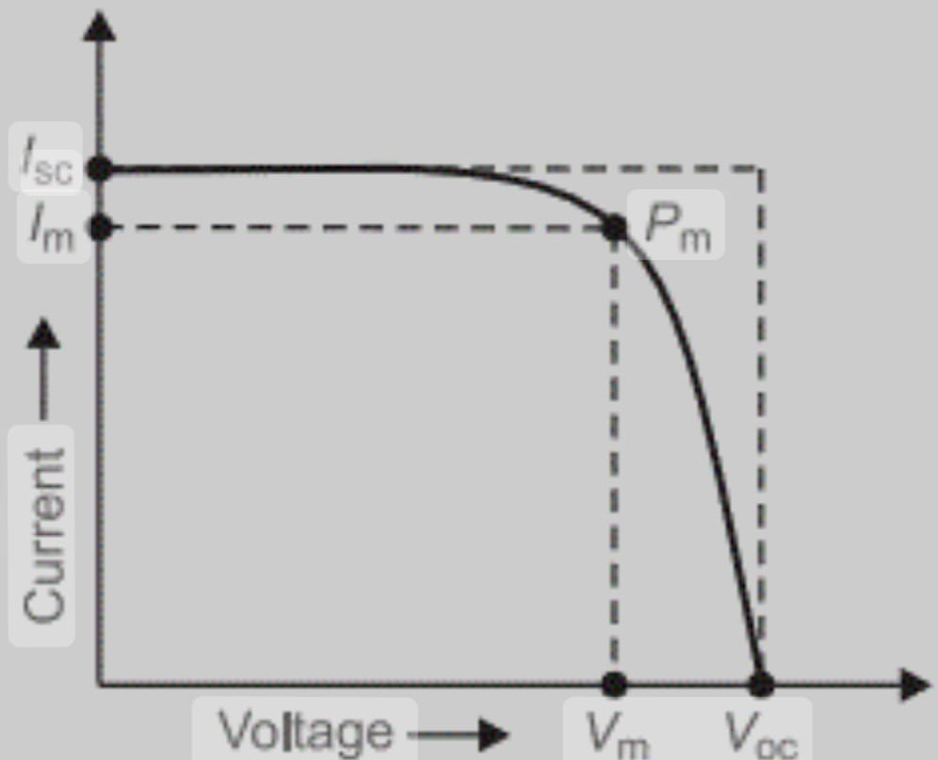

Figure 2.2- graphical representation of V-I characteristics.

2.2 SOLAR SERIES CONNECTION

Solar cell series connection is a method of connecting multiple solar cells together in a series to increase the voltage output. This technique is commonly used in solar panel systems to generate higher voltages for efficient power production. In a series connection, the positive terminal of one solar cell is connected to the negative terminal of the next cell, creating a continuous flow of current. This configuration allows for the combined voltage of each cell to be additive, resulting in a higher overall output voltage. One of the main advantages of solar cell series connection is the increased voltage output.

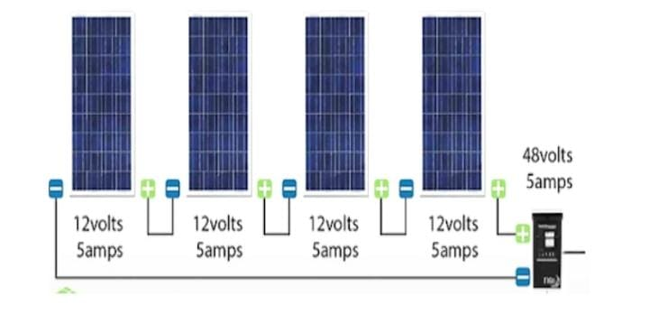

Figure 2.3- series connection.

2.3 SOLAR PARALLEL CONNECTION

Solar cell parallel connection is a popular method used in photovoltaic systems to increase the overall power output while maintaining the same voltage. By connecting solar cells in parallel, the current is increased while the voltage remains the same. This allows for a higher power output without the need for additional equipment or changes to the system. By connecting cells in parallel, the overall current is increased, allowing for more power to be generated from the same voltage.

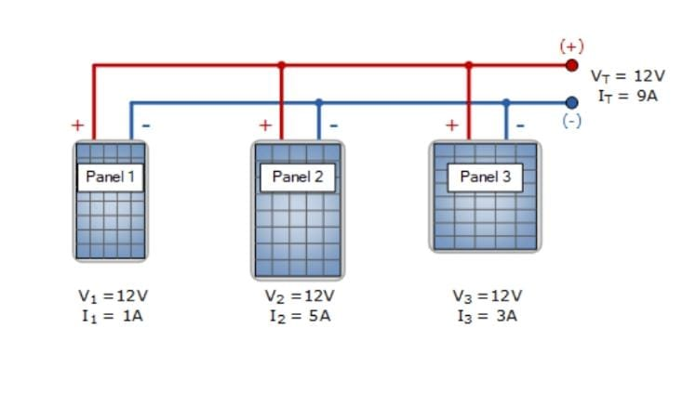

Figure 2.4- parallel connection.

2.4 V-I CHARACTERISTICS OF SOLAR CELL

Components required

Solar panel

Rheostat

Voltmeter

Ammeter

CIRCUIT DIAGRAM

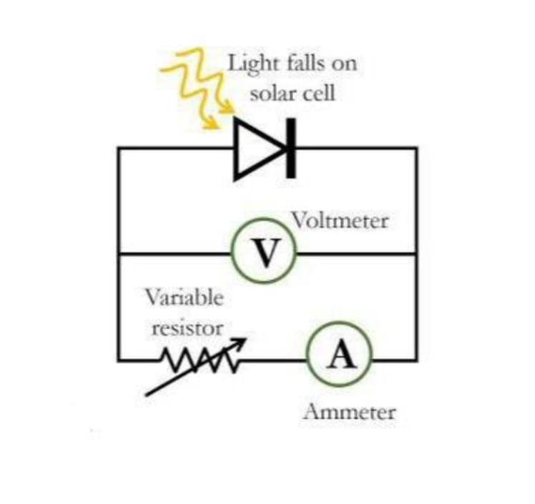

Figure 2.5- circuit diagram of V-I characteristics

The connection are made as shown in the figure .the solar cell is forward biased in this connection .the positive and negative terminals of the cell are connected to the positive and negative terminals of the voltmeter and ammeter .The voltmeter is connected across the load resistance . the experiment is repeated by changing the rheostat In each step the corresponding voltage and current are determined. The voltage and current are plotted along the X and Y axis of a graph.

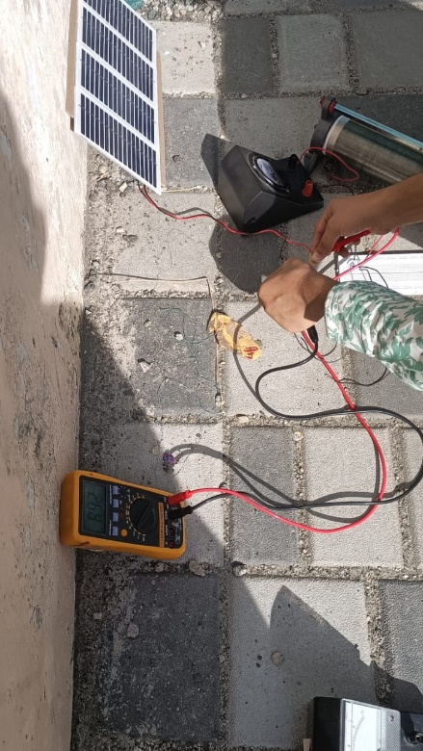

Figure 2.6- V-I characteristics of 7.5 V solar panel

2.5OBSERVATION

V-I Characteristics of 7.5V solar panel

|  |  |  |
| --- | --- | --- |
| CURRENT (A) | VOLTAGE (V) | POWER(P)=V*I |
| 0.2 | 0 | 0 |
| 0.19 | 1 | 0.19 |
| 0.19 | 1.7 | 0.323 |
| 0.19 | 2.5 | 0.475 |
| 0.16 | 3.4 | 0.544 |
| 0.14 | 4 | 0.56 |
| 0.12 | 4.8 | 0.576 |
| 0.1 | 5.4 | 0.54 |
| 0.08 | 6 | 0.48 |
| 0.06 | 6.6 | 0.396 |
| 0.04 | 7 | 0.28 |
| 0.001 | 7.5 | 0.0075 |

GRAPH

|  |  |  |  |  |  |  |  |  |  |
| --- | --- | --- | --- | --- | --- | --- | --- | --- | --- |
|  |  |  |  |  |  |  |  |  |  |
|  |  |  |  |  |  |  |  |  |  |
| |  | | --- | |  | |  |  |  |  |  |  |  |  |  |
|  |  |  |  |  |  |  |  |  |  |
|  |  |  |  |  |  |  |  |  |  |
| Current  (A) |  |  |  |  |  |  |  |  |  |
| Imax |  |  |  |  |  |  |  |  |  |
|  |  |  |  |  |  |  |  |  |  |
|  |  |  |  |  |  |  |  |  |  |
|  |  |  |  |  |  |  |  |  |  |
|  |  |  |  |  |  |  |  |  |  |
|  |  |  |  |  |  |  |  |  |  |
|  |  |  |  |  |  |  |  |  |  |
| Vmax |  |  | Voltage(v) |  |  |  |  |  |  |
|  |  |  |  |  |  |  |  |  |  |
|  |  |  |  |  |  |  |  |  |  |
| Figure 2.7- Graphical representation of V-I characteristics |  |  |  |  |  |  |  |  |  |
|  |  |  |  |  |  |  |  |  |  |
| CALCULATION |  |  |  |  |  |  |  |  |  |
|  |  |  |  |  |  |  |  |  |  |
|  |  |  |  |  |  |  |  |  |  |
|  |  |  |  |  |  |  |  |  |  |
| Maximum current, Imax=0.12A  Maximum voltage, Vmax=4.8V  Ideal power, Pmax=Imax X Vmax= 0.12 X 4.8= 0.576W  Open circuit voltage, Voc=7.5V  Short circuit current, Isc=0.2A  Maximum useful power=  Voc X Isc=7.5X0.2=1.5W  Fill factor=  Imax X Vmax/ Voc X Isc=0.576/1.5=0.384  Efficiency=(ImaxxVmax/L(m)xB(m)x10)100  =(0.576/0.20x0.35x10)x100=82.2% |  |  |  |  |  |  |  |  |  |
|  |  |  |  |  |  |  |  |  |  |
|  |  |  |  |  |  |  |  |  |  |
| |  | | --- | |  | |  |  |  |  |  |  |  |  |  |
|  |  |  |  |  |  |  |  |  |  |
|  |  |  |  |  |  |  |  |  |  |
|  |  |  |  |  |  |  |  |  |  |
|  |  |  |  |  |  |  |  |  |  |
|  |  |  |  |  |  |  |  |  |  |
|  |  |  |  |  |  |  |  |  |  |
|  |  |  |  |  |  |  |  |  |  |
|  |  |  |  |  |  |  |  |  |  |
|  |  |  |  |  |  |  |  |  |  |
|  |  |  |  |  |  |  |  |  |  |
|  |  |  |  |  |  |  |  |  |  |
|  |  |  |  |  |  |  |  |  |  |
| 2.6 APPLICATIONS OF PHOTOVOLTAICCELL |  |  |  |  |  |  |  |  |  |
|  |  |  |  |  |  |  |  |  |  |
| The primary applications are |  |  |  |  |  |  |  |  |  |
|  |  |  |  |  |  |  |  |  |  |
|  |  |  |  |  |  |  |  |  |  |
|  |  |  |  |  |  |  |  |  |  |
|  |  |  |  |  |  |  |  |  |  |
|  |  |  |  |  |  |  |  |  |  |

* Solar panels can be integrated into the roofs or facades of buildings to generate clean and sustainable electricity. This helps to reduce electricity bills and reliance on the grid, especially during peak demand periods.
* Another important application of photovoltaic cells is in off-grid and remote areas where access to electricity is limited or non-existent. Solar panels can be used to power lights, appliances, and telecommunications equipment in rural communities, helping improve living standards and economic opportunities.
* Additionally, photovoltaic cells can provide electricity during natural disasters or emergencies, offering a crucial lifeline to affected individuals and communities.
* Large-scale solar power plants, also known as solar farms, are another significant application of photovoltaic cells. These utility-scale installations can generate megawatts of electricity, feeding into the grid to meet the energy needs of cities and regions. Solar farms are a key component of the shift towards a clean energy future, replacing coal and gas-fired power plants and reducing greenhouse gas emissions. The falling costs of solar panels and the increasing efficiency of photovoltaic technology have made solar farms a cost-effective and scalable solution for meeting growing energy demand.
* Photovoltaic cells are also being integrated into transportation systems to power electric vehicles (EVs). Solar panels can be installed on the roofs or hoods of cars, buses, and even trains to generate electricity for propulsion and auxiliary systems. This helps reduce the carbon footprint of transportation and promotes sustainable mobility. In addition, solar-powered EV charging stations are becoming more common, enabling drivers to recharge their vehicles with clean energy while on the go.
* In the agricultural sector, photovoltaic cells are being used to power irrigation systems, lighting, and other equipment on farms. Solar panels can be installed on rooftops, open fields, or even floating on water bodies to generate electricity for agricultural operations. This not only reduces operating costs for farmers but also provides a reliable and sustainable source of energy, especially in remote or off-grid areas. Solar-powered irrigation systems, in particular, have the potential to improve water efficiency and crop yields, helping farmers adapt to changing climate conditions.
* The aerospace industry is also exploring the application of photovoltaic cells for powering satellites and spacecraft. Solar panels are deployed on spacecraft to capture sunlight and convert it into electricity to operate onboard systems and instruments. This enables missions to be conducted in deep space or in regions where sunlight is scarce. In addition, solar-powered satellites can provide a renewable source of energy for telecommunications, weather monitoring, and other applications on Earth.

This renewable energy technology offers a clean and sustainable solution for meeting growing energy demand, reducing reliance on

fossil fuels, and mitigating climate change.

**CHAPTER 3**

### **EXPERIMENTAL STUDIES**

3.1 Solar mobile charging unit

Components required

* Solar panel
* [Micro USB cable](https://quartzcomponents.com/products/raspberry-pi-cable-for-charging) -1
* [LM317 Voltage Regulator](https://quartzcomponents.com/products/lm317t-adjustable-voltage-regulator-ic) - 1
* [BC547 NPN Transistor](https://quartzcomponents.com/products/bc547-npn-amplifier-transistor)  -1
* [Small Breadboard](https://quartzcomponents.com/products/small-breadboard-mini-solderless-board)
* [Potentiometer (10K)](https://quartzcomponents.com/products/10k-ohm-preset-potentiometer)
* [1N5819 Diodes](https://quartzcomponents.com/products/1n5819-shottky-barrier-diode) - 2
* [Resistors 100 Ohms](https://quartzcomponents.com/products/100-ohm-1-4-watt-resistor) and [150 Ohms](https://quartzcomponents.com/products/150-ohm-1-4-watt-resistor) - 2
* [5.6V 1N4734A Zener Diode](https://quartzcomponents.com/products/zener-diode-1n4734a-5-6v)- 1

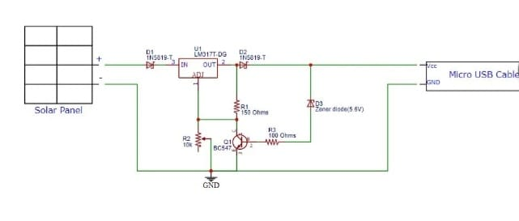

FIGURE 3.1- circuit diagram of solar mobile charger.

Polycrystalline solar panels

Polycrystalline or multi-crystalline solar panels are solar panels that consist of several crystals of silicon in a single PV cell polycrystalline solar panels are more eco-friendly than monocrystalline solar panels as they do not require individual shaping and placement of each crystal and most of the silicon is utilized during production. So, very little waste. These panels are less expensive compared to monocrystalline solar panels.

USB MODULE

USB module stands for universal serial bus is a common interface that allows devices to communicate with a host controller, such as a personal computer or smartphone. It provides an expandable, fast, bi-directional, low-cost, hot-pluggable plug-and-play serial hardware interface. 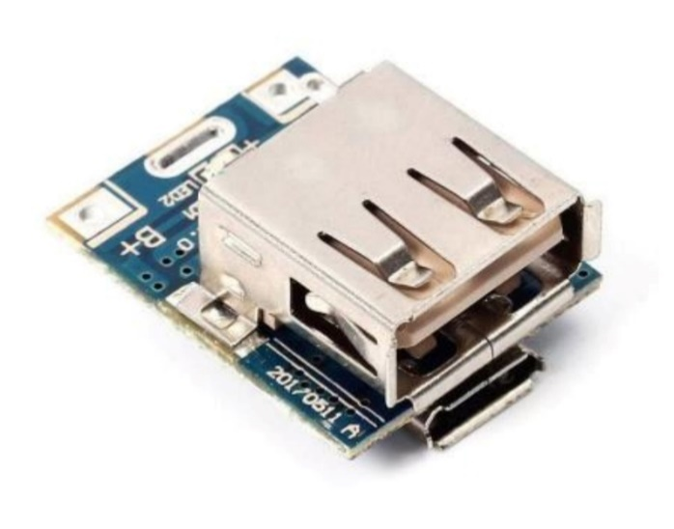

RESISTORS

A resistor is a two-terminal electrical component that provides electrical resistance. In electronic circuits, resistors are mainly used to lower the flow of current, divide voltages, block transmission signals, and bias active elements. The above circuit consists of two resistors of resistance 150ohm and 100ohm.

150 ohm



100ohm

DIODE

The main function of a diode is to allow an electric current to pass in one direction(called the diode’s forward direction) while blocking it in the opposite direction (the reverse direction ). The above circuit consists of two 1N5819-T Diodes.

ZENER DIODE(5.6V IN4734)

A Zener diode is a type of diode that is designed to operate in the reverse breakdown region. Zener diodes are specifically designed to operate reliably in this breakdown region. Zener diodes are used primarily for voltage regulation. When operated in the reverse breakdown region, a Zener diode maintains a nearly constant voltage drop across its terminals. This makes them useful for applications such as voltage regulation, voltage reference, and overvoltage protection.

POTENTIOMETER(10k)

A potentiometer is a three-terminal resistor with a sliding or rotating contact that forms an adjustable voltage divider. It's a common electronic component used to vary the resistance in a circuit manually.



LM317-VOLTAGE REGULATOR

A voltage regulator is an electronic circuit that maintains a constant output voltage irrespective of changes in input voltage, load current, or temperature. It is used to ensure that the voltage supplied to a load remains within specified limits, preventing damage to the load due to voltage fluctuations. The LM317 is a popular linear voltage regulator integrated circuit (IC) that can output a regulated voltage between 1.25 volts and 37 volts with currents up to 1.5 amperes. It's commonly used in a variety of circuits where a stable voltage source is required The LM317 is commonly used in power supply circuits, battery chargers, and voltage regulator circuits where a stable and adjustable voltage source is required.

BREADBOARD

A breadboard is a common tool used in electronics prototyping to build and test circuits quickly and easily without the need for soldering.



BC547 NPN TRANSISTOR

The BC547 is a general-purpose NPN bipolar junction transistor (BJT) that is commonly used in low to medium power amplification and switching applications. It is divided into 3 sections: Emitter, Base and Collector.

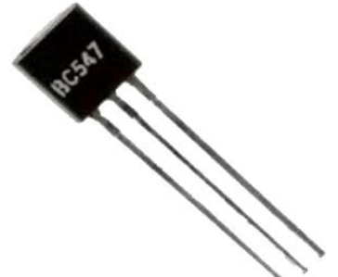

The circuit diagram shown below consists of voltage and current regulation along with the **over-voltage protection circuit**. The connections are as follows: the anode terminal of the diode (D1) is connected to the positive terminal of the solar panel, and the cathode terminal of the diode (D2) is connected to the input pin of the LM317 voltage regulator. The output terminal of the LM317 is connected to the anode terminal of the diode (D2), and the cathode terminal of the diode (D2) is connected to the cathode terminal of the Zener diode. The anode terminal of the Zener diode is connected to the base of the BC547 transistor through a 100 Ohm resistor. The collector terminal of the BC547 transistor is connected to the output pin of the LM317 voltage regulator through a 150 Ohm resistor. The emitter terminal of the BC547 transistor is connected to the GND. The adjust pin of the LM317 is connected to the potentiometer’s variable end and the collector terminal of the BC547 transistor. One of the potentiometer’s fixed end is connected to the GND. The wire connected to the VCC pin of the micro USB cable is connected to the cathode terminal of the Zener diode and the wire connected to the GND pin of the USB cable is connected to the GND.

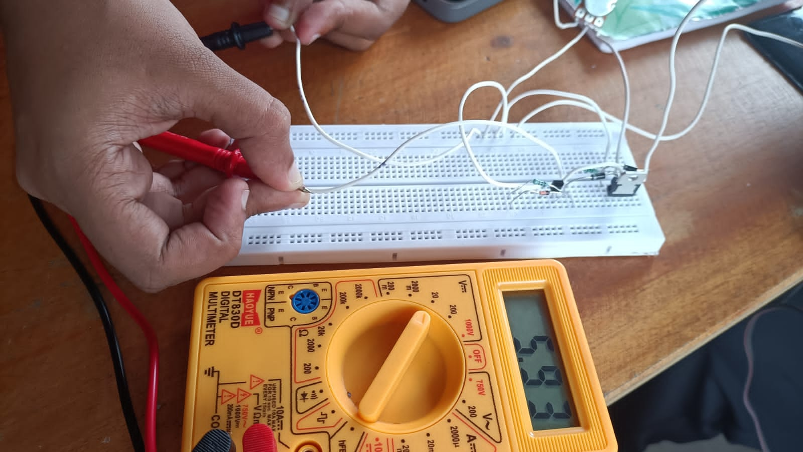

Figure3.2- connection diagram.

3.2 STORAGE SYSTEM

A storage system stores electrical energy and can be used to charge other electronic devices such as smartphones, tablets, and other USB-powered devices. It consists of a battery pack and charging circuitry enclosed in a case, often with one or more USB ports for connecting devices.

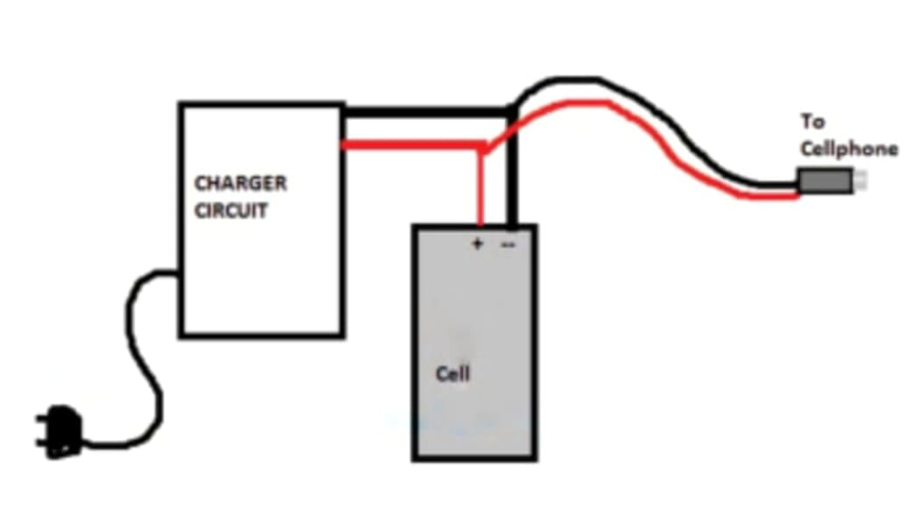

Figure3.3-storage system .

The incorporation of reduced lithium ion battery in solar mobile charging unit represents a significant step towards achieving a more environmental friendly and reliable energy solution for consumers worldwide. In this project, we had incorperated the solar charging unit with the reused lithium-ion battery of 3.2V,which stores the charge.



Figure 3.4-charging of mobile phone



Figure3.5-solar powered bag.

**CHAPTER 4**

**CONCLUSION**

These solar powered bags are equipped with solar panels that harness the power of the sun to charge a the battery, which can then be used to charge a phone or other electronic devices. This not only provides a convenient and environmental friendly way to charge the phone , but also serves as a sustainable alternative to traditional methods of charging.

The use of solar-powered bags for charging phones is a prime example of how technology can be harnessed to promote sustainability and reduce our dependence on non-renewable energy sources. By utilizing the power of the sun, these bags offer a clean and renewable energy solution that can help reduce our carbon footprint and contribute to a more sustainable future.

In this project, we built a solar powered bag incorporated with mobile charging unit and storage system. Firstly, we measured the V-I characteristics of a 7.5V solar panel. In bright sunlight, charging was noticed. It takes 4-5 minutes to charge 1% of the phone. Through this project, we were able to create our own solar powered bag at a reasonable cost, which helps to reduce our dependence on conventional charging methods.

4.1 INFERENCE

* Solar assisted powered bag, battery designed by using recycled e-waste.
* The time taken for charging of the powered bag were determined and it was found out that the powered bag is able to charge a mobile within 4-5min one percentage can be charged.
* We used a 7.5 V panel for charging.
* Charging time for the available powered bag panel was able to be determined.
* Modified as a storage device by using an e-waste battery.

4.2 DISCUSSION

Solar powered bag is efficient to charge and it's convenient to carry a bag wherever we need it. Advantage of solar powered bag is that we can charge mobile or any electronic device whenever we our out we can easily charge it under sun and also we are able to charge the phone under the emergency situation by using this solar powered bag .Also we can able to store charge by using battery that made from E-waste able to charge even there is no sunlight. The battery for storage we use is a lithium ion battery of 3.2 V .Used laptop batteries as well as other rechargeable batteries can be used in this solar powered bag and hence it is the best way of reuse of E-waste. Hence the solar powered bag can be used with situations where a solar energy panel does not work like cloudy days as well as during night time and moreover solar powered bags are portable ,convenient and easy to use whenever we need them .

4.3 FUTURE SCOPE

Nowadays we are using renewable energy as a source of energy for different purposes. So we are currently facing an energy crisis and the various energy sources that we depend upon are in depletion. So we use renewable energy as solar energy for charging. We constructed a solar powered bag which we can use whenever we need it .Solar energy is the ultimate source of energy that we will get forever. Our project is basically about a solar powered bag that can Store using battery which we designed using e- waste .It has a great scope in the future when every energy needs will be able to be used as a renewable source of energy as long term sources.

4.4 REFERENCE

Handbook of solar energy – G.N Tiwari ,Arvind Tiwari , Shyam

[www.slideshare.in](http://www.slideshare.in)

[www.alternativeenergy.com](http://www.alternativeenergy.com)

[www.byjus.com](http://www.byjus.com)

https://quartzcomponents.com/blogs/electronics-projects/solar-powered-mobile-phone-charger-circuit.