**ENTREPRENEURSHIP AS A CAREER CHOICE: AN ANALYSIS OF ENTREPRENEURIAL INTENTION OF POST GRADUATE COMMERCE STUDENTS WITH SPECIAL REFERENCE TO ERNAKULAM DISTRICT**

Project Report

Submitted by

**APARNA V NAIR**

Reg. No. AM22COM005

Under the guidance of

**Ms. NEENA GEORGE**

*In partial fulfilment of requirements for award of the post graduate degree of*

Master of Commerce and Management



**ST. TERESA’S COLLEGE (AUTONOMOUS), ERNAKULAM**

COLLEGE WITH POTENTIAL FOR EXCELLENCE

Nationally Re-Accredited at ‘A++’ Level (Fourth Cycle)

Affiliated to

**MAHATMA GANDHI UNIVERSITY**

Kottayam-686560

**March 2024**

**ST. TERESA’S COLLEGE (AUTONOMOUS), ERNAKULAM**

**COLLEGE WITH POTENTIAL FOR EXCELLENCE**

Nationally Re-Accredited at ‘A++’ Level (Fourth Cycle)



**CERTIFICATE**

This is to certify that the project report titled **‘ENTREPRENEURSHIP AS A CAREER CHOICE: AN ANALYSIS OF ENTREPRENEURIAL INTENTION OF POST GRADUATE COMMERCE STUDENTS WITH SPECIAL REFERENCE TO ERNAKULAM DISTRICT’** submitted by **APARNA V NAIR** towards partial fulfilment of the requirements for the award of post graduate degree of Master of Commerce and Management is a record of Bonafide work carried out during the academic year 2023-24

**Supervising Guide Head of the Department**

**Ms. NEENA GEORGE Ms. ELIZABETH RINI**

**Assistant Professor Assistant Professor**

**Dept. of Commerce Dept. of Commerce**

**Place: Ernakulam**

**Date: 31.03.2024**

**DECLARATION**

I**, APARNA V NAIR** hereby declare that this dissertation titled, **‘ENTREPRENEURSHIP AS A CAREER CHOICE: AN ANALYSIS OF ENTREPRENEURIAL INTENTION OF POST GRADUATE COMMERCE STUDENTS WITH SPECIAL REFERENCE TO ERNAKULAM DISTRICT’** has been prepared by me under the guidance of **Ms. NEENA GEORGE,** Assistant Professor, Department of Commerce, St Teresa’s College, Ernakulam.

I also declare that this dissertation has not been submitted by me fully or partly for the award of any Degree, Diploma, Title or Recognition before.

**Place: ERNAKULAM APARNA V NAIR**

**Date: 31.03.2024**

**ACKNOWLEDGEMENT**

I wish to acknowledge all those who helped us to complete this study. I thank God almighty for helping me and guiding me in the right path and who made all things possible.

I take this opportunity to express my profound gratitude and deep regards to my guide **Ms. Neena George,** Assistant professor, St. Teresa’s college, Ernakulam for her exemplary guidance, monitoring and constant encouragement throughout the course of this study. The blessings, help and guidance given by her time to time shall carry us a long way in the journey of life on which we are about to embark. She has taken pain to go through the project and make necessary corrections as and when needed. We express our sincere thanks to the Director Rev. **Sr. Emeline CSST**, Provincial Superior and Manager Rev. **Dr. Sr. Vinitha CSST**, Principal **Dr. Alphonsa Vijaya Joseph** and **Ms. Elizabeth Rini** Head of the Department of Commerce, to all other faculties of the department of commerce, St. Teresa’s College, for their support and valuable suggestions.

I would like to express my thanks to all respondents and colleagues in developing the project.

I also extent heartfelt thanks to my family for their constant encouragement without which this project would not be possible.

APARNA V NAIR

**CONTENTS**

|  |  |  |
| --- | --- | --- |
| **Sl.No:** | **Particulars** | **Page No:** |
| 1 | List of figures |  |
| 2 | List of tables |  |
| 3 | Chapter 1 –Introduction |  |
| 4 | Chapter 2 – Review of Literature |  |
| 5 | Chapter 3 – Theoretical Framework |  |
| 6 | Chapter 4 - Data Analysis and Interpretation |  |
| 7 | Chapter 5 – Summary, Findings, Recommendations and Conclusion |  |
| 8 | Bibliography |  |
| 9 | Appendix-Questionnaire |  |

**LIST OF TABLES**

|  |  |  |
| --- | --- | --- |
| **Table**  **No** | **Title** | **Page**  **No** |
| 4.1 | Gender of respondents |  |
| 4.2 | Stream of respondents |  |
| 4.3 | Factors attracting towards entrepreneurial career |  |
| 4.4 | Resources that are considered as the most helpful for considering entrepreneurship as a career choice |  |
| 4.5 | Family members or friends who are entrepreneurs |  |
| 4.6 | Influence of experience on entrepreneurship |  |
| 4.7 | Resources or support available on the campus for aspiring entrepreneurship |  |
| 4.8 | Utilization of the resources |  |
| 4.9 | Factors that need the most improvement to create a more favorable environment for entrepreneurship |  |
| 4.10 | Factors that mostly demotivates from choosing entrepreneurship as a career choice |  |
| 4.11 | Interest in pursuing entrepreneurship as a career choice |  |
| 4.12 | Confidence level |  |
| 4.13 | Risk perception associated with entrepreneurship |  |
| 4.14 | Optimistic about the factors of entrepreneurship |  |
| 4.15 | Descriptive statistics of attitude of students towards entrepreneurship as a career choice |  |
| 4.16 | Gender wise distribution of attitude of students towards entrepreneurship as a career choice |  |
| 4.17 | Stream wise distribution of attitude of students towards entrepreneurship as a career choice |  |
| 4.18 | Normality of variables related to attitude of students towards entrepreneurship as a career choice |  |
| 4.19 | Mann-Whitney U Test on attitude of students towards entrepreneurship as a career choice based on gender |  |
| 4.20 | Kruskal Wallis Test on attitude of students towards entrepreneurship as a career choice based on stream |  |
| 4.21 | Level of importance to the factor in choosing entrepreneurship as your career choice |  |
| 4.22 | Role that educational institution plays in fostering an entrepreneurial career |  |
| 4.23 | Accessible of resources for aspiring entrepreneurship in academic environment |  |
| 4.24 | Descriptive statistics on the factors that attract students towards entrepreneurial career |  |
| 4.25 | Significance of environmental factors in promoting entrepreneurship |  |
| 4.26 | Importance of government support to entrepreneurship |  |
| 4.27 | Importance of access to technology and infrastructure |  |
| 4.28 | Descriptive statistics on the various environmental factors which promote entrepreneurship |  |
| 4.29 | Gender wise distribution of various environmental factors which promote entrepreneurship |  |
| 4.30 | Stream wise distribution of various environmental factors which promote entrepreneurship |  |
| 4.31 | Normality distribution related to various environmental factors which promote entrepreneurship |  |
| 4.32 | Mann-Whitney U Test on various environmental factors which promote entrepreneurship based on gender |  |
| 4.33 | Kruskal-Wallis Test on various environmental factors which promote entrepreneurship based on stream |  |
| 4.34 | Demotivating factors wise distribution of students |  |
| 4.35 | Descriptive statistics on demotivating factors |  |
| 4.36 | Test statistics on demotivating factors |  |
| 4.37 | Chi-square Test summary on demotivating factors on students |  |

**LIST OF FIGURES**

|  |  |  |
| --- | --- | --- |
| **Table**  **No** | **Title** | **Page**  **No** |
| 4.1 | Gender of respondents |  |
| 4.2 | Stream of respondents |  |
| 4.3 | Factors attracting towards entrepreneurial career |  |
| 4.4 | Resources that are considered as the most helpful for considering entrepreneurship as a career choice |  |
| 4.5 | Family members or friends who are entrepreneurs |  |
| 4.6 | Influence of experience on entrepreneurship |  |
| 4.7 | Resources or support available on the campus for aspiring entrepreneurship |  |
| 4.8 | Utilization of the resources |  |
| 4.9 | Factors that need the most improvement to create a more favorable environment for entrepreneurship |  |
| 4.10 | Factors that mostly demotivates from choosing entrepreneurship as a career choice |  |
| 4.11 | Interest in pursuing entrepreneurship as a career choice |  |
| 4.12 | Confidence level |  |
| 4.13 | Risk perception associated with entrepreneurship |  |
| 4.14 | Optimistic about the factors of entrepreneurship |  |
| 4.21 | Level of importance to the factor in choosing entrepreneurship as your career choice |  |
| 4.22 | Role that educational institution plays in fostering an entrepreneurial career |  |
| 4.23 | Accessible of resources for aspiring entrepreneurship in academic environment |  |
| 4.25 | Significance of environmental factors in promoting entrepreneurship |  |
| 4.26 | Importance of government support to entrepreneurship |  |
| 4.27 | Importance of access to technology and infrastructure |  |

**CHAPTER 1**

**INTRODUCTION**

* 1. **INTRODUCTION**

The concept of entrepreneurship is associated with strength and business expansion. It is an integral part of economic development and plays a vital role in the process of development. It creates jobs and more possibilities. Entrepreneurs have been the driving force behind business success in the modern era. However, development is not only about entrepreneurship. It is also one of the key factors in innovation, product and service development and growth. This study aims to analyse the interest of students in becoming entrepreneurs. Young people are increasingly turning into entrepreneurs due to the lack of work and the desire to work under someone’s guidance. Encouraging innovation and entrepreneurship transforms the student into an able and capable person, ready to face the challenges of the world.

In this study, we focus on how and to what extent we approach learning to support, develop and maintain student's entrepreneurial skills and analyse their entrepreneurship. The ultimate goal of this research is to understand the student’s experiences and views about the learning methods we use to develop student’s entrepreneurial skills. This study delves into the factors influencing the entrepreneurial intentions of these commerce graduates, exploring the intricate interplay of personal aspirations, perceived feasibility, and the broader economic landscape. By understanding the motivations and challenges faced by this aspiring generation of business builders, we can gain valuable insights into the future of entrepreneurship and the role educational institutions and government can play in fostering its growth.

India’s economy has reached new heights in recent years, but economic development has not been commensurate with the growth of university facilities. In fact, business education in India is currently in some of the educational institutions, the industrial and social needs of the country are not considered, leading to mass unemployment of qualified young business and management professionals and wastage of valuable human resources. This trend must be overcome as soon as possible if we want to ensure sustainability. The challenges arising from the new industrial policy and the globalization of the economy must be answered effectively. India needs a large number of entrepreneurs to exploit new opportunities and create jobs. Government In the future India expects the under-25s to emerge as a group of entrepreneurs and employers. Entrepreneurship and small business development is an important focus area that attracts the primary and full attention of the Central and State Governments of India through various agencies such as Ministries and Industries Departments, Industrial Development Bank of India, Regional Industrial Centres, National Small-Scale Industries. Corporation. And National Institute of Entrepreneurship and Small Business Development, etc. These agencies provide much needed encouragement and assistance in various ways not only to management graduates but also to other individuals trying to start their own small businesses. With entrepreneurship becoming increasingly important in modern and economic life, this study aims to discover the business intentions of business graduates of Ernakulam district.

* 1. **STATEMENT OF THE PROBLEM**

Students who are about to complete their final year have an urgent decision to make their future profession. People interested in corporate career cannot do so due to many reasons like lack of family support, lack of money etc. This situation can have complex and multifaceted effects on students, depending on individual circumstances and personal resilience. This study investigated students' intentions towards entrepreneurship and entrepreneurial careers. Whether entrepreneurship can be considered a career in today's world, many other questions are discussed in this project work. The purpose of the research is to know the attitude of post graduate commerce students towards entrepreneurship a career choice, the factors that attract students towards entrepreneurial career, the various environmental factors which promote entrepreneurship and also to know about the factors that demotivates them in choosing entrepreneurship career.

* 1. **SIGNIFICANCE OF THE STUDY**

Entrepreneurship has increasing popularity among students as an area of study and application around the world, as a means of achieving wealth creation and personal fulfilment. With each economic slump, it has been proven that it is the entrepreneurial spirit and perseverance that restores economic prosperity. It is an individual’s ability to innovate, manage risk, predict project outcomes, and have the confidence and competence to deal with unforeseen and adverse circumstances. Entrepreneurial activities are critical to the economic process and success of modern civilization. As a result, attempts to learn more about entrepreneurship and the elements that influence their decision to become entrepreneurs, as well as their eventual success, are becoming increasingly crucial. It is becoming a topic of discussion among policymakers all around the world. The present study aims to find out the attitude of Post graduate commerce students towards entrepreneurship. As post graduate commerce students they can identify some of the business opportunities. As a result, if these students start a business, they will be able to expand and create money several times faster than entrepreneurs from other backgrounds.

* 1. **SCOPE OF THE STUDY**

The purpose of this study is to ascertain the intention towards entrepreneurship and the entrepreneurial careers among the post graduate commerce students undergoing their studies in Ernakulam district. The study is restricted to only final year postgraduate commerce students. The whole appraisal and analysis have been done from the angle of student’s point of view.

* 1. **OBJECTIVES OF THE STUDY**

This study is undertaken with the following objectives:

* To study the attitude of students towards entrepreneurship as a career option.
* To find out the factors that attract students towards entrepreneurial career.
* To study the various environmental factors which promote entrepreneurship among post graduate commerce students.
* To study some of the factors such as fear of failure, financial constraints, lack of motivation, personal risk aversion that demotivates the post graduate commerce students.
  1. **HYPOTHESIS OF THE STUDY**

Following are the null hypothesis for the study:

**Hypothesis 1:**

**H0:** There is no significant difference in attitude of students towards entrepreneurship as a career choice based on gender and stream.

**H1:** There is significant difference in attitude of students towards entrepreneurship as a career choice based on gender and stream.

**Hypothesis 2:**

**H0:** There is no significant difference in various environmental factors which promote entrepreneurship in students based on gender and stream.

**H1:** There is significant difference in various environmental factors which promote entrepreneurship in students based on gender and stream.

**Hypothesis 3:**

**H0:** There is no evidence to suggest that the categories of demotivating factors do not occur with equal probabilities among students.

**H1:** There is evidence to suggest that the categories of demotivating factors do not occur with equal probabilities among students.

* 1. **RESEARCH METHODOLOGY OF THE STUDY**

**1.7.1 Research design**

The present study includes both descriptive and analytical study. This study tries to look out the influence of factors that influence entrepreneurial intention among PG students. During this study, five independent variables and one dependent variable are tested. Dependent variable is entrepreneurial intention, and independent variables are motivation, fear of failure, environmental factors, entrepreneurial behaviour and educational factors. Descriptive and Analytical

**1.7.2 Sampling design**

**Population**: The population considered under the study is limited to post graduate commerce students in Ernakulam district.

**Sample size**: 100 samples were selected by using convenience sampling method from the total population

**1.7.3 Source of Data**

Sources of information are mainly classified into two:

1.7.3.1 Primary data

In this study primary data was collected in the form of questionnaire which was distributed among the sample population. Data are collected from the respondents irrespective of their age and gender using structured questionnaire prepared digitally in Google forms. Google form questionnaire was sent to respondents and response were taken from Google response sheet.

1.7.3.2 Secondary data

Secondary data for the study was collected from various books, various articles published in online journals, Magazines, and websites.

**1.7.4 Tools for Analysis**

The primary data collected were statistically coded, processed, classified, tabulated and analysed by using statistical and mathematical tools and techniques like percentages, mean, mode and standard deviation. Pie charts, Bar diagrams are used as a tool for analysis in this study.

* 1. **LIMITATIONS OF THE STUDY**

Some of the limitations of the study:

* Time and resources factors are the most limiting one for the study
* Some students are hesitant to fill the questionnaire.
* The study is influenced by the subjective opinions of the respondents.
  1. **KEYWORDS**

Entrepreneurship – Entrepreneurship is the process of starting, running, and managing a new business with the goal of making money while taking on financial risk. In a broader sense, entrepreneurship is the process of upending the status quo by addressing the most important issues and needs in our society, frequently by launching a brand-new goods or service or penetrating untapped markets.

* 1. **CHAPTERISATION**

For the convenience of the study and the analysis the work is divided into four different chapters.

**Chapter 1 – Introduction**

This provides an introduction to the study. It provides details including problem statement, relevance, scope, objectives, hypothesis, research methodology, limitations, study data analysis method and chapter presentation scheme.

**Chapter 2 – Literature Review**

It includes various previous studies related to the topic.

**Chapter 3 – Theoretical Framework**

It includes the concept, definition, meaning of entrepreneurship and business plan, which were obtained from various published sources and serve as secondary data for the study.

**Chapter 4 – Analysis and interpretation of data**

This explains the examination and analysis of data to obtain the objectives of the study. The chapter deals with the analysis of data collected from the sample population, their result and interpretation.

**Chapter 5 – Findings, Conclusion and suggestions**

It is the final chapter that presents the findings, suggestions and conclusions resulting from the study.

**CHAPTER 2**

**REVIEW OF LITERATURE**

A literature review is the summary of previous research on a topic. The main purpose of literature review is to gain knowledge and understanding the existing research and debates that are essential for a particular topic or area of study. The various literature reviews relating to Entrepreneurship as a Career Choice are presented in this chapter.

**2.1Krueger and Carsrud (1993)**, investigates, “Entrepreneurial intentions: Applying the Theory of Planned Behaviour” emphasizes that entrepreneurship training and participation in entrepreneurship classes can significantly increase students’ entrepreneurial intentions. They also emphasize that personal motivation plays an important role in the development of entrepreneurial intention. Attitudes toward the goal behaviour, which in turn represent ideas and perceptions, are what shape intentions. Intentions-based models of entrepreneurial activity provide new avenues for the study of venture initiation while also aligning with the findings of current research. By defining not only what but also how different antecedents of organizational emergence influence emergence, intentions models help them comprehend their effects more fully.

**2.2 Norris F Krueger and Deborah V Brazeal (1994)**, they studied, “Entrepreneurial Potential and Potential Entrepreneurs” highlights those intrinsic motivations, such as a strong desire for autonomy and a penchant for innovative ideas, are the main motivations that drive GUT students to view review business projects. This paper explores the factors that could lead to such potential and offers a model for the entrepreneurial event that is based on Shapero’s (1982) model. Next, they examine this model in light of supporting data from the corporate venturing and enterprise development viewpoints.

**2.3 Shook, Priem and McGee (2003)**, In their study, “Venture creation and the enterprising individual: A review and synthesis” has emphasized the importance of many factors. Their research shows that having a supportive start-up ecosystem, access to mentors, available resources, and exposure to success role models strongly influence students’ entrepreneurial tendencies. In order to uncover understudied subjects and enhance study methods, they evaluate and assess the venture development literature that has looked at the role of the individual in this article. They then point out that further study on the role of innovative individuals in venture formation should focus specifically on individual judgment. They also cover methods for assessing entrepreneurial judgments and for reaching out to entrepreneurs.

**2.4 Edmund Thompson (2004)**, In his study, “Individual entrepreneurial intent: Construct Clarification and Development of an Internationally Reliable Metric” emphasizes that if the attitude complements intention, then this will lead to an increase business quality. Intention is an essential element of entrepreneurship. This study reports on the construction and validation of a valid and trustworthy scale measuring individual entrepreneurial intent that can be used globally after first attempting to define the concept of individual entrepreneurial intent.

**2.5 Nikolaus and Luthje (2004)**, the study “Entrepreneurial intentions of business students: A benchmarking study” they compared entrepreneurship Intentions of two German university students. Three architectures are used in their work is an attitude towards self-employment, an attitude of willingness to take risks, need for independence and control. The result is the student’s entrepreneurial intentions are stronger and more ambitious in terms of business growth. In their study, the entrepreneurial aspirations of students at the University of Munich and the Vienna University of Economics and Business Administration—two German-speaking universities—are compared with the corresponding findings for Massachusetts Institute of Technology (MIT), a pioneer in this field. These universities exhibit quite different entrepreneurial spirit patterns. The findings also imply that Munich and Vienna students’ less unique entrepreneurial education may be the reason for their lower level of starting aspirations.

**2.6 Fitzsimmons and Douglas (2005)**, the study was about “Entrepreneurial Intentions towards Individual vs. Corporate Entrepreneurships. They found out the evidence that attitudes towards ownership, independence and income related to the person’s intention to participate in entrepreneurial activities. Individuals’ perspectives regarding the autonomy, ownership, and risk involved in each alternative have an impact on their decision regarding a career between working for themselves and becoming an intrapreneur. This study discovers that because self-employment entails risk and decision-making, attitudes about these components influence intentions, and self-efficacy mitigates these impacts. These predictions are corroborated by empirical investigations, which identify different attitudinal components for corporate and individual entrepreneurship.

**2.7Veciano and Urbano (2005)**, According to their research, “University students’ Attitude Towards Entrepreneurship: A Two Countries Comparison” states that entrepreneurs in family or among relatives foster intention towards entrepreneurship. According to this study, students were excited about starting their own businesses and thought that doing so would lead to a greater sense of satisfaction. Using Shapero’s approach, this study sought to explore the entrepreneurial aspirations of management professors with a particular focus on perceived attractiveness, tendency to act, and feasibility. Data collection was done at an Ahmedabad business school using a questionnaire, and SPSS was used for analysis. According to the study, management students were excited about entrepreneurship and associated it with a feeling of fulfilment. It was recommended that specific entrepreneurship modules be included to the management curriculum in order to spark students’ interest and improve their entrepreneurial abilities.

**2.8 Zhao, Seibert and Hills (2005)**, In their study, “The Mediating Role of Self Competence in Developing Business Intentions” the authors found that fear of failure negatively affects self-efficacy, thus making reduce people’s ability to engage in business activities. The aim of this research was to examine how self-efficacy functions as a mediator in the formation of students’ entrepreneurial aspirations. To test their theories, the authors employed structural equation modelling on a sample of 265 master’s degree holders in business administration from five different colleges. The findings demonstrated that entrepreneurial self-efficacy acted as a complete mediating factor between the impacts of perceived learning from entrepreneurship-related courses, prior entrepreneurial experience, and risk inclination on entrepreneurial intents. Contrary to predictions, gender had a clear impact on self-efficacy, with women reporting lower aspirations to pursue entrepreneurial careers. Future research directions and their practical ramifications are deliberated by the writers.

**2.9 Souitaries, Zerbinati and Andreas (2007)**, In their research, “Do Entrepreneurship Programmes Raise Entrepreneurial Intention of Science and Engineering Students?”. The impact of learning, inspiration and resources shows that by providing students with the knowledge, skills and persuasion, they can choose entrepreneurship as a career. Entrepreneurial education promotes the subjective standards and desires of students. The programs’ greatest significant advantage, according to their research, is inspiration—a construct with an emotional component—which also increases some attitudes and total entrepreneurial ambition. The results have larger ramifications for a theory of entrepreneurial emotions as well as for the practice of teaching entrepreneurship.

**2.10 Linan and Chen (2009)**, their study focuses on, “Testing The Entrepreneurial Intention model On a Two-Country Sample” found out a positive correlation between educational attainment and entrepreneurial intention, suggesting that higher education instils the confidence and skills needed to succeed. This study examines the Theory of Planned Behaviour’s Entrepreneurial Intention Model using a sample of 533 people from two very different nations: Taiwan, a South Asian nation, and Spain, a European nation. The Entrepreneurial Intention Questionnaire (EIQ), which was recently developed, attempts to address some of the shortcomings of earlier tools. In the empirical analysis, structural equations approaches were employed. Overall positive results suggest that the model is definitely sufficient for researching entrepreneurship. The combined sample and each of the national ones both showed support for the model.

**2.11 ZaidatolAkmaliah Lope Pihie (2009)**, In her study, “Entrepreneurial Intention of University Students” a study to determine the self-sufficiency perception and entrepreneurial intentions of undergraduate students. The results show that those who believe that entrepreneurship is something that should be studied in college have a high mean score. It also suggests that to improve university students’ entrepreneurial intention, certain teaching strategies to be included. According to this study, in order to foster good entrepreneurial intention and aspiration among teacher candidates, an entrepreneurship course and appropriate entrepreneurial teaching practices should be devised. The study’s conclusion is that future educators should cultivate entrepreneurial values in order to encourage entrepreneurship in secondary school pupils.

**2.12 Sarah Thebaud (2010)**, In her study, “Gender and Entrepreneurship as a Career Choice: Do Self-assessments of Ability start-ups” she assesses the degree to which cultural perceptions of gender and entrepreneurship affect one’s self-evaluation of one’s capacity for entrepreneurship as well as the gender gap in company start-ups. The result found that women are less likely to perceive themselves as able to be an entrepreneur and they hold themselves to stricter standard of competence while compared to men. The findings indicate that, in comparison to males in identical situations, women are much less likely to believe they are capable of being entrepreneurs and hold themselves to a higher standard of competence. After adjusting for pertinent resources, a sizable percentage of the gender disparity in entrepreneurship can be attributed to this gender difference in self-evaluations. Further examination reveals that among seasoned business leaders, notable gender disparities in self-assessed ability still exist.

**2.13 Graevenitz, G. von, D. Harhoff and R. Weber (2010)**. According to their study, “The Effects of Entrepreneurship Education,” Journal of Economic Behaviour and Organization” they find that the academic courses provide informative signals to students, helping them evaluate their aptitude for entrepreneurial tasks. The study emphasizes the importance of understanding the nuanced effects of entrepreneurship education for educators and policymakers.

**2.14 Dr. Mohsin Shaikh (2012)**, In his study, “Students Intention towards Entrepreneurship: A Review of Empirical Studies” they arrive at a finding that a student’s education influences their Intention to become an entrepreneur. Based on his findings, age, autonomy, Independence, self-efficiency, and ownership have a greater impact on the desire to start a venture. Additionally, while the level of education increases, the Likelihood of venturing into entrepreneurship decreases. This paper aims to examine and evaluate the empirical research conducted to determine university students’ inclination towards entrepreneurship and the factors that impact their choice to pursue entrepreneurship.

**2.15 Daniel Badulescu, Mariana Vancea (2013)**, In his research, “Entrepreneurial Perception Of Master Students: Realistic Or Rather Enthusiastic?” they examines the effectiveness of entrepreneurship as a career option and the practicality of self-efficacy and self-assessment in this regard. This paper explores entrepreneurship perceptions among master students in Business Administration at the University of Oradea, Romania. The study, based on survey research, reveals that students are drawn to riskier forms of entrepreneurship, particularly start-ups. Despite expressing confidence in their knowledge and skills for future entrepreneurial endeavours, they acknowledge threats beyond their control. The paper emphasizes the responsibility of higher education institutions to align academic programs with economic demands and guide students toward successful entrepreneurship.

**2.16 Arunkumar Veluswamy (2014)**, In his study,” Students Attitudes and Intentions toward Entrepreneurship” investigates the importance of entrepreneurial intention and self- efficacy of individual’s intention towards entrepreneurship. The result finds that those who prefer more income, more independence and more ownership have high intention towards entrepreneurship. This paper aims to examine and evaluate the empirical research conducted to determine university students’ inclination towards entrepreneurship and the factors that impact their choice to pursue entrepreneurship.

**2.17 Liñán and Fayolle (2015)**, they focused on, “The Impact of Entrepreneurship Education in Higher Education: A Systematic Review and Research Agenda” they highlighted the significance of academic programs and curricula that emphasize entrepreneurship, which in turn heightened students’ interest and motivation to engage in entrepreneurial activities. By using a teaching model framework, they find the impact of entrepreneurship education (EE) in higher education was systematically evaluated in a thorough assessment of 159 articles published between 2004 and 2016. Their results show that short-term and subjective results are still prioritized, and that the studied pedagogies are not sufficiently described in detail. This study highlights the need for more thorough and empirically grounded studies in the future, emphasizing the need to investigate less obvious but viable avenues for evaluating the impact of university-based entrepreneurship education.

**2.18 Ponmani R (2015)**, In her research, “A Study on Entrepreneurial Attitude Orientation and Intention among various Categories of Students” suggest that entrepreneurial attitude, orientation, and intention vary among male and female students across different academic streams. Students with high levels of achievement and commitment were more likely to pursue entrepreneurial activities. Based on the findings, her study came to the conclusion that male and female students should be distinguished across academic streams based on their entrepreneurial attitude, orientation, and aim. The intention to launch a business endeavour was strongly influenced by the socioeconomic features of the households.

**2.19 Dr. Norman Rudhumbu, Douglas Svotwa, TakaruzaMunyanyiwa and Morgen Mutsau (2016)**, In their study, “Attitudes of Students towards Entrepreneurship Education at Two Selected Higher Education Institutions in Botswana: A Critical Analysis and Reflection” cite the idea that entrepreneurial education can influence people’s perceptions about entrepreneurship. The majority of students, according to their study’s findings, have a favourable attitude toward entrepreneurship education and would want to start their own business after graduation.

**2.20 Hussain, Hashmi and Gilani (2018)**, According to their study, “Attitude Towards Entrepreneurship: An Exploration of Technology Education Students” they found out that students in technology have positive attitudes toward entrepreneurship. Additionally, they recommended that institutions (educational) conduct workshops and seminars so that students’ entrepreneurial abilities should be developed in order for them to advance in their careers. Their results show that technology education students have a favourable attitude toward entrepreneurship. It is determined that there are no appreciable differences between gender and session in terms of students’ attitudes toward entrepreneurship. Still, there’s a big contrast in the morning and self-supporting students’ perspectives on business. It is recommended that educational institutions hold seminars and workshops to help students develop their entrepreneurial abilities in order to advance in their careers.

**2.21 Johan Wiklund, Dimo Dimov, Dean A. Shepherd (2021)**, In their study, “Envisioning Entrepreneurship’s Future: Introducing Me-Search and Research Agendas” they arrive at the findings that the future of entrepreneurship is promising due to abundant research opportunities. Scholars are encouraged to explore these opportunities through “me-search” and research-agenda papers from leading scholars. This study presents me-search and a special collection of research agenda papers from eminent academics as instruments for breaking new ground in the field of entrepreneurial studies. Me-search and the agenda papers emphasize the significance of applying empirical theorizing to investigate entrepreneurial phenomena, problematizing, contextualizing, and abstracting entrepreneurship research, and finding a solution to a real-world problem.

**CHAPTER 3**

**THEORETICAL FRAMEWORK**

**3.1 Entrepreneurship–MEANING**

Entrepreneurship, a word often thrown around but rarely dissected, holds a captivating allure. It evokes images of daring individuals forging their own paths, transforming ideas into empires, and driving economic progress. But what truly defines this pursuit?

Firstly, entrepreneurship transcends the mere act of starting a business. It's an inherent mindset, a relentless energy that thrives on innovation and problem-solving. It whispers about seizing opportunity, even amidst uncertainty, and building something meaningful from the ground up. While profit can be a motivator, true entrepreneurs are driven by a deeper desire: to create value, leave a mark, and build something that outlasts them.

This journey necessitates a unique blend of skills and traits. Passion and perseverance are the fuel, while resilience and adaptability pave the path through inevitable challenges. Risk-taking isn't recklessness, but a calculated dance with calculated risks, balanced by sound judgment and strategic planning. Effective communication and leadership become crucial to rally teams and navigate dynamic landscapes. The impact of entrepreneurship extends far beyond individual ventures. It drives economic growth by creating jobs, fostering competition, and propelling innovation. It fuels social change by addressing unmet needs and developing solutions for a better future. It empowers individuals, fostering self-reliance and offering paths to personal fulfilment.

Yet, the entrepreneurial journey is not for the faint of heart. It's a rollercoaster of victories and setbacks, demanding tireless effort and unwavering commitment. Long hours, self-doubt, and financial strain are constant companions. But for those who embrace the challenge, the rewards are unparalleled. The freedom to shape your destiny, the joy of seeing your vision come to life, and the impact you create on the world offer a unique kind of satisfaction. Entrepreneurship is not a one-size-fits-all pursuit. It manifests in diverse forms, from solopreneurs chasing their dreams to social entrepreneurs tackling global challenges. Ultimately, the meaning of entrepreneurship lies in its transformative power. It transforms individuals, businesses, and societies, pushing boundaries and shaping the future. It's a testament to the human spirit, a celebration of our innate desire to create, innovate, and leave a lasting legacy.

**Promoting entrepreneurship education**

Promoting entrepreneurship education is crucial for individual and societal growth. It equips individuals with essential skills like problem-solving, creativity, resilience, and critical thinking, regardless of their career path. Integrating entrepreneurship across all age groups, from primary school to universities, can be incredibly powerful. This can involve incorporating interactive workshops, guest speaker sessions with local entrepreneurs, or even business plan competitions. Additionally, fostering a supportive ecosystem with mentorship programs, incubators, and access to funding empowers individuals to turn their ideas into reality. Ultimately, promoting entrepreneurship education cultivates a generation of innovative thinkers and problem-solvers, driving economic development and positive change within communities. By nurturing an entrepreneurial spirit from a young age and providing the necessary skillset, we empower individuals to become proactive changemakers, driving economic growth and innovation within their communities. Remember, entrepreneurship education isn't just about creating business owners, it's about cultivating resourceful, adaptable individuals who can thrive in a dynamic world.

**2.1.2 Characteristics of an Entrepreneur**

* **Ability to take risk**

Starting any new business venture carries a significant risk of failure. Therefore, an entrepreneur must be brave and capable of assessing and taking risks, which is an integral part of entrepreneurship.

* **Innovation**

Generating new ideas, building a business and generating profits must be highly creative. The change could be the introduction of a new product to the market or a process that does the same thing in a more efficient and cost-effective way.

* **Visionary and leadership quality**

To be successful, an entrepreneur must have a clear vision for his new business. However, bringing an idea to life requires a lot of resources and staff. Here, leadership quality is paramount, because leaders lead their employees on the right path to success.

* **Open-minded**

In business, every situation can be an opportunity and use it to your advantage. For example, Paytm recognized the severity of monetization and realized that there would be more demand for online transactions, so they took advantage of the situation and grew significantly during the period.

* **Flexible**

Entrepreneurs must be flexible and open to changes depending on the situation. To stay on top, an entrepreneur must be willing to change products and services as needed.

* **Know your product**

The owner of the company must know the products offered, as well as be aware of the latest trends in the market. It’s important to know if an existing product or service meets the needs of the current market, or it’s time to improve it a bit. The ability to take responsibility and then make the necessary changes is an essential part of being an entrepreneur.

**2.1.3 Importance of Entrepreneurship**

* **Innovation**

Entrepreneurship drives innovation by encouraging individuals to think creatively and develop new products or services, fostering technological advancements and improvements in various industries.

* **Job Creation**

Entrepreneurs play a crucial role in job creation, establishing and expanding businesses that contribute to employment opportunities and economic growth.

* **Economic Development**

Entrepreneurial activities contribute to the overall economic development of a region or country by fostering competition, attracting investments, and enhancing productivity.

* **Wealth Creation**

Successful entrepreneurship can lead to wealth creation for individuals and communities, contributing to an increase in standards of living and prosperity.

* **Adaptability and Flexibility**

Entrepreneurs are often agile and adaptable, capable of responding quickly to market changes, which is essential for staying competitive in dynamic business environments.

* **Community Impact**

Entrepreneurial ventures can positively impact local communities by providing goods and services, supporting local economies, and engaging in socially responsible practices.

* **Global Competitiveness**

Entrepreneurial initiatives contribute to a nation's global competitiveness by promoting the development of cutting-edge technologies and fostering a culture of continuous improvement and competitiveness.

* **Problem Solving**

Entrepreneurs identify and address market needs and problems, driving solutions that can lead to societal advancements and improved quality of life.

**2.1.4 Qualities of a Successful Entrepreneur**

* **Willpower**

Willpower is the key to success. It is a strong will to succeed. Despite many failures, the entrepreneur never loses the will to act.

* **Management**

Management is the ability to plan, develop goals and then execute them.

* **Obsession**

An entrepreneur who is obsessed with his ultimate goals and vision will make others believe in them. Mind. Entrepreneurs must have early intuition, be able to make good decisions, and be able to work productively with others.

* **Confidence**

An entrepreneur is confident, confident in his abilities, able to look to the future and make good plans. A confident person gives you more confidence.

* **Commitments**

An entrepreneur is committed to his goals, working hard and hard, day and night to achieve them.

* **Inspiration**

Business requires inspiration and creativity, which will lead to better products and better results.

* **Flexible**

Creating a product that meets the needs of the market requires flexibility. This quality is very important. Stubborn, inflexible people are not good entrepreneurs.

* **Decisiveness**

In order to navigate uncertainty, entrepreneurship requires the ability to make timely and informed decisions, which calls for decisiveness. Successful businesspeople encourage adaptation in changeable corporate contexts by weighing risks, gathering information, and acting quickly to seize opportunities.

* **Professionalism**

Professional is a quality that all good entrepreneurs must have. Entrepreneurs’ mannerisms and behaviour between employees and their customers contribute significantly to the development of cultural culture.

* **Risk-taking**

The ability to take risks is very important for an entrepreneur. Without the desire to discover the unknown, it is impossible to discover the unique. And this uniqueness could be the key. Risk involves many things. The use of unconventional methods also involves risks. Investing in ideas that no one else believes in is also risky.

**2.1.5 Factors that Motivates Entrepreneurship**

* **Independence and Autonomy**

Being their own boss is a common motivator for entrepreneurs. One of the main motivators is having the autonomy to choose how their firm is run and make decisions.

* **Financial Incentives**

One of the biggest incentives is the possibility of financial success. The possibility of making money and reaching financial security or even affluence via the success of their businesses is what motivates entrepreneurs.

* **Passion for Innovation**

A sincere desire to innovate or enhance current solutions can serve as a powerful source of inspiration. Entrepreneurs frequently look for novel approaches to solve problems or create value.

* **Learning and Growth**

Being an entrepreneur means you’re always learning new things and developing yourself, which may be a great motivation. Entrepreneurs frequently cherish the chance to learn new things from the hurdles they encounter.

* **Social Impact**

Social responsibility drives the actions of some business owners. Through ethical business models, social initiatives, or sustainable practices, they aim to establish firms that make a good impact on society.

**2.1.6 Types of Entrepreneurs**

1. **Based on the Type of Business:**

* **Trading Entrepreneurs**

A trader is someone who engages in business activities. These kinds of entrepreneurs frequently purchase completed goods in bulk at a particular discount from producers. They then sell these goods directly to customers or via suppliers or retailers that operate for profit. An entrepreneur in business frequently serves as a go-between for a production and a buyer. A wholesaler, retailer, agency, etc. could be this person.

* **Entrepreneurs in Manufacturing**

A manufacturing entrepreneur is the person who started a business that manufactures products. Entrepreneur-manufacturers use a range of tools or technologies to analyse market or consumer demands and then create products that fulfil those needs. To put it simply, manufacturing entrepreneurs convert raw resources into completed goods based on the demands of their clients.

* **Agricultural Entrepreneurs**

An entrepreneur who focuses on agriculture is referred to as an agribusiness owner. They work in many different aspects of agriculture, including farming, irrigation, production, technology, mechanization, and so forth.

1. **Based on Technology:**

* **Technical Entrepreneurs**

These entrepreneurs are referred to as technology entrepreneurs since they primarily develop and produce goods based on science and technology. These entrepreneurs create fresh concepts and transform them into inventions and technological advances. In the fields of technology and research, they are constantly trying to develop new production techniques. They also make goods that can support non-tech entrepreneurs and regular people in running their businesses.

* **Non-Technical Entrepreneurs**

As the term suggests, entrepreneurs do not set up and start companies using science and technology—this is why it is called folly of entrepreneurs. To put it simply, entrepreneurs are non-blood vessels who work on inventions using conventional techniques. They frequently engage with clients personally through non-technical distribution techniques and unconventional, excellent marketing techniques. In the end, this aids in their ability to flourish in a competitive marketplace. Furthermore, they fulfil client wants and enhance partnerships.

1. **Based on Ownership**

* **Private Entrepreneurs**

An entrepreneur is referred to as a private entrepreneur when he initiates something personal, such launching a firm. A lone proprietor is the only individual operating as the only owner of the business and assumes all related risks.

* **State Entrepreneurs**

When a state or government is engaged in the business or industrial enterprise, it shall be referred to as a State Enterprise.’ In that case, the State is the sole owner of the company and is responsible for all its profits and losses.

* **Joint Entrepreneurs**

A joint venture is a business or an industrial undertaking established and operated by the private sector and the state. Joint venture partners are those parties involved. The risk and profit are shared between the two parties in this case. However, the percentage of shares is usually determined on the basis of the type of business and by agreement among the two parties.

**D. Based on Gender**

* **Men Entrepreneurs**

When any business venture is created, led and managed by men, these people are known as male entrepreneurs.

* **Women Entrepreneurs**

When any business venture is started, run and managed by women, those women are known as businesswomen. In addition, if the percentage of women in the capital is at least 51%, they can also be called female entrepreneurs.

**E. Based on Enterprise Size**

* **Small-scale Entrepreneurs**

If an entrepreneur has invested up to 1 crore to set up a business including plant and equipment, that entrepreneur is called a small entrepreneur.

* **Medium-scale Entrepreneurs**

If an entrepreneur has invested from 1 core to 5 cores to set up the business, including facilities and equipment, then the entrepreneur is called a medium-sized entrepreneur.

* **Large-scale Entrepreneurs**

If an entrepreneur has invested more than 5 crops at the beginning of the business, including factories and cars, such an entrepreneur is called a large businessman. This includes any investments over 5 crores.

**F. Based on Clarence Danhof Study**

* **Innovative Entrepreneurs**

Creative entrepreneurs, also known as innovators, refer to a type of entrepreneur who often enters the market with new ideas or innovations. In particular, they create new products, find new production methods, create new markets and restructure the company. These entrepreneurs are always looking for innovation and invest time and money in research and development.

* **Fabian Entrepreneurs**

Fabian entrepreneurs are defined as the types of entrepreneurs who are often reluctant to introduce changes in their business methods. They are very careful when applying any approach and careful when making any changes. These entrepreneurs are known not to make hasty decisions. They only pretend to change strategy when it is completely clear that there will be no harm in not doing so.

* **Drone Entrepreneurs**

Drone entrepreneurs are defined as those unwilling to embrace any commercial technological change. They strictly follow their traditional development, production or marketing strategies or methods. These entrepreneurs feel or experience the pride and tradition of the old ways of doing business. As a result, those in the drone business sometimes suffer losses, but they do not change the current method.

**Other Types of Entrepreneurs**

* **Solo Operators**

Often start businesses alone. However, these entrepreneurs employ few workers if the need arises. This is the most common type of entrepreneur and most people start a business as a sole proprietor.

* **Active partners**

Active partners are entrepreneurs who start businesses together. This may involve two or more people. However, each person should have an equal share in running the business. In addition, when entrepreneurs support each other only with money, without actively participating in the operation of the business, they are simply called “partners”.

* **Inventors**

Inventors are productive businessmen and invent new products with their abilities and ingenuity. These entrepreneurs tend to be primarily interested in innovative strategies.

* **Challengers**

Candidates include entrepreneurs who are looking for new opportunities in the company’s business ventures including manufacturing, distribution and marketing. As soon as the assigned task is achieved, they begin to assign and absorb the new task.

* **Buyers**

Among the buyers were entrepreneurs who did not like to take too much risk in the start-up factories. Basically, these entrepreneurs buy existing businesses, pay a decent amount and get started. This ultimately reduces the risk of starting a new venture as an existing business tends to have more business value and customer reach.

* **Researchers**

Scientists are entrepreneurs who believe in facts and figures based on business research. These entrepreneurs analyse every aspect of the venture and spend enough time gathering enough information to make solid predictions. They then apply their detailed work and insights to bring the product to market. Researchers tend to fail the least because they leave no room for error. They collect information and analyse every opinion from every angle based on every aspect.

* **Life-timers**

Lifetime embraces entrepreneurs who consider business an integral part of their lives. In particular, these entrepreneurs often learn skills from older people and run family businesses. These entrepreneurs often consider their business a family tradition.

**2.1.7 Risk involved in Entrepreneurship**

* **Financial Risk**

To launch a firm, entrepreneurs will require capital in the form of loans from savings accounts, family finances, or investors. The founder will have to wear his “game skin”. Every new business should have a financial plan as part of its overall business plan that outlines sales projections, cash needed to break even, and expected returns for investors.

* **Strategic Risk**

An impressive business plan will appeal to investors. However, we live in a dynamic and rapidly changing world where strategies can quickly become obsolete. Changes in the market or the business environment may result in the chosen strategy being incorrect and the company may have difficulty in achieving the set goals.

* **Technology Risk**

Especially during the Fourth Industrial Revolution, new technologies continue to emerge. Some of these changes have been described as “paradigm-switching” or “disruptive” technologies. To be competitive, a new company may have to make significant investments in new systems and processes, which can have a significant impact on profitability.

* **Market Risk**

Many factors that can influence the market for product or service. Economic ups and downs and new market trends threaten new ventures, and a certain product may be popular one year but not the next. For example, when there is an economic downturn, people are less likely to buy luxury items or necessities. If a competitor releases a similar product at a lower price, it can gain market share. Entrepreneurs must conduct market analysis to assess market factors, demand for products or services, and customer behaviour.

* **Competitive Risk**

An entrepreneur must always be aware of his competitors. If there were no competitors, there might be no demand for the product. If there are several larger competitors, the market may become saturated or the company may find it difficult to compete. In addition, entrepreneurs with new ideas and innovations must protect their intellectual property by applying for patents to protect themselves from competition.

* **Reputational Risk**

A company’s reputation is everything, and this can be especially true when a business is just starting out and customers have pre-existing expectations. If the new company disappoints consumers in the early stages, it may never be adhered to. Social networks play a huge role in business relations and mouth -to -mouth marketing. A negative tweet or post from an unhappy customer can lead to huge loss of revenue. Reputational risk can be managed with strategies for communicating product information and building relationships with consumers and other stakeholders.

* **Environmental, Political and Economic Risk**

Some things cannot be controlled with a good business plan or proper insurance. Earthquakes, tornadoes, hurricanes, wars, and recessions are some of the risks that new businesses and entrepreneurs can face. An underdeveloped country may have a strong market for a product, but these countries may be volatile and uncertain, and logistics, tax rates, or tariffs may impede trade depending on the political climate at the time.

**2.1.7 Challenges of Entrepreneurship**

* **Lack of finance**

This is the first critical and inevitable situation for a start-up. You can never run a business without enough money. You can manage your capital from many sources like family members, friends, bank loans, to venture capital, business angels, etc. And currently, the most effective and strategic way is crowdfunding.

* **Lack of infrastructural facilities**

There are several accessibility issues: Lack of infrastructure: no electricity, no running water, bad roads, etc. The cost of Internet access and communication projects may be prohibited.

* **Lack of business knowledge**

It is generally accepted that starting a business is easy. But when you don’t have the right business knowledge, the actual scenario is a bit different than people think.

* **High degree of Competition**

Most entrepreneurs do not know or understand the necessity of competitive analysis and how to conduct it. But when you don’t know who is minimizing your sales by defrauding customers, it can be a serious threat to your business. In fact, sometimes the sense of analysing competitors and observing them can help convince investors of a company’s potential for growth in the near future.

* **Lack of quick and prompt decision making**

Quick decision is crippled and one of those decisions can take your business off the field or take you to the pinnacle of success.

* **Lack of Technology**

No matter what type of business you run, from physical to service delivery, you should use technology for everything, such as marketing or product development. And in this situation, if you don’t have basic technical knowledge, you can fall behind the competition.

* **Lack of entrepreneurial mindset**

Successful entrepreneurs are also competitive. It doesn’t sound like a threat, but some people fear failure. On the other hand, you cannot succeed by avoiding failure. Their mindset must be strong enough to accept failure with passion and hard work.

* **Lack of skilled labours**

Lack of a qualified workforce can slow down a company’s growth. In the CME survey, manufacturers identified three main consequences of skills shortages: forced hiring of unsuitable candidates, loss of production capacity, and less investment in business and development.

# **CHAPTER 4**

# **DATA ANALYSIS AND INTERPRETATION**

Analyzing the data is important in research because it helps in studying the data in a simple manner and more accurate. In analysis, data were analyzed in various formats. By analyzing the data, it helps to clean and transform all the data into a consistent form so it can be studied effectively. The table used for analysis, charts and interpretations are given below.

**TABLE 4.1**

**Gender-wise Classification of the Respondents**

|  |  |  |
| --- | --- | --- |
| **Gender** | **Frequency** | **Percentage** |
| Male | 47 | 47.0 |
| Female | 53 | 53.0 |
| Total | 100 | 100.0 |

*Source: primary data*

**FIGURE 4.1**

**Gender-wise Classification of Respondents**

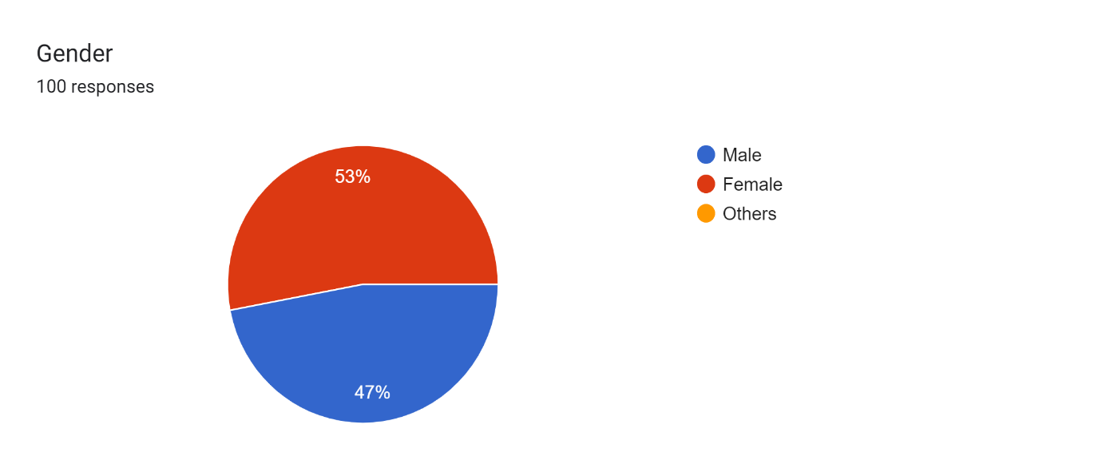

**Interpretation**

From the figure and table, it can be inferred that total out of 100 students surveyed, 47 percentage of respondents are male and 53 percentage of respondents are female. Thus, it concludes that majority of respondents are female.

**TABLE 4.2**

**Stream-wise Classification of Respondents**

|  |  |  |
| --- | --- | --- |
| **Stream** | **Frequency** | **Percentage** |
| Arts | 36 | 36.0 |
| Science | 9 | 9.0 |
| Engineering | 24 | 24.0 |
| Others | 31 | 31.0 |
| Total | 100 | 100.0 |

*Source: primary data*

**FIGURE 4.2**

**Stream-wise Classification of Respondents**

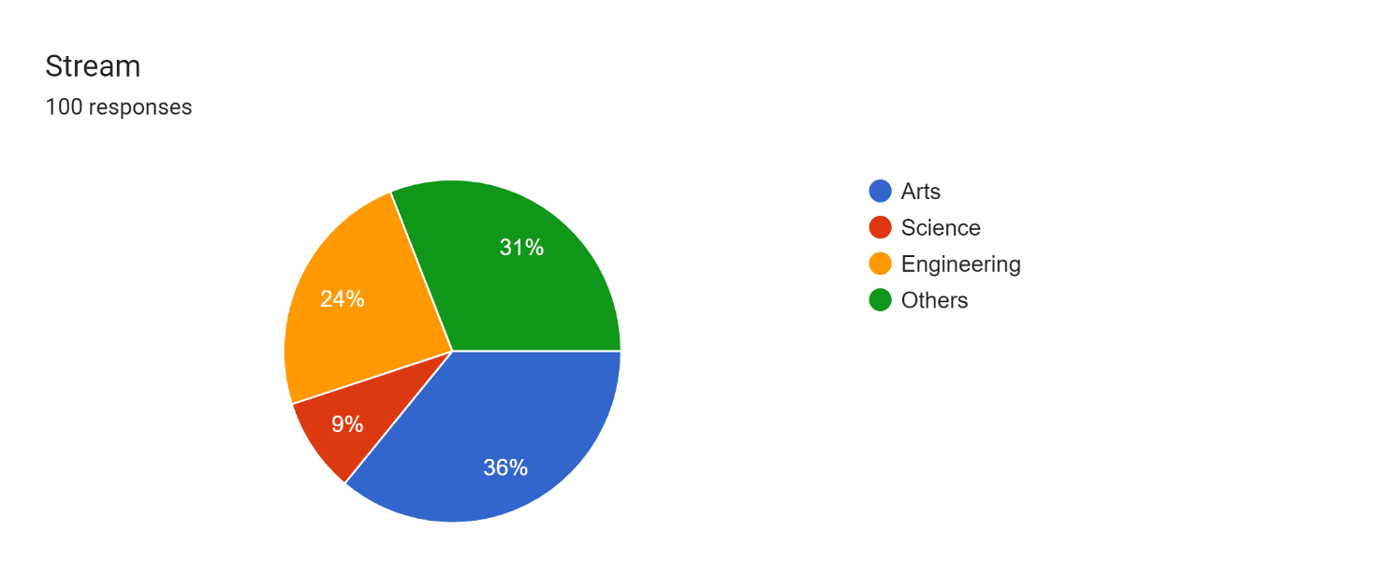

**Interpretation**

The 100 respondents’ stream-wise classification of 100 responders is displayed in the pie chart. With 36 respondents (36% of the total) among the four streams, Arts has the highest frequency. Engineering comes in second with 24 respondents (24%), Others in third place with 31 respondents (31%), and Science in third place with 9 respondents (9%). In this case, the pie chart makes it clear that Arts is the most popular stream among the respondents, followed by Engineering, Science and Other fields.

**TABLE 4.3**

**Factors Attracting Towards Entrepreneurial Career**

|  |  |  |
| --- | --- | --- |
| **Factors attracting towards entrepreneurial career** | **Frequency** | **Percentage** |
| Financial Incentives | 46 | 46.0 |
| Personal Passion and Interest | 64 | 64.0 |
| Educational Background | 21 | 21.0 |
| Influence from Family and Friends | 14 | 14.0 |
| Others | 1 | 1.0 |

*Source: primary data*

**FIGURE 4.3**

**Factors Attracting Towards Entrepreneurial Career**

**Interpretation**

The table and its bar graph show that personal passion and interest is the biggest motivator for people to start a business, with 64% surveyed indicating this as a factor. Financial incentives are the second most common motivator, with 46% of people reporting it as a factor. Educational background and influence from family and friends are fewer common motivators, with 21% and 14% of people reporting them respectively.

**TABLE 4.4**

**Resources that are Considered as the Most Helpful for Considering Entrepreneurship as a Career Choice**

|  |  |  |
| --- | --- | --- |
| **Resources** | **Frequency** | **Percentage** |
| Workshops and training programs on entrepreneurship | 41 | 41.0 |
| Mentorship from successful entrepreneurs | 40 | 40.0 |
| Networking events with other aspiring entrepreneurs | 37 | 37.0 |
| Access to funding and investment opportunities | 41 | 41.0 |

*Source: primary data*

**FIGURE 4.4**

**Resources that are Considered as the Most Helpful for Considering Entrepreneurship as a Career Choice**

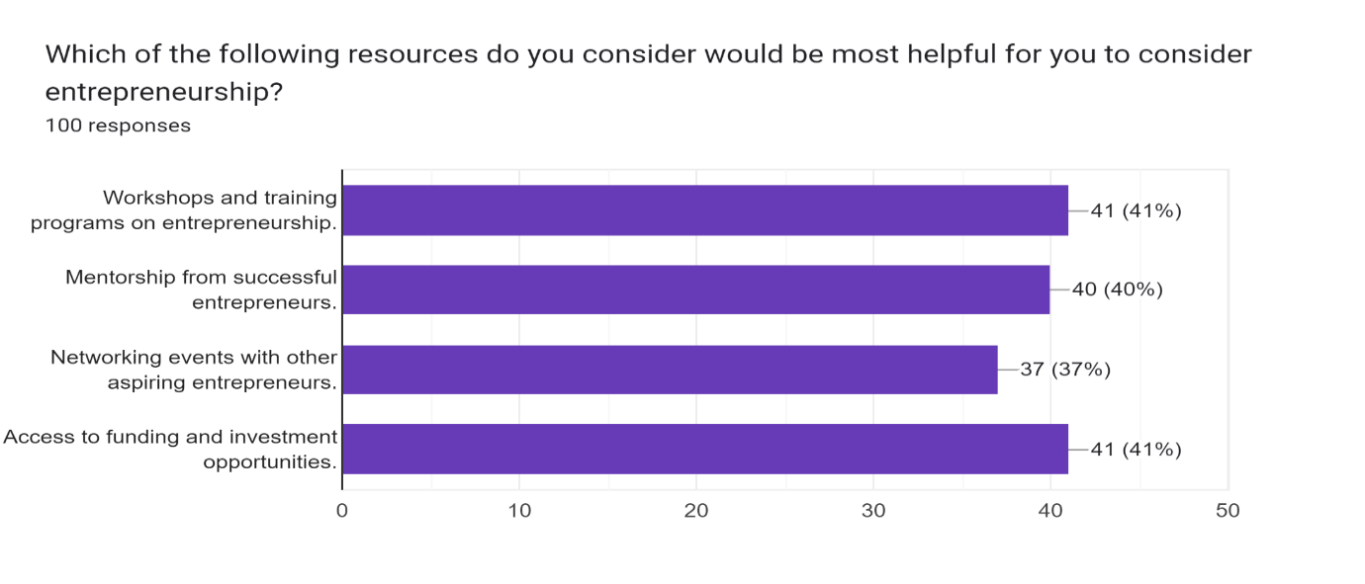

**Interpretation**

Table 4.4 shows that workshops and training programs on entrepreneurship are ranked the most helpful resources, with 41% of respondents indicating this as a helpful resource. Mentorship from successful entrepreneurs and access to funding and investment opportunities are tied for second place, with 40% of respondents considering each to be helpful. Networking events with other aspiring entrepreneurs round out the list at 37% of respondents finding them helpful. Overall, this survey suggests that a combination of educational resources, membership, access to funding and networking opportunities are seen as the most helpful resources for those considering entrepreneurship as a career path.

**TABLE 4.5**

**Family Members or Friends Who are Entrepreneurs**

|  |  |  |
| --- | --- | --- |
| **Yes/No** | **Frequency** | **Percentage** |
| Yes | 61 | 61.0 |
| No | 39 | 39.0 |
| Total | 100 | 100.0 |

*Source: primary data*

**FIGURE 4.5**

**Family Members or Friends Who are Entrepreneurs**

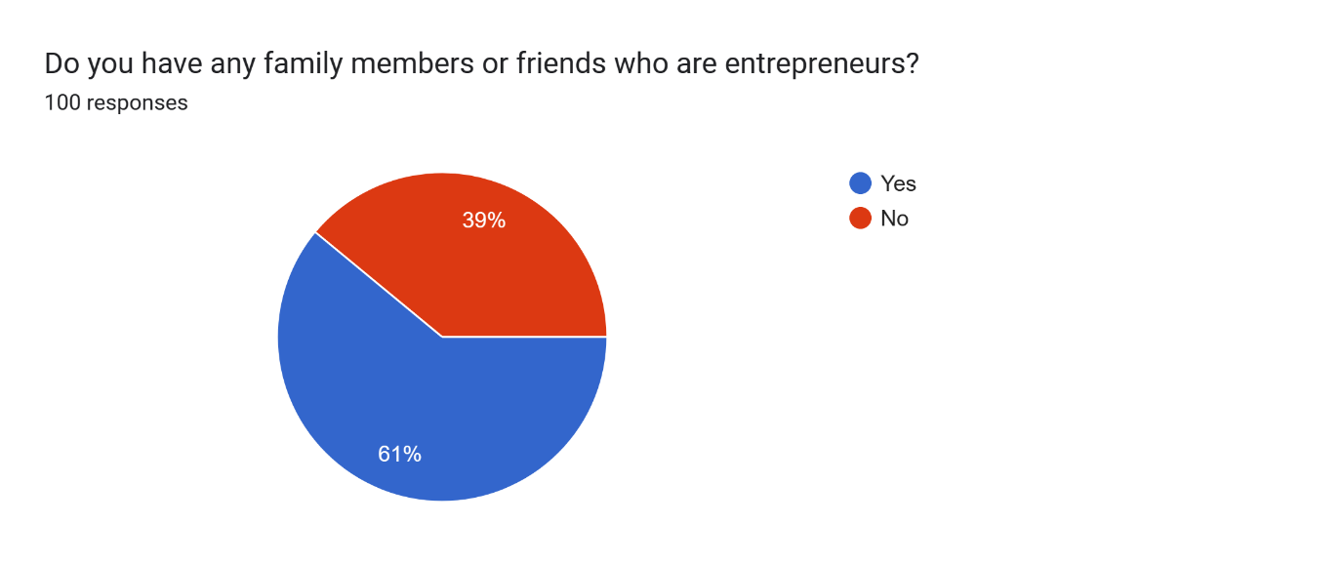

**Interpretation**

The above table and its pie chart show that 61% of the people surveyed said that they have at least one family member or friend who is an entrepreneur. The remaining 39% said that they do not have any family or friends who are entrepreneurs.

**TABLE 4.6**

**Influence of Experience on Entrepreneurship**

|  |  |  |
| --- | --- | --- |
| **Influence** | **No. of students** | **Percentage** |
| Positively | 45 | 73.8 |
| Negatively | 12 | 19.7 |
| Not at all | 4 | 6.5 |
| Total | 61 | 100.0 |

*Source: primary data*

**FIGURE 4.6**

**Influence of Experience in the View on Entrepreneurship**

**Interpretation**

It is interpreted from the above table and pie chart 4.6 that 73.8% of respondents said that experiences have a positive influence on their view of entrepreneurship. About 19.7% of respondents said experiences have a negative impact. The remaining 6.5% of students said it has no influence at all. Overall, the survey results suggests that experience has a positive influence on students' interest in entrepreneurship.

**TABLE 4.7**

**Resources or Support Available on the Campus for Aspiring Entrepreneurs**

|  |  |  |
| --- | --- | --- |
| **Resources or Support Available** | **Frequency** | **Percentage** |
| Yes | 41 | 41.0 |
| No | 59 | 59.0 |
| Total | 100 | 100.0 |

*Source: primary data*

**FIGURE 4.7**

**Resources or Support Available on the Campus for Aspiring Entrepreneurs**

**Interpretation**

The table 4.7 shows the availability of resources or support for aspiring entrepreneurs on campus. According to the survey, 59% of respondents said there are resources or support available, while 41% said there are not. This gives the information that a slight majority of students surveyed believe their campus offers resources or support for aspiring entrepreneurship.

**TABLE 4.8**

**Utilisation of the Resources**

|  |  |  |
| --- | --- | --- |
| **Yes/No** | **No. of students** | **Percentage** |
| Yes | 19 | 46.3 |
| No | 22 | 53.7 |
| Total | 41 | 100.0 |

*Source: primary data*

**FIGURE 4.8**

**Utilisation of the Resources**

**Interpretation**

It is clear from the above table and chart that out of 100 respondents 41 people responded to the question. The chart shows two slices. The larger blue slice labelled “No” represents 53.7% of the people surveyed. The smaller red slice labelled “Yes” represents 46.3% of the people surveyed. In conclusion, most of the people surveyed said they have not utilized any of the resources. However, it is important to note that a significant minority, 46.3%, said they have used the resources.

**TABLE 4.9**

**Factor that needs the most improvement to create a more favourable environment for entrepreneurship**

|  |  |  |
| --- | --- | --- |
| **Factors** | **Frequency** | **Percentage** |
| Access to funding | 51 | 51.0 |
| Regulatory Ease | 44 | 44.0 |
| Educational Support | 36 | 36.0 |
| Market Access | 38 | 38.0 |
| Risk-taking and Innovative Mindset | 53 | 53.0 |

*Source: primary data*

**FIGURE 4.9**

**Factor that needs the most improvement to create a more favourable environment for entrepreneurship**

**Interpretation**

The table shows the results of a survey on what factors respondents believe need the most important to create a more favourable environment for entrepreneurship. Of the 100 responses, 51 (51%) said access to funding needs the most improvement. This suggests that access to funding is seen as the important factor for creating a more favourable environment for entrepreneurship. Regulatory ease was ranked second at 44%, followed by educational support at 36%. Market access and risk-taking and innovative mindset were tied for fourth at 38%.

**TABLE 4.10**

**The Factors that Mostly Demotivates from Choosing Entrepreneurship as Your Career Choice**

|  |  |  |
| --- | --- | --- |
| **Factors** | **Frequency** | **Percentage** |
| Lack of Motivation | 14 | 14.0 |
| Financial Constrains | 31 | 31.0 |
| Fear of Failure | 34 | 34.0 |
| Lack of Business Skills and Knowledge | 17 | 17.0 |
| Others | 4 | 4.0 |
| Total | 100 | 100.0 |

*Source: primary data*

**FIGURE 4.10**

**The Factors that Mostly Demotivates from Choosing Entrepreneurship as Your Career Choice**

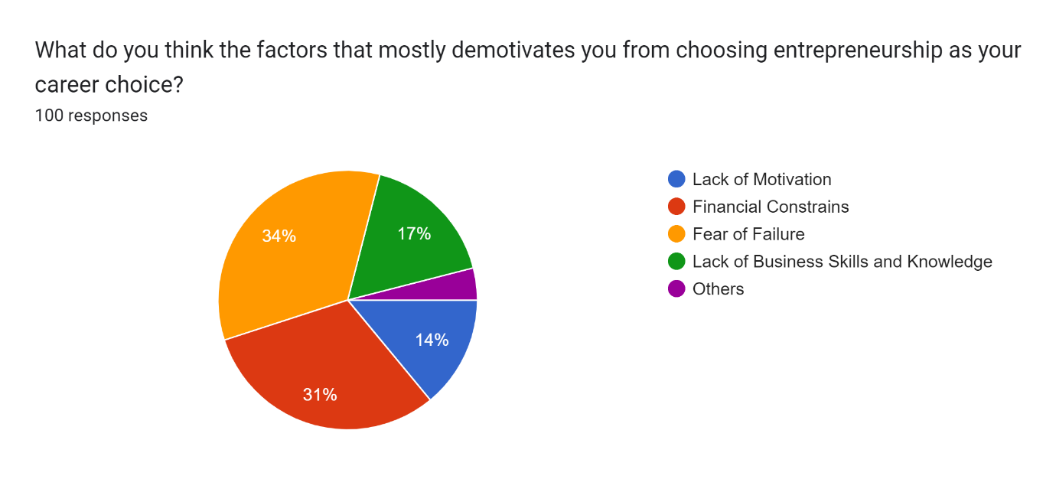

**Interpretation**

From the above table and pie chart, it shows that the most common factor that demotivates from choosing entrepreneurship as a career choice is fear of failure, with 34% of respondents reporting it. Financial constraints are the second most common demotivator, with 31% of respondents reporting it. Lack of motivation and lack of business skill and knowledge are also listed as demotivators, with 14% and 17% respectively. In conclusion this pie chart suggests that fear of failure and financial insecurity are the top two reasons why people are discouraged from pursuing entrepreneurship as a career choice.

**Objective 1: To study the attitude of students towards entrepreneurship as a career option**

**TABLE 4.11**

**Interest in Pursuing Entrepreneurship as a Career Option**

|  |  |  |
| --- | --- | --- |
| **Interest in pursuing entrepreneurship as a career option** | **Frequency** | **Percentage** |
| Extremely Interested | 15 | 15.0 |
| Very Interested | 39 | 39.0 |
| Moderately Interested | 33 | 33.0 |
| Slightly Interested | 10 | 10.0 |
| Not at all Interested | 5 | 5.0 |

*Source: primary data*

**FIGURE 4.11**

**Interest in Pursuing Entrepreneurship as a Career Option**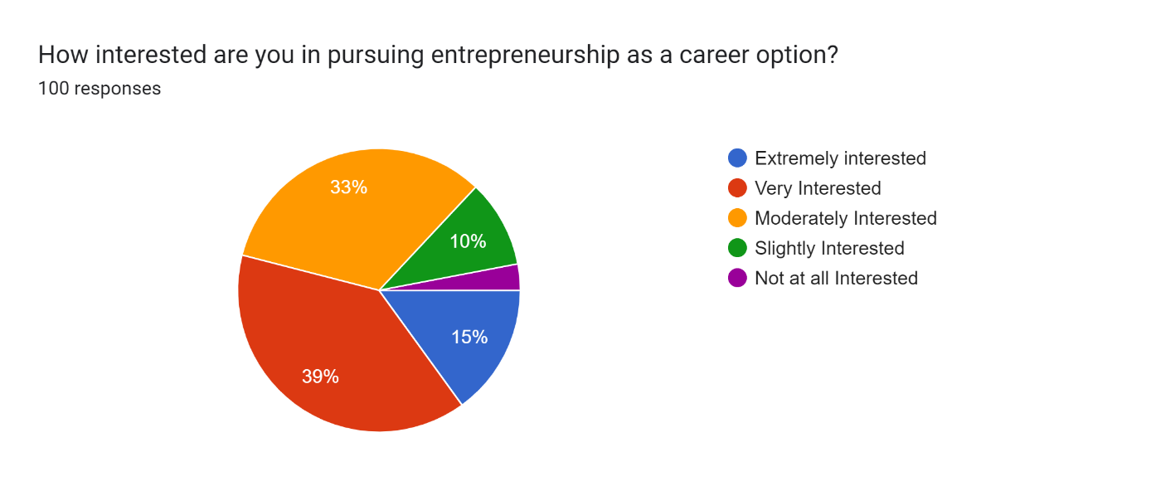

**Interpretation**

It is clear from the table and pie chart that a significant portion of the people surveyed, 15% are extremely interested and 39% are very interested in pursuing entrepreneurship as a career choice. Another third, 33% are moderately interested, while only 10% are slightly interested and only 5% are not at all interested. This suggests that entrepreneurship is a fairly attractive career option for the people surveyed.

**TABLE 4.12**

**Confidence Level**

|  |  |  |
| --- | --- | --- |
| **Confidence Level** | **Frequency** | **Percentage** |
| Extremely Confident | 17 | 17.0 |
| Very Confident | 35 | 35.0 |
| Moderately Confident | 37 | 37.0 |
| Somewhat Confident | 8 | 8.0 |
| Not Confident | 3 | 3.0 |

*Source: primary data*

**FIGURE 4.12**

**Confidence Level**

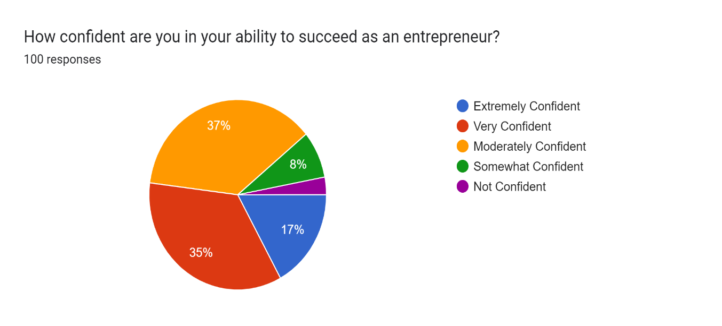

**Interpretation**

From figure 4.12 it is clear that the largest percentage of respondents, 37%, said that they are very confident. Following that, 35% said that moderately confident, 17% said extremely confident, and 8% said somewhat confident. Overall, this chart suggests that a majority of people who were surveyed about their entrepreneurial confidence believe they have at least a moderate chance of success.

**TABLE 4.13**

**Risk Perception Associated with Entrepreneurship**

|  |  |  |
| --- | --- | --- |
| **Risk Perception** | **Frequency** | **Percentage** |
| High | 53 | 53.0 |
| Moderate | 44 | 44.0 |
| Low | 3 | 3.0 |

*Source: primary data*

**FIGURE 4.13**

**Risk Perception Associated with Entrepreneurship**

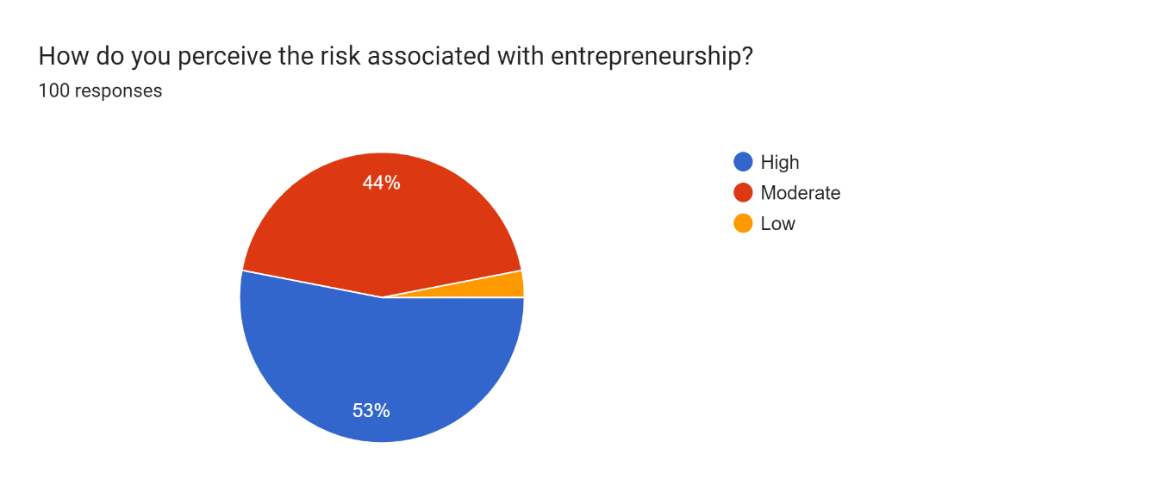

**Interpretation**

It is being interpreted that the majority of respondents, 53%, perceived the risk associated with entrepreneurship to be high. A smaller percentage, 44%, perceived the risk to be moderate, only 3% perceived the risk to be low. This suggests that entrepreneurship is generally seen as a risky endeavor. However, it is also important to note that a significant number of people (44%) view the risk as moderate, and a small number (3%) view it as low. This suggests that some people are willing to take on the risk of entrepreneurship in order to pursue their business goal.

**TABLE 4.14**

**Optimistic about the Future of Entrepreneurship**

|  |  |  |
| --- | --- | --- |
| **Optimistic** | **Frequency** | **Percentage** |
| Very optimistic | 31 | 31.0 |
| Somewhat Optimistic | 47 | 47.0 |
| Neutral | 21 | 21.0 |
| Somewhat Pessimistic | 1 | 1.0 |
| Very Pessimistic | 0 | 0.0 |

*Source: primary data*

**FIGURE 4.14**

**Optimistic about the Future of Entrepreneurship**

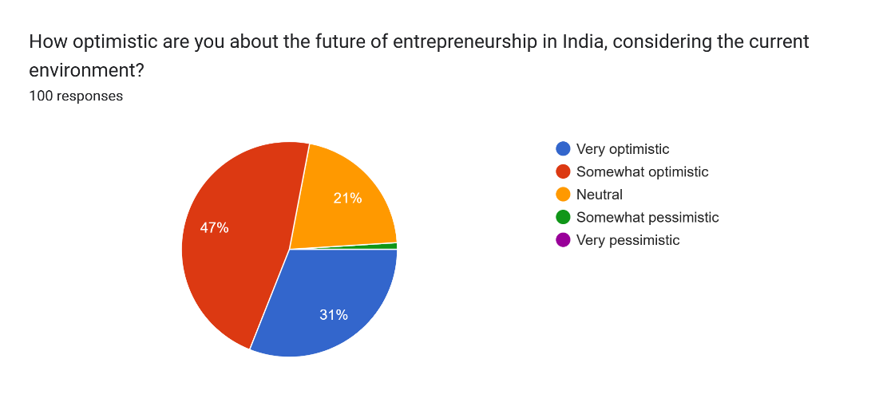

**Interpretation**

The above table and chart 4.14 represent that most respondents are optimistic about the future of entrepreneurship in India. When asked how optimistic they were on the scale of very optimistic to very pessimistic, 31% of the respondents said they were very optimistic and 47% said somewhat optimistic. In total, 78% of the respondents were either very or somewhat optimistic about the future of entrepreneurship in India. Only a small percentage, 5%, said they were neutral, and a very small percentage, 1%, said they were somewhat pessimistic. None of the respondents said that they were very pessimistic.

**H0**: There is no significant difference in attitude of students towards entrepreneurship as a career based on gender and stream.

**H1**: There is a significant difference in attitude of students towards entrepreneurship as a career based on gender and stream.

**TABLE 4.15**

**Descriptive Statistics of Attitude of Students Towards Entrepreneurship as a Career Choice**

|  |  |  |
| --- | --- | --- |
|  | Mean | Std. Deviation |
| Career option | 3.5300 | 0.96875 |
| Confidence | 3.5500 | 0.96792 |
| Future of entrepreneurship in India | 4.0800 | 0.74779 |

*Source: primary data*

**Interpretation**

The above table 4.15 shows the mean and standard deviation on three metrics: career option, confidence, and future of entrepreneurship in India. The survey indicates that students have a positive outlook on future of entrepreneurship in India, with an average rating of 4.08. The standard deviation of 0.74779 implies that there is a less spread of responses for this metric compared to the other two.

**TABLE 4.16**

**Gender Wise Distribution of Attitude of Students Towards Entrepreneurship as a Career Choice**

|  |  |  |  |  |
| --- | --- | --- | --- | --- |
| Gender |  | Career option | Confident | Future of entrepreneurship in India |
| Male | Mean | 3.7660 | 3.9149 | 4.0851 |
|  | N | 47 | 47 | 47 |
|  | Std. Deviation | 0.93745 | 0.90481 | 0.74687 |
| Female | Mean | 3.3208 | 3.2264 | 4.0755 |
|  | N | 53 | 53 | 53 |
|  | Std. Deviation | 0.95623 | 0.91234 | 0.75572 |
| Total | Mean | 3.5300 | 3.5500 | 4.0800 |
|  | N | 100 | 100 | 100 |
|  | Std. Deviation | 0.96875 | 0.96792 | 0.74779 |

*Source: primary data*

**Interpretation**

The table 4.16 shows the gender-wise distribution of attitudes of students towards entrepreneurship as a career in India. Overall, both male and female students have a moderately positive outlook on entrepreneurship as a career option, with male students rating it slightly higher (3.766) than female students (3.321). There is also a standard deviation around 0.9 for both genders, indicating a spread of responses around the mean. Both genders also expressed a moderate level of confidence in their entrepreneurial abilities. Male students again rated their confidence slightly higher (4.085) than female students (4.076). The standard deviation is around 0.7 for both genders, suggesting a tighter range of responses for confidence compared to career option. Finally, both genders have a positive outlook on the future of entrepreneurship in India, with an average rating of over 4.0 on a scale of 1 to 5. There is very little difference in the means between genders, and the standard deviation is around 0.75, which is again lower than career option. This suggests that both genders are optimistic about the future of entrepreneurship in India, and their responses are fairly clustered around the mean.

**TABLE 4.17**

**Stream Wise Distribution of Attitude of Students Towards Entrepreneurship as a Career Choice**

|  |  |  |  |  |
| --- | --- | --- | --- | --- |
| Stream |  | Career option | Confident | Future of entrepreneurship in India |
| Arts | Mean | 3.5556 | 3.4167 | 4.0278 |
|  | N | 36 | 36 | 36 |
|  | Std. Deviation | 0.90851 | 0.93732 | 0.77408 |
| Science | Mean | 3.5556 | 3.7778 | 4.0000 |
|  | N | 9 | 9 | 9 |
|  | Std. Deviation | 0.52705 | 0.66667 | 0.70711 |
| Engineering | Mean | 3.6250 | 3.7500 | 4.0833 |
|  | N | 24 | 24 | 24 |
|  | Std. Deviation | 1.09594 | 0.89685 | 0.82970 |
| Others | Mean | 3.4194 | 3.4839 | 4.1613 |
|  | N | 31 | 31 | 31 |
|  | Std. Deviation | 1.05749 | 1.12163 | 0.68784 |
| Total | Mean | 3.5300 | 3.5500 | 4.0800 |
|  | N | 100 | 100 | 100 |
|  | Std. Deviation | 0.96875 | 0.96792 | 0.74779 |
|  |  |  |  |  |

*Source: primary data*

**Interpretation**

The table 4.17 reveals that, across all academic streams, students at the university have a moderately positive outlook on entrepreneurship as a career choice (averaging above 3.4), with Engineering students appearing most interested (mean rating 3.6250). There is some variation in responses within each stream (standard deviation around 1). Similarly, students expressed moderate confidence in their entrepreneurial abilities (average above 3.4), with Engineering students again having the highest average rating (3.7500) and standard deviations around 1 indicating some spread in confidence levels. Finally, the survey shows a positive outlook on the future of entrepreneurship in India (average rating above 4.0 across all streams), with Engineering students again the most optimistic (averaging 4.0833). Notably, the standard deviation for future outlook is lower (around 0.7), suggesting a tighter clustering of responses compared to the other two metrics.

**TABLE 4.18**

**Normality of Variables Related to Attitude of Students Towards Entrepreneurship as a Career Choice**

|  |  |  |  |  |
| --- | --- | --- | --- | --- |
|  | Null Hypothesis | Test | Sig. | Decision |
| 1 | The distribution of Career option is normal with mean 3.53 and standard deviation .96875. | One-Sample Kolmogorov-Smirnov Test | .000a | Reject the null hypothesis. |
| 2 | The distribution of Confident is normal with mean 3.55 and standard deviation .96792. | One-Sample Kolmogorov-Smirnov Test | .000a | Reject the null hypothesis. |
| 3 | The distribution of Future of entrepreneurship in India is normal with mean 4.08 and standard deviation .74779. | One-Sample Kolmogorov-Smirnov Test | .000a | Reject the null hypothesis. |
| Asymptotic significances are displayed. The significance level is .050. | | | | |
| 1. Lilliefors Corrected   **Interpretation** | | | | |

Table 4.18 presents the results of the normality tests conducted on variables related to attitude of students towards entrepreneurship as a career. The null hypothesis for each test is that the distribution of the respective variable is normal, with specified mean and standard deviation. The tests were performed using the One-Sample Kolmogorov-Smirnov Test, and the significance level was set at .050. For all three variables tested—career option, confidence, and future of entrepreneurship in India—the p-values obtained were .000, leading to the rejection of the null hypothesis in each case. Therefore, based on these tests, the distributions of the variables are not considered normal. The Lilliefors correction was applied to calculate asymptotic significances. These results provide insights into the distributional characteristics of the variables related to students’ attitude.

**TABLE 4.19**

**Mann-Whitney U Test on Attitude of Students Towards Entrepreneurship as a Career based on Gender**

|  |  |  |  |  |
| --- | --- | --- | --- | --- |
|  | Null Hypothesis | Test | Sig. | Decision |
| 1 | The distribution of Career option is the same across categories of Gender. | Independent-Samples Mann-Whitney U Test | 0.026 | Reject the null hypothesis. |
| 2 | The distribution of Confident is the same across categories of Gender. | Independent-Samples Mann-Whitney U Test | 0.000 | Reject the null hypothesis. |
| 3 | The distribution of Future of entrepreneurship in India is the same across categories of Gender. | Independent-Samples Mann-Whitney U Test | 0.007 | Reject the null hypothesis. |
| Asymptotic significances are displayed. The significance level is .050.  **Interpretation** | | | | |

Table 4.19 presents the results of Mann-Whitney U Tests conducted to assess the attitudes of students towards entrepreneurship as a career based on gender categories. The null hypotheses tested for each attitude dimension were rejected at different significance levels. First, the null hypothesis regarding the distribution of Career option across gender categories was rejected with a significance level of 0.026, indicating a significant difference in career preferences between genders. Second, the null hypothesis concerning the distribution of Confidence levels across gender categories was rejected at a significance level of 0.000, suggesting gender-related differences in confidence levels regarding entrepreneurship. Lastly, the null hypothesis related to the distribution of Future of entrepreneurship in India across gender categories was rejected with a significance level of 0.007. These findings suggest that gender plays a significant role in shaping students' attitudes towards entrepreneurship, highlighting the need for gender-sensitive approaches in promoting entrepreneurial aspirations and opportunities among students.

**TABLE 4.20**

**Kruskal-Wallis Test on Attitude of Students Towards Entrepreneurship as a Career based on Stream**

|  |  |  |  |  |
| --- | --- | --- | --- | --- |
|  | Null Hypothesis | Test | Sig. | Decision |
| 1 | The distribution of Career option is the same across categories of Stream. | Independent-Samples Kruskal-Wallis Test | 0.008 | Reject the null hypothesis. |
| 2 | The distribution of Confident is the same across categories of Stream. | Independent-Samples Kruskal-Wallis Test | 0.015 | Reject the null hypothesis. |
| 3 | The distribution of Future of entrepreneurship in India is the same across categories of Stream. | Independent-Samples Kruskal-Wallis Test | 0.008 | Reject the null hypothesis. |
| Asymptotic significances are displayed. The significance level is .050.  **Interpretation**  The above table shows that the P value is less than 0.05 for all three variables tested, that means the attitude of students towards entrepreneurship as a career choice is based on stream. So, we reject the null hypothesis. Therefore, there is significant difference in attitude of students towards entrepreneurship as a career based on gender and stream.  **Conclusion:**  There is significant difference in attitude of students towards entrepreneurship as a career based on gender and stream. | | | | |

**Objective 2: To find out the factors that attract students towards entrepreneurship.**

**TABLE 4.21**

**The Level of Importance to the Factors in Choosing Entrepreneurship as Your Career Choice.**

|  |  |  |  |  |  |  |
| --- | --- | --- | --- | --- | --- | --- |
| **Factors** | **Very Important** | **Important** | **Neutral** | **Low Importance** | **Not at all Important** | **Total** |
| Financial Independence | 65 | 30 | 4 | 1 | 0 | 100 |
| Job Security | 33 | 43 | 21 | 2 | 1 | 100 |
| Creative Freedom | 65 | 27 | 5 | 4 | 0 | 100 |
| Making a positive impact | 53 | 35 | 8 | 1 | 3 | 100 |
| Personal Development | 61 | 30 | 7 | 1 | 1 | 100 |

*Source: primary data*

**FIGURE 4.21**

**The Level of Importance to the Factors in Choosing Entrepreneurship as Your Career Choice.**

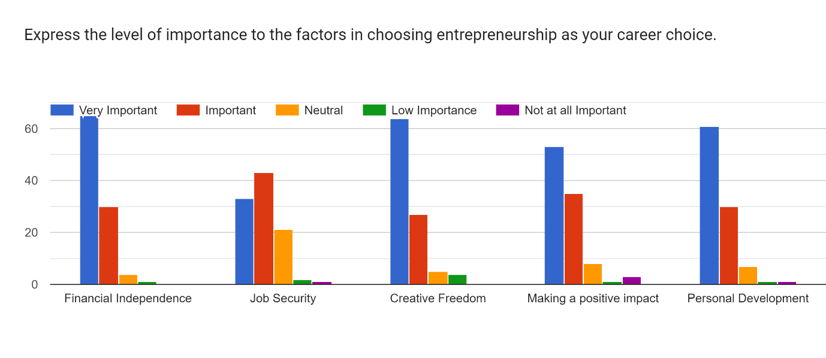**Interpretation**

It is interpreted from the table and its bar graph that financial independence and job security are ranked as the most important factor, with 65% and 33% of respondents rating them as very important, respectively. This suggests that financial security is a primary motivator for people who choose entrepreneurship. Interestingly, creative freedom and making a positive impact are ranked as the least important factor, with only 27% and 35% of respondents rating them as very important respectively.

**TABLE 4.22**

**Roles that Educational Institutions Play in Fostering an Entrepreneurial Career**

|  |  |  |
| --- | --- | --- |
| **Role** | **Frequency** | **Percentage** |
| Pivotal role | 11 | 11.0 |
| Significant role | 49 | 49.0 |
| Moderate role | 21 | 21.0 |
| Limited role | 15 | 15.0 |
| No role | 4 | 4.0 |

*Source: primary data*

**FIGURE 4.22**

**Role that Educational Institutions Play in Fostering an Entrepreneurial Career**

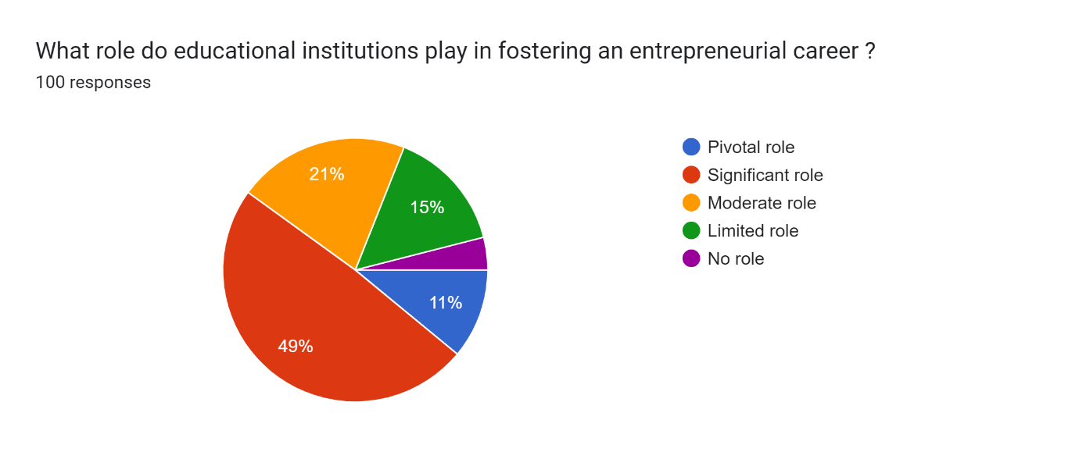

**Interpretation**

The above table and chart provide the findings that nearly half, 49% of the respondents believe educational institutions play a significant role in fostering an entrepreneurial career. An additional 21% believe that they play a moderate role. Only 4% of the respondents think that the educational institutions do not have any role in fostering entrepreneurial career. This suggests that over two-thirds of the people surveyed believe educational institutions play a role in fostering entrepreneurial careers.

**TABLE 4.23**

**Accessible of Resources for Aspiring Entrepreneurs in Academic Environment**

|  |  |  |
| --- | --- | --- |
| **Accessibility** | **Frequency** | **Percentage** |
| Very Accessible | 47 | 47.0 |
| Accessible | 36 | 36.0 |
| Neutral | 11 | 11.0 |
| Limited Access | 4 | 4.0 |
| No Access | 2 | 2.0 |

*Source: primary data*

**FIGURE 4.23**

**Accessible of Resources for Aspiring Entrepreneurs in Academic Environment**

Forms response chart. Question title: How accessible are resources such as funding, mentorship, and co-working spaces for aspiring entrepreneurs in your academic environment?
. Number of responses: 100 responses.

**Interpretation**

The table and its chart show that nearly half, 47% of respondents indicated that resources for aspiring entrepreneurs in academic environment are very accessible. Another 36% said that these resources are accessible. This suggests that a large majority, 83% of the respondents of found the resources to be very or somewhat accessible. On the other hand, 11% of the respondents said that the resources were neutral, and 4% said that access was limited. Only 2% said that there was no access to resources. Overall, the pie chart suggests that the academic environment offers good access to resources for aspiring entrepreneurs.

**TABLE 4.24**

**Descriptive Statistics on the Factors that Attract Students Towards Entrepreneurial Career**

|  |  |  |  |
| --- | --- | --- | --- |
|  | Mean | Std. Deviation | Coefficient of Variation (CV) |
| Financial Independence | 4.5900 | 0.62109 | **13.53** |
| Job Security | 4.0500 | 0.84537 | 20.87 |
| Creative Freedom | 4.5100 | 0.77192 | 17.12 |
| Making a Positive Impact | 4.3400 | 0.90140 | 20.77 |
| Personal Development | 4.4900 | 0.75872 | 16.90 |

Source: primary data

**Interpretation**

The table 4.24 reveals the factor that students towards entrepreneurial career. Most of the respondents says that Financial Independence is the major factor that attract students towards entrepreneurial career. Coefficient of Variation is a measure of relative variability and the least value shows that it is more consistent. In this table, 13.53 is the least value, so Financial Independence is the most consistent variable in this factor.

**Objective 3: To study the various environmental factors which promote entrepreneurship among post graduate commerce students.**

**TABLE 4.25**

**Significant of Environmental Factors in Promoting Entrepreneurship**

|  |  |  |
| --- | --- | --- |
| **Significance** | **Frequency** | **Percentage** |
| Extremely Significant | 24 | 24.0 |
| Very Significant | 51 | 51.0 |
| Moderately Significant | 20 | 20.0 |
| Slightly Significant | 4 | 4.0 |
| Not Significant | 1 | 1.0 |

*Source: primary data*

**FIGURE 4.25**

**Significant of Environmental Factors in Promoting Entrepreneurship**

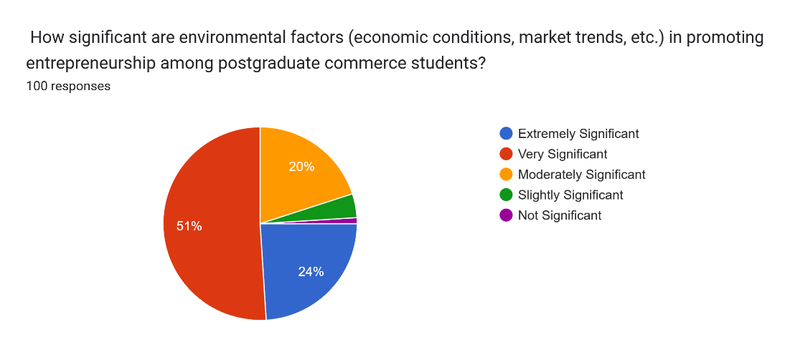

**Interpretation**

The above frequency table 4.25 shows that most of the respondents, 51% believed that environmental factors are very significant. About 24% believed them to be extremely significant, 20% believed them to be slightly significant, and only 1% believed them to be not significant. In conclusion, vast majority of the students surveyed believed that environmental factors play a significant role in promoting entrepreneurship.

**TABLE 4.26**

**Importance of Government Support to Entrepreneurship**

|  |  |  |
| --- | --- | --- |
| **Importance** | **Frequency** | **Percentage** |
| Very Important | 47 | 47.0 |
| Important | 36 | 36.0 |
| Neutral | 11 | 11.0 |
| Low Importance | 4 | 4.0 |
| Not at all Important | 2 | 2.0 |

*Source: primary data*

**FIGURE 4.26**

**Importance of Government Support to Entrepreneurship**

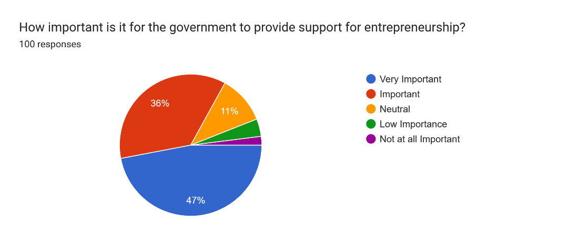

**Interpretation**

It is understood from the above table 4.26 that nearly half, 47% of the respondents said that government support is very important. Another 36% said it is important. This suggests that a larger majority, 83% of the respondents believe government support is very or somewhat important. On the other hand, 11% of the respondents said that government support is neutral in importance, and 4% said its important is low. Only 2% said that government support is not at all important. Overall, this suggests that most people believe government support plays a significant role in entrepreneurship.

**TABLE 4.27**

**Important of Access to Technology and Infrastructure**

|  |  |  |
| --- | --- | --- |
| **Importance** | **Frequency** | **Percentage** |
| Very Important | 46 | 46.0 |
| Important | 44 | 44.0 |
| Neutral | 7 | 7.0 |
| Low Importance | 1 | 1.0 |
| Not at all Important | 2 | 2.0 |

*Source: primary data*

**FIGURE 4.27**

**Important of Access to Technology and Infrastructure**

Forms response chart. Question title: How important is access to technology and infrastructure for facilitating entrepreneurial ventures according to your point of view?
. Number of responses: 100 responses.

**Interpretation**

According to the survey, the above table and its chart shows that nearly half, 46% of the respondents believe that access to technology and infrastructure is very important. An additional 44% said it is important. This suggests that a large majority, 90% of the respondents consider access to technology and infrastructure to be very or somewhat important for facilitating entrepreneurial ventures. Only a small percentage, 10% of the respondents said that access to technology and infrastructure is neutral in importance, low in importance, or not at all important.

**H0:** There is no significant difference in the various environmental factors which promote entrepreneurship in students based on gender and stream.

**H1:** There is a significant difference in the various environmental factors which promote entrepreneurship in students based on gender and stream.

**TABLE 4.28**

**Descriptive Statistics on the Various Environmental Factors that Promote Entrepreneurship**

|  |  |  |
| --- | --- | --- |
|  | Mean | Std. Deviation |
| Environmental factors | 3.9300 | 0.83188 |
| Government support | 4.2200 | 0.93830 |
| Technology and infrastructure | 4.3100 | 0.81271 |

*Source: primary data*

**Interpretation**

Table 4.28 reveals various environmental factors which promote entrepreneurship. The table depicts descriptive statistics on various environmental factors that promote entrepreneurship. The environmental factors included in the table are government support, technology and infrastructure. The average score for both these factors is above 4 on a scale of 1 to 5, with a standard deviation of 0.9. This suggests that entrepreneurs perceive both government support and technology and infrastructure as relatively positive aspects of the environment.

**TABLE 4.29**

**Gender wise Distribution of Various Environmental Factors that Promote Entrepreneurship**

|  |  |  |  |  |
| --- | --- | --- | --- | --- |
| Gender |  | Environmental factors | Government support | Technology and infrastructure |
| Male | Mean | 3.9574 | 4.1489 | 4.4043 |
|  | N | 47 | 47 | 47 |
|  | Std. Deviation | 0.85865 | 1.06278 | 0.79836 |
| Female | Mean | 3.9057 | 4.2830 | 4.2264 |
|  | N | 53 | 53 | 53 |
|  | Std. Deviation | 0.81487 | 0.81753 | 0.82372 |
| Total | Mean | 3.9300 | 4.2200 | 4.3100 |
|  | N | 100 | 100 | 100 |
|  | Std. Deviation | 0.83188 | 0.93830 | 0.81271 |

*Source: primary data*

**Interpretation**

Above table 4.29 reveals the average scores for environmental factors, government support, and technology and infrastructure by gender. The data suggests that there is a slight difference in the means between men and women in each category. Men have a slightly higher mean score for environmental factors (3.96) compared to women (3.91). Women have a slightly higher mean score for government support (4.28) compared to men (4.15). Both genders have a nearly identical mean score for technology and infrastructure (4.40 for men and 4.23 for women). The standard deviation is relatively high for all categories, meaning the data points are spread out around the mean. Overall, the table suggests that there may be some gender differences in experiences with environmental factors, government support, and technology and infrastructure.

**TABLE 4.30**

**Stream Wise Distribution of Various Environmental Factors that Promote Entrepreneurship**

|  |  |  |  |  |
| --- | --- | --- | --- | --- |
| Stream |  | Environmental factors | Government support | Technology and infrastructure |
| Arts | Mean | 3.9167 | 4.2778 | 4.2222 |
|  | N | 36 | 36 | 36 |
|  | Std. Deviation | 0.90633 | 0.94449 | 0.89797 |
| Science | Mean | 3.7778 | 4.3333 | 4.5556 |
|  | N | 9 | 9 | 9 |
|  | Std. Deviation | 0.66667 | 1.00000 | 0.52705 |
| Engineering | Mean | 3.9583 | 4.0417 | 4.3333 |
|  | N | 24 | 24 | 24 |
|  | Std. Deviation | 0.85867 | 1.08264 | 0.96309 |
| Others | Mean | 3.9677 | 4.2581 | 4.3226 |
|  | N | 31 | 31 | 31 |
|  | Std. Deviation | 0.79515 | 0.81518 | 0.65254 |
| Total | Mean | 3.9300 | 4.2200 | 4.3100 |
|  | N | 100 | 100 | 100 |
|  | Std. Deviation | 0.83188 | 0.93830 | 0.81271 |

*Source: primary data*

**Interpretation**

The table shows the average score for three environmental factors that are believed to promote entrepreneurship: government support, technology and infrastructure, across four different streams - Arts, Science, Engineering and Others. Entrepreneurial environments are perceived to be most supportive in science with an average score of 4.56 for technology and infrastructure, followed by Engineering at 4.33. Government support is perceived to be around 4.2-4.3 for all streams. There seems to be a fairly even spread of scores across all streams based on the standard deviation values.

**TABLE 4.31**

**Checking the Normality Distribution Related to Various Environmental Factors that Promote Entrepreneurship**

|  |  |  |  |  |
| --- | --- | --- | --- | --- |
|  | Null Hypothesis | Test | Sig. | Decision |
| 1 | The distribution of Environmental factors is normal with mean 3.93 and standard deviation .83188. | One-Sample Kolmogorov-Smirnov Test | .000a | Reject the null hypothesis. |
| 2 | The distribution of Government support is normal with mean 4.22 and standard deviation .93830. | One-Sample Kolmogorov-Smirnov Test | .000a | Reject the null hypothesis. |
| 3 | The distribution of Technology and Infrastructure is normal with mean 4.31 and standard deviation .81271. | One-Sample Kolmogorov-Smirnov Test | .000a | Reject the null hypothesis. |
| Asymptotic significances are displayed. The significance level is .050. | | | | |
| a. Lilliefors Corrected | | | | |

**Interpretation**

Table 4.31 presents the results of the normality tests conducted on variables related to various environmental factors which promote entrepreneurship. The null hypothesis for each test is that the distribution of the respective variable is normal, with specified mean and standard deviation. The tests were performed using the One-Sample Kolmogorov-Smirnov Test, and the significance level was set at .050. For all three variables tested—Environmental factors, Government Support, Technology and Infrastructure —the p-values obtained were .000, leading to the rejection of the null hypothesis in each case. Therefore, based on these tests, the distributions of the variables are not considered normal. The Lilliefors correction was applied to calculate asymptotic significances. These results provide insights into the distributional characteristics of the variables related to various environmental factors.

**TABLE 4.32**

**Mann-Whitney U Test on Various Environmental Factors that Promote Entrepreneurship based on the Gender**

|  |  |  |  |  |
| --- | --- | --- | --- | --- |
|  | Null Hypothesis | Test | Sig. | Decision |
| 1 | The distribution of Environmental factors is the same across categories of Gender. | Independent-Samples Mann-Whitney U Test | 0.006 | Reject the null hypothesis. |
| 2 | The distribution of Government support is the same across categories of Gender. | Independent-Samples Mann-Whitney U Test | 0.005 | Reject the null hypothesis. |
| 3 | The distribution of Technology and Infrastructure is the same across categories of Gender. | Independent-Samples Mann-Whitney U Test | 0.000 | Reject the null hypothesis. |

Asymptotic significances are displayed. The significance level is .050.

**Interpretation**

Table 4.32 presents the results of Mann-Whitney U Tests conducted to assess various environmental factors which promote entrepreneurship based on gender categories. The null hypothesis tested for each factor dimension were rejected at different significance levels. First, the null hypothesis regarding the distribution of Environmental factors across gender categories was rejected with a significance level of 0.006, indicating a significant difference in gender basis on various factors which promote entrepreneurship. Second, the null hypothesis concerning the distribution of Government Support across gender categories was rejected at a significance level of 0.005, suggesting gender-related differences on environmental factors which promote entrepreneurship. Lastly, the null hypothesis related to the distribution of Technology and Infrastructure is the same across gender categories was rejected with a significance level of 0.000. These findings suggest that gender plays a significant role in accessing various environmental factors which promote entrepreneurship

**TABLE 4.33**

**Kruskal-Wallis Test on Various Environmental Factors that Promote Entrepreneurship based on the Gender**

|  |  |  |  |  |
| --- | --- | --- | --- | --- |
|  | Null Hypothesis | Test | Sig. | Decision |
| 1 | The distribution of Environmental factors is the same across categories of Stream. | Independent-Samples Kruskal-Wallis Test | 0.016 | Reject the null hypothesis. |
| 2 | The distribution of Government support is the same across categories of Stream. | Independent-Samples Kruskal-Wallis Test | 0.007 | Reject the null hypothesis. |
| 3 | The distribution of Technology and infrastructure is the same across categories of Stream. | Independent-Samples Kruskal-Wallis Test | 0.004 | Reject the null hypothesis. |

Asymptotic significances are displayed. The significance level is .050.

**Interpretation**

The above table shows that the P value is less than 0.05 for all three variables tested, that means the various environmental factors which promote entrepreneurship based on the gender. So, we reject the null hypothesis. Therefore, there is significant differences on gender and stream based on various environmental factors which promote entrepreneurship

**Objective 4: To study some of the factors such as fear of failure, financial constraints, lack of motivation, personal risk aversion that demotivates the post graduate commerce students.**

**TABLE 4.34**

**Demotivating Factors Wise Distribution of Students**

|  |  |  |
| --- | --- | --- |
| Demotivating Factors | No. of Students | Percent |
| Lack of Motivation | 14 | 14.0 |
| Financial Constrains | 31 | 31.0 |
| Fear of Failure | 34 | 34.0 |
| Lack of Business Skills and Knowledge | 17 | 17.0 |
| Others | 4 | 4.0 |
| Total | 100 | 100.0 |

**Interpretation**

Table 4.34 presents the distribution of students based on demotivating factors they experience. Among the surveyed students, the demotivating factors were categorized into Lack of Motivation, Financial Constraints, Fear of Failure, Lack of Business Skills and Knowledge, and Others. The data shows that Fear of Failure was the most prevalent demotivating factor reported by 34% of the students, followed by Financial Constraints at 31%, while Lack of Business Skills and Knowledge and Lack of Motivation were each reported by 17% and 14% of the students respectively. Additionally, a small percentage of students, 4%, cited other demotivating factors. The total percentage accounts for 100% of the surveyed students. This distribution underscores the diverse array of challenges students face, with fear of failure and financial constraints being particularly significant factors affecting student motivation.

**TABLE 4.35**

**Descriptive Statistics on Demotivating Factors**

|  |  |  |
| --- | --- | --- |
|  | Mean | Std. Deviation |
| Demotivating Factors | 2.6600 | 1.04659 |

**Interpretation**

Table 4.35 provides descriptive statistics regarding demotivating factors among students. The mean value, representing the average level of demotivation experienced by students across various factors, is calculated to be 2.6600. This suggests a moderate level of demotivation on average. The standard deviation, which measures the dispersion or variability of demotivation scores around the mean, is reported as 1.04659. A higher standard deviation implies greater variability in the reported levels of demotivation among students. In this context, the standard deviation indicates that there is some degree of variability in the extent of demotivation experienced by students across different factors, with scores deviating from the mean by approximately 1.05 units on average. These descriptive statistics provide insights into the overall level and variability of demotivating factors among the surveyed student population.

**H0:** There is no evidence to suggest that the categories of Demotivating Factors do not occur with equal probabilities among students.

**H1:** There is evidence to suggest that the categories of Demotivating Factors do not occur with equal probabilities among students

**TABLE 4.36**

**Test Statistics on Demotivating Factors**

|  |  |
| --- | --- |
| One-Sample Chi-Square Test Summary | |
| Total N | 100 |
| Test Statistic | 30.900a |
| Degree Of Freedom | 4 |
| Asymptotic Sig. (2-sided test) | 0.000 |

There are 0 cells (0%) with expected values less than 5. The minimum expected value is 20.

**Interpretation**

Table 4.36 presents the results of a One-Sample Chi-Square Test conducted to analyse demotivating factors among a sample of 100 students. The test yielded a significant statistic of 30.900 with 4 degrees of freedom, indicating substantial variability in the reported demotivating factors. The asymptotic significance value of 0.000 suggests that the results are statistically significant at the 0.05 significance level, implying that the differences among the demotivating factors are not due to random chance. Moreover, the absence of cells with expected values less than 5, and a minimum expected value of 20, ensures the reliability of the analysis. These findings imply that there are notable variations in the prevalence of demotivating factors among students, highlighting the need for targeted interventions to address these challenges effectively.

**TABLE 4.37**

**Chi-Square Test Summary on Demotivating Factors on Students**

|  |  |  |  |  |
| --- | --- | --- | --- | --- |
|  | Null Hypothesis | Test | Sig. | Decision |
| 1 | The categories of Demotivating Factors occur with equal probabilities. | One-Sample Chi-Square Test | 0.000 | Reject the null hypothesis. |
| Asymptotic significances are displayed. The significance level is .050. | | | | |

Table 4.37 outlines the results of a Chi-Square Test conducted to examine demotivating factors among students. The null hypothesis, positing that the categories of demotivating factors occur with equal probabilities, was rejected with a significance level of 0.000, indicating a significant departure from equal probabilities. Asymptotic significances were displayed, and the significance level was set at 0.050. The rejection of the null hypothesis suggests that the distribution of demotivating factors among students is not uniform, implying that certain factors may be more prevalent or impactful than others in contributing to student demotivation. This finding underscores the importance of identifying and addressing specific demotivating factors to foster a supportive and conducive learning environment for students.



# **CHAPTER 5**

# **FINDINGS, SUGGESTIONS AND**

# **CONCLUSION**

**5.1 SUMMARY**

This project was carried out to study the entrepreneurial intention of post graduate commerce students with special reference to Ernakulam district. The data collection is carried out among the students of Ernakulam district of Kerala. The data collection is done through the circulation of google forms, so I have collected the primary data for this project. The study is mainly focused on the attitude of the students towards entrepreneurship as a career option and the factors that attract students towards entrepreneurship. It also carried out to know about various environmental factors which promote entrepreneurship among post graduate commerce students. The study also focuses on knowing about the various factors that also demotivate the students in selecting entrepreneurship as a career choice. The data analysis for this study is carried out in the SPSS software and the tests that are conducted are as follows: mean, standard deviation, Mann-Whitney U Test, Chi-Square Test and Kruskal Wallis test.

**5.2 FINDINGS**

After analyzing the primary data collected by distributing questionnaires to the respondents, the following findings were obtained.

* The respondents of this questionnaire, that is the female are 53% and the male respondents are 47%.
* The majority of the respondents come under the field of study category is Arts students with a percentage of 36.
* The majority of the respondents as per the gender category for the question attitude of students towards entrepreneurship as a career choice are from the female gender category and from the field of studies, arts have a highest majority.
* For the question about the factors attracting towards entrepreneurial career, majority of the respondents (64%) choose personal passion and interest as the most important factor that is attracting them towards entrepreneurship.
* Majority of the respondents as per gender category for the question about the various environmental factors which promote entrepreneurship were female and in the case of the field of study the majority responses are from the arts students.
* The question to know about the significance of environmental factors in promoting entrepreneurship, about 51% of the respondents ranked it as very significant.
* The respondents for the next question that is about the resources that are considered as the most helpful for considering entrepreneurship as a career choice, majority of the vote goes to workshops and training programs and access to funding and investment opportunities with a percentage of 41 each.
* Majority of the students (41 out of 100 respondents) votes No to the question ‘Are you aware of any resources or support available on your campus for aspiring entrepreneurship’ and 22 out of 100 respondents said that they haven’t used any resources or support that are available on the campus.
* Most of the respondents for the question, ‘do you have any family members or friends who are entrepreneurs’, votes yes with a percentage of 61 and about 45 out of 100 respondents said that there is a positive influence of experiences from their family and friends.
* For the question factors that need the most improvement to create a more favorable environment for entrepreneurship, the highest response goes to risk-taking and innovative mindset with a percentage of 53.
* What do you think are the factors that most demotivate you from choosing entrepreneurship as a career choice, the response for this question shows that about majority of students (34%) said that fear of failure is the most demotivating factor.
* The majority of response to the question, how interested are u in pursuing entrepreneurship as a career choice, 39% of the respondents prefer that they are very interested in pursuing entrepreneurship as a career choice.
* The question on the confidents level of the respondents in succeeding as an entrepreneur shows that about 53% of the respondents marked that they are highly confident.
* In knowing about the percentage of respondents who are optimistic about the future of entrepreneurship, it is noted that majority of the respondents pointed that they are somewhat optimistic about the future of entrepreneurship with considering the current environment.
* The level of importance to the factors in choosing entrepreneurship as a career choice according to the majority of the respondents is financial independence and creative freedom as 65% of the respondents rated it as a very important factor.
* For the question about what role educational institutions play in fostering an entrepreneurial career, the majority of the respondents marked that educational institutions play a significant role in fostering entrepreneurial career.
* Majority of the respondents rated that various supports from government for entrepreneurship is very important.
* Majority of the respondents rated that access to technology and infrastructure for facilitating ventures is very important.
* Question on the risk perception associated with entrepreneurship, majority of respondents responded that entrepreneurship is a high-risk element.

**5.3 SUGGESTIONS**

These are the suggestions from me after conducting this project research. They are as follows: -

* Students from every field of study should be encouraged to come up in the entrepreneurship field.
* To give more awareness and to make them feel at ease every institution must conduct awareness classes, seminars and other extracurricular activities or workshops for the students which helps them to gain more confidence and also helps them to overcome various fears related to entrepreneurship.
* If students are not familiar with the laws, start up support schemes etc. teachers must provide them with such information.
* Every institution must have an incubation center for idea development and also to support the students with procedures to start a business.
* Institutions should focus on the step-by-step procedures on starting entrepreneurship.
* Governments must provide students with various supports.
* Access to technology and infrastructure must be made more available.

**5.4 CONCLUSION**

Entrepreneurship is the act of setting up of an enterprise and developing it assuming the risk and return of it. Entrepreneur refers to the person who engages in this activity. They significantly contribute to the nation's progress.

This study is mainly conducted among the students of Ernakulam district of Kerala. We have received up to 100 responses from the students regarding the entrepreneurial intention of post graduate commerce students. The primary data has been collected by circulating google forms. The data analysis is done by using SPSS software and mean, standard deviation, co-efficient of variations, Kruskal Wallis Test etc. are the tests that have been done to carry out the analysis. The results are interpreted by using bar diagrams and tables as well as descriptions. The data analysis met with the objectives stated in the first chapter of this project. So, from my point of view students’ entrepreneurial intentions are quite strong as they are supported by a number of factors, such as support from relatives or family, the environment etc. that will really help them get started. Becoming a successful entrepreneur is not easy as it takes quite a long process, entrepreneurs must have a warrior spirit in starting and maintaining their business. Therefore, in addition to trying to develop an entrepreneurial personality, it is very important to have full support from the educational world, family and politics from the local environment. There is a need to strengthen the provision of entrepreneurial skills from academia and government support through policies that can stimulate potential entrepreneurs to pursue their business plans.

**BIBLIOGRAPHY**

**Books and Journals**

**Books**

* Entrepreneurship: Creating and Leading an Entrepreneurial Organization – Arya Kumar
* Entrepreneurship Development- Ali J. Ahmed,

Punita Bhatt, Iain Acton

* Entrepreneurship Development and Management- Dr R K Singal

**Journals**

* Piotr S. Tomki's, (2014) “Entrepreneurship as a career choice. The empirical perspective” Polish Journal of Management Studies 9:244-253
* Muhammed Shahid Shams, (2019) “Entrepreneurship as a Career Choice: Does Entrepreneurship Education Matter”Kardan Journal of Economics and Management Sciences
* Bustanul Arifin Noer, Muhammad Syafi’ieIdrus, DjumilahHadiwijoyo, BudisantosoWirjodirdjo, “Entrepreneur as a Career Choice: Interrelationship between Risk Taking, Competitive Aggressiveness, Proactiveness, Innovativeness, and Autonomy” Journal of Business and Management (IOSR-JBM) Volume 11, Issue 5, PP 21-28, January 2013
* Shook, C. L., priem, R. L., & McGee, J. E., “Venture Creation and The Enterprising Individual: A Review and Synthesis” Journal of Management, 29(3), 379–399, June 2003
* Norris F Krueger and Deborah V Brazeal, “Entrepreneurial Potential & Potential Entrepreneurs” Entrepreneurship Theory and Practice 18(3), January 1994
* E. Liguori, C. Winkler, J. Vanevenhoven, D. Winkel & M. James, “Entrepreneurship as a career choice: Intentions, Attitudes, and Outcome Expectations” Journal of Small Businesses and Entrepreneurship, July 2019

**Websites**

* <https://www.researchgate.net>
* <https://www.academia.edu>
* <https://www.slideshare.net/> entrepreneurship
* <https://www.scholar.google.com>
* <https://doi.org/10.3390/educsci14010046>
* <https://wikipedia.org>

**ANNEXURE**

**QUESTIONAIRE**

Entrepreneurship as a Career Choice: An Analysis of Entrepreneurial Intention of Post Graduate Commerce Students.

1. Name
2. Gender:

* Male,
* Female
* Others

1. Stream:

* Arts
* Science
* Engineering
* Others

1. How interested are you in pursuing entrepreneurship as a career option?

* Extremely interested
* Very Interested
* Moderately Interested
* Slightly Interested
* Not at all Interested.

1. How confident are you in your ability to succeed as an entrepreneur?

* Extremely Confident
* Very Confident
* Moderately Confident
* Somewhat Confident
* Not Confident

1. How do you perceive the risk associated with entrepreneurship?

* High
* Moderate
* Low

1. How optimistic are you about the future of entrepreneurship in India, considering the current environment?

* Very optimistic
* Somewhat optimistic
* Neutral
* Somewhat pessimistic
* Very pessimistic

1. Which of the following factors most attract you towards entrepreneurial career?

* Financial Incentives
* Personal Passion and Interest
* Educational Background
* Influence from Family and Friends
* Others

1. Express the level of importance to the factors in choosing entrepreneurship as your career choice.

|  |  |  |  |  |  |
| --- | --- | --- | --- | --- | --- |
|  | Very Important | Important | Neutral | Low Importance | Not at all Important |
| Financial Independence |  |  |  |  |  |
| Job Security |  |  |  |  |  |
| Creative Freedom |  |  |  |  |  |
| Making a Positive Impact |  |  |  |  |  |
| Personal Development |  |  |  |  |  |

1. Which of the following resources do you consider would be most helpful for you to consider entrepreneurship?

* Workshops and training programs on entrepreneurship.
* Mentorship from successful entrepreneurs.
* Networking events with other aspiring entrepreneurs.
* Access to funding and investment opportunities.
* Others

1. What role do educational institutions play in fostering an entrepreneurial career?

* Pivotal role
* Significant role
* Moderate role
* Limited role
* No role

1. How accessible are resources such as funding, mentorship, and co-working spaces for aspiring entrepreneurs in your academic environment?

* Very Accessible
* Accessible
* Neutral
* Limited Access
* No Access

1. Are you aware of any resources or support available on your campus for aspiring entrepreneurs?
   * + Yes
     + No
2. If yes, have you ever utilized any of these resources?

* Yes
* No

1. How significant are environmental factors (economic conditions, market trends, etc.) in promoting entrepreneurship among postgraduate commerce students?

* Extremely Significant
* Very Significant
* Moderately Significant
* Slightly Significant
* Not Significant

1. How important is it for the government to provide support for entrepreneurship?

* Very Important
* Important
* Neutral
* Low Importance
* Not at all Important

1. How important is access to technology and infrastructure for facilitating entrepreneurial ventures according to your point of view?

* Very Important
* Important
* Neutral
* Low Importance
* Not at all Important

1. What factor do you think needs the most improvement to create a more favourable environment for entrepreneurship in India?

* Access to funding
* Regulatory ease
* Educational support
* Market access
* Risk-taking and Innovative mindset

1. Do you have any family members or friends who are entrepreneurs?

* Yes
* No

1. If yes, how do their experiences influence your views on entrepreneurship?
   * Positively
   * Negatively
   * Not at all
2. What do you think the factors that mostly demotivates you from choosing entrepreneurship as your career choice?

* Lack of Motivation
* Financial Constrains
* Fear of Failure
* Lack of Business Skills and Knowledge
* Others