# PSYCHOLOGICL IMPACT OF OVERSHARING AMONG YOUNGSTERS ON SOCIAL MEDIA WITH REFERENCE TO INSTAGRAM

DISSERTATION

Submitted by

# JAIME LESTER PEREIRA, SM22JMC009

Under the guidance of

# Ms. GAYATHRI M

*In partial fulfilment of requirements for award of the degree Of Master of Arts*

St. Teresa’s College (Autonomous), Ernakulam



College With Potential for

Excellence Accredited by NAAC with ‘A++’ Grade

Affiliated to Mahatma Gandhi University

Kottayam-686560 March 2024

# PSYCHOLOGICL IMPACT OF OVERSHARING AMONG YOUNGSTERS ON SOCIAL MEDIA WITH REFERENCE TO INSTAGRAM

DISSERTATION

Submitted by

# JAIME LESTER PEREIRA, SM22JMC009

Under the guidance of

# Ms. GAYATHRI M.

*In partial fulfilment of requirements for award of the degree Of Master of Arts*

St. Teresa’s College (Autonomous), Ernakulam



College With Potential for

Excellence Accredited by NAAC with ‘A++’ Grade

Affiliated to Mahatma Gandhi University

Kottayam-686560 March 2024

Declaration

I do affirm that the dissertation “**PSYCHOLOGICL IMPACT OF OVERSHARING AMONG YOUNGSTERS ON SOCIAL MEDIA WITH REFERENCE TO**

**INSTAGRAM**” submitted in partial fulfilment of the requirement for the award of the Master of Arts in Journalism and Mass Communication has not previously formed the basis for the award of any degree, diploma, fellowship or any other similar title or recognition.

Jaime Lester Pereira SM22JMC009

MA in Journalism and Mass Communication Department of Communicative English St. Teresa’s College (Autonomous)

Ernakulam

Certificate

I hereby certify that this project entitled “**PSYCHOLOGICL IMPACT OF OVERSHARING AMONG YOUNGSTERS ON SOCIAL MEDIA WITH**

**REFERENCE TO INSTAGRAM” by** JAIME LESTER PEREIRA is a record of Bonafede work carried out by her under my supervision and guidance.

Ms. GAYATHRI M.

Department of Communicative English St. Teresa’s College (Autonomous)

Ernakulam

# Acknowledgement

I take this opportunity to offer my humble prayers and thanks to God Almighty for His mercy and blessings for the completion of this project.

I am deeply grateful to Rev. Dir. Sr. Vinitha, CSST, Provincial Superior and Manager, St.

Teresa’s College (Autonomous), Ernakulam, for her kind cooperation and I am highly indebted to Rev. Sr. Emeline, CSST, Director, St. Teresa’s College (Autonomous), Ernakulam and Dr. Alphonsa Vijaya, Principal, St. Teresa’s College (Autonomous),

Ernakulam for their unconditional support and encouragement during my course of study in this institution.

I am extremely grateful to Allu Alfred, Head of the Department of Communicative English, St. Teresa’s College (Autonomous) for the valuable suggestions and guidance provided by her in fulfilling this project. I am profoundly indebted to my guide for her constant support and help for the successful completion of this project.

I am extremely thankful to my supervising guide Ms. Gayathri M., Department of Communicative English for her guidance and for all the teachers of the department for their valuable help rendered for the successful completion of this project.

Last but not the least, I wish to express my gratitude to my friends and family for their love and support.

# JAIME LESTER PEREIRA

**TABLE OF CONTENTS**

**Chapter 1. Introduction** ................................................................................................

1.1 Theory ........................................................................................................................

1.2 Objectives ..................................................................................................................

1.3 Statement of the Research..........................................................................................

1.4 Need of the Research .................................................................................................

1.5 Scope of the Research ................................................................................................

1.6 Limitations of the Research .......................................................................................

**Chapter 2. Review of Literature**...................................................................................

2.1 Sharing or Oversharing ..............................................................................................

2.2 Demographics ............................................................................................................

2.3 Psychological factors .................................................................................................

2.3.1 Oversharing and Mental Health ........................................................................

2.4 Privacy Concerns .......................................................................................................

**Chapter 3. Research Methodology** ...............................................................................

3.1 Variables used in the Study........................................................................................

3.1.1 Independent Variables ......................................................................................

3.1.2 Dependent Variables .........................................................................................

3.2 Sample Selection........................................................................................................

3.3 Data Collection Tool..................................................................................................

3.4 Instruments used for the Study ..................................................................................

3.5 Distribution of Samples .............................................................................................

3.5.1 Frequency Distribution based on Age...............................................................

3.5.2 Frequency Distribution based on Gender .........................................................

3.6 Research Questions ....................................................................................................

**Chapter 4. Data Analysis, Findings and Discussion** ...................................................

4.1 Findings......................................................................................................................

4.2 Discussion ..................................................................................................................

4.2.1 Privacy ................................................................................................................

4.2.2 Content................................................................................................................

4.2.3 Emotional Wellbeing ..........................................................................................

4.2.4 Psychological Impact ..........................................................................................

4.2.5 Awareness ...........................................................................................................

4.2.6 Validation............................................................................................................

**Chapter 5. Conclusion** ...................................................................................................

**Bibliography** ...................................................................................................................

**Appendix**.........................................................................................................................

**Questionnaire**.................................................................................................................

# ABSTRACT

In the present scenario people are more connected in the virtual web than the real world. And social media plays a vital role in everyone’s day to day life. Through social media one will be entertained, educated and informed. But people nowadays tend to share everything through this social media to stay connected with the friends

and loved ones, and sometimes these contents are misused This study investigates the relationship between oversharing on social media like Instagram and the mental

health and well being of young adults along with certain privacy concerns. This examines the connection between frequent oversharing and its psychological impacts and privacy concerns of its users. An online survey will be conducted with frequent Instagram users aged 18-30 to access their social media usage pattern and their concerns while using social media.

Keywords- Oversharing, Psychological impacts, Privacy, Instagram, Wellbeing

# CHAPTER 1 INTRODUCTION

The world today is no longer contained in maps and constellations, waiting to be discovered and wondered about. With one swipe and a double tap on flashing screens, people watch the world in its entirety, stripped naked while trying to intertwine and detangle between reality and the illusions clouded by present day social media.

Although it has its own set of struggles of trying to stay in a moral and ethical grey area, it still cannot be denied that social media platforms have become an integral part of modern society. By offering everyone across the globe, the perfect means to connect, share, and interact, social media also has inadvertently become the starting and finishing line of an average human being's life. That being said, it's important to understand that while these platforms have revolutionized communication, they have also raised concerns about the extent to which people share their personal information and experiences.

Oversharing on social media has become a topic of significant interest and concern due to its drastic implications on privacy, mental health, and societal well-being. The act of oversharing includes the common and often specific sharing of personal reviews, evaluations, and sports on social media, now and again to the factor of excess. Within the area of hiking, oversharing manifests inside the shape of

meticulously curated posts offering lovely landscapes, adventurous trails, and private anecdotes, frequently observed by hashtags and geotags to maximize visibility and engagement. It is a matter of grave concern and it is also the basic questioning of where an individual's ability to separate real life and media life lies at, as they course through their lives, leaving a cyber presence that outlives them. Every click, every

data imprinted onto these platforms, sometimes even aides in the unravelling of a person's mental and physical health. With each new app on the market, the vulnerability of each piece of information provided to these platforms by every

individual has become increasingly unchecked and that's why, this study, intend to further expand on the concept of oversharing via social media.

There are many factors which led to this study including the mental stability of Social media users, the oversharing behaviour which leads to various psychological impacts, privacy concerns and behavioural routine.

# THEORY

The theory used in this research is Social Exchange Theory, which confer a psychological and sociological perspective to examine the relationships and

interactions in terms of cost and benefits involved for individuals. This theory is

mainly implemented to find the motivation behind the oversharing behaviour, as this theory explains that people engage in sharing behaviours on social media by

maximising their rewards, which comes in the form of Attention, Validation, Social connection etc. while minimising the cost such as Time, Effort, Emotional Stress, Privacy etc. This theory provides an insight into the human behaviour which even sacrifices their well-being to maintain social connections.

According to social alternate theory, individuals have interaction in a steady assessment of the rewards and charges associated with their movements. In the context of oversharing, people may additionally weigh the advantages of social approval and connection towards the capability drawbacks of privateness worries and comparison-caused pressure. - Over time, individuals may also alter their conduct based totally on these critiques. For a few, the rewards of sharing may outweigh the

costs, leading to continued oversharing. Others may also emerge as extra selective of their sharing or select to limit their on-line presence altogether. In precis, social trade idea offers a framework for know-how the motivations at the back of the trekking

trend of oversharing on social media amongst teenagers. By considering the rewards and fees associated with sharing hiking reviews on line, we will benefit insights into the underlying dynamics of this phenomenon.

# OBJECTIVES

The primary objective of the research study is to understand the oversharing behaviour visible among the youth and the motivation behind it.

Specifically, the study aims to:

* Explore the motivations behind Oversharing and the reasons which encourage people to overshare on social media platforms
* Examine the psychological impact of oversharing and analyse the emotional consequences, including its effect on one’s well-being, stress levels and self- esteem.
* Evaluate the privacy concerns raised due to this behaviour and to identify potential risks.

# STATEMENT OF THE RESEARCH

In this digital age, social media platforms like Instagram hold a great influence over the young minds. And social media platforms nowadays encourage the act of over sharing among the youth. Over sharing is the intentional or unintentional act of posting content on social media platforms frequently without any heed to one’s

privacy or emotional well-being. Oversharing in virtual space can’t be recognized or controlled without proper awareness as this phenomenon is highly normalized among the users today. So, this research study focuses on creating an awareness about over sharing and also to identify the possible motivations behind this behaviour. Also, this study goals to research the impact of this phenomenon on one’s mental well-being and privacy and security while being in a virtual space.

# NEED FOR THE STUDY

The gravity of this study lies in its capability to educate people about the spreading oversharing behaviour among the youth in today’s digital world and also this study

tries to evaluate the effect of this behaviour on the emotional well-being of the youth. In the present scenario, people are rushing toward building virtual relationships rather than offline interactions, and also youngsters tend to be more vulnerable to the

negative effects of oversharing as in their developmental stage itself they are being over exposed to various social media platforms. So, identifying the consequences and implications can lead to the development of digital literacy initiatives and individual responsibility.

# SCOPE OF THE STUDY

This study is useful in understanding Instagrams effects on the youth. This reveals the effects of social media platforms on its users and also creates an awareness regarding screen time, usage and the tendency to share everything on social media platforms

like Instagram. In the present scenario, people aren’t aware about the oversharing behaviour they showcase, thus this study will shed light on this tendency, which in turn allow people to be more alert about the content they post and information they share.

# LIMITATIONS OF THE STUDY

* + - Sample length: The restricted sample size of hundred and fifty people to cover people ranging from the age 18-30, may not offer accurate findings, as there might be people who can provide us with more information above or below

this age bar.

* + - Time limit: This study was conducted within a short time frame, which restricts the deep analysis of long-term effects or consequences through oversharing, thus, providing a glimpse of the phenomenon.

# CHAPTER 2

**REVIEW OF RELATED LITERATURE**

With the advent of social media platforms in our society, there have been many drastic changes in different realms of the society. It began to educate, entertain and even

helps to raise our concerns against an issue, thus becoming the voice of the voiceless.

But, at the same time the users of social media are being moulded into virtual creatures as they now spend more time in the virtual world than in the real world.

People have more friends in the virtual space than in the physical world. Also, being an influencer and sharing everything that happens in life is a real time job and one even get paid if he/she has a humongous number of followers. And this influences the youth to a great extent and they are now oversharing each and every happening in

their life without even realising they are oversharing. And the saddest part is that people doesn’t even realise the dangers of oversharing and are also normalising this trend without understanding its potential to invade your privacy and cause harm.

# SHARING OR OVERSHARING

People in today’s world are interconnected in the digital web. And sometimes people often feel trapped being in this web, and this sense of confinement kicks in because of our self-exposing behaviour while in these virtual spaces. The younger generation with the luxury of smartphones and their spot-on knowledge about the technological advancements aces the art of oversharing. Oversharing refers to disclosing an excessive or inappropriate amount of personal information, especially in contexts where such information is unexpected or unwarranted. This occurs both online and offline, often creating discomfort or awkwardness for those receiving the information and sometimes regret for the over sharer (Travers,2023). But, actually are they able to

differentiate between sharing and oversharing. Many are not able to do the self- diagnose, while some others over share intentionally.

‘I’m a chronic over sharer on social media — and usually an intentional one. Mostly, I write about my severe mental health struggles and things that deeply enrage me, but that constant oversharing can be hard to maintain. As much as I post, I delete a lot too, either because posts are too vulnerable, too hurtful, or too likely to spark conflict. It’s hard to know if the defiant overshares are really helping, or if I’m just worried about how a judgmental world will respond.’(Burton,2021). In social media we start off by posting our pictures, then we start live updating our social media handles, which

allows our general audience to know our location and activities we are engaged into, which is a grave threat to our privacy. ‘Each year, by adding more features to these social platforms, making them fun to navigate and simpler to use, they encourage us to share everything. This includes locations, photos, videos, and so

on’(Tanzeem,2022). So, it is clear that we tend to overshare because of some external pressure and also in the present scenario where everyone knows about everything, one’s fear of being left out or ones need to be heard can also lead them to oversharing. So, the thin line between sharing a picture and oversharing their life should be recognized by the social media user in order to create a healthy virtual space.

# DEMOGRAPHICS

Around 95% of young people between the ages of 13–17 use at least one social media platform. More than one-third of those report using social media nearly constantly (French,2023). While people aged above 18 are subjected to even more complex difficulties, ‘Youth reported that social media also harmed their connections with others. They provided examples of bullying and threats and an atmosphere of

criticism and negativity during social media interactions. Youth cited the anonymity of social media as part of the problem, as well as miscommunication that can occur online. Study participants also reported a feeling of disconnection associated with relationships on social media. Some youth felt rejected or left out when their social media posts did not receive the feedback they expected. Others reported feeling

frustrated, lonely, or paranoid about being left out’ (Psychology Today,2021). In most of the studies there are no definite numbers provided regarding the percentage of young population (above 18) being affected and they are collectively referred as the Youth.

# PSYCHOLOGICAL FACTORS

In the New World Order, friends are audience, and posts are the new public journal. Fear of missing out (FOMO) plunges people into a world of other people’s status updates, plans, and check-in locations. Many over sharers assume that their main value is pleasing others with their stories and jokes, for many, the number of likes, comments and followers that derive from social media sharing is a measure of

influence and importance. It can dictate the day’s mood (Boag,2021). Research related to media and pshycology shows that oversharing online is linked to anxiety, attention- seeking and social media addiction. Individuals often turn to social media to cope with feelings of loneliness and make friends online when they are struggling with

real-world connections. While this can often be a genuine source of support and a space to be heard if one is feeling marginalized or ignored, oversharing online can also create a false sense of closeness with a large audience, fostering a belief in

meaningful connections that may in reality be superficial.

Another psychological factor contributing to oversharing is narcissism. Individuals with narcissistic tendencies may feel an insatiable desire for attention and admiration and seek to fulfil it by sharing personal achievements, experiences or even hardships on a public platform. Despite meeting immediate psychological needs, constant

validation-seeking through oversharing may lead to a cycle of dependency on external affirmation. Cultivating intrinsic self-worth and resilience can help avoid relying solely on external validation, which is often fleeting and unpredictable (Travers,2023). Thus, its evident that oversharing in social media is intricately connected with one’s psychological realm and eventually it will have the powers to control his/her actions in the virtual space.

“Seeking Validation” refers to the psychological drive to seek approval, recognition, or validation from others. Individuals who seek validation often seek external

validation to validate their self-esteem and boost their confidence. This can manifest in behaviours such as seeking praise, attention, or positive feedback from others. In the context of oversharing, individuals may overshare personal information as a way to seek validation and support from their social circle, reassurance and acknowledgment of their experiences or feelings (Echoalerts,2023).

Many of us tend to avoid letting silence fester during a conversation. In fact, for some individuals, awkward silences are so unbearable that they will do anything to avoid

them. Research has found that it only takes 4 seconds for individuals to feel rattled, rejected and/or insecure. Moreover, the constant presence of social media has led

individuals to have a lower tolerance for silence, dreading it so much that it can trigger panic attacks or significant anxiety. Thus, we try to reduce these gaps by

talking to the other individual which can sometimes lead to us oversharing with them. For example, it is often said that individuals spill the latest gossip at the hairdressers.

This is because when someone is touching us including cutting our hair or doing our nails, it creates a false sense of intimacy. And although you may not even know the person’s name, the fact that they are in your personal space subconsciously makes you open up to them (Vadivu,2023).

This clearly draws out the vulnerable angle of the human mind. Our fear of being left out or being disregarded is being skilfully utilised by the social media by providing us with a false closure. Man being a social animal always seeks attention, validation, recognition, and what not. And these cravings are satiated by the social media

networks by welcoming us into the oversharing culture. Oversharing cant even be recognised nowadays as it is being normalised as sharing life updates with family and friends to stay connected.

‘Often, people take to their social media accounts to reveal things. They’re then met with a community of people who feel the same or have experienced the same thing.

Suddenly, they’re not alone anymore. Oversharing isn’t always a terrible thing, as long as it’s met by likeminded people (Storey,2019).

# OVERSHARING AND MENTAL HEALTH

“Anxiety can be a big driver among people who tell-all, as well as feeling lonely and needing to connect with others. Often, oversharing is an unconscious act — "many

times people don’t realize it until after the fact that they've just spilled major details about their personal lives. Yet sometimes, over sharers become aware of their behaviour midway through the conversation, and suddenly find themselves feeling vulnerable for revealing too much info — or, in some cases, they are aware the entire time that they're oversharing, but don’t see it as problematic (Lusinski,2019). This explains that the phenomenon of oversharing is greatly related with a person’s mental

health. According to research oversharing occurs when a person is anxious or tensed, and they reveal way too much about themselves and this same trend happens in social media also, because the over sharer is seeking validation in the virtual space where he will be applauded by many anonymous people.

‘Social media has been linked to depression, anxiety, and loneliness. It can make people feel isolated and alone. One of 2017 studies related to this topic found that young people who use social media more than two hours per day are much more

likely to categorize their mental health as fair or poor compared to occasional social media users. Social media can become an unhealthy way of coping with

uncomfortable feelings or emotions. For instance, if you turn to social media when you're feeling down, lonely, or bored, you're potentially using it as a way to distract you from unpleasant feelings. Ultimately, social media is a poor way to self-soothe, especially because perusing social media can often make you feel worse instead of better’(Gordon,2023). The over sharer is not the only one who will suffer the aftermath of oversharing but the viewers also experience FOMO as they sometimes compare their lives with the lives of influencers or their friends who all are active

social media participants, thus this depressed feeling can lead to isolation and can turn one into an indolent person.

# PRIVACY CONCERNS

As we discussed about the effects of oversharing on one’s mental and emotional wellbeing, Oversharing on social media can also be dangerous because of the

tendency to expose sensitive information which jeopardizes your privacy and security. Today, social media is a prevalent method of communication, and sharing the

highlights of our daily lives has become the norm. Unfortunately, there are many risks associated with oversharing your life on social media platforms. Oversharing on

social media exposes intimate details about your personal life such as relationships, friendships, family matters or your daily routine. Although it may be fun to let others know what is going on with your life, you can accidentally let them know too much

about it and give up your privacy (Tran,2022). As we all know, being active in a social media platform and posting everything including your daily activities, your routines, even your location status and also the people you hang out with can trigger cyber criminals, taking a toll on your privacy. Surprisingly, majority of the social media users are aware about the concept of digital footprint or digital shadow, and still

manages to ignore it and continue with oversharing leaving a trail of data in the internet.

‘A little more digging into your Facebook timeline will tell others what kind of person you are – your likes and dislikes, your habits and hobbies, what you do during the day (or night) and more. Each Facebook timeline is a story about a person. The more you dig into the Timeline, the more facts you find about them. This is another interesting website that showcases the problems of over-sharing on Facebook. It used data from Twitter and Foursquare to show what all houses and places are vacant and can be robbed. It kind of served a one-stop place for robbers to find out the places they can attack (TheWindowsClub).

Scammers do not need a great deal of information to steal someone's identity. They can start with publicly available information on social media to help target victims. Even with an email address or phone number, a scammer can find more information, such as leaked passwords, Social Security numbers and credit card numbers. Social

media can be used for cyberbullying. Bad actors don't need to get into someone's account to send threatening messages or cause emotional distress (Hetler,2023).

Your social media profiles may seem personal, but 70% of employers say they use social media to research candidates during the hiring process. Even worse, 57% say they found content that caused them not to hire a candidate (MacKay,2023). This explains that social media can alter our life in unimaginable ways as its effects are unpredictable and can cause long term effects.

# CHAPTER 3 RESEARCH METHODOLOGY

This research will make use of a mixed-strategies method, incorporating each

qualitative and quantitative strategies to provide a comprehensive knowledge of the phenomenon. Conduct semi-based interviews with youth participants who actively have interaction in oversharing on social media structures. Through this aimed to explore their motivations, stories, and perceptions associated with oversharing

trekking stories.

Developed a survey questionnaire to acquire quantitative information on the frequency of oversharing behaviours, desired social media systems, perceived advantages, and concerns associated with oversharing hiking reports. Included standardized scales to degree constructs which include social media use intensity, self- disclosure dispositions, and privateness worries.

An established questionnaire guarantees that all contributors reply to the same set of questions in a constant manner. This standardization minimizes interviewer bias and guarantees the reliability of the facts amassed. Structured questionnaires are commonly extra efficient than other statistics collection methods consisting of

interviews or open-ended surveys. Participants can fast respond to closed-ended questions without the want for giant probing or observe-up. Structured questionnaires are nicely-suitable for collecting quantitative facts, enabling researchers to acquire numerical measurements and frequencies that may be analysed statistically.

# VARIABLES USED IN THE STUDY

* + 1. **Independent variables and its distribution**

|  |  |  |
| --- | --- | --- |
| **SI NO** | **Independent variables** | **Levels** |
| **1.** | **Age** | **18-20, 21-25,26-30** |
| **2.** | **Gender** | **Male, Female, non-binary** |

# Dependant variables

|  |  |
| --- | --- |
| **SI NO** | **Dependent variables** |
| **1.** | **Psychological impacts** |
| **2.** | **Behavioural motivation** |

* 1. **SAMPLE SELECTION**

For the study, 155 respondents were selected from the age group of 18-30. The study was conducted through online platforms like Google forms. This age group was

selected because they belong to the youth category and tend to use social media platforms more than other age groups. So, because of the same reason they were very much helpful throughout the study as they were able to share insights about oversharing. Thus, tis range helped to seize different perspectives. Participants were aware about the nature of the study and their consent were acquired before conducting the survey, also anonymity was maintained throughout the research.

# DATA COLLECTION TOOL

In order to complete the survey within a definite time frame, online platform was used, which helped to reach out a larger audience. Also, participants were in a position to respond at their convenience, and also their anonymity was maintained

which in turn increased the response rate. The questions in the survey were structured in a crisp and concise manner which was recognizable for everyone.

# INSTRUMENTS USED FOR THIS STUDY

The survey was conducted online, by the means of google forms. The form comprising of 21 structured questions were circulated among the samples. The questionnaire was divided into two parts were primarily they were asked for their demographical details and in the latter, they were bound to answer the questions related to oversharing on social media, their motivation to overshare, privacy

concerns they face due to oversharing and the behavioural and psychological impacts they face due to oversharing on social media.

The questionnaire was structured in a way to explore the psychological motives behind oversharing and to analyse if they were aware about this behavioural pattern which they showcase knowingly or unknowingly. Also, their sharing patterns and the contents they share were evaluated to know whether it is related to any privacy concerns.

The google form is a common instrument used in survey research to collect data from participants and it allows participants to respond at their own pace. This questionnaire

intended to collect participants Instagram experience and their oversharing behaviour while being in a virtual space and also to address their concerns related to privacy, security and overall, well-being.

# DISTRIBUTION OF SAMPLES

The researcher used 155 samples for this study. The samples were distributed based on demographic variables such as ‘Age’ and ‘Gender’.

# Frequency distribution based on Age

|  |  |
| --- | --- |
| **AGE** | **FREQUENCY** |
| **18-20** | **28** |
| **21-25** | **94** |
| **26-30** | **33** |
| **TOTAL** | **155** |

* + 1. **Frequency distribution based on Gender**

|  |  |
| --- | --- |
| **GENDER** | **FREQUENCY** |
| **Female** | **94** |
| **Male** | **61** |
| **TOTAL** | **155** |
|  |  |

# RESEARCH QUESTIONS

1. What are the motivations behind the oversharing trait showcased by youth in social media?
2. How does this oversharing behaviour affect ones mental or emotional well- being?
3. Why should an over sharer be concerned about their privacy and security while oversharing on Social media?

# CHAPTER 4

**DATA ANALYSIS, FINDINGS AND DISCUSSIONS**

The information collected through Quantitative method collected the statistical responses and used to evaluate and gauge the effect and impact of oversharing on social media among youth. The Likert scale implemented in the research

allowed to estimate the responses between agreement and disagreement with statements related to oversharing and its effects

Qualitative analysis was done through informal interactions or face to face interviews which involved open ended questions to obtain a more comprehensive insights about the topic and also to understand their perspectives on the phenomenon being discussed. The questions were constructed for the comprehensibility of the respondents which in turn provides a clear understanding.

# FINDINGS AND DISCUSSIONS

1. According to the survey, more than half of the respondents use Instagram for an average time period of 3-5 hours, which is more than the healthy stipulated time to use social media platforms, while others use it for an average of 1-2 hours, and a minority using it for more than 5 hours a day.
2. The survey shows that majority of respondents tend to share their personal

information on social media unknowingly or intentionally, while 30.3% of the respondents denied this tendency.

1. Based on the responses, it is clear that people commonly and frequently share their photos (84.4%), followed by daily activities (42%), location (40.8%),

personal opinions (39.5%), then comes the relationship status (17.7%), followed by other content (10.9%). Here, it is evident that people more actively share their pictures showcase a self-obsessed trait.

1. The survey reveals that more than half of the respondents were very concerned about their privacy being compromised in the virtual world, while the rest were somewhat concerned and neutral about the issue.
2. Based on the responses, we can infer that more than half the respondents (61%) have not been exposed to any kind of internet frauds, while the other 31% have come across such privacy related issues, which exposes the dark side of internet.
3. The survey shows that majority of the Instagram users review and update their privacy policies occasionally, while the other half rarely does the same, along with a few others who have never been to the privacy settings.
4. According to the survey, the majority of the respondents have a followers count in between 500-1000 and some having in between 1000-5000, which indicates

business or influential activities. And other few having below 500 followers indicating their personal interests.

1. The survey reveals that most of the respondents have experienced anxiety, stress, fear of missing out, comparison to others due to these social media activities

always or sometimes. This indicates the effect of social media platforms on our mindfulness and how it affects our daily life activities.

1. The survey also revealed that 34% of the users agreed that social media is

affecting their self-esteem to an extent, while others (36%) took a neutral take on the statement, with 30% of the respondents disagreeing with the statement. This clearly explains the effect of social media on our daily lives and our well-being.

1. Based on the responses, majority of the users (47.7%) denied the act of modifying their social media posts for more likes and comments, while 38% agreed to the statement and accepted that they seek validation from the public which explain the Social Exchange theory where individuals engage in sharing behaviours on social media to maximize rewards (e.g., attention, validation, social connection) while

minimizing costs (e.g., potential privacy risks or negative reactions).

1. Based on the responses, it seems that significant number of people check the reactions like comments, shares and likes more often. This showcases the internal

need of a social media user to be recognised or noticed by others, and the users are unknowingly seeking others validation.

1. Based on the responses, it is evident that most of the respondents (45.9%) are not aware about their own oversharing tendency while being in a virtual environment. This suggests that social media users lack awareness in many spheres.
2. Based on the responses, a striking number of respondents (62.4%) were open to change their oversharing behaviour and alter their screen time accordingly. This

showing the openness of people to change a particular behaviour after realising the consequences.

1. Based on the responses, it is clear that the majority have experienced negative emotions like jealousy, anxiety or depression after viewing others post on

Instagram. This explains how social media affects one’s mental well-being and an ill effect of over sharing.

# DISCUSSION

4.2.1 Privacy

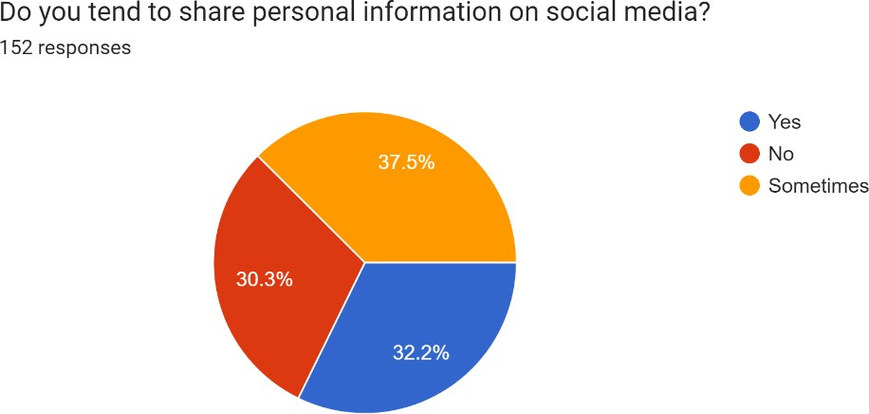

The question was aimed to find out whether they share personal information in virtual space and the options ‘Yes’ and ‘Sometimes’ were selected the most which means that people are sharing their sensitive information out in the public giving everyone access. It doesn’t matter if you share sometimes or always, once shared will always remain and can’t be removed and is known as Digital footprint.

Through over sharing we are leaving these digital footprints all over the place unknowingly. This is one of the most common risks we face while oversharing, we may think that sharing such information can create no harm, but we are exposing ourselves to the frauds and making ourselves vulnerable. Posting

information about your relationships. Vacations or daily routines can easily grab the attention of criminals and can even result in monetary loss. And in the same survey people even reflected their concern about their privacy while using Instagram. Here, a stark contrast is being drawn, the same people who tends to share everything are the ones who admitted that they are very much concerned

about their privacy in virtual space. And on the other hand, the people who doesn’t

share much of the sensitive information are only somewhat concerned about their privacy and this clearly draws out the relationship between the oversharing behaviour and privacy concerns.

* + 1. Content

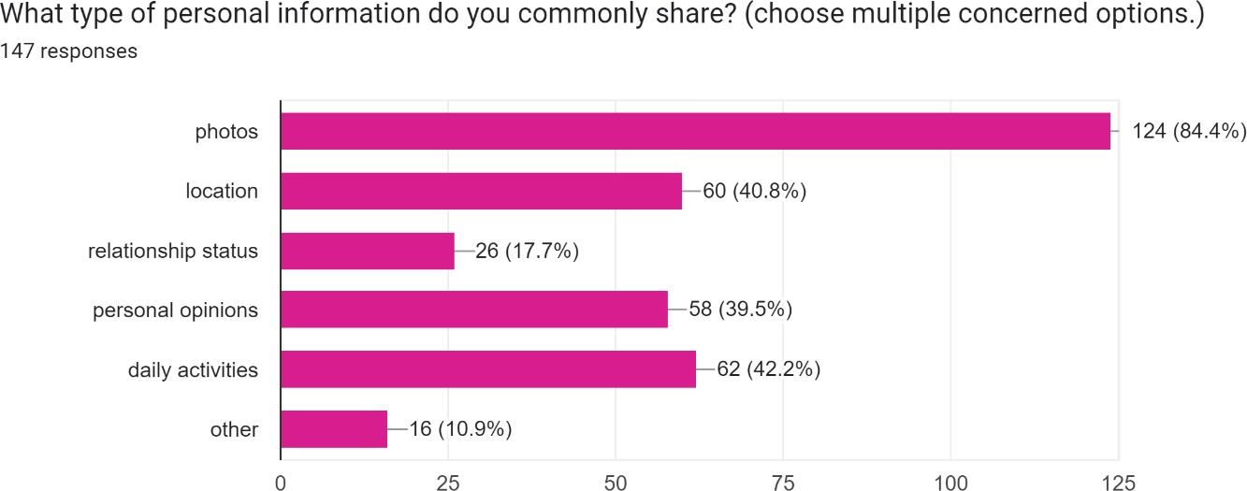

This chart above explains the types of content generally shared by an instagram user. The survey revealed that pictures are the most common type of content shared by the respondents, this shows the users need to constantly put their life or self in display for others appreciation or validation or self satisfaction. People tend to post content online to keep others informed, to keep in touch and to define themselves, but one doesn’t know if their content has a positive or negative impact on the viewers and

themselves. Sometimes giving out more information than needed can make one feel vulnerable, which is another downside of oversharing. Here, daily activities and

location are the commonly shared content after pictures, and this again explain the behaviour of sharing each and every happenings in ones daily life. People arent aware about the potential risk of sharing these informations, because you are letting others know about your routine and your location, which can easily cause privacy violation

or other frauds. While sharing your location with your emergency contacts at times are beneficial, one should not mistake its use for casually sharing location details with a bunch of random online friends.

* + 1. Emotional wellbeing

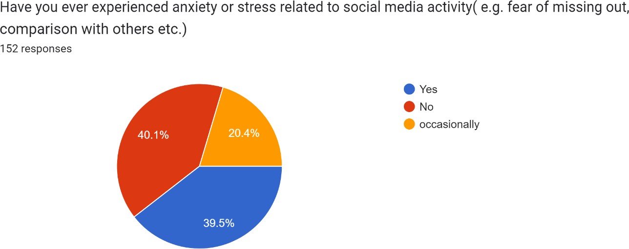

Even though, there is a slight majority for a NO, we can’t ignore the latter part. It

indicates that people are nowadays feeling the pressure to keep up with their peers and often end up comparing their lives to others. This more often happens when a person shares the exciting part of their life, and the one with no particular happenings in their life come across this content, they are more likely to compare themselves with the other person and end up sulking. This is an emotional process and if we are not aware about the difference between reel life and real life, it can easily alter our thought process.

Also, FOMO or fear of missing out is another common issue faced prominently

among the youth. Teenagers and youngsters are the ones who face more peer pressure in this digitally thriving world, so in order to keep up with the peers many may rush to

make their lives exciting and share it among online friends. And here we are unknowingly oversharing and normalising this behaviour, not even realising one’s self worth.

* + 1. Psychological impact

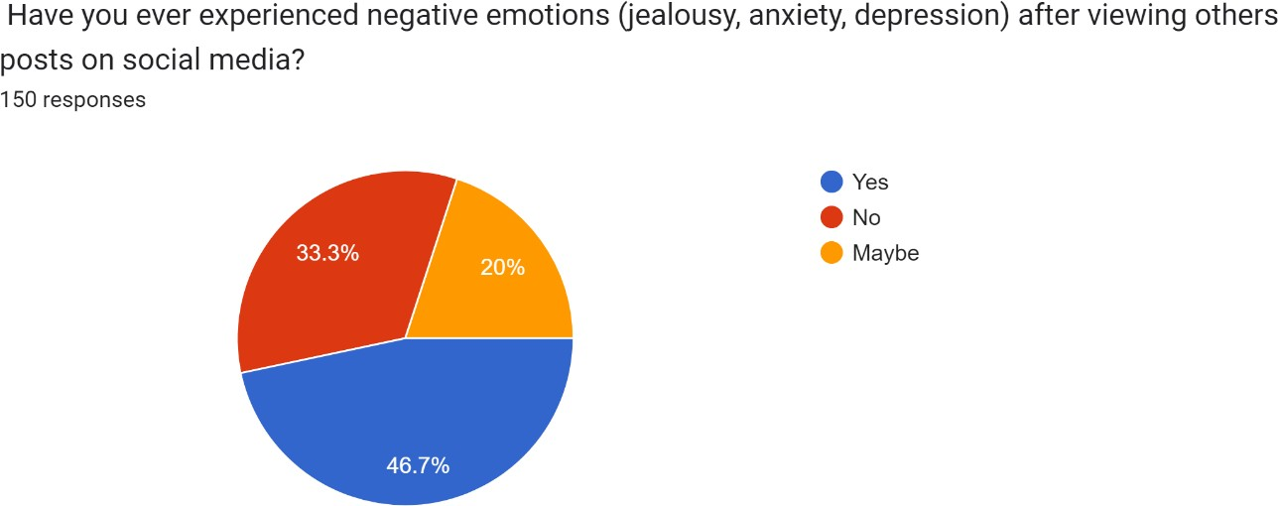

This question is clearly related to the effect of social media on ones life. Social media pushes you to a point where you feel jealous about others life and compare your life with their life and rushes you to build an intagrammable life, which in the long run makes you tired and depressed compromising your self esteem and worth. This is how social media affects the soft side of humans, the word negative thoughts was

inculcated into the question to bring out the innermost feeling of the user. Because, negative emotions cant be taken easily, as they have the power to ruin ones life and make him isolated.

When people try to normalize over sharing by defending it as a method to stay connected with friends and family, no one is aware or concerned about its ill effects and to explain this behaviour, this question was inevitable. While the majority agreed, 20% of the users were unsure about the thought and the rest of 33.3% admitted that

they felt no negative emotions in their social media encounters.

In a nutshell, we can infer that this question and its response itself explains the dowside of over sharing behaviour. Further the research also tend to explore whether these respondents are aware about this bahaviour and tries to create an awareness on the same.

* + 1. Awareness

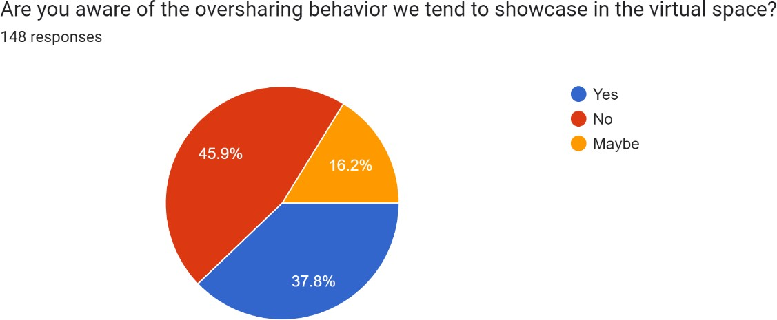

This was the vital question asked among the respondents, for which the majority admitted their unawareness about the over sharing phenomena occuring in virtual spaces. This can clearly explain why this behaviour and its effects are spreading. People are not given proper awareness about this tendency and to make it even worse, people are normalising this behaviour by posititioning it as a means of

communication, just to stay connected.

Oversharing is basically the excessive sharing of information, thoughts, photos,

location and many other content without considering the privacy implication. People wont even suspect any harm that can be caused through sharing such harmless

informations. From a privacy perception oversharing can expose a person to internet frauds and other cyber crimes, while from an emotional perspective it can sometimes generate negative emotions in a person, and these happening to a person without his knowing is more striking. From this alogrithm it is clear that majority of the youth need awareness and this can be done through providing digital literacy and individual responsibility, otherwise lack of knowledge and ignorance my take a toll on ones personal life.

In the later part of the survey, respondents even showed the interests to know more about the behaviour and ways to controll their screen time and changing their unhealthy habits while using social media.

Thus, the survey aims to provide an insight into the issue of oversharing and provide a basic awareness about the same.

* + 1. Validation

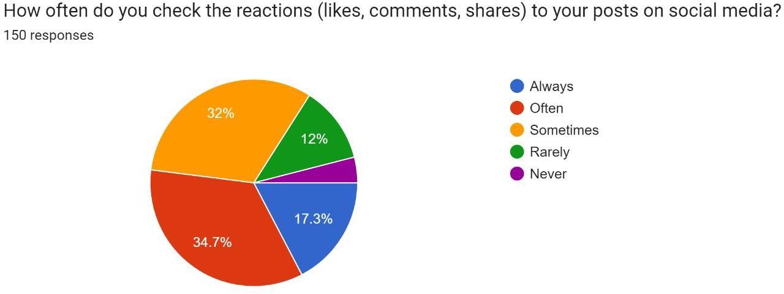

The survey findings related to the question, imply a strong tendency among the users to check their social media handles to keep a tab on the likes and comments received on their posts. In social media, reactions arent just mere responses you receive.

Reactions including likes,comments and shares can make people really happy and content and sometimes even encourage them to post more. So a clear relation between oversharing and these reactions can be drawn out, as people will be encouraged to be active in social media if they receive enough acknowledgement from the target audience.

Here, 34.4% admitted that they often check these reactions, while 17.3% agreed that they always check for these responses, thus forming a majority.likes and comments can always instill a sense of self esteem in people and in many situations they seek validation and affirmations from others through these means. Also these can help in building an online presence and can also release a sense of satisfaction in the users brain. Also people often check their social media handles to avoid the fear of missing out and to stay updated, eventually leading to oversharing in virtual space.

# CHAPTER 5 CONCLUSION

Based on the comprehensive evaluation of the survey findings concerning oversharing behavior amongst youth on social media, it's far glaring that this phenomenon has

multifaceted implications for individuals' properly-being, privacy, and social

interactions. The conclusions drawn from the survey shed light on the complicated dynamics of social media usage amongst youth and the want for focused interventions and consciousness campaigns to cope with the demanding situations related to oversharing.

The survey points out a concerning fashion of excessive social media usage, with many respondents spending more time than encouraged on systems like Instagram. This overindulgence in social media not only increases questions about virtual dependancy but additionally highlights the need for promoting healthier screen time

behavior amongst youngster. Despite extensive worries approximately privateness on social media, a significant number of respondents admit to sharing non-public data and photos unknowingly or deliberately. This finding underscores the significance of teaching users approximately the risks of oversharing and empowering them to make informed choices about their online privacy.

The survey findings highlight the unfavorable psychological outcomes of social media, which includes anxiety, pressure, and feelings of inadequacy. Oversharing behavior, coupled with the strain to preserve a curated on-line image, exacerbates

those bad feelings, underscoring the need for promoting digital resilience and self- care strategies among adolescents.An enormous percentage of users admit to seek validation through likes and feedback, reflecting the ideas of social trade concept.

This reliance on outside validation perpetuates a cycle of approval-looking for behavior, in which individuals prioritize on line reputation over true social connections and well-being. Despite the lack of knowledge regarding oversharing

dispositions, many customers express a willingness to alter their behavior and reduce screen time. This readiness for exchange offers an possibility for implementing

targeted interventions and academic projects geared toward promoting mindful social media use and digital citizenship.

In end, the survey findings states the complex interplay among social media

utilization, self-presentation, and psychological nicely-being among youth. By selling digital literacy, privateness awareness, and self-law talents, we should be able to

empower youth to harness the fantastic capacity of social media.

# BIBLIOGRAPHY

Amanda Hetler. (2023, January 30). 6 common social media privacy issues. *Tech Target.* Jory Mackay. (2023, October 30). Social media privacy: What are the risks. *Aura.*

Mark Travers. (2023, October 30). 3 reasons why you Overshare online, according to a psychologist. *Forbes.*

Nylah Burton. (2021,June 11). When does sharing become oversharing. *The Verge.*

Phil Reed. (2022, January 31). Avoiding an open life: The case against over sharing on social media. *Psychology Today.*

Simon Boag. (2021, March 26). Why do people overshare on social media. *Mq.edu.au.*

Tim Tran. (2023, November 3). How oversharing on social media affects your privacy.

*Keeper.*

[common social media privacy issues (techtarget.com)](https://www.techtarget.com/whatis/feature/6-common-social-media-privacy-issues)

[Social Media Privacy: What Are The Risks? (How To Stay Safe) (aura.com)](https://www.aura.com/learn/social-media-privacy-risks#9.-Romance-scams-on-social-media)

[3 Reasons Why You Overshare Online, According To A Psychologist (forbes.com)](https://www.forbes.com/sites/traversmark/2023/10/30/3-reasons-why-you-overshare-online-according-to-a-psychologist/?sh=6b12cae2fcdd)

[When does sharing become oversharing? - The Verge](https://www.theverge.com/22526811/oversharing-social-media-protect-personal-harassment)

[Avoiding an Open Life: The Case Against Over-Sharing on Social Media | Psychology Today](https://www.psychologytoday.com/us/blog/digital-world-real-world/202201/avoiding-open-life-the-case-against-over-sharing-social-media)

[Why do people overshare on social media? | The Lighthouse (mq.edu.au)](https://lighthouse.mq.edu.au/article/march-2021/Why-do-people-overshare-on-social-media)

[How Oversharing on Social Media Affects Your Privacy - Keeper (keepersecurity.com)](https://www.keepersecurity.com/blog/2022/12/23/how-oversharing-on-social-media-affects-your-privacy/)

# APPENDIX

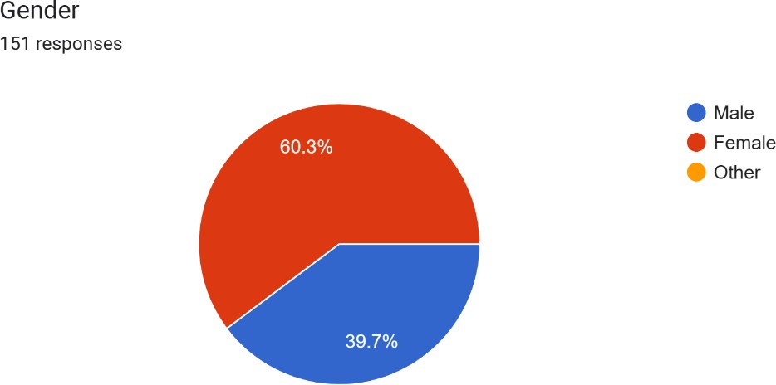

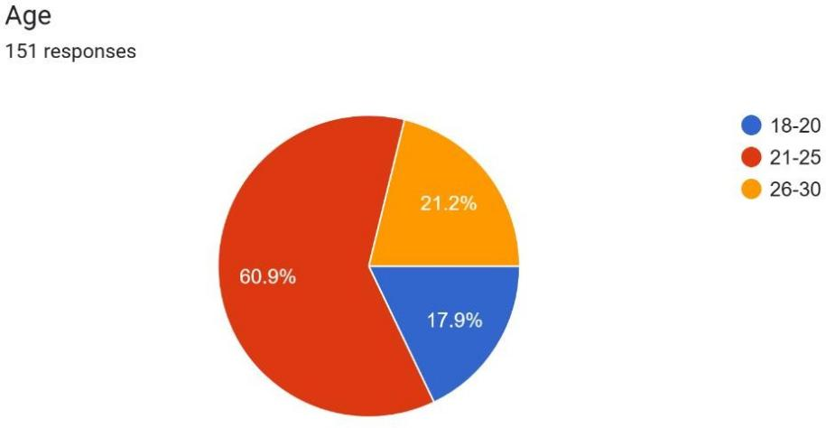

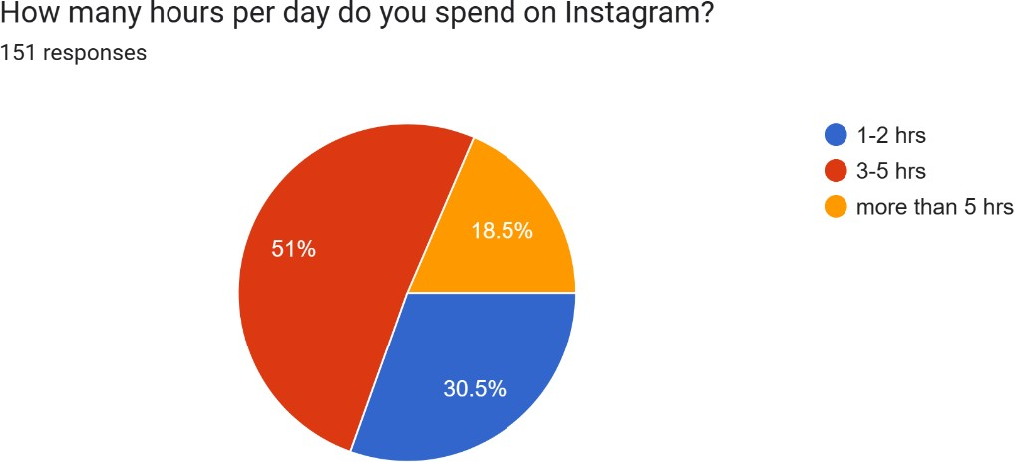

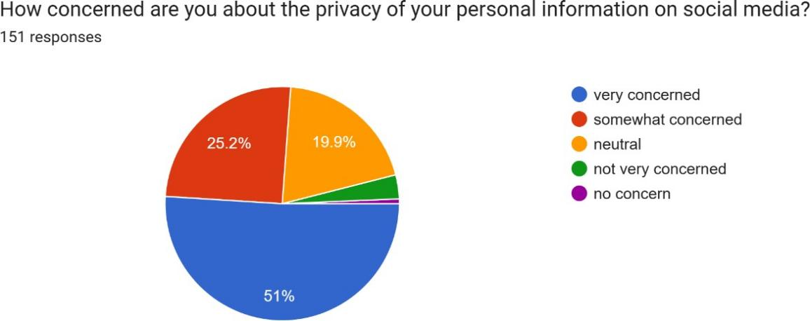

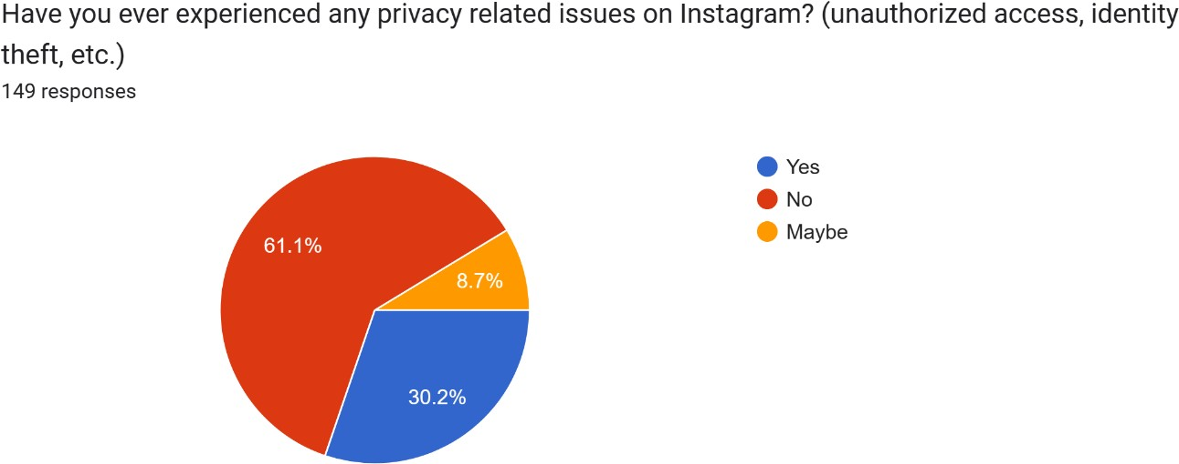

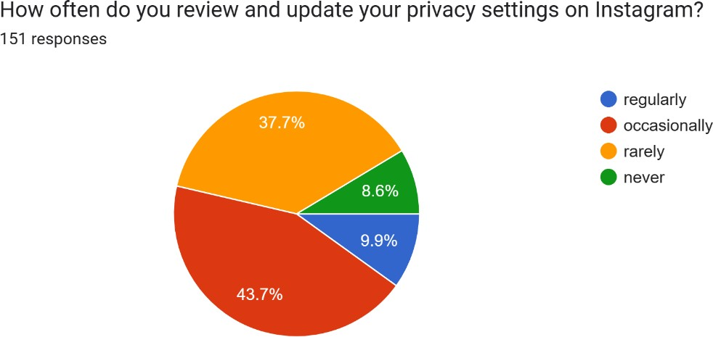

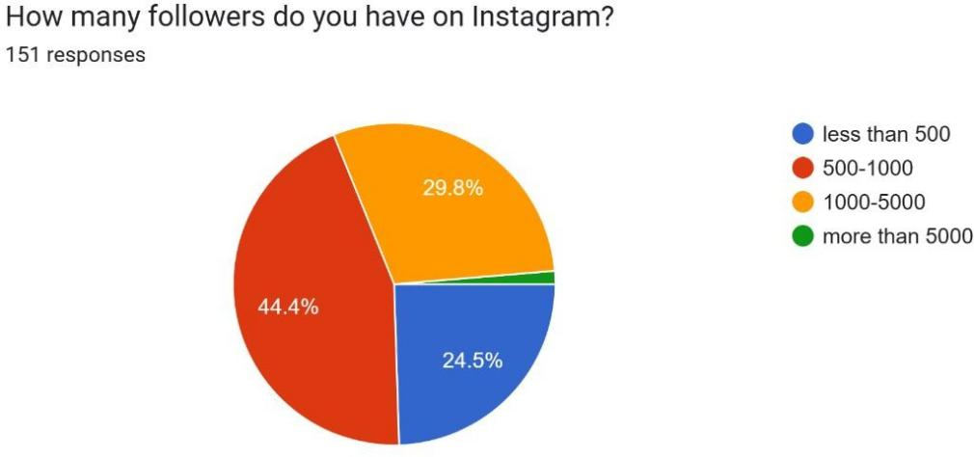

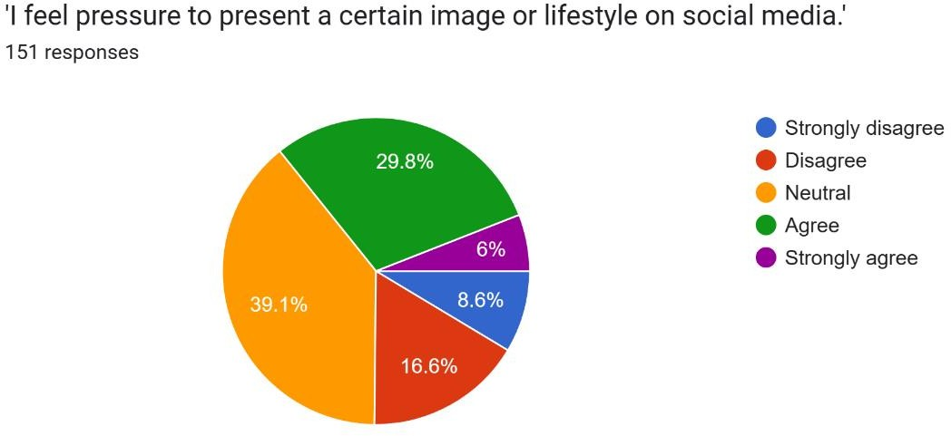

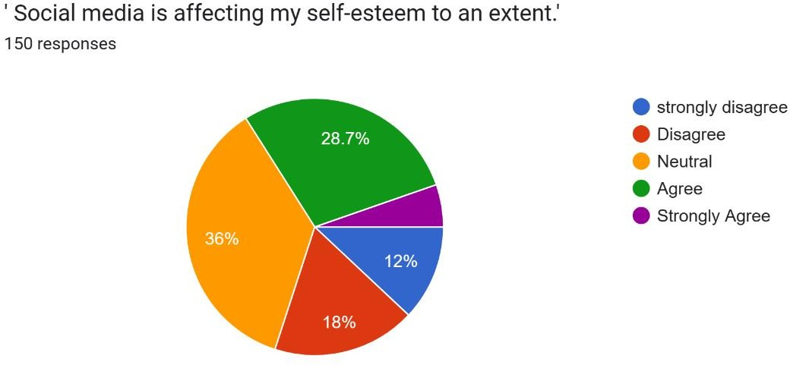

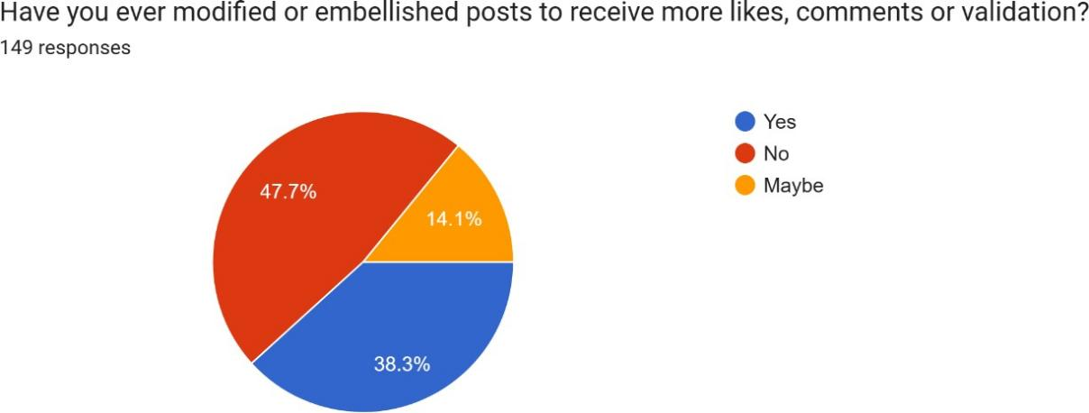

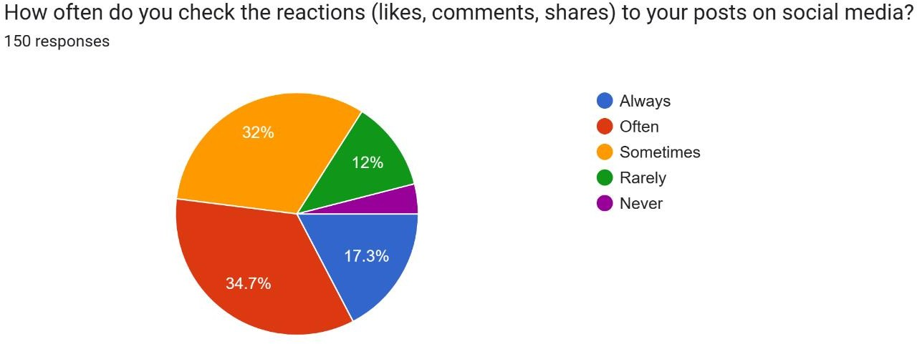

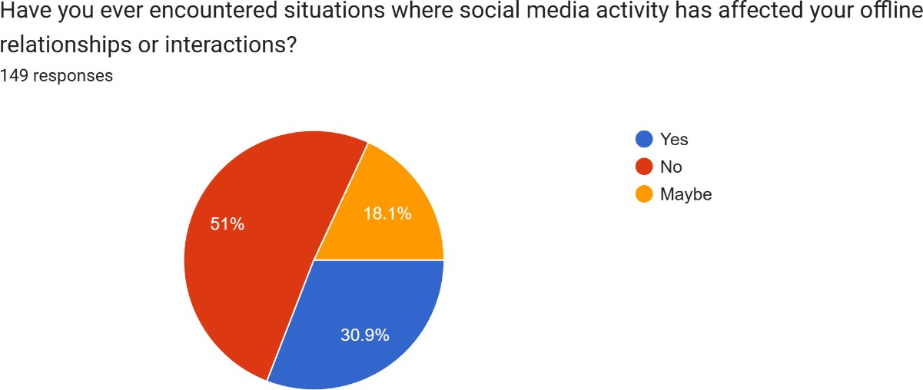

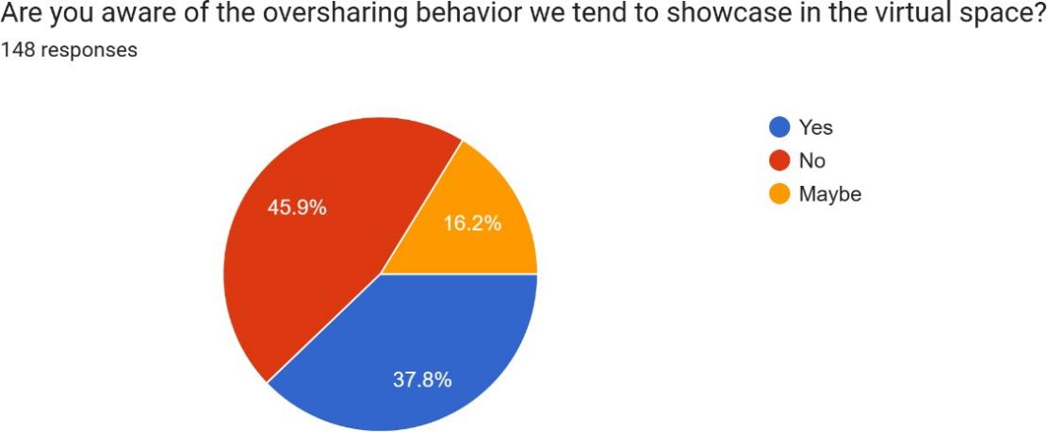

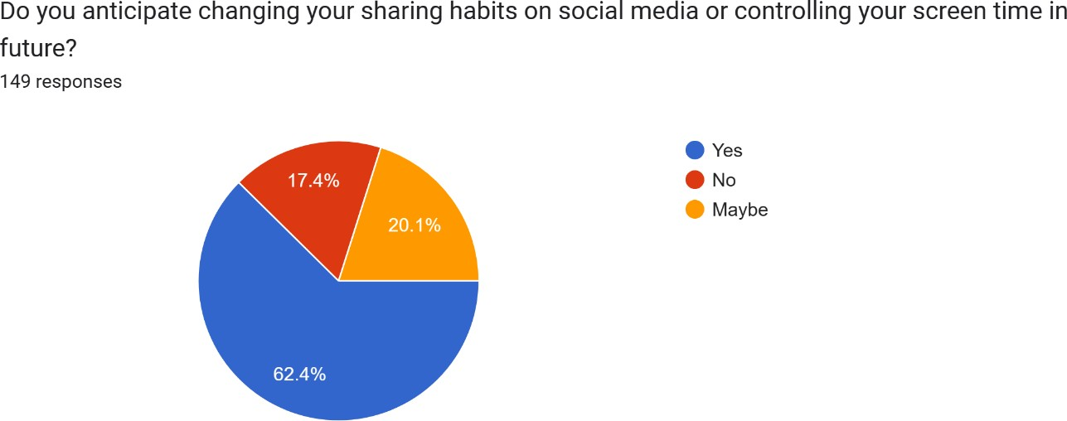

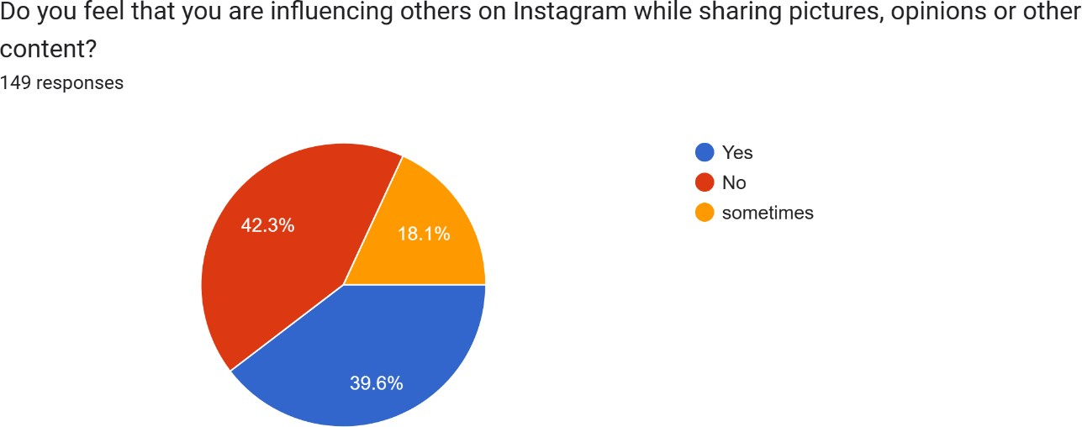

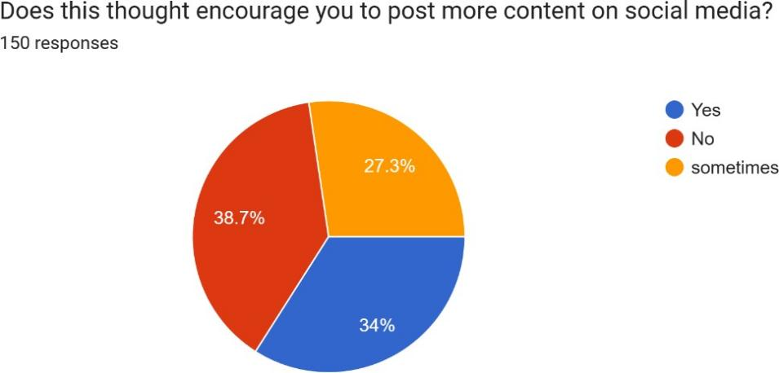

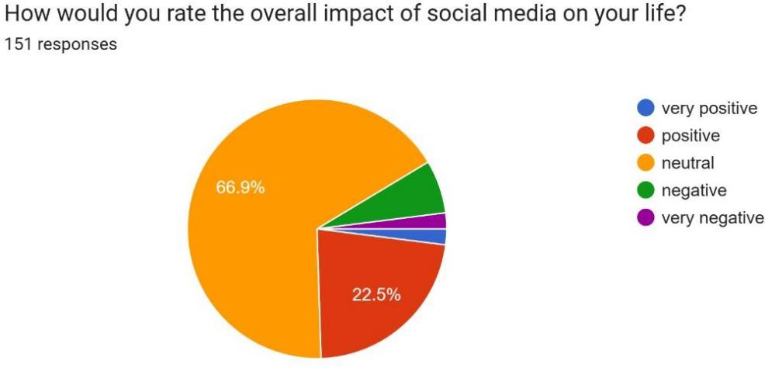

1. Age

a) 18-20

b) 21-25

c) 26-30

# QUESTIONNAIRE

1. Gender
   1. Female
   2. Male
   3. Other
2. How many hours per day do you spend on Instagram?
3. 1-2 hrs
4. 3-5 hrs
5. More than 5 hrs
6. Do you tend to share personal information on social media?
   1. Yes
   2. NO
   3. Sometimes
7. What type of personal information do you commonly share?
8. Photos
9. Location
10. Relationship status
11. Personal opinions
12. Daily activities
13. Others
14. How concerned are you about the privacy of your personal information on social media?
15. Very concerned
16. Somewhat concerned
17. Neutral
18. Not very concerned
19. No concern
20. Have you ever experienced any privacy related issues on Instagram? (unauthorized access, identity theft, etc.)
21. Yes
22. No
23. Maybe
24. How often do you review and update your privacy settings on Instagram?
25. Regularly
26. Occasionally
27. Rarely
28. Never
29. Other
30. How many followers do you have on Instagram?

a) Less than 500

b) 500-1000

c) 1000-5000

d) More than 5000

1. Have you ever experienced anxiety or stress related to social media activity( e.g. fear of missing out, comparison with others etc.)
2. Yes
3. No
4. Occasionally
5. 'I feel pressure to present a certain image or lifestyle on social media.'
6. Strongly disagree
7. Disagree
8. Neutral
9. Agree
10. Strongly agree
11. ' Social media is affecting my self-esteem to an extent.'
12. Strongly disagree
13. Disagree
14. Neutral
15. Agree
16. Strongly agree
17. Have you ever modified or embellished posts to receive more likes, comments or validation?
18. Yes
19. No
20. Maybe
21. How often do you check the reactions (likes, comments, shares) to your posts on social media?
22. Always
23. Often
24. Sometimes
25. Rarely
26. Never
27. Have you ever encountered situations where social media activity has affected your offline relationships or interactions?
28. Yes
29. No
30. Maybe
31. Are you aware of the oversharing behaviour we tend to showcase in the virtual space?
32. Yes
33. No
34. Maybe
35. Do you anticipate changing your sharing habits on social media or controlling your screen time in future?
36. Yes
37. No
38. Maybe
39. Have you ever experienced negative emotions (jealousy, anxiety, depression) after viewing others posts on social media?
40. Yes
41. No
42. Maybe
43. Do you feel that you are influencing others on Instagram while sharing pictures, opinions or other content?
44. Yes
45. No
46. Sometimes
47. Does this thought encourage you to post more content on social media?
48. Yes
49. No
50. Sometimes
51. How would you rate the overall impact of social media on your life?
52. Very positive
53. Positive
54. Neutral
55. Negative
56. Very negative