 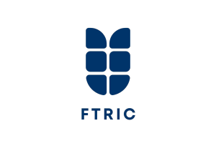

**DEVELOPMENT AND FORMULATION OF *ALLIUM SATIVUM* AND *CITRUS SINESIS* PEEL INCORPORAED MILLET BASED INSTANT DOSA MIX**

A Dissertation submitted by

Ms. RENU.R

(REG NO. VM22FPT019)

ST TERESA’S COLLEGE (AUTONOMOUS), ERNAKULAM

Affiliated to Mahatma Gandhi University ,Kottayam, Kerala

In partial fulfilment of the degree of

**MASTER OF VOCATIONAL STUDIES In FOOD PROCESSING TECHNOLOGY**

Under the guidance of

**Mr. Akshay A.T**

ASSISTANT PROJECT MANAGER

FOOD TECH RESEARCH AND INCUBATION CENTRE-FTRIC Calicut

JULY 2024

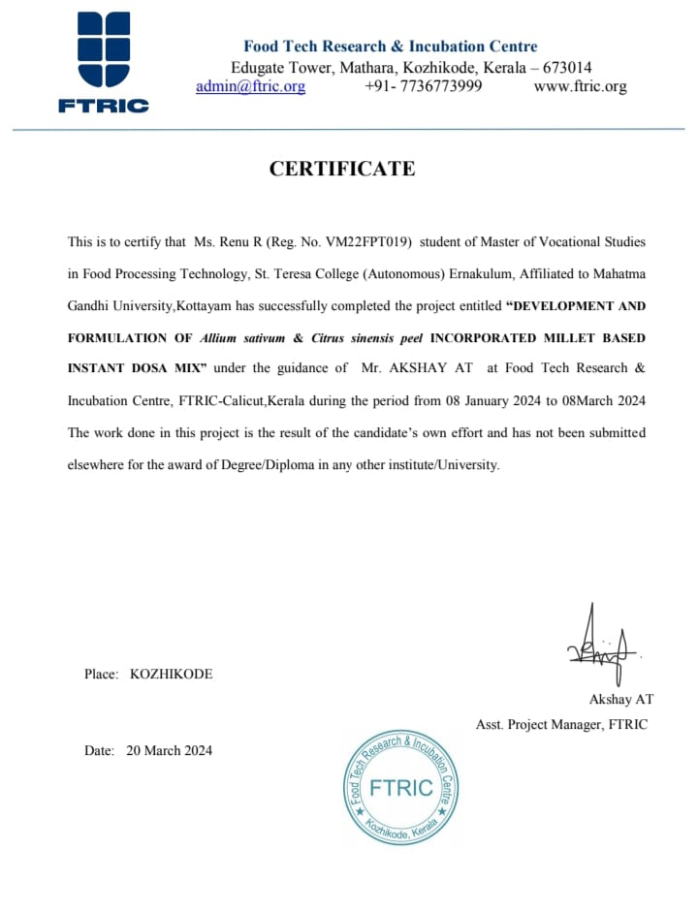

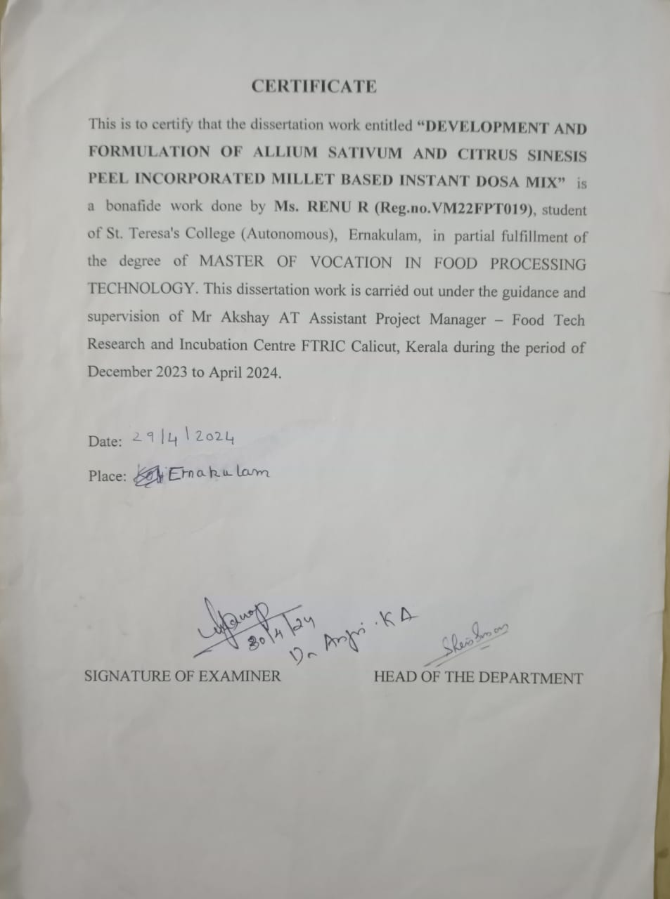

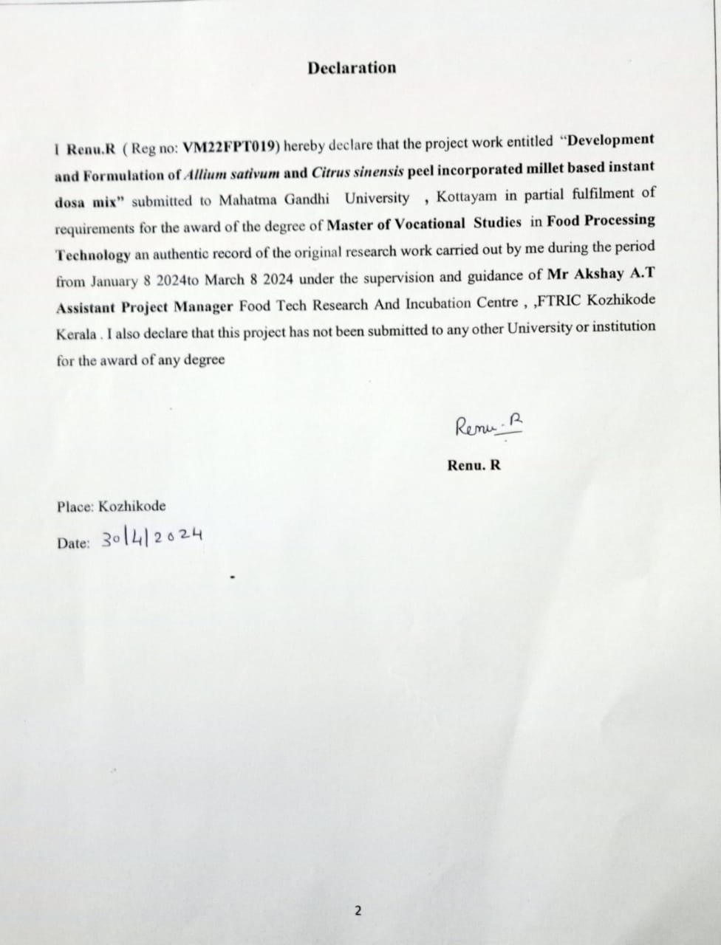 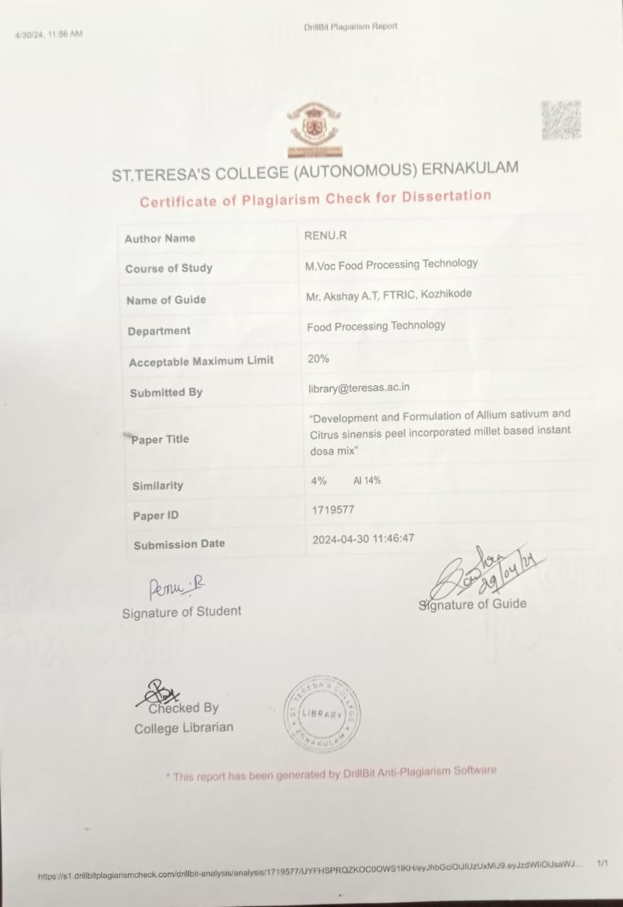

**Acknowledgement**

It is my pleasure to be indebted to various people, who directly or indirectly accompanied in the development of this work and influenced my thoughts and acts during the study

First of all, I would like to thank **God Almighty** for guiding me throughout all his blessing for the successful completion of my project

I express my deepest gratitude and sincere salutations to **Food Tech research and Incubation Centre, FTRIC – Calicut**, **Kerala** and **Mr. Ameer Faisal (**Director FTRIC), Mr Mohammed Rafeeque (Technical Director- FTRIC) for providing me the opportunity and facilities to undertake this work. I extend my profound gratitude to the staffs and team members of FTRIC for their constant help for carrying out this work.

With great pleasure and respect I express my deep sense of gratitude to my advisor and guide **Mr. Akshay A.**T(AssistantManager FTRIC, Kozhikode) **,** for his constant encouragement valuable guidance , support and altruistic nature in dispending of scientific knowledge which made me carry out this project work.

It is my great privilege to thank **Mrs. Akhila** Salim (R &Dexecutive FTRIC Kozhikode) **Ms. Ashwathy M.R** (Research and analytical laboratory in charge FTRIC Kozhikode) and to **Ms. Safa KT** (Food Technologist, FTRIC Kozhikode for their timely help and guidance throughout the project

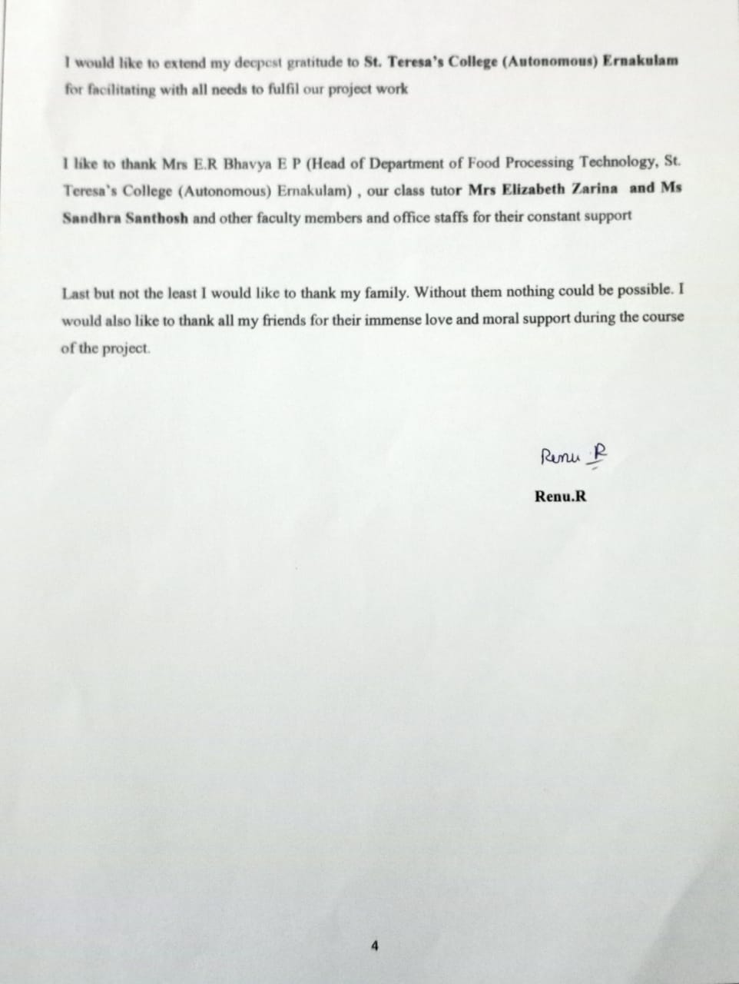

**INDEX**

|  |  |  |
| --- | --- | --- |
| SL. NO | CHAPTER | PAGE NO |
| 1 | INTRODUCTION | 9 |
| 2 | AIM AND OBJECTIVE | 10 |
| 3 | REVIEW OF LITERATURE | 11-24 |
| 4 | MATERIALS AND METHODS | 25-33 |
| 5 | RESULTS AND DICUSSION | 34 |
| 6 | CONCLUSION | 35 |
| 7 | REFERENCE | 36-38 |

**LIST OF FIGURES**

|  |  |  |
| --- | --- | --- |
| SL No | FIGURE NAME | Page no |
| 1 | Carbohydrate and lipid content | 11 |
| 2 | Protein | 11-12 |
| 3 | Aminoacid | 12 |
| 4 | Mineral | 12-13 |
| 5 | Biological properties of garlic peel | 13 |
| a | Antioxidant | 13-14 |
| b | Anticancer | 14-15 |
| c | Antidiabetic | 15 |
| d | Antimicrobial | 15-16 |
| e | Antiviral | 16 |
| f | Anti -inflammatory | 16-17 |
| g | Cardio protective | 17 |
| h | Neuro protective | 17-19 |
| i | Hepato protective | 19 |
| 6 | Biological properties of citrus peel | 19 |
| a | Antioxidant activity | 19-20 |
| b | Polyphenol | 20 |
| c | Antimicrobial properties | 20 |
| d | Flavonoid | 20 |
| e | Anti - inflammatory | 20 |
| f | Carotenoids | 20-21 |
| g | Tannin | 21 |
| 7 | Orange peel | 22 |
| 8 | Banana peel | 22-23 |
| 9 | Garlic peel | 23-24 |
| 10 | Moisture | 24-25 |
| 11 | Ash | 25-26 |
| 12 | Protein | 26-27 |
| 13 | Fat | 27-28 |
| 14 | Fibre | 28-29 |
| 15 | PH | 29 |
| 16 | Carbohydrate | 29-30 |
| 17 | Starch | 30-31 |

**ABBREVATIONS**

|  |  |
| --- | --- |
| **Word** | **Full form** |
| ml | Milliliter |
| g | Gram |
| HCl | Hydrogen chloride |
| NaOH | Sodium Hydroxide |
| % | Percentage |
| H2SO4 | Sulfuric acid |
| ℃ | Celsius |
| mins | Minutes |
| CuSO4 | Copper sulphate |

**ABSTRACT**

The traditional food sector is primarily restricted to households and it is increasingly being realized to bring it out in the open for a much varied use. The present study aimed to formulate and standardize the products through blend ratio, sensory evaluation and the quality characteristics of developed products. The formulation of millet based dosa mixat 8% banana peel, 6% orange peel ,1.7% garlic peel, 3.5 % amla seed powder, 25% ragi, 24% oats, 25% foxtail ,6.8% salt. These instant mixes can be considered as therapeutic food for health conscious peoples and also can be prepared at cottage industries to improve women empowerment

**CHAPTER :1 - Introduction**

Foxtail millet (*Setaria italica*) also called Italian millet or kangni, is one of the oldest cultivated cereal, with its origin in China and subsequently extending into India and most of Africa and parts of the Southern United States (Liu et al., 2012) [16]. It has good nutritional profile and is comparable to staple cereals as rice and wheat in terms of protein, fibre, minerals and vitamins but its potential role as low GI food has remained unrealized and unexploited. It has been proved to be suitable for people suffering from metabolic disorders (Itagi, 2003) [14] . Foxtail millet is a good source of protein (12.3 g/100 g), dietary fibre (14 g/100 g), moderate carbohydrate (60.9 g/100 g), rich in minerals (3 g/100 g) and ß carotene (126-191 μg/100 g.

**Instant dosa mix**

A study was carried out by Jawaharlal Nehru Krishi Vishwa Vidyalaya, Jabalpur (MP) and they formulated and standardized different products by blending various ratios of powders and the quality analysis and sensory evaluation were conducted to characterize the developed products. The optimised millet-based dosa mix formulation was found to be 30% rice, 40% small millet, 20% black gram, and 10% of lentil flour. Kodo and kutki were used in place of rice, and lentils were used in the place of black gram and Bengal gram. These quick mixes could be used in cottage businesses for women empowerment and are also considered as therapeutic foods for health-conscious individuals (Roopa et al., 2017).

***Allium sativum***

Garlic is a member of the plant family Alliaceae, which is widely known as an important spice with pungent smell and could be used in remedies for various diseases and disorders. Garlic is grown everywhere on Earth, although it seems to have started in Central Asia and travelled to China, the Near East, and the Mediterranean before heading west to Mexico, Central and Southern Europe, and Northern Africa (Egypt). For thousands of years, people have utilized garlic as medicine.

The main medical applications of garlic are treating and prevents cardiovascular diseases, by reducing cholesterol, blood pressure, and act as an antibacterial, and prevents cancer. Various complex with sulfur-containing molecules that are quickly absorbing, changing, and digesting make up the active ingredients. Garlic improves the HDL/LDL ratios and reduce total cholesterol by 10%, according to data from various trials. Garlic reduces blood pressure and is effective mild antihypertensive. Moreover, garlic increases the fibrinolytic activity and suppresses the platelet aggregation, which lower clots on the injured endothelium. Antibacterial effects have been suggested by in vitro research, however these have not been assessed in human controlled trials (Karakannavar et al., 2021).

***Citrus sinensis***

Citrus sinensis (L. Osbeck), or sweet oranges, which are consumed worldwide as a rich source of vitamin C, a potent natural antioxidant that strengthens the immune system. Significant phytochemicals such as synephrine, liminoids.   
Additionally present are hesperidin flavonoids, polyphenols, pectin, and enough levels of folacin, calcium, potassium, thiamine, niacin, and magnesium. These biologically active substances lower blood pressure and cholesterol levels, prevent cancer, kidney stones, stomach ulcers, arteriosclerosis, and high blood pressure—all conditions that are beneficial to human health. However, the production of sweet oranges is limited by a complex of nematodes, pierce's disease, citrus variegated chlorosis ctrus greening or huanglgbin, citrus canker, viruses, and various diseases caused by fungi, including powdery mildew, citrus black spot, and sweet orange scab.

**Millet**

In order to meet the demands of an expanding population in both developed and emerging nations, as well as to address the global food deficit, minor millets are acknowledged as an important alternative to major cereal crops [1]. Despite its high nutritional value, kodo millet has not been given much thought as a product. The inclusion of millet in cereal-based goods has gained popularity because of its benefits, both financially and nutritionally. They offer nutritional security and are regarded as a defense against nutritional deficiency disorders. Kodo millet was a highly acceptable addition to ready-to-cook mixes used in recipes. An analysis of the shelf life revealed that the microbiological load in the ready-to-cook mixes with kodo millet was within a safe range for up to 45 days (Rani, R. L., & Jamuna, K. V. (2023).

**Orange peels**

Orange peel carry health-promoting compounds such as vitamins, minerals and flavonoids. Vitamins A and C, which are abundant in orange peels, are naturally occurring antioxidants that strengthen the immune system and aid in the battle against infection, colds, and flu. Orange peels have anti-inflammatory qualities that can help with digestion because they contain more phytonutrients and flavonoids than the inside pulp.

**CHAPTER :2 - AIM AND OBJECTIVE**

**Aim**

This study aims the “Development and formulation of millet based instant dosa mix”

**Objective**

* Develop and formulate the millet-based instant dosa mix
* By product utilization
* Sensory evaluation
* Proximate analysis and other basic physiochemical analysis

**Chapter :3 - REVIEW OF LITERATURE**

**Nutritional composition of garlic peel**

Due to its possible health advantages and its use as an ingredient in foods, the nutritional makeup of garlic peel has been the focus of several studies. Garlic peel is an inedible byproduct of garlic. It has moisture content of 3.52 ± 0.03%, a high protein content of 8.4 ± 0.41%, and a low lipid content of 0.86 ± 0.04%. [8] The aforementioned findings were in line with other studies for other agro-industrial byproducts, such as dry soy husk (9% protein, 1% lipid) (Vriesmann et al., 2011) and cocoa husk (8.6% protein, 1.5%). [21] The garlic peel has the highest percentage of total fiber (62.23 ± 1.03%). Dietary fiber was found to be 4.16% insoluble and 58.07% soluble, respectively. Both fenugreek husk (77.1%) and soy husk powder (74.41%) contained comparable amounts of total and insoluble fibers. The level of lignin in garlic peel (8.31 ± 0.12%) was likewise notable

**Carbohydrates and lipids content**

The weight of the garlic peel is roughly 26.58% total carbs and 18.62% cellulose. The peel of garlic contains a variety of sugars, including rhamnose, trehalose, mannitol, and sorbitol. According to reports, pectin (26–27%) is what makes garlic peel unique. The enzymatic hydrolyzate of garlic peel contains sinapic acid, ferulic acid and p-coumaric acid. It also includes arabinose, xylose, rhamnose, mannitol, glucose, and galactose or their polymers. The majority of the overall sugar content is made up of rhamnose. It contains only trace amounts of lipids, with total sterols accounting for 62% of the unsaponified lipid fraction. The polysaccharides in garlic peel exhibited outstanding DPPH radical scavenging action, significantly reducing power, and inhibiting linoleic acid peroxidation.

Protein and amino acid

**Protein**

There are 67 proteins in both the inner and outer garlic peel. 43 of these proteins were located in the inner peel and 61 in the outer peel of the fruit. Between the two peels, 37 of these proteins were present, with 24 being unique to the outer peel and 6 to the inner peel. Biological process classification of the proteins revealed that only 9 of the 55 proteins were associated with reactions to stimuli, including chitinases, peroxidases, and heat shock proteins (HSPs). Eight proteins were identified as belonging to the serine and cysteine proteases. All 17 proteins involved in responding to stimuli and protein modifying enzymes were found in the outer peel, with just 7 proteins present in the inner peel.

**Amino acid**

The order of amino acid concentrations in the garlic peel powder was observed as follows: Cys > Pro > Val > Tre > Arg > Ser > Trip > Ala > Tyr > Asp > Gly > Gl > Gl to-ta > Asp> Iso> His> Lei> Liz > Met > and so on . It contains the highest concentrations of tryptophan, glutamine, proline, cysteine, and arginine. In contrast, cysteine, proline, valine, threonine, and arginine are the amino acids that are most prevalent in garlic peel powder.

**Mineral**

Here is a detailed description of each mineral found in garlic peel; Calcium is necessary for developing and maintaining healthy bones and teeth, and is found in plenty in garlic peel. Additionally, calcium is essential for the health of your muscles, nerves, blood clotting, and cells. Garlic peel is a fantastic complement to a calcium-rich diet due to its high calcium concentration.[20] Potassium: It is the second most common mineral in garlic peel and aids in controlling fluid balance, muscular contractions, and nerve messages. Additionally, consuming enough potassium helps lower blood pressure and lower the risk of stroke.[34] Magnesium: It is necessary for maintaining healthy bones, nerves, and blood pressure regulation, and is abundant in garlic peel. Magnesium also contributes to the synthesis of DNA and protein, as well as the metabolism of energy.[35] Sodium: Although a high salt diet is frequently linked to poor health results, the moderate sodium content of garlic peel is essential for maintaining fluid balance and nerve function.[36] Sulfur: Garlic is renowned for having a high sulfur content, which is what gives it its distinctively strong smell and odor. The synthesis of proteins, enzymes, and other compounds in the body depends on sulfur.[37] Iron: Garlic peel is a valuable source of iron despite having lesser concentrations of the mineral than certain other minerals. Hemoglobin, the protein in red blood cells that transports oxygen throughout the body, is produced only in the presence of iron.[38] Manganese: This mineral is also essential for the growth of bones, the healing of wounds, and metabolism. Additionally, manganese serves as an antioxidant, assisting in preventing cell deterioration brought on by free radicals.[39] Zinc: It is a vital mineral involved in a variety of physiological functions, such as immune response, wound healing, and DNA synthesis.[40] Despite having less zinc than some other minerals, garlic peel is nevertheless a good source of this nutrient. Copper: It is essential for the production of red blood cells and the preservation of bone, neuron, and immune system function.[41] Copper is present in garlic peel in a moderate proportion. Phosphorus: Garlic peel also contains phosphorus, which is necessary for DNA synthesis,. energy metabolism, and bone and dental health.[42] Selenium: A trace mineral called selenium has antioxidant qualities that can help prevent cell deterioration brought on by free radicals. Additionally, it influences thyroid and immune system health.[43] Chromium: It is present in garlic peel and helps the body use carbohydrates, lipids, and proteins for energy, and is involved in controlling blood sugar levels.[44] Aluminum: Many foods, including garlic and garlic peel, contain trace levels of aluminum, a naturally occurring metal.[45] Even though garlic and garlic peel contain a little amount of aluminum, it is still safe to eat. However, it is important to take into account the possibility of aluminum toxicity from other food sources, such as cookware or antacids. However, consuming too much aluminum from other sources may have negative health effects, especially neurotoxicity and cognitive decline. Boron: The peel of the garlic contains traces of the trace element boron, which can be found in variable concentrations. Although boron may not be regarded as a significant mineral in garlic peel, it is crucial for plant growth and development (Table 3). Boron has been investigated for its ability to improve bone health, brain function, and immunological function in terms of human health. It may contribute to bone health by boosting bone mineral density and lowering the incidence of osteoporosis.[46] Additionally, borax has immune-modulating properties and promotes the synthesis of cytokines and other immune system elements

**Biological properties of garlic peel**

**Antioxidant**

Garlic peel was regarded as a useless waste product in the business, but numerous recent studies have shown that it contains potent antioxidant capabilities. It should be taken into account in the creation of disease-preventive products in the nutraceutical business.Flavonoids, organosulfur compounds, phenolic compounds, and vitamin C make up the majority of the bioactive components in garlic peel.An extract’s antioxidant capacity is evaluated using the DPPH radical scavenging action. An extract of garlic peels (ethanol) at a concentration of just 0.1% is shown to eliminate 90% of DPPH radicals.These results primarily attribute the antioxidant and antibacterial activities of garlic peel to the presence of the phytochemicals caffeic acid, p-coumaric acid, ferulic acid, and di-ferulic acid.It contains significant levels of phenylpropanoids such as N-trans-coumaroyloctopamine, N-transferuloyloctopamine, guaiacylglycerol-ferulic acid ether, and coumaric acid, and ferulic acid, In an aqueous solution of garlic peel, gas chromatography mass spectrometry found the presence of dimethyl 2-methoxyhexane-1,6-dioate, dibutyl phthalate, 4-hydroxy-3-methoxy acid, 4-hydroxy-benzoic acid, and mequinol that had antimicrobial and antibacterial properties in addition to antioxidant properties **.**The total antioxidant content of garlic peel is 33.38 mg/ml which is indicated by the valorization of garlic peel for product development **.** This demonstrates the significantly high antioxidant activity of garlic peel. Additionally, the total flavonoid content of garlic peel is extremely high (33.27 mg Quercetin/ml), and flavonoids are well-known for their potent antioxidant properties

**Anticancer**

The significant antioxidant activity that garlic peel exhibits are primarily responsible for its anticancer effects. Antioxidants scavenge free radicals, which lowers the risk of developing cancer. Even though the organosulfur level of garlic skins is lower than that of garlic cloves, they nevertheless possess anti-cancer capabilities. Antioxidants scavenge free radicals, which lowers the risk of developing cancer. Even though the organosulfur level of garlic skins is lower than that of garlic cloves, they nevertheless possess anti-cancer capabilities. On the other hand, garlic skins have a substantially larger total phenolic content than cloves, which fundamentally alters the bioactive characteristics of peel. Phenolic substances are thought to be effective anticancer agents. Because they have demonstrated significant promise in the treatment of cancer, such as via enhancing wound healing. Plant phenolics target metastasis, promote cell differentiation, inhibit uncontrolled cell proliferation, and promote apoptosis(S)-N-trans- feruloyloctopamine, which is derived from garlic skin, has demonstrated promising benefits in the prevention of skin cancers like melanoma.

**Antidiabetic**

An oral administration of a mixture of garlic peel and onion peel extract (800 mg/kg BW and 200 mg/ kg BW, respectively) reduced blood sugar levels in both naturally occurring and induced diabetic rats, according to a rat study. Compared to the group receiving metformin and glibenclamide combination therapy, it demonstrated a good response, although there was no discernible difference from insulin therapy. The presence of significant bioactive components in garlic peel, including organoselenium, tellurium, flavonoids like kaempferol-3-O-b-D-glukopirosa and iso-ikamnetin -3-O-b-D-glukopirosa, fructopeptides, beta-carotene, thiamine, riboflavin, niacin.

**Antimicrobial**

Due to the presence of bioactive substances like allicin, alliin, and ajoene, garlic peel has been discovered to have antibacterial effects. These substances have inhibitory effects on a variety of harmful bacteria, fungi, and viruses. Garlic peel extract is effective against Bacillus subtilis, Listeria monocytogenes Staphylococcus aureus, Escherichia coli, Salmonella, Bacillus subtilis, Streptococcus mutans, and Staphylococcus aureus. Additionally, it possesses antifungal effects against Candida albicans and Aspergillus niger. It also shows antiviral properties against the respiratory syncytial virus (RSV) and herpes simplex virus type 1 (HSV-1In an in vitro setting, the antibacterial activity of various doses of garlic extract against the microbiota found in human dental plaque.

This shows that using garlic extract instead of synthetic antibacterial medications may be a natural alternative for preventing and treating tooth plaque and related disorders like periodontitis. According to a study, ciprofloxacin and garlic extract work together synergistically, indicating that garlic extract could be used as adjuvant therapy for bacterial infections in addition to antibiotics. The absence of synergism between ampicillin and garlic extract, however, indicates that the antibacterial mechanisms of garlic extract may differ from those of several common antibiotics. It showed that a combination of garlic and ginger extracts had antibacterial action against clinical infections that were resistant to many drugs, including Pseudomonas aeruginosa. In order to prevent and treat microbial infections that are resistant to manmade antibiotics, this suggests that garlic and ginger extracts may have some value. Garlic may be a viable treatment for multi-drug resistant tuberculosis. This shows that garlic extract may have the potential as a natural substitute for common medications for treating and preventing tuberculosis and other bacterial infections that are resistant to common antibiotics. Overall, these investigations offer more evidence in favor of garlic extract’s antibacterial capabilities and its potential therapeutic uses in the prevention and treatment of bacterial infections, especially those that are resistant to traditional antibiotics

**Antiviral**

Due to the presence of several bioactive substances such allicin, alliin, ajoene, and diallyl sulfides, garlic peel has been reported to have antiviral activities. Numerous viruses, including the RSV, HSV-1, influenza virus and human immunodeficiency virus (HIV), have been demonstrated to be inhibited by these substances. Although the exact mechanisms by which garlic peel exerts its antiviral effects are unknown, studies have shown that it may work by obstructing different phases of viral replication. For instance, it has been demonstrated that a garlic peel extract can prevent RSV and HSV-1 from adhering to surfaces and entering host cells. Inhibition of HIV’s reverse transcriptase function, which is necessary for the virus to replicate, has also been discovered. The immune-modulatory characteristics of garlic peel, in addition to its direct antiviral benefits, may help strengthen the body’s built-in defenses against viral infections. Activating the immune response against viral infections, for instance, may be made possible by the discovery that garlic peel stimulates the synthesis of cytokines and other immune system chemicals. The antiviral qualities of garlic peel point to its potential as a natural substitute for synthetic antiviral medications for a variety of medical uses, including the treatment of viral infections.

**Anti-inflammatory**

Due to the inclusion of several bioactive substances, including flavonoids, polyphenols, and organo-sulfur compounds, garlic peel has been discovered to have anti-inflammatory properties. Inflammatory mediators and enzymes, which play a role in the emergence of chronic inflammation, are inhibited by garlic peel. Interleukin-6 (IL-6), tumor necrosis factor-alpha (TNF-α), and interleukin-1 beta (IL-1β), among other pro-inflammatory cytokines, have been found in studies to be inhibited by garlic peel extract. Additionally, it blocks the action of enzymes including cyclooxygenase (COX) and lipoxygenase (LOX), which are crucial for the production of pro-inflammatory eicosanoids. The antioxidant properties of garlic peel extract potentially contribute to its anti- inflammatory effects. Free radicals and reactive oxygen species (ROS) can cause oxidative damage and set off inflammatory reactions. Antioxidants can scavenge these molecules. Garlic peel may be beneficial against arthritis, cardiovascular disease, and some malignancies. To find the best dosages and formulations for efficient anti-inflammatory activity in people, more research is nonetheless required.

**Cardioprotective**

Numerous bioactive substances, including flavonoids, polyphenols, and organosulfur compounds, which have been shown to have cardioprotective characteristics, have been discovered in garlic peel. These substances have been discovered to improve blood flow, lower blood pressure, and reduce cholesterol levels, all of which are good for cardiovascular health. Angiotensinconverting enzyme (ACE), which is involved in the control of blood pressure, is inhibited by garlic peel extract and lowers blood pressure. The mechanism of ACE inhibitor medications, which are frequently prescribed to treat hypertension, is comparable to this one. In animal tests, garlic peel extract has also been shown to lower levels of triglycerides, low-density lipoprotein (LDL) cholesterol, and total cholesterol. These effects could be brought about by the stimulation of cholesterol metabolism and excretion as well as the stimulation of cholesterol synthesis and absorption.

**Neuroprotective**

Furthermore, garlic peel extract increases nitric oxide (NO) production, a vasodilator that relaxes blood vessels and enhances blood flow. The blood pressure-lowering benefits of garlic peel extract may also be attributed to this mechanism. Numerous cardiovascular disorders, including hypertension, atherosclerosis, and heart disease, may benefit from the cardioprotective effects of garlic peel. The aging population is prone to neurodegenerative illnesses, which result in the gradual degeneration and/or death of neurons. Although the molecular processes causing this degeneration are not fully understood, however, synaptic damage, mitochondrial malfunction, and protein misfolding are common in addition to neuronal loss. The progression of neurodegenerative disorders such as Alzheimer’s disease, Parkinson’s disease, Huntington’s disease, stroke, and amyotrophic lateral sclerosis is significantly influenced by neuroinflammation. Neuroinflammation results in the activation of microglia, the innate immune cells of the central nervous system. Activated microglia can then release pro-inflammatory mediators, which in turn can cause oxidative/nitrosative stress and ultimately result in the death of neuronal cells. Many botanical preparations and substances with antioxidant capabilities have been studied in the search for efficient therapies for neuroinflammation and neurodegeneration. The medicines that are available for these illnesses are not particularly effective. Interestingly, the improvement in medical care in the form of natural products has led to an increase in life expectancy. This encourages in treating age-related neurodegenerative illnesses, which pose significant social and financial burdens. Unfortunately, the great increase in life expectancy is masked by the decline in mental capacity with advancing age. The main underlying factor contributing to neurovascular injury is an increase in oxidative stress. Enhanced platelet aggregation and coagulation, endothelial dysfunction, hyperlipidemia, hypertension, ischemic heart disease, atherosclerosis, and hyperhomocysteinemia are additional risk factors for these illnesses. A treatment approach called neuroprotection reduces the damaging effects on the brain. In order to prevent the negative effects of synthetic medications, recent developments in illness treatment favor the use of natural molecules. Garlic has been demonstrated to help prevent many chronic illnesses and ailments connected to aging since it is high in antioxidant chemicals and organic Sulphur. Phenolic chemicals with significant antioxidant and antibacterial activity are present in garlic husk. Garlic husk has enormous health advantages for individuals, thus it should be used in all its forms to improve people’s lives and prevent food from going to waste.The amino acid S-allyl-L-cysteine (SAC), which is found in garlic, has been linked to brain ischemia, Alzheimer’s disease, Parkinson’s disease, amyotrophic lateral sclerosis, and Huntington’s disease. Garlic peel possesses neuroprotective qualities due to the presence of organosulfur compounds, flavonoids, and polyphenols. These substances have a number of positive impacts on brain health, including a decrease in oxidative stress, inflammation, and neuronal damage. By boosting the activity of antioxidant enzymes such as catalase (CAT), superoxide dismutase (SOD), and glutathione peroxidase (GPx), garlic peel extract can lower oxidative stress in the brain. Free radicals and ROS can harm brain cells, thus this method can help prevent it. Garlic peel extract also exhibits antiinflammatory actions in the brain. Neurodegenerative illnesses, including Parkinson’s and Alzheimer’s disease (AD), have been linked to chronic inflammation in the brain. Garlic peel extract has neuroprotective properties against neuronal damage brought on by a variety of toxins and oxidative stressors. This extract shield brain cells from harm brought on by beta-amyloid protein in AD.

**Hepatoprotective**

Garlic peel exhibits hepatoprotective properties. Numerous positive benefits on liver health, including a decrease in oxidative stress, inflammation, and liver damage, have been linked to the presence of bioactive molecules of garlic peel. It decreases oxidative stress in the liver by boosting the activity of GPx, catalase, and SOD. By preventing the generation of pro-inflammatory cytokines and chemokines, garlic peel extract express anti-inflammatory actions in the liver .Non-alcoholic fatty liver disease (NAFLD) and hepatitis have been linked to chronic inflammation in the liver. Garlic peel extract possesses prevent liver damage brought on by numerous toxins and medications and shields liver cells from harm. This extract is also beneficial against liver cancer.

**Biological properties of Citrus peel**

Antioxidant activity

Antioxidants in juice and edible parts of oranges of different origin and from different varieties. As far as the peel is concerned, extracts from this part of the fruit were found to have a good total radical antioxidative potential.

**Polyphenol**

Phenolic compounds have a major role in growth and reproduction, providing protection against pathogens and predators besides contributing towards the color and sensory characteristics of fruits and vegetables. Phenolic compounds exhibit a wide range of physiological properties such as antiallergenic, anti-inflammatory, antimicrobial, antioxidant, antithrombotic, cardio protective and vasodilatory effects In 11 addition, chemical composition may be factor to explain the different behavior of citrus against various external stress. Phenols and polyphenolic compounds, such as flavonoids, are widely found in food products derived from plant sources, and they have been shown to possess significant and antioxidant activities . As reported, antioxidant activity of fruits and vegetables significantly increases with the presence of high concentration of total polyphenol content .The several beneficial effects derived from phenolic compounds have been attributed to their antioxidant activity. The antioxidant properties of phenolics is mainly due to their redox potential, which allow them to act as reducing agents, hydrogen donors and singlet oxygen quenchers

**Antimicrobial properties**

In an in vitro study, an ethanol extract of Citrus tangerina inhibited five clinical strain of Helicobacter pylori. The antibacterial activity of citrus essential oils was tested against human pathogenic bacteria. The oils were effective against Gram(+) and Gram(-) bacteria, with a major activity against S. aureus and E. coli. Bitter orange, lemon and orange were effective against P. aeruginosa only at maturity. Tangerine oil shows the highest antibacterial activity

**Flavonoid**

Characterization of the phytochemical composition of citrus peels with modern analytical technology indicated that citrus peels are an abundant source of polyhydroxyl flavonoids (PHFs) such as hesperidin, neohesperidin and naringin; and almost the sole source of polymethoxyflavones (PMFs) with high content, which are mainly represented by nobiletin, tangeretin, sinesetin, 3,5,6,7,8,3′,4′-heptamethoxyflavone and 3,5,6,7,3′,4′- hexamethoxyflavone . Research in anti-cancer activity of citrus flavonoids has been majorly focused on in vitro experiments to elucidate action mechanisms such as anti-proliferative effects, enzyme inhibition and cancer cell attenuation. PMFs have demonstrated the growth inhibition of human leukemic cell (HL-60) lines. Of PMFs, tangeretin played important inhibitory roles in cancer-cell proliferation and metastasis stage by inhibiting cell adhesion and invasion . The main flavanoid found in citrus species are hesperidine, narirutin and eriociritin

**Anti-inflammatory activity**

Chronic inflammation is widely recognized as a major underlying cause of various degenerative diseases including cardiovascular, Alzheimer's, diabetes, and cancer. It has been reported that citrus peel which contain polymethoxylated flavones and other flavonoids and bioactive compounds displayed anti-inflammatory activity

**Carotenoids**

Carotenoids are found to be lipo-soluble antioxidants. The major factors responsible for the antioxidants action include the presence of oxygenated functional groups in the pigment. Carotenoids have been used in therapy to reduce the effect of erythropoetic protoporphyria, skin related disease with metabolism of porphyrin. Beta carotene is perhaps the best known carotenoid. Carotenoids are those red, yellow and orange pigments which are responsible for giving many fruits and vegetables their bright colors. Beta-carotene , a source of vitamin, belongs to a group of plant compounds called carotenoids. These are the pigments that provide the yellow, orange and red coloration in fruits and vegetables. In the citrus peel the main carotenoids are b-carotene, violaxanthin, b-citraurin, and b-cryptoxanthin. Some furanoids (neochrome, auroxanthin) and Z-isomers were also detected .

**Tannin**

Tannins are the relatively high molecular weight compounds, which constitute the 3rd important group of phenolics, may be sub-divided into hydrolysable and condensed tannins. The hydrolysable tannins are esters of gallic acid (gallo- and ellagic-tannins), while the condensed tannins are polymers of polyhydroflavan-3-ol monomers. Tannin usually gives rise to a dry and astringent sensation in the mouth Many therapeutic actions of tannin have been reported. Showed that tannin could be used for healing of wounds and inflamed mucous membranes. Tannins are reported to exhibit anti-diuretic, anti-inflammatory and anti-bacterial, antiulcer, anti-diarrhoeal, antiviral and anti-tumor activities and also reported to be able to inhibit HIV replication selectively.

**Chapter: 4 – Materials and Methods**

**Orange peel powder**

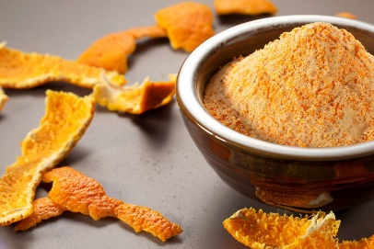

**Methodology:**

Cut the orange peel into slices

Keep it in hot air oven for drying at 56 ℃

Grind it well

Sieve it nicely

**Banana peel**

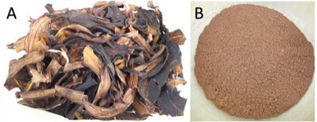

Cut the banana peel into slices

Keep it in hot air oven at 56℃ for 24 hours

Grind it well

Sieve it nicely

**Garlic peel powder**

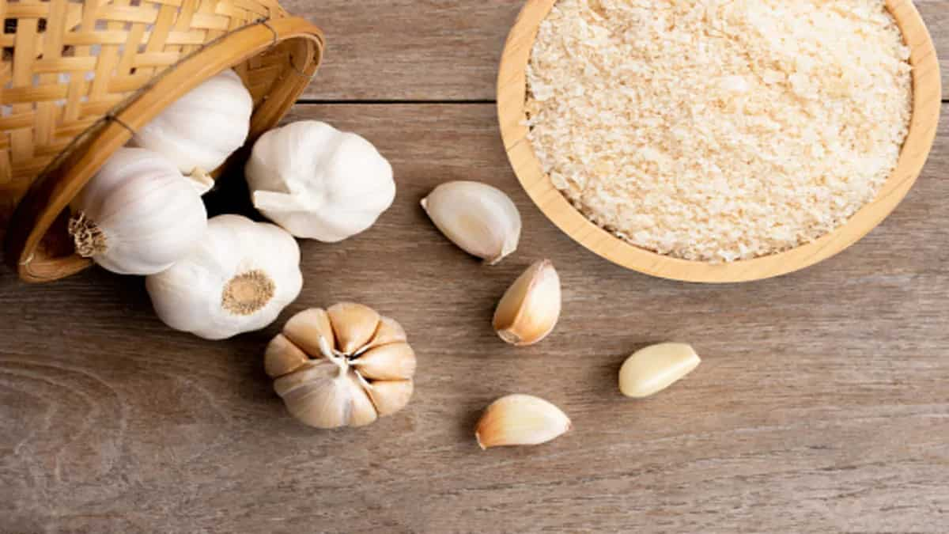

**Methodology**

Cut the garlic peel into pieces

Roast it for 15 mins

Keep it in hot air oven at 56℃ for 24 hours

Grind it well

Sieve it nicely

By mixing banana peel, orange peel ,banana peel garlic peel powders , amla seed powders ,ragi ,oats, foxtail and pinch of salt and making into a batter format

Normal dosa mix

Add ½ cup urad dal , 2 table spoon chana dal and ½ teaspoon methi seeds to a large bowl/pot . Add ½ cups raw rice o another bowl

Rinse the dal thoroughly a few times and soak in lots of filtered water for 4 hours . during cold it can be soaked up to 6hours or even overnight

Rinse rice too afew times until the

**PHYSICO CHEMICAL ANALYSIS**

**Determination of moisture**

Moisture is analysed by oven drying method. This method consists in measuring the weight lost by foods due to the evaporation of water. The weight after drying is subtracted from the weight before so the loss of moisture is determined using the loss of mass. Dry in hot air oven at 100̊̊ - 20℃ for 3 hours. Cool in a desiccator and weigh. Dry again for 30 minutes cool in a desiccator and weigh . Repeat the process of heating and cooling in a desiccator until the difference in two successive weight is less than 1 mg . Record the lowest weight

**Calculation:**

% Moisture = (w2 – w1 ) – (w3 –  w1 ) 100

w

where

weight of the sample (w) = g

weight of empty petri dish (w1 ) = g

weight of petri dish containing sample before drying (w2) = g

weight of petri dish containing sample after drying (w3) = g

**DETERMINATION OF TOTAL ASH**

The total ash content of Soup Mix were determined by method . 5g of sample is placed in a dried weighed crucible and heat the content for about 1-2 minutes in a heating source . Then it was kept in a muffle furnace at550-560 for 5-6 hours . Cool it in a desiccator and note the weight

**Calculation:**

% total ash = ( w3 – w) 100

(w2 –w)

Where

Weight of empty crucible (w)

Weight of sample (w1 )

Crucible + sample (w2)

Weight of crucible after ashing (w3 )

**DETERMINATION OF PROTEIN**

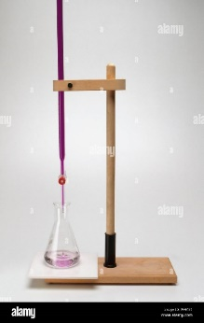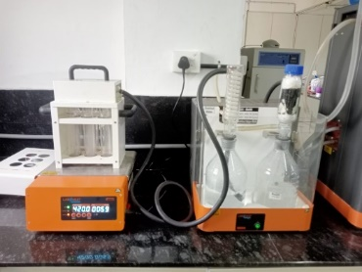 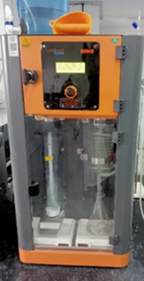

Crude protein content was determined by using Automatic Kjeldahl unit . 0.2g of sample was taken and digested with 3g of catalyst mixture in 10 ml sulphuric acid. After one hour and 45 minutes it was kept for cooling and 30 ml water was added . For distillation in Kjeldahl unit the total programme time was 9 minute and the liberated NH3 was collected in a conical flask containing boric acid . The amount of NH3 liberated was determined by titrating with 0.1N H2SO4 using mixed indicator (Bromocresol green and Methyl red ) . Crude protein content was calculated by multiplying the total nitrogen content with conversion factor of 6.25 and expressed as percentage

**Calculation**

%N = 14.1 ( S –B) Normality of HCl

Sample weight 10

Where

S is the Titre Value of Sample and B is the Titre value of Blank

% Protein = % N 6.25

**DETERMINATION OF CRUDE FAT**

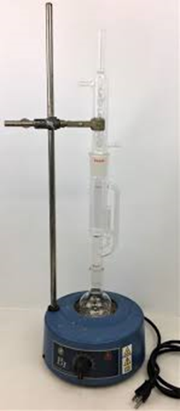

5 grams of sample was weighed into a thimble. The thimble was then cotton plugged and inserted into Soxhlet apparatus which was then connected to a previously weighed Round bottom flask n-hexane was used as the solvent for extraction. it was then refluxed until the solvent becomes clear. the extracted fat collected in the round bottom flask was dried in a water bath and kept in hot air oven (110℃ for 1hr) to get a constant weight

**Calculations:**

% Crude fat = (w2 –w1) 100

w

Where

W = Weight of sample

W1 = weight of round bottom flask

W2 = Weight of round bottom flask containing fat

**DETERMINATION OF CRUDE FIBRE**

The crude fibre was determined by 978.10 method. 2g of fatless sample was added to 200ml 0.128 M H2SO4 in a conical flask and digested for 30 minutes in a hot plate with periodic agitation. Place muslin cloth in funnel and discard the filtrate. Wash the retentate thoroughly with hot water to remove acid residues completely. transfer the retentate completely to a conical flask with 200 ml of 0.313 M NaOH. Digest the contents for another 30 minutes in hot plate with periodic agitation. discard the filtrate by placing muslin cloth in funnel. Wash the content thoroughly with hot water to remove base residue completely. Transfer the retentate to clean dry crucible and place it on hot plate to remove excess water. The retentate is dried in hot air oven at 130℃ for 2hrs. cool and note the weight of dried content. Then place the crucible in muffle furnace at 550℃ for 2hrs. After incineration take out the crucible and cool it in desiccator for about 20 minutes. Take the weight of crucible containing ash

**Calculations:**

% Crude fibre = (w1- w2) 100

Ws

Where

W1 = weight of crucible containing fibre

W2 = weight of crucible containing ash

Ws = weight of sample taken

**ESTIMATION OF pH**

The pH was measured as per the procedure of 943.02 method (Lane1995). The pHof sample was determined using a digital pocket pH meter, calibrated with pH 4,7, and 10 buffers according to manufacturer instructions. Total of 2g of sample weighed and placed in a beaker added with 20ml distilled water at 25℃. After the water was added, the content was mixed in an electronic agitator, till it is homogenous. Immerse the pH electrode of the meter in to the sample solution ensuring it is submerged and not touching the container walls. Allow the reading to stabilize, typically within a few seconds. Record the pH reading displayed on the meter. Rinse the electrode with distilled water between the measurement to avoid errors before and after the estimation

**CARBOHYDRATE**

After determining the percentage of moisture, ash, protein and fat, percentage of carbohydrate was calculated

**Calculation:**

%total carbohydrate = 100 – (A+B+C+D)

Where

A= % by weight of moisture

B=% by weight of ash

C= % by weight of protein

D= % by weight of fat

**ESTIMATION OF STARCH**

Take 3g of homogenized sample and transfer to conical flask add 200ml of distilled water mix he contents well. Add 20 ml of con. HCl and swoirl well heat the contents for 45 minutes cool the flask at room temperature transfer for contents to beaker and adjust the pH to 7 by adding 50% NaOH solution filter the contents to beaker and collect the filtrate to250ml standard flask makeup to the mark using distilled water and let it stand for 24 hrs

Fehling A :17.3195g CuSO4 is made upto 250 ml with distilled water, store in cool and dark place

Fehling B: 86.5-gram Sodium Potassium tartrate and 25 g NaOH is made upto 250 ml with dilute water, let it stand for 2 days and then filter the contents

Stock solution: 5-gram sucrose and 1.25 ml con. HCl. add 50ml distilled water, swirl well and make upto 250 ml using distilled water after 3 days.

**Working standard 3(2.5 mg/ml);**

62.5 ml stock solution is made upto 250 ml standard flask using distilled water 2-3 drops of phenolphthalein is added and neutralized using 20%NaOH

Titration rd

5ml Fehling a and 5ml Fehling b taken in a conical flash. Add 30ml distilled water place it on a pre heated magnetic hot plate filled burette with working standard note the read. 17 ml working standard is added first and then 4 drops of methylene blue indicator is introduced. Start titration with working standard on continuous addition of solution burette dropwise. Stop the titration until it reaches the same colour before adding methylene blue. (Perform for sample taking different volumes)

**Calculations:**

% starch = % total sugar 0.9 %

% Total sugar = C (Made up volume of W.S) (blank titre value –

Sample titre value) 100 100

Volume of sample solution weight of sample 50

Where

C = Concentration of working standard

**Chapter :5 - Result and Discussion**

**Development and Formulation of millet based Dosa Mix**

|  |  |
| --- | --- |
| Ingredients | percentage |
| Banana peel | 8% |
| Orange peel | 6% |
| Garlic peel | 1.7% |
| Amla seed powder | 3.5% |
| Ragi | 25% |
| Oats | 24% |
| Foxtail | 25% |
| Salt | 6.8% |

**Proximate analysis**

|  |  |  |
| --- | --- | --- |
| **Sample** | **Normal mix** | **Instant mix** |
| Moisture | 9.6% | 9.8% |
| Ash | 0.016% | 0.27% |
| Protein | 0.78 % | 0.79% |
| Fat | 0.251% | 0.195% |
| Fibre | 0.9% | 1.85% |
| pH | 3.5% | 4.7% |
| Carbohydrate | 88.453% | 87.095% |
| Starch | 54.65% | 28.35% |

**CHAPTER: 6 – CONCLUSION**

Garlic has long been used to treat and prevent different diseases due to its medicinal properties. In past, garlic peels are thrown away as waste despite research showing that they contain considerable levels of bioactive compounds. We discuss the medicinal advantages of garlic peel which are due to the presence of bioactive chemicals such as phenolic components including quercetin, kaempferol, rutin, and phenolic acids. Antioxidant, antibacterial, anti-cancer, anti-inflammatory, and antiviral 2650 F. AZMAT ET AL. characteristics are just a few of the health benefits of garlic peel. Garlic peel has the potential to be a useful alternative source in the creation of dietary supplements or functional meals for the treatment and prevention of cancer, neurodegenerative disease, diabetes, cardiovascular disease, and hepatic disorders. Based on our understanding, it can be concluded that garlic peel is excellent but needs to be treated carefully to completely enjoy its enormous medical advantages, keeping in mind that improper application may have unforeseen repercussions.

**CHAPTER : 7 – REFERENCE**

Nurmilah, S.; Cahyana, Y.; Utama, G. L.; Aït-Kaddour, A. Strategies to Reduce Salt Content and Its Effect on Food Characteristics and Acceptance: A Review. Foods. 2022, 11(19), 3120. DOI: 10.3390/foods11193120.

Bhatwalkar, S. B.; Mondal, R.; Krishna, S. B. N.; Adam, J. K.; Govender, P.; Anupam, R. Antibacterial Properties of Organosulfur Compounds of Garlic (Allium Sativum). Front. Microbiol. 2021, 12, 613077. DOI: 10.3389/fmicb. 2021.613077.

Mishra, S.; Patel, M. Role of Nutrition on Immune System During COVID-19 Pandemic. J. Food Nutr Health. 2020, 3(2)

Castellanos-Gutiérrez, A.; Sánchez-Pimienta, T. G.; Carriquiry, A.; da Costa, T. H.; Ariza, A. C. Higher Dietary Magnesium Intake is Associated with Lower Body Mass Index, Waist Circumference and Serum Glucose in Mexican Adults. Nutr. J. 2018, 17(1), 1–8. DOI: 10.1186/s12937-018-0422-2.

Rouf, R.; Uddin, S. J.; Sarker, D. K.; Islam, M. T.; Ali, E. S.; Shilpi, J. A.; Sarker, S. D., Tiralongo, E., Sarker, S D. Antiviral Potential of Garlic (Allium Sativum) and Its Organosulfur Compounds: A Systematic Update of Pre-Clinical and Clinical Data. Trends In Food Science & Technology. 2020, 104, 219–234. DOI: 10.1016/j.tifs. 2020.08.006.

Pourahmad, J.; Salami, M.; Zarei, M. H. Comparative Toxic Effect of Bulk Copper Oxide (CuO) and CuO Nanoparticles on Human Red Blood Cells. Biol. Trace Elem. Res. 2023, 201(1), 149–155. DOI: 10.1007/s12011- 022-03149-y.

Tang, Z.; Kong, N.; Ouyang, J.; Feng, C.; Kim, N. Y.; Ji, X.; Wang, C.; Farokhzad, O. C.; Zhang, H.; Tao, W. Phosphorus Science-Oriented Design and Synthesis of Multifunctional Nanomaterials for Biomedical Applications. Matter. 2020, 2(2), 297–322. DOI: 10.1016/j.matt.2019.12.007.

Habibian, M.; Sadeghi, G.; Ghazi, S.; Moeini, M. M. Selenium as a Feed Supplement for Heat-Stressed Poultry: A Review. Biol. Trace Elem. Res. 2015, 165, 183–193. DOI: 10.1007/s12011-015-0275-x. [44] Kumar, K. S.; Paswan, S.; Srivastava, S. Tomato-A Natural Medicine and Its Health Benefits. J. Pharmacogn. Phytochem. 2012, 1(1), 33–43.

Exley, C. The Toxicity of Aluminium in Humans. Morphologie. 2016, 100(329), 51–55. DOI: 10.1016/j.morpho. 2015.12.003.

Nielsen, F. H. Boron in Human and Animal Nutrition. Plant Soil. 1997, 193(1–2), 199–208. DOI: 10.1023/ A:1004276311956.

Putra, N. R.; Aziz, A. H. A.; Faizal, A. N. M.; Che Yunus, M. A. Methods and Potential in Valorization of Banana Peels Waste by Various Extraction Processes: In Review. Sustainability. 2022, 14(17), 10571. DOI: 10.3390/ su141710571.

Shang, A.; Cao, S.-Y.; Xu, X.-Y.; Gan, R.-Y.; Tang, G.-Y.; Corke, H.; Mavumengwana, V.; Li, H.-B. Bioactive Compounds and Biological Functions of Garlic (Allium Sativum L). Foods. 2019, 8(7), 246. Article. DOI: 10.3390/ foods8070246.

Kanatt, S. R.; Rao, M. S.; Chawla, S. P.; Sharma, A. Active Chitosan–Polyvinyl Alcohol Films with Natural Extracts. Food. Hydrocoll. 2012, 29(2), 290–297. DOI: 10.1016/j.foodhyd.2012.03.005.

Lyngdoh, J.; Ray, S. Valorization of Garlic Peel as a Potential Ingredient for the Development of ValueAdded Rice Based Snack Product Pukhelein. Agri And Food Sci. Res. 2022, 9(2), 50–58. DOI: 10.20448/aesr.v9i2.4110.

Lyngdoh, J.; Ray, S. Valorization of Garlic Peel as a Potential Ingredient for the Development of ValueAdded Rice Based Snack Product Pukhelein. Agri And Food Sci. Res. 2022, 9, 50–58. DOI: 10.20448/aesr.v9i2.4110.

Santhosha, S. G.; Jamuna, P.; Prabhavathi, S. N. Bioactive Components of Garlic and Their Physiological Role in Health Maintenance: A Review. Food Biosci. 2013, 3, 59–74. DOI: 10.1016/j.fbio.2013.07.001.

Phan, A. D. T.; Netzel, G.; Chhim, P.; Netzel, M. E.; Sultanbawa, Y. Phytochemical Characteristics and Antimicrobial Activity of Australian Grown Garlic (Allium Sativum L.) Cultivars. Foods (Basel, Switzerland). 2019, 8(9), 358. DOI: 10.3390/foods8090358.

Ejaz, S.; Chekarova, I.; Cho, J. W.; Lee, S. Y.; Ashraf, S.; Lim, C. W. Effect of Aged Garlic Extract on Wound Healing: A New Frontier in Wound Management. Drug Chem. Toxicol. 2009, 32(3), 191–203. DOI: 10.1080/ 01480540902862236. INTERNATIONAL JOURNAL OF FOOD PROPERTIES 2653 [55] Anantharaju, P. G.; Gowda, P. C.; Vimalambike, M. G.; Madhunapantula, S. V. An Overview on the Role of Dietary Phenolics for the Treatment of Cancers. Nutr. J. 2016, 15(1), 1–16. DOI: 10.1186/s12937-016-0217-2.

Wu, Y.; Wu, Z.-R.; Chen, P.; Yang, L.; Deng, W.-R.; Wang, Y.-Q.; Li, H.-Y. Effect of the Tyrosinase Inhibitor (S)-N-Trans-Feruloyloctopamine from Garlic Skin on Tyrosinase Gene Expression and Melanine Accumulation in Melanoma Cells. Bioorg. Med. Chem. Lett. 2015, 25(7), 1476–1478. DOI: 10.1016/j.bmcl.2015.02.028.

Thomson, M.; Al-Amin, Z. M.; Al-Qattan, K. K.; Shaban, L. H.; Ali, M. Anti-Diabetic and Hypolipidaemic Properties of Garlic (Allium Sativum) in Streptozotocin-Induced Diabetic Rats. DOAJ. 2007, 15(3), 108–115.

Lolok, N.; Mashar, H. M.; Annah, I.; Saleh, A.; Yuliastri, W. O.; Isrul, M. Antidiabetic Effect of the Combination of Garlic Peel Extract (Allium sativum) and Onion Peel (Allium cepa) in Rats with Oral-Glucose Tolerance Method. Res. J. Pharm. Technol. 2019, 12(5), 2153–2156. DOI: 10.5958/0974-360X.2019.00357.3.

Banerjee, S. K.; Maulik, S. K. Effect of Garlic on Cardiovascular Disorders: A Review. Nutr. J. 2002, 1(1), 4. DOI: 10.1186/1475-2891-1-4.

Bayan, L.; Koulivand, P. H.; Gorji, A. Garlic: A Review of Potential Therapeutic Effects. Avicenna J. Phytomed. 2014, 4(1), 1. [61] Pai, S. T.; Platt, M. W. Antifungal Effects of Allium Sativum (Garlic) Extract Against the Aspergillus Species Involved in Otomycosis. Lett Appl. Microbiol. 1995, 20(1), 14–18. DOI: 10.1111/j.1472-765X.1995.tb00397.x.

Houshmand, B.; Mahjour, F.; Dianat, O. Antibacterial Effect of Different Concentrations of Garlic (Allium Sativum) Extract on Dental Plaque Bacteria. Indian J. Dental Res. 2013, 24(1), 71. DOI: 10.4103/0970-9290. 114957.

Zain Al-Abdeen, S. S.; Abdullah, I. T.; Al-Salihi, S. S. The Synergism Effect of Aqueous Garlic Extract and Ciprofloxacin Against Some Multi-Resistant Bacteria. J. Microbiol. Biotech. Res. 2013, 3(3).

Karuppiah, P.; Rajaram, S. Antibacterial Effect of Allium Sativum Cloves and Zingiber Officinale Rhizomes Against Multiple-Drug Resistant Clinical Pathogens. Asian Pac. J. Trop. Biomed. 2012, 2(8), 597–601. DOI: 10. 1016/S2221-1691(12)60104-X.

Dini, C.; Fabbri, A.; Geraci, A. The Potential Role of Garlic (Allium Sativum) Against the Multi-Drug Resistant Tuberculosis Pandemic: A Review. Annali. dell’Istituto superiore di sanità. 2011, 47, 465–473. DOI: 10.4415/ ANN_11_04_18.

Tsai, Y.; Cole, L. L.; Davis, L. E.; Lockwood, S. J.; Simmons, V.; Wild, G. C. Antiviral Properties of Garlic: In vitro Effects on Influenza B, Herpes Simplex and Coxsackie Viruses. Planta. med. 1985, 51(5), 460–461. DOI: 10.1055/ s-2007-969553.

Majdalawieh, A. F.; Carr, R. I.; Ingle, D. L. Anti-Inflammatory and Anti-Allergic Properties of Garlic Constituent Compounds: A Review. Food Funct. 2017, 8(3), 935–948. DOI: 10.1039/c6fo01763k.

Park, Y. K.; Kim, J. S.; Kang, M. H.; Lee, H. S. Garlic (Allium Sativum L.) Peel Extract Attenuates Inflammation and Improves Insulin Sensitivity in High Fat Diet-Induced Obese Mice. Nutr. Res. Pract. 2013, 7(6), 465–471.

Borlinghaus, J.; Albrecht, F.; Gruhlke, M.; Nwachukwu, I.; Slusarenko, A. J. Allicin: Chemistry and Biological Properties. Molecules. 2014, 19(8), 12591–12618. DOI: 10.3390/molecules190812591.