**IMPACT OF INNOVATIVE PACKAGING ON CONSUMER PERCEPTION OF COSMETIC PRODUCTS**

**Project Report**

**Submitted by**

**FIDA FATHIMA S (Reg. No. SB21BMS013)**

**Under the guidance of**

**Dr. SHOBITA P.S**

In partial fulfilment of the requirements for award of the degree of

**Bachelor of Management Studies (International Business)**



**ST. TERESA’S COLLEGE (AUTONOMOUS), ERNAKULAM**

COLLEGE WITH POTENTIAL FOR EXCELLENCE

Nationally Re-Accredited at ‘A++’ Level (NAAC Fourth Cycle

**March 2024**

ST. TERESA’S COLLEGE (AUTONOMOUS), ERNAKULAM, KOCHI – 682011



**CERTIFICATE**

*This is to certify that the project report entitled, “A Study on the impact of innovative packaging on consumer perception of cosmetic products”, has been**successfully completed by Ms. FIDA FATHIMA S, Reg. No.SB21BMS013 in**partial fulfilment of the requirements for the award of the Degree of Bachelor of**Management Studies in International Business under my guidance during the academic years 2021-2024.*

**DATE: FACULTY GUIDE**

**DR SHOBITA P S**

**DECLARATION**

*I, Fida Fathima s, Reg. No.SB21BMS013, hereby declare that this project work entitled “A Study on the impact of innovative packaging on consumer perception” is my original work.*

*I further declare that this report is based on the information collected by me and has not previously been submitted to any other university or academic body.*

**DATE: FIDA FATHIMA S**

**REG NO: SB21BMS013**

**ACKNOWLEDGEMENT**

I would like to place on Project Report my debt of gratitude to those who helped me in the preparation of this project.

I thank Dr Alphonsa Vijaya Joseph, Principal and Dr. Sr.Vineetha, Director of St. Teresa’s College, Ernakulam for permitting me to take up this opportunity of doing an in-depth study on role of scent marketing in impulsive buying behavior and quality perception.

I take this opportunity to express my deep sense of gratitude and whole hearted thanks to Dr. Anu Raj, Head of the department of Management Studies for guiding me in all stages of this project, without whom this project would have been a distant reality.

I also thank my guide, Dr. Shobitha p s for her constant support throughout the project.

I would also like to express my heartfelt gratitude to Dr Sunitha TR for her immense support and guidance throughout the project.

Last but not least; I extend my heartfelt thanks to my family and friends for their continuous support through this journey.

**FIDA FATHIMA S**

**EXECUTIVE SUMMARY**

In the cosmetics industry, packaging plays a crucial role in safeguarding items, preserving their quality, and improving their aesthetic appeal. It functions as a channel for branding and informing customers about products. The sector that produces, distributes, and sells goods intended for personal hygiene and beautification is known as the cosmetic industry. Products from the skincare, haircare, cosmetics, fragrance, and personal hygiene categories are all included in this industry. The cosmetics sector provides goods that improve appearance, support personal hygiene, and preserve the health of skin and hair to customers across all demographic groups. Trends, innovation, and consumer tastes drive this dynamic and competitive business, while cultural, societal, and economic variables impact global marketplaces. This research focuses on studying impact of innovative packaging on customer brand perception in the cosmetic industry. Data was collected using primary data collection tools like questionnaires and secondary data tools like articles and already published research papers. The sampling method used was convenience sampling and 50 responses were collected through social media platforms like WhatsApp, Instagram, etc. Data was analyzed using SPSS and tool used was Percentage analysis. Overall, it was found that packaging does impact consumers brand perception. It was found out that people were attracted to cosmetic products with innovative packaging and it was also found out that the packaging material was also an important aspect. Furthermore, it was also understood that the color, graphics and design, size and shape were the main factors that the people first look in the packaging and it was based on these factors that customers purchase a cosmetic product based on its packaging. It was also understood that the packaging of the product reflects its quality. Hence, we can conclude that packaging has an impact on customer brand perception.

**TABLE OF CONTENTS**

|  |  |  |
| --- | --- | --- |
| Chapter no | Title | Pg no |
|  | Acknowledgement |  |
|  | Executive summary |  |
| One | **Introduction**  Introduction to Study  Statement of Problem  Literature Review  Objectives of the Study  Scope of Study  Significance of Study  Research Methodology  Limitations to Study | 1  2  3  4  9  9  10  10  12 |
| Two | **Industry Profile, Company and Product profile**  Industry Profile | 13  14 |
| Three | **Data Analysis and Interpretation** | 22 |
| Four | **Summary of Findings, Suggestions and Conclusion** | 38 |

**LIST OF CHARTS**

|  |  |  |
| --- | --- | --- |
| Charts |  | Pg no |
| Chart 1 | It shows the age group of the respondents. | 23 |
| Chart 2 | It shows the gender of the respondents. | 24 |
| Chart 3 | It shows the occupation of the respondents. | 25 |
| Chart 4 | It shows the product features. | 26 |
| Chart 5 | It shows the cosmetic packaging attribute. | 27 |
| Chart 6 | It shows the frequency of purchase of cosmetic products. | 28 |
| Chart 7 | It shows the impact of packaging of cosmetic products on buying decision. | 29 |
| Chart 8 | It shows the importance of packaging material in decision making. | 30 |
| Chart 9 | It shows the appealing of innovative packaging design in purchase decision. | 31 |
| Chart 10 | It shows that the packaging of a cosmetic product reflects its quality. | 32 |
| Chart 11 | It shows the preference of cosmetic products with ecofriendly packaging | 33 |
| Chart 12 | It shows the importance of color scheme of packaging while purchasing a cosmetic product | 34 |
| Chart 13 | It shows the importance of design of packaging while purchasing a cosmetic product | 35 |
| Chart 14 | It shows the importance of size and shape of packaging while purchasing a cosmetic product | 36 |
| Chart 15 | It shows the importance of typographic of packaging while purchasing a cosmetic product | 37 |

**1.1 INTRODUCTION TO STUDY**

**CHAPTER – 1**

**INTRODUCTION**

Panwar (2004) defined packaging as the act of containing, protecting and presenting the contents through the long chain of production, handling and transportation to their destinations in as good a state, as they were, at the time of production. Thus, packaging secures the contents of the pack as it moves through different places. Product packaging serves as the first point of interaction between a customer and a product. It encompasses the design, materials, and presentation that encase and protect items for distribution, sale, and use. Beyond its practical role in safeguarding products, packaging plays a crucial role in communicating brand identity, conveying information, and influencing consumer purchase intentions.

To draw in both current and new clients, packaging's tactile and visual components—such as its size, shape, font, colors, and graphics—are carefully thought out. Good packaging ensures the product reaches the customer in the best possible condition and is both aesthetically beautiful and practical.

Additionally, packaging is a communication tool that communicates important information about ingredients, usage guidelines, product attributes, and brand values. It builds brand recognition, forges an emotional bond, and tells a story. Careful and purposeful packaging design may make a product stand out in a crowded market, drawing customers in and influencing their decisions to buy.

Environmentally friendly packaging designs and materials are becoming more and more vital as sustainability and environmental preservation gain importance. The packaging sector is making an effort to take these factors into account and support the attainment of the sustainability objectives.

In short, product packaging is more than just a protective covering; it is a powerful tool that bridges the gap between the product and the consumer, leaving a lasting impression and contributing to the overall consumer experience.

**1.2 PROBLEM STATEMENT**

"Despite the pivotal role of packaging in influencing consumer behavior, there is a lack of comprehensive research addressing the most effective design elements for attracting customers in diverse markets. This research aims to investigate the key factors influencing consumer packaging preference and purchasing intention regarding packaging, with a focus on simplicity and visual appeal. By identifying and understanding the critical aspects of packaging design that resonate with consumers, this study seeks to provide actionable insights for businesses to optimize their packaging strategies and enhance customer engagement."

**1.3 LITERATURE REVIEW**

Packaging is the science, art and technology of enclosing or protecting products for distribution, storage, sale, and use. Packaging also refers to the process of designing, evaluating, and producing packages. Panwar (2004) defined packaging as the act of containing, protecting and presenting the contents through the long chain of production,

handling and transportation to their destinations in as good a state, as they were, at the time of production. Thus, a product’s package secures the main contents of the product as it moves through its channel of distribution and while it is still in use. Packaging also does the job of prolonging the shelf life of a product, which is important to producers, middlemen, and final buyers (Gaafar and Ra'id, 2013).

Earlier the purpose of packaging was to protect the product from damage. But now the main purpose of packaging is to attract the customers to purchase the product using subliminal elements. Today, packaging is functioning as a silent salesman which attracts the buyer's attention. There are many characteristics or elements of packaging which drive consumers choice or preference for products. In a related study on the impact of packaging characteristics on consumer brand preference conducted by Hassan and Khan (2009), the following independent variables were considered as packaging characteristics; size of package, shape of package, safety of product, shelf life of product, convenience storage, convenience of use, extra use of package and package attractiveness.

There are various elements which makes the customers attracted to a product. These elements may make the customers to try out new products in the market because of their packaging. Some of the elements are listed below.

**1.3.1 COLOUR**

Colour plays a crucial role in product packaging as it influences consumer perception, emotions, and purchasing decisions. In choosing packaging colour, Valentya et al (2014) stated that companies should decide on what colour combinations that can be used in order to attract consumers to respond positively to their brands. The colors on a product's packaging can make a big difference in how we feel about it. Bright and beautiful colors catch our attention and make a product stand out on the shelf. Different colors can also make us feel different emotions – like red for energy or blue for calmness. When the colors match the product or create a certain mood, it helps us understand what the product is about. When it comes to cosmetic packaging, color is extremely important since it shapes consumer impressions and purchasing decisions. Beyond aesthetics, colors are powerful communicators that help distinguish products in a crowded market and build brand identity. Bright colors draw the eye, yet subdued shades imply refinement. Colors have an emotional impact; whilst colder hues like blue suggest tranquility, warmer tones like red radiate excitement. Moreover, hues represent the qualities of a product; muted pastels are used for delicate skincare, while bright hues are used for dramatic makeup. Cultural nuances also come into play because various locations have different meanings for the same hues. Colors provide a practical purpose in organizing packaging information and directing customers through product options. Furthermore, eco-friendly companies choose earthy colors to convey sustainability. Essentially, color on cosmetic packaging serves as a strategic tool that shapes consumer perceptions, feelings, and emotions.

**1.3.2 SIZE AND SHAPE**

Silayoi & Speece (2007) identified size and shape as crucial dimension in packaging attributes. One way in which consumers appear to use these things according to Silayoi & Speece (2007) is as a simplifying visual heuristic to make volume judgments. The size and shape of packaging significantly influence how consumers perceive and interact with products. A well-designed package size and shape can enhance the overall consumer experience. The shape of the package can evoke emotions and convey the product's identity; sleek and modern shapes may suggest innovation, while traditional shapes convey a sense of familiarity.

The utility and impression of cosmetic packaging by consumers are greatly influenced by its size and design. The size and style of the package is quite important in drawing attention to cosmetics on store shelves. Shapes that are distinctive and eye-catching might stand out and help the product stick in the minds of potential customers. Customers' brand preferences are significantly influenced by the size and shape. Special sizes and forms could draw a buyer to a specific product. It draws in new clients for a company. While larger sizes might suggest abundance or value for money, compact sizes might be considered travel-friendly and convenient for on-the-go use. Consumers are also impacted by the packaging's practicality, including its ease of handling and storage.

**1.3.3 GRAPHICS**

Graphics on packaging play a big role in how we choose products. When a package has attractive and clear graphics, it can catch our eye and make us interested. Pictures and designs help us understand what's inside, especially when we're quickly browsing in a store. Sometimes, a simple logo or a fun illustration can make a product more memorable. Graphics also tell a story about the brand – whether it's a playful, eco-friendly, or high-tech vibe. Clear and appealing graphics make it easy for us to recognize and remember our favorite products, making the shopping experience more enjoyable and straightforward. In a nutshell, graphics on packaging are like a visual invitation that helps us decide which products to bring home**.**

**1.3.4 TYPOGRAPHY/FONT STYLE**

Typography plays a crucial role in packaging design as it not only communicates essential information but also conveys the brand's personality and establishes a visual hierarchy. Typography on packaging is like the voice of a product – it speaks to us through words. The style, size, and arrangement of letters on a package can significantly affect how we perceive a product. Fancy or playful fonts can make a product feel fun, while elegant or bold lettering might suggest something more luxurious. Typography is not just about words; it's about creating a feeling or a vibe that connects with us when we're shopping.

**1.3.5 PACKAGING MATERIAL**

Various aspects of packaging, such as cost-effectiveness, sustainability, aesthetics, and functionality, are significantly impacted by the choice of packaging material in the cosmetics sector.

To begin with, the material used for packaging affects how well it works. Protection against light, moisture, and air is provided to varied degrees by different materials. Because of its impermeability and capacity to maintain the integrity of delicate compositions, glass is frequently used, but plastics are lightweight and provide flexibility in terms of design and dispensing systems.

Second, the material utilized has a big impact on how appealing packaging looks visually. High-end materials like glass, metal, or thick plastic are frequently used by luxury brands to communicate exclusivity and premiumness. These materials provide complex patterns, embossing, and unique finishes that improve the product's aesthetic appeal and appeal to customers looking for an opulent experience.

In addition, the cosmetics sector is becoming increasingly concerned about the sustainability of packaging materials. Customers are calling for environmentally friendly packaging options that decrease waste and lessen their influence on the environment as environmental challenges become more and more apparent. As firms work to meet consumer expectations for environmentally conscious products and align with sustainable practices, biodegradable materials, recyclable plastics, and compostable packaging are becoming more and more popular.

**1.3.6 BRAND VALUE**

The totality of elements that appeal to consumers and influence their opinions, loyalty, and market positioning is what constitutes the value of a cosmetic brand. It represents the faith that customers have in a brand, which is built through reliable product delivery, successful advertising, and satisfying customer service. Brand value includes intangible assets like customer loyalty, brand equity, and reputation in addition to tangible assets.

The value of a cosmetic brand is largely influenced by factors including product innovation, efficacy, and differentiation. Brands that consistently innovate—adding novel formulations, technologies, and trends—often fetch premium prices for their brands. Furthermore, over time, businesses that put an emphasis on efficacy—that is, producing measurable outcomes and successfully meeting customer needs—develop trust and loyalty.

Good marketing tactics—which include influencer partnerships, internet interaction, and advertising—are essential for building brand value. Brands that successfully convey their values, brand story, and USPs engage with customers on an emotional level and encourage brand loyalty.

Customer experiences, which include things like packaging, customer service, and the total brand experience, also have a big impact on brand value. Remarkable customer service and memorable brand experiences leave a lasting impression on brands, encouraging positive word-of-mouth and repeat business.

**1.3.6 BRAND PERCEPTION**

In cosmetic packaging, brand perception is essential for drawing in customers and encouraging loyalty. As the initial point of interaction between the customer and the brand, the packaging shapes both short- and long-term attitudes. Brand identity, values, and product positioning are communicated through the packaging's aesthetic design, material quality, and messaging. Packaging that represents quality, authenticity, and congruence with consumer preferences helps to build a positive brand perception. In the cutthroat cosmetics industry, brands that continually live up to package promises—like product performance and sustainability—build consumer loyalty and trust, which in turn propels their success.

**1.4 OBJECTIVES OF THE STUDY**

The objective of this study is to examine the effect of packaging characteristics on packaging preference for cosmetics products.

**Specifically, the aims are to;**

* Study the influence of packaging size and shape on cosmetics brand perception
* Study the influence of innovative packaging material on consumer perception of cosmetic products
* Study whether consumers give packaging as an important crieteria for judging cosmetic brands value
* Study the effects of packaging colour on cosmetics brand perception.
* Study the effects of packaging graphics on cosmetics brand perception.

**1.5 SCOPE OF THE STUDY**

Packaging has a big impact on customer attractiveness, product protection, and preservation in many facets of our everyday lives and businesses. Packaging has an impact on consumer perception, brand awareness, and market competitiveness in addition to its primary role of confining and protecting goods. Product shelf life can be increased, waste can be decreased by preventing spoiling and damage, and sustainability objectives can be met by using eco-friendly materials and designs in packaging. It also functions as a potent communication tool, providing crucial details about the product, its attributes, and how to use it. Packaging's use to logistics involves distribution and transportation, which in turn affects supply chains' overall effectiveness. To put it simply, packaging has an influence that goes well beyond its physical presence. It shapes customer experiences, commercial outcomes, and environmental concerns. My respondents are individuals using cosmetics based in Kochin district of Kerala.

**1.6 SIGNIFICANCE OF THE STUDY**

Packaging has a huge impact on both industry and daily life. It does more than merely package goods; it guarantees that they stay accessible, undamaged, and fresh. Consider the satisfaction of opening a neatly packed item or the annoyance of receiving a damaged item. Important information about a product, such as ingredients or usage directions, is also communicated through packaging. It is essential to branding because it makes goods stand out on store shelves. Furthermore, by using eco-friendly materials and cutting waste, good packaging promotes sustainability. Packaging has a wide range of effects, from influencing customer decisions to safeguarding items during transit, making it an essential component of daily life and company operations.

**1.7 RESEARCH METHODOLOGY**

**1.7.1 DATA COLLECTION**

The process of obtaining and analyzing data on certain variables in a pre-existing system allows one to assess results and respond to pertinent queries. This is known as data collection or data gathering. Determining the study question or problem, choosing the best data sources and methodologies, creating the instruments for data collection, gathering the data, organizing and analyzing the data are all common steps in the data collection process.

Careful planning, close attention to detail, and a firm grasp of the study objectives are necessary for effective data collecting. Ensuring the accuracy, dependability, and relevance of the data acquired to the study topic is crucial. Furthermore, it's critical to adhere to ethical standards when gathering data, which include getting research participants' informed consent and maintaining their confidentially.

There are two approaches that researchers frequently take while gathering data. These techniques fall into the categories of primary and secondary data collection techniques. Schedules, case studies, projective techniques, interviews, questionnaires, and observation are some of the data collection methods used for primary data. Data that is already available and may be obtained from published or unpublished sources is referred to as secondary data. Public documents, bank records, government publications, and so on are examples of published sources. Unpublished sources of data include letters, notebooks, unpublished works and biographies, and so on.

Questionnaires were the main data gathering instrument utilized by the researcher to determine how cosmetic packaging affects consumers' perceptions of brands.

The industry profile was discovered through the utilization of secondary data in the investigation. It was also utilized for the study's introduction and literature review. All material pertaining to secondary data was gathered from reliable websites and previously published research papers.

**1.7.2 SAMPLING**

***1.7.2.1 Population***

A population is an elemental collection that shares some or all of its properties. The amount of elements inside the population determines its size. Customers in the cosmetic industry or retail customers make up the population in this survey.

**1.7.2.2 *Sample size***

Owing to time and budget limitations, a sample size of 50 responders was selected. To lower sample mistakes, questionnaires were sent to respondents through social media sites including Instagram and WhatsApp. Enough time was given for them to finish the surveys.

***1.7.2.3 Sampling technique***

Probability sampling techniques and non-probability sampling techniques are the two categories of sampling techniques. Probability sampling approaches use randomization to make sure that each component of the population has an equal chance of being represented in the sample that is chosen. Simple random, systematic, stratified random, cluster, and multi-stage sampling are examples of probability sampling approaches. The ability of the researcher to choose sample items is particularly crucial when using the non-probability sampling technique. This kind of sampling may yield results that are criticized for being biased, and extrapolating the results to the entire population may be quite challenging. Techniques for non-probability sampling include quota, purposive, snowball, and convenient sampling.

Convenience sampling was employed by the researcher to ensure timely data collection and prevent poor response rates.

**1.7.3 TOOLS USED FOR DATA COLLECTION**

The researcher has thoughtfully created the questionnaire to ensure that it satisfies the needs of the study. There are two sections to the questionnaire. The demographics of the respondent are the main focus of the first part. Inquiries regarding cosmetic packaging are included in the second half.

**1.7.4 DATA ANALYSIS TECHNIQUES**

Simple percentage analysis was used to analyse the data.

**1.8 LIMITATIONS OF THE STUDY**

Like every other research, this research too has certain limitations. Some of the limitations are:

* One of the major problems was the lack of time to conduct the research.
* Results of the survey are based on the assumptions that the respondent has given correct response.
* Another limitation was that of the lack of respondents.

**CHAPTER-2**

**INDUSTRY, COMPANY AND PRODUCT PROFILE**

**2.1 INDUSTRY PROFILE**

**2.1.1 COSMETIC INDUSTRY**

The sector engaged in the manufacture, marketing, and distribution of goods intended to improve grooming and personal appearance is referred to as the cosmetic industry. These products cover a broad spectrum, including skincare, cosmetics, hair care, fragrances, and personal hygiene items. Because cosmetics are utilized for self-expression, hygiene, and confidence-building by people of all ages and demographics, the cosmetics sector is very important to society. Cosmetics are frequently seen as necessary for upholding grooming and personal cleanliness standards, which enhances general wellbeing and self-esteem.

The industry includes a wide range of businesses, from start-ups and tiny independent brands to big global enterprises. Distributors and retailers make sure that these products are distributed to consumers through a variety of channels, including department stores, specialty beauty stores, pharmacies, supermarkets, e-commerce platforms, and direct sales. Manufacturers create formulations, carry out research and development, and supervise production processes.

The cosmetic industry has experienced development and evolution due to various factors such as evolving customer tastes, technical advancements, globalization, developing beauty trends, regulatory compliance, and sustainability initiatives. Cosmetic firms are changing their strategy to accommodate changing demands and tastes as consumer awareness of ingredients, environmental effect, and ethical sourcing rises.

In general, the cosmetics market is vibrant, cutthroat, and always changing to satisfy the wide range of demands and preferences of customers around the globe.

The cosmetic industry is highly significant in many different aspects of the economy and society:

1. Confidence and Self-Expression: Cosmetics give people a way to improve and express who they are. They provide people the freedom to try out various colors, looks, and styles, which can increase self-esteem and give people the confidence to show themselves whatever they like.
2. Economic Impact: Producing large amounts of revenue and opening up job possibilities in a number of industries, including production, retail, marketing, and distribution, the cosmetics industry makes a major contribution to the economies of the world.
3. Health and Wellness: Skin health, environmental factor protection, and general well-being are the main goals of many cosmetic products. For instance, chemicals in skincare products may hydrate, moisturize, and shield the skin from harm.

**2.1.2 COSMETIC INDUSTRY IN INDIA**

Rising disposable incomes, shifting lifestyles, and growing customer awareness of beauty have all contributed to the spectacular expansion and evolution of the Indian cosmetics business in recent years. With a broad range of products covering skincare, hair care, color cosmetics, fragrances, and personal care items, the market is vibrant and diverse.

The rising demand for natural and herbal products is one of the major factors influencing the Indian cosmetics market. India has a long history of using natural medicines, including Ayurveda, and its consumers are becoming more interested in items that contain organic and plant-based ingredients. The trend toward natural beauty products has given rise to both local firms and global businesses that sell ranges of herbal and Ayurvedic-inspired goods.

The fast urbanization of the country and the growth of contemporary retail channels including department stores, specialist beauty shops, and internet platforms are also having an impact on the Indian cosmetics business. E-commerce, which enables customers from tier II and tier III towns to easily buy a variety of products, has been especially important in democratizing access to cosmetics.

Furthermore, the Indian cosmetics business has witnessed a sharp increase in demand for men's grooming products due to shifting views on masculinity and men's increasing embrace of self-care. To capitalize on this profitable market niche, companies are launching cutting-edge products specifically designed to meet the demands of males in terms of skincare, hair care, and grooming.

But there are other obstacles the Indian cosmetics sector must overcome, such complicated rules requiring adherence to strict guidelines for product registration and labelling. Furthermore, as domestic and foreign businesses fight for market share, competition is growing, which is fueling creative product development and aggressive marketing tactics.

Notwithstanding these obstacles, there are a lot of growth and investment potential in the Indian cosmetics sector. The market is expected to develop because to factors like a big and youthful population, rising urbanization, and a growing focus on wellness and personal grooming. In India's dynamic cosmetic market, businesses that can successfully negotiate regulatory obstacles, take advantage of new trends, and provide cutting-edge, culturally-relevant goods stand a good chance of success.

**2.1.3 HISTORY OF COSMETIC INDUSTRY**

The cosmetics industry has a long and rich history that reflects shifting societal trends, technological breakthroughs, and cultural standards across thousands of years. Here's a quick rundown:

1. Ancient Civilizations: The usage of makeup may be traced back to the times of Egypt, Mesopotamia, Greece, and Rome, among others. Egyptians adorned their eyes and improved their beauty with materials like kohl, a dark powder derived from minerals. Cosmetics such as lotions, powders, and perfumes were widely employed by the Greeks and Romans for religious events and beauty rituals.
2. Medieval and Renaissance Era: Religious and cultural pressures that linked makeup to immorality caused cosmetics to lose popularity in Europe during the Middle Ages. Nonetheless, the Renaissance saw a return of the use of cosmetics, with affluent people employing ornate makeup to denote social standing and prestige.
3. Industrial Revolution: The mass manufacture of cosmetics was made possible by innovations in manufacturing and distribution during the Industrial Revolution, which brought about substantial changes to the cosmetics sector. During this time, well-known companies like Max Factor, Elizabeth Arden, and Revlon came to prominence and invented innovative formulas and advertising strategies.
4. 20th Century: The cosmetics industry had tremendous expansion and innovation during this century. The launch of new cosmetics like nail polish, lipstick, and mascara transformed women's beauty regimens. Thanks to the development of new formulas, packaging, and distribution methods made possible by technological improvements, cosmetics are now more widely available.
5. Modern Era: The cosmetics industry continued to grow quickly in the second half of the 20th century and the first part of the 21st. The way cosmetics are sold and used has changed dramatically with the rise of social media influencers, celebrity endorsements, and digital marketing. Furthermore, in response to customer desire for cleaner and greener beauty products, there has been an increasing focus on sustainability, ethical sourcing, and natural and organic components.

**2.1.4 HISTORY OF COSMETIC INDUSTRY IN INDIA**

India's cosmetics business has a colorful and lengthy history that goes back many centuries. India has long been known for its age-old medical system, Ayurveda, which is the basis of its traditional beauty regimens. For skincare, haircare, and general well-being, Ayurvedic formulations made of natural components such as herbs, oils, and minerals were utilized.

Indian society began to be influenced by Western ideals of beauty during the colonial era. Western cosmetics were consequently brought to the Indian market. However, because of their high price and restricted availability, these products were initially exclusively available to the upper class.

Following independence, India's cosmetic business experienced substantial changes due to globalization and economic reforms. The deregulation of the economy in the 1990s brought about a sea change by permitting international cosmetic brands to penetrate the Indian market. As a result, there was more competition and more products that were available to the general public.

The market for cosmetic items has expanded dramatically in recent decades due to a variety of factors, including changing lifestyles, rising disposable money, and growing awareness of personal grooming. Indian customers are increasingly drawn to skincare-enhancing cosmetics as well as ones that improve looks.

In addition, social media and internet platforms have completely changed how cosmetics are promoted and sold in India. Consumer preferences and purchases are largely shaped by beauty influencers and online beauty forums.

The Indian cosmetics market, which includes a broad range of goods like skincare, haircare, makeup, fragrances, and personal hygiene, is currently a vibrant and quickly expanding business. In this industry, local businesses and global behemoths engage in fierce competition while meeting the varying demands and tastes of their clientele. Furthermore, there is a growing movement in favor of natural, organic, and Ayurvedic goods, which represents a return to conventional beauty procedures in the face of modernity.

**2.1.5 MAJOR PLAYERS IN THE INDIAN COSMETIC INDUSTRY**

The Indian cosmetics sector is characterized by a heterogeneous landscape, with a number of prominent firms controlling several market niches. Here are a few prominent figures across multiple categories:

1. Hindustan Unilever Limited (HUL) is a prominent FMCG (fast-moving consumer goods) company based in India. It is the owner of well-known cosmetic brands like Ponds, Lakme, Fair & Lovely, and Dove. In the categories of personal hygiene, haircare, and skincare, HUL is well-represented.
2. L'Oréal India: With brands including L'Oréal Paris, Maybelline New York, Garnier, and Matrix, L'Oréal is a major player in the worldwide cosmetics market and has a significant presence in India. L'Oréal serves a number of market areas, including those for makeup, skincare, haircare, and professional salon services.
3. Procter & Gamble (P&G): With brands including Gillette, Olay, Pantene, and Head & Shoulders, P&G is another significant participant in the Indian cosmetics market. Products from P&G are available in the skincare, haircare, and personal grooming categories.
4. Johnson & Johnson (J&J): J&J is a well-known international business that works in the consumer products and healthcare industries. Popular brands including Johnson's Baby, Neutrogena, and Clean & Clear are among J&J's offerings in India.
5. Nykaa: It is an online Indian beauty and wellness retailer that is expanding quickly. It provides a large selection of skincare, haircare, and wellness items from both domestic and foreign brands. Nykaa also sells cosmetics under its own brand.

**2.1.6 FUTURE OF INDIAN COSMETIC INDUSTRY**

With a number of trends and advancements that are anticipated to influence the direction of the Indian cosmetics market in the years to come, the industry's future seems bright. Growing urbanization, increased disposable incomes, and a growing population all point to continuing growth in the need for cosmetics. Additionally, customer preferences are shifting towards a greater range of cosmetic solutions due to changing lifestyles, increased knowledge of personal care, and altering beauty standards.

A noteworthy development that is anticipated to impact the industry's future is the increasing focus on sustainability and well-being. Products that are not only efficient but also devoid of cruelty, kind to the environment, and composed of natural or organic materials are in high demand. With an emphasis on environmentally friendly methods and openness in the sourcing and production processes, this change is probably going to spur innovation in product compositions and packaging.

Moreover, the marketing, sales, and consumption of cosmetic items are being transformed by digitization. Digital marketing techniques, social media influencers, and e-commerce platforms are all essential for reaching customers in a variety of demographic and geographic contexts. Online sales channels in the cosmetics sector are predicted to develop as a result of the ease of online buying and the availability of product information and reviews.

In addition, customized beauty solutions are becoming more and more popular in the Indian cosmetics business. As a result of technological breakthroughs like augmented reality and artificial intelligence, businesses are looking into ways to meet the unique needs and preferences of their customers by providing individualized product recommendations, unique formulas, and virtual try-on experiences.

In conclusion, the Indian cosmetics sector has a promising future thanks to changing consumer tastes, advancing technology, and expanding demand. Businesses who can adjust to these shifts, embrace sustainability, and take use of digitization stand to gain in the fiercely competitive Indian cosmetics sector.

**2.1.7 PACKAGING IN COSMETIC INDUSTRY**

In the cosmetics sector, packaging plays a variety of roles that include both practical and decorative elements. In terms of functionality, it guarantees the preservation, hygienic handling, and application of cosmetic items, preserving their quality and improving the user's experience. The selection of packaging materials and designs is based on maintaining product efficacy, avoiding contamination, and promoting easy usage and storage.

Beyond its practical uses, packaging in the cosmetics sector has an important aesthetic purpose. Beautiful packaging is an effective tool for marketing, branding, and customer interaction. When cosmetic packaging is displayed on a store or online, it draws the attention of consumers with eye-catching designs, eye-catching colors, and creative shapes. It conveys the personality, identity, and values of the brand, building consumer loyalty and a strong brand presence.

High-end finishes, elaborate details, and luxurious packaging materials give cosmetics an air of exclusivity and elegance that increases its perceived worth. Consumers are given a sensory experience by emotionally resonant packaging designs, which encourages emotional bonds and influences purchasing decisions. Additionally, visually appealing packaging is very likely to be shared on social media, increasing brand awareness and interaction with a larger audience.

In conclusion, packaging in the cosmetics sector has a significant role in driving sales, consumer engagement, and brand distinction in addition to its functional duty. Cosmetic brands may effectively catch customer attention, communicate brand identity, and create memorable experiences that resonate with their target demographic by investing in visually stunning and inventive packaging designs.

**3.1 RESPONDENTS PROFILE**

**CHAPTER-3**

**DATA ANALYSIS AND INTEPRETATION**

Chart: 1

Age of Respondents

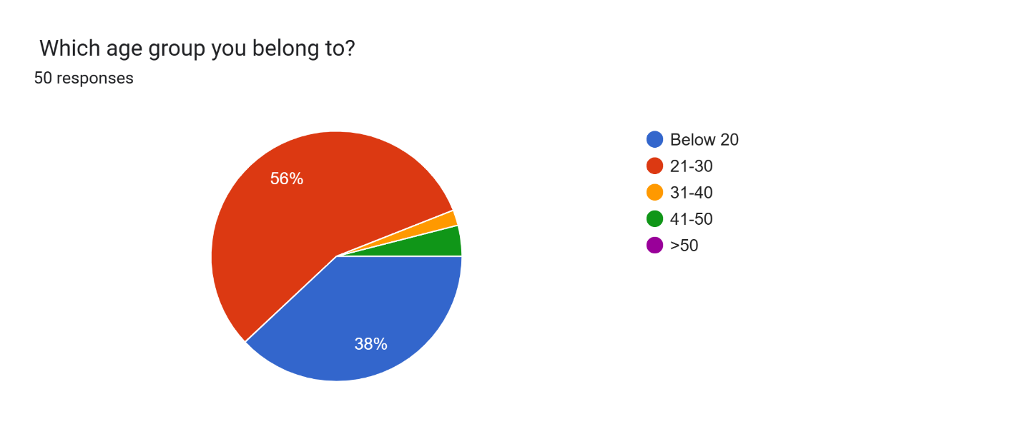

***Interpretation:*** This survey of various age groups shows that 37.3% belong to the age group of below 20, 54.9% belong to the age group between 21-30, 2% belong to the age group between 31-40, 3.9% belong to the age group between 41-50. Therefore, majority of the respondents belong to the age group between 21-30.

Chart: 2

Gender of Respondents

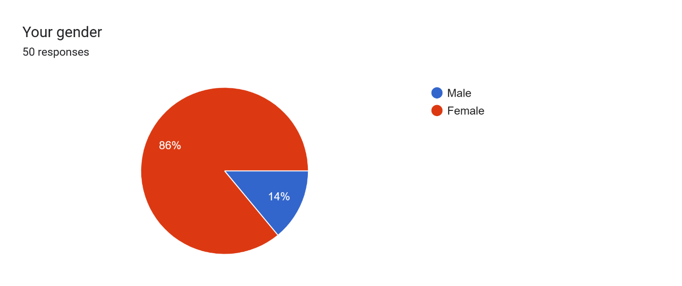

***Interpretation:*** This survey of gender shows that 86.3% of the respondents are female and the rest 13.7% of the respondents are male. So the majority of the respondents are female.

Chart: 3

Occupation of the Respondents

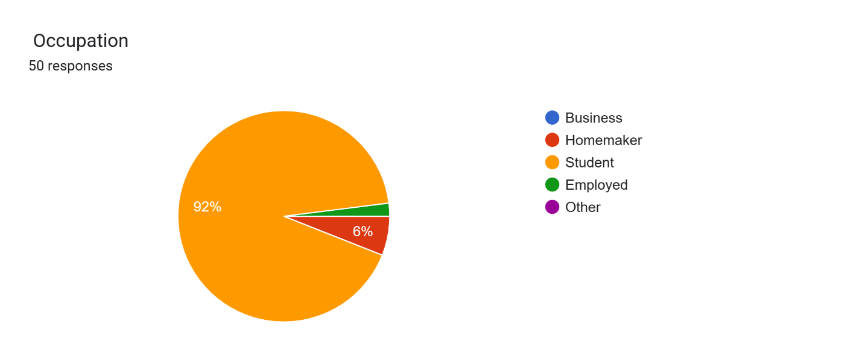

***Intrepretation:*** This survey of occupations shows that out of 51 respondents, 2% are employed, 5.9% are home makers and 92.2% are students. Therefore, the majority of the respondents are students.

Chart: 4

Product Features

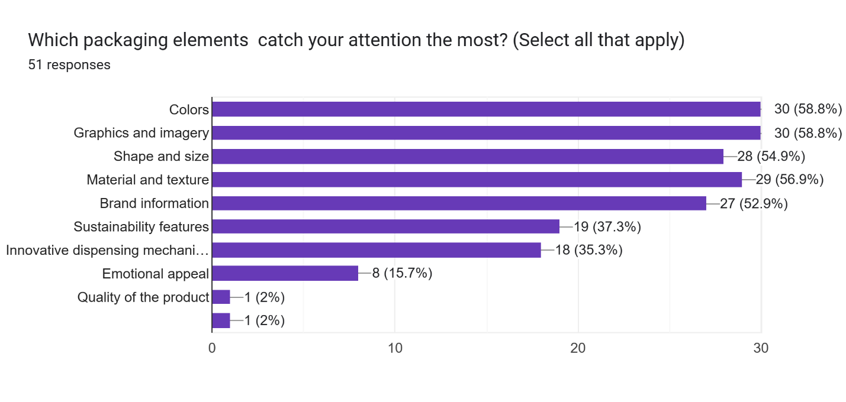

***Interpretation:*** This graph shows that majority of the respondents look for Colours(58.8%), Graphic and Imagery(58.8%), Shape and Size(54.9%), material and texture(56.9%) and Brand Information(52.9%).

Chart: 5

Cosmetic Packaging Attributes

Forms response chart. Question title:  In cosmetic packaging, which attributes do you give importance to?

Rank from 1-4 in which 1 being the highest and 4 being the lowest


. Number of responses: .

***Intrerpretation:***This graph shows survey regarding ranking of attributes. It states that user attractiveness is ranked the highest and protectiveness is ranked the least.

Chart: 6

Frequency of purchase of cosmetic products

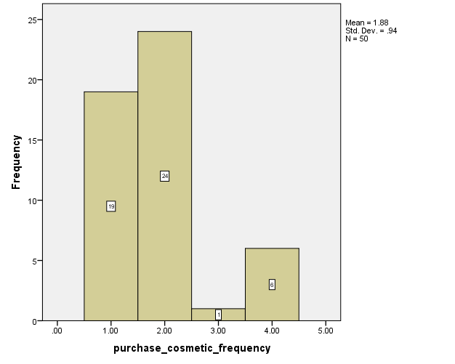

***Interpretation:*** This histogram shows that out of the 50 respondents, 24 respondents(48%) purchase cosmetics on monthly basis and 19 respondents(42%) purchase cosmetics on quaterly basis.

Chart: 7

Impact of packaging of cosmetic products on buying decision

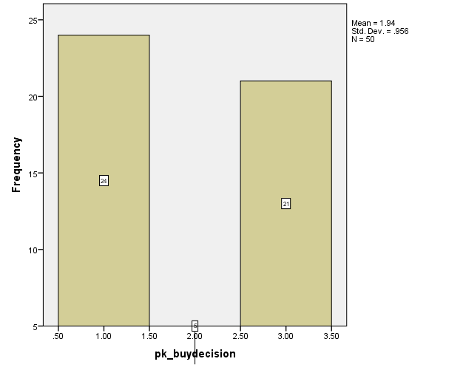

***Interpretation:***The inference that we can draw from this histogram is that the majority of the respondents(48%) says that packaging of the cosmetic product impact their buying decision.

Out of the 50 respondents, 21 respondents (42%) are confused whether to purchase a cosmetic product based on its packaging.

Chart: 8

Importance of packaging material in decision making to purchase cosmetic products

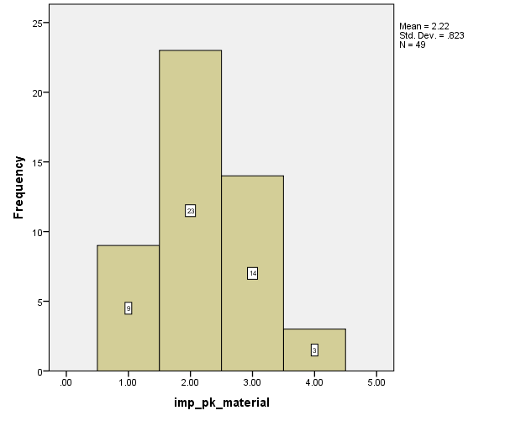

***Interpretation:***This histogram shows that out of the 50 respondents, 23 respondents(46%) give importance to the packaging material used in the cosmetic product

Chart: 9

Appealing of Innovative packaging design in purchase decisions

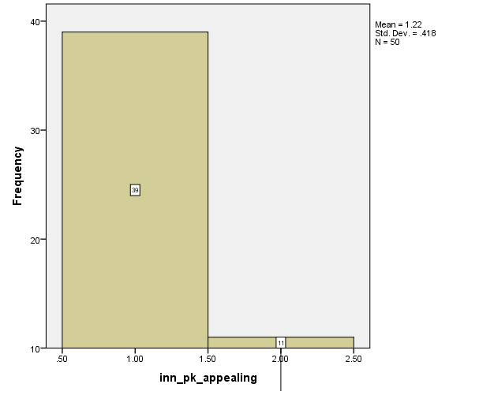

***Interpretation:***From this graph, we can understand that 39 respondents (78%) find innovative packaging appealing enough to purchase a cosmetic product based on its packaging.

Chart: 10

Packaging of a cosmetic product reflects the quality

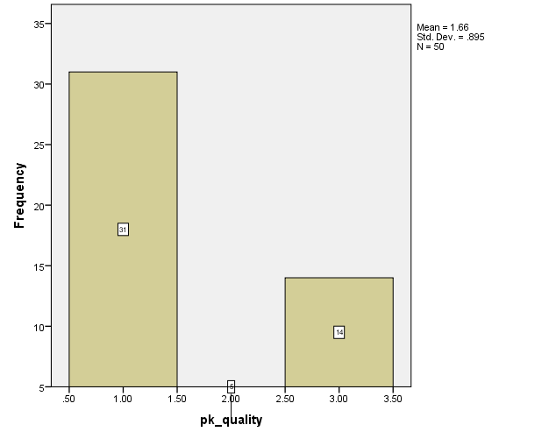

***Interpretation:*** This histogram shows that out of the 50 respondents, 31 respondents (62%) believes that the packaging of the cosmetic product reflects its quality.

Chart: 11

Preference of cosmetic products with eco-friendly packaging

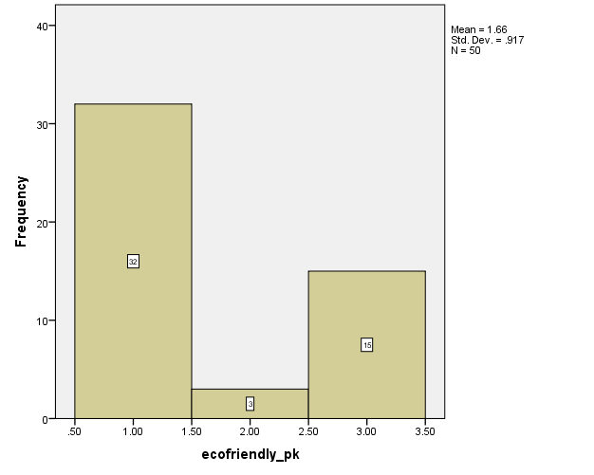

***Interpretation:***This survey shows that out of the 50 respondents, 32 respondents(64%) prefer cosmetic products with ecofriendly packaging

Chart: 12

Important of colour scheme of packaging while purchasing cosmetic product.

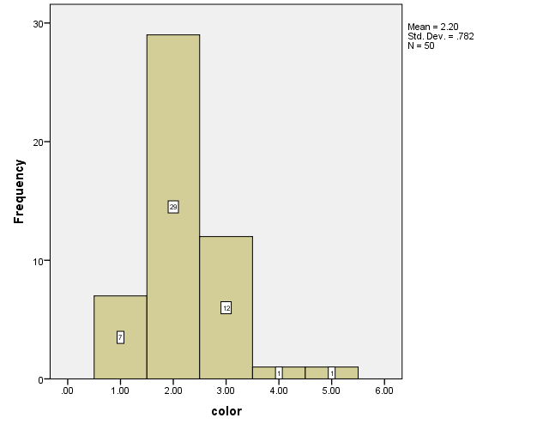

***Interpretation:***This graph shows that out of the 50 respondents, majority of the respondents (58%) find colour as an important factor while purchasing a cosmetic product and the minority of the respondents don’t find colour as an important aspect while purchasing a cosmetic product. From this graph, we can infer that colour is an important aspect when it comes to purchasing a cosmetic product.

Chart: 13

Importance of design of packaging while purchasing cosmetic product.

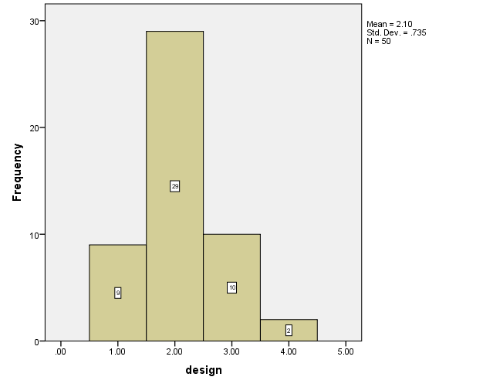

***Interpretation:***This graph shows that out of the 50 respondents, majority of the respondents(58%) find design as an important factor while purchasing a cosmetic product and the minority of the respondents don’t find design as an important aspect while purchasing a cosmetic product. From this graph, we can infer that design is an important factor when it comes to purchasing a cosmetic product.

Chart: 14

Importance of size and shape of packaging while purchasing cosmetic product

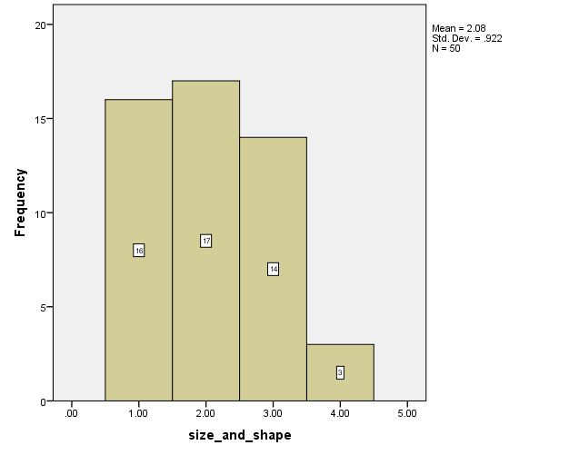

***Interpretation:***This graph shows that out of the 50 respondents, majority of the respondents (66%) find size and shape as an important factor while purchasing a cosmetic product and the minority of the respondents don’t find size and shape as an important aspect while purchasing a cosmetic product. From this graph, we can infer that size and shape is an important factor when it comes to purchasing a cosmetic product.

Chart: 15

Importance of typography of packaging while purchasing cosmetic product

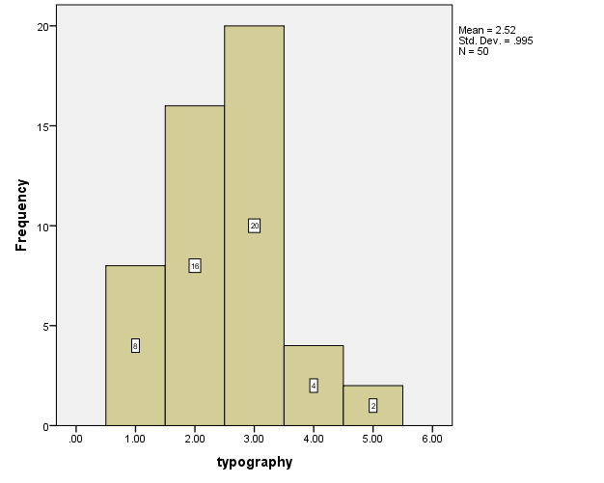

***Interpretation:*** This graph shows that out of the 50 respondents, 48% find typographic as an important factor while purchasing a cosmetic product. From this graph, we can infer that size and shape is an important factor when it comes to purchasing a cosmetic product.

**CHAPTER-4**

**SUMMARY, FINDINGS, CONCLUSION**

**4.1 LIST OF FINDINGS**

Chart 1 to Chart 3 shows the demographic details of the respondents include age, gender and occupation. It was found that the majority of the respondents belonged to the age group of 21-30. The majority of the respondents were female and most of the respondents belonged to the student category.

Chart 4 shows the which all elements of packaging catches eyes of the respondents and it was found out that colour and graphics catches the eye of the respondents the most.

Chart 5 shows that the respondents find attractiveness as the most important attribute and protectiveness as the least important.

Chart 6 shows how frequently respondents purchase cosmetics and it was found out that the majority of respondents purchase cosmetics on monthly basis.

Chart 7 shows that packaging of a cosmetic product impact their purchase decision.

Chart 8 shows that majority of the respondents find packaging material as an important aspect.

Chart 9 shows that the majority of the respondents find innovative packaging as appealing.

Chart 10 shows that majority of the respondents find packaging of the product reflects its quality.

Chart 11 shows that majority of the respondents prefer cosmetics with ecofriendly packaging

From Chart 12 to Chart 15 , it was found out that majority of the respondents find color, graphics, size and typography as an important factor when it comes to purchasing a cosmetic product.

**4.2 SUGGESTIONS**

1. In the future, color psychology will allow cosmetic companies to improve their packaging designs. Consumers may connect with personalization choices, eco-friendly messaging, and colors that promote wellbeing. Bright colors indicate vitality, while simple patterns suggest refinement. Relevance is ensured by seasonal themes and cultural sensitivity.
2. Businesses in the cosmetics sector will be able to use package graphics in the future to create memorable consumer experiences. Adopt cutting-edge graphic designs that visually captivate customers, elicit strong brand tales, and arouse emotions. In the competitive cosmetic market, firms may stand out from the competition, build closer relationships with customers, and propel brand success by giving innovative and functional graphic design top priority in their packaging.
3. Businesses that sell cosmetics may experiment with novel shapes and sizes for their packaging in the future. Take into account small and movable solutions that accommodate hectic lifestyles for consumers who are constantly on the go. Try using unusual shapes to make packaging that stands out and attracts attention on shelves or online. Prioritize eco-friendly packaging designs and materials as well to satisfy environmentally sensitive customers. In the cutthroat cosmetics market, companies may stand out from the competition, satisfy changing consumer demands, and promote brand success by concentrating on size and form innovation.
4. Packaging for cosmetics can be revolutionized in the future by giving priority to sustainable materials. To lessen your influence on the environment, choose eco-friendly solutions like compostable packaging, recyclable materials, and biodegradable plastics. Create innovative products using materials that come from renewable resources, like as bamboo or plant-based plastics, to appeal to environmentally sensitive customers.
5. Cosmetic companies will be able to increase the value of their brands in the future by emphasizing high-quality materials, stylish designs, and cutting-edge features in their packaging. To communicate sophistication and exclusivity, embrace opulent finishes like metallic accents or embossed branding. Use interactive components, such as augmented reality or QR codes, to improve customer interaction and narrative

**4.3 CONCLUSION**

In the competitive business world of today, standing out is essential. It's vital to try out novel marketing strategies in addition to the conventional ones.

In the cosmetic industry, the competition is increasing day by day. In order for them to stand out and be the first to come in the minds of the customers, they must make sure that the first thing that the customer sees is what that attracts them to buy the product which is its packaging.

In the cosmetics market, packaging is essential for branding, consumer interaction, product safety, and hygiene. It helps to guarantee product safety, stop contamination, and maintain the integrity of cosmetic compositions. Furthermore, packaging is essential for communicating positioning, values, and brand identification as well as drawing customers' attention on store shelves and internet platforms. Creative and eye-catching container designs can improve brand identification.

From this study , we came to a conclusion that customers prefer cosmetic products with innovative packaging that catches their eye. Furthermore, it was also understood that colour, graphics and size and shape of the cosmetic product impact the customers brand perception.

**4.4 REFERENCES**

1. Panwar, R. (2004). Role of packaging in consumer buying behavior. International Journal of Management Research and Reviews, 4(1), 55-60.
2. Gaafar, T., & Ra'id, A. (2013). The impact of packaging characteristics on consumer brand preference: A descriptive study. European Journal of Business and Management, 5(12), 23-30.
3. Hassan, Z., & Khan, A. (2009). Impact of packaging characteristics on consumer brand preference: A study of packaged milk brands. International Journal of Business and Management, 4(9), 167-176.
4. Valentya, M., et al. (2014). The role of color on consumer behavior: A comprehensive review. Journal of Retailing and Consumer Services, 21(1), 176-183.
5. Silayoi, P., & Speece, M. (2007). Packaging and purchase decisions: An exploratory study on the impact of involvement level and time pressure. British Food Journal, 109(11), 917-930.
6. Ahmad, N., Billoo, M., & Lakhan, A., (2012). Effect of Product Packaging in Consumer Buying Decision. Journal of Business Strategies, 6(2), 1-10.
7. Raheem, A., R., Ahmad, N., Vishnu, P., & Imamuddin, K., (2014). Role of Packaging and

Labeling on Pakistani Consumers Purchase Decision. European Journal of Scientific Research, 10(16), 464-473.

1. Silayoi, P., & Speece, M., (2007). The importance of packaging attributes: A conjoint analysis approach. European Journal of Marketing, 41(11/12), 1495-1517.
2. Silayoi, P., & Speece, M., (2004). Packaging and Purchase Decisions: An Exploratory Study on the Impact of Involvement Level and Time Pressure. British Food Journal, 106(8), 607-628

**ANNEXURE**

1. Name
2. How old are you?

* Below 20
* 21-30
* 31-40
* 41-50
* >50

1. Gender :

* Male
* Female

1. Occupation :

* Business
* Homemaker
* Student
* Employed
* Other

1. How often do you purchase cosmetic products?

* Yearly
* Quarterly
* Monthly
* Weekly
* Daily

1. Does packaging of cosmetic products impact your buying behaviour?

* Yes
* No

1. How important is the packaging material in your decision to purchase of cosmetic products?
   * Very important
   * Important
   * Neutral
   * Not important
   * Not at all important
2. How likely are you to purchase a cosmetic product with innovative packaging?
   * Very likely
   * Likely
   * Neutral
   * Unlikely
   * Less unlikely
3. Does innovative packaging design make it appealing enough for you to purchase a cosmetic product.
   * Yes
   * No
   * Maybe
4. Which packaging elements catch your attention the most? (Select all that apply)

* Colors
* Graphics and imagery
* Shape and size
* Material and texture
* Brand information
* Sustainability features
* Innovative dispensing mechanism
* Emotional appeal
* Other

1. Do you believe that the packaging of a cosmetic product reflects its quality?

* Yes
* No
* Maybe

1. How much does the packaging influence your perception of the value of a cosmetic product?
   * Significantly
   * Moderately
   * Slightly
   * Not at all
2. In cosmetic packaging, which attributes do you give importance to?

Rank from 1-4 in which 1 being the highest and 4 being the lowest

* + Attractiveness
  + Protectiveness
  + User friendly
  + Convenient size

1. Would you rather buy a cosmetic product in a plain white packaged box or a colorfully designed box that attracts your eye?

* Plain box
* Colorful aesthetic box

1. Do you prefer cosmetic products with ecofriendly packaging?

* Yes
* No

1. Which packaging feature do you find most find appealing?

* Minimalist design
* Luxurious design
* Travel friendly size
* Other

1. Do you think that packaging of a cosmetic product affect your perception of the brand?

* Yes
* No
* Maybe

18. How frequently have you purchased the following products based on its packaging? Moisturiser

* Very frequently
* Often
* Neutral
* Less frequently
* Never

Sunscreen

* Very frequently
* Often
* Neutral
* Less frequently
* Never

Lipstick

* Very frequently
* Often
* Neutral
* Less frequently
* Never

Perfume

* Very frequently
* Often
* Neutral
* Less frequently
* Never

19. How important are the following factors of packaging while making a purchase?

Color of the packaging

* Very important
* Important
* Neutral
* Less important
* Not at all important

Design of the packaging

* Very important
* Important
* Neutral
* Less important
* Not at all important

Size and shape of the packaging

* Very important
* Important
* Neutral
* Less important
* Not at all important

Typographic found in the packaging

* Very important
* Important
* Neutral
* Less important
* Not at all important

20. Does design of a cosmetic product inspire your purchase decision?

* Yes
* No

21. Would you buy a cosmetic product if it had a size and shape different from the normal one?

* Yes
* No
* Maybe