**A STUDY ON CONSUMER PURCHASE INTENTION ON LIMITED EDITION PRODUCTS**

**Project Report**

**Submitted by**

**SANA SANTHOSH (Reg. No. SB21BMS031)**

**Under the guidance of**

**DR. MINU MARY JOSEPH**

**In partial fulfilment of the requirements for award of the degree of**

**Bachelor of Management Studies (International Business)**



**ST. TERESA’S COLLEGE (AUTONOMOUS), ERNAKULAM**

COLLEGE WITH POTENTIAL FOR EXCELLENCE Nationally Re-Accredited at ‘A++’ Level (NAAC Fourth Cycle)

**March 2024**

ST. TERESA’S COLLEGE (AUTONOMOUS), ERNAKULAM, KOCHI – 682011



**CERTIFICATE**

*This is to certify that the project report entitled, “A Study on Investigating the influential factors behind limited edition product preference”, has been successfully completed by sana Santhosh Reg. No.SB21BMS031 in partial fulfilment of the requirements for the award of the Degree of Bachelor of Management Studies in International Business under my guidance during the academic years 2021-2024.*

**DECLARATION**

*I, SANA SANTHOSH, Reg. No.SB21BMS031, hereby declare that this project work entitled “A Study on investigating the influential factors behind limited edition product preference” is my original work. I further declare that this report is based on the information collected by me and has not previously been submitted to any other university or academic body.*

**ACKNOWLEDGEMENT**

I would like to place on Project Report my debt of gratitude to those who helped me in the preparation of this project.

I thank Dr Alphonsa Vijaya Joseph, Principal and Dr. Sr.Vineetha, Director of St. Teresa’s College, Ernakulam for permitting me to take up this opportunity of doing an in-depth study on investigating the influential factors behind limited edition product preference .

I take this opportunity to express my deep sense of gratitude and wholehearted thanks to Ms. DR. Anu Raj, Head of the department of Management Studies for guiding me in all stages of this project, without whom this project would have been a distant reality.

I also thank my guide, Ms. Minu Mary Joseph for her constant support throughout the project.

I would also like to express my heartfelt gratitude to DR Sunitha TRfor her immense support and guidance throughout the entire project.

Last but not the least; I extend my heartfelt thanks to my family and friends for their valuable and proficient guidance and enormous support bestowed during the tenure of this exertion.

SANA SANTHOSH

**EXECUTIVE SUMMARY**

The study investigates what influences consumers' preferences for limited-edition goods. Customers are drawn to limited edition products because of their uniqueness and rarity, making them a distinct market niche. Marketers looking to profit from this trend must comprehend the elements influencing consumer demand for these products. A thorough literature review and empirical analysis have produced a number of important conclusions. First, one important factor influencing consumer preference is the perceived worth of limited-edition products. Due to their perceived collectability and uniqueness, limited edition products might command a higher price from customers. Second, consumers' preferences for limited edition products are significantly influenced by brand Trust. Limited edition products associated with a brand are more likely to be purchased by brand loyal consumers. Third, a key element influencing consumer preference for limited edition products is status signalling and social motivation. These things are frequently bought by customers to express their social standing or to identify with a specific social group. Finally, two key components that add to the allure of limited-edition products are scarcity and exclusivity. Customers feel pressured to decide about what to buy immediately because of the limited supply of these products. Several suggestions are made for marketers considering these findings. First, highlighting the special qualities and limited availability of limited-edition goods helps raise consumer perceptions of their worth. Second, boosting consumer interest in limited edition products can be achieved by utilizing brand loyalty through focused marketing initiatives. Finally, limited edition products might become more appealing by evoking a feeling of scarcity and exclusivity through exclusive distribution channels or limited production runs. In conclusion, marketers hoping to profit from this expanding trend must comprehend the key elements influencing consumers' demand for limited edition products. Marketers can create compelling methods to entice customers and boost sales of limited-edition products by concentrating on perceived value, brand loyalty, social impact, and scarcity.

**TABLE OF CONTENTS**

|  |  |  |
| --- | --- | --- |
| **Chapter No** | **Title** | **Page No** |
|  | **Acknowledgement** |  |
|  | **Executive Summary** |  |
| **One** | **Introduction** |  |
| Introduction to Study |  |
| Statement of Problem |  |
| Literature Review |  |
| Significance of the Study |  |
| Scope of Study |  |
| Objectives of Study |  |
| Research Hypothesis |  |
| Conceptual Model |  |
| Research Methodology |  |
| Limitation to Study |  |
| **Two** | **Industry profile, company and product profile** |  |
| Industry profile |  |
| **Three** | **Data analysis and interpretation** |  |
| **Four** | **Summary of findings, suggestions and conclusions** |  |

**CHAPTER-1**

**INTRODUCTION**

**1.1 INTRODUCTION TO STUDY**

In the ever-changing landscape of marketing, a successful campaign's ability to connect with its target audience depends on an understanding of consumer behaviour. The attraction of limited editions is one intriguing component of customer purchase intention that marketers have been capitalizing on for a long time. The psychology of limited editions has a significant influence on consumer buy intention for everything from high-end fashion goods to computer gadgets, apparel, food, and textiles. Some clients become curious in an item and feel compelled to purchase it right away due to the perception of scarcity.

Products labelled as "limited edition" take advantage of consumer needs in this manner (Gierl et al., Citation2008). Previously, limited-edition collectors' products were exclusive to specific product categories, such luxury cars. Because of the growing consumer desire for self-expression, these components are increasingly being extended to commonplace home objects. The apparel industry is one of these industries that uses limited-edition marketing to its advantage. Similarly, Lynn (Citation1992) proposed the S-E-D (Scarcity–Expensiveness–Desirability) model, which posits that people understand why scarcity products are desired by assuming that people believe the nature and status of these products to be superior and that their cost is higher.

The study by Snyder and Frocking (Citation 1980), which includes their theory of uniqueness, makes the desire more understandable by implying that individuals must hold onto their feeling of uniqueness. The intention to buy is motivated by such a need (Belk et al., Citation2003). Customers anticipate brands or products to seem more unique than the actual product (Edom & Lee, Citation 2012). Marketers aim to alter the product scarcity in order to meet this need by offering limited-edition products (Balachander & Stock, Citation 2009). Limited-edition product (LEP) sales are generally positively impacted by scarcity appeals (Aggarwal et al., Citation2011). For example, limited-edition products are sometimes released as samples prior to the main product's launch. After confirming the market's overwhelming response, luxury company Burberry re-released a limited-edition keyring that had sold out in just one day. Furthermore, the "re-selling" market will drive up prices when there is a relatively small supply, which raises the value of the brand.

Many companies release limited-edition or special products to increase sales during a particular campaign or occasion. But very few highlight the most crucial aspect of them—that is, that they are limited—which is clear from their name. In order to save expenses, FMCG manufacturers typically do not restrict the production of these variants. They avoid giving customers the impression that this is "something that is hard to get" or that this is a special chance that should not be passed up. The phrase "the scarcity effect" refers to this notion. Customers are subject to a cognitive bias known as the "scarcity effect," which makes them value rare goods more highly than abundant ones. These rare things catch our attention and hence become more appealing right away compared to an abundant offering. Price is frequently a crucial component for luxury brands to communicate their distinctiveness.

One reason that drives demand for Non-Fungible Tokens (NFTs) nowadays is somewhat analogous to that of luxury product limited editions. They provide the product's purchaser with the joy of possessing something that not everyone can. We refer to this component as "social currency." Pierre Bourdieu first introduced this idea in his theory of "social capital," and Jonah Berger later refined it with more recent instances in his book Contagious. The power people acquire from possessing goods or information that few others do, or from belonging to communities that few others can access, is known as social currency. It makes them feel important and acknowledged. Limited edition products are used by brands to test consumer reaction to new flavours and features as well as to create a product that offers consumers a sense of exclusivity.

**1.2 STATEMENT OF PROBLEM**

The issue that the researcher is attempting to address here is whether spending money on the production of limited-edition products can gain more popularity to the brand and attract high end consumers. The psychological factors that influencing customers to buy these limited-edition products must be evaluated carefully. Often firms are unaware about those factors, which make them inefficient in evaluating customers perception to limited edition products ultimately reflecting in loosing potential customers or reduced sales of these products. As a result, researcher aims to understand the factors that makes the customer progress towards purchase intention of limited-edition products.

**The Scarcity Principle**

At the heart of limited editions lies the scarcity principle, a psychological phenomenon that suggests people perceive scarce items as more valuable and desirable. This perception is rooted in evolutionary psychology—our ancestors had to compete for limited resources, so the drive to acquire scarce items became ingrained in our behaviour. Marketers play on this primal urge by creating limited edition products that trigger a sense of urgency and exclusivity.

**Creating Urgency**

Limited editions evoke a fear of missing out (FOMO) among consumers. When a product is available in limited quantities, consumers often feel a heightened sense of urgency to make a purchase decision quickly. This urgency can be strategically amplified through marketing techniques like countdown timers, exclusive pre-order windows, and "while supplies last" messaging. By capitalizing on FOMO, marketers can drive faster purchase decisions and higher conversion rates.

Humans have a natural inclination to want to belong to exclusive groups. Limited editions tap into this desire by offering consumers the chance to own something unique, standing out from the crowd. Whether it's a limited-edition sneaker collaboration or a luxury handbag with a numbered plaque, the exclusivity associated with these products creates a sense of pride among consumers. Marketers can leverage this by using storytelling to emphasize the craftsmanship, rarity, and the story behind each limited-edition item.

**1.3 LITERATURE REVIEW**

**1.3.1 PURCHASE INTENTION**

A key component of the larger study of consumer behaviour is consumer attitude, which summarizes people's feelings, opinions, and assessments about goods, companies, or services. It is a driving force behind the decisions and actions of consumers, influencing their cognitive, emotive, and behavioural aspects. The affective component captures people's sentiments and emotional reactions to a specific thing, whereas the cognitive facet deals with people's knowledge and opinions about it. The observable behaviours or intents about the product or brand are the manifestation of the behavioural component.

Numerous factors, such as individual experiences, social interactions, cultural backgrounds, and marketing communications, shape consumer opinions. Positive attitudes have a significant influence on customer decision-making since they are frequently translated into product choice, brand loyalty, and repeat business.

Companies that are interested in building great relationships with their audience need to be aware of the attitudes that are currently held and take deliberate steps to impact and match those attitudes with their brand story, values, and products. Companies navigating the complex terrain of consumer attitudes must constantly monitor and adjust to changing consumer emotions since attitudes are dynamic and subject to change.

An important stage in the decision-making process for consumers is purchase intention, which comes before actual purchasing behaviour. It represents a person's stated propensity or desire to purchase a specific good or service in the future. A complex interaction of situational, social, and psychological elements shapes this aim. Purchase intentions are influenced by a variety of factors, including perceived product value, brand reputation, marketing communications, and individual requirements.

Companies use this information to better position their products, adjust their marketing tactics, and remove any obstacles that might stand in the way of customers converting. It's crucial to remember that purchasing intention and actual action are not necessarily the same thing because circumstances or outside influences can change.

Companies may remain flexible in the constantly changing world of consumer preferences and market trends by routinely evaluating and responding to changes in the dynamics of purchase intention.

**1.3.2 SCARCITY VALUE**

Consumers expect goods or brands to feel more individual than the product itself (Edom & Lee, 2012). Limited-edition products are the commodities that are intended by marketers to change the product scarcity to satisfy this demand (Balachander & Stock, 2009). Generally, scarcity appeals can have a positive impact on the sales of limited-edition products (LEP) (Aggarwal et al., 2011). Specifically, the study by L. Wu and Lee (2016) contends that LEPs can be helpful when they are purchased specifically for personal use, rather than for others (as presents, for instance). Balachander and Stock (2009) confirm that the overall profit of a company’s product portfolio may be increased once LEPs have been introduced into it. Snyder and Frocking (1977) claim that, by possessing something that others do not have, customers seek to show that their individuality or identity is distinct from others. If many people use a product and it becomes popular, consumers want another product. This market psychology, which is referred to as the “snob effect”, is the reason for many enterprises to use limited-edition in commercialisation. For instance, before the launch of the main product, there are cases of limited- edition products released as samples. A limited-edition keyring by Burberry, a luxury brand, has been sold out in only one day and then re-released it since that explosive response from the market has been confirmed. In addition, when there is a relatively limited supply, the prices will increase through the “re-selling” market which then increases brand value. Scarcity has played a major strategic role in advertising over the decades.

Scarcity is based on the principle of reactance, which states that when a product is in short supply, people respond by placing a higher psychological value on perceived scarce products, leading them to engage in behaviours such as having a sense of urgency to purchase these products in order to regain their previously lost freedom (S. S. Bream, 1981; J. W. Bream, 1966). Scarcity means that the value of goods is favourably linked to demand and negatively linked to supply (Kim & Beak, 2014). Scarcity induces a sudden purchasing urgency with fewer scanning, shorter buying intervals and more purchasing amounts (Aggarwal et al., 2011; Latter et al., 2010). Product scarcity may be divided into two categories: demand-induced scarcity or supply-induced scarcity (Roy & Sharma,2015). Increasing customer demand causes the product supply to outgrow the available inventory, whereas decreasing an inventory causes consumer demand to fail to match the available invent-tory (i.e. a supply-demand mismatch). When demand is high, perceived product value increases over supply-induced scarcity (Weichel et al., 1975). Consumers’ needs for conformity and demand- induced scarcity are inextricably linked which corresponds with conformity theory (Bergheim, 1994), and between supply-induced scarcity and consumer need for uniqueness, which corresponds to the commodity theory (Brock, 1968; Shi et al., 2020). Research by Girl and

Hutt (2010) and Roy and Sharma (2015) contend that supply-induced scarcity is more vulnerable to consumers who have a higher need for uniqueness. Demand-induced scarcity, on the other hand, is more effective for people who have a higher desire for conformity (Ku et al., 2013; Van Herpes et al., 2009). Scarcity reflects a product’s availability and people assume that something less common is more precious (Coalmine, 2008). The psychological impact of scarcity is tremendous and the fear of complete consumption of the commodity will increase its relative value (Lynn, 1991). In their experiment, Aggarwal, and Vaidya Nathan (2003) proved that restricting promotional offer can accelerate its impact on buying intention. In such shortages, the testers were also more willing to purchase and were less likely to look any further for a better price. Finally, the product’s scarcity raises the psychological importance of the product ascribed by customers and influences the motives of purchases. By analysing the shortage of goods and the knowledge of exclusiveness, Kelan (1953) assumed that customers who knew about the shortage of this item were twice as likely to purchase this item as consumers who did not. Scarcity thus directly impacts customer habits. Suri and Monroe (2003) suggest that the products’ shortages facilitate the consumption and disrupts consumers’ capacity to process information through analysis. Therefore, increasingly scarce goods cause impulsive behaviour by adapting the psychology of the consumers.

**1.3.3 UNIQUENESS VALUE**

Uniqueness is the only different attribute which contrasts with other certain properties of an object, and it also implies a quality that is not uniform (Chee et al., 2020). The consumer need for uniqueness is closely associated with commodity theory (Brock, 1968; Frocking, 1970). This is because consumers generally require a sense of being somewhat unique (Belk, 1988; Snyder & Frocking, 1980), and they discern a better value in the items which may characterise their uniqueness. By purchasing the uniqueness commodity, the customer is showing a special desire to communicate their personality and individuality differently from others. The demands of customers for uniqueness encompasses all the ways in which they can feel distinctive. Snyder (1992) states that, as goods are an essential source of self-definition in western society, that is because scarce goods are a way of deciding one’s particularity when there is an active desire for unique-ness. Research which combine commodity scarcity (low versus high) with a need for individuality (low versus high) have generally created a relationship in which the desire for uniqueness is particularly drawn to scarce goods (Lynn, 1991). Items which could further intensify this expected relationship and their significance for the American society, including a potential loop of customer searches for new and unique goods, are investigated. In contrast to other conceptual explications, there is a need for a uniqueness explanation for the assessment of scarce resources. Previous experiments have shown that a perceived shortage can improve the attractiveness of an item (Jung & Cellars, 2004; Lynn, 1991). Product scarcity satisfies this need by allowing consumers to possess items that others do not; consequently, those with a strong desire for uniqueness demonstrate a higher propensity for scarce items (Lynn, 1991; Wu et al., 2012). Since the heuristic of shortage is great and is used to define one’s individuality based on the demand for uniqueness principle (Snyder & Frocking, 1980). Lynn (1991) promotes this effect, which advertisers use to create promotional campaigns that appeal to the ability of customers to be distinctive (Lynn & Harris, 1997; Snyder, 1992). Amado’s and Jain (2005) discovered that, while the consumer desire for uniqueness results in higher product prices and thus higher profits, the consumer desire for conformity results in lower product prices and lower profits. For example, while consumers with a greater need for uniqueness (than for conformity) are more willing to adopt radical new products, scarcity can have the opposite effect, thus increasing their willingness to adopt incrementally new products (Ma et al., 2014). When buyers purchase an item to meet their need for individuality, the valuation of the item also rises as the expected uniqueness improves. That is, customers will appreciate a commodity less when more people have it. Snyder and Frocking (1980) describe motivation further by suggesting that individuals have a social preference to preserve a feeling of uniqueness. Such an urge drives the consumption’s power (Belk et al., 2003). Growth and McDaniel (1993) claim that the product’s specific and unique perception is tied to its price. They indicate that the uniqueness of a commodity helps it to order a comparatively higher price than most of the comparable goods. The study by Amado’s and Jain Ha, Cogent Business & Management (2021 (2005) endorses the same argument that the demand to accomplish uniqueness leads to higher prices in the case of a duopoly. Their findings reveal that, when a commodity price decreases, more consumers are interested, and the product is thus less snob attractive. Consequently, increased uniqueness could also contribute to higher values, which would result in extra costs. Furthermore, consumers who have a higher need for uniqueness may be less willing to share information with others to protect their own uniqueness (Jang et al., 2015). Thus, it is reasonable to formulate the following hypotheses:

**1.3.4 BRAND TRUST**

The perceived value of an item is assessed based on the usefulness of that product for the consumer (Zeithaml, 1988). In disparate situations, the customers perceive distinction through one product (Cooper, 1988), so during the process of buying, the consumers appreciate that product, and this forms the purchasing behaviour (Patterson & Spring, 1997). a phenomenon in people who like shoes where they purchase the information about selling limited-edition shoes or buy activities using information such as the sale that is not pre- announced as the “sneaker game”, and they are fond of both the buying action and the purchasing itself (Chee et al., 2020). Schindler (1998) once stated that gaining the tacit buy competition is the method for seeking compensation from the economy and psychology. Specifically, with the use of other alternatives, consumers can get what they’re after even though they cannot successfully buy the limited- edition product for themselves to use (See, 2017). However, customers who collect or resell them cannot substitute these items for other items. Consequently, the intention to buy is greater than the customer intention relative to the perceived worth. Sheath, Newman and Gross (1991) suggested that the process of buying evaluation is affected by a consumer’s value perception. Sweeney and Souter (2001) researched the perceived value in many dimensions, concentrating on the evaluation of the item or the product overall rather than one single manner in the relationship between the customer’s attentiveness and the risk of this item. J. Kim and Cho (2017) stated that the item’s high perceived worth impacts the brand trust of customers. The aim of this study is to explore the influence of a customer’s perception of value on brand trust. It is important to evaluate the value perception as a parameter of purchasing decision (Sweeney & Souter, 2001)

Following J. C. Anderson and Nares (1990), brand trust is built based on mutual involvement and actions, and it is also an essential principle for good relations between a firm and its clients. S. H. Choi (2012) described trust as the belief that the customers’ preferred choices would bring them the best advantages. Besides, brand trust raises the probability that clients are willing to select their goods (Eidem & Swati, 2004). Even though there is a shortage of logic in the transactional relations, sustaining and exchanging repeatedly establishes long-term outgoing relationships between vendors and customers (E. H. Kim, 2005). According to J. L. Asker (1997), purchase intention is an individual, aware attempt to buy a brand item and to represent a purchase plan for the customer. The purchase intention is strongly linked to the real buying behaviour and is a potential measure and the consumer’s intention to contribute to the buying habits (Janzen & Fischbein, 1977; Davidson & Jacquard, 1979). In addition, the buying habit influences the efforts of consumers, and it is necessary to estimate them (Y. S. Kim, 2018).

With the focus on developing long-term relations, trust has become a key element in the growth.

of the marketing philosophy (Dwyer et al., 1987; Morgan & Hunt, 1994) and the practical philosophy (Der ouzos et al., 1989). A customer who has faith in a brand is more engaged in—and wants to continue in a relationship with—the brand (E. Anderson & waits, 1989; Morgan & Hunt, 1994). In addition, trust is regarded as an indicator of the buying habits (Downey & Cannon, 1997). K. S. Kim et al. (2004) reported that brand trust typically influences the intention to buy. Brand trust will have a positive impact on the buying intention, lowering the risk of confusion and thus contributing to the purchases (Kim & Kim, 2017).

**1.3.5 SOCIAL MOTIVATION**

Through products, consumers can improve their social consciousness, and these social values lead to a boost in their standing among others by buying or using those items (Hurl & Han, 2009). J. H. Lee and I’m (2008) observed that the intentions of customers for buying were greater with the growing expectations of positive social value and lower purchasing intentions with the diminished perceptions of social values. Thus, the social value must also be carefully considered to grasp the actions of buyers to purchase goods (Kang et al., 2016). D. A. Asker (1991) suggested that the social value positively impacts brand equity, especially the brand trust. In his research, the social value of a product adds the value to the brand equity by increasing brand trust for its participating consumers The expense, time, commitment, and both intrinsic and extrinsic qualities of the consumer when buying goods are factors to determine economic value (Zeithaml, 1988). The proportion between the payable cost and the actual cost of a product is the economic value (Sweeney & Souter, 2001). Owing to retail shortage, LES have a greater economic value than actual value (Jug & Koo, 2014).

Economic value was assumed to be the dominant factor of consumer preference in the theoretical context of perceived value developed by Sheath, Newman, and Gross (1991). While the choice to use filtered or unfiltered smoke, for example, is dominated by practical and social importance, the economic value was essential consideration to the smoking decision. Depending on the judgment stage (e.g., purchase/not buy or buy brand A/ brand B), the various measure-mints of the valuation can be apparent. Webster (2000) also discussed the impact of perceived. Ha, Cogent Business & Management (2021

**1.4 SIGNIFICANCE**

Limited edition products often evoke feelings of exclusivity and scarcity. Consumers are attracted to the idea of owning something with unique features, designs and that are rare. Understanding why consumers are attracted to limited edition products provides valuable insights into consumer behaviour. It helps companies that make limited edition products understand the psychological drivers and preferences that motivate purchasing decisions, which can inform marketing strategies and product development efforts. This study is important as it helps understand characteristics and motivations of consumers interested in these products.

* 1. **OBJECTIVES**

The objectives of studying consumer purchase intention on limited edition products are multi-faceted and aim to provide valuable insights into consumer behaviour in this unique market context. Firstly, the research seeks to identify the key factors influencing consumers' decisions to purchase limited edition items, exploring elements such as exclusivity, scarcity, and perceived value. Secondly, to study how brand trust, social motivation, and scarcity interact to shape consumers' perceptions, attitudes, and behaviours towards limited edition products.

* 1. **SCOPE**

A study focusing on consumer purchase intention regarding limited edition products entails examining the unique attributes and marketing strategies associated with these products. It involves understanding consumer behaviour factors such as perceptions of scarcity, exclusivity appeal, brand loyalty, and the influence of marketing tactics on purchase decisions. The scope extends to analysing product attributes, brand image, pricing strategies, and promotional efforts aimed at creating desirability and urgency among consumers. Market segmentation based on consumer attitudes and preferences, along with ethical considerations related to marketing practices and sustainability, are also integral parts of the study. Ultimately, the goal is to offer strategic insights for marketers to optimize limited edition product strategies, enhance brand engagement, and foster long-term consumer relationships in a competitive marketplace.

**1.7 CONCEPTUAL MODEL**

BRAND TRUST

SOCIAL MOTIVATION

PURCHASE INTENTION

ATTITUDE

SCARCITY VALUE

UNIQUENESS VALUE

**1.8 RESEARCH HYPOTHESIS**

H1: There is a relationship between uniqueness of the product and purchase of limited-edition products.

H2: There is a relationship between consumer’s social motivation and purchase of limited-edition products.

H3: There is relationship between brand trust and purchase of limited-edition products.

**1.9 RESEARCH METHODOLOGY**

**1.9. Population**

A population is a group of elements that share some or all their characteristics. The population size is determined by the number of elements in the population. In this survey, the population comprises of the customers in the who purchases limited edition products.

**1.9.2Sampling Technique**

There are two types of sampling techniques: probability sampling techniques and non-probability sampling techniques. Randomization is used in probability sampling techniques to ensure that every element of the population has an equal chance of being represented in the selected sample. Probability sampling techniques include simple random, systematic, stratified random, cluster, and multistage sampling. The non-probability sampling technique is more dependent on the researcher's ability to select sample elements. The results of this type of sampling may be accused of bias, and extrapolation to the population may be extremely difficult. Non-probability sampling techniques include convenience, purposive, quota, and snowball sampling. The researcher has used convenience sampling technique to collect data on time and to avoid low response rate.

**1.9.3Sample Size**

Given the constraints of time and resources, the sample size chosen is 53 respondents. Questionnaires were distributed to respondents via social media platforms like WhatsApp, and enough time was allowed for them to complete them to reduce sampling errors.

**1.9.4 Data Collection**

Data collection or data gathering is the process of gathering and measuring information on targeted variables in an established system, which then enables one to answer relevant questions and evaluate outcomes. The process of data collection typically involves defining the 12-research question or problem, selecting the appropriate data sources and methods, designing the data collection instruments, collecting the data, and organizing and analysing the data. Effective data collection requires careful planning, attention to detail, and a clear understanding of the research objectives. It is important to ensure that the data collected is accurate, reliable, and relevant to the research question. Additionally, it is essential to follow ethical guidelines for data collection, such as obtaining informed consent from research participants and protecting their privacy and confidentiality. When it comes to data collection, there are two methods that are commonly used by researchers. These methods are classified as primary data collection methods and secondary data collection methods. Data collection methods for primary data include observation, interviews, questionnaires, case studies, projective techniques, and schedules. Secondary data is data that already exists and can be acquired through published or unpublished sources. Published sources include government publications, public records, bank records, and so on. Unpublished data sources encompass letters, diaries, unpublished biographies, and work, and so on. The tool used by researcher for the primary data collection to understand impact of scent marketing on impulsive buying behaviour was through questionnaires. Secondary data in research was used to find about the industry profile. It was also used for introduction of the study and literature review. All secondary data related information has been collected from previously done research papers, and credible internet websites.

**1.9.5 Tools used for data collection.**

The questionnaire is carefully designed by the researcher to meet the research requirements. The questionnaire is divided into three sections. The first section concentrates on the respondent's demographics. The second section includes questions about respondents awareness about limited edition product and the third section includes questions about factors that influences consumers to purchase LEP such as social motivation, brand trust, scarcity value and uniqueness and other variables of the study. The questionnaire mainly consists of Likert scales ranging between 1 – Strongly agree, 2 –agree, 3 – Neutral, 4 – Disagree, 5 – Strongly Disagree. A rating scale has been used to measure Impulsive buying behaviour called Consumer impulsiveness scale. There is also use of ratio and nominal scales in the questionnaire.

**1.9.6 Data Analysis Techniques**

Entire data has been analysed using SPSS (version 20) software. The tools used for analysis in SPSS for this research are as follows.

:1. regression

**1.10 LIMITATIONS OF STUDY**

I. One major limitation was the time constraints.

ii. Convincing people to fill in the questionnaire was also an issue.

iii. Also, another limitation faced by the respondent was getting surveys from the few customers without hampering their shopping experience.

iv. One of the major constraints – Findings of the survey are based on the assumptions that the respondent has given correct response

**CHAPTER 2**

**INDUSTRY, COMPANY, AND PRODUCT PROFILE**

**2.1 MARKETING STRATEGY**

Marketing strategy is a set of strategic decisions and actions that guide a business in achieving its marketing objectives and goals. It is a series of actions that promote a product or a service, attract customers, drive sales, and generate revenue. One of the most important aspects of a marketing strategy is understanding your target market. You need to understand who your target market is, what they need and want, and how you can provide them with a better product or service than your competitors.

Once you have a good understanding of your target market and your value proposition, it’s time to figure out how you can reach and engage your customers. You can do this by choosing the best marketing channels for your target audience based on where they are most likely to find you. Beyond reaching your target audience, your marketing strategy should also help you retain your customers and encourage them to keep coming back. This includes things like loyalty programs, targeted marketing campaigns, personalized marketing, and great customer service.

Pricing is another key part of your marketing strategy. Pricing strategies can differ depending on the value of your product, the competition, and how much your target market is willing to pay for it. It’s important to find the right pricing strategy to maximize your profits while staying competitive in your market. All in all, a well-thought-out marketing plan is the foundation of any successful business. It sets the tone for your marketing efforts, makes sure you’re getting the most out of your resources, and helps you build your brand and customer base in the long run.

**2.1.2 COMPONENTS OF MARKETING STRATEGY**

*1. Market research*: It is essential to carry out in-depth market research prior to creating a marketing plan. This entails researching the market, comprehending rivals, and seeing patterns and business prospects. Businesses can make well-informed decisions regarding their target market, messaging, and positioning with the use of market research.

*2. Target Audience*: Identifying your target market is necessary to develop a successful marketing plan. This entails dividing the market into segments according to psychographics, behaviour, and demography. Businesses can better connect with potential customers by customizing their marketing efforts to their target audience.

*3.Value Proposition*: A value proposition is an explanation of the special advantages of a good or service and the reasons it outperforms its rivals. A company that has a great value proposition can stand out from the competition and persuade customers to buy their product.

*4.Marketing Mix*: Often referred to as the 4Ps (Product, Price, Place, and Promotion), the marketing mix lists the specific elements that make up a marketing plan. It involves choices about the attributes of the product, price plans, methods of distribution, and marketing initiatives.

*5.Branding*: Developing a unique identity for a company or product is a crucial component of branding, which is a marketing strategy. Long-term success can be fuelled by developing consumer loyalty and recognition through a great brand.

*6.Digital Marketing*: As we live in a digital age, any marketing strategy must include digital marketing. This covers techniques that assist firms contact their intended audience online, like email marketing, content marketing, social media marketing, and search engine

*7.Metrics and Analytics*: Monitoring key performance indicators (KPIs) and conducting data analysis are crucial to determining how successful a marketing plan is. Metrics like return on investment (ROI), conversion rate, and cost of customer acquisition can assist firms in making data-driven decisions and optimizing their marketing campaigns over time

.

*8.Optimization and Adaptation*: A marketing plan should be flexible enough to adjust to shifting consumer demands and market condition

**2.1.3 MARKETING STRATEGIES IN INDIA**

Marketing strategy in India are diverse and dynamic, influenced by the country's unique cultural, economic, and social factors. Here are some key aspects to consider when developing a marketing strategy for the Indian market.

*1.Recognizing Diversity*: India is a multilingual, multicultural nation with a vast array of customs and languages. This diversity should be considered in any successful marketing plan in India, and campaigns and messaging should be customized to appeal to various regional and ethnic groups.

*2. Digital transition*: With so many people using smartphones to access the internet, India has experienced a major digital transition in recent years. Digital marketing platforms, including mobile apps, social media, and search engines, are essential for connecting with Indian customers.

*3. Localization*: In the Indian market, success hinges on effective localization. This entails modifying product offerings, advertising, and message to account for regional quirks and preferences as well as tastes.

*4.Value for Money*: Indian customers are highly sensitive to price and frequently seek out value for their money. Using promotions and competitive pricing might be a successful tactic to draw in Indian customers.

*5.Relationship Building*: In India, establishing enduring bonds with clients is crucial. Building trust and loyalty can be facilitated by offering superior customer service, interacting with clients through loyalty programs, and sending them tailored messages.

*6.Conventional Marketing*: Radio, print, and television are still important traditional marketing channels for reaching Indian consumers, particularly in rural areas, even though digital marketing is becoming more and more important.

**2.1.4 MARKETING STRATEGY IN LIMITED EDITION PRODUCTS**

Marketing limited edition goods requires a calculated strategy to in still in customers a sense of urgency and exclusivity. Emphasizing the product's scarcity is important. To do this, use phrases like "Limited Edition" or "Exclusive Release," which indicate how limited the supply is. Because of the perceived scarcity, buyers may feel pressured to act quickly to secure a purchase before the product runs out. Making the limited-edition product special and distinct from your standard offerings is another crucial tactic. This could entail a distinctive style, hue, packaging, or extra elements that set the product apart. Offering something unique and distinctive will draw in more customers and increase attention. Marketing limited edition products also requires targeted promotion. Marketing limited edition goods requires a calculated strategy to instil in customers a sense of urgency and exclusivity. Emphasizing the product's scarcity is important. To do this, use phrases like "Limited Edition" or "Exclusive Release," which indicate how limited the supply is. Because of the perceived scarcity, buyers may feel pressured to act quickly to secure a purchase before the product runs out. Making the limited-edition product special and distinct from your standard offerings is another crucial tactic. This could entail a distinctive style, hue, packaging, or extra elements that set the product apart. Offering something unique and distinctive will draw in more customers and increase attention. Marketing limited edition products also requires targeted promotion. Another crucial component of marketing limited edition goods is storytelling. You can establish a stronger bond with customers by telling them the product's backstory, which may include the reasons for its limited availability, the process of development, or the inspiration behind it. Customers are more inclined to buy a product if they sense an emotional connection to it thanks to this storytelling. Another essential marketing tactic for limited edition products is providing incentives. This can entail exclusive goodies with purchases, early access, or exclusive pricing. By providing these incentives, you can entice customers to buy from you and establish the product's uniqueness and worth all things considered, selling limited edition goods necessitates a calculated strategy that highlights exclusivity, scarcity, targeted advertising, partnerships, narrative, and rewards. Through the efficient implementation of these tactics, you can generate excitement and increase sales for your products that are limited edition.

**2.1.5 MARKETING STRATEGY USED IN LIMITED EDITION PRODUCTS IN INDIA**

Marketing limited edition products in India can be an exciting opportunity to create buzz, drive sales, and enhance brand image. Here are some strategies to consider:

*1.Create Scarcity*: To convey a sense of urgency and exclusivity, highlight the product's limited supply. Emphasizing that a product is only accessible in limited quantities or for a short period of time may entice buyers to act fast.

*2.Create Excitement and expectation*: Use sneak peeks, social media teasers, and teaser marketing to create excitement and expectation for the limited-edition product. Establish a buzz about the product introduction to attract the attention of your intended market.

*3.Make Use of Exclusivity*: Promote the limited-edition item as a high-end, exclusive item. Emphasize the special qualities, creative touches, or joint ventures that set it apart from other products and draw in buyers.

*4.Work with Influencers*: To promote the limited-edition product, team up with celebrities or influencers who have a similar following to your target market. Their support may stimulate curiosity and raise awareness among their followers.

*5.Provide distinctive Packaging or Add-ons*: Raise the limited-edition product's worth by providing unique accessories, extra benefits, or distinctive packaging. Customers may find the goods more appealing as a result, supporting a higher price point.

*6. Develop a Sense of Collectability*: To draw in collectors and enthusiasts, highlight the product's collectible qualities. Customers find limited edition products to be a worthwhile investment since they frequently increase in value and become sought after.

*7.Employ Digital Marketing*: To reach a large audience, make use of digital marketing platforms like social media, email marketing, and online advertising. Provide interesting material that highlights the special qualities of the limited-edition product and motivates users to act.

*8.Put into Practice a Multi-Channel Sales Strategy*: Offer the limited-edition goods across a variety of channels, such as internet retailers, physical storefronts, and exclusive pop-up shops. By doing so, you can increase sales and reach various target audience segments.

**CHAPTER 3**

**DATA ANALYSIS AND INTERPRETATION**

**3.1 DESCRIPTIVE ANALYSIS**

**3.1.1 RESPONDENTS PROFILE**

Table 3.1.1

|  |  |  |  |
| --- | --- | --- | --- |
| Demographic Characteristics | | Number of respondents | Percentage (%) |
| Gender | male | 9 | 17% |
| Female | 43 | 81.1% |
| Prefer not  to say | 1 | 1.9% |
| Total | | 53 | 100% |

The researcher has tried to study the demographic variables of the respondents.

3.1.2 Graphical Representation of Demographics

*Table 3.1.2. representation of “gender”*

|  |  |  |  |  |  |
| --- | --- | --- | --- | --- | --- |
| **Gender** | | | | | |
|  | | Frequency | Percent | Valid Percent | Cumulative Percent |
| Valid | Female | 43 | 79.6 | 81.1 | 81.1 |
| Male | 8 | 14.8 | 15.1 | 96.2 |
| Prefer Not to Say | 2 | 3.7 | 3.8 | 100.0 |
| Total | 53 | 98.1 | 100.0 |  |
| Missing | System | 1 | 1.9 |  |  |
| Total | | 54 | 100.0 |  |  |

*Figure 3.1.2*

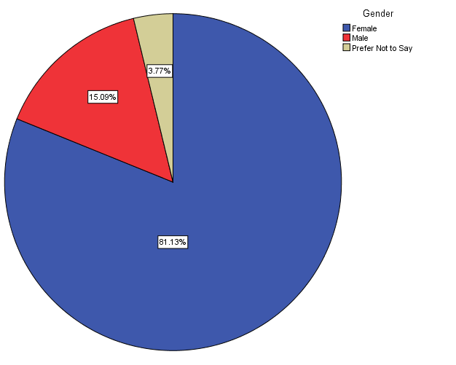

This analysis shows that the sample consists of 15.09 % of male, 81.13% of female and 3.77% preferred not to say . Majority of the sample are female.

*Table 3.1.3 Representation of “occupation “*

|  |  |  |  |  |  |
| --- | --- | --- | --- | --- | --- |
| **Occupation** | | | | | |
|  | | Frequency | Percent | Valid Percent | Cumulative Percent |
| Valid | .00 | 1 | 1.9 | 1.9 | 1.9 |
| employed | 4 | 7.4 | 7.4 | 9.3 |
| student | 49 | 90.7 | 90.7 | 100.0 |
| Total | 54 | 100.0 | 100.0 |  |
|  |  |  |  |  |  |

*Figure 3.1.3*

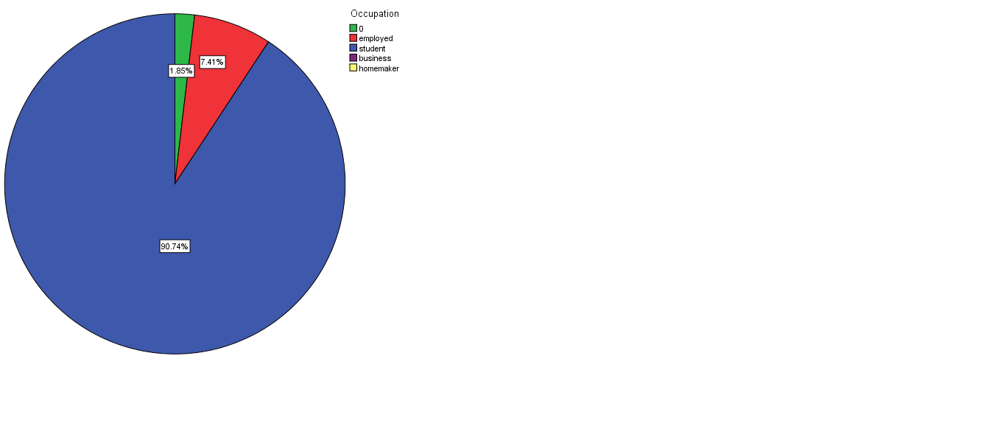

*Table 3.1.4 represents “income”*

|  |  |  |  |  |  |
| --- | --- | --- | --- | --- | --- |
| **incomelevel** | | | | | |
|  | | Frequency | Percent | Valid Percent | Cumulative Percent |
| Valid | .00 | 7 | 13.0 | 13.2 | 13.2 |
| 1.00 | 28 | 51.9 | 52.8 | 66.0 |
| 2.00 | 5 | 9.3 | 9.4 | 75.5 |
| 3.00 | 3 | 5.6 | 5.7 | 81.1 |
| 4.00 | 3 | 5.6 | 5.7 | 86.8 |
| 5.00 | 4 | 7.4 | 7.5 | 94.3 |
| 6.00 | 3 | 5.6 | 5.7 | 100.0 |
| Total | 53 | 98.1 | 100.0 |  |
| Missing | System | 1 | 1.9 |  |  |
| Total | | 54 | 100.0 |  |  |

*Figure 3.1.4*

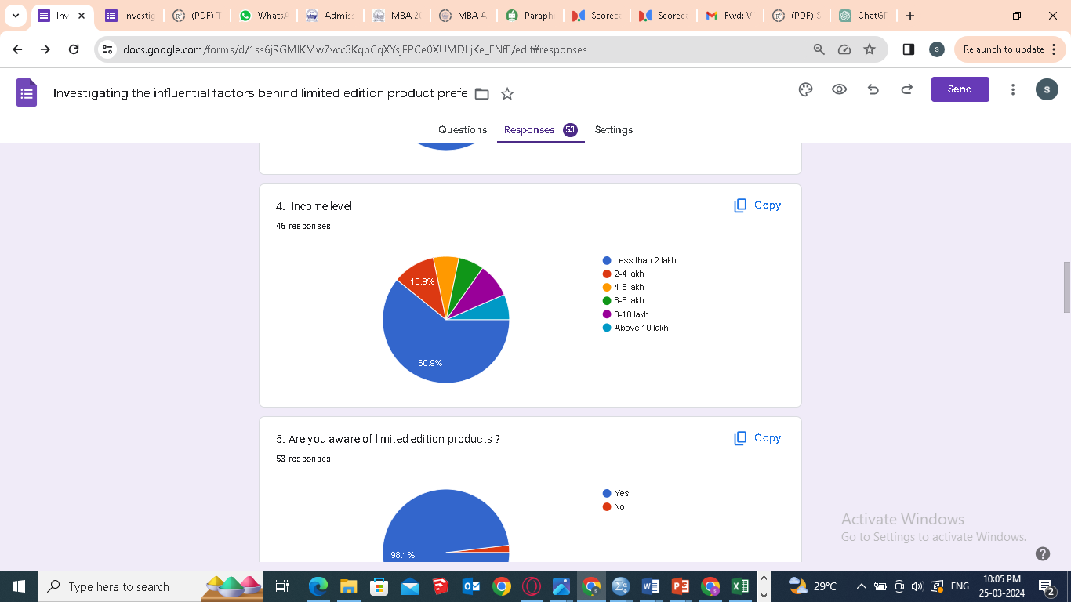

*Table 3.1.5 represents “ awareness of limited edition product”*

|  |  |  |  |  |  |
| --- | --- | --- | --- | --- | --- |
| **awarness_lep** | | | | | |
|  | | Frequency | Percent | Valid Percent | Cumulative Percent |
| Valid | yes | 52 | 96.3 | 98.1 | 98.1 |
| no | 1 | 1.9 | 1.9 | 100.0 |
| Total | 53 | 98.1 | 100.0 |  |
| Missing | System | 1 | 1.9 |  |  |
| Total | | 54 | 100.0 |  |  |
|  | |  |  |  |  |

*Figure 3.1.6*

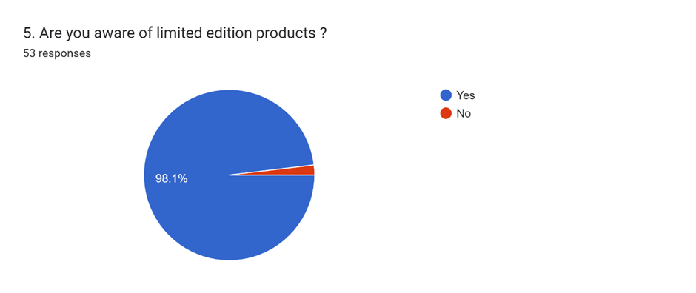

The survey on awareness of a limited product shows that 98.1% are aware of limited-edition products. And only a small sample of 1.9% are not aware of limited-edition products. Majority of the sample are aware.

*Table 3.1.6 graphical representation of “ have you purchased limited edition products”*

|  |  |  |  |  |  |
| --- | --- | --- | --- | --- | --- |
| **purchase_lep** | | | | | |
|  | | Frequency | Percent | Valid Percent | Cumulative Percent |
| Valid | 1.00 | 30 | 55.6 | 56.6 | 56.6 |
| 2.00 | 23 | 42.6 | 43.4 | 100.0 |
| Total | 53 | 98.1 | 100.0 |  |
| Missing | System | 1 | 1.9 |  |  |
| Total | | 54 | 100.0 |  |  |

*Figure 3.1.6*

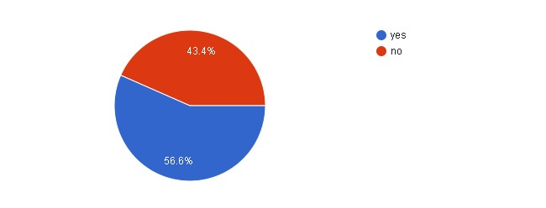

The survey of have you purchased limited edition products shows that 43.4 % shows that they have purchased limited edition products and 56.6% have not purchased limited edition products .

*Chart 3.1.7 represents “consumer need for uniqueness value” that influences consumers in buying limited edition products .*

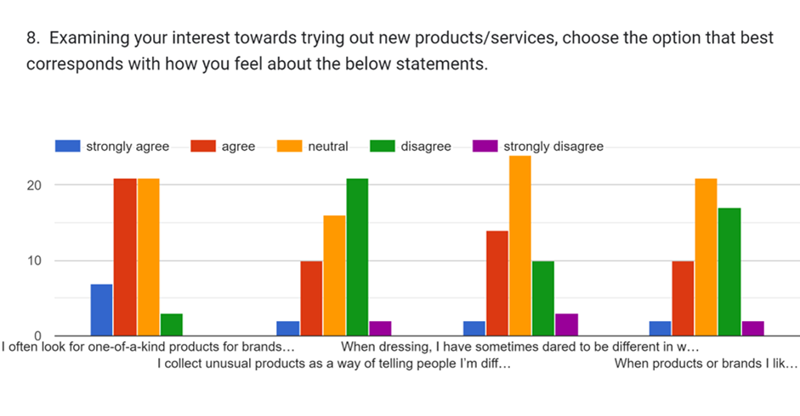 *Table 3.1.7*

|  |  |  |  |  |  |  |
| --- | --- | --- | --- | --- | --- | --- |
|  |  | Strongly agree | agree | neutral | disagree | Strongly disagree |
| I often look for one-of-a-kind products for brands so that I create a style that is all my own | Number | 7 | 21 | 21 | 3 | 0 |
| Percent | 13.0 | 39.6 | 39.6 | 5.7 | 0 |
| I collect unusual products as a way of telling people I’m different | Number | 2 | 10 | 16 | 21 | 2 |
| Percent | 3.7 | 18.5 | 29.6 | 38.9 | 3.7 |
| When dressing, I have sometimes dared to be different in ways that others are likely to disapprove | Number | 2 | 14 | 24 | 10 | 3 |
| Percent | 3.7 | 25.9 | 44.4 | 18.5 | 5.6 |
| When products or brands I like become extremely popular, I lose interest in them | Number | 2 | 10 | 21 | 17 | 2 |
| Percent | 3.7 | 18.5 | 38.9 | 31.5 | 3.7 |

The above graph represents whether uniqueness value influences people in buying limited edition products. The result shows that most of the respondents give least importance to product uniqueness. They often look for uniqueness, but never makes an impulsive purchase*.*

*Chart 3.1.8 showing “social motivation “as a factor influencing consumers in buying limited edition products .*

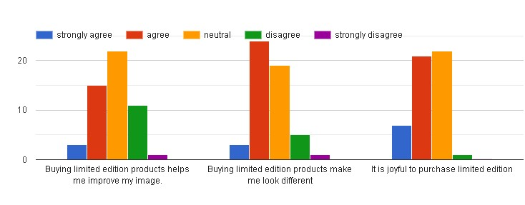

|  |  |  |  |  |  |  |
| --- | --- | --- | --- | --- | --- | --- |
|  |  | Strongly agree | agree | neutral | disagree | Strongly disagree |
| Buying limited edition products helps me improve my image. | Number | 3 | 15 | 22 | 11 | 1 |
| Percent | 5.6 | 27.8 | 40.7 | 20.4 | 1.9 |
| Buying limited edition products make me look different | Number | 3 | 24 | 19 | 5 | 1 |
| Percent | 5.6 | 44.4 | 35.2 | 9.3 | 1.9 |
| It is joyful to purchase limited edition | Number | 7 | 21 | 21 | 2 | 53 |
| Percent | 13.0 | 38.9 | 38.9 | 3.7 | 98.1 |
|  |  |  |  |  |  |  |
|  |  |  |  |  |  |
|  |  |  |  |  |  |  |

*…….*

The above graph represents whether social motivation becomes a factor which causes consumers to buy limited edition products. The results shows that most of the respondents give importance to their social image while buying LEP, which gives them utmost satisfaction.

*Table 3.1.9 shows the factor “ BRAND TRUST” as a factor that influences consumer s to buy limited edition products .*

|  |  |  |  |  |  |  |
| --- | --- | --- | --- | --- | --- | --- |
|  |  | Strongly agree | agree | Neutral | disagree | Strongly disagree |
| limited edition products show the brand's superior quality. | Number | 6 | 25 | 17 | 3 | 53 |
| Percent | 11.1 | 46.3 | 31.5 | 5.6 | 98.1 |
| limited edition products show the brand’s specialised skills and know-how | Number | 7 | 30 | 12 | 2 | 53 |
| Percent | 13.0 | 55.6 | 22.2 | 3.7 | 98.1 |
| limited edition products give experience as a friend to brands. | Number | 1 | 21 | 29 | 53 | 1 |
| Percent | 1.9 | 38.9 | 53.7 | 98.1 | 1.9 |
| If there is a problem with the LES brand, I will not buy it again. | Number | 7 | 24 | 19 | 53 | 1 |
| Percent | 13.0 | 44.4 | 35.2 | 98.1 | 1.9 |

*Figure 3.1.9*

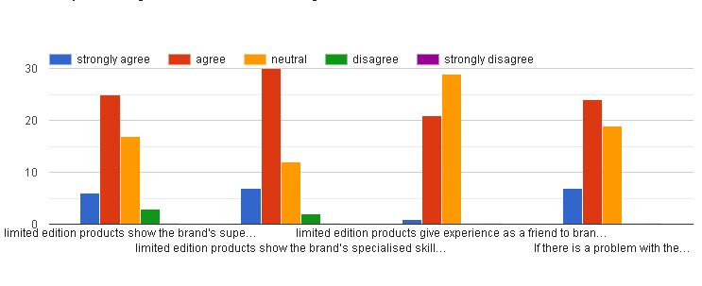

The graph shows whether brand trust influences people in buying limited edition products . the results show that limited edition products have a positive relationship with brand trust as most of the respondents agree to the statements. This shows that they put a higher emphasises by trusting the brand that ultimately influences them in buying those brand’s limited edition products .The level of trust consumers have for different brands vary accordingly .

*Table 3.1.10 shows how “uniqueness value ” influences consumers in buying LEP*

|  |  |  |  |  |  |  |
| --- | --- | --- | --- | --- | --- | --- |
|  |  | Strongly agree | agree | neutral | disagree | Strongly disagree |
| I think limited edition products are distinct | Number | 6 | 26 | 19 | 3 | 0 |
| Percent | 11.1 | 48.1 | 35.2 | 5.7 | 0 |
| I think limited edition products are unique | Number | 12 | 28 | 11 | 21 | 2 |
| Percent | 22.2 | 51.9 | 20.4 | 38.9 | 3.7 |
| I think limited edition products are different | Number | 9 | 32 | 8 | 2 | 3 |
| Percent | 16.7 | 59.3 | 14.8 | 3.7 | 5.6 |
| I think limited edition products are specially designed | Number | 18 | 19 | 12 | 17 | 2 |
| Percent | 33.3 | 35.2 | 22.2 | 31.5 | 3.7 |
|  |  |  |  |  |  |  |

*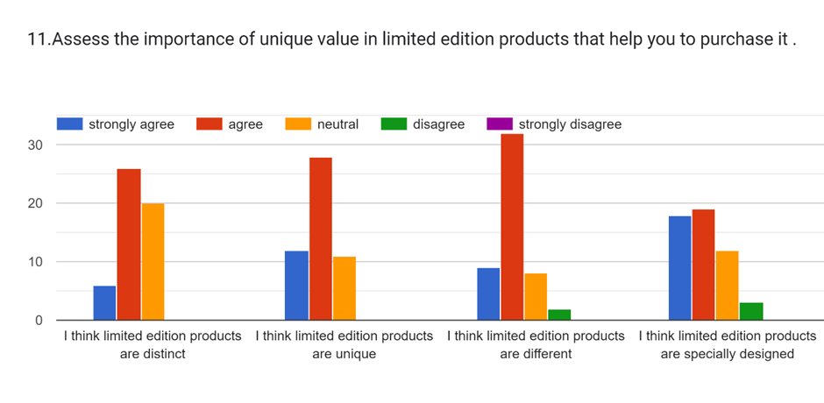figure 3.1.10*

The graph shows whether uniqueness value of a product plays a major role in influencing consumers to buy LEP .The results finds that it has a positive impact since most of the respondents agrees with the statement . Thus we can conclude that uniqueness of the product is a significant factor that consumers look into while purchasing a product .

**3.2 CORRELATION**

Correlation refers to a statistical measure that describes the extent to which two or more variables change together. In other words, it quantifies the relationship between two variables. There are 2 main correlation , namely positive and negative.

***Positive correlation:*** This occurs when an increase in one variable is associated with an increase in the other variable, and a decrease in one variable is associated with a decrease in the other variable. The correlation coefficient for a positive correlation ranges from 0 to +1, with +1 indicating a perfect positive correlation

***Negative correlation*:** This occurs when an increase in one variable is associated with a decrease in the other variable, and vice versa. The correlation coefficient for a negative correlation ranges from -1 to 0, with -1 indicating a perfect negative correlation.

Correlation does not imply causation, meaning that even if two variables are correlated, it does not necessarily mean that one variable causes the other to change.

**3.3 HYPOTHESIS TESTING**

**3.3.1Association between uniqueness of the product and purchase of limited edition products**

Uniqueness of a product can influence consumers in buying it . Researcher sees the possibility of an association between uniqueness of a product and purchase intention ,. Hence it is tested if uniqueness can lead to ultimate purchase . regression is done in order to understand the association between the two variables . Hence, the following hypothesis is proposed:

H1: There is a significant relationship between uniqueness value and purchase intention .

To check the correlation between Uniqueness Value and Purchase Intention , a correlation analysis was conducted using SPSS and the output table is displayed below 3.3.1. From the table is it evident that there is a significant correlation between Uniqueness Value and Purchase Intention (r =.52, p<.005)

*Table 3.3.1 showing the correlation between the variables*

|  |  |  |  |
| --- | --- | --- | --- |
| **Correlations** | | | |
|  | | uniquenessvalue | purchaseintention |
| uniquenessvalue | Pearson Correlation | 1 | .518** |
| Sig. (2-tailed) |  | .000 |
| N | 53 | 53 |
| purchaseintention | Pearson Correlation | .518** | 1 |
| Sig. (2-tailed) | .000 |  |
| N | 53 | 53 |
| **. Correlation is significant at the 0.01 level (2-tailed). | | | |

The Pearson correlation coefficient between Uniqueness Value and Purchase Intention is 0.518. This value indicates a moderate positive relationship between the two variables. Since the correlation coefficient is positive (0.518), it means that as Uniqueness Value increases, Purchase Intention also tends to increase. Similarly, as Uniqueness Value decreases, Purchase Intention tends to decrease. The correlation is statistically significant at the 0.01 level (2-tailed), which means that the likelihood of observing such a moderate relationship between Uniqueness Value and Purchase Intention by random chance is very low. This suggests that the relationship is likely to be a true reflection of the underlying population. Based on these results, we can conclude that there is a moderate positive relationship between Uniqueness Value and Purchase Intention. This means that individuals who perceive a product or brand as unique are more likely to have a higher intention to purchase.

**3.3.2 Association between social motivation and purchase intention**

Social motivation of the customers often influences them to buy limited edition products .

They emphasises on the social image that they have in the society and associates with the purchase of limited edition products .regression analysis is done for the two varibales to see their correlation .

H2: There is a significant relationship between social motivation and purchase intention

.

To check the correlation between social motivation and Purchase Intention , a correlation analysis was conducted using SPSS and the output table is displayed below 3.3.2. From the table is it evident that there is a significant correlation between social motivation and Purchase Intention (r =.715, p<.005)

*Table 3.3.2 showing the correlation between the two variables*

|  |  |  |  |
| --- | --- | --- | --- |
| **Correlations** | | | |
|  | |  |  |
|  | | SocialMotive | purchaseintention |
| SocialMotive | Pearson Correlation | 1 | .715** |
| Sig. (2-tailed) |  | .000 |
| N | 53 | 53 |
| purchaseintention | Pearson Correlation | .715** | 1 |
| Sig. (2-tailed) | .000 |  |
| N | 53 | 53 |

The Pearson correlation coefficient between Social Motive and Purchase Intention is 0.715. This value indicates a strong positive relationship between the two variables. Since the correlation coefficient is positive (0.715), it means that as Social Motive increases, Purchase Intention also tends to increase. Similarly, as Social Motive decreases, Purchase Intention tends to decrease. The correlation is statistically significant at the 0.01 level (2-tailed), which means that the likelihood of observing such a strong relationship between Social Motive and Purchase Intention by random chance is very low. This suggests that the relationship is likely to be a true reflection of the underlying population. Based on these results, we can conclude that there is a strong positive relationship between Social Motive and Purchase Intention. This means that individuals with a higher social motive (such as a desire to connect with others or a desire for social approval) are more likely to have a higher intention to purchase.

**3.3.3Association between brand trust and purchase of limited edition products**

The analysis is done to draw a relationship between the brand trust and purchase intention of the consumers .the variables are analysed to see how the trust that consumers have towards ultimately makes them to buy the product .

H3: there is a significant relation between brand trust and purchase of limited edition products

To check the correlation between brand trust and Purchase Intention , a correlation analysis was conducted using SPSS and the output table is displayed below 3.3.3. From the table is it evident that there is a significant correlation between Uniqueness Value and Purchase Intention (r =.723, p<.005)

|  |  |  |  |
| --- | --- | --- | --- |
| *Table 3.3.3 showing the correlation between the two variables* | | | |
|  | | brandtrust | purchaseintention |
| brandtrust | Pearson Correlation | 1 | .723** |
| Sig. (2-tailed) |  | .000 |
| N | 53 | 53 |
| purchaseintention | Pearson Correlation | .723** | 1 |
| Sig. (2-tailed) | .000 |  |
| N | 53 | 53 |
| **. Correlation is significant at the 0.01 level (2-tailed). | | | |
|  | | | |

The Pearson correlation coefficient between brand trust and purchase intention is 0.723. This value indicates a strong positive relationship between the two variables. Since the correlation coefficient is positive (0.723), it means that as brand trust increases, purchase intention also tends to increase. Similarly, as brand trust decreases, purchase intention tends to decrease. The correlation is statistically significant at the 0.01 level (2-tailed), which means that the likelihood of observing such a strong relationship between brand trust and purchase intention by random chance is very low. This suggests that the relationship is likely to be a true reflection of the underlying population. Based on these results, we can conclude that there is a strong positive relationship between brand trust and purchase intention. This means that consumers who trust a brand are more likely to intend to purchase its products or services.

**Association between social motivation , uniqueness value and brand trust with purchase intention**

1. **Social Motive** : For every one-unit increase in the social motive, there is an estimated increase of 0.447 units in purchase intention. This suggests that consumers who are more motivated by social factors (e.g., wanting to fit in with others) are more likely to intend to purchase the limited edition product.
2. **Brand Trust** : For every one-unit increase in brand trust, there is an estimated increase of 0.567 units in purchase intention. This indicates that consumers who trust the brand are more likely to intend to purchase the limited edition product.
3. **Uniqueness Value** : The coefficient for uniqueness value is not statistically significant (p = 0.805), suggesting that there is no meaningful relationship between uniqueness value and purchase intention in this model.

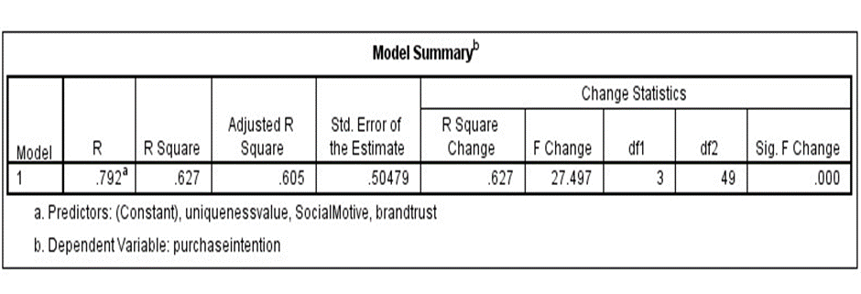Table 3.3.4

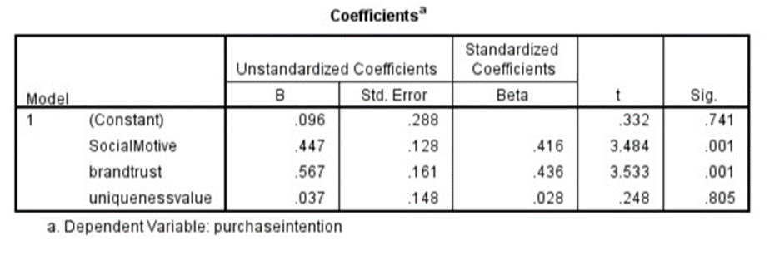

CHAPTER 4

SUMMARY, FINDINGS, CONCLUSIONS

LIST OF FINDINGS

1. 3.1 shows the demographic details of the respondents.
2. From the table 3.1.5 and 3.1.6 we get the data about the respondents who are aware of limited edition product and who all purchase limited edition product
3. . From table 3.1.7 we can see come to a conclusion that respondents give less importance to consumer uniqueness as a value while selecting limited edition product
4. From Table 3.1.8 we can arrive at a conclusion that respondents place more importance on their social image which can be measured by the factor social motivation . results find out that there is a positive relationship.
5. From the table 3.1.9 we can infer that there is a strong relationship between brand trust and purchase decision of the respondents
6. Table 3.1.10 shows that respondents agree to the statement that they look for uniqueness of the product while purchasing it .
7. From table 3.1.11 ,we can come to a conclusion that respondents place less emphasises on scarcity value .

**SUGGESTIONS**

To cultivate brand trust, a company can leverage limited edition products by ensuring that scarcity is authentic and communicated transparently. This can be achieved by producing limited quantities and clearly stating the exclusivity of the offer. Investing in unique designs that not only stand out but also reflect the brand's values and commitment to quality is essential. Highlighting the craftsmanship and attention to detail in each limited edition item reinforces the brand's dedication to excellence. Compelling storytelling can further deepen the emotional connection with customers. Developing narratives that underscore the brand's heritage, sustainability practices, or community involvement can add meaning to the limited edition product. Partnering with influencers and brand ambassadors who resonate with the target audience and align with the brand's values is crucial. Selecting influencers who are authentic and genuinely support the brand ensures that their endorsement enhances brand trust. Engaging with the community through exclusive events, social media interactions, and personalized experiences can foster a sense of belonging and loyalty. Offering value-added experiences, such as exclusive access to events or behind-the-scenes tours, reinforces the value of the limited edition purchase. Creating a sense of exclusivity through transparent and fair practices, such as offering limited edition products through exclusive channels or events, further enhances brand trust. Continuously gathering feedback from customers and monitoring market trends to adapt the limited edition strategy ensures that the brand remains responsive to customer preferences and expectations, strengthening its relationship with customers and driving loyalty."

**CONCLUSIONS**

Investigating influential factors for limited edition product preference reveals a nuanced landscape where consumer behavior is shaped by a variety of interrelated factors. The study emphasizes the pivotal role of creating genuine scarcity, a strategy that taps into consumers' fear of missing out (FOMO) and desire for exclusivity.

The research into influential factors behind limited edition product preference elucidates a complex interplay of variables that significantly impact consumer behavior and purchase decisions. Brand trust emerges as a fundamental factor, with consumers gravitating towards limited edition products from brands they trust, attributing higher quality and authenticity to these offerings. Social motivation plays a crucial role, as consumers are influenced by social trends, peer recommendations, and the desire for social status and belongingness. Limited edition products that offer a sense of exclusivity and uniqueness tap into this social motivation, driving consumer interest and preference.

Scarcity value is a key driver of limited-edition product preference, as consumers are drawn to products that are perceived as rare and exclusive. Marketers can leverage scarcity by effectively communicating the limited availability of products, creating a sense of urgency and desire among consumers. Furthermore, the research underscores the importance of uniqueness in design and concept, as consumers are attracted to limited edition products that offer innovative and distinctive features not found in regular products.

Overall, the investigation into influential factors for limited edition product preference underscores the importance of a holistic approach that considers various aspects of consumer behavior and psychology. By understanding and leveraging these factors, marketers can effectively position and promote limited edition products to drive consumer preference and loyalty in an increasingly competitive market."

In conclusion, the investigation into influential factors behind limited edition product preference highlights the importance of building brand trust, understanding social motivations, emphasizing scarcity value, and delivering uniqueness in design. By incorporating these factors into their marketing strategies, brands can enhance the appeal of their limited-edition products, drive consumer preference, and ultimately achieve greater success in the market."

REFERENCES

1. Gierl, H., Huettl, V., & McCarthy, I. P. (2008). Limited editions: Limiting the number of editions increases consumers’ appreciation and purchase intention. *Psychology & Marketing, 25*(12), 1109-1129.
2. Lynn, M. (1992). Scarcity effects on value: A quantitative review of the commodity theory literature. *Psychology & Marketing, 9*(4), 237-253.
3. Snyder, C. R., & Fromkin, H. L. (1980). Uniqueness: The human pursuit of difference. Springer.
4. Belk, R. W., Sherry Jr, J. F., & Wallendorf, M. (2003). The sacred and the profane in consumer behavior: Theodicy on the Odyssey. *Journal of Consumer Research, 31*(4), 672-678.
5. Edson, E. F., & Lee, Y. H. (2012). Understanding product scarcity and value perceptions from a commodity theory perspective. *Psychology & Marketing, 29*(9), 659-673.
6. Balachander, S., & Stock, J. R. (2009). The marketing of “limited edition” products: An empirical investigation. *Journal of Marketing Channels, 16*(1-2), 41-64.
7. Aggarwal, P., & Vaidyanathan, R. (2003). Using a multi-attribute model to evaluate the impact of scarcity cues on consumer intention to purchase deal-limited products. *Journal of Retailing, 79*(1), 25-40.
8. Wu, L., & Lee, H. (2016). Can limited edition products benefit from scarcity appeals? The roles of consumers’ buying mode and need for uniqueness. *Marketing Letters, 27*(4), 691-702.
9. Kim, J. W., & Beak, J. G. (2014). The effect of perceived scarcity on consumer buying behavior: The role of perceived value. *Journal of Retailing and Consumer Services, 21*(5), 872-879.
10. Lynn, M. (1991). Scarcity effects on desirability: Mediated by assumed expensiveness? *Journal of Economic Psychology, 12*(1), 107-127.
11. Aggarwal, P., Vaidyanathan, R., & Venkatesh, R. (2011). The effects of online brand community characteristics on community-based brand value: An application of the S-D logic. *Journal of Brand Management, 18*(6), 375-389.
12. Brock, T. C. (1968). Implications of commodity theory for value change. In A. G. Greenwald, T. C. Brock, & T. M. Ostrom (Eds.), *Psychological foundations of attitudes* (pp. 243–275). Academic Press.
13. Snyder, C. R., & Fromkin, H. L. (1980). Uniqueness: The human pursuit of difference. Springer.
14. Kim, K. H., & Kim, J. H. (2017). The effect of perceived value on brand trust and purchase intention of luxury fashion brands of female consumers in 20s. *Fashion & Textile Research Journal, 19*(3), 325-335.
15. Choi, S. H. (2012). The effect of consumer trust in brands on word-of-mouth marketing: Moderating role of consumers’ need for uniqueness. *The Journal of Global Business Issues, 6*(2), 103-110.
16. Lee, J. H., & Im, H. H. (2008). The effect of social value on purchasing intention: Moderating effect of social presence. *Korean Management Review, 37*(1), 225-248.
17. Webster, C. (2000). Perceived value of the leisure service: A market segmentation study. *The Journal of Services Marketing, 14*(2), 159-178.

ANNEXURE



