**A STUDY ON THE RELATIONSHIP BETWEEN EMPLOYER BRAND AND EMPLOYEE SATISFACTION CONDUCTED IN UNITAC ENERGY SOLUTIONS PVT LTD**

**Project Report**

**Submitted by**

**SIYAN SHELJU**

**(Reg.No.AM22COM020)**

**Under the guidance of**

**BONITTA CLARA DSOUZA**

**In partial fulfilment of requirements for award of the postgraduate degree of Masters of Commerce and Management**



**ST.TERESA’S COLLEGE (AUTONOMOUS), ERNAKULAM**

**COLLEGE WITH POTENTIAL FOR EXCELLENCE**

**Nationally Re-Accredited at “A++”Level (Fourth Cycle)**

**Affiliated to**

**MAHATMAGANDHI UNIVERSITY**

**Kottayam-686560**

**March 2024**

**ST. TERESA'S COLLEGE (AUTONOMOUS), ERNAKULAM**

**COLLEGE WITH POTENTIAL FOR EXCELLENCE**

Nationally Re-Accredited at "A++" Level (Fourth Cycle)



CERTIFICATE

This is to certify that the project report title “**A STUDY ON THE RELATIONSHIP BETWEEN EMPLOYER BRAND AND EMPLOYEE SATISFACTION CONDUCTED IN UNITAC ENERGY SOLUTIONS PVT LTD**" submitted by **SIYAN SHELJU** towards partial fulfillment of the requirements for the award of post graduate degree of **Master of Commerce and Management** is a record of bonafide work carried out by them during the academic year 2022-2024.

Supervising GuideHead of the Department

Ms. Bonitta Clara Dsouza Ms.Elizabeth Rini K F

Assistant Professor Assistant Professor

Dept. of CommerceDept. of Commerce

Place: Ernakulam

Date: 31-03-2024

**DECLARATION**

I, **SIYAN SHELJU**Thereby declare that this dissertation titled, "**A STUDY ON THE RELATIONSHIP BETWEEN EMPLOYER BRAND AND EMPLOYEE SATISFACTION CONDUCTED IN UNITAC ENERGY SOLUTIONS PVT LTD**" has been prepared by me under the guidance of Ms. **BONITTA CLARA DSOUZA**,Assistant Professor, Department of Commerce, St Teresa's College, Ernakulam.

I also declare that this dissertation has not been submitted by me fully or partly for the award of any Degree, Diploma, Title or Recognition before.

**Place: ERNAKULAM SIYAN SHELJU**

**Date: 25.03.2024**

**ACKNOWLEDGEMENT**

I wish to acknowledge all those who helped us to complete this study. I thank God almighty for helping me and guiding me in the right path and who made all things possible.

I take this opportunity to express our profound gratitude and deep regards to my guide Ms. Bonitta Clara Dsouza Assistant professor, St. Teresa's college, Ernakulam for her exemplary guidance monitoring and constant encouragement throughout the course of this study. The blessings, help and guidance given by her time to time shall carry us a long way in the journey of life on which we are about to embark. She has taken pain to go through the project and make necessary corrections as and when needed.

We express our sincere thanks to the Director, Rev. Sr. Emeline CSST, Provincial Superior and Manager, Rev. Dr. Sr. Vinitha CSST, Principal Dr.Alphonsa Vijaya Joseph and Ms. Elizabeth Rini K F , Head of the Department of Commerce to all other faculties of the department of commerce, St. Teresa's College, for their support and valuable suggestions. I would like to express my thanks to all respondents and colleagues in developing the project.

1 also extent heartfelt thanks to my family for their constant encouragement without which this project would not be possible.

**SIYAN SHELU**

**CONTENTS**

|  |  |  |
| --- | --- | --- |
| Sl.No | Particulars | Page No. |
| 1 | List of tables |  |
| 2 | List of figures |  |
| 3 | Chapter 1- Introduction |  |
| 4 | Chapter2 -Review of Literature |  |
| 5 | Chapter 3- Theoretical Framework |  |
| 6 | Chapter 4- Data Analysis  AndInterpretation |  |
| 7 | Chapter 5- Summary, Findings, Recommendations and conclusion |  |
| 8 | Bibliography |  |
| 9 | Appendix- Questionnaire |  |

**LIST OF TABLES**

|  |  |  |
| --- | --- | --- |
| Table No. | Title | Page No. |
| 4.1 | Age of the employees |  |
| 4.2 | Academic background of the employees |  |
| 4.3 | Years of experience in the organisation |  |
| 4.4 | Job training in the organisation |  |
| 4.5 | Pay and other benefits offered by the company |  |
| 4.6 | Momentary incentives par in the company |  |
| 4.7 | Fairness in job promotions |  |
| 4.8 | Division and assignment of work |  |
| 4.9 | Satisfaction with work expected |  |
| 4.10 | Working environment |  |
| 4.11 | Adequate existence of safety measures |  |
| 4.12 | Employee grievance redressal mechanism |  |
| 4.13 | Motivation as a result of good supervision |  |
| 4.14 | Fairness in absenteeism and tardiness |  |
| 4.15 | Labour management communication |  |
| 4.16 | Employee participation |  |
| 4.17 | Consistent treatment of employees |  |
| 4.18 | Involvement of management in improving the organisation |  |
| 4.19 | Job responsibility contributes to professional development |  |
| 4.20 | Opportunity to specialize in strength of employees |  |
| 4.21 | Organisation’s effort to help employees |  |
| 4.22 | Clear instructions from top management |  |
| 4.23 | Advising others to apply for job in this company |  |
| 4.24 | Desire for change of organisation |  |
| 4.25 | Descriptive Statistics on Satisfaction of Employees towards various Strategies |  |
| 4.26 | Age wise distribution of Satisfaction of Employees towards various Strategies |  |
| 4.27 | Education wise distribution of Satisfaction of Employees towards various Strategies |  |
| 4.28 | Year of Experience wise distribution of Satisfaction of Employees towards various Strategies |  |
| 4.29 | Checking normality of the variables related to satisfaction of Employees towards various Strategies |  |
| 4.30 | Kruskal Wallis Test with respect to satisfaction of Employees towards various Strategies based on their age |  |
| 4.31 | Kruskal Wallis Test with respect to satisfaction of Employees towards various Strategies based on their education |  |
| 4.32 | Kruskal Wallis Test with respect to satisfaction of Employees towards various Strategies based on their Year of Experience |  |
| 4.33 | Model Summary on Strategies and Employees Satisfaction |  |
| 4.34 | ANOVA with respect to Strategies and Employees Satisfaction |  |
| 4.35 | Coefficient with respect to Strategies and Employees Satisfaction |  |
| 4.36 | Model Summary on employee brand and employee satisfaction |  |
| 4.37 | ANOVA on employee brand and employee satisfaction |  |
| 4.38 | Coefficient on employee brand and employee satisfaction |  |
| 4.39 | Descriptive Statistics on Employees perception towards organization incentives |  |
| 4.40 | Age wise distribution of Employees perception towards organization incentives |  |
| 4.41 | Education wise distribution of Employees perception towards organization incentives |  |
| 4.42 | Year of Experience wise distribution of Employees perception towards organization incentives |  |
| 4.43 | Normality of the distribution of Employees perception towards organization incentives |  |
| 4.44 | Kruskal Wallis Test with respect to Employees perception towards organization incentives based on their Age |  |
| 4.45 | Kruskal Wallis Test with respect to Employees perception towards organization incentives based on their Education |  |
| 4.46 | Kruskal Wallis Test with respect to Employees perception towards organization incentives based on their Education |  |
| 4.47 | Model Summary on Incentives and employee satisfaction |  |
| 4.48 | ANOVA on Incentives and employee satisfaction |  |
| 4.49 | Coefficient on Incentives and employee satisfaction |  |

**LIST OF FIGURES**

|  |  |  |
| --- | --- | --- |
| Figure No. | Title | Page No. |
| 4.1 | Age of the employees |  |
| 4.2 | Academic background of the employees |  |
| 4.3 | Years of experience in the organisation |  |
| 4.4 | Job training in the organisation |  |
| 4.5 | Pay and other benefits offered by the company |  |
| 4.6 | Momentary incentives par in the company |  |
| 4.7 | Fairness in job promotions |  |
| 4.8 | Division and assignment of work |  |
| 4.9 | Satisfaction with work expected |  |
| 4.10 | Working environment |  |
| 4.11 | Adequate existence of safety measures |  |
| 4.12 | Employee grievance redressal mechanism |  |
| 4.13 | Motivation as a result of good supervision |  |
| 4.14 | Fairness in absenteeism and tardiness |  |
| 4.15 | Labour management communication |  |
| 4.16 | Employee participation |  |
| 4.17 | Consistent treatment of employees |  |
| 4.18 | Involvement of management in improving the organisation |  |
| 4.19 | Job responsibility contributes to professional development |  |
| 4.20 | Opportunity to specialize in strength of employees |  |
| 4.21 | Organisation’s effort to help employees |  |
| 4.22 | Clear instructions from top management |  |
| 4.23 | Advising others to apply for job in this company |  |
| 4.24 | Desire for change of organisation |  |

**CHAPTER 1**

**INTRODUCTION**

**CHAPTER 2**

**REVIEW OF LITERETATURE**

**CHAPTER 3**

**THEORETICAL FRAMEWORK**

**CHAPTER 4**

**DATA ANALYSIS AND INTERPRETATION**

**CHAPTER 5**

**FINDINGS, SUGGESTIONS,AND CONCLUSION**

**BIBLIOGRAPHY**

* 1. **INTRODUCTION**

Employees are the substance of the organization. They are the most crucial assets for any organizations. Companies that prioritize employee development will outperform their competitors. As a result, ensuring that employees are satisfied becomes an important topic for the company as well as potential and current employees. A company with satisfied employees is more important to a qualified employee. Employer brand is one of the many factors that play a role in attracting skilled workers to an organization. The business brand concentrated right off the bat by Simon Cart and Richard Mosley was characterized later on by Simon Hand truck and Tim Ambler. As indicated by Hand truck and Ambler, the business brand is a useful financial and mental support agreement introduced by the business. "Business brand is a fundamental part for giving representative fulfillment. The components of business brand are connected with representative fulfillment and that the business brand influences worker fulfillment. To make its employees happy, an organization uses a variety of strategies. Variety, wellbeing and security work environment conditions self-improvement work/life barrens and compensation are issues that mindful businesses need to address to guarantee a cheerful persuaded labor force. The workmanship and study of boss marking is subsequently worried about the fascination commitment and maintenance drives focus at upgrading your organization's manager image.

* 1. **SIGNIFICANCE**

By fostering a positive business Brand, associations are not simply prepared to attract qualified opportunities for ensured work open doors yet moreover build long stretch relationship with potential enlisted people who may be sensible for future positions inside the affiliation. Furthermore, organizations should explore the developing assumptions and upsides of their representatives with respect to profession needs, balance between fun and serious activities, and adaptable working plans. The ascent of remote and cross breed work models has additionally convoluted the errand of adjusting representative assumptions to business needs. Richard Mosley, Universe Worldwide Client Chief, underscores the significance of finding some kind of harmony between flagging a worker well disposed and adaptable working environment while additionally keeping up with assumptions for efficiency and responsibility.

**1.3 PROBLEM STATEMENT**

This study aims to deal with measures adopted by Unitac Energy solutions Pvt Ltd to satisfy its employees to perform better and align their performance towards organizational goals. It also throws light on how the company maintains a congenial work environment.

* 1. **SCOPE OF THE STUDY**

This research enables to study various schemes adopted by Unitac Energy solutions Pvt Ltd so as to satisfy their employees and maintain their employer brand. The detailed analysis of gathered data through questionnaireenvisage appropriate conclusions which may help in improving the existing schemes according to the change in needs of employees so as to attract skilled and qualified employees to uphold their employer brand.

* 1. **OBJECTIVES OF THE STUDY**
* To understand the various strategy adopted by Unitac Energy solutions to satisfy their employees.
* To study the effect of those strategies which ae adopted by the firm.
* To know the relationship between employee brand and employee satisfaction.
* To understand the impact of monetary and non-monetary incentives of the organisation .
  1. **HYPOTHESIS OF STUDY**

​

Hypothesis 1:

​•​H1: Employees who receive proper job training upon joining the company are more likely to report higher levels of job satisfaction.

​•​H0: There is no significant difference in job satisfaction levels between employees who receive proper job training and those who do not.

​​Hypothesis 2:

•​H1: Perception of fair and objective job promotions within the organization positively influences overall employee satisfaction.

​•​H0: There is no significant relationship between perception of fair and objective job promotions and overall employee satisfaction.

* 1. **RESEARCH METHODOLOGY**
     1. **Problem Statement**: To identify the various employee motivational schemes used by Unitac Energy solutions Pvt Ltd and to assess its impact on the employees.

1.7.2 **Data Collection**:

* Primary Data: Primary data was obtained by visiting the industry seeking answers through distribution of questionnaires
* Secondary Data: Collected from published sources like, reports, manuals and company websites.

1.7.3 **Tools and technique**: Various accounting techniques and statistical tools like percentages , ANOVA , regression analysis ,coefficient correlation , Kruskal Wallis Test, etc were used to effectively analyse and to arrive at accurate conclusions and recommendations. Graphical representations, tabular representations and charts were used in this study in order to arrive at clear and effective presentation of the available data.

1.7.4 **Population**: The survey was conducted on 100 employees of Unitac Energy solutions Pvt Ltd in order to derive the relation between employer brand and employee satisfaction.

1.7.5 **Sample size**: Out of the total employees, 100 employees were selected as sample for the purpose of the study.

1.5.6 **Type of sampling**: Random sampling was used for this survey.

* 1. **LIMITATIONS**

In spite of all the sincere efforts the study is not a fool proof in nature. it suffers from various limitations due to following reasons:

* Time constraints affected the planning, execution, and delivery phases of the project. Due to the restricted time available, certain aspects of the project, such as comprehensive planning, extensive data collection, and in-depth analysis, had to be carefully managed to meet the project's objectives within the given time constraints.
* Lack of accuracy in primary and secondary data
* Sampling errors
* Unsatisfactory response to questionnaire owing to the employees busy schedules.
  1. **KEY WORDS**

1. Employer Brand: Employer brand is a commonly used to describe an organizations reputation as an employer and its value proposition to its employees. It is a functional, economic and psychological benefit package presented by the employer.

2.Employee Satisfaction: According to Locke, employee satisfaction is pleasurable or positive emotional status as a result of the evaluation of their job and job experience.

**1.10 CHAPTERISATION**

CHAPTER 1: INTRODUCTION

It covers introduction of the study. Here the researcher gives a brief description of the topic under study. This chapter also covers significance of the study, problem statement and objectives of the study, limitations, methodology and key words.

CHAPTER 2: REVIEW AND LITERATURE

It covers various theories and information related to the topic, collection from various journals and reports.

CHAPTER 3: THEORITICAL FRAMEWORK

Third chapter gives a brief description of the company under study. It includes the description of the company, Advantages of employee branding its present position in the concerned market, brief idea of employee branding, determinants of employee satisfaction.

CHAPTER 4: DATA ANALYSIS AND INTERPRETATION

It covers various diagrams, tables, charts and graphs prepared from the collected data. It also includes analysis of such diagrams and its interpretation.

CHAPTER 5: SUMMARY, FINDINGS AND RECOMMENDATIONS

Here, the researcher summarizes the entire study; put forth the findings and conclusions derived from the study and also impart necessary recommendations or suggestions.

1. **Christina G.(1998)**

The study looks at how customer satisfaction acts as a mediator between employee satisfaction and financial performance. This study gathered information from managers, customers, and employees of three- and four-star hotels. Underlying condition demonstrating (SEM) with a two-step approach was used to test the proposed speculations and the connections between the develops exactly. Employee satisfaction appears to have no direct significant impact on financial performance, despite the fact that customer satisfaction has a positive significant impact. Instead, there is a connection between financial performance and employee satisfaction, which is mediated by customer satisfaction.

**2. Jacob K. Eskildsen (2002)**

Academics and practitioners alike agree that today's organizations' most valuable asset is their workforce. The EFQM Excellence Model also shows how important employees are because two of the criteria deal with issues related to employees. The EFQM Greatness Model is by a long shot the most broadly involved model for self - evaluation in Europe, yet there is no information about the connections between the empowering agent standards and the most urgent of the outcomes rules: ' individuals results'. In this paper a casing of reference for representative fulfilment is built by looking at the EFQM Greatness Model and Hackman and Oldham's Work Configuration Model. The enabler criteria and "people results" are linked in a number of ways, as this comparison has shown. The Structural Equation Model was used to empirically test these causal relationships, and the results show that the EFQM Excellence Model enablers have a positive effect on the criterion "people results."

**3. Cranny. Smith & stone (1992)**

The term "employee satisfaction" is used to describe whether workers are content, happy, and getting what they want and need from their jobs. Many estimates support that representative fulfilment is a consider representative inspiration, worker objective accomplishment and positive employee confidence in the work place. Susan M. Heath field (characterized ES as the " mix of full of feeling responses to the differential impression of what he/she needs to get contrasted and he/she really gets.

**4. Nancy C. Morse (1997)**

Satisfaction is the degree to which one's needs, wants, and desires are met. Satisfaction is basically determined by what a person wants from the world and what he gets." The degree to which professionals are content with their work environment and workplace is a factor in representative satisfaction. Employee satisfaction is one of the many factors that can have an impact on an organization's effectiveness.

**5. Potter field (1999)**

Employees who are satisfied are more loyal and productive, and satisfied employees have an impact on both customer satisfaction and organizational productivity. There is no limit to the level of satisfaction that an employee can achieve, and it may vary from employee to employee. According to Miller, in order to carry out their responsibilities more effectively and enjoy their jobs more, they may need to alter their behavior from time to time.

Employee satisfaction may be linked to a higher salary, good working conditions, good relationships with coworkers, opportunities for training and education, career advancement, and other benefits.

**6. Goyal (1995)**

It was analysed the extent to which textile workers are satisfied with their jobs—primarily as a result of the statutory labor welfare programs offered by the private, public, and cooperative textile sectors in Punjab—as well as the awareness and implementation of these programs and the relationship between them and job satisfaction.

**7. Srivastava (2004)**

A comparative study of workers in Kanpur's private and public sectors was carried out to compare the effects of labor welfare on employee attitudes and job satisfaction.

The researcher set out to evaluate the quality of labor welfare programs, the degree to which workers in both the public and private sectors are satisfied with their jobs, and workers' attitudes toward management in both sectors.

**8. Allen and Meyer, 1996; Karrasch, 2003;**

Employee loyalty and involvement in the organization are examples of organizational commitment. Consistency commitment, affective commitment, and normative commitment are the three general dimensions of commitment.

**9. BrikendAziri Management Research and Practice 12/2011:**

When it comes to managing employees, one of the most challenging issues managers face today is employee satisfaction. Numerous studies have demonstrated that employees' levels of motivation and job satisfaction have a significant impact on productivity and, consequently, business organizations' performance. Unfortunately, neither academics nor managers of various businesses have paid sufficient attention to our region's issue of job satisfaction.

**10. AlamSageer, Dr.SameenaRafat, Ms. Puja Agarwal ISSN: 2278-487X. Volume 5. Issue 1 (Sep-Oct. 2012),**

The term "employee satisfaction" is used to describe whether workers are content, happy, and getting what they want and need from their jobs. Employee motivation, goal achievement, and high employee morale at work are all influenced by employee satisfaction, according to numerous studies. In essence, employee satisfaction is a measure of how satisfied workers are with their work and the environment in which they work. This paper discusses a number of factors that contribute to employee satisfaction, including organizational development, job security, work task satisfaction, compensation and benefit policies, and opportunities for employee satisfaction, such as promotion and career development. It also discusses a number of ways to increase employee satisfaction.

**11. Cranny, Smith & Stone 1992**.

These investigations follow the suspicion that when a specific arrangement of occupation conditions are available a specific degree of occupation fulfillment will follow. In the early 20th century, the Hawthorne Studies are regarded as the most significant study of the human aspects of industrial relations. They were finished at the Ringer Phone Western Electric assembling plant in Chicago starting in 1924 through the early long periods of the Downturn.

In the early work on morale, the Hawthorne plant set up an Industrial Research Division to find the most important aspects of behaviour. This division has changed the behaviour it was created to find. The initial Hawthorne effect was the observation that workers' productivity increased with each change in work conditions. When people realize that their actions are being watched, they change how they behave. The beginning of applied psychology as we know it today can be traced back to the Hawthorne studies. The beginning of research on job satisfaction in relation to ergonomics, design, and productivity can be traced back to these early studies.

**12. HalilZaimSelimZaim Fatih University, TURKEY**

Organizational success is thought to depend on employee satisfaction. The idea of representative fulfillment has acquired an exceptional worry from the two academicians and professionals.

Based on the data that was collected from Turkey, the purpose of this study is to provide a framework for employee satisfaction, identify the critical factors that contribute to employee satisfaction, and measure their impact on the overall evaluation of employee satisfaction in small and medium-sized enterprises (SME). According to the findings of the data analysis, there is a positive relationship between overall employee loyalty in SMEs and satisfaction from pay and benefits (P&B), satisfaction from peers (P), satisfaction from management (M), satisfaction from the working environment (WE), and satisfaction from superiors (S).

In addition, appropriate suggestions and measures for increasing employee satisfaction are made.

**13. Suman Kumar Dawn, Suparna Biswas**

They conducted research and wrote a paper with the title "Employer Branding: Another Essential Components Of Indian Corporations" where they dissected top to bottom the beginning of business branding specially the linkage between manager brand and promoting communication methods, they fostered an essential model on Boss Marking, where in they bifurcated the marking of an organization in to Outside Marking and Internal Marking. Outer Marking alludes to marking utilizing external sources like getting sorted out occasions, utilization of sites, flags, papers, email,CSR and so forth. Since current and potential employees' employment experiences are part of Internal Branding, having them participate in decision-making, policy formulation, and regularly conducting Stay interviews with employees, among other things, will improve their experience. In their investigation, they carried out a case study on CEAT tires, Infosys, TCS, Tata Steel, and others.

EMPLOYEE BRAND

Employer brand refers to the reputation and image that an organization has as an employer. It encompasses the perceptions and attitudes that both current employees and potential candidates have about a company as a place to work. A strong employer brand is crucial for attracting and retaining top talent.

One of the main elements of an employer brand is the company culture, which consists of the norms, values, and behaviours that characterise the work environment.

1. Employee Value Proposition (EVP): A special range of advantages and services provided to staff members in return for their knowledge, abilities, and expertise.
2. Communication: The manner in which the business interacts with the outside world and conveys its values, mission, and work culture.
3. Recruiting and Onboarding: How applicants are treated during the employment process and how well they fit in with the business.
4. Employee Engagement: The degree of dedication, drive, and contentment that staff members have with their jobs and the company.
5. Leadership and Management: The standard of the organization's management and leadership techniques.
6. Work-Life Balance: The extent to which the organization supports a healthy balance between work and personal life.
7. Company Culture: The values, beliefs, and practices that define the workplace atmosphere.

Having a positive employer brand is important for several reasons:

1.Attraction of Talent: A strong employer brand helps attract high-quality candidates who are more likely to be a good fit for the organization.

2.Retention: Employees are more likely to stay with a company that has a positive reputation as an employer.

3.Employee Advocacy: Satisfied employees are likely to become brand ambassadors, promoting the company to their networks.

4.Competitive Advantage: A positive employer brand can give a company a competitive edge in the talent market.

5.Organizational Success: Engaged and satisfied employees are more likely to contribute to the overall success and productivity of the organization.

Companies often invest in strategies to build and maintain a positive employer brand, including showcasing their company culture on social media, offering competitive benefits, fostering a positive work environment, and actively seeking employee feedback to make improvements.

WHAT IS EMPLOYEE BRANDING ?

The reputation you have as an employer among your workforce and employees is known as employer branding. It's likewise the way that you market your organization to work searchers and inner representatives.

Employer branding is a key factor in retaining and attracting top talent, as 69% of employees surveyed consider it extremely or very important that their employer has a brand they can be proud of.

With your products or services, let's say you've done a fantastic job of demonstrating strengths for a. Unfortunately, that without anyone else won't convince someone to work at, or stay at, your association. At the point when you need to convey the authority, values, and culture of your business, you really want to utilize a similar marking technique.

If an undertaking searcher asks a delegate at your association, "What's it like to work there?" " We've constructed some amazing product" won't be said by the specialist. In light of everything, he's going to lay into the ordinarily of people the leaders, association values, and work space culture. You really want to recount a convincing story in the event that you need a positive business brand.

Business marking goes further than narrating — you additionally need to walk the walk. Telling your representatives and the overall population that having a ping-pong table makes you an incredible work environment won't cut it.

Advantages of Employer Brand

* Increase in the level of employee's loyalty:

Provided that the employees see the organization as "the best place to work" they should never think of working in another organization. This increases the level of employee's loyalty and the level of employee turnover decreases.

* Motivation and performance increases:

People see themselves as lucky because of working at an organization the people around them want to work for. This increases their motivation and performance.

* Increase in job application and qualities:

A strong employer brand increases the rates of highly qualified people towards the organization, so the candidates quality increases in parallel way. In addition to this, an increase in the brand awareness means an increase in the application for the organization.

* Long term effect:

Employer brand management is needed a strategic approach in respect of its content. This helps human resources gain a strategic identity and get a long term effect.

* Concentration:

Business brand gives application and the organization of competitors pool to be made due. For example, the business brand has a chance to draw in imaginative individuals by bringing a few elements like support, drives, free working space in boss brand - to the front line in the event that the association gives significance on inspiration.

* Expansion in offer acknowledgment rates:

Offers to passive candidates are more likely to be accepted the longer the employer brand remains strong.

* Increase in employees’ references:

Employer brand provides people to be proud of their works and increase the rates that they advise to the people around them.

* Increase in manager satisfaction:

The increase in candidates’ quality lessens the interview time for the managers, and increases their satisfaction.

* A strong corporate culture:

The aim of employer brand management is to create a message regarding the reasons of existence of the organization. The fact that the message is perceived and embraced in the same way by all the employees is important. As a result of this, reconciliation on the value and norms of the organizations increases and the corporate culture is strengthened.

* Decrease in the cost of recruitment:

The organization having strong employer brands do not experience any hardship to fill the critical positions.

* Increasing competitive capacity:

Competitive capacity increases as the employer brand increases in human quality.

Determinants of employee satisfaction

1.WORKING CONDITION

The most dissatisfied and frustrated workers are those who do not feel at home in their workplaces and do not have access to a suitable workstation. Respect and consideration must be shown to employees. In order for them to develop a sense of job satisfaction, they need to feel safe at work. Support sound vibe at work and furthermore propel representatives not to take part in awful workplace issues.

2.EMPLOYEE BENEFITS

It incorporates both financial and non-money related benefits. Money related is the advantages given and given as a trade off of the administrations they give to the association. It covers essential compensation, recompenses, clinical repayments, reward, fortunate asset, tip, and so forth. Non-financial advantages are those not got in type of cash. It incorporates regard, scholarly and proficient test, proficient status, improvement and progression open doors satisfactory admittance to data, adaptable working hours and so on. The job of both prize framework in an association is to propel the workers to contribute their endeavours and abilities to limit of their true capacity towards accomplishing the authoritative objectives.

3.MOTIVATION

Inspiration of representatives increments worker fulfillment level. Both intrinsic and extrinsic motivation can exist. Natural inspiration can be depicted as the course of inspiration by work itself to the extent that it fulfills the individual necessities of the representative. The variables affecting inherent inspiration are liability, opportunity to act, boldness to utilize, and foster people own abilities, fascinating undertakings and potential open doors for headway. Extraneous inspiration is how much exertion others provide for the workers to spur them. It is the prizes that administration gives, for example, pay rise, applause or advancement.

4.COMMUNICATION

The greater part of the issues emerge when workers are not happy with their more significant level administration. Instead of imparting the issue eye to eye with their administration they like to insult behind their backs. The executives need to cause the representatives to feel that they are consistently with them regardless of the conditions and circumstances. All employees will receive accurate information if there is good communication, and no one will feel excluded from the system.

5. SAFETY MEASURES

Laborers who communicated more fulfilment at their posts have positive view of security environment. Security measures ought to be more dedicated to somewhere safe and secure administration strategies and therefore enlisted a lower pace of mishap inclusion. Laborers ought to be given a sound wellbeing working circumstances to expand their fulfilment level.

6. SUPERVISION

Representative impression of oversight impact worker work fulfilment and execution. Organizations are at risk when supervisors treat employees badly. The administration totally have some control over how managers act towards their subordinates. The administration ought to think about conduct of managers, offering help and preparing, making remedial moves for negative way of behaving and evaluating workers' impression of these particular ways of behaving consistently. Accordingly increments worker fulfillment with their bosses.

COMPANY PROFILE

Unitac Energy Arrangements (I) Pvt. Ltd. has worked in India for more than two decades installing and putting into operation active and passive telecom infrastructure. Their expertise is utilized in partnering with major IP companies for cell site operation, rollout, and maintenance activities because of our years of experience managing rollouts and infra maintenance.

Company profile highlights are as outlined hereunder.

* New Form accomplice for driving telecom IP
* Telecom site tasks for a sum of 9400 cell towers in

Kerala, Tamil Nadu, Karnataka Circles.

* 1,60,000 Square Kilometers, 40 Locale Covered, with a

decentralized method of activity.

* TSP/NI partners for major telecom passive and active infrastructure providers; HT transmission tower construction and erection; SME for diesel generators; logistical support for material movements and fuel filling of DG for telecom site;
* 1000+ on roll employees

PROCESS AND MANPOWER DEPLOYMENT

The key centre has forever been to keep up with strategic command over the field by empowering a sense of responsibility over the site by particular engineers/experts. As a result, preventative and corrective maintenance procedures are strictly followed with little need for instruction or correction. We in this way keep up with the best track record, for the most un-number of blackout occurrences and the least normal time expected for establishment, dispatching, roll outs and remedial upkeep.

UNITAC - PERSONAL PROTECTIVE EQUIPMENT POLICIES HR POLICY

Through the use of personal protective equipment (PPE), the Personal Protective Equipment Policies aim to safeguard UNITAC employees from exposure to workplace hazards and injury. PPE is certainly not a substitute for more powerful control techniques and its utilization will be viewed as just when different method for security against dangers are not satisfactory or achievable. It will be utilized related to different controls except if no different method for danger control exist.

Personal protective equipment will be provided to an employee when they join, used, and maintained when it has been determined that its use is required to ensure the safety and health of our employees and that its use will lessen the likelihood of occupational injury or illness.

Review of PPE packs on a monthly basis to ensure that no packs are damaged or broken.

Innovative services for the network evolution

At Unitac, our undertaking is to offer a-list inactive telecom foundation and increase the value of the specialist co-ops. As the genuine trailblazer in the field, we have profound information on the administrator's necessities, goals and elements of the market. Insofar as we can tell, the O&M business is more about regulating and overseeing labour supply than it is about the innovation in question. We thusly follow a stringently hands on approach with regards to dealing with the O&M business. One of our assets has been a committed supervisory crew, who include by and by in each issue connecting with the tasks. The following describes some of our procedures: Our ongoing areas of tasks in India are in the Territories of Kerala, Tamil Nadu and Karnataka. We have district-level offices and other infrastructure available to us, so we can make use of all synergies for operations that are both effective and cost-effective.

Services

Integrated O&M Operations

Coordinated O&M Tasks is an all-encompassing methodology that consolidates functional and support capabilities, utilizing innovation and information to improve processes, diminish margin time, and upgrade effectiveness in different ventures.

SME Services

Unitac is crucial to ensuring that service runs smoothly and without interruption. Our specialists has inside and out information, mastery, and experience, making them a go-to asset for all matters connected with site Diesel Generators, Climate control systems, Battery bank

Operations & Maintenance

We help administrators in the center of their telecom network upkeep and methodology. As administrators progressively underscore the functional and administrative parts of organization innovation. We grasps the extent of administration and the specialized respectability.

Network Implementation

Network Execution Works include the organization and arrangement of organization framework, guaranteeing that it capabilities consistently and meets explicit necessities. The actual implementation is the focus of these projects.

Electrical & Civil Works

Our Electrical and Common Works incorporate a scope of administrations connected with electrical frameworks and common development projects. These administrations include the establishment, upkeep, and of electrical foundation and common designs.

The purpose of this study is to explore employee's perception about the companies brand and to understand its relationship with employee satisfaction. The data collected from the Unitac Energy solutions Pvt Ltd helps in understanding the level of employee satisfaction in the company. The company can be rated from the employee's response.

The study helps in understanding the meaningful relation between the employer brand and the employee satisfaction. Employee satisfaction raises employee productivity. The better the employer brand components are, the more employee satisfaction is. A strong employer brand component consist of relation and communication of manager employee providing employee satisfaction, career, wages, job security, social components, firm's reputation.

In the circumstances a strong brand creates satisfaction in the eye of all the employees. Hence employees that are most satisfied are likely to stay at their job for a longer period than those that are dissatisfied, and the employees that are loyal are likely to be more satisfied.

Analysis of data focuses on studying the tabulated material in order to find out inherent facts and meaning. Interpretation points out the inferences from the collected facts after analytical study. The tables used for analysis, charts and interpretations are given below.

**4.1AGE**

Table 4.1. Age of the employees

|  |  |  |  |
| --- | --- | --- | --- |
| SL.NO. | AGE | FREQUENCY | PERCENTAGE |
| 1 | Below 30 years | 18 | 18% |
| 2 | 30-40 years | 68 | 68% |
| 3 | 41-50 years | 13 | 13% |
| 4 | 50 and above | 1 | 1% |
|  | TOTAL | 100 | 100 |

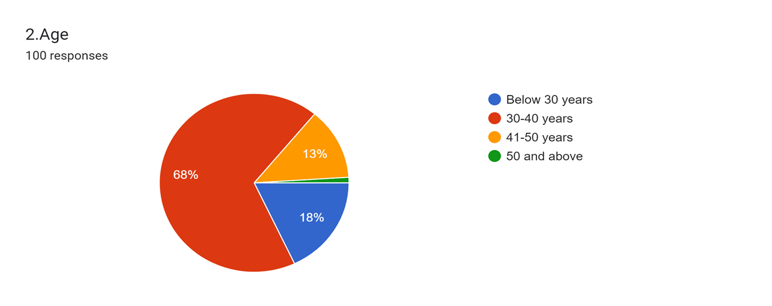Figure 4.1 Age of the employees

INTERPREATATION:

The sample is predominantly composed of individuals between 30 and 40 years old, constituting the largest portion (68%).Individuals below 30 years and in the 41-50 age range are also present, though in smaller proportions.The 50 and above age group has the smallest representation in the sample, with only 1% of the individuals.

**4.2 ACADEMIC BACKGROUND**

Table 4.2. Academic background of the employees

|  |  |  |  |
| --- | --- | --- | --- |
| SL.NO. | ACADEMIC BACKGROUND | FREQUENCY | PERCENTAGE |
| 1 | Below Graduate | 0 | 0 |
| 2 | Graduate | 16 | 16 |
| 3 | Post Graduate | 60 | 60 |
| 4 | Diploma | 18 | 18 |
| 5 | Others | 6 | 6 |
|  | TOTAL | 100 | 100 |

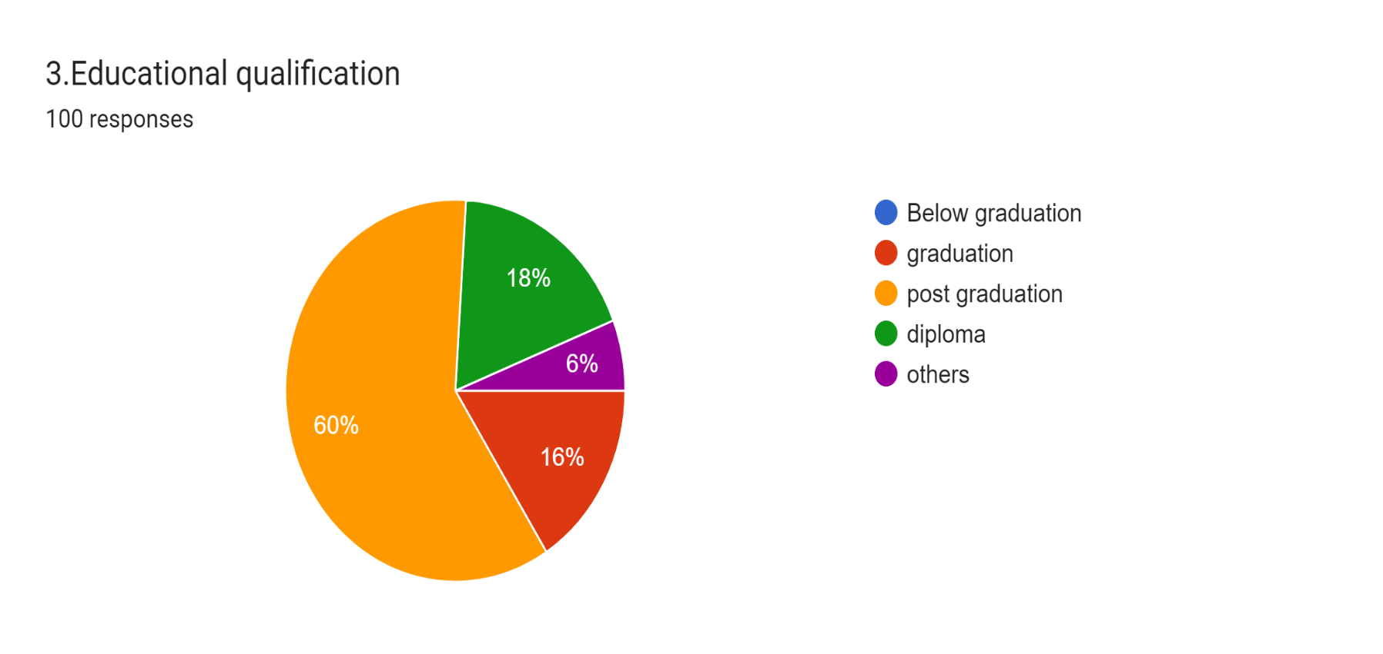Figure 4.3 Academic background of the employees

INTERPRETATION:

The majority of individuals in the sample have a postgraduate degree, comprising 60% of the total. Graduates and those with a diploma make up 16% and 18%, respectively. There are no individuals in the "Below Graduate" category, and a smaller percentage (6%) fall into the "Others" category.

**4.3 YEARS OF EXPERIENCE IN THE ORGANISATION**

Table 4.3Years of experience in the organisation

|  |  |  |  |
| --- | --- | --- | --- |
| SL.NO | YEARS OF EXPERIENCE | FREQUENCY | PERCENTAGE |
| 1 | Below 5 years | 15 | 15 |
| 2 | 5-10 years | 54 | 54 |
| 3 | 11-20 years | 27 | 27 |
| 4 | 20 and above | 4 | 4 |
|  | TOTAL | 100 | 100 |

Figure 4.4 Years of experience in the organisation

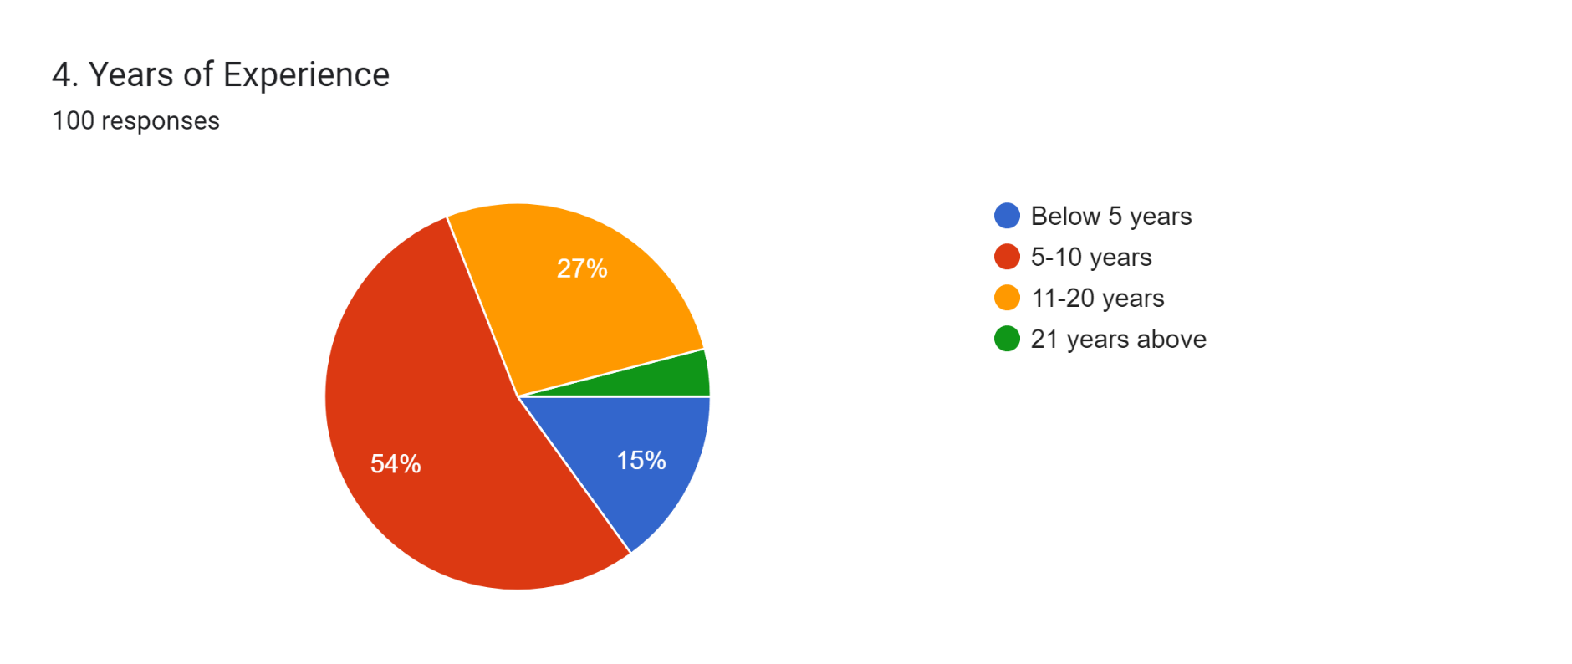

INTERPRETATION:

The majority of employees in the organisation fall within the 5-10 years of experience category, making up the largest proportion at 54%.There is a fairly distributed representation in the "Below 5 years" and "11-20 years" categories, constituting 15% and 27%, respectively. A smaller percentage (4%) of individuals in the sample has 20 or more years of experience within the organization.

**4.4 JOB TRAINING IN THE COMPANY**

Table4.4 Job training in the organisation

|  |  |  |  |
| --- | --- | --- | --- |
| SL.NO. | RESPONSE | FREQUENCY | PERCENTAGE |
| 1 | Yes | 96 | 96 |
| 2 | No | 4 | 4 |
|  | TOTAL | 100 | 100 |

Figure 4.4 Job training in the organisation

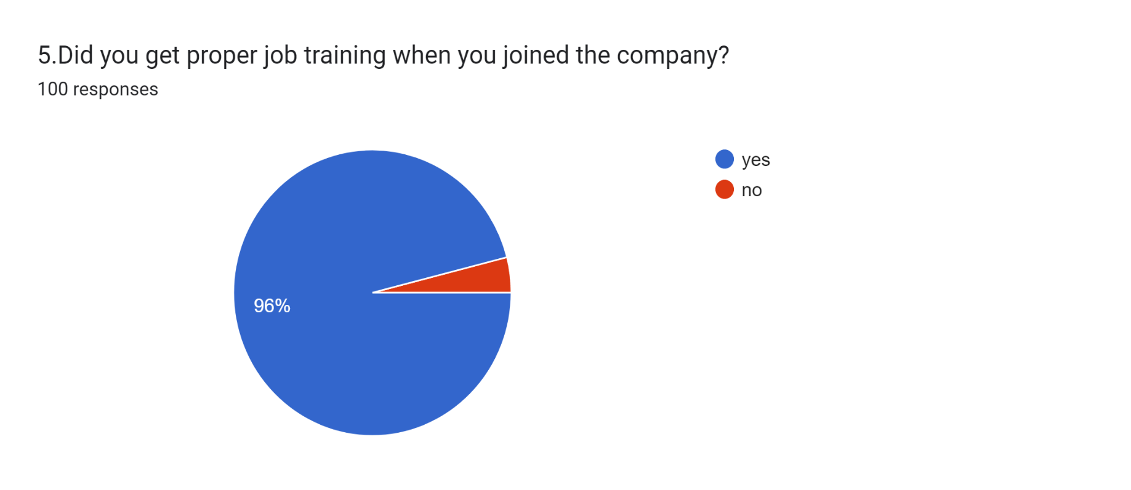

INTERPRETATION:

The overwhelming majority of respondents (96%) reported that they received proper job training upon joining the company. A small minority (4%) indicated that they did not receive proper job training.

**4.5 ARE YOU SATISFIED WITH PAY AND OTHER BENEFITS OFFERED BY THE COMPANY**

Table 4.5 Pay and other benefits offered by the company

|  |  |  |  |
| --- | --- | --- | --- |
| SL.NO. | RESPONSE | FREQUENCY | PERCENTAGE |
| 1 | Yes | 87 | 87 |
| 2 | No | 2 | 11 |
| 3 | Maybe | 11 | 2 |
|  | TOTAL | 100 | 100 |

Figure4.5 Pay and other benefit offered by the company

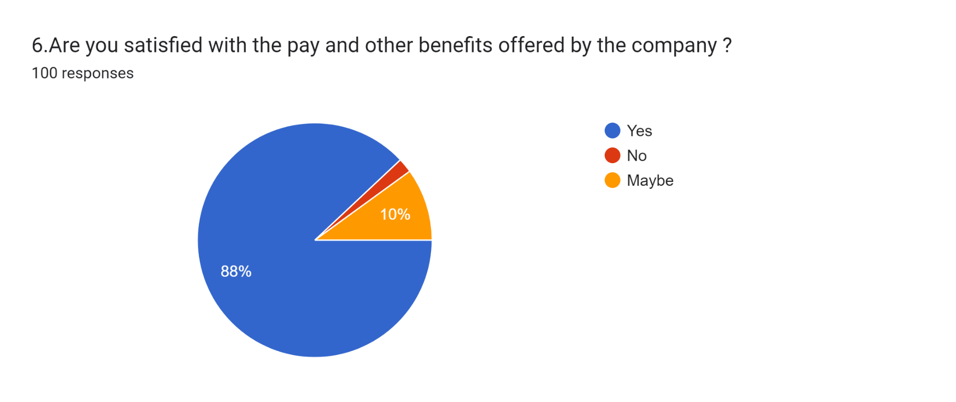

INTERPRETATION:

The majority of employees (87%) expressed satisfaction with the pay and other benefits offered by the company.

A small portion (11%) indicated dissatisfaction with these aspects.

A smaller percentage (2%) responded with uncertainty or mixed feelings regarding their satisfaction with pay and benefits.

**4.6 ARE THE MONENTARY INCENTIVES PAR WITH OTHER COMPANY**

Table 4.6 Momentary incentives par in the company

|  |  |  |  |
| --- | --- | --- | --- |
| SL.N0. | RESPONSE | FREQUENCY | PERCENTAGE |
| 1 | Strongly Agree | 25 | 25 |
| 2 | Agree | 56 | 56 |
| 3 | Neutral | 17 | 17 |
| 4 | Strongly Disagree | 2 | 2 |
| 5 | Disagree | 0 | 0 |
|  | TOTAL | 100 | 100 |

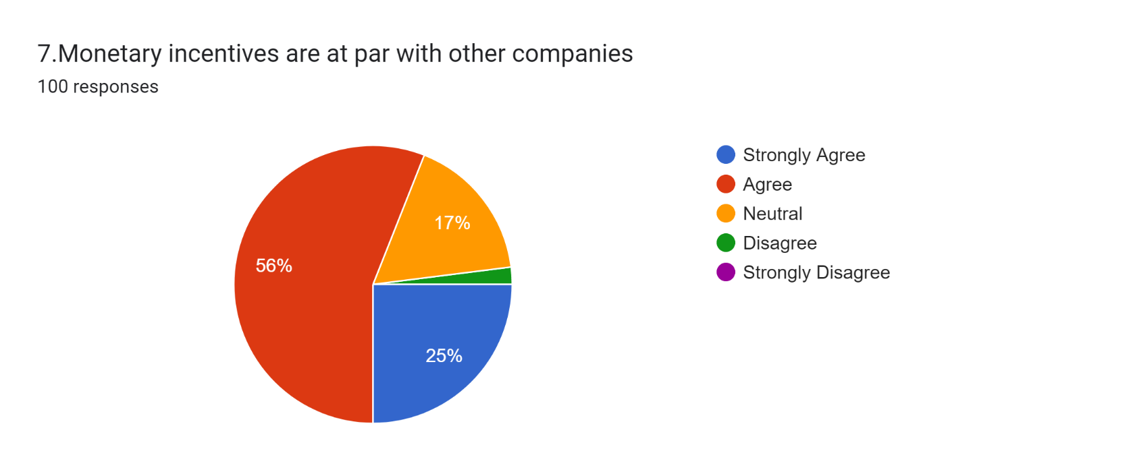Figure4.6 Momentary incentives par in the company

INTERPRETATION:

The combined percentage of those who strongly agree and agree is 81%, suggesting that a majority of individuals perceive the monetary incentives to be on par with other companies.A notable percentage (17%) remains neutral on this aspect, indicating a degree of uncertainty or mixed opinions.A small minority (2%) strongly disagrees with the idea that the monetary incentives are comparable to those of other companies.

**4.7 JOB PROMOTIONS IN THE COMPANY FAIR AND OBJECTIVE**

Table4.7 Fairness in job promotions

|  |  |  |  |
| --- | --- | --- | --- |
| SL.NO. | RESPONSE | FREQUENCY | PERCENTAGE |
| 1 | Yes | 87 | 87 |
| 2 | No | 2 | 2 |
| 3 | Sometimes | 11 | 11 |
|  | TOTAL | 100 | 100 |

Figure 4.7 Fairness in job promotions

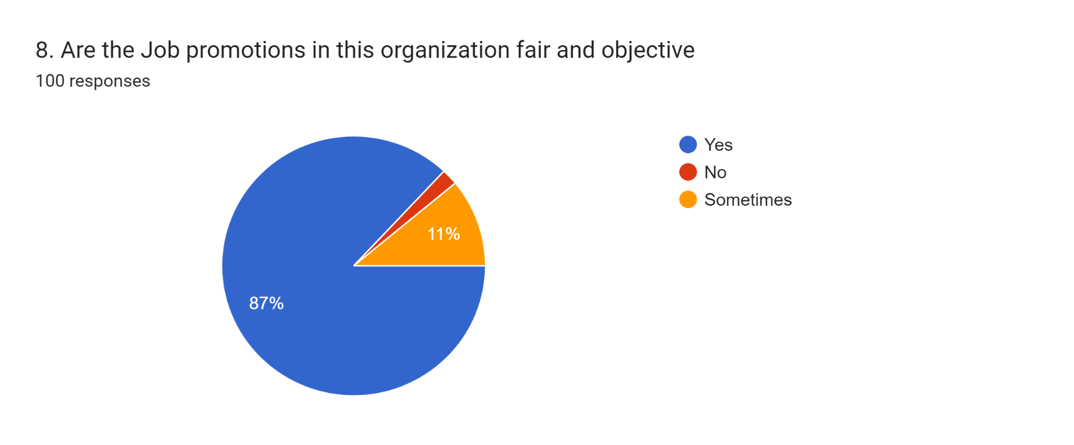

INTERPRETATION:

The vast majority of employees (87%) have a positive perception, believing that job promotions in the company are fair and objective.

A very small percentage (2%) holds a negative view, expressing a belief that promotions are not fair and objective.

A notable percentage (11%) indicated a more nuanced view, suggesting that job promotions are perceived as fair and objective only sometimes.

**4.8DIVISION AND ASSIGNMENT OF WORK**

Table 4.8Division and assignment of work

|  |  |  |  |
| --- | --- | --- | --- |
| SL.NO | RESPONSE | FREQUENCY | PERCENTAGE |
| 1 | Yes | 95 | 95 |
| 2 | No | 5 | 5 |
|  | TOTAL | 100 | 100 |

Figure 4.8 Division and assignment of work

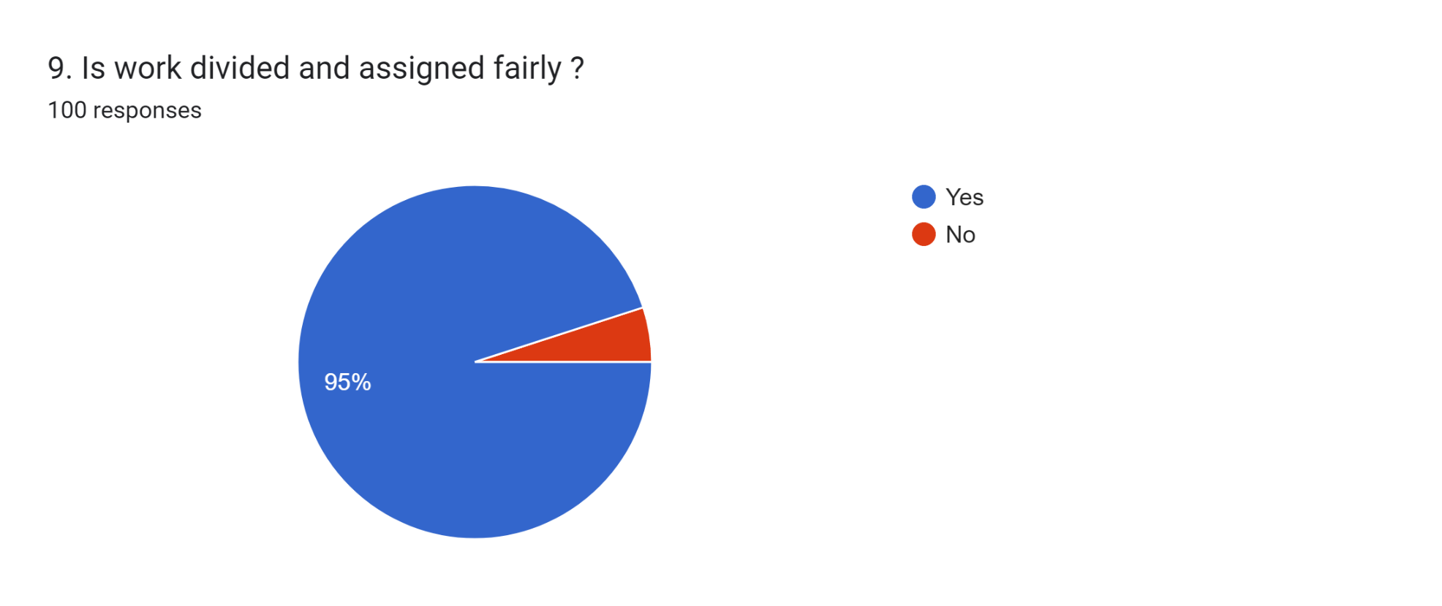

INTERPRETATION:

The overwhelming majority of respondents (95%) have a positive perception, believing that work is divided and assigned fairly within the company.

A small percentage (5%) holds a negative view, expressing a belief that work assignments are not fair.

**4.9 SATISFACTION WITH THE WORK EXPECTED**

Table4.9 Satisfaction with work expected

|  |  |  |  |
| --- | --- | --- | --- |
| SL.NO | RESPONSE | FREQUENCY | PERCENTAGE |
| 1 | Yes | 87 | 87 |
| 2 | No | 1 | 1 |
| 3 | Maybe | 12 | 12 |
|  | TOTAL | 100 | 100 |

Figure 4.9 Satisfaction with work expected

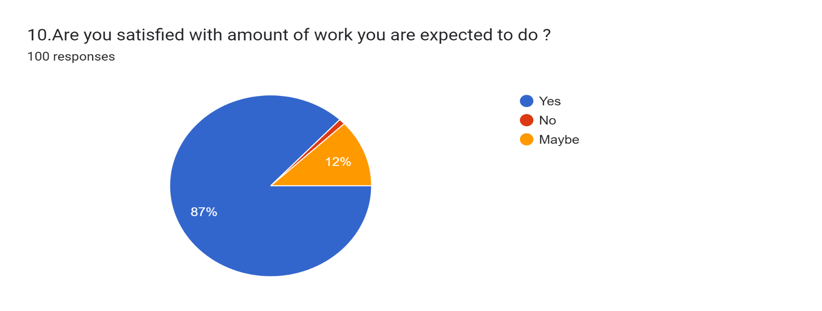

INTERPRETATION:

The majority of respondents (87%) express satisfaction with the work expected from them.

A very small percentage (1%) indicates dissatisfaction with the work expectations.

A notable percentage (12%) remains neutral or uncertain about their satisfaction with the work expected.

**4.10WORKING ENVIRONMENT**

Table4.10 Working environment

|  |  |  |  |
| --- | --- | --- | --- |
| SL.NO | RESPONSE | FREQUENCY | PERCENTAGE |
| 1 | Strongly Agree | 25 | 25 |
| 2 | Agree | 54 | 54 |
| 3 | Neutral | 17 | 17 |
| 4 | Strongly Disagree | 4 | 4 |
| 5 | Disagree | 0 | 0 |
|  | TOTAL | 100 | 100 |

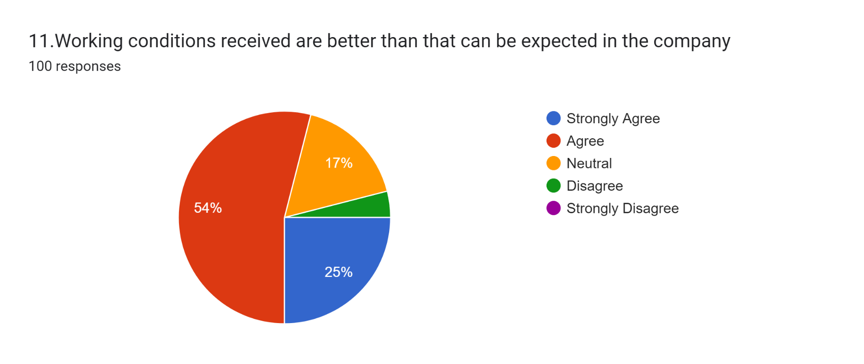Figure 4.10 Working environment

INTERPRETATION:

The combined percentage of those who strongly agree and agree is 79%, suggesting that a majority of individuals perceive the working environment positively.

A significant percentage (17%) remains neutral on this aspect, indicating a degree of uncertainty or mixed opinions.

A small minority (4%) strongly disagrees with the idea that the working environment is positive.

**4.11SAFETY ON THE JOB HAS ADEQUATE ATTENTION**

Table 4.11 Adequate existence of safety measures

|  |  |  |  |
| --- | --- | --- | --- |
| SL.NO | RESPONSE | FREQUENCY | PERCENTAGE |
| 1 | Strongly Agree | 24 | 24 |
| 2 | Agree | 52 | 52 |
| 3 | Neutral | 18 | 18 |
| 4 | Strongly Disagree | 4 | 4 |
| 5 | Disagree | 2 | 2 |
|  | TOTAL | 100 | 100 |

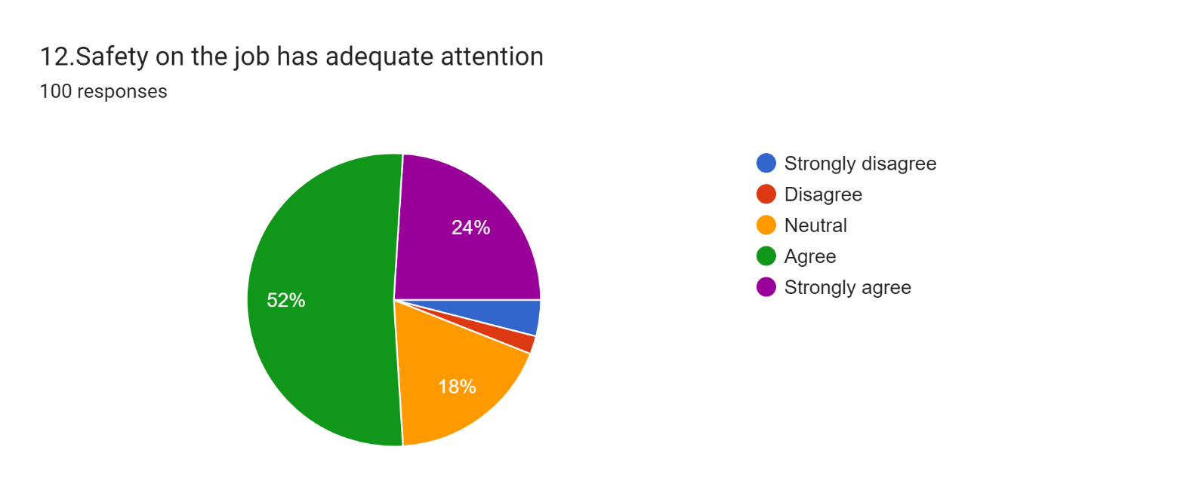Figure 4.11 Adequate existence of safety measures

INTERPRETATION:

Overall, the majority of respondents (76%) either strongly agree or agree that safety on the job receives adequate attention. This indicates a generally positive perception of safety measures in the workplace among the surveyed individuals.

However, it's worth noting that a minority (6%) either disagree or strongly disagree with this statement, suggesting that there may be some concerns or areas for improvement in the safety practices or perceptions within the organization.

**4.12 PROBLEMS IN THE WORKPLACE ARE ADRESSED QUICKLY AND ADEQUATELY**

Table 4.12 Employee grievance redressal mechanism

|  |  |  |  |
| --- | --- | --- | --- |
| SL.NO | RESPONSE | FREQUENCY | PERCENTAGE |
| 1 | Strongly Agree | 23 | 23 |
| 2 | Agree | 53 | 53 |
| 3 | Neutral | 16 | 16 |
| 4 | Strongly Disagree | 4 | 4 |
| 5 | Disagree | 4 | 4 |
|  | TOTAL | 100 | 100 |

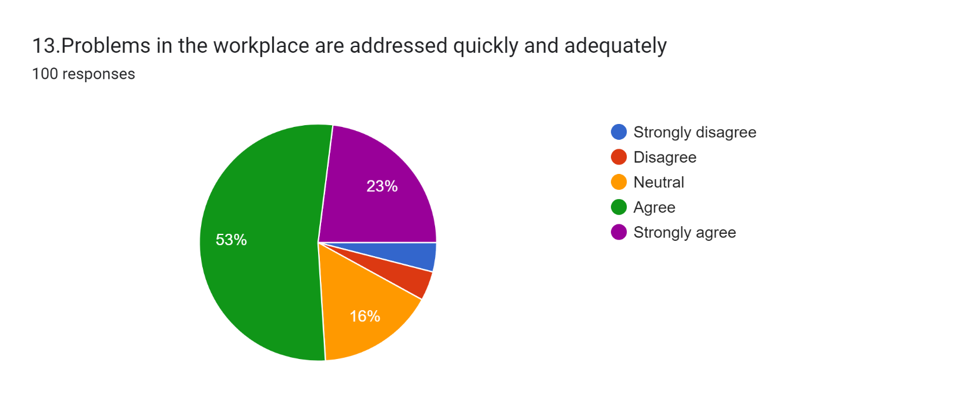Figure 4.12 Employee grievance redressal mechanism

INTERPRETATION:

While the majority of respondents hold positive views (76% combined in either "Strongly Agree" or "Agree" categories), it's notable that there are segments (8% combined in "Strongly Disagree" and "Disagree" categories) expressing dissatisfaction or disagreement with the effectiveness of problem-solving processes.

This highlights potential areas for improvement in addressing workplace issues promptly and satisfactorily for all employees.

Top of Form

**4.13 MOTIVATION AS A RESULT OF GOOD SUPERVISON**

Table 4.13 Motivation as a result of good supervision

|  |  |  |  |
| --- | --- | --- | --- |
| SL.NO | RESPONSE | FREQUENCY | PERCENTAGE |
| 1 | Strongly Agree | 23 | 23 |
| 2 | Agree | 54 | 54 |
| 3 | Neutral | 18 | 18 |
| 4 | Strongly Disagree | 3 | 3 |
| 5 | Disagree | 2 | 2 |
|  | TOTAL | 100 | 100 |

Figure 4.13 13 Motivation as a result of good supervision

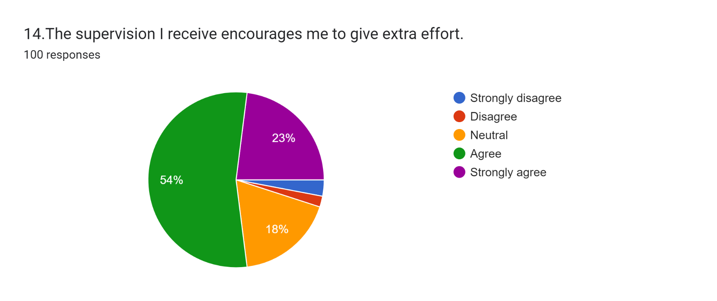INTERPRETATION:

The data from Table 4.13 suggests that most employees (77%) feel that supervision encourages them to put in extra effort, indicating overall satisfaction. However, a small portion (5%) disagrees, highlighting areas for improvement. Additionally, 18% remain neutral, signaling a need for further investigation. Overall, while supervision is seen as a positive motivator by many, addressing concerns of dissatisfaction and neutrality can enhance its effectiveness in fostering employee engagement.

Top of Form

**4.14 TARDINESS AND ABSENTISIM HANDLED FAIRLEY**

Table4.14 Fairness in absenteeism and tardiness

|  |  |  |  |
| --- | --- | --- | --- |
| SL.NO | RESPONSE | FREQUENCY | PERCENTAGE |
| 1 | Strongly Agree | 27 | 27 |
| 2 | Agree | 52 | 52 |
| 3 | Neutral | 14 | 14 |
| 4 | Strongly Disagree | 3 | 3 |
| 5 | Disagree | 4 | 4 |
|  | TOTAL | 100 | 100 |

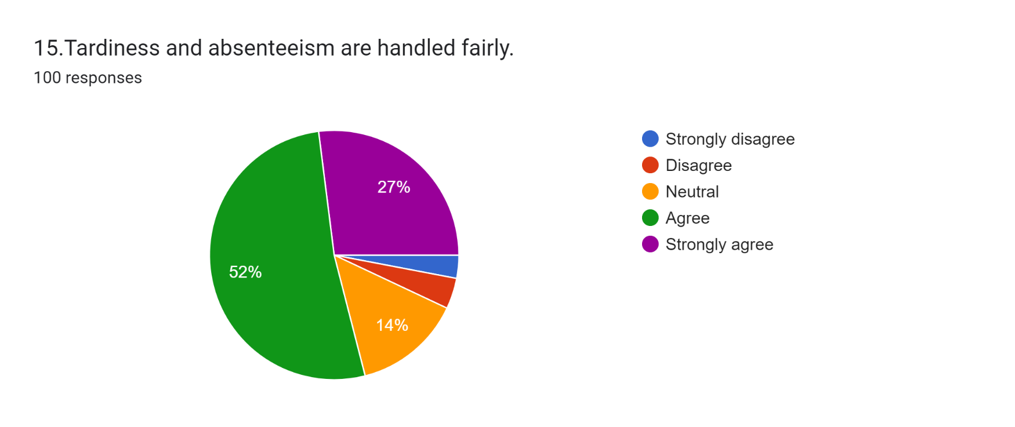Figure 4.14 Fairness in absenteeism and tardiness

INTERPRETATION:

The data indicates that the majority of respondents (79%) either strongly agree or agree that tardiness and absenteeism are handled fairly within the workplace. This suggests a generally positive perception regarding the fairness of the handling of these issues.

However, there is a notable minority (7%) who express either strong disagreement or disagreement with this sentiment, indicating potential areas of concern or dissatisfaction with the handling of tardiness and absenteeism. Additionally, 14% of respondents remain neutral, which may suggest uncertainty or a lack of strong opinion on the matter.

**4.15ARE THERE GOOD CHANNELSOF COMMUNICATION WHEN THERE ARE PROBLEMS**

Table4.15 Labour management communication

|  |  |  |  |
| --- | --- | --- | --- |
| SL.NO | RESPONSE | FREQUENCY | PERCENTAGE |
| 1 | Yes | 80 | 80 |
| 2 | No | 6 | 6 |
| 3 | Sometimes | 14 | 14 |
|  | TOTAL | 100 | 100 |

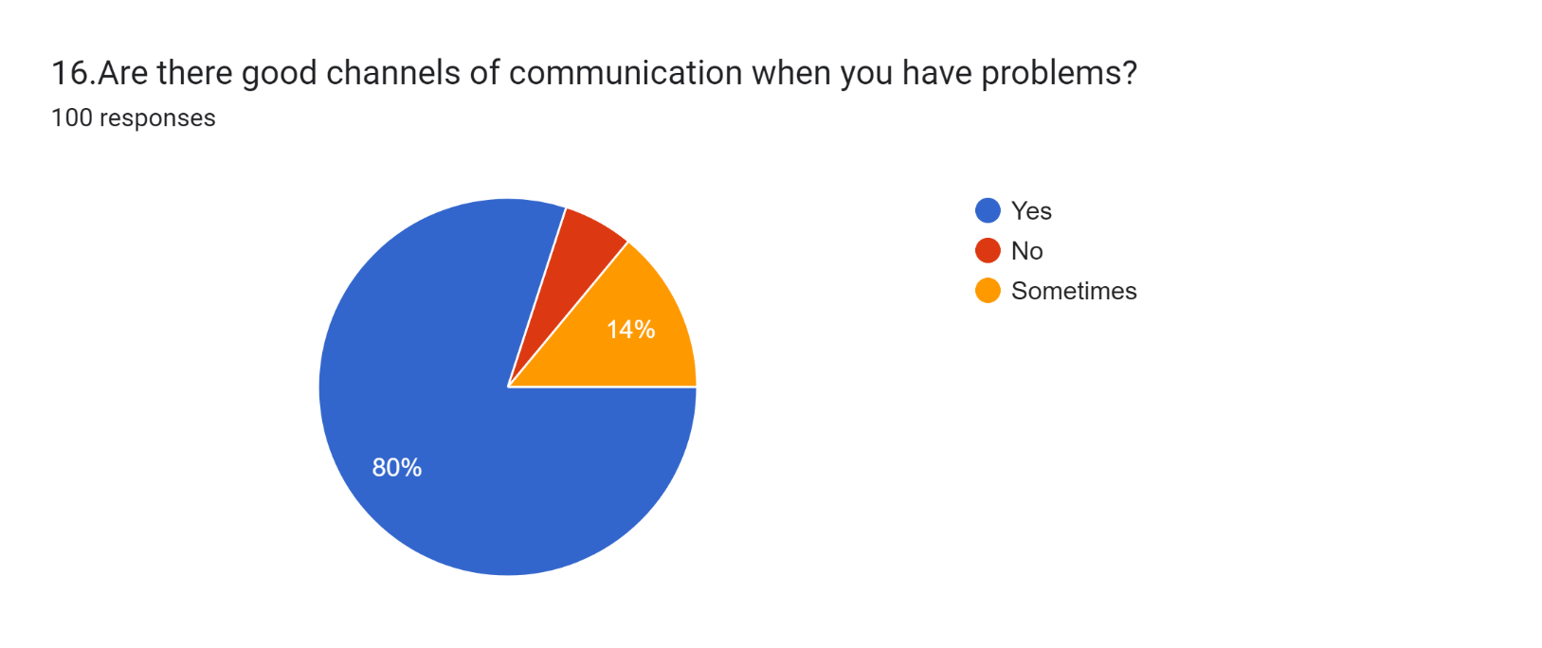Figure4.15 Labour management communication

INTERPRETATION:

The data suggests that a large majority of respondents (80%) believe there are good channels of communication available when they encounter problems in the workplace. This indicates a high level of satisfaction with the communication avenues provided by the organization. However, a small percentage (6%) indicates that there are no such channels, which may suggest areas for improvement in facilitating communication.

Additionally, 14% of respondents indicate that communication channels are sometimes available, implying a need for consistency or enhancement in communication practices to ensure effective problem-solving processes.

Top of Form

**4.16 EMPLOYESS ARE CONSULTED ABOUTH CHANGES THAT DIRETLY AFFECT THEM**.

Table 4.16 Employee participation

|  |  |  |  |
| --- | --- | --- | --- |
| SL.NO | RESPONSE | FREQUENCY | PERCENTAGE |
| 1 | Strongly Agree | 25 | 25 |
| 2 | Agree | 59 | 59 |
| 3 | Neutral | 14 | 14 |
| 4 | Strongly Disagree | 2 | 2 |
| 5 | Disagree | 0 | 0 |
|  | TOTAL | 100 | 100 |

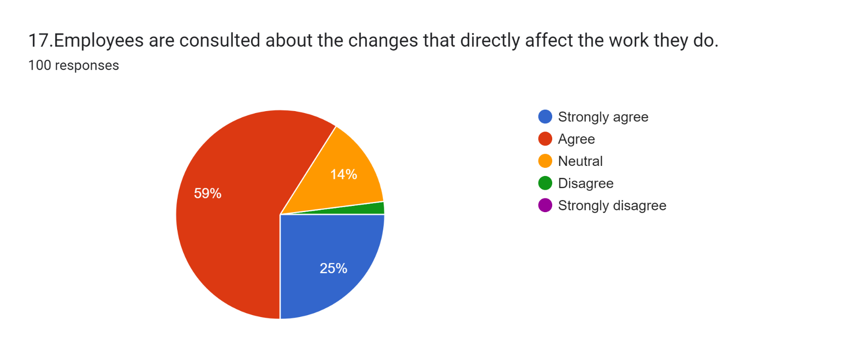Figure 4.16 Employee participation

INTERPRETATION:

The data shows that 84% of respondents feel they are consulted about changes directly impacting their work, indicating a strong sense of satisfaction with their level of involvement in decision-making processes. Interestingly, 14% of respondents remain neutral, suggesting a potential gap in communication or awareness regarding consultation practices. Notably, there are 2% respondents who strongly disagree. Overall, the data suggests a positive organizational environment where employees are actively engaged in discussions about changes impacting their roles.

Top of Form

**4.17 TREATMENT OF EMPLOYEES IS CONSISTENT**.

Table 4.17 Consistent treatment of employees

|  |  |  |  |
| --- | --- | --- | --- |
| SL.NO | RESPONSE | FREQUENCY | PERCENTAGE |
| 1 | Strongly Agree | 18 | 18 |
| 2 | Agree | 61 | 61 |
| 3 | Neutral | 15 | 15 |
| 4 | Strongly Disagree | 3 | 3 |
| 5 | Disagree | 3 | 3 |
|  | TOTAL | 100 | 100 |

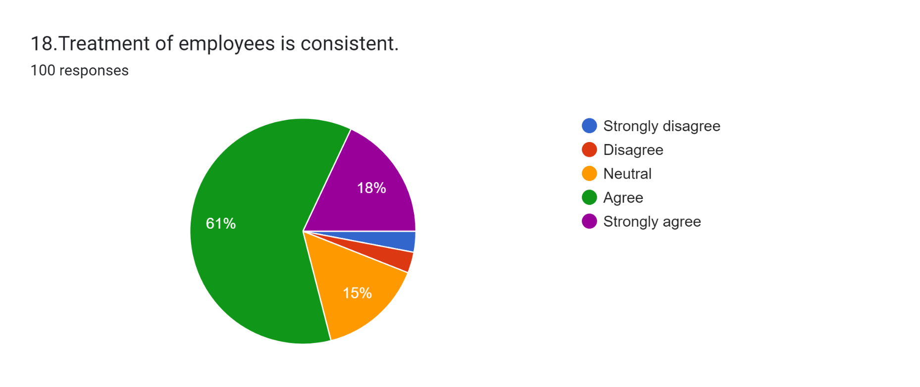Figure 4.17 Consistent treatment of employees

INTERPRETATION:

From this data, it appears that a majority of respondents (79%) either strongly agree or agree that the treatment of employees is consistent. Additionally, only a small minority (6%) disagrees or strongly disagrees with this statement.

This suggests that, according to the respondents, there is a perception of consistency in the treatment of employees within the organization or context being surveyed.

**4.18 MANAGEMENT MAKING STRONG EFFORTS TO IMPROVING THE ORGANISATION**

Table4.18 Involvement of management in improving the organisation

|  |  |  |  |
| --- | --- | --- | --- |
| SL.NO | RESPONSE | FREQUENCY | PERCENTAGE |
| 1 | Yes | 82 | 82 |
| 2 | No | 15 | 15 |
| 3 | Maybe | 3 | 3 |
|  | TOTAL | 100 | 100 |

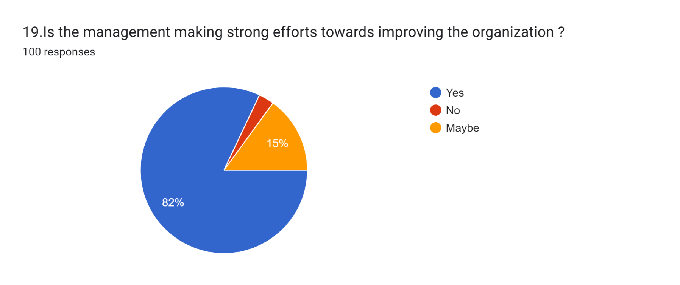Figure4.18 Involvement of management in improving the organisation

INTERPRETATION:

The data indicates that 82% of respondents believe management is actively making strong efforts to improve the organization. However, 15% express scepticism, while 3% are uncertain.

This suggests a largely positive perception of management's initiatives, though there are notable pockets of doubt and uncertainty among respondents.

**4.19 JOB RESPONSIBILITY CONTRIBUTES TO PROFESSIONAL DEVELOPMENT**

Table 4.19 Job responsibility contributes to professional development

|  |  |  |  |
| --- | --- | --- | --- |
| SL.NO | RESPONSE | FREQUENCY | PERCENTAGE |
| 1 | Yes | 85 | 85 |
| 2 | No | 12 | 12 |
| 3 | Maybe | 3 | 3 |
|  | TOTAL | 100 | 100 |

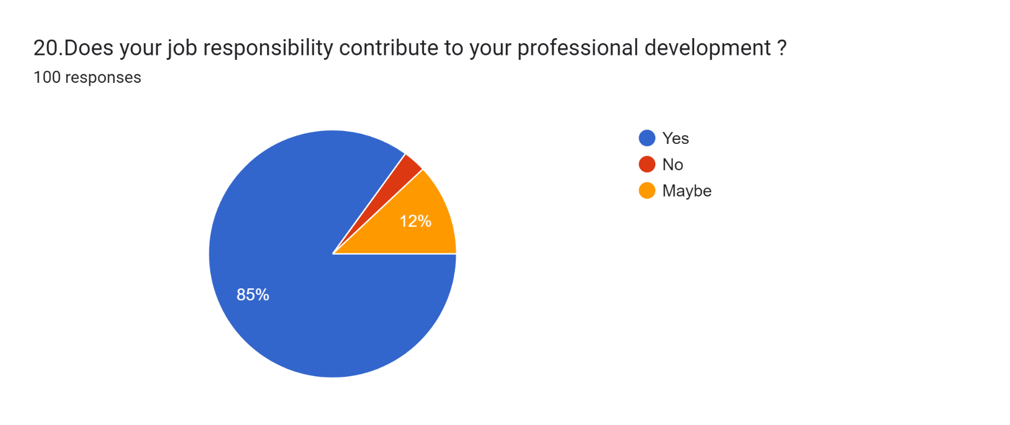Figure4.19 Job responsibility contributes to professional development

INTERPRETATION:

The data from Table 4.19 indicates respondents' perspectives on whether their job responsibilities contribute to their professional development. 85% of respondents answered affirmatively, suggesting that they believe their job responsibilities contribute to their professional development.

12% of respondents indicated that their job responsibilities do not contribute to their professional development. Only 3% of respondents were uncertain or neutral about the extent to which their job responsibilities contribute to their professional development.

**4.20 GIVE OPPORTUNITY TO SPECIALIZE IN STRENGHT OF THE EMPLOYEES**

Table4.20 Opportunity to specialize in strength of employees

|  |  |  |  |
| --- | --- | --- | --- |
| SL.NO | RESPONSE | FREQUENCY | PERCENTAGE |
| 1 | Yes | 81 | 81 |
| 2 | No | 3 | 3 |
| 3 | Sometimes | 16 | 16 |
|  | TOTAL | 100 | 100 |

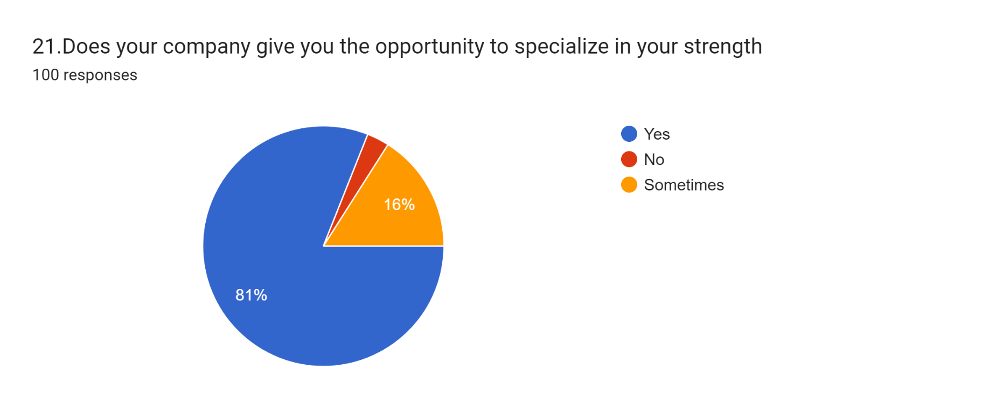Figure 4.20 Opportunity to specialize in strength of employees

INTERPRETATION:

From this data, it appears that a majority of respondents (81%) feel that their company does indeed provide them with opportunities to specialize in their strengths.

However, there is a small percentage (3%) who do not perceive such opportunities, while a notable proportion (16%) feel that these opportunities are only available to them intermittently. This suggests that while many employees feel supported in leveraging their strengths, there may be room for improvement in ensuring consistent access to these opportunities across the organization.

**4.21ORGANISATION MAKES AN EFFORT TO HELP EMPLOYEES IMPROVE THEMSELVES**

Table 4.21Organisation’s effort to help employees

|  |  |  |  |
| --- | --- | --- | --- |
| SL.NO | RESPONSE | FREQUENCY | PERCENTAGE |
| 1 | Strongly Agree | 24 | 24 |
| 2 | Agree | 60 | 60 |
| 3 | Neutral | 12 | 12 |
| 4 | Strongly Disagree | 3 | 3 |
| 5 | Disagree | 1 | 1 |
|  | TOTAL | 100 | 100 |

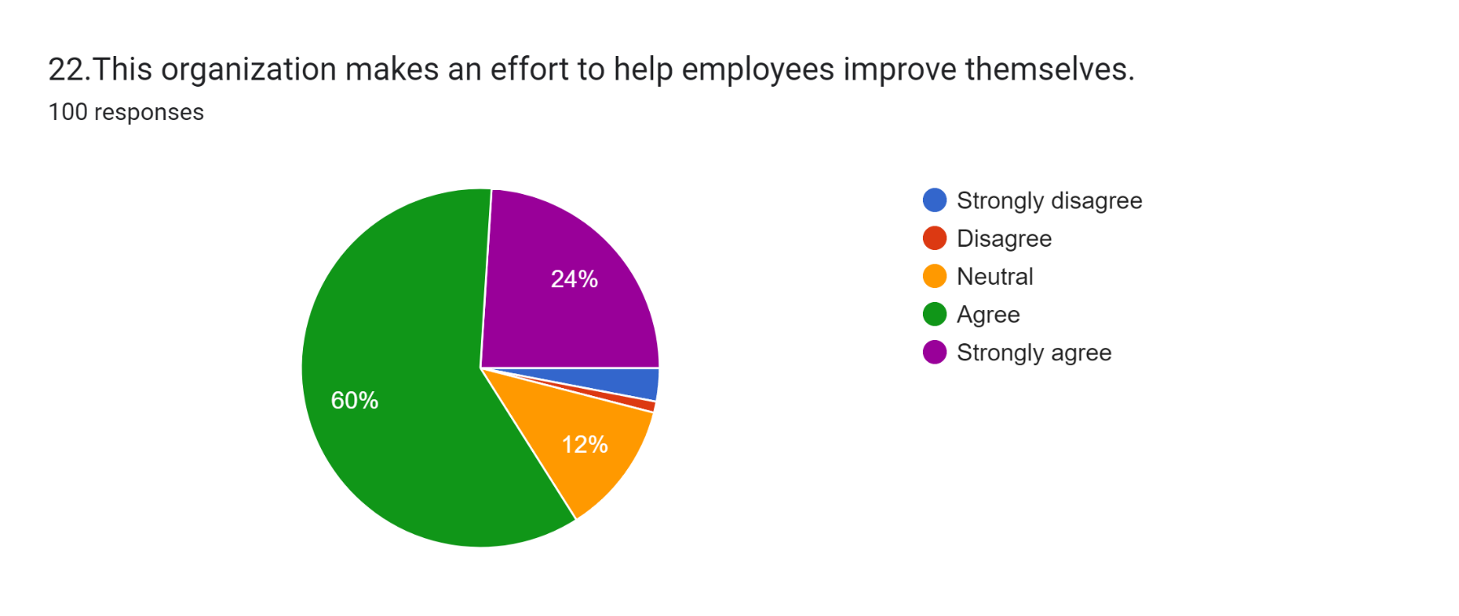Figure 4.21 Organisation’s effort to help employees

INTERPRETATION:

The data indicates a strong positive perception among employees towards the organization's efforts to help them improve themselves. A significant majority (84%) either strongly agree or agree with this sentiment, while only a small fraction (4%) express disagreement.

The presence of a neutral stance from 12% of respondents suggests some room for further investigation or improvement in specific areas. Overall, the data reflects a generally positive outlook regarding the organization's support for employee self-improvement.

**4.22 CLEAR INSTRUCTIONS FROM THE TOP MANAGEMENT**

Table 4.22 Clear instructions from top management

|  |  |  |  |
| --- | --- | --- | --- |
| SL.NO | RESPONSE | FREQUENCY | PERCENTAGE |
| 1 | Yes | 83 | 83 |
| 2 | No | 2 | 2 |
| 3 | Maybe | 15 | 15 |
|  | TOTAL | 100 | 100 |

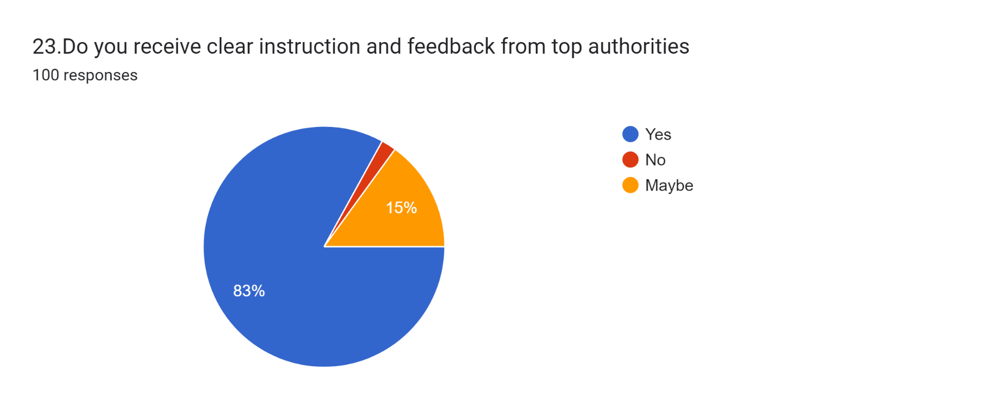Figure 4.22 Clear instructions from top management

INTERPRETATION:

Based on the data, it appears that a majority of respondents (83%) affirm receiving clear instruction and feedback from top authorities within the organization. However, there is a notable proportion (15%) who responded with "Maybe," suggesting some ambiguity or uncertainty regarding the clarity of instructions and feedback. Only a small minority (2%) outright stated they do not receive clear instruction and feedback. While the majority's positive response is encouraging, the presence of a significant "Maybe" category warrants attention, indicating a potential need for the organization to enhance clarity in communication and feedback processes to address any uncertainties among employees.

Top of Form

**4.23 LIKLINESS OF EMPLOYEES TO ADVICE OTHERS TO APPLY FOR JOB IN THIS COMPANY**

Table 4.23 Advising others to apply for job in this company

|  |  |  |  |
| --- | --- | --- | --- |
| SL.NO | RESPONSE | FREQUENCY | PERCENTAGE |
| 1 | Yes | 78 | 78 |
| 2 | No | 19 | 19 |
| 3 | Maybe | 3 | 3 |
|  | TOTAL | 100 | 100 |

Figure 4.23 Advising others to apply for job in this company

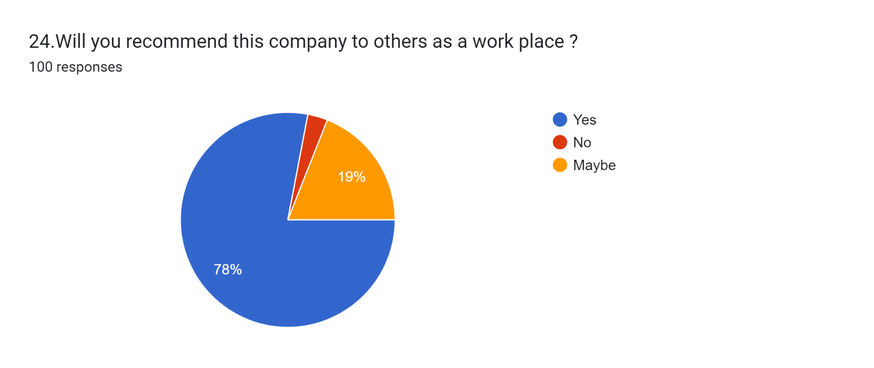

INTERPRETATION:

Based on the data, it appears that a majority of respondents (78%) would recommend the company as a workplace to others. However, a notable proportion (19%) indicated they would not recommend it, while a smaller percentage (3%) responded with "Maybe." While the majority's positive recommendation is significant, the presence of a substantial "No" category suggests there may be areas of concern or dissatisfaction among some employees that could impact their willingness to endorse the company as a workplace.It would be essential for the organization to investigate and address any issues identified by those who would not recommend the company, in order to improve overall employee satisfaction and perception.

**4.24 DESIRE FOR CHANGE OF ORGANISATION**

Table 4.24 Desire for change of organisation

|  |  |  |  |
| --- | --- | --- | --- |
| SL.NO | RESPONSE | FREQUENCY | PERCENTAGE |
| 1 | Yes | 10 | 10 |
| 2 | No | 80 | 80 |
| 3 | Maybe | 10 | 10 |
|  | TOTAL | 100 | 100 |

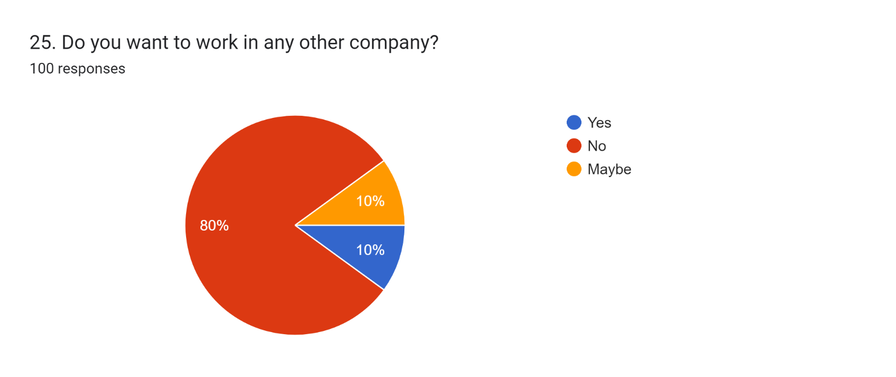Figure 4.24 Desire for change of organisation

INTERPRETATION:

Based on the data, the majority of respondents (80%) indicated that they do not want to work in any other company. However, 10% responded affirmatively, stating they do want to work elsewhere, while another 10% expressed uncertainty with a "Maybe" response. While the majority seems content with their current employment, the presence of respondents considering other opportunities or uncertain about their future plans suggests a need for the organization to assess and address potential factors contributing to this sentiment. It could involve exploring opportunities for career development, addressing any concerns regarding workplace culture or job satisfaction, and fostering a supportive environment that encourages long-term commitment from employees.

**Objective 1: To understand the various strategy adopted by Unitac Energy solutions to satisfy their employees.**

Table 4.25

Descriptive Statistics on Satisfaction of Employees towards various Strategies

|  |  |  |
| --- | --- | --- |
| Elements of Satisfaction | Mean | Std. Deviation |
| Problems in the workplace are addressed quickly and adequately | 3.8700 | 0.94980 |
| Employees are consulted about the changes that directly affect the work they do | 4.0700 | 0.68542 |
| Treatment of employees is consistent | 3.8800 | 0.84423 |

Table 4.25 presents the descriptive statistics regarding employee satisfaction with various strategies within the workplace. The elements of satisfaction include the prompt and adequate addressing of workplace problems, consultation with employees regarding changes directly impacting their work, and the consistency in the treatment of employees. The mean values indicate the average level of satisfaction reported by employees for each element, with scores ranging from 3.87 to 4.07 out of 5. A lower standard deviation suggests less variability in responses, indicating a relatively consistent perception among employees for each element. Overall, the table suggests that employees generally perceive positively the prompt addressing of workplace issues and consultation about changes, although there may be some variability in the consistency of treatment received, albeit still within a generally favourable range.

Table 4.26

Age wise distribution of Satisfaction of Employees towards various Strategies

|  |  |  |  |  |
| --- | --- | --- | --- | --- |
| Age |  | Problems addressed quickly and adequately | Employees are consulted | Treatment of employees is consistent |
| Below 30 years | Mean | 3.7778 | 3.8889 | 3.7778 |
|  | N | 18 | 18 | 18 |
|  | Std. Deviation | 1.00326 | 0.90025 | 0.80845 |
| 30-40 years | Mean | 3.9265 | 4.1471 | 3.9853 |
|  | N | 68 | 68 | 68 |
|  | Std. Deviation | 0.95129 | 0.67503 | 0.81940 |
| 41-50 years | Mean | 3.7143 | 3.9286 | 3.5000 |
|  | N | 14 | 14 | 14 |
|  | Std. Deviation | 0.91387 | 0.26726 | 0.94054 |
| Total | Mean | 3.8700 | 4.0700 | 3.8800 |
|  | N | 100 | 100 | 100 |
|  | Std. Deviation | 0.94980 | 0.68542 | 0.84423 |

Table 4.26 provides the age-wise distribution of employee satisfaction towards various strategies within the workplace. It outlines the mean satisfaction scores and standard deviations across three age groups: below 30 years, 30-40 years, and 41-50 years, along with the overall totals. For the element "Problems addressed quickly and adequately," the mean satisfaction scores range from 3.7143 to 3.9265 across age groups, with standard deviations indicating the variability in responses. Similarly, for "Employees are consulted," mean scores range from 3.8889 to 4.1471, and for "Treatment of employees is consistent," mean scores range from 3.5000 to 3.9853. The table illustrates that generally, higher mean satisfaction scores are observed in the 30-40 years age group, particularly for consultation with employees and consistency in treatment. However, the below 30 years age group demonstrates slightly lower mean scores across all elements. These statistics provide insights into age-related differences in employee perceptions of workplace strategies.

Table 4.27

Education wise distribution of Satisfaction of Employees towards various Strategies

|  |  |  |  |  |
| --- | --- | --- | --- | --- |
| Education |  | Problems addressed quickly and adequately | Employees are consulted | Treatment of employees is consistent |
| Graduation | Mean | 3.5000 | 3.8125 | 3.8125 |
|  | N | 16 | 16 | 16 |
|  | Std. Deviation | 1.09545 | 0.54391 | 0.83417 |
| Post-graduation | Mean | 3.9833 | 4.1667 | 3.9667 |
|  | N | 60 | 60 | 60 |
|  | Std. Deviation | 0.91117 | 0.76284 | 0.84305 |
| Diploma | Mean | 3.7778 | 4.0000 | 3.6667 |
|  | N | 18 | 18 | 18 |
|  | Std. Deviation | 1.06027 | 0.59409 | 0.97014 |
| Others | Mean | 4.0000 | 4.0000 | 3.8333 |
|  | N | 6 | 6 | 6 |
|  | Std. Deviation | 0.00000 | 0.00000 | 0.40825 |
| Total | Mean | 3.8700 | 4.0700 | 3.8800 |
|  | N | 100 | 100 | 100 |
|  | Std. Deviation | 0.94980 | 0.68542 | 0.84423 |

Table 4.27 displays the education-wise distribution of employee satisfaction towards various workplace strategies. It presents mean satisfaction scores and standard deviations across different educational backgrounds: Graduation, Post-graduation, Diploma, and Others, along with the overall totals. For the aspect "Problems addressed quickly and adequately," mean satisfaction scores range from 3.5000 to 4.0000 across education levels, with standard deviations reflecting the variability in responses. Regarding "Employees are consulted," mean scores vary from 3.8125 to 4.1667, while for "Treatment of employees is consistent," mean scores range from 3.6667 to 3.9667. Notably, individuals with post-graduation degrees tend to report higher satisfaction levels across all aspects compared to those with other educational backgrounds. Conversely, those with graduation and diploma qualifications demonstrate slightly lower satisfaction scores, particularly in the prompt addressing of problems and consistency in treatment. These statistics offer insights into how education levels might influence employee perceptions of workplace strategies.

Table 4.28

Year of Experience wise distribution of Satisfaction of Employees towards various Strategies

|  |  |  |  |  |
| --- | --- | --- | --- | --- |
| Years of Experience |  | Problems addressed quickly and adequately | Employees are consulted | Treatment of employees is consistent |
| Below 5 years | Mean | 3.7333 | 3.8667 | 3.7333 |
|  | N | 15 | 15 | 15 |
|  | Std. Deviation | 1.09978 | 0.99043 | 0.88372 |
| 5-10 years | Mean | 3.9815 | 4.1481 | 3.9815 |
|  | N | 54 | 54 | 54 |
|  | Std. Deviation | 0.92125 | 0.68425 | 0.85761 |
| 11-20 years | Mean | 3.7407 | 4.0741 | 3.8519 |
|  | N | 27 | 27 | 27 |
|  | Std. Deviation | 0.94432 | 0.47442 | 0.76980 |
| 21 years above | Mean | 3.7500 | 3.7500 | 3.2500 |
|  | N | 4 | 4 | 4 |
|  | Std. Deviation | 0.95743 | 0.50000 | 0.95743 |
| Total | Mean | 3.8700 | 4.0700 | 3.8800 |
|  | N | 100 | 100 | 100 |
|  | Std. Deviation | 0.94980 | 0.68542 | 0.84423 |

Table 4.28 illustrates the distribution of employee satisfaction towards various workplace strategies based on years of experience. It presents mean satisfaction scores and standard deviations across different experience levels: Below 5 years, 5-10 years, 11-20 years, and 21 years and above, along with the overall totals. For the category "Problems addressed quickly and adequately," mean satisfaction scores range from 3.7333 to 3.9815 across experience levels, with corresponding standard deviations reflecting the variability in responses. Regarding "Employees are consulted," mean scores vary from 3.7500 to 4.1481, while for "Treatment of employees is consistent," mean scores range from 3.2500 to 3.9815. Notably, employees with 5-10 years of experience tend to report higher satisfaction levels across all aspects compared to other experience groups. Conversely, those with 21 years and above of experience demonstrate slightly lower satisfaction scores, particularly in terms of the treatment consistency. These statistics provide insights into how years of experience may influence employee perceptions of workplace strategies.

Table 4.29

Checking normality of the variables related to satisfaction of Employees towards various Strategies

|  |  |  |  |  |
| --- | --- | --- | --- | --- |
|  | Null Hypothesis | Test | Sig. | Decision |
| 1 | The distribution of problems in the workplace are addressed quickly and adequately is normal with mean 3.87 and standard deviation .94980. | One-Sample Kolmogorov-Smirnov Test | .000a | Reject the null hypothesis. |
| 2 | The distributions of Employees are consulted about the changes that directly affect the work they do is normal with mean 4.07 and standard deviation .68542. | One-Sample Kolmogorov-Smirnov Test | .000a | Reject the null hypothesis. |
| 3 | The distribution of Treatment of employees is consistent is normal with mean 3.88 and standard deviation .84423. | One-Sample Kolmogorov-Smirnov Test | .000a | Reject the null hypothesis. |
| Asymptotic significances are displayed. The significance level is .050. | | | | |
| a. Lilliefors Corrected | | | | |

Table 4.29 presents the results of the normality tests conducted on variables related to employee satisfaction towards various workplace strategies. The null hypothesis for each test is that the distribution of the respective variable is normal, with specified mean and standard deviation. The tests were performed using the One-Sample Kolmogorov-Smirnov Test, and the significance level was set at .050. For all three variables tested—problems addressed quickly and adequately, employees consulted about changes affecting their work, and treatment consistency—the p-values obtained were .000, leading to the rejection of the null hypothesis in each case. Therefore, based on these tests, the distributions of the variables are not considered normal. The Lilliefors correction was applied to calculate asymptotic significances. These results provide insights into the distributional characteristics of the variables related to employee satisfaction.

**Null Hypothesis:**There is no significant difference in employee satisfaction towards various strategies across different age groups, educational backgrounds, and years of experience.

**Alternative Hypothesis:** There is a significant difference in employee satisfaction towards various strategies across different age groups, educational backgrounds, and years of experience.

Table 4.30

Kruskal Wallis Test with respect to satisfaction of Employees towards various Strategies based on their age

|  |  |  |  |  |
| --- | --- | --- | --- | --- |
|  | Null Hypothesis | Test | Sig. | Decision |
| 1 | The distributions of problems in the workplace are addressed quickly and adequately are the same across categories of Age. | Independent-Samples Kruskal-Wallis Test | 0.004 | Reject the null hypothesis. |
| 2 | The distributions of Employees are consulted about the changes that directly affect the work they do is the same across categories of Age. | Independent-Samples Kruskal-Wallis Test | 0.005 | Reject the null hypothesis. |
| 3 | The distribution of Treatment of employees is consistent is the same across categories of Age. | Independent-Samples Kruskal-Wallis Test | 0.006 | Reject the null hypothesis. |
| Asymptotic significances are displayed. The significance level is .050. | | | | |

Table 4.30 summarizes the results of the Kruskal-Wallis tests conducted to examine the relationship between employee satisfaction towards various workplace strategies and age. The null hypothesis for each test posited that the distributions of satisfaction scores across different age groups were the same. However, the obtained p-values for all three tests were below the threshold of 0.050, leading to the rejection of the null hypothesis in each case. This rejection indicates that there are statistically significant differences in employee satisfaction scores across age groups for each aspect examined: problems addressed quickly and adequately, employees consulted about changes affecting their work, and treatment consistency. These findings suggest that age may indeed play a significant role in influencing employee perceptions of workplace strategies, highlighting the importance of considering age-related factors in organizational policies and practices aimed at enhancing employee satisfaction and overall organizational effectiveness.

Table 4.31

Kruskal Wallis Test with respect to satisfaction of Employees towards various Strategies based on their education

|  |  |  |  |  |
| --- | --- | --- | --- | --- |
|  | Null Hypothesis | Test | Sig. | Decision |
| 1 | The distributions of Problems in the workplace are addressed quickly and adequately are the same across categories of Education. | Independent-Samples Kruskal-Wallis Test | 0.003 | Reject the null hypothesis. |
| 2 | The distributions of Employees are consulted about the changes that directly affect the work they do is the same across categories of Education. | Independent-Samples Kruskal-Wallis Test | 0.019 | Reject the null hypothesis. |
| 3 | The distribution of Treatment of employees is consistent is the same across categories of Education. | Independent-Samples Kruskal-Wallis Test | 0.598 | Retain the null hypothesis. |
| Asymptotic significances are displayed. The significance level is .050. | | | | |

Table 4.31 presents the outcomes of the Kruskal-Wallis tests examining the relationship between employee satisfaction towards various workplace strategies and education levels. The null hypothesis for each test assumed that the distributions of satisfaction scores across different education categories were the same. However, the obtained p-values reveal distinct outcomes for the different aspects examined. For "Problems in the workplace addressed quickly and adequately" and "Employees consulted about changes affecting their work," the p-values were 0.003 and 0.019, respectively, falling below the significance threshold of 0.050. Therefore, the null hypotheses for these aspects are rejected, indicating significant differences in satisfaction scores across education levels. However, for "Treatment of employees is consistent," the p-value obtained was 0.598, above the significance level, leading to the retention of the null hypothesis. This suggests that there is no significant difference in satisfaction scores for this aspect across education categories. These findings underscore the importance of considering education levels in addressing employee satisfaction, particularly concerning problem resolution and consultation about changes in the workplace.

Table 4.32

Kruskal Wallis Test with respect to satisfaction of Employees towards various Strategies based on their Year of Experience

|  |  |  |  |  |
| --- | --- | --- | --- | --- |
|  | Null Hypothesis | Test | Sig. | Decision |
| 1 | The distributions of Problems in the workplace are addressed quickly and adequately are the same across categories of Years of Experience. | Independent-Samples Kruskal-Wallis Test | 0.006 | Retain the null hypothesis. |
| 2 | The distributions of Employees are consulted about the changes that directly affect the work they do is the same across categories of Years of Experience. | Independent-Samples Kruskal-Wallis Test | 0.004 | Retain the null hypothesis. |
| 3 | The distribution of Treatment of employees is consistent is the same across categories of Years of Experience. | Independent-Samples Kruskal-Wallis Test | 0.014 | Retain the null hypothesis. |
| Asymptotic significances are displayed. The significance level is .050. | | | | |

Table 4.32 presents the results of the Kruskal-Wallis tests examining the relationship between employee satisfaction towards various workplace strategies and years of experience. The null hypothesis for each test posited that the distributions of satisfaction scores across different experience categories were the same. The obtained p-values for each test were compared against the significance level of 0.050. The results indicate that for "Problems in the workplace addressed quickly and adequately," the p-value was 0.006, for "Employees consulted about changes affecting their work" it was 0.004, and for "Treatment of employees is consistent" it was 0.014. In all three cases, the p-values were below the significance level, leading to the retention of the null hypothesis. Therefore, there is insufficient evidence to suggest significant differences in satisfaction scores across experience categories for each aspect examined. This implies that years of experience may not significantly influence employee perceptions of the workplace strategies under consideration in this analysis.

**Conclusion:**There is a significant difference in employee satisfaction towards various strategies across different age groups, educational backgrounds, and years of experience.

**Objective 2: To study the effect of those strategies which are adopted by the firm**

**Null Hypothesis:** Work place strategies adopted by the organization have no significant impact on employee job satisfaction.

**Alternative Hypothesis:** Work place strategies adopted by the organization have a significant impact on employee job satisfaction.

Table 4.33

Model Summary on Strategies and Employees Satisfaction

|  |  |  |  |  |
| --- | --- | --- | --- | --- |
| Model Summary | | | | |
| Model | R | R Square | Adjusted R Square | Std. Error of the Estimate |
| 1 | .558a | 0.311 | 0.282 | 0.55675 |
| a. Predictors: (Constant), Tardiness and absenteeism are handled fairly, Working conditions received are better than what can be expected , Safety on the job has adequate attention, The supervision I receive encourages me to give extra effort | | | | |

.

Table 4.33 offers a succinct summary of a regression model examining the relationship between workplace strategies and employee satisfaction. The correlation coefficient (R) of 0.558 indicates a moderate positive linear relationship between the predictors—Tardiness and absenteeism are handled fairly, Working conditions received are better than what can be expected, Safety on the job has adequate attention, The supervision I receive encourages me to give extra effort—and employee satisfaction. The R Square value of 0.311 suggests that approximately 31.1% of the variance in employee satisfaction can be explained by the included workplace strategies. The adjusted R Square, a more conservative measure, is 0.282, indicating a slight reduction due to the number of predictors in the model. The standard error of the estimate is 0.55675, representing the variability in predicting employee satisfaction scores. Overall, the model indicates a moderate level of explanation for employee satisfaction based on the specified workplace strategies, though further analysis of individual predictors and their coefficients is needed for deeper insights.

Table 4.34

ANOVA with respect to Strategies and Employees Satisfaction

|  |  |  |  |  |  |  |
| --- | --- | --- | --- | --- | --- | --- |
| ANOVAa | | | | | | |
| Model |  | Sum of Squares | df | Mean Square | F | Sig. |
| 1 | Regression | 13.303 | 4 | 3.326 | 10.729 | .000b |
| Residual | 29.447 | 95 | 0.310 |  |  |
| Total | 42.750 | 99 |  |  |  |
| a. Dependent Variable: Job Satisfaction | | | | | | |
| b. Predictors: (Constant), Tardiness and absenteeism are handled fairly, Working conditions received are better than what can be expected , Safety on the job has adequate attention, The supervision I receive encourages me to give extra effort | | | | | | |

Table 4.34 presents the results of an analysis of variance (ANOVA) assessing the relationship between workplace strategies and employee job satisfaction. The ANOVA table is divided into two main components: "Regression" and "Residual." The "Regression" component accounts for the variability in job satisfaction explained by the regression model, while the "Residual" component represents unexplained variability. The sum of squares for regression is 13.303, indicating the extent to which the model explains variability in job satisfaction, while the sum of squares for the residual is 29.447, representing unexplained variability. The F value of 10.729 suggests that the regression model is statistically significant in explaining job satisfaction, with a p-value (Sig.) of .000, indicating strong evidence against the null hypothesis. Therefore, the included workplace strategies collectively have a significant impact on employee job satisfaction.

Table 4.35

Coefficient with respect to Strategies and Employees Satisfaction

|  |  |  |  |  |  |  |
| --- | --- | --- | --- | --- | --- | --- |
| Coefficientsa | | | | | | |
| Model |  | Unstandardized Coefficients | | Standardized Coefficients | t | Sig. |
|  | B | Std. Error | Beta |  |  |
| 1 | (Constant) | 3.236 | 0.327 |  | 9.883 | 0.000 |
| Working conditions received are better | 1.362 | 0.084 | 0.422 | 16.241 | 0.000 |
| Safety on the job | 1.013 | 0.119 | 0.019 | 8.496 | 0.912 |
| The supervision encourages | 1.092 | 0.152 | 0.123 | 7.195 | 0.544 |
| Tardiness and absenteeism are handled fairly | 1.240 | 0.145 | 0.337 | 8.554 | 0.101 |
| a. Dependent Variable: Job Satisfaction | | | | | | |

Table 4.35 provides the coefficients from a regression analysis examining the relationship between workplace strategies and employee job satisfaction. The table presents unstandardized and standardized coefficients, along with t-values and significance levels for each predictor included in the model. The "Constant" term indicates the intercept of the regression equation, with a coefficient of 3.236 and a significant t-value of 9.883. Among the predictors, "Working conditions received are better" shows the highest unstandardized coefficient of 1.362, indicating that for every unit increase in this predictor, job satisfaction increases by 1.362 units, with a highly significant t-value of 16.241. "Safety on the job" and "The supervision encourages" have unstandardized coefficients of 1.013 and 1.092, respectively, though only the former is statistically significant. "Tardiness and absenteeism are handled fairly" has an unstandardized coefficient of 1.240, but with a non-significant t-value. These coefficients shed light on the strength and direction of the relationship between each workplace strategy and job satisfaction, providing valuable insights for organizations aiming to enhance employee satisfaction and well-being.

Job Satisfaction=3.236 + (1.362×Working conditions received are better) + (1.013×Safety on the job) + (1.092×The supervision encourages) + (1.240×Tardiness and absenteeism are handled fairly)

This equation represents the relationship between the predictors (working conditions, safety on the job, supervision encouragement, and handling of tardiness and absenteeism) and job satisfaction. Each predictor's coefficient indicates the change in job satisfaction associated with a one-unit change in the predictor, holding other predictors constant. For instance, for every unit increase in the score related to "Working conditions received are better," job satisfaction is expected to increase by 1.362 units, provided that the other predictors remain constant. This equation can be used to predict job satisfaction levels based on the scores or ratings of the workplace strategies included in the model.

**Objective 3: To know the relationship between employee brand and employee satisfaction.**

**Null Hypothesis:** There is no significant relationship between employee brand and employee satisfaction.

**Alternative Hypothesis:** There is a significant relationship between employee brand and employee satisfaction.

Table 4.36

Model Summary on employee brand and employee satisfaction

|  |  |  |  |  |
| --- | --- | --- | --- | --- |
| Model Summary | | | | |
| Model | R | R Square | Adjusted R Square | Std. Error of the Estimate |
| 1 | .547a | 0.299 | 0.292 | 0.37812 |
| a. Predictors: (Constant), Employee brand | | | | |

Table 4.36 presents the model summary for the regression analysis examining the relationship between employee brand and employee satisfaction. The table includes several key metrics to assess the fit and performance of the regression model. The correlation coefficient (R) of 0.547 indicates a moderate positive correlation between employee brand and employee satisfaction. The R Square value of 0.299 suggests that approximately 29.9% of the variance in employee satisfaction can be explained by variations in employee brand perceptions. The adjusted R Square, which accounts for the number of predictors in the model, is slightly lower at 0.292. The standard error of the estimate, representing the average deviation of observed values from predicted values, is 0.37812. Overall, the model provides insights into the relationship between employee brand and employee satisfaction, indicating that employee brand perceptions explain a significant portion of the variability in employee satisfaction levels.

Table 4.37

ANOVA on employee brand and employee satisfaction

|  |  |  |  |  |  |  |
| --- | --- | --- | --- | --- | --- | --- |
| ANOVAa | | | | | | |
| Model |  | Sum of Squares | df | Mean Square | F | Sig. |
| 1 | Regression | 5.988 | 1 | 5.988 | 41.883 | .000b |
| Residual | 14.012 | 98 | 0.143 |  |  |
| Total | 20.000 | 99 |  |  |  |
| a. Dependent Variable: Employee Satisfaction | | | | | | |
| b. Predictors: (Constant), Employee brand | | | | | | |

Table 4.37 presents the results of an analysis of variance (ANOVA) conducted to assess the significance of the regression model examining employee brand's relationship with employee satisfaction. The table includes three main components: regression, residual, and total. The regression component indicates the variation in employee satisfaction explained by the inclusion of employee brand as a predictor in the model. The sum of squares for regression is 5.988, with one degree of freedom, indicating significant variability explained by the model. The residual component represents unexplained variability in employee satisfaction, with a sum of squares of 14.012 and 98 degrees of freedom. The total sum of squares is 20.000, reflecting the overall variability in employee satisfaction. The F statistic of 41.883 suggests a significant relationship between employee brand and employee satisfaction, with a p-value (Sig.) of .000, indicating strong evidence against the null hypothesis. Therefore, employee brand is a significant predictor of employee satisfaction.

Table 4.38

Coefficient on employee brand and employee satisfaction

|  |  |  |  |  |  |  |
| --- | --- | --- | --- | --- | --- | --- |
| Coefficientsa | | | | | | |
| Model |  | Unstandardized Coefficients |  | Standardized Coefficients | t | Sig. |
|  | B | Std. Error | Beta |  |  |
| 1 | (Constant) | 1.532 | 0.082 |  | 18.781 | 0.000 |
| Employee brand | 0.374 | 0.058 | 0.547 | 6.472 | 0.000 |
| a. Dependent Variable: Employee Satisfaction | | | | | | |

Table 4.38 presents the coefficients derived from a regression analysis examining the relationship between employee brand and employee satisfaction. The table reveals that for every one-unit increase in the employee brand score, employee satisfaction is expected to increase by 0.374 units, as indicated by the coefficient associated with employee brand. With a standardized coefficient (Beta) of 0.547, the strength and direction of the relationship between employee brand and employee satisfaction are quantified after standardizing the variables. The high t-value of 6.472 and the significant p-value of .000 underscore the statistical significance of the coefficient for employee brand, providing strong evidence against the null hypothesis. Consequently, these findings emphasize the substantial impact of positive employee brand perceptions on enhancing overall employee satisfaction within the organization, highlighting the importance of fostering a favourable employee brand to bolster employee morale and engagement.

Employee Satisfaction=1.532 + (0.374×Employee Brand)

This equation represents the relationship between the predictor variable "Employee Brand" and the dependent variable "Employee Satisfaction" in the regression model. The constant term (1.532) represents the expected value of employee satisfaction when the employee brand score is zero. The coefficient for "Employee Brand" (0.374) indicates the change in employee satisfaction for every one-unit increase in the employee brand score. This regression equation can be used to predict employee satisfaction levels based on the employee brand perceptions within the organization.

**Objective 4: To understand the impact of monetary and non-monetary incentives of the organization.**

Table 4.39

Descriptive Statistics on Employees perception towards organization incentives

|  |  |  |
| --- | --- | --- |
| Elements of Incentives | Mean | Std. Deviation |
| Monetary and non-monetary incentives are at par with other companies | 4.0400 | 0.70953 |

Table 4.39 provides descriptive statistics concerning employees' perceptions regarding organizational incentives. The table includes the mean and standard deviation for the element of incentives titled "Monetary and non-monetary incentives are at par with other companies." The mean value of 4.0400 indicates that, on average, employees perceive the organization's incentives to be slightly above the midpoint of the scale, suggesting a positive perception overall. The standard deviation of 0.70953 reflects the variability or dispersion of responses around the mean. A lower standard deviation suggests that responses tend to cluster closely around the mean, indicating relatively consistent perceptions among employees regarding the parity of monetary and non-monetary incentives compared to other companies. Overall, the table offers insights into employees' perceptions of organizational incentives, providing valuable information for organizational management to assess and potentially adjust incentive structures to meet employee expectations and enhance satisfaction and retention efforts.

Table 4.40

Age wise distribution of Employees perception towards organization incentives

|  |  |  |  |
| --- | --- | --- | --- |
| Age | Mean | N | Std. Deviation |
| Below 30 years | 3.8333 | 18 | 0.78591 |
| 30-40 years | 4.1176 | 68 | 0.68086 |
| 41-50 years | 3.9286 | 14 | 0.73005 |
| Total | 4.0400 | 100 | 0.70953 |

Table 4.40 illustrates the age-wise distribution of employees' perceptions regarding organizational incentives. The table is segmented into three age groups: Below 30 years, 30-40 years, and 41-50 years. Each segment provides the mean perception score, the number of respondents (N), and the standard deviation. The mean perception scores vary slightly across age groups, with employees aged 30-40 years demonstrating the highest mean score of 4.1176, followed by those aged 41-50 years with a mean score of 3.9286, and employees below 30 years with a mean score of 3.8333. The standard deviations indicate the level of dispersion or variability in perceptions within each age group, with scores ranging from 0.68086 to 0.78591. Overall, the table offers insights into how employees' perceptions of organizational incentives vary across different age demographics, highlighting potential trends or areas of focus for organizational management to consider when designing incentive programs and addressing the diverse needs of employees across age groups.

Table 4.41

Education wise distribution of Employees perception towards organization incentives

|  |  |  |  |
| --- | --- | --- | --- |
| Education | Mean | N | Std. Deviation |
| Graduation | 3.8750 | 16 | 0.71880 |
| Post-graduation | 4.0833 | 60 | 0.71997 |
| Diploma | 4.1667 | 18 | 0.61835 |
| Others | 3.6667 | 6 | 0.81650 |
| Total | 4.0400 | 100 | 0.70953 |

Table 4.41 presents the distribution of employees' perceptions regarding organizational incentives based on their educational qualifications. The table categorizes employees into four educational groups: Graduation, Post-graduation, Diploma, and Others. For each group, the table provides the mean perception score, the number of respondents (N), and the standard deviation. Employees with post-graduation qualifications recorded the highest mean perception score of 4.0833, followed by those with a diploma qualification at 4.1667, and graduates at 3.8750. Employees with other qualifications recorded the lowest mean perception score at 3.6667. The standard deviations indicate the degree of variability in perceptions within each educational group, ranging from 0.61835 to 0.81650. This table offers insights into how employees' educational backgrounds may influence their perceptions of organizational incentives, providing valuable information for human resource management to tailor incentive programs effectively and address the diverse needs of employees across educational levels.

Table 4.42

Year of Experience wise distribution of Employees perception towards organization incentives

|  |  |  |  |
| --- | --- | --- | --- |
| Years of Experience | Mean | N | Std. Deviation |
| Below 5 years | 3.8667 | 15 | 0.83381 |
| 5-10 years | 4.0741 | 54 | 0.69640 |
| 11-20 years | 4.0741 | 27 | 0.67516 |
| 21 years above | 4.0000 | 4 | 0.81650 |
| Total | 4.0400 | 100 | 0.70953 |

Table 4.42 displays the distribution of employees' perceptions regarding organizational incentives based on their years of experience. Employees are categorized into four groups based on their years of experience: Below 5 years, 5-10 years, 11-20 years, and 21 years above. For each group, the table provides the mean perception score, the number of respondents (N), and the standard deviation. Employees with 5-10 years of experience and those with 11-20 years of experience both recorded the highest mean perception score of 4.0741, followed by employees with 21 years above experience at 4.0000, and those with below 5 years of experience at 3.8667. The standard deviations indicate the level of variability in perceptions within each experience group, ranging from 0.67516 to 0.83381. This table offers insights into how employees' years of experience may influence their perceptions of organizational incentives, which can be valuable for organizational management in tailoring incentive programs to meet the diverse needs of employees at different stages of their careers.

Table 4.43

Normality of the distribution of Employees perception towards organization incentives

|  |  |  |  |  |  |
| --- | --- | --- | --- | --- | --- |
|  | | Null Hypothesis | Test | Sig. | Decision |
| 1 | The distribution of Monetary and non- monetary incentives are at par with other companies is normal with mean 4.04 and standard deviation .70953. | | One-Sample Kolmogorov-Smirnov Test | .000a | Reject the null hypothesis. |
| Asymptotic significances are displayed. The significance level is .050. | | | | | |
| a. Lilliefors Corrected | | | | | |

Table 4.43 presents the results of the normality test conducted on the distribution of employees' perceptions regarding organizational incentives, specifically focusing on the statement "Monetary and non-monetary incentives are at par with other companies." The null hypothesis posits that this distribution follows a normal distribution, characterized by a mean of 4.04 and a standard deviation of 0.70953. However, the One-Sample Kolmogorov-Smirnov Test with a Lilliefors correction yielded a significance level (Sig.) of .000, leading to the rejection of the null hypothesis. This indicates that the distribution of perceptions regarding organizational incentives deviates significantly from a normal distribution. The rejection of the null hypothesis suggests that the distribution may be skewed or exhibit significant outliers, emphasizing the importance of further examination and potentially different analytical approaches when assessing employee perceptions towards organizational incentives.

**Null Hypothesis:**There is no significant difference in employee perception towards organization incentives across different age groups, educational backgrounds, and years of experience.

**Alternative Hypothesis:** There is a significant difference in employee perception towards organization incentives across different age groups, educational backgrounds, and years of experience.

Table 4.44

Kruskal Wallis Test with respect to Employees perception towards organization incentives based on their Age

|  |  |  |  |  |
| --- | --- | --- | --- | --- |
|  | Null Hypothesis | Test | Sig. | Decision |
| 1 | The distribution of Monetary and non- monetary incentives are at par with other companies is the same across categories of Age. | Independent-Samples Kruskal-Wallis Test | 0.002 | Retain the null hypothesis. |
| Asymptotic significances are displayed. The significance level is .050. | | | | |

Table 4.44presents the results of the Kruskal-Wallis Test conducted to examine the variation in employees' perceptions regarding organizational incentives across different age groups. The null hypothesis states that the distribution of perceptions regarding monetary and non-monetary incentives being at par with other companies is consistent across age categories. The test yielded a significance level (Sig.) of 0.002, which is below the significance level of 0.050. However, the decision indicates that the null hypothesis is retained, suggesting that there is insufficient evidence to conclude that the distribution of perceptions varies significantly across different age groups. This implies that employees across different age categories perceive organizational incentives similarly, at least concerning the aspect of parity with other companies. Further analysis may be warranted to explore potential differences in perceptions across age groups regarding other aspects of organizational incentives.

Table 4.45

Kruskal Wallis Test with respect to Employees perception towards organization incentives based on their Education

|  |  |  |  |  |
| --- | --- | --- | --- | --- |
|  | Null Hypothesis | Test | Sig. | Decision |
| 1 | The distribution of Monetary and non- monetary incentives are at par with other companies is the same across categories of Education. | Independent-Samples Kruskal-Wallis Test | 0.000 | Retain the null hypothesis. |
| Asymptotic significances are displayed. The significance level is .050. | | | | |

Table 4.45 provides the outcomes of the Kruskal-Wallis Test, which aims to analyze the variations in employees' perceptions regarding organizational incentives across different educational backgrounds. The null hypothesis posits that the distribution of perceptions regarding monetary and non-monetary incentives being at par with other companies remains consistent across various education levels. The test yielded a significance level (Sig.) of 0.000, indicating that the p-value is lower than the significance level of 0.050. However, the decision suggests retaining the null hypothesis, implying insufficient evidence to conclude that the distribution of perceptions significantly differs across educational categories. This outcome suggests that employees across diverse educational backgrounds perceive organizational incentives similarly in terms of their comparability with other companies. Nonetheless, further exploration may be necessary to investigate potential variations in perceptions concerning other aspects of organizational incentives among employees with different educational qualifications.

Table 4.46

Kruskal Wallis Test with respect to Employees perception towards organization incentives based on their Education

|  |  |  |  |  |
| --- | --- | --- | --- | --- |
|  | Null Hypothesis | Test | Sig. | Decision |
| 1 | The distribution of Monetary and non- monetary incentives are at par with other companies is the same across categories of Years of Experience. | Independent-Samples Kruskal-Wallis Test | 0.851 | Retain the null hypothesis. |
| Asymptotic significances are displayed. The significance level is .050. | | | | |

Table 4.46 presents the results of the Kruskal-Wallis Test conducted to assess the variations in employees' perceptions regarding organizational incentives across different years of experience. The null hypothesis posits that the distribution of perceptions regarding monetary and non-monetary incentives being at par with other companies remains consistent across various experience levels. The test yielded a significance level (Sig.) of 0.851, which is higher than the significance level of 0.050. Therefore, the decision suggests retaining the null hypothesis, indicating insufficient evidence to conclude that the distribution of perceptions significantly differs across categories of years of experience. This implies that employees with varying years of experience perceive organizational incentives similarly in terms of their comparability with other companies. However, further investigation may be warranted to explore potential differences in perceptions concerning other aspects of organizational incentives among employees with different levels of experience.

**Null Hypothesis:** There is no significant relationship between monetary and non-monetary incentives, and employee satisfaction.

**Alternative Hypothesis:** There is a significant relationship between monetary and non-monetary incentives, and employee satisfaction.

Table 4.47

Model Summary on Incentives and employee satisfaction

|  |  |  |  |  |
| --- | --- | --- | --- | --- |
| Model Summary | | | | |
| Model | R | R Square | Adjusted R Square | Std. Error of the Estimate |
| 1 | .677a | 0.458 | 0.392 | 0.25712 |
| a. Predictors: (Constant), Monetary and Non-Monetary Incentives | | | | |

Table 4.47 provides the model summary for the regression analysis investigating the relationship between incentives and employee satisfaction. The table includes several key metrics to evaluate the performance of the regression model. The correlation coefficient (R) of 0.677 indicates a moderately strong positive correlation between incentives and employee satisfaction. The R Square value of 0.458 suggests that approximately 45.8% of the variance in employee satisfaction can be explained by variations in incentives. The adjusted R Square, which considers the number of predictors in the model, is slightly lower at 0.392. The standard error of the estimate, representing the average deviation of observed values from predicted values, is 0.25712. Overall, the model summary indicates that incentives, including monetary and non-monetary incentives, significantly contribute to explaining the variability in employee satisfaction levels. The findings suggest that organizational efforts to enhance and optimize incentive programs may lead to improvements in overall employee satisfaction within the company.

Table 4.48

ANOVA on Incentives and employee satisfaction

|  |  |  |  |  |  |  |
| --- | --- | --- | --- | --- | --- | --- |
| ANOVAa | | | | | | |
| Model |  | Sum of Squares | df | Mean Square | F | Sig. |
| 1 | Regression | 11.988 | 3 | 2.002 | 6.629 | .000b |
| Residual | 29.015 | 96 | 0.302 |  |  |
| Total | 41.003 | 99 |  |  |  |
| a. Dependent Variable: Employee Satisfaction | | | | | | |
| b. Predictors: (Constant), Monetary and Non-Monetary Incentives | | | | | | |

Table 4.48 presents the results of the analysis of variance (ANOVA) conducted to assess the significance of the regression model examining the relationship between incentives and employee satisfaction. The table comprises three main components: regression, residual, and total. The regression component indicates the variation in employee satisfaction explained by the inclusion of monetary and non-monetary incentives as predictors in the model. The sum of squares for regression is 11.988, with three degrees of freedom, suggesting significant variability explained by the model. The residual component represents unexplained variability in employee satisfaction, with a sum of squares of 29.015 and 96 degrees of freedom. The total sum of squares is 41.003, reflecting the overall variability in employee satisfaction. The F statistic of 6.629 indicates a significant relationship between incentives and employee satisfaction, with a p-value (Sig.) of .000, suggesting strong evidence against the null hypothesis. Therefore, the predictors, including monetary and non-monetary incentives, are significant in predicting employee satisfaction. These results underscore the importance of incentive programs in influencing employee satisfaction levels within the organization.

Table 4.49

Coefficient on Incentives and employee satisfaction

|  |  |  |  |  |  |  |
| --- | --- | --- | --- | --- | --- | --- |
| Coefficientsa | | | | | | |
| Model |  | Unstandardized Coefficients |  | Standardized Coefficients | t | Sig. |
|  | B | Std. Error | Beta |  |  |
| 1 | (Constant) | 2.112 | 0.112 |  | 18.857 | 0.000 |
| Monetary and Non-Monetary Incentives | 1.664 | 0.048 | 0.547 | 34.666 | 0.000 |
| a. Dependent Variable: Employee Satisfaction | | | | | | |

Table 4.49 provides the coefficients derived from a regression analysis examining the relationship between incentives, including both monetary and non-monetary incentives, and employee satisfaction. The table reveals that for every one-unit increase in the incentive score, employee satisfaction is expected to increase by 1.664 units, as indicated by the coefficient associated with incentives. With a standardized coefficient (Beta) of 0.547, the strength and direction of the relationship between incentives and employee satisfaction are quantified after standardizing the variables. The high t-value of 34.666 and the significant p-value of .000 underscore the statistical significance of the coefficient for incentives, providing strong evidence against the null hypothesis. Consequently, the coefficient for incentives is a significant predictor of employee satisfaction, highlighting the crucial role of both monetary and non-monetary incentives in fostering higher levels of employee satisfaction within the organization.

Employee Satisfaction=2.112 + (1.664×Incentives)

In this equation, the constant term (2.112) represents the expected value of employee satisfaction when the incentive score is zero. The coefficient for incentives (1.664) indicates the change in employee satisfaction for every one-unit increase in the incentive score. This regression equation provides a straightforward way to predict employee satisfaction levels based on the perceived effectiveness of both monetary and non-monetary incentives within the organization.

**SUMMARY**

In this project, the relationship between employer branding and employee satisfaction is explored. In the research carried out, the components making the employee satisfied are being evaluated. The objective of retaining and engaging current work force can be argued as an equally important purpose of employer branding. A positive employer brand consists of a strong social responsibility conscious. At this point, employer brand communication is not just important for consumer, but also for current and potential employees.

The main objective of the study is to understand the relationship between employer brand and employee satisfaction and also to analyse the impact of monetary and non monetary incentives of an organization in increasing the satisfaction level of employees. The study was also helpful in understanding the effect of such schemes of the organization, working of the organization and management-employee relationship.

All the data necessary for the study was obtained through primary data collection method. The data was obtained by visiting the industry seeking answers through distribution of questionnaires. This data was then analysed and interpreted to arrive at meaningful conclusions.

Secondary data was also used from various journals, reports, manuals and by browsing internet.

**FINDINGS**

The data collected have been analysed by the investigator to obtain the following findings.

1. 54% of the employees are having an experience between 5-10 years which indicates hat company prefers younger employees as they bring in new ideas and innovations in the organization.
2. Vast majority of respondents, 96%, reported receiving adequate job training upon joining the company. However, a small minority, only 4%, indicated that they did not receive proper job training. This suggests that the company generally provides effective job training to its employees, but there is still room for improvement to ensure all employees receive adequate training.
3. It show that 87% of employees are satisfied with pay and benefits, while 2% are dissatisfied. Only 11% feel uncertain or have mixed feelings about it.
4. 25% of employees strongly agree and 56% agreed to the monetary incentives provided by the organization while 2% are respondents strongly disagree. Hence it can be concluded that the monetary incentives are at par with its contemporaries.
5. The vast majority of employees 87% have a positive perception, believing that job promotions in the company are fair and objective. A very small percentage 2% holds a negative view, expressing a belief that promotions are not fair and objective.

A notable percentage 11% indicated a more nuanced view, suggesting that job promotions are perceived as fair and objective only sometimes.

1. Majority of the respondents are of the opinion that division of work is done fairly only while 5%of minority are not satisfied regarding the division and assignment of work.
2. 87% are satisfied with amount of work they are expected do while 12% remains neutral and rest 1% indicates dissatisfaction in amount of work expected to do.
3. 79% of respondents express that the working environment is favourable. While 4% have an unfavourable opinion regarding the working environment. An employee will be more satisfied when the working conditions are good.
4. 76% of the employees are of the opinion that the organisation takes adequate measures regarding the safety of the employees. Only 2% disagree and 4% strongly disagree about the safety measures adopted.
5. 23% of employees strongly agree and 53% of employees agree that they are satisfied with the redressal mechanism adopted by the organisation. While 8% respondents feel that the redressal mechanism must be improved.
6. Majority of the employees are of the opinion that the supervision they receive encourages them to taken an extra effort.
7. Majority of employees suggest that tardiness and absenteeism are effectively managed by the organisation.
8. Majority of respondents are of the opinion that good communication between the worker and higher authority exists.
9. The data indicates high satisfaction with consultation processes among 84% of respondents, with some room for improvement suggested by 14% expressing neutrality and 2% strong disagreement.
10. Only 18% of employees strongly agree and 61% agree that the organisation treats its employees equitably. 6% is of the opinion that the organisation does not treat the employees consistently.
11. It reveals that 82% of respondents perceive management as actively working to enhance the organization, yet 15% express scepticism and 3% remain uncertain, indicating a predominantly positive perception tempered by pockets of doubt and uncertainty.
12. Majority agree that they experienced a professional development from the responsibility assigned to the employees.
13. Majority of the employees strongly agree that the organisation gives them an opportunity to specialize in their strengths. While 8% of minority disagreeabout the same.
14. 84% have a strong opinion that the organisation makes an effort to improve the employees. While 4% feels that the organisation has to make more efforts in order to help the employees improve themselves.
15. Majority of the employees receive clear instructions and feedback for improving their work.
16. Majority of employees are likely to advice others to apply for the job in the company.
17. Majority of employees have expressed their desire to retain in the organisation.

**SUGGESTION**

In the light of the findings of the study, the following changes are suggested;

1.Continuous Improvement in Training and Development: Enhance training programs to ensure all employees receive comprehensive and consistent job training, addressing the concerns of the 4% who felt inadequately trained, and consider implementing ongoing professional development opportunities.

2. Promote Fairness and Transparency: Review and refine processes related to promotions, workload distribution, and monetary incentives to ensure fairness and objectivity, addressing concerns raised by respondents regarding these areas.

3. Enhance Communication and Feedback Channels: Strengthen communication channels between management and employees, particularly regarding consultation processes, redressal mechanisms, and safety measures, to address concerns and foster a more collaborative and transparent work environment.

4. Focus on Employee Well-being and Satisfaction: Take proactive measures to address areas of dissatisfaction, such as workload, working environment, and perceived inconsistency in treatment, while also recognizing and maintaining positive aspects highlighted in the findings to promote overall employee well-being and satisfaction.

**CONCLUSION**

This project is aimed at deriving a meaningful relation between employer brand and employee satisfaction. The project was completed by conducting a survey in Unitac Energy Solutions Pvt Ltd OHSAS 18001: 2007 certified company has20 years of years of experience in the telecom infrastructure in India.

The perception employees hold plays a vital role in driving an organization's success and advancement. It encompasses the psychological processes involved in identifying needs and seeking ways to fulfill them. Continuous exploration of employee needs and making adjustments within the organization is crucial. Both physical and social factors must be closely monitored for effective employer branding.

It's essential to recognize that being recognized by employees differs from inspiring a desire in them to join the organization, which is the essence of employer branding. Employee attitudes often mirror the overall morale of the company, particularly in customer-facing roles like customer service and sales. Hence, organizations must devise strategies to bolster the work environment and enhance employee satisfaction.

Boosting employee morale and satisfaction is crucial for improving employee performance and productivity, leading to increased profits and a stronger employer brand. Based on the report , it can be concluded that majority of the employees are satisfied with them facilities offered by Unitac Energy Solutions Pvt Ltd. Satisfied employees will reduce labour turnover and increases efficiency and productivity.

BIBLIOGRAPHY

1. <https://www.slideshare.net/ajeeshmk52/project-report-44375280>
2. <http://www.hr-survey.com/EmployeeSurveyQuestions.htm>
3. www.yourarticlelibrary.com/employee.../theories-of-job-satisfaction...em ployee.../295..
4. https://oshwiki.eu/wiki/Job_satisfaction:_theories_and_definitions
5. https://blog.beamery.com/employer-branding/
6. dergipark.gov.tr/download/article-file/367515
7. <https://econjournals.com/index.php/irmm/article/download/4426/pdf>
8. <https://uesipl.com/>

**APPENDIX**

Top of Form

1.Name

Your answer

2.Age

* Below 30 years
* 30-40 years
* 41-50 years
* 50 and above

3.Educational qualification

* Below graduation
* graduation
* post graduation
* diploma
* others

4. Years of Experience

* Below 5 years
* 5-10 years
* 11-20 years
* 21 years above

5.Did you get proper job training when you joined the company?

* yes
* no

6.Are you satisfied with the pay and other benefits offered by the company ?*

* Yes
* No
* Maybe

7.Monetary incentives are at par with other companies*

* Strongly Agree
* Agree
* Neutral
* Disagree
* Strongly Disagree

8. Are the Job promotions in this organization fair and objective*

* Yes
* No
* Sometimes

9. Is work divided and assigned fairly ?*

* Yes
* No

10.Are you satisfied with amount of work you are expected to do ?*

* Yes
* No
* Maybe

11.Working conditions received are better than that can be expected in the company*

* Strongly Agree
* Agree
* Neutral
* Disagree
* Strongly Disagree

12.Safety on the job has adequate attention *

* Strongly disagree
* Disagree
* Neutral
* Agree
* Strongly agree

13.Problems in the workplace are addressed quickly and adequately *

* Strongly disagree
* Disagree
* Neutral
* Agree
* Strongly agree

14.The supervision I receive encourages me to give extra effort.*

* Strongly disagree
* Disagree
* Neutral
* Agree
* Strongly agree

15.Tardiness and absenteeism are handled fairly.*

* Strongly disagree
* Disagree
* Neutral
* Agree
* Strongly agree

16.Are there good channels of communication when you have problems?*

* Yes
* No
* Sometimes

17.Employees are consulted about the changes that directly affect the work they do.*

* Strongly agree
* Agree
* Neutral
* Disagree
* Strongly disagree

18.Treatment of employees is consistent.*

* Strongly disagree
* Disagree
* Neutral
* Agree
* Strongly agree

19.Is the management making strong efforts towards improving the organization ?*

* Yes
* No
* Maybe

20.Does your job responsibility contribute to your professional development ?*

* Yes
* No
* Maybe

21.Does your company give you the opportunity to specialize in your strength *

* Yes
* No
* Sometimes

22.This organization makes an effort to help employees improve themselves.*

* Strongly disagree
* Disagree
* Neutral
* Agree
* Strongly agree

23.Do you receive clear instruction and feedback from top authorities*

* Yes
* No
* Maybe

24.Will you recommend this company to others as a work place ?*

* Yes
* No
* Maybe

25. Do you want to work in any other company?*

* Yes
* No
* Maybe