A CULTURAL TREASURE IN TRANSITION:

UNRAVELLING THE RICH HISTORICAL TAPESTRY OF NILAMBUR KOVILAKAM

A project submitted in partial fulfillment of the requirements for the award of a B.A.Degree in History

St. Teresa’s College (Autonomous), Ernakulum

Affiliated to Mahatma Gandhi University, Kottayam

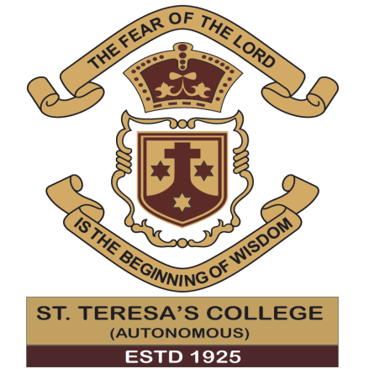

AB21HIS005 FARHA K

AB21HIS008 SREENIVEDHYA K

AB21HIS023 AISHWARYA P S

AB21HIS033 ASHA K V

AB21HIS035 CHITHRA T K

AB21HIS040 MEGHA RAJENDRAN

**DEPARTMENT OF HISTORY**

**ST. TERESA’S COLLEGE**

**MARCH 2024**

A CULTURAL TREASURE IN TRANSITION:

UNRAVELLING THE RICH HISTORICAL TAPESTRY OF NILAMBUR KOVILAKAM

A project submitted in partial fulfillment of the requirements for the award of a B.A.Degree in History

St. Teresa’s College (Autonomous), Ernakulam

Affiliated to Mahatma Gandhi University, Kottayam



AB21HIS005 FARHA K

AB21HIS008 SREENIVEDHYA K

AB21HIS023 AISHWARYA P S

AB21HIS033 ASHA K V

AB21HIS035 CHITHRA T K

AB21HIS040 MEGHA RAJENDRAN

**DEPARTMENT OF HISTORY**

**ST. TERESA’S COLLEGE**

**MARCH 2022**

CERTIFICATE

This is to certify that the project titled “A Cultural treasure in Transition: Unravelling the Rich Historical Tapestry of Nilambur Kovilakam.” is being submitted by name in partial fulfillment of the requirements for the award of a B.A. Degree in History of St. Teresa’s College (Autonomous), affiliated to Mahatma Gandhi University, is a bonafide record of the work done by the students under my supervision and guidance. No part of this work has been submitted elsewhere for the award of any degree.

Dr. Stancy S Dr.Vinitha T Tharakan

Assistant Professor, Associate Professor,

Head of the Department, Department of History,

Department of History, St.Teresa’s College,

St.Teresa’s College, Ernakulam.

Ernakulam.

DECLARATION

We hereby declare that this project “A Cultural Treasure in Transition: Unravelling the Rich Historical Tapestry of Nilambur Kovilakam” is an original work done by us under the guidance of Dr. Vinitha T Tharakan , Associate Professor, Department of History, St.Teresa’s College ( Autonomous). No part of this work has been submitted elsewhere for the award of any degree.

Place: Ernakulam Farha K (AB21HIS005)

Date: Sreenivedhya K (AB21HIS008)

Aiswarya P S ( AB21HIS023)

Asha K V (AB21HIS033)

Chithra T K (AB21HIS035)

Megha Rajendran (AB21HIS040)

ACKNOWLEDGEMENT

We would like to thank everyone who assisted us in completing the project. First and foremost, we thank God for leading us down the right route and ensuring the success of this initiative.

We take this opportunity to thank our guide and our class teacher Dr Vinitha T Tharakan , Associate Professor, Department of History, St Teresa's College, for her continual encouragement and exceptional guidance throughout this project. She has gone to great lengths to go over the project and make any necessary changes when needed.

We are grateful to Dr. Stancy S, Head of the Department, for her unwavering support and guidance. We would also like to express our gratitude to the staff of the Kerala History Association, Ernakulam and St. Teresa's College Library for allowing us to utilise their library. We would like to use this opportunity to express our gratitude to all the respondents for cooperating with us.

Last but not the least, we like to thank our families, friends, and classmates for their ceaseless support throughout the process of completing this project.

Place: Ernakulam Farha K (AB21HIS005)

Date: Sreenivedhya K(AB21HIS008)

Aiswarya P S (AB21HIS023)

Asha K V (AB21HIS033)

Chithra T K (AB21HIS035

Megha Rajendran (AB21HIS040)

**CONTENTS**

|  |  |  |
| --- | --- | --- |
| S.NO | Title | Page |
| 1 | CHAPTER 1- INTRODUCTION | 1-8 |
| 2 | CHAPTER 2- HISTORY OF NILAMBUR KOVILAKAM | 9-27 |
| 3 | CHAPTER 3- THRONES AND LEGACY : REIGN AND POLITICAL- CULTURAL ODYSSEY | 28-39 |
| 4 | CHAPTER 4- CONCLUSION | 40-44 |
| 5 | BIBLIOGRAPHY | 45-50 |
| 6 | APPENDIX 1 – MAPS | 51-53 |
| 7 | APPENDIX 2 – PICTURES | 54-56 |

**CHAPTER 1**

**INTRODUCTION**

Kerala, located in the south western part of India, boasts a rich cultural history that spans centuries. The region’s unique cultural tapestry is woven from the interplay of diverse influences, encompassing traditions, art forms, religious practices and historical events . It’s history is a part of the general history of India and it’s culture is one of the major streams that have enriched the composite culture of the country. At the same time Kerala has had distinction of being an geographical and political entity from very early days[1]. Kerala is a land filled with rich heritage and culture that has been carefully preserved and conserved for centuries. Culture of Kerala is quite affluent and rich. The cosmopolitan populace of Kerala has helped in defining the culture of Kerala[2]. The modern state of Kerala was formed in 1956. Prior to its formation, Kerala was divided into three separate political units called Malabar, Cochin and Travancore .[3] Both Travancore and Cochin were kingdoms and Malabar was under the direct control of Madras Presidency.

Malabar, a historic region in the northern part of Kerala , is a fascinating tapestry woven with various influences ,reflecting the confluences of various civilizations ,trade routes ,and religious traditions. The region has been a melting pot of cultural exchange with its rich history .The land was under the rule of the Cheras until their fall in the 12th century. During colonial period, it was under British rule and after independence it became under the Madras Presidency. Geographically situated between the Western Ghats and the Arabian Sea, Malabar’s irregularly shaped coastal area is shielded from the influences of Dravidian people by surrounding mountain ranges .Arab navigators , who reached Malabar Coast as early as 12th century used the word “ *Male*” to represent this region. Also seafarer , who came in search for pepper and other spices , called this region as *Malibar*, *Manibar* ,*Munibar,* *Malibur*.[4] It is believed that the Arab geographer Yaqut (1179 to 1229) was the first to use the name ‘*Malabar*’ to refer this region , who created this word by combining the Dravidian word ‘*mala*’ which means hill or mountain and the Arabic word ‘*barr*’ or the Persian word ‘*bar*’ which means continent and country respectively[5] .

The land was under the rule of the Cheras until their fall in the 12th century It was then divided into three parts, each under a separate ruler : the Kolathiri in North Malabar ,the Zamorin in Calicut and the Valluvankonathiri in Valluvanad .Trade relations with the world flourished in these times and brought cultural innovations along them, signs of which are visible even to this day.[6] Until the arrival of British , the term *Malabar* was used in foreign trade circles as a general name for Kerala .[7]

By the end of the 15th Century, the Zamorin was the most powerful sovereign in Kerala and his empire consisted of nearly half of the entire country. His authority extended from Puthuppatanam in the north to Kayamkulam in the south.[8] Zamorin occupied northern Kerala .The Zamorin’s ruling Dynasty which was titled the Nediyirippu Swaroopam belong to Eradi subdivision of the Nair caste , hailed from a place called Nediyirippu in Eranad, a locale which is part of the part of the present day district of Malappuram, in Kerala.[9] In order to initiate and expand trade relation with outer part of the world . In pursuit of this goal , the Eradi led their Nairs to panniankara , laying siege to the Porlathiri’s headquarter . Eventually, the Eradis triumphed in capturing Poland and subsequently shifted their capital from Nediyirippu to Calicut .Zamorin along with their vassal kings from Nilambur kingdom made Calicut as the most important trading zone . The culture of Calicut was diverse from that of rest of Kerala, owing to its European influence.With the expansion of power , new palaces or kovilakams were constructed . There were mainly three kovilakams existed in Zamorin’s kingdom .They are Kilakke kovilakam, Putiya kovilakams ,Padinjare kovilakam[10]

The residence of kings and ruling classes were usually called as *kovilakams* (residence or temples ).The records of Malabr commission of 1793 refers it as “*colgun*” .[11] A kovilakam is the principal manor , estate or palace of a princely Kshatriya (Thampuran, Koyi Thampuran, Thamban, Thirumulpad)or Samanthan and Samantha Kshatriya lineages of ruling dynasties. It is the royal residence where all the family members who did not become a Raja or Rani remain under the management of the eldest resident male or female member of that particular branch of the family. This seat of residence for royal families in Kerala is called as *Sthanam***.**In the north Malabar region, it is sometimes pronounced as *Kolom* .[12] The emergence of Kovilakams in Kerala is deeply rooted in the cultural ,social, and historical condition of this region .Kovilakams also played a significant role in shaping the socio- cultural landscape of Kerala .Several factors are responsible for the appearance and prominences of Kovilakams . They include feudal system and the land ownership ,traditional joint family structure , preservation of cultural practices ,connection to royalty and aristocracy ,religious and social functions , architectural significances as well as the economic prosperity .

The British colonial presence in Malabar , had a profound impact on its economy and policies during the colonial period. One of their most important economic motivations was the extraction of teakwood. The Nilambur region in Malabar was known for its high-quality teak wood. The British exploited this resource for shipbuilding and other purposes. They implemented forestry policies and established plantations to ensure a steady supply of teak, contributing to the economic development of the region. This region was not only famous for richness of teak wood plantations ,but also the presence of Nilambur Kovilakam , where the *Nilambur Rajas* resided and ruled the land. *Nilambur Rajas* were vassals to the Zamorins of Calicut, based at Nilambur.[13]

Nilambur Kovilakam was built in 13th century by Thachirakkavil Eradies who came from Nediyiruppu Swaroopam. As mentioned they were the part of family of Zamorins of Calicut. He sent them to look after the properties in the Nilambur area .They were given authority over the property and land here, and thus they later became known by Nilambur Kovilakam. It also referred to as Nilambur Kingdom. Its architectural magnificence, historical significance, and cultural richness add immense credit to the heritage history of Malabar .Nilambur Kovilakam has played an important role in the development of present day Nilambur and the transformation of Nilambur into Nilambur as seen today .The history of Nilambur is that of Kovilakam , on the other hand is filled through its raja , Manavedan raja .His individuality and services immensely contributed in the development of this region including the areas like education ,health etc. Another source that has a significant role in history in Nilambur as well as Kovilakam is the *Nilambur paattu*, which plays a considerable part in the socio economic condition of Nilambur . This is held at the Vettakkorumakan temple[14] ,which is managed by Nilambur Kovilakam. It is celebrated in praise of lord Vettakkorumakan and marked by the participation of tribal people. Now *Nilambur Paattu* became a festival and celebration time more than cultural event. Peoples from every religion participate in these festivals as it became a festival of Nilambur.[15]

This dissertion is divided into four chapters. The first chapter deals with the introduction to the topic “A Cultural treasure in Transition: Unravelling the Rich Historical Tapestry of Nilambur Kovilakam.”. It explains the basic terminologies in relation to the Kovilakams and describes the objectives and methodologies used for the project as well as the limitations faced . The second chapter consists of the historical background of Nilambur Kovilakam, also the socio political factors which favoured the growth and prominence of the Kovilakam . It also gives a brief narrative of the historically prominent Malabar and it’s most powerful rulers – The Zamorins. The Third chapter comprises of the political and cultural evolution of Nilambur Kovilakam, majorly focusing on the reign of Manavedan Raja and a comprehensive description on the local festival of Nilambur – Nilambur Paattu , it’s traditions and customs and the changes that were brought about in the course of Time. In the concluding chapter, which is the fourth and final section of this project, the outcomes and conclusions derived from the dissertation are presented.

**Relevance of the study**

The cultural history of a region is complex as it influence multiple aspect of society,the cultural history of a region is shaped by a multitude of factors , each playing a prominent role in defining and redefining the unique identity of the region .These influences can be categorized into geographical ,social, historical, political and economic factor.

The present efforts concentrates on a regional study but its is a wider part of a wider topic. The topic mainly focuses on the Nilambur kovilakam ,its historical and cultural dimensions and its ruler.as mentioned above , this Kovilakam defined and portrayed the region of Nilambur in several ways. Especially through preserving its cultural heritage , mouling its identity, education, community enagement .

**Review of Literature**

The present study under the topic “A Cultural treasure in Transition: Unravelling the Rich Historical Tapestry of Nilambur Kovilakam” was undertaken with an intention to understand and capture the historical aspect of Kovilakam. Kerala has witnessed the growth and prominence of different Kovilakams. On account of this the term “Kovilakam” has been used several times. Basically it refers to the house or residence of royal patronages.in the literary work of M T Vasudevan Nair, Kaalam , the term kovilakam used in the same sense as the residence of royal families. The history of Nilambur Kovilakam is connected with the Zamorins of Calicut . their reign ,spanning several centuries ,left an indelible mark on the history , culture and trade of the Malabar region particularly , Kerala as a whole.In this regard , A Survey of Kerala History , Kerala Samskaram by A sreedhara Menon ,provides comprehensive history and its cultural elements of Kerala . Malabar Manual by William Logan, the Evolution of Kerala History and Culture by T K Gangadharan , Kerala Samskaram by Prof . A Achuthavaryar ,Malabar Gazetteer by C. A Innes I.C.S, Tales of Malabar by Sreekumari Ramachandran, Kerala District Gazetteers Malappuram by Dr. C. K Kareem, Historiography and History of Kerala by Dr. G Krishna Nadar ,The Zamorins of Calicut by K V Krishna Iyer, Agrarian society in Kerala by K N Ganesh, Kerala Charithram by M Raghava Varrier and Rajan Gurukkal provides a multi -dimensional perspective and to the Kerala’s historical background. Apart from this the Malabar ; Paithrukavum Prathapavum edited by Dr. P.B Saleem , N.P Hafis Muhammed , A.C Vashisht gives the background of cultural heritage of Malabar .

Nilambur K.R.C’S Nilimbapurathinte Nalavazhikal has concentrated on the socio political historical background of the Nilambur region , along with providing insight into the Nilambur Kovilakam. It brings about the historical context provided for the establishment of Nilambur Kovilakam , important rulers , socio-cultural- political arena of this region

The source material consists of variety of texts like travel accounts of foreigners ,books, reports , gazetteers ,journals and magazines, dissertations ,newspapers common knowledge souvenirs have been very much useful throughout the study.

**Objecives**

The emergence of Kovilakams in Kerala is closely tied in it’s cultural social and historical aspects of the region . Basically Kovilakam refers to the residence of royal family members. So they are usually associated to the royal and aristocratic families of Kerala. Emergence of Kovilakams can be analyzed in association with the historical conditions which evolved after the emergence of Nadus .The development of Nadus and Swaroopams was witnessed in the post Perumal period. So this period witnessed drastic changes in the early medieval land holding rights and agrarian relations. It is argued that the political development took place , was mainly contributed by the agrarian expansion. The era also saw a growth in agriculture.

The emergence of swaroopams provided ground for the political history of kerala .As their power expanses they built many palaces including Kovilakams .

This dissertation focus on one such Kovilakam, Nilambur Kovilakam , which influenced the socio-cultural-political and economic history of a region.

The following are the main objective of the present study:

* To trace out the historical background of Nilambur kovilakam,
* To analyze the important event took place there.
* To understand its evolution under its rulers.
* To evolve a better understanding of the cultural significance and aims to explain role played in the development of the Nilambur region.
* To describe the major local festival Nilambur paattu,, its history , events , changes over time .

**Methodology**

The methodology used is a combination of descriptive and analytical method. Descriptive method is primarily used to trace out the historical background of the Nilambur Kovilakam .Analytical approach is used to evaluate the importance of the Nilambur Kovilakam in defining and redefining the region of Nilambur,

Primary sources for this project include the District Gazetteers of Malabar, Malabar Manual by William Logan. A survey comprising 15 participants from either Nilambur or those who have visited or heard about Nilambur Kovilakam was conducted via a google form . the survey comprised of multiple choice questions , yes/no inquiries and descriptive questions.In addition to this surveys , telephone interview were conducted through telephones with the important personnel of Nilamabur Kovilakam although it was limited ,as well as the local residents and authors of the book who wrote about the history of the region. The data gathered and analyses serves as a crucial primary source for this present study , because of the scarcity of written material on the particular region. Furthermore the field visit to the Nilambur Kovilakam and it’s surrounding region were undertaken to gather authentic data related .When vernacular words are used, their meanings or near meanings in English are given in brackets.

Published books which were available in the college library , other public library were also used for this study .Also we relied on various e-books available on internet because of the non availability of certain books. Along with this various data and information are accessed from many published dissertation of research scholars which great use in this study .

Various articles published by the major newspapers and magazaines , journals also were used . Government records also were considered . Several online websites provided informative in developing a broader understanding of the subject matter.

**Limitations**

The topic under study is less studied .The history of Nilambur Kovilakam is associated with the history of Zamorins of Calicut . Although there are wide range of availability of wriiten materials related to Zamorins were available , written source for the exact topic was scarce . Many government documents only providing some notion on the topic . The members of the Nilambur Kovilakam were unwilling for cooperating with us for an interview because of the health condition of its senior members and other reasons. The information derived through the telephone interview with its members was meagre.

For gathering information on the region and Nilambur Kovilakam ,we mainly relied on specific number of books , which may contain subjective notions. We have made efforts to authenticate such data through cross examination , ensuring its reliability and accuracy to the best of our abilities . But we encountered limitation because of the un- availability of Other sources for cross examination .

**CHAPTER 2**

**THE HISTORY OF NILAMBUR KOVILAKAM**

Malabar

The modern state of Kerala was formed in 1956. Prior to its formation, Kerala was divided into three separate political units called Malabar, Cochin and Travancore.[16] Malabar is a historical region on the southwestern coast of India, renowned for its rich cultural heritage, diverse landscapes and significant historical events. Unlike Travancore and Cochin who was independent princely states, Malabar was directly under the control of Madras Presidency. Malabar has been a significant center for trade, and the Arab influence is particularly notable .The historic spice trade route brought Arab traders to this region leaving a lasting impact on language , cuisine and architecture . Additionally European powers , including the Portuguese , the Dutch , the French and later the British , established trading centers and forts , contributing to the cultural amalgamation.

As mentioned above, Malabar was famous for its spice ,pepper ,cinnamon ,black gold and other products.So this eventually attracted many foreigners including travelers and writers to this coast mainly for the purpose of trade. They were received by the hospitality of Malabar people. The etymology of this region is derived from many sources . There are many interpretations regarding this. The traveler’s account of a particular region is very significant to understand the historic background of that region. Likewise for the reconstruction of Malabar is also great in need of travelers account. Among the travelers most outstanding was Ibn- Battuta.in his book , “*Rihlah*,” which has been translated into English , was another instrument for free circulation of idea and thought between Arabia and Malabar .[17] *Malabar* is referred to all the Arabs as country of pepper including Battuta.[18]Arab navigators had used the term “*Mala”* to refer to this coast , as early as the sixth century CE . The merchants and sailors reached for spice trade called it *Malabar* , *Manibar*, *Muliber* or *Muniber* .[19]It’s believed that the Arab geographer Yaqut (1179-1229) was the first to use this name Malabar to refer this region.[20]This probably created by combining the Dravidian words “*Mala”* (Hill) and “*puram”*(region), meaning the hilly region , due to the country’s physical features. In course of time this term shrinked to Malabar. [21]

During the period spanning from the 2nd century BCE to the 3rd century CE, the Malabar Coast was governed by The Early Cheras. In the 14th to 16th centuries, the term Malabar extended beyond the entire northern coast of present-day Kerala, encompassing the regions of south Goa and the western coast of Karnataka. The Vijayanagara Empire, founded in the 14th century, held sway over South India during this timeframe. During the reign *Settis* held higher position in the society .Barbosa in his book mentions as *Chatis*[22] and knowns as *Chettis* in Kerala. Amongst the 18 castes in Malabar , Barbosa identified them as most prominent one .the *Settis* were quite active between the periods of 14th to the 16th century , notably during the reign of Vijayanagar rulers like Harihara 2 and Devaraya 2. Judging from their trading commodities, we could for sure conclude that they held a prominent and prestigious position in the society at that time. They are mentioned in many inscriptions including , inscription from the time of Hariahara 2 , dated 1379 A D. What is surprising here is the absence of pepper, which was used everwhere in the kingdom and brought from Malabar on asses and pack- cattle.[23] .The *Settis* are said to have been skilled in the keeping of accounts and were thus appointed as clerks to look after the affairs of foreign merchants in Malabar .[24]

The 8th and 9th centures CE witnessed the rise of monarchical political power in kerala ,with the Perumals establishing the first monarchy . Referred to as later Cheras or Kulashekharas, they ruled from 800 CE to 1122 CE , with Makotai or Mahodayapuram as their capital( modern day Kodungallur). Geneological accounts of Perumals are not well –documented, and Vatezhuthu[25] inscriptions serve as a primary source for studying this early monarchical rule in Kerala. The empire was divded into *Nadus* or provinces for the administrative convience.The *Nadus* were under the control of chiefs or *Naduvazhis.*they are further divided into *Desams* under *Desavazhis* or V*azhkaivazhis*.Under their rulers , upto 10th century ,was a golden age in the history of Kerala ,politically , socially , economically and culturally which characterized by progress, prosperity etc. After that almost from 12th to 18th century was period of continuity and change in the areas like agriculture production ,exchange ,structure of polity, system of land tenure, land holdings ,land relations etc. This period also marked the advent of Europeans, the Mysorean invasion and the establishment of British colonial rule in Kerala

The most important event took place in the 12th century was the disintegration of second Chera Kingdom.It resulted in the emergence of independent kingdoms Naduvazhis and Vazhkaivazhis became all powerful and independent. But the these kingdoms fought each other for dominations which resulted in war. The origin of feudalism in Kerala can be considered as the significant impact of this war .The Namboothiri Brahmins became powerful and established their supremacy.

At the onset of the 12th century , the centralized administration of the Perumals in Mahodayapuram came to close .the post Perumal era saw the rise of influential Naduvazhi Swaroopams.The Swaroopams were originally joint families of feudal lords known by the name of their localities. The major Swaroopams during the period were Trippappur Swaroopam in Venad, Perumpadappu Swaroopam in Kochi, Nediyiruppu Swaroopam in Kozhikode, and Kolaswaroopam in Chirakkal. The emergence of swaroopams is considered as the most important chapter in the political structure of kerala. In course of time they became the prominent ruling factions of the medieval period. Swaroopams was characterized as the autonoumus region controlled by the powerful matrilineal joint families ( Marumakkathaya Taravadu ). Various female lineages, referred to as *Tavazhi* or *Kuru* , existed within each matrilineal household. The eldest member (*muppu*) of the Kuru lineage assumed the leadership of Swaroopam in a practice knowns as *Kuruvazhcha* or *Muppumura*. Distinct ruling residence, *Kovilakams* or *koolakams* ,were designated for each lineage faction. The history of central and north kerala during the pre- portuguse period and after is centred primarily around the kingdom of Calicut , under the illustrious Zamorins..[26]

Zamorins

During the medieval era , Kozhikode also known as Calicut , held a significant influence in north and central kerala .Following decline of Mahodayapuram, Kozhikode emerged as an autonoumous region with rulers referred to as Zamorins , who were formidable and noteworthy. The term zamorin, was derived from the malayalam word Samutiri , abbreviated into Samuri , which derived from the Malayalam word *Swami –sri* , “*the lord master*”.[27] The term Samuri term can to seen as similar to the term of Samurai of Japan , meaning military chiefs related to sea , ship and merchandise . the Zamorins were descended from the Ernad Utaiyavar who appears to a signatory in the Jewish and Syrian copper plates.[28] Their origin story is narrated in a 17th CE text called *Keralolpathi,* the earliest known account of the history of the Malabar region. The text, largely a collection of myths and legends mixed with historical events, mentions the advent of two brothers Manichan and Vikraman from Eranadu, who were the most trusted generals in the army of the Chera dynasty that then ruled the region. When the Chera Perumal decided to abdicate, the brothers were not around and so did not originally bequeath any land to them. These young men upon their return reminded the Perumal that they had been forgotten in the process. With little left, the Perumal gifted a small area of land, then no more than a thicket of shrubs to the brothers, which would later be known as *Koilkode* (*Kallikut* or *Calicut*). He also gave them his sword, his broken prayer conch and an edict that they could conquer more territory if they wanted to.[29]

The Zamorin’s family originally resided in Nediyiuppu,a village in the Kondotty Taluk of the present Malappuram district. The head of the house held the title Nediyiruppu Mutta Eradi . Under the Chera rulers of Thiruvanchikkulam , the Mutta Eradi governed Eroad with the title of Ernad Utaiyar .After Cheraman Perumal’s empire partition , the Ernad Utaiyar , like other provincial governors , became an independent king and his family became known as the Nediyiruppu swaroopam . Members of this Swaroopam belong to the Eradi subdivision of the Samanta section of the Nayar race , who were feudatories under the imperial cheras , forming aristocracy based on birth and office . The origin of term “ *Eradi*” is uncertain , but comparative history leans towards it being a tribal name rather than derived from Ernad.

Calicut was not an important port and capital of Zamorins until 13th century .The Eradis of Nediyiruppu of Ernad planned to attack Poland under the control of Porlatiri , in order to get the outlet to the sea and obtain own share of the profit derived from the international trade. As per this they marched towards Panniankara with their Nairs and besieged the Porlatiri. The war was lasted about half a century and finally the victory was at the hands of Eradis. Subsequently, Porlatiri fled to Kolathunadu for political asylum . In the wake of conquest , Eradis shifted their headquarters from Nediyiruppu to Calicut . the Kingdom of Calicut also came to be known as Nediruppu Swaroupam after the original house of the Eradis at Nediyiruppu. [30]The Zamorin was sometimes called by the title *Erlatiri* ( chief of Ernad) and Nediyiruppu Muppan ( chief of the Nediyiruppu Swaroopam) . Under his suzerainty , Calicut developed into as prominent sea port in South India . In the ‘The Rise of Calicut’ , says K .V Krishna Iyer , “Is at once a cause and a consequence of the Zamorin’s ascendancy in Kerala . Its trade filled his coffers and enabled him to extend his authority . and the expansion of his empire in turn increased its commerce. Originally a barren strip covered all over with thorny jungle,the genius of the Manivikramans converted it into a mighty sea-port , where the Arabs and the Chinese met to exchange the products of the west with those of east .[31]

Kovilakams

In Kerala, India, a Kovilakamis the principal manor, estate or palace of a princely Kshatriya  is the principal manor, estate or palace of a princely Kshatriya. In the North Malabar region, it is sometimes pronounced as “*Kolom” .* A chief princely lineage of Kerala consists of several Kovilakams representing different matrilineal branches of the same family from which the individual members could ascend to the status of Raja in accordance to their seniority in age within the lineage. The Kovilakam residences are usually large and beautiful manors or palaces with extensive wood work and mural paintings in the traditional medieval Kerala architecture style. A Kovilakam was usually endowed with estates and properties (crown lands), sufficient for the maintenance of its constituent members. At the very moment when a member ascends to any seat/station (Sthanam), they lose their residence in the Kovilakam and reside in the royal palace instead. However, there are instances when such members on ascending to a station have preferred to stay back in their Kovilakams of birth.[32] The records of Malabr Commission of 1793 refers it as “*colgun*”.[33]

The genesis of Kovilakams in Kerala is deeply rooted in its cultural ,social and historical features of the region .There are so many factors contributed for its prominence .When we look through the history of Kerala , Kerala can be seen as a region based on the feudal system. Under this system, noble families or royalty were often owned a vast stretch of land and Kovilakams served as their residence .The land under them were closely connected to the socio-economic status and which in turn contributed to the establishment of the ancestral homes. Kerala traditionally had a joint family system where several generation lived together .With its grand structure, magnificent architecture, the Kovilakam provided the sufficient and necessary space for the families to coexist .This in turn helped to build and strengthen the family bonds and played a pivotal role in cultural ethos of the region.

Kovilakams were not only residence palace , but they were cultural hubs where traditions , rituals and art forms were preserved and practiced. The noble families were often patrons of classical art forms , literature and religious rituals .This patronage played a crucial role in the continuity and flourishing of Kerala’s rich cultural heritage. Kovilakams were usually associated with royal and aristocratic families of kerala. So the inhabitants of these were often been a part of ruling class or had deep tied relationship with the rulers .This can be analysed as the symbol of prestige and authority . Kovilakams served as the platform for various religious and social functions .Festivals , ceremonies and gathering were hosted in these ancestral homes , fostering a sense of community and shared identity.

The architecture of Kovilakams reflected the traditional building style of Kerala , with intricate woodwork , spacious courtyards ,and distinctive designs . In the Kovilakams under Zamrorins , there they constructed high and smooth platform where the higher people sat . It was daily plastered with cow-dung . [34] The homes of kings and feudal lords were made stronger by constructing forts. Large residence ,including kovilakams , had protective walls with substantial gates. These structures were strategically placed almost in the centre of the land and were surrounded by trees and plants , adding to their natural beauty .these residence were well equipped with all necessary facilities . Big house contained numerous rooms and there was spacious verandah in front of the house , providing a pleasant space to enjoy the breeze. Besides a kitchen room was to the main building or kept apart from the main portion of the house.[35] A number of mini temples were also associated with these ancestral homes.

These structures showcased the craftsmanship and aesthetic sensibilities of the time ,contributing to the architectural heritage of the region . Many kovilakams were associated with economic prosperity , often supported by agricultural activities on the vast landholdings . The wealth generated contributed to the maintenance and grandeur of these ancestral homes , reinforcing their cultural significance .

Nilambur

Nilambur is a major town, a municipality and a Taluk in the Malappuram district of the Indian state of Kerala. It is located close to the Nilgiris range of the Western Ghats on the banks of the Chaliyar River. Nilambur, also known as "*Teak Town*," earns its nickname from the plentiful Nilambur teaks that thrive in the area—a variety of large, deciduous trees found in mixed hardwood forests. Distinguishing itself from many other municipalities in India, Nilambur boasts extensive vegetation, creating a close-to-nature environment that is both scenic and inspiring.

In the British records , it has been recorded as Nilambur valley for Nilambur and its surrounding area. Nilambur valley means the area involving Chungathara , Edakkara ,Amarabhalam, Kalikavu and Nilambur .[36] It lies in the south of Wayanad and to the west of Nilagiri district of Tamil Nadu .It has an area of 324.690 sq.kms .The remnants of old temples , inscription on slabs and tanks can been seen scattered here and there in the Nilambur forest .Tradition says that , it was a colony of Nambuthiris who were driven to Karikad Kesam of Trikkalangode by the unwelcome attentions to their women of the asuran or demon named *Bagan*. The Antharjanams of this region were avoided wearing bangles worn by Namboothiri women in other places , reminiscent of these days when they lived in fear of demon.

The most important contribution put forwarded by the British in this region is the Nilambur- Shoranur line . the world’s most oldest teak planatation , “ *Conoll’s plot*” is situated here and was raised by Lord Conolly , one of the most prominent district collector Malabar district . Logan mentiones , “no better site for planting could have been chosen. The Nilambur valley is of horse shoe and lies 4000 ft. above mean sea level beneath the shadow of amphitheatre of hills.”[37] The teaks for the construction of *Uru* a kind of ships those were used for maritime trade through eBeypore port, were usually taken from Nilambur Teak Forests.[38]

It is recorded as the bamboos obtained from the forest area of this region was utilized by the Birlas for a paper pulp factory. The Chola – Nayickens said to be one of the oldest aborgins of Kerala are seen in the thick forest of Nilambur .The historical lineage of Nilambur can be traced to a time preceding recorded history , where indications of prehistoric cultures manifest in the discovery of various artefacts such as choppers crafted from quartzite pebble tools , as well as bifacial and unifacial scrapers dating back to the Paleolithic era .

Nilambur is said to have originated from Nilimbapuram . A lot of gold was found in the soil on the banks of river chaliyar. So ther’s an old saying that the area was called Nilamponnur. Later it became Nilambur . Nilimba is the Sanskrit term for Bamboos , as the area is crowded with Bamboos , it’s naturally interpreted as Nilambur (നിലിമ്പയുടെ നിലവറ). Other myths suggest, the forbears say that the term Nilabur traces its origin from Nalambaoor which means good village. Scholars state that Nalambaoor evolved into Nilambur after Nalambur and later Nelambur .

Also there’s an argument , which states that the land was named Viratapuri in connection with epic period . The legend goes that the Pandavas came to the Virata Kingdom and Arjuna gave Ghandivam to scare the tribals who frequently attacked them. Arrows fell among the tribals and they were scared. The place where the arrow landed on the ground turned into Nilathambur and later it became Nilambur.

Nilambur has rich cultural , historical significants on account of teak woods , Kovilakams , colonial influences, traditional arts, and a diverse community. The town's story is one of resilience, adaptation, and a commitment to preserving its cultural roots amid changing times. The town may have historical monuments and structures that reflect its past, providing a tangible link to the bygone eras. These could include old buildings adorned with architectural intricacies, ancient temples resonating with spiritual significance, or other captivating architectural gems that stand as eloquent reminders of Nilambur's rich and storied historical journey which include Nilambur Teak Museum, Conolly's Plot, Bungalow Hill.

One of the most important factor which contributed in the cultural pattern of this region is the Nilambur Kovilakam .it has substantial influence on Nilambur region custodian of historical narratives, a preserver of cultural traditions, and a contributor to the local economy through landownership and tourism-related activities.

Nilambur Kovilakam

The Zamorin’s ruling Dynasty which was titled the Nediyirippu Swaroopam belong to Eradi subdivision of the Nair caste , hailed from a place called Nediyirippu in Eranad, a locale which is part of the part of the present day district of Malappuram, in Kerala . They ruled the region between 12th and 18th centuries .They were the most prominent , powerful ruling families marked in the chapters of the medieval history of Kerala . The Eradis aspired to establish an international connection for engaging in trade and commercial activities with distant regions. In order to achieve this objective , the Eradi community led by the Nairs , embarked on a march towards Panniankara , region under the regime of Porlathiri. They besieged the headquarters of Porlathiri and conquered Poland . Subsequently they relocated their capital from Nediyiruppu to Calicut . In order to secure their new territories, they constructed fortress at Velapuram.

Traditionally they got five *Stanams* or positions. They are :

1. Samuthiri Tirumulpad
2. Ernad Elamkur Nambiyatiri Tirumulpad
3. Ernad Munamkur Nambiyatiri Tirumulpad
4. Edataranad Nambiyatiri Tirumulpad
5. Nediyiruppil Mootha Eradi Tirumulpad

In course of time , their power was increased , new palaces were constructed .K V Krishna iyer mentions , First rose the Kilakke Kovilakam or the eastern palace in Chinta- Valappu, north of the present Zamorin's College; then came into existence the Putiya Kovilakam or the new palace, west of the Tali tank. The former has completely disappeared without leaving any trace behind it; the ruins of the latter, its ancient gateway and the stone steps leading into the tank, are, however, still visible. The rulers were known by palace – names such as kovilakattu Raja . The Padinjare Kovilakam Raja was named Kilakkekovilakattu Raja .[39] The Zamorins of Calicut also built Ampati Kovilakam for their princesses.

A Tampuratti of the Kilakke Kovilakam had Sambandham with Chalappurattu Nambutiri. As he had no heirs he made a gift of all his property including his own *illom* or house to the Tampuratti. A palace was built on the site of the old illom, and it came to be known as the Chalappurattu Kovilakam. For a long time the members of the Kilakke Kovilakam continued to call themselves Chalappurattu Kovilakattu Tampurans.[40]

In the granthavari in relation to the Zamorin, they are number of mentioning Kovilakams . Usually the abode or the residence of royal personages was called a Kōvilakam[41] in Malayalam. The residence of the locality chiefs and Ēṟāṭis ( who were of a junior and parallel lineage to the royal house of the zamoris) was also known as Kōvilakam.in granthavari , Kōvilakamākuka used to refer the place for the overnight stay of the Zamorin and princes., which may implied in way such as wherever they stayed , their place of residence is called as Kōvilakam. There is another record , in which mentions as , when the Zamorins was residing at or its neighbourhood than at Calicut .there is only vivid account on Zamorins kovilakam in foreign accounts .There were also Kovilakams for Eratis , locality chiefs which may stood for specific reasons. It may have helped them to maintain relatively strong control over the area and the Kovilakams may have acted as functional centres .

The region of Nilambur might have been influenced by the Zamorin’s historical activities including trade and cultural developments. Historically, Nilambur referred to as east Ernad. The first images appears on our memories is that of Kovilakam and teak plantations. The modern history of Nilambur town can be traced back to the establishment and prominence of Nilambur Kovilakam. It played a prominent role in various aspect of its growth and evolution over the years .As there are not much written records we have to rely on mostly on oral stories .In a hurry to obtain fertile land , he assigned his men from Nediyiruppu Swaroopam to all the four direction. Shakthan , a Thamban reached on account of this liked black soil , the majestic trees and calm waters of the rivers. He asked Zamorin for the permission for the management of this land . It is rumoured that due to the reluctance to fight , permission was finally given and Kovilakam was established in Nilambur . How ever it was only after the Zamorins that Nilambur Kovilakam was able to survive in all its senses.

The Nilambur Kovilakam, built in the 13th century AD by Thachirakkavil Eradis from Nediyirippu, was under the control of the Zamorins of Calicut until the 18th century. The 14th and 15th centuries witnessed a development in agrarian land and settlements all over the Kerala .

The most powerful and prominent divison of Nediyiruppu Swaroopam were Zamorin Kovilakam and Chirayil Kutalmanna Kovilakam. They were related to each other and became rulers of the areas on the banks of river Chaliyar . As they came from Thiruchirakkavu from Chirayil village ,they were known as Thiruchirakkavu Kovilakakkar , and later it became as Thachirakkavu Kovilakam. There were three Thavazhis ( royal families ) associated with these . One of these was settled at Mannazhi ( present day Mambad ) and other one at Edavanna. The Mannazhi Kovilakam later merged with Nilambur Kovilakams on account of the absence of heirs .Also Edavanna Kovilakam gradually changed its location to Amarambalam and became Amarambalam Kovilakam owing to specific reasons.

The historical context following the rise of Nadus should be examined to understand the eastward expansion of Nediyirippu Swaroopam and the founding of Nilambur Kovilakam. Emergence of Nadus. Historians argue that, "a major factor behind the whole political process in this period was the agrarian expansion.[42]The tremendous growth of agriculture occurred after the emergence of Nadus induced the Naduvazhis to acquire more cultivable lands.[43] Additionally, the recently constructed Kovilakam had to derive its income primarily from the nearby forest to cover daily expenses. However, the royal family recognized that expanding eastward and obtaining forest resources required the support of the tribal communities.

The analysis of installing the tribal deity and granting tribal privileges is essential in this historical context. The ritual installation of the Vettakkorumakan deity was a strategic move by the royal family to assert dominance over the potentially prosperous Nilambur valley, where tribes constituted a distinct population segment. This legend appears to be an ideological construct by the royal family to legitimize their established power in the tribal homeland. Furthermore, the festival served as a means to extract revenue, receiving gifts and donations from the subjects.

When the Kovilakam took control of the region, the local tribal people were either enslaved or forced to leave their homes in the forest for more remote areas. Those who were enslaved became bonded labourers, with the majority being Paniyar. The Kovilakam then sold the 'conquered' lands, along with the tribes, to Nair or Mappila landowners brought in from Nediyirippu to boost trade and agriculture. Until recently, these landowners served as supervisors (mestris) for various Kovilakams in the area. Almost 98% of the Paniyan settlements in the region are found alongside the paddy fields owned by the descendants of these landowners. In the midst of the paddy fields, there was a *Kalam*. *Kalam* was the farm house around which the labourers lived in small huts that made them available to the Jenmis at any time required for work irrespective of day and night .[44]

Buchanan observes another aspect of Jenmi- tribal relation prevalent here - "The forests are divided into *Puddies* [45] in which one or more tribe lived. Each puddy was the property of Jenmi .The tribes sold the forest products to a landowner (Jenmi), who then sold them to merchants known as *Chetti* or *Mannadi*. These *Chettis*, brought by Nilambur Kovilakam from Tamil Nadu, settled near the Kovilakam to boost trade. This area is now called Chettiyarangadi. Additionally, the British appointed Nilambur Raja as an agent to collect forest products from the tribes, avoiding a repeat of the challenge they faced in suppressing a tribal revolt in Wayanad in 1812.

The Kovilakam of Nilambur do not claim Kshatriya clan like the Zamorins. In relation to the Kovilakam , they were addressed as Eradikal and Eralpadikal. Samantan is the generic name of the group of cates forming the aristocracy of Malabar and it includes the division ; Nambiyar , Unnitiri,Adiyodi , all belong to North Malabar and Nedungadi ,Vallodi , Eradi and Thirumulpad,all belong to South Malabar .[46]Only the Kshatriya clan member received the title of Raja .The Manavedan Raja of Nilmbur Kovilakam , was the only king called as Raja , which was honourably given by the British Kovilakams growth was memorable . If we look through the history, we can see that many favourable conditions have come together and used them effectively . The absence of considerable opposition and interference from one side to land management and clearing and the close association with Zamorin’s Kovilakam was a great advantage for them. Zamorin’s had a commercial strategy that no other rulers could have .There was no hindrance to conduct forest product marketing through Nilambur Kovilakam.

The ceremony of ‘Ariyittuvazhicha’ of the Zamorin required the consent and presence of lord of Nilambur Kovilakam. Perhaps this is only the regional power that existed at that time , but the glory and pride of Nilambur is visible . During the war of Hyder and Tippu sultan , the descendants of Thacharathukavu swaroopam were destroyed . Many women said to have committed suicide .In order to maintain the tradition , three women were adopted from Eradi Tharavadu near Cherpulasserry. The praises of Thacharakkavu Nilambur swaroopam crossed the sea and attracted Vasco Da Gama and others. In 1498 , when a trade agreement was concluded with the Gama and Zamorin , a Thricheri Thirumulpad was there among the witness. It is said that , he was the Thampuran of Nilambur Kovilakam. Gama came to Nilambur Kovilakam knowing that there are trees in Nilambur forest which are necessary for ships . Godavarman Thamban says ,Gama was fascinated by the structure of vessel used to wash feet . On his second visit , he was gifted with vessel made of glass and later handed over to Thiruvananthapuram museum.

It was for the purpose of Kovilakam that potters were brought from Andhra ,in which Vandikkaran Chami was the most prominent one . His main duty was to bring stones and other necessities needed for the construction . They distinguished themselves from other communities by upholding diversity. Their unique identity was expressed through the use of a language known as "*Koyappan basha*," which is associated with Telugu. They were provided with a free residence in the Kovilakam of Nilambur. In Erand , it was in Nilambur that has large number of potters. Their influence played a key role in articulating the pride of Nilambur.

The Kovilakam dominates the area that stretches from Vadappuram Kuthirappuzha to the Naduvattam in Goodallur Taluk. These areas , which were dense forest were cleared for cultivation . In this regard they took a non – religious caste approach . In each area ,there were many places like fields were rubble stones were placed in the form of ‘*mini Kovilakam*’. There were about 14 of these kind namely , Amarambalam,Pothala ,Perumbathur , Chaliyar , Nediyiruppu etc. In these places , authorities gave land on lease to the tenants and collected the lease properly and delivered the Kovilakam on time. Usually it was carried on bullock carts .Some people carry them on foot and for them to transfer their burden and rest , ‘*Athanis*’ were built along the roadsides . He had to go to Kovilakam and measure it and get the receipt . There are people today who remember that bullock carts were lined for two to three days in order to measure lease from Kovilakam Padippura to Naduvilakkulam Subrahmanya Kovil ( Keerthypadi ).It says that one para seed is equal to 50 cents of land .there are many special names related to this term.

Orumeni Pattam - Oru Para Pattam (ഒരു പറ പാട്ടം)

Vithuvalli - Vithu Nellu (വിത്തുനെല്ല് )

Malachikrishi - Name of Agriculture Land (കൃഷിസ്ഥലത്തിന്റെ പേര് )

Ucharal - Ucharapittenn (കൃഷിസ്ഥലത്തിന്റെ പേര്)

Pathayam - മൂവ്വായിരം പറ ( ആയിരം വീതം 3 അറ ) എടക്കര  ചേരിക്കല്ലിൽ 30000( മുപ്പതിനായിരം ) കൊള്ളുന്ന പത്തായമാണ് ഉണ്ടായിരുന്നത്.

Kalambat - Area (പ്രദേശം)

Oru vandi Nellu -105 Para of Paddy (105 പറ നെല്ല് )

Another part of farming was elephant trapping .It was practiced by making holes in forest and catching them. The ways in which they usually moving were found , near to them dug the pit and spread garbage on the top with wooden stakes in such a way that the elephant did not stray. The belief was true that , the tribal Paniyan can quickly recognize the smell of elephants . And if they come and say that ,immediately informs the necessary authorities and takes follow up measures. There were reward for this and its quite a festive feeling.The mounted elephant was first brought to Nilambur to teach the rules , this was the only elephant camp at that time . Later there elephant camps in places like Edakkara, Iyyamkuzhi .The elephant catchers were given silk and bangles.

There were evidence of elephants destroying land by smelling the paddy . When there was no other way of capturing elephants other than being on guard and bursting firecrackers , Palengara Kunjan Nair , who were farming in Uppada village made a plan to capture the elephants , dig and catch elephants at their own expenses .The captured elephants were handed over to Kovilakam in due course . Kovilakam was given the name elephant capture Kunjan , because he was given elephant for the first time.it is said that about thirty five elephants were captured and thus it got its own department . Also gave the official name of ‘*Aanajamendharumar*’.It is in Kovilakam records that in 1940 ,Appukkutty Menavn was one of them. Nilambur forest was the southern route of Asian Elephants .But they were mainly used for logging. Elephants , originally a symbol of pride , later became mere usage for timber industries .

Nambalakode in Gudallur Taluk has been the centre of Malayans since ancient times .About 12kms from this area came under the control of the king of Kurumbranadu around 1826.His son Kelukutty Vazhunnore reignes as its ruler and they settled here.In 1836 , the amount due to the british government fell into arrears . The case reached the court .based on the decision of munsif , some land was sold to Nilambur Kovilakam to clear the debt .Thirumulpad , who had always had an interest in Nampalakode , appealed to the ruler Subhadhra to take protection and annex the site to Kovilakam , but was refused .Subhadra and her son lived near the temple of Vettakaran , as the lord always used to come to see Vettakkorumakan on horse back. Thampuran brought them as guest to Nilambur Kovilakam and in 1853 , he bought entire rights on Nambalakode from that lady .

Kovilakam fell out with the government . It was not only because of legal battle caused , but they also believd that the Nilambur Kovilakam was helping Pazhassi Raja of Wayanad , who was an enemy of British . although were no evidemce for apparaently , the facts that whites captured Pallur Rerappan , prominent to Pazhassi , from Vellimuttam and Kodiri forests , ten to fifteen kilimeteres north to Kovilakam.

Rumours of tremendous progress under British rule reached Kovilakam. Development activities in the British settlements in the adjacent Nilagiris and Gudallur region prompted a rethink in Thirumulpad. Later we see a picture of him trying to get close to them in any way . The British rulers who saw the glory . Powers ,and capacity of kovilakam welcomed the attempt .In 1888 , the rights over Nambalakode was handed back to Thirumulpad . Thus , Muthumala – Bandippur forest regions of Karnataka and Tamil Nadu became under Kovilakam. In the book named ‘The ‘Nilagiris’ written by W. Francis , mentiones as Muthumala was leased to the government for 99 years .Kovilakam’s relation with British can be seen as an element of revival. The Malabar Rebellion was started at Pookottur with and attempt of British to arrest the local Khilafat Secretary . On august 1921 , the police attempted to arrest Vadakkeveetil Muhammed , the secretary of Khilafat Committee in Ernad at Pookkottur , alleging that he had stolen the pistol of Hindu Thirumulpad from Nilambur Kovilakam. This is an important chapter in the history of Nilambur Kovilakam.

It is Manavedan Raja , the greatest ruler of Kovilakam had ever seen. He had to live in foreign countries during the days of rebellion and implemented the positive facts he had seen, heard and experienced on his home turf. While modernist views were the seed and fertilizer, the humanist views that could be called progressive were woven together. Manavedan Raja wrote the first Harisri of anything that can be described as modern for Nilambur. Realizing that education is the stepping stone to the upliftment, he introduced English education in Kovilakam and encourage its memebers. Also started separate libraries for men and women also school named Manavedan Higher Secondary School.Tampuran had created the conditions to provide education to all Kovilakam members wherever they wanted for this he made facilities to stay and study in MancherI .when the Madan Mohan Malavya reached Kovilakam on account of financial assistance ,Thampuran extended both of his hands and given necessary funds . Through this the members were able to get special treatment and benefit there.

Temples are the ones that can claim inseparable connection with Kovilakam.The four temples in Nilambur were established by giving their own land .They are also specially allotted to certain dependent classes. Examples are Vettakkorumakan Kavu , Veeradur Kshethram , Chettiyangadi Mariyamman Kovil and Naduvilakkulam Swamikovil. Kirathamurthy has been worshipped since ancient times in Nambalakode forest area near Gudallur which is under the jurisdiction of Nilambur kovilakam. Kovilakam devotee Thirumulpad was a great admirer of Vettakkoruman , a Kirathamurthy.When he was unable to travel due to his old age to see deity , he appealed to come to Nilambur . He came to Nilambur according to the request of devotee. When the deity Vettakkorumakan of tribes was assigned , certain rituals had to be performed.

Donating food to the poor is considered an act of atonement for the unfortunate events occurred after the possessions of Nambalakode. During the day *’Ssarvani feast’*( Sarvani Sadhya ) is held in connection with Valiyakalam Paattu.The tenants had taken over the materials and other things required for the this as a right.Five hundred paras of rice was used . about half of the rice soaked in water , about thirty five white param ( panamb ) are laid out in a wide area and the soaked rice is placed on it .Then they cook the rice . Including the tribals , the majority of the inhabitants of Nilambur use these rice as medicine after drying . The curry for this made in a variety way . A large canoe is washed and cleaned and add to this . The curry , which include all kind of vegetable pieces , has a special taste . No one goes to work for a week after paattu , everything needed for food will be obtained from the Pattulsavam.

Legends has it that Shiva Parvati took the form of a wild boar drying her sojourn in the forest and the offspring born of it was Vettakkorumakan. Kirathamurthy , the family deity of Kovilakam ,who was worshipped by the tribals when he settled in Nilambur , came down to the mountain once a year to see them and worship them.

Nilambur Kovilakam , the centre of growth that was destined to grow by shaping the forest into land and ruling over the soil , man , pillar and rust , was divided in1949. Thus the three decades of royal rule became the part of history and the past can only be seen as memories before the sceptre and crown of memories.

**CHAPTER 3**

**THRONES AND LEGACY :KING’S REIGN AND POLITICAL – CULTURAL ODYSSEY**

The political and cultural evolution of Kovilakams , traditional royal households in Kerala , is shaped and influenced by many factors . One of the most important is the leadership or the ruler . The personality of the respective ruler has indispensable relation to the growth and developments in many aspects such as culturally, politicaly , economically , socialy of that Kovilakams in particular , of course the region in general.

In association with the Kovilakams , they are the venues of various religious and social functions. Number of festivals , ceremonies by hosted under the leadership in and out of this place . Also the economic activities of Kovilakams , such as agriculture trade etc contributed to the political and cultural significance of the region.Their connection with other tribes and local communities influence the political and cultural dynamics of Kovilakams.

Manavedan Raja

The history of Nilambur is that of Kovilakam , on the other hand is filled through its raja , Manavedan raja .His individuality and services immensely contributed in the development of this region including the areas like education ,health etc.

The history of Nilambur is intertwined with that of Kovilakam. It is through the rule of Manavedan Raja that Nilambur blossomed. If not for him, history wouldn't have unfolded in that direction. Nilambur, enriched through the fall of the Samoothiri kingdom in Kozhikode, and experienced a significant blow during the Mappila Rebellion of 1921. The residents of Kovilakam sought refuge in foreign lands during this period. When they returned, they faced the challenge of rebuilding its diminished treasury and depleted manpower. What emerged from there was a profound reflection on the longevity and governance acumen of the Manavedan Raja.

Manavedan Raja was born in 1880 as the son of the Nambuthiri of  Vandoor Pathisseri illom,  and the Tamburatti  Kovilakam. He was one among seven siblings, with four sons and three daughters. During his time, his elder brother, Kunjettan Thampuran, held the position of Valiya Thampuran. Amidst the tumultuous period of the Mappila Rebellion, Manavedan left his homeland with Kovilakam members, seeking refuge at Peringavu Kovilakam in the princely state of Thrissur. In  the two years as expatriates, "Valyampuran" died  . According to tradition, his mortal remains were to be interred only in his own land for which ,a land with a length of six feet and a width of three feet , was purchased at Kizhakkekotta , to perform the final rites.  
  
  
 Manavedan Raja returned to power in 1923.  He faced a situation where he had to start over, inorder to establish stability in the Kovilakam.While still the Elayaraja, he had the experience of actively participating in kingdom rule and public activity. In addition to the formal education he received at a young age, he studied English with an English tutor. Through this, he was able to get to know English literature and acquired different perspectives about life. Because of his habit of reading, even the books that were published in Europe were brought in. All this has helped a lot in his way forward.  
  
At first, it was decided to make effective use of the land and forest area that existed at that time. The immigrants were encouraged at the call of the British Government to find more land and cultivate it to compensate for the existing famine. Though they had encroached and cultivated, the lease receipts were low. About 42 elephants captured from forest areas were the main assets. Keeping in view the debt to Peringavu Kovilakam in Thrissur, the heavy cost of caring for so many elephants and the monetisation required to move forward, it was decided to sell the elephants. A camp office has been opened in Kozhikode. A list of the type and number of elephants was made and made public. This was the first such incident. A Bombay, Parsi man named Billimoria was a close friend of the  Thampuran. Ooty was his headquarters. He had come to export the red akil, which is found only in the Gudalur area, to Bombay.  
  
BillyMori was entrusted with the task of bringing the elephants to auction. (It was he who named Guruvayur Kesavan, Everest because of its height and uniqueness.) He reached Thrissur Kovilakam with the money he got from the sale of the elephants. But they did not accept it and returned it to the Thampuran . That amount provided the capital for later growth of the Kovilakam.  
  
  
The case was filed in the Manjeri Munsiff Court when the lease was not received regularly. Years later, the verdict came in favour of the Kovilakam. By then, the Kovilakam faced downfall. All the tenants were summoned and given a *meni* (if a para seed is sown then a para should be given to the kovilakam) for the minimum lease to them or those they suggested. (At that time, in places like Palakkad , the lease was twice .)  
  
Not all the Thamurakans of Kovilakam titled Raja. They were Thirumulpads. Only Manavedan Raja was given that title. It is also an acknowledgement of a unique personality.  More than just a royal ruler, he was a tolerant collaborator to all. When the sparks of rebellion burned in every nook and corner of Malabar, it failed only in Nilambur. Because he was also the Raja of the Muslim Mappilas.  
  
He encouraged all sections of people irrespective of caste and creed. The migrations from the Travancore side are proof of this. It was on his Majesty's soil that mass Christian migrations took place more widespread than in any other region.  
  
  
That his Majesty has a great passion for reformative ideas.Thampuran was present at the namboodiri widow's remarriage, which is described as the communal revolution of 1927-28. He attended M.R. Bhattathiripad's widow marriage at Rasika Sadan, the home of V.T. Bhattathiripad. Thampuran, who opposed the ban on widow marriage and child marriage, had to face the hatred from the Zamorin. He responded to this in an interesting way. Saying that Guruvayoorappan was in his mind, he went straight to Guruvayur, took a bath, took Prathikshana around the outer road of the temple fifty times and returned.He had the courage to defy the insistence of untouchability.  
  
While he knew Sanskrit and English, he also had immense talent in Ayurveda, Visha vaidyam and Astrology. He learnt visha vaidyam from Kochunni Thampuran of the Kochi dynasty during his exile. In Nilambur, which was a very forested area, many people were always suffering from snake bites. Poison treatment was started at Kovilakam for everyone irrespective of caste, religion, rich and poor. However, it was not able to provide the required treatment. His disciple, V.R.Ramavaryar, who lived with him. Rama Warrier was taught visha vaidyam and established a medical school. It was inaugurated by Senior Raja Kochunni Thampuran and that is the Nilambur Vaidyashala, which is now known as 'Kolom Vaidyashala'. Snake bites is usually occurs at night. Even though it was midnight, he did not hesitate to accompany the warriar to see the patients and give them necessary instructions.  
  
His son Narayanankutty married a woman who was not of his own caste without permission. It was enough to create a stir at a time when casteism was rampant. It is an incident that even though he was saddened, he showed a broad-mindedness to come to terms with it and to allow them to enter the temple despite all the objections.  
  
He Adopted and raise an orphaned girl of a kovilakam washerwoman who was accidentally hacked to death during the riots and married her off to a high-ranking officer when she grew to age.  
  
It was Thampuran who gave a second chance to the famous Kathakali exponent Sri Kavungal Sankara Panicker.  
He was invited to the temple considering the artistic talent of Panikkar, who was expelled from the field of Kathakali. Kathakali was performed for twenty-one long days. This paved the way for a rethink for all those who outcasted him.  
  
His Excellency was passionate about arts and literature . He had connections with most of the writers of the time. Namboothiri participated in and supported the drama activities of the Yuvajana Sabha. In 1934, samastha kerala sahitya parishad,  
The eighth session was held in Nilambur. The four-day conference is a milestone in the history not only of the Parishad but also of Nilambur.Renowned literary figures such as Mahakavi Vallathol, Ulloor S. Parameswara Iyer, P. Kunhiraman Nair, Neelakanta Sharma, Murkoth Kumaran, Puthenveetil Ramankutty, and G. Shankara Kurup actively participated.   
  
He was respected in the role of a Janmi, even though he was never a member of the Janmi Sabha. Regardless, he unanimously gained acceptance. In the transition from Janmi seat to the Council of State, he contested and defeated the ruler of Puthuparamba in the elections. He served as a member of the India Kings Council, a post-British government rehabilitation committee, and actively participated in various capacities such as District Board Member, Taluk Board President, and Assembly Member.  
  
The services rendered by the Lord for the prosperity of the country are numerous. The beauty of the Nilambur area was given by the facilities provided for the cutting down and export of the large trees that have grown over the centuries. In this way, we were able to create good wealth. It is noteworthy that Manavedan Raja was the first president of the Timber Merchants Association, which was established in Kozhikode (Kallai), a world-renowned timber industry centre. Plans were made to exploit the gold deposits in nilambur areas. In 1833, lieutenant W. W. Of the Swiss watch-making company.Nicholson and his team began exploring. About six hundred Mappilas were released for this purpose. But the exploration was stopped midway as three-quarters of them died of malaria. It continued again. In 1937, a company called South Indian Gold Prospectus started gold mining at the church east of Nilambur, but by chance it did not succeed due to the liquidation faced by the company. No attempts were made after that. The last mining was carried out in 1920 by a company called Nilambur Gold Mines. However, gold mining gave a good income to the kovilakam.  
  
In the name of Nilambur Bank, Manavedan Raja ran a bank in Nilambur on his own responsibility. As an eternal memorial to this, the son of a hunter can be seen carved under the lamppost in front of the temple. The Nilambur United Coin Society, established in 1939 for the debt relief of the farmers, is a contribution to the co-operative sector. This is later the Nilambur Co.Op. Evolved into an urban bank. Bus services were also operated to provide travel facilities. Similarly, when there was no electricity even in the developed cities, it was the Thampuran who provided electricity from Paikara by providing the required teak feet and providing the light.There was an unwritten condition that had been confined to the name since 1863. Doctors should visit the Kovilakam every morning. It continued unabated until recently. The building where the late Unni Raja Master was staying near the police station was given as residence for them. For the efficient implementation of law and order, the police inspector was given a building adjacent to the main road at Keerthipadi junction as a quarters for the maintainance of law and order  
  
At the same time, special care was taken to ensure the freedom of the members of the Kovilakam. The existing system of Marumakkathayam was subservient to the generosity of those who caused it. It made a fundamental change. The system of giving monthly allowance to all the members from the toddler born at Kovilakam to live according to their status was implemented. It provided an opportunity to get food, clothing, etc. accurately. The food was prepared together for everyone. The soldiers are in charge. When the time comes, the bell will ring. There was also an arrangement for it to be delivered to those who had to deliver it. He made all the newspapers he could have read at the time.  
  
Above all, the temple proclamation, which history should record as a revolutionary event. There was a demand to open the Viradur temple under the kovilakam to the Avarnas. This was a time when protests for temple entry were raging in Kerala. Naturally, the Aikya Brotherhood Group in Nilambur and the Sree Narayana Movement under the leadership of Sri Kootai Vaidyar submitted a memorandum to Thampuran. Without any delay it was announced that twenty-one temples had been opened to the Avarnas. It was the Thammpuran's broad mindedness and courage which could seen through this.  
  
His Majesty, who was able to read the variations of the times, had prepared an agreement to place the kovilakam portion accordingly . The forest, which was an important factor in the growth of the kovilakam, was given to the government and all others were distributed among all the members. According to proper documents, kovilakam was divided into 112 shares. 111 share members and one share hunter. That was the condition. Historians say. "There are documents for all the transactions of Nilambur Kovilakam. There is also an unambiguously clear description of it. There is also a system of keeping them all in a proper manner.  
  
The billiard building at Kovilakkam is a testimony to the connection with English culture. Built on the British model of glass, this guest house is a part of history. Relations with the English rulers were strong. The bullets were fired without stopping at the music festival.  
  
Sri Manavedan Raja ,born in 1880,he pursued primary education in Manjeri. In October 1922, he assumed a senior position. Details about his family life are recorded in "Havissu" (K. O. P. College) as follows: "His family life was very peaceful. His first wife was Meenakshikkuttiyamma  of Mukkashatta Pullaratharavadu. She passed away at the birth of their fourth son, thereafter he married her sister Kalyanikkuttyamma.He had twelve children, namely Meenakshikutty, Kunnulakshmi, Kalyanikkutty, Ramankutty, Padmavathi, Thankam, Ammukutty, Narayanan Kutty, Satyanathan, Rajasimhan, Srinivasan, Narendran, Rathnam, Shanta, Sukumari, and Nandini. Until his final days, he enjoyed good health. On May 25, 1948, he participated in a yoga session at the Nilambur Forest Office, but later faced a decline in mental strength. On the morning of May 28, at 11 AM, he passed away, leaving a mark in the history of Nilambur.

Nilambur Paattu

A festival is an extraordinary event celebrated by a community and centering on some characteristic aspect or aspects of that community and its religion or cultures. Festivals often serve to fulfill specific communal purposes, especially in regard to commemoration or thanking to the gods, goddesses or saints: they are called patronal festivals.[47]

Nilambur Paattu , a well known local festival of Nilambur in Malappuram district of Kerala state. Nilambur Paattu takes place at the Vettakkorumakan temple managed by the Nilambur royal family for six days in the Malayalam month of Dhanu (January-February). Also known as Vettakkaran Paattu, it praises Lord Vettakkorumakan or Kirathamoorthi. The festival, famous for Kalamezhuthu Paattu (ritual powder drawing), holds historical significance for Nilambur and the Kovilakam. It continues to shape the socio-economic scenario. The festival involves tribal people from Nilambur forests, warmly welcomed by the royal family. Nilambur Paattu becomes a festival for everyone, uniting various communities, including tribals, who enjoy special privileges throughout the celebration, distinguishing it from other temples or festivals in Malabar.

The festival begins with Kodiyettam, where tribes bring a long bamboo to hoist the festival flag. Another small flag, called Annapoorna flag or Annakkodi, is also raised, signifying the availability of free food. Following Kodiyettam, a ceremonial cracking of a kadina takes place. Although Kodiyettam marks the start, the actual beginning of the festival is with the koora kodukkal ceremony. The Valiya Tampuran of the Royal family presents a red and black silk cloth, the koora, to the Kurupu, who supervises the festival. The koora is placed on the sacred platform in Manipanthal, where the kalm (figure of Lord Vettakkorumakan) is drawn using various colours. Near the temple's sanctum sanctorum, there is a Paattupura, a hall where Paattu is conducted, cleaned with cow dung.Normal Paattus are conducted during Dhanu 20-22. Uchcha Paattu is the most important occasion in those days.[48] Uchcha Paattu covers the incidents related with the travel of the Lord in the forest. At this occasion the priest invokes the Lord to the dagger (churika) of the komaram, the representative of god, with fourteen poojas and places at manipanthal.

On the fourth day of the festival, the *Valiya Kalm Paattu* takes place, being the most significant event. It includes traditional dances, music programs, Deeparadhana (light offering), Vadyamelam, Nadeswara concert, Thayambaka, and Keli. Around 9:00 PM, Mullakkal Paattu begins, focusing on the Lord's journey to the jungle. The priest gives two garlands to Komaram: one of rechi (Ixora coccinea) worn around the neck and another of thulasi (ocimum) placed around the Churika. Komaram, followed by others, exits the padippura. As the Lord enters the temple, Komaram circulates the temple in a ritual called eedum koorum chavittuka. Afterward, Komaram performs a captivating dance around the kalam with drum beats, believed to make the Lord disappear. This is followed by kalam pooja, where Komaram enters the kalam with his dagger, dances in a ceremony called kalathalattam, and then hands the dagger to the Kuruppu. The god's idol is taken into the Sri Kovil at the end of Kalam pooja. On this day, *Sarvani Sadhya* (free public food) is provided.

On the fifth day, the Paattu is called *Vazhipad Kalam Paattu*, where the senior most member of the royal family makes an offering. The important ritual, *Paalumvellari*, is performed at 12:00 PM, followed by *Ari eriyal* (rice throwing). People gather the thrown rice as Prasadam. At night, *Naalikeram Eru Paattu*, also known as *Pantheerayiram Eru* (throwing 12 thousand coconuts), takes place. After the last coconut is thrown, the Komaram rushes to the kalam, sits on the sacred seat, blesses the Kuruppu, and distributes powder from the kalam to the devotees. On the sixth day, Ayyappan Paattu praises Lord Ayyappa. When the Thampuran permits pulling back the koora, a kadina is cracked. At night, the flag post is lowered, marking the end of the Paattu festival.

The Nilambur Paattu, rather than being a mere festival, unveils profound ethno- historical implications that serve as a veritable treasure trove of insights into the past and present of the tribes under scrutiny. Within the rich tapestry of this celebration, various names such as *Vettakkaran Paattu* and *Kalamezhuthu Paattu* emerge, intricately associated with tribes, echoing the echoes of ancient warfare and nomadic hunting lifestyles.  
  
At the core of this cultural phenomenon lies the veneration of *Vettakkorumakan* or *Kirathamoorthi*, a tribal deity whose celebration is intricately woven into the fabric of the festival. This deity, with roots in Shaiva amsham, is deeply embedded in the ethno-historical narrative. Legend weaves a tale where Shiva and Parvathi, assuming the guise of tribal hunters, embarked on a journey to teach a humbling lesson to the proud Arjuna during his penance (Tapas). In the course of their hunting trip, a mischievous boy is born to the divine couple, disrupting the peace of both people and saints alike.  
  
Responding to the collective pleas of the disturbed populace, Maha vishnu intervenes, donning the disguise of a hunter. His intervention not only humbles the mischievous boy but also culminates in the bestowment of a sacred dagger, known as Churika. Upon earning the boy's favor, Mahavishnu imparts his blessings. This son of Shiva, deified as Vettakkorumakan, translates to the "*Gifted Son for Hunting*," capturing the essence of his divine origin.  
  
Revered under various names such as Vettakaran, Vettakoruswami, and Kirathamoorthi, the festival Vettakkorumakan Paattu unfolds as a harmonious "song in praise of the son born during a hunting trip." Beyond the festive revelry, it stands as a living testament to the intricate fusion of myth, history, and cultural heritage, resonating with the ethno-historical roots of the tribes participating in this sacred celebration.  
  
The nomenclature "*Kalamezhuthu Paattu*" derives its essence from the enactment of a distinctive ritualistic art form involving the intricate floor painting with vibrant coloured powders. At its core lies the creation of a unique drawing known as Kalam, alternatively referred to as *Dhulee Chithram* or powder drawing, depicting the divine figure of Lord Vettakkorumakan. This artistic endeavour unfolds harmoniously with melodious songs extolling the divine attributes of the Lord.  
  
*Kalamezhuthu* is not merely an aesthetic display but also an integral part of the elaborate rituals dedicated to the worship and appeasement of the god Vettakkorumakan. The artistic process of drawing Kalam transcends conventional boundaries as it actively involves the collaboration with tribes residing in the valley. These tribes contribute significantly by collecting natural pigments required for the creation of the Kalam, emphasizing the festival's commitment to using exclusively natural products in this ceremonial artistry.  
  
The preparation of coloured powders for *Kalam* involves a meticulous extraction process from various natural sources. White hues are derived from rice flour, black hues from charcoal powder, yellow hues from turmeric powder, green hues from powdered green leaves, and red hues from a combination of turmeric powder and lime. This deliberate reliance on natural pigments not only imparts vibrancy to the artistic expression but also reflects a profound connection with the environment.  
  
Beyond its aesthetic allure, the ritual of *Kalamezhuthu* unveils a window into the eco-friendly lifestyle of the tribes, showcasing their intimate knowledge of herbal resources and their adept technology in extracting colours from nature. This symbiotic relationship between the artistic ritual and the tribes' ecological wisdom contributes to the festival's unique identity, celebrating not only the divine but also the harmonious coexistence of cultural practices with the natural world.  
  
The captivating legend surrounding the genesis of the festival and the establishment of the Vettakkorumakan temple at the esteemed Royal residence intricately intertwines with the early nomadic existence of the forest dwellers in Nilambur. This enduring narrative unfolds as follows:  
  
Valyedath, the venerable eldest member of the Royal family hailing from Nilambur Kovilakam, was a devout pilgrim who regularly paid homage to Lord Vettakkorumakan at Nambaolakod near Gudallur, situated on the border of Tamil Nadu. As the challenges of the daily pilgrimage mounted, Valyedath fervently requested the Lord to relocate and dwell with him in Nilambur. The Lord, in his divine wisdom, initially declined, citing an unwavering commitment to his faithful tribals.  
  
Undeterred, Valyedath persisted in his prayers, beseeching the Lord to reconsider. The divine accord materialized with a conditional agreement: Lord Vettakkorumakan would consent to dwell in Nilambur only if all his bhoothaganas (attendants) were permitted to visit him in his new abode annually, provided with free sustenance and shelter. In a solemn commitment, Valyedath embraced the conditions, pledging to facilitate the tribals' pilgrimage to Nilambur for the worship of their beloved Lord.  
  
This divine accord unfolded as Lord Kiratha, also known as Vettakkorumakan, accompanied Valyedath, taking residence in the sacred precincts of the Royal temple on the auspicious day of Dhanu in the Malayalam calendar. Since that pivotal moment, an annual pilgrimage tradition has endured, with the tribals making their sacred journey to Nilambur to partake in the worship and celebration of their revered Lord. This enchanting legend not only encapsulates the cultural significance of the festival but also serves as a testament to the enduring connection between the divine, the Royal family, and the cherished tribals in the heart of Nilambur.  
  
The veracity and reliability of the legend, purportedly unfolding in the modern era, are not the focal points of our discussion. Nonetheless, delving into the historical backdrop that compelled the royal family to introduce and enshrine a non-Brahminic deity associated with the marginalized Adivasis within the confines of the royal headquarters is an intriguing avenue of exploration. This inquiry gains significance against the backdrop of an entrenched Brahminic hegemony prevalent during that historical epoch.  
  
The decision of the royal family to embrace and install a deity revered by the downtrodden Adivasis carries a historical weight that invites scrutiny. The sociocultural dynamics of the time were marked by the dominance of Brahminic influence, yet the royal family, in a seemingly divergent move, opted to bring forth a non-Brahminic deity, thereby challenging the established order. Unpacking the motivations and circumstances surrounding this choice provides a window into the complex interplay of socio-religious dynamics and the quest for more inclusive spiritual representation.  
  
Intriguingly, the decision to honour and embrace a deity associated with the Adivasis suggests a nuanced understanding by the royal family of the need for diversification and inclusivity in the spiritual realm. This deliberate shift from the prevailing Brahminic hegemony prompts questions about the social, political, or even economic factors that may have influenced this pivotal decision. Unravelling the layers of historical context surrounding the installation of the non-Brahminic deity at the royal headquarters unveils a compelling narrative, shedding light on the intricate dynamics of power, identity, and societal evolution during that period.

The Nilambur Pattulsavam, organized by the Nilambur municipality and trade organizations, used to be conducted by the royal family known as Kovilakam. The festival is associated with Nilambur Pattu and Kovilakam, representing Nilambur's heritage. Over time, Nilambur Pattulsavam has transformed from a cultural event into a festive celebration. Now, people of all religions participate in these festivals, turning it into a community celebration for Nilambur. The valiyakalam Pattulsavam of Kovilakam became Malabar’s largest celeberation from 2006 onwards.

Nilambur Pattu allows Nilambur residents to fondly recall memories of Nilambur Kovilakam. Now promoted as a tourism festival and cultural event, Nilambur Pattu is celebrated with enthusiasm and grandeur. People from various religions and backgrounds, even from distant places, actively participate in this cultural celebration, fostering religious tolerance and harmony. Since 2005, Nilambur Municipality, along with Kerala Vyapari Vyavasayi Ekopana Samithi and Nilambur Merchants Association, has organized Nilambur Pattulsavam. The Malappuram District Tourism Promotion Council (DTPC) actively supports and promotes this unique cultural event, making it a prestigious fixture on Kerala's tourism calendar.

**CHAPTER 4**

**CONCLUSION**

The earlier sections endeavoured to consolidate specific facets of the historical ,cultural and political atmosphere within a Kovilakam in Kerala, specifically Nilambur Kovilakam. The aim was to analyse different dimensions of royal home and its support for cultural endeavours. By delving into the development of sophisticated cultural practices during this era and the involvement of royalty therein, the intention was to portray a comprehensive view of the multidimensional milieu within the Nilambur Kovilakam.

Even though centuries have passed, numerous creations that uphold tradition still exist today. One of the main objectives of this study was to trace out the historical background of Nilambur Kovilakam. The rich history of Kerala, particularly in the Malabar region , reflects centuries of diverse influences , trade relations and religious traditions. Wedged between the Western Ghats and the Arabian sea , Malabar covers the geographical area, north of the Bharathapuzha, Stretching over parts of Thrissur ,Palakkad ,Malappuram,Kozhikode,Wayanad,Kannur and kasargode districts of kerala.[49] Through the second chapter , the history and traces of Nilambur Kovilakam can be traced. Even though topic focuses on a particular kovilakam , it is neccessery to study from a larger context.

From information,it's evident that Malabar, situated on the southwestern coast of India, has a deeply layered history marked by political fragmentation, trade dynamics, and cultural richness. The region's pre-modern landscape was shaped by the presence of influential entities like Malabar, Cochin, and Travancore, each contributing to the area's socio-political fabric. Malabar's strategic location made it a pivotal hub for the spice trade, attracting Arab traders and European powers, while also fostering the rise of local powers like the Zamorins of Calicut. The matrilineal joint families, Naduvazhi Swaroopams, and Kovilakams, served as key political and cultural institutions, influencing governance structures and preserving Kerala's cultural heritage.

Furthermore, the rise of Calicut under the Zamorins' rule symbolizes the region's economic prosperity and strategic importance as a trading center. The transformation of Calicut from a jungle-covered strip to a thriving port facilitated trade connections between the East and West, contributing to the Zamorins' ascendancy and regional influence. Additionally, the establishment of Kovilakams, such as Nilambur Kovilakam, played a crucial role in agrarian development and cultural preservation, while also reflecting the complex relationships between ruling elites and tribal communities. The narrative highlights the interconnectedness of political power, trade networks, and cultural practices in shaping Malabar's history.

Moreover, it also provides insights into daily life in medieval Malabar, including agricultural practices, elephant trapping, and interactions with neighboring regions. It also underscores the role of individuals like Manavedan Raja in introducing modern education and progressive reforms, signifying the region's socio-cultural evolution. The eventual division of Nilambur Kovilakam in 1949 marks a significant turning point, signaling the end of royal rule and the transition into a historical memory, while also reflecting broader socio-political changes in Kerala's post-colonial era. Overall, the text paints a vivid picture of Malabar's rich and diverse history, encompassing political dynamics, trade networks, cultural traditions, and the intricacies of everyday life.

The third chapter of this project centres on the subject of political and cultural aspect of Nilamabur Kovilakam. The development of Kovilakams, traditional royal households in Kerala, is influenced by various factors, with the leadership or ruler playing a crucial role. The personality of the ruler significantly impacts the cultural, political, economic, and social aspects of the Kovilakams and the region as a whole.

Kovilakams serve as venues for numerous religious and social events, with festivals and ceremonies often organized under the leadership of the ruler. Additionally, the economic activities of Kovilakams, including agriculture and trade, contribute to their political and cultural significance. Their interactions with other tribes and local communities also shape the political and cultural dynamics of the Kovilakams.

The story of Nilambur is closely tied to its royal house, known as Kovilakam. This connection is largely shaped by the leadership of one man: Manavedan Raja. His influence and contributions played a crucial role in the region's development, especially in areas like education and healthcare.

Born in 1880, Manavedan Raja hailed from a respected family. Despite facing challenges, he rose to prominence and eventually became a key figure in Nilambur's history. During the tumultuous times of the Mappila Rebellion, he sought refuge elsewhere, but returned to lead his people in rebuilding their lives.

Manavedan Raja's leadership was marked by various initiatives aimed at uplifting the community. He encouraged economic activities, such as agriculture and trade, and even ventured into ventures like gold mining to boost the region's prosperity. He also established institutions like banks and medical schools to support the local population.

Beyond his role as a ruler, Manavedan Raja was known for his progressive ideas and humanitarian efforts. He supported reforms like widow remarriage and opposed social evils like untouchability. He also championed arts and literature, fostering a vibrant cultural scene in Nilambur.

Manavedan Raja's legacy lives on through his numerous contributions and the impact he had on Nilambur's growth and development. His story serves as a testament to the power of leadership and the potential for positive change in communities.

A festival is a special occasion where a community comes together to celebrate certain aspects of its culture or religion. These events often have specific purposes, such as honoring gods, goddesses, or saints, and are known as patronal festivals.

One such festival is the Nilambur Paattu, held in the Nilambur region of Kerala. This festival, which takes place at the Vettakkorumakan temple managed by the Nilambur royal family, lasts for six days in the Malayalam month of Dhanu (January-February). Also called Vettakkaran Paattu, it pays tribute to Lord Vettakkorumakan or Kirathamoorthi. It is a tourism festival organised by the Nilambur municipality and trade organisations . Earlier kovilakam, the royal family conducted the festival. Nilambur Pattu and Kovilakam are the two things associated with Nilambur heritage[50]. The festival, renowned for its Kalamezhuthu Paattu (ritual powder drawing), holds great historical significance for Nilambur and the Kovilakam, shaping the socio-economic landscape of the area. Tribal people from the Nilambur forests play a significant role in the festival, symbolizing unity among various communities, including tribals, who enjoy special privileges during the celebration, setting it apart from other temples or festivals in Malabar.

The festival kicks off with Kodiyettam, where tribes bring a tall bamboo pole to hoist the festival flag. Another small flag, known as the Annapoorna flag or Annakkodi, is also raised, indicating the availability of free food. Following Kodiyettam, a ceremonial cracking of a kadina (a kind of vessel) takes place. Although Kodiyettam marks the beginning, the actual start of the festival is with the koora kodukkal ceremony. During this ritual, the Valiya Tampuran of the Royal family presents a red and black silk cloth, the koora, to the Kurupu, who oversees the festival. The koora is then placed on the sacred platform in Manipanthal, where the kalam (figure of Lord Vettakkorumakan) is drawn using various colors.

Throughout the festival, various rituals and performances take place, including traditional dances, music programs, and ceremonial offerings. One of the highlights is the Valiya Kalm Paattu, which features elaborate performances and culminates in the Mullakkal Paattu, where the Lord's journey to the jungle is depicted. The festival also includes rituals like Paalumvellari and Ari eriyal, along with the symbolic throwing of coconuts. On the final day, Ayyappan Paattu praises Lord Ayyappa, and the festival concludes with the lowering of the flag post.

The Nilambur Paattu festival is not just a cultural event but also holds deep historical and ethno-historical significance, reflecting the rich heritage and traditions of the region. It serves as a platform for celebrating diversity and fostering religious harmony, making it a cherished fixture on Kerala's cultural and tourism calendar.

In short, the rich cultural history of Kerala, particularly in the Malabar region, reflects centuries of diverse influences, trade relations, and religious traditions. From the rule of the Cheras to the colonial period and beyond, Malabar has been a melting pot of cultural exchange, evident in its architecture, traditions, and societal structures like the Kovilakams. The impact of British colonialism, particularly in economic terms with the extraction of teakwood, has also left a lasting imprint on the region. Additionally, the significance of places like Nilambur Kovilakam, with its historical and cultural contributions, highlights the intricate tapestry of Kerala's heritage and its ongoing evolution into the present day.

**BIBLIOGRAPHY**

**PRIMARY SOURCES**

**GOVERNMENT PUBLICATIONS**

C.A Innes , I.C.S ,Malabar Gazetteer

Dr. C.K Kareem ,Kerala District Gazetteers, Malappuram

Malabar Commission Foreign Miscellaneous ,Vol.55

C.A Innes and Evans(ed), Malabar Gazetteer, Thiruvananthapuram,1997.

Travancore Information and Listener, Government of Travancore , May 1942, Vol.1.

Malabar Second Commission Diaries, Revenue ,1797.

**NEWSPAPER**

Alphonsa P George. “കാലത്തിന് കീഴടങ്ങാത്ത നിലമ്പൂർ കോവിലകം.” *Mathrubhumi,* February 14,2018.

<https://archives.mathrubhumi.com/myhome/home-plans/nilambur-kovilakam-the-royal-palace-of-nilambur-1.2602626>

Ummer Neyvathukkal. “തേക്കിൻ നാട്ടിൽ കൂടിയിരുത്തപ്പെട്ട  കിരാതമൂർത്തി  കോവിലകവുമായി ഇഴചേർന്ന് നിലമ്പൂർ പാട്ടിന്റെ ചരിത്രം”. *Madhyamam*, January 4, 2024.

<https://www.madhyamam.com/kerala/local-news/malappuram/nilambur/nilambur-kovilakam-special-story-1244018>

P K Manoharpraveen bhargav .“The architect of an omnibus forest-protection case”. *The Hindu*, July 5,2016.

<https://www.thehindu.com/opinion/open-page/The-architect-of-an-omnibus-forest-protection-case/article14470903.ece>

# K.R Rajeev.“Kerala: It's always jumbos first in Malappuram”.*The Times of India*, Jun 7 ,2020

# SECONDARY SOURCES

# BOOKS

# K R C , Dr.Nilambur .*Nilimbapurathinte Nalvazhikal*. March ,2011.

# Logan,William. *Malabar Manual*. Asiatic Educational Service ,1979.

# Menon, A Sreedharan. *A Survey of Kerala History*. D CBooks, 2019.

# Menon, A Sreedharan. *Kerala Samskaram*. n.d.

# Gangadharn,T K. *Evolution of Kerala History & Culture* .Calicut University Central Co-operative Stores,n.d.

# Nadar, Dr. G Krishna . *Historigraphy and History of Kerala*.Learners Book House ,Kottayam,2001.

# Iyer, K V Krishna . *The Zamorins of Calicut: From the Earliest Times to A D 1806*.Norman Printing Bureau.1938.

# Zainddin, Shaykh.Tuhfat Al Mujahidin .(tr.Velayudhan Panikkassery , Keralam Patinanchum Pathinarum Nootandil.) Current books, 1963.

# Barbosa, Duarte. *The Book of Duarte Barbosa* . in Vol 2, ed.Mansel Longworth Dames , Asiatic Educational Service , New Delhi ,1989.

# Travernier, Jean Baptiste . *Travels in India* .Vol 1 ( 2nd ed.) , London , 1925.

# Ramachandran,Sreekumari . *Tales of Malabar* .Darpan An Imprint of Prism ,2021

# Ganesh , K N .*Agrarian Society in Kerala (1500-1800.)* In P J Cheriyan,ed., Perspective on Kerala History , Thiruvanathapuram ,1999.

# M R Raghava Varrier , Rajan Gurukkal .*Kerala Charithram.*Vallath Vidyapeedam , Sukapuram,1992.

# Salim P B , Hafiz Mohammed N P, Vashisht M C(ed).Malabar- Paithrukavum Prathapavum.Mathrubhumi Books,2017.

# Prof . A .Achuthavaryar. *kerala Samskaram* .Kerala State Institute of Languages , Thiruvanthapuram,2003.

# Nair, M.T Vasudevan. *Kaalam*. Cosmo Books, Thrissur , January 1, 1969.

# DISSERTATIONS

Fuckar Ali C.A. “*Ethinohistory of Tribes in Malappuram Districts”. University of Calicut*,(n.d)

<http://hdl.handle.net/10603/13206>.

Swarna Kumari E.K. “*Social Changes in Malabar with Special Reference to Traditional Communities 1881-1933*”.University of Calicut,2001.

<http://hdl.handle.net/10603/49596>.

Thanumalayan,V. *“History of the Zamorins of Calicut 1500 to 1800 ,a Political Cultural Study.”*Manonmaniam Sundaranar University,2007.

<http://hdl.handle.net/10603/14212>.

**ENCYCLOPEDIA**

**“**Nilambur.” In *wikepedia.* January 19,2024.

<https://en.wikipedia.org/wiki/Nilambur>.

**“**Nilambur Pattullsavam.” In *wikepedia.* January 14,2024.

<https://en.wikipedia.org/wiki/Nilambur_Pattulsavam>.

**“**Nilambur Kingdom**.”** In *wikepedia.* December 4,2023.

<https://en.wikipedia.org/wiki/Nilambur_Kingdom>.

“Vatteluttu.” In *wikepedia.* December 7,2023.

<https://en.wikipedia.org/wiki/Vatteluttu>.

“Zamorin.” In *wikepedia.*January 7,2024.

<https://en.wikipedia.org/wiki/Zamorin>.

# “Malabar District.” In *wikepedia*. November 15,2023.

# <https://en.wikipedia.org/wiki/Malabar_District>.

# “Festival.” In *wikepedia*. January 21,2024.

# <https://en.wikipedia.org/wiki/Festival>.

# “Kovilakam.” In *wikepedia* .January 2,2024.

# <https://en.wikipedia.org/wiki/Kovilakam>.

**JOURNALS**

Fuckar Ali C.A. “*Festival as a Source for Reconstructing Tribal Ethnohistory: The Nilambur Paattu.*”Proceedings of the Indian History Cingress,2011,Vol.72, Part- II.

Thenchery, D. (2018). "*Scrutinizing the Role of Cultural Spaces as a Common Factor in Tangible and Intangible Cultural Heritage*", Athens: ATINER'S Conference Paper Series, No: ARC2017-2374.

Dr. Praveen O.K. “*History of Padinjare Kovilakam- The Zamorin’s Household*.” International Journal of Creative Research Thought,2018

Haridas V.V. “*The Emergence of a Medieval South Indian Kingdom : Calicut Under the Zamorins*”. Proceedings of the Indian History Congress,[Vol. 59 (1998)](https://www.jstor.org/stable/i40173376),

The Malabar District of India. *Nature* **129**, 503 (1932).

<https://doi.org/10.1038/129503d0>.

Khalid Ponmulathodi. “*SETTI MERCHANTS ON THE MALABAR COAST — A STUDY BASED ON THE INSCRIPTIONS OF THE VIJAYANAGAR EMPIRE.”* Proceedings of the Indian History Congress,Vol.73(2012),

<https://www.jstor.org/stable/44156219>.

**WEBSITES**

**“** Culture of Kerala.” Accessed January 17,2024.<https://www.indianetzone.com/5/culture_kerala.htm>

“ Malabar “ Accessed January 18, 2024

<https://www.keralatourism.org/malabar/introduction/2#:~:text=Wedged%20between%20the%20Western%20ghats,and%20Kasaragod%20districts%20of%20Kerala>.

“The Rise and Fall of the Zamorins of Calicut.” Accessed January 19,2024.

<https://www.peepultree.world/livehistoryindia/story/eras/zamorins-of-calicut>.

“Nilambur Kovilakam.” Accessed November 15,2023.

<https://www.keralatourism.org/destination/nilambur-kovilakom-malappuram/560>.

“Vettakkorumakan Temple, Nilambur.” Accessed November 13, 2023.

<https://www.keralatourism.org/destination/vettakkorumakan-temple-nilambur/394>.

## “Nilambur Kovilakam.” Accessed September 29,2023.

<https://village.kerala.gov.in/Office_websites/more_touristplaces.php?nm=1328Nilamburvillageoffice>.

## “Nilambur Kovilakam.” Accessed September 29,2023.

<https://www.kovilakam.com/index.php>.

# “Nilambur.” Accessed December 8,2023.

# <https://www.keralatourism.org/malabar/nilambur/62>.

# “Nilambur Kovilakam.”Accessed September 5,2023.

# <https://www.facebook.com/vowstay/videos/nilambur-kovilakam-kerala-tourism-exploring-malappuram/280198852958614/>.

# “nilambur kovilakam.”Accessed September 4, 2023.

# <https://www.youtube.com/watch?v=sfbE38pE8_U>.

# “ചരിത്രമുറങ്ങുന്ന കോവിലകം.” Accessed September 4,2023.

# <https://www.youtube.com/watch?v=GQQNaObDpIk>.

# “Nilambur kovilakam history” Accessed September 2, 2023.

# <https://www.youtube.com/watch?v=szSDoAQGAn0>.

# “Nilamabur Kovilakam.”Accessed September 2,2023.

# <https://www.google.com/search?sca_esv=3f1c3586695c6e75&sca_upv=1&rlz=1C1CHBD_enIN1029IN1037&tbm=vid&sxsrf=ACQVn0-DheYvzunVBIpixOD3coA-D-Ym1w:1707634938181&q=nilambur+kovilakam&sa=X&sqi=2&ved=2ahUKEwihq5Xv26KEAxUOUGwGHfRVBEAQ8ccDegQIMBAG&biw=1280&bih=593&dpr=1.5#fpstate=ive&vld=cid:8991966d,vid:0PocAUS3Y4k,st:0>.

# “[Information – Statistics](https://www.malabarchamber.org/information-statistics/).” Accessed February 11,2024

# <https://www.malabarchamber.org/information-statistics/>.

# “Zamorin.” Accessed February 1,2024.

# <https://www.britannica.com/biography/Zamorin>.

# “Zamorin of Calicut.” Accessed January 2,2024.

# <https://www.indianetzone.com/21/the_zamorins_calicut_india.htm>.

# Manoramaonline.”റേഷൻ കാർഡിൽ പേരുചേർത്ത ആനകളും കോവിലകവും...”Accessed December 28.2023.

# <https://www.manoramaonline.com/travel/travel-kerala/2018/05/25/nilambur-kovilakam-journey.html>.

# “നിലമ്പൂർ കോവിലകം വേട്ടക്കൊരുമകൻ ‘പാട്ടുൽസവം’ കർശന നിയന്ത്രങ്ങളോടെ ജനുവരി 4 മുതൽ.” Accessed January 26,2024. <https://www.malabarnews.com/nilambur-kovilakam-vettakorumakan-kavile-pattadiyantiram-january-4-to-9/>.

# 

# INTERVIEW

# Interview with Dr. Nilambur K R C, Author of Nilinbapurathinte Nalvazhikal( historical study)

# Rajendra Verma , Royal Family member of Nilambur Kovilakam

# APPENDIX 1 : MAPS

# 

Erstwhile Malabar District with Revenue Divisional Head Quarters and Taluks

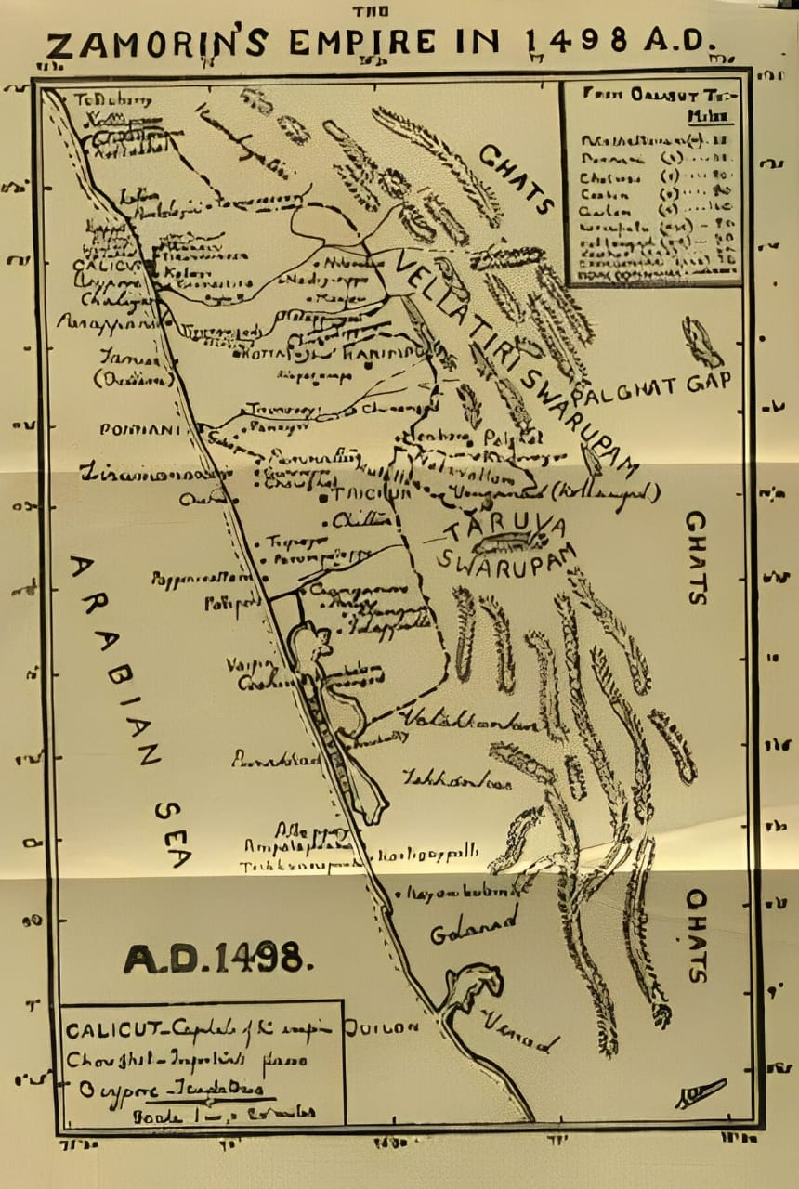

Zamorin’s Empire in 1489 A D

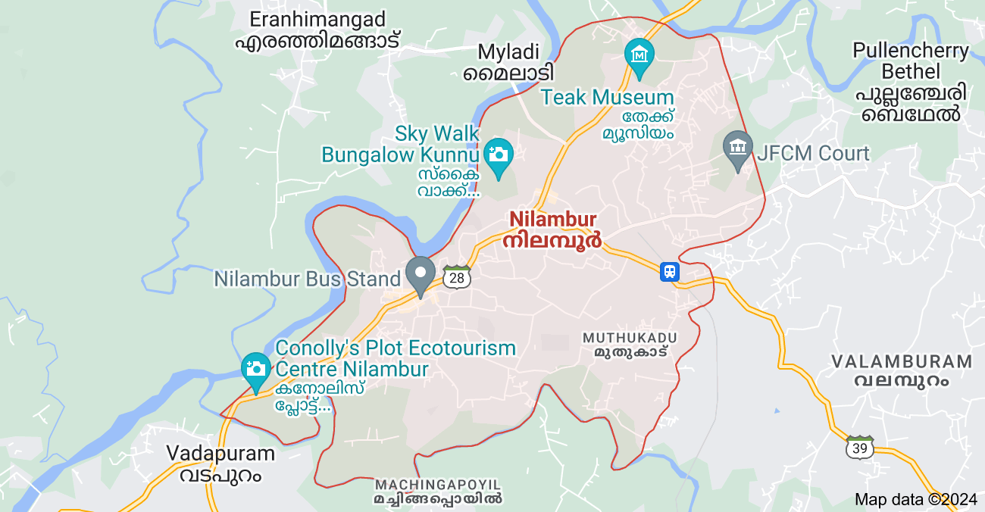

Nilamabur

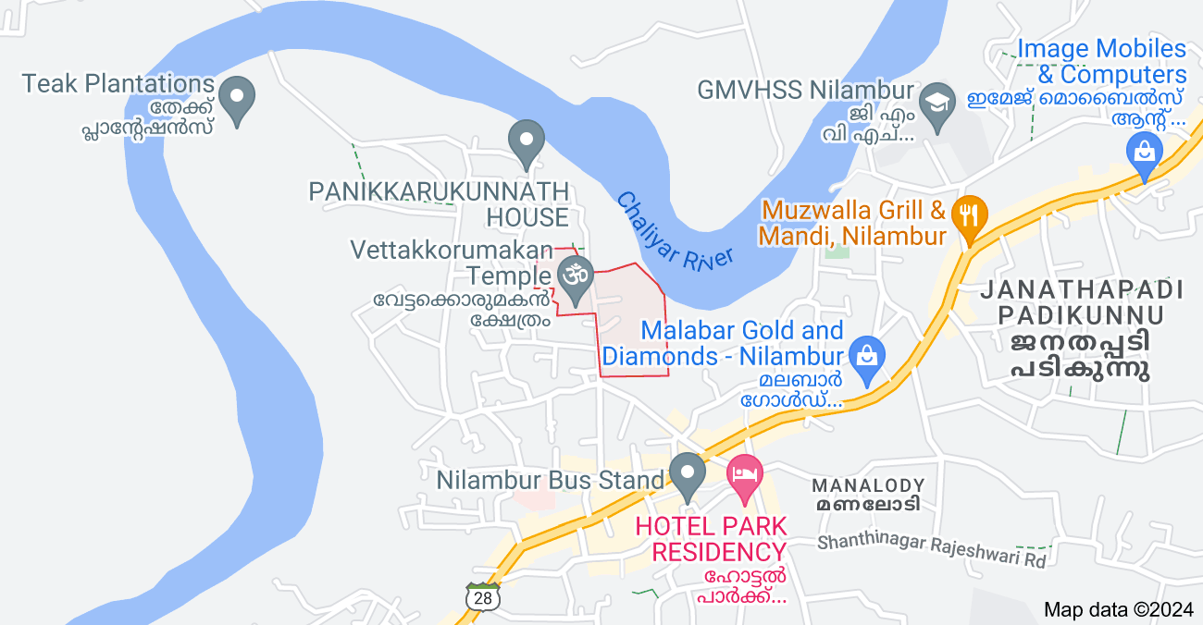

Vettakkorumakan Temple and Nilambur Kovilakam

**APENDIX 2 : PICTURES**

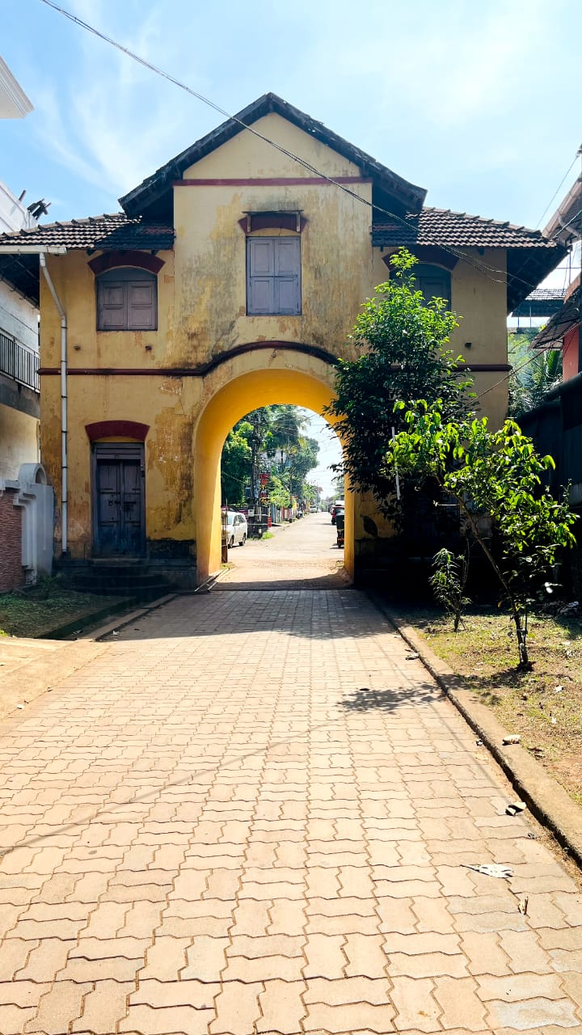

**Kovilakam Kavadam**

**Vettakkorumakan Temple**

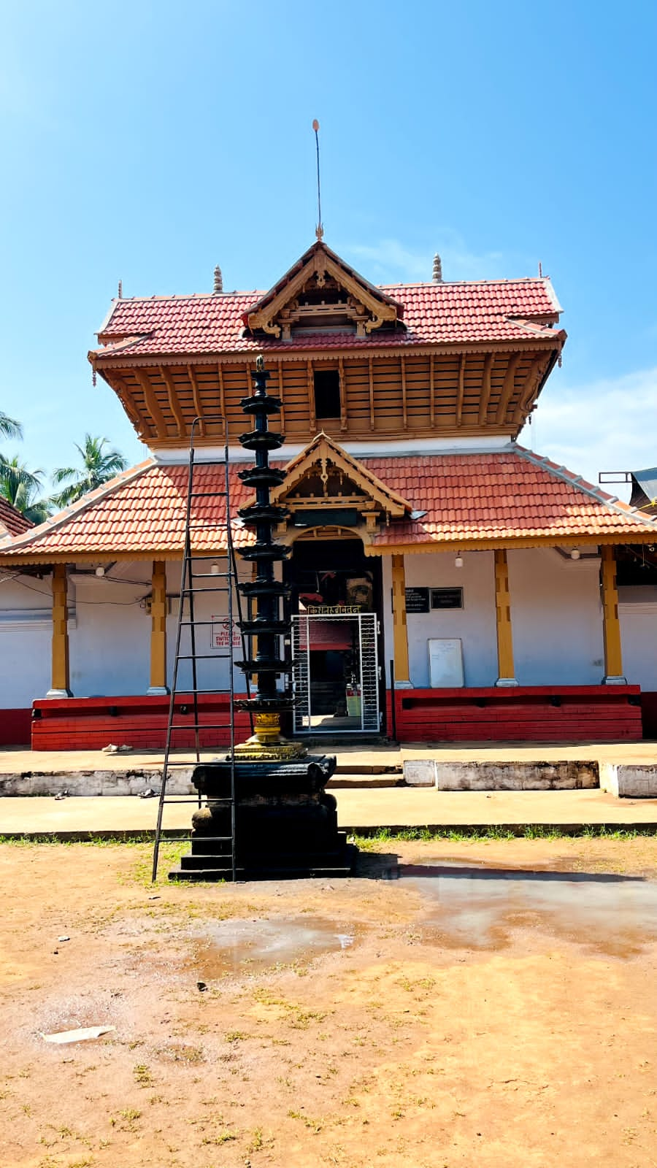

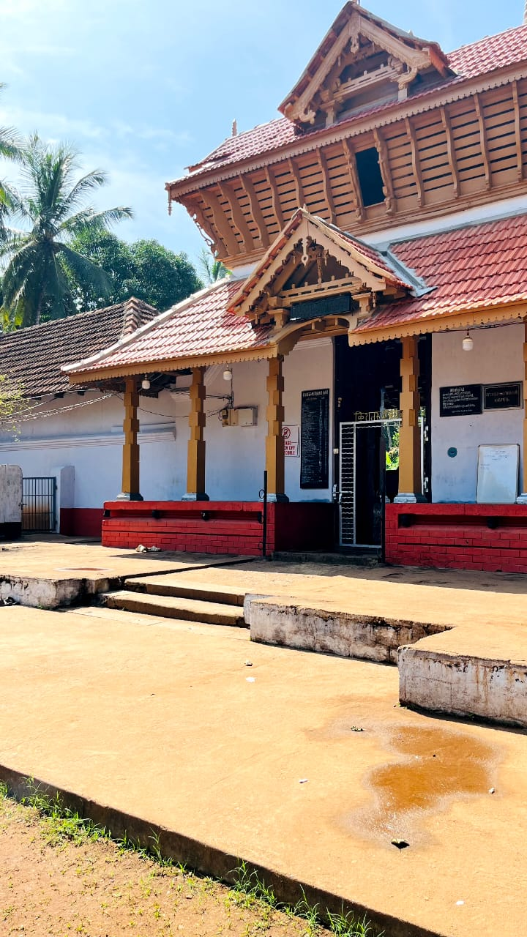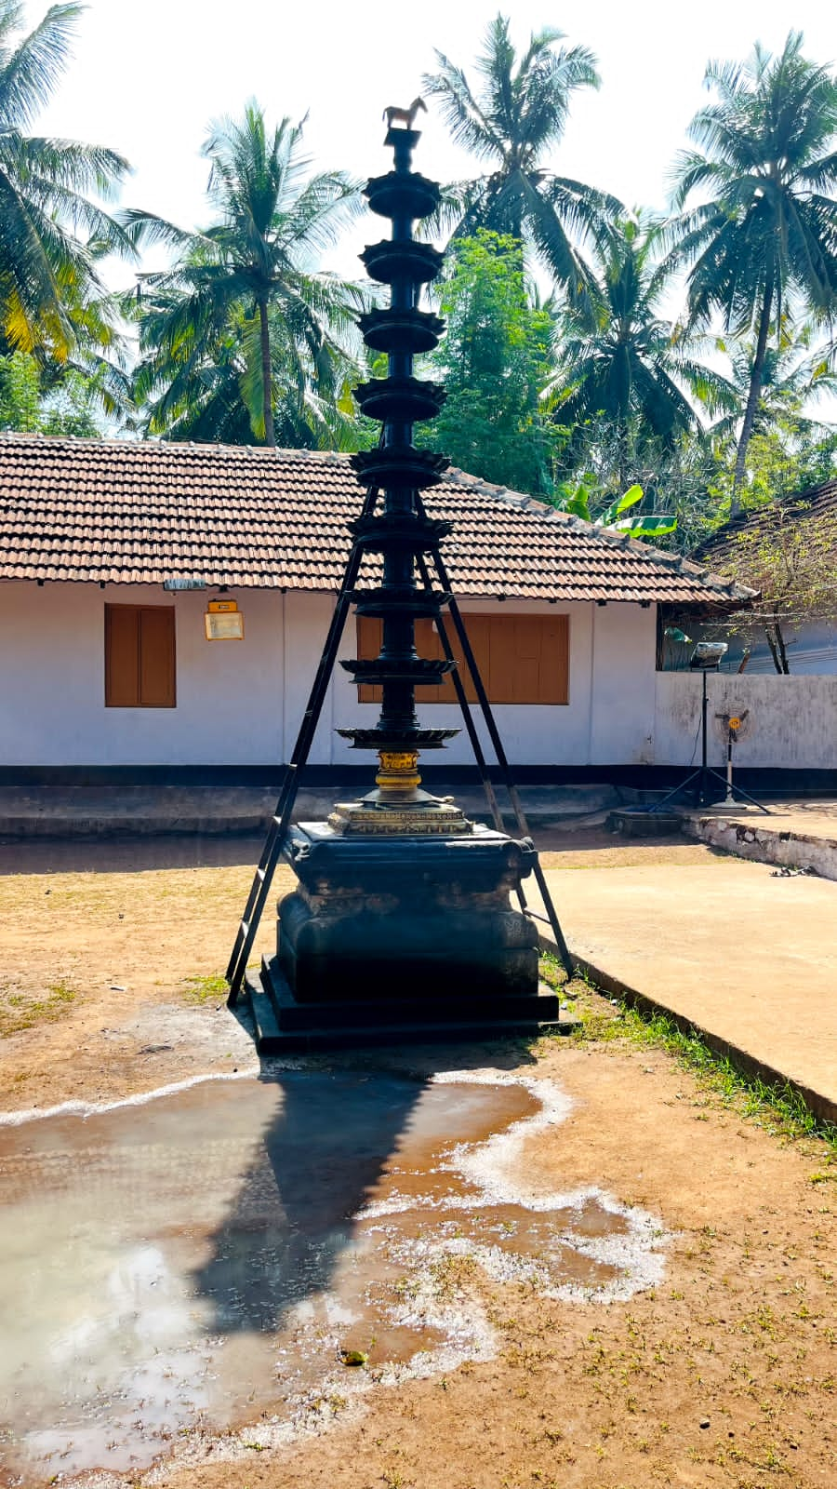

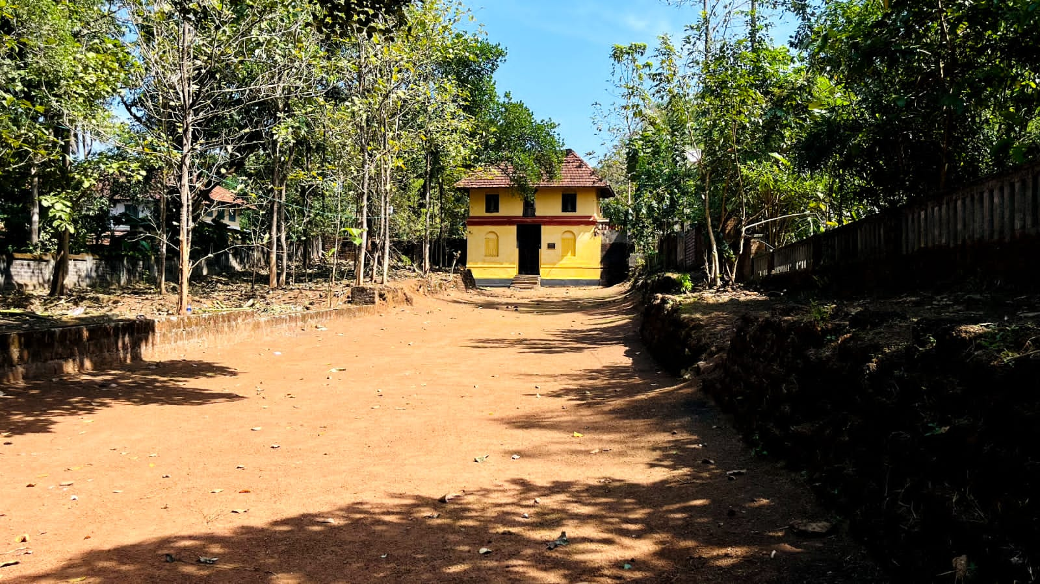

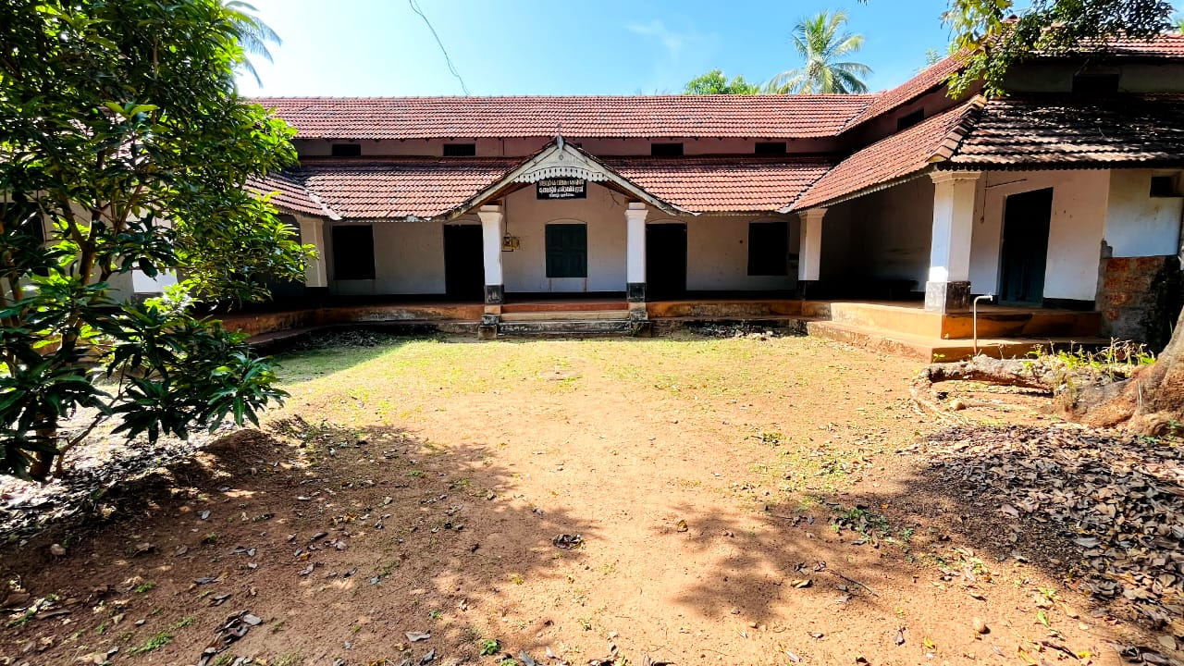

1. A Sreedhara Menon. “*A Survey of Kerala History” .*D C Books, 2019,p.13.
2. “Culture of Kerala” accesessed January 17, 2024

   https://www.indianetzone.com/5/culture_kerala.htm
3. T K Gangadharan. “ *Evolution of Kerala History & Culture”* .Calicut University Central Co-operative Stores ,n.d,p.1.
4. William Logan . “*Malabar Manual”.*Asiatic Educational Service,vol.1*,*1979*,*p.2.
5. Ibid.
6. “ Malabar”accessed January 18, 2024 , https://www.keralatourism.org/malabar/introduction/2#:~:text=Wedged%20between%20the%20Western%20ghats,and%20Kasaragod%20districts%20of%20Kerala.
7. A Sreedhara Menon . “*Kerala Charithram”*.D C Books ,2007*,*
8. Dr.G.Krishna Nadar. “ *Hiistoriography and History of Kerala”.* Learners’ Books House ,2001,p.187.
9. “The rise and fall of the Zamorins of Calicut” acceessed January 19, 2024,

   https://www.peepultree.world/livehistoryindia/story/eras/zamorins-of-calicut
10. K V Krishna Iyer. *“Zamorins of Calicut : From the earliest times to AD 1806”.*Norman Printing Bureau ,1938,p.3.
11. Malabar commission foreign miscellaneous ,Vol.55,1793.p.67.
12. “Kovilakam” in *Wikipedia ,* January 2,2024

    https://en.wikipedia.org/wiki/Kovilakam
13. “Nilambur” In Wikepedia .January 19,2024

    https://en.wikipedia.org/wiki/Nilambur
14. Vettakkoru Makan is a Hindu deity venerated in certain regions of Northern Kerala. Also known as Kiratha-Sunu in Sanskrit, this divine figure is regarded as the offspring of Shiva and Parvati. According to mythology, Vettakkoru Makan was born when Shiva assumed the guise of a Kirata (hunter) to bestow the potent weapon Pashupatastra upon Arjuna.
15. “Nilambur Pattulsavam.” In Wikepedia .January 14,2024

    <https://en.wikipedia.org/wiki/Nilambur_Pattulsavam>
16. T K Gangadharan. *“Evolution of Kerala History and Culture”*.Calicut university Central ,n.d,p.1.
17. Travancore Information and Listener , Government of Travancore , May 1942, Vol. 1, No.9, p.27
18. Shaykh Zainuddin. “*Tuhfat al Mujahidin*”.tr. Velayudhan Pnikkassery , Keralam Patinanchum Pathinarum Noottandukkalil, Current Books, 1963,p.22-23.
19. William Logan. “*Malabar Manual,Asian”.* educational services ,vol.1,New Delhi,1979,p.1.
20. S M Nainar. “*Arab Geographer”* .University of Madrs ,Madras,1972,p.19.
21. Roland E Miller. “*Mappila Muslim of Kerala*”.Orient Longaman , Madras,1976,p.18.
22. Duarte Barbosa. “*The Book of Duarte Barbosa”*,vol.2, ed.Mansel Longworth Dames , Asian Educational Services , New Delhi ,1989,p.71.
23. Barbosa.1, p.203.
24. Barbosa .11, p.77. As soon as the foreign merchant reached Malabar , The king assigned him,along with a Nair and broker , a Chatin (Sei) clerk to look after his accounts.
25. Vatteluthu, popularly Romanised as Vattezhuthu , was an alphasyllabic writing system of south India and Sri Lanka used for writing the Tamil and Malayalam languages.Vatteluttu belonged to the group of Tamil- Malayalam scripts among the Southern Brahmi derivatives.
26. A Sreedhara Menon. “*Kerala Charithram” .*D C Books ,2007,p.147.
27. Jean Baptiste Travernier . “*Travels in India” ,* vol .1 ( 2nd ed),London ,1925 ,p.189.
28. A Sreedhara Menon . “*Kerala Charithram”.* D C Books ,2007,p.152.
29. “The Rise and Fall of Zamorins of Calicut.” Accessed January 19,2024.

    https://www.peepultree.world/livehistoryindia/story/eras/zamorins-of-calicut
30. Ibid.
31. K V Krishna Iyer. “*The Zamorins of Clicut* :from Earliest Times to A D 1806”.Norman Printing Bureau,1938,p.80.
32. “Kovilakam” In *Wikepedia*. January 2,2024

    https://en.wikipedia.org/wiki/Kovilakam
33. Malabar Commission Foreign Miscellaneous ,vol.55,1793,p.67.
34. Mansel Longworth Dames , Vol 11, New Delhi ,1989, pp.8-9.
35. C A Innes &Evans (ed), “*Malabar Gazetteer”*.Thiruvananthapuram,1997,pp.139-141.
36. Malappuram Gazetteers ,p.307
37. Logan ,William, “*Malabar Manual*”, Vol .1. reprint ,New Delhi , 1989,p.9.
38. “Nilambur.” In *Wikepedia* .January 19 ,2024 .https://en.wikipedia.org/wiki/Nilambur#cite_ref-8
39. Malabar Second Commission Diaries ,Revenue – 1797 , vol .1711,pp.236-239.
40. K V Krishna Iyer. “*The Zamorins of Clicut*”, p.3.
41. Sreekumari Ramachandran”.*Tales of Malabar*”. Darpan An Imprint of Prism,2021,p.59.
42. K.N.Ganesh."*Agrarian Society in Kerala(1500-1800)”,* in P.J. Cheriyan, ed., Perspectives on Kerala History , Thiruvanathapuram , 1999,p.73.
43. M.R.Raghava Varrier and Rajan Gurukkal. “*Kerala Charithram*” .Vallath Vidya Peedam, Sukapuram,1992,pp.196-272.
44. Fuckar Ali,C.A. “*Ethnohistory of Tribes in Malappuram Distric*t” . PhD. Thesis, Unpublished, Calicut University, 2009 ,pp.181-183.
45. Puddies were territorial divisions or assigned area.
46. C A Innes I .C.S, *Malabar gazetteer* ,vol 1&11 ,p.114
47. “ Festival”. In *Wikepedia* .January 21 ,2024

    https://en.wikipedia.org/wiki/Festival
48. M A Sree Vettakorumakanum Sree Dharma Sasthavum (Kottayam, 1999),pp.21-22.
49. “ Malabar “ Accessed January 18, 2024

    https://www.keralatourism.org/malabar/introduction/2#:~:text=Wedged%20between%20the%20Western%20ghats,and%20Kasaragod%20districts%20of%20Kerala
50. **“**Nilambur Pattullsavam.” Accessed January 14,2024.

    https://en.wikipedia.org/wiki/Nilambur_Pattulsavam