**EVALUATION OF GENETIC DIVERSITY IN *Nelumbo nucifera* Gaertn., USING ISSR MARKERS: A COMPARATIVE STUDY OF NATURAL AND CULTIVATED VARIETIES**

Dissertation submitted in partial fulfillment of the requirements

for the award of the degree of **Masters of Science** in

**BOTANY**

**MANEESHA NATH N. M**

**Reg. No: AM21BOT011**



DEPARTMENT OF BOTANY AND CENTER FOR RESEARCH

ST. TERESA’S COLLEGE (AUTONOMOUS), ERNAKULAM

2022-24

**CERTIFICATE**

This is to certify that the dissertation entitled **“Evaluation of Genetic Diversity in *Nelumbo nucifera Gaertn.*, Using Inter Simple Sequence Repeat (ISSR) markers: A Comparative Study of Natural and Cultivated Varieties”** is an authentic record of work carried out by Maneesha Nath N.M under my supervision and guidance in the partial fulfilment of the requirement of the M.Sc. Degree of Mahatma Gandhi University Kottayam. I, further certify that no part of the work embodied in this dissertation work has been submitted for the award of any other degree or diploma.

Smt. I. K. Nishitha Dr. Liza Jacob

Supervising Teacher Head, Department of Botany

Department of Botany St. Teresa’s College (Autonomous)

St. Teresa’s College (Autonomous) Ernakulam

Ernakulam

Place:Ernakulam

Date:20-03-24

External Examiners

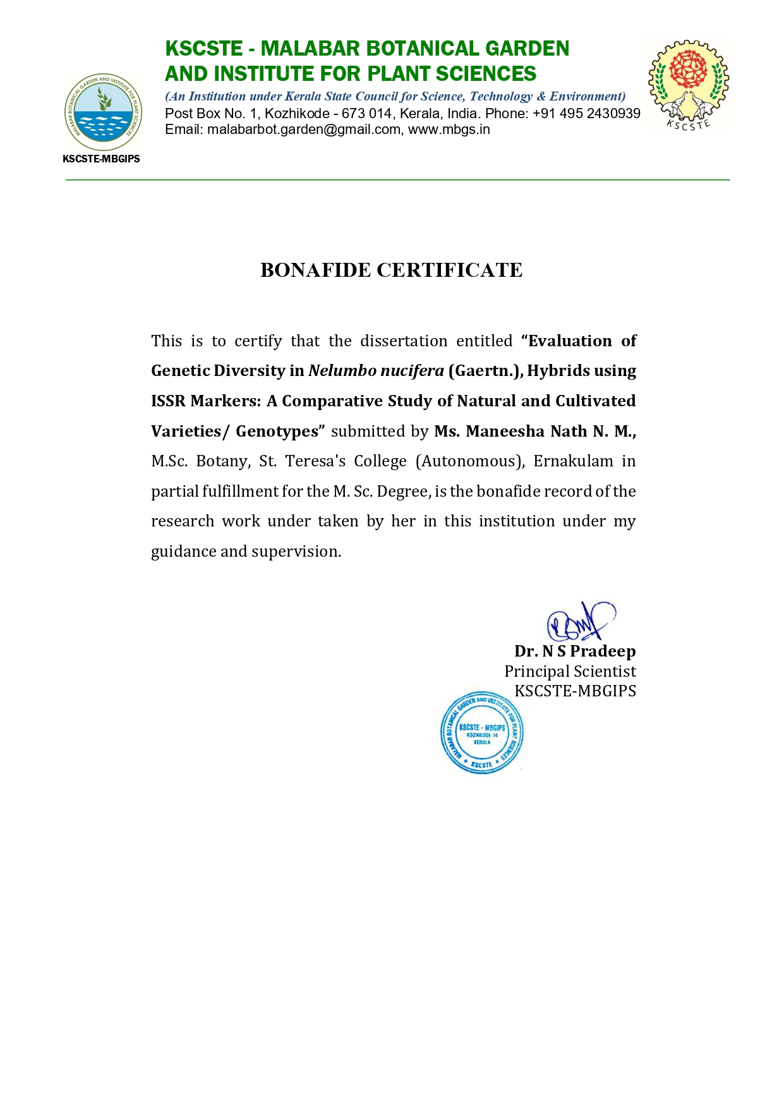

# DECLARATION

I hereby declare that the work which is being presented in the dissertation, entitled “**Evaluation of Genetic Diversity in Nelumbo nucifera Gaertn., hybrids Using ISSR Markers: A Comparative study of Natural and Cultivated Varieties**” in fulfillment of the requirements for the award of the degree of Master of **Science in Botany and submitted to St. Teresa’s College (Autonomous), Ernakulam is an** authentic record of my own work carried out during M.Sc. period under the supervision of Smt. I.K. Nishitha

The matter embodied in this dissertation has not been submitted by me for the award of any other degree of this or any other University/ Institute.

Place: Ernakulam

Date : Signature of the Candidate

**ACKNOWLEDGMENT**

I wish to express my sincere thanks and a deep sense of gratitude to **Mr. Harshid P**, KSCSTE- Malabar Botanical Garden and Institute for Plant Sciences, Calicut, for introducing the present topic and for his inspiring guidance and valuable suggestions throughout this work. His able knowledge and expert supervision with patience played an essential role in the successful completion of this work.

I would like to express my sincere thanks to **Dr. N.S. Pradeep Kumar**, Director, Malabar Botanical Garden and Institute for Plant Sciences, Calicut- 14, and Dr. N S Pradeep, Senior scientist for his immense concern throughout the project work and for providing laboratory facilities.

I consider it a pleasure and privilege to extend my profound sense of gratitude to **Smt. I. K. Nishitha,** Faculty of Department of Botany and Centre for Research, St. Teresa’s College (Autonomous), Ernakulam, for permitting me to carry out my project at KSCSTE-Malabar Botanical Garden and Institute for Plant Sciences, Calicut.

I wish to express my sincere thanks to **Dr. Liza Jacob**, Head of the Department, Department of Botany and Centre for Research, St. Teresa's College (Autonomous), Ernakulam, for the guidance and intellectual support extended to me for the successful completion of my work.

I also express my deepest gratitude and appreciation for the guidance and encouragement given by all the teachers.

I gratefully acknowledge **Dr. Alphonsa Vijaya Joseph**, Principal, St. Teresa's College (Autonomous), Ernakulam, for allowing me to do a project in this institution.

A special word of thanks **to Ms. Pooja P and Mrs. Jaseela V T,** for their constant support throughout this work.

Last but not least, I would like to thank the almighty God whose blessings have enabled me to accomplish my dissertation work.

Sincere thanks also go to the non-teaching staff and also my friends who have helped me to take this work to completion.

I am extremely grateful to my beloved parents who have given their love, affection, encouragement, and blessing which have guided me to complete this work.

MANEESHA NATH N. M

**TABLE OF CONTENT**

|  |  |  |
| --- | --- | --- |
| Sl No: | TITLE | PAGE NO; |
| 1 | INTRODUCTION | 1-6 |
| 2 | REVIE OF LITERATURE | 7-13 |
| 3 | MATERIALS AND METHODS | 14-25 |
| 4 | RESULT | 26-33 |
| 5 | DISCUSSION | 34-36 |
| 6 | CONCLUSION | 37-38 |
| 7 | REFERENCE | 39-43 |

**LIST OF TABLES**

|  |  |  |
| --- | --- | --- |
| Sl No: | TITLE | PAGE NO; |
| 1 | Stock solutions required for genomic DNA extraction | 18-19 |
| 2 | Stock solution required for Agarose gel electrophoresis | 20 |
| 3 | List of Equipment's Used in the Study | 21-22 |
| 4 | List of ISSR primers used in the study | 22-23 |
| 5 | Conditions for PCR reaction | 23 |
| 6 | Quantitative Estimation of Genomic DNA | 26 |
| 7 | Data for ISSR primers used for analyzing 08 acessions of Nelumbo nucifera Gaertn. | 28 |
| 8 | Similarity index table showing Jaccard's coefficient foe genetic similarity | 30 |
| 9 | Seed setting and viability of Nelumbo hybrid seeds | 31-32 |
| 10 | Seed viability of Nelumbo hybrids | 32 |

**LIST OF PLATES**

|  |  |  |
| --- | --- | --- |
| Sl No: | TITLE | PAGE NO; |
| 1 | Flowers of *Nelumbo nucifera* Gaertn. | 15 |
| 2 | Fruits of *Nelumbo nucifera* Gaertn. | 31 |

**LIST OF FIGURES**

|  |  |  |
| --- | --- | --- |
| Sl No: | TITLE | PAGE NO; |
| 1 | *Nelumbo nucifera* natural hybrids geographical distribution in Kerala | 16 |
| 2 | Gel image of genomic DNA of *Nelumbo nucifera* Gaertn. | 27 |
| 3 | Dendrogram Based on Jaccard's coefficient of Genetic similarity (UPGMA) Showing genetic distance | 29 |
| 4 | Seed germination | 30 |
| 5 | After seed germination | 30 |
| 6 | Graph showing seed viability of *Nelumbo nucifera* Gaertn. | 32 |

# ABSTRACT

*Nelumbo nucifera*, commonly known as sacred lotus, holds significant cultural, economic, and ecological value. The plant is an aquatic herbaceous perennial with significant ecological, decorative, and commercial value comes under the family Nelumbonaceae. In the context of *Nelumbo nucifera*, hybridization events have been documented both in natural settings and through deliberate breeding efforts aimed at enhancing desirable traits such as flower color, size, and disease resistance. These hybrids often exhibit a wide array of morphological, physiological, and genetic characteristics, making them intriguing subjects for scientific inquiry. Genetic variation of *Nelumbo nucifera* was evaluated using Inter simple sequence repeats (ISSR) markers. A total of 8 hybrids of *Nelumbo nucifera* were collected. Plant populations are named NE 1 (*Nelumbo nucifera* 1) to NE 8 (*Nelumbo nucifera* 8). The UPGMA techniques for creating dendrograms were utilized to estimate the phylogenetic tree using the Numerical Taxonomy and Multivariate Analysis System (NTSYS). For polymorphism detection, it was discovered that ISSR markers were more effective than RAPD markers. Seed setting and growth rate are fundamental aspects of plant reproductive biology and are critical determinants of plant fitness, population dynamics, and crop productivity. Understanding the factors influencing seed setting and growth rate in Nelumbo nucifera hybrids is essential for optimizing breeding strategies, improving cultivation practices, and ensuring sustainable production. Hybridization between genetically diverse parental lines may result in variations in seed fertility and viability, necessitating thorough investigations into the mechanisms governing seed setting in *Nelumbo nucifera* hybrids. Moreover, the growth rate of *Nelumbo nucifera* hybrids is a multifaceted trait shaped by genetic, physiological, and environmental factors.

Key Words: Nelumbo nucifera hybrids, Inter simple sequence repeats (ISSR) markers, Numerical Taxonomy and Multivariate Analysis System (NTSYS), Seed setting, Growth rate

**I. INTRODUCTION**

Angiosperms are the largest and most diverse group of flowering. Approximately 80% of all currently recognized green plants are angiosperms. The ovule (egg) in an enclosed hollow ovary becomes a seed when fertilized. They are vascular seed plants. The portion of an angiospermous plant that houses either or both of the reproductive organs the male or the female is called a flower, and it typically encloses the ovary. Because they are produced from the developing floral organs of the angiospermous plant, fruits are a distinctive feature of angiosperms plants in the kingdom Plantae over 300,000 (Bir, Bahadur., et al., 2024). Among terrestrial plants, angiosperms are exceptional due to their tremendous morphological, physiological, and biochemical diversity. Their growth habits, leaves, inflorescences, flowers, and root and shoot systems are all very diverse (Else et al., 2011). Angiosperm variety has been bolstered by substantial genome evolution, including whole genome duplications, which are hallmarks of their evolutionary past (Quentin et al., 2016).

While having a high degree of morphological and functional diversity, aquatic angiosperm diversity is comparatively lower than that of their terrestrial cousins. In watery angiosperms, reduced speciation and higher extinction rates are the causes of the low diversity. Although the majority of the transition from land to water occurred in the last 25 million years, it began early in the history of angiosperms. At higher rates, reversals to a terrestrial habitat began 40 million years ago. Throughout the Cenozoic, lineages within aquatic angiosperms gradually accumulated and their rates of diversification remained relatively low and consistent. It is thought that the restricted global surface area of the aquatic habitat and its stressful conditions account for the current low variety of aquatic angiosperms (Andrea et al., 2022)

**GENUS**

The family Nelumbonaceae, which includes various species with a variety of morphological and physiological characteristics, is well recognized for having ancient taxa in the genus Nelumbo, generally known as lotuses. It is well renowned for its exquisite blossoms, lengthy history of cultivation, and distinct religious and cultural importance (Tian et al., 2008). The plant is an aquatic herbaceous perennial with significant ecological, decorative, and commercial value. It is hardy and simple to grow. These plants are well-known for both their beautiful, solitary blooms that bloom on the surfaces of ponds and lakes, as well as their eye-catching, big, and uniquely formed leaves. Additionally, they maintain biodiversity, enhance water quality, and stabilize habitats, among other ecologically significant functions. Its distinct adaptations to watery habitats have a complex impact on the two species that make up the Genus Nelumbo: Nelumbo lutea and N. nucifera. The primary distribution regions of N. nucifera are China, India, Thailand, Japan, and Australia (Li *et al.,* 2010). A group of plants with great beauty, culinary, and therapeutic significance is called the genus Nelumbo, sometimes referred to as lotuses. Over 4,000 cultivars of lotus have been found and cultivated over the thousands of years that they have been cultivated (Ping et al., 2022)

**APPLICATIONS**

For more than 2,000 years, Nelumbo nucifera, or sacred lotus, has been important to mankind as a vegetable, functional food, and herbal medicine. This plant has historically been used to treat hyperlipidemia, neurological problems, sleeplessness, and chronic dyspepsia (Chen et al., 2019). It is a significant horticultural plant that has been widely used, particularly in Southeast Asia, for purposes ranging from nutritional to medicinal. This plant has strong astringent and cooling qualities, making it an excellent source of herbal medicine in addition to being elegant and decorative. In South East Asia, where the seeds and leaves are also consumed, lotuses are also considered sacred. (Prabhsimran et al.,2019). Because of the presence of a steroidal triterpenoid in the rhizome extract, it has been used for its anti-inflammatory and antidiabetic qualities. I.e. Hematemesis, epistaxis, hemoptysis, hematuria, and metrorrhagia were medical conditions for which leaves were a useful medication. Diarrhea, cholera, fever, and hyperdipsia were all treated using flowers (Keshav et al.,2015)

**HYBRIDS AND SEED SETTING OF *NELUMBO***

A key process in determining the genetic variety and evolutionary paths of plant species, including those in the Nelumbo genus, is hybridization. Nelumbo, or lotus, is a genus that includes a wide range of species with unique morphological and physiological traits. Intentional hybridization of several Nelumbo species has produced a large number of hybrids with distinct genetic makeup and phenotypic characteristics. The genetic diversity present in hybrids of Nelumbo underscores the dynamic nature of lotus hybridization and its importance for biodiversity conservation, horticultural innovation, and ecosystem resilience. Continued research efforts aimed at elucidating the genetic basis of lotus hybridization and assessing genetic diversity in hybrid populations will contribute to the sustainable management and utilization of Nelumbo species in diverse cultural, ecological, and agricultural.

One of the most well-known characteristics of lotus seeds is their long-term viability in harsh environments. Numerous elements contribute to this resilience, one of which is the special makeup of lotus seeds, which are shielded from diseases, desiccation, and other stresses by a tough, impenetrable seed coat (Salaemae et al., 2018). "Seed setting" is the process via which fertilized blossoms turn into fully grown seeds. Depending on the exact crossbreeding that took place and the fertility of the parent plants, seed setting in Nelumbo hybrids might vary. The pace at which plants expand and get bigger over time is referred to as the Nelumbo hybrid growth rate. This includes both vegetative (such as leaf expansion and stem elongation) and reproductive (such as flower production and seed development) growth of plants. Here we are using the natural hybrids as well as the cultivated hybrids as the known hybrids are Kanyakumari and Thirunavaya.

**GENETIC DIVERSITY**

A wide range of variability that arises between genotypes with regard to the overall genetic composition of a single species or between species is collectively referred to as genetic diversity. Evolutionary changes are based on genetic diversity. A plant species’ genetic diversity and its distribution are influenced by various factors, such as its breeding system, evolution, and environment. For genetic variety to be used and conserved effectively, a deeper comprehension of genetic diversity and its distribution is necessary (Ramanatha Rao, 2002).

The molecular underpinnings of the fundamental biological processes in plants must be understood in order to effectively conserve, manage, and use plant genetic resources (PGR). The evaluation of genetic diversity is often carried out at the molecular level by a variety of laboratory-based methods, including direct measurement of levels of variation through allozyme or DNA analysis (Mondini, L., et al. 2009). There are several different types of DNA molecular markers used in molecular investigations of genetic variation. A genomic locus is called a molecular marker if its existence clearly separates the chromosomal feature it represents from the surrounding areas at the 3’ and 5’ extremities. A genomic locus can be discovered using a probe or specialized initiator (primer) (Barcaccia, G., et al. 2000).

Since increasing population pressure, agricultural land urbanization, and rapid modernization are the main causes of food insecurity in the developing world, the significance of plant genetic diversity (PGD) is now understood. Workers are most interested in genetic variety. There are significant concerns about the declining genetic variability and diversity among crop plant species, and it will be difficult to enhance crop varieties going forward.

**MOLECULAR MARKERS**

Each and every organism has an own DNA sequence. Variations are mutations that happen in an organism’s DNA sequences, and they cause the emergence of new alleles in a population. Polymorphism is the existence of two or more alternative variants of a certain DNA sequence that can exist in various people or communities. Balanced polymorphism is the state in which non-identical alleles for a trait are preserved at frequencies higher than 1% in a population. The degree of polymorphism in a species’ gene pool determines both its chances of surviving and its capacity for evolution. The majority of plants have significant genetic variation in their natural populations, and these variations that set each plant apart (Sebastian, V. A., 2009).

A gene or DNA sequence that has a defined position on a chromosome and is always linked to a certain gene or trait is called a genetic marker. A genetic marker can be a long DNA sequence, such as mini- and microsatellites, or a short one, such as a single nucleotide polymorphism (SNP). DNA polymorphism is shown by molecular markers (Al-Samarai, F. R., 2015).

Allozymes and other physical and biochemical features have long been used to quantify genetic diversity within a species’ gene pool. But these days, allozymes are Insufficient to evaluate genetic diversity among populations (Heun et al. 1994). These population-level investigations are now feasible because to a variety of molecular-based methods, such as RFLP (Restricted Fragment Length Polymorphism), ISSR (Inter Simple Sequence Repeat), and RAPD (Random Amplified Polymorphic DNA).

Because of their simplicity and speed, RAPDs are among the molecular markers that have been utilized most frequently in genetic studies (Penner, 1996). Every technique has benefits and drawbacks of its own. The degree to which these techniques can address genetic Distinctions, the kinds of data they provide, and the extent of their applicability. Molecular markers find application in a wide range of fields, including population history, genetic mapping, paternity testing, cultivar identification, marker-assisted crop breeding, and the detection of mutant genes linked to hereditary disorders.

**INTER-SIMPLE SEQUENCE REPEATS (ISSR) MARKERS**

Microsatellite sequences surround certain areas of the genome known as inter-simple sequence repeats (ISSRs). When a single primer is used to amplify these areas, several amplification products are produced that can be used as a dominant multi-locus marker system to investigate genetic diversity in a variety of organisms. Compared to other ascendant markers, ISSR markers are inexpensive, easy to use, and require less rigorous methodology, which makes them a perfect genetic marker for tyros and species with incomplete genetic information.

The very diversified and widely distributed microsatellite sequences used in the creation of ISSR markers are found across the genome. It is less expensive and time-consuming than AFLP and more reproducible than RAPD. For a variety of research, including those on genetic variation and diversity, DNA fingerprinting, and phylogenetics, among others, all of these make ISSR an excellent genetic marker (Ng, W. L., & Tan, S. G., 2015). ISSR markers are categorized as dominant markers and display the Mendelian method of inheritance. Numerous studies in the fields of molecular ecology, genetic diversity, genetic mapping, gene tagging, and cultivar identification have made extensive use of this technique.

The fact that ISSR does not require sequence data for primer creation is a significant benefit.Because the analytical approach uses PCR, very little template DNA is needed. Additionally, ISSRs are dispersed at random across the entire genome. The drawback of ISSR, being a multilocus technique, is that homology may not be present in pieces of comparable sizes.   
Furthermore, ISSR has repeatability issues just like his RAPD. ISSR analysis can be applied to research pertaining to genetic identity, phylogeny, clone and strain identification, and taxonomy investigations of closely related species because of the multilocus fingerprinting patterns that are obtained. Furthermore, ISSR is thought to be helpful for research on genomic mapping.

**OBJECTIVES**

1. Survey and collection of *Nelumbo nucifera* hybrids from Kerala.

2. Evaluate the genetic diversity and relatedness among different hybrids of *Nelumbo* and PCR amplification of isolated genomic DNA using ISSR markers.

3. Analyzing the fecundity of hybrids using the number of seed setting.

**II. REVIEW OF LITERATURE**

**GENUS**

A genus of water plants called Nelumbo has big, eye-catching blossoms. Although the term "lotus" is frequently used to refer to a number of other plants and plant groups, including the unrelated genus Lotus, members are commonly referred to as "lotuses." There are only two species of lotus that are now known to exist: the more well-known Nelumbo nucifera, which is native to East, South, and Southeast Asia as well as possibly Australia. It is widely grown, consumed, and utilized in traditional Chinese medicine. Nelumbo lutea, a native of the Caribbean and North America, is the other lotus. These two allopatric species have created hybrids used in horticulture.

An overview of current studies on lotuses (Nelumbo nucifera) is given in the study written by Lin et al. (2019), emphasizing the plant's rise to prominence as a model in horticulture. Numerous facets of lotus biology are included in the paper, including as molecular biology, physiology, and genetics. The writers talk about the latest developments in lotus research and stress the plant's value as a model for examining a range of biological processes. They look at things like the lotus's genetic foundation, the molecular processes that give it its distinct features, and its uses in horticulture. In general, the paper provides an extensive overview of the most recent research conducted on lotuses, highlighting their increasing significance as model organisms in horticultural studies.

Kubo et al. (2009) employs SSR (Simple Sequence Repeat) markers to particularly investigate the genetic links among flowering lotus cultivars in Japan, with an emphasis on the taxonomy and diversity of sacred (Nelumbo nucifera) and American (Nelumbo lutea) lotus species. The researchers sought to comprehend the genetic links between several lotus cultivars grown in Japan through their analysis. SSR markers are a kind of molecular tool that they used to evaluate the genetic diversity and inter-cultivar interactions. The study's conclusions shed light on the genetic diversity and connections between Japanese flowering lotus cultivars. This study advances our knowledge of lotus genetics and helps to categorize and preserve many lotus cultivars, all of which are crucial for horticulture and conservation initiatives.

Yang et al. (2012) used two different molecular marker types—SSR (Simple Sequence Repeat) and SRAP (Sequence-Related Amplified Polymorphism)—to compare the genetic diversity of lotus (Nelumbo). The objective of the research was to evaluate and contrast the genetic diversity found in lotus species. Using both SSR and SRAP markers, the authors assessed the genetic diversity between several lotus cultivars through their investigation. In molecular biology, these markers are frequently used to investigate genetic variation within plant populations. The study's conclusions offered a comparative examination of the efficacy of SSR and SRAP markers in determining the genetic diversity of lotus species, which gave rise to important new insights. Such data is essential for conservation initiatives, lotus breeding programs, and the general understanding of lotus genetics.

**GENETIC DIVERSITY OF HYBRIDS**

Matra et al.'s 2021 study investigates the genetic diversity and interrelationships of Mangifera casturi Kosterm's natural hybrids. Casturi, also known as Mangifera casturi Kosterm, is a native species of mango found in Indonesia. It is renowned for having a distinct flavor and set of qualities. This species' natural hybrids, which result from cross-breeding with other mango kinds, are the subject of the study. The genetic variety seen in these naturally occurring hybrids was examined by the researchers using molecular techniques. They evaluated the links and diversity among the hybrids using a variety of genetic markers. Understanding the genetic makeup and relatedness of the various hybrid populations was made possible by the genetic data that was collected.

Hartati and Muliawati's 2020 study use Random Amplified Polymorphic DNA (RAPD) markers to evaluate the genetic variety of Coelogyne pandurate, C. rumphii, and their hybrids. The study, which looks into the genetic variety found in these orchid species and their hybrids, was published in the Biodiversitas Journal of Biological variety. The genetic profiles of C. rumphii, Coelogyne pandurate, and their hybrids were examined by the researchers using RAPD markers. Molecular biologists frequently employ RAPD markers to find genetic diversity and polymorphisms within populations. The study's conclusions shed light on the genetic diversity among the hybrids and explored orchid species. In addition to highlighting genetic differences within the hybrid populations, the RAPD markers provided unique genetic profiles for every species.

Das et al. (2018) used Inter Simple Sequence Repeat (ISSR) markers in a study to evaluate the genetic diversity in a number of banana hybrids. Their study, which was published in the International Journal of Current Microbiology and Applied Sciences, sought to assess the genetic variability of these hybrid bananas. An example of a molecular marker that is frequently used to identify polymorphisms and evaluate genetic diversity in different plant species was utilized by the researchers: ISSR markers. They looked into the genetic characteristics of the hybrid bananas they were studying by examining these markers. The study's conclusions shed light on the genetic diversity among hybrid bananas. The hybrid populations had unique genetic patterns and variations identified by the ISSR markers, suggesting that there was genetic diversity among them.

Samal et al. (2012) used cumulative RAPD and ISSR to evaluate the genetic diversity across different mango cultivars, hybrids, and local genotypes in India. A total of 48 genotypes, including hybrids, commercial cultivars, and regional variants of mango, were assessed by the researchers. They discovered substantial genetic variation among the various genotypes of mangos through their investigation. It was found that RAPD and ISSR markers worked well for evaluating this diversity. The study provided useful information for mango breeding programs by identifying particular molecular markers that were exclusive to particular genotypes. In general, the study advances our knowledge of the genetic diversity among Indian mango varieties, which is important for breeding initiatives, conservation campaigns, and the long-term sustainable management of mango genetic resources.

Using ISSR (Inter-Simple Sequence Repeat) markers, Alhajturki, Al Jamali, and Kanbar set out to evaluate the genetic variance across several sorghum (Sorghum bicolor L. Moench) cultivars in their 2011 study. They looked into a variety of sorghum cultivars in order to comprehend the genetic diversity of this crop. Significant genetic heterogeneity was discovered by the researchers among the sorghum cultivars they examined. The ISSR markers worked well as instruments to evaluate this diversity. For sorghum breeding programs, this diversity is essential because it offers information on the genetic resources that may be used to improve qualities like yield, resistance to environmental stress, and nutritional quality. All things considered, the study advances our knowledge of sorghum's genetic diversity, which is critical for creating superior cultivars that can satisfy the demands of both agriculture and food security.

**MOLECULAR MARKERS**

The use of molecular markers to measure genetic diversity in plants is thoroughly reviewed by Schulman (2007). In order to better understand genetic diversity, population structure, and evolutionary processes in plant populations, the article addresses several kinds of molecular markers and how to use them. The author discusses the fundamentals and procedures of molecular marker analysis, highlighting its benefits such as high sensitivity, high repeatability, and the capacity to identify genetic variation at the DNA level. In particular, Schulman concentrates on the importance of molecular markers in describing genetic variation within and between plant populations a critical aspect of conservation, breeding, and evolutionary research.

In Acarology, the scientific study of mites and ticks, Navajas and Fenton (2000) provide an extensive discussion of the use of DNA markers in the study of diversity. In order to understand genetic diversity, population structure, and evolutionary relationships among acarine species, the review emphasizes the need of molecular markers. The article goes into detail on the ways that molecular markers are used in acarine diversity investigations, including how they are used to evaluate genetic divergence between populations, find cryptic species, follow evolutionary lineages, and examine gene flow patterns. Improved knowledge of the ecology, epidemiology, and evolution of acarine species is a result of these uses.

He et al. (2012) used molecular markers to evaluate the genetic diversity of tropical hybrid rice germplasm. In order to support breeding programs that create better rice varieties suited for tropical climates, the research sought to comprehend the genetic variation found in this germplasm. The genetic diversity among the hybrid rice lines was examined by the authors using molecular markers. These markers offer information about the diversity and genetic makeup of the germplasm.

A thorough review of molecular markers and their uses in wheat breeding may be found in Gupta et al. (1999). All things considered, it emphasizes the significance of molecular markers as essential tools in wheat breeding, providing insights into how these markers are transforming breeding practices and helping to sustainably improve wheat quality and production.

The potential of molecular markers in plant biotechnology is well reviewed by Kumar et al. (2009). Molecular markers are applied in many ways to crop improvement and plant biotechnology research, as the article explains. In plant biotechnology, it demonstrates the wide range of uses of molecular markers, including molecular fingerprinting of plant varieties, genetic diversity analysis, marker-assisted selection (MAS), genetic mapping of traits and genes, marker-assisted breeding for crop improvement, and QTL (Quantitative Trait Loci) identification. Through these applications, it is easier to create crop varieties that are better in terms of agronomic qualities, resistance to biotic and abiotic stress, and nutritional value.

**INTER-SIMPLE SEQUENCE REPEATS (ISSRS) MARKERS**

Prakashkumar et al. (2015) used ISSR Markers to assess the genetic diversity of Lagenandra species (Araceae) in Kerala, South India. This investigation uncovered molecular variation in several Lagenandra species, an aquatic plant gathered from various Kerala, India, geographic locations. ISSR markers were utilized in the molecular analysis process. The 18 primers that were examined produced 66 evaluable polymorphic markers in total. The genetic identities and genetic distances between the populations varied from 0.9732 to 0.9984 and from 0.0016 to 0.0271, respectively. The Lagenandra species present in Kerala clearly exhibit a high degree of genetic diversity. This study showed that genetic variation in Lagenandra species may be detected using ISSR-PCR.

It was determined that SCoT and ISSR markers were utilized to reveal genetic variation within Xiang Ya Mango type in Luo et al.'s 2011 study on the genetic diversity among mango cultivars among 23 mango cultivars gathered from Xinyang province of China. Comparing SCoT and ISSR markers, more polymorphisms were found. Comparing the ISSR analysis with the SCoT analysis reveals more accurate connections.

Li and Ge (2001) used Inter-Simple Sequence Repeat (ISSR) markers in a study to evaluate the genetic variation and clonal diversity of *Psammochloa villosa,* a species of grass in the Poaceae family. Understanding this species' genetic makeup and population dynamics was the goal of the study. The findings showed that *Psammochloa villosa* populations varied significantly genetically, pointing to a varied genetic makeup within the species. Furthermore, the presence of both sexual reproduction and clonal propagation processes within populations is suggested by the observation of clonal diversity.

ISSR markers were used by Abou-Deif et al. (2013) to characterize 20 different wheat cultivars. Analyzing the genetic diversity of hexaploid, tetraploid, and diploid wheat cultivars was the primary goal of the study.20 genotypes of wheat were examined using ISSR markers. The phylogenetic tree constructed with ISSR markers demonstrated that it was able to differentiate 20 wheat varieties of evolutionary relevance and that they fit the categorization scheme, which groups hexaploid and tetraploid types together.

In 2002, Wang, J. B. examined ISSR markers and their uses in plant genetics. With the benefits and dependability of microsatellites (SSR), Inter Simple Sequence Repeat (ISSR) markers have become a viable substitute. Molecular tools for genetic study, namely for molecular breeding, population genetics, and genetic diversity assessment in plants, are ISSR markers. The paper addresses the fundamentals and methods of ISSR marker analysis, emphasizing its benefits in terms of repeatability, affordability, and ease of use. Wang goes into further detail about the technical aspects of developing and optimizing ISSR markers.

**SEED SETTING AND VIABILITY**

Pterolobium species frequently exhibit seed dormancy, which presents difficulties for seed germination and seedling establishment. Alem et al.'s (2023) study looked into the mechanisms underlying seed dormancy and found dormancy-breaking strategies that work well for Pterolobium species, including scarification, stratification, and hormone treatments. The importance of environmental signals and seed priming strategies in encouraging germination under varied conditions and examined the effects of temperature, light, and seed treatments on the germination of Pterolobium species.

The study conducted by Wawrzyniak et al., (2020) investigates the impact of various storage conditions on seed viability and seedling growth of six European wild fruit woody plants. They have examined seed viability and longevity in various woody plant species, highlighting species-specific responses to storage conditions, seed morphology, and dormancy mechanisms. They investigated how seed treatments, humidity, and temperature affected the viability and germination of seeds in several forest tree species. The results offered insights into the best ways to store seeds to preserve their quality over time.

**III**. **MATERIALS AND METHODS**

**3.1 PLANT MATERIAL**

A total of 8 hybrids of *Nelumbo nucifera* were collected. These plants were then successfully maintained in the aquatic plant conservatory at KSCSTE- Malabar Botanical Garden and Institute for Plant Science, Calicut, Kerala, India. The total number of hybrids selected for the studies were 8. Out of which two of them are natural hybrids and the remaining were cultivated hybrids. Plant populations are named NE 1 (*Nelumbo nucifera* hybrid 1) to NE 8 *(Nelumbo nucifera* hybrid 8). The germplasm was well maintained with proper irrigation and under favorable conditions of growth. Thus, a healthy plant population of all 8 samples was available for study at any time.

*Nelumbo nucifera*, also referred to as Indian lotus, sacred lotus, or just lotus, is one of the two kinds of aquatic plants that still exist in the Nelumbonaceae family. The term "water lily" is occasionally used in casual speech, although it more frequently refers to plants in the Nymphaeaceae family. Large spherical leaves that are held up to two meters above the water's surface rather than floating on it are a telltale sign of sacred lotus plants. The slightly hairy leaves can form a funnel or a cup and can get as big as 60 cm across. The robust, leafless stalks supporting the enormous, lovely, fragrant blossoms reach up to 1.8 meters above the sea. The flowers feature many pink or rose-colored petals that close at night. They can reach a diameter of up to 25 cm. There are numerous cultivars of the sacred lotus, including dwarf versions and color variations ranging from white to crimson.

Through the process of hybridization between wild and domesticated species, lotuses can create novel hybrids. Numerous varieties of *N. nucifera* have been created thus far. Notably, different agro-climatic circumstances have contributed to the existence of numerous genotypes of wild lotus throughout China, and wild lotus populations have been vital sources of germplasm for breeding reasons.

Figure:1 containing the *Nelumbo nucifera* hybrids studied which includes two natural hybrids and six cultivated hybrids and also figure :2 contains the locations of the two natural hybrids which are located in Kanyakumari and Thirunavaya.

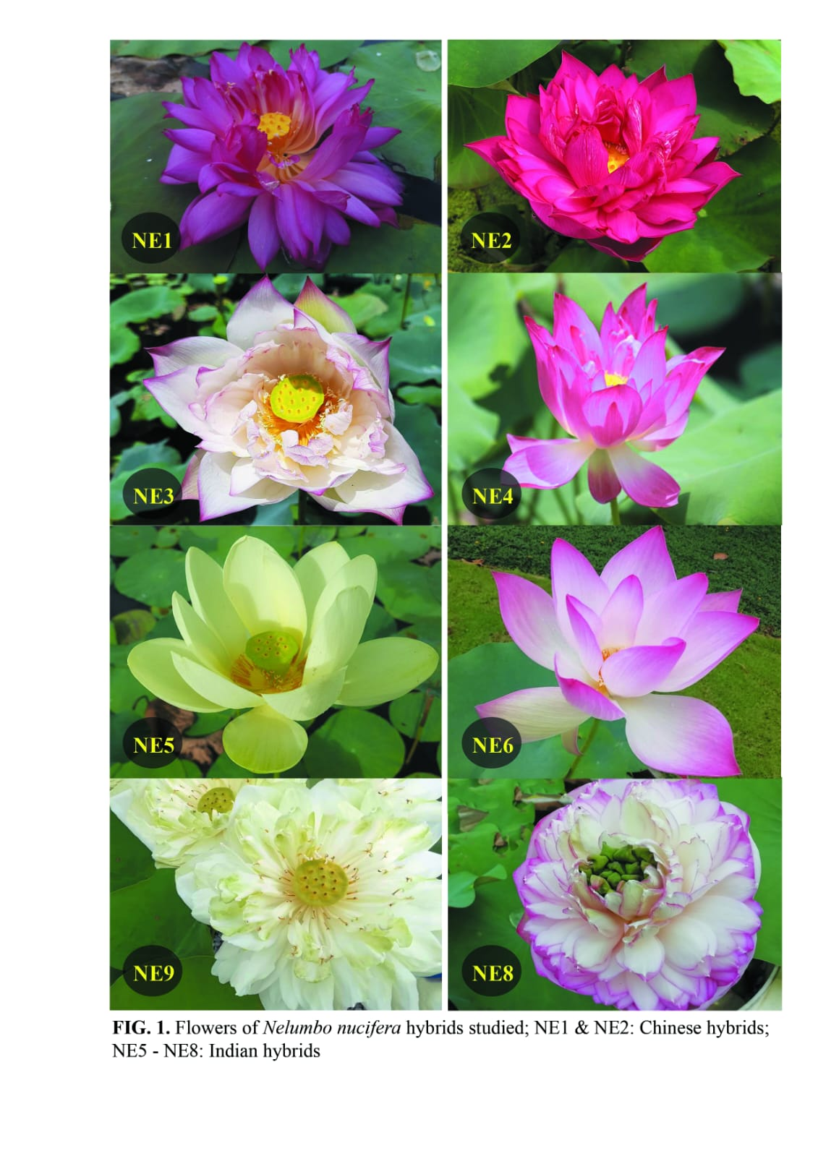

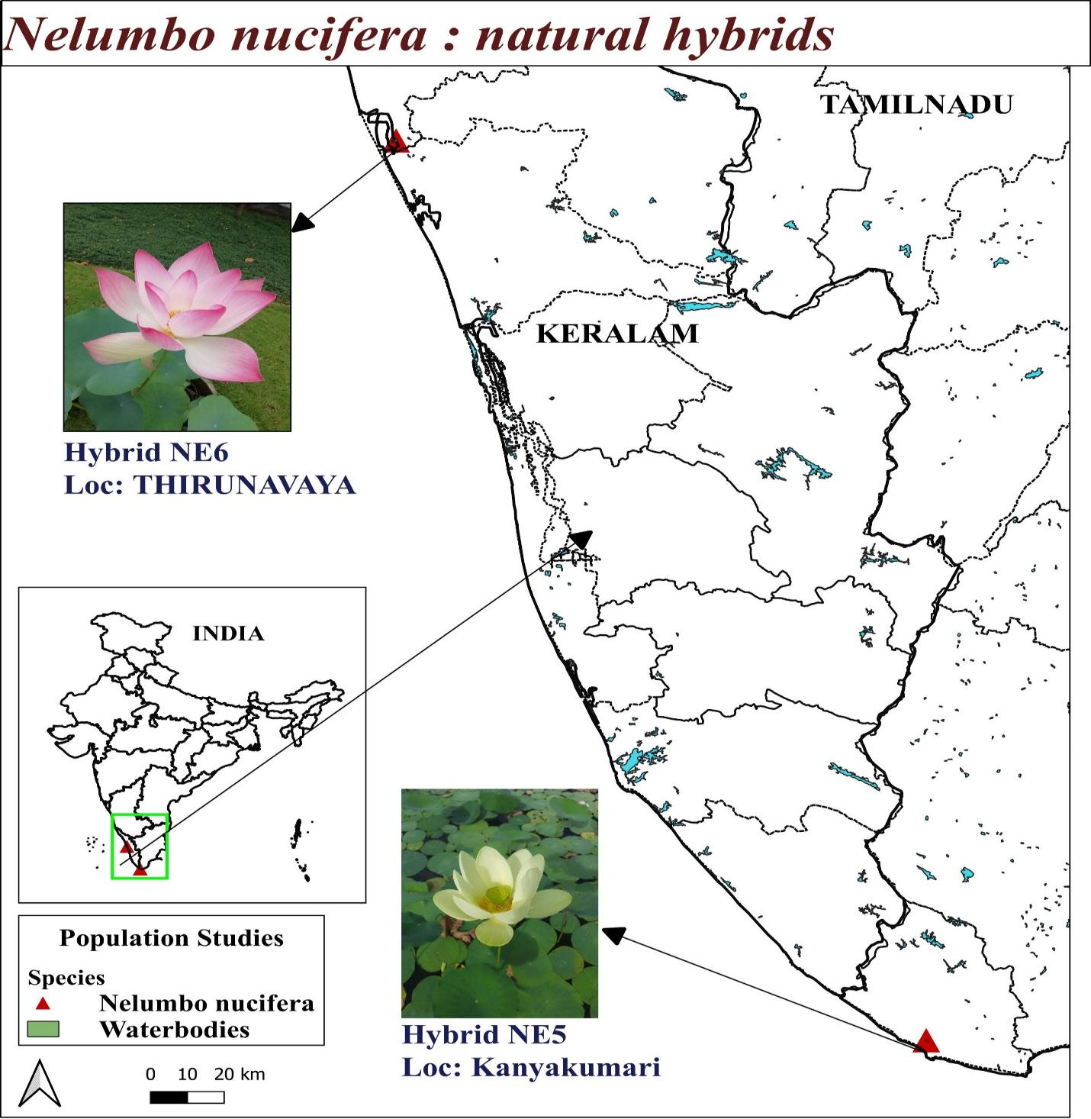

**Figure 2: *Nelumbo nucifera* natural hybrids geographical distribution in Kerala**

**3.2 PREPARATION OF GENOMIC DNA FROM PLANT TISSUE**

Take samples of tender, healthy leaves from every accession. Rinse well and pat dry with sterile filter paper. After a full rinse, pat dry with sterile filter paper. Weigh one gram of leaf material, then chop it into pieces in a mortar that has already cooled. Prior to extraction, add polyvinylpyrrolidone (PVP) to the CTAB Extraction Buffer and preheat it. Using a mortar and pestle, pulverize the tissue. Add 500–1000 µl of extraction buffer (Table 1), stir to form a slurry, and then transfer to a 2 ml centrifuge tube. The tubes should be in the water bath for 45 minutes at 65°C, with periodic stirring.

After bringing the liquid down to room temperature, add 70 μl of the chloroform: isoamyl alcohol (24:1) combination, stir thoroughly to create an emulsion, and centrifuge for 15 minutes at 25°C at 12,000 rpm. Transfer the top aqueous phase to a fresh tube and fill it with 1/10 of the CTAB/NaCl solution. After giving the mixture, a gentle stir and adding the same amount of chloroform, centrifuge it for ten minutes at 4°C at 12,000 rpm. Transfer the top aqueous phase to a fresh eppendorf tube, add the same volume of chloroform, and centrifuge for ten minutes at 4°C at 12,000 rpm. After carefully mixing by inverting the tubes, transfer the supernatant to a new eppendorf tube and add cold 100% isopropanol through the walls. For one hour, keep the mixture at 20°C. Centrifuge for 15 minutes at 4°C at 7850 rpm. Dry the pellets in the air after collecting them twice with cold 70% ethanol at 1000 rpm for five minutes. Pellets should be suspended in 200 µl of TE buffer. In a water bath, incubate at 37°C for one to two hours after adding 4 μl of RNase.

Incorporate 500 μl of phenol: Chloroform: Isoamyl mixture (24:25:1), gently mix, and centrifuge for 10 minutes at 4 °C at 10,000 rpm. Gather the supernatant into a new Eppendorf tube, then carefully mix with 500 μl of chloroform. Centrifuge for ten minutes at 1000 rpm Gather the supernatant and put double the volume of cooled ethanol into a new 1.5 ml Eppendorf tube and 0.1 liter of 7.5 M sodium acetate.

Overnight, store the sample at -20 °C. Centrifuge the pellets for 15 minutes at 4 °C at 10,000 rpm to collect the pellets. After cleaning the pellet in cold 75% ethanol, let it air dry. Pelletize again in around 50 μl of TE buffer (Table 1). The pellets that had been reconstituted were gathered and kept at -20 °C.

**Table 1: Stock solution required for Genomic DNA extraction**

|  |  |  |
| --- | --- | --- |
| **Solutions** | **Composition** | **Quantity** |
| Tris buffer    pH 8 | Tris 1M    H2O | 12.11 gm    100 ml |
| EDTA | Na2EDTA    H2O | 18.61 gm    100 ml |
| CTAB Extraction buffer pH 8.0  (stored at room temperature) | CTAB 2% W/V    Tris buffer 100 mM    Na2EDTA 20 mM    PVP 1%    NaCl 1.4 M    H2O | 2 gm    10 ml    4 ml    1 gm    8.2 gm    100 ml |
| TE buffer | Tris buffer 10mM    Na2EDTA 1M    H2O | 1 ml    0.2 ml    100 ml |
| Sodium acetate | Sodium acetate 3 M    H2O | 24.61 gm    100 ml |

**3.3 QUANTIFICATION AND VISUALIZATION OF DNA**

Using a nanodrop spectrophotometer (Multiskan sky), optical density (O.D.) at A260 and A280 was measured in order to quantify DNA. The software called nanodrop (Thermo Scientific, USA) was used to record the samples' concentration and purity. The samples of DNA that were diluted to a 50 ng/μl concentration and kept for usage at -20°C. To prepare DNA samples, 6X loading dye was mixed with 1X final concentration. To assess the quality of the isolated DNA, 1μl loading dye (Table 2) and 5μl of isolated genomic DNA were loaded onto a 0.8% agarose gel stained with ethidium bromide. The gel was then electrophoresed in 1x TAE buffer (Table 2) for 30 minutes at 100 V. The gels were captured on camera using a Bio-Rad Gel Documentation system.

**Table 2: Stock solution required for Agarose gel electrophoresis**

|  |  |  |
| --- | --- | --- |
| Solution | Composition | Quantity |
| TAE Buffer (10x) pH 8 | Tris base  acetic acid  Na2EDTA 0.5Mm  H2O | 21.6 gm  11 gm  8 ml  100 ml |
| Gel loading buffer | Bromo phenol blue 0.25%  Xylene cyanole 0.25 %  Sucrose 40%(w/v)  H2O | 250 gm  250 gm  40 gm  100 ml |
| Ethidium bromide | Ethidium bromide  H2O | 1gm  100 ml |

**Table 3:List of Equipment’s used**

|  |  |  |
| --- | --- | --- |
| No | Equipment | Make/ Model |
| 1 | Autoclave | Trueklav, India |
| 2 | Deep freezer (-20℃) | Cellfrost, India |
| 3 | Deep freezer (-80℃) | New Brunswick, U101, Germany |
| 4 | Electronic balance | Sartorius, Germany |
| 5 | Electrophoresis Power Unit | Bio-Rad Laboratories, USA |
| 6 | Gel Documentation | Bio-Rad gel doc XR+ System with image lab software,  Bio-Rad Laboratories, Hercules,  California, US |
| 7 | Gel Electrophoresis | Bio-Rad Laboratories, USA |
| 8 | Hot Air Oven | Beston; Universal, India |
| 9 | Micro Centrifuge | Eppendorf, Germany |
| 10 | Micro Wave Oven | LG, India |
| 11 | Micropipettes | Eppendorf, Germany |
| 12 | pH Meter | Horiba, LAQUA pH -1100 |
| 13 | Refrigerated Micro Centrifuge | Eppendorf, Germany |
| 14 | Thermal cycler (PCR) | Bio-Rad S1000 |
| 15 | Nanodrop Spectrophotometer | Multiskan sky, Thermo scientific |
| 16 | Water bath | Julabo, Germany |
| 17 | Water purification System | Lab sil instruments, India |

**3.4 PCR AMPLIFICATION**

Six Inter Simple Sequence Repeats (ISSR) (Table 3) synthesized by Bioserve Biotechnologies according to the sequence of Operon technologies, Inc. USA were employed for the PCR amplification of eight accessions of genomic DNA of *Nelumbo nucifera* hybrids. A 25μl volume was used for PCR amplification reactions, which included 1μl of template DNA, 12.5μl of Takara Master Mix, 1μl of 10pmol primers, and enough Milli Q water to get the volume to 25μl. One quick spin was used to combine all of the reagents. A Bio-Rad thermal cycler was used to carry out the amplification process.

The ISSR amplification procedure comprised 39 cycles of 0.30 min at 94 ◦C, 1 min at 53 ◦C, and 2 min at 72 ◦C, after which there was a single cycle of 2 min at 95 ◦C, 2 min at 53 ◦C, and 2 min at 72 ◦C. After the final cycle, there was a 10-minute rest period at 72 °C (Table 4).

**Table 4: List of ISSR Primers used in the study**

|  |  |  |
| --- | --- | --- |
| **Primer name** | **Primer sequence**  **(5︲-3︲)** | **G C content (%)** |
| ISSR 2 | 5’-CTCTCTCTCTCTCTCTAC-3’ | 46.7 |
| ISSR 8 | 5’-CTCTCTCTCTCTCTCTG-3’ | 52.9 |
| ISSR 9 | 5’-CACACACACACACACAG-3’ | 52.9 |
| ISSR 10 | 5’-TCTCTCTCTCTCTCTCG-3’ | 52.9 |
| ISSR 11 | 5’-AGAGAGAGAGAGAGAGT-3’ | 47.1 |
| ISSR 12 | 5’-CACCACCACGC-3’ | 72.7 |

**Table 5: Conditions for PCR reaction**

|  |  |  |
| --- | --- | --- |
| **PCR steps** | **Temperature** | **Time** |
| Initial denaturation | 94℃ | 2 min |
| Denaturation | 95℃ | 2 min |
| Annealing | 35℃ | 2min |
| Extension | 72℃ | 2min |
| No. of cycles of denaturation, annealing, extension | 39 cycles at 93℃,36℃,72℃ | 1min,1min, and 2min |
| Final extension | 72℃ | 7 min |

**3.5 DATA ANALYSIS**

The bands were qualitatively scored using gel photos derived from ISSR analysis. Data were recorded in a binary matrix sheet with “0” denoting absence and “1” denoting presence, based on clearly repeatable bands from each accession that were scored as unit characters. The data set contained both polymorphism and monomorphic bands to demonstrate an objective assessment of genetic variation. The software package Numerical Taxonomy and Multivariate Analysis System (NTSYSpc) (version 2.02) was utilized to evaluate the binary data that was acquired from the marker systems.

The “J” coefficient was chosen in NTSYS, and a dendrogram was created using UPGMA (Unweighted Pair Group Method with Arithmetic Mean) to analyze diversity patterns and interpret data.

**3.6 PIC (Polymorphism Information Content)**

Due to the polymorphism that the dominant marker reveals, we elaborate on a binary matrix of bands' presence or absence. The following general equation can be used to estimate the Polymorphism Information Content (PIC) if we take the frequency of bands present as P and the frequency of absents as q.

PIC = 1- (p2 +q2) (Nunes dos Santos, K., et.al, 2019)

By dividing the number of isolate alleles where the band was discovered by the total number of isolates, the frequency of an allele was determined. To evaluate genetic diversity, PIC is a useful metric. When measuring a genetic marker's information for linkage studies, PIC value is frequently employed. It is possible to assess the degree of gene variation whereby using the PIC index.

A locus with a PIC >0.5 is considered to have great variety.

PIC <0.25 denotes a low level of diversity at the locus.

PIC of 0.25 to 0.5 suggests that the locus has an intermediate level of diversity.

PIC analyses can be used to assess markers, allowing the best marker to be chosen for phylogenetic and genomic mapping

**3.7 EMR (EFFECTIVE MULTIPLEX RATIO)**

"The product of the fraction of polymorphic loci and the number of polymorphic loci of the individual assay" is the definition of an EMR for a primer (Milbourne, et al. 1997). It is the result of multiplying the fraction of polymorphic fragments (β) by the total number of fragments per primer (n).

E=nβ

were β = total number of polymorphic DNA and n = total number of bands.

**3.8 MARKER INDEX**

The marker index MI was computed for each of the ten markers in order to assess the overall utility of a particular marker system. Rather than the degree of polymorphism found, the high MI is a reflection of the marker's ability to assess a greater number of bands simultaneously. PIC and EMR produce MI (Varshney et al., 2005).

MI=PIC *EMR,were PIC is for polymorphism information content, and EMR stands for effective multiplex ratio.

**SEED SETTING AND VIABILTY**

Top of Form

The methodology for analyzing seed setting in the *Nelumbo nucifera* hybrids was by establishing uniform plots. Throughout the flowering season diligent monitoring and tracking of the production of flowers from each sample was done. Continuous observation allowed for the recording of seed setting occurrences within the flowers. Upon maturation seeds were collected from the flowers ensuring preservation of their viability through proper storage conditions. Subsequently these collected seeds underwent a stratification process period, the seeds were transitioned to optimal germination conditions. Throughout this phase the germination process was closely monitored.

Top of Form

**IV. RESULT**

From the samples of eight *Nelumbo nucifera* hybrids, genomic DNA was extracted; two of the hybrids were naturally occurring, while the other hybrids were cultivated. In this study DNA samples underwent purity checks, with those exhibiting values greater than 1.7 being selected for further analysis. The purity and concentration of the DNA samples are given in the table 6. Figure 2 representing the qualitative estimation of these isolates.

**Table 6**: Quantitative Estimation of Genomic DNA

|  |  |  |  |
| --- | --- | --- | --- |
| **Sl.No.** | **Plant ID** | **Concentration of Genomic DNA (ng/µl)** | **Purity**  **(A260/A280)** |
| 1 | NE 1 | 1430 | 1.95 |
| 2 | NE 2 | 875 | 1.95 |
| 3 | NE 3 | 819 | 1.94 |
| 4 | NE 4 | 917 | 1.91 |
| 5 | NE5 | 1280 | 2.0 |
| 6 | NE6 | 1540 | 1.96 |
| 7 | NE7 | 719 | 1.90 |
| 8 | NE8 | 892 | 1.93 |

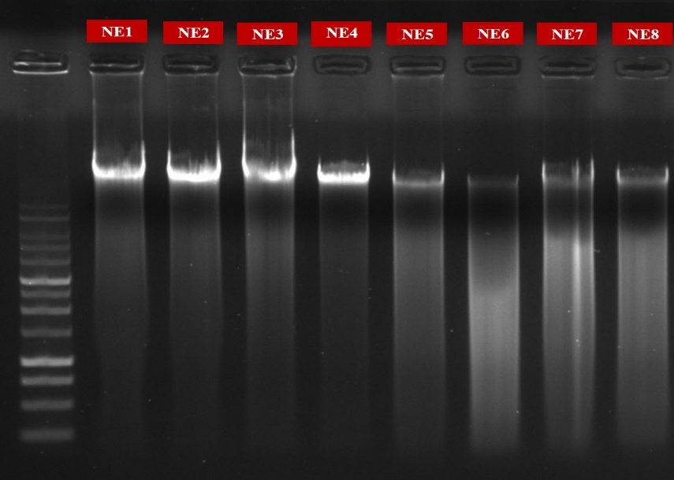

Figure 2: Gel image of genomic DNA

**ISSR BAND ANALYSIS**

The present study analyzed genetic diversity among the natural and cultivated hybrids of *Nelumbo nucifera* populations. Samples from eight populations were subjected to amplification using ISSR primers. The banding pattern obtained by ISSR primers clearly distinguished populations into different clusters, indicating genetic diversity among them. Diversity estimates provide useful information for understanding the genetic structure of the hybrids using ISSR. In this study, six ISSR primers were screened for polymorphism survey in pooled DNA accessions of hybrids of *Nelumbo nucifera*.

The PCR analysis for 08 samples taken in the study with 6 ISSR primers (Inter Simple Sequence Repeats) primers generated 53 scorable bands. An average of 8.8 bands per primer was generated. Among the six ISSR primers ISSR 8 and ISSR 9 produced a maximum number of bands (10) whereas ISSR 10 produced less no: of bands (7). The primers ISSR 2 and ISSR 12 produce 09 bands, and ISSR 11 produced 08 bands respectively.

|  |  |  |  |  |  |  |
| --- | --- | --- | --- | --- | --- | --- |
| **ISSR**  **Primer** | **Number of bands** | **No. of Polymorphic bands** | **Percentage of Polymorphism** | **PIC** | **EMR** | **MI** |
| **ISSR 2** | 9 | 9 | 100 % | 0.38 | 81 | 30.78 |
| **ISSR 8** | 10 | 10 | 100 % | 0.37 | 100 | 37 |
| **ISSR 9** | 10 | 8 | 80 % | 0.27 | 80 | 21.6 |
| **ISSR 10** | 7 | 6 | 85 % | 0.18 | 42 | 7.56 |
| **ISSR 11** | 8 | 8 | 100 % | 0.36 | 64 | 23.04 |
| **ISSR 12** | 9 | 8 | 88 % | 0.32 | 72 | 23.04 |
| **Total** | 53 | 49 | 553 % | 1.88 | 439 | 143.02 |
| **Average** | 8.83 | 8.16 | 92.16 % | 0.313 | 73.1 | 23.83 |

**Table7**: Data for ISSR primers used for analyzing 08 hybrids of *Nelumbo nucifera*

Out of 53 scoring bands 49 were found to be polymorphic and the average number of polymorphic bands was found to be 8.16. ISSR 8 was found to have a higher number of polymorphic bands whereas ISSR 2 showed 9 polymorphic band and ISSR 9, ISSR 11, ISSR12 produced 8 polymorphic bands each. The level of polymorphism was found to be high for ISSR 2, ISSR 8, ISSR 11 (100%) and minimum for ISSR 9(80%). The average level of polymorphism was found to be 92.16%.

PIC (polymorphism information content) values obtained from the primers ranged from 0.18 (ISSR10) to 0.38 (ISSR2) with an average of 1.88 for all the primers. The primer ISSR 12 was found to be more convenient for studies in this species as the PIC value came closest to 0.3. The effective multiplex ratio (EMR) was calculated by multiplying the of polymorphic bands and no: of bands, which is highest for the primer ISSR8 (100) and lowest for the primer ISSR10 (42). The marker index was calculated by multiplying EMR and PIC. ISSR primer ISSR 8 shows the highest Marker index with a value of (37) and primer ISSR 10 shows the lowest (7.56). (Table 7)

**CLUSTER ANALYSIS**

A dendrogram generated from UPGMA (Unweighted Paired Group Method using arithmetic averages) cluster analysis of ISSR primer is shown in Figure X2. The dendrogram is based on Jaccard’s coefficient of genetic similarity. The dendrogram consist of two major clusters, Cluster 1 and Cluster 2. The major cluster 1 is divided in to two populations NE1 and NE2.They are closely related with a similarity index 0.6829. Cluster 2 is divided into 2 sub-clusters. In sub-cluster 1 there is 1 population, NE3 and in sub cluster 2 there is 6 populations.Although NE4 is a cultivated hybrid it shows a higher similarity with NES (0.9024) as they share a common ancestor, they have a closer relationship among them. In this NES and NE6 related with a similarity of 0.5854. NE7 and NE8 demonstrate a close genetic affinity with a substantial similarity value of 0.6098. NE7 and NEI shows lower genetic similarity (0.4634) compared to other hybrids.****  **Figure 3: Dendrogram Based on Jaccard’s coefficient of Genetic similarity (UPGMA) Showing genetic distance**

|  |
| --- |
| NE1 NE2 NE3 NE4 NE5 NE6 NE7 NE8 |
| NE1| 1.0000 |
| NE2| 0.6829 1.0000 |
| NE3| 0.5854 0.7073 1.0000 |
| NE4| 0.5854 0.7561 0.6098 1.0000 |
| NE5| 0.6341 0.8537 0.6585 0.9024 1.0000 |
| NE6| 0.7561 0.5854 0.5366 0.6341 0.5854 1.0000 |
| NE7| 0.4634 0.7317 0.6341 0.5854 0.6829 0.5122 1.0000 |
| NE8| 0.6098 0.7317 0.8293 0.6829 0.7317 0.5610 0.6098 1.0000 |

**Table 8: Similarity index table showing Jaccard’s coefficient for genetic similarity**

**FECUNDITY OF HYRIDS USING THE NUMBER OF SEED SETTING**

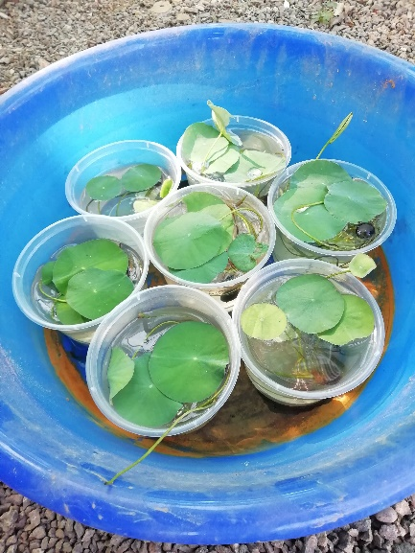

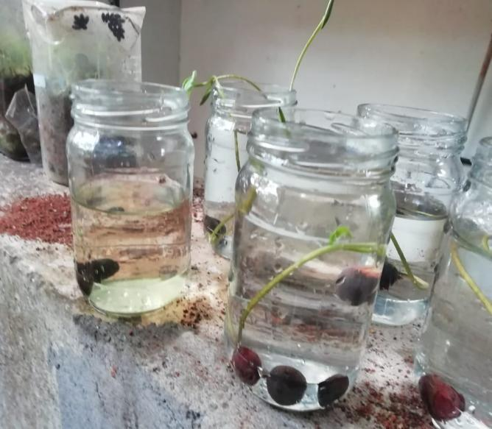

**Fig 4:**Seed germination **Fig 5:**After germination of seeds

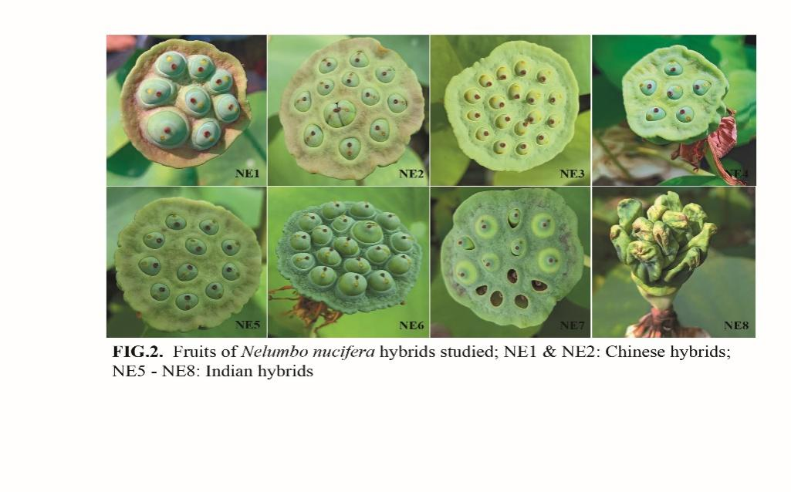

**Plate 2:**Fruits of *Nelumbo nucifera* studied

|  |  |  |  |  |  |
| --- | --- | --- | --- | --- | --- |
| Hybrid | No. of Seeds | No of Viable seeds | Percentage of viability | Mean | standard deviation |
| NE1 | 8 | 7 | 87.5 | 91.07143 | 7.783748113 |
| NE1 | 7 | 6 | 85.71 |
| NE1 | 8 | 8 | 100 |
| NE2 | 12 | 5 | 41.66 | 37.69841 | 7.926581093 |
| NE2 | 14 | 6 | 42.85 |
| NE2 | 14 | 4 | 28.57 |
| NE3 | 15 | 14 | 93.33 | 89.62963 | 3.394500515 |
| NE3 | 15 | 13 | 86.66 |
| NE3 | 18 | 16 | 88.88 |
| NE4 | 6 | 4 | 66.66 | 55.55556 | 9.622504486 |
| NE4 | 6 | 3 | 50 |
| NE4 | 6 | 3 | 50 |
| NE5 | 10 | 10 | 100 | 96.66667 | 5.773502692 |
| NE5 | 10 | 10 | 100 |
| NE5 | 10 | 9 | 90 |
| NE6 | 18 | 18 | 100 | 98.14815 | 3.207501495 |
| NE6 | 18 | 17 | 94.44 |
| NE6 | 18 | 18 | 100 |
| NE7 | 12 | 6 | 50 | 65.55556 | 15.03083251 |
| NE7 | 10 | 8 | 80 |
| NE7 | 12 | 8 | 66.66 |
| NE8 | 24 | 0 | 0 | 0 | 0 |
| NE8 | 26 | 0 | 0 |
| NE8 | 26 | 0 | 0 |

Table 9: Seed setting and viability of Nelumbo hybrid seeds

|  |  |
| --- | --- |
| Hybrid | Hybrid Seed viability |
| NE1 | 91.07143 ± 7.78 |
| NE2 | 37.69841 ± 7.92 |
| NE3 | 89.62963 ± 3.394 |
| NE4 | 55.55556 ± 9.62 |
| NE5 | 96.66667 ± 5.77 |
| NE6 | 98.14815 ± 3.2 |
| NE7 | 65.55556 ± 15.03 |
| NE8 | 0 |

Table 10: Seed Viability of Hybrids

Figure 6: Graph showing seed viability of *Nelumbo* hybrids

From the seed viability studies, it was found that hybrids NE 1, NE 5, and NE 6 exhibited significantly high viability values, with NE 6 showing the highest viability at 98%, followed by NE 5 at 96%, and NE 1 at 91%. On the other hand, hybrid NE 8 recorded a percentage of zero, indicating a total lack of seed viability. Among the natural hybrids, NE 6 showed better seed viability than NE 5, which is noteworthy. Furthermore, out of all the hybrids under study, NE 2 had the lowest seed viability, with the exception of hybrid NE 8.Although NE4 and NE5 shows greater similarity the percentage of seed viability is differ in both of them.

# DISCUSSION

# 

*Nelumbo nucifera*, is a plant species that is important to culture and the economy. It comes in both natural and developed hybrid forms. It is essential for conservation efforts, breeding programs, and the sustainable use of this priceless resource to comprehend the genetic variety of these hybrids (Zhou *et al*.,2013). *Nelumbo nucifera* hybrids present a range of traits and difficulties. The choice of male or female parent and pollination technique in hybridizations between distinct Nelumbo nucifera cultivars produce notable differences in setting percentages. Genetic differences between Nelumbo nucifera and Nelumbo lutea, as well as within flower lotus accessions, have been shown by molecular marker research, showing genetic variety and potential difficulties in differentiating closely related hybrids (Chalopin *et al*.,2015).

Genetic diversity is the degree of genetic heterogeneity present in individuals or populations within a species. It is the outcome of recombination of genetic material (DNA) during inheritance, genetic drift, gene flow, and mutations Brown *et al.,* (1983).

As phenotypic qualities are simple, inexpensive, and don't require complex instruments or methodologies, they are the basis for genetic diversity research. Due to the environment's impact on gene expression, phenotypic assessments of genetic diversity could not be reliable or precise. (Fonseca R. M, 2008).

Population genetic studies are essential for conservation initiatives and the recovery of fragile populations. The developments in molecular genetics serve as the cornerstone of genomic research. The potential for developing comprehensive and effective conservation strategies for plant species that are in danger of extinction depends on the knowledge of conservation biology. On the other hand, population ecology study assesses the fitness of a population's diverse variations and sheds light on the variables influencing the fertility and survival of individual plants.

The new approach known as inter-simple sequence repeat (ISSR) markers is dependable and offers the benefits of microsatellites (SSR). This method amplifies genomic areas surrounded by closely spaced and inversely orientated microsatellite sequences by utilizing one or two primers based on SSRs attached 5' or 3' with 1-4 purine or pyrimidine residues. The repetition sequences and anchor nucleate are selected at random. Compared to RAPD, ISSR amplification can reveal substantially more fragments per primer when paired with the separation of amplified products on polyacrylamide or agarose gels. ISSR markers are transformed into dominant markers via Mendelian mode of inheritance. Numerous research on cultivar identification, genetic mapping, gene tagging, genetic diversity, evolution, and molecular ecology have made extensive use of this technique (Wang *et al.,* 2002).

In the present study, genomic DNA from 8 hybrids of *Nelumbo nucifera*, out of which 2 are natural hybrids and other six were cultivated hybrids isolated and DNA is amplified in PCR using Inter simple Sequence Repeat markers and they are ISSR 2, ISSR 8, ISSR 9, ISSR 10, ISSR 11 and ISSR 12. The amplified products are visualized by Gel Electrophoresis. Populations were clearly divided into several groups according to the banding pattern produced by ISSR primers, demonstrating genetic variation among them. Diversity estimates provide useful information for understanding the genetic structure of the plant using ISSR. 53 scorable bands were produced by the PCR analysis using six ISSR primers on the six study samples. An average of 8.83 bands per primer was generated. Among the six ISSR primers ISSR 8 and 9 produced a maximum number of bands (10 bands). Whereas ISSR 10 produced a minimum number of bands (07 bands) in all the genomic pools.

Out of 53 scoring bands 49 were found to be polymorphic and the average number of polymorphic bands was found to be 8.16. ISSR 08 is found to have a higher number of polymorphic bands whereas ISSR 10 produced to be found have 06 polymorphic bands. The level of polymorphism was found high for ISSR 2, ISSR 8 and ISSR 11 and minimum for ISSR 12 (100%). The average level of polymorphism was found to be 92.16%.

Based on the ISSR marker band pattern a dendrogram was constructed using the UPGMA method (Unweighted Paired Group Method using arithmetic averages). Jaccard’s coefficient of genetic similarity (J) was considered for analyzing the genetic distance between each population in this analysis. The dendrogram reveals two prominent clusters denoted as cluster 1 and 2. Within cluster 1 populations NE5 and NE6 exhibit a noteworthy similarity of 0.5854, suggesting a close genetic relationship as natural hybrids.NE4 although genetically diverse from sub cluster 2 shares a common ancestor with the natural hybrids indicating a closer relationship to them. As Chinese hybrids populations NE1 and NE2 on the other hand show a different relationship from NE5 and NE6.Notably NE7 and NE8 show a close genetic affinity with a substantial similarity value of 0.6098. NE1 and being Chinese hybrids do not have a common ancestor with the remaining six populations of hybrids. Furthermore, NE3 and NE5 show less of a resemblance with a Jaccard’s value of 0.6585 suggesting a lower degree of genetic relatedness than NE4 and NE5.

As we compared the natural population and the cultivated population, we observed that some populations show the same amount of fecundity as the natural populations (NE1 and NE3). However, in some cases of hybrids even the seeds are not setting or the seeds that are being set get aborted eventually (NE8). NE1 and NE2 possess the same ancestor, however they exhibit differences in their seed viability percentages NE1 possess a higher variability percentage while the other exhibits a comparatively lower viability percentage.

Top of Form

Top of Form

**CONCLUSION**

This study concentrated on *Nelumbo nucifera Gaertn.,* one of the two extant species of aquatic plant in the family Nelumbonaceae. An examination of hybrids genetic diversity as well as the comparative study of seed setting and viability in different hybrids was conducted. Eight hybrids were taken out of which two of them are natural hybrids whereas the other six are cultivated ones. The natural hybrids that are taken from Kanyakumari and Thirunavaya. After isolating the DNA from each sample, six primers were employed to assess their diversity. ISSR 2, ISSR 8, ISSR10, ISSR11, ISSR 12 were the primers that are employed for the same.

Following primer hybridization, gel electrophoresis was used to separate the DNA, and the gel documentation method was used to visualize the DNA bands. Number of polymorphic and non-polymorphic bands were identified via the band image analysis. Then computed their PIC, EMR, and MI values. According to the results, 49 of the 53 scoring bands exhibited polymorphism. On the basis of the band analysis, a dendrogram was then made. Two main clusters were visible in the dendrogram: cluster 1 held the clade-divided populations NE1, and NE2, whereas cluster 2 held the other six population. Based on the band analysis of the samples and cluster analysis, it was indicated that these accessions showed a small degree of diversity.

The similarity analysis using the Jaccard coefficient approach was done. This revealed the populations with the greatest degree of resemblance asNE5 and NE6. On the other hand, there was significant differences between the populations NE3, NE4 in comparison to NE5 and NE6 containing they have the same common ancestor.

The dendrogram created utilizing the band analysis of the samples and cluster analysis revealed a limited degree of diversity among these eight populations in the *Nelumbo nucifera.* Some shows greater affinity to the natural populations where as some shows very little affinity towards the natural hybrids. Indian hybrids have their own similarity with other populations except Chinese hybrids as they both do not have a common ancestor.

The seed viability study of *Nelumbo nucifera* hybrid seeds reveal the significant variation in the reproductive success among the different hybrids. Notably hybrids NE1,5,6 exhibit considerably high viability values with NE6 demonstrating the highest viability at 98% followed by the NE5 and NE1. Conversely hybrid NE8 displays a complete lack of seed viability recording a percentage of zero. Of particular interest is the observation that NE6 displays better viability than NE5, despise both being natural hybrids. This difference suggests potential genetic or environmental factors influencing their reproductive performance

These findings provide insights in to the reproductive dynamics of Nelumbo hybrids and the highlight the importance of considering the genetic and environmental factors in breeding and cultivation efforts

**REFERENCE**

* Abou-Deif. M. H. Rashed, M. A.. Sallam. M. a. A., Mostafa, E. a. H., & Ramadan, W. A. (2013). Characterization of twenty wheat varieties by ISSR markers. Middle East Journal of Scientific Research, 15(2), 168-175.
* Alem. S., Habrová, H., & Houšková, K. (2023). Germination responses with different treatments, seed vigour and seedling growth of Pterolobium steilatum (Forssk.) provenances stored from 19 to 30 years. "Genetic Resources and Crop Evolution". Advance online publication. <https://doi.org/10.1007/s10722-023-01784-5>
* Alhajturki, D., Al Jamali, M., & Kanbar. A. (2011). Genetic variation of sorghum (Sorghum bicolor L. Moench) varieties assessed by ISSR markers. Adv Environ, Biol, 5(11), 3504- 3510.
* Al-Samarai, F. R., & Al-Kazaz, A. A. (2015). Molecular markers. An introduction and applications. European journal of molecular biotechnology, 9(3), 118-130
* Andrea, S., Meseguer., Rubén, Carrillo., Sean, W., Graham., Isabel, Sanmartin. (2022). Macroevolutionary dynamics in the transition of angiosperms to aquatic environments. New Phytologist, 235(1):344-355. Doi: 10.1111/nph.18100
* Barcaccia, G., Mazzucato, A., & Falcinelli, M. (2000). Inheritance of apomictic seed production in Kentucky bluegrass (Poa pratensis L.). Journal of New Seeds, 2(1), 43-58
* Bir, Bahadur., T., Pullaiah., Karthik, Krishnamurthy. (2015). Angiosperms: An Overview. doi: 10.1007/978-81-322-2286-6-15
* Chalopin, M., Chalopin, M., Ségurens, B., & Pissis, S. P. (2015). Molecular markers. A potential tool for the identification of hybrids in the genus Nelumbo (Lotus). Aquatic Botany, 127, 37-42, doi: 10.1016/j.aquabot.2015.09.006
* Chen, G., Zhu, M., & Guo, M. (2019). Research advances in traditional and modern use of Nelumbo nucifera: phytochemicals, health promoting activities and beyond. Critical Reviews in Food Science and https://doi.org/10.1080/10408398.2018.1553846 Nutrition, 59(supl), S189-$209
* Das. S. C. Balamotan, T. N., Poornima, K., & Bergh. 1. V.D. (2018). Evaluation of genetic diversity in some banana hybrids using ISSR markers. butl J Curr Microbiol App Sci, 7(1). 146-157.
* Else, Marie, Friis, Peter, R., Crane, Kaj, Raunsgaard, Pedersen. (2011). Early Flowers and Angiosperm Evolution: Introduction to angiosperms doi: 10.1017/CBO9780511980206.002
* Fonseca, R. M., Lopes, R., Barros, W. S., Lopes, M. T. G., & Ferreira, F. M. (2008). Morphologic characterization and genetic diversity of Capsicum chinense Jacq. accesions along the upper Rio Negro-Amazonas. Embrapa Amazónia OcidentalArtigo em periódico indexado (ALICE).
* Gupta. P. K., Varshney, R. K., Sharma, P. C., & Ramesh, B. (1999), Molecular markers and their applications in wheat breeding. . Plant breeding, 118(5), 369-390
* Hartati, S., & Muliawati, E. S. (2020). Genetic variation of Coelogyne pandurate, C. rumphii and their hybrids based on RAPD markers. Biodiversitas Journal of Biological Diversity, 21(10).
* HE, Z. Z., XIE, F. M., CHEN, L. Y., & PAZ, M. A. D. (2012), Genetic diversity of tropical hybrid rice germplasm measured by molecular markers. Rice Science, 19(3), 193-201.
* Heun, M., Murphy, J. P., & Phillips, T. D. (1994). A comparison of RAPD and isozyme analyses for determining the genetic relationships among Avena sterilis L. accessions. Theoretical and Applied Genetics, 87(6), 689-696.
* Keshav, Raj, Paudel., Nisha, Panth. (2015). Phytochemical Profile and Biological Activity of Nelumbo nucifera. Evidence-based Complementary and Alternative Medicine, doi:10.1155/2015/789124
* Kumar, P., Gupta, V. K., Misra, A. K., Modi, D. R., & Pandey, B. K. (2009). Potential of molecular markers in plant biotechnology. Plant omics, 2(4), 141-162.
* Kubo, N., Hirai, M., Kaneko, A., Tanaka, D., & Kasumi, K. (2009). Classification and diversity of sacred and American Nelumbo species: the genetic relationships of flowering lotus cultivars in Japan using SSR markers. Plant Genetic Resources, 7(3), 260-270.
* Lin. Z. Zhang, C., Cao. D. Damaris, R. N., & Yang, P. (2019). The latest studies on lotus Nelumbo nucifera) an emerging horticultural model plant. International journal of molecular sciences, 20(15), 3680.
* LL. Z., Liu, X., Gituru. R. W. Juntawong, N., Zhou, M. & Chen, L. (2010), Genetic diversity Und classification of Nelumbo germplasm of different origins by RAPD and ISSR analysis. Scientia horticulturae, 125(4), 724-732.
* Luo, C., He. X., Chen, H., Ou, S., Gao, M., Brown, J. S., Tondo, C. T. & Schnell, R. J (2011). Genetic diversity of mango cultivars estimated using SCoT and ISSR markers. Biochemical Systematics and Ecology, 39(4) 676-684.https://doi.org/10.1016/j.bse.2011.05.023
* LL. A. & Ge, S. (2001). Genetic Variation and Clonal Diversity of Psammochloa villosa(Poaceae) Detected by ISSR Markers. Annals of Botany, 87(5), 585-590. <https://doi.org/10.1006/anbo.2001.1390>
* Matra, D.D., Fathoni, M.A.N.. Majiidu, M. et al. The genetic variation and relationship among the natural hybrids of Mangifera casturi Kosterm. Sci Rep 11, 19766 (2021) <https://doi.org/10.1038/s41598-021-99381->
* Milbourne, D., Meyer, R., Bradshaw, J. E., Baird, E., Bonar, N., Provan, J., & Waugh, R. (1997). Comparison of PCR-based marker systems for the analysis of genetic relationships in cultivated potato. Molecular breeding, 3, 127-136.
* Mondini, L., Noorani, A., & Pagnotta, M. A. (2009). Assessing plant genetic diversity by molecular tools. Diversity, 1(1), 19-35
* Missiaggia, D., & Leite, M. F. (2019). Polymorphism in the promoter region of NFE2L2 gene is a genetic marker of susceptibility to cirrhosis associated with alcohol abuse. International Journal of Molecular Sciences, 20(14), 3589.
* Navajas, M., Fenton, B. The Application of Molecular Markers in the Study of Diversity in Acarology:aReview. Exp Appl Acarol 24, 751-774 (2000).
* Ng. W. L., & Tan, S. G. (2015). Inter-simple sequence repeat (ISSR) markers: are we doing it right. ASM Science Journal, 9(1), 30-39.
* Penner, G. A. (1996). RAPD analysis of plant genome. In "Methods of genome analysis in plants". (P. P. Jaguar, Ed.0, pp. 251-268, CRC Press, New York.
* Prakashkumar, R., Anoop. K. P., Ansari, R., Sivu, A. R., Pradeep, N. S., & Madhusoodanan, P. V. (2015). Analysis of genetic diversity of Lagenandra spp. (Araceae) of Kerala (South India) using ISSR Markers. Int J Sci Res, 4(6), 775-777.
* Prabhsimran, Kaur., Loveneet, Kaur, Navjeet, Kaur., Ajaypal, Singh., Jaspreet, Kaur., Harjot, Kaur, Navjot, Kaur., Manjot, Kaur. (2019). A brief review on pharmaceutical uses of Nelumbo nucifera. Journal of Pharmacognosy and Phytochemistry,
* Ping, Zhou., Qijiang. Jin., Ping, Qian.. Yanjie, Wang, Xiaowen, Wang.. Hui-Ping. Jiang. Dongrui, Yao.. Xiaojing, Liu., Feng, Qi, Liu., Jun, Li., Yingchun, Xu. (2022). Genetic resources of lotus (Nelumbo) and their improvement. Ornamental Plant Research, doi: 10.48130/opr-2022-0005
* Quentin, C., B., Cronk., Andrew, Groover. (2016). Introduction: Comparative Genomics of Angiosperm Trees: A New Era of Tree Biology. doi: 10.1007/7397_2016_33
* Ramanatha Rao, V., & Hodgkin, T. (2002). Genetic diversity and conservation and utilization of plant genetic resources. Plant cell, tissue and organ culture, 68, 1-19.
* Salaemae, W., & Bunnag, S. (2018a). Lotus (Nelumbo nucifera Gaertn.) seed longevity and its implication for seed storage. Seed Science and Technology, 46(2), 299-310.
* Samal, K. C., Jena, R. C., Swain, S. S., Das. B. K., & Chand, P. K. (2012). Evaluation of genetic diversity among commercial cultivars, hybrids and local mango (Mangifera indica L.) genotypes of India using cumulative RAPD and ISSR markers. Euphytica, 185, 195-213.
* Schulman, A.H. Molecular markers to assess genetic diversity. Euphytica 158, 313-321 (2007). <https://doi.org/10.1007/s10681-006-9282-5>
* Sebastian, V. A., (2009). Development and analysis of molecular markers for certain endangered species of Tylophora.
* Tian, H. L., Xue, J. H., Wen, J., Mitchell, G., & Zhou, S. L. (2008). Genetic diversity and relationships of lotus (Nelumbo) cultivars based on allozyme and ISSR markers. Scientia Horticulturae, 116(4), 421-429.
* Varshney, R. K., Graner, A., & Sorrells, M. E. (2005). Genic microsatellite markers in plants: features and applications. TRENDS in Biotechnology, 23(1), 48-55.
* Wang. J. B. (2002). ISSR markers and their applications in plant genetics. Yi Chuan Hereditas, 24(5), 613-616
* Wang, P., Li, X., Zhang, C., & Liu, X. (2020). Impact of hybridization on seed setting and growth rate in Nelumbo genus. Journal of Plant Breeding and Crop Science, 12(3), 123-134.
* Wawrzyniak, M., Michalak, M., & Chmielarz, P. (2020). Effect of different conditions of storage on seed viability and seedling growth of six European wild fruit woody plants. Annals of Forest Science, 77*(1), 58. <https://doi.org/10.1007/s13595-020-00963-2>
* Yang, M., Han, Y., Xu, L., Zhao, J., & Liu, Y. (2012). Comparative analysis of genetic diversity of lotus (Nelumbo) using SSR and SRAP markers. Scientia horticulturae. 142. 185-195.
* Zhou, J. (2013). Genetic studies on the origin and evolution of Nelumbo cultivars. "Scientia Horticulturae, 150, 103-113. doi: 10.1016/j.scienta.2012.10.028