PROJECT REPORT

On

“TURN ON FLUORESCENCE SENSOR FOR AMINO ACID TRYPTOPHAN”

Submitted by

FABEENA P.H.
(AM21CHE006)

In partial fulfillment for the award of the
Post graduate Degree in Chemistry



DEPARTMENT OF CHEMISTRY
AND
CENTRE FOR RESEARCH

ST. TERESA’S COLLEGE (AUTONOMOUS)
ERNAKULAM
2022-2023



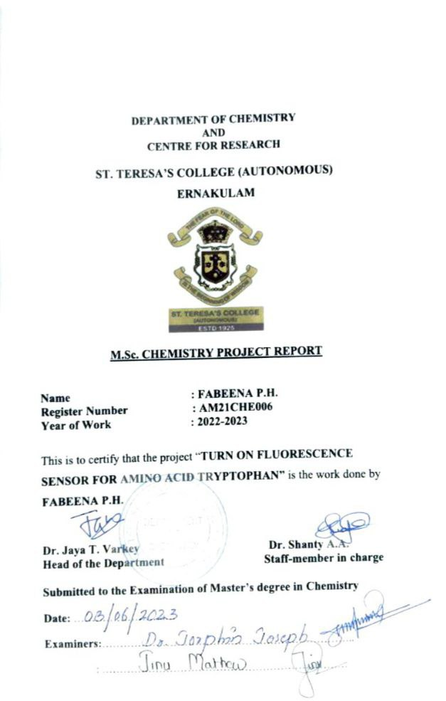

DEPARTMENT OF CHEMISTRY
AND
CENTRE FOR RESEARCH

ST. TERESA’S COLLEGE (AUTONOMOUS)
ERNAKULAM

CERTIFICATE

This is to certify that the project work entitled “TURN ON FLUORESCENCE SENSOR FOR AMINO ACID TRYPTOPHAN” is the work done by FABEENA P.H. under the guidance of Dr. SHANTY A.A., ASSISTANT PROFESSOR, Department of Chemistry and Centre for Research, St. Teresa’s College, Ernakulam in partial fulfilment of the award of the Degree of Master of Science in Chemistry at St. Teresa’s College, Ernakulam affiliated to Mahatma Gandhi University, Kottayam.

Dr. Shanty A.A. Dr. Jaya T. Varkey
Project Guide Head of the Department

DEPARTMENT OF CHEMISTRY
AND
CENTRE FOR RESEARCH

ST. TERESA’S COLLEGE (AUTONOMOUS)
ERNAKULAM

CERTIFICATE

This is to certify that the project work entitled “TURN ON FLUORESCENCE SENSOR FOR AMINO ACID TRYPTOPHAN” is the work done by FABEENA P.H. under my guidance in the partial fulfilment of the award of the Degree of Master of Science in Chemistry at St. Teresa’s College (Autonomous), Ernakulam affiliated to Mahatma Gandhi University, Kottayam.

Dr. SHANTY A.A.
Project Guide

DECLARATION

I hereby declare that the project work entitled “TURN ON FLUORESCENCE SENSOR FOR AMINO ACID TRYPTOPHAN” submitted to Department of Chemistry and Centre for Research, St. Teresa’s College (Autonomous) affiliated to Mahatma Gandhi University, Kottayam, Kerala is a record of an original work done by me under the guidance of Dr. SHANTY A.A, ASSISTANT PROFESSOR, Department of Chemistry and Centre for Research, St. Teresa’s College (Autonomous), Ernakulam. This project work is submitted in the partial fulfillment of the requirements for the award of the Degree of Master of Science in Chemistry.

FABEENA P.H.

Acknowledgements

First of all, I thank God Almighty for being with me throughout the days and helping me to complete the project successfully.

I respect and thank my project guide Dr. Shanty A.A., Assistant Professor, Department of Chemistry, St. Teresa’s College (Autonomous) Ernakulam for directing me to a world of research and opportunities, I thank her for her guidance and constant supervision as well as for providing information regarding the project and also for her support in complete the project.

I thank Dr. Jaya T. Varkey, HOD of the Chemistry Department, for providing an opportunity to do the project and giving all support and guidance which helped me complete the project duly.

I extend our sincere gratitude to Dr. Sr. Vinitha, Provincial Superior and Manager, and Dr. Alphonsa Vijaya Joseph, Principal, St. Teresa’s College (Autonomous), Ernakulam for their extended support and cooperation during the project work. I Would like to thank all the teachers, and non-teaching staff of the Department of Chemistry, St. Teresa’s College, Ernakulam for their support and cooperation during the entire project.

I heartily thank STIC (CUSAT) for providing all the spectroscopic assistance needed for the characterization of the samples within the time limit.

I also feel proud to have a group of good friends who offered as much needed help in completing this project.

Fabeena P.H

Contents

Chapter 1 Introduction | 1
1.1 Schiff Bases | 1
1.2 Importance of Imine | 3
1.3 Applications of Schiff Bases | 3
1.3.1 Antimalarial Activity | 3
1.3.2 Antibacterial Activity | 4
1.3.3 Antifungal Activity | 5
1.3.4 Antiviral Activity | 6
1.3.5 Schiff Bases and their complexes as light  emitting diodes | 6
1.3.6 Catalysis | 7
1.3.7 Sensor | 7
1.3.8 Application in modern Technologies | 8
1.4 Aldehydes and Amines | 8
1.5 Objectives | 10

Chapter 2 Literature Review | 11

Chapter 3 Materials and Methods | 17
3.1 Chemical Requirements | 17
3.1.1 Terephthaldehyde | 17
3.1.2 Ortho Phenylene diamine | 18
3.1.3 4-Chloro-ortho phenylene diamine | 18
3.1.4 Cyclohexanediamine | 19
3.1.5 Solvent Methanol | 19
3.2 Experimental Method | 19
3.2.1 Magentic Stirrer | 19
3.2.2 Sonication | 20
3.3 Characterization Techniques | 21
3.3.1 Elemental Analysis | 21
3.3.2 Electronic Spectra | 21
3.3.3 FT-IR Spectroscopy | 21
3.3.4 1H NMR Spectroscopy | 21
3.3.5 13C NMR Spectroscopy | 22
3.4 Method and Synthesize | 22
3.4.1 Reaction between Terephthaldehyde and  Ortho Phenylene diamine | 22
3.4.2 Reaction between Terepthaldehyde and  4-chloro-ortho phenylene diamine | 24
3.4.3 Reaction between Terephthaldehyde and  Cyclohexanediamine | 25

Chapter 4 Results and Discussion | 27
4.1 Elemental Analysis | 27
4.2 Spectrum Analysis of TOMINE | 27
4.2.1 UV-Visible Spectroscopy | 27
4.2.2 FT-IR Spectroscopy | 28
4.2.3 NMR Spectroscopy | 29
4.3 Spectrum Analysis of TOCLOMINE | 32
4.3.1 UV-Visible Spectroscopy | 32
4.3.2 FT-IR Spectroscopy | 33
4.3.3 NMR Spectroscopy | 34
4.4 Spectrum Analysis of T-CYCLO | 36
4.4.1 UV-Visible Spectroscopy | 36
4.4.2 FT-IR Spectroscopy | 37
4.4.3 NMR Spectroscopy | 38
4.5 Application | 40
4.5.1 Sensors | 40
4.5.2 Fluorescence Sensors | 40
4.5.3 Fluorescent Sensors for Amino acids | 41
4.6 Tryptophan Detection | 41
4.7 Fluorescence of TOMINE and TOCLOMINE | 42
4.8 Overlay of Fluorescence emission and Absorption  Spectrum of TOMINE | 44
4.9 Overlay of Fluorescence emission and Absorption  Spectrum of TOCLOMINE | 45
4.10 TOMINE a Fluorescence Sensor for Amino acid  Tryptophan | 46
4.11 Selectivity Study | 47
4.12 Time Study | 48
Chapter 5 Conclusion | 51
Reference | 53

LIST OF TABLES
Table 1 CHN Data
Table 2 Vibrational peaks of TOMINE
Table 4 Vibrational peaks of TOCLOMINE
Table 5 Vibrational peaks of T-CYCLO

LIST OF FIGURES
Figure 1 | General structure of an imine
Figure 2 | Mechanism of formation of Schiff Base
Figure 3 | [1-((3-(4-fluorophenyl)-1-isopropyl-1H-indol-2-yl) methylene) hydrazine] ligand
Figure 4 | Thiophene-2-aldehyde thiosemicarbazone
Figure 5 | 2-thiophene carboxaldehyde-sulphametrole
Figure 6 | Abacavir derived Schiff Base
Figure 7 | Cobalt (II) SBC with triphenyl phosphine
Figure 8 | Terephthaldehyde
Figure 9 | Ortho Phenylene Diamine
Figure 10 | 4-Chloro-ortho phenylenediamine
Figure 11 | Cyclohexane Diamine
Figure 12 | Magnetic Stirrer
Figure 13 | Sonicator
Figure 14 | Compound TOMINE
Figure 15 | Compound TOCLOMINE
Figure 16 | Electronic spectrum of TOMINE
Figure 17 | IR spectrum of TOMINE
Figure 18 | ¹H NMR spectrum of TOMINE
Figure 19 | ¹³C NMR spectrum of TOMINE
Figure 20 | Electronic spectrum of TOCLOMINE
Figure 21 | IR spectrum of TOCLOMINE
Figure 22 | ¹H NMR spectrum of TOCLOMINE
Figure 23 | ¹³C NMR spectrum of TOCLOMINE
Figure 24 | Electronic spectrum of T-CYCLO
Figure 25 | IR spectrum of T-CYCLO
Figure 26 | ¹H NMR spectrum of T-CYCLO
Figure 27 | ¹³C NMR spectrum of T-CYCLO
Figure 28 | Structure of Tryptophan
Figure 29 | TOMINE in UV chamber
Figure 30 | Emission spectrum of TOMINE
Figure 31 | TOCLOMINE in UV chamber
Figure 32 | Emission spectrum of TOCLOMINE
Figure 33 | TOMINE+ Tryptophan in UV chamber
Figure 34 | Fluorescence spectrum of TOMINE+ Tryptophan
Figure 35 | Time study

Abbreviations
FT-IR | Fourier Transform Analysis
NMR | Nuclear Magnetic Resonance
SBC | Schiff Base Ligand

Chapter 1

INTRODUCTION

  - SCHIFF BASES
A Schiff base is a substance with the general formula R¹R²C=NR³ and is regarded as a subclass of imines (imines are substances having a carbon-nitrogen double bond) (Fig.1). They prepared easily by condensation of primary amines and carbonyl compounds. Schiff base ligands are regarded as favoured ligands. Hugo Schiff, a German scientist and Nobel Prize laureate, developed Schiff bases in 1864, and he was given his name as a result. Schiff bases are regarded as a very important class of chemicals in coordination chemistry because of their capacity to form complexes with transition metal ions, amino acids, and other biologically significant molecules. Schiff base ligands are simple to make and interact with practically all metal ions via azomethine nitrogen to create complexes. In recent years there was a great interest in Schiff base ligands for their unusual properties. Many research groups have prepared extensive Schiff base derivatives by introducing fluorescence units. They have a wide range of medical applications because of their pharmacological characteristics. They have been used as sensors for biological applications, as models in bioinorganic chemistry, as antiviral, antibacterial, antifungal agents etc. So, Schiff bases are a good alternative in the field of medical applications. In supramolecular chemistry, catalysis, material science, separation and encapsulation procedures, biological applications, and the synthesis of molecules with exceptional properties and structures, the significance of Schiff base complexes has been extensively recognized and discussed. For azomethine derivatives to have biological activity, the C=N group is necessary.^{[1]}

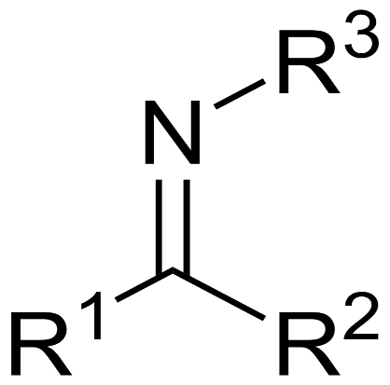
Fig.1. structure of an imine. R³- alkyl or aryl group.
R¹ or R²- Hydrogen

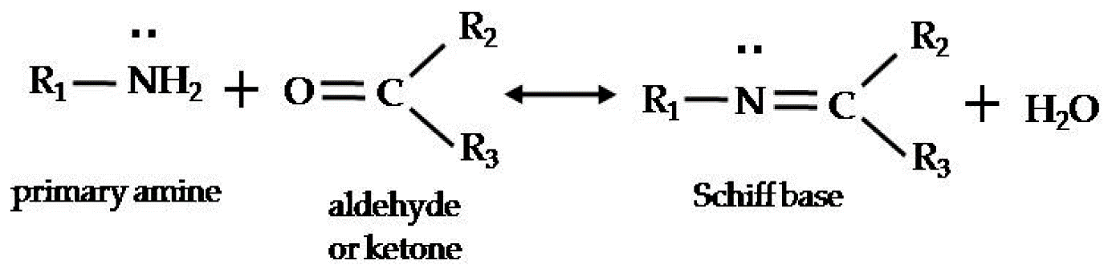
Fig.2. Mechanism of formation of Schiff Base

Some of the most popular organic compounds are Schiff bases. They are employed as pigments and dyes, catalysts, steps in the synthesis of organic compounds, and stabilizers of polymers. The biological activity of the metal complexes is higher than that of their ligands. The complexes of the Schiff-bases are of great consideration due to their stability, electron donating capacity, optical nonlinearity, catalytic, photochromic, and biological activity.^{[2]}

Due to their chelating abilities and capacity to coordinate with a variety of transition, lanthanide, and actinide ions in various oxidation states using their nitrogen and oxygen atoms to form stable complexes, they are regarded as a significant class of organic compounds. Exploring the possible uses of metal complexes from various Schiff bases in addressing issues like antimicrobial resistance and environmental contamination has sparked a great deal of interest. Because of the multiple uses for Schiff bases and their metal complexes in analytical, material science, organic, bioinorganic, and medicinal chemistry, there has been a lot of interest in this field. For these applications, the azomethine group's presence in Schiff bases and capacity to coordinate with different metal ions are crucial.^{[3]} Liquid crystal characteristics, chelating propensities, thermal stability, optical nonlinearity, and the capacity to design new molecular conductor structures by utilising proton transfer in conjunction with electrical qualities. Schiff base is employed as the stationary phase in gas chromatography due to its thermal stability. Schiff bases are typically bi- or tri-dendate ligands that can form extremely stable complexes with transition metals. They are utilized as intermediates in the synthesis of organic compounds and in catalysis.^{[4]}

  - IMPORTANCE OF IMINE

Imide derivatives with an azomethine group N=CH are a significant family of chemicals with a wide range of uses in numerous domains. These derivatives are among the most extensively investigated organic molecules, as evidenced by the variety of applications for these types of compounds in organic systems, particularly for the production of heterocyclic compounds containing nitrogen.

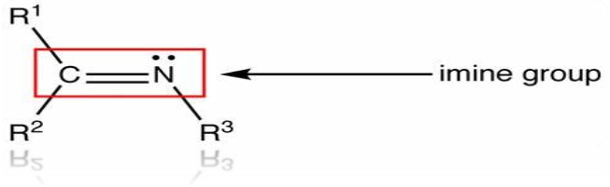
These compounds successfully stop the corrosion of mild steel, copper, aluminium, and zinc in an acidic media because of the imine group, the electron cloud of the aromatic ring, and the electronegative nitrogen, oxygen, and sulphur atoms present in Schiff base molecules. The nitrogen atom in the azomethine group forms hydrogen bonds with the centres of living cells, enhancing biological processes ^{[4]}.

  - APPLICATIONS OF SCHIFF BASES

1.3.1 ANTIMALARIAL ACTIVITY

Malaria is a serious disease continues to have a significant negative impact on public health. Four Plasmodium species Plasmodium falciparum, P. vivax, P. ovale, and P. malariae are mostly responsible for human malaria. The vector of Plasmodium is a female mosquito belonging to the genus Anopheles. It is obvious that finding new medications, vaccines, and insecticides to treat or prevent this disease is a top priority. It has been demonstrated that Schiff bases are a useful moiety for creating antimalarial drugs.

Nirmal R. Joshi and co-workers reported the Synthesis of [1- ((3(4fluorophenyl)-1-isopropyl-1H-indol-2-yl) methylene) hydrazine] ligand (Fig.3). Condensing hydrazine hydrate with 3(4fluorophenyl)-1-isopropyl-1H-indole-2-carbaldehyde produced the ligand. Following the broth microdilution assay, the ligand’s in vitro antimalarial activity was examined against P. falciparum K14, a chloroquine-resistant parasite. Data obtained demonstrated that compound displayed high antimalarial activity.^{[5]}

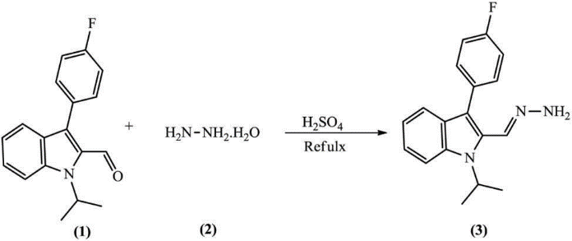
Fig.3. [1-((3-(4-fluorophenyl)-1-isopropyl-1H-indol-2-yl)
methylene) hydrazine] ligand

1.3.2 ANTIBACTERIAL ACTIVITY

The increase in the mortality rate associated with the infectious diseases is closely related to bacteria that shows multiple antibiotic resistance. The main reason for this issue is the lack of efficient therapies. There is unquestionably and urgent medical need for the creation of new antibacterial drugs with inventive and more effective modes of action. It has been suggested that Schiff bases are effective antibacterial substances. Chandran Mohan and co-workers has synthesized 2-acetylthiophene thiosemicarbazone and thiophene-2-aldehyde thiosemicarbazone (Fig.4) ligands and their metal complexes. The results of the antibacterial activity show that these compounds significantly inhibited the growth of gram-positive bacterial strains including Bacillus sp. and E. Coli. ^{[6]}

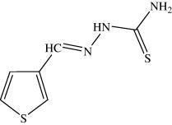
Fig.4. Thiophene-2-aldehyde thiosemicarbazone

    - ANTIFUNGAL ACTIVITY
Fungal infections are not typically restricted to the surface tissues; in fact, a considerable rise in systemic fungal infections that can be fatal has been noted. It is imperative to find and create more powerful antifungal medicines, and several Schiff bases are recognized as having antifungal potential. The majority of cruciferous crops, including broccoli, cauliflower, mustard, turnip, cabbage, rapeseed, and radish, are negatively impacted by the phytopathogenic fungus Alternaria brassicae and Alternaria brassicicola.
Carmen M. Sharaby synthesized the Schiff Base ligand through the condensation of 2-thiophene carboxaldehyde and sulfametrole [N'-(4methoxy-1,2,5-thiadiazol-3-yl] sulfanilamide (Fig.5). The Aspergillus terreus and Aspergillus flavus fungi were tested against the Schiff base ligand and its complexes.^{[7]}

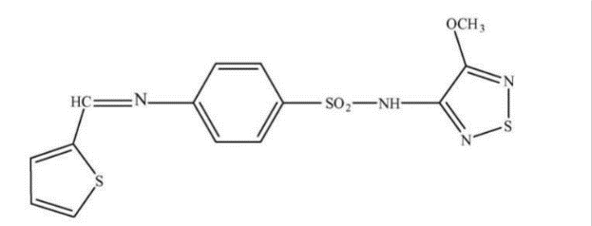
Fig.5. 2-thiophene carboxaldehyde-sulfametrole

1.3.4 ANTIVIRAL ACTIVITY
Vaccination could result in the eradication of viral diseases including rubella, polio, and smallpox. For immune lacking individuals, viral illnesses provide a life-threatening risk, and this issue needs to be resolved quickly. Recently, Sriram and co-workers reported the synthesis and antiviral activity of the abacavir-derived Schiff bases (Fig.6). These compounds are a new series of abacavir prodrugs. Abacavir is a nucleoside analogue capable of inhibiting the activity of reverse transcriptase. It is used to treat human immunodeficiency virus (HIV) and AIDS. ^{[8]}

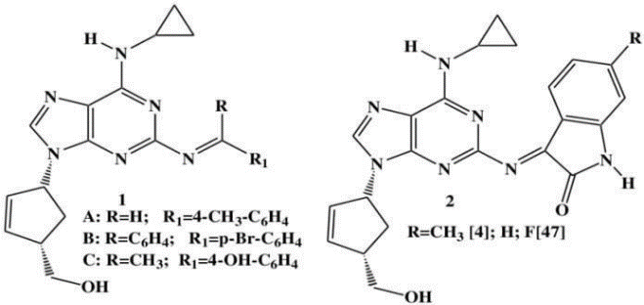
Fig.6. Abacavir derived Schiff Base

1.3.5 SCHIFF BASES AND THEIR COMPLEXES AS LIGHT
EMITTING DIODES

In the search for potential applications in a variety of fields such as nonlinear optics, molecular/metal ion sensing, dye-sensitized solar cells, molecular magnetism, and photoluminescence, Schiff bases and their complexes with transition metals have been thoroughly investigated. With the aid of imine nitrogen and the functional groups that are frequently found with their aldehyde equivalents, Schiff bases can function as ligands and chelate with metals. When making OLEDs, Schiff bases and related complexes are frequently used to adjust the emission color and boost the device's efficiency. These complexes' physical, photophysical, and photochemical properties can easily be changed, and by making the ligand more rigid, complexes with less non-radiative decay participation can be created, leading to more efficient devices. Zhang et al. created Pt-based Schiff base compounds and used them to make phosphorescent light-emitting diodes.^{[9]}
1.3.6 CATALYSIS

Schiff Base as catalysts have been studied for various organic transformations such as oxidation, epoxidation, reduction, coupling reactions, Polymerization reactions, and many more. Bi- or tri-dentate ligands, which are frequently used as Schiff Base ligands, can attach to transition metals to form very stable complexes. Since the majority of liquid crystals feature an azomethine group, they are occasionally used for this purpose as well. In organic synthesis, Schiff base reactions can result in the creation of carbon-nitrogen bonds. Understanding the properties of both ligands and metals can aid in the synthesis of compounds that have high activity because complexation frequently results in an increase in activity. Oxidation of alcohols into carbonyl compounds is a crucial catalytic conversion process. Triphenylphosphine was used to create a complex, cobalt (II)-SBC (SBC-Schiff base ligand) (Fig.7). ^{[10]}

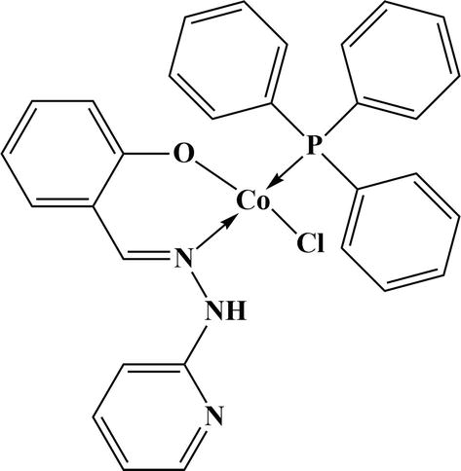
Fig.7. Cobalt (II) SBC with triphenyl phosphine

1.3.7 SENSORS

In numerous research, Schiff bases have been used successfully as extremely effective and selective sensing materials for metal ions and amino acids. other significant biologically active substances, including membrane, optical, and electrochemical sensors. Due to the distinct size of the ion, the electron configuration of the metal and the ligand, the charge on the metal ion, and the size of the cavity of the Schiff base, these structures showed selectivity towards particular metal ions over the others depending on the type of Schiff base. In order to produce sensing signals, Schiff bases and metal ions must interact chemically. Based on the type of signal that the sensing materials release, chemosensors can be divided into different categories such as colorimetric sensors, fluorogenic sensors, and electrochemical sensors. The sensing signal is produced in Schiff base-based chemosensors by changes in their electronic characteristics brought on by various charge transfer processes, such as ligand-to-metal charge transfer and metal-to-ligand charge transfer. The sensor signals showed a clear dependence on how metal ions and Schiff bases interact. For instance, a number of phenomena, including excited state intramolecular proton transfer, excimer-exciplex production, fluorescence resonance energy transfer, and photo-induced electron transfer, have an impact on the signals of fluorescent sensors. ^{[11]}

1.3.8 APPLICATION IN MODERN TECHNOLOGIES

They are utilised, in optical computers that measure and regulate radiation intensity, in imaging systems, and in molecular memory storage. Schiff compounds could act as photostabilizers or dyes for solar filters because of their photochromic characteristics. They are also used in optical sound recording technology. Schiff bases are intermediates in the oxidative ring-closing process that produces polycyclic derivatives of quinoline and isoquinoline when they are exposed to ultraviolet light. Additionally, they are utilised to make acyclic and macrocyclic chemicals such as cryptants, coronates, and podates. These substances cause Ruhemann's purple to appear (a result of an amino acid and ninhydrin reaction), which can be used to identify and detect fingerprints. ^{[4]}

1.4 ALDEHYDES AND AMINES

An aldehyde is an organic molecule having a functional group that has the formula R-CH=O in organic chemistry. Aldehydes are widely used and have significant functions in both the technological and biological realms. Depending on the rest of the molecule, aldehydes have a variety of different properties. Essential oils include traces of many aldehydes, which frequently contribute to their pleasant aromas.^{[12]} Aldehydes are crucial building blocks for the synthesis of Schiff base ligands because they generate an imine bond with amines by removing a water molecule.

Amines are substances and functional groups in organic chemistry that include a basic nitrogen atom and a lone pair. Amines are technically derivatives of ammonia (NH₃) in which one or more hydrogen atoms have been swapped out for a substituent such as an alkyl or aryl group (referred to as alkylamines and arlyamines, respectively; amines with both types of substituents attached are known as alkylarylamines). ^{[13]} Trimethylamine and aniline are two significant amines. These chemicals undergo an essential reaction that produces imines when primary amines interact with aldehydes or ketones. Starting materials for the production of azo dyes are primary aromatic amines. As amine hydrochlorides are utilised as decongestants, amine functional groups are found in around 42% of medicines and drug prospects, including phenylephrine and ephedrine. As cure agents for epoxy resin, amines are frequently utilised.

1.5 OBJECTIVES

- The objective of this work is to synthesize Schiff base as these compounds have a wide variety of applications in both medicine and industry.
- To confirm the formation of compounds, characterize the synthesized compounds by various spectroscopic techniques.
- To analyze the fluorescent properties shown by them and based on it, to develop a fluorescent probe for selective detection of amino acids.
- To develop a Sensor for a particular Amino acid.

Chapter 2
Literature Review
Ming-Ching Lee, developed a chiral "urea-carboxylic acid" binding site for a chiral carbazole-based sensor (CCS). The sequential detection of Fe³⁺$,$L-tryptophan (Trp), and L-histidine (His) by the naked eye was successfully accomplished using CCS. When exposed to Fe³⁺and Fe^{2+,} CCS displays various colour changes and a fluorescent "turn-off" reaction. In a solution with a highwater content (99% water), 84 nm is the lower limit of detection for Fe³⁺ by CCS. Fe³⁺ can be detected using a CCS sensor as a reversible fluorescence quenching sensor. In a solution with a highwater content (99% water), the CCS- Fe³⁺ complex can detect tryptophan or histidine by a dose-dependent turn-on fluorescence response. The mass spectra indicate that a 1:1 CCS- Fe³⁺: amino acid binding ratio was used to detect L-histidine or L-tryptophan by CCS- Fe³⁺$.$ In comparison to other chemosensors described in the literature, CCS has a low limit of detection for L-Trp and L-His in an environment with a lot of water (0.31 M L-Trp, 7.64 M L-His). Furthermore, the L-tryptophan content of commercial capsules designed to improve sleep and comprising a variety of substances was successfully quantified using the CCS -complex based chemosensor.^{[14]}

Pundi et al, developed a dimedone-phenylalanine-based chiral sensor (SDPA) in a water/DMSO (3/7) solution, it demonstrated substantial fluorescence quenching by Fe³⁺ and Cu²⁺with detection limits of 2.29 10-6 M and 6.37 10-6 M, respectively. After being EDTA-treated, the sensor can be utilized at least five more times. With a detection limit of 9.35 10-6 M for L-tryptophan and 8.86 10-6 M for L-cysteine, respectively, the SDPA- Cu²⁺ complex can detect these amino acids at trace amounts by turning on fluorescence. Additionally, using the SDPA- Cu²⁺ complex for the quantitative analysis of L-tryptophan in actual capsules that improve sleep led to a successful recovery. The amount of L-tryptophan in the Elining pill was found to be 190.8 10.5 mg/g (mg L- tryptophan/g medication), which is close to the stated amount of 180 mg/g. Additionally, the L-Try residues in proteins and unbound L-Try molecules can both be specifically detected by the SDPA- Cu²⁺ complex. ^{[15]}

Aazam have synthesized mononuclear metal (II) complexes of Zn, Cd, Cu, Ni and Pd with Schiff-base ligand derived from 8-acetyl-7-hydroxycoumarin and P-phenylenediamine. Zn and Cd complexation of the ligand results in metal-mediated amplification, whereas Cu, Ni, and Pd complexation results in metal-mediated fluorescence quenching. Similar to this, Taha et al. created lanthanide (III) complexes (Nd, Dy, Sm, Pr, Gd, Tb, La and Er) using the Schiff base created from salicylaldehyde and 1,3-propyldiamine. The centre metal ions in Sm, Tb, and Dy complexes emit the distinctive luminescence that is linked to energy transfer from the ligand to the metal. While Zhang et al. (2012) created the Schiff base ligands by substituting the 2 hydroxybenzaldehydes with diamines. Choosing specific compounds as phosphorescent emitting components allowed researchers to create yellow light-emitting devices with enhanced efficiency. Additionally, a single emissive layer made of materials that produce both yellow and blue light was used to create the phosphorescent white organic light-emitting device. ^{[16]}

Umran Duru Kamaci et al, synthesized fluorescence sensor based on Schiff base and boric acid for quick and simple L-tryptophan detection in various samples, including milk and bovine serum albumin, the. A series of different analytes, including cations, amino acids, and organic compounds, were used to investigate the selectivity of the fluorescent chemosensor. The photoluminescence intensity was measured using fluorescent measurements, and the results showed that the developed fluorescent sensor was exhibited selective, sensitive, and reliable determination against L-tryptophan. The chemosensor's linear range and detection limit were determined to be 0.82 M and 0.1-500 M, respectively. ^{[17]}

Xuefang Shang et al, developed fluorescent probe comprising a Schiff base and hydroxyl group and demonstrated to have a high sensitivity and specificity for Arginine (Arg). Chemical modification of Schiff base derivatives with function groups, inspired by biological counterparts, may offer a highly effective technique to identify amino acids. Since there are normally eighteen different types of standard amino acids. Theoretical research also provided additional examples of the potential binding mode in the host-guest interaction and the functions of molecular frontier orbitals in molecular contact. A biosensor for the in vivo detection of Arginine can also be used, as the synthesised fluorescent probe demonstrated high binding ability for Arg and low cytotoxicity to MCF-7 cells over a concentration range of 0-200 g mL.^{[18]}

Wen-Da Li successfully developed and synthesised to create a unique double-armed salamo-based probe DAS for the detection of tryptophan and ${Al}^{3+}$. In the mixed solvent DMF: H2O (9: 1, V/V, pH = 7.2), the probe DAS demonstrated high selectivity to tryptophan and ${Al}^{3+}$. Calculations were made to estimate the probe DAS's limit of detection (LOD), limit of quantitation (LOQ), and association constant (Ka) for detecting tryptophan and ${Al}^{3+}$ .This probe demonstrated a lower detection limit than other reported probes and offered a comparatively easy-to-use approach for the detection of tryptophan. Additionally, the DAS probe in this investigation demonstrated comparatively strong detection performance compared to the probe used to detect ${Al}^{3+}$, and the substantial colour shift after adding ${Al}^{3+}$ played a crucial role in detection process.^{[19]}

Zhang et al. synthesized salicylaldehyde derived Schiff base sensor for fluorescence-based detection of Co²⁺. Only Co²⁺ in ethanol solution displayed high selectivity among the several metal ions in the sensor. The sensor’s fluorescence titration with Co²⁺, showed an increase in emission intensity at 350 nm (ex = 298 nm). Between 8.0 107 and 2.0 106 M, the fluorescence intensity vs Co²⁺ Concentration curve was linear. For Co²⁺ the limit of detection was 0.782 M. The complex's 1: 4 stoichiometry was discovered by Job's plot. The nitrogen atom of the NC-H group and the phenolic O-H group may have been involved in coordination with Co²⁺, according to ¹H NMR investigations conducted in the absence and presence of Co^{2+.} The monitoring of Co²⁺ in environmental analysis could employ a sensor. ^{[20]}

Patole et al. developed number of Schiff base ligands containing p-aminosalicylic acid with improved antimycobacterial activity against Mycobacterium and Mycobacterium Lovis. Hydroxy-rich side chains in ligands exhibited increased antimycobacterial activity. Some Cu (II) and Ni (II) complexes of Schiff bases bearing cyclobutane and thiozole ring exhibited antibacterial activity against Colibacillus and P. aeruginosa. Zn (II) complexes of Schiff bases derived from glycylglycine with imidazole-2-carboxaldehyde or indole-3-carboxaldehyde showed higher antimicrobial activity against S. aureus, E. coli, K. pneumoniae, Proteus vulgaris and P. aeruginosa than the free ligands.^{[1]}

Maria Sadia et al, designed a fluorescent sensor L for sensing of Ce³⁺ion. Its fluorescence behavior towards metal ion was examined by fluorescence spectroscopy. Chelation-enhanced fluorescence was shown by the sensor L upon interaction with Ce³⁺ ion. This fluorescent sensor exhibits high sensitivity and selectivity towards Ce³⁺ ion in acetonitrile solution, forming 2 :1 (L : M) complex as determined by Job’s plot. Association constant was found from the Benesi-Hildebrand plot. No significant interference was observed in the presence of other studied alkali, alkaline, and transition metal ions. A rapid response was observed when employed for the determination of Ce³⁺ ion in spiked water samples with a limit of detection.^{[21]}

Yuannian Zhang et al, reported a sensitive and selective method for detection and quantification of tryptophan and cysteine utilizing 1,8-pyrenedione as turn-on fluorescent probe. Non-fluorescent PYRENEDIONE was hydrogenated to highly fluorescent 1,8-pyrenediol by tryptophan and cysteine, but not by other amino acids, within minutes at room temperature. Dose dependent fluorescent turn-on were observed for both cysteine and tryptophan (linear range: 0-7 µM, R2 = 0.9930; LOD 0.15 µM; LOQ 0.45 µM). The method shows good accuracy with spike and recovery rate of 92.1-106.4% and excellent precision with run-to-run variation of smaller than 4.0 %. The validated assay was successfully applied to quantify tryptophan contents in soy sauce. The results shown that the content of tryptophan in naturally fermented soy sauce ranges from 34 to 891 µM while it is low (< 34 µM) in “soy” sauce that contains less soy-bean based raw materials. Therefore, as an example of its application in analysis of tryptophan in complicated food matrix, pyrenedione is a handy probe for rapid and reliable testing the quality and authenticity of soy sauces. ^{[22]}

Yoon and Lee, reported a selective colorimetric and fluorescent chemosensor based on pyrene for lysine. Only when lysine is present does the colorimetric transition from light yellow to pink occur uniquely. The resulting colour change is visible with the unaided eye. The complex produced by the probe and Lys has a predicted dissociation constant of Kd = 2.78 10 3 M based on a linear plot of UV absorbance related to 1:1 host-guest binding. In addition, when it interacts with lysine but not with the other amino acids, a sensitive and selective fluorescence increase takes place. The calculations show that the observed colorimetric change is caused by the products' development of a stacked dimeric form, in which the CQN and OH groups interact intramolecularly through an H-bond water relay. ^{[23]}

Chapter 3
MATERIALS AND METHODS

This chapter gives a brief description of the materials and experimental procedures adopted for the present investigation.

3.1 CHEMICAL REQUIREMENTS

3.1.1 TEREPHTHALDEHYDE

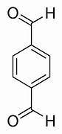
Fig.8. Terephthaldehyde

Molecular formula: C₈H₆O₂

Melting point: 114-117

Boiling Point: 245

Solubility: Soluble in hot water, alcohol and ether.

To create dyes and fluorescent whitening agents, Terephthaldehyde (Fig.8) is utilized as an intermediary. By interacting with aliphatic diamines, it is utilized to create poly imines. By copolymerizing with pyrrole, indole, and carbazole, it serves as a precursor for the creation of paramagnetic microporous polymeric organic frameworks (POFs). Two aldehyde groups make this substance an excellent precursor for the synthesis of Schiff bases
3.1.2 ORTHO PHENYLENE DIAMINE

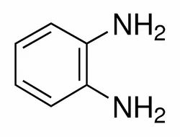
Fig.9. Ortho Phenylene Diamine

O-Phenylene diamine (Fig.9) is a crucial precursor to a ligand. Its metal phenylene diamine complexes can be oxidised to produce di imine derivatives, which are vividly coloured and frequently have several oxidation states. It is a solid compound with a yellowish-brown tint that dissolves in alcohol better than water, but rarely in chloroform ether. Boiling points range from (256–258) and melting points from (103–104).

Biological applications

Derivatives of phenylene diamine utilized in rubber goods as antioxidants. Orthophenylene diamine condensation with various diketones is utilized in the manufacturing of a variety of medications as ligands, dyes, and other applications in the bio- and chemical-fields, for the creation of bioinorganic molecules utilized in the synthesis of medicinal medicines.

SAFETY: With an LD50 of 44 mg/L, O-phenylene di ammine is 1000 times less toxic than the para isomer.

3.1.3 4-CHLORO-O-PHENYLENE DIAMINE

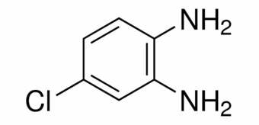
Fig.10. 4-chloro-ortho phenylene Diamine

4-chloro-ortho phenylene diamine is dark crystalline solid (Fig.10). A man-made beige to grey-brown crystalline powder known as 4-Chloro-ortho phenylene diamine is soluble in benzene, petroleum ether, ethanol, and diethyl ether but not highly soluble in water. It serves as an oxidative base, an intermediate in the synthesis of 5-chlorobenzotriazole (an isomer that is a chemical used in photography), an epoxy resin curing agent, and a reagent in gas chromatography.

3.1.4 CYCLOHEXANE DIAMINE

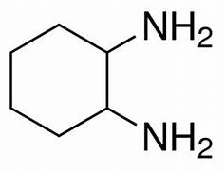
Fig.11. Cyclohexane diamine

An aliphatic amine is Cyclohexane diamine (Fig.11). A cheap, easily accessible chiral diamine with numerous uses in all types of asymmetric synthesis is Cyclohexane diamine.

3.1.5 SOLVENT-METHANOL

Because of its polarity, methanol is a useful solvent for extraction and is extensively employed in biology. Both hydrophilic and lipophilic molecules or compounds can be extracted by it. The fact that it is very volatile and may be easily removed at room temperature is another benefit.

3.2 EXPERIMENTAL METHOD

The experimental set up consists of,

3.2.1 MAGNETIC STIRRER

A magnetic stirrer is a device widely used in laboratories and consists of a rotating magnet or a stationary electromagnet that creates a rotating magnetic field (Fig.12). This device is used to make a stir bar, immerse in a liquid, quickly spin, or stirring or mixing a solution.

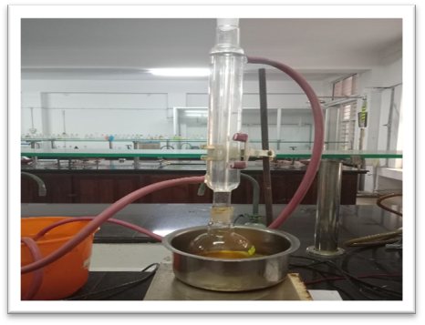
Fig.12. Magnetic stirrer

3.2.2 SONICATOR

Sonicators are high-frequency devices (20 kHz) that agitate particles in liquids using ultrasonic radiation (Fig.13). These tools are used to speed up a wide range of procedures, including sample preparation, cell disruption, cleaning, degassing, and mixing.
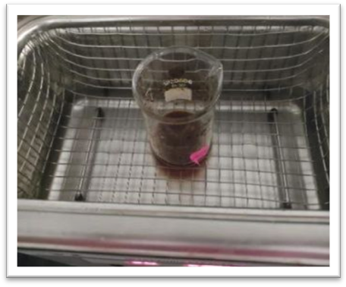
Fig.13. Sonicator

3.3 CHARACTERIZATION TECHNIQUES

3.3.1 ELEMENTAL ANALYSIS

The classical approach of discovering an unknown substance's elemental makeup is through elemental analysis. A known quantity of an unidentified chemical is transformed into straightforward molecules that only contain the target ingredient. All synthesised compounds were subjected to carbon, hydrogen, and nitrogen analyses using a Vario EL CHNS analyzer at the Sophisticated Test Instrumentation Centre (SAIF), Cochin University of Science and Technology, Kochi, India. Both quantitative and qualitative elements can be analysed.

3.3.2. ELECTRONIC SPECTRA

Electron spectroscopy, method of determining the energy with which electrons are bound in chemical species by measuring the kinetic energies of the electrons emitted upon bombardment of the species with X-ray or ultraviolet radiation. Electronic spectra of the ligands were recorded in different solvents such as methanol, acetonitrile and chloroform on a Thermo electron Nicolet Evolution 300 UV-Vis Spectrometer. UV-Visible spectroscopy deals with UV Visible region of electronic spectrum. UV-Visible spectrum is plotted as absorbance against wave length.

3.3.3. FT-IR SPECTROSCOPY

Fourier transform infrared spectroscopy (FTIR) is a ubiquitous spectroscopic technique. Spectral interpretation is a time-consuming process, but it yields important information about functional groups present in compounds and in complex substances. In this work Infrared spectra were recorded on a JASCO FT-IR-5300 Spectrometer in the range 4000-400 cm-1 using KBr pellets at the Department of Applied Chemistry CUSAT.

3.3.4. ¹H NMR SPECTROSCOPY

H NMR is the go-to technique to help identify or confirm the structure of organic compounds or those that contain protons. A solution-state proton spectrum is relatively fast to acquire, compared with other nuclei, and a lot of information about the structure of a compound can be deduced from it. NMR spectra detected using CDCl₃ on a Burker Advance DRX 300NFTNMR spectrometer at SAIF, CUSAT with TMS as the standard.

3.3.5. ¹³C NMR SPECTROSCOPY

The ¹³C NMR is directly about the carbon skeleton not just the proton attached to it. The number of signals tell us how many different carbons or set of equivalent carbons. The splitting of a signal tells us how many hydrogens are attached to each carbon. NMR spectra of ligands were recorded in CDCl₃ using TMS as internal standard in Bruker Advance lll, 400MHz FT-NMR Spectrometer at sophisticated Test and instrumentation centre (SAIF), cochin university of science and Technology, Kochi, India

3.4 METHOD AND SYNTHESIS

The three Schiff base compounds are synthesized by condensation reactions. The reagents used as amine are o-phenylenediamine, 4-chloro-o-phenylene diamine and cyclohexane-1,2-diamine.

Terephthaldehyde used as the aldehyde in synthesize of all these three compounds. Methanol is used as the solvent. All the reagents we used here are soluble in methanol and they are of biological as well as industrial use.

3.4.1. REACTION BETWEEN TEREPHTHALDEHYDE AND O-PHENYLENE DIAMINE.

Compound TOMINE (1:2) synthesized by weighing accurately 0.1g of terephthaldehyde and dissolved in methanol. In another beaker 0.16 g of o-Phenylene diamine also dissolved in methanol. It is then transferred into an RB flask connected to a water condenser. The solution was refluxed for 6 hours with continuous stirring using a magnetic stirrer. An orange- coloured precipitate (Fig.14) formed filtered using whatmann filter paper, washed with water and dried. It is then collected to a bottle (scheme 1).

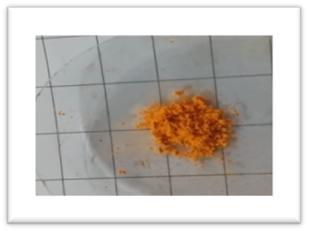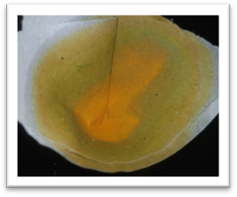
Fig.14. TOMINE

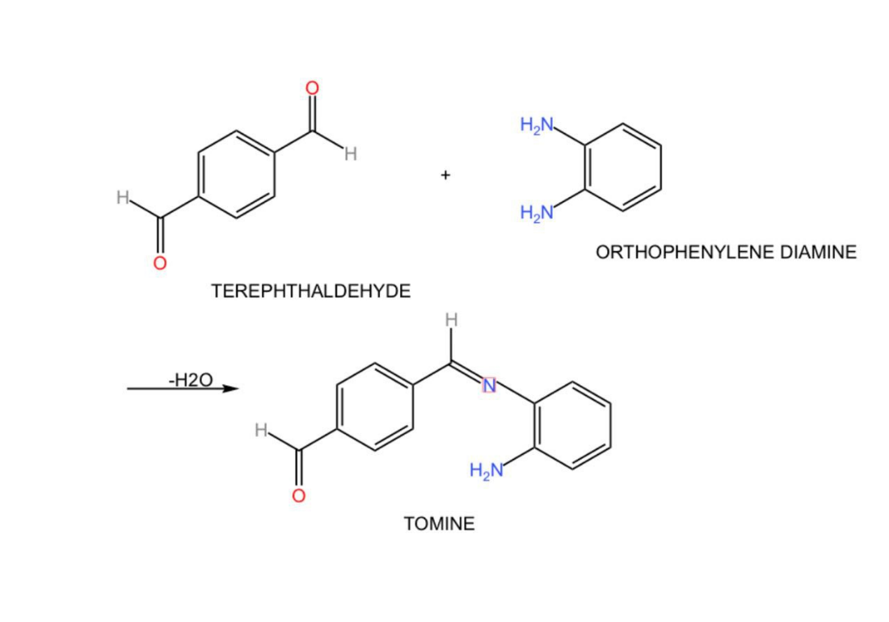

Scheme 1. Synthesis of TOMINE

3.4.2 REACTION BETWEEN TEREPHTHALDEHYDE AND 4- CHLORO-ORTHOPHENYLENE DIAMINE

Compound TOCLOMINE (1:1) (Fig.15) synthesized by weighing accurately terephthaldehyde and 4-chloro-orthophenylene diamine in 1:1 proportion. Both are dissolved in methanol and transfered in to the round bottom flask which is connected to water condenser. The solution was refluxed for 6 hours with continuous stirring using a magnetic stirrer. The product formed was extracted with methanol and kept in beaker covered with butter paper drilled with holes. The solution was slowly evaporated to get a brown colored compound (scheme 2).
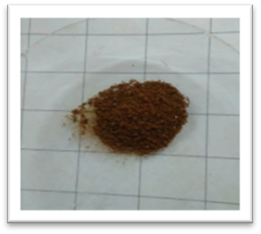
Fig.15. TOCLOMINE

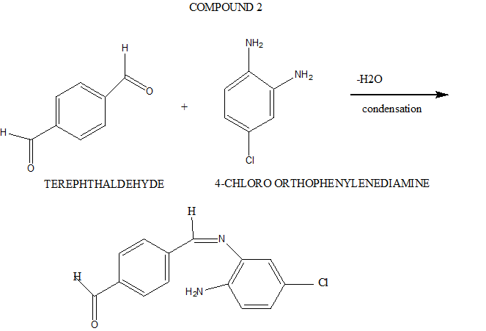Scheme 2. Synthesis of TOCLOMINE

3.4.3 REACTION BETWEEN TEREPHTHALDEHYDE AND
CYCLOHEXANE-1,2-DIAMINE

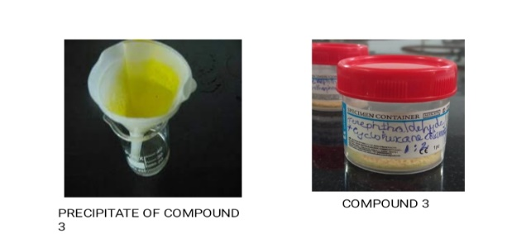
Compound TCYCLO (1:1) synthesized by weighing accurately terephthaldehyde and Cyclohexane-1,2-diamine in 1:1 proportion. Both are dissolved in methanol and transferred in to the round bottom flask which is connected to water condenser. The solution was refluxed for 6 hours with continuous stirring using a magnetic stirrer. The product formed was extracted with methanol and kept in beaker covered with butter paper drilled with holes. The solution was slowly evaporated to get a yellow-colored compound (scheme 3).

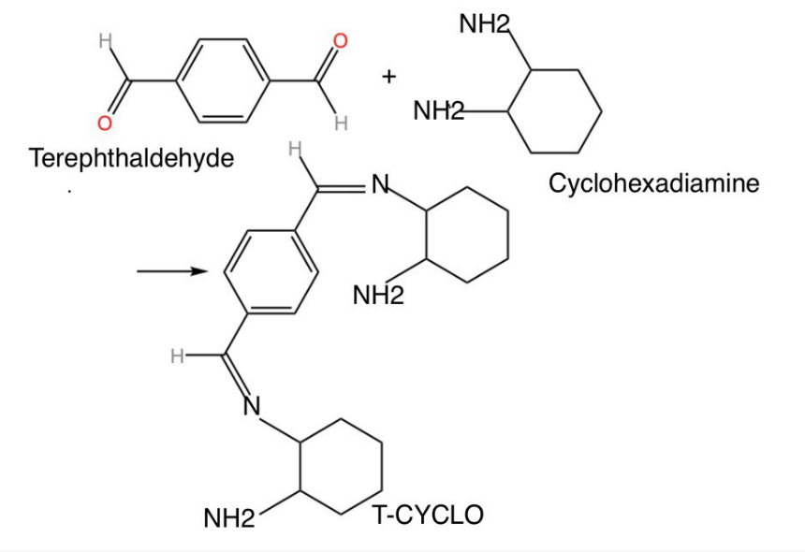
Scheme 3. Synthesis of T-CYCLO

Chapter 4

RESULTS AND DISCUSSION

The synthesized compounds were characterized by elemental analysis, FT-IR, UV Visible, NMR, fluorescence spectroscopy.

4.1 ELEMENTAL ANALYSIS

The analytical data for the synthesized compounds TOMINE, TOCLOMINE and T-CYCLO are given in the Table.1.

Compound | Mol Wt. | Mol  formula | Color | C observed(calculated)% | H% | N% | S%
TOMINE | 224.4 | C₁₄H₁₂N₂O | Orange | 66.96(66.91) | 3.59 | 11.17 | 0.12
TOCLOMINE | 258.59 | C₁₄H₁₁N₂ClO | Brown | 75.29(75.27) | 6.73 | 17.76 | ND
T-CYCLO | 230.19 | C₂₀H₂₆N₄ | Yellow | 74.66(74.63) | 7.88 | 2.26 | ND
Table.1 CHN Data

4.2 SPECTRUM ANALYSIS OF TOMINE

4.2.1 UV-VISIBLE SPECTROSCOPY

UV Visible spectrum of TOMINE has showed characteristic main absorption band at 340 nm and is due to the n-π* transition of the compound, which corresponds to the excitation of chromophore group C=N. Spectrum is given below in Fig.16.

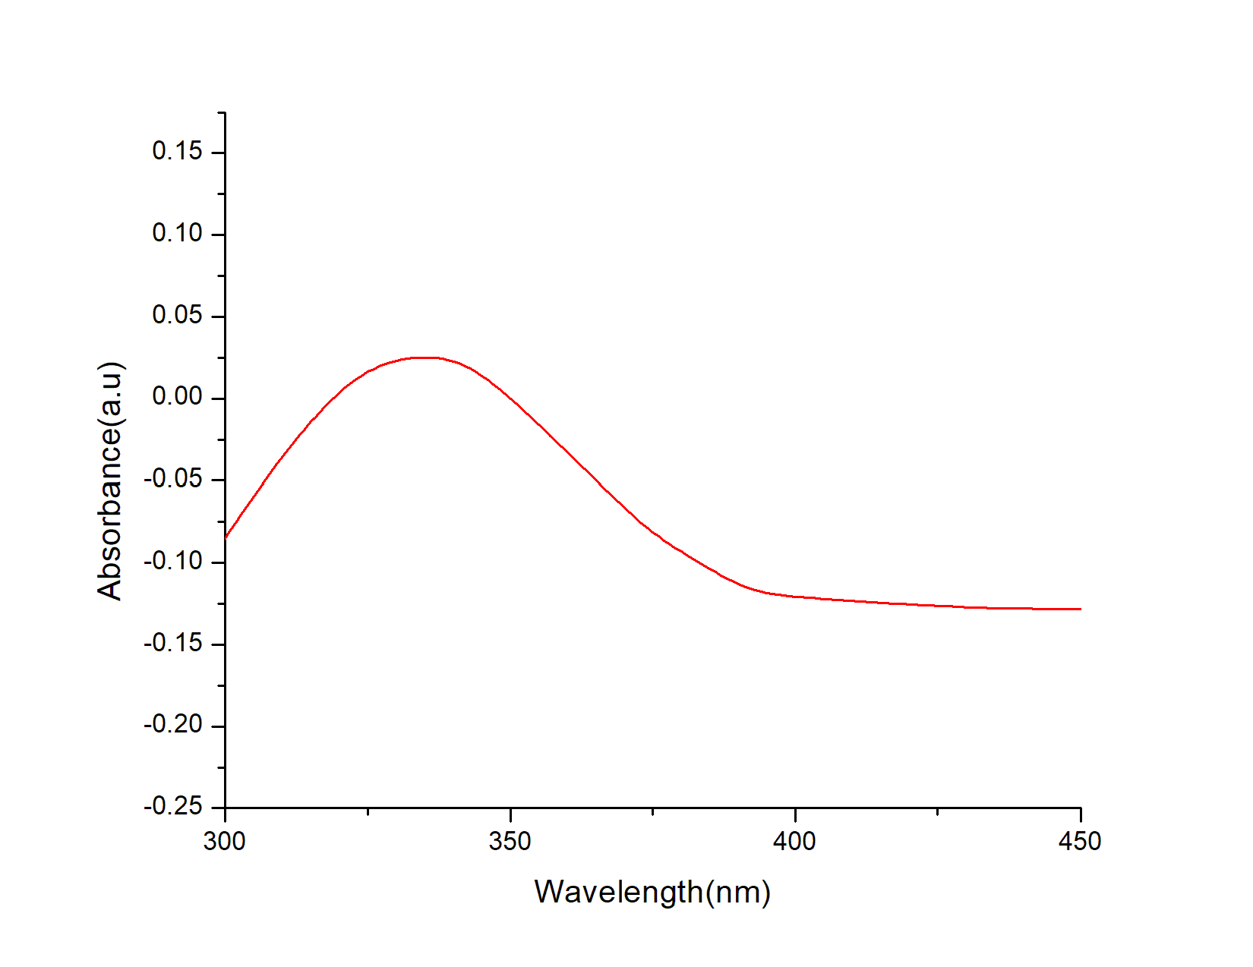
Fig.16 Electronic spectrum of TOMINE

4.2.2 FT-IR SPECTROSCOPY

For the identification of functional group present in the synthesized compound, FTIR Spectroscopic analysis was peformed. The peak details are presented in Table.2. The characteristic band assigned to different functional groups were based on comparison with the available literature.^{[21]} The IR spectrum of TOMINE is in Fig.17. The three characteristics bands observed are 3365 cm⁻¹, 1610 cm⁻¹ and in the range of 1710-1740cm⁻¹. The appearance of characteristic stretching band (C=N) in compound at 1610 cm⁻¹ confirms the formation of TOMINE. Strong band at 3365 cm⁻¹ were assigned to NH group and aldehyde stretching frequency at 1609 cm⁻¹.

Frequency cm⁻¹ | Vibration
3365 cm⁻¹ | NH
1610 cm⁻¹ | Azomethine
1730 cm⁻¹ | CHO
Table.2 Vibrational peaks of TOMINE

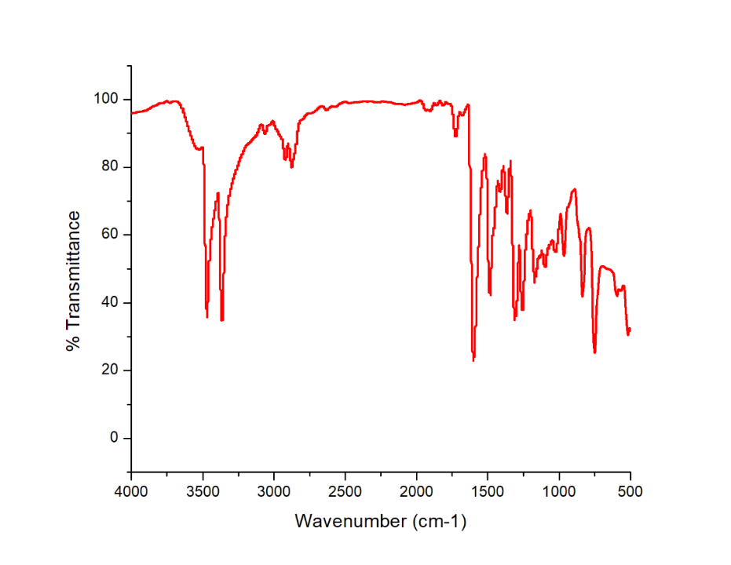
Fig.17 IR spectrum of TOMINE

4.2.3 NMR SPECTROSCOPY

¹H NMR

The ¹H NMR spectrum of TOMINE was recorded in CDCl₃ is given in Fig.18. The chemical shifts observed at 8.6 ppm, is due to imine protons confirms the formation of C=N group, the multiplet signals obtained in the 6.7 to 7.1 is due to aromatic protons respectively. The data set obtained for the compound is well comparable with the reported data for structurally analogous compounds. ^{[24]}

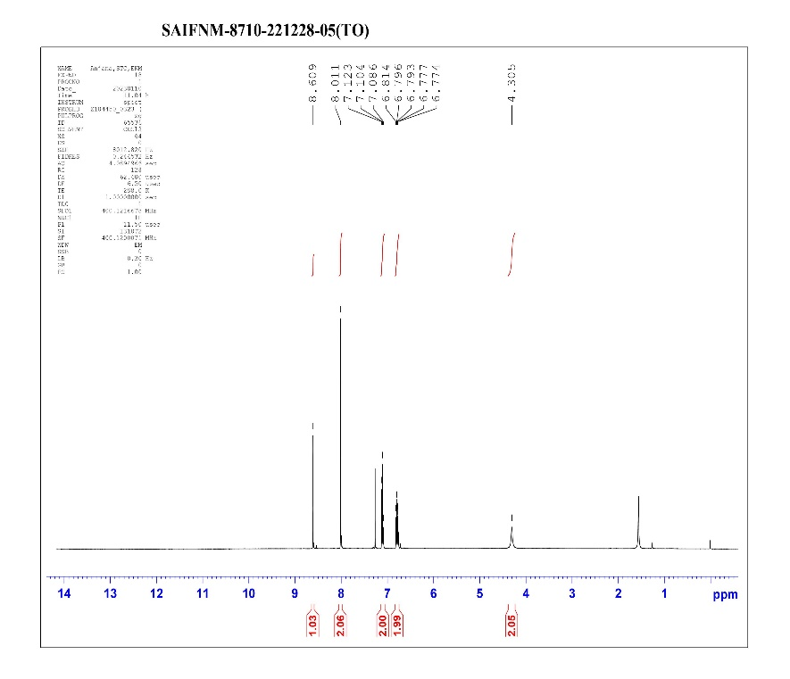
Fig.18. ¹H NMR spectrum of TOMINE

¹³C NMR

The carbon skeleton of the compound was further confirmed by ¹³C NMR The Fig.19 shows the ¹³C NMR spectrum of compound TOMINE.

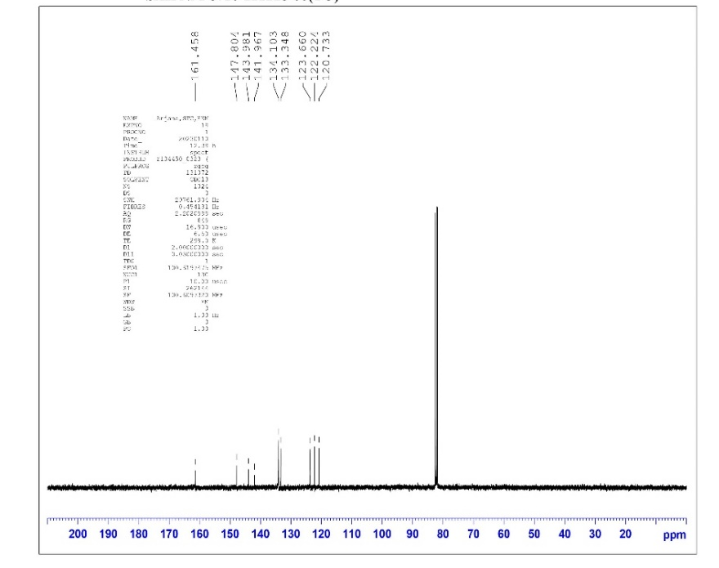
Fig.19. ¹³C NMR of TOMINE

4.3 SPECTRUM ANALYSIS OF TOCLOMINE

4.3.1 UV- VISIBLE SPECTROSCOPY

UV-Visible spectrum of TOCLOMINE in Fig.20 shows one main characteristic absorption peak at 270 nm and is due to the n-π* transition of the compound.

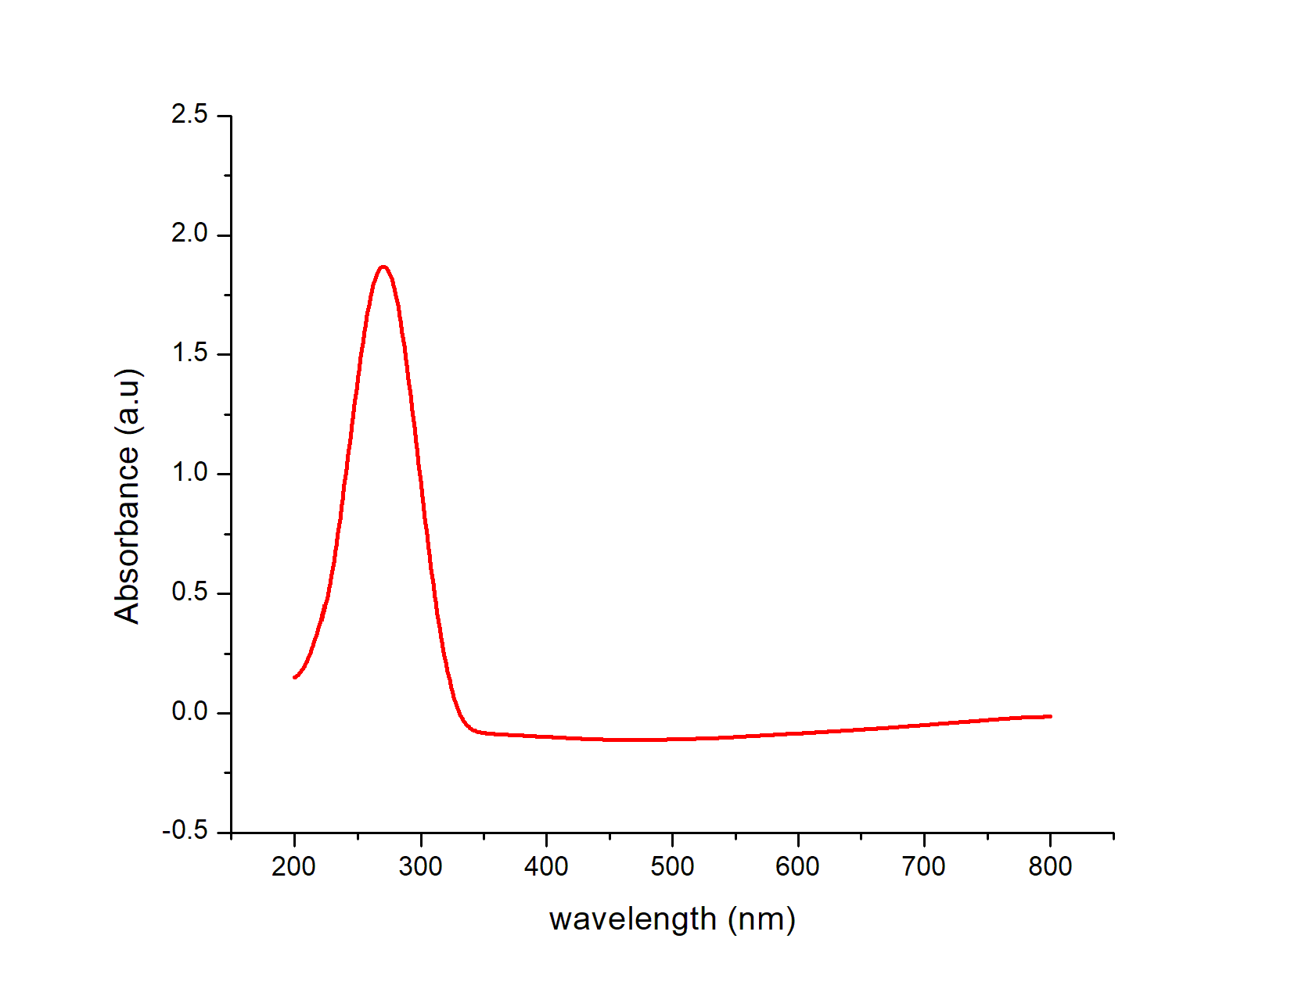
Fig.20. Electronic spectrum of TOCLOMINE

4.3.2 FT-IR SPECTROSCOPY

The IR Spectrum of TOCLOMINE is shown below in Fig.21. The three characteristics band observed are 3412 cm⁻¹, 1618 cm⁻¹ and 1609 cm⁻¹. They were assigned as the vibrational modes of NH, azomethine, and group respectively. The frequencies of all peaks are summarized in Table 3.

Frequency cm⁻¹ | Vibration
3412 cm⁻¹ | NH
1618 cm⁻¹ | Azomethine
1740cm⁻¹ | CHO
Table.3 Vibrational peaks of TOCLOMINE

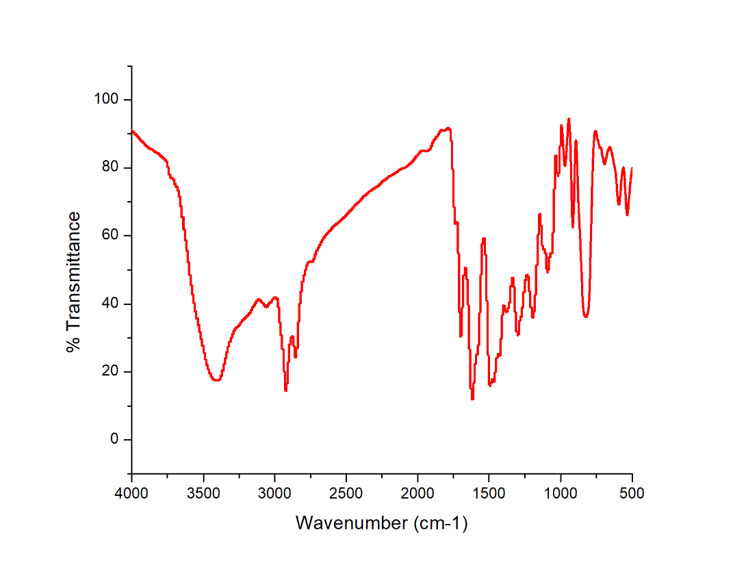
Fig.21. IR spectrum of TOCLOMIN

4.3.3 NMR SPECTROSCOPY

¹H NMR

The ¹H NMR of TOCLOMINE is given in Fig.22. The chemical shifts observed at 8.5 ppm, 6.5 to 7.5 ppm and 10 ppm is due to imine protons, aromatic protons and aldehyde proton respectively. The peak at 8.5 ppm which indicates the imine proton confirms the formation of Schiff base.

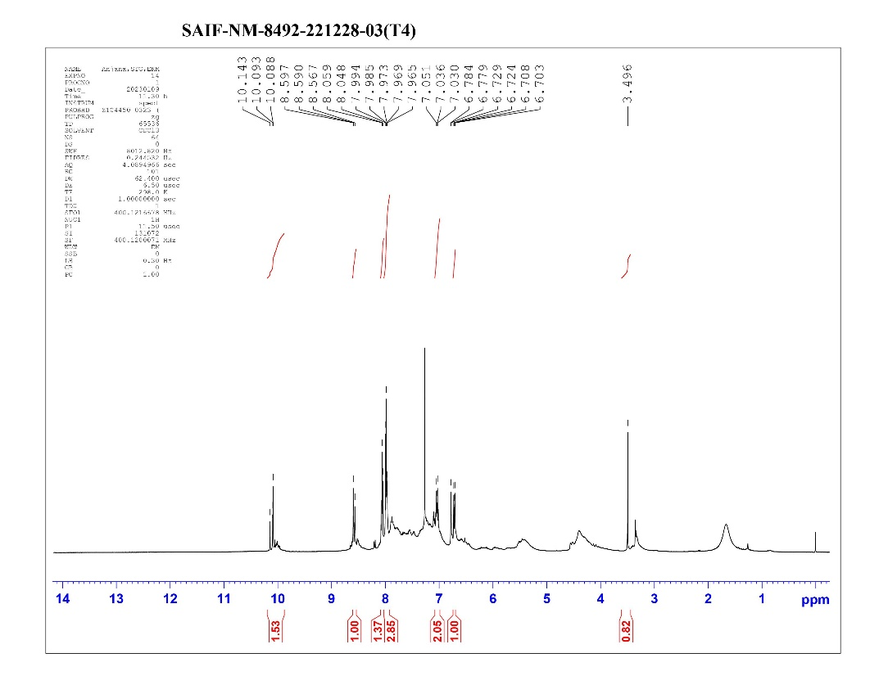
Fig 22. ¹H NMR of TOCLOMINE

¹³C NMR

The carbon skeleton of the compound was further confirmed by ¹³C NMR. The Fig.23 shows the compound spectrum of compound TOCLOMINE.

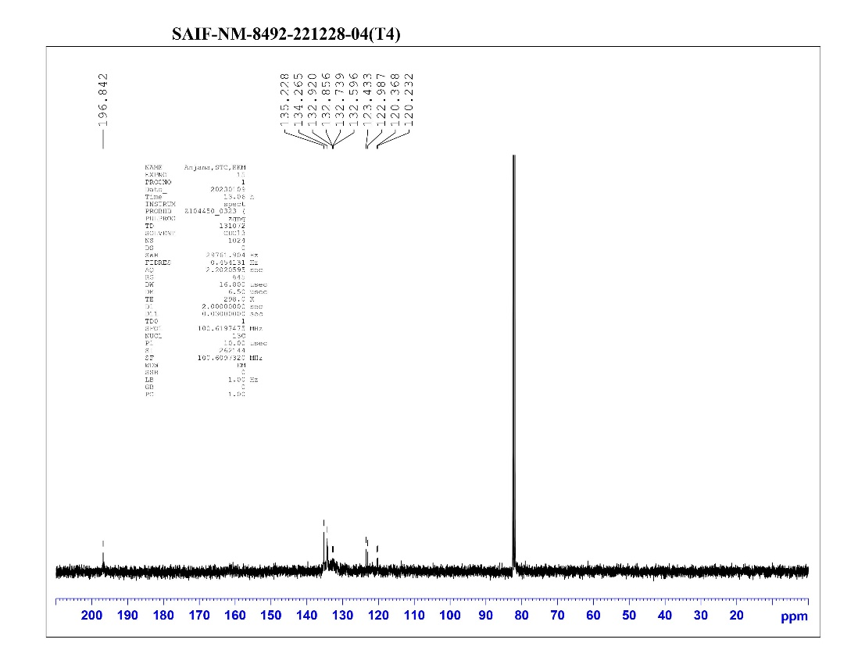
Fig.23. ¹³ C NMR of TOCLOMINE

4.4 SPECTRUM ANALYSIS OF T-CYCLO

4.4.1 UV- VISIBLE SPECTROSCOPY

UV spectrum of T-CYCLO in Fig.24 shows one peak. The absorption peak is at 280 nm.

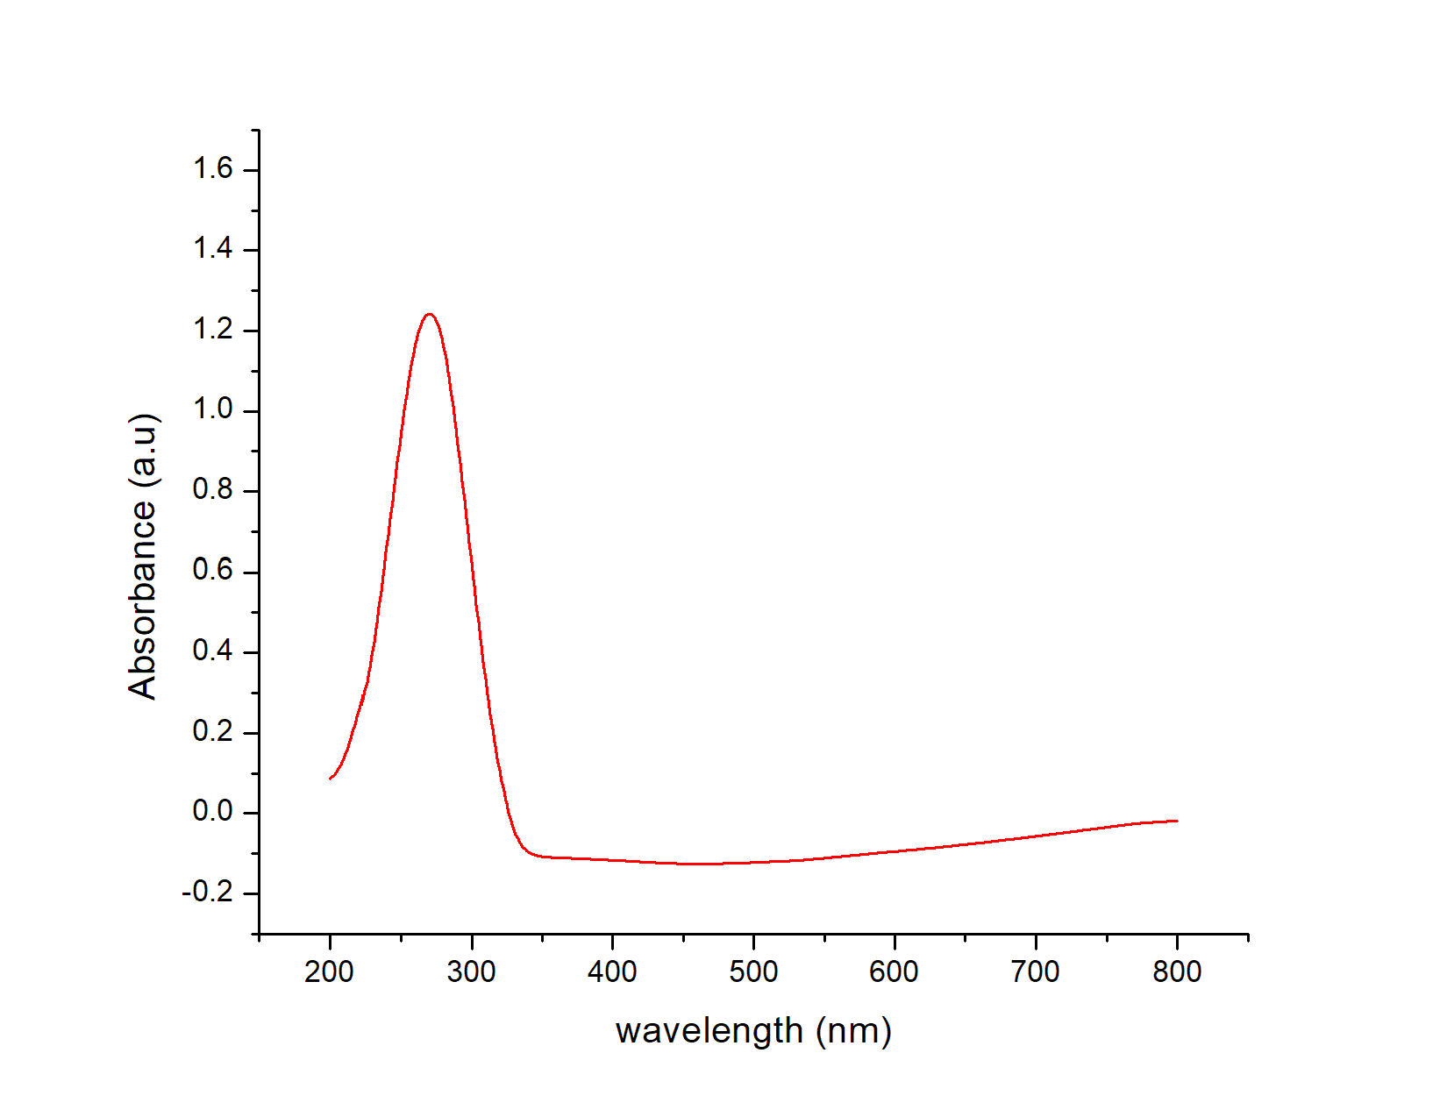

Fig.24. Electronic spectrum of T-CYCLO

4.4.2 FT-IR SPECTROSCOPY

The IR spectrum of T-CYCLO is shown below in Fig.25. The two characteristics band observed are 3494 cm⁻¹ and 1696 cm⁻¹. They were assigned as the vibrational modes of NH, Azomethine respectively. The frequencies of peaks are summarized in Table.4.

Frequency cm⁻¹ | Vibration
3494 cm⁻¹ | NH
1696 cm⁻¹ | Azomethine
Table.4 Vibrational peaks of T-CYCLO

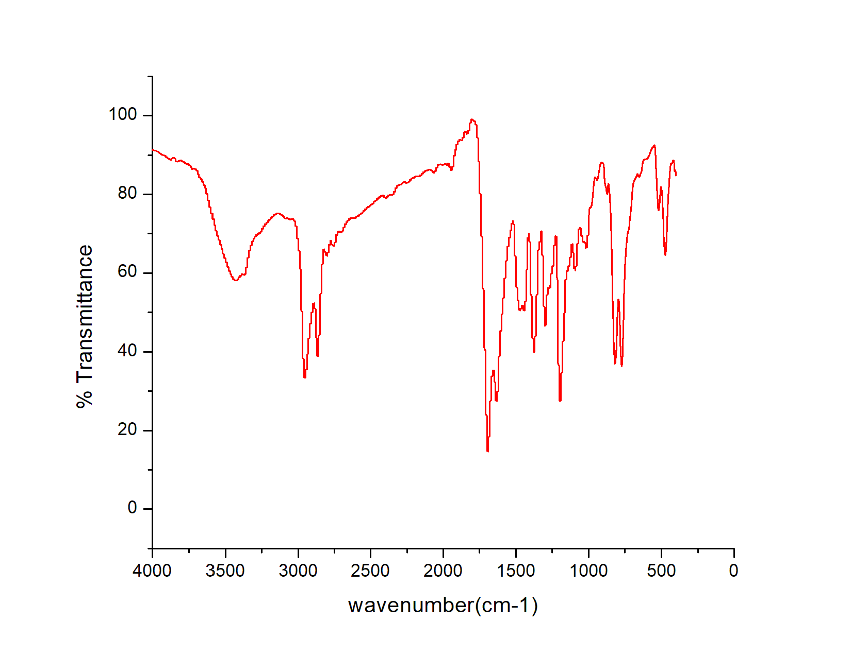
Fig.25.IR Spectrum of T-CYCLO

4.4.3 NMR SPECTROSCOPY

¹H NMR

The ¹H NMR of T-CYCLO is given in Fig.26. The chemical shifts observed at 8.29 ppm and at range of 6. to 8 ppm due to imine protons, aromatic protons respectively.

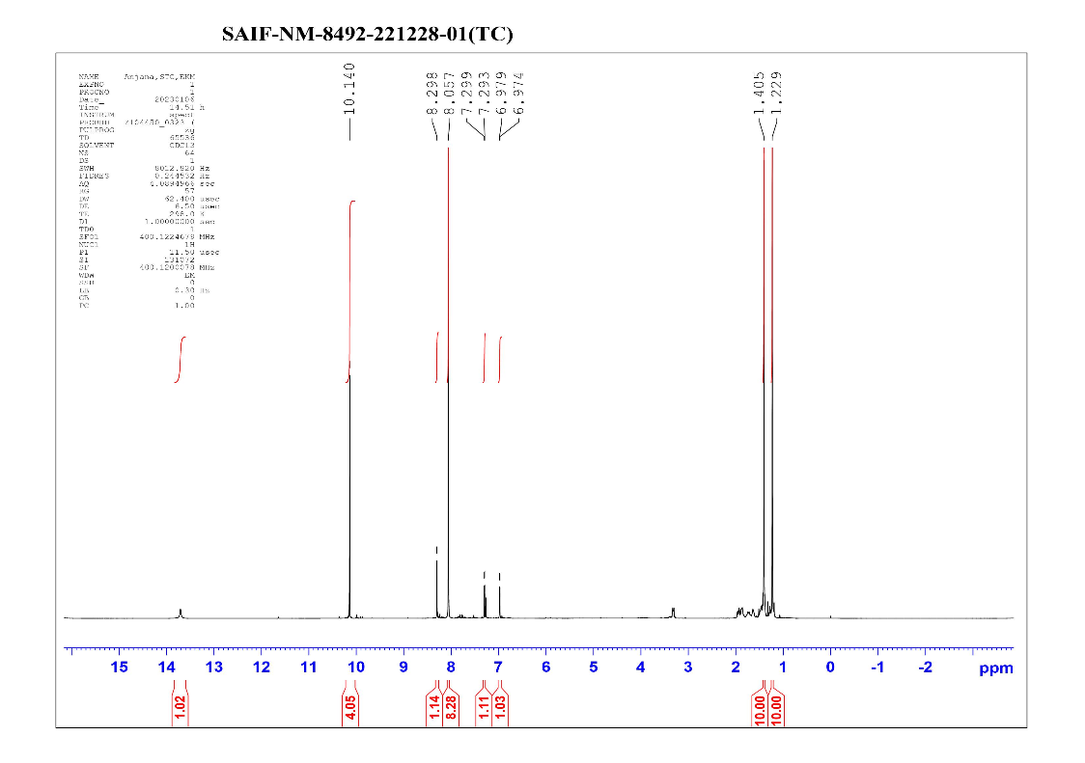
Fig.26. ¹H NMR of T-CYCLO

¹³C NMR

The carbon skeleton of the compound was further confirmed by ¹³C NMR. The Fig.27 shows the spectrum of compound T-CYCLO.

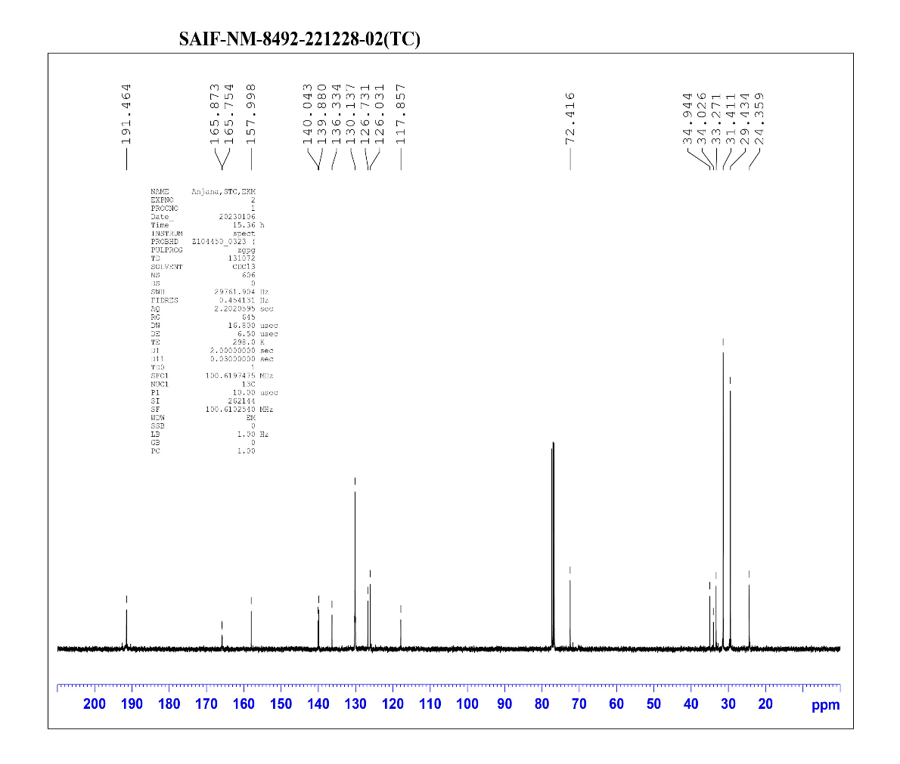
Fig.27. ¹³C NMR of T-CYCLO
4.5 APPLICATION

TOMINE and TOCLOMINE shows high fluorescence property and TOMINE have the ability to act as a fluorescence sensor for detection of amino acid tryptophan based on its sensitivity and selectivity with tryptophan.

4.5.1 SENSORS

Sensors are tools that can identify the presence of biomolecules, metal ions, chemicals, poisons, pollutants, etc. in the environment or inside of living things. The presence and quantity of these chemicals can be found using sensors. ^{[25]} The component of a sensor is a probe, which is a ligand similar to a Schiff base molecule that exhibits sensing activity when it binds to the specific analyte. A colorimetric sensor's sensitivity to a certain analyte can be seen by the colour shift it causes. Depending on the categories into which environmental elements are divided to,
- Fluorescence sensor
- Optical sensor
- Chemo sensor
- Colorimetric sensor
- IR sensor
- Electrochemical sensor
- Ultrasonic sensor
As the compounds shows fluorescence property our application is mainly based upon fluorescence sensors.

4.5.2 FLUORESCENCE SENSORS

Due to its great selectivity, specificity, sensitivity, simplicity of use, immunity to light scattering, low cost, etc., fluorescence sensors are tools that aid in the detection of biomolecules and metal ions. Today's environmental and medical research specifically uses fluorescence sensors. ^{[26]} By increasing interest in producing fluorescent probes, a problem for diverse detection of harmful analytes in the environment, biological organs, and tissues has been resolved. Scientists from a variety of fields, including biology, materials science, and medicinal sciences, use fluorescence technology. The fluorescence measurement typically provides a submicromolar assessment of guest species and is flexible, very sensitive, and has a low detection limit. Due to their capacity to form stable complexes with metal ions, Schiff base molecules are crucial in the field of molecular recognition. ^{[27]} In a fluorescent sensor sensing activity of the probe noted with taking the fluorescent spectrum of the ligand with various analytes. The sensitivity measured by noting the fluorescence colour change by placing in an UV chamber.

4.5.3 FLUORESCENT SENSOR FOR AMINO ACIDS

The fundamental building blocks of all living processes are amino acids. A wide range of disciplines, including nutritional analysis, pancreatitis and Alzheimer disease detection, require the ability to sense amino acids. The primary building blocks of proteins, amino acids, are tiny molecules with a variety of functional side chain groups. In this family, tryptophan is crucial for biological processes like protein biosynthesis, animal growth, and plant development. Lysine is closely related to the Krebs-Henseleit cycle and polyamine synthesis, and an adequate amount of lysine in the diet is necessary for the metabolic processes and weight gain of animals. Histidine regulates the transmission of metal elements in biological bases. Furthermore, a lack of particular amino acids can result in a variety of abnormalities. For instance, a cysteine shortage can induce sluggish growth, hair depigmentation, edema, lethargy, liver damage, and muscle and fat loss. Numerous efforts have been made to create novel techniques for amino acid analysis as a result of the increased focus on human health, disease diagnosis, and treatment. As fluorescence sensors based on Schiff bases exhibit good selectivity towards diverse amino acid detection and are a more straightforward technique, they are currently the most used analytical processes used to detect and characterize amino acids. ^{[23]}

4.6 TRYPTOPHAN DETECTION

Tryptophan is the amino acid that TOMINE has identified. Tryptophan is essential for the production of proteins. Tryptophan is a polar molecule with a non-polar aromatic beta carbon substituent because it has amino group, a carboxylic acid group, and an indole side chain (Fig.28). The neurotransmitter serotonin, the hormone melatonin, and vitamin B3 are all precursors to tryptophan. Tryptophan is a necessary amino acid because it cannot be produced by humans or many animals, therefore they must consume it through their diet. The majority of protein-based foods, including peanuts, cocoa, oats, dried dates, milk, yoghurt, cheese, meat, eggs, fish, and poultry, as well as sesame, chickpeas, almonds, sunflower seeds, pumpkin seeds, hemp seeds, buckwheat, contain tryptophan. It has been suggested that consuming tryptophan or 5-HTP may help depression symptoms by raising the level of serotonin in the brain because tryptophan is transformed into 5-hydroxytryptophan (5-HTP), which is subsequently turned into the neurotransmitter serotonin. ^{[28]} It is used to treat depression, sleeplessness, and premenstrual disorders. The measurement and quantitative analysis of tryptophan is a worrying topic since the variation or deficit of tryptophan in our bodies will result in serious health issues.

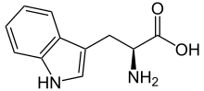
Fig.28. Structure of Tryptophan

4.7 FLUORESCENCE OF TOMINE AND TOCLOMINE

The compound TOMINE act as a fluorescence sensor because it exhibits high fluorescence properties. These properties were found by analyzing the fluorescence color they exhibit and by taking the fluorescence spectrum.
First, a solution prepared by dissolving a small quantity of TOMINE in methanol was taken in a test tube and placed in a UV chamber. An intense bluish fluorescence color (Fig.29) was noted for TOMINE. From that, it was found that TOMINE is having a fluorescence property. It was further confirmed by conducting fluorescence spectroscopy. A 10⁻³ concentration of compound TOMINE was prepared by dissolving in solvent methanol and a fluorescent spectrum was taken at the excitation wavelength 340 nm and an emission spectrum obtained at 380 nm (fig.31). From this we were able to understand that, TOMINE has high fluorescence property.

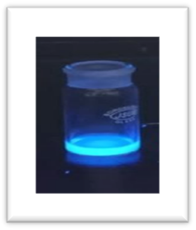
Fig.29. TOMINE in UV chamber

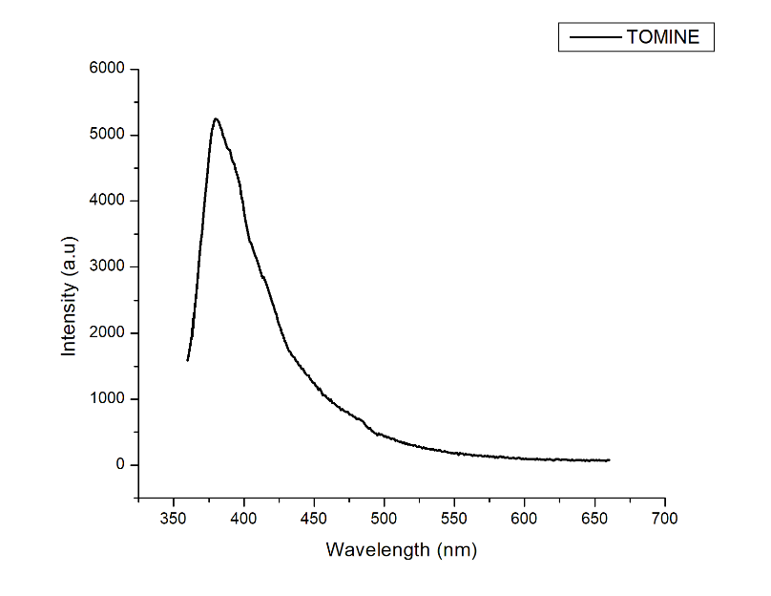

Fig.30 Emission spectrum of TOMINE

Similarly, fluorescence properties of TOCLOMINE were confirmed by placing its methanolic solution in a UV chamber and obtained a bluish fluorescence (Fig.31) and its fluorescence spectrum was taken in its excitation wavelength 270 nm and emission spectrum obtained at 378 nm (Fig.32), confirmed TOCLOMINE has high fluorescence property.

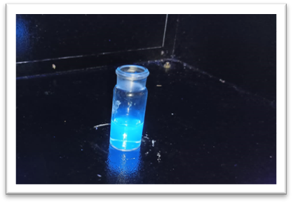
Fig.31. Bluish fluorescence

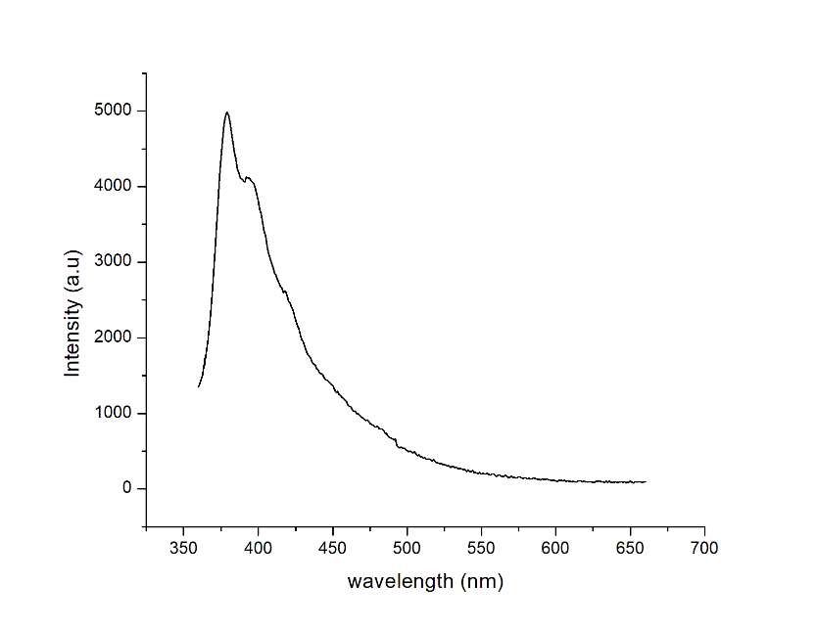

Fig.32. Emission spectrum of TOCLOMINE

4.8 OVERLAY OF FLUORESCENCE EMISSION AND
ABSORBTION SPECTRUM OF TOMINE
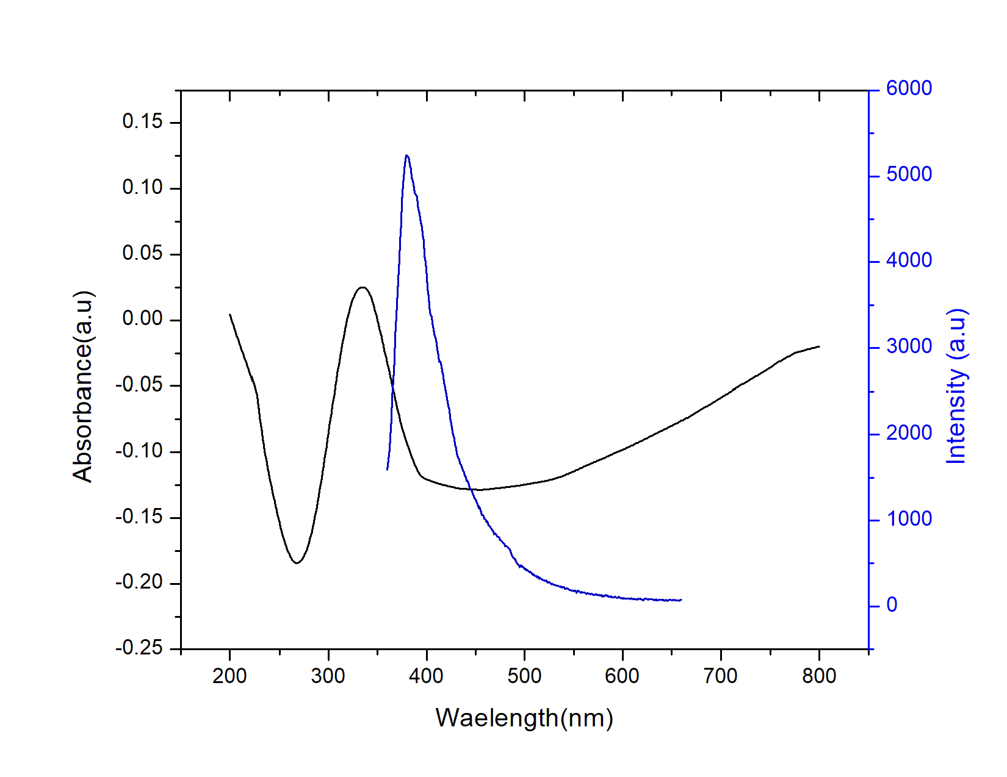

4.9 OVERLAY OF FLUORESCENCE EMISSION AND
ABSORBTION SPECTRUM OF TOCLOMINE

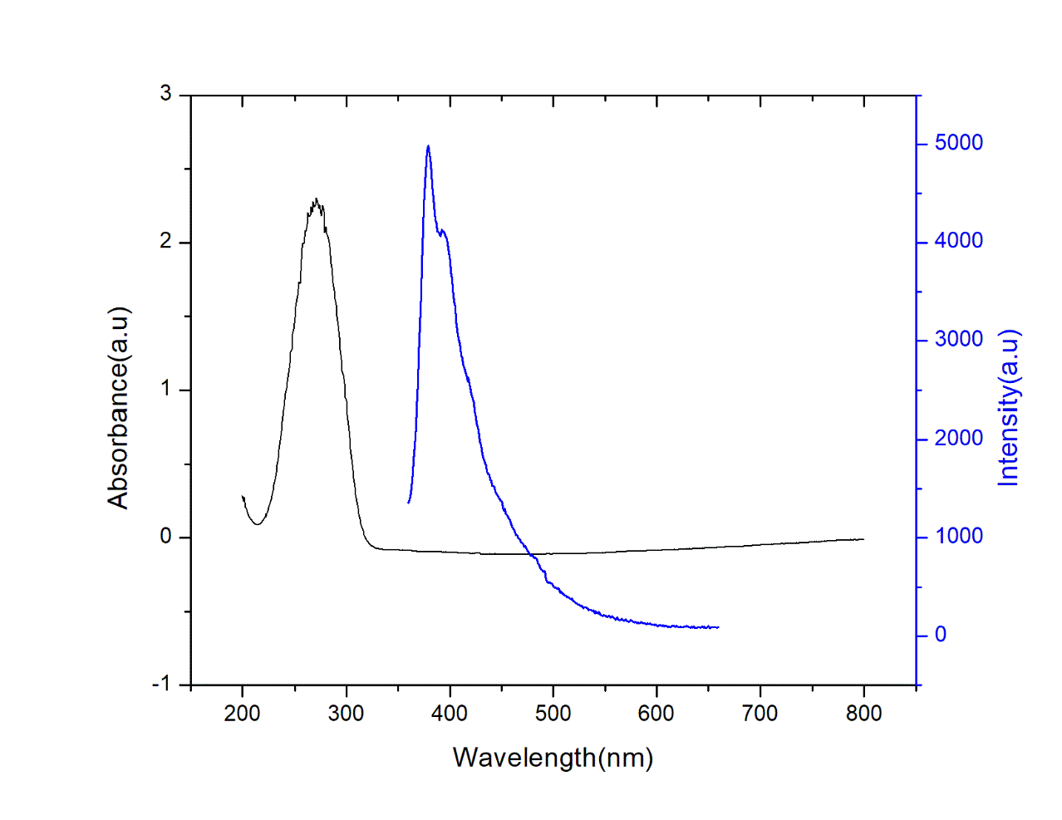

4.10 TOMINE AS FLUORESCENCE SENSOR FOR AMINO ACID TRYPTOPHAN

To develop a sensor for tryptophan, the sensitivity of probe TOMINE with tryptophan needs to be analyzed. For this, I prepared 10⁻³ concentrations of the probe.100 microlitre of it were taken for the fluorescence spectroscopic study. Then 100 microlitres of both probe and tryptophan of 10⁻³ concentration were taken and its emission spectrum was obtained. Tryptophan showed an enhancement in fluorescence intensity of probe of about 44970 au at 378 nm (Fig.33). To notice the color change of probe with tryptophan two beakers having same volume of methanol taken to both the beakers 100 microlitres of probe (10⁻³M) added. To one of them, 100 microlitres of 10⁻³ concentration tryptophan were added and placed in a UV chamber. It was able to observe that the beaker containing TOMINE with tryptophan is having an Indigo fluorescence which was different from the bluish fluorescence color of the solution of compound TOMINE alone (Fig.32). This shows tryptophan enhanced the fluorescence property of TOMINE and confirm the sensitivity of probe with tryptophan. Thereby TOMINE can act as a sensor for amino acid tryptophan detection. ^{[29]}

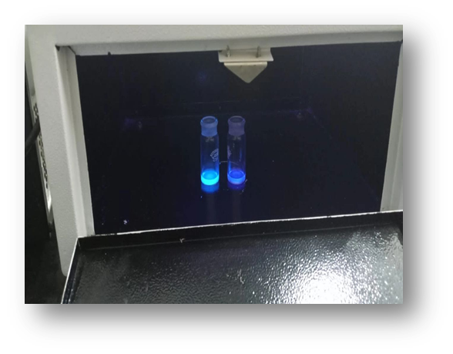
Fig.34. TOMINE+ Tryptophan in UV chamber

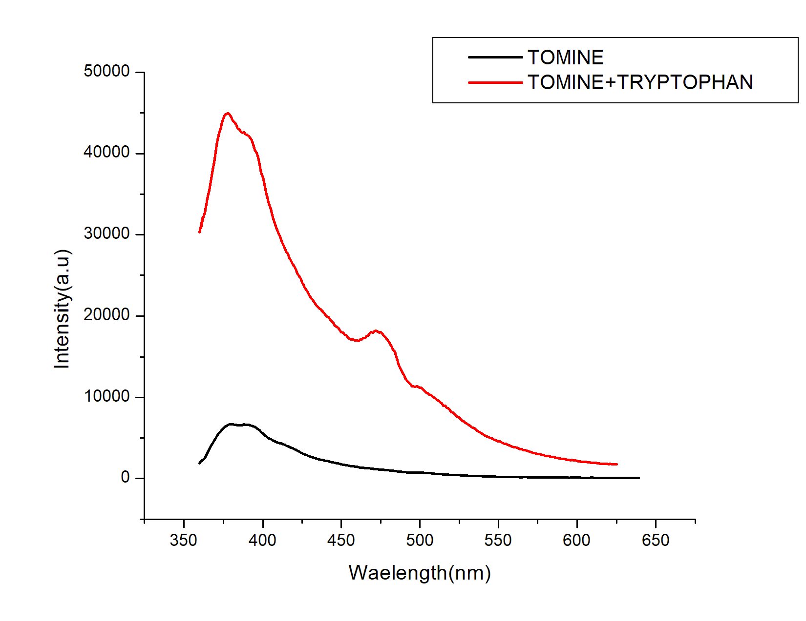
Fig.33. Fluorescence spectrum of TOMINE +Tryptophan

4.11 SELECTIVITY STUDY

The major property of a sensor is its selectivity. It must specifically detect a particular group, metal ion, or compound. Here to check the selectivity of our probe, we need to do the selectivity study with other amino acids. If the probe shows a particular property with tryptophan only then we can say the probe is selective with tryptophan. For that eight amino acids (tryptophan, tyrosine, histidine, alanine, aspartame, methionine, glycine, phenylalanine) were selected and their solution at the same concentration were prepared. The Fluorescence spectrum was obtained with 100 microlitres of the probe with 100 microlitres of each amino acid.

From the spectrum, only the spectrum of tryptophan with TOMINE had shown an enhancement in fluorescence emission. From this, I was able to understand that, TOMINE exhibited a remarkable sensitivity towards tryptophan in fluorescence spectra among other amino acids. I confirmed compound TOMINE can act as a fluorescence sensor for detection of amino acid tryptophan. ^{[22]}

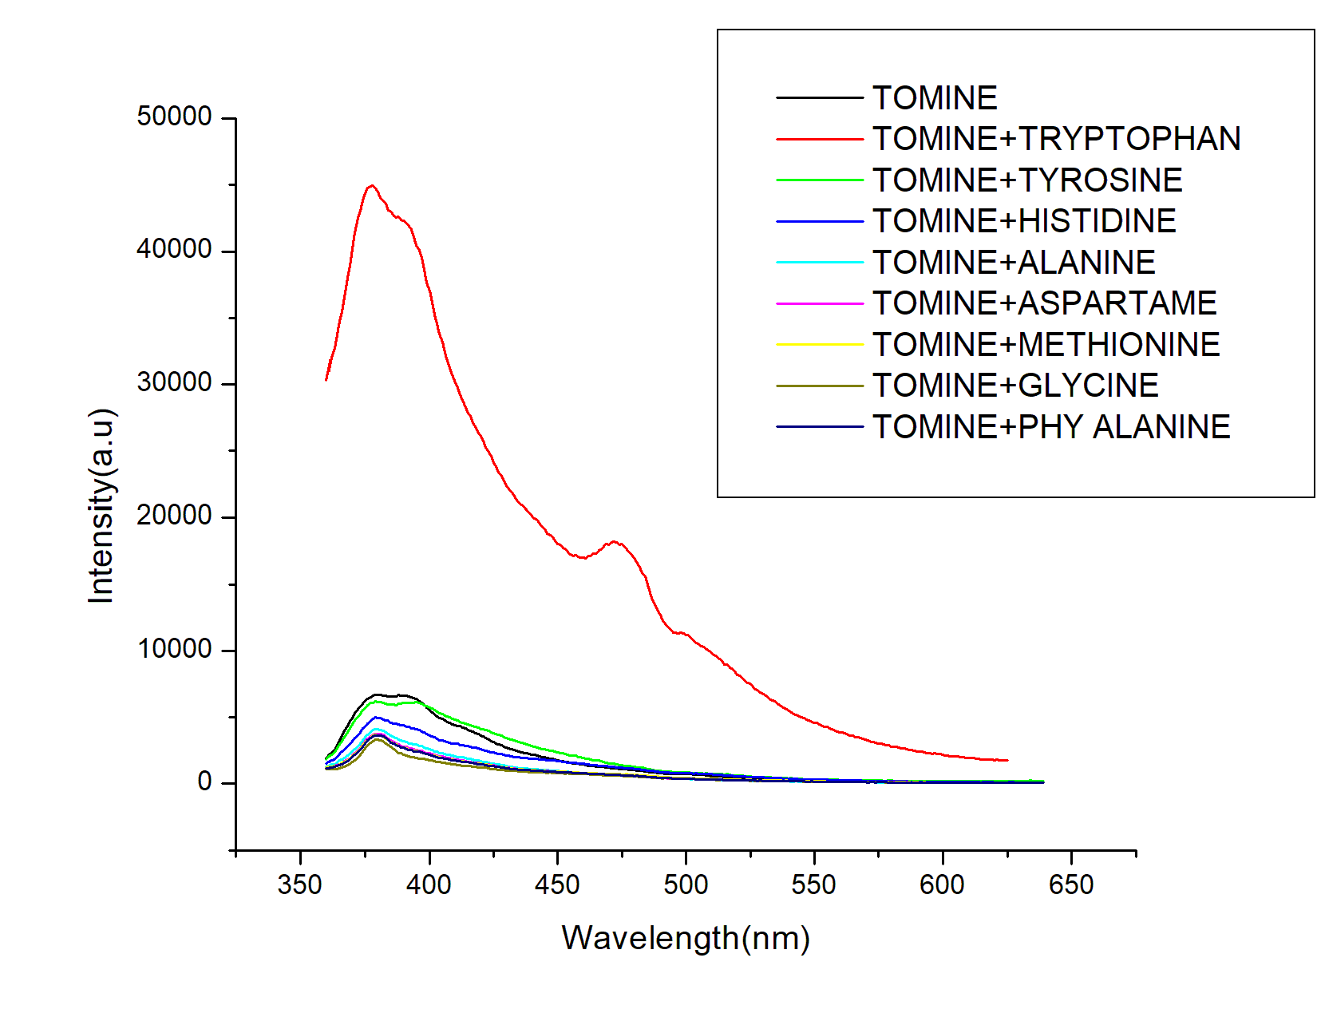

4.12 TIME STUDY

To confirm whether the compound TOMINE is a stable complex, I have done the time study with the 10⁻³ concentration of probe. The need for time study is if only it was a stable complex. we can check its sensitivity for tryptophan and then develop a sensor.

For that 50 microlitres of the probe was taken and its fluorescence spectrum was taken for 30 minutes in the time interval of 5 minutes. The graph showing fluorescence emission of probe at each time interval is shown below (Fig.35). ^{[24]}

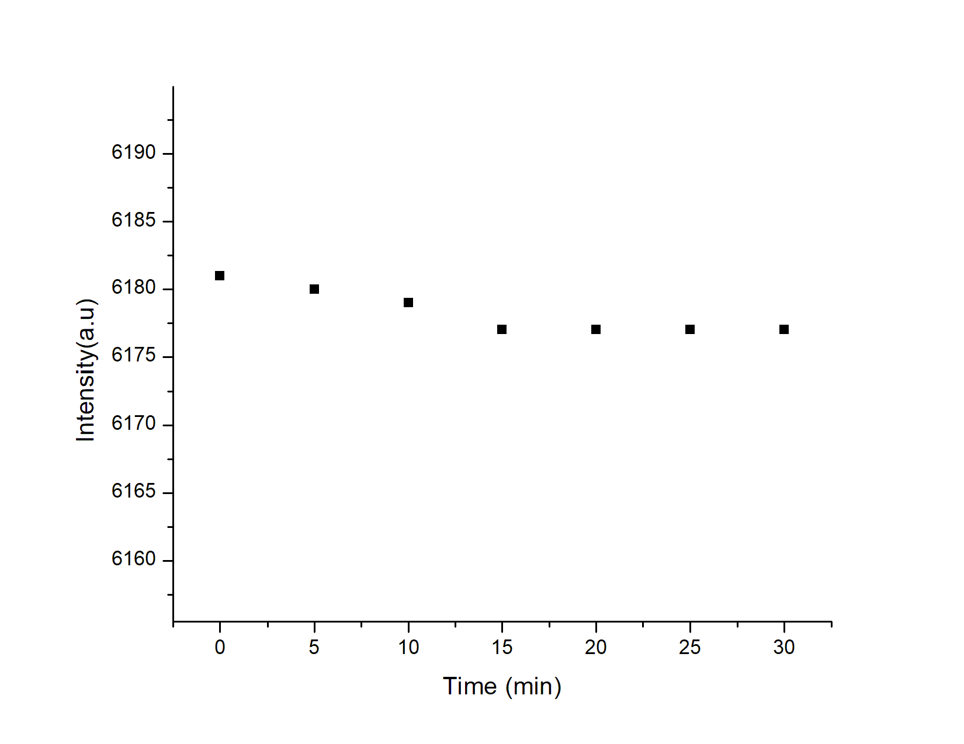

Fig.35. Time study

From the data obtained, I was able to understand probe shows a constant value of fluorescence emission at each time interval and hence it is a stable complex.

Chapter 5

Conclusions
In conclusion, three new Schiff bases were synthesized. The synthesized compounds were TOMINE, TOCLOMINE, T-CYCLO. TOMINE was a orange-colored powder, TOCLOMINE was a brown coloured powder, while T-CYCLO was a yellow coloured powder. These synthesized compounds were characterized using different spectroscopic techniques including Elemental analysis, NMR Spectroscopy, FT-IR Spectroscopy, UV-Visible Spectroscopy.

Of the three compounds synthesized two compounds, TOMINE and TOCLOMINE shows high fluorescence property and were checked by observing its fluorescence colour by placed in an UV chamber and further confirmed by fluorescence spectroscopy. The compound TOMINE exhibited remarkable sensitivity with amino acid Tryptophan and confirmed it by taking the fluorescence spectrum of the probe with tryptophan. Selectivity of probe was further studied with the other selected amino acids and confirmed TOMINE can act as a fluorescence sensor for tryptophan. Further studied about the stability of the compound and it found to be in good agreement. The ability of Schiff base to bind with biomolecules led to the application of sensor.

References

[1] Uddin M.N., Ahmed S.S., Alam S.R., Biomedical applications of Schiff base metal complexes. Journal of Coordination Chemistry, 2020; 73: 3109-49.

[2] Soroceanu A., Bargan A., Advanced and biomedical applications of Schiff-base ligands and their metal complexes, 2022; 12: 1436-1448.

[3] Khalil R.A., Jalil A.H., Abd-Alrazzak A.Y., Application of a Schiff base derived from sulfanilamide as an acid-base indicator.Journal of the Iranian Chemical Society, 2009; 6: 345-352.

[4] Brodowska K., Lodyga‐Chruscinska E., Schiff bases-interesting range of applications in various fields of science, 2015; 46: 129-134

[5] Da Silva C.M., da Silva D.L., Modolo L.V., Alves R.B., de Resende M.A., Martins C.V., de Fátima Â., Schiff bases: A short review of their antimicrobial activities. Journal of Advanced research, 2011; 2:1-8.

[6] Sharaby C.M., Synthesis, spectroscopic, thermal and antimicrobial studies of some novel metal complexes of Schiff base derived from [N1-(4-methoxy-1, 2, 5-thiadiazol-3-yl) sulfanilamide] and 2-thiophene carboxaldehyde. Spectrochimica Acta Part A. Molecular and Biomolecular Spectroscopy, 2007; 66: 1271-1278.

[7] Ibrahim F.M., Abdalhadi S.M., Performance of Schiff Bases Metal Complexes and their Ligand in Biological Activity. Journal of Science. 2021; 24: 1-10.

[8] Krishna G.A., Dhanya T.M., Shanty A.A., Raghu K.G., Mohanan P.V. Transition metal complexes of imidazole derived Schiff bases: Antioxidant/anti-inflammatory/antimicrobial/enzyme inhibition and cytotoxicity properties. Journal of Molecular Structure, 2023; 1274: 134384

[9] Kagatikar S., Sunil D. Schiff bases and their complexes in organic light emitting diode application. Journal of Electronic Materials, 2021; 50: 1-6.
[10] Dalia S.A., Afsan F., Hossain M.S., Khan M.N., Zakaria C., Zahan M.K., Ali M., A short review on chemistry of schiff base metal complexes and their catalytic application, 2018; 6: 2859-2866.

[11 Berhanu A.L., Mohiuddin I., Malik A.K., Aulakh J.S., Kumar V., Kim K.H., A review of the applications of Schiff bases as optical chemical sensors.Trends in Analytical Chemistry, 2019; 116: 74-91.

[14] Pundi A., Chang C.J., Chen J., Hsieh S.R., Lee M.C., A chiral carbazole based sensor for sequential “on-off-on” fluorescence detection of Fe3+ and tryptophan/histidine. Sensors and Actuators B, 2021; 328: 129084.

[15] Pundi A., Chang C.J., Chen J., Hsieh S.R., Lee M.C., A dimedone-phenylalanine-based fluorescent sensor for the detection of iron (III), copper (II), L-cysteine, and L-tryptophan in solution and pharmaceutical samples. Spectrochimica Acta Part A: Molecular and Biomolecular Spectroscopy, 2022; 274: 121108.

[16] Aazam E.S., Husseiny A.E., Al-Amri H.M., Synthesis and photoluminescent properties of a Schiff-base ligand and its mononuclear Zn (II), Cd (II), Cu (II), Ni (II) and Pd (II) metal complexes. Arabian Journal of Chemistry, 2012; 5: 45-53.

[17] Kamaci Ü.D., Kamaci M., Boric acid and Schiff base-based fluorescent sensor for detection of L-tryptophan in milk and BSA samples. Turkish Journal of Chemistry,2022; 46: 929-40.

[18] Shang X., Li J., Guo K, Ti T., Wang T., Zhang J., Development and cytotoxicity of Schiff base derivative as a fluorescence probe for the detection of l-Arginine. Journal of Molecular Structure, 2017; 1134: 369-73.
[19] Li W.D., Huang Y., Li S.Z., Dong W.K., A novel double-armed salamo-based probe for highly selective fluorescence detection of tryptophan and Al3+. Journal of Molecular Structure, 2023; 1284: 135360-135368

[20] Goshisht M.K., Patra G.K., Tripathi N., Fluorescent Schiff base sensors as a versatile tool for metal ion detection: strategies, mechanistic insights, and applications. Materials Advances, 2022; 3: 2612-69.

[21] Sadia M., Khan J., Naz R., Zahoor M., Khan E., Ullah R., Bari A. Schiff-Based Fluorescent-ON Sensor L Synthesis and Its Application for Selective Determination of Cerium in Aqueous Media. Journal of Sensors, 2020; 2020: 1-10.

[22] Zhang Y., Yao W., Liang D., Sun M., Wang S., Huang D., Selective detection and quantification of tryptophan and cysteine with pyrenedione as a turn-on fluorescent probe. Sensors and Actuators B: Chemical, 2018; 259: 768-774.

[23] Zhang J.F, Zhou Y., Yoon J., Kim J.S., Recent progress in fluorescent and colorimetric chemosensors for detection of precious metal ions (silver, gold and platinum ions). Chemical Society Reviews, 2011; 40: 3416-3429.

[24] Hasan A.H., Synthesis and characterization of fluorescent Schiff Bse and their metal complexes from 9-Anthracenecarboxaldehyde. A systematic review journal in the field of pharmacy, 2021; 12: 306-314

[25] Chhetri A., Chettri S., Rai P., Sinha B., Brahman D., Exploration of inhibitory action of Azo imidazole derivatives against COVID-19 main protease (Mpro): A computational study. Journal of molecular structure, 2021; 1224: 129178.

[26] Reshma R., Selwin Joseyphus R., Arish D., Reshmi Jaya R.J., Johnson J., Tridentate imidazole-based Schiff base metal complexes: Molecular docking, structural and biological studies. Journal of Biomolecular Structure and Dynamic, 2022; 40: 8602-8614.

[27] Udhayakumari D.W, Inbaraj V., A review on Schiff Base fluorescent Chemosensors for cell imaging applications. Journal of Fluorescence, 2020; 30: 1203-1223.

[29] Sathya V., Srinivasadesikan V., Ming-Chang L., Padmini V., Highly sensitive and selective detection of tryptophan by antipyrine based fluorimetric sensor. Journal of Molecular Structure, 2023; 1272: 134241.

e-REFERENCES
12. https://en.wikipedia.org/wiki/Aldehyde

13. https://en.wikipedia.org/wiki/Amine

28. https://en.wikipedia.org/wiki/Tryptophan

